THE THIRD SUNDAY AFTER THE EPIPHANY
January 23, 2022

Jesus began his ministry with these words read from a scroll of the prophet Isaiah: “The Spirit of the Lord is upon me to proclaim the acceptable year of the Lord.” The arrival of the dominion of God was, in those words, inextricably tied to helping the poor, releasing prisoners, healing the sick. And yet the poor remain in our streets, our prisons are overcrowded as never before, and everyone of us will eventually succumb to ill health and physical death.
Had Jesus failed? . . . Following in his steps from that early synagogue worship service, to the hills of Galilee, the road to Jerusalem, and the way of the cross, we discover that suffering is not God’s will. Rather, life in the face of suffering is God’s will; courage in the face of fear; faith in the face of doubt and abandonment; love in the face of hatred and prejudice. God’s will is to call these things out of the hurt and brokenness that we are and that we find around us. With Christ, the prophecy is fulfilled, in you and in me.

Bruce J. Evenson
“The Work of Christmas” by Howard Thurman
When the song of the angels is stilled,
when the star in the sky is gone,
when the kings and princes are home,
when the shepherds are back with their flocks,
the work of Christmas begins:
to find the lost,
to heal the broken,
to feed the hungry,
to release the prisoner,
to rebuild the nations,
to bring peace among the people,
to make music in the heart.
In the Name of Jesus
INTRODUCTION

The glory of the Lord is revealed in the reading of scripture. People stand at attention. People weep. People prostrate themselves in prayer. The unity of the church is another reflection of the glory of God. Most gloriously, the promises of God are fulfilled in the person of Jesus Christ. Gather round. Listen up. Glimpse the glory of God.

Lydia, Dorcas, and Phoebe, witnesses to the faith

Women as well as men were important Christian leaders from the beginning, as demonstrated by these coworkers of the apostle Paul. Lydia, a seller of purple goods, lent her home for a church; Dorcas was known for charitable works; and Phoebe was a deacon in the church at Cenchrae.

GATHERING

PRELUDE Angelic Songs Mark Sedio

ANNOUNCEMENTS

As you are able please rise

CONFESSION AND ABSOLUTION

P: In the name of the Father and of the Son and of the Holy Spirit.

C: Amen.

P: “The judgments of the LORD are true and righteous altogether … by them also is Your
servant enlightened, and in keeping them there is great reward.” (Psalm 19:9, 11) Let
us, therefore, in confidence and hope, confess our sins, that God may “enlighten” the
darkness of our hearts with the light of Christ.

Silence for self-examination and reflection is kept

P: Most merciful God,

C: We confess that we have sinned against You and our neighbor in thought, word,
and deed. We have not been attentive to Your Word (Nehemiah 8:4). We have
failed to use the gifts given by the Spirit for the good of the whole body of Christ
(1 Corinthians 12:26). We have allowed and caused dissension among us (12:25).
We have been blind to Your presence and deaf to Your call to continue the
ministry of Jesus. For all our sins: known and unknown, done and left undone,
forgive us, O God. Fill us with the power of Your Spirit (Luke 4:14), that released
from our sins (4:18), we may bring and be Your good news to those in need (4:18).

P: God sent Jesus to proclaim the very “release” you seek. Therefore, as a called and
ordained minister of the Church of Christ, and by His authority, I declare to you “today”
(Luke 4:21) the entire forgiveness of all your sins, in the name of the Father and of
the Son and of the Holy Spirit.

C: Amen.

GATHERING HYMN 239 Hark! The Glad Sound page 12

THE GREETING, PRAYER OF THE DAY AND PEACE

P: Arise; shine; for your light has come. The grace of our Lord Jesus Christ, the love of
God, and the communion of the Holy Spirit be with you all.

C: And also with you.

P: Let us pray. Almighty God, You sent Your Son to proclaim Your Kingdom and to
teach with authority. Anoint us with the power of Your Spirit, that we, too, may bring
good news to the afflicted, bind up the brokenhearted, and proclaim liberty to the
captive; through Your Son, Jesus Christ, our Savior and Lord.

C: Amen.

The assembly is seated

WORD

FIRST READING Nehemiah 8:1-3, 5-6, 8-10

The exiles have returned. Under Nehemiah they have rebuilt the city of Jerusalem and its walls. Now the people ask Ezra, the priest, to read the law of Moses to them in the public square. When they hear it they weep for their sins, for the long years in exile, and for the joy of the Lord that was their strength.

When the seventh month came—the people of Israel being settled in their towns—
all the people gathered together into the square
before the Water Gate.
They told the scribe Ezra to bring the book of the law of Moses,
which the LORD had given to Israel.
Accordingly, the priest Ezra brought the law before the assembly,
both men and women and all who could hear with understanding.
This was on the first day of the seventh month.
He read from it facing the square before the Water Gate from early morning
until midday, in the presence of the men and women and
those who could understand; and the ears of all the people
were attentive to the book of the law.
And Ezra opened the book in the sight of all the people, for he was
standing above all the people; and when he opened it, all the
people stood up.
Then Ezra blessed the LORD, the great God, and the people answered,
“Amen, Amen,” lifting up their hands.
Then they bowed their heads and worshiped the LORD with their faces
to the ground.
So they read from the book, from the law of God, with interpretation.
They gave the sense, so that the people understood the reading.
And Nehemiah, who was the governor, and Ezra the priest and scribe,
and the Levites who taught the people said to all the people,
“This day is holy to the LORD your God; do not mourn or weep.”
For all the people wept when they heard the words of the law.
Then he said to them, “Go your way, eat the fat and drink the sweet wine
and send portions of them to those for whom nothing is prepared,
for this day is holy to our LORD;
and do not be grieved, for the joy of the LORD is your strength.”

The Word of the Lord.

Thanks be to God.

THE PSALM: Psalm 19 Read responsively

¹The heavens declare the glory of God,
and the sky proclaims its maker's handiwork.

²One day tells its tale to another,
and one night imparts knowledge to another.

³Although they have no words or language,
and their voices are not heard,

⁴their sound has gone out into all lands, and their message to the ends of the world,
where God has pitched a tent for the sun.

⁵It comes forth like a bridegroom out of his chamber;
it rejoices like a champion to run its course.

⁶It goes forth from the uttermost edge of the heavens and runs about to the end of it
again; nothing is hidden from its burning heat.

⁷The teaching of the LORD is perfect and revives the soul;
the testimony of the LORD is sure and gives wisdom to the simple.

⁸The statutes of the LORD are just and rejoice the heart;
the commandment of the LORD is clear and gives light to the eyes.

⁹The fear of the LORD is clean and endures forever;
the judgments of the LORD are true and righteous altogether.

¹⁰More to be desired are they than gold, more than much fine gold,
sweeter far than honey, than honey in the comb.

¹¹By them also is Your servant enlightened,
and in keeping them there is great reward.

¹²Who can detect one's own offenses?
Cleanse me from my secret faults.

¹³Above all, keep Your servant from presumptuous sins; let them not get dominion over
me; then shall I be whole and sound, and innocent of a great offense.

¹⁴Let the words of my mouth and the meditation of my heart be acceptable in Your
sight, O LORD, my strength and my redeemer.

THE SECOND READING 1 Corinthians 12:12-31a

Paul writes to the divided congregation in Corinth to tell them what it means for the church to be the one body of Christ.

For just as the body is one and has many members, and all the members of the body,
though many, are one body, so it is with Christ.
For in the one Spirit we were all baptized into one body—
Jews or Greeks, slaves or free—and we were all made to drink
of the one Spirit.
Indeed, the body does not consist of one member but of many.
If the foot would say, “Because I am not a hand, I do not belong to the body,”
that would not make it any less a part of the body.
And if the ear would say, “Because I am not an eye, I do not belong to the body,”
that would not make it any less a part of the body.
If the whole body were an eye, where would the hearing be?
If the whole body were hearing, where would the sense of smell be?
But as it is, God arranged the members in the body, each one of them,
as He chose.
If all were a single member, where would the body be?
As it is, there are many members, yet one body.
The eye cannot say to the hand, “I have no need of you,” nor again the head
to the feet, “I have no need of you.”
On the contrary, the members of the body that seem to be weaker are
indispensable, and those members of the body that we think less
honorable we clothe with greater honor,
and our less respectable members are treated with greater respect;
whereas our more respectable members do not need this.
But God has so arranged the body, giving the greater honor to the inferior member,
that there may be no dissention within the body, but the members
may have the same care for one another.
If one member suffers, all suffer together with it; if one member is honored,
all rejoice together with it.
Now you are the body of Christ and individually members of it.
And God has appointed in the church first apostles, second prophets, third teachers,
then deeds of power, then gifts of healing, forms of assistance, forms
of leadership, various kinds of tongues.
Are all apostles? Are all prophets? Are all teachers? Do all work miracles?
Do all possess gifts of healing? Do all speak in tongues? Do all interpet?
But strive for the greater gifts.

The Word of the Lord.

Thanks be to God.

As you are able please rise

THE VERSE

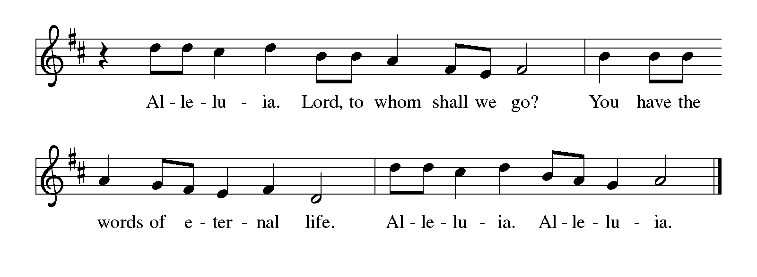
THE HOLY GOSPEL Luke 4:14-21

Near the beginning of Jesus’ public ministry, he visits his hometown. In the words of Isaiah, he clearly states his purpose, his mission.

P: The Holy Gospel according to St. Luke, the fourth chapter.

C: Glory to you, O Lord!

Then Jesus, filled with the power of the Spirit, returned to Galilee, and a
report about Him spread through all the surrounding country.
He began to teach in their synagogues and was praised by everyone.
When He came to Nazareth, where He had been brought up,
He went to the synagogue on the Sabbath day, as was His custom.
He stood up to read, and the scroll of the prophet Isaiah was given to Him.
He unrolled the scroll and found the place where it was written:
“The Spirit of the Lord is upon me,
because He has anointed me to bring good news to the poor.
He has sent me to proclaim release to the captives
and recovery of sight to the blind,
to let the oppressed go free,
to proclaim the year of the Lord’s favor.”
And He rolled up the scroll, gave it back to the attendant, and sat down.
The eyes of all in the synagogue were fixed on Him.
Then He began to say to them, “Today this scripture has been fulfilled in your hearing.”

P: The Gospel of the Lord.

C: Praise to you, O Christ!

The assembly is seated

THE SERMON
Silence for reflection follows the sermon

As you are able please rise

THE HYMN OF THE DAY 710 Let Streams of Living Justice page 13

THE APOSTLES’ CREED

A: God has made us His people through our Baptism into Christ. Living together in trust
and hope, we confess our faith.

C: I believe in God, the Father Almighty,
Creator of heaven and earth.
I believe in Jesus Christ, His only Son, our Lord.
He was conceived by the power of the Holy Spirit,
and born of the Virgin Mary.
He suffered under Pontius Pilate,
was crucified, died, and was buried.
He descended into hell.
On the third day He rose again.
He ascended into heaven,
and is seated at the right hand of the Father.
He will come again to judge the living and the dead.
I believe in the Holy Spirit,
the holy catholic Church,
the communion of saints,
the forgiveness of sins,
the resurrection of the body,
and the life everlasting. Amen.

THE PRAYER OF THE CHURCH

A: We have heard God’s Word in faith. Let us now respond in prayer for the Church, the
world, and all those in need.

A: That the Church might proclaim the gospel with power and courage so all who hear
God’s Word may be brought to faith in Christ, let us pray to the Lord:

C: Lord, hear our prayer.

A: That those who live in the ravages of war, under oppressive governments, or in places
of famine and poverty may be granted peace, freedom, sustenance, and hope, let us
pray to the Lord:

C: Lord, hear our prayer.

A: That we in this congregation might be united in the one Spirit we share through Baptism
so there might be no dissension among us but a common purpose and mission, let us
pray to the Lord:

C: Lord, hear our prayer.

A: That the poor, the captive in body or spirit, the blind, the dying, the hungry, and the
Sick especially: . . .might find release from their distress and the fullness of God’s
favor, let us pray to the Lord:

C: Lord, hear our prayer.

A: That those celebrating birthdays, especially Wayne Simerlien; Elaine Bogart and
Eloise Ponder might be filled with grace this day and every day and grow in grace in
the days ahead, let us pray to the Lord:

C: Lord, hear our prayer.

A: That those who mourn, especially the family and friends of Joan Coughlin, who died in the
Lord this week may be comforted by the promise of resurrection to life everlasting and of
being reunited with those they love before the throne of the Lamb, let us pray to the Lord:

C: Lord, hear our prayer.

A: That with those who have died in the faith, especially Lydia, Dorcas, and Phoebe,
witnesses to the faith whom we commemorate this Day we too may faithfully bear
witness to Christ as the fulfillment of all our hopes and God’s promises, let us pray to
the Lord:

C: Lord, hear our prayer.

P: Loving God, we come to You as beloved children, bringing the hopes and concerns of
our hearts. Hear our prayers, and grant us Your Good News today, through Your Son,
Jesus Christ our Lord.

C: Amen.
MEAL

THE PEACE

P: The peace of the Lord be with you always.

C: And also with you.

The assembly is seated

THE VOLUNTARY Bright and Glorious Is The Sky Susan Bagby

As you are able please rise

THE OFFERTORY PRAYER

A: Let us pray. Loving God,

C: This day is holy to You, and in its strength we find our joy. Make holy all that we
offer You, and receive it for the sake of Your Son. Grant us the power of Your
Spirit, that today we may both know and proclaim Your good news, Jesus Christ
our Lord. Amen.

THE GREAT THANKSGIVING

P: The Lord be with you.

C: And also with you.

P: Lift up your hearts.

C: We lift them up to the Lord.

P: Let us give thanks to the Lord our God.

C: It is right to give Him thanks and praise.

P: To worship You, Lord God, is our joy and our strength.
As the heavens tell Your glory and the firmament proclaims Your handiwork, we open
our hearts in thanksgiving to pour forth Your praise.
Your prophets foretold a Day when Your Anointed One would bring good news to the
poor, release to the captives, and recovery of sight to the blind.
In Christ You proclaimed the year of Your favor and fulfilled the promise of Your
glory.
In His death He faced Your world’s impulse to remain in the prison of sin, but by
raising Him from death You opened the gates of everlasting life and set us
free.
Baptizing God, as You created the body with many parts, each in need of one another,
and from many members make us one, transform us around this Table to
realize our common need for one another.
Make us holy as we drink of the one Spirit to make us one in You.
Send Your Holy Spirit upon this bread and cup that they may be for us the Body and
Blood of Your Son, Jesus Christ,
Who, in the night … “Do this for the remembrance of Me.”
As often as we eat … we proclaim the Lord’s death until He comes.

C: Christ has died. Christ is risen. Christ will come again.

P: Wondrous God, Whose ways are to be desired more than gold, even much fine gold,
hasten the Day when those ways shall be known in all the earth.
Fix Your promise in the hearts of Your children who suffer, that as members of
Your Body they may never suffer alone.
Let loose Your praise from the lips of those who rejoice, that in Your Body they may
never rejoice alone.
Make the simplest among us the wisest in You.
Revive those who wait on You and restore the hearts that rest in Your, until eternity
dawns and the voice of thanksgiving is heard through all the earth,
Giving glory to You, our living God: Father, Son, and Holy Spirit.

C: Amen!

THE LORD’S PRAYER

P: Because in Christ we have received the Spirit of adoption, as daughters and sons of
God, we dare to pray:

C: (Sung) page 14

INVITATION TO THE MEAL

P: Behold the true Light of the world, the Beloved of God, anointed by the Spirit. Blessed
are those who are called to the Supper of the Lamb. God’s holy gifts for God’s holy
people. Come, for all is now ready.

The assembly is seated

THE DISTRIBUTION

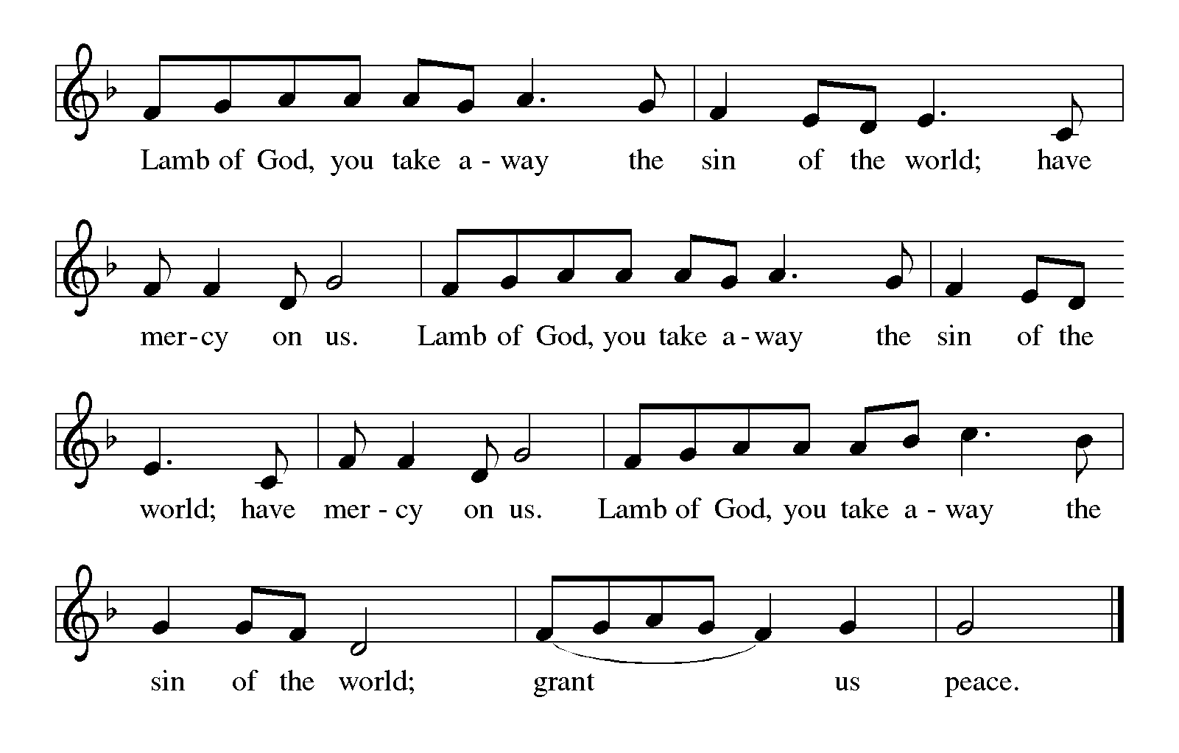
HYMN DURING DISTRIBUTION
843 Praise the One Who Breaks the Darkness p.15
332 I Heard the Voice of Jesus Say p. 16

As you are able please rise

THE POST COMMUNION BLESSING

P: The Body and Blood of our Lord Jesus Christ strengthen you and keep you in His
grace.

C: Amen.

THE POST-COMMUNION PRAYER

A: Let us pray. Lord God, in Baptism we were all made to drink of the one Spirit. In this
Meal we have eaten and drunk of the one body and blood of Your Son. By Your Spirit,
grant us courage to proclaim Your good news, faith to live in the fullness of Your
promises, and joy in Your Word of grace. Grant this through Christ our Lord.

C: Amen.
SENDING
THE BENEDICTION

P: Almighty God: Father, Son,and Holy Spirit bless you now and forever.

C: Amen.

SENDING HYMN 314 Arise! Your Light Has Come page 17

THE DISMISSAL

A: You are servants of God; you are light to the nations.
Go in peace. Serve the Lord.

C: Thanks be to God!

POSTLUDE Trumpet Tune in G Sam Batt Owens

To God Alone Be Glory

The Meditation is from Sundays and Seasons Online. Copyright 2015 Augsburg Fortress.

The Eucharistic Prayer is adapted from Eucharistic Prayers. Samuel Wells and Abigail
Kocher. (Grand Rapids: Eerdmann’s Publishing Company, 2016) 85-86.

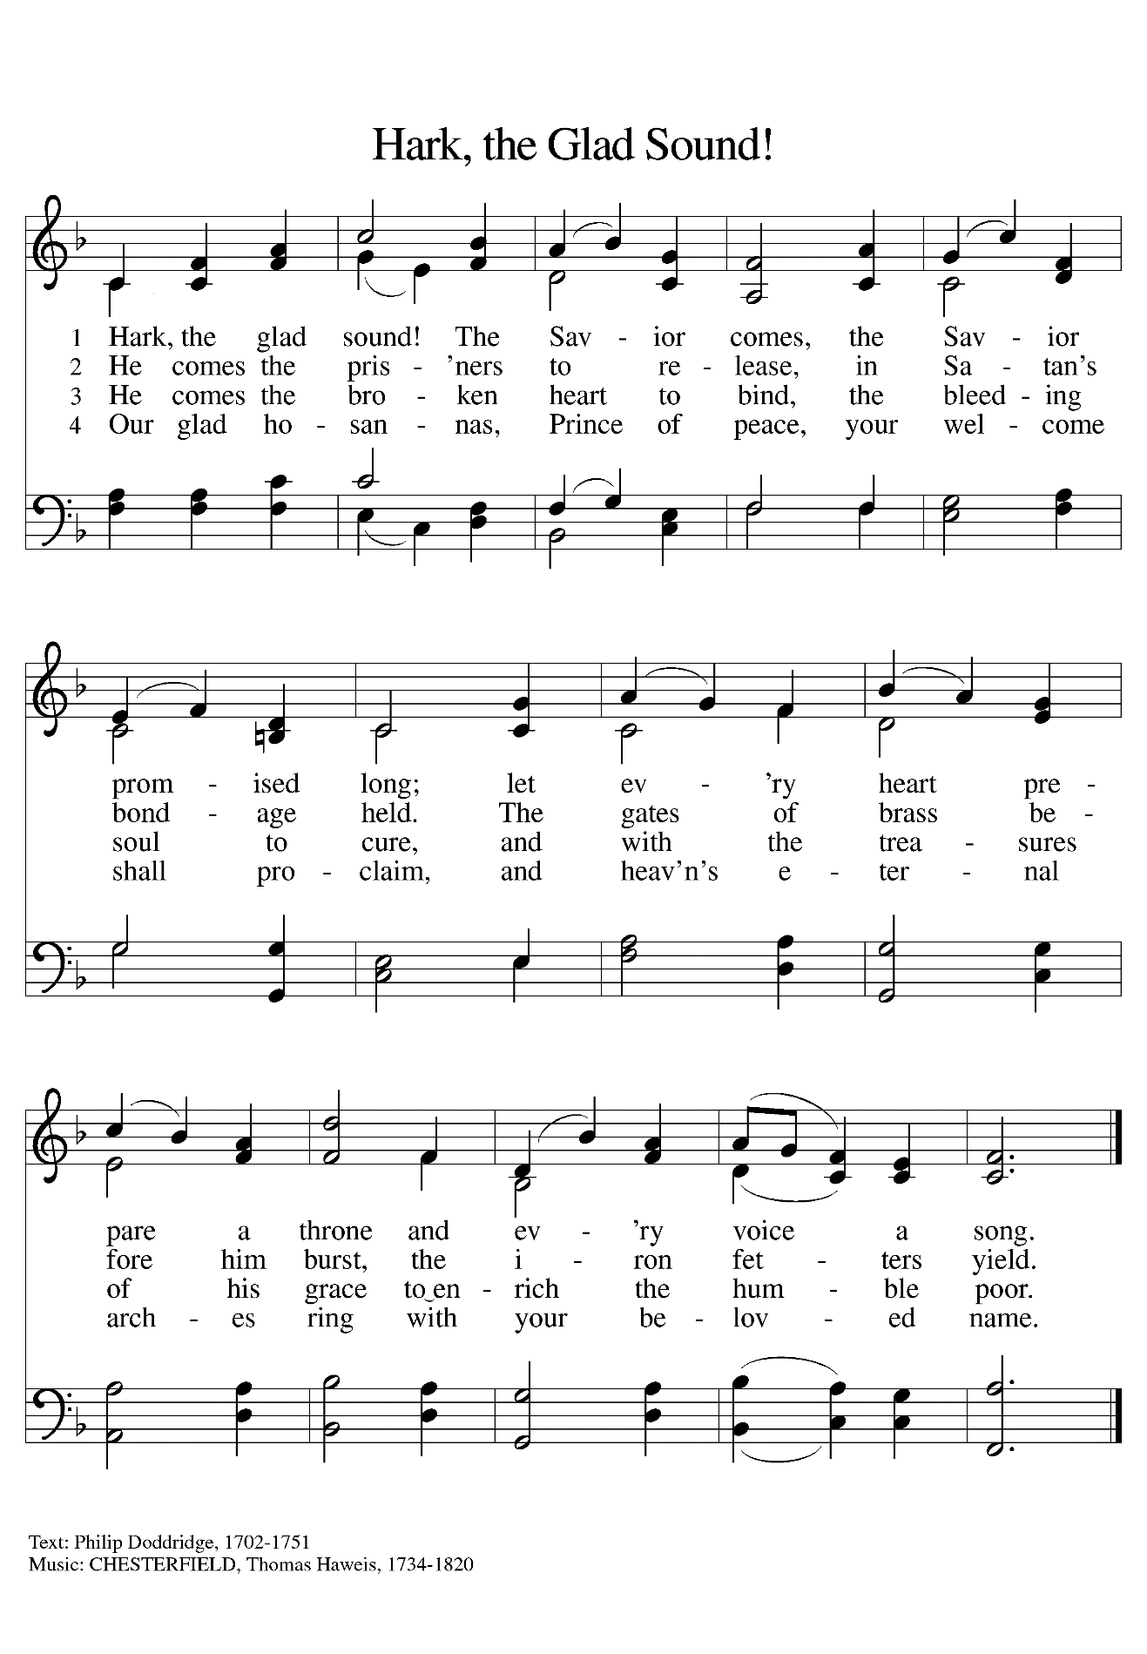

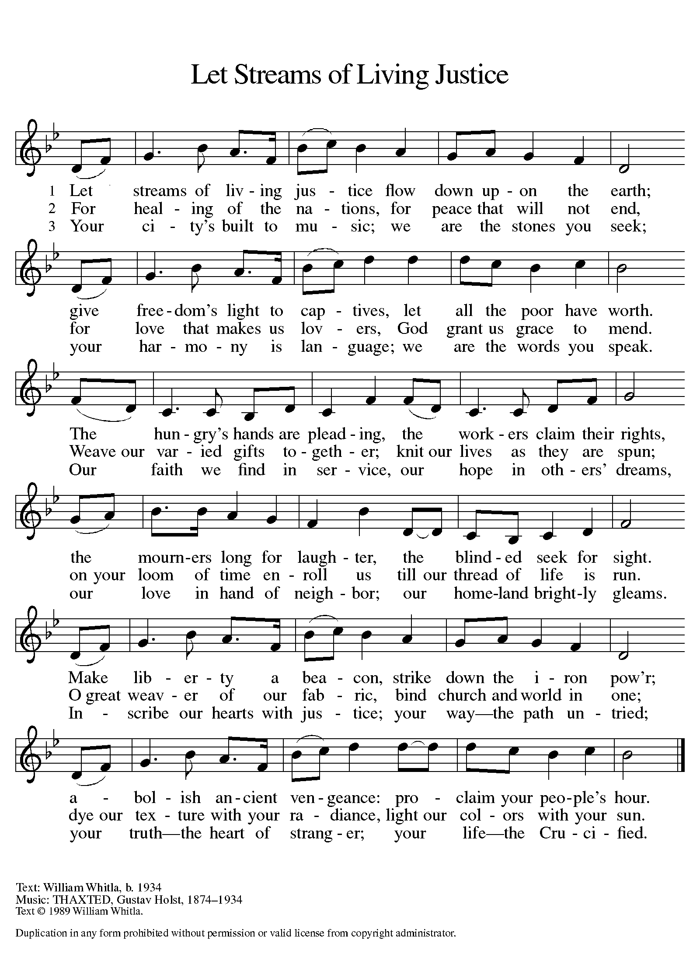

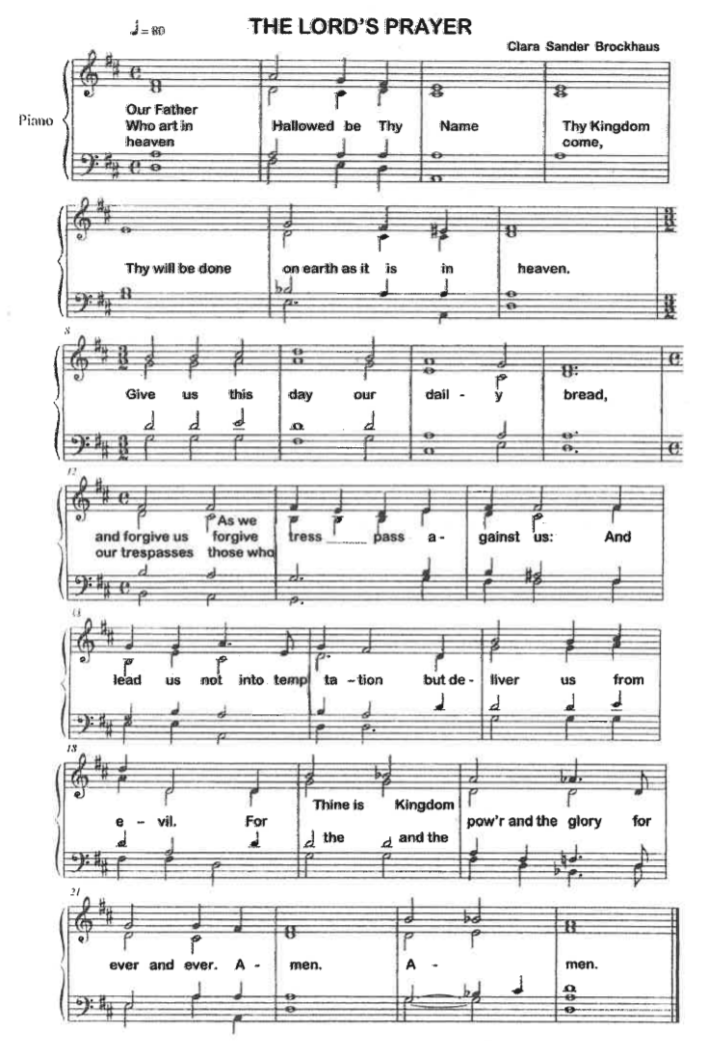
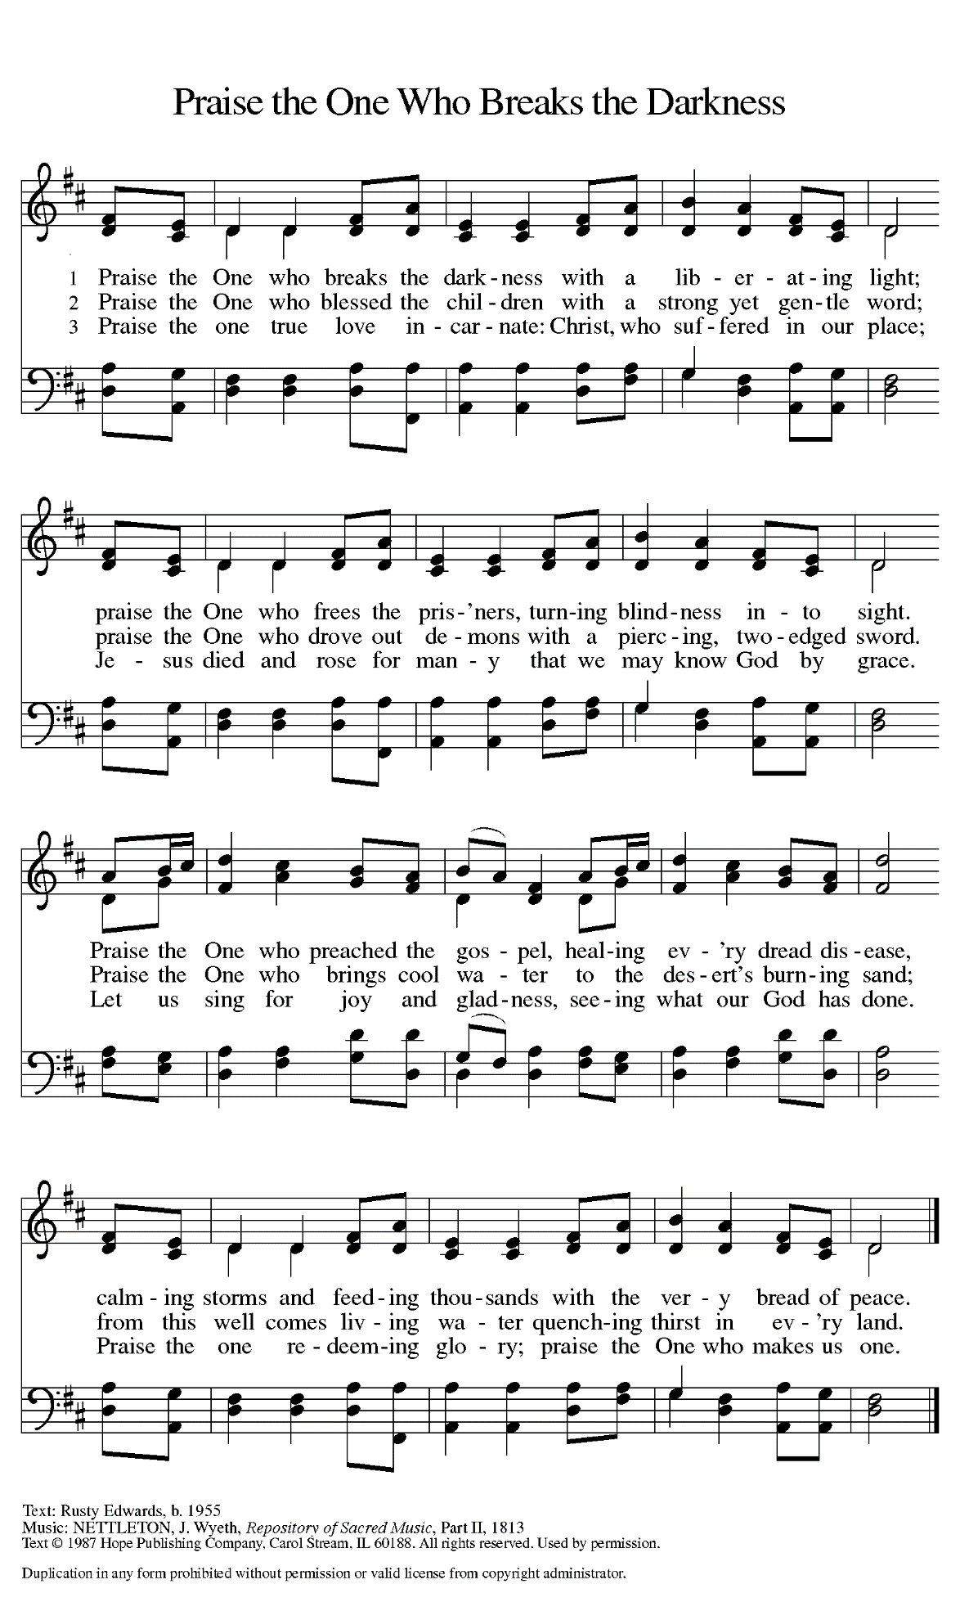
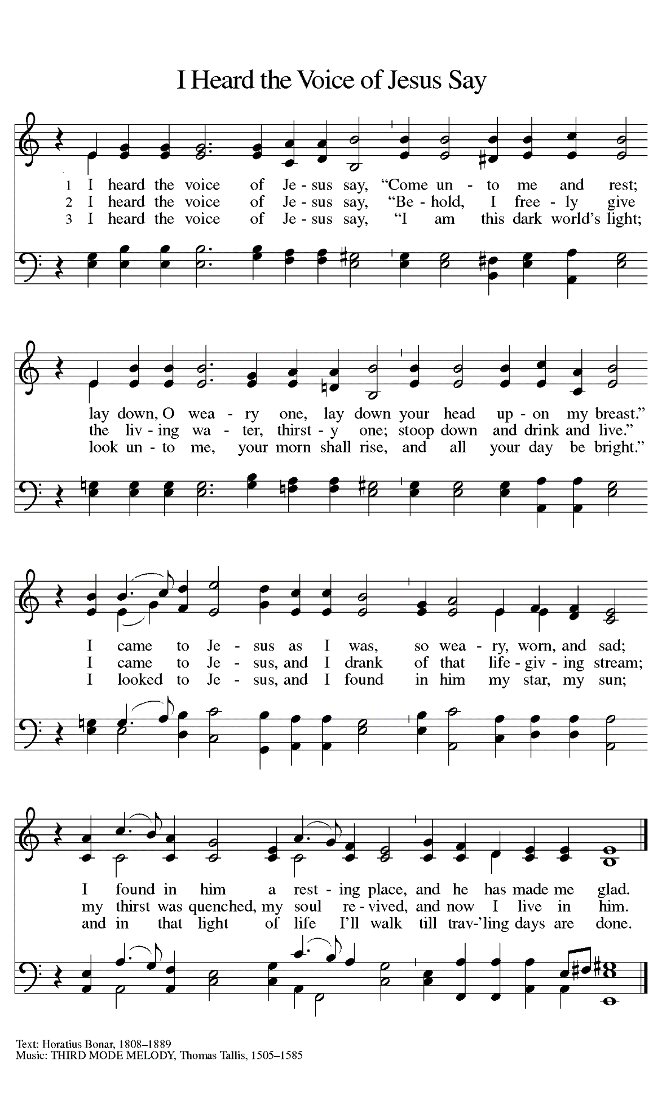
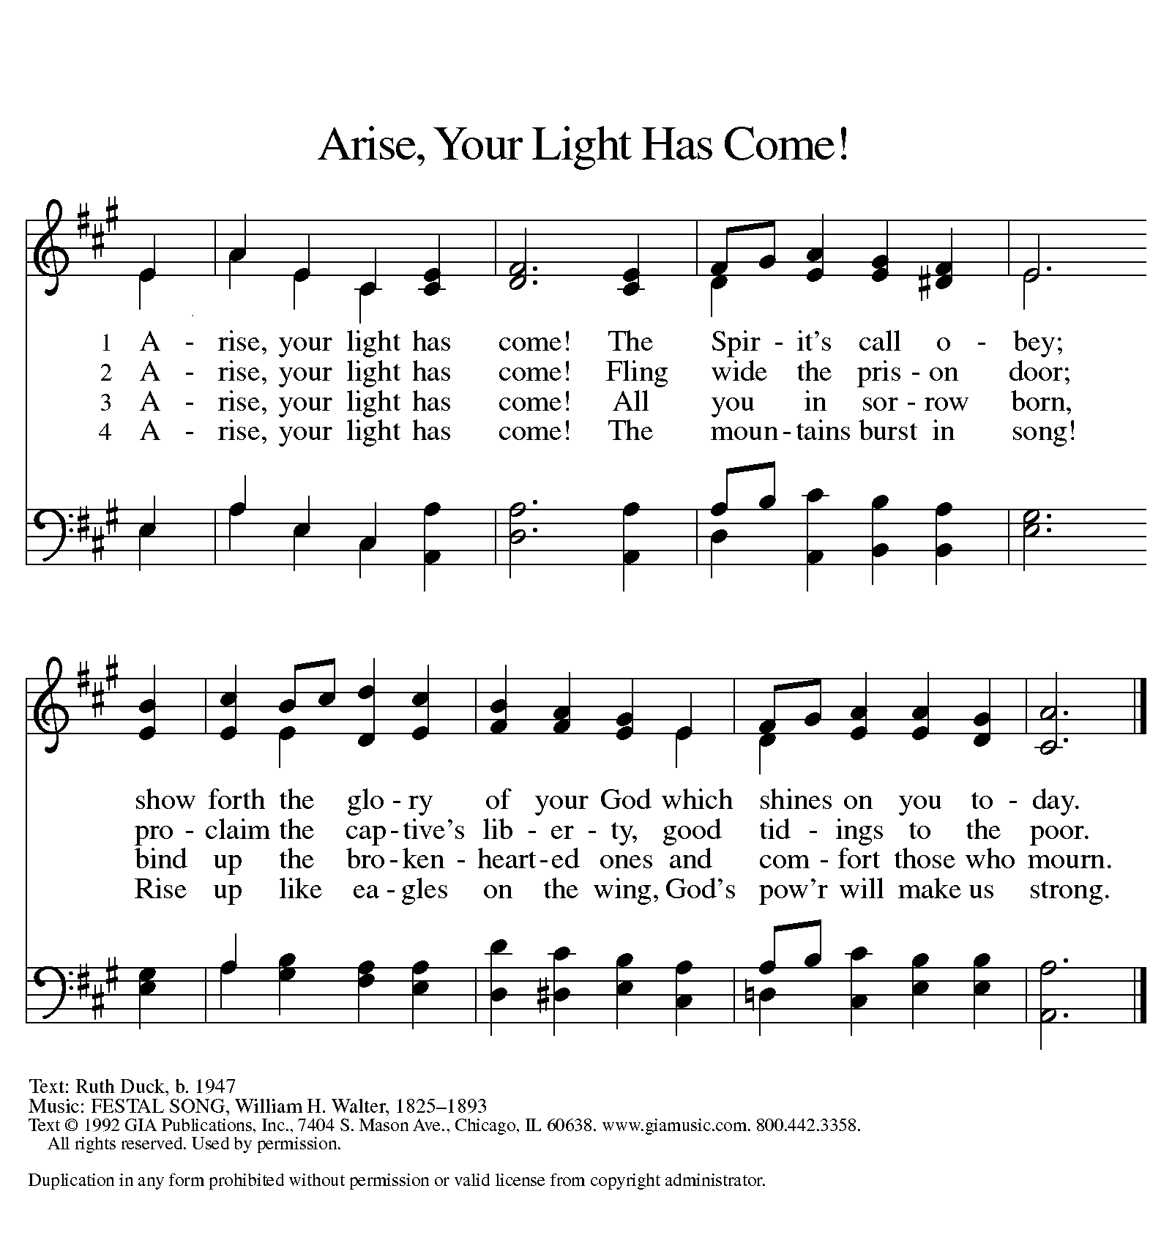

ANNOUNCEMENTS

Please remember to mail your offering to the Church Office at 818 Franklin Street, Michigan City, IN 46360. Another alternative is to give on-line through Tithe.ly. Please see your closure letter for information on how to set up a Tithe.ly account.

St. Paul Members are reminded to have a loved one contact the office if you are hospitalized. Many times, the Pastor doesn’t know someone is in the hospital. If you call and leave a message, please tell us which hospital the patient is at.

Next Sunday’s lessons are Jeremiah 1: 4-10; Psalm 71: 1-6; I Corinthians 13: 1-13; Luke 4: 21-30 for those of you who like to study them in advance.

Birthdays: Wayne Simerlein (1/25); Elaine Bogart (1/28); Eloise Ponder (1/28)

PRAYER CONCERNS: Kathy Thielman, Audrey Beyer, Bethany Manning, Marla Furness, Ryan Krueger, Donna Bostater, Maxine Powell, Jess Kalvaitis, Jan Paholski, Laura Dovey, Shane Nevels, Jim Tomscheck, Ed Gustum, Ken Mulder, Ryan Sirk, Carl Loetz, Ed Riddle and Donna Sutor.

If you requested someone’s name to be on the prayer list and are aware that they need continued imminent prayer then contact the church office and let us know. Otherwise we will gradually transfer names to the long-term list.

OFFICE HOURS: Libby will be in the office on Mondays, Wednesdays, and Fridays; volunteers will cover Tuesdays and Thursdays.

Monday & Wednesday 8:00 a.m. – 5 p.m.
Tuesday & Thursday 9:00 a.m. – 12:00 p.m.
Friday 8:00 a.m. – 12:00 p.m.

If you are listening to the worship broadcast on the radio and would like to watch the Sunday morning service live stream follow these steps:

- If you have You.Tube available on your TV, search for
St. Paul Lutheran Church Michigan City, IN.

(2) The direct link on the computer is
https://www.youtube.com/channel/UC5AIPNaKr3QN50984jGOa1g.

(3) This link is also on the main page of the church’s website in the church section and will continue to be posted weekly on the St. Paul Facebook page.

And it will always be available on the radio broadcast Sunday mornings at 11:00 a.m. on WEFM (95.9), and on the local cable access station #99 for the previous week’s service on Sundays at 4:00 p.m. and the current service on Wednesdays at 7:00 p.m. and Fridays at 8:30 p.m.

To send e-mail to the church office, please use the following addresses:
Pastor Mark Reshan: seniorpastor@stpaulmichigancity.com
Church Office Secretary (Libby Pollock): churchsecretary@stpaulmichigancity.com
Church Treasurer (Karen Fleming) and Bookkeeper (Billie Atchinson):
finance@stpaulmichigancity.com.

The Good News Newsletter: If you have an article or anything you want included in The Good News please send it to the following e-mail address: splcgoodnews@gmail.com. Pastor Pamela Thiede will be using this e-mail address to assemble The Good News each month. The deadline for getting information to Pastor Pamela will be the 20th of each month.

WORSHIP ATTENDANCE for January 15 and 16, 2022
4:00 p.m. 30
9:00 a.m. 36
Total= 66

The Community Soup Kitchen serving out of First United Methodist is in need of volunteers. Sunday through Tuesday is always need, as is occasionally Wednesdays and Thursdays. Hours are 9:30 a.m. to 1:15 p.m. and it is not necessary to stay the entire time. There is also a need for volunteers to be available to help pick up deliveries from the Food Bank when they arrive. If you are able to help please contact their church office at 872-7200.

For information regarding worship closure due to inclement weather or COVID concerns please utilize one of these resources:

- If the decision is made early enough in the week to cancel worship an email will be sent to those on the church email list
- You may tune to WEFM 95.9 for an announcement during their broadcast
- The church and school Facebook page (St Paul Lutheran Church & School - Michigan City, IN | Facebook) will post an announcement
- You may dial the church office number (219-874-7293) and when the automated menu begins press the # button for a recorded announcement

Between these sources we hope to keep everyone informed as to the status of our worship services.

We have received word that Merlyn Kasemeier, a former teacher at our school died on January 12 in Waverly, Iowa. “Rest eternal grant him, O Lord, and let light perpetual shine upon him. Amen.”

JANUARY MEETINGS AND ACTIVITIES

Worship Service: Saturday, January 22, 2022 at 4:00pm

Worship Service: Sunday, January 23, 2022 at 9:00am
Executive Board Meeting: Monday, January 24, 2022 at 5:30pm/Luther House
Wednesday Bible Study: January 26, 2022 at 9:45am/Luther House
God’s Purls: Wednesday, January 26, 2022 at 10:00am/St. Paul Room
Church Council Meeting: Wednesday, January 26, 2022 at 5:30pm/St. Paul Room
GIVE-BACK AT Galveston Steakhouse: Thursday, January 27, 2022 at 4pm—10pm
Worship Service: Saturday, January 29, 2022 at 4:00pm

Worship Service: Sunday, January 30, 2022 at 9:00am

GIVE-BACK AT Galveston Steakhouse

We received $158.00 from our Give-Back night at Holly’s on December 14, 2021. Thanks to all who participated.
This month,we will see you at Galveston! We’re giving you two coupons so you can invite a friend and give them their own coupon. Remember, the coupon is required for the Give-Back bucks.
