**THE THIRD SUNDAY IN LENT**

**March 20, 2022**

Pastoral theologian Seward Hiltner used to tell about the state-run mental hospital where truly hopeless cases were relegated to a back ward. The psychiatrists and other medical staff avoided this ward, making only the bare minimum of calls and writing off the patients there as unsalvageable.

Then a women’s group from a local church began, as a matter of compassion, to visit the patients in this hospital. No one bothered to tell them that the patients in the back ward were abandoned cases, so they visited them regularly, bringing flowers, fresh baked cookies, prayer, cheerfulness and mercy.

Before long, some of the patients began to respond, a few of them becoming healthy enough to move to other wards. At one level, this was merely a church group doing a church groups do.

At another level, it was a sign of the times.

**Thomas Long**

“(Jesus’) response to the recent atrocities is not exactly comforting. Instead of sympathy for “*those poor people*,” we get urgency: “*it might have been you*.” Jesus doesn’t downplay life’s tendency to deal harsh hands. He essentially asks, “Why should any of you survivors sleep easier tonight?”

And by the way, he adds, if you don’t repent, you will perish, too.

He follows this cheery thought with a story about an unproductive fig tree given one more chance — aided by some reinvigorating horticulture — to realize its purpose. The parable clarifies Jesus’ motivations for previously exhorting people to “repent.” It’s not that repenting will extend our lives or offer a miraculous shield against tyrants, superstorms, computer hackers and disease. Rather, our repentance will lead, figuratively, to our bearing fruit. True living is about fruition, coming to the place of experiencing God’s intentions for us even in the midst of a sometimes menacing universe…”

“... The word translated as “repent” is, at its root, about *thinking* and *perception*. It refers to a wholesale change in how a person understands something. It implies an utter reconfiguration of your perspective on reality and meaning, including (in the New Testament) a reorientation of yourself toward God. Your behavior might change as a result of this new perception, certainly; but repentance first involves seeing things differently and coming to a new understanding of what God makes possible.

Jesus’ summons to repent is not escapism or a minimization of life’s hardships. It means coming to discover God as the source of sustenance, belonging, meaning and hope in this difficult life and into future existence. Repentance names the change that occurs within us when God meets us and reshapes our understanding…”

“…Repenting entails trust. It entails trust in God, yes, but also trust that, because of God’s commitment to us, what we read in the news does not capture the full extent of any story. Every disappointing news item includes a summons to look and work for God’s grace, mercy, and justice, even if those things linger slightly hidden below the fold.”

**Matt Skinner**

***✠ In the Name of Jesus ✠***

**INTRODUCTION**

*The warnings are plentiful and blunt on the third Sunday in Lent. Lent is a season of repentance. Cut it out or get cut down! The warnings are accompanied by God's invitation to attentiveness: "Incline your ear, and come to me; listen, so that you may live." The landowner's ultimatum is forestalled by the gardener's readiness to till the ground one more year. That is good news for all of us. Thanks be to God!*

**Joseph, Guardian of Jesus**

*Though the Bible tells us little about the husband of Jesus' mother Mary, we know that he was a carpenter or builder by trade. He is also shown as being devoted both to God and to Mary and Jesus. It is assumed that he died before Jesus became an adult.*

**Thomas Cranmer, Bishop of Canterbury, martyr, died 1556**

*Cranmer's lasting achievement is contributing to and overseeing the creation of the Book of Common Prayer, which remains (in revised form) the worship book of the Anglican Communion. He was burned at the stake under Queen Mary for his support of the Protestant Reformation.*

**✠ GATHERING ✠**

**PRELUDE *In the Cross of Christ I Glory*  Wilbur Held**

**ANNOUNCEMENTS**

*As you are able please rise*

**CONFESSION AND ABSOLUTION**

P: In the name of the Father, and of the ✠ Son, and of the Holy Spirit.

C: **Amen.**

P: “Seek the LORD while He may be found, call upon Him while He is near; let the wicked

forsake their ways, and the unrighteous their thoughts; let them return to the LORD,

that He may have mercy on them, and to our God, for He will abundantly pardon.”

(Isaiah 55:6-7) In the hope of that merciful pardon, let us draw near with a true heart,

and confess our sins to God.

*Silence for self-examination and reflection is kept*

P: Our spending of money on that which is not true bread; our labor for that in life which

does not satisfy; and our failure to forsake our sinful ways, we confess to You, O Lord:

C: **Lord, have mercy.**

P: Our loyalty to other sources of life and hope; our testing of Your patience; and our

complaining and grumbling, we confess to You, O Lord:

C: **Lord, have mercy.**

P: Our self-righteous stance against others; our lack of repentance, and the fruitlessness of

our faith, we confess to You, O Lord:

C: **Lord, have mercy.**

P: Almighty God grant us true repentance, and Your Holy Spirit, that our lives may be

pure and holy.

C: **Amen.**

**GATHERING HYMN 324 *In the Cross of Christ I Glory*  p.12**

**THE GREETING AND PRAYER OF THE DAY**

P: The grace of our Lord Jesus Christ, the love of God, and the communion of the Holy

Spirit be with you all.

C: **And also with you.**

P: Let us pray. Eternal God, Your kingdom has broken into our troubled world through

the life, death, and resurrection of Your Son. Help us to hear Your Word and obey it,

and bring Your saving love to fruition in our lives, through Jesus Christ, our Savior and

Lord, Who lives and reigns with You and the Holy Spirit, one God, now and forever.

C: **Amen.**

*The assembly is seated*

**✠ WORD ✠**

**FIRST READING Isaiah 55:1-9**

*To those who have experienced long years in exile, the return to their native land seems like an unbelievable promise of free food and drink for all who come to the celebration. What's more, those who return to the Lord also enjoy new life and forgiveness, because God's ways are not our ways.*

1Ho, everyone who thirsts,

come to the waters;

and you that have no money,

come, buy and eat!

Come, buy wine and milk

without money and without price.

2Why do you spend your money for that which is not bread,

and your labor for that which does not satisfy?

Listen carefully to Me, and eat what is good,

and delight yourselves in rich food.

3Incline your ear, and come to Me;

listen, so that you may live.

I will make with you an everlasting covenant,

My steadfast, sure love for David.

4See, I made him a witness to the peoples,

a leader and commander for the peoples.

5See, you shall call nations that you do not know,

and nations that do not know you shall run to you,

because of the Lord your God, the Holy One of Israel,

for He has glorified you.

6Seek the Lord while He may be found,

call upon Him while He is near;

7let the wicked forsake their way,

and the unrighteous their thoughts;

let them return to the Lord, that He may have mercy on them,

and to our God, for He will abundantly pardon.

8For My thoughts are not your thoughts,

nor are your ways My ways, says the Lord.

9For as the heavens are higher than the earth,

so are My ways higher than your ways

and My thoughts than your thoughts.

The Word of the Lord.

**Thanks be to God.**

**THE PSALM: Psalm 63:1-8** **Read responsively**

1O God, You are my God; eagerly I seek You;

     my soul thirsts for You, my flesh faints for You, as in a dry and weary land where there is no water.

**2Therefore I have gazed upon You in Your holy place,**

**that I might behold Your power and Your glory.**

3For Your steadfast love is better than life itself;

     my lips shall give You praise.

**4So will I bless You as long as I live**

**and lift up my hands in Your name.**

5My spirit is content, as with the richest of foods,

     and my mouth praises You with joyful lips,

**6when I remember You upon my bed,**

**and meditate on You in the night watches.**

7For You have been my helper,

     and under the shadow of Your wings I will rejoice.

**8My whole being clings to You;**

**Your right hand holds me fast.**

**SECOND READING 1 Corinthians 10:1-13**

*Paul uses Old Testament images to speak the truth of Jesus Christ: He is our rock, our water, our food, and our drink. Christ is the living sign of God's faithfulness.*

1I do not want you to be unaware, brothers and sisters, that our ancestors were all under the cloud, and all passed through the sea, 2and all were baptized into Moses in the cloud and in the sea, 3and all ate the same spiritual food, 4and all drank the same spiritual drink. For they drank from the spiritual rock that followed them, and the rock was Christ. 5Nevertheless, God was not pleased with most of them, and they were struck down in the wilderness.

6Now these things occurred as examples for us, so that we might not desire evil as they did. 7Do not become idolaters as some of them did; as it is written, "The people sat down to eat and drink, and they rose up to play." 8We must not indulge in sexual immorality as some of them did, and twenty-three thousand fell in a single day. 9We must not put Christ to the test, as some of them did, and were destroyed by serpents. 10And do not complain as some of them did, and were destroyed by the destroyer.

11These things happened to them to serve as an example, and they were written down to instruct us, on whom the ends of the ages have come. 12So if you think you are standing, watch out that you do not fall. 13No testing has overtaken you that is not common to everyone. God is faithful, and He will not let you be tested beyond your strength, but with the testing He will also provide the way out so that you may be able to endure it.

The Word of the Lord.

**Thanks be to God.**

*As you are able please rise*

**THE VERSE**

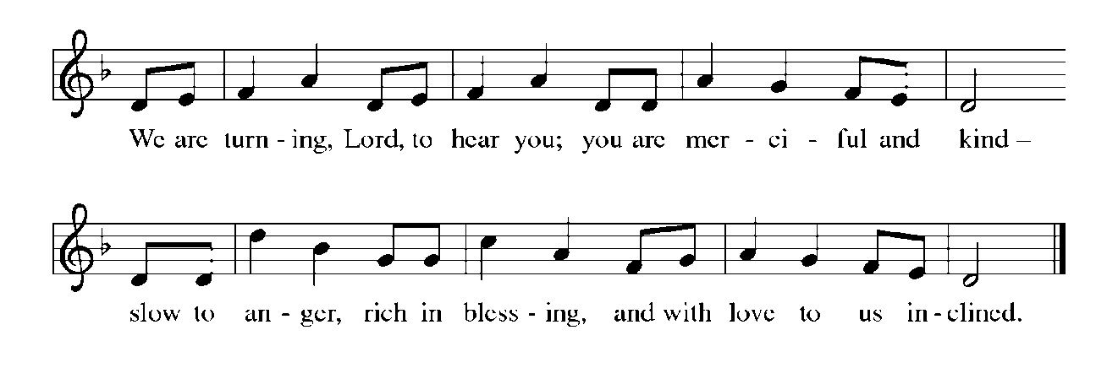

**THE HOLY GOSPEL Luke 13:1-9**

*Jesus addresses the age-old question of whether people deserve the bad things that happen to them. The short answer is "No." Yet, it is better to repent than to test the forbearance of God indefinitely.*

P: The Holy Gospel according to St. Luke, the thirteenth chapter.

C: **Glory to You, O Lord!**

1At that very time there were some present who told him about the Galileans whose blood Pilate had mingled with their sacrifices. 2Jesus asked them, "Do you think that because these Galileans suffered in this way they were worse sinners than all other Galileans? 3No, I tell you; but unless you repent, you will all perish as they did. 4Or those eighteen who were killed when the tower of Siloam fell on them-- do you think that they were worse offenders than all the others living in Jerusalem? 5No, I tell you; but unless you repent, you will all perish just as they did."

6Then He told this parable: "A man had a fig tree planted in his vineyard; and he came looking for fruit on it and found none. 7So he said to the gardener, 'See here! For three years I have come looking for fruit on this fig tree, and still I find none. Cut it down! Why should it be wasting the soil?' 8He replied, 'Sir, let it alone for one more year, until I dig around it and put manure on it. 9If it bears fruit next year, well and good; but if not, you can cut it down.' "

P: The Gospel of the Lord.

C: **Praise to You, O Christ!**

*The assembly is seated*

**THE SERMON**

*Silence for reflection follows the sermon*

*As you are able please rise*

**THE HYMN OF THE DAY NSB 75 *Rock of My Salvation* p. 13**

**THE NICENE CREED**

A: God has made us His people through our Baptism into Christ. Living together in trust

and hope, we confess our faith.

C: **We believe in one God,**

**the Father, the Almighty,**

**maker of heaven and earth,**

**of all that is, seen and unseen.**

**We believe in one Lord, Jesus Christ,**

**the only Son of God,**

**eternally begotten of the Father,**

**God from God, Light from Light,**

**true God from true God,**

**begotten, not made,**

**of one Being with the Father.**

**Through Him all things were made.**

**For us and for our salvation**

**He came down from heaven;**

**by the power of the Holy Spirit**

**He became incarnate from the virgin Mary, and was made man.**

**For our sake He was crucified under Pontius Pilate;**

**He suffered death and was buried.**

**On the third day He rose again**

**in accordance with the Scriptures;**

**He ascended into heaven**

**and is seated at the right hand of the Father.**

**He will come again in glory to judge the living and the dead,**

**and His kingdom will have no end.**

**We believe in the Holy Spirit, the Lord, the giver of life,**

**Who proceeds from the Father and the Son.**

**With the Father and the Son He is worshiped and glorified.**

**He has spoken through the prophets.**

**We believe in one holy catholic and apostolic Church.**

**We acknowledge one Baptism for the forgiveness of sins.**

**We look for the resurrection of the dead,**

**and the life of the world to come. Amen**

**THE PRAYER OF THE CHURCH**

A: As we mark these forty days with repentance and forgiveness, let us pray for the renewal

of the Church and the restoration of the world to the life of God.

A: That the Church, those preparing for Baptism, and all the holy people of God, may heed

the God Who calls us to repentance in the events of our lives, let us pray to the Lord:

C: **Lord, have mercy.**

A: That we might be freed from the hatred and fear of others that leads to violence and

bloodshed so all might live in safety and peace, especially in Ukraine, let us pray to the

Lord:

C: **Lord, have mercy.**

A: That during this holy season God’s nourishing mercy might produce in us the fruits

God seeks, let us pray to the Lord:

C: **Lord, have mercy.**

A: That those whose spirit is fragile find courage in the rock that is Christ and not be tested

beyond their strength, let us pray to the Lord:

C: **Lord, have mercy.**

A: That the sick, especially . . . might rejoice under God’s healing wings, let us pray to the

Lord:

C: **Lord, have mercy.**

A: That those celebrating anniversaries, especially **Wayne and Suzann Dolson; Larry**

**and Judy Litchford; and Marvin and Diane Dirks** may be filled with Your grace

this day and every day and may live in Your grace in all the days ahead, let us pray to

the Lord:

C: **Lord, have mercy.**

A: That those who mourn, especially the family and friends of **Carl Loetz,** who died in the Lord

this week may be comforted by the promise of resurrection to life everlasting and of being

reunited with those they love before the throne of the Lamb, let us pray to the Lord:

C: **Lord have mercy.**

A: That with all the saints, especially **Joseph Guardian of Jesus, and Thomas Cramner**

**Bishop of Canterbury and martyr,**  whom we commemorate this Day we may at

length eat and drink at the promised Feast of the Lamb, let us pray to the Lord:

C: **Lord, have mercy.**

P: Gracious God, hear the prayers of Your people, whose hunger and thirst You satisfy in

Christ Jesus our Lord.

C: **Amen.**

*The assembly is seated*

**✠ MEAL✠**

**THE VOLUNTARY Praise Band**

***How Deep the Father’s Love/We Bow Down Medley***

*As you are able please rise*

**THE OFFERTORY PRAYER**

A: Let us pray. Gracious God,

C: **You invite us to Your rich Feast to satisfy us with Your abundant mercy. We**

**bring You these fruits of our time and labor in grateful thanksgiving. By this holy**

**Sacrament, revive in us the new life of Christ, that we may yield a great harvest**

**of faith, hope, love, and joy. We ask this in the name of Jesus the Lord. Amen.**

**THE GREAT THANKSGIVING**

P: The Lord be with you.

C: **And also with you.**

P: Lift up your hearts.

C: **We lift them up to the Lord.**

P: Let us give thanks to the Lord our God.

C: **It is right to give Him thanks and praise.**

P: It is right, and a good and joyful thing to give our thanks to You, Holy One on high,

for You shaped all living beings and every wonder of creation to bear fruit

that glorifies You.

In the soil of covenant You planted a life with Your chosen people and nourished a

family to bless all the earth.

When through human faithlessness that life was grieved and barren, You sent Your

Son to be the soil of our redemption.

Through His resurrection You brought us out of the deadness of sin into the fullness

of Your fruit-bearing, fruit-sharing life.

God Who summons everyone who thirsts to come and drink, make all who drink

from this cup thirst for the wine of Your Kingdom.

As we remember through this fruit of the vine Your Son’s saving passion, send Your

Holy Spirit to lead us into life.

By Your same Spirit, bless this bread and cup that they may be for us the Body and

Blood of Your Son, Jesus Christ,

Who, in the night … “Do this for the remembrance of Me.”

As often as we eat ... we proclaim the Lord’s death until He comes.

C: **Christ has died. Christ is risen. Christ will come again.**

P: God of our flourishing, through the fast of Lent nourish in Your Church a life that is

wholly fruitful.

Give patience to all who abide through long seasons of barrenness and long for new

life.

Tend and care for any who hunger for mercy and thirst for forgiveness.

Bless Your children when they seek restored relationships in church and

community in a spirit of humble confession.

Shape Your people to hunger and thirst for the Day when there is one shared

flourishing for all, one feasting with You in glory, when with the saints,

apostles, and martyrs Your creation shall be, at last, wholly fruitful in

Your,

One God: Father,✠ Son, and Holy Spirit.

C: **Amen!**

**THE LORD’S PRAYER**

P: Baptized into Christ’s death that we might share in the resurrection, let us pray for the

fulfillment of the mystery as Jesus taught us:

C: **Our Father in heaven, hallowed be Your name. Your Kingdom come. Your will**

**be done on earth as it is in heaven. Give us this day our daily bread, and forgive**

**us our sins as we forgive those who sin against us. Save us from the time of trial**

**and deliver us from evil. For the Kingdom, the power, and the glory are Yours,**

**now and forever. Amen.**

**INVITATION TO THE MEAL**

P: Behold the Servant of God, obedient unto death on a cross, highly exalted as Lord of

glory. Blessed are those who are called to the banquet of the Lamb. God’s holy gifts

for God’s holy people. Come, for all is now ready.

*The assembly is seated*

**THE DISTRIBUTION**

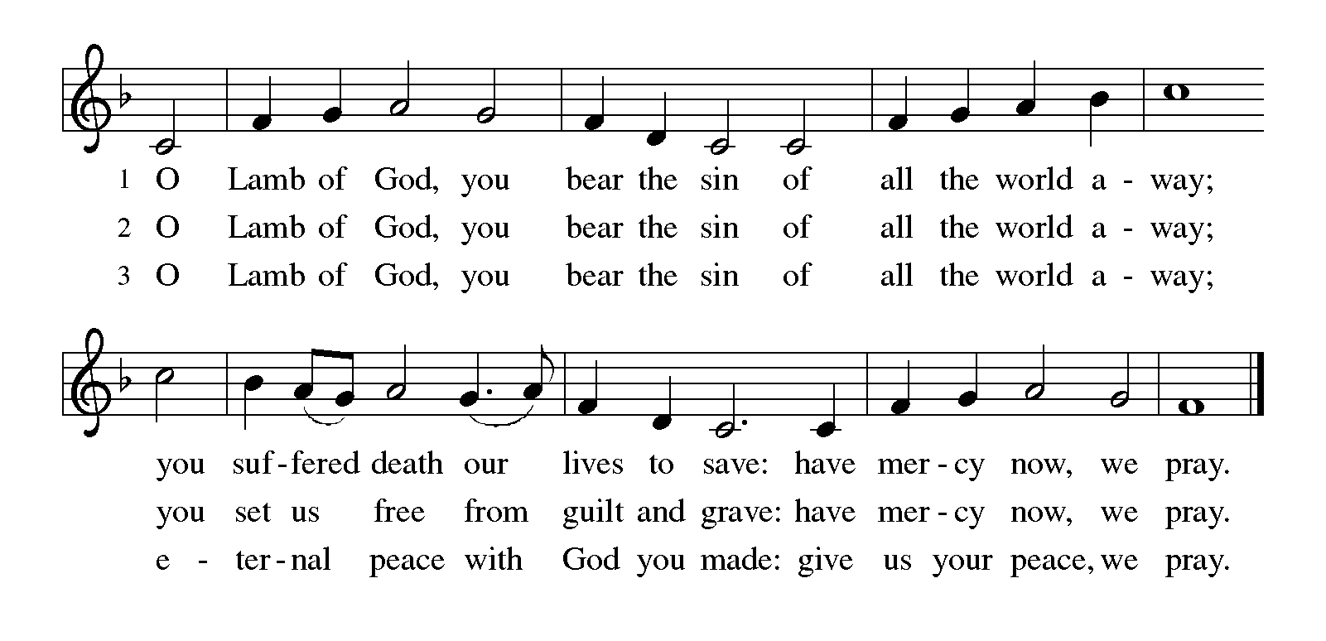

**HYMN DURING DISTRIBUTION 779 *Amazing Grace, How Sweet the Sound* p. 14**

**484** ***Here is Bread*  p. 15**

**483 *You Satisfy the Hungry Heart*  p. 16**

**NSB 22 *Change My Heart, O God*  p. 17**

*As you are able please rise*

**THE POST COMMUNION BLESSING**

P: The Body and Blood of our Lord Jesus Christ strengthen you and keep you in His

grace.

C: **Amen.**

**THE POST-COMMUNION PRAYER**

A: Let us pray. Lord Jesus Christ, in this holy Meal You satisfy us with the rich Food of

Your Body and Blood. Grant us a repentant heart, strength to endure trials and testings,

and fruitful lives of love and service. We bless You now and forever.

C: **Amen.**

**✠ SENDING ✠**

**THE BENEDICTION**

P: Jesus took the form of a servant and was obedient to death, even death on a cross. May

you follow His example and share in the resurrection.

C: **Amen.**

P: Almighty God: Father, Son, **✠** and Holy Spirit bless you now and forever.

C: **Amen.**

**SENDING HYMN 624 *Jesus Still Lead On*  p. 18**

**THE DISMISSAL**

A: Reconciled to God through Christ, let us go out into the world in peace.

C: **Thanks be to God!**

**POSTLUDE *Lift Up Your Heads*  Michael Burkhardt**

***✠ To God Alone Be Glory✠***

The Meditations are from“Breaking and Entering.” Thomas G. Long. *The Christian*

*Century.* March 7, 2001; and *Working Preacher Online.* Copyright Luther

Seminary 2022.

The Eucharistic Prayer is adapted from *Eucharistic Prayers.* Samuel Wells and Abigail

Kocher. (Grand Rapids: Eerdmann’s Publishing Company, 2016) 136-37.

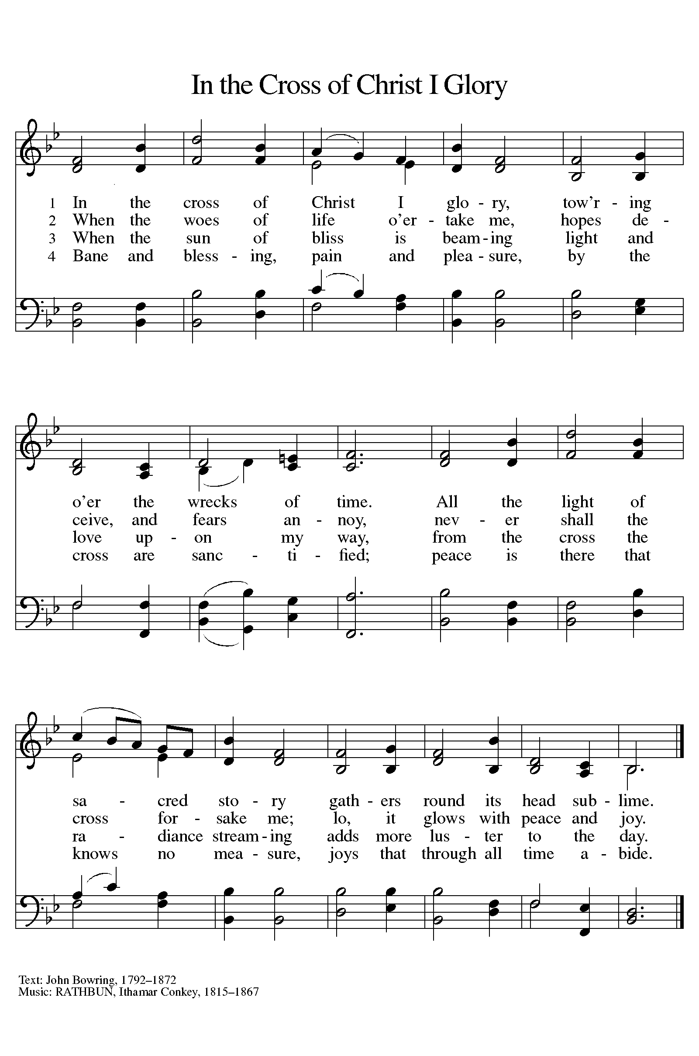

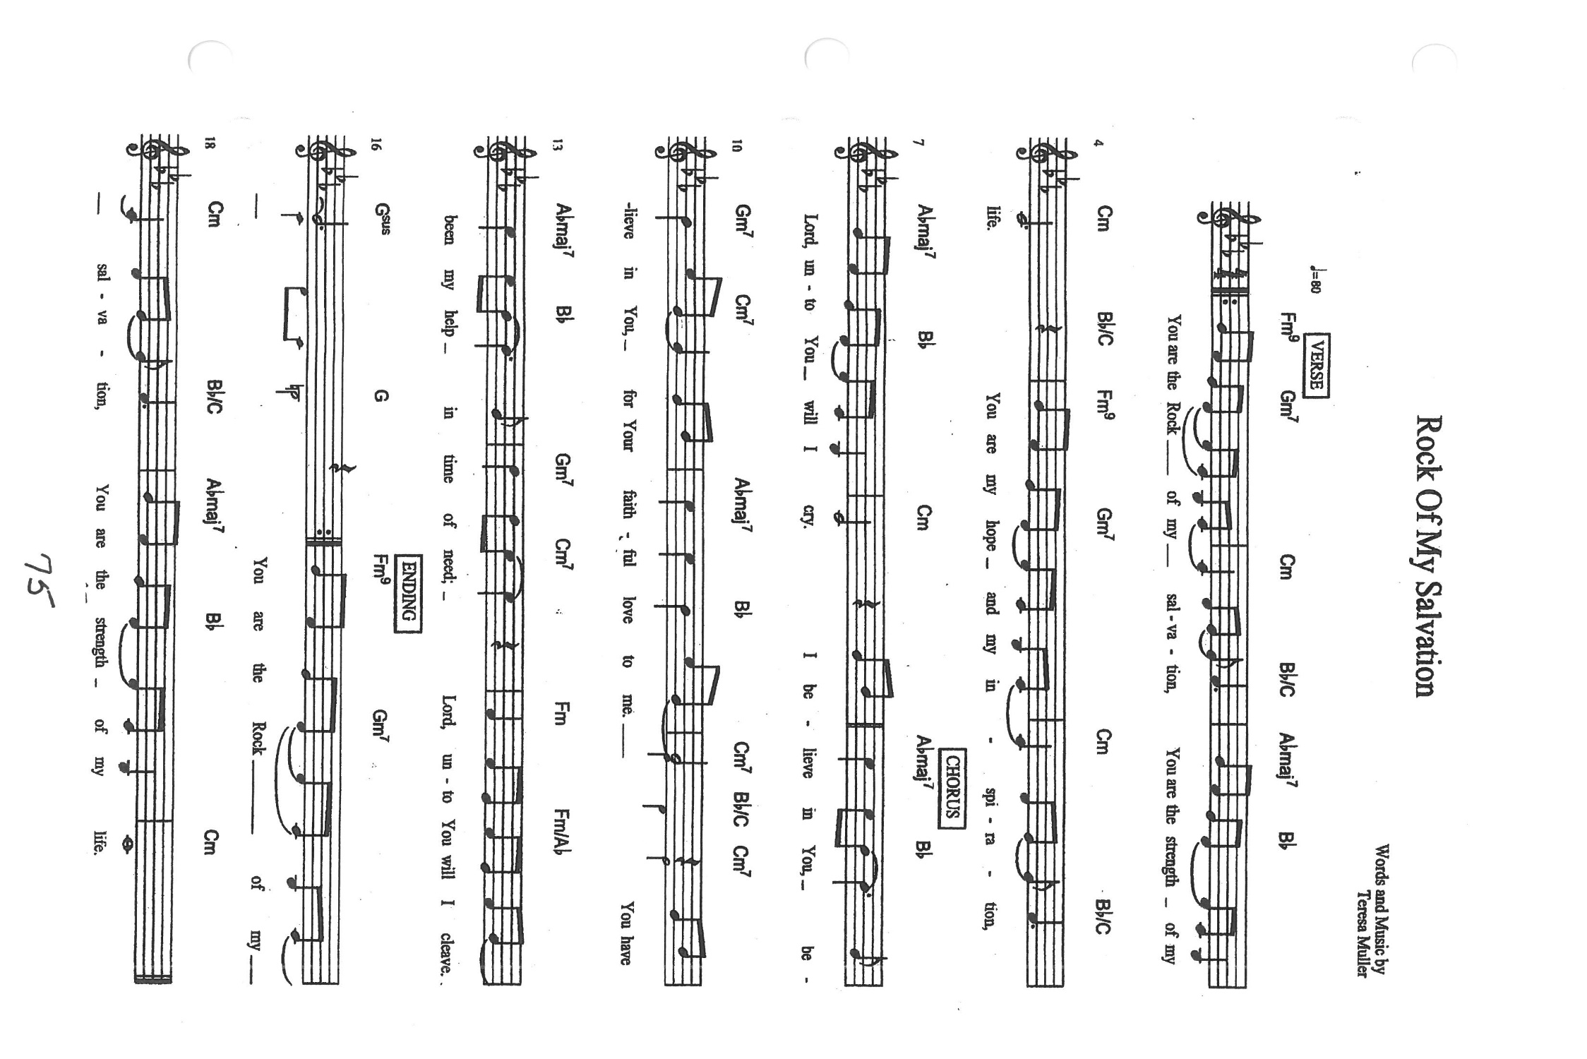

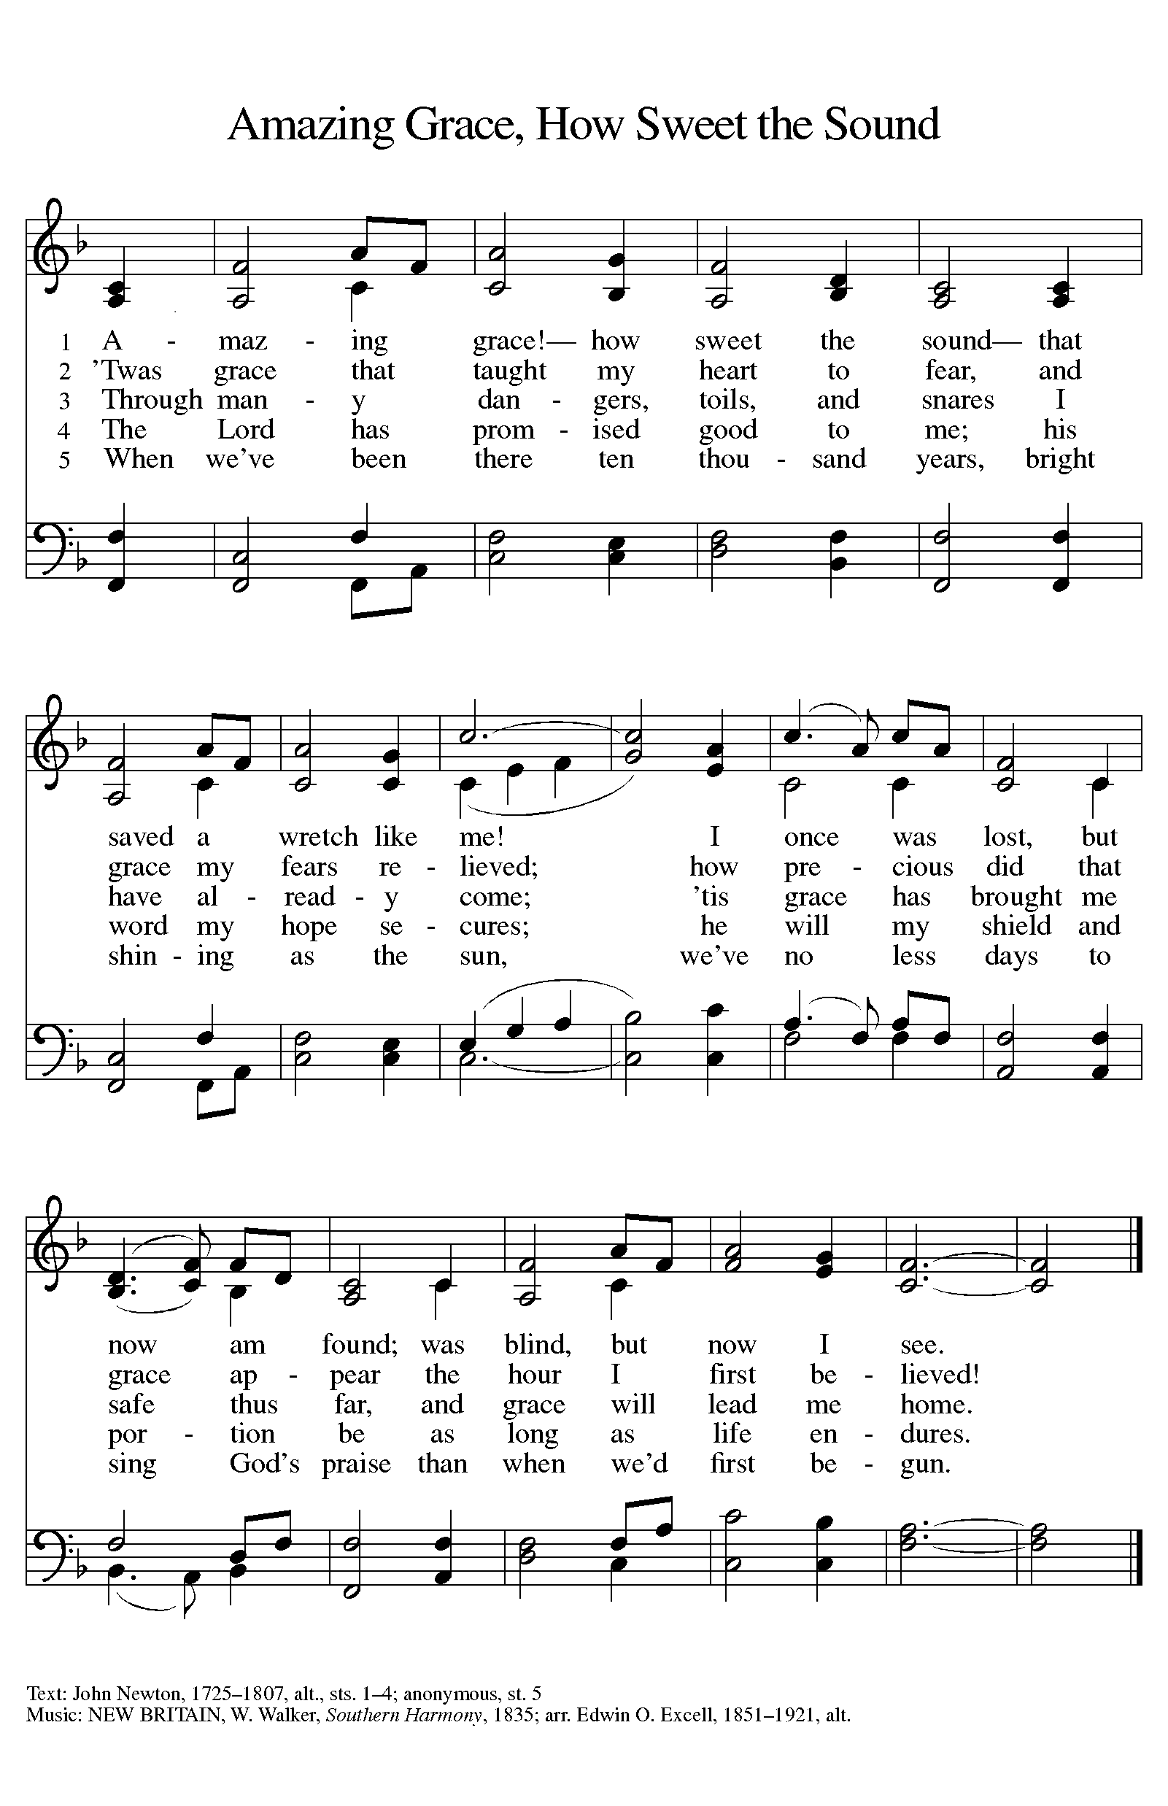

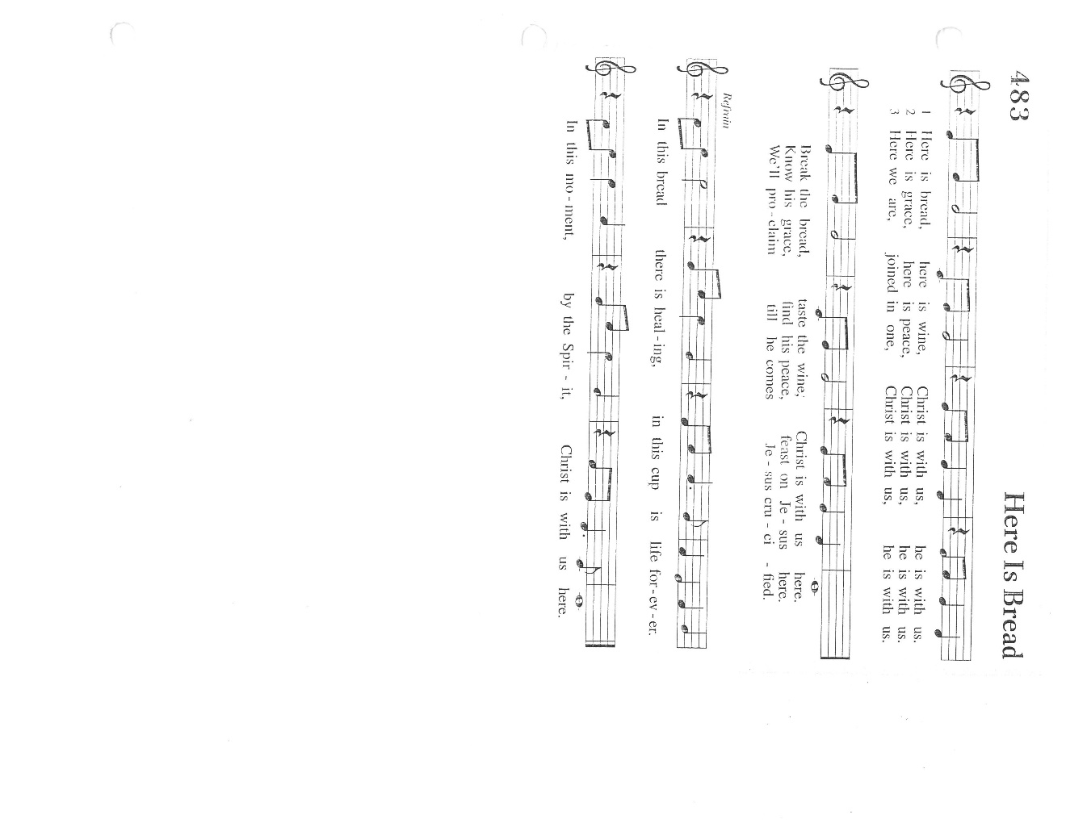

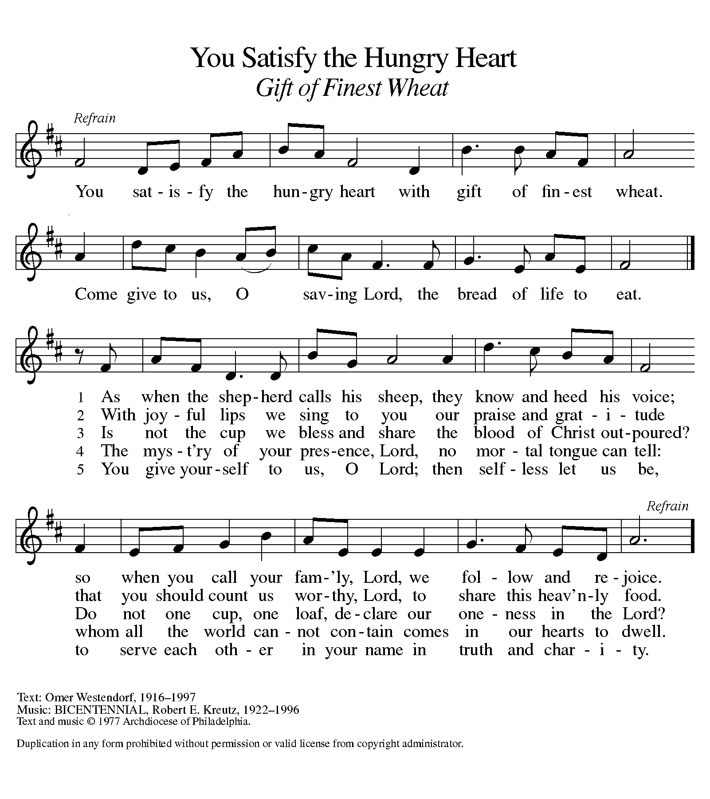

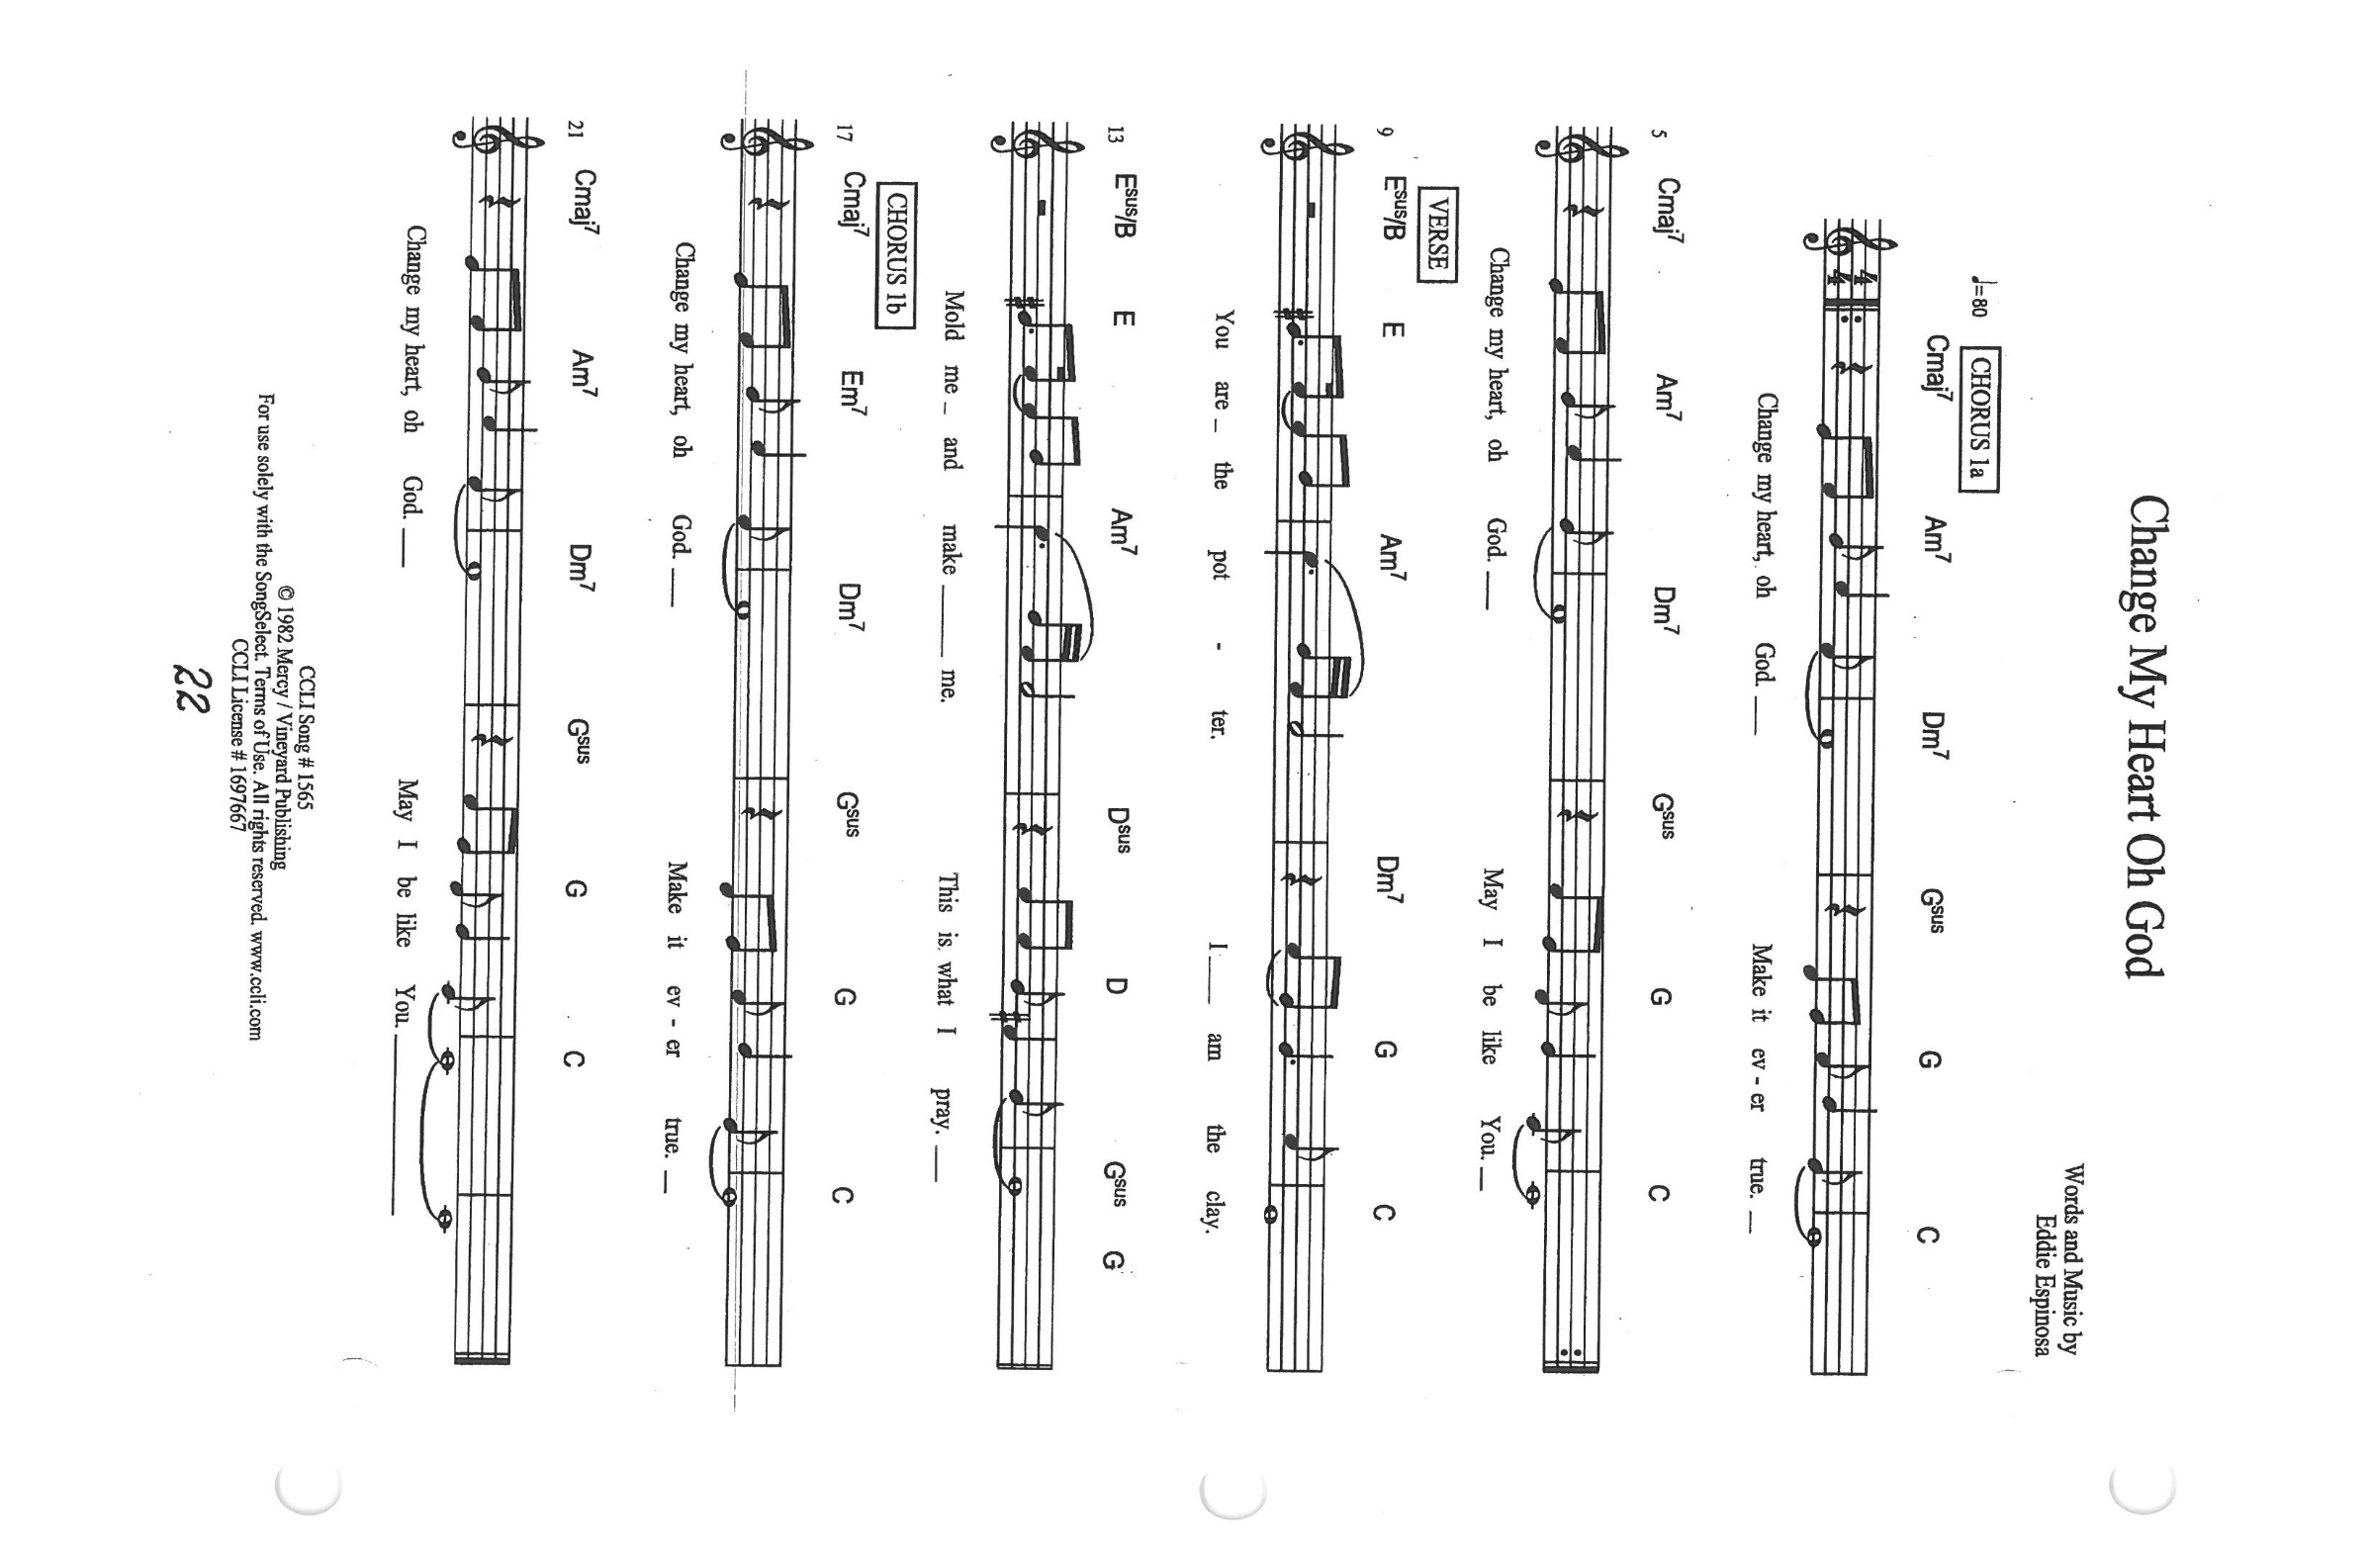

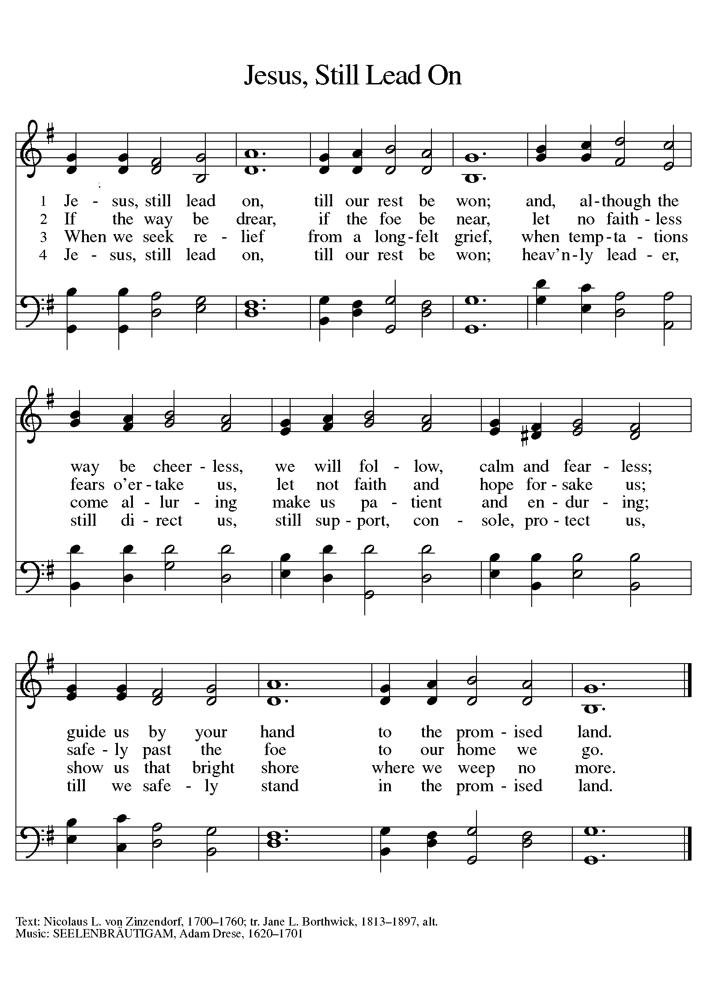

**ANNOUNCEMENTS**

**Please remember to mail your offering to the Church Office** at 818 Franklin Street, Michigan City, IN 46360**.** Another alternative is to give on-line through Tithe.ly. Please see your closure letter for information on how to set up a Tithe.ly account.

**St. Paul Members are reminded to have** a loved one contact the office if you are hospitalized. Many times, the Pastor doesn’t know someone is in the hospital. If you call and leave a message, please tell us which hospital the patient is at.

**Next Sunday’s lessons are Joshua 5: 9-12; Psalm 32; 2 Corinthians 5: 16-21; Luke 15:1-3, 11b-32** for those of you who like to study them in advance.

**Anniversaries: Wayne & Suzann Dolson (3/23); Marvin & Diane Dirks (3/24);**

**Larry & Judy Litchford (3/26)**

**PRAYER CONCERNS:** Audrey Beyer, Ryan Krueger, Donna Bostater, Maxine Powell, Jim Tomscheck, Ken Mulder, Roger Milzarek, Eloise Ponder, Mark & Jary Tannehill.

**If you requested someone’s name to be on the prayer list and are aware that they need continued imminent prayer then contact the church office and let us know.** Otherwise we will gradually transfer names to the long-term list.

**OFFICE HOURS:** Libby will be in the office on Mondays, Wednesdays, and Fridays; volunteers will cover Tuesdays and Thursdays.

Monday & Wednesday 8:00 a.m. – 5 p.m.

Tuesday & Thursday 9:00 a.m. – 12:00 p.m.

Friday 8:00 a.m. – 12:00 p.m.

**If you are listening to the worship broadcast on the radio and would like to watch the Sunday morning service live stream follow these steps:**

1. If you have You.Tube available on your TV, search for

**St. Paul Lutheran Church Michigan City, IN.**

(2) The direct link on the computer is

https://www.youtube.com/channel/UC5AIPNaKr3QN50984jGOa1g.

(3) This link is also on the main page of the church’s website in the church section and will continue to be posted weekly on the St. Paul Facebook page.

And it will always be available on the radio broadcast Sunday mornings at 11:00 a.m. on WEFM (95.9), and on the local cable access station #99 for the previous week’s service on Sundays at 4:00 p.m. and the current service on Wednesdays at 7:00 p.m. and Fridays at 8:30 p.m.

**To send e-mail to the church office**, please use the following addresses:

Pastor Mark Reshan: seniorpastor@stpaulmichigancity.com

Church Office Secretary (Libby Pollock): churchsecretary@stpaulmichigancity.com

Church Treasurer (Karen Fleming) and Bookkeeper (Billie Atchinson):

finance@stpaulmichigancity.com.

**The Good News Newsletter**: If you have an article or anything you want included in **The Good News** please send it to the following e-mail address: splcgoodnews@gmail.com. Pastor Pamela Thiede will be using this e-mail address to assemble **The Good News** each month. The deadline for getting information to Pastor Pamela will be the 20th of each month.

**WORSHIP ATTENDANCE for March 9, 2022 Mid-week Lenten Service**

**6:30 p.m. 29**

**WORSHIP ATTENDANCE for March 12 and 13, 2022**

**4:00 p.m. 31**

**9:00 a.m. 50**

**Total = 81**

**The Community Soup Kitchen serving out of First United Methodist is in need of volunteers.** Sunday through Tuesday is always need, as is occasionally Wednesdays and Thursdays. Hours are 9:30 a.m. to 1:15 p.m. and it is not necessary to stay the entire time. There is also a need for volunteers to be available to help pick up deliveries from the Food Bank when they arrive. If you are able to help please contact their church office at 872-7200.

**For information regarding worship closure due to inclement weather or COVID concerns** please utilize one of these resources:

* If the decision is made early enough in the week to cancel worship an email will be sent to those on the church email list
* You may tune to WEFM 95.9 for an announcement during their broadcast
* The church and school Facebook page ([St Paul Lutheran Church & School - Michigan City, IN | Facebook](https://www.facebook.com/stpaulmichigancity)) will post an announcement
* You may dial the church office number (219-874-7293) and when the automated menu begins press the # button for a recorded announcement

Between these sources we hope to keep everyone informed as to the status of our worship services.

**Easter Plants**

A variety of spring plants will be available to order for decorating St. Paul’s Church on Easter Morning! The varieties available will be Lily, Tulips, Hydrangeas, and Fern Hanging Baskets. Orders must be placed by Monday, April 4th.

The varieties and color available are Lily, Tulips in yellow, and pink, Hydrangeas in pink or purple/blue, and new to order the 10” Hanging Fern Basket.

**Cost per plant is as follows:**

Lily - $9.50

Tulip - $8.50 (yellow or pink)

Hydrangea - $16.00 (pink or purple/blue)

Hanging Fern - $10.50

**Please specify your choice of plant and your choice of color when applicable.**

**Orders MUST be placed by Monday morning, April 4th.**

Your order may be placed ‘In memory or Honor of a Loved One’. Please call the Church Office, 219-874-7293**, or place your order in an envelope and title it ‘Easter Flowers’ for ordering. REMEMBER,** you must specify what type of plant and color, if applicable!! All checks should be made out to St. Paul Church.

Please plan on picking up your plant after the Easter Morning Service by 11:30 a.m..

Thank$ for $haring

This month,we will see you at Swingbelly’s! We’re giving you two coupons so you can invite a friend and give them their own coupon. Remember, the coupon is required for the Give-Back bucks.

**MARCH 2022 MEETINGS & ACTIVITIES**

Worship Service: Saturday, March 19, 2022 at 4:00pm

Worship Service: Sunday, March 20, 2022 at 9:00am

Finance Committee Meeting: Monday, March 21, 2022 at 4:00pm/St. Paul Room

Executive Board Meeting: Monday, March 21, at 5:30pm/Luther House

SWINGBELLY’S GIVE BACK: Tuesday, March 22, 2022 at 11am-close

Wednesday Bible Study: March 23, 2022 at 9:45am/Luther House

God’s Purls: Wednesday, March 23, 2022 at 10:00am/St. Paul Room

Lenten Service: Wednesday, March 23, 2022 at 6:30pm

Church Council Meeting: Thursday, March 24, 2022 at 5:30pm/St. Paul Room

Worship Service: Saturday, March 26, 2022 at 4:00pm

Worship Service: Sunday, March 27, 2022 at 9:00am

Wednesday Bible Study: March 30, 2022 at 9:45am/Luther House

God’s Purls: Wednesday, March 30, 2022 at 10:00am/St. Paul Room

Lenten Service: Wednesday, March 30, 2022 at 6:30pm

Worship Service: Saturday, April 2, 2022 at 4:00pm

**SYNOD NEWS:** A Synod Convention will be held in Muncie, Indiana from June 9 through June 11, 2022. Jan Bakken and Pastor Pamela will be attending. We still need a male to attend. Savings on your reservations end on March 25, 2022. Please call the church office to let them know if you would like to participate.

**Church Council:** The approved and signed minutes from the January 2022 Council Meeting are available on the table at the back of the Narthex. Please feel free to take a copy.

**Are you curious about the Lion’s Club box?** In case you are, there is a representative from the Lion’s Club that comes to empty the box once a month. The box is found in the church foyer next to the elevator. The Lion’s Club collects used or broken eye glasses, hearing aids and empty prescription bottles (please remove the labels from them first). All these items can be placed in the Lion’s Club box for pick up. Instead of letting these things pile up around the house collecting dust bring them with you the next time you’re at church. I assure you the Lion’s Club will recycle these items for future use!