**THE THIRD SUNDAY IN LENT**

**March 12, 2023**

John’s gospel says the Samaritan woman was invited to take all the water she needed. The early centuries of the church, and now we again, have seen in the Samaritan woman an image of us all. We all search in the wrong place for refreshment, lugging home water which gives out or goes bad; we continuously need more water; we are always somewhat thirsty, dirty or raw.

We thought to find water there, down at the stream, and were surprised to find it here, directly before us. Turning around—the word is conversion—we find a water source we had not even imagined. Baptism, says the church, is this water source, this fountain of God, this conversation with Christ, this gift of self-knowledge, this sense of mission, this true religious rite, this conversion of life.

**Gail Ramshaw**

Jesus met the Samaritan woman at Jacob’s well.

The One who covers the earth with clouds asks water of her.

Oh, what a wonder!

The One who suspended the earth on the waters asks for water!

**Byzantine Vespers**

I am the vessel.

The draught is God’s.

And God is the thirsty one.

**Dag Hammarskjold**

***✠ In the Name of Jesus ✠***

**INTRODUCTION**

In today's gospel the Samaritan woman asks Jesus for water, an image of our thirst for God. Jesus offers living water, a sign of God's grace flowing from the waters of baptism. The early church used this gospel and those of the next two Sundays to deepen baptismal reflection during the final days of preparation before baptism at Easter. As we journey to the resurrection feast, Christ comes among us in word, bath, and meal—offering us the life-giving water of God's mercy and forgiveness.

**Gregory the Great, Bishop of Rome, died 604**

*Born into wealth and power, Gregory was for a time the chief administrator of the city of Rome. Giving this up for a life in the church, he was elected pope in 590. He influenced public worship through the establishment of a lectionary and prayers to correlate with the readings. Gregorian chant is named in his honor.*

**✠ GATHERING ✠**

**PRE-SERVICE MUSIC *The Heart of Worship*  Praise Band**

**ANNOUNCEMENTS**

*As you are able please rise*

**CONFESSION AND ABSOLUTION**

P: In the name of the Father and of **✠** the Son and of the Holy Spirit.

**C: Amen.**

P: “Since we are justified by faith, we have peace with God through our Lord Jesus Christ,

through Whom we have obtained access to this grace in which we stand ...” (Romans

5:1) God comes this Day to make peace for us through the grace of His Word of

forgiveness. Let us therefore confess our sins with “the hope that does not disappoint

us” (Romans 5:5) of God’s unfailing love.

*Silence for self-examination and reflection is kept*

P: Most merciful God,

**C: We confess that we are sinners in need of Your forgiveness. We have put You to**

**the test with our complaining and quarreling. (Exodus 17:2) We have been weak**

**in faith and hope. (Romans 5:4-5) We are thirsty for the true and living water**

**only You can give, but we draw from “wells” that do not satisfy. (John 4:15)**

**Return us, O God, to the refreshing streams of our Baptism. Wash our fears and**

**failures from us, and cause Your eternal life to gush up in us, that we may live**

**renewed, forgiven, and free.**

P: “God proves His love for us in that while we were yet sinners Christ died for us.”

(Romans 5:8) Almighty God have mercy on you, forgive you all your sins through our

Lord Jesus Christ, strengthen you in all goodness, and by the power of the Holy Spirit

keep you in everlasting life.

**C: Amen.**

**GATHERING SONG NSB 81 *Spirit Song***

**THE GREETING**

P: The grace of our Lord Jesus Christ, the love of God, and the communion of the Holy

Spirit be with you all.

**C: And also with you.**

**THE KYRIE**

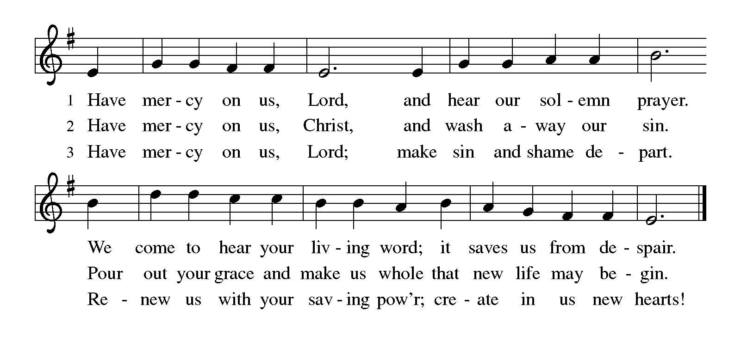

**THE PRAYER OF THE DAY**

P: The Lord be with you.

**C: And also with you.**

P: Let us pray. Merciful God, the Fountain of living water, You quench our thirst and

wash away our sin. Give us this water always. Bring us to drink from the well that

flows with the beauty of Your truth, through Your Son, Jesus Christ, our Savior and

Lord, Who lives and reigns with You and the Holy Spirit, one God, now and forever.

**C: Amen.**

*The assembly is seated*

**✠ WORD ✠**

**FIRST READING Exodus 17:1-7**

*Today's reading is one of several that tell of experiences during the wilderness wandering. In this case, the people complain because they have a legitimate need and God responds by providing for them. Later in their wanderings, when the people complain because of their wants, God responds with anger.*

From the wilderness of Sin the whole congregation of the Israelites journeyed by stages, as the LORD commanded. They camped at Rephidim, but there was no water for the people to drink. 2The people quarreled with Moses, and said, "Give us water to drink." Moses said to them, "Why do you quarrel with me? Why do you test the LORD?"

3But the people thirsted there for water; and the people complained against Moses and said, "Why did you bring us out of Egypt, to kill us and our children and livestock with thirst?" 4So Moses cried out to the LORD, "What shall I do with this people? They are almost ready to stone me." 5The LORD said to Moses, "Go on ahead of the people, and take some of the elders of Israel with you; take in your hand the staff with which you struck the Nile, and go.

6I will be standing there in front of you on the rock at Horeb. Strike the rock, and water will come out of it, so that the people may drink." Moses did so, in the sight of the elders of Israel. 7He called the place Massah and Meribah, because the Israelites quarreled and tested the LORD, saying, "Is the LORD among us or not?"

The Word of the Lord.

**Thanks be to God.**

**THE PSALM: Psalm 95** Antiphon by May Schwarz

Choir sings refrain first, followed immediately by the congregation

and as indicated

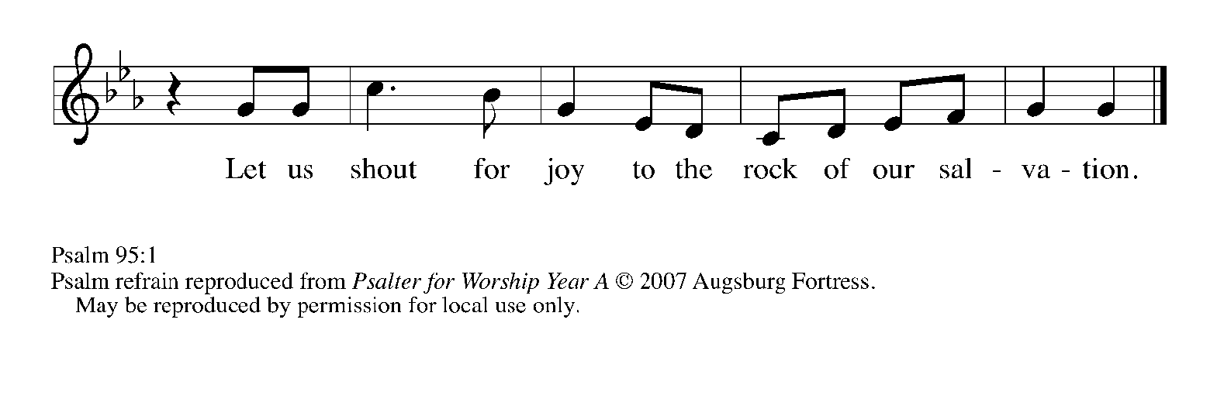

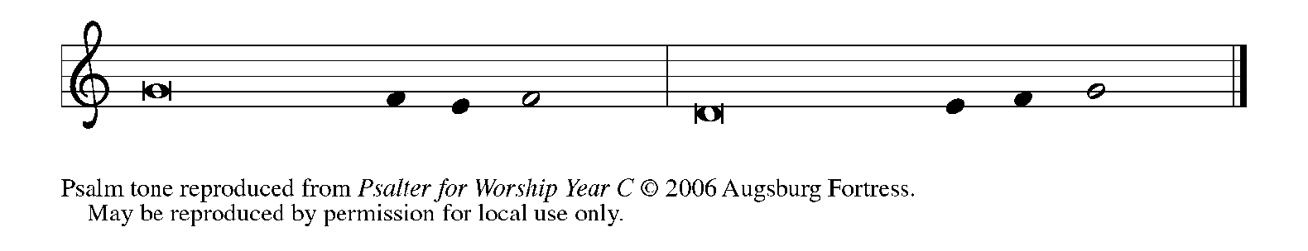

1Come, let us sing | to the LORD;

     let us shout for joy to the rock of | our salvation.

**2Let us come before God's presence | with thanksgiving**

**and raise a loud shout to the | LORD with psalms.**

3For You, LORD, | are a great God,

     and a great ruler a- | bove all gods.

**4In Your hand are the caverns | of the earth;**

**the heights of the hills are | also Yours.**

5The sea is Yours, | for You made it,

     and Your hands have molded | the dry land.

**6Come, let us worship | and bow down,**

**let us kneel before the | LORD our maker.   REFRAIN**

7For the LORD is our God, and we are the people of God's pasture

and the sheep | of God's hand.

     Oh, that today you would | hear God's voice!

**8"Harden | not your hearts,**

**as at Meribah, as on that day at Massah | in the desert.**

9There your ancestors | tested Me,

     they put Me to the test, though they had | seen My works.

**10Forty years I loathed that gener- | ation, saying,**

**'The heart of this people goes astray; they do not | know My ways.'**

11Indeed I swore | in My anger,

     'They shall never come | to My rest.'"   **REFRAIN**

**SECOND READING Romans 5:1-11**

*Through Jesus' death on the cross, sinners have been put right with God through faith. But being made right with God produces results--ultimately, sure hope for the future produced by God's Spirit.*

Since we are justified by faith, we have peace with God through our Lord Jesus Christ, 2through Whom we have obtained access to this grace in which we stand; and we boast in our hope of sharing the glory of God. 3And not only that, but we also boast in our sufferings, knowing that suffering produces endurance, 4and endurance produces character, and character produces hope, 5and hope does not disappoint us, because God's love has been poured into our hearts through the Holy Spirit that has been given to us.

6For while we were still weak, at the right time Christ died for the ungodly. 7Indeed, rarely will anyone die for a righteous person--though perhaps for a good person someone might actually dare to die. 8But God proves His love for us in that while we still were sinners Christ died for us.

9Much more surely then, now that we have been justified by His blood, will we be saved through Him from the wrath of God. 10For if while we were enemies, we were reconciled to God through the death of His Son, much more surely, having been reconciled, will we be saved by His life. 11But more than that, we even boast in God through our Lord Jesus Christ, through Whom we have now received reconciliation.

The Word of the Lord.

**Thanks be to God.**

*As you are able please rise*

**THE VERSE**

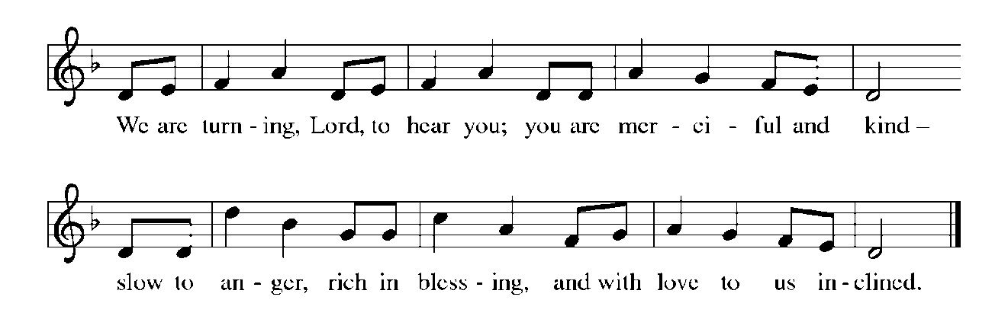

**THE HOLY GOSPEL John 4:5-42**

*In the culture of Jesus' time, Judeans tended to avoid dealings with Samaritans, and men did not converse with women in public. When Jesus crosses these boundaries to speak with a Samaritan woman, He makes Himself known as the agent of God Who knows all.*

P: The Holy Gospel according to St. John, the fourth chapter.

**C: Glory to You, O Lord!**

[Jesus] came to a Samaritan city called Sychar, near the plot of ground that Jacob had given to his son Joseph. 6Jacob's well was there, and Jesus, tired out by His journey, was sitting by the well. It was about noon.

7A Samaritan woman came to draw water, and Jesus said to her, "Give me a drink." 8(His disciples had gone to the city to buy food.) 9The Samaritan woman said to Him, "How is it that you, a Judean, ask a drink of me, a woman of Samaria?" (Judeans do not share things in common with Samaritans.)

10Jesus answered her, "If you knew the gift of God, and Who it is that is saying to you, 'Give me a drink,' you would have asked Him, and He would have given you living water." 11The woman said to Him, "Sir, you have no bucket, and the well is deep. Where do you get that living water? 12Are you greater than our ancestor Jacob, who gave us the well, and with his sons and his flocks drank from it?"

13Jesus said to her, "Everyone who drinks of this water will be thirsty again, 14but those who drink of the water that I will give them will never be thirsty. The water that I will give will become in them a spring of water gushing up to eternal life." 15The woman said to Him, "Sir, give me this water, so that I may never be thirsty or have to keep coming here to draw water."

16Jesus said to her, "Go, call your husband, and come back." 17The woman answered Him, "I have no husband." Jesus said to her, "You are right in saying, 'I have no husband'; 18for you have had five husbands, and the one you have now is not your husband. What you have said is true!"

19The woman said to Him, "Sir, I see that you are a prophet. 20Our ancestors worshiped on this mountain, but you say that the place where people must worship is in Jerusalem." 21Jesus said to her, "Woman, believe Me, the hour is coming when you will worship the Father neither on this mountain nor in Jerusalem. 22You worship what you do not know; we worship what we know, for salvation is from the Judeans.

23But the hour is coming, and is now here, when the true worshipers will worship the Father in spirit and truth, for the Father seeks such as these to worship Him. 24God is spirit, and those who worship Him must worship in spirit and truth." 25The woman said to Him, "I know that Messiah is coming" (who is called Christ). "When He comes, He will proclaim all things to us." 26Jesus said to her, "I am He, the One Who is speaking to you."

27Just then His disciples came. They were astonished that He was speaking with a woman, but no one said, "What do you want?" or, "Why are You speaking with her?" 28Then the woman left her water jar and went back to the city. She said to the people, 29"Come and see a man Who told me everything I have ever done! He cannot be the Messiah, can he?" 30They left the city and were on their way to Him.

31Meanwhile the disciples were urging Him, "Rabbi, eat something." 32But He said to them, "I have food to eat that you do not know about." 33So the disciples said to one another, "Surely no one has brought Him something to eat?" 34Jesus said to them, "My food is to do the will of Him Who sent Me and to complete His work. 35Do you not say, 'Four months more, then comes the harvest'? But I tell you, look around you, and see how the fields are ripe for harvesting.

36The reaper is already receiving wages and is gathering fruit for eternal life, so that sower and reaper may rejoice together. 37For here the saying holds true, 'One sows and another reaps.' 38I sent you to reap that for which you did not labor. Others have labored, and you have entered into their labor."

39Many Samaritans from that city believed in him because of the woman's testimony, "He told me everything I have ever done." 40So when the Samaritans came to Him, they asked Him to stay with them; and He stayed there two days. 41And many more believed because of His word. 42They said to the woman, "It is no longer because of what you said that we believe, for we have heard for ourselves, and we know that this is truly the Savior of the world."

P: The Gospel of the Lord.

**C: Praise to You, O Christ!**

*The assembly is seated*

**THE SERMON**

*Silence for reflection follows the sermon*

*As you are able please rise*

**THE HYMN OF THE DAY 332 *I Heard the Voice of Jesus Say***

(Sung to the tune of: *My Soul Proclaims Your Greatness)*

**I heard the voice of Jesus say,**

**"Come unto Me and rest;**

**lay down, O weary one, lay down**

**your head upon My breast."**

**I came to Jesus as I was,**

**so weary, worn, and sad;**

**I found in Him a resting-place,**

**and He has made me glad.**

**I heard the voice of Jesus say,**

**"Behold, I freely give**

**the living water, thirsty one;**

**stoop down and drink and live."**

**I came to Jesus, and I drank**

**of that life-giving stream;**

**my thirst was quenched, my soul revived,**

**and now I live in Him.**

**I heard the voice of Jesus say,**

**"I am this dark world's light;**

**look unto Me, your morn shall rise,**

**and all your day be bright."**

**I looked to Jesus, and I found**

**in Him my star, my sun;**

**and in that light of life I'll walk**

**till trav'ling days are done.**

**THE NICENE CREED**

A: God has made us His people through our Baptism into Christ. Living together in trust

and hope, we confess our faith.

**We believe in one God,**

**the Father, the Almighty,**

**maker of heaven and earth,**

**of all that is, seen and unseen.**

**We believe in one Lord, Jesus Christ,**

**the only Son of God,**

**eternally begotten of the Father,**

**God from God, Light from Light,**

**true God from true God,**

**begotten, not made,**

**of one Being with the Father.**

**Through Him all things were made.**

**For us and for our salvation**

**He came down from heaven;**

**by the power of the Holy Spirit**

**He became incarnate from the virgin Mary, and was made man.**

**For our sake He was crucified under Pontius Pilate;**

**He suffered death and was buried.**

**On the third day He rose again**

**in accordance with the Scriptures;**

**He ascended into heaven**

**and is seated at the right hand of the Father.**

**He will come again in glory to judge the living and the dead,**

**and His kingdom will have no end.**

**We believe in the Holy Spirit, the Lord, the giver of life,**

**Who proceeds from the Father and the Son.**

**With the Father and the Son He is worshiped and glorified.**

**He has spoken through the prophets.**

**We believe in one holy catholic and apostolic Church.**

**We acknowledge one Baptism for the forgiveness of sins.**

**We look for the resurrection of the dead,**

**and the life of the world to come. Amen.**

**THE PRAYER OF THE CHURCH**

A: Let us pray to God, Whose love has been poured into our hearts through the Holy Spirit

that has been given to us, for the Church, the world, and all those who thirst for Jesus,

the Living Water.

A: That in the wilderness of the world the Church may be the rock of God, providing the

waters of life to all who thirst, let us pray to the Lord:

**C: Lord, have mercy.**

A: That those preparing for Baptism might grow in faith, love, and obedience to the will

of God, let us pray to the Lord:

**C: Lord, have mercy.**

A: That the millions facing famine and starvation in North Korea, Somolia, Kenya,

Tanzania, Ethiopia, and other countries in East Africa might find relief, help, and hope

from humanitarian agencies and the generosity of the world community, let us pray to

the Lord:

**C: Lord, have mercy.**

A: That this assembly might be refreshed this Day by the living water of our Baptism to

faithfully work in God’s harvest, let us pray to the Lord:

**C: Lord, have mercy.**

A: That those who thirst for the grace only Christ can give, the hungry for God’s goodness,

and the sick, especially . . . might be quenched, filled, and healed, let us pray to the

Lord:

**C: Lord, have mercy.**

A: That those celebrating birthdays, especially **Jean Warner** might grow in grace this day

and every day and be filled with grace for the days ahead, let us pray to the Lord:

**C: Lord, have mercy.**

A: That with the baptized who have gone before us, especially **Gregory the Great, Bishop**

**of Rome,** whom we commemorate this Day we might live and worship in Spirit and

truth until we see God face-to-face, let us pray to the Lord:

**C: Lord, have mercy.**

P: Pour Your love into our hearts, O God of peace. Give us joy in our suffering, endurance

in trials, character in times of weakness, and hope in adversity. So may we live in You:

Father, Son, **✠** and Holy Spirit, one God, forever and ever.

**C: Amen.**

**✠ MEAL ✠**

**THE PEACE**

P: The peace of the Lord be with you always.

**C: And also with you.**

*The assembly is seated*

**THE OFFERING**

**THE VOLUNTARY *Love is Here*  Praise Band**

*As you are able please rise*

**THE OFFERTORY**

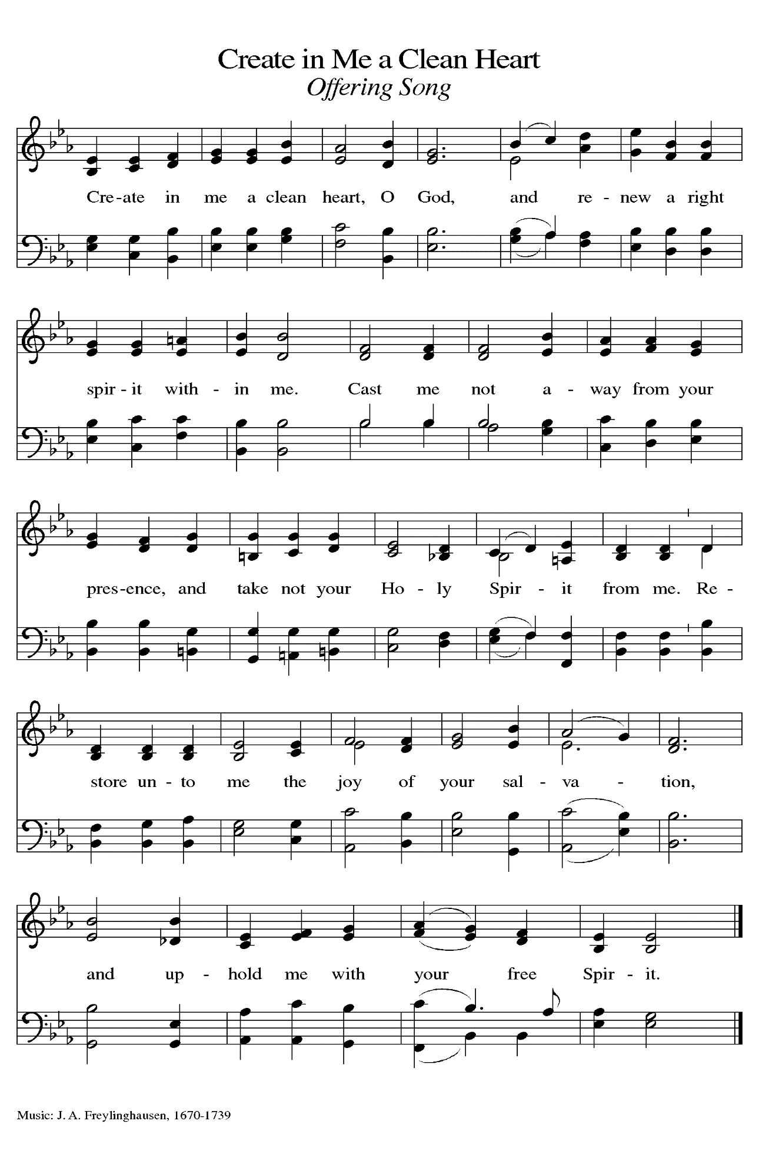

**THE OFFERTORY PRAYER**

A: Let us pray. God of mercy,

**C: You are the Rock of our salvation. With these gifts we bow our hearts and lives**

**to You in praise and thanksgiving. Receive all we offer You, and bring us now to**

**the Living Water, Jesus Christ our Lord. Amen.**

**THE GREAT THANKSGIVING**

P: The Lord be with you.

**C: And also with you.**

P: Lift up your hearts.

**C: We lift them up to the Lord.**

P: Let us give thanks to the Lord our God.

**C: It is right to give Him thanks and praise.**

P: It is indeed right, our duty, and our joy … join their unending hymn:

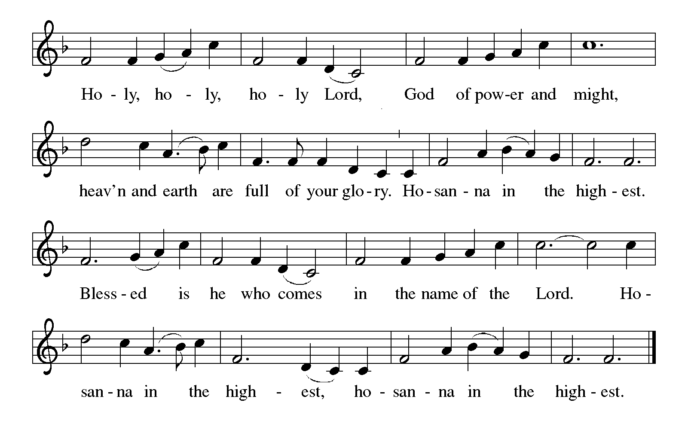

P: Living God, You created all things out of nothing; You called a people out of the desert;

You sent Your Son to us when we were hard-hearted and far from Your grace;

and You send Your Holy Spirit to us today despite our foolishness and forget-

fullness.

Through Your servant Moses You drew water out of the rock, and in Your Son Jesus

You brought living water that we might never be thirsty again.

Out of Your Son’s pierced side on the cross flowed water and blood, and in the glory

of His resurrection we are baptize into wondrous forgiveness and

everlasting life with You.

Overflowing God, in You we discover that all our striving and thirsting are truly a

striving and thirsting for You, and in all our desert wanderings we find that

only You can satisfy.

Come among us in the power of Your Holy Spirit, that Your people may taste Your

living water,

And that these gifts of bread and wine may become for us the Body and Blood of Your

Son Jesus Christ,

Who, in the night … “Do this for the remembrance of Me.”

As often as we eat ... we proclaim the Lord’s death until He comes.

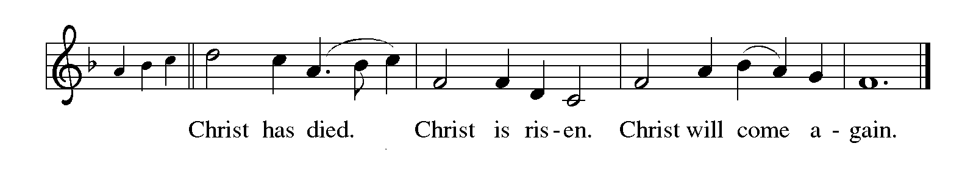

P: Cleansing God, bring the healing power of Your living water to visit with all who labor

with disease today.

Pour the refreshment of Your living water to invigorate all who are weary.

Send the momentum of Your living water to roll down justice like a never-failing

stream.

Make us, Your Church, a fountain of Your living water, until the Day when hunger and

thirst are no more,

And we live Your life abundant with the communion of saints, and You are all in all,

In the presence and companionship of Your Holy Trinity,

Father, ✠ Son, and Holy Spirit, ever one God.

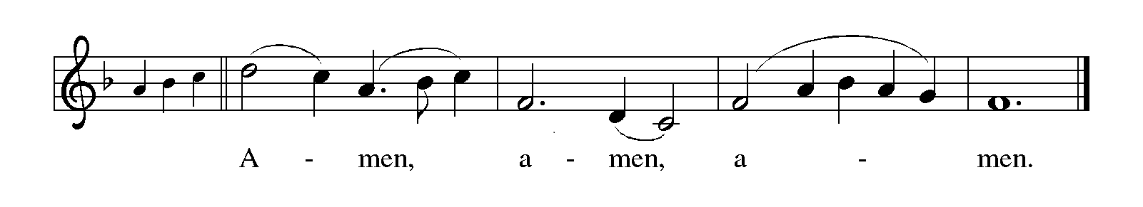

**THE LORD’S PRAYER**

P: While we were still sinners, Christ died for us, that, with confidence in God’s love for

us, we might dare to pray:

**C: Our Father in heaven, hallowed be Your name. Your Kingdom come. Your will**

**be done on earth as in heaven. Give us this day our daily bread, and forgive us**

**our sins as we forgive those who sin against us. Save us from the time of trial**

**and deliver us from evil, for the Kingdom, the power, and the glory are Yours,**

**now and forever. Amen.**

**INVITATION TO THE MEAL**

P: Behold our Savior Christ Jesus, Who abolished death and brought life through the

Gospel. Blessed are those called to the Banquet of the Lamb. God’s holy gifts for

God’s holy people. Come, for all is now ready.

*The assembly is seated*

**THE DISTRIBUTION**

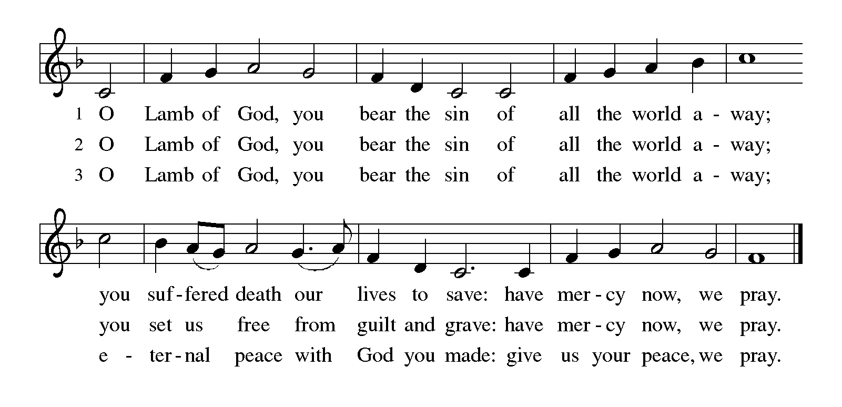

**HYMN DURING COMMUNION 807 *Come Thou Fount of Every Blessing***

**ELW432 *Shall We Gather at the River***

**NSB 6 *Amazing Love***

**NSB 86 *The Power of Your Love***

*As you are able please rise*

**THE POST-COMMUNION BLESSING**

P: The Body and Blood of our Lord Jesus Christ strengthen you and keep you in His grace.

**C: Amen.**

**THE POST-COMMUNION PRAYER**

A: Let us pray. God of our pilgrimage, once again in this Meal You have poured Your

love into our hearts. Refresh and sustain us as we go forth on our journey. Grant us

the confidence to know that You are among us, leading us one day to share in Your

glory, through Your Son, Jesus Christ our Lord.

**C: Amen.**

**✠ SENDING ✠**

**THE BENEDICTION**

P: Jesus took the form of a servant and was obedient to death, even death on a cross. May

you follow His example and share in the resurrection.

**C: Amen.**

P: Almighty God: Father, Son, ✠ and Holy Spirit bless you now and forever.

**C: Amen.**

**SENDING SONG 543 *Go My Children With My Blessing***

**THE DISMISSAL**

A: Reconciled to God through Christ, let us go out into the world in peace.

**C: Thanks be to God!**

**THE POSTLUDE *Toccata on “Regent Square”*  Smith**

***✠ To God Alone Be Glory✠***

The Meditations are from *Sundays and Seasons Online.* Copyright 2016 Augsburg

Fortress; and *A Lent Sourcebook: The Forty Days.* Book One. (Chicago: Liturgy

Training Publications, 1990). 203.

The Greeting, Prayers, Peace, Offertory, Post-Communion, and Dismissal are adapted

from *Sundays and Seasons.* Copyright 2001 Augsburg Fortress.

The Prayers, Introduction to the Lord’s Prayer, and Invitation to the Meal are adapted from

*Prayers for Sundays and Seasons. Year A.* Peter J. Scagnelli. (Chicago: Liturgy

Training Publications, 1998) 34-35.

The Eucharistic Prayer is adapted from *Eucharistic Prayers.* Samuel Wells and Abigail

Kocher. (Grand Rapids: Eerdmann’s Publishing Company, 2016) 132-33.

**ANNOUNCEMENTS**

**Please remember to mail your offering to the Church Office** at 818 Franklin Street, Michigan City, IN 46360**.** Another alternative is to give on-line through Tithe.ly. Please see your closure letter for information on how to set up a Tithe.ly account.

**St. Paul Members are reminded to have** a loved one contact the office if you are

hospitalized. Many times, the Pastor doesn’t know someone is in the hospital. If you call and leave a message, please tell us which hospital the patient is at.

**Next Saturday’s lessons are: I Samuel 16: 1-13; Psalm 23; Ephesians 5: 8-14; and John 9: 1-41** for those of you who like to study them in advance.

**Birthdays: Jean Warner (3/14)**

**PRAYER CONCERNS:** Audrey Beyer, Donna Bostater, Maxine Powell, Jim Tomscheck, Eloise Ponder, Mark & Jary Tannehill, Leonard Cross, Margie Torres, Jayla Jacobi, Barbara Reichert, Diane Fischer, Jim Gleason and Trent Robinson.

**OFFICE HOURS:** Libby will be in the office on Mondays, Wednesdays, and Fridays; volunteers will cover Tuesdays and Thursdays.

Monday & Wednesday 8:00 a.m. – 5 p.m.

Tuesday & Thursday 9:00 a.m. – 12:00 p.m.

Friday 8:00 a.m. – 12:00 p.m.

**If you are listening to the worship broadcast on the radio and would like to watch the Sunday morning service live stream follow these steps:**

(1) If you have You.Tube available on your TV, search for

**St. Paul Lutheran Church Michigan City, IN.**

(2) The direct link on the computer is

https://www.youtube.com/channel/UC5AIPNaKr3QN50984jGOa1g.

(3) This link is also on the main page of the church’s website in the church sec-

tion and will continue to be posted weekly on the St. Paul Facebook page.

And it will always be available on the radio broadcast Sunday mornings at 11:00 a.m. on WEFM (95.9), and on the local cable access station #99 for the previous week’s service on Sundays at 4:00 p.m. and the current service on Wednesdays at 7:00 p.m. and Fridays at 8:30 p.m.

**To send e-mail to the church office**, please use the following addresses:

Pastor Mark Reshan: seniorpastor@stpaulmichigancity.com

Church Office Secretary (Libby Pollock): churchsecretary@stpaulmichigancity.com

Church Treasurer (Karen Fleming): finance@stpaulmichigancity.com

**The Good News Newsletter**: If you have an article or anything you want included in **The Good News** please send it to the following e-mail address: splcgoodnews@gmail.com. Pastor Pamela Thiede will be using this e-mail address to assemble **The Good News** each month. The deadline for getting information to Pastor

Pamela will be the 20th of each month.

**WORSHIP ATTENDANCE for March 1, 4 and 5, 2023**

**7:00 p.m. 35**

**4:00 p.m. 33**

**9:00 a.m. 71**

**TOTAL 139**

**Warren Schacht has generously offered to convert audio tapes and cassettes to CD’s and VHS tapes to DVDs** at no charge! He is currently converting our church audio tapes/cassettes and has extended the offer to anyone who is interested in updating their material. You may call him directly at: 219-448-1444 or email him at: [w.schacht230@comcast.net](mailto:w.schacht230@comcast.net). Thank you, Warren!

**The approved minutes of the December 20, 2022 and the January 26, 2023 Church Council meetings are on the table at the back of the church in the Narthex.**

**2023 Financial Stewardship**

Weekly Church Operating Needs (x 2 weeks): $ 18,615.68

February 11 and12, and 18 and 19, 2023

General Fund (including General Memorials): $ 12,631.50

Overage/Shortage: -- $ 5,984.18

Restricted Income (not including Memorials)

Supports IK Synod & Church wide Ministries: $400.00

Ministries in our Community/Congregation: $ 50.00

Capital Fund: $ 616.00

General Fund: $ 11,340.00

**ACTIVITIES, EVENTS & MEETINGS**

**MARCH 2023**

**Sunday,** March 5, 2023 @ 9:00 a.m. Worship Service

**Wednesday,** March 8, 2023 @ 9:45 a.m. Bible Study/Luther House

@ 10:00 a.m. God’s Purls/St. Paul Room

@ 6:00 p.m. Holden Evening Prayer Worship

@ 6:30 p.m. Choir Rehearsal

**Thursday,** Marh 9, 2023 @ 4:30 p.m. Anniversary Planning Committee Mtg.

**Saturday,** March 11, 2023 @ 4:00 p.m. Worship Service

**Sunday,** March 12, 2023 @ 9:00 a.m. Worship Service

**Monday,** March 13, 2023 @ 12:30 p.m. Harmony Circle/Green Room (Nursery)

@ 3:30 p.m. School Board Meeting/Luther House

**Tuesday,** Marc h 14, 2023 @ 9:30 a.m. Charity Circle/Green Room (Nursery)

@ 11:00 a.m. – ‘til close Swingbelly’s GIVE-BACK

@ 7:00 p.m. Estuary/Luther House

**Wednesday,** March 15, 2023 @ 9:45 a.m. Bible Study/Luther House

@ 10:00 a.m. God’s Purls/St. Paul Room

@ 6:00 p.m. Holden Evening Prayer Worship

@6:30 p.m. Choir Rehearsal

**Saturday,** March 18, 2023 @ 4:00 p.m. Worship Service

**Sunday,** March 19, 2023 @ 9:00 a.m. Worship Service

**Monday,** March 20, 2023 @ 4:00 p.m. Finance Committee Mtg./Luther House

@ 5:30 p.m. Executive Board Mtg./Luther House

**Wednesday,** March 22, 2023 @ 9:45 a.m. Bible Study/Luther House

@ 10:00 a.m. God’s Purls/St. Paul Room

@ 6:00 p.m. Holden Evening Prayer Worship

@6:30 p.m. Choir Rehearsal

**Thursday,** March 23, 2023 @ 5:30 p.m. Church Council Mtg./St. Paul Room

**Saturday,** March 25, 2023 @ 4:00 p.m. Worship Service

**Sunday,** March 26, 2023 @ 9:00 a.m. Worship Service

**Wednesday,** March 29, 2023 @ 9:45 a.m. Bible Study/Luther House

@ 10:00 a.m. God’s Purls/St. Paul Room

@ 6:00 p.m. Holden Evening Prayer Worship

@6:30 p.m. Choir Rehearsal

**Saturday,** April 1, 2023 @ 4:00 p.m. Worship Service

**Saturday of the Passion/Palm Saturday**

Thank$ for $haring

This month,we will see you at Swingbelly’s on Tuesday, March 14! Here are two coupons: one for you and one for a friend.

*Attention please*

We will be taking orders for Easter Plants very soon. The ordering time will be shorter in length than before. We will be having the Lily, Tulip in pink or yellow, Hydrangea in pink or purple/blue and the Hanging Fern. We are waiting on prices from our supplier. This information should be coming out this week. Please have an idea of what you would like to order. As always you may call in your order to the church office or write information on an envelope and put payment inside it. Checks are made out to St. Paul Lutheran Church.