THE THIRD SUNDAY AFTER PENTECOST
June 26, 2022

Never a pause, O Christ, in Your persistent questioning, “Who do you say that I am?”

You are the One Who loves me into endless life.

You open up the way of risk. You go ahead of me along the way of holiness, where happy are they who die of love, where the ultimate response is martyrdom.

Day by day You transfigure the “No” in me into “Yes.” You ask me, not for a few scraps, but for the whole of my existence. You are the One Who prays in me day and night. My stammerings are prayer: simply calling You by name, Jesus, fills our communion to the full.

You are the One Who, every morning, slips on my finger the ring of the prodigal son, the ring of festival.

So why have I waited so long? You have been seeking me unwearingly. Why did I hesitate once again, asking for time to deal with my own affairs? Once I had set my hand to the plow, why did I look back? Without realizing it, I was making myself unfit to follow You.

Yet, though I had never seen you, I loved You.

You kept on saying: live the little bit of the gospel you have grasped. Proclaim My life. Light fire on the earth ... you, follow Me ...

Until one day I understood: You were asking me to commit myself to the point of no return.

Roger Schutz

“Jesus has set his face for Jerusalem and so will let nothing deter him from embracing the cross that awaits him there. He travels through a portion of Samaria and the residents of a Samaritan village don’t receive him because “his face was set toward Jerusalem.” I don’t, quite frankly, understand exactly why they wouldn’t receive him or how his urgency played into that. And maybe James and John don’t either. But they don’t really care. They immediately suggest calling down fire from heaven to consume this unreceptive community…”
“…But …, James and John are disciples and have been with Jesus for some time by now. Shouldn’t they know better? Yes, they should. But, it turns out, even disciples can be affected by triumphalist tribalism. Even disciples can see those who thwart their plans or disagree with their convictions as the enemy. Even disciples can decide that to be different is to be less than human…”
“ …Jesus is in a hurry to get to Jerusalem to die for sinners like James and John… and us. He’s set his face for the cross in order to redeem those who can always think of just always one more thing they should do before heeding Jesus’ call to love each other… including us…”
“ …Maybe, then, we can remember that there is another scene Luke penned that mentions fire coming down from heaven. This time in Acts, the second chapter, when the Holy Spirit descends upon the disciples as tongues of flame. The true fire from heaven, it turns out, is to make us understandable to each other, to reconnect us, to help us to hear each other, see each other, care for each other.” David Lose

In the Name of Jesus

GATHERING

INTRODUCTION
We have no good apart from God. That makes our Lord’s call to follow him an invitation to freedom. This is freedom to revel in the Spirit’s fruits: love, joy, peace, patience, and the like. This is the path of life.

Philipp Melanchthon, renewer of the church, died 1560

Though he died on April 19, Philipp Melanchthon is commemorated today because of his connection with the Augsburg Confession. Colleague and co-reformer with Martin Luther, Melanchthon was a brilliant scholar, known as "the teacher of Germany."

Cyril, Bishop of Alexandria, died 444

Cyril defended the orthodox teachings about the person of Christ. After a conflict involving all of the major Christian leaders of the time, it was decided that Cyril's interpretation, that Christ's person included both divine and human natures, was correct.

PRELUDE Jesus, Thy Church with Longing Eyes Paul Manz

ANNOUNCEMENTS

As you are able please rise

CONFESSION AND ABSOLUTION

P: In the name of the Father and of the Son and of the Holy Spirit.

C: Amen.

P: “Protect me, O God, for I take refuge in You; I have said to the LORD, “You are my
Lord, my good above all other.”“ (Psalm 16:1) Let us, with confidence and hope,
confess our sins against God and one another, taking refuge in His promise of abundant
mercy and forgiveness.

Silence for self-examination and reflection is kept

P: Most merciful God,

C: We confess that we have sinned against You in thought, word, and deed. We have
been shallow in our commitment to You and hesitant in our ministry to others.
We have heard Your call to follow You, (Luke 9:59) but have left it to others to
take up Your work. We have many excuses. (9:59, 61) We are too tied to the past
or our own desires to give ourselves to You. Forgive us, Lord God, and free us
from our guilts and fears. Grant us the courage and trust to follow joyfully where
You lead.

P: We follow Jesus as forgiven people with a call to ministry, free to love and serve in His
name, “For you were called to freedom, sisters and brothers ... through love (to) become
slaves to one another.” (Galatians 5:13) You are free, for as a called and ordained
minister of the Church of Christ, and by His authority, I therefore declare to you the
entire forgiveness of all your sins, in the name of the Father and of + the Son and of the
Holy Spirit.

C: Amen.

GATHERING HYMN 767 Lord, Take My Hand and Lead Me

THE GREETING AND PRAYER OF THE DAY

P: The grace of our Lord Jesus Christ, the love of God, and the communion of the Holy
Spirit be with you all.

C: And also with you.

P: Let us pray. Sovereign God, Ruler of all hearts, You call us to obey You, and You
favor us with true freedom. Keep us faithful to the ways of Your Son, that, leaving
behind all that hinders us, we may steadfastly follow Your paths, through Jesus Christ,
our Savior and Lord.

C: Amen.

The assembly is seated
WORD

FIRST READING 1 Kings 19:15-16, 19-21

In the story preceding today's reading, the prophet Elijah flees for his life to the security of God's mountain. There the Lord reveals to Elijah the work that is to be done and the promise of the Lord's presence where God's people are faithful in their work.

¹⁵Then the Lord said to (Elijah), "Go, return on your way to the wilderness of Damascus; when you arrive, you shall anoint Hazael as king over Aram. ¹⁶Also you shall anoint Jehu son of Nimshi as king over Israel; and you shall anoint Elisha son of Shaphat of Abel-meholah as prophet in your place."
¹⁹So he set out from there, and found Elisha son of Shaphat, who was plowing. There were twelve yoke of oxen ahead of him, and he was with the twelfth. Elijah passed by him and threw his mantle over him. ²⁰He left the oxen, ran after Elijah, and said, "Let me kiss my father and my mother, and then I will follow you." Then Elijah said to him, "Go back again; for what have I done to you?" ²¹He returned from following him, took the yoke of oxen, and slaughtered them; using the equipment from the oxen, he boiled their flesh, and gave it to the people, and they ate. Then he set out and followed Elijah, and became his servant.

The Word of the Lord.

Thanks be to God.

THE PSALM: Psalm 16 Read responsively

¹Protect me, O God, for I take refuge in You;
I have said to the LORD, "You are my Lord, my good above all other."

²All my delight is in the godly that are in the land,
upon those who are noble among the people.

³But those who run after other gods
shall have their troubles multiplied.

⁴I will not pour out drink offerings to such gods,
never take their names upon my lips.

⁵O LORD, You are my portion and my cup;
it is You who uphold my lot.

⁶My boundaries enclose a pleasant land;
indeed, I have a rich inheritance.

⁷I will bless the LORD Who gives me counsel;
my heart teaches me night after night.

⁸I have set the LORD always before me;
because God is at my right hand, I shall not be shaken.

⁹My heart, therefore, is glad, and my spirit rejoices;
my body also shall rest in hope.

¹⁰For you will not abandon me to the grave,
nor let Your holy one see the pit.

¹¹You will show me the path of life;
in Your presence there is fullness of joy, and in Your right hand are pleasures forevermore.

SECOND LESSON Galatians 5:1, 13-25

For Paul, the freedom Christ gives is not permission to do whatever we want. It is the ability to be what we could not be otherwise. The power and guidance of the Spirit produce a different kind of life, one marked by the qualities Paul lists in this reading.

¹For freedom Christ has set us free. Stand firm, therefore, and do not submit again to a yoke of slavery.
¹³For you were called to freedom, brothers and sisters; only do not use your freedom as an opportunity for self-indulgence, but through love become slaves to one another. ¹⁴For the whole law is summed up in a single commandment, "You shall love your neighbor as yourself." ¹⁵If, however, you bite and devour one another, take care that you are not consumed by one another.
¹⁶Live by the Spirit, I say, and do not gratify the desires of the flesh. ¹⁷For what the flesh desires is opposed to the Spirit, and what the Spirit desires is opposed to the flesh; for these are opposed to each other, to prevent you from doing what you want. ¹⁸But if you are led by the Spirit, you are not subject to the law. ¹⁹Now the works of the flesh are obvious: fornication, impurity, licentiousness, ²⁰idolatry, sorcery, enmities, strife, jealousy, anger, quarrels, dissensions, factions, ²¹envy, drunkenness, carousing, and things like these. I am warning you, as I warned you before: those who do such things will not inherit the kingdom of God.
²²By contrast, the fruit of the Spirit is love, joy, peace, patience, kindness, generosity, faithfulness, ²³gentleness, and self-control. There is no law against such things. ²⁴And those who belong to Christ Jesus have crucified the flesh with its passions and desires. ²⁵If we live by the Spirit, let us also be guided by the Spirit.

The Word of the Lord.

Thanks be to God.

As you are able please rise

THE VERSE (Sung twice)

THE HOLY GOSPEL Luke 9:51-62

Luke's gospel describes a long journey to Jerusalem during which Jesus teaches his followers about the costs of discipleship. Today's reading describes the outset of this journey.

P: The Holy Gospel according to St. Luke, the ninth chapter.

C: Glory to You, O Lord!

⁵¹When the days drew near for Jesus to be taken up, He set His face to go to Jerusalem. ⁵²And He sent messengers ahead of Him. On their way they entered a village of the Samaritans to make ready for Him; ⁵³but they did not receive Him, because His face was set toward Jerusalem. ⁵⁴When His disciples James and John saw it, they said, "Lord, do you want us to command fire to come down from heaven and consume them?" ⁵⁵But He turned and rebuked them. ⁵⁶Then they went on to another village.
⁵⁷As they were going along the road, someone said to Him, "I will follow You wherever You go." ⁵⁸And Jesus said to him, "Foxes have holes, and birds of the air have nests; but the Son of Man has nowhere to lay His head."
⁵⁹To another He said, "Follow Me." But he said, "Lord, first let me go and bury my father." ⁶⁰But Jesus said to him, "Let the dead bury their own dead; but as for you, go and proclaim the kingdom of God." ⁶¹Another said, "I will follow You, Lord; but let me first say farewell to those at my home." ⁶²Jesus said to him, "No one who puts a hand to the plow and looks back is fit for the kingdom of God."

P: The Gospel of the Lord.

C: Praise to You, O Christ!

The assembly is seated

THE SERMON
Silence for reflection follows the sermon

As you are able please rise

THE HYMN OF THE DAY 798 Will You Come and Follow Me

THE APOSTLES’ CREED

A: God has made us His people through our Baptism into Christ. Living together in trust
and hope, we confess our faith.

C: I believe in God, the Father almighty,
creator of heaven and earth.

I believe in Jesus Christ, His only Son, our Lord.
He was conceived by the power of the Holy Spirit
and born of the virgin Mary.
He suffered under Pontius Pilate,
was crucified, died, and was buried.
He descended into hell.
On the third day He rose again.
He ascended into heaven,
and is seated at the right hand of the Father.
He will come again to judge the living and the dead.

I believe in the Holy Spirit,
the holy catholic Church,
the communion of saints,
the forgiveness of sins,
the resurrection of the body,
and the life everlasting. Amen.

THE PRAYER OF THE CHURCH

A: The God Who yearns for us calls us to come as a people with our prayers and petitions
for the Church, the world, and all those in need.

A: That the whole Church: bishops, especially Elizabeth and Bill; pastors, especially
Mark, Al, Dale, Pamela and Mark; seminarians; missionaries, diaconal ministers,
associates in ministry, and all the baptized may be led by the Spirit to answer Christ’s
call and proclaim the Reign of God, we pray to You, O Lord:

C: Lord, hear our prayer.

A: That the violence and unrest in Ukraine; Afghanistan; Nigeria; Ethiopia, and other
places of turmoil might be ordered by God’s Spirit into peace and hope, we pray to
You, O Lord:

C: Lord, hear our prayer.

A: That this congregation might be enriched with the fruits of the Spirit to better love and
serve our neighbors, we pray to You, O Lord:

C: Lord, hear our prayer.

A: That the persecuted for following Christ, the abused, the forgotten, and the sick,
especially . . . might find refuge and hope in God’s strong presence, we pray to You, O
Lord:

C: Lord, hear our prayer.

A: That those celebrating anniversaries, especially Ed and Judy Gustum; Pastor Al and
Clara Lorentzen; Chip and Audrey Claussen; and Dave and Nancy Squires might
grow in grace this day and every day and be filled with grace for the days ahead, we
pray to You, O Lord:

C: Lord, hear our prayer.

A: That with those before us who heard and answered Christ’s call, especially Philip
Melanchthon, renewer of the Church; and Cyril, Bishop of Alexandraia, whom we
commemorate this Day we may follow Him through life, into death, and into
everlasting life, we pray to You, O Lord:

C: Lord, hear our prayer.

P: God of light and life, strip us of selfishness and the loneliness it brings. Help us to live
and love as freely as did Your Son, Jesus Christ our Lord, Whom we follow and adore,
and in Whose name we pray.

C: Amen.
MEAL

THE PEACE

P: The peace of the Lord be with you always.

C: And also with you.

The assembly is seated

THE OFFERING

VOLUNTARY Jesus, Refuge of the Weary Donald Busarow

As you are able please rise

THE OFFERTORY 465 As the Grains of Wheat

THE OFFERTORY PRAYER

A: Let us pray. God of wisdom,
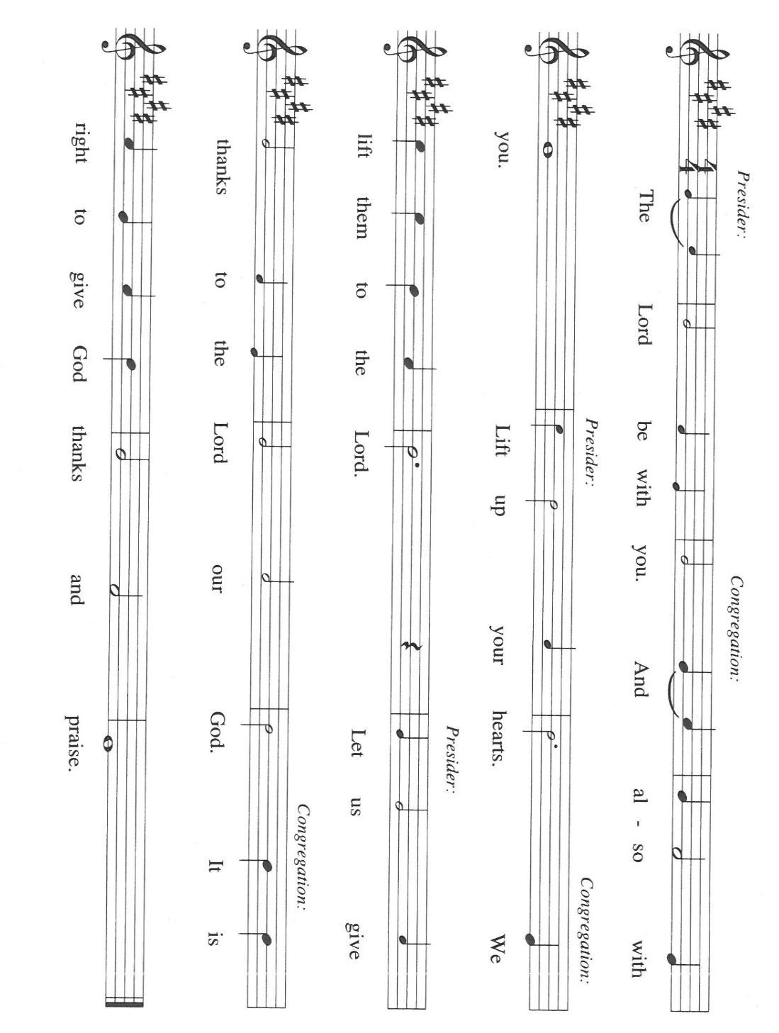
C: Receive all we offer You this day. Enrich our lives with the fruits of Your Spirit,
that we may follow the way of our Lord Jesus, and serve one another in freedom
and love. We ask this in the name of Jesus the Lord. Amen.

THE GREAT THANKSGIVING

P: It is our duty and delight … join their unending hymn

C: “Holy, holy, holy”

P: God of the whirlwind, You created all things out of nothing; You called Your chosen
people out of the wilderness; and in Your Son’s dying and rising You re-
created us out of the chaos of our sin.
You passed the mantle from Elijah to Elisha, and in the power of Your Holy Spirit
You passed the mantle of Jesus to the apostles and to Your Church.
God of the journey, Your Son Jesus Christ had nowhere to lay His head, but still
He sets a table in our wilderness and meets us in the sustenance of bread
and wine.
Now send down Your Holy Spirit, that in them we may find our home in You, and
that these gifts of the earth and human hands may be for us the Body and
Blood of Your Son, Jesus Christ;
Who in the night ... “Do this for the remembrance of Me.”
As often as we eat ... we proclaim the Lord’s death until He comes.

P: Ever-gracious God, as Elisha asked Elijah for a double portion of his spirit, so now
we seek a double share of Your Spirit.
Fill our bodies with Your heavenly Food, fill Your Church with truth and grace,
fill Your world with righteousness and peace, and fill Your whole creation
with the praise of Your glory,
That our deepest hungers may be met in You, the deepest thirst of all who struggle
through each day may be met in the coming of Your Kingdom, and the
deepest needs of all who are oppressed may be met in the never-failing
stream of Your liberating love,
Until the Day when we are filled forever with the abundant fruits of Your Spirit
in union with Christ, ever one God.

C: Amen.

THE LORD’S PRAYER

P: As disciples who follow Jesus on the way to the Kingdom, with persevering faith let us
pray:

C: (Sung) Music is on the front cover of the red hymnal

INVITATION TO THE MEAL

P: This is the Lamb of God Who takes away the sin of the world Blessed are those who
are called to the Supper of the Lamb. God’s holy gifts for God’s holy people. Come,
for all is now ready.

The assembly is seated

THE DISTRIBUTION “Lamb of God”

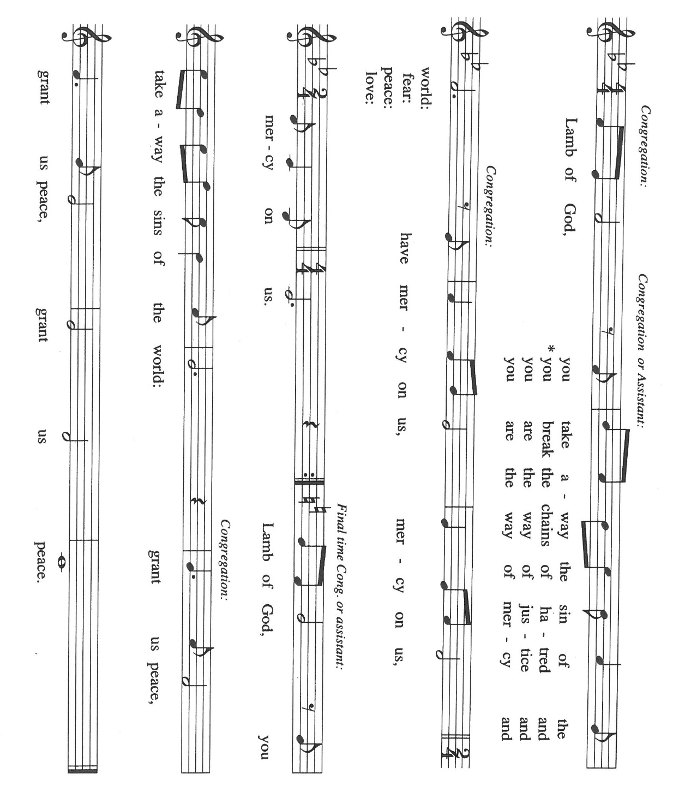
HYMNS DURING DISTRIBUTION 768 Lead Me, Guide Me
697 Just a Closer Walk With Thee

As you are able please rise

THE POST-COMMUNION BLESSING

P: The Body and Blood of our Lord Jesus Christ strengthen you and keep you in His grace.

C: Amen.

THE POST-COMMUNION PRAYER

A: Let us pray. God of power, we are nourished by the riches of Your grace. Raise us to
new life in Your Son Jesus Christ, and fit us for His eternal Kingdom, that all the world
may call Him Lord. Grant this through Christ our Lord.

C: Amen.

SENDING

THE BENEDICTION

P: Almighty God: Father, Son, and Holy Spirit, bless you now and forever.

C: Amen.

THE SENDING HYMN 810 O Jesus, I Have Promised

THE DISMISSAL

A: Go in peace to bear Christ’s love to all the world.

C: Thanks be to God!

POSTLUDE Fantasia J. Pachelbel

To God Alone Be Glory

The Meditation is from Richer Fare for the Christian People. Gail Ramshaw, ed. (New
York: Pueblo Publishing Company, 1990) 189.

The Greeting, Prayers, and Dismissal are adapted from Sundays and Seasons. Copyright
2001 Augsburg Fortress.

The Eucharistic Prayer is adapted from Eucharistic Prayers. Samuel Wells and Abigail
Kocher. (Grand Rapids: Eerdmann’s Publishing Company, 2016) 210-211.

ANNOUNCEMENTS

Please remember to mail your offering to the Church Office at 818 Franklin Street, Michigan City, IN 46360. Another alternative is to give on-line through Tithe.ly. Please see your closure letter for information on how to set up a Tithe.ly account.

St. Paul Members are reminded to have a loved one contact the office if you are hospitalized. Many times, the Pastor doesn’t know someone is in the hospital. If you call and leave a message, please tell us which hospital the patient is at.

Next Sunday’s lessons are Isaiah 66: 10-14; Psalm 66: 1-9; Galations 6: [1-6] 7-16; Luke 10: 1-11, 16-20 for those of you who like to study them in advance.

Anniversaries: Ed & Judy Gustum (6/29); Al & Clara Lorentzen (6/29);
Chip & Audrey Claussen (7/1); David and Nancy Squires (7/3)

PRAYER CONCERNS: Audrey Beyer, Ryan Krueger, Donna Bostater, Maxine Powell, Jim Tomscheck, Eloise Ponder, Mark & Jary Tannehill, Leonard Cross, George Ottersen and Annette Scroggin.

If you requested someone’s name to be on the prayer list and are aware that they need continued imminent prayer then contact the church office and let us know. Otherwise we will gradually transfer names to the long-term list.

OFFICE HOURS: Libby will be in the office on Mondays, Wednesdays, and Fridays; volunteers will cover Tuesdays and Thursdays.

Monday & Wednesday 8:00 a.m. – 5 p.m.
Tuesday & Thursday 9:00 a.m. – 12:00 p.m.
Friday 8:00 a.m. – 12:00 p.m.

If you are listening to the worship broadcast on the radio and would like to watch the Sunday morning service live stream follow these steps:

(1) If you have You.Tube available on your TV, search for
St. Paul Lutheran Church Michigan City, IN.

(2) The direct link on the computer is
https://www.youtube.com/channel/UC5AIPNaKr3QN50984jGOa1g.

(3) This link is also on the main page of the church’s website in the church section and will continue to be posted weekly on the St. Paul Facebook page.

And it will always be available on the radio broadcast Sunday mornings at 11:00 a.m. on WEFM (95.9), and on the local cable access station #99 for the previous week’s service on Sundays at 4:00 p.m. and the current service on Wednesdays at 7:00 p.m. and Fridays at 8:30 p.m.

To send e-mail to the church office, please use the following addresses:

Pastor Mark Reshan: seniorpastor@stpaulmichigancity.com

Church Office Secretary (Libby Pollock): churchsecretary@stpaulmichigancity.com

Church Treasurer (Karen Fleming) and Bookkeeper (Billie Atchinson):

finance@stpaulmichigancity.com.

The Good News Newsletter: If you have an article or anything you want included in The Good News please send it to the following e-mail address: splcgoodnews@gmail.com. Pastor Pamela Thiede will be using this e-mail address to assemble The Good News each month. The deadline for getting information to Pastor Pamela will be the 20th of each month.

WORSHIP ATTENDANCE for June 18 and 19, 2022
4:00 p.m. 30
9:00 a.m. 51
Total = 81

The Community Soup Kitchen serving out of First United Methodist is in need of volunteers. Sunday through Tuesday is always need, as is occasionally Wednesdays and Thursdays. Hours are 9:30 a.m. to 1:15 p.m. and it is not necessary to stay the entire time. There is also a need for volunteers to be available to help pick up deliveries from the Food Bank when they arrive. If you are able to help please contact their church office at 872-7200.

The return of coffee and fellowship: on Sunday, June 26, 2022 coffee and fellowship will again be available in the St. Paul Room following the 9:00 a.m. services each Sunday.

JULY 2022 ACTIVITIES, MEETINGS AND SERVICES

Saturday, July 2, 2022 at 4:00 p.m. Worship Service

Sunday, July 3, 2022 at 9:00 a.m. Worship Service

Wednesday, July 6, 2022 at 10:00 a.m. God’s Purls/St. Paul Room

Saturday, July 9, 2022 at 4:00 p.m. Worship Service

Sunday, July 10, 2022 at 9:00 a.m. Worship Service

Monday, July 11, 2022 at 12:30 p.m. Harmony Circle/Nursery/Green Room

at 3:30 p.m. School Board Meeting/Luther House

Tuesday, July 12, 2022 at 11:30 a.m. Charity Circle to meet at Sugar Bowl Restaurant

Wednesday, July 13, 2022 at 10:00 a.m. God’s Purls/St. Paul Room

Saturday, July 16, 2022 at 4:00 p.m. Worship Service

Sunday, July 17, 2022 at 9:00 a.m. Worship Service

Monday, July 18, 2022 at 4:00 p.m. Finance Committee Meeting/St. Paul Room

Wednesday, July 20, 2022 at 10:00 a.m. God’s Purls/St. Paul Room

Saturday, July 23, 2022 at 4:00 p.m. Worship Service

Sunday, July 24, 2022 at 9:00 a.m.Worship Service

Monday, July 25, 2022 at 5:30 p.m. Executive Board Meeting/Luther House

Wednesday, July 27, 2022 at 10:00 a.m. God’s Purls/St. Paul Room

Thursday, July 28, 2022 from 4 p.m. – 10 p.m. GIVE-BACK at Galveston Steakhouse

at 5:30 p.m. Church Council Meeting/St. Paul Room

Saturday, July 30, 2022 at 4:00 p.m. Worship Service

Sunday, July 31, 2022 at 9:00 a.m. Worship Service

