**THE SEVENTH SUNDAY AFTER PENTECOST**

**July 27, 2025**

“ …the Lukan version of the Lord’s Prayer breaks into two parts. The first part (v. 2) consists of two imperative petitions, both about God: thy name be hallowed, may thy kingdom come. These two petitions function as acts of praise and doxology because they acknowledge God’s *holiness* and God’s *sovereignty.*

The beginning point for the Lord’s Prayer is thus not very different from the beginning point for Abraham’s petitions in Genesis 18. Abraham’s confidence in God’s sovereign holiness leads him to expect a new way of justice in the world. In the Lord’s Prayer, confidence in God’s sovereign holiness leads to expectations about a new way of life. The assurance of God’s holy name and God’s sovereign kingdom provides the contexts out of which it is possible to pray about our life …”

“ … To come to God timidly in prayer and petition is a sign that we do not trust God’s sovereign holiness. To come to God in timidity is a sign that we do not trust God’s ability to answer, that we are not sure God has the strength to deal with us as we are. It is almost as if we want to protect God from the full weight of our petitions, but by trying to protect God, we actually restrict the arena in which God’s justice and righteousness can act.

To come to God boldly, however, as Abraham did in Genesis 18 and as Jesus instructs in Luke 11, is to proclaim our confidence that God will hear and God will answer. To come to God boldly, pressing God for a new way of life in the world, for daily bread, for the end of brokenness, is an expression of our passionate trust in God.”

**Gail R. O’Day**

Jeremiah lay in squalor, and the Lord hearkened to his prayer. Job prayed from his dunghill, and the Lord was gracious to him. Jonah was in the belly of a whale, and the Lord listened to his prayer. And you, even if you are in the baths, pray; wherever you are, pray.

Do not seek for a place to pray in: you yourself are a temple. And what is the meaning of stretching out hands in prayer? They have been the instrument of many iniquities, and because of this we are bidden to lift them up, that the ministry of prayer may serve them as a withdrawal from iniquity. Thus should you be on the point of committing a theft, or oppressing or striking someone, you may remember that you must raise those hands in pleading before God.

**John Chrysostom**

**Fourth Century**

**✠ In the Name of Jesus ✠**

**✠ GATHERING ✠**

**INTRODUCTION**

Persistence in prayer evoked the admiration of Jesus and wins the attention of the Lord when Abraham intercedes for Sodom. The life of the baptized—to be rooted and built up in Christ Jesus the Lord—is to be rooted in prayer. God hears and answers prayer and so strengthens God’s own. "When I called, you answered me; you increased my strength within me."**Johann Sebastian Bach, died 1750; Heinrich Schütz, died 1672; George Frederick Handel, died 1759; musicians**

*These three German-born musicians have done much to enrich the life of the church. Schütz was an early master who focused on settings of biblical texts. Bach wrote over 300 cantatas along with works for organ and instrumental pieces, and has been called the "fifth evangelist" for the way he proclaimed the gospel in music. Handel's great work, Messiah, is a setting of scriptural texts.*

**PRELUDE**

**ANNOUNCEMENTS**

*As you are able please rise*

**CONFESSION AND ABSOLUTION**

P: In the name of the Father and of **✠** the Son and of the Holy Spirit.

**C: Amen.**

P: “When I called, (O God), You answered me; You increased my strength within me.”

(Psalm 138: 4) Jesus commands us to “ask; search, and knock” (Luke11: 9) in prayer,

promising that we will receive the good gifts God desires to bring. In confidence that

God deals with us not according to His anger but in overflowing mercy, let us “call”

upon the Lord in the confession of our sins.

*Silence for self-examination and reflection is kept*

P: Most merciful God,

**C: We confess that we have sinned against You and others. You desire us to call**

**upon You in prayer, but often we make no time for You. We use prayer as a way**

**to “get” what we desire from You instead of as a gift by which You prepare us for**

**Your Kingdom and teach us Your will. Forgive us for our failures in prayer, O**

**God. Daily “teach us to pray” (Luke 11: 1) in ways what will lay hold of Your**

**promises, root us deeply in Christ, and bring Your transforming love to our**

**broken world.**

P: “Everyone who asks, receives, and everyone who searches finds, and for everyone who

knocks, the door will be opened.” (Luke 11: 10) “Because of (God’s) love and

faithfulness” (Psalm 138 :3) God grants the mercy for which we pray. For as a called

and ordained minister of the Church of Christ and by His authority, I therefore declare

to you the entire forgiveness of all your sin, in the name of the Father, and of **✠**  the

Son, and of the Holy Spirit.

**C: Amen.**

**GATHERING HYMN 533 *Open Now Thy Gates of Beauty***

**THE GREETING AND PRAYER OF THE DAY**

P: The grace of our Lord Jesus Christ, the love of God, and the communion of the Holy

Spirit be with you all.

**C: And also with you.**

P: Let us pray. Almighty and ever-living God, You are always more ready to hear than

we are to pray, and You gladly give more than we either desire or deserve. Pour upon

us Your abundant mercy. Forgive us those things that weigh on our conscience, and

give us those good things that come only through Your Son, Jesus Christ, our Savior

and Lord.

**C: Amen.**

*The assembly is seated*

**✠ WORD ✠**

**FIRST READING Genesis 18: 16-32**

In today's reading, Abraham undertakes the role of a mediator between God and sinful humanity. Appealing to God's justice, Abraham boldly asks for mercy for the city of Sodom, for the sake of the few righteous people who are in it, including Abraham's nephew, Lot.

16 Then the men set out from there, and they looked toward Sodom, and Abraham went with them to set them on their way. 17 The Lord said, “Shall I hide from Abraham what I am about to do, 18 seeing that Abraham shall become a great and mighty nation, and all the nations of the earth shall be blessed in him? 19 No, for I have chosen him, that he may charge his children and his household after him to keep the way of the Lord by doing righteousness and justice, so that the Lord may bring about for Abraham what he has promised him.”

20Then the LORD said, "How great is the outcry against Sodom and Gomorrah and how very grave their sin! 21I must go down and see whether they have done altogether according to the outcry that has come to me; and if not, I will know."

22So the men turned from there, and went toward Sodom, while Abraham remained standing before the LORD. 23Then Abraham came near and said, "Will You indeed sweep away the righteous with the wicked?" 24Suppose there are fifty righteous within the city; will You then sweep away the place and not forgive it for the fifty righteous who are in it? 25Far be it from You to do such a thing, to slay the righteous with the wicked, so that the righteous fare as the wicked! Far be that from You! Shall not the Judge of all the earth do what is just?"

26And the LORD said, "If I find at Sodom fifty righteous in the city, I will forgive the whole place for their sake." 27Abraham answered, "Let me take it upon myself to speak to the LORD, I who am but dust and ashes. 28Suppose five of the fifty righteous are lacking? Will You destroy the whole city for lack of five?" And He said, "I will not destroy it if I find forty-five there."

29Again he spoke to Him, "Suppose forty are found there." He answered, "For the sake of forty I will not do it." 30Then he said, "Oh do not let the LORD be angry if I speak. Suppose thirty are found there." He answered, "I will not do it, if I find thirty there." 31He said, "Let me take it upon myself to speak to the LORD. Suppose twenty are found there." He answered, "For the sake of twenty I will not destroy it." 32Then he said, "Oh do not let the LORD be angry if I speak just once more. Suppose ten are found there." He answered, "For the sake of ten I will not destroy it."

The Word of the Lord.

**Thanks be to God.**

**THE PSALM: Psalm 138** **Read responsively**

1I will give thanks to You, O LORD, with my whole heart;

     before the gods I will sing Your praise.

**2I will bow down toward Your holy temple and praise Your name, because of Your steadfast love and faithfulness;**

**for You have glorified Your name and Your word above all things.**

3When I called, You answered me;

     You increased my strength within me.

**4All the rulers of the earth will praise You, O LORD,**

**when they have heard the words of Your mouth.**

5They will sing of the ways of the LORD,

     that great is the glory of the LORD.

**6The LORD is high, yet cares for the lowly,**

**perceiving the haughty from afar.**

7Though I walk in the midst of trouble, You keep me safe;

     You stretch forth Your hand against the fury of my enemies; Your right hand shall save me.

**8You will make good Your purpose for me;**

**O LORD, Your steadfast love endures forever; do not abandon the works of Your hands.**

**SECOND READING Colossians 2: 6-15**

Paul warns his congregation in Colossae about "the empty lure" of philosophies and traditions that compromise faith. Through the gift of faith, the church is mystically connected with Christ in his death and resurrection, which is enacted in baptism.

6As you therefore have received Christ Jesus the Lord, continue to live your lives in Him, 7rooted and built up in Him and established in the faith, just as you were taught, abounding in thanksgiving.

8See to it that no one takes you captive through philosophy and empty deceit, according to human tradition, according to the elemental spirits of the universe, and not according to Christ. 9For in Him the whole fullness of deity dwells bodily, 10and you have come to fullness in Him, Who is the head of every ruler and authority. 11In Him also you were circumcised with a spiritual circumcision, by putting off the body of the flesh in the circumcision of Christ; 12when you were buried with Him in baptism, you were also raised with Him through faith in the power of God, Who raised Him from the dead.

13And when you were dead in trespasses and the uncircumcision of your flesh, God made you alive together with Him, when He forgave us all our trespasses, 14erasing the record that stood against us with its legal demands. He set this aside, nailing it to the cross. 15He disarmed the rulers and authorities and made a public example of them, triumphing over them in it.

The Word of the Lord.

**Thanks be to God.**

*As you are able please rise*

**THE VERSE** Sung twice

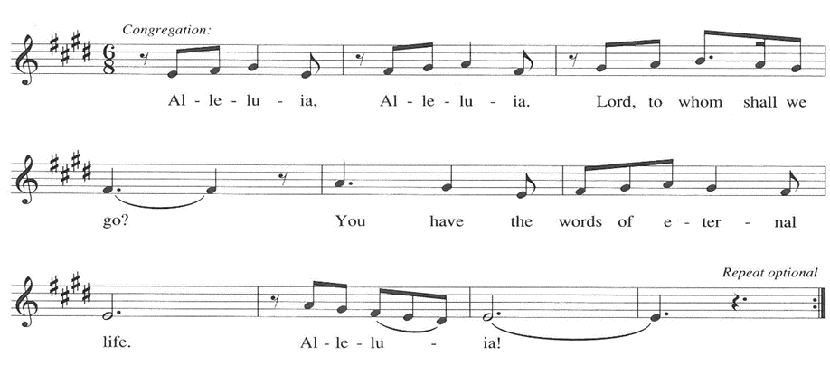

**THE HOLY GOSPEL Luke 11: 1-13**

In teaching his disciples this prayer, Jesus also reminds them to focus on God's coming reign, God's mercy, and the strengthening of the community. Jesus encourages his disciples to child-like trust and persistence in prayer.

P: The Holy Gospel according to St. Luke, the eleventh chapter.

**C: Glory to You, O Lord!**

Jesus was praying in a certain place, and after He had finished, one of His disciples said to Him, "Lord, teach us to pray, as John taught his disciples." 2He said to them, "When you pray, say:

Father, hallowed be Your name.

Your kingdom come.

3Give us each day our daily bread.

4And forgive us our sins, for we ourselves forgive everyone indebted to us.

And do not bring us to the time of trial."

5And He said to them, "Suppose one of you has a friend, and you go to him at midnight and say to him, 'Friend, lend me three loaves of bread; 6for a friend of mine has arrived, and I have nothing to set before him.' 7And he answers from within, 'Do not bother me; the door has already been locked, and my children are with me in bed; I cannot get up and give you anything.'

8I tell you, even though he will not get up and give him anything because he is his friend, at least because of his persistence he will get up and give him whatever he needs.  
9So I say to you, Ask, and it will be given you; search, and you will find; knock, and the door will be opened for you. 10For everyone who asks receives, and everyone who searches finds, and for everyone who knocks, the door will be opened.

11Is there anyone among you who, if your child asks for a fish, will give a snake instead of a fish? 12Or if the child asks for an egg, will give a scorpion? 13If you then, who are evil, know how to give good gifts to your children, how much more will the heavenly Father give the Holy Spirit to those who ask Him!"

P: The Gospel of the Lord.

**C: Praise to You, O Christ!**

*The assembly is seated*

**THE SERMON**

*Silence for reflection follows the sermon*

*As you are able please rise*

**THE HYMN OF THE DAY NSB 77 *Seek Ye First***

**THE APOSTLES’ CREED**

A: God has made us His people through our Baptism into Christ. Living together in trust

and hope, we confess our faith.

**C: I believe in God, the Father almighty,**

**creator of heaven and earth.**

**I believe in Jesus Christ, His only Son, our Lord.**

**He was conceived by the power of the Holy Spirit**

**and born of the virgin Mary.**

**He suffered under Pontius Pilate,**

**was crucified, died, and was buried.**

**He descended into hell.**

**On the third day He rose again.**

**He ascended into heaven,**

**and is seated at the right hand of the Father.**

**He will come again to judge the living and the dead.**

**I believe in the Holy Spirit,**

**the holy catholic Church,**

**the communion of saints,**

**the forgiveness of sins,**

**the resurrection of the body,**

**and the life everlasting. Amen.**

**THE PRAYER OF THE CHURCH**

A: We have been taught to pray by the Lord. Therefore with the boldness and confidence

of Abraham, we persistently ask, seek, and knock for the life of the Church, the world,

those in need, and all of God’s good creation.

A: That the Church might remain rooted deeply in Christ, built up in Him and established

in a courageous and missionary faith, let us pray to the Lord:

**C: Lord, hear our prayer.**

A: That in places of unrest, especially Ukraine; Gaza; Israel and Iran; Kenya, Rwanda,

Sudan, and Mozambique peace might prevail over violence, bloodshed, and hatred, let

us pray to the Lord:

**C: Lord, hear our prayer.**

A: That this congregation may diligently ask and seek Your mission for us that we may

continue our life in Him with deep joy, hope, and thanksgiving, let us pray to the Lord:

**C: Lord, hear our prayer.**

A: That the persistent cries of the hungry, the homeless, refugees, the abused, and the sick,

especially: **Shirley Freels; Shirley McCarty; Larry Litchford; Lucas Bradshaw;**

**Carol Radke; Martha Schroeder; Joyce Stark; David Weiss; Fred Weiss; Bob**

**Pheanis; Christine Kiser; and Carol Pauluhn** may elicit our compassionate help and

God’s healing grace, let us pray to the Lord:

**C: Lord, hear our prayer.**

A: That **Stacie Summers and Randon Trinklein,** newly married, would continue to grow

into the fullness of their new life together as husband and wife in Christ, let us pray to

the Lord:

**C: Lord, hear our prayer.**

A: That those celebrating birthdays, especially: **Susan Dolson; Sandra Robbins; Jim**

**Galinowski; Mike Bockover and Carol Hanft,** and anniversaries, especially: **Amy**

**and John VanGemeren; Virgil and Patricia Miller; and Richard and Karen**

**Fleming, Jr.** may grow in grace this day and every day and be filled with grace for the

days ahead, let us pray to the Lord:

**C: Lord, hear our prayer.**

A: That with all the saints and martyrs, especially: **Johann Sebastian Bach, Heinrich**

**Schütz, and George Frederick Handel, musicians,** whom we commemorate this

Day, we may faithfully testify by word and life to Your Kingdom that is surely coming,

let us pray to the Lord:

**C: Lord, hear our prayer.**

P: Loving God, our Father, You fashioned the human heart; You know the needs that make

it ache. Hear us, Your children, praying as Your Son taught us. His is the name we

evoke; His is the Kingdom we await: Jesus Christ, the Lord.

**C: Amen.**

**✠ MEAL ✠**

**THE PEACE**

P: The peace of the Lord be with you always.

**C: And also with you.**

*The assembly is seated*

**THE OFFERING**

**THE VOLUNTARY *For the Lord is Good* New Song Praise Band**

**(Lynn DeShazo & Gary Sadler)**

*As you are able please rise*

**THE OFFERTORY 465 *As the Grains of Wheat***

**THE OFFERTORY PRAYER**

A: Let us pray. God of grace,

**C: We offer You our prayers in the confidence that You will hear them. With joy**

**and thanksgiving we bring You these gifts of our time, talents, and possessions.**

**Receive them for the sake of Your Son, Jesus Christ, and through this Bread,**

**strengthen us to do Your will on earth as it is in heaven. We ask this in the name**

**of Jesus the Lord. Amen.**

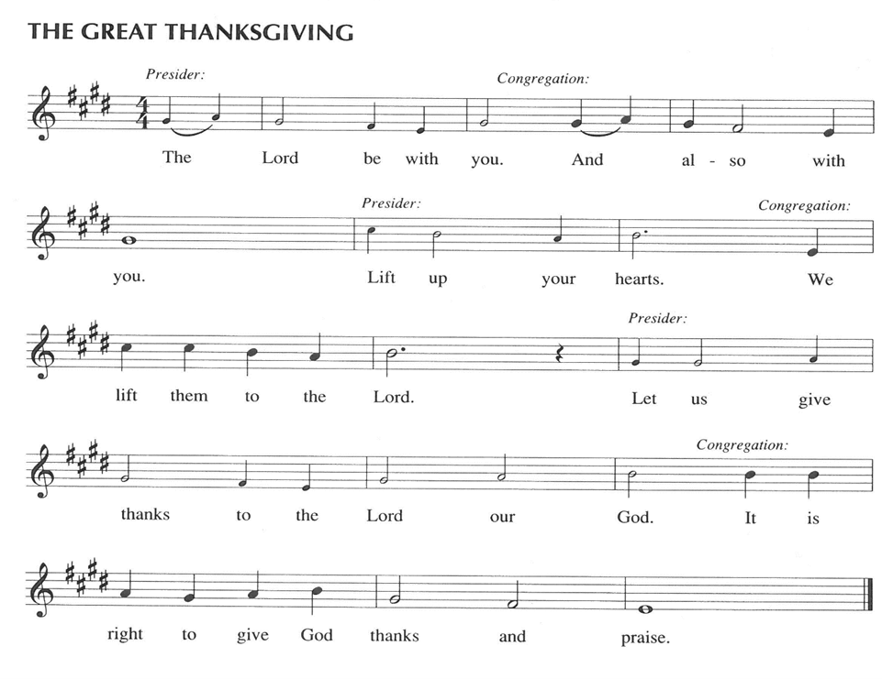

P: It is our duty and delight … join their unending hymn:

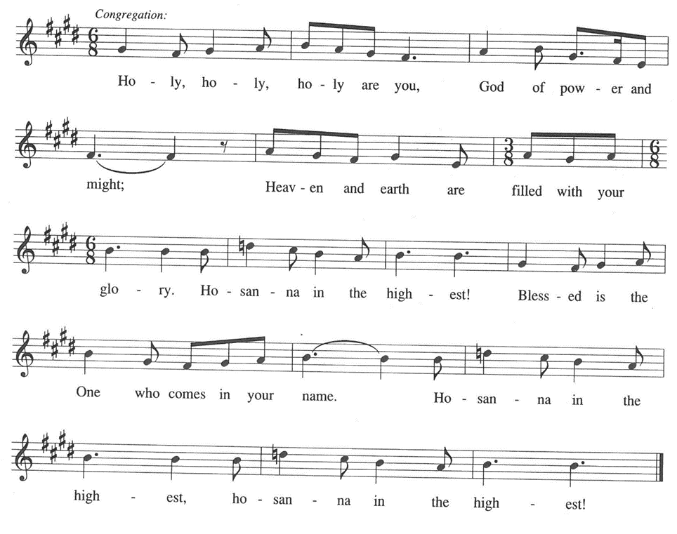

P: *Father, hallowed be Your name;* for You have glorified it through Your everlasting love

and faithfulness.

Heaven and earth praise You, for by Your Word they were created.

Through Your love *Your Kingdom comes,* full of promise, life, and hope.

You gave birth to Your promise in Israel, Your chosen, through whom You raised up

Jesus, Your Son, in Whom all Your purposes will be made good.

In the night … “Do this for the remembrance of Me.”

As often as we eat … we proclaim the Lord’s death until He comes.

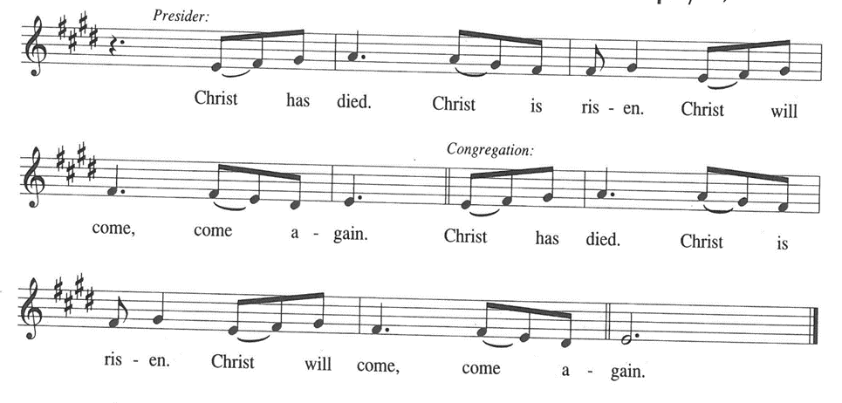

P: Remembering, His willing entry into death and His glorious rising into Life, His

Ascension and sending of the Holy Spirit to those who ask You,

We lift this *Bread* and cup given to us *this day,* seeking Your blessings as we await

His promised return.

Pour out Your Spirit on us and these gifts that we who share this Meal may *forgive*

*as we have been forgiven,* and in the power of the Spirit be *saved from the time of trial* until Christ comes in final victory.

As You teach us to pray, Father, gather our petitions with those of Christ in the unity

of the Holy Spirit, until all honor and glory is Yours, in heaven and on earth,

now and forever.

**C: Amen!**

**THE LORD’S PRAYER**

P: Gathered into one by the Spirit, let us pray as Jesus taught us:

**C: Father, hallowed be Your name.**

**Your kingdom come.**

**Give us each day our daily bread.**

**And forgive us our sins, for we ourselves forgive everyone indebted to us.**

**And do not bring us to the time of trial.**

**INVITATION TO THE MEAL**

P: This is the Lamb of God Who takes away the sin of the world. Blessed are those who

are called to the Supper of the Lamb. God’s holy gifts for God’s holy people. Come,

for all is now ready.

*The assembly is seated*

**THE DISTRIBUTION *Lamb of God***

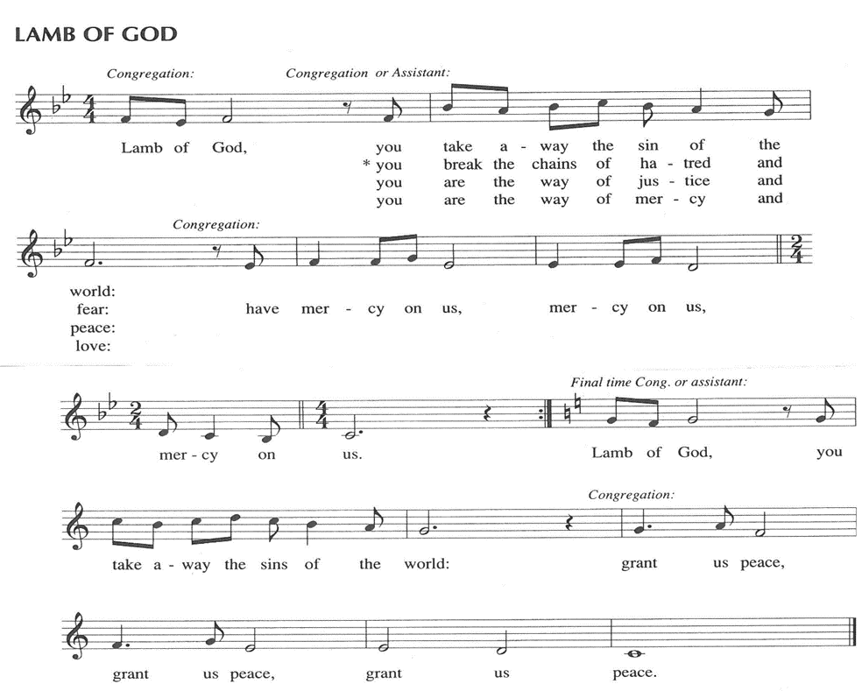

**HYMN DURING DISTRIBUTION 742 *What a Friend We Have in Jesus***

**NSB 48 *I Am the Bread of Life***

**ELW 490 *Let All Mortal Flesh Keep Silence***

**ELW 733 *Great Is Thy Faithfulness***

**NSB 37 *Give Thanks***

*As you are able please rise*

**THE POST-COMMUNION BLESSING**

P: The Body and Blood of our Lord Jesus Christ strengthen you and keep you in His grace.

**C: Amen.**

**THE POST-COMMUNION PRAYER**

A: Let us pray. God of grace, we have again received the gift of the Body and Blood of

Your Son. May this Bread strengthen us to hallow Your name and live out Your

forgiveness until Your Kingdom fully comes in Your Son, Jesus Christ our Lord.

**C: Amen.**

**✠ SENDING ✠**

**THE BENEDICTION**

P: Almighty God: Father, Son, **✠** and Holy Spirit bless you now and forever.

**C: Amen.**

**THE SENDING SONG ELW 543 *Go, My Children, with My Blessing***

**THE DISMISSAL**

A: Go in peace to bear Christ’s love to all the world.

**C: Thanks be to God!**

**POSTLUDE**

**✠ To God Alone Be Glory ✠**

The Meditation is from *Proclamation: Pentecost 2.* Gail R. O’Day. (Philadelphia: Fortress Press, 1989) 5, 9-10; and *Sundays and Seasons Online.* Copyright 2019 Augsburg Fortress.

The Prayers are adapted from *Intercessions for the Christian People.* Gail Ramshaw, ed. (New York: Pueblo Publishing Company, 1988) 186.

**ANNOUNCEMENTS**

**Please remember to mail your offering to the Church Office** at 818 Franklin Street, Michigan City, IN 46360**.** Another alternative is to give on-line through Tithe.ly. Please see your closure letter for information on how to set up a Tithe.ly account.

**St. Paul Members are reminded to have** a loved one contact the office if you are hospitalized. Many times, the Pastor doesn’t know someone is in the hospital. If you call and leave a message, please tell us at which hospital the patient is located.

**Birthdays: Susan Dolson (8/1); Sandr Robbins(8/4); Jim Galinowski (8/4); Mike**

**Bockover (8/6); Carol Hanft (8/9)**

**Anniversaries: Amy & John VanGemeren (8/3); Virgil & Patricia Miller (8/5);**

**Richard & Karen Fleming, Jr. (8/9)**

**PRAYER CONCERNS:** Bob Pheanis; Larry Litchford, Sarah McNabb, Carol Radke, Jeanie Boatman Shepple, Nolan Wilson, Debbie Martin, Mark Tannehill, Brian Wiseman, Kathy Stein, Danielle Schnell, Jan Paholski, Laura Dovey, and Grace

Romine.

**OFFICE HOURS:** Libby will be in the office on Mondays, Wednesdays, and Fridays; volunteers will cover Tuesdays and Thursdays.

  Monday & Wednesday 8:00 a.m. – 5 p.m.

Tuesday & Thursday 9:00 a.m. – 12:00 p.m.

Friday 8:00 a.m. – 12:00 p.m.

**If you are listening to the worship broadcast on the radio and would like to watch the Sunday morning service live stream follow these steps:**

(1) If you have You Tube available on your TV, search for

**St. Paul Lutheran Church Michigan City, IN.**

(2) The direct link on the computer is [https://](https://www.youtube.com/channel/UC5AIPNaKr3QN50984jGOa1g)

[www.youtube.com/channel/UC5AIPNaKr3QN50984jGOa1g](https://www.youtube.com/channel/UC5AIPNaKr3QN50984jGOa1g).

   (3) This link is also on the main page of the church’s website in

the church section and will continue to be posted weekly on the St.

Paul Facebook page.

And it will always be available on the radio broadcast Sunday mornings at 11:00 a.m.

on WEFM (95.9), and on the local cable access station #99 for the previous week’s

service on Sundays at 4:00 p.m. and the current service on Wednesdays at 7:00 p.m.

and Fridays at 8:30 p.m.

**Sunday’s lessons are Ecclesiastes 1: 2, 12-14; 2: 18-23; Psalm 49: 1-12; Colossians 3: 1-11 and Luke 12: 13-21** for those of you who like to study them in advance.

**To send e-mail to the church office**, please use the following addresses:

Pastor Mark Reshan: seniorpastor@stpaulmichigancity.com

Church Office Secretary (Libby Pollock): churchsecretary@stpaulmichigancity.com

Church Treasurer (Karen Fleming): finance@stpaulmichigancity.com

**2025 Church Council:**

Mark Reshan - Pastor

 Janet Bakken – President

 Donna Knoll – Vice President

 Judy Hunt – Secretary

 Karen Fleming – Treasurer

 Members: Paul Brooks, Diane Egilske, Sue Koziel, Judy Mutchler,

Jim Schraidt, Trish Sprague

**Worship Attendance:**

**Saturday , July 19, 2025 @ 4:00 p.m. 22**

**Sunday, July 20, 2025 @ 9:00 a.m. 63**

**TOTAL 85**

**Copies of the minutes from the May 1, 2025 and the June 26, 2025 Church Council meetings are on the back table in the upper Narthex. They were approved by the council via email.**

**FYI:**

In response to the ever rising costs for postage we will be putting your copy

of the “Good News” in your hanging file folder in the narthex each month

from now on. Those of you who are unable to attend services on a regular

basis may still receive your copies through your email address or in the

U.S. mail. If you normally receive your copy of the newsletter via your

email address anyway, nothing will change for you. Thank you so much for

your understanding and cooperation!

**The Good News Newsletter**: If you have an article or anything you want included in **The Good News** please send it to the following e-mail address: splcgoodnews@gmail.com. Pastor Pamela Thiede will be using this e-mail address to assemble **The Good News** each month. The deadline for getting information to Pastor Pamela will be the 20th of each month.

**AUGUST 2025 MISSION OF THE MONTH**

**The Mission of the Month for August: Michigan City Area Schools – It’s back to school time already!** Let’s help our area kids start the year out on a good note! We will be collecting money to support different projects in various elementary schools in Michigan City through Donors Choose. Donors Choose provides a list of teacher-led classroom projects that need funding. Flexible seating, music education, and classroom supplies are some of the options we can provide to our elementary schools. Please consider donating to help fund our local teachers’ classroom projects! Checks can be written to St. Paul Lutheran Church and can be marked for MCAS and placed in the offering plate. Noisy coin offering will also support the mission of the month. To see a full list of projects visit, [www.donorschoose.org](http://www.donorschoose.org) and search for Michigan City.

**2025 Financial Stewardship**

Weekly Church Operating Needs (x 2 weeks)

July 12-13, 2025; July 19-20, 2025: $ 13,545.00

General Fund (including General Memorials): $ 5,674.00

Overage/Shortage: — $ 6,258.00

Restricted Income (not including Memorials)

Supports IK Synod & Church wide Ministries: $ 145.00

Ministries in our Community/Congregation: $ 1,040.00

Capital Fund: $ 225.00

**ACTIVITIES, EVENTS & MEETINGS**

**JULY 2025**

**Sunday,** July 20, 2025 @ 9:00 a.m. Pent 6 Worship Service/Sanctuary

**Wednesday,** July 23, 2025 @10:00 a.m. God’s Purls/St. Paul Room

**Saturday,** July 26, 2025 @ 4:00 p.m. Pent 7 Worship Service/Sanctuary

**Sunday,** July 27, 2025 @ 9:00 a.m. Pent 7 Worship Service/Sanctuary

**Wednesday,** July 30, 2025 @ 10:00 a.m. God’s Purls/St. Paul Room

**ACTIVITIES, EVENTS & MEETINGS**

**AUGUST 2025**

**Saturday,** August 2, 2025 @ 4:00 p.m. Pent 8 Worship Service/Sanctuary

**Sunday,** August 3, 2025 @ 9:00 a.m. Pent 8 Worship Service/Sanctuary

With coffee after/St. Paul Room

**Wednesday,** August 6, 2025 @ 10:00 a.m. God’s Purls/St. Paul Room

**@ 4:00 p.m. – 8:00 p.m. GIVEBACK @ PANERA**

**Thursday,** August 7, 2025 Faith Circle

**Saturday,** August 9, 2025 @ 4:00 p.m. Pent 9 Worship Service/ Sanctuary

**Sunday,** August10, 2025 @ 9:00 a.m. Pent 9 Worship Service/Sanctuary

With coffee after/St. Paul Room

**Monday,** August 11, 2025 @ 1:00 p.m. Hope Circle/Green Room

**Tuesday,** August 12, 2025 @ 7:00 p.m. Estuary/Luther House

**Wednesday,** August 13, 2025 @10:00 a.m. God’s Purls/St. Paul Room

@ 3:30 p.m. Worship & Music Comm./Luther House

**Saturday,** August 16, 2025 @ 4:00 p.m. Pent 10 Worship Service/Sanctuary

**Sunday,** August 17, 2025 @ 9:00 a.m. Pent 10 Worship Service/Sanctaury

With coffee after/St. Paul Room

**Wednesday,** August 20, 2025 @10:00 a.m. God’s Purls/St. Paul Room

@ 5:30 p.m. 150th Anniv. Comm. Mtg./Luther House

**Saturday,** August 23, 2025 @ 4:00 p.m. Pent 11 Worship Service/Sanctuary

**Sunday,** August 24, 2025 @ 9:00 a.m. Pent 11 Worship Service/Sanctuary

With coffee after/St. Paul Room

**Monday,** August 25, 2025 @ 2:00 p.m. Finance Comm. Mtg./Luther House

@ 3:00 p.m. Executive Board Mtg./Luther House

**Wednesday,** August 27, 2025 @ 10:00 a.m. God’s Purls/St. Paul Room

**Thursday,** August 28, 2025 @ 5:30 p.m. Church Council Meeting/St. Paul Room

**Saturday,** August 30, 2025 @ 4:00 p.m. Pent 12 Worship Service/Sanctuary

**Sunday,** August 31, 2025 @ 9:00 a.m. Pent 12 Worship Service/Sanctuary with

Coffee after/St. Paul Room

**POP (SODA) FOR SALE**

The pop machine in the basement of the church has been emptied and the cans of pop are for sale, 3 cans for $1.00. What is available (Mountain Dew, Sunkist Orange, Coke and Lemon Brisk) is in the left side of the kitchen refrigerator. You may buy what you want and leave the money in the refrigerator.

**For Your Information:**

While the Church Council has decided to stop stocking the Little Pantry box in the church yard the Hope Circle (WELCA) will continue their long time mission of filling the grocery cart in the narthex which always goes to the Salvation Army Food Pantry. Please continue to support their efforts!

**JULY 2025 MISSION OF THE MONTH**

Attached are the order forms for the Lutheran World Relief kits which will be the Mission of the Month for July 2025.

**Lutheran World Relief Kits**

We will be purchasing supplies to assemble two kinds of Lutheran World Relief kits together as a congregation this fall. Lutheran World Relief kits are sent to people around the world who are experiencing poverty, disaster, conflict, or more. To make it easier, we are offering everyone an opportunity to sponsor kits. Please indicate how many of each kit you would like to sponsor and return this form with payment to the church office (or in the offering plate). We will take care of purchasing all the supplies. We will hold an assembly day after Sunday worship this fall where we will assemble all the kits together. (No purchase necessary to help us assemble. We will assemble as a team; you will not be responsible for assembling all the kits you purchase yourself.)

**Please make checks payable to St. Paul Lutheran Church.**

**Orders are due Sunday, July 27th, 2025**

**______________# of health kits at $10 each**

(Health kits contain a towel, bar soap, toothbrush, comb, and nail clippers.)

**______________# of school kits at $10 each**

(School kits contain a drawstring backpack, notebooks, rulers, pencils and pens, pencil sharpener, scissors, crayons, and an eraser.)

**Total $______________**

**Thank$ for $haring**

  This month our GIVE BACK is at PANERA on Wednesday, August 6, 2025. From 4:00 p.m. – 8:00 p.m.  Here are two coupons—one for you and one for a friend.



