THE FIFTH SUNDAY AFTER PENTECOST
June 28, 2026

By the fourth century, the churches of Rome were feeding an estimated 20,000 of that city’s poor each week. The church succeeded, in great part, because it presented the world a visible alternative to the world’s social orders:

Christianity entered history as a new social order, or rather a new social dimension. From the very beginning Christianity was not primarily a “doctrine,” but exactly a “community.” There was not only a “Message” to be proclaimed and delivered, and “Good News” to be declared. There was precisely a New Community, distinct and peculiar, in the process of growth and formation, to which members were called and recruited. Indeed, “fellowship” (koinonia) was the basic category of Christian existence.

William Willimon, quoting Georges Florovsky
“Empire and Desert: Antimonies of Christian History”

In the Name of Jesus

INTRODUCTION

Without God's loving presence, we are like a parched and waterless land. In the waters of baptism, Christ becomes our life-giving spring, quenching our thirst and pouring God's love into our hearts.
In today's gospel, Christ promises that the disciple who gives a cup of cold water to the little ones serves Christ himself. Our baptism leads us to hear Jesus' words as words concerning our baptismal mission to serve the little ones of this world--with a gesture as simple as offering a cup of cold water.

Irenaeus, Bishop of Lyons, died around 202

This important early church leader tried very hard to hold to the faith handed down by the apostles. An opponent of the movement known as gnosticism, Irenaeus was one of the first to speak of the church as catholic, or linked together.

GATHERING

PRE-SERVICE MUSIC For the Lord is Good New Song Praise Band
(Lynn DeShazo & Gary Sadler)
ANNOUNCEMENTS

As you are able please rise

CONFESSION AND ABSOLUTION

P: In the name of the Father and of the Son and of the Holy Spirit.

C: Amen.

P: “Do not let sin exercise dominion in your mortal bodies, to make you obey their
passions.” (Romans 6: 12) We are called to obey the Lord. Let us confess our sin, that
through God’s forgiveness we may know again the grace under which we live.

Silence for self-examination and reflection is kept

P: Most merciful God,

C: We confess that we are captive to sin and cannot free ourselves. We remain
enslaved to passions and desires that separate us from You and others. (Romans
6: 12) We have been inhospitable and unwelcoming to those in need. (Matthew
10: 40) We have ignored the poor and hungry in our midst. For the sake of Your
Son, Jesus Christ, have mercy on us. Forgive us our sins, and lead us by Your
Holy Spirit into the new life of grace into which You have called us.

P: “ ...Present yourselves to God as those who have been brought from death to life ... for
sin will have no dominion over you, since you are not under law but grace.” (Romans
6: 13-14) God in Christ has freed you from your slavery to sin. Now “you are enslaved
to God.” (Romans 6: 22) And God’s grace for you is this: as a called and ordained
minister of the Church of Christ, and by His authority, I therefore declare to you the
entire forgiveness of all your sins, in the name of the Father and of the Son and of
the Holy Spirit.

C: Amen.

GATHERING SONG NSB 61 Kyrie Eleison

THE GREETING AND PRAYER OF THE DAY

P: The grace of our Lord Jesus Christ, the love of God, and the communion of the Holy
Spirit be with you all.

C: And also with you.

P: Let us pray. O God, You direct our lives by Your grace, and Your words of justice and
mercy reshape the world. Mold us into a people who welcome Your word and serve
one another, through Jesus Christ, our Savior and Lord.

C: Amen.

The assembly is seated

WORD

FIRST READING Jeremiah 28: 5-9

The prophets Hananiah and Jeremiah were not at odds simply because of their differing views of upcoming events. Hananiah announces peace and restoration within two years; Jeremiah sees the path to peace as one that requires repentance--recognition of one's sins and reliance on God's forgiveness. Jeremiah knows that when Hananiah's comforting prediction does not come true, all will know that Hananiah has not been sent by God.
The prophet Jeremiah spoke to the prophet Hananiah in the presence of the priests and all the people who were standing in the house of the LORD; ⁶and the prophet Jeremiah said, "Amen! May the LORD do so; may the LORD fulfill the words that you have prophesied, and bring back to this place from Babylon the vessels of the house of the LORD, and all the exiles.
⁷But listen now to this word that I speak in your hearing and in the hearing of all the people. ⁸The prophets who preceded you and me from ancient times prophesied war, famine, and pestilence against many countries and great kingdoms. ⁹As for the prophet who prophesies peace, when the word of that prophet comes true, then it will be known that the LORD has truly sent the prophet."

The Word of the Lord.

Thanks be to God.

THE PSALM: Psalm 89: 1-4, 15-18 Antiphon by Michael Krentz
Choir sings refrain first, followed immediately by the congregation and as indicated
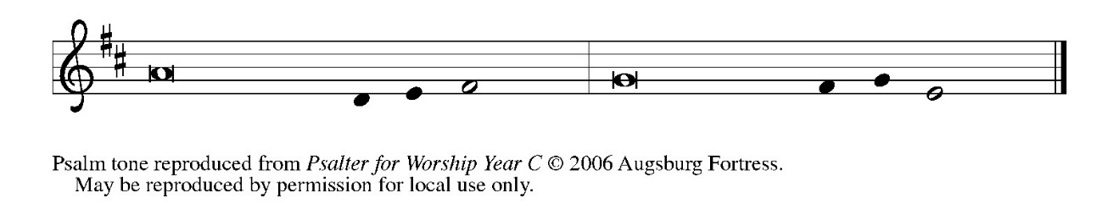
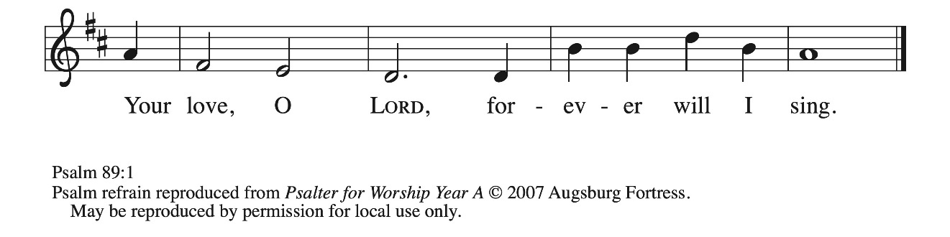

¹Your love, O Lord, forever | will I sing;
from age to age my mouth will pro- | claim Your faithfulness.

²For I am persuaded that Your steadfast love is estab- | lished forever;
You have set your faithfulness firmly | in the heavens.

³“I have made a covenant with My | chosen one;
I have sworn an oath to Da- | vid My servant:

⁴‘I will establish your | line forever,
and preserve your throne for all | generations.’” REFRAIN

¹⁵Happy are the people who know the | festal shout!
They walk, O Lord, in the light | of Your presence.

¹⁶They rejoice daily | in Your name;
they are jubilant | in Your righteousness.

¹⁷For You are the glory | of their strength,
and by Your favor our might | is exalted.

¹⁸Truly, our shield belongs | to the Lord;
our king to the Holy | One of Israel. REFRAIN

SECOND READING Romans 6: 12-23

Paul has told the Roman Christians that in baptism they were not only made right with God through grace, but were also made free from the slavery of sin. Thus, he now claims that those who are accepted by God as sinners may also be used by God for righteousness.

Do not let sin exercise dominion in your mortal bodies, to make you obey their passions. ¹³No longer present your members to sin as instruments of wickedness, but present yourselves to God as those who have been brought from death to life, and present your members to God as instruments of righteousness. ¹⁴For sin will have no dominion over you, since you are not under law but under grace.
¹⁵What then? Should we sin because we are not under law but under grace? By no means! ¹⁶Do you not know that if you present yourselves to anyone as obedient slaves, you are slaves of the one whom you obey, either of sin, which leads to death, or of obedience, which leads to righteousness? ¹⁷But thanks be to God that you, having once been slaves of sin, have become obedient from the heart to the form of teaching to which you were entrusted, ¹⁸and that you, having been set free from sin, have become slaves of righteousness. ¹⁹I am speaking in human terms because of your natural limitations. For just as you once presented your members as slaves to impurity and to greater and greater iniquity, so now present your members as slaves to righteousness for sanctification.
²⁰When you were slaves of sin, you were free in regard to righteousness. ²¹So what advantage did you then get from the things of which you now are ashamed? The end of those things is death. ²²But now that you have been freed from sin and enslaved to God, the advantage you get is sanctification. The end is eternal life. ²³For the wages of sin is death, but the free gift of God is eternal life in Christ Jesus our Lord.

The Word of the Lord.

Thanks be to God.

As you are able please rise

THE VERSE Sung twice (see p. 5)

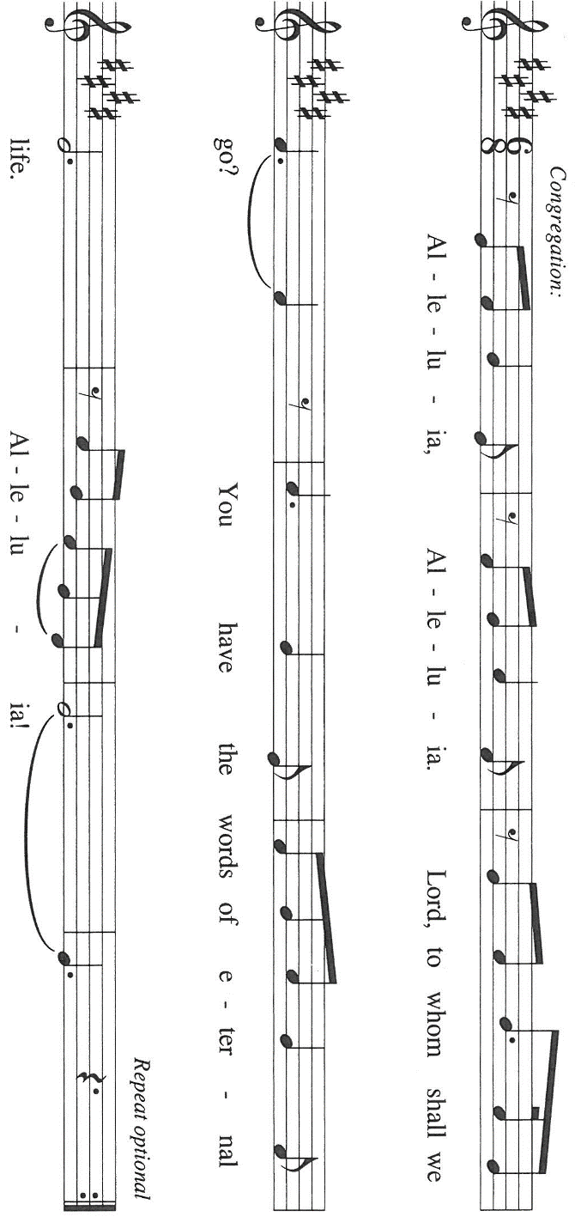

THE HOLY GOSPEL Matthew 10: 40-42

When Jesus sends His disciples out as missionaries, He warns them of persecution and hardships they will face. With this in mind, He also promises to reward any who aid His followers and support their ministry.

P: The Holy Gospel according to St. Matthew, the tenth chapter.

C: Glory to You, O Lord!

Jesus said to the twelve: "Whoever welcomes you welcomes Me, and whoever welcomes Me welcomes the One Who sent Me. ⁴¹Whoever welcomes a prophet in the name of a prophet will receive a prophet's reward; and whoever welcomes a righteous person in the name of a righteous person will receive the reward of the righteous; ⁴²and whoever gives even a cup of cold water to one of these little ones in the name of a disciple--truly I tell you, none of these will lose their reward."

P: The Gospel of the Lord.

C: Praise to You, O Christ!

The assembly is seated

THE SERMON
Silence for reflection follows the sermon

As you are able please rise

THE HYMN OF THE DAY 729 The Church of Christ, in Every Age
Stanza 2—Women; Stanza 4--Men

THE APOSTLES’ CREED
A: God has made us His people through our Baptism into Christ. Living together in trust
and hope, we confess our faith.

I believe in God, the Father almighty,
creator of heaven and earth.

I believe in Jesus Christ, His only Son, our Lord.
He was conceived by the power of the Holy Spirit
and born of the virgin Mary.
He suffered under Pontius Pilate,
was crucified, died, and was buried.
He descended into hell.
On the third day He rose again.
He ascended into heaven,
and is seated at the right hand of the Father.
He will come again to judge the living and the dead.

I believe in the Holy Spirit,
the holy catholic Church,
the communion of saints,
the forgiveness of sins,
the resurrection of the body,
and the life everlasting. Amen

THE PRAYER OF THE CHURCH

A: Through Baptism we have been made alive in Christ Jesus. Let us speak the words of
this new life by praying for the well-being of the Church, the world, and all those in
need.

A: For the Church, that we might be faithful in our discipleship, willing to serve, constant
in grace, and receptive to God’s Word and call, we pray: Hear us, O Lord,

C: For Your mercy is great.

A: For this congregation, that we might be eager to welcome, diligent in prayer, and
generous to those in need, we pray: Hear us, O Lord,

C: For Your mercy is great.

A: For the world, that in all places of violence, bloodshed, warfare, and oppression,
especially Iran and Israel, Ukraine and Lebanon, nations may die to past hatred and rise
to walk in peace and reconciliation, we pray: Hear us, O Lord,

C: For Your mercy is great.

A: For those who grieve, those in places of care, those in prison, those who are addicted,
and the sick, especially especially: Jon Samuelson; Pastor Dale Zylstra; Mark
Tannehill; Major Payne; Jean Warner; Martha Schroeder; and Kathy Thielman
that they may be brought to healing and wholeness, we pray: Hear us, O Lord,

C: For Your mercy is great.

A: For those celebrating birthdays, especially; and anniversaries, especially Dave and
Nancy Squires; and Chip and Audrey Claussen; that they may be filled with grace
this day and grow in grace in the days ahead, we pray: Hear us, O Lord:

C: For Your mercy is great.

A: For perseverance as we follow Jesus, that with all the saints, especially Irenaeus,
Bishop of Lyon, whom we commemorate this Day we may one day enjoy the reward
He promised to the righteous, we pray: Hear us, O Lord,

C: For Your mercy is great.

P: Yours, O God, is the Kingdom, the power, and the glory forever and ever. Accept our
prayers and praises as we offer them, and our whole lives to You, through Your Son,
Jesus Christ our Lord.

C: Amen.

MEAL

THE PEACE

P: The peace of the Lord be with you always.

C: And also with you.

The assembly is seated

THE OFFERING

THE VOLUNTARY In Jesus’ Name St. Paul Senior Choir
(R. Vader & J. Rouse, arr. J. Rouse)

As you are able please rise

THE PRESENTATION OF GIFTS (see p. 8) As the Grains of Wheat

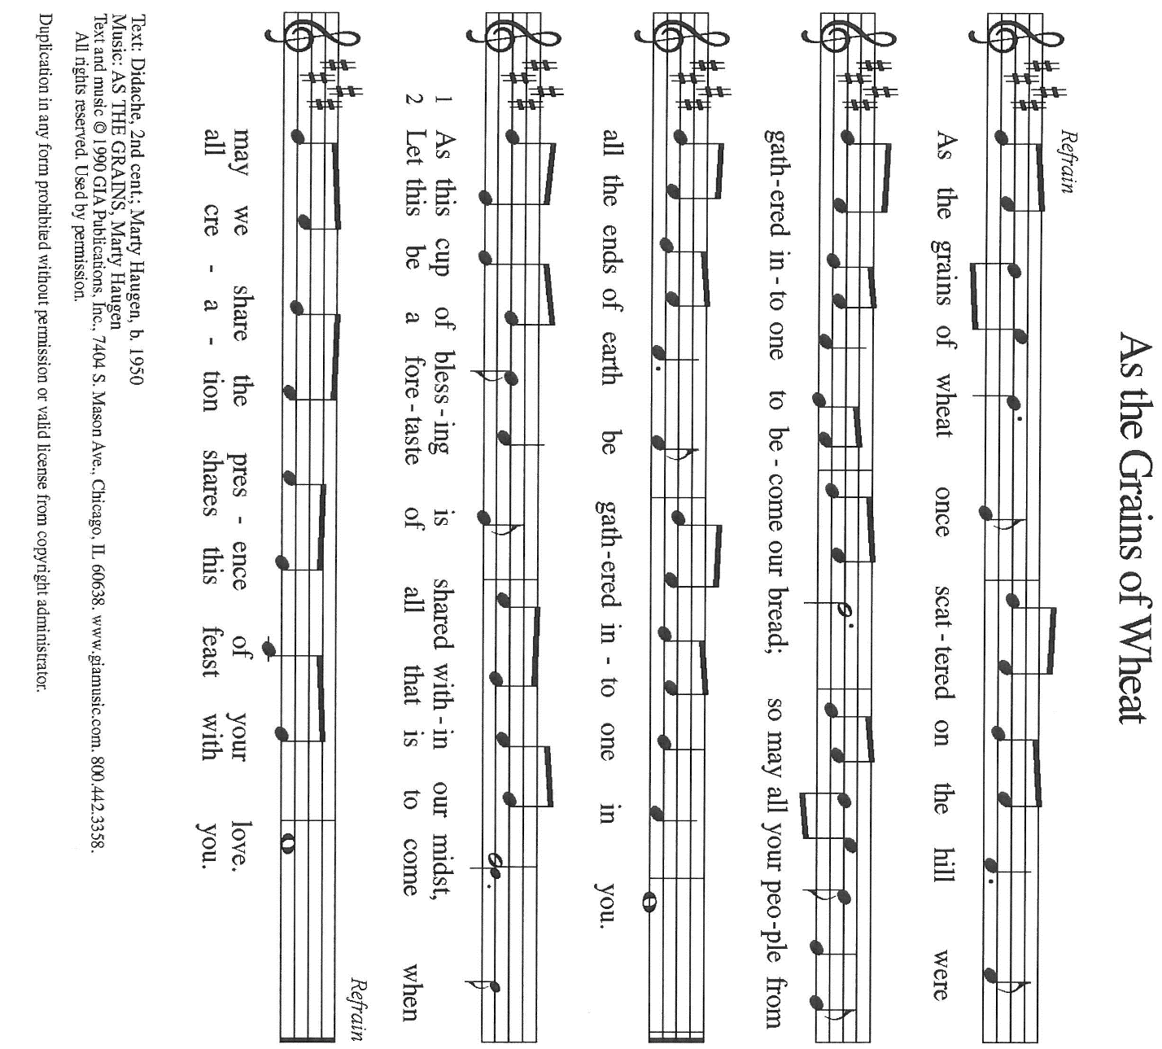

THE OFFERTORY PRAYER

A: Let us pray. God of grace,

C: You call us to present ourselves to You as instruments of righteousness. In
obedience to Your command, with these gifts we offer You all that we are and
have. Receive them for the sake of Your Son, Jesus Christ. By this Feast of grace,
make us holy for Your ministry of mercy. We ask this in the name of Jesus the
Lord. Amen.

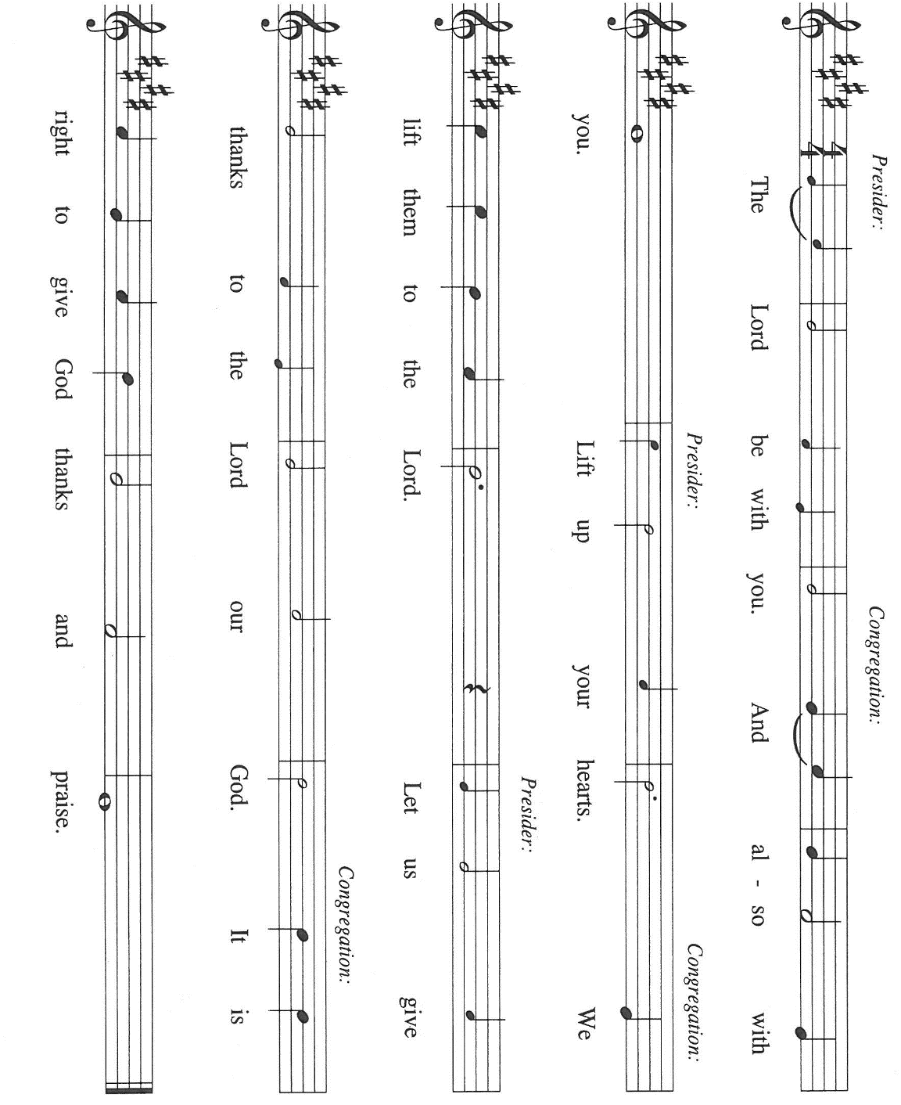
THE GREAT THANKSGIVING

P: It is our duty and delight … join their unending hymn:

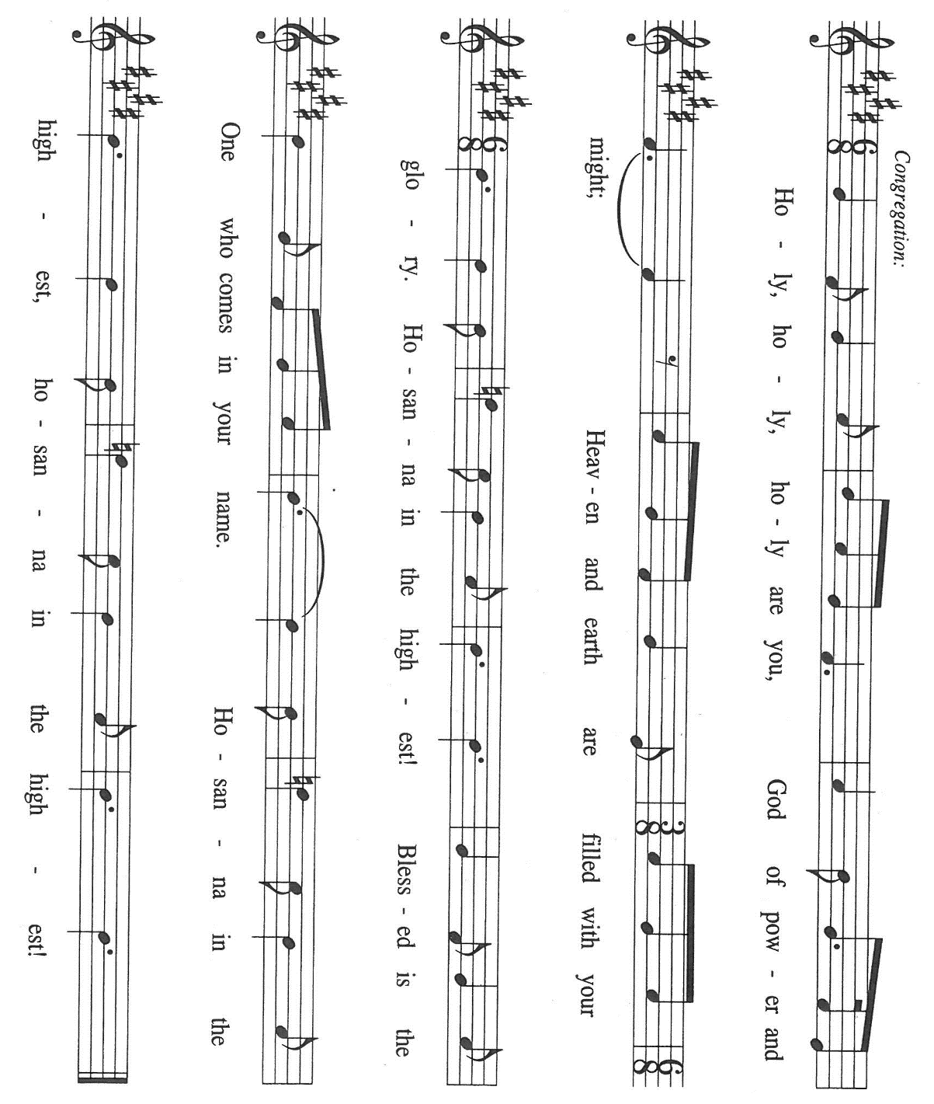

P: God of mercy and grace, we praise and thank You in Spirit and in truth;
For You have asked everything of us, and at the same time You have given us
everything You ask of us.
In Abraham and Sarah You called a people and invited them to entrust their future to
You.
In the sacrifice of Isaac and the provision of the ram You foretold Your gracious
redemption of the world.
You sent Jesus, Your own Lamb, as the new Isaac, the true offering, that we might
belong in Your company forever.
In His death and resurrection we know You to be the Lord Who provides.
Freely giving God, in Christ You deliver us from the wages of sin and invite us into
eternal life.
Make holy Your people gathered around Your holy Table, that every heart may offer
You welcome.
Send Your Holy Spirit upon this bread and cup, that they may be for us the Body and
Blood of Your Son, Jesus Christ,
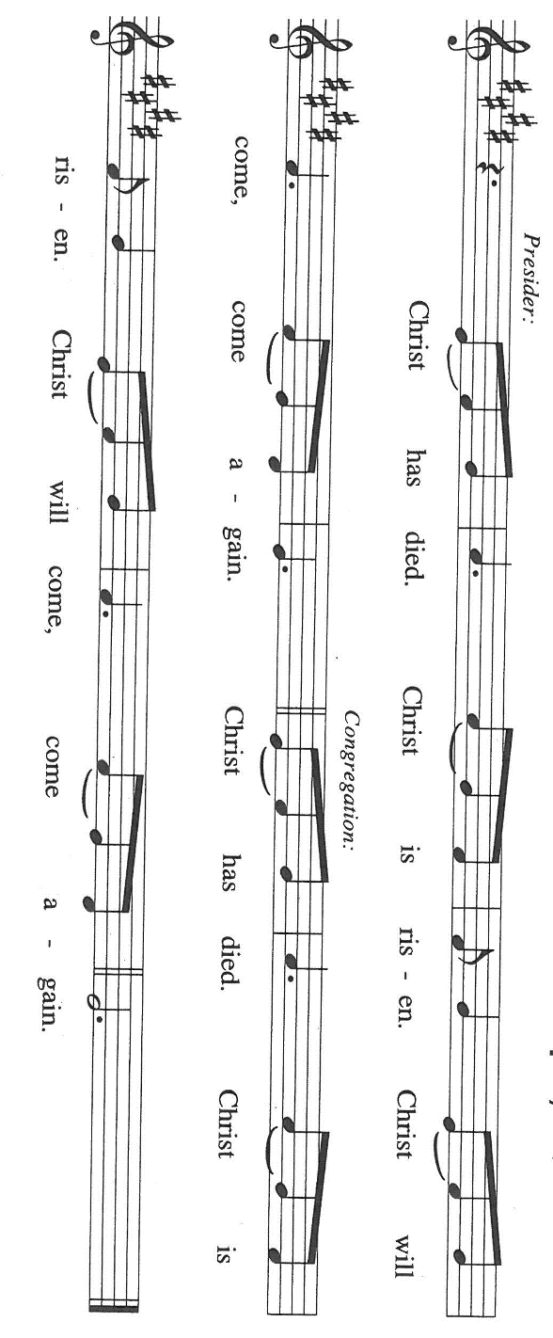
Who, in the night …”Do this for the remembrance of Me.”
As often as we eat …we proclaim the Lord’s death until He comes.

P: God of creation and covenant, You order Your world in springtime and harvest, and
restore Your world in resurrection and final glory.
Put a song in every weary throat and hope in every troubled heart.
Uphold Your little ones where they face hardship, sorrow, or abandonment.
Bless parents who have lost the trust of their children, and children who live outside
the care of loving arms.
Make this Meal a sign of Your abundance in a world of scarcity and Your
companionship in a world of loneliness.
Make us heralds of Your Kingdom and fill our hearts with longing for Your heavenly
Banquet, where You will be all in all,
One God: Father, Son, and Holy Spirit, forevermore.

C: Amen.

THE LORD’S PRAYER

P: Seeking first the Kingdom of God and its righteousness, with trust in God’s daily care
for us, we now pray:

C: (Sung) Music is on the front cover of the red hymnal

INVITATION TO THE MEAL

P: Behold the Teacher Who gathers us as disciples to teach us the mysteries of God’s
Kingdom. Blessed are those who are called to the Supper of the Lamb. God’s holy
gifts for God’s holy people. Come, for all is now ready.

The assembly is seated

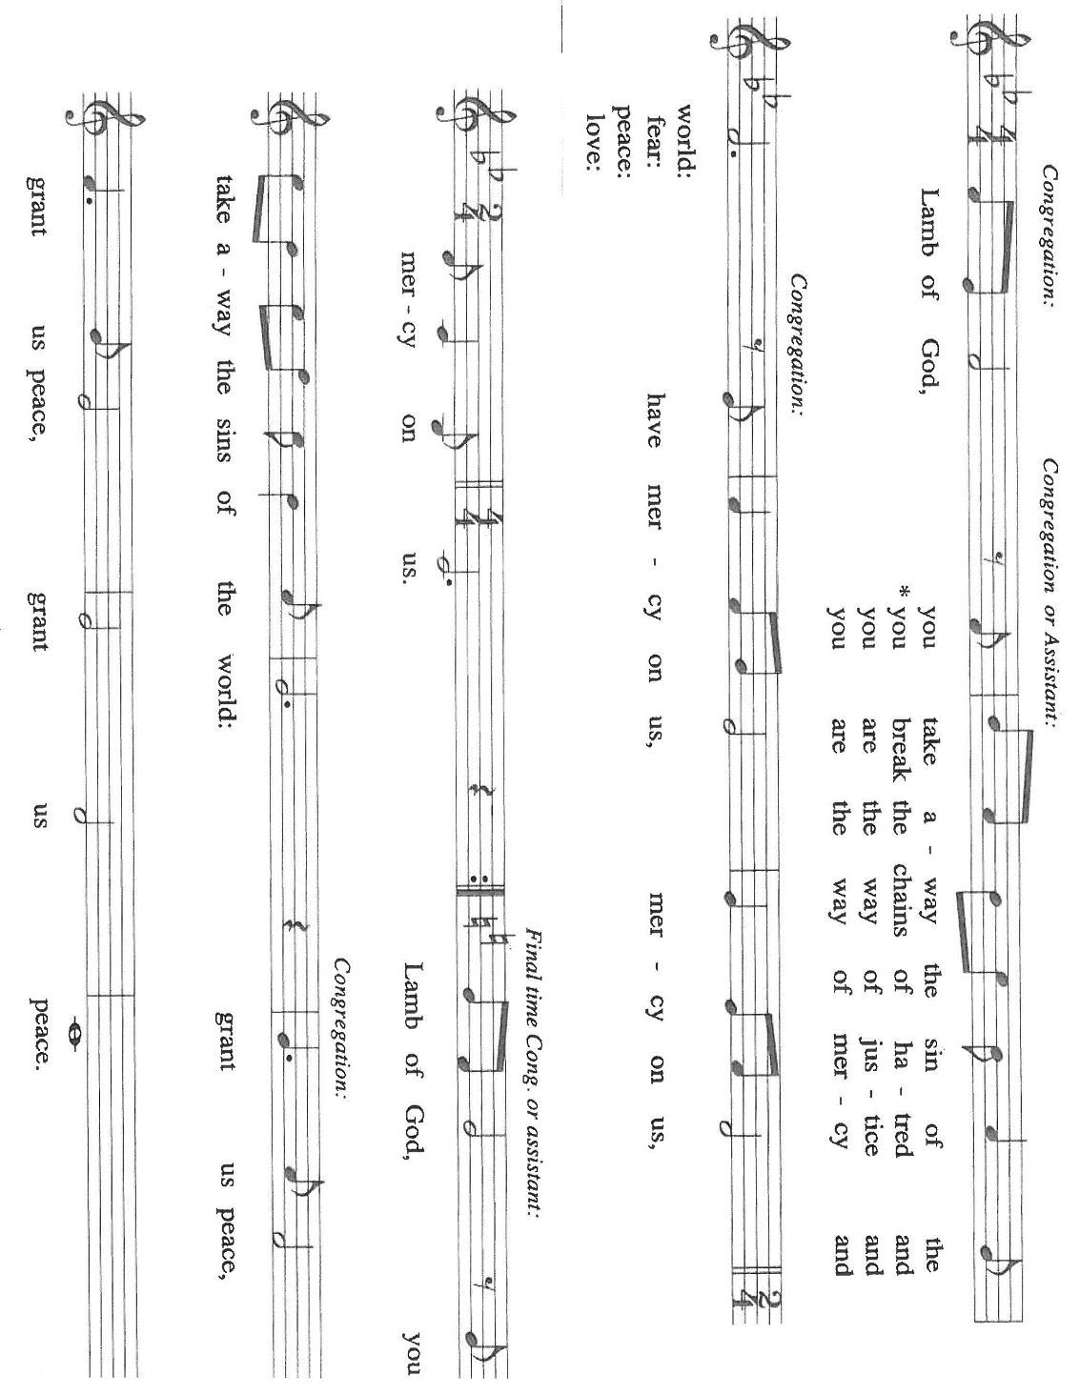
THE DISTRIBUTION Lamb of God

HYMN DURING DISTRIBUTION 641 All Are Welcome

ELW 733 Great is Thy Faithfulness

ELW 592 Just As I Am Without One Plea

ELW 472 Eat the Bread

NSB 56 I Offer My Life

As you are able please rise

THE POST-COMMUNION BLESSING

P: The Body and Blood of our Lord Jesus Christ strengthen you and keep you in His
grace.

C: Amen.

THE POST-COMMUNION PRAYER

A: Let us pray. Lord Jesus, You have again welcomed us at Your Table. Send us now in
the power of Your Spirit to welcome others into the grace of Your Kingdom, where
You live and reign with the Father and the Holy Spirit, now and forever.

C: Amen.

SENDING

THE BENEDICTION

P: Almighty God: Father, Son, and Holy Spirit bless you now and forever.

C: Amen.

THE SENDING SONG 583 Take My Life That I May Be

THE DISMISSAL

A: Go forth with God’s blessing to love and serve the Lord.

C: Thanks be to God!

POSTLUDE

To God Alone Be Glory

The Meditation is from Pulpit Resource. William Willimon, ed. Vo. 27, No. 2
(Inver Heights, MN: Logos Productions, 1999) 58.

The Greeting, Prayers, Peace, Offertory , Post-Communion Prayers, and Dismissal are
used by permission of Sundays and Seasons. Copyright Augsburg Fortress 1999.

The Prayers, Introduction to the Lord’s Prayer, and Invitation to the Meal are adapted
From Prayers for Sundays and Seasons. Year A. Peter J. Scagnelli. (Chicago: Liturgy Training Publications, 1998) 90-91.

The musical setting of the liturgy, “Now the Feast and Celebration” by Marty Haugen, is
used by permission of GIA Publishers, Inc. OneLicense.net License #A-702836.

ANNOUNCEMENTS

Please remember to mail your offering to the Church Office at 818 Franklin Street, Michigan City, IN 46360. Another alternative is to give on-line through Tithe.ly. Please see your closure letter for information on how to set up a Tithe.ly account.

St. Paul Members are reminded to have a loved one contact the office if you are hospitalized. Many times, the Pastor doesn’t know someone is in the hospital. If you call and leave a message, please tell us at which hospital the patient is located.

ANNIVERSARIES: Chip & Audrey Claussen (7/1); Dave & Nancy Squires (7/3)

PRAYER CONCERNS: Debbie Martin; Mark Tannehill; Kathy Stein; Jan Paholski; Laura Dovey; Bill Hazelgrove; Al Levenhagen; Carl Wipperman; Major Payne.

OFFICE HOURS: Libby will be in the office on Mondays, Wednesdays, and Fridays; volunteers will cover Tuesdays and Thursdays.

Monday & Wednesday 8:00 a.m. – 5 p.m.
Tuesday & Thursday 9:00 a.m. – 12:00 p.m.
Friday 8:00 a.m. – 12:00 p.m.

If you are listening to the worship broadcast on the radio and would like to watch the Sunday morning service live stream follow these steps:

(1) If you have You Tube available on your TV, search for
St. Paul Lutheran Church Michigan City, IN.

(2) The direct link on the computer is https://
www.youtube.com/channel/UC5AIPNaKr3QN50984jGOa1g

(3) This link is also on the main page of the church’s website in
the church section and will continue to be posted weekly on the St.
Paul Facebook page.

And it will always be available on the radio broadcast Sunday mornings at 11:00 a.m.
on WEFM (95.9), and on the local cable access station #99 for the previous week’s
service on Sundays at 4:00 p.m. and the current service on Wednesdays at 7:00 p.m.
and Fridays at 8:30 p.m.

To send e-mail to the church office, please use the following addresses:

Pastor Mark Reshan: seniorpastor@stpaulmichigancity.com

Church Office Secretary (Libby Pollock): churchsecretary@stpaulmichigancity.com

Church Treasurer (Karen Fleming): finance@stpaulmichigancity.com

2026 Church Council:

Pastor - Mark Reshan

President - Donna Knoll

Vice President - Jan Bakken

Secretary - Judy Hunt

Treasurer - Karen Fleming

Members: Sue Koziel; Jim Schraidt; Trish Sprague; Bob Kiser; Barry Anderson; and
Pam Soule

Worship Attendance:

Saturday, June 20, 2026 @ 4:00 p.m. 27

Sunday, June 21, 2026 @ 9:00 a.m. 57

TOTAL 84

Copies of the minutes from the April 23, 2026 and May 21, 2026 Church Council meetings are on the back table in the upper Narthex. They were approved by the council via email.

The Good News Newsletter: If you have an article or anything you want included in The Good News please send it to the following e-mail address: splcgoodnews@gmail.com. Pastor Pamela Thiede will be using this e-mail address to assemble The Good News each month. The deadline for getting information to Pastor Pamela will be the 20th of each month.

Next week’s lessons are Zechariah 9: 9-12; Psalm 145: 8-14, ; Romans 7: 15-25a; Matthew 11: 16-19, 25-30 for those of you who like to study them in advance.

CELEBRATING OUR NATION’S 250TH ANNIVERSARY
There will not be a worship service on Saturday, July 4th, 2026. However, the Sunday, July 5, 2026 worship service will be at the usual time at 9:00 a.m. with coffee after.

THANK YOU!
We would like to thank Tim Crozier, Rich Fleming and Pastor Mark Kloess for glazing, painting and washing the windows on Luther House. Another job well done! Bob Kiser

JUNE MONTHLY MISSION:
The Service League of Michigan City is a non-profit organization of volunteers that loans medical equipment and provides supplemental adult incontinence supplies to the residents of LaPorte County. Equipment loans are for three months and most items can be borrowed for free. As a non-profit, they maintain their services through the generosity of community donations, competitive grants, memorials and member support. The Service League receives no government funds. To help their generous mission, we will be collecting both monetary donations as well as the following items:

Disposable gloves
Disposable Gauze rolls, dressing pads and surgical tape
Disposable pull up and tab adult briefs (opened and unopened packages)

Please make checks payable to St. Paul and mark for Service League and place in the offering. Noisy Coin for the month of June will also go to support the Service League. Items can be placed in the bin in the outer Narthex. Thank you for your generosity each month! Lora

MISSION OF THE MONTH FOR JULY, 2026
July’s mission of the month will be the Lutheran World Relief Kits. Attached is the order form for people to sponsor kits and place this order form with payment in the offering plate or send to the church office.



ACTIVITIES, EVENTS & MEMORIALS
JULY 2026

Sunday, June 28, 2026 @ 9:00 a.m. 5 Pentecost Worship Service/Sanctuary with coffee after
Wednesday, July 1, 2026 @ 10:00 a.m. God’s Purls
@ 12:15 p.m. Organ Concert Summer Series/Sanctuary
Thursday, July 2, 2026 NO Faith Circle today
Saturday, July 4, 2026 NO Worship Service today

Sunday, July 5, 2026 @ 9:00 a.m. 6 Pentecost Worship Service/Sanctuary; with coffee after
Wednesday, July 8, 2026 @ 10:00 a.m. God’s Purls/St. Paul Room
@12:15 p.m. Organ Concert Summer Series/Sanctuary
Saturday, July 11, 2026 @ 4:00 p.m. 7 Pentecost Worship Service/Sanctuary

Sunday, July 12, 2026 @ 9:00 a.m. 7 Pentecost Worship Service/Sanctuary to
include the Baptism of Molly Brooks; with coffee after
Monday, July 13, 2026 @ 1:00 p.m. Hope Circle
Wednesday, July 15, 2026 @ 10:00 a.m. God’s Purls/St. Paul Room
@ 10:00 a.m. – 9:00 p.m. GIVE BACK @ 5 GUYS
@12:15 p.m. Organ Concert Summer Series/Sanctuary
Saturday, July 18, 2026 @ 4:00 p.m. 8 Pentecost Worship Service/Sanctuary

Sunday, July 19, 2026 @ 9:00 a.m. 8 Pentecost Worship Service/Sanctuary; with
coffee after @ 10:30 a.m. ICE CREAM SOCIAL/St. Paul Room
Wednesday, July 22, 2026 @ 10:00 a.m. God’s Purls/St. Paul Room
@ 12:15 p.m. Organ Concert Summer Series/Sanctuary
Saturday, July 25, 2026 9 Pentecost Worship Service/Sanctuary

Sunday, July 26, 2026 @ 9:00 a.m. 9 Pentecost Worship Service/Sanctuary; with coffee after
Wednesday, July 29, 2026 @ 10:00 a.m. God’s Purls/St. Paul Room
@ 12:15 p.m. Organ Concert Summer Series/Sanctuary

2026 Financial Stewardship

Weekly Church Operating Needs (x 2 weeks)
June 13-14 & June 20-21, 2026: $ 10,501.82

General Fund (including General Memorials): $ 6,026.00

Overage/Shortage: — $ 4,475.82

Restricted Income (not including Memorials)
Supports IK Synod & Church wide Ministries: $ 169.00

Ministries in our Community/Congregation: $ 167.00

Capital Fund: $ 252.00

MEMORIALS
General Fund $ 230.00

Thank$ for $haring
Thank you to all who participate in our Give-Back opportunities each month. On Wednesday, July 15, 2026 from 10:00 a.m. —9:00 p.m. we’ll be meeting at 5 Guys Restaurant for our GIVE BACK for July. Here are two coupons. One for you and one for a friend.

