**THE FIFTH SUNDAY AFTER PENTECOST**

**July 13, 2025**

“ ...To me, the central figure in the parable is not the Samaritan. He is simply one of the three characters in the story who have the opportunity to display neighborliness as Jesus defines it. The defining character--the one to whom the other three respond by being non-neighbor or neighbor--is the man who fell among thieves. The actual Christ-figure in the story, therefore, is yet another loser, yet another down-and-outer who, by just lying there in his lostness and proximity to death (“practically dead” is the way Jesus describes him), is in fact the closest thing to Jesus in the parable ...”

“ ... What I am most concerned to skewer at this point is precisely the theological mischief caused by the misnaming of the parable. Calling it the Good Samaritan inevitably sets up its hearers to take it as a story whose hero offers them a good example for imitation. I am, of course, aware of the fact that Jesus ends the parable precisely on the note of imitation: “You, too, go and do likewise.” But the common, good-works interpretation of the imitation to which Jesus invites us all too easily gives the Gospel a fast shuffle ...”

“ ...For if the world could have been saved by providing good examples to which we could respond with appropriately good works, it would have been saved an hour and twenty minutes after Moses came down from Mt. Sinai ... Salvation is not some felicitous state to which we can lift ourselves by our own bootstraps after the contemplation of sufficiently good examples. It is an utterly new creation into which we are brought by our death in Jesus’ death and our resurrection in his ...”

“ ...Jesus’ whole parable, especially with its piling up of detail after detail of extreme, even irrational, behavior on the part of the Samaritan, points not to meritorious exercises of good will but to the sharing of the passion as the main thrust of the story. What is to be imitated in the Samaritan’s action is not his moral uprightness in doing good deeds but his spiritual insight into the truly bizarre working of the mystery of redemption.

The lawyer is told by Jesus, in effect, to stop trying to live and to be willing to die, to be willing to be lost rather than found--to be, in short, a neighbor to the One who, in the least of his brethren, is already neighbor to the whole world of losers ...”

**Robert Farrar Capon**

***The Parables of Grace***

**✠ In the Name of Jesus ✠**

**✠ GATHERING ✠**

**INTRODUCTION**

To love the Lord your God with all your heart, soul, strength, and mind is to reflect God’s mercy in responding to one’s neighbor. That mercy found its most profound expression in the "gospel that has come to you"—namely the life, death, and resurrection of Jesus Christ. That gospel mercy comes to us again today: at the font, at the altar, and from the pulpit. It is very near to you.

**Nathan Söderblom, Bishop of Uppsala, died 1931**

*A winner of the Nobel Prize for peace for his efforts to unite peoples after the First World War, Söderblom also called attention to the revival of early church worship principles, and helped to lay the groundwork for the World Council of Churches.*

**PRELUDE**

**ANNOUNCEMENTS**

*As you are able please rise*

**CONFESSION AND ABSOLUTION**

P: In the name of the Father and of **✠** the Son and of the Holy Spirit.

**C: Amen.**

P: “To You, O Lord, I lift up my soul; my God, I put my trust in You ...” (Psalm 25: 1).

Because the LORD is “gracious and upright” (25: 7), and “guides the humble in doing

right” (25: 8), we may approach God with confidence and hope. Let us therefore

confess our sins.

*Silence for reflection and self-examination is kept*

P: Most merciful God,

**C: We confess that we have sinned against You in thought, word, and deed. We have**

**not “observed Your commandments and decrees,” nor have we “turned to (You)**

**with all our heart and all our soul.” (Deuteronomy 30: 10) We have turned from**

**Your ways and wandered from Your paths (Psalm 25: 3). We have failed to “bear**

**fruit in every good work,” (Colossians 1: 10), and to “love our neighbor as**

**ourselves.” (Luke 10: 27) In Your great mercy, O God, forgive us for the sake of**

**Your Son, Jesus Christ. “Lead us in Your truth and teach us” (Psalm 25: 4) that**

**we may “prosper” in Your “grace” and “peace” (Colossians 1: 2).**

P: “Remember, O LORD, Your compassion and love ...Remember not the sins of my

youth and my transgressions; remember me according to Your love and for the sake of

Your goodness, O LORD.” (Psalm 25: 6) God’s “love” and “goodness” is “very near

to you” (Deuteronomy 30: 14) this Day, for as a called and ordained minister of the

Church of Christ, and by His authority, I therefore declare to you the entire forgiveness

of all your sins, in the name of the Father and of **✠** the Son and of the Holy Spirit.

**C: Amen.**

**GATHERING HYMN 522 *As We Gather At Your Table***

**THE GREETING AND PRAYER OF THE DAY**

P: The grace of our Lord Jesus Christ, the love of God, and the communion of the Holy

Spirit be with you all.

**C: And also with you.**

P: Let us pray. O Lord God, Your mercy delights us, and the world longs for Your loving

care. Hear the cries of everyone in need, and turn our hearts to love our neighbor with

the love of Your Son, Jesus Christ, our Savior and Lord.

**C: Amen.**

*The assembly is seated*

**✠ WORD ✠**

**FIRST READING Deuteronomy 30: 9-14**

*Moses calls the people to renew the covenant God made with their ancestors. Through this covenant God gives life and asks obedience. God's word is brought near to the people so that they may remain true to the covenant.*

9The Lord your God will make you abundantly prosperous in all your undertakings, in the fruit of your body, in the fruit of your livestock, and in the fruit of your soil. For the Lord will again take delight in prospering you, just as He delighted in prospering your ancestors, 10when you obey the Lord your God by observing His commandments and decrees that are written in this book of the law, because you turn to the Lord your God with all your heart and with all your soul.

11Surely, this commandment that I am commanding you today is not too hard for you, nor is it too far away. 12It is not in heaven, that you should say, "Who will go up to heaven for us, and get it for us so that we may hear it and observe it?" 13Neither is it beyond the sea, that you should say, "Who will cross to the other side of the sea for us, and get it for us so that we may hear it and observe it?" 14No, the word is very near to you; it is in your mouth and in your heart for you to observe.

The Word of the Lord.

**Thanks be to God.**

**THE PSALM: Psalm 25: 1-9** **Read responsively**

1To You, O LORD,

     I lift up my soul.

**2My God, I put my trust in You; let me not be put to shame,**

**nor let my enemies triumph over me.**

3Let none who look to You be put to shame;

     rather let those be put to shame who are treacherous.

**4Show me Your ways, O LORD,**

**and teach me Your paths.**

5Lead me in Your truth and teach me,

     for You are the God of my salvation; in You have I trusted all the day long.

**6Remember, O LORD, Your compassion and love,**

**for they are from everlasting.**

7Remember not the sins of my youth and my transgressions;

     remember me according to Your steadfast love and for the sake of Your goodness, O LORD.

**8You are gracious and upright, O LORD;**

**therefore You teach sinners in Your way.**

9You lead the lowly in justice

     and teach the lowly Your way.

**10All Your paths, O LORD, are steadfast love and faithfulness**

**to those who keep Your covenant and Your testimonies.**

**SECOND READING Colossians 1: 1-14**

*The letter to the Colossians was written to warn its readers of various false teachings. The first part of the letter is an expression of thanks for the faith, hope, and love that mark this community. It concludes with a prayer for continued growth in understanding.*

1Paul, an apostle of Christ Jesus by the will of God, and Timothy our brother,

2To the saints and faithful brothers and sisters in Christ in Colossae:

Grace to you and peace from God our Father.

3In our prayers for you we always thank God, the Father of our Lord Jesus Christ, 4for we have heard of your faith in Christ Jesus and of the love that you have for all the saints, 5because of the hope laid up for you in heaven. You have heard of this hope before in the word of the truth, the gospel 6that has come to you. Just as it is bearing fruit and growing in the whole world, so it has been bearing fruit among yourselves from the day you heard it and truly comprehended the grace of God. 7This you learned from Epaphras, our beloved fellow servant. He is a faithful minister of Christ on your behalf, 8and he has made known to us your love in the Spirit.

9For this reason, since the day we heard it, we have not ceased praying for you and asking that you may be filled with the knowledge of God's will in all spiritual wisdom and understanding, 10so that you may lead lives worthy of the Lord, fully pleasing to Him, as you bear fruit in every good work and as you grow in the knowledge of God.

11May you be made strong with all the strength that comes from His glorious power, and may you be prepared to endure everything with patience, while joyfully 12giving thanks to the Father, Who has enabled you to share in the inheritance of the saints in the light. 13He has rescued us from the power of darkness and transferred us into the kingdom of His beloved Son, 14in Whom we have redemption, the forgiveness of sins.

The Word of the Lord.

**Thanks be to God.**

*As you are able please rise*

**THE VERSE** Sung twice

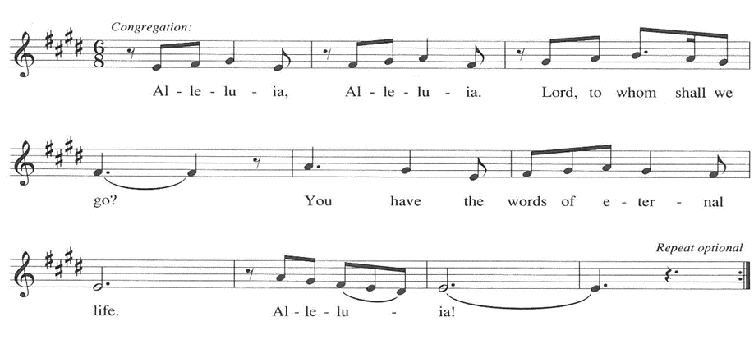

**THE HOLY GOSPEL: Luke 10: 25-37**

*In this well-known parable, Jesus shifts the focus of concern from speculation concerning who is one's neighbor to the treatment of one's neighbor with mercy*

P: The Holy Gospel according to St. Luke, the tenth chapter.

**C: Glory to You, O Lord!**

25Just then a lawyer stood up to test Jesus. "Teacher," he said, "what must I do to inherit eternal life?" 26He said to him, "What is written in the law? What do you read there?" 27He answered, "You shall love the Lord your God with all your heart, and with all your soul, and with all your strength, and with all your mind; and your neighbor as yourself." 28And He said to him, "You have given the right answer; do this, and you will live."

29But wanting to justify himself, he asked Jesus, "And who is my neighbor?" 30Jesus replied, "A man was going down from Jerusalem to Jericho, and fell into the hands of robbers, who stripped him, beat him, and went away, leaving him half dead. 31Now by chance a priest was going down that road; and when he saw him, he passed by on the other side. 32So likewise a Levite, when he came to the place and saw him, passed by on the other side.

33But a Samaritan while traveling came near him; and when he saw him, he was moved with pity. 34He went to him and bandaged his wounds, having poured oil and wine on them. Then he put him on his own animal, brought him to an inn, and took care of him. 35The next day he took out two denarii, gave them to the innkeeper, and said, 'Take care of him; and when I come back, I will repay you whatever more you spend.'

36"Which of these three, do you think, was a neighbor to the man who fell into the hands of the robbers?" 37He said, "The one who showed him mercy." Jesus said to him, "Go and do likewise."

P: The Gospel of the Lord.

**C: Praise to You, O Christ!**

*The assembly is seated*

**THE SERMON**  *Silence for reflection follows the sermon*

*As you are able please rise*

**THE HYMN OF THE DAY 641 *All Are Welcome***

**THE APOSTLES’ CREED**

A: God has made us His people through our Baptism into Christ. Living together in trust

and hope, we confess our faith.

**C: I believe in God, the Father almighty,**

**creator of heaven and earth.**

**I believe in Jesus Christ, His only Son, our Lord.**

**He was conceived by the power of the Holy Spirit**

**and born of the virgin Mary.**

**He suffered under Pontius Pilate,**

**was crucified, died, and was buried.**

**He descended into hell.**

**On the third day He rose again.**

**He ascended into heaven,**

**and is seated at the right hand of the Father.**

**He will come again to judge the living and the dead.**

**I believe in the Holy Spirit,**

**the holy catholic Church,**

**the communion of saints,**

**the forgiveness of sins,**

**the resurrection of the body,**

**and the life everlasting. Amen.**

**THE PRAYER OF THE CHURCH**

A: Many people’s needs press upon our daily lives and fill our daily news. That we may

respond as neighbors, let us ask the Lord for help in showing Christ’s mercy and

compassion.

A: Help the Church to be neighbors to those yet in darkness, fear and doubt, strong in the

love and forgiveness of God. Lord, in Your mercy,

**C: Hear our prayer.**

A: Help those peoples and nations in conflict, especially in Ukraine to live together

peaceably as neighbors. Lord, in Your mercy,

**C: Hear our prayer.**

A: Help us in this assembly in this week to be compassionate and merciful neighbors to

family members, co-workers, friends, and those in need, bearing fruit in every good

work. Lord, in Your mercy,

**C: Hear our prayer.**

A: Help us to never cease praying for our neighbors who suffer: the hungry, the homeless,

the abused, and the sick, especially: **Bob Pheanis;** **Shirley Freels; Ronwynn Jones;**

**Shirley McCarty; Larry Litchford; Carol Radke; Martha Schroeder; David**

**Weiss; Fred Weiss; Lucas Bradshaw; and Jess Kalvaitis** that they might be filled

with the knowledge of God’s life-giving peace and hope. Lord, in Your mercy,

**C: Hear our prayer.**

A: Help those celebrating birthdays, especially **Norma Milzarek and** **Bev Johnson** and

anniversaries, especially **Al and JoAnne Sydow; and Mike and Amy Maesch** that

they might grow in grace this day and every day and be filled with grace for the days

ahead: Lord, in Your mercy,

**C: Hear our prayer.**

A: Help us to lead lives worthy of our Baptism until that Day when we join with all the

saints, especially **Nathan Söderblom, Bishop of Uppsala** whom we commemorate

this Day in Christ as neighbors in God’s eternal Kingdom. Lord, in Your mercy,

**C: Hear our prayer.**

P: Lord God, You formed us in love; You command us to live in Your love. Hear the

prayers we make in the name of the Son You sent to dwell among us, the Neighbor

Who is attentive to all our needs, Jesus Christ our Lord.

**C: Amen.**

**✠ MEAL ✠**

**THE PEACE**

P: The peace of the Lord be with you always.

**C: And also with you.**

*The assembly is seated*

**THE OFFERING**

**THE VOLUNTARY *To You, O Lord* New Song Praise Band**

**(Graham Kendrick & Matt Redmond)**

*As you are able please rise*

**THE OFFERTORY 465 *As the Grains of Wheat***

**THE OFFERTORY PRAYER**

A: Let us pray. Gracious God,

**C: We bring these offerings from the bountiful gifts You shower upon us. Use them**

**and bless them as help to all in need, and through this holy Sacrament make us as**

**merciful as You are gracious to us. We ask this in the name of Jesus the Lord.**

**Amen.**

**THE GREAT THANKSGIVING**

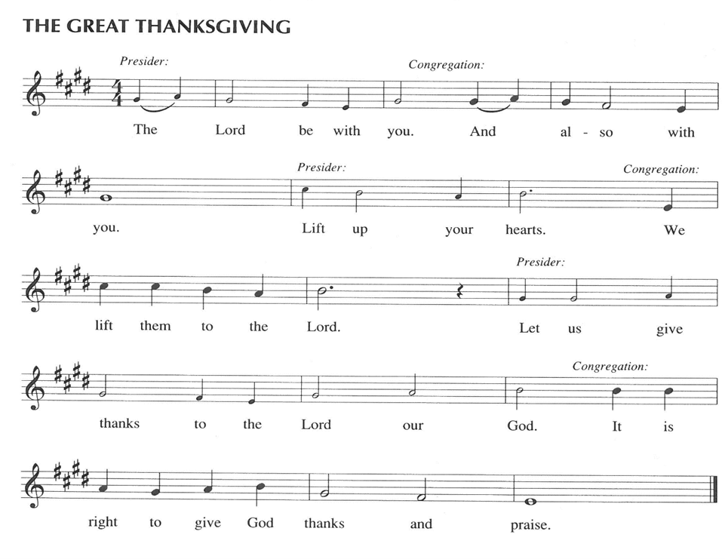

P: It is our duty and delight … join their unending hymn:

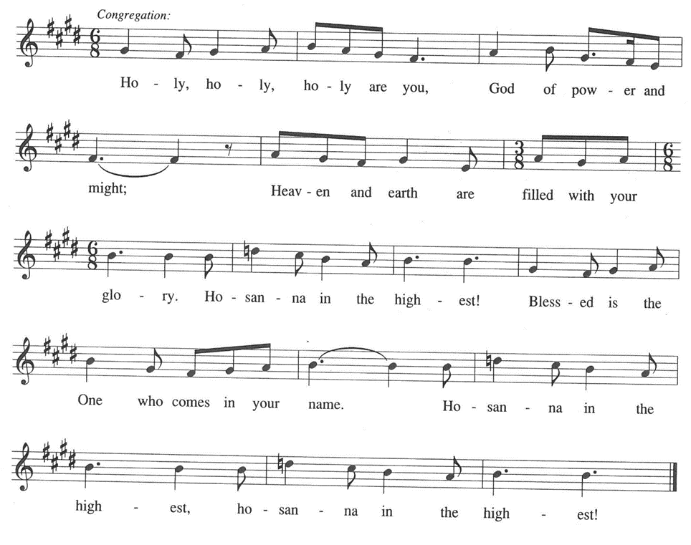

P: God our Savior, we give You thanks and praise, that when the nations had strayed

far from Your ways You called Abraham,

And when Your people were lost and oppressed You sent Jesus,

And when we were defeated, downcast, and desolate, in the power of the Holy Spirit

You make Jesus present to us.

You pick us up from our failure, our oppression, and our sin, and journey with us and

bring us to safety and promise to return.

In the death and resurrection of Christ You heal the wounds of the past and offer

the gift of an everlasting future with You.

God our Redeemer, on our journey with You, You turn us from Your burden into

carriers of one another’s burdens.

On the way You feed us with the Bread of Life and the cup of salvation.

Now send down Your Holy Spirit, that we may be made holy as You are holy,

and that these gifts of the earth and human hands

May be for us the Body and Blood of Your Son, Jesus Christ,

Who, in the night ... “Do this for the remembrance of Me.”

As often as we eat ... we proclaim the Lord’s death until He comes.

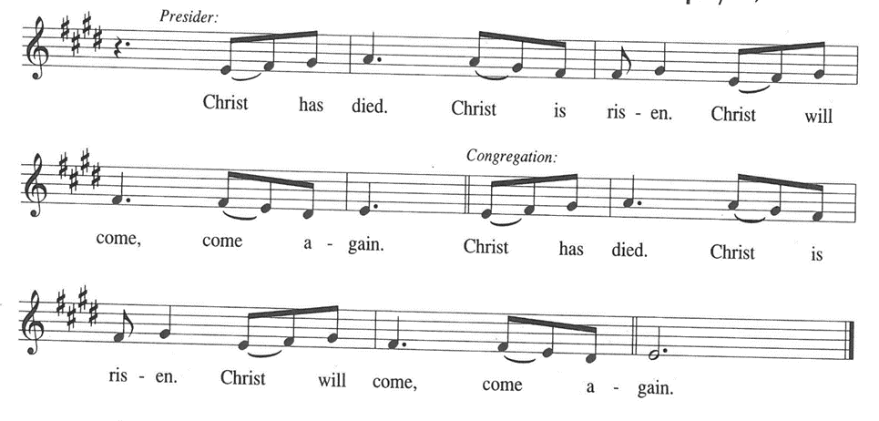

P: Merciful God, in Jesus, through story, miracle, and example, You turn us and all

creation upside down.

Direct our hearts in the way we should go, visit the downtrodden and set them on their

feet again,

And restore the land, sea, and air of Your creation,

That all things and all people may fulfill their created purpose in reflecting Your glory

and singing Your praise,

Until the Day when You are all in all, in union with Christ, ever one God.

**C: Amen!**

**THE LORD’S PRAYER**

P: As disciples who seek to follow Jesus to the Kingdom, with persevering faith let us

pray:

**C: Our Father in heaven, hallowed be Your name.**

**Your Kingdom come, Your will be done on earth as in heaven.**

**Give us today our daily bread, and forgive us our sins, as we forgive**

**those who sin against us.**

**Save us from the time of trial, and deliver us from evil.**

**For the Kingdom, the power, and the glory are Yours, now and forever.**

**Amen.**

**INVITATION TO THE MEAL**

P: This is the Lamb of God Who takes away the sin of the world Blessed are those who

are called to the Supper of the Lamb. God’s holy gifts for God’s holy people. Come,

for all is now ready.

*The assembly is seated*

**THE DISTRIBUTION “Lamb of God”**

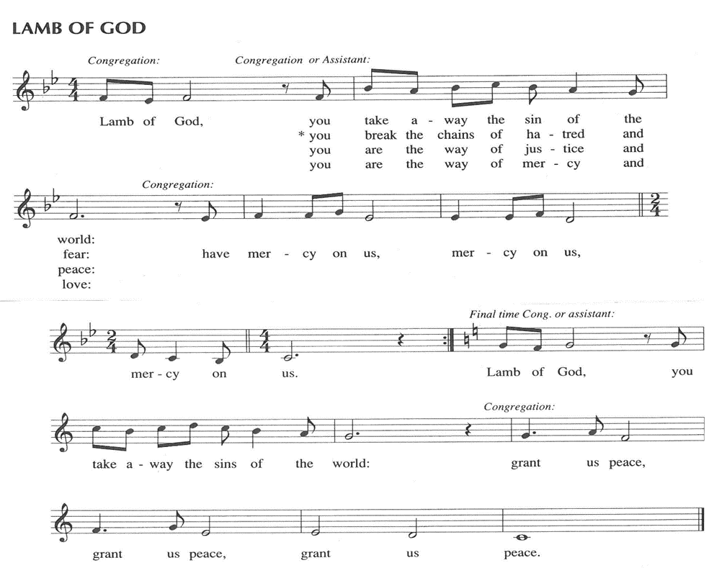

Those wishing to receive the Laying on of Hands, Anointing with Oil, and Prayer for Healing may go to Pastor at the side aisle

**HYMN DURING DISTRIBUTION 712 *Lord, Whose Love in Humble Service***

**ELW 526 *God Is Here!***

**ELW 487 *What Feast of Love***

**ELW 708 *Jesu, Jesu, Fill Us with Your Love***

**ELW 482 *I Come with Joy***

*As you are able please rise*

**THE POST-COMMUNION BLESSING**

P: The Body and Blood of our Lord Jesus Christ strengthen you and keep you in His grace.

**C: Amen.**

**THE POST-COMMUNION PRAYER**

A: Let us pray. Lord Jesus, by the Spirit of Your perfect love offered in this Sacrament

help us grow ever more fully into Your love. Call us daily out of darkness into Your

marvelous light, that we may be living signs of Your abundant mercy. We bless You

now and forever.

**C: Amen.**

**✠ SENDING ✠**

**THE BENEDICTION**

P: Almighty God: Father, Son, **✠** and Holy Spirit bless you now and forever.

**C: Amen.**

**SENDING HYMN 722 *O Christ, Your Heart, Compassionate***

**THE DISMISSAL**

A: Go in peace to bear Christ’s love to all the world.

**C: Thanks be to God!**

**POSTLUDE**

**✠ To God Alone Be Glory ✠**

**POP (SODA) FOR SALE**

The pop machine in the basement of the church has been emptied and the cans of pop are for sale, 3 cans for $1.00. What is available (Mountain Dew, Sunkist Orange, Coke and Lemon Brisk) is in the left side of the kitchen refrigerator. You may buy what you want and leave the money in the refrigerator.

The Meditation is from *The Parables of Grace.* Robert Farrar Capon. (Grand Rapids:

Eerdmanns Publishing Company, 1988) 61,65.

The musical setting of the liturgy, “Now the Feast and Celebration” by Marty Haugen, is

used by permission of GIA Publishers, Inc. OneLicense.net License #A-702836.

**ANNOUNCEMENTS**

**Please remember to mail your offering to the Church Office** at 818 Franklin Street, Michigan City, IN 46360**.** Another alternative is to give on-line through Tithe.ly. Please see your closure letter for information on how to set up a Tithe.ly account.

**St. Paul Members are reminded to have** a loved one contact the office if you are hospitalized. Many times, the Pastor doesn’t know someone is in the hospital. If you call and leave a message, please tell us at which hospital the patient is located.

**Birthdays: Norma Milzarek (7/12); Beverly Johnson (7/20)**

**Anniversaries: Allen & JoAnne Sydow (7/17); Mike & Amy Maesch (7/18)**

**PRAYER CONCERNS:** Bob Pheanis; Larry Litchford, Sarah McNabb, Carol Radke, Jeanie Boatman Shepple, Nolan Wilson, Debbie Martin, Mark Tannehill, Brian Wiseman, Kathy Stein, Danielle Schnell, Jan Paholski, Laura Dovey, and Grace

Romine.

**OFFICE HOURS:** Libby will be in the office on Mondays, Wednesdays, and Fridays; volunteers will cover Tuesdays and Thursdays.

  Monday & Wednesday 8:00 a.m. – 5 p.m.

Tuesday & Thursday 9:00 a.m. – 12:00 p.m.

Friday 8:00 a.m. – 12:00 p.m.

**If you are listening to the worship broadcast on the radio and would like to watch the Sunday morning service live stream follow these steps:**

(1) If you have You Tube available on your TV, search for

**St. Paul Lutheran Church Michigan City, IN.**

(2) The direct link on the computer is [https://](https://www.youtube.com/channel/UC5AIPNaKr3QN50984jGOa1g)

[www.youtube.com/channel/UC5AIPNaKr3QN50984jGOa1g](https://www.youtube.com/channel/UC5AIPNaKr3QN50984jGOa1g).

   (3) This link is also on the main page of the church’s website in

the church section and will continue to be posted weekly on the St.

Paul Facebook page.

And it will always be available on the radio broadcast Sunday mornings at 11:00 a.m.

on WEFM (95.9), and on the local cable access station #99 for the previous week’s

service on Sundays at 4:00 p.m. and the current service on Wednesdays at 7:00 p.m.

and Fridays at 8:30 p.m.

**Sunday’s lessons are Genesis 18: 1-10a; Psalm 15; Colossians 1: 15-28; Luke 10: 38-42** for those of you who like to study them in advance.

**To send e-mail to the church office**, please use the following addresses:

Pastor Mark Reshan: seniorpastor@stpaulmichigancity.com

Church Office Secretary (Libby Pollock): churchsecretary@stpaulmichigancity.com

Church Treasurer (Karen Fleming): finance@stpaulmichigancity.com

**2025 Church Council:**

Mark Reshan - Pastor

 Janet Bakken – President

 Donna Knoll – Vice President

 Judy Hunt – Secretary

 Karen Fleming – Treasurer

 Members: Paul Brooks, Diane Egilske, Sue Koziel, Judy Mutchler,

Jim Schraidt, Trish Sprague

**Worship Attendance:**

**Saturday , Juy 5, 2025 @ 4:00 p.m. 24**

**Sunday, July 6, 2025 @ 9:00 a.m. 61**

**TOTAL 85**

**Copies of the minutes from the May 1, 2025 Church Council meetings are on the back table in the upper Narthex. They were approved by the council via email.**

**FYI:**

In response to the ever rising costs for postage we will be putting your copy

of the “Good News” in your hanging file folder in the narthex each month

from now on. Those of you who are unable to attend services on a regular

basis may still receive your copies through your email address or in the

U.S. mail. If you normally receive your copy of the newsletter via your

email address anyway, nothing will change for you. Thank you so much for

your understanding and cooperation!

**The Good News Newsletter**: If you have an article or anything you want included in **The Good News** please send it to the following e-mail address: splcgoodnews@gmail.com. Pastor Pamela Thiede will be using this e-mail address to assemble **The Good News** each month. The deadline for getting information to Pastor Pamela will be the 20th of each month.

**JULY 2025 MISSION OF THE MONTH**

Attached are the order forms for the Lutheran World Relief kits which will be the Mission of the Month for July 2025.

**Lutheran World Relief Kits**

We will be purchasing supplies to assemble two kinds of Lutheran World Relief kits together as a congregation this fall. Lutheran World Relief kits are sent to people around the world who are experiencing poverty, disaster, conflict, or more. To make it easier, we are offering everyone an opportunity to sponsor kits. Please indicate how many of each kit you would like to sponsor and return this form with payment to the church office (or in the offering plate). We will take care of purchasing all the supplies. We will hold an assembly day after Sunday worship this fall where we will assemble all the kits together. (No purchase necessary to help us assemble. We will assemble as a team; you will not be responsible for assembling all the kits you purchase yourself.)

**Please make checks payable to St. Paul Lutheran Church.**

**Orders are due Sunday, July 27th, 2025**

**______________# of health kits at $10 each**

(Health kits contain a towel, bar soap, toothbrush, comb, and nail clippers.)

**______________# of school kits at $10 each**

(School kits contain a drawstring backpack, notebooks, rulers, pencils and pens, pencil sharpener, scissors, crayons, and an eraser.)

**Total $______________**

**ACTIVITIES, EVENTS & MEETINGS**

**JULY 2025**

**Sunday,** July 6, 2025 @ 9:00 a.m. Pent 4 Worship Service/Sanctuary

**Tuesday,** July 8, 2025 @ 7:00 p.m. Estuary/Luther House

**Wednesday,** July 9, 2025 @ 10:00 a.m. God’s Purls/St. Paul Room

**Thursday,** July 10, 2025 @ **11:00 a.m. – 10:00 p.m. GIVE BACK at CHILI’S**

**Saturday,** July 12, 2025 @ 4:00 p.m. Pent 5 Worship Service/Sanctuary

**Sunday,** July 13, 2025 @ 9:00 a.m. Pent 5 Worship Service/Sanctuary

**Monday,** July 14, 2025 @ 1:00 p.m. Hope Circle/Green Room

**Wednesday,** July 16, 2025 @ 10:00 a.m. God’s Purls/St. Paul Room

**Saturday,** July 19, 2025 @ 4:00 p.m. Pent 6 Worship Service/Sanctuary

**Sunday,** July 20, 2025 @ 9:00 a.m. Pent 6 Worship Service/Sanctuary

**Wednesday,** July 23, 2025 @10:00 a.m. God’s Purls/St. Paul Room

**Saturday,** July 26, 2025 @ 4:00 p.m. Pent 7 Worship Service/Sanctuary

**Sunday,** July 27, 2025 @ 9:00 a.m. Pent 7 Worship Service/Sanctuary

**Wednesday,** July 30, 2025 @ 10:00 a.m. God’s Purls/St. Paul Room

**2025 Financial Stewardship**

Weekly Church Operating Needs (x 2 weeks)

June 28-29, 2025; July 5-6, 2025: $ 13,545.00

General Fund (including General Memorials): $ 10,431.50

Overage/Shortage: — $ 1,500.50

Restricted Income (not including Memorials)

Supports IK Synod & Church wide Ministries: $ 293.50

Ministries in our Community/Congregation: $ 495.00

Capital Fund: $ 348.50