THE DAY OF PENTECOST
June 8, 2025

It is the divine way to be seen, or to be described, under the appearance of fire. Moses had seen fire in the bush. The bush was on fire, yet it was not burnt. So the Lord might show us by this mystery that Christ would come to cast light on the thorns of our body, that he would baptize in the Holy Spirit and in fire, and that he would give us grace and destroy our sins.
And Gideon, when he was about to defeat the Midianites, commanded his three hundred men to carry burning torches in their pitchers. Our bodies are pitchers, formed from the clay of the earth, that burn with the fire of spiritual grace and bear witness with the voice of confession to the passion of the Lord Jesus. Also in the Acts of the Apostles the Holy Spirit descended upon the faithful in the image of fire.
This is a fire which, as with gold, makes what is good better and devours sin as stubble. As the Spirit is the light of the divine countenance, so also is the Spirit the fire that burns before the face of God.

Ambrose, Bishop of Milan
Fourth Century

“Backwoods Galileans speaking foreign languages attract attention among the other Jews in Jerusalem -- both residents and pilgrims celebrating the Feast of Weeks (also known as the Day of the First Fruits, Shavuot, or Pentecost). Capturing attention is one thing; making sense is another. The cosmopolitan crowd expresses curiosity and scorn. They clamor for an explanation, for meaning. Peter's entire speech in 2:16-36 offers his answer to their foundational question, "What does this mean?" (2:12)…”
“…What does Pentecost mean? The gift of God's Spirit indicates that something new in human history has begun. The times have changed. ..What does Pentecost mean? The Spirit has come to mark the church -- every member of it -- as belonging to God and as God's agent in the world. They are God's slaves….What does Pentecost mean? The foreign languages are not an instance of trickery or mass hysteria. God is at work here, equipping people to communicate about God. The Spirit prompts them to engage in prophecy. The community of faith is a community of prophets…”
“…Peter does not speak of prophecy as predicting the future. Instead, prophecy is truth-telling. It is naming the places and ways where God intervenes or initiates in the world. It is a component of proclaiming the word of God and identifying God's salvation at work…”
“…It is too easy to view Peter as the resident expert, the one who makes sense of things so others can watch from the sidelines. However, Peter insists that God's Spirit is poured out widely, across social boundaries. The Spirit empowers interpretation that happens corporately. Also, Peter and other luminaries in Acts do not receive all the answers along with the Spirit. Throughout the narrative they must live into God's future, themselves susceptible to error and reliant on others to make sense of God's ways. This is the choppy work, the inspired work, of all God's people.”
Matt Skinner
In the Name of Jesus
GATHERING

INTRODUCTION

On Pentecost, we celebrate that we have been given an Advocate to accompany us. Poured out in wind and fire, water, wine, and bread, the Holy Spirit abides in and among us. We give thanks that God speaks to each of us, no matter our origins, language, or life path. Filled with the Spirit of truth, we go out from worship to proclaim the saving power of Christ’s love and the freedom of God’s grace with all the world.

Seattle, chief of the Duwamish Confederacy, died 1866

Noah Seattle led a coalition of tribes, and convinced them to live peacefully with encroaching white settlers. When he became a Roman Catholic, he held morning and evening prayer with his tribe. The city of Seattle is named for him.

PRELUDE

THE EASTER ACCLAMATION

P: Christ is risen! Alleluia!

C: He is risen indeed! Alleluia!

ANNOUNCEMENTS

As you are able please rise

A LITANY FOR PENTECOST

P: O Lord, on this Day of rushing Wind, flaming Fire, and new tongues of witness and
praise, we lift before You our cry:

C: Come, Holy Spirit!

P: We praise You for the visions, the sighs, the prayers:

C: Come, Holy Spirit!

P: We praise You for the Power from on high:

C: Come, Holy Spirit!

P: We praise You for the Spirit, blessed Gift:

C: Come, Holy Spirit!

P: O Spirit of God, seek us:

C: Come, Holy Spirit!

P: Spirit of counsel, inform us:

C: Come, Holy Spirit!

P: Spirit of truth, enlighten us:

C: Come, Holy Spirit!

ALL: O Holy Spirit, dwell in us!

THE PROCESSIONAL HYMN 786 O Holy Spirit, Enter In

The congregation faces the cross as it enters

THE GREETING AND PRAYER OF THE DAY

P: Alleluia! Christ is risen!

C: Christ is risen indeed! Alleluia!

P: The grace of our Lord Jesus Christ, the love of God, and the communion of the Holy
Spirit be with you all.

C: And also with you.

P: Let us pray. God our Creator, the resurrection of Your Son offers life to all peoples of
earth. By Your Holy Spirit, kindle in us the fire of Your love, empowering our lives
for service and our tongues for praise, through Jesus Christ, our Savior and Lord, Who
lives and reigns with You and the Holy Spirit, one God, now and forever.

C: Amen.

The assembly is seated

WORD

FIRST READING Acts 2: 1-21

Before Jesus ascended into heaven, he told his disciples they would be filled with the Holy Spirit and become witnesses for him to the ends of the earth. As the people spoke in many languages, the all-encompassing nature of the church and its mission was revealed.

¹When the day of Pentecost had come, they were all together in one place. ²And suddenly from heaven there came a sound like the rush of a violent wind, and it filled the entire house where they were sitting. ³Divided tongues, as of fire, appeared among them, and a tongue rested on each of them. ⁴All of them were filled with the Holy Spirit and began to speak in other languages, as the Spirit gave them ability.
⁵Now there were devout Jews from every nation under heaven living in Jerusalem. ⁶And at this sound the crowd gathered and was bewildered, because each one heard them speaking in the native language of each. ⁷Amazed and astonished, they asked, "Are not all these who are speaking Galileans?
⁸And how is it that we hear, each of us, in our own native language? ⁹Parthians, Medes, Elamites, and residents of Mesopotamia, Judea and Cappadocia, Pontus and Asia, ¹⁰Phrygia and Pamphylia, Egypt and the parts of Libya belonging to Cyrene, and visitors from Rome, both Jews and proselytes, ¹¹Cretans and Arabs--in our own languages we hear them speaking about God's deeds of power." ¹²All were amazed and perplexed, saying to one another, "What does this mean?" ¹³But others sneered and said, "They are filled with new wine."
¹⁴But Peter, standing with the eleven, raised his voice and addressed them, "Men of Judea and all who live in Jerusalem, let this be known to you, and listen to what I say. ¹⁵Indeed, these are not drunk, as you suppose, for it is only nine o'clock in the morning. ¹⁶No, this is what was spoken through the prophet Joel:
¹⁷'In the last days it will be, God declares,
that I will pour out My Spirit upon all flesh,
and your sons and your daughters shall prophesy,
and your young men shall see visions,
and your old men shall dream dreams.
¹⁸Even upon My slaves, both men and women,
in those days I will pour out My Spirit;
and they shall prophesy.
¹⁹And I will show portents in the heaven above
and signs on the earth below,
blood, and fire, and smoky mist.
²⁰The sun shall be turned to darkness
and the moon to blood,
before the coming of the Lord's great and glorious day.
²¹Then everyone who calls on the name of the Lord shall be saved.' "

The Word of the Lord.

Thanks be to God.

THE PSALM: Psalm 104: 25-35, 37 Antiphon by Carl Schalk

Choir sings refrain first, followed immediately by the congregation
and as indicated
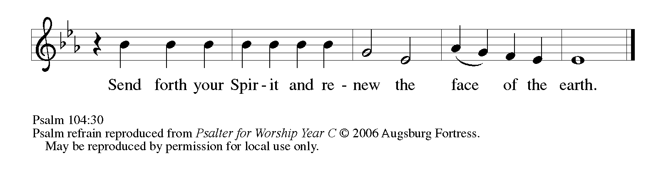
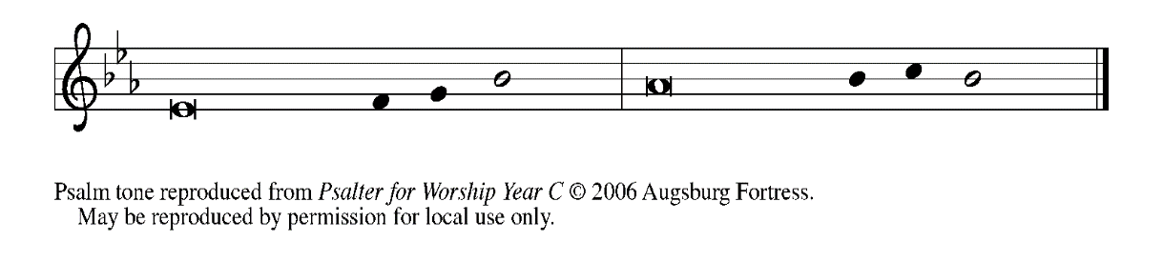
²⁴How manifold are Your | works, O LORD!
In wisdom You have made them all; the earth is full | of Your creatures.

²⁵Yonder is the sea, great and wide, with its swarms too man- | y to number,
living things both | small and great.

²⁶There go the ships | to and fro,
and Leviathan, which You made for the | sport of it.

²⁷All of them | look to You
to give them their food | in due season. REFRAIN

²⁸You give it to them; they | gather it;
You open Your hand, and they are filled | with good things.

²⁹When you hide Your face, | they are terrified;
when You take away their breath, they die and return | to their dust.

³⁰You send forth Your Spirit, and they | are created;
and so You renew the face | of the earth.

³¹May the glory of the LORD en- | dure forever;
O LORD, rejoice in | all Your works. REFRAIN

³²You look at the earth | and it trembles;
You touch the mountains | and they smoke.

³³I will sing to the LORD as long | as I live;
I will praise my God while I | have my being.

³⁴May these words of | mine please God.
I will rejoice | in the LORD.

³⁵Bless the LORD, | O my soul.
Hal- | lelujah! REFRAIN

SECOND READING Romans 8: 14-17

Here Paul speaks about the mystery of baptism: through the Spirit we are adopted, gathered, welcomed into Christ's body, the church. And we receive new names: brother, sister, child of God.

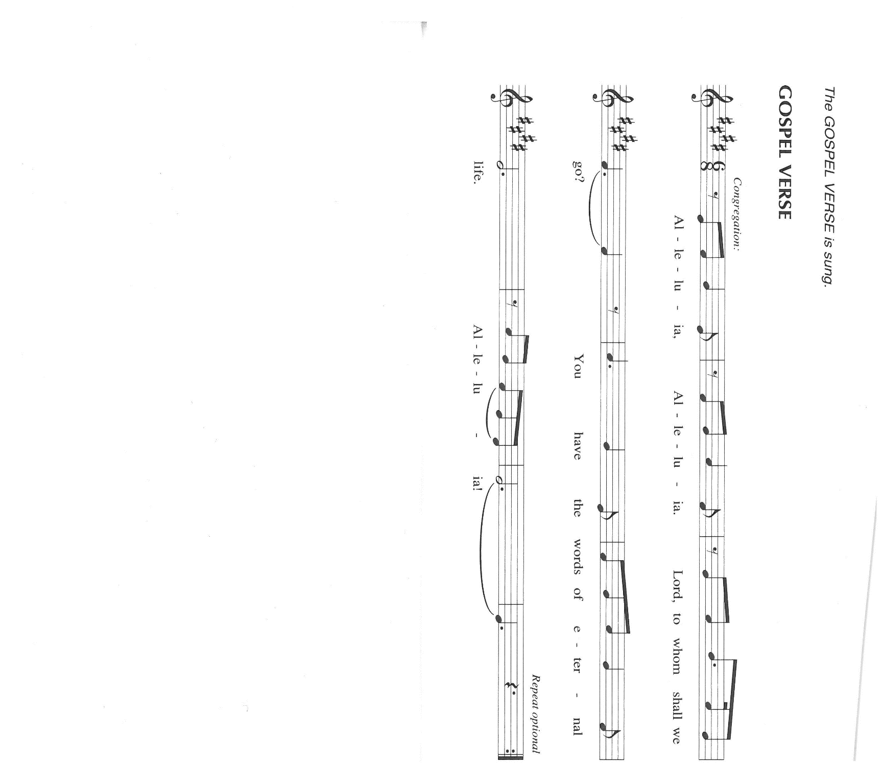
¹⁴For all who are led by the Spirit of God are children of God. ¹⁵For you did not receive a spirit of slavery to fall back into fear, but you have received a spirit of adoption. When we cry, "Abba! Father!" ¹⁶it is that very Spirit bearing witness with our spirit that we are children of God, ¹⁷and if children, then heirs, heirs of God and joint heirs with Christ--if, in fact, we suffer with Him so that we may also be glorified with Him.

The Word of the Lord.

Thanks be to God.

As you are able please rise

THE VERSE (Sung twice)

THE HOLY GOSPEL John 14: 8-17

On the night he was betrayed, in his final address to his disciples, Jesus promises that though he must now leave them, they will soon receive the presence of an Advocate, the Spirit of truth, whom God will send to comfort and enlighten them.

P: The Holy Gospel according to St. John, the fourteenth chapter.

C: Glory to You, O Lord!

⁸Philip said to Jesus, "Lord, show us the Father, and we will be satisfied." ⁹Jesus said to him, "Have I been with you all this time, Philip, and you still do not know Me? Whoever has seen Me has seen the Father. How can you say, 'Show us the Father'? ¹⁰Do you not believe that I am in the Father and the Father is in Me? The words that I say to you I do not speak on My own; but the Father Who dwells in Me does His works.
¹¹Believe me that I am in the Father and the Father is in Me; but if you do not, then believe Me because of the works themselves. ¹²Very truly, I tell you, the one who believes in Me will also do the works that I do and, in fact, will do greater works than these, because I am going to the Father. ¹³I will do whatever you ask in My name, so that the Father may be glorified in the Son. ¹⁴If in My name you ask me for anything, I will do it.
¹⁵"If you love Me, you will keep My commandments. ¹⁶And I will ask the Father, and He will give you another Advocate, to be with you forever. ¹⁷This is the Spirit of truth, Whom the world cannot receive, because it neither sees Him nor knows Him. You know Him, because He abides with you, and He will be in you."

P: The Gospel of the Lord.

C: Praise to You, O Christ!

The assembly is seated

THE SERMON

Silence for reflection follows the sermon

As you are able please rise

THE HYMN OF THE DAY ELW 396 Spirit of Gentleness

THE NICENE CREED

A: God has made us His people through our Baptism into Christ. Living together in trust
and hope, we confess our faith.

C: We believe in one God,
the Father, the Almighty,
maker of heaven and earth,
of all that is, seen and unseen.

We believe in one Lord, Jesus Christ,
the only Son of God,
eternally begotten of the Father,
God from God, Light from Light,
true God from true God,
begotten, not made,
of one Being with the Father.
Through Him all things were made.
For us and for our salvation
He came down from heaven;
by the power of the Holy Spirit
He became incarnate from the virgin Mary, and was made man.
For our sake He was crucified under Pontius Pilate;
He suffered death and was buried.
On the third day He rose again
in accordance with the Scriptures;
He ascended into heaven
and is seated at the right hand of the Father.
He will come again in glory to judge the living and the dead,
and His kingdom will have no end.

We believe in the Holy Spirit, the Lord, the giver of life,
Who proceeds from the Father and the Son.
With the Father and the Son He is worshiped and glorified.
He has spoken through the prophets.
We believe in one holy catholic and apostolic Church.
We acknowledge one Baptism for the forgiveness of sins.
We look for the resurrection of the dead,
and the life of the world to come. Amen

THE PRAYER OF THE CHURCH

A: On this Pentecost, let us raise our prayer to God for the Spirit sent to anoint us.

A: That the whole Church might be stirred to prophecy, witness, and service, to new
visions and dreams, that through our ministry the whole world might know of Your
love, we pray:

C: Come, Holy Spirit!

A: That the winds of war, chaos, hatred, and disorder that batter our world, especially in
Ukraine, Gaza, Haiti, Sudan, the Democratic Republic of Congo, and Libya might be
swept into currents of peace, reconciliation, and justice, we pray:

C: Come, Holy Spirit!

A: That this assembly might passionately pursue Jesus’ works of feeding the hungry,
comforting the grieving, and caring for the poor, we pray:

C: Come, Holy Spirit!

A: That the sick, especially: Ken Mulder; Jess Kalvaitis; Joyce Stark; Larry Litchford;
Fred Weiss; Martha Schroeder; Lucas Bradshaw; Nick Henrich; Christine Kiser;
and Grace Romine might be restored to health and wholeness, we pray:

C: Come, Holy Spirit!

A: That all graduates, especially Sarah Sutor from our congregation would continue to
grow in the wisdom, knowledge and fear of the Lord, we pray:

C: Come, Holy Spirit!

A: That those celebrating birthdays, especially Janet Bakken; Ivye Benson and Leigh
Coburn; and anniversaries, especially: Daniel and Brittany Streubing; Ron and
Melinda Nagle; David and Donna Sutor; Tom and Amy Petri; and Doug and Pam
Kienitz may know Your grace this day and every day and grow in grace in the days
ahead, we pray:
C: Come, Holy Spirit!

A: That with all the faithful, especially Seattle, chief of the Duwamish Confederacy,
whom we commemorate this Day we may one day see God face to face, we pray:

C: Come, Holy Spirit!

P: Good and gracious God, send forth Your Spirit into our hearts. Wipe away the fear
between churches, nations, and families. Tear down the walls that divide us, and make
us one through Christ our Lord.

C: Amen.

MEAL

THE PEACE

P: The peace of the risen Lord be with you always.

C: And also with you.

The assembly is seated

THE OFFERING

THE VOLUNTARY Fill-A-Me Up! St. Paul Senior Choir
(P. Choplin) (Guest Soloist: Lori Zylstra)
As you are able please rise

THE PRESENTATION OF THE GIFTS 465 As the Grains of Wheat

THE OFFERTORY PRAYER

A: Let us pray. God of wind and fire,

C: You announced the sending of Your Spirit with new gifts. In Your mercy, receive
these offerings we bring before You. By the grace of this holy Sacrament, use us
to proclaim Your name, that all who call upon You may know of Your salvation.
We ask this in the name of Jesus the Lord. Amen.

THE GREAT THANKSGIVING

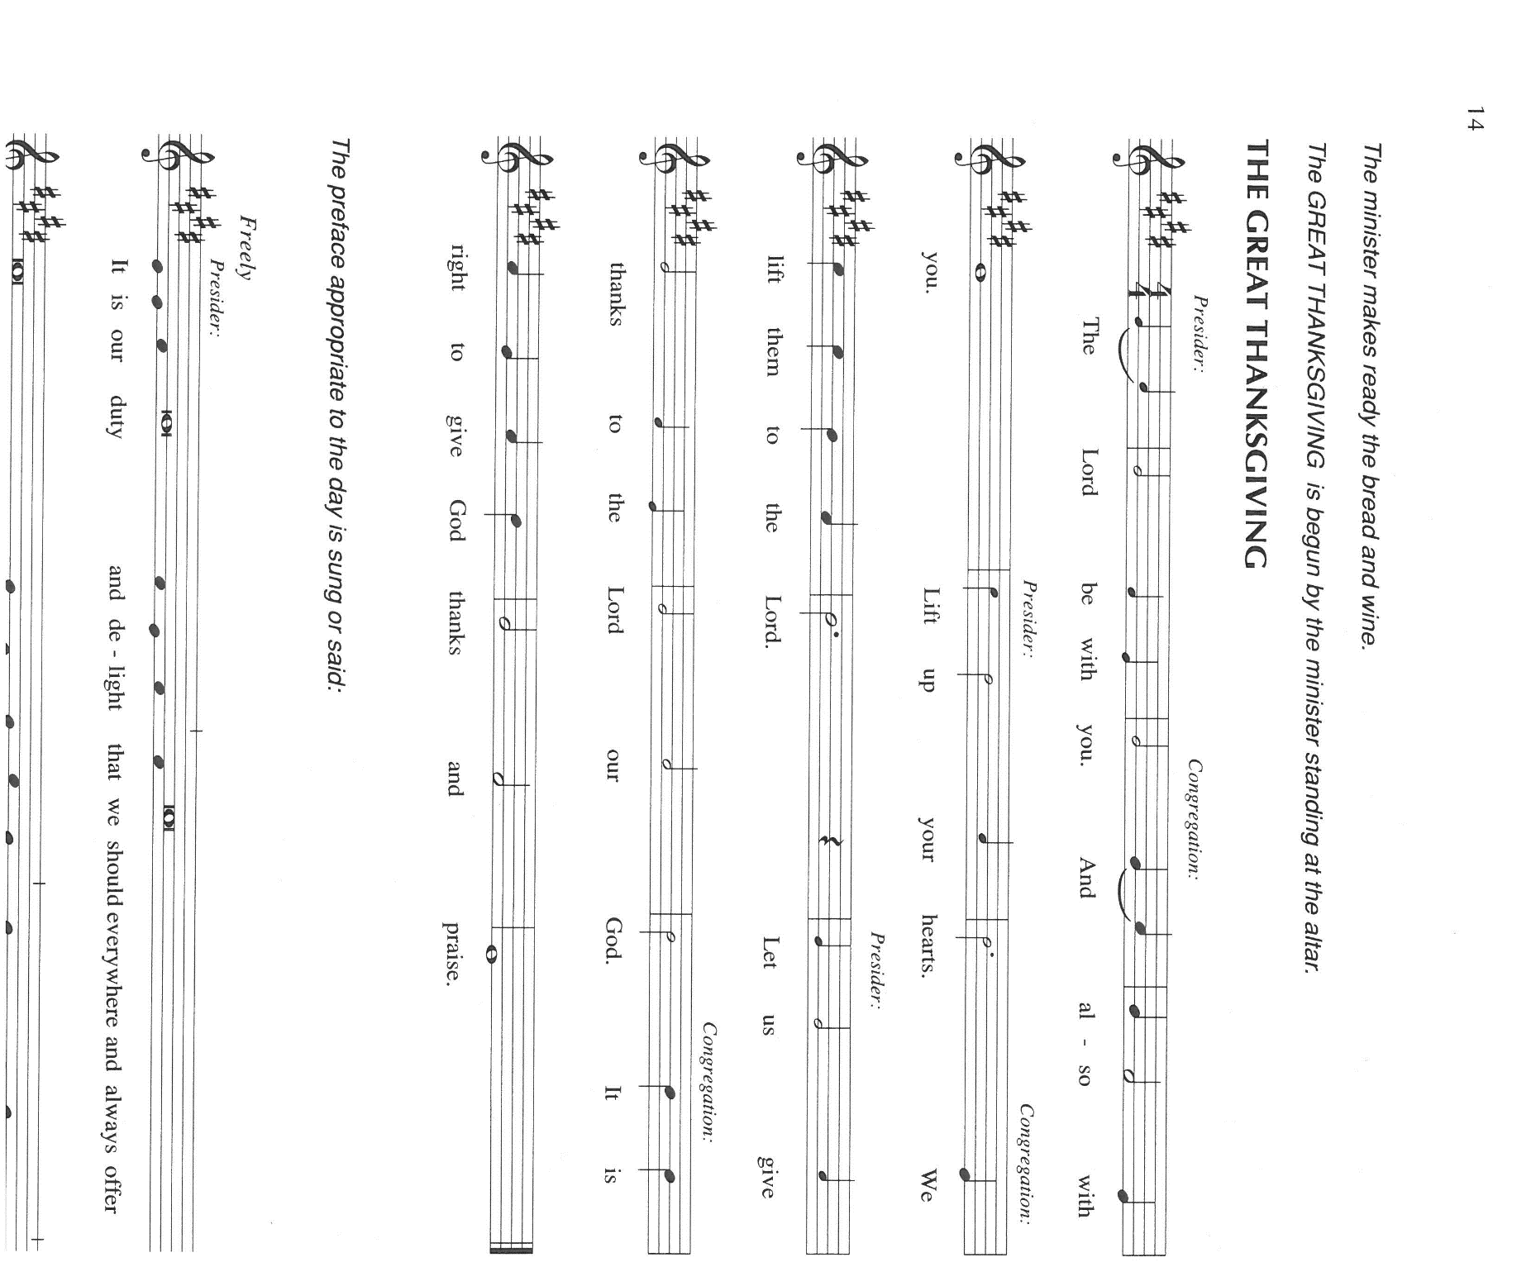

P: It is our duty and delight … join their unending hymn:

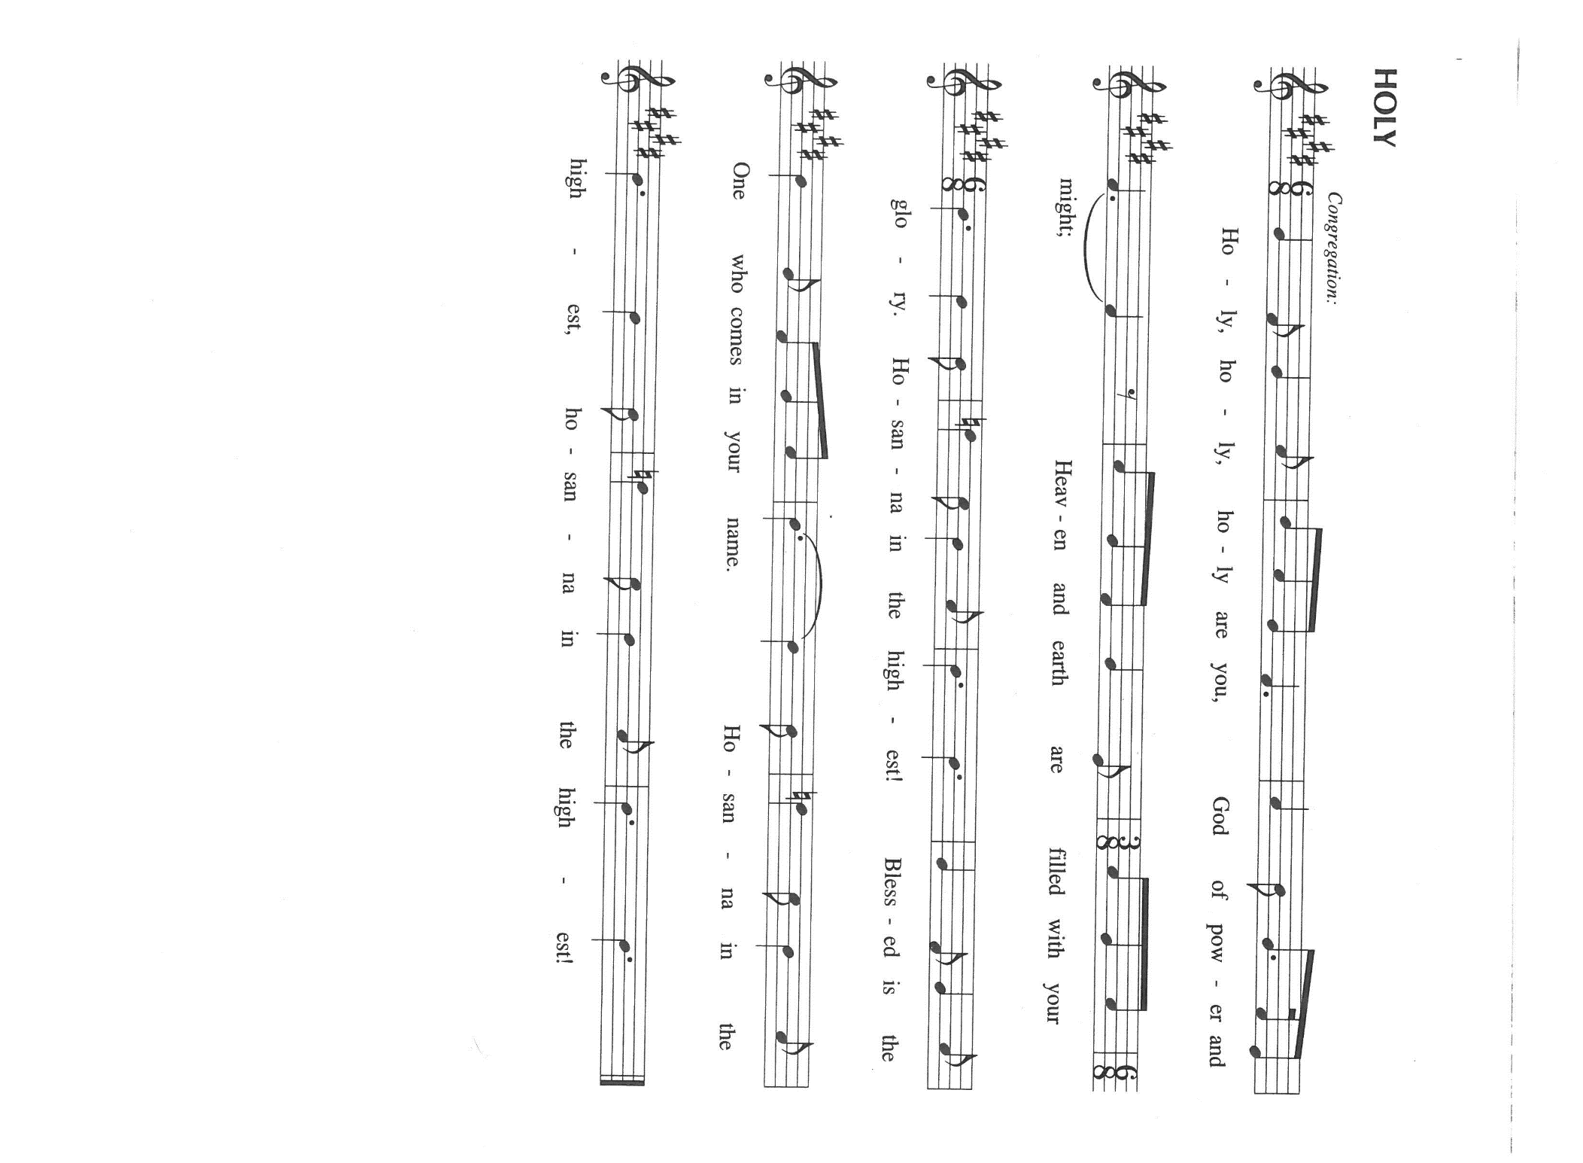

P: God of surprises, Your Spirit brooded over the waters at creation and lived among Your
chosen people in wilderness, exile, and promised land.
Your Spirit filled Mary’s womb at the moment of Jesus’ conception and came upon
Him like a dove at His Baptism.
When Christ died on the cross Your power raised Him from the tomb on the third day,
and that same evening He breathed Your forgiving grace on those who had
deserted Him.
On the Day of Pentecost You sent Your Spirit upon the fearful disciples, filling them
with fire, with power, with wonder and joy and making them Your Church.
God of comfort and strength, we look to Your Holy Spirit to be with us in sorrow
and in contentment, in crisis and in abiding stillness.
Come among us now through the power of Your Spirit, that we may be transformed
into Your image, and these gifts of bread and wine may become for us the
Body and Blood of Your Son, Jesus Christ,
Who, in the night ... “Do this for the remembrance of Me.”
As often as we eat ... we proclaim the Lord’s death until He comes.

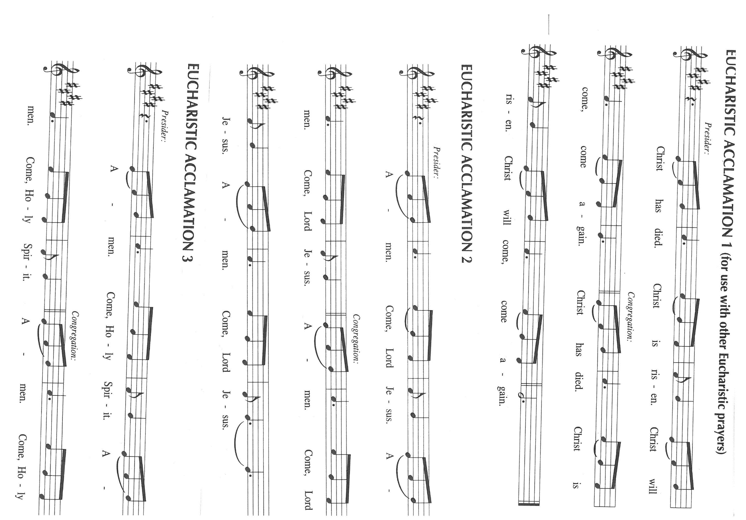

P: God of dreams and prophecy, send down upon us Your gifts of wisdom, knowledge,
and faith; of healing discernment, and interpretation, that Your Church may
be built up in the likeness of Your Son.
Let anyone who is hungry find in You the Bread of Life, and anyone who is thirsty
find in Your rivers of living water.
Speak Your Word to all who are alone and in fear or despair, and let each one of
Your children hear Your voice in their own language, whether that language
be of art or science, work or play.
Make holy Your groaning creation, that Your universe might breathe Your breath
and be filled with Your life anew, that we may love what You love, and do
what You would do,
Father, Son, and Holy Spirit, ever one God.

C: Amen!

THE LORD’S PRAYER

P: Lord, remember us in Your Kingdom and teach us to pray:

C: Our Father in heaven, hallowed be Your name.
Your Kingdom come, Your will be done on earth as in heaven.
Give us today our daily bread, and forgive us our sins, as we forgive
those who sin against us.
Save us from the time of trial, and deliver us from evil.
For the Kingdom, the power, and the glory are Yours, now and forever.
Amen.

INVITATION TO THE MEAL

P: This is the Lamb of God Who takes away the sin of the world Blessed are those who
are called to the Supper of the Lamb. God’s holy gifts for God’s holy people. Come,
for all is now ready.

The assembly is seated
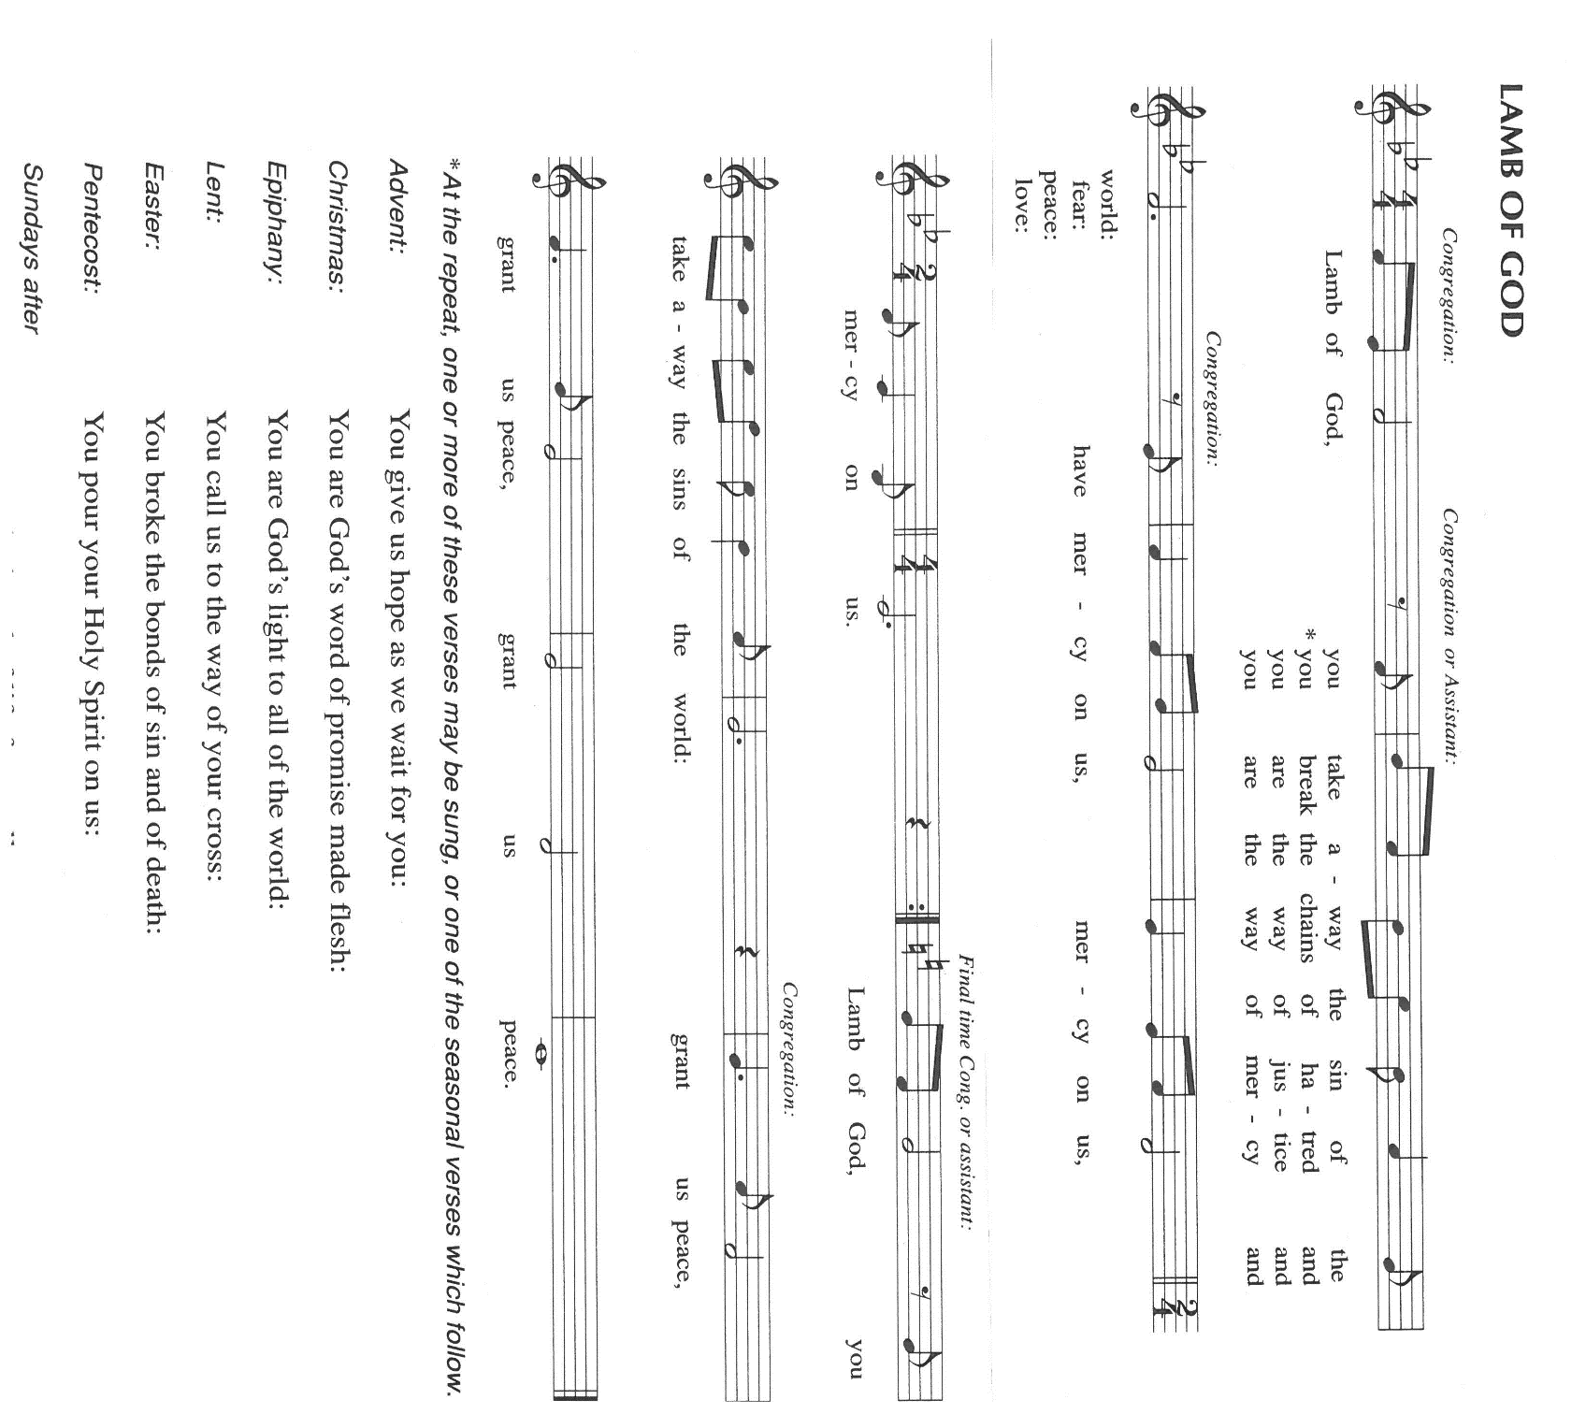
THE DISTRIBUTION

Those wishing to receive the Laying on of Hands, Anointing with Oil, and Prayer for Healing may go to Pastor at the side aisle

HYMN DURING DISTRIBUTION 627 O Day Full of Grace
ACS 942 Every Time I Feel the Spirit
ELW 407 O Living Breath of God
ELW 401 Gracious Spirit, Hear Our Pleading
NSB 81 Spirit Song
As you are able please rise

THE POST-COMMUNION BLESSING

P: The Body and Blood of our Lord Jesus Christ strengthen you and keep you in His grace.

C: Amen.

THE POST-COMMUNION PRAYER

A: Let us pray. Father, may we who have received this Eucharist live in the unity of Your
Holy Spirit, that we may show forth His gifts to all the world. Grant this through Christ
our Lord.

C: Amen.

SENDING

THE BENEDICTION

P: Almighty God: Father, Son, and Holy Spirit bless you now and forever.

C: Amen.

SENDING HYMN 400 God of Tempest, God of Whirlwind

The congregation faces the cross as it leaves the nave

THE DISMISSAL

A: Rejoicing in the power of the Spirit, go in peace to love and serve the Lord.

C: Thanks be to God!

POSTLUDE

To God Alone Be Glory

The Meditation is from Pulpit Resource. William Willimon, ed. Vol. 29 No. 2 (Inver
Heights, MN: Logos Productions, 2001) 44.

ANNOUNCEMENTS

Please remember to mail your offering to the Church Office at 818 Franklin Street, Michigan City, IN 46360. Another alternative is to give on-line through Tithe.ly. Please see your closure letter for information on how to set up a Tithe.ly account.

St. Paul Members are reminded to have a loved one contact the office if you are hospitalized. Many times, the Pastor doesn’t know someone is in the hospital. If you call and leave a message, please tell us at which hospital the patient is located.

Birthdays: Janet Bakken (6/14); Ivye Benson (6/14); Leigh Coburn (6/12)

Anniversaries: Daniel & Brittany Streubing (6/8); Ron & Melinda Nagle (6/9);
David & Donna Sutor (6/12); Tom & Amy Petri, Jr. (6/ 13); Doug & Pam Kienitz (6/15)

PRAYER CONCERNS: Larry Litchford, Sarah McNabb, Carol Radke, Jeanie Boatman Shepple, Nolan Wilson, Debbie Martin, Mark Tannehill, Brian Wiseman, Kathy Stein, Danielle Schnell, Jan Paholski, Laura Dovey, and Grace Romine.

OFFICE HOURS: Libby will be in the office on Mondays, Wednesdays, and Fridays; volunteers will cover Tuesdays and Thursdays.

Monday & Wednesday 8:00 a.m. – 5 p.m.
Tuesday & Thursday 9:00 a.m. – 12:00 p.m.
Friday 8:00 a.m. – 12:00 p.m.

If you are listening to the worship broadcast on the radio and would like to watch the Sunday morning service live stream follow these steps:

(1) If you have You Tube available on your TV, search for
St. Paul Lutheran Church Michigan City, IN.

(2) The direct link on the computer is
https://www.youtube.com/channel/UC5AIPNaKr3QN50984jGOa1g.

(3) This link is also on the main page of the church’s website in
the church section and will continue to be posted weekly on the St.
Paul Facebook page.

And it will always be available on the radio broadcast Sunday mornings at 11:00 a.m.
on WEFM (95.9), and on the local cable access station #99 for the previous week’s
service on Sundays at 4:00 p.m. and the current service on Wednesdays at 7:00 p.m.
and Fridays at 8:30 p.m.

Sunday’s lessons are Proverbs 8: 1-4, 22-31; Psalm 8; Romans 5: 1-5; John 16: 12-15 for those of you who like to study them in advance.

To send e-mail to the church office, please use the following addresses:
Pastor Mark Reshan: seniorpastor@stpaulmichigancity.com
Church Office Secretary (Libby Pollock): churchsecretary@stpaulmichigancity.com
Church Treasurer (Karen Fleming): finance@stpaulmichigancity.com

2025 Church Council:

Mark Reshan - Pastor

Janet Bakken – President

Donna Knoll – Vice President

Judy Hunt – Secretary

Karen Fleming – Treasurer

Members: Paul Brooks, Diane Egilske, Sue Koziel, Judy Mutchler,
Jim Schraidt, Trish Sprague

Worship Attendance:
Saturday , May 31, 2025 @ 4:00 p.m. 34
Sunday, June 1, 2025 @ 9:00 a.m. 71
TOTAL 105

Do you love to sing?

The St. Paul Choir is hosting an open rehearsal on Wednesday, June 11, 2025 from 4:30 p.m. – 5:30 p.m. in the Sanctuary. It’s OK if you don’t know if you are a Bass, Tenor, Alto or Soprano (our rockstar director, Maggie, can help you with that) and you don’t need to know how to read music! During the open rehearsal we will learn a simple song to sing during the service on Sunday, June 15. Then the choir will be on summer break from mid-June until after Labor Day, giving you time to consider joining in September. We look forward to seeing everyone on June 11th!

ACTIVITIES, EVENTS & MEETINGS
JUNE 2025

Saturday, May 31, 2025 @ 4:00 p.m. 7th Easter Worship Service

Sunday, June 1, 2025 @ 9:00 a.m. 7th Easter/Observed Ascension Worship Service
Coffee in St. Paul Room after service
Tuesday, June 3, 2025 @ 10:00 a.m. Altar Guild/St. Paul Room
Wednesday, June 4, 2025 @ 10:00 a.m. God’s Purls/St. Paul Room
@ 4:30 p.m. Choir Rehearsal/Sanctuary
Thursday, June 5, 2025 Faith Circle
Saturday, June 7, 2025 @ 4:00 p.m. Day of Pentecost Worship Service/Sanctuary

Sunday, June 8, 2025 @ 9:00 a.m. Day of Pentecost Worship Service/Sanctuary
NO COFFEE TODAY
Monday, June 9, 2025 @ 1:00 p.m. Hope Circle/Green Room
Tuesday, June 10, 2025 from 11:00 a.m. – close GIVE BACK AT HOLLY’S
@ 7:00 p.m. Estuary/Luther House
Wednesday, June 11, 2025 @ 10:00 a.m. God’s Purls/St. Paul Room
@ 4:30 p.m. OPEN CHOIR REHEARSAL/Sanctuary
(this will also be the last rehearsal of the season)
Saturday, June 14, 2025 @4:00 p.m. The Holy Trinity Worship Service/Sanctuary
Sunday, June 15, 2025 @ 9:00 a.m. The Holy Trinity Worship Service/Sanctuary
Coffee in St. Paul Room after service
Wednesday, June 18, 2025 @ 10:00 a.m. God’s Purls/St. Paul Room
Saturday, June 21, 2025 @ 4:00 p.m. Pent 2 Worship Service/Sanctuary

Sunday, June 22, 2025 @ 9:00 a.m. Pent 2 Worship Service/Sanctuary
Coffee in St. Paul Room after service
Monday, June 23, 2025 @ 2:00 p.m. Finance Comm. Mtg./Luther House
@3:00 p.m. Executive Board Meeting/Luther House
Wednesday, June 25, 2025 @ 10:00 a.m. God’s Purls/St. Paul Room
@5:00 p.m. 150th Anniversary Comm. Mtg./Luther House
Thursday, June 26, 2025 @ 5:30 p.m. Church Council Mtg./St. Paul Room
Saturday, June 28, 025 @ 4:00 p.m. Pent 3 Worship Service/Sanctuary

Sunday, June 29, 2025 @9:00 a.m. Pent 3 Worship Service/Sanctuary
Coffee in St. Paul Room after service HOSTED BY THE ALTAR GUILD

MISSION OF THE MONTH FOR JUNE 2025

The mission of the month for St. Paul Lutheran is the Team Kentucky Storm Relief Fund. The governor of Kentucky has established this fund to assist those impacted by the severe weather and tornadoes this year. The fund has no administration fees, so every dollar goes to help Kentuckians affected by the historic flooding and sever weather. Governor Beshear has said that the fund will first go towards paying funeral expenses for those lost to the storms, stating that people who have lost so much in a natural disaster shouldn’t have to worry about how to bury their loved ones. Please make checks payable to St. Paul and mark for the June Mission of the Month and place in the offering plate. June noisy coin offering will also support the mission of the month. Thank you for your generosity in helping those affected by this natural disaster as well as your continued prayers for the victims and their loved ones.

Copies of the minutes from the March 27, 2025 and the May 1, 2025 Church Council meetings are on the back table in the upper Narthex. They were approved by the council via email.

FYI:

In response to the ever rising costs for postage we will be putting your copy
of the “Good News” in your hanging file folder in the narthex each month
from now on. Those of you who are unable to attend services on a regular
basis may still receive your copies through your email address or in the
U.S. mail. If you normally receive your copy of the newsletter via your
email address anyway, nothing will change for you. Thank you so much for
your understanding and cooperation!

The Good News Newsletter: If you have an article or anything you want included in The Good News please send it to the following e-mail address: splcgoodnews@gmail.com. Pastor Pamela Thiede will be using this e-mail address to assemble The Good News each month. The deadline for getting information to Pastor Pamela will be the 20th of each month.

Thank$ for $haring
Thank you for all who participate in our Give Back days! On April 3 we met at Galveston Steakhouse and earned $150. Our May 7th Give Back at Swingbelly’s earned $125. Our next Give Back will be at Holly’s on Tuesday, June 10th from 11:00 am — close. A coupon is required in order for us to claim the discount. Here are two coupons: one for you and one for a friend.

