THE SEVENTH SUNDAY AFTER PENTECOST
July 12, 2026

“ ...The first thing I know when I read texts like these (for the Day) is that I emphatically do not believe them ...They are too easily and too obviously disconfirmable. I am far more aware of the ways in which God’s word simply blows about emptily in the world, without God’s stated purposes being fulfilled in any verifiable fashion. I know too much about the seed plucked from the rocks, smothered by thorns and dried from the lack of moisture in wasted sowings of the human spirit ...”
“ ...Part of me therefore resists the authority assumed by these texts not only to know what is happening in the world (and in the mind of God) but also to interpret them in positive terms ...(But) perhaps that is part of the point of listening to these texts.
When we look around and within us, we find only the closure of idolatry, sin, and despair. Left to ourselves, we cannot break out to freedom. Maybe these texts ask us not to look simply at ourselves and at the so-called evidence (of which we are so fond, so long as we get to select it).
Maybe they ask us to listen to a Voice that provides an opening to freedom by providing a perspective other than our own, enunciated by the Voice of One Who creates this world at every moment and knows where it is going, Who calls prophets to speak and knows the purpose of their words, Who sows the seed of the Word with joyful abandon, secure in the knowledge of the harvest ...”

Luke Timothy Johnson

If we are honest with ourselves, we can probably find evidence of several kinds of soil in our lives and in our congregations on any given day. It is noteworthy that Jesus does not use the parable to exhort hearers to "be good soil," as though we could make that happen. If there is any hope for the unproductive soil, it is that the sower keeps sowing generously, extravagantly, even in the least promising places. Jesus' investment in his disciples shows that he simply will not give up on them, in spite of their many failings. We trust that he will not give up on us either, but will keep working on whatever is hardened, rocky, or thorny within and among us. We trust in his promise to be with us to the end of the age.

Elizabeth Johnson

INTRODUCTION

God's word is like the rain that waters the earth and brings forth vegetation. It is also like the sower who scatters seed indiscriminately. Our lives are like seeds sown in the earth. Even from what appears to be little, dormant, or dead, God promises a harvest. At the Lord's table we are fed with the bread of life, that we may bear fruit in the world.

Nathan Söderblom, Bishop of Uppsala, died 1931

A winner of the Nobel Prize for peace for his efforts to unite peoples after the First World War, Söderblom also called attention to the revival of early church worship principles, and helped to lay the groundwork for the World Council of Churches.

GATHERING

PRE-SERVICE MUSIC God Will Make a Way New Song Praise Band
(Doug Moen)

ANNOUNCEMENTS

As you are able please rise

THE BAPTISMAL HYMN732 I Was There to Hear Your Borning Cry

THE GREETING

P: The grace of our Lord Jesus Christ, the love of God, and the communion of the Holy
Spirit be with you all.

C: And also with you.

The assembly is seated

THE SACRAMENT OF HOLY BAPTISM
Presentation

The presiding minister may address the assembly in these or similar words:

In baptism our gracious heavenly Father frees us from sin and death by joining us to the death and resurrection of our Lord Jesus Christ. We are born children of a fallen humanity; by water and the Holy Spirit we are reborn children of God and made members of the church, the body of Christ. Living with Christ and in the communion of saints, we grow in faith, love, and obedience to the will of God.

Sponsors for each candidate, in turn, present the candidates:

I present Maggie Louise for baptism.

The presiding minister addresses parents or others who bring for baptism children who are not able to answer for themselves:

Called by the Holy Spirit, trusting in the grace and love of God, do you desire to have Maggie Louise baptized into Christ?

Response:

I do.

The presiding minister continues:

As you bring Maggie Louise to receive the gift of baptism, you are entrusted with responsibilities:

to live with her among God's faithful people,
bring her to the word of God and the holy supper,
teach her the Lord's Prayer, the Creed, and the Ten Commandments,
place in her hands the holy scriptures,
and nurture her in faith and prayer,
so that she may learn to trust God,
proclaim Christ through word and deed,
care for others and the world God made,
and work for justice and peace.
Do you promise to help Maggie Louise grow in the Christian faith and life?

Response:

I do.

The presiding minister addresses sponsors:

Sponsors, do you promise to nurture Maggie Louise in the Christian faith as you are empowered by God's Spirit, and to help her live in the covenant of baptism and in communion with the church?

Response:

I do.

The presiding minister addresses the assembly:

People of God, do you promise to support Maggie Louise and pray for her in her new life in Christ?

We do.

Profession of Faith

The presiding minister addresses candidates for baptism as well as the parents and sponsors of young children. The assembly may join in the responses.

I ask you to profess your faith in Christ Jesus, reject sin, and confess the faith of the church.

Do you renounce the devil and all the forces that defy God?

Parents and sponsors:

I renounce them.

Do you renounce the powers of this world that rebel against God?

Parents and sponsors:

I renounce them.

Do you renounce the ways of sin that draw you from God?

Parents and sponsors:

I renounce them.
The presiding minister addresses the candidates and the assembly.

Do you believe in God the Father?

I believe in God, the Father almighty,
creator of heaven and earth.

Do you believe in Jesus Christ, the Son of God?

I believe in Jesus Christ, His only Son, our Lord.
He was conceived by the power of the Holy Spirit
and born of the virgin Mary.
He suffered under Pontius Pilate,
was crucified, died, and was buried.
He descended into hell.
On the third day He rose again.
He ascended into heaven,
and is seated at the right hand of the Father.
He will come again to judge the living and the dead.

Do you believe in God the Holy Spirit?

I believe in the Holy Spirit,
the holy catholic church,
the communion of saints,
the forgiveness of sins,
the resurrection of the body,
and the life everlasting. Amen.

Thanksgiving at the Font

Water may be poured into the font before or during the thanksgiving. At the font, the presiding minister begins the thanksgiving:

The Lord be with you.

And also with you.

Let us give thanks to the Lord our God.

It is right to give our thanks and praise.

Blessed are You, O God, maker and ruler of all things. Your voice thundered over the waters at creation. You water the mountains and send springs into the valleys to refresh and satisfy all living things.

Through the waters of the flood You carried those in the ark to safety. Through the sea You led Your people Israel from slavery to freedom. In the wilderness You nourished them with water from the rock, and You brought them across the river Jordan to the promised land.

By the baptism of His death and resurrection, Your Son Jesus has carried us to safety and freedom. The floods shall not overwhelm us, and the deep shall not swallow us up, for Christ has brought us over to the land of promise. He sends us to make disciples, baptizing in the name of the Father, and of the Son, and of the Holy Spirit.

Pour out Your Holy Spirit; wash away sin in this cleansing water; clothe the baptized with Christ; and claim Your daughters and sons, no longer slave and free, no longer male and female, but one with all the baptized in Christ Jesus, Who lives and reigns with You in the unity of the Holy Spirit, one God, now and forever.

Amen.

Baptism

The presiding minister baptizes each candidate.

Maggie Louise, I baptize you in the name of the Father, and of the Son, and of the Holy Spirit.

Amen.

You belong to Christ,
in Whom you have been baptized.

The presiding minister continues:

Let us pray.
We give you thanks, O God, that through water and the Holy Spirit you give your daughters and sons new birth, cleanse them from sin, and raise them to eternal life.

Laying both hands on the head of each of the newly baptized, the minister prays for each:

Sustain Maggie Louise with the gift of Your Holy Spirit: the spirit of wisdom and understanding, the spirit of counsel and might, the spirit of knowledge and the fear of the Lord, the spirit of joy in Your presence, both now and forever.

Amen.

The presiding minister marks the sign of the cross on the forehead of each of the baptized. As the sign of the cross is made, the minister says:

Maggie Louise, child of God, you have been sealed by the Holy Spirit and marked with the cross of Christ forever.

Amen.

Welcome

A lighted candle may be given to each of the newly baptized (to a sponsor of a young child) as a representative of the congregation says:

Let your light so shine before others
that they may see your good works
and glorify your Father in heaven.

The ministers and the baptismal group face the assembly. A representative of the congregation leads the assembly in the welcome.

Let us welcome the newly baptized.

We welcome you into the body of Christ and into the mission we share:
join us in giving thanks and praise to God
and bearing God's creative and redeeming word to all the world.

THE PRAYER OF THE DAY

P: The Lord be with you.

C: And also with you.

P: Let us pray. Almighty God, we thank You for planting in us the seed of Your Word.
By Your Holy Spirit help us to receive it with joy; live according to it, and grow in
faith and hope and love; through Jesus Christ, our Savior and Lord.

C: Amen.

The assembly is seated

WORD

FIRST READING Isaiah 55: 10-13

Preaching to the Babylonian exiles around 540 b.c., the prophet announces the good news that the Lord will bring the exiles home. The effectiveness of God's word is a theme that runs through chapters 40-55. What God says, will happen. Moreover, not only will the people return, the Lord will transform their path through the desert into a paradise.

For as the rain and the snow come down from heaven,
and do not return there until they have watered the earth,
making it bring forth and sprout,
giving seed to the sower and bread to the eater,
¹¹so shall My word be that goes out from My mouth;
it shall not return to Me empty,
but it shall accomplish that which I purpose,
and succeed in the thing for which I sent it.
¹²For you shall go out in joy,
and be led back in peace;
the mountains and the hills before you
shall burst into song,
and all the trees of the field shall clap their hands.
¹³Instead of the thorn shall come up the cypress;
instead of the brier shall come up the myrtle;
and it shall be to the LORD for a memorial,
for an everlasting sign that shall not be cut off.
The Word of the Lord.

Thanks be to God.

THE PSALM: Psalm 65: 1-13 Read responsively

¹You are to be praised, O God, in Zion;
to You shall vows be fulfilled.

²To You, the One Who answers prayer,
to You all flesh shall come.

³Our sins are stronger than we are,
but You blot out our transgressions.

⁴Happy are they whom You choose and draw to Your courts to dwell there!
They will be satisfied by the beauty of Your house,
by the holiness of Your temple.

⁵Awesome things will You show us in Your righteousness, O God of our salvation,
O hope of all the ends of the earth and of the oceans |far away.

⁶You make firm the mountains by Your power;
You are girded about with might.

⁷You still the roaring of the seas,
the roaring of their waves, and the clamor of the peoples.

⁸Those who dwell at the ends of the earth will tremble at Your marvelous signs;
You make the dawn and the dusk to sing for joy.

⁹You visit the earth and water it abundantly; You make it very plenteous;
the river of God is full of water.
You prepare the grain, for so You provide for the earth.

¹⁰You drench the furrows and smooth out the ridges;
with heavy rain You soften the ground and bless its increase.

¹¹You crown the year with Your goodness,
and Your paths overflow with plenty.

¹²May the fields of the wilderness be rich for grazing,
and the hills be clothed with joy.

¹³May the meadows cover themselves with flocks,
and the valleys cloak themselves with grain;
let them shout for joy and sing.

SECOND READING Romans 8: 1-11

Paul has explained that, in spite of good intentions, no human being can ever please God by living in complete obedience to the law. Still, we have been reconciled to God through Christ and introduced to the new life of the Spirit.

There is therefore now no condemnation for those who are in Christ Jesus. ²For the law of the Spirit of life in Christ Jesus has set you free from the law of sin and of death. ³For God has done what the law, weakened by the flesh, could not do: by sending His own Son in the likeness of sinful flesh, and to deal with sin, He condemned sin in the flesh, ⁴so that the just requirement of the law might be fulfilled in us, who walk not according to the flesh but according to the Spirit.
⁵For those who live according to the flesh set their minds on the things of the flesh, but those who live according to the Spirit set their minds on the things of the Spirit. ⁶To set the mind on the flesh is death, but to set the mind on the Spirit is life and peace. ⁷For this reason the mind that is set on the flesh is hostile to God; it does not submit to God's law--indeed it cannot, ⁸and those who are in the flesh cannot please God.
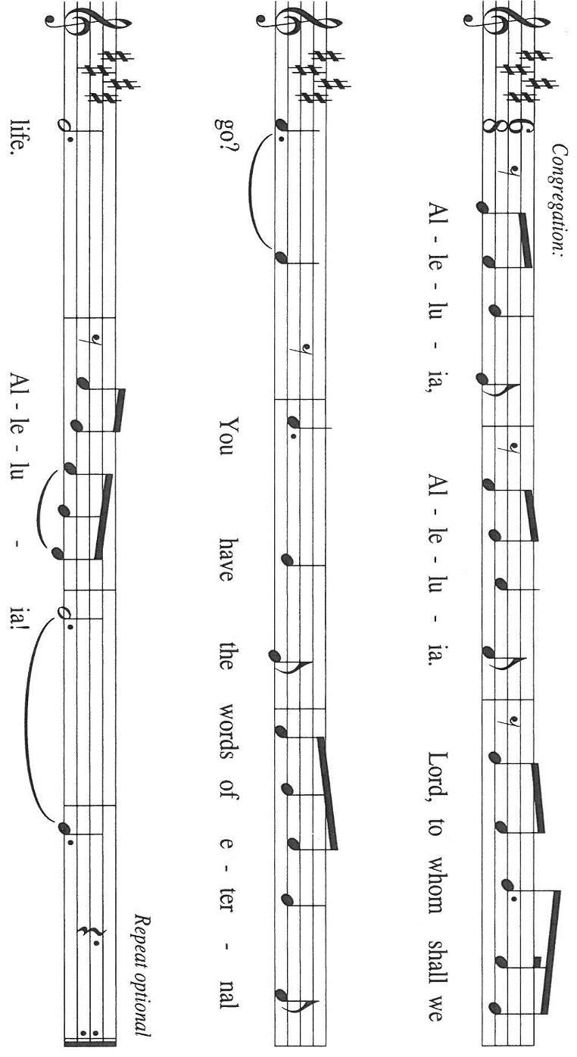
⁹But you are not in the flesh; you are in the Spirit, since the Spirit of God dwells in you. Anyone who does not have the Spirit of Christ does not belong to Him. ¹⁰But if Christ is in you, though the body is dead because of sin, the Spirit is life because of righteousness. ¹¹If the Spirit of Him Who raised Jesus from the dead dwells in you, He Who raised Christ from the dead will give life to your mortal bodies also through His Spirit that dwells in you.

The Word of the Lord.

Thanks be to God.

As you are able please rise

THE VERSE Sung twice

THE HOLY GOSPEL Matthew 13: 1-9, 18-23

In Matthew's gospel, both Jesus and his disciples "sow the seed" of God's word by proclaiming the good news that "the kingdom of heaven is near." Now, in a memorable parable, Jesus explains why this good news produces different results in those who hear.

P: The Holy Gospel according to St. Matthew, the thirteenth chapter.

C: Glory to You, O Lord!

That same day Jesus went out of the house and sat beside the sea. ²Such great crowds gathered around Him that He got into a boat and sat there, while the whole crowd stood on the beach. ³And He told them many things in parables, saying: "Listen! A sower went out to sow. ⁴And as he sowed, some seeds fell on the path, and the birds came and ate them up.
⁵Other seeds fell on rocky ground, where they did not have much soil, and they sprang up quickly, since they had no depth of soil. ⁶But when the sun rose, they were scorched; and since they had no root, they withered away. ⁷Other seeds fell among thorns, and the thorns grew up and choked them. ⁸Other seeds fell on good soil and brought forth grain, some a hundredfold, some sixty, some thirty. ⁹Let anyone with ears listen!"
¹⁸"Hear then the parable of the sower. ¹⁹When anyone hears the word of the kingdom and does not understand it, the evil one comes and snatches away what is sown in the heart; this is what was sown on the path. ²⁰As for what was sown on rocky ground, this is the one who hears the word and immediately receives it with joy; ²¹yet such a person has no root, but endures only for a while, and when trouble or persecution arises on account of the word, that person immediately falls away.
²²As for what was sown among thorns, this is the one who hears the word, but the cares of the world and the lure of wealth choke the word, and it yields nothing. ²³But as for what was sown on good soil, this is the one who hears the word and understands it, who indeed bears fruit and yields, in one case a hundredfold, in another sixty, and in another thirty."

P: The Gospel of the Lord.

C: Praise to You, O Christ!

The assembly is seated

THE SERMON

Silence for reflection follows the sermon

As you are able please rise

THE HYMN OF THE DAY (see p. 10) God of the Fertile Fields
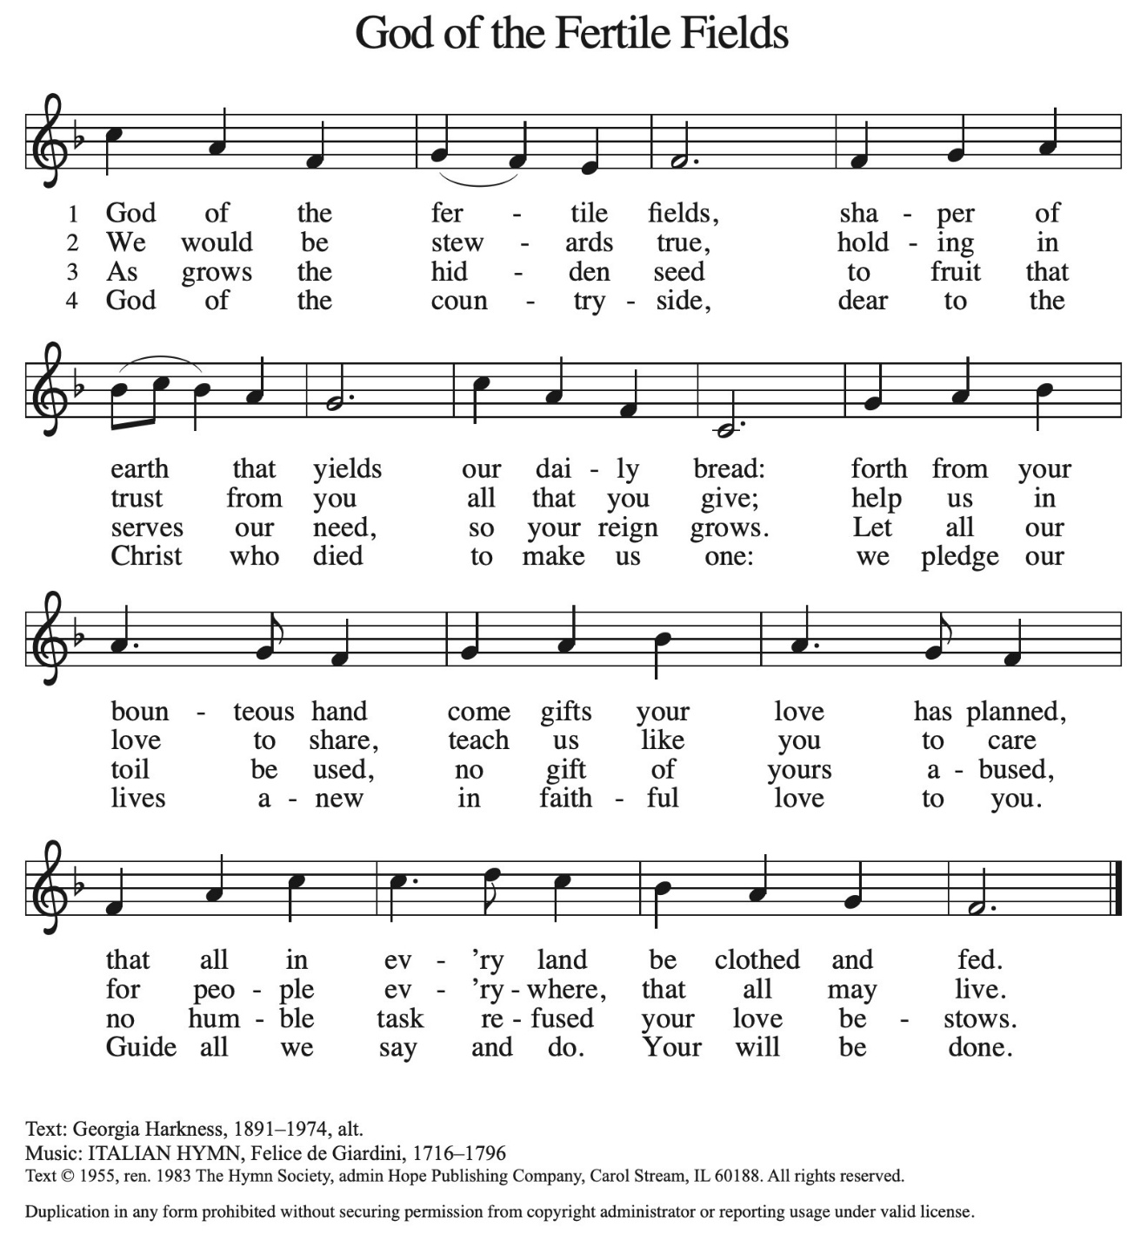

The assembly is seated

THE RECEPTION OF A NEW MEMBER

P: This person has come to us from another congregation and desires to transfer her
membership into our community of faith.

A: We welcome you as a member of St. Paul Lutheran Church to join with us in worshiping
God, hearing His Word and sharing in His Supper, proclaiming the Good News of God
in Christ through word and deed, serving all people, and striving for justice and peace
in all the earth.

A: Let us pray. We thank You, Lord, for this new member of our congregation. By Your
life-giving power, bind us to each other in You, strengthen us for service, support us
all our days, and bring us at last to that Day when all Your children will be one and
You will be All-in-All.

C: Amen.

As you are able please rise

THE PRAYER OF THE CHURCH

A: Lest the Word of God return empty to the heavens, let us turn our hearts to the needs
of the whole creation that waits with eager longing for God’s Word to accomplish its
purpose.

A: That the Church recklessly and abundantly sow the seed of God’s Word, we pray: God
of salvation,

C: Bring forth the fruit of Your Kingdom.

A: That the Word sown among our assembly this Day might accomplish its purpose and
yield a harvest of commitment, compassion, and mercy, we pray: God of salvation,

C: Bring forth the fruit of Your Kingdom.

A: That crops, especially in places of drought and famine, might be given good soil and
adequate rain for an ample harvest to feed the hungry and poor, we pray: God of
salvation,

C: Bring forth the fruit of Your Kingdom.

A: That the injured, the lonely, the forgotten, the institutionalized, and the sick, especially:
Jon Samuelson; Pastor Dale Zylstra; Mark Tannehill; Martha Schroeder, Jean
Warner and Hazel Miller might receive life and healing for their bodies and spirits,
we pray: God of salvation,

C: Bring forth the fruit of Your Kingdom.

A: That Maggie Louise Brooks, newly baptized, may be delivered from the way of sin
and death, filled with the Holy Spirit, lack no spiritual gift, and may always bear witness
to the Lord by word and life, we pray: God of salvation,

C: Bring forth the fruit of Your Kingdom.

A: That our new member, Linda Green, might be enriched by her membership in our
community of faith and that our mission might be blessed by her gifts and ministry, we
pray: God of salvation,

C: Bring forth the fruit of Your Kingdom.

A: That those celebrating birthdays, especially Bev Johnson; and anniversaries, especially
Al and JoAnne Sydow and Mike and Amy Maesch might be filled with grace this
day and grow in grace in the days ahead, we pray: God of salvation,
C: Bring forth the fruit of Your Kingdom.

A: That with all the faithful saints who have gone before us, especially Nathan
Soderblum, Bishop whom we commemorate this day may receive the first-fruits of
God’s new creation, we pray:

C: Bring forth the fruit of Your Kingdom.

P: Blessed and praised are You, O God, for the Word of Your mouth. In Your mercy,
listen to all who call on You in faith. Let Your Word find root in our lives. We ask
this in the name of Jesus the Lord.

C: Amen.

MEAL

THE PEACE

P: The peace of the Lord be with you always.

C: And also with you.

The assembly is seated

THE OFFERING

THE VOLUNTARY The Universe Bows New Song Praise Band
(Chris Crow)

As you are able please rise

THE PRESENTATION OF GIFTS (see p. 13) As the Grains of Wheat

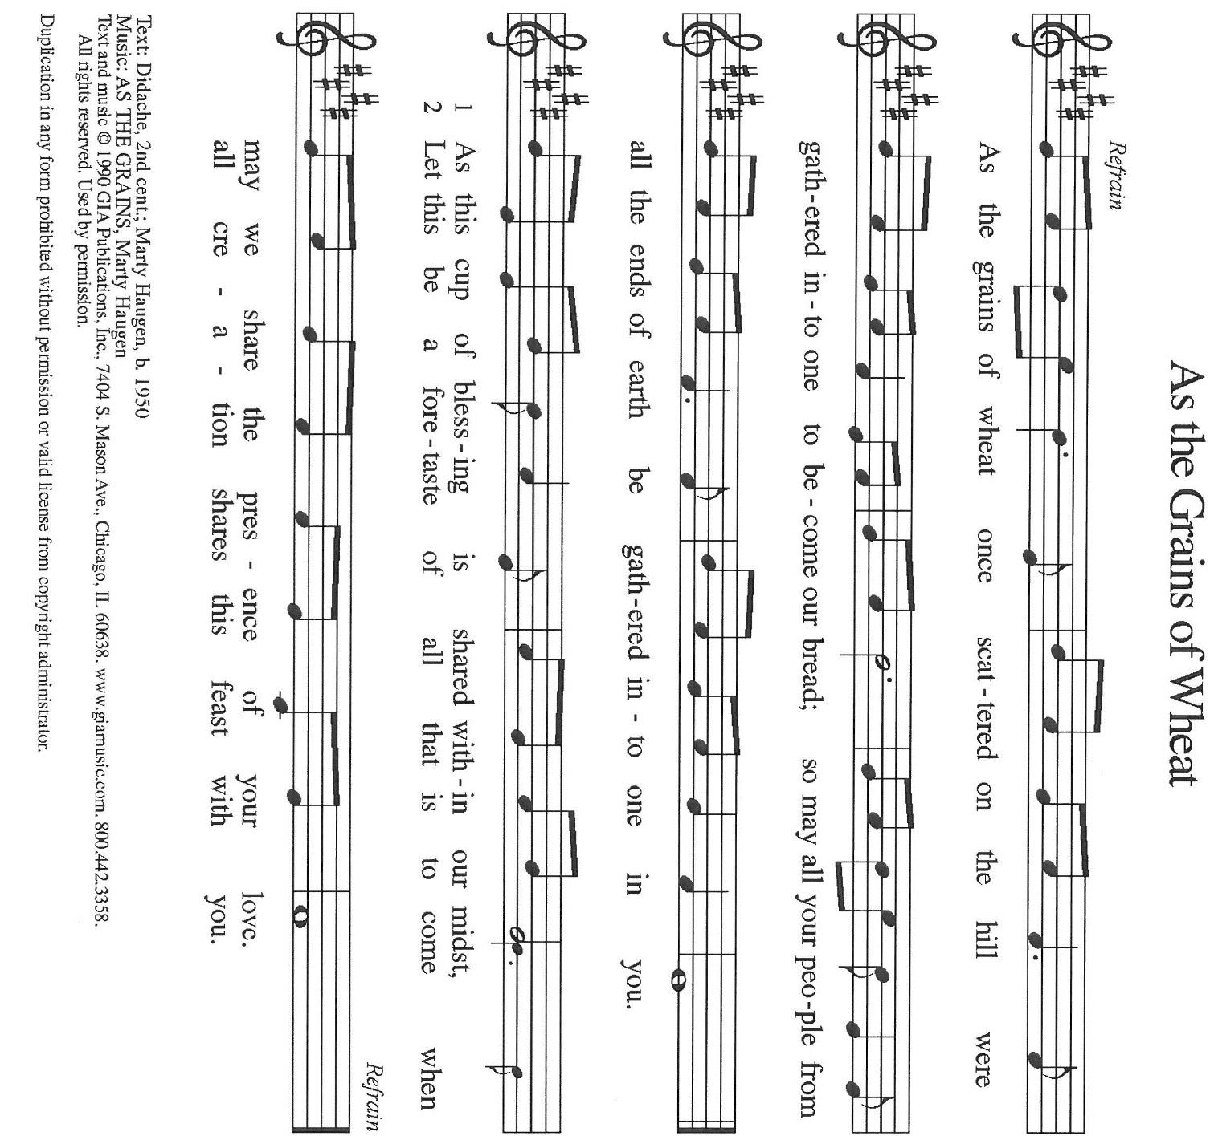

THE OFFERTORY PRAYER

A: Let us pray. Gracious God,

C: You send rain and snow to give seed to the sower and bread to the eater. We offer
You these fruits of our lives which we have received from Your abundant mercy.
By this bread and wine, fill us with Your grace, and accomplish in us Your
purposes of life and peace in the Spirit. We ask this in the name of Jesus the Lord.
Amen.

THE GREAT THANKSGIVING
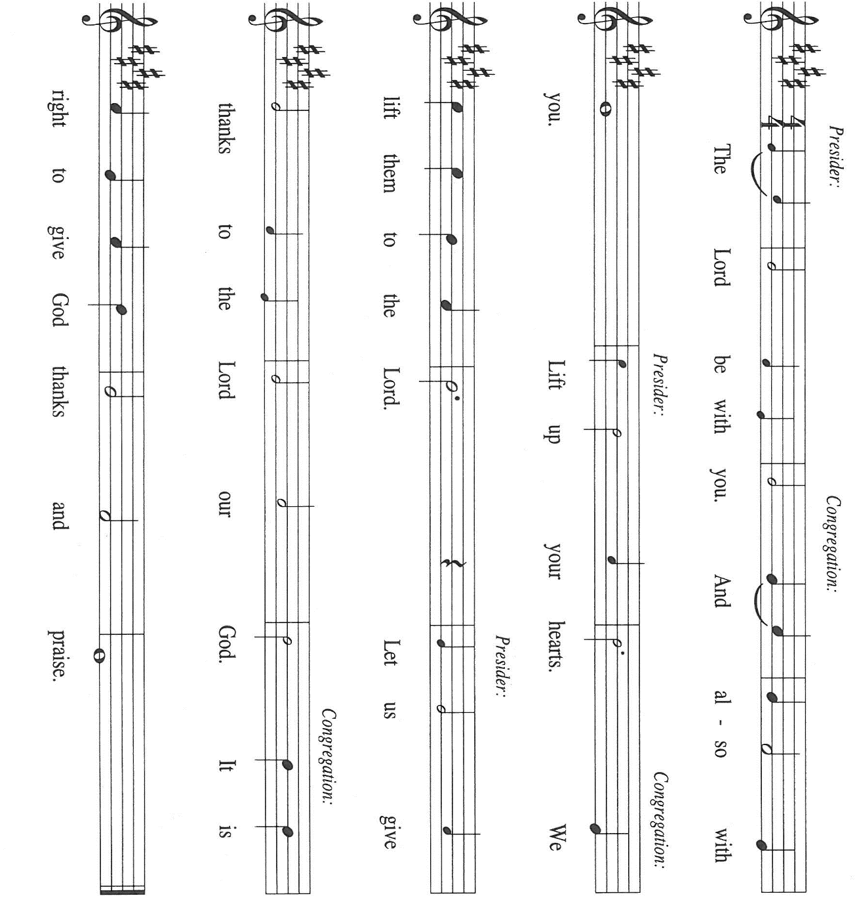

P: It is our duty and delight … join their unending hymn:

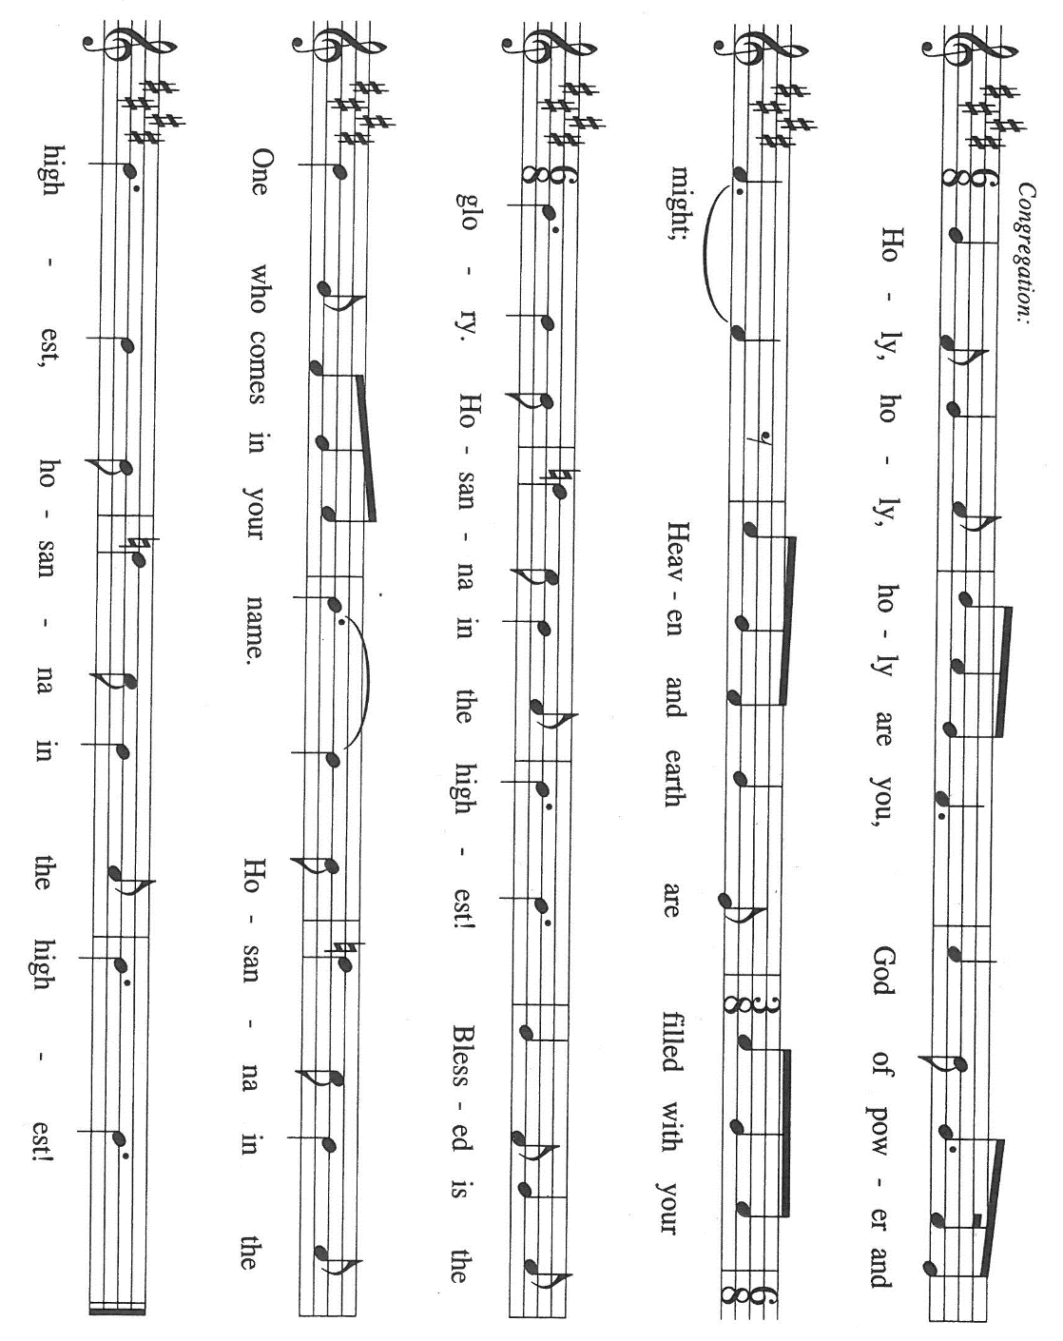

P: Creator God, You made this earth of paths and rocks and thorns and soil.
To Abraham You promised fertile land, and to Moses You offered blessing and
freedom.
In Your prophets You called Your people to cultivate the promises of Your land and
cherish the blessings of Your freedom..
In Jesus You gave us Your superabundant soil.
In His cross He was plowed and broken open, that we might be restored, replenished,
and renewed, to be planted again as Your good seed in this earth.
Come now among us through the power of Your Spirit, that we may be transformed
into Your likeness, and that these gifts of bread and wine may become
for us the Body and Blood of Your Son Jesus Christ,
Who, in the night ... “Do this for the remembrance of Me.”
As often as we eat this bread ... we proclaim the Lord’s death until He comes.

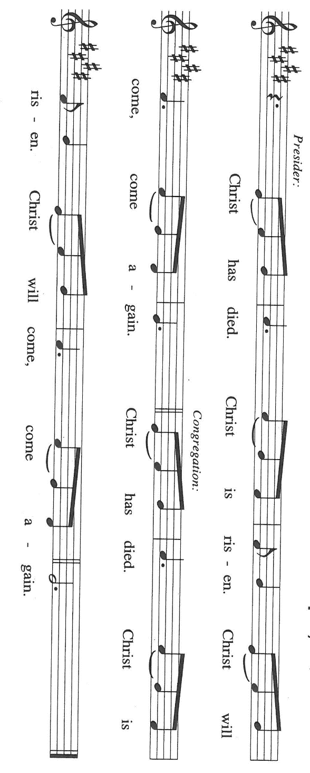

P: Transforming God, where Your children are in the grip of evil and bewilderment,
bring them Your courage and clarity.
Where they are without deep root and facing trouble or persecution, give them
patience and endurance.
When they are burdened by the cares of this world and tempted by the lure of wealth,
offer them wisdom and understanding.
And where they bear fruit and yield, make that fruit so plentiful that it may feed all in
Your world who hunger for faith, for hope, or for love.
Make holy Your groaning creation, that Your universe may breathe Your breath and
be filled with Your life anew,
That we may love what You love and do what You would do,
Father, Son, and Holy Spirit, ever one God.

C: Amen!

THE LORD’S PRAYER

P: Let the good seed of God’s Word bear fruit now as we offer the prayer Jesus taught us
to pray:

C: Our Father, Who art in heaven, hallowed be Thy name.
Thy Kingdom come, Thy will be done on earth as it is in heaven.
Give us this day our daily bread, and forgive us our trespasses as we forgive those
who trespass against us.
And lead us not into temptation, but deliver us from evil.
For Thine is the Kingdom, and the power, and the glory, forever and ever. Amen.

INVITATION TO THE MEAL

P: Behold, the Lamb of God Who takes away the sin of the world. Blessed are those who
are called to the Supper of the Lamb. God’s holy gifts for God’s holy people. Come,
for all is now ready.

The assembly is seated
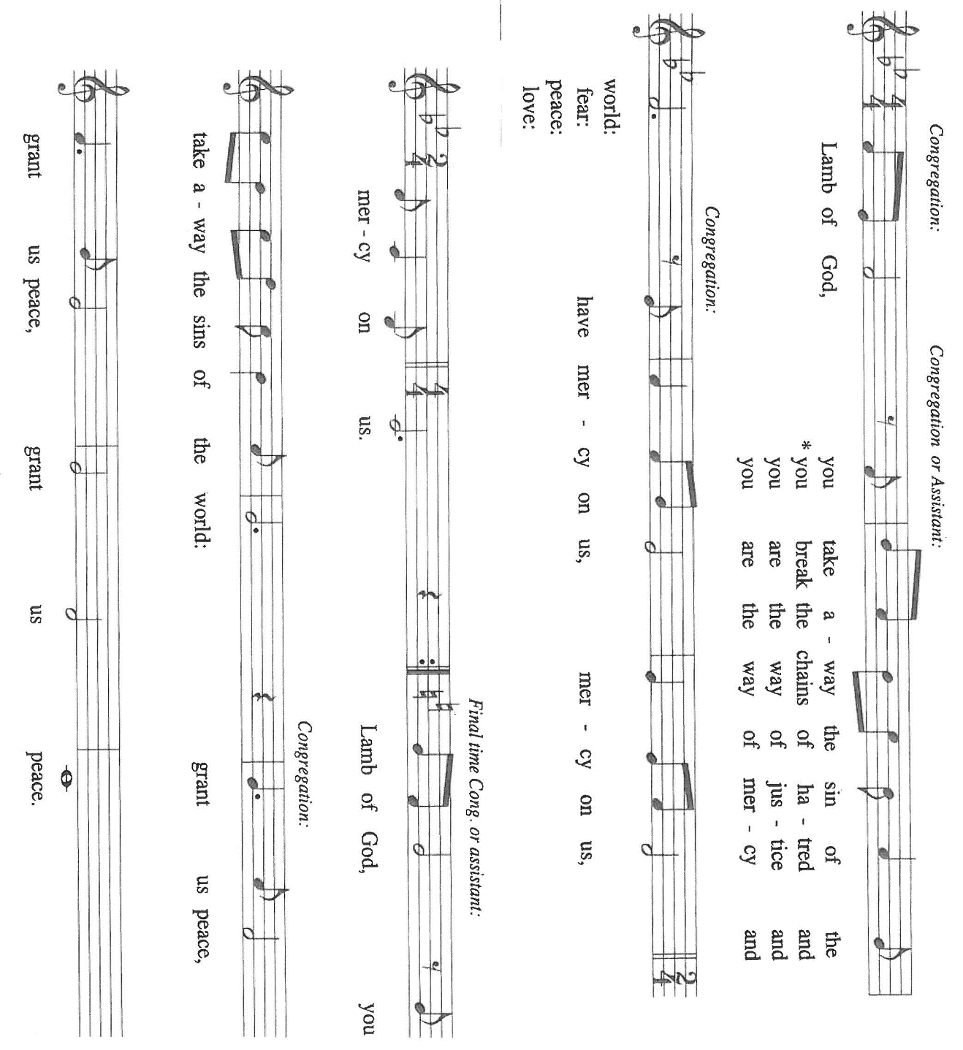
THE DISTRIBUTION Lamb of God

Those who wish to receive the Laying on of Hands, Anointing with Oil, and Prayer for Healing may go to Pastor at each side aisle

HYMN DURING DISTRIBUTION 550 On What Has Now Been Sown

NSB 16 Blessed Be Your Name

NSB 18 Bring Forth The Kingdom

NSB 56 I Offer My Life

ELW 512 Lord, Let My Life Be Good Soil

As you are able please rise

THE POST-COMMUNION BLESSING

P: The Body and Blood of our Lord Jesus Christ strengthen you and keep you in His grace.

C: Amen.

THE POST-COMMUNION PRAYER

A: Let us pray. Lord Jesus, once again You have sown Your Word in us. Make our hearts
and lives receptive to Your grace, help us to hear and understand it, and produce in us
one hundred-fold fruits of obedience to You and service to others. You are the Lord
forevermore.

C: Amen.

SENDING

THE BENEDICTION

P: Almighty God: Father, Son, and Holy Spirit bless you now and forever.

C: Amen.

THE SENDING HYMN 679 For the Fruit of All Creation

THE DISMISSAL

A: Go forth with God’s blessing to love and serve the Lord.

C: Thanks be to God!

POSTLUDE

To God Alone Be Glory

The Meditation is from the Christian Century. (July 18, 1990) 668.

The Prayers, Introduction to the Lord’s Prayer, and Invitation to the Meal are from Prayers
for Sundays and Seasons. Year A. Peter J. Scagnelli. (Chicago: Liturgy Training
Publications, 1998) 98-99.

The musical setting of the liturgy, “Now the Feast and Celebration” by Marty Haugen, is
used by permission of GIA Publishers, Inc. OneLicense.net License #A-702836.

The Eucharistic Prayer is adapted from Eucharistic Prayer. Samuel Wells and Abigail
Kocher. (Grand Rapids:Wm. Eerdmann Publishing Company, 2016) 218-219.

ANNOUNCEMENTS

Please remember to mail your offering to the Church Office at 818 Franklin Street, Michigan City, IN 46360. Another alternative is to give on-line through Tithe.ly. Please see your closure letter for information on how to set up a Tithe.ly account.

St. Paul Members are reminded to have a loved one contact the office if you are hospitalized. Many times, the Pastor doesn’t know someone is in the hospital. If you call and leave a message, please tell us at which hospital the patient is located.

BIRTHDAYS: Bev Johnson (7/20)

ANNVERSARIES: Allen & JoAnne Sydow (7/17); Mchael & Amy Maesch (7/18)

PRAYER CONCERNS: Debbie Martin; Mark Tannehill; Kathy Stein; Jan Paholski; Laura Dovey; Bill Hazelgrove; Al Levenhagen; Carl Wipperman; Major Payne.

OFFICE HOURS: Libby will be in the office on Mondays, Wednesdays, and Fridays; volunteers will cover Tuesdays and Thursdays.

Monday & Wednesday 8:00 a.m. – 5 p.m.
Tuesday & Thursday 9:00 a.m. – 12:00 p.m.
Friday 8:00 a.m. – 12:00 p.m.

If you are listening to the worship broadcast on the radio and would like to watch the Sunday morning service live stream follow these steps:

(1) If you have You Tube available on your TV, search for
St. Paul Lutheran Church Michigan City, IN.

(2) The direct link on the computer is https://
www.youtube.com/channel/UC5AIPNaKr3QN50984jGOa1g

(3) This link is also on the main page of the church’s website in
the church section and will continue to be posted weekly on the St.
Paul Facebook page.

And it will always be available on the radio broadcast Sunday mornings at 11:00 a.m.
on WEFM (95.9), and on the local cable access station #99 for the previous week’s
service on Sundays at 4:00 p.m. and the current service on Wednesdays at 7:00 p.m.
and Fridays at 8:30 p.m.

DON’T FORGET!
Next weekend is our ICE CREAM SOCIAL, Sunday, July 19, 2026 right after the Sunday morning worship service. Anyone who owns one of our 150th Anniversary t-shirts please wear them on Sunday July 19.

To send e-mail to the church office, please use the following addresses:

Pastor Mark Reshan: seniorpastor@stpaulmichigancity.com

Church Office Secretary (Libby Pollock): churchsecretary@stpaulmichigancity.com

Church Treasurer (Karen Fleming): finance@stpaulmichigancity.com

2026 Church Council:

Pastor - Mark Reshan

President - Donna Knoll

Vice President - Jan Bakken

Secretary - Judy Hunt

Treasurer - Karen Fleming

Members: Sue Koziel; Jim Schraidt; Trish Sprague; Bob Kiser; Barry Anderson; and
Pam Soule

Worship Attendance:

Wednesday, July 1, 2026 Organ Concert @12:15 p.m. 56

Sunday, July 5, 2026 @ 9:00 a.m. 67

TOTAL 123

Copies of the minutes from the May 21, 2026 and June 25, 2026 Church Council meetings are on the back table in the upper Narthex. They were approved by the council via email.

The Good News Newsletter: If you have an article or anything you want included in The Good News please send it to the following e-mail address: splcgoodnews@gmail.com. Pastor Pamela Thiede will be using this e-mail address to assemble The Good News each month. The deadline for getting information to Pastor Pamela will be the 20th of each month.

Next week’s lessons are Isaiah 44: 6-8; Psalm 86: 11-17; Romans 8: 12-25; Matthew 13: 24-30, 36-43 for those of you who like to study them in advance.

MISSION OF THE MONTH FOR JULY, 2026
July’s mission of the month will be the Lutheran World Relief Kits. Attached is the order form for people to sponsor kits and place this order form with payment in the offering plate or send to the church office.



2026 Financial Stewardship

Weekly Church Operating Needs (x 2 weeks)
June 27-28 & July 4 -5, 2026: $ 10,989.91

General Fund (including General Memorials): $ 6,310.00

Overage/Shortage: — $ 4,679.91

Restricted Income (not including Memorials)
Supports IK Synod & Church wide Ministries: $ 88.50

Ministries in our Community/Congregation: $ 385.00

Capital Fund: $ 89.50

PLEASE NOTE

During the month of July, the front doors of the church (those doors facing Franklin Street) will be open on Wednesdays to invite new visitors in to hear the organ concert. Any Wednesday, at your choosing, at 11:30 a.m. Concerts begin at 12:15 p.m. Please come and help us greet visitors. Your help is appreciated.

ACTIVITIES, EVENTS & MEMORIALS
JULY 2026

Sunday, July 5, 2026 @ 9:00 a.m. 6 Pentecost Worship Service/Sanctuary;
with coffee after
Wednesday, July 8, 2026 @ 10:00 a.m. God’s Purls/St. Paul Room
@12:15 p.m. Organ Concert Summer Series/Sanctuary
Saturday, July 11, 2026 @ 4:00 p.m. 7 Pentecost Worship Service

Sunday, July 12, 2026 @ 9:00 a.m. 7 Pentecost Worship Service/Sanctuary
to include the Baptism of Maggie Louise Brooks; with coffee after
Monday, July 13, 2026 @ 1:00 p.m. Hope Circle
Wednesday, July 15, 2026 @ 10:00 a.m. God’s Purls/St. Paul Room
@ 10:00 a.m. – 9:00 p.m. GIVE BACK @ 5 GUYS
@12:15 p.m. Organ Concert Summer Series/Sanctuary
Saturday, July 18, 2026 @ 4:00 p.m. 8 Pentecost Worship Service

Sunday, July 19, 2026 @ 9:00 a.m. 8 Pentecost Worship Service/Sanctuary
with coffee after @ 10:30 a.m. ICE CREAM SOCIAL/St. Paul Room
Wednesday, July 22, 2026 @ 10:00 a.m. God’s Purls/St. Paul Room
@ 12:15 p.m. Organ Concert Summer Series/Sanctuary
Saturday, July 25, 2026 9 Pentecost Worship Service/Sanctuary

Sunday, July 26, 2026 @ 9:00 a.m. 9 Pentecost Worship Service/Sanctuary;
with coffee after
Wednesday, July 29, 2026 @ 10:00 a.m. God’s Purls/St. Paul Room
@ 12:15 p.m. Organ Concert Summer Series/Sanctuary

Thank$ for $haring
Thank you to all who participate in our Give-Back opportunities each month. On Wednesday, July 15, 2026 from 10:00 a.m. —9:00 p.m. we’ll be meeting at 5 Guys Restaurant for our GIVE BACK for July. Here are two coupons. One for you and one for a friend.

