**THE FOURTH SUNDAY IN LENT**

**March 30, 2025**

“ ...It is usual, when expounding the word *metanoéein* (repent), to go about the job etymologically. Since the word is a compound of *metá* (after) and *noéein* (think), its root meaning is to change one’s mind or, better said, to change one’s heart about one’s sins.

That approach, however, does not work well here. Neither the lost coin nor the lost sheep was capable of any repentance at all. The entire cause of the recovery operation in both stories is the shepherd’s, or the woman’s, determination to find the lost. Neither the lost sheep nor the lost coin does a blessed thing except hang around in its lostness. On the strength of (these parables) therefore, it is precisely our sins, and not our goodness, that most commend us to the grace of God ...”

“ ...These parables of lostness, therefore, are far from being exhortations to repentance. They are emphatically not stories designed to convince us that if we will wind ourselves up to some acceptable level or moral and/or spiritual improvement, God will *then* forgive us; rather they are parables about God’s determination to move *before* we do–in short, to make lostness and death the only tickets we need to the Supper of the Lamb ...”

“ ...Neither the lostness, nor the deadness, or the repentance is in itself redemptive; God alone gives life, and he gives it freely and fully on no conditions whatsoever. These stories, therefore, are parables of grace and grace only. There is in them not one single note of earning or merit, not one breath about rewarding the rewardable, correcting the correctible, or improving the improvable.

There is only the gracious, saving determination of the shepherd, the woman, and the father–all surrogates for God–*to raise the dead.*”

**Robert Farrar Capon**

“Kathy, I’m lost,” I said, though I knew she was sleeping.

“I’m empty and aching and I don’t know why.”

**Paul Simon, “America”**

**✠** ***In the Name of Jesus* ✠**

**INTRODUCTION**

*The message of the cross offers power to the church in the days of Lent. As the sign of the cross is traced over us, we are not ashamed of its cruelty and humiliation, but strengthened by its liberating force. In baptism, we were marked with the cross. In death, we will be blessed with its power. Between birth and death, the cross is God's sign of mercy and forgiveness.*

**Hans Nielsen Hauge, renewer of the church, died 1824**

*Hauge was a layperson who wished to revitalize the church in Norway. As a result of a mystical experience, he felt called to preach. Many professionals in the church feared his motives and influence, and he was imprisoned for leading unauthorized gatherings.*

**✠ GATHERING ✠**

**PRELUDE**

**ANNOUNCEMENTS**

*As you are able please rise*

**CONFESSION AND ABSOLUTION**

P: In the name of the Father, and of the **✠** Son, and of the Holy Spirit.

**C: Amen.**

P: “Now all the tax collectors and sinners were coming near to listen to Him. And the Pharisees

and scribes were grumbling and saying, ‘This fellow welcomes sinners and eats with them.’”

(Luke 15: 1-2) Jesus invites us to come near so that He might welcome us back into His

forgiveness. Come, let us return to the Lord and confess our sinfulness.

*Silence for self-examination and reflection is kept*

P: Our sin against heaven and against You, our abuse of Your generosity, and our foolish use of

Your good gifts, we confess to You, O Lord:

**C: Lord, have mercy.**

P: Our waste of the treasures You have given us, our greed and selfishness with the talents we

have received, and our use of Your mercies for our own good instead of for Your glory, we

confess to You, O Lord:

**C: Lord, have mercy.**

P: Our hurtful ways toward each other, our slowness to forgive and our refusal to seek

reconciliation, we confess to You, O Lord:

**C: Lord, have mercy.**

P: Almighty God grant us true repentance, and Your Holy Spirit, that we may return to You and

be forgiven.

**C: Amen.**

**GATHERING HYMN 807 *Come, Thou Fount of Every Blessing***

**THE GREETING**

P: The grace of our Lord Jesus Christ, the love of God, and the communion of the Holy Spirit be

with you all.

**C: And also with you.**

**THE KYRIE**

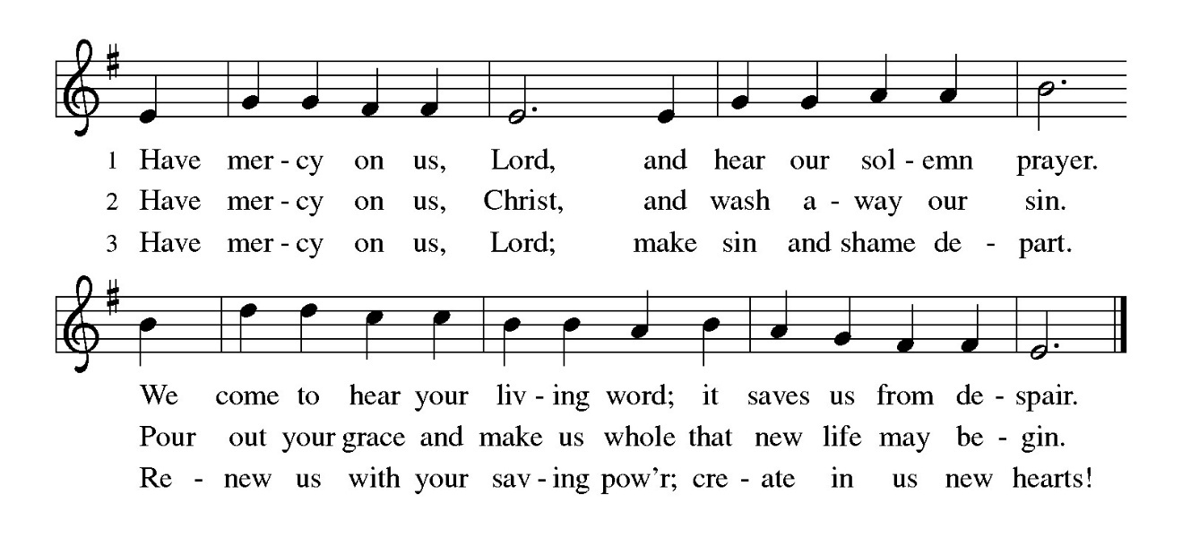

**THE PRAYER OF THE DAY**

P: The Lord be with you.

**C: And also with you.**

P: Let us pray. God of compassion, You welcome the wayward, and You embrace us all with

Your mercy. By our Baptism clothe us with garments of Your grace, and feed us at the table

of Your love, through Your Son, Jesus Christ, our Savior and Lord, Who lives and reigns with

You and the Holy Spirit, one God, now and forever.

**C: Amen.**

*The assembly is seated*

**✠ WORD ✠**

**FIRST READING Joshua 5 : 9-12**

*By celebrating the Passover and eating the produce of the promised land, instead of the miraculous manna that had sustained them in the desert, the Israelites symbolically bring their forty years of wilderness wandering to an end at Gilgal.*

9The Lord said to Joshua, "Today I have rolled away from you the disgrace of Egypt." And so that place is called Gilgal to this day.

10While the Israelites were camped in Gilgal they kept the passover in the evening on the fourteenth day of the month in the plains of Jericho. 11On the day after the passover, on that very day, they ate the produce of the land, unleavened cakes and parched grain. 12The manna ceased on the day they ate the produce of the land, and the Israelites no longer had manna; they ate the crops of the land of Canaan that year.

The Word of the Lord.

**Thanks be to God.**

**THE PSALM: Psalm 32** **Antiphon by Thomas Keesecker**

Choir sings refrain first, followed immediately by the congregation

and as indicated

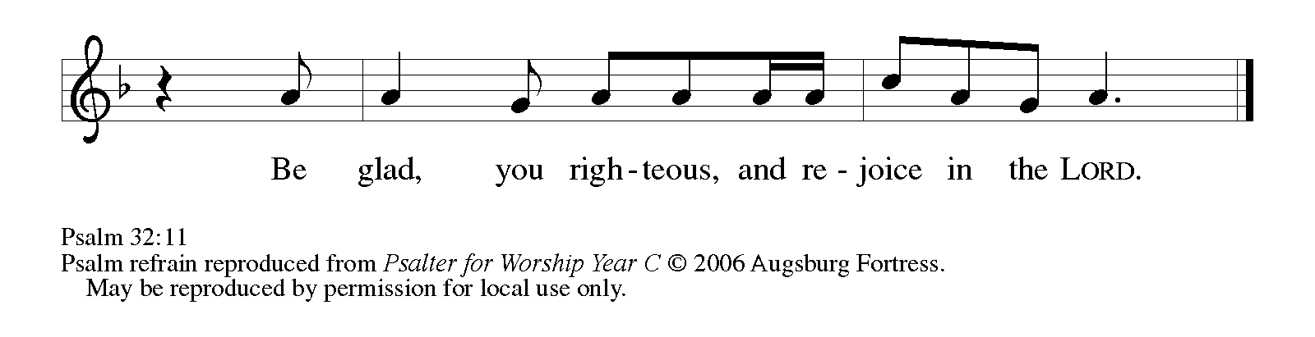

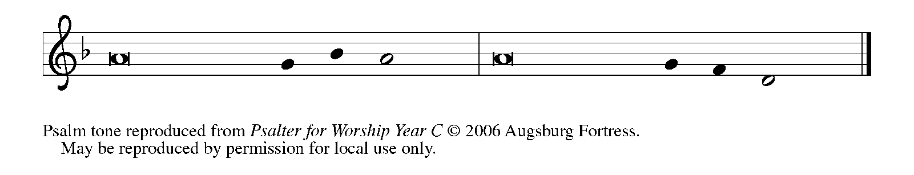

1Happy are they whose transgressions | are forgiven,

     and whose sin is | put away!

**2Happy are they to whom the LORD im- | putes no guilt,**

**and in whose spirit there | is no guile!   REFRAIN**

3While I held my tongue, my bones with- | ered away,

     because of my groaning | all day long.

**4For Your hand was heavy upon me | day and night;**

**my moisture was dried up as in the | heat of summer.**

5Then I acknowledged my sin to You, and did not con- | ceal my guilt.

     I said, "I will confess my transgressions to the LORD." Then You forgave me the guilt | of my sin.

**6Therefore all the faithful will make their prayers to You in | time of trouble;**

**when the great waters overflow, they | shall not reach them.   REFRAIN**

7You are my hiding-place; You preserve | me from trouble;

     You surround me with shouts | of deliverance.

**8"I will instruct you and teach you in the way that | you should go;**

**I will guide you | with My eye.**

9Do not be like horse or mule, which have no | understanding;

     who must be fitted with bit and bridle, or else they will | not stay near you."

**10Great are the tribulations | of the wicked;**

**but mercy embraces those who trust | in the LORD.**

11Be glad, you righteous, and rejoice | in the LORD;

     shout for joy, all who are | true of heart.   **REFRAIN**

**SECOND READING 2 Corinthians 5: 16-21**

*In Jesus' death on the cross God works to persuade us of divine love that we might be reconciled to God. As new creations, we are challenged to share with others the good news of our reconciled relationship to God.*

16From now on, therefore, we regard no one from a human point of view; even though we once knew Christ from a human point of view, we know Him no longer in that way. 17So if anyone is in Christ, there is a new creation: everything old has passed away; see, everything has become new! 18All this is from God, who reconciled us to Himself through Christ, and has given us the ministry of reconciliation; 19that is, in Christ God was reconciling the world to Himself, not counting their trespasses against them, and entrusting the message of reconciliation to us.

20So we are ambassadors for Christ, since God is making His appeal through us; we entreat you on behalf of Christ, be reconciled to God. 21For our sake He made Him to be sin who knew no sin, so that in Him we might become the righteousness of God.

The Word of the Lord.

**Thanks be to God.**

*As you are able please rise*

**THE VERSE**

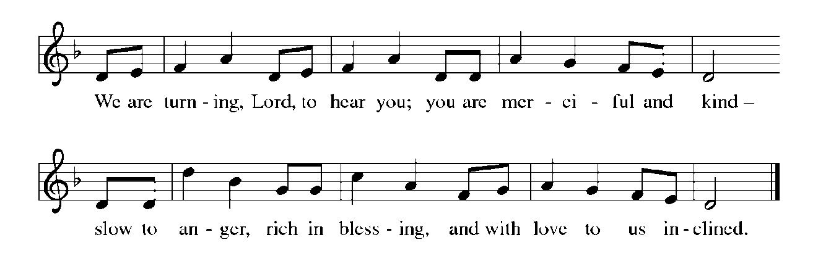

**THE HOLY GOSPEL Luke 15: 1-32**

*The inclusive character of Jesus' ministry is embarrassing, if not disconcerting, to many religious people--in Jesus' time and in the present. In three famous parables, Jesus likens this attitude to jealousy at what ought to be a joyous family reunion.*

P: The Holy Gospel according to St. Luke, the fifteenth chapter.

**C: Glory to You, O Lord!**

1Now all the tax collectors and sinners were coming near to listen to Jesus. 2And the Pharisees and the scribes were grumbling and saying, "This fellow welcomes sinners and eats with them."

3So He told them this parable: 4 "Which one of you, having a hundred sheep and losing one of them, does not leave the ninety-nine in the wilderness and go after the one that is lost until he finds it? 5 When he has found it, he lays it on his shoulders and rejoices. 6 And when he comes home, he calls together his friends and neighbors, saying to them, 'Rejoice with me, for I have found my sheep that was lost.' 7 Just so, I tell you, there will be more joy in heaven over one sinner who repents than over ninety-nine righteous persons who need no repentance.

8 "Or what woman having ten silver coins, if she loses one of them, does not light a lamp, sweep the house, and search carefully until she finds it? 9 When she has found it, she calls together her friends and neighbors, saying, 'Rejoice with me, for I have found the coin that I had lost.' 10 Just so, I tell you, there is joy in the presence of the angels of God over one sinner who repents."

11 Then Jesus said, "There was a man who had two sons. 12The younger of them said to his father, 'Father, give me the share of the property that will belong to me.' So he divided his property between them. 13A few days later the younger son gathered all he had and traveled to a distant country, and there he squandered his property in dissolute living. 14When he had spent everything, a severe famine took place throughout that country, and he began to be in need.

15So he went and hired himself out to one of the citizens of that country, who sent him to his fields to feed the pigs. 16He would gladly have filled himself with the pods that the pigs were eating; and no one gave him anything. 17But when he came to himself he said, 'How many of my father's hired hands have bread enough and to spare, but here I am dying of hunger! 18I will get up and go to my father, and I will say to him, "Father, I have sinned against heaven and before you; 19I am no longer worthy to be called your son; treat me like one of your hired hands." '

20So he set off and went to his father. But while he was still far off, his father saw him and was filled with compassion; he ran and put his arms around him and kissed him. 21Then the son said to him, 'Father, I have sinned against heaven and before you; I am no longer worthy to be called your son.' 22But the father said to his slaves, 'Quickly, bring out a robe--the best one--and put it on him; put a ring on his finger and sandals on his feet. 23And get the fatted calf and kill it, and let us eat and celebrate; 24for this son of mine was dead and is alive again; he was lost and is found!' And they began to celebrate.

25"Now his elder son was in the field; and when he came and approached the house, he heard music and dancing. 26He called one of the slaves and asked what was going on. 27He replied, 'Your brother has come, and your father has killed the fatted calf, because he has got him back safe and sound.'

28Then he became angry and refused to go in. His father came out and began to plead with him. 29But he answered his father, 'Listen! For all these years I have been working like a slave for you, and I have never disobeyed your command; yet you have never given me even a young goat so that I might celebrate with my friends. 30But when this son of yours came back, who has devoured your property with prostitutes, you killed the fatted calf for him!'

31Then the father said to him, 'Son, you are always with me, and all that is mine is yours. 32But we had to celebrate and rejoice, because this brother of yours was dead and has come to life; he was lost and has been found.' "

P: The Gospel of the Lord.

**C: Praise to You, O Christ!**

*The assembly is seated*

**THE SERMON**

*Silence for reflection follows the sermon*

*As you are able please rise*

**THE HYMN OF THE DAY 779 *Amazing Grace***

**THE NICENE CREED**

A: God has made us His people through our Baptism into Christ. Living together in trust and

hope, we confess our faith.

**C: We believe in one God,**

**the Father, the Almighty,**

**maker of heaven and earth,**

**of all that is, seen and unseen.**

**We believe in one Lord, Jesus Christ,**

**the only Son of God,**

**eternally begotten of the Father,**

**God from God, Light from Light,**

**true God from true God,**

**begotten, not made,**

**of one Being with the Father.**

**Through Him all things were made.**

**For us and for our salvation**

**He came down from heaven;**

**by the power of the Holy Spirit**

**He became incarnate from the virgin Mary, and was made man.**

**For our sake He was crucified under Pontius Pilate;**

**He suffered death and was buried.**

**On the third day He rose again**

**in accordance with the Scriptures;**

**He ascended into heaven**

**and is seated at the right hand of the Father.**

**He will come again in glory to judge the living and the dead,**

**and His kingdom will have no end.**

**We believe in the Holy Spirit, the Lord, the giver of life,**

**Who proceeds from the Father and the Son.**

**With the Father and the Son He is worshiped and glorified.**

**He has spoken through the prophets.**

**We believe in one holy catholic and apostolic Church.**

**We acknowledge one Baptism for the forgiveness of sins.**

**We look for the resurrection of the dead,**

**and the life of the world to come. Amen**

**THE PRAYER OF THE CHURCH**

A: As we mark these forty days with repentance and forgiveness, let us with humility bring the

concerns of the Church and of our lives before God’s care.

A: For the Church, God’s new creation in Christ, that we may be faithful ambassadors for Christ,

making God’s appeal for reconciliation with compassion and joy, let us pray to the Lord:

**C: Lord, have mercy.**

A: For those preparing for Baptism, that they may be guided by and into God’s own truth and life,

let us pray to the Lord:

**C: Lord, have mercy.**

A: For an end to terrorism and violence, warfare and bloodshed, especially in Ukraine, and for the

safety of our military personnel stationed around the world, especially **Blake Waltz and**

**Katreen Somers,** let us pray to the Lord:

**C: Lord, have mercy.**

A: For this congregation, that we may be a safe place of relief and hope for those who are lost and

seeking their way to God, let us pray to the Lord:

**C: Lord, have mercy.**

A: For the sick, especially: **Martha Schroeder; Carol Radke; Judy Gustum; Joyce Stark;**

**Russ Fischer; Jess Kalvaitis; Debbie Martin; and Christine Kiser** that they might be

delivered from their pain and distress, let us pray to the Lord:

**C: Lord, have mercy.**

A:  For those who mourn, especially the family and friends of **Charles Ponder, Sr.,** who

died in the Lord this week, that they may be comforted by the promise of resurrec-

tion to life everlasting and of being reunited with those they love before the throne

of the Lamb, let us pray to the Lord:

**C: Lord, have mercy.**

A: For those celebrating birthdays, especially **Jana Thomas,** that they may be filled with grace

this day and every day and grow in grace in the days ahead, let us pray to the Lord:

**C: Lord, have mercy.**

A: That with all the faithful departed, especially **Hans Nielsen Hauge, renewer of the Church,**

whom we commemorate this Day we might celebrate the new creation that is ours in Christ

Jesus, let us pray to the Lord:

**C: Lord, have mercy.**

P: God of mercy and compassion, bring us back to You when we stray, and give us again the joy

of proclaiming among the nations Your saving deeds. We ask this through Christ our Lord.

**C: Amen.**

**✠ MEAL ✠**

**THE PEACE**

P: Through Christ we have been reconciled to God, Who has given us the ministry of

reconciliation. Let us be reconciled with one another.

The peace of the Lord be with you always.

**C: And also with you.**

*The assembly is seated*

**THE OFFERING**

**THE VOLUNTARY *Softly and Tenderly Calling* St. Paul Senior Choir**

**(Arr. P. Drennan)**

*As you are able please rise*

**THE PRESENTATION OF THE GIFTS**

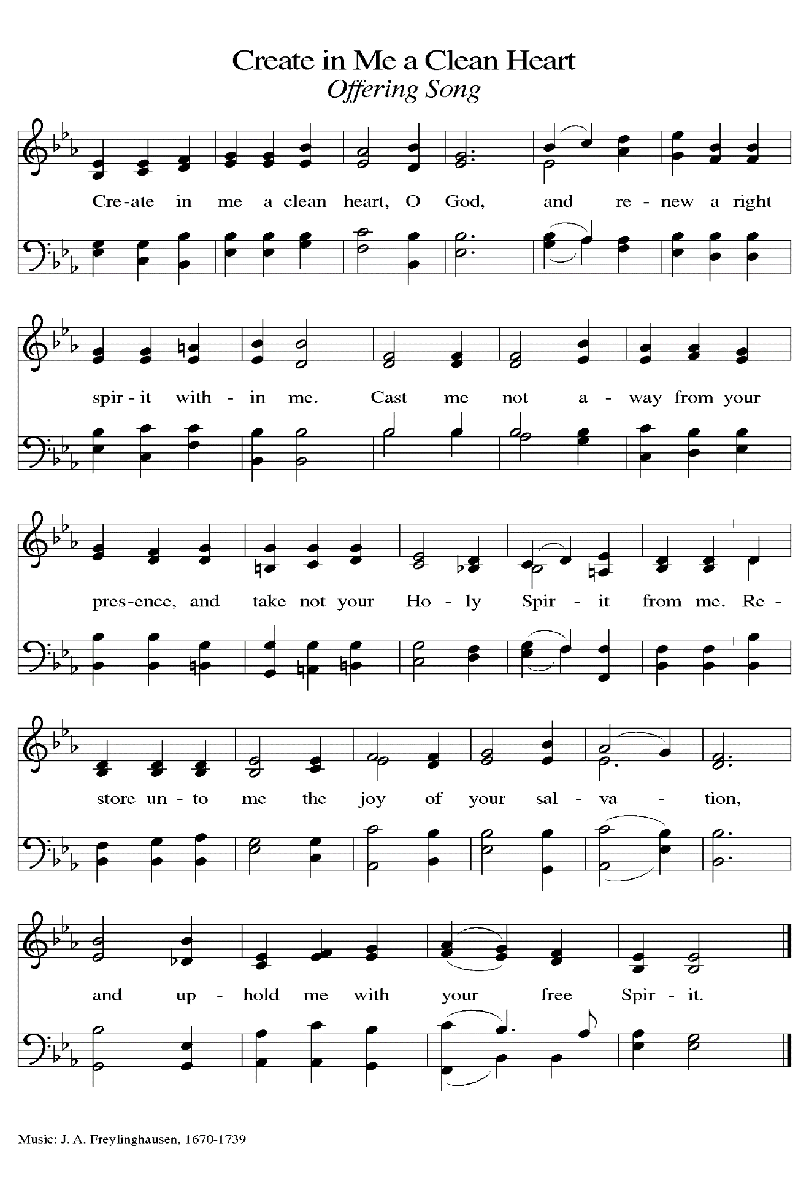

**THE OFFERTORY PRAYER**

A: Let us pray. God of mercy,

**C: Your Word calls us home to forgiveness, and to hope in Your abundant compassion.**

**Accept these gifts we offer You this Day, and fill us with joy as we are found again at**

**Your lavish Feast. We ask this in the name of Jesus the Lord. Amen.**

**THE GREAT THANKSGIVING**

P: The Lord be with you.

**C: And also with you.**

P: Lift up your hearts.

**C: We lift them up to the Lord.**

P: Let us give thanks to the Lord our God.

**C: It is right to give Him thanks and praise.**

P: It is indeed right, our duty, and our joy …join their unending hymn:

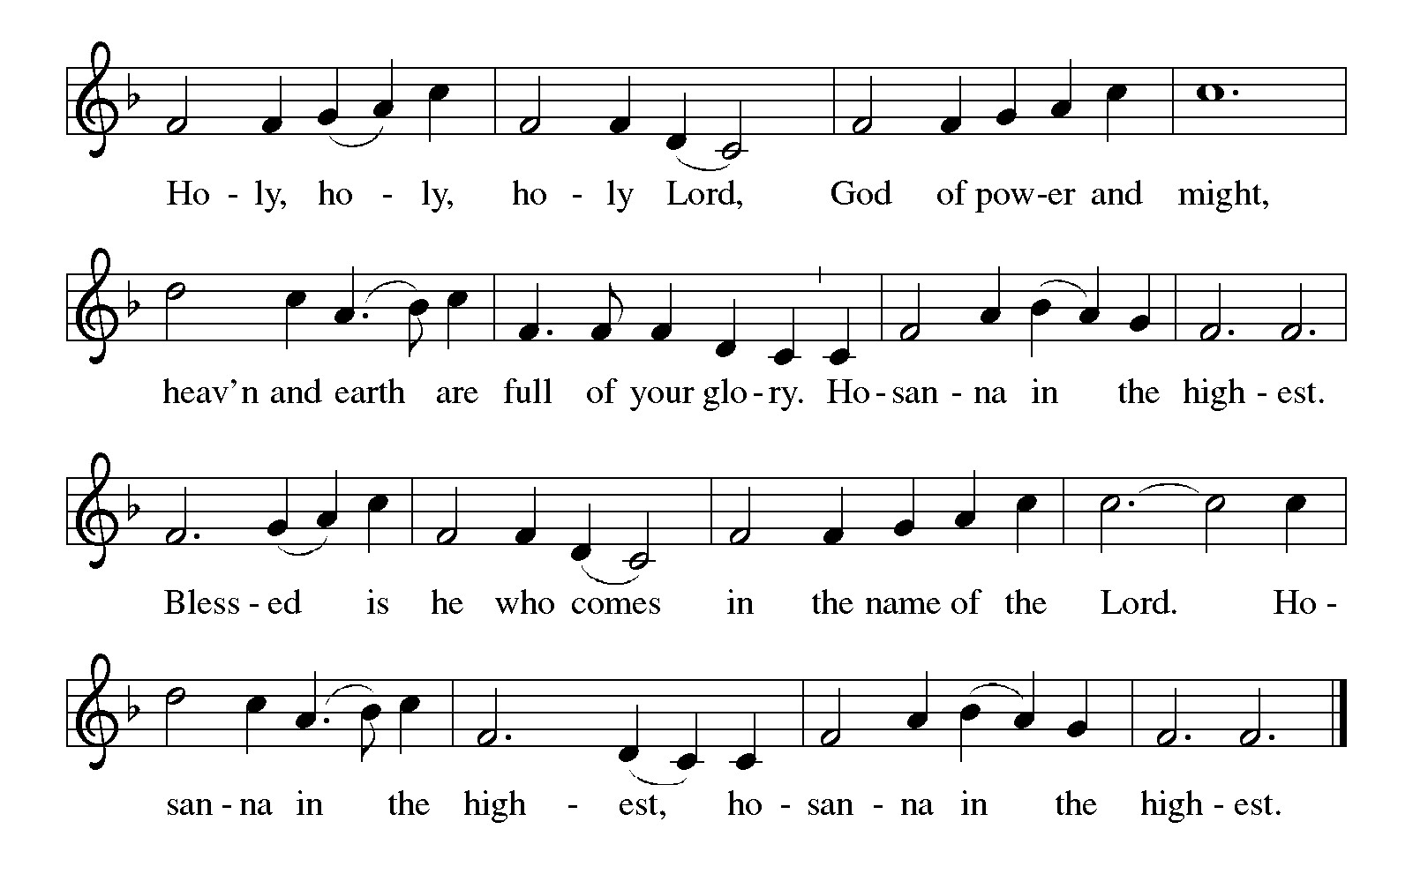

P: God of grace, You lift our hearts because, though we squandered Your abundant gifts,

You waited for us to turn back to You; and though we hardened our hearts to

Your mercy, You came to find us and draw us home to Your Banquet.

In Christ You made the journey into the far country of our exile from You, and in His

death and resurrection You justify us and make us holy to stand in Your

presence and be reunited with Your grace.

God of blessing, You are the host for our joy; in Christ You have made every preparation

for this Fast, even giving Your own Body that we might never be hungry again.

Send down Your Holy Spirit, that we may once again belong to Your house as Your

sons and daughters, and that these signs of sustaining bread and renewing wine

may be for us the Body and Blood of Your Son, Jesus Christ,

Who, in the night ... “Do this for the remembrance of Me.”

As often as we eat ... we proclaim the Lord’s death until He comes.

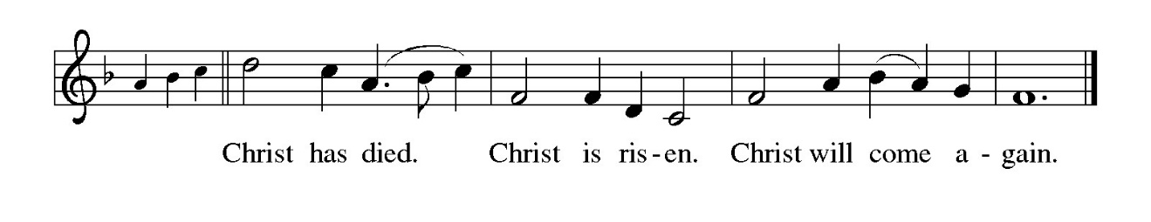

P: Gathering God, when we languish in a humiliation of our own make, may this broken

Body heal, restore, and renew our bodies.

When we lurk in the shadows in a resentment of our own devising, may this shed Blood

soften and cleanse and refresh our hearts.

Strengthen our hands, that we may seek a world where there is no hunger except for You.

Empower our spirits, that we may strive for a world where there is no thirst except for

Your righteousness.

Hasten the Day when this Body shows us Your desire for our well-being, and this Blood

reveals how far You will go to save us from ourselves and restore us in the image

of Your Son,

Through Whom, and with Whom, and in Whom all honor and glory are Yours, now and

forever.

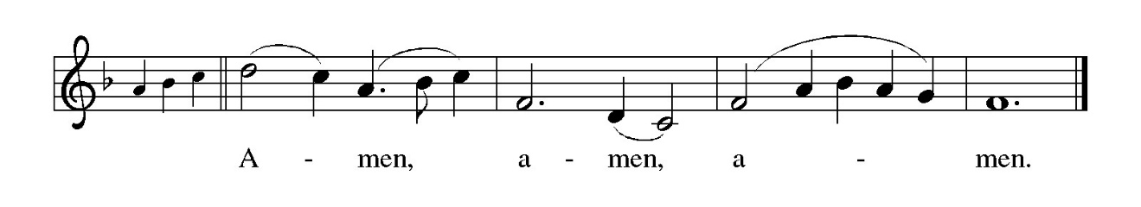

**THE LORD’S PRAYER**

P: Baptized into Christ’s death that we might share in the resurrection, let us pray for the

fulfillment of the mystery as Jesus taught us:

**C: (Sung) Music is on the front cover of the red hymnal**

**INVITATION TO THE MEAL**

P: Behold the Servant of God, obedient unto death on a cross, highly exalted as Lord of glory.

Blessed are those who are called to the banquet of the Lamb. God’s holy gifts for God’s holy

people. Come, for all is now ready.

*The assembly is seated*

**THE DISTRIBUTION**

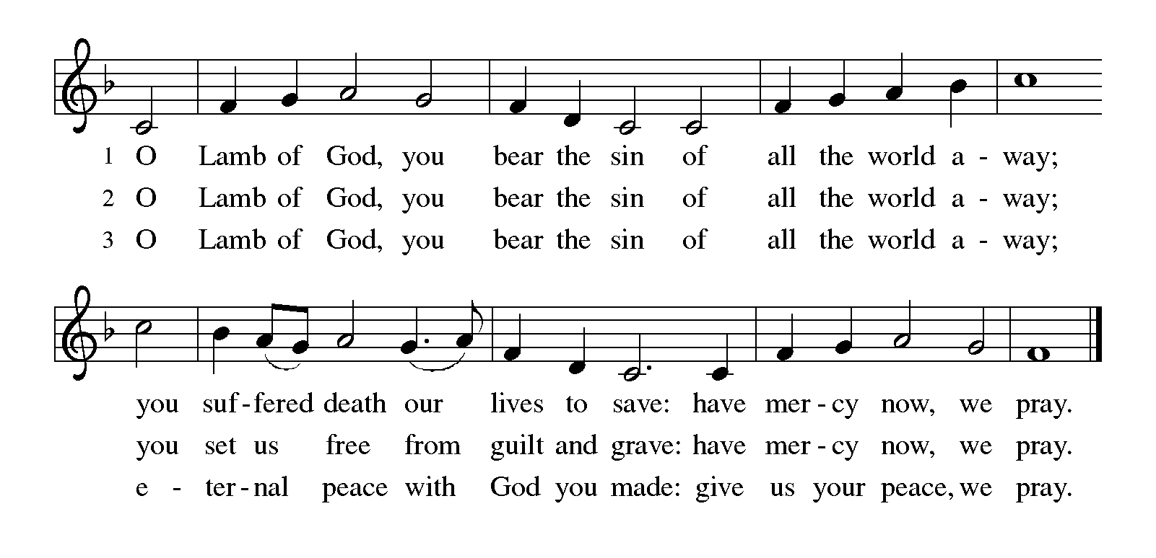

**HYMN DURING DISTRIBUTION 606 *Our Father, We Have Wandered***

**ELW 608 *Softly and Tenderly***

**NSB 6 *Amazing Love***

**NSB 104 *You Are My Hiding Place***

*As you are able please rise*

**THE POST COMMUNION BLESSING**

P: The Body and Blood of our Lord Jesus Christ strengthen you and keep you in His grace.

**C: Amen.**

**THE POST-COMMUNION PRAYER**

A: Let us pray. God our Father, in this Feast You forgive us and welcome us again into Your love.

Strengthen us through this Food from heaven that we may live in the joy and hope of the Gospel

until we come to Your great and final Feast of love. Grant this through Christ our Lord.

**C: Amen.**

**✠ SENDING ✠**

**THE BENEDICTION**

P: Jesus took the form of a servant and was obedient to death, even death on a cross. May you

follow His example and share in the resurrection.

**C: Amen.**

P: Almighty God: Father, Son **✠** and Holy Spirit bless you now and forever.

**C: Amen.**

**SENDING SONG NSB 90 *‘Tis So Sweet to Trust in Jesus***

**THE DISMISSAL**

A: Reconciled to God through Christ, let us go out into the world in peace.

**C: Thanks be to God!**

**THE POSTLUDE**

**✠  *To God Alone Be Glory* ✠**

The Meditation is from *The Parables of Grace.* Robert Farrar Capon. (Grand Rapids: Eerdmanns

Publishing Company, 1988) 38-39.

**ANNOUNCEMENTS**

**Please remember to mail your offering to the Church Office** at 818 Franklin Street, Michigan City, IN 46360**.** Another alternative is to give on-line through Tithe.ly. Please see your closure letter for information on how to set up a Tithe.ly account.

**St. Paul Members are reminded to have** a loved one contact the office if you are hospitalized. Many times, the Pastor doesn’t know someone is in the hospital. If you call and leave a message, please tell us which hospital the patient is at.

**Birthdays: Jana Thomas (4/1); Marge Bockover (4/1); Sarah McNabb (4/3)**

**PRAYER CONCERNS:** Pope Francis, Ken Mulder, Larry Litchford, Sarah McNabb, Carol Radke, Jeanie Boatman Shepple, Nolan Wilson, Debbie Martin, Mark Tannehill, Brian Wiseman, Kathy Stein, Danielle Schnell, Jan Paholski, Laura Dovey, and Grace

Romine.

**OFFICE HOURS:** Libby will be in the office on Mondays, Wednesdays, and Fridays; volunteers will cover Tuesdays and Thursdays.

Monday & Wednesday 8:00 a.m. – 5 p.m.

Tuesday & Thursday 9:00 a.m. – 12:00 p.m.

Friday 8:00 a.m. – 12:00 p.m.

**If you are listening to the worship broadcast on the radio and would like to watch the Sunday morning service live stream follow these steps:**

(1) If you have You Tube available on your TV, search for

**St. Paul Lutheran Church Michigan City, IN.**

(2) The direct link on the computer is

https://www.youtube.com/channel/UC5AIPNaKr3QN50984jGOa1g.

   (3) This link is also on the main page of the church’s website in

the church section and will continue to be posted weekly on the St.

Paul Facebook page.

And it will always be available on the radio broadcast Sunday mornings at 11:00 a.m.

on WEFM (95.9), and on the local cable access station #99 for the previous week’s

service on Sundays at 4:00 p.m. and the current service on Wednesdays at 7:00 p.m.

and Fridays at 8:30 p.m.

**Next Sunday’s lessons are Isaiah 43: 16-21; Psalm 126; Philippians 3: 4b-14; John12: 1-8** for those of you who like to study them in advance.

**To send e-mail to the church office**, please use the following addresses:

Pastor Mark Reshan: seniorpastor@stpaulmichigancity.com

Church Office Secretary (Libby Pollock): churchsecretary@stpaulmichigancity.com

Church Treasurer (Karen Fleming): finance@stpaulmichigancity.com

**The Good News Newsletter**: If you have an article or anything you want included in **The Good News** please send it to the following e-mail address: splcgoodnews@gmail.com. Pastor Pamela Thiede will be using this e-mail address to assemble **The Good News** each month. The deadline for getting information to Pastor Pamela will be the 20th of each month.

**Worship Attendance:**

**Wednesday, March 19, 2025 @ 6:00 p.m. 29**

**Saturday , March 22, 2025 @ 4:00 p.m. 26**

**Sunday, March 23, 2025 @ 9:00 a.m. 75**

**TOTAL 130**

**Copies of the minutes from the January 23, 2025 and February 27, 2025 Church Council meetings are on the back table in the upper Narthex. They were approved by the council via email.**

**FYI:**

In response to the ever rising costs for postage we will be putting your copy

of the “Good News” in your hanging file folder in the narthex each month

from now on. Those of you who are unable to attend services on a regular

basis may still receive your copies through your email address or in the

U.S. mail. If you normally receive your copy of the newsletter via your

email address anyway, nothing will change for you. Thank you so much for

your understanding and cooperation!

**MISSION OF THE MONTH FOR MARCH 2025:**

We will be supporting The Social and Learning Institute as our Mission of the Month for March. The Institute has been serving LaPorte County since 1976 by helping individuals with developmental disabilities expand their minds, learn important life skills and recognize their worth through a structured balance of socialization and learning activities. If you would like to make a monetary donation, please make checks out to St. Paul and mark it for the March mission and place in the offering plate. Noisy coin offering will also go to support the monthly mission. The Institute also has an Amazon wish list of classroom supplies. When ordering from the wish list, select Abby Hinsch LaPorte, IN as the shipping address and items will be delivered directly to the Institute. If you prefer to shop in person, items can be placed in the bin in the Narthex.

**Wishlist URL (also available on our Facebook page; note: the last 3 characters are zero f zero):** [**https://shorturl.at/xg0f0**](https://shorturl.at/xg0f0)

**Items needed:**

**Personal Care:** Facial tissues w/ lotion, 2-ply toilet paper, band aids, first aid kits

**Cleaning**: Sweeper wet mopping pad refills, Lysol disinfectant spray or wipes, 30 gallon and kitchen sized drawstring trash bags, nitrile gloves

**Games/Toys:** Magnatiles, board games, stress balls or squishy toys, Montessori learning toys, sensory toys

**Classroom:** Colored cardstock, construction paper, crayons, Elmer’s liquid glue or glue sticks, retractable permanent markers, Post-it pop up notes, bulletin board supplies (paper, boarders, letters, mounting tape)

**MISSION OF THE MONTH FOR APRIL 2025**

April Monthly Mission: Michigan City Area Schools. We will be collecting money to support different projects in various elementary schools in Michigan City through Donors Choose. Donors Choose provides a list of teacher-led classroom projects that need funding, Flexible seating, bubbling fish tubes, classroom supplies, Tinker Tar guitars, and a kid wash for field day are some of the options we can provide to our elementary schools. Please consider donating to help fund our local teachers’ classroom projects! Checks can be written to St. Paul and can be marked for MCAS and placed in the offering plate. Noisy coin offering will also support the mission of the month. To see a full list of projects, visit [www.donorschoose.org](http://www.donorschoose.org) and search for Michigan City.

**ACTIVITIES, EVENTS & MEETINGS**

**APRIL 2025**

**Tuesday,** April 1, 2025 @ 10:00 a.m. Altar Guild Meeting/Green Room

**Wednesday,** April 2, 2025 @ 9:15 a.m. Bible Study/ Luther House

@10:00 a.m. God’s Purls/St. Paul Room

@ 4:30 p.m. Choir Rehearsal/Sanctuary

@6:00 p.m. 5th Lenten Service

**Thursday,** April 3, 2025 Faith Circle

**@ 4:00 p.m. – 10:00 p.m. GIVE BACK at Galveston Steakhouse**

**Saturday,** April 5, 2025 @ 4:00 p.m. 5th Lent Worship Service

**Sunday,** April6, 2025 @ 9:00 a.m. 5th Lent Worship Service

**Tuesday,** April 8, 2025 @ 7:00 p.m. Estuary/Luther House

**Wednesday,** April 9, 2025 @ 9:15 a.m. Bible Study/Luther House

@10:00 a.m. God’s Purls/St. Paul Room

@ 3:30 p.m. Worship & Music Comm. Mtg./Luther House

@ 4:30 p.m. Choir Rehearsal/Sanctuary

@6:00 p.m. Lenten Service

**Saturday,** April 12, 2025 @ 4:00 p.m. **Palm/Passion Saturday Worship Service**

**Sunday,** April 13, 2025@ 9:00 a.m. **Palm/Passion Sunday Worship Service**

**Monday,** April 14, 2025 1:00 p.m. Hope Circle/Green Room

**Wednesday,** April 16, 2025 No Bible Study

@ 10:00 a.m. God’s Purls/St. Paul Room

**Thursday,** April 17, 2025 @ 10:00 a.m**. Maundy Thursday Senior Communion**

**@ 11:00 a.m. Luncheon/St. Paul Room**

**Friday,** April 18, 2025 **@ 7:00 p.m. Good Friday Worship Service**

**Saturday,** April 19, 2025 **@ 7:00 p.m. Vigil of Easter Worship Service**

**Sunday, April 20, 2025 @ 9:00 a.m. Resurrection of Our Lord Easter Service**

(No Coffee Hour After)

**Monday,** April 21, 2025 @ 2:00 p.m. Finance Comm. Mtg./Luther House

**Wednesday,** April 23, 2025 No Bible Study

@ 10:00 a.m. God’s Purls/St. Paul Room

**Saturday,** April 26, 2025 @ 4:00 p.m. 2 Easter Worship Service

**Sunday,** April 27, 2025 @ 9:00 a.m. 2 Easter Worship Service

**Monday,** April 28, 2025 @ 3:00 p.m. Executive Board Mtg./Luther House

**Wednesday,** April 30, 2025 @ 9:5 a.m. Bible Study/Luther House

  @ 10:00 a.m. God’s Purls/St. Paul Room

**Thursday,** May 1, 2025 @ 5:30 p.m. Church Council Mtg./St. Paul Room

Thank$ for $haring

Thank you for all who participate in our Give Back days! On February 6 we met at Swingbelly’s and earned $148. On March 11 we met at Holly’s and we earned $156. Our next Give Back is on Thursday, April 3 from 4:00 p—10:00 p at Galveston Steakhouse. A coupon is required in order for us to claim the discount. Here are two coupons: one for you and one for a friend.

