**THE FOURTH SUNDAY IN ADVENT**

**December 18, 2022**

“It is both terrible and comforting to dwell in the inconceivable nearness of God, and so to be loved by God that the first and last gift is infinity and inconceivability itself. But we have no choice. God is with us.”

**Karl Rahner**

In the Psalms of David,

in the words of the prophets,

in the dream of Joseph,

Your promise is spoken, eternal God,

and takes flesh at last

in the womb of the Virgin.

May Emmanuel find welcome in our hearts,

take flesh in our lives, and be for all peoples

the welcome advent of redemption and grace.

We ask this through Him Whose coming is certain,

Whose Day draws near:

Your Son, our Lord Jesus Christ,

Who lives and reigns with You and the Holy Spirit,

one God, for ever and ever.

**Prayer for the Fourth Sunday in Advent**

**INTRODUCTION**

Today Isaiah prophesies that a young woman will bear a son and name him Emmanuel. The gospel is Matthew's account of the annunciation and birth of the one named Emmanuel, God-with-us. During these final days of Advent we pray, "O come, O come, Emmanuel," a beloved hymn based on ancient prayers appointed for the seven days preceding Christmas. On this final Sunday in Advent we prepare to celebrate the birth of the one born to save us from the power of sin and death.

**Katharina von Bora Luther, renewer of the church, died 1552**

*Born to an impoverished nobleman, Katie eventually took vows as a nun, but around age twenty-four she and several other nuns who were influenced by the writings of Martin Luther left the convent. Six children were born to Katie and Martin.*

**✠ In the Name of Jesus ✠**

**✠ GATHERING ✠**

**PRE-SERVICE MUSIC *Beautiful Savior (All My Days)*  Praise Band**

**ANNOUNCEMENTS**

*As you are able please rise*

**CONFESSION AND ABSOLUTION**

P: In the name of the Father and of ✠ the Son and of the Holy Spirit.

**C: Amen.**

P: “Restore us, O LORD God of hosts; show the light of Your countenance, and we shall

be saved.” (Psalm 80:7) In penitence and trust we come seeking God’s face this Day.

We believe that Christ is coming soon. Let us therefore prepare our hearts as we

confess our sins against God and one another, that we too might be restored and “saved”

by God’s gracious love.

*Silence for self-examination and reflection is kept*

P: Most merciful God,

**C: We confess that we are sinners in need of Your mercy. We have wearied You by**

**our stubborn refusal to take You at Your Word (Isaiah 7:13). By our thoughts,**

**words, and deeds, we have tested Your patience. We have failed to watch for Your**

**coming and to make ready Your way. Yet You are faithful, O Lord. Open us to**

**Your advent in grace and glory, O Christ. Make us ready to receive You. Grant**

**us a sign of Your forgiveness, that we may serve You in peace and joy.**

P: God has given a sign of His forgiveness: His Word made flesh in Jesus-Emmanuel,

‘God-with-us.’ “You are to name the child Jesus, for He will save His people from

their sins.” (Matthew 1:21) You have been saved from the power of sin and death, for

by the command and authority of Jesus-Emmanuel Himself, I declare to you the entire

forgiveness of all your sins, in the name of the Father and of ✠ the Son and of the Holy

Spirit.

**C: Amen.**

**GATHERING SONG 723 *Canticle of the Turning***

**THE GREETING AND PRAYER OF THE DAY**

P: “Restore us, O LORD God of hosts,

**C: Show us the light of Your countenance, and we shall be saved.”** (Psalm 80:3)

P: The grace of our Lord Jesus Christ, the love of God, and the communion of the Holy

Spirit be with you all.

**C: And also with you.**

**THE KYRIE**

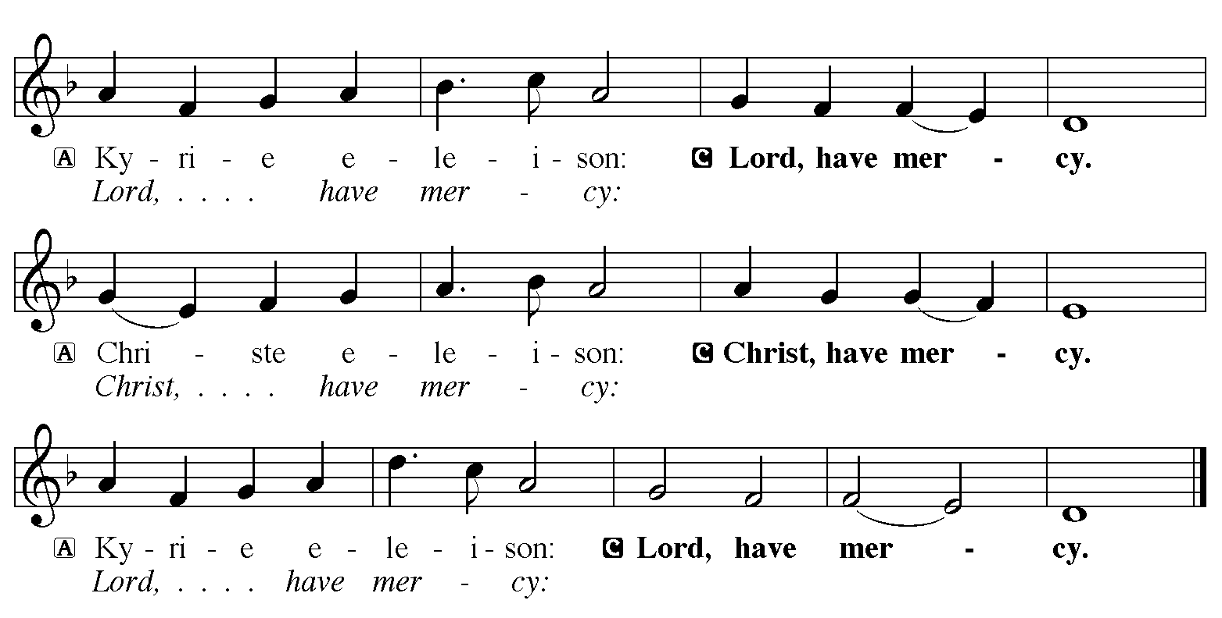

**THE PRAYER OF THE DAY**

P: The Lord be with you.

**C: And also with you.**

P: Let us pray. Stir up Your power, Lord Christ, and come. With Your abundant grace

and might, free us from the sin that hinders our faith, that eagerly we may receive Your

promises, for You live and reign with the Father and the Holy Spirit, one God, now and

forever.

**C: Amen.**

*The assembly is seated*

**✠ WORD ✠**

**LIGHTING OF THE ADVENT LOG 240 *Light One Candle to Watch for Messiah***

**(All stanzas)**

P: Let us pray. Blessed are You, O Lord our God, Ruler of the universe. In Your Son, Emmanuel, You have shown us Your light and saved us from the power of sin. Bless us as we light the candles on this log. Increase our longing for Your presence, that at the celebration of Your Son’s birth His Spirit might dwell anew in our midst, for He is our Light and our Salvation. Blessed be God forever.

**C: Amen.**

All four candles are lit.

**FIRST READING Isaiah 7:10-16**

*An Israelite and Aramean military coalition presents a serious threat to King Ahaz of Judah. In response, Ahaz decides to secure his throne and kingdom by asking mighty Assyria for help. In today's reading, Isaiah reminds him that human attempts to establish security will only fail. The prophet repeats the promise that God alone will make God's people secure.*

The LORD spoke to Ahaz, saying, 11Ask a sign of the LORD your God; let it be deep as Sheol or high as heaven. 12But Ahaz said, I will not ask, and I will not put the LORD to the test. 13Then Isaiah said: "Hear then, O house of David! Is it too little for you to weary mortals, that you weary my God also?

14Therefore the Lord himself will give you a sign. Look, the young woman is with child and shall bear a son, and shall name him Immanuel. 15He shall eat curds and honey by the time he knows how to refuse the evil and choose the good. 16For before the child knows how to refuse the evil and choose the good, the land before whose two kings you are in dread will be deserted."

The Word of the Lord.

**Thanks be to God.**

**THE PSALM: Psalm 80:1-7, 7-19** **Read responsively**

1Hear, O Shepherd of Israel, leading Joseph like a flock;

     shine forth, You that are enthroned upon the cherubim.

**2In the presence of Ephraim, Benjamin, and Manasseh,**

**stir up Your strength and come to help us.**

3Restore us, O God;

     let Your face shine upon us, and we shall be saved.

**4O LORD God of hosts,**

**how long will Your anger fume when your people pray?**

5You have fed them with the bread of tears;

     You have given them bowls of tears to drink.

**6You have made us the derision of our neighbors,**

**and our enemies laugh us to scorn.**

7Restore us, O God of hosts;

     let Your face shine upon us, and we shall be saved.

**17Let Your hand be upon the one at Your right hand,**

**the one you have made so strong for Yourself.**

18And so will we never turn away from You;

     give us life, that we may call upon Your name.

**19Restore us, O LORD God of hosts;**

**let Your face shine upon us, and we shall be saved.**

**SECOND READING Romans 1:1-7**

*Paul's letter to the Romans is devoted to presenting the gospel (or "good news") of God, which provides salvation for all who believe. This theme is introduced already in the opening words of the letter, where Paul expands the typical salutation to include a statement of faith.*

Paul, a servant of Jesus Christ, called to be an apostle, set apart for the gospel of God, 2which He promised beforehand through His prophets in the holy scriptures, 3the gospel concerning His Son, Who was descended from David according to the flesh 4and was declared to be Son of God with power according to the spirit of holiness by resurrection from the dead, Jesus Christ our Lord,

5through Whom we have received grace and apostleship to bring about the obedience of faith among all the Gentiles for the sake of His name, 6including yourselves who are called to belong to Jesus Christ,

7To all God's beloved in Rome, who are called to be saints:

Grace to you and peace from God our Father and the Lord Jesus Christ.

The Word of the Lord.

**Thanks be to God.**

*As you are able please rise*

**THE VERSE**

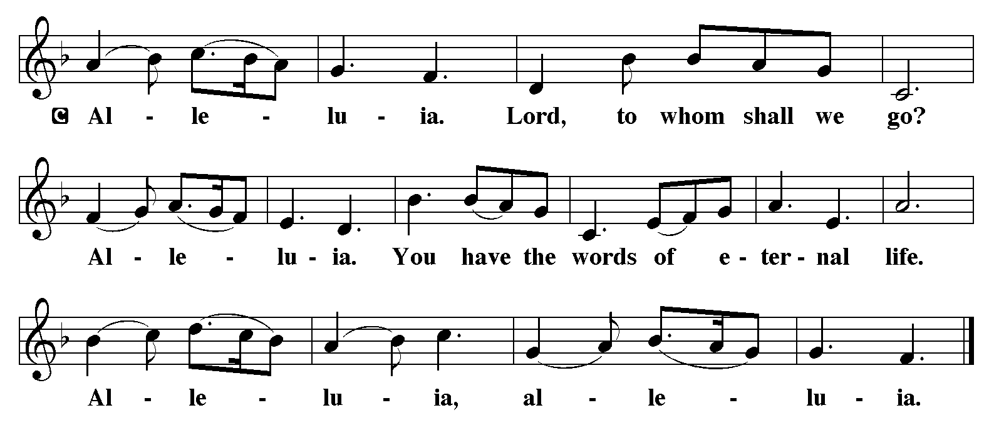

**THE HOLY GOSPEL** **Matthew1:18-25**

*Matthew's story of Jesus' birth focuses on the role of Joseph, who adopts the divinely begotten child into the family of David and obediently gives him the name Jesus, which means, literally, "God saves."*

P: The Holy Gospel according to St. Matthew, the first chapter.

**C: Glory to You, O Lord!**

Now the birth of Jesus the Messiah took place in this way. When His mother Mary had been engaged to Joseph, but before they lived together, she was found to be with child from the Holy Spirit. 19Her husband Joseph, being a righteous man and unwilling to expose her to public disgrace, planned to dismiss her quietly.

20But just when he had resolved to do this, an angel of the Lord appeared to him in a dream and said, "Joseph, son of David, do not be afraid to take Mary as your wife, for the child conceived in her is from the Holy Spirit. 21She will bear a son, and you are to name Him Jesus, for He will save His people from their sins." 22All this took place to fulfill what had been spoken by the Lord through the prophet:

23"Look, the virgin shall conceive and bear a son,

and they shall name him Emmanuel,"

which means, "God is with us."

24When Joseph awoke from sleep, he did as the angel of the Lord commanded him; he took her as his wife, 25but had no marital relations with her until she had borne a son; and he named Him Jesus.

P: The Gospel of the Lord.

**C: Praise to You, O Christ!**

*The assembly is seated*

**THE SERMON**

*Silence for reflection follows the sermon*

*As you are able please rise*

**THE HYMN OF THE DAY 254 *Come, Thou Long-Expected Jesus***

**THE NICENE CREED**

A: God has made us His people through our Baptism into Christ. Living together in trust

and hope, we confess our faith.

**We believe in one God,**

**the Father, the Almighty,**

**maker of heaven and earth,**

**of all that is, seen and unseen.**

**We believe in one Lord, Jesus Christ,**

**the only Son of God,**

**eternally begotten of the Father,**

**God from God, Light from Light,**

**true God from true God,**

**begotten, not made,**

**of one Being with the Father.**

**Through Him all things were made.**

**For us and for our salvation**

**He came down from heaven;**

**by the power of the Holy Spirit**

**He became incarnate from the virgin Mary, and was made man.**

**For our sake He was crucified under Pontius Pilate;**

**He suffered death and was buried.**

**On the third day He rose again**

**in accordance with the Scriptures;**

**He ascended into heaven**

**and is seated at the right hand of the Father.**

**He will come again in glory to judge the living and the dead,**

**and His kingdom will have no end.**

**We believe in the Holy Spirit, the Lord, the giver of life,**

**Who proceeds from the Father and the Son.**

**With the Father and the Son He is worshiped and glorified.**

**He has spoken through the prophets.**

**We believe in one holy catholic and apostolic Church.**

**We acknowledge one Baptism for the forgiveness of sins.**

**We look for the resurrection of the dead,**

**and the life of the world to come. Amen**

**THE PRAYER OF THE CHURCH**

A: As we anticipate the fullness of the presence of Christ, we join with the Church

throughout the world, praying for all who are in need.

A: For the Church and all servants of the Gospel; for poets and artists, for musicians and

preachers; for theologians and teachers, that they may enrich and enliven our

proclamation that God is with us in Christ, let us pray to the Lord:

**C: Lord, hear our prayer.**

A: For all plants and animals, seas and skies, snow and rain, and all of God’s marvels, that

it may grow and thrive as we bless, protect, and use with care God’s good creation

entrusted to us, let us pray to the Lord:

**C: Lord, hear our prayer.**

A: For all nations and those in authority; for peace and justice throughout the world; for

those who advocate on behalf of those who have no voice; for all those in positions of

leadership that they may refuse what is evil and choose what is good for those they

serve, let us pray to the Lord:

**C: Lord, hear our prayer.**

A: For those who travel in these days that their journeys might be safe and their

homecomings joyful, let us pray to the Lord:

**C: Lord, hear our prayer.**

A: For this congregation, that by the grace and peace of God we might live and serve as

the saints in Christ You have set us apart to be, let us pray to the Lord:

**C: Lord, hear our prayer.**

A: For those who find no joy in these days; the hungry, the homeless, the grieving, and

the sick, especially . . . that You would turn Your face toward them with blessing and

grant them healing, strength, and peace, let us pray to the Lord:

**C: Lord, hear our prayer.**

A: For those celebrating birthdays, especially **Virgil Miller,** that they might grow in grace

this day and every day and be filled with grace for the days ahead, let us pray to the

Lord:

**C: Lord, hear our prayer.**

A: For Joseph and Mary and their obedience to Your will, and for all the saints, that we

might follow in their ways as Christ is born again into our hearts and lives, let us pray

to the Lord:

**C: Lord, hear our prayer.**

P: Hear the prayers of Your people, glorious God, for the sake of the One Who took on

our nature and our form to redeem the whole world, Jesus Christ our Lord.

**C: Amen.**

**✠ MEAL ✠**

**THE PEACE**

P: The peace of the Lord be with you always.

**C: And also with you.**

*The assembly is seated*

**OFFERING**

**VOLUNTARY *With Open Hearts, We Are Waiting*  Pepper Choplin**

*As you are able please rise*

**THE OFFERTORY 490 *Let All Mortal Flesh Keep Silence***

***(*Stanzas 1, 2)**

**THE OFFERTORY PRAYER**

A: Let us pray. God our Savior,

**C: You call us to be patient and strong, for the Day of Your advent is near. You come**

**to us now in this holy Sacrament for our life, health, and hope. Receive these**

**offerings we bring, and by our eating and drinking strengthen our witness, that**

**we might with joy prepare Your way. We ask this in the name of Jesus the Lord.**

**Amen.**

**THE GREAT THANKSGIVING**

P: The Lord be with you.

**C: And also with you.**

P: Lift up your hearts.

**C: We lift them to the Lord.**

P: Let us give thanks to the Lord our God.

**C: It is right to give Him thanks and praise.**

P: It is indeed right and salutary … we praise Your name and join their unending hymn:

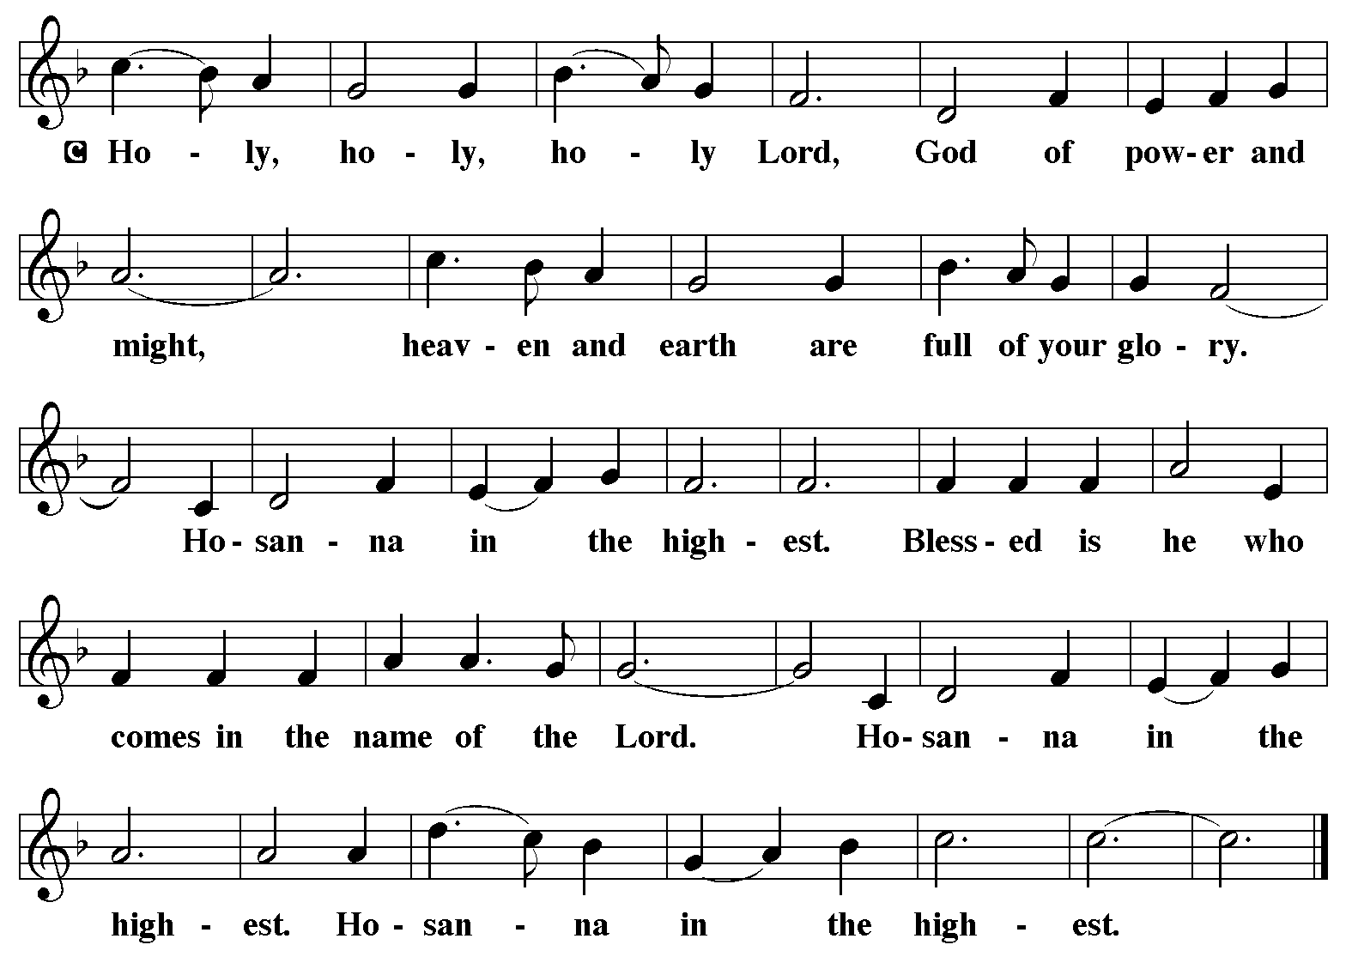

P: Holy God, the Beginning and the end, our Salvation and our Hope,

We praise You, for You are the God of our salvation.

You created a world of order and beauty; in You all things have life.

With a love higher than the heavens and deeper than Sheol You chose

Israel to be a sign of Your blessing for the world.

You delivered them from every threat and brought life for them out of

every death.

When the time had fully come, You sent Your Son, Jesus-Emmanuel,

born of the Holy Spirit and the Virgin Mary, to save us from

our sins.

In the night ... “Do this for the remembrance of Me.”

As often as we eat ... we proclaim the Lord’s death until He comes.

**C: Christ has died. Christ is risen. Christ will come again.**

P: With this bread and cup, O God, we remember the Incarnation of our

Lord’s life.

He was with us in life and in death, and raised by the power of Your

Spirit from death.

He will return to bring us, with all the saints, into Your eternal glory.

Send now Your Spirit on us and these gifts of bread and wine.

Grant us the grace to live as Your saints, joined with Christ as He has

joined Himself to us, in His work of preparing the world for the

birth of His justice and joy.

Through Him all glory and honor is Yours, Almighty Father, with the

Holy Spirit, in Your holy church, both now and forever.

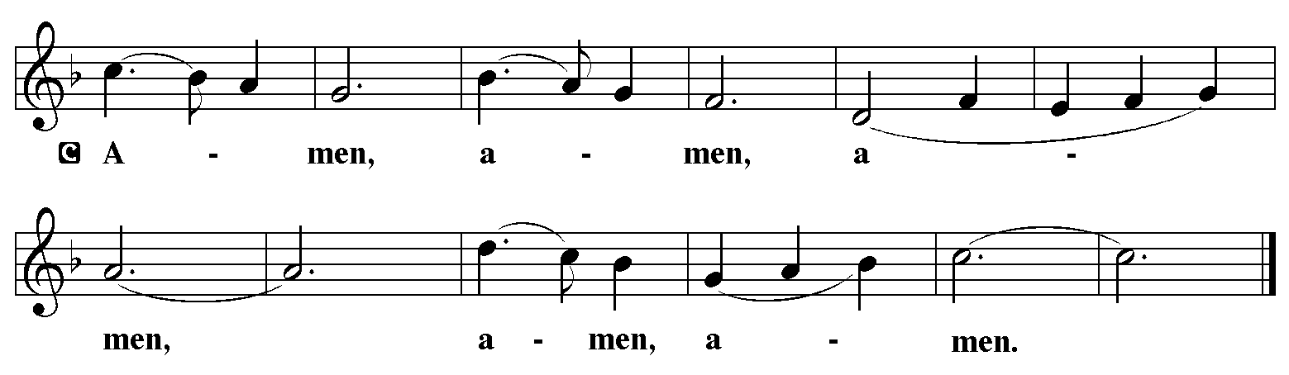

**THE LORD’S PRAYER**

P: Let us pray for the coming of God’s Reign as Jesus taught us:

**C: Our Father, Who art in heaven, hallowed be Thy Name. Thy Kingdom come.**

**Thy will be done on earth as it is in heaven. Give us this day our daily bread, and**

**forgive us our trespasses as we forgive those who trespass against us. And lead us**

**not into temptation, and deliver us from evil, for Thine is the Kingdom, and the**

**power, and glory, forever and ever. Amen.**

**INVITATION TO THE MEAL**

P: Behold the Lord Whose advent we await, Who will come with glory on the Day of

judgment. Blessed are those who are called to the Supper of the Lamb. God’s holy

gifts for God’s holy people. Come, for all is now ready.

*The assembly is seated*

**THE DISTRIBUTION**

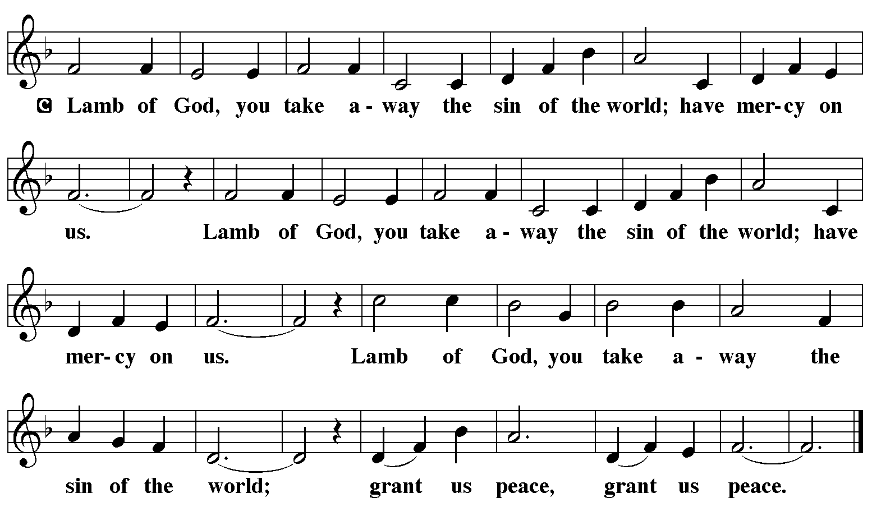

**HYMN DURING DISTRIBUTION 257 *O Come, O Come, Emmanuel* Stanzas 1-4**

**ELW 510 *Word of God, Come Down to Earth***

**NSB 59 *Jesus, Name Above All Names***

*As you are able please rise*

**THE POST-COMMUNION PRAYER**

A: Let us pray. Lord, in this Sacrament we receive the promise that You have saved us

from our sins. As Christmas draws near, make us grow in faith and love to celebrate

the coming of Jesus our Savior, Who is Lord forever and ever.

**C: Amen.**

**✠ SENDING ✠**

**THE BENEDICTION**

P: The Lord bless you and keep you. The Lord make His face shine on you and be gracious

to you. The Lord look upon you with favor ✠ and give you peace.

**C: Amen.**

**SENDING HYMN 267 *Joy to the World***

**THE DISMISSAL**

A: Go in peace. Walk in the light of the Lord.

**C: Thanks be to God!**

**POSTLUDE *Joy to the World*  Michael Burkhardt**

**✠ To God Alone Be Glory ✠**

The Meditation is from *An Advent Sourcebook.* Thomas J. O’Gorman, ed. (Chicago:

Liturgy Training Publications, 1988) 154.

The Invitation to the Lord’s Prayer, the Prayers, and the Invitation to Communion are from

*Prayers for Sundays and Seasons. Year A.* Peter J. Scagnelli. (Chicago: Liturgy

Training Publications, 1998) 7-8.

**ANNOUNCEMENTS**

**Please remember to mail your offering to the Church Office** at 818 Franklin Street, Michigan City, IN 46360**.** Another alternative is to give on-line through Tithe.ly. Please see your closure letter for information on how to set up a Tithe.ly account.

**St. Paul Members are reminded to have** a loved one contact the office if you are hospitalized. Many times, the Pastor doesn’t know someone is in the hospital. If you call and leave a message, please tell us which hospital the patient is at.

**Next Saturday’s (Christmas Eve) lessons are: Isaiah 9: 2-7; Psalm 96; Titus 2: 11-14; and Luke 2: 1-14 [15-20]** for those of you who like to study them in advance. **Next Sunday’s (Christmas Day) lessons are: Isaiah 52: 7-10; Psalm 98; Hebrews 1:1-4; and John 1: 1-14.**

**Birthdays: Virgil Miller (12/22)**

**PRAYER CONCERNS:** Audrey Beyer, Ryan Krueger, Donna Bostater, Maxine

Powell, Jim Tomscheck, Eloise Ponder, Mark & Jary Tannehill, Marvin Dirks, Leonard Cross, George Ottersen, Valerie Waltz, Margie Torres, Dan Pursely, Jayla Jacobi and Lyle Peters.

**If you requested someone’s name to be on the prayer list and are aware that they need continued imminent prayer then contact the church office and let us know.** Otherwise we will gradually transfer names to the long-term list.

**There are some names on the long-term prayer list that have been listed for many months.** We would like to keep the list current so if you requested them to be included please contact the church office and tell us whether you would still like them on the list: Robert Atwood; Laura Eilers-Straight; Terry Hygema; Jess Kalvaitis; Tom and Larry Lueth; Duane Ormsby; Cameron Rackard; Ryan Sirk; Jean Thomas; Heidi Happel; Christian Martinez; Ron Armer.

**OFFICE HOURS:** Libby will be in the office on Mondays, Wednesdays, and Fridays; volunteers will cover Tuesdays and Thursdays.

  Monday & Wednesday 8:00 a.m. – 5 p.m.

Tuesday & Thursday 9:00 a.m. – 12:00 p.m.

Friday 8:00 a.m. – 12:00 p.m.

**If you are listening to the worship broadcast on the radio and would like to watch the Sunday morning service live stream follow these steps:**

1. If you have You.Tube available on your TV, search for

**St. Paul Lutheran Church Michigan City, IN.**

(2) The direct link on the computer is

https://www.youtube.com/channel/UC5AIPNaKr3QN50984jGOa1g.

(3) This link is also on the main page of the church’s website in the church sec-

tion and will continue to be posted weekly on the St. Paul Facebook page.

And it will always be available on the radio broadcast Sunday mornings at 11:00 a.m. on WEFM (95.9), and on the local cable access station #99 for the previous week’s service on Sundays at 4:00 p.m. and the current service on Wednesdays at 7:00 p.m. and Fridays at 8:30 p.m.

**To send e-mail to the church office**, please use the following addresses:

Pastor Mark Reshan: seniorpastor@stpaulmichigancity.com

Church Office Secretary (Libby Pollock): churchsecretary@stpaulmichigancity.com

Church Treasurer (Karen Fleming): finance@stpaulmichigancity.com

**The Good News Newsletter**: If you have an article or anything you want included in **The Good News** please send it to the following e-mail address: splcgoodnews@gmail.com. Pastor Pamela Thiede will be using this e-mail address to assemble **The Good News** each month. The deadline for getting information to Pastor Pamela will be the 20th of each month.

**WORSHIP ATTENDANCE for December 10 and 11, 2022**

**4:00 p.m. 36**

**9:00 a.m. 59**

**Total = 95**

**Support St. Paul School**

Most of us (St. Paul Church members) are of the age to be grandparents or even great or great great grandparents. Our school has some students in need of someone to read to them or maybe to offer some instruction one on one. The students are from K-8 so you can choose an age that you’d be comfortable with. Please consider sharing your grandparenting skills with our students one time or regularly.

Contact Tracy McCay school principle at 219-874-7409 or a

School board member to schedule.

**Activities, Events & Meetings**

**December 2022**

**Sunday,** December 11, 2022 at 9:00 a.m. Worship Service/3rd Sunday in Advent

**Monday,** December 12, 2022 at 3:30 p.m. School Board Meeting/Luther House

**Tuesday,** December 13, 2022 at 11:30 a.m. Charity Circle/Sophia’s Restaurant

at 12:30 p.m. Harmony Circle/Nursery

at 7:00 p.m. Estuary/Luther House

**Wednesday,** December 14, 2022 at 10:00 a.m. **Advent Senior/Quiet Communion**

**Service with luncheon after**

at 7:00 p.m. Choir Rehearsal

**Saturday,** December 17, 2022 at 4:00 p.m. Worship Service/4th Saturday in Advent

**Sunday,** December 18, 2022 at 9:00 a.m. Worship Service/4th Sunday in Advent

**Monday,** December 19, 2022 at 4:00 p.m. Finance Committee Meeting/Luther House

  at 5:30 p.m. Executive Board Meeting/Luther House

**Wednesday,** December 21, 2022 at 9:45 a.m. Bible Study/Luther House

at 10:00 a.m. God’s Purls/St. Paul Room

at 7:00p.m. Choir Rehearsal

**Thursday,** December 22, 2022 at 5:30 p.m. Church Council Meeting/St. Paul Room

**Saturday,** December 24, 2022 at 6:00 p.m. Christmas Eve. Worship Service

**Sunday,** December 25, 2022 at 9:00 a.m. Christmas Day Worship Service

**A Reminder**

**The discussion group “Estuary”** led by Pastor Dale Zylstra meets the second Tuesday of the month in the Luther House at 7:00 p.m. The group addresses topics of interest to the participants and is open to everyone.

**2022 Financial Stewardship**

Weekly Church Operating Needs (x 2 weeks): $ 14,615.68

November 19 and 20, and 26 and 27, 2022

General Fund (including General Memorials): $ 13,198.89

Overage/Shortage: -- $ 1,416.79

Restricted Income (not including Memorials)

Supports IK Synod & Church wide Ministries: $440.00

Ministries in our Community/Congregation: $110.00

Capital Fund: $560.00

General Fund $ 2,695.00