THE FOURTH SUNDAY OF EASTER
April 21, 2024

“There is a downside to all the talk in Psalm 23 and John 10 about being God’s sheep ... I am wary of these texts. Christians have been instilled with a sheepish docility that has played into the hands of the powers for centuries. Obedience has been made the highest Christian virtue ... As a result, Christians have colluded in their own injury. They have accepted without resistance totalitarian rulers. They have been submissive in the face of tyrannous hierarchies in church and state, corporations and schools. Women have submitted to battering, economic exploitation, and wage inequality. Men have been led off to war like sheep, flocking to their doom without resistance ...”
“There is nothing sheepish, however, in the reading from Acts. Peter and John have been arrested by the authorities ... for healing a man and preaching the resurrection of the Jesus these authorities had killed. A night in the poky does nothing to dampen their spirits. Normally ‘idiots’ (idiotai, common) are cowed by the panoply of power and the bearing of the powerful. But not these goats. They use the occasion of their arraignment as a platform for preaching. ‘When they saw the boldness of Peter and John and realized that they were uneducated and idiotai, they were amazed ...’ (Acts 4:13)
Jesus takes sheep and makes them goats. He takes those who have internalized the system of ranking and stratification as divinely ordained and frees them from these delusions. He awakens common, ordinary people who have never before sensed their power and sends them into the very maw of the system to denounce it.”

Walter Wink
...Jesus Christ, the Good Shepherd, works still to subvert our isolation, worthlessness, and despair, our pride and complacency, all of which grow out of the power of death. In so doing, he opens for us a space to know the victory of the resurrection; space to be led in the green pastures, beside the still waters, and to dwell in the blessedness of the Lord's House.
Jerome Neyrey
In the Name of Jesus
INTRODUCTION

The image of the Good Shepherd shows us how the risen Christ brings us to life. It is the relationship between the shepherd and the sheep, one of mutual knowledge and love, that gives the shepherd authority. The shepherd's willingness to lay down his life for the sheep shows his love. First John illustrates what it means to lay down our lives for one another by the example of sharing our wealth with any sister or brother in need.

Anselm, Bishop of Canterbury, died 1109

This eleventh and twelfth century Benedictine monk stands out as one of the greatest theologians between Augustine and St. Thomas Aquinas. He is probably best known for his “satisfaction” theory of atonement. He argued that human rebellion against God demands a payment, but because humanity is fallen it cannot make that payment. But God takes on human nature in Jesus to make the perfect payment for sin.

GATHERING

PRELUDE

THE EASTER ACCLAMATION

P: Christ is risen! Alleluia!

C: He is risen indeed! Alleluia!

ANNOUNCEMENTS

As you are able please rise

CONFESSION AND ABSOLUTION

P: In the name of the Father and of the Son and of the Holy Spirit.

C: Amen.

P: “Little children, let us love, not in word or speech, but in truth and action. And by this
we will know that we are from the truth and will reassure our hearts before Him
whenever our hearts condemn us; for God is greater than our hearts, and He knows
everything.” (1 John 3: 18-19) Because God knows our hearts, and does not condemn
us, we may therefore confess our sins with confidence and hope.

Silence for reflection and self-examination is kept

P: Most merciful God,

C: We confess that we have sinned against You in thought, word, and deed. We have
not laid down our lives for others. (1 John 3: 16) We have refused help to our
sisters and brothers in need. (3: 17) We have loved one another in word and
speech only, and not in truth and action. (3: 18) We have not loved one another
as Christ has loved us. For the sake of Your Son, Jesus Christ, have mercy on us.
Forgive us, strengthen us with Your Spirit, and grant us the will and courage to
bear the fruits of Your mercy and grace in Jesus Christ our Lord.

P: “Beloved, if our hearts do not condemn, we have boldness before God; and we receive
from Him whatever we ask, because we obey His commandments and do what pleases
Him.” (1 John 3: 22) As you have asked, so you receive: for as a called and ordained
minister of the Church of Christ, and by His authority, I therefore declare to you the
entire forgiveness of all your sins, in the name of the Father and of the Son and of
the Holy Spirit.

C: Amen.

GATHERING HYMN 385 Good Christian Friends, Rejoice and Sing!

THE GREETING AND PRAYER OF THE DAY

P: Alleluia! Christ is risen!
C: Christ is risen indeed! Alleluia!

P: The grace of our Lord Jesus Christ, the love of God, and the communion of the Holy
Spirit be with you all.

C: And also with you.

P: Let us pray. O Lord Christ, good shepherd of the sheep, You seek the lost and guide us
into Your fold. Feed us, and we shall be satisfied; heal us, and we shall be whole. Make
us one with You, for You live and reign with the Father and the Holy Spirit, one God,
now and forever.

C: Amen.

The assembly is seated

WORD

FIRST READING Acts 4: 5-12

Peter and John have been arrested the previous day because they were proclaiming the news of the resurrection to the people. In today’s reading, Peter is filled with the Holy Spirit so that he is able to proclaim salvation in Jesus’ name to the religious authorities.

⁵The next day their rulers, elders, and scribes assembled in Jerusalem, ⁶with Annas the high priest, Caiaphas, John, and Alexander, and all who were of the high-priestly family. ⁷When they had made the prisoners stand in their midst, they inquired, "By what power or by what name did you do this?" ⁸Then Peter, filled with the Holy Spirit, said to them, "Rulers of the people and elders, ⁹if we are questioned today because of a good deed done to someone who was sick and are asked how this man has been healed, ¹⁰let it be known to all of you, and to all the people of Israel, that this man is standing before you in good health by the name of Jesus Christ of Nazareth, Whom you crucified, Whom God raised from the dead.
¹¹This Jesus is
'the stone that was rejected by you, the builders;
it has become the cornerstone.'
¹²There is salvation in no one else, for there is no other name under heaven given among mortals by which we must be saved."

The Word of the Lord.

Thanks be to God.

THE PSALM: Psalm 23 Read responsively

¹The LORD is my shepherd;
I shall not be in want.

²The LORD makes me lie down in green pastures
and leads me beside still waters.

³You restore my soul, O LORD,
and guide me along right pathways for Your name's sake.

⁴Though I walk through the valley of the shadow of death,
I shall fear no evil;
for You are with me;
Your rod and Your staff, they comfort me.

⁵You prepare a table before me in the presence of my enemies;
You anoint my head with oil, and my cup is running over.

⁶Surely goodness and mercy shall follow me all the days of my life,
and I will dwell in the house of the LORD forever.

SECOND READING 1 John 3: 16-24

Jesus’ death on our behalf is the clearest demonstration of divine love. This is the very love we share with others, not just through our words but especially through our deeds. In sharing such love we fulfill God’s commandments.

¹⁶We know love by this, that He laid down His life for us — and we ought to lay down our lives for one another. ¹⁷How does God's love abide in anyone who has the world's goods and sees a brother or sister in need and yet refuses help?
¹⁸Little children, let us love, not in word or speech, but in truth and action. ¹⁹And by this we will know that we are from the truth and will reassure our hearts before Him ²⁰whenever our hearts condemn us; for God is greater than our hearts, and He knows everything. ²¹Beloved, if our hearts do not condemn us, we have boldness before God; ²²and we receive from Him whatever we ask, because we obey His commandments and do what pleases Him.
²³And this is His commandment, that we should believe in the name of His Son Jesus Christ and love one another, just as He has commanded us. ²⁴All who obey His commandments abide in Him, and He abides in them. And by this we know that He abides in us, by the Spirit that He has given us.

The Word of the Lord.

Thanks be to God.

As you are able please rise

THE VERSE

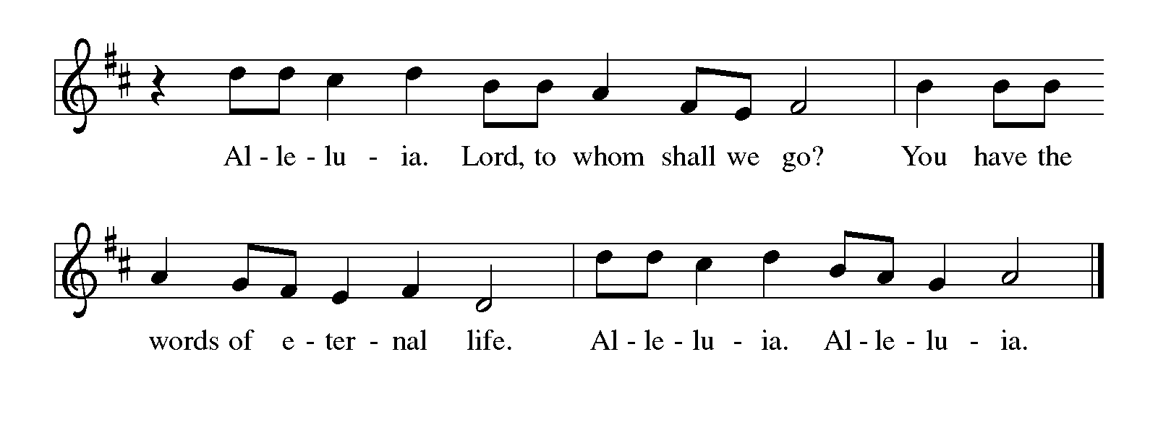
THE HOLY GOSPEL John 10: 10b-18

In language that recalls the twenty-third Psalm, Jesus describes Himself as the shepherd Who cares for His sheep. He is willing to die for them, and is able to overcome death for them.

P: The Holy Gospel according to St. John, the tenth chapter.

C: Glory to You, O Lord!

(Jesus said): ^{10b} I came that (the sheep) may have life and may have it abundantly. ¹¹I am the good shepherd. The good shepherd lays down His life for the sheep. ¹²The hired hand, who is not the shepherd and does not own the sheep, sees the wolf coming and leaves the sheep and runs away — and the wolf snatches them and scatters them.
¹³The hired hand runs away because a hired hand does not care for the sheep. ¹⁴I am the good shepherd. I know My own and my own know Me, ¹⁵just as the Father knows Me and I know the Father. And I lay down My life for the sheep.
¹⁶I have other sheep that do not belong to this fold. I must bring them also, and they will listen to My voice. So there will be one flock, one shepherd. ¹⁷For this reason the Father loves Me, because I lay down My life in order to take it up again. ¹⁸No one takes it from Me, but I lay it down of My own accord. I have power to lay it down, and I have power to take it up again. I have received this command from My Father."
P: The Gospel of the Lord.

C: Praise to You, O Christ!

The assembly is seated

THE SERMON

Silence for reflection follows the sermon

As you are able please rise

THE HYMN OF THE DAY You, Lord, Are Both Lamb and Shepherd

(Sung to the tune of, Let All Mortal Flesh Keep Silent)

1 You, Lord, are both Lamb and Shepherd.
You, Lord, are both prince and slave.
You, peacemaker and sword-bringer
of the way You took and gave.
You, the everlasting instant;
You, Whom we both scorn and crave.

2 Clothed in light upon the mountain,
stripped of might upon the cross,
shining in eternal glory,
beggared by a soldier's toss,
You, the everlasting instant;
You, who are both gift and cost.

3 You, who walk each day beside us,
sit in power at God's side.
You, Who preach a way that's narrow,
have a love that reaches wide.
You, the everlasting instant;
You, Who are our pilgrim guide.

4 Worthy is our earthly Jesus!
Worthy is our cosmic Christ!
Worthy Your defeat and vict'ry;
worthy still Your peace and strife.
You, the everlasting instant;
You, Who are our death and life.

THE NICENE CREED

A: God has made us His people through our Baptism into Christ. Living together in trust
and hope, we confess our faith.

C: We believe in one God,
the Father, the Almighty,
maker of heaven and earth,
of all that is, seen and unseen.

We believe in one Lord, Jesus Christ,
the only Son of God,
eternally begotten of the Father,
God from God, Light from Light,
true God from true God,
begotten, not made,
of one Being with the Father.
Through Him all things were made.
For us and for our salvation
He came down from heaven;
by the power of the Holy Spirit
He became incarnate from the virgin Mary, and was made man.
For our sake He was crucified under Pontius Pilate;
He suffered death and was buried.
On the third day He rose again
in accordance with the Scriptures;
He ascended into heaven
and is seated at the right hand of the Father.
He will come again in glory to judge the living and the dead,
and His kingdom will have no end.

We believe in the Holy Spirit, the Lord, the giver of life,
Who proceeds from the Father and the Son.
With the Father and the Son He is worshiped and glorified.
He has spoken through the prophets.
We believe in one holy catholic and apostolic Church.
We acknowledge one Baptism for the forgiveness of sins.
We look for the resurrection of the dead,
and the life of the world to come. Amen

THE PRAYER OF THE CHURCH

A: Comforted by the promise that the Good Shepherd gives His life for us, and renewed
by Easter faith, let us pray for the Church, the world, and all who await the fullness of
Christ’s Easter life.

A: That the Church may be unified in Christ, one flock under the one Shepherd, let us pray
to the Lord:

C: Lord, hear our prayer.

A: That those who do not yet belong to God’s fold may be brought under the care of Jesus,
let us pray to the Lord:

C: Lord, hear our prayer.

A: That God’s goodness and mercy might overcome the terror and hatred in our world and
the violence in our homes and hearts, let us pray to the Lord:

C: Lord, hear our prayer.

A: That we in this assembly might love this week not in words or speech only but in truth
and action, let us pray to the Lord:

C: Lord, hear our prayer.

A: That those who are sick, especially . . . might find health in the name of Jesus and care
at the hands of us His disciples, let us pray to the Lord:

C: Lord, hear our prayer.

A: That those celebrating birthdays, especially Jean Kleinschmidt; and anniversaries,
especially Tim and Stacie Crozier may be filled with grace this day and every day
and grow in grace in the days ahead, let us pray to the Lord:

C: Lord, hear our prayer.

A: That with those who have abided in Christ through death and into everlasting life,
especially Anselm, Bishop of Canterbury, whom we commemorate this Day we
might dwell in the house of the Lord forever, let us pray to the Lord:

C: Lord, hear our prayer.

P: God, in You we live and move and have our being. You seek us before we know Your
name, and You give us joy in Your life. Accept our prayer of joy in being found and
forgiven and loved by You, for we pray in the name of Christ Your Son and in the joy
of the Holy Spirit.

C: Amen.

MEAL

THE PEACE

P: The peace of the risen Lord be with you always.

C: And also with you.

The assembly is seated

THE OFFERING

THE VOLUNTARY

As you are able please rise

THE PRESENTATION OF THE GIFTS (see p. 9) This Joyful Eastertide
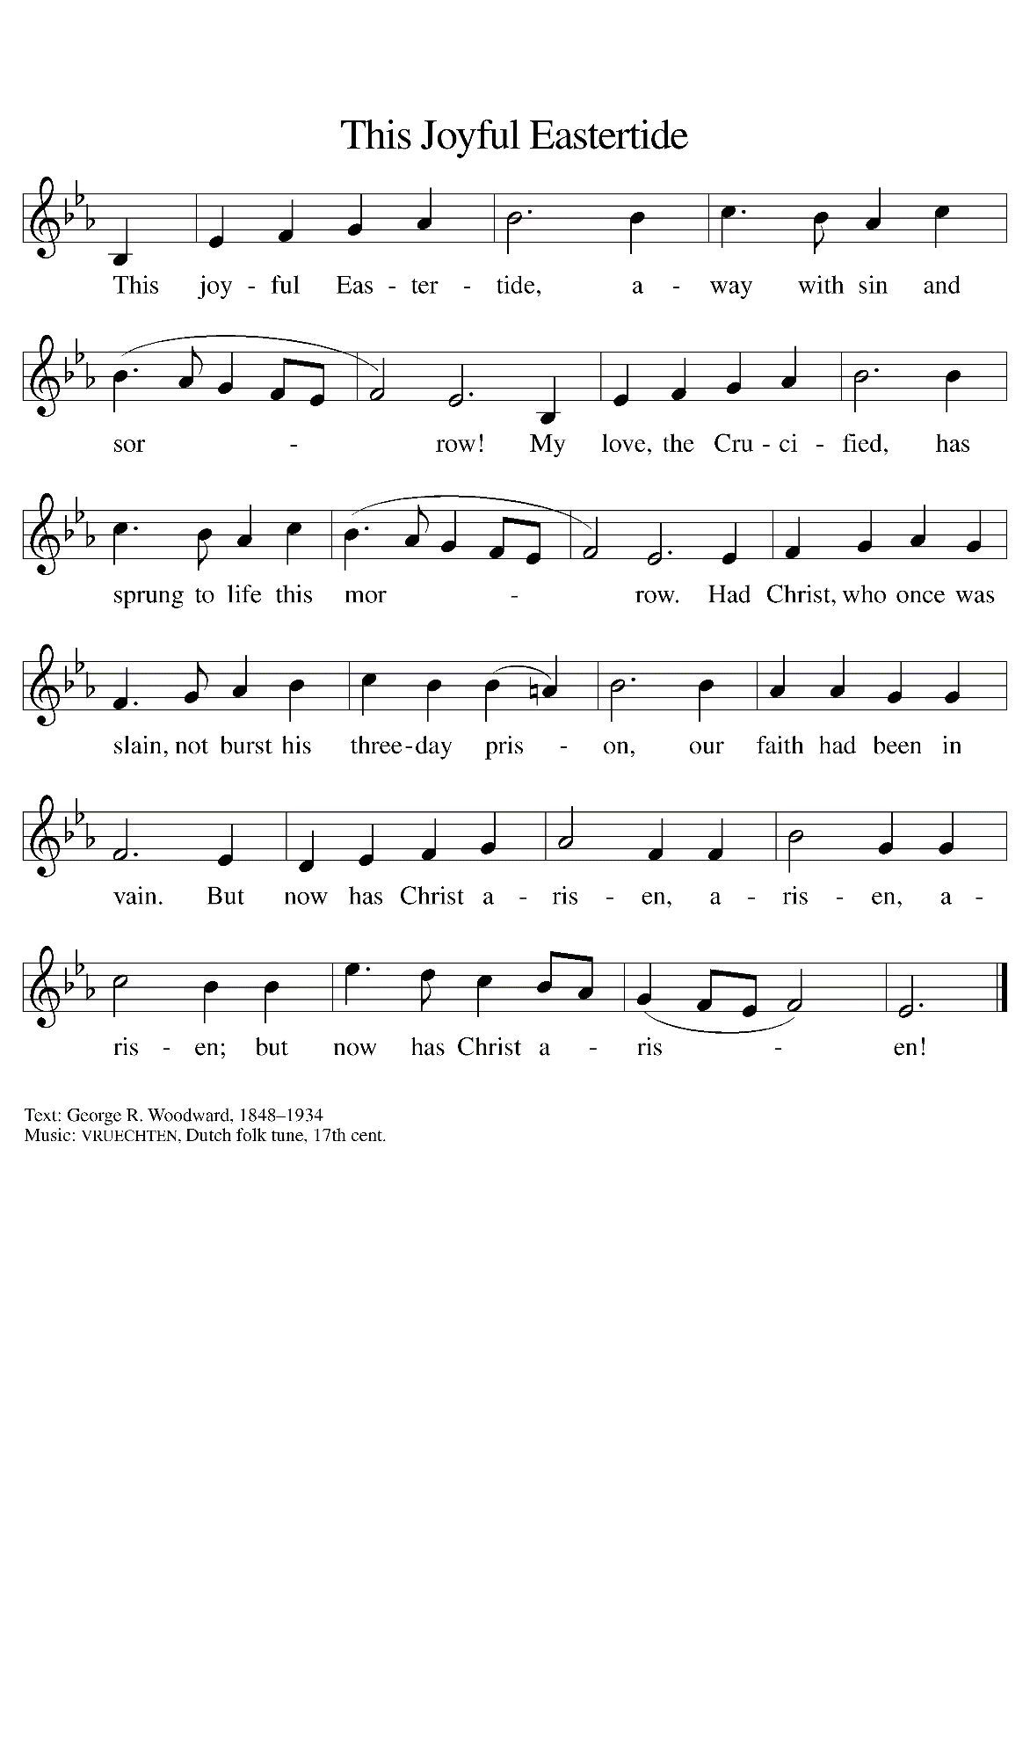
THE OFFERTORY PRAYER

A: Let us pray. God our Good Shepherd,

C: You spread a Table before us. We offer You the gifts of our time, our possessions,
and this bread and wine as signs of Your gracious love and tokens of our grateful
hearts. Nourish us at the Feast of the Lamb, that we may proclaim to all the world
Your triumphant love in Jesus Christ our Lord. Amen.

THE GREAT THANKSGIVING

P: The Lord be with you.

C: And also with you.

P: Lift up your hearts.

C: We lift them to the Lord.

P: Let us give thanks to the Lord our God.

C: It is right to give Him thanks and praise.

P: Shepherding God, we praise and thank You because You gathered Your flock
around Abraham,
And through Moses and Joshua You brought Your sheep to a place of safety.
In Jesus You came to us as a Passover Lamb to take away the sins of the world.
As our everlasting Good Shepherd You promise that those who hear Your voice
shall never be in want, for You know Your sheep by name, and You call
us Your own
And give to each of us a place in the sheepfold of Your Kingdom.

Sustaining God, as You lead Your sheep to great pastures and guide them
beside still waters,
So You have led us to this Table where in bread and wine You restore our soul.
Send down Your Holy Spirit and restore Your Church through the abundance of
this sacred Meal.
As we remember the Story of Your Son’s life laid down for us, sanctify this bread
and cup and make them be for us the Body and Blood of Your Son Jesus
Christ,
Who, in the night ... “Do this for the remembrance of Me.”
As often as we eat ... we proclaim the Lord’s death until He comes.

C: Christ has died. Christ is risen. Christ will come again.

P: Saving God, Your rod and staff comfort all who look to You in faith.
Search out Your sheep that are lost and bring them home.
When You find them in the valley of fear, gather them into Your arms.
When they face evil in the presence of enemies, follow them with Your goodness
and mercy all the days of their life.
On that day when the shadow of death covers them, bring them to dwell in Your
house forever.
Shepherd us with all Your saints of every age into Your glorious presence, where
we shall behold Your Lamb in seated glory, most holy Trinity,
Now and always.

C: Amen!

THE LORD’S PRAYER

P: Alleluia! The risen Christ intercedes on our behalf before the throne of God. Let us
therefore join Him in His prayers in the words He taught us:

C: Our Father in heaven, hallowed be Your name.
Your Kingdom come, Your will be done on earth as in heaven.
Give us today our daily bread, and forgive us our sins, as we forgive
those who sin against us.
Save us from the time of trial, and deliver us from evil.
For the Kingdom, the power, and the glory are Yours, now and forever.
Amen.

INVITATION TO THE MEAL

P: Alleluia! Christ our paschal Lamb has been sacrificed. Therefore, let us keep the Feast.
Blessed are those who are called to the Supper of the Lamb. God’s holy gifts for God’s
holy people. Come, for all is now ready.

The assembly is seated

THE DISTRIBUTION
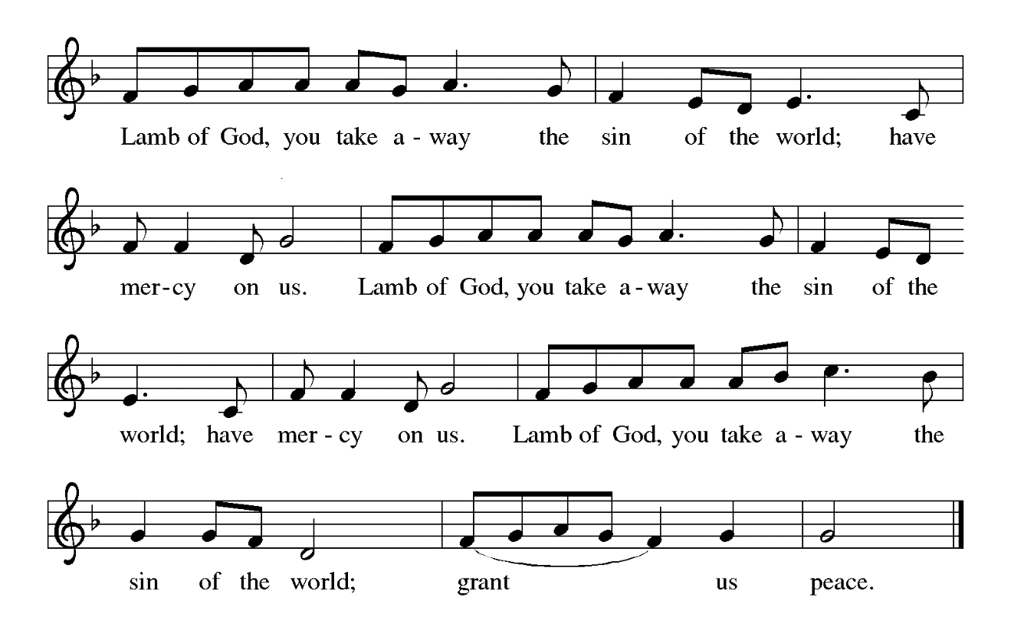
HYMNS DURING DISTRIBUTION 484 You Satisfy the Hungry Heart
502 The King of Love My Shepherd Is

As you are able please rise

THE POST-COMMUNION BLESSING

P: The Body and Blood of our Lord Jesus Christ strengthen you and keep you in His grace.

C: Amen.

THE POST-COMMUNION PRAYER

A: Let us pray. Author of life, in the breaking of the bread we know the risen Lord. Feed
us always in these mysteries, that we may show Your glory to all the world. Grant this
through Christ our Lord.

C: Amen.

SENDING

THE BENEDICTION

P: God the Father, Who raised our Lord Jesus from death, lift you up and restore you to
wholeness.

C: Amen.

P: God the Son, Jesus Christ, the Word of Life, bless you and send you to be His witnesses.

C: Amen.

P: God the Holy Spirit, Who renews the earth, refresh you in the gift of Baptism this day
and always.

C: Amen.

P: Almighty God: Father, Son, and Holy Spirit bless you now and forever.

C: Amen.

SENDING HYMN 536 God Be With You Till We Meet Again

THE DISMISSAL

A: Alleluia! Go and tell the News that Christ is risen!

C: Christ is risen indeed! Alleluia!

POSTLUDE

To God Alone Be Glory

The Meditation is from Pulpit Resource. William Willimon, ed. Vol. 25 No. 2 (Inver
Heights, MN: Logos Productions, 1997), 13-14.

The Greeting, Offertory Prayer, Post-Communion Prayer, and Dismissal are adapted from
Sundays and Seasons. Copyright Augsburg Fortress, 1999.

The Prayer of the Church is adapted from Intercessions for the Christian People. Gail
Ramshaw, ed. (New York: Pueblo Publishing Company, 1988) 102.

ANNOUNCEMENTS

Please remember to mail your offering to the Church Office at 818 Franklin Street, Michigan City, IN 46360. Another alternative is to give on-line through Tithe.ly. Please see your closure letter for information on how to set up a Tithe.ly account.

St. Paul Members are reminded to have a loved one contact the office if you are hospitalized. Many times, the Pastor doesn’t know someone is in the hospital. If you call and leave a message, please tell us which hospital the patient is at.

Birthdays: Jean Kleinschmidt (4/23)

Anniversaries: Stacie & Tim Crozier (4/22)

PRAYER CONCERNS: Marsha Kenney, Grace Romine, Debbie Martin, Erica McMahan, Sue Koziel, Jana Thomas, Margie Torres, Jayla Jacobi, Ronwynn Jones, Chris Jones, Mark Tannehill, Joan Seifert, Virginia Murray, Brian Wiseman, Jary Tannehill, Sue Granacki, and Kathy Stein.

OFFICE HOURS: Libby will be in the office on Mondays, Wednesdays,
and Fridays; volunteers will cover Tuesdays and Thursdays.

Monday & Wednesday 8:00 a.m. – 5 p.m.
Tuesday & Thursday 9:00 a.m. – 12:00 p.m.
Friday 8:00 a.m. – 12:00 p.m.

If you are listening to the worship broadcast on the radio and would like to watch the Sunday morning service live stream follow these steps:

(1) If you have You Tube available on your TV, search for
St. Paul Lutheran Church Michigan City, IN.

(2) The direct link on the computer is
https://www.youtube.com/channel/UC5AIPNaKr3QN50984jGOa1g.

(3) This link is also on the main page of the church’s website in
the church section and will continue to be posted weekly on the St.
Paul Facebook page.

And it will always be available on the radio broadcast Sunday mornings at 11:00 a.m.
on WEFM (95.9), and on the local cable access station #99 for the previous week’s
service on Sundays at 4:00 p.m. and the current service on Wednesdays at 7:00 p.m.
and Fridays at 8:30 p.m.

Next Sunday’s lessons are Acts 8: 26-40; Psalm 22: 25 - 31; 1 John 4: 7- 21; John 15: 1- 8 for those of you who like to study them in advance.

The approved and signed minutes of the January 25 and February 22, 2024 Church Council Meetings are on the table at the back of the church in the Narthex. Please take a copy with you as you go.

To send e-mail to the church office, please use the following addresses:

Pastor Mark Reshan: seniorpastor@stpaulmichigancity.com

Church Office Secretary (Libby Pollock): churchsecretary@stpaulmichigancity.com

Church Treasurer (Karen Fleming): finance@stpaulmichigancity.com

The Good News Newsletter: If you have an article or anything you want included in The Good News please send it to the following e-mail address: splcgoodnews@gmail.com. Pastor Pamela Thiede will be using this e-mail address to assemble The Good News each month. The deadline for getting information to Pastor Pamela will be the 20th of each month.

Worship Attendance:
Saturday, April 13, 2024 @ 4:00 p.m. 42
Sunday, April 14, 2024 @ 9:00 a.m. 59
TOTAL 101

THANK YOU! Thank you for your support of the Service League for March’s monthly mission. We were able to donate $380.00 to help further their mission in Michigan City.

MISSION OF THE MONTH FOR APRIL 2024

April’s monthly mission is Keys to Hope. Keys to Hope helps homeless and disenfranchised individuals get back to sustainable self-sufficiency through a variety of programs. We will be collecting money as well as razors and deodorant. Please make checks out to the church and place in the offering marked for Keys to Hope. There will be a bin in the Narthex for razors and deodorant.

IT’S TIME FOR A NEW DIRECTORY

As you all are well aware the last two years have seen many changes and we are in need of an updated Directory for the church. Please think about how you want to be represented in the new Directory. If you have any changes to any of your information (i.e. new mailing and email addresses, new phone numbers, etc.) please send me an email or call the church office in the next couple weeks and let me know. I look forward to hearing from you as soon as you’re able.

Libby Pollock
Church Secretary

ACTIVITIES, EVENTS & MEETINGS
APRIL 2024

Sunday, April 21, 2024 @ 9:00 a.m. Worship Service
Monday, April 22, 2024 @ Noon Choir Rehearsal
@ 2 p.m. Finance Committee Meeting/Luther House
@ 3:00 p.m. Executive Board Meeting/Luther House
Wednesday, April 24, 2024 @ 9:15 a.m. Bible Study/Luther House
@ 10:00 a.m. God’s Purls/St. Paul Room
Thursday, April 25, 2024 @ 5:30 p.m. Church Council Meeting/St. Paul Room
Saturday, April 27, 2024 @ 4:00 p.m. Worship Service

Sunday, April 28, 2024 @ 9:00 a.m. Worship Service

Coming Soon:

We invite you to join us for an lakeshore cruise on the Emita II on Tuesday, June 4. The cost is $35 per person with $10 of that going to the church (no coupon required). Children up to age three are free. The link for making a reservation is:

https://app.bookingcentral.com/book/product/harborcountryadventures?location=5cb18b14-6f6a-46ba-a655-0d19a685fc47&product=21a85c71-60f2-4e91-ae49-75182f98bd2c&referer=&clearcart

For now, the day is blocked out on their main page, so the above link is the only way to book a reservation for this particular cruise. The cruise will be made public two to three weeks prior to the cruise date, so the earlier you make your reservation, the better.

2024 Financial Stewardship

Weekly Church Operating Needs (x 2 weeks): $ 14,450.00

April 6 -7; April 13 –14, 2024
General Fund (including General Memorials): $ 8,527.00

Overage/Shortage: —- $ 5,923.00

Restricted Income (not including Memorials)
Supports IK Synod & Church wide Ministries: $ 340.00

Ministries in our Community/Congregation: $ 40.00

Capital Fund: $ 411.00

Memorials
General Fund $ 115.00

Please Join Us for a 90th Birthday Celebration honoring

Jean Kleinschmidt

Sunday, April 28, 2024 immediately following
Sunday Worship Service at 9:00 a.m.
St. Paul Lutheran Church
818 Franklin Street
Michigan City, Indiana 46360

Hosted by her children: Edward, Laura and Kaye

In lieu of gifts, please consider a donation to
Meals on Wheels
in honor of Jean’s dedicated volunteer service

Check can be mailed to:

Meals on Wheels LaPorte County
301 E. 8th St. Suite 110
Michigan City, Indiana 46360

