**THE FOURTH SUNDAY AFTER THE EPIPHANY**

**January 29, 2023**

Fortunate are the poor in spirit.

That means:

fortunate are those who are willing

to let themselves be censured by the word of God,

to re-examine their views,

to believe that haven’t yet understood a thing,

to be taken by surprise,

to have their mind changed ...

and everything they took for granted

swept out from under them,

and to face the fact, once for all,

that there’s no such thing as a matter of course,

and that God can ask anything.

**Louis Everly**

Christ’s liberation goes to the roots of all injustice and exploitation. It is not a liberation which is susceptible to a “spiritualist” interpretation, which is still so tenaciously present in certain Christian spheres. Love and sin (that is, the negation of love) are historical realities. They live in concrete conditions. It is for this reason that the Bible speaks of justice and liberation as opposed to slavery and the humiliation of the poor.

God becomes truth in the heart of the society when the social classes question themselves and take the part of the poor of the grass-roots classes, of the despised races, of the marginalized cultures. To believe is to love God, to be united with the poor and exploited of this world. To believe is to preach, as Christ did, the kingdom from within the struggle for justice which led him to his death.

**Gustavo Gutierrez, OP**

***✠ In the Name of Jesus ✠***

**INTRODUCTION**

Who are the blessed ones of God? For Micah, they are those who do justice, love kindness, and walk humbly with God. For Paul, they are the ones who find wisdom in the weakness of the cross. For Jesus, they are the poor, mourners, the meek, those who hunger for righteousness, the merciful, the pure in heart, the peacemakers. In baptism we find our blessed identity and calling in this countercultural way of living and serving.

**Thomas Aquinas, teacher, died 1274**

*One of the most brilliant and creative theologians in the church's history, Aquinas worked to bring together scripture and the philosophy of Aristotle. A member of the Order of Preachers (Dominicans), Aquinas was also a hymnwriter.*

***✠* In the Name of Jesus *✠***

**✠ GATHERING ✠**

**PRE-SERVICE MUSIC *The Mountain of the Lord*  Praise Band**

**ANNOUNCEMENTS**

*As you are able please rise*

**CONFESSION AND ABSOLUTION**

P: In the name of the Father and of ✠ the Son and of the Holy Spirit.

**C: Amen.**

P: “With what shall I come before the LORD, and bow myself before God on high? Shall I come before Him with burnt offerings, with calves a year old? Will the LORD be pleased with thousands of rams, with ten thousand rivers of oil? Shall I give my firstborn for my transgression, the fruit of my body for the sin of my soul? (God) has told you, O mortal, what is good; and what does the LORD require of you but to do justice, love kindness, and to walk humbly with your God?” (Micah 6:6-8) God calls us to account for our sinfulness this day, urging us to repentance. Come, let us confess our sins, that we may know God’s just kindness.

*Silence for self-examination and reflection is kept*

P: Most merciful God,

**C: We confess that we have sinned against You in thought, word, and deed. Our lives have not been blameless (Psalm 15:2). Instead of speaking the truth from our heart, there has been guile upon our tongue (15:2,3). We have done evil to our friends, and heaped contempt upon our neighbor. We have neither hungered and thirsted for Your righteousness, nor shown mercy, nor sought to bring Your peace (Matthew 5:6,7,9). For the sake of Your Son, Jesus Christ, let Your mercy dawn upon us, that we may come to know true blessedness. Forgive us, and set us on the path of justice and righteousness. Within our hearts and lives, let there be light!**

P: “The message of the cross is foolishness to those who are perishing, but to us who are being saved it is the power of God.” (1Corinthians 1:18) God’s power to save you from bondage to sin and death flows from this “message:” as a called and ordained minister of the Church of Christ, and by His authority, I declare to you the entire forgiveness of all your sins, in the name of the Father and of ✠ the Son and of the Holy Spirit.

**C: Amen.**

**GATHERING SONG 720 *We Are Called***

**THE GREETING**

P: To the Church of God in this place, to those who are called to be saints, to all those who call upon the name of our Lord Jesus Christ:

The grace of our Lord Jesus Christ, the love of God, and the communion of the Holy Spirit be with you all.

**C: And also with you.**

P: Let us pray. Holy God, You confound the world's wisdom in giving Your kingdom

to the lowly and the pure in heart. Give us such a hunger and thirst for justice, and

perseverance in striving for peace, that in our words and deeds the world may see

the life of Your Son, Jesus Christ, our Savior and Lord.

**C: Amen.**

*The assembly is seated*

**✠ WORD ✠**

**FIRST READING Micah 6:1-8**

*With the mountains and the foundations of the earth as the jury, God brings a lawsuit against Israel. Acting first as plaintiff, God charges that though the Lord has provided constant care for the people, they have not responded appropriately. Acting as judge, God indicts Israel for bringing burnt offerings instead of justice and mercy.*

Hear what the LORD says:

Rise, plead your case before the mountains,

and let the hills hear your voice.

2Hear, you mountains, the controversy of the LORD,

and you enduring foundations of the earth;

for the LORD has a controversy with His people,

and He will contend with Israel.

3"O my people, what have I done to you?

In what have I wearied you? Answer Me!

4For I brought you up from the land of Egypt,

and redeemed you from the house of slavery;

and I sent before you Moses,

Aaron, and Miriam.

5O My people, remember now what King Balak of Moab devised,

what Balaam son of Beor answered him,

and what happened from Shittim to Gilgal,

that you may know the saving acts of the LORD."

6"With what shall I come before the LORD,

and bow myself before God on high?

Shall I come before Him with burnt offerings,

with calves a year old?

7Will the LORD be pleased with thousands of rams,

with ten thousands of rivers of oil?

Shall I give my firstborn for my transgression,

the fruit of my body for the sin of my soul?"

8He has told you, O mortal, what is good;

and what does the LORD require of you

but to do justice, and to love kindness,

and to walk humbly with your God?

The Word of the Lord.

**Thanks be to God.**

**THE PSALM: Psalm 15** **Read responsively**

1LORD, who may dwell in Your tabernacle?

     Who may abide upon Your holy hill?

**2Those who lead a blameless life and do what is right,**

**who speak the truth from their heart;**

3they do not slander with the tongue, they do no evil to their friends;

     they do not cast discredit upon a neighbor.

**4In their sight the wicked are rejected, but they honor those who fear the LORD.**

**They have sworn upon their health and do not take back their word.**

5They do not give their money in hope of gain, nor do they take bribes against the innocent.

     Those who do these things shall never be overthrown.

**SECOND READING 1 Corinthians 1:18-31**

*In the city of Corinth, many Christians prided themselves on their sophistication and learning. Paul reminds them that God identifies with what is considered foolish, weak, and despised. This is the wisdom of the cross.*

The message about the cross is foolishness to those who are perishing, but to us who are being saved it is the power of God. 19For it is written,

"I will destroy the wisdom of the wise,

and the discernment of the discerning I will thwart."

20Where is the one who is wise? Where is the scribe? Where is the debater of this age? Has not God made foolish the wisdom of the world? 21For since, in the wisdom of God, the world did not know God through wisdom, God decided, through the foolishness of our proclamation, to save those who believe.

22For Jews demand signs and Greeks desire wisdom, 23but we proclaim Christ crucified, a stumbling block to Jews and foolishness to Gentiles, 24but to those who are the called, both Jews and Greeks, Christ the power of God and the wisdom of God. 25For God's foolishness is wiser than human wisdom, and God's weakness is stronger than human strength.

26Consider your own call, brothers and sisters: not many of you were wise by human standards, not many were powerful, not many were of noble birth. 27But God chose what is foolish in the world to shame the wise; God chose what is weak in the world to shame the strong; 28God chose what is low and despised in the world, things that are not, to reduce to nothing things that are, 29so that no one might boast in the presence of God.

30He is the source of your life in Christ Jesus, who became for us wisdom from God, and righteousness and sanctification and redemption, 31in order that, as it is written, "Let the one who boasts, boast in the Lord."

The Word of the Lord.

**Thanks be to God.**

*As you are able please rise*

**THE VERSE**

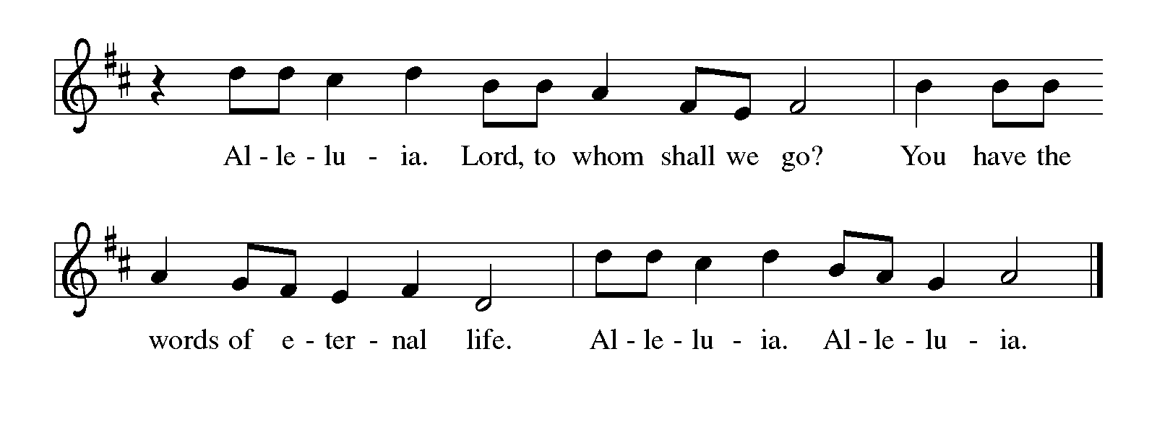

**THE HOLY GOSPEL Matthew 5:1-12**

*Jesus opens the Sermon on the Mount by describing God’s care for those who are blessed in the Reign of God.*

P: The Holy Gospel according to St. Matthew, the fifth chapter.

**C: Glory to You, O Lord!**

When Jesus saw the crowds, He went up the mountain; and after He sat down, His disciples came to Him. 2Then He began to speak, and taught them, saying:

3"Blessed are the poor in spirit, for theirs is the kingdom of heaven.

4"Blessed are those who mourn, for they will be comforted.

5"Blessed are the meek, for they will inherit the earth.

6"Blessed are those who hunger and thirst for righteousness, for they will be filled.

7"Blessed are the merciful, for they will receive mercy.

8"Blessed are the pure in heart, for they will see God.

9"Blessed are the peacemakers, for they will be called children of God.

10"Blessed are those who are persecuted for righteousness' sake, for theirs is the kingdom of heaven.

11"Blessed are you when people revile you and persecute you and utter all kinds of evil against you falsely on My account. 12Rejoice and be glad, for your reward is great in heaven, for in the same way they persecuted the prophets who were before you."

P: The Gospel of the Lord.

**C: Praise to You, O Christ!**

*The assembly is seated*

**THE SERMON**

*Silence for reflection follows the sermon*

*As you are able please rise*

**THE HYMN OF THE DAY 728 *Blest Are They***

**THE APOSTLES’ CREED**

A: God has made us His people through our Baptism into Christ. Living together in trust and hope, we confess our faith.

**C: I believe in God, the Father Almighty,**

**Creator of heaven and earth.**

**I believe in Jesus Christ, His only Son, our Lord.**

**He was conceived by the power of the Holy Spirit,**

**and born of the Virgin Mary.**

**He suffered under Pontius Pilate,**

**was crucified, died, and was buried.**

**He descended into hell.**

**On the third day He rose again.**

**He ascended into heaven,**

**and is seated at the right hand of the Father.**

**He will come again to judge the living and the dead.**

**I believe in the Holy Spirit,**

**the holy catholic Church,**

**the communion of saints,**

**the forgiveness of sins,**

**the resurrection of the body,**

**and the life everlasting. Amen.**

**THE PRAYER OF THE CHURCH**

A: Illumined by the light of Christ, let us pray for all nations, and for all in need of His healing presence.

A: That the Church might be rescued from the seductive promises of the world’s powers, looking to Christ alone for wisdom and courage in proclaiming and living out the Good News, we pray:

**C: Send forth Your light, O God.**

A: That those in our military and police forces might be kept in safety, and that all those working for order and peace in society might be blessed with endurance and hope, we pray:

**C: Send forth Your light, O God.**

A: That all those who oppress the weak, exploit the poor, and plan and enact evil would be defeated, we pray:

**C: Send forth Your light, O God.**

A: That this congregation might be granted the purity and integrity of heart to reach out in mercy to those in need, we pray:

**C: Send forth Your light, O God.**

A: That the persecuted for their faith in Christ, those who hunger and thirst, the poor in body and spirit, and the sick, especially . . . might be comforted by God’s healing, we pray:

**C: Send forth Your light, O God.**

A: That those celebrating birthdays, especially **Richard Cains** may grow in grace this day and every day and be filled with grace for the days ahead, we pray:

**C: Send forth Your light, O God.**

A:  That those who mourn, especially the family and friends of **Dorothy Coursel,**

Who died in the Lord this week may be comforted by the promise of resurrection

to life everlasting and of being reunited with those they love before the throne of

the Lamb, we pray:

**C: Send forth Your light, O God.**

A: That with all those who have hungered and thirsted for God’s righteousness, especially **Thomas Aquinas, teacher,** whom we commemorate this Day we too may one day see God face to face, we pray:

**C: Send forth Your light, O God.**

P: Almighty God, You have taught us to do justice, love kindness, and practice humility before You. Make our faith active in love, that Your name may be praised and Your people served throughout the world; through Jesus Christ our Lord.

**C: Amen.**

**✠ MEAL ✠**

**THE PEACE**

P: The peace of the Lord be with you always.

**C: And also with you.**

*The assembly is seated*

**THE OFFERING**

**THE VOLUNTARY *The Power of the Cross*  Praise Band**

*As you are able please rise*

**THE PRESENTATION OF THE GIFTS 312 *Jesus, Come! For We Invite You***

**(Stanzas** **1,4)**

(Sung to the tune of, *Angels From the Realms of Glory)*

**Jesus, come! for we invite You,**

**Guest and Master, Friend and Lord;**

**now, as once at Cana's wedding,**

**speak and let us hear Your word:**

**lead us through our need or doubting,**

**hope be born and joy restored.**

**Jesus, come! surprise our dullness,**

**make us willing to receive**

**more than we can yet imagine,**

**all the best You have to give:**

**let us find Your hidden riches,**

**taste Your love, believe, and live!**

**THE OFFERTORY PRAYER**

A: Let us pray. Gracious God,

**C: We do not bring You burnt offerings or rivers of oil, but a repentant and humble spirit. Receive these gifts for the sake of Your Son, Jesus Christ, and strengthen us through this Meal to love and walk in the way of Your Kingdom. We ask this in the name of Jesus the Lord. Amen.**

**THE GREAT THANKSGIVING**

P: The Lord be with you.

**C: And also with you.**

P: Lift up your hearts.

**C: We lift them up to the Lord.**

P: Let us give thanks to the Lord our God.

**C: It is right to give Him thanks and praise.**

P: Blessed are You, holy God: You are the Light and Life of all.

You created and sustain heaven and earth and all creatures in them.

To Israel, Your chosen, You showed great mercy.

You redeemed them from slavery, returned them home from exile, and sent

prophets called them to bear Your light through justice and kindness.

In all this we bless You for Your only-begotten Son, Jesus Christ.

He is Your power and wisdom.

In the night ... “Do this for the remembrance of Me.”

As often as we eat ... we proclaim the Lord’s death until He comes.

**C: Christ has died. Christ is risen. Christ will come again.**

P: Therefore, O God, with this bread and cup we remember the life our Lord offered

for us:

He blessed the poor in spirit, fed those who hungered for Your righteousness, and

by His death, made peace that we might be called children of God.

Risen to life, He will come again to renew creation in Your glory and light.

Send now we pray Your Holy Spirit on us and these Your gifts of bread and wine,

that we and all who share the Lord’s Body and Blood

May do justice, love kindness, and walk humbly in Christ’s service to all the world

until He comes in final victory.

To You, O God: Father, Son, and Holy Spirit, be all honor and glory, in Your holy

Church, in heaven and on earth, now and forever.

**C: Amen!**

**THE LORD’S PRAYER**

P: Because in Christ we have received the Spirit of adoption, as daughters and

sons of God, we dare to pray:

**C: Our Father, Who art in heaven, hallowed be Thy Name. Thy Kingdom come. Thy will be done on earth as it is in heaven. Give us this day our daily bread, and forgive us our trespasses as we forgive those who trespass against us. And lead us not into temptation, and deliver us from evil, for Thine is the Kingdom, and the power, and glory, forever and ever. Amen.**

**INVITATION TO THE MEAL**

P: Behold the true Light of the world, the Beloved of God, anointed by the Spirit. Blessed are those who are called to the Supper of the Lamb. God’s holy gifts for God’s holy people. Come, for all is now ready.

*The assembly is seated*

**THE DISTRIBUTION**

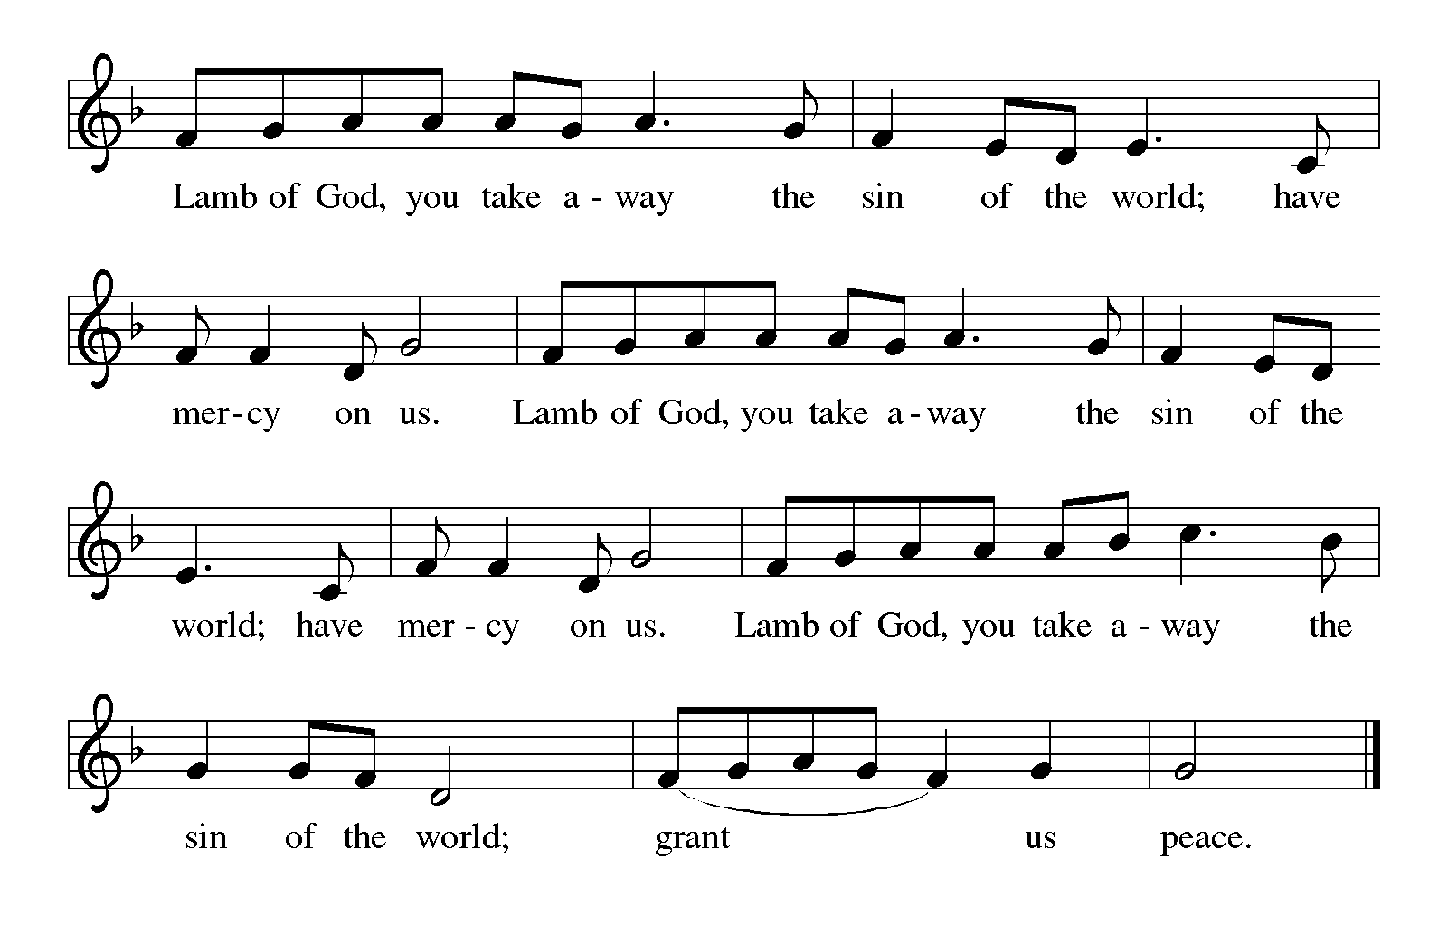

**SONGS DURING DISTRIBUTION**

*As you are able please rise*

**THE POST-COMMUNION BLESSING**

P: The Body and Blood of our Lord Jesus Christ strengthen you and keep you in His

grace.

**C: Amen.**

**THE POST-COMMUNION PRAYER**

A: Let us pray. Gracious God, in this Meal we have again tasted the source of our life, the Body and Blood of Your Son, Jesus Christ. Grant us His wisdom, that as we live His way of justice, kindness, and faithfulness, we may always point to the presence and goodness of Your Kingdom, where You live and reign with Him and the Holy Spirit, forever and ever.

**C: Amen.**

**✠ SENDING ✠**

**THE BENEDICTION**

P: Almighty God: Father, Son, ✠ and Holy Spirit bless you now and forever.

**C: Amen.**

**SENDING SONG Band**

**THE DISMISSAL**

A: You are servants of God; you are light to the nations.

Go in peace. Serve the Lord.

**C: Thanks be to God!**

**✠ To God Alone Be Glory ✠**

The Greeting, Prayers, Peace, and Dismissal are used by permission of *Sundays and*

*Seasons.* Copyright Augsburg Fortress 1999.

The Prayers, Introduction to the Lord’s Prayer, and Invitation to the Meal are adapted from

*Prayers for Sundays and Seasons. Year A.* Peter J. Scagnelli. (Chicago: Liturgy

Training Publications, 1998) 27-28.

The Post-Communion Prayer is also adapted from *The Book of Alternative Services.*

(Toronto: Anglican Book Centre, 1985) 231.

**ANNOUNCEMENTS**

**Please remember to mail your offering to the Church Office** at 818 Franklin Street, Michigan City, IN 46360**.** Another alternative is to give on-line through Tithe.ly. Please see your closure letter for information on how to set up a Tithe.ly account.

**St. Paul Members are reminded to have** a loved one contact the office if you are hospitalized. Many times, the Pastor doesn’t know someone is in the hospital. If you call and leave a message, please tell us which hospital the patient is at.

**Next Saturday’s lessons are: Isaiah 58: 1-9a [9b-12]; Psalm 112: 1-9 [10]; 1 Corinthians 2: 1-12 [13-16]; and Matthew 5: 13-20** for those of you who like to study them in advance.

**Birthdays: Richard Cains (2/5)**

**PRAYER CONCERNS:** Audrey Beyer, Ryan Krueger, Donna Bostater, Maxine

Powell, Jim Tomscheck, Eloise Ponder, Mark & Jary Tannehill, Marvin Dirks, Leonard Cross, Margie Torres, Dan Pursely, Jayla Jacobi and Barbara Reichert.

**OFFICE HOURS:** Libby will be in the office on Mondays, Wednesdays, and Fridays; volunteers will cover Tuesdays and Thursdays.

Monday & Wednesday 8:00 a.m. – 5 p.m.

Tuesday & Thursday 9:00 a.m. – 12:00 p.m.

Friday 8:00 a.m. – 12:00 p.m.

**If you are listening to the worship broadcast on the radio and would like to watch the Sunday morning service live stream follow these steps:**

(1) If you have You.Tube available on your TV, search for

**St. Paul Lutheran Church Michigan City, IN.**

(2) The direct link on the computer is

https://www.youtube.com/channel/UC5AIPNaKr3QN50984jGOa1g.

(3) This link is also on the main page of the church’s website in the church sec-

tion and will continue to be posted weekly on the St. Paul Facebook page.

And it will always be available on the radio broadcast Sunday mornings at 11:00 a.m. on WEFM (95.9), and on the local cable access station #99 for the previous week’s service on Sundays at 4:00 p.m. and the current service on Wednesdays at 7:00 p.m. and Fridays at 8:30 p.m.

**To send e-mail to the church office**, please use the following addresses:

Pastor Mark Reshan: seniorpastor@stpaulmichigancity.com

Church Office Secretary (Libby Pollock): churchsecretary@stpaulmichigancity.com

Church Treasurer (Karen Fleming): finance@stpaulmichigancity.com

**The Good News Newsletter**: If you have an article or anything you want included in **The Good News** please send it to the following e-mail address: splcgoodnews@gmail.com. Pastor Pamela Thiede will be using this e-mail address to assemble **The Good News** each month. The deadline for getting information to Pastor

Pamela will be the 20th of each month.

**WORSHIP ATTENDANCE for January 21and January 22, 2023**

**4:00 p.m. 34**

**9:00 a.m. 59**

**TOTAL 93**

**Thanks**

**Our Finance and Property Committee** would like to thank Warren Schacht, David

Squires, Charlie Marks and Mark Kloess for changing the light bulbs in the ceiling of the church.

**Warren Schacht has generously offered to convert audio tapes and cassettes to CD’s and VHS tapes to DVDs** at no charge! He is currently converting our church audio tapes/cassettes and has extended the offer to anyone who is interested in updating their material. You may call him directly at: 219-448-1444 or email him at: [w.schacht230@comcast.net](mailto:w.schacht230@comcast.net). Thank you, Warren!

**A Reminder**

**The discussion group “Estuary”** led by Pastor Dale Zylstra meets the second Tuesday of the month in the Luther House at 7:00 p.m. The group addresses topics of interest to the participants and is open to everyone.

**In an effort to save money on postage**: yearly donation state-ments have been emailed to those members who have email. Any members without email will find your statements in your hanging file folder in the Narthex. If you are unable to attend church please let the church office know so we can send your statement through the regular mail.

**2023 Financial Stewardship**

Weekly Church Operating Needs (x 2 weeks): $ 14,988.18

January 14, and 15, and 21and 22, 2023

General Fund (including General Memorials): $ 9,861.50

Overage/Shortage: -- $ 5,126.68

Restricted Income (not including Memorials)

Supports IK Synod & Church wide Ministries: $230.00

Ministries in our Community/Congregation: $ 70.00

Capital Fund: $ 415.00

General Fund: $175.00

Altar Guild: $20.00

