THE FOURTH SUNDAY AFTER THE EPIPHANY
January 28, 2024

Against the demon snares of sin,
The vice that gives temptation force,
The natural lusts that war within,
The hostile men that mar my course;
Or few or many, far or nigh,
In every place and in all hours,
Against their fierce hostility,
I bind to me these holy powers.

Against all Satan’s spells and wiles,
Against false words of heresy,
Against the heart’s idolatry,
Against the wizard’s evil craft,
Against the death wound and the burning,
The choking wave and the poisoned shaft,
Protect me, Christ, till thy returning.

From the Baptismal hymn, “I Bind Unto Myself This Day” (ELW 450)

In the Name of Jesus

GATHERING

INTRODUCTION

In Deuteronomy God promises to raise up a prophet like Moses, who will speak for God; in Psalm 111 God shows the people the power of God's works. For the church these are ways of pointing to the unique authority people sensed in Jesus' actions and words. We encounter that authority in God's word, around which we gather, the word that trumps any lesser spirit that would claim power over us, freeing us to follow Jesus.

Thomas Aquinas, teacher, died 1274

One of the most brilliant and creative theologians in the church's history, Aquinas worked to bring together scripture and the philosophy of Aristotle. A member of the Order of Preachers (Dominicans), Aquinas was also a hymnwriter.

PRELUDE

ANNOUNCEMENTS

As you are able please rise

CONFESSION AND ABSOLUTION

P: In the name of the Father and of the Son and of the Holy Spirit.

C: Amen.
P: “Great are the deeds of the LORD ... the works of His hands are faithfulness and justice;
all His commandments are sure.” (Psalm 111: 2, 7) We too, are the works of God’s
hands, created to reflect and embody God’s “faithfulness and justice.” Let us confess
our unfaithfulness, that we may live with “wisdom” and “a good understanding.”
(Psalm 111: 10)

Silence for self-examination and reflection is kept

P: Most merciful God,

C: We confess that we have sinned against You in thought, word, and deed. We have
not listened to the words of Your prophets and their call for just living.
(Deuteronomy 18: 19) We have acted in ways that have caused offense to other
Christians. (1 Corinthians 8: 9) We have allowed ourselves to be possessed by
thoughts, words, and actions that are “unclean.” (Mark 1: 23) We have refused to
submit ourselves to Your authority. For the sake of Your Son, Jesus Christ, have
mercy on us. Forgive us our sin and destroy all that is impure in us, that we may
be healed and live in joyful service to You.

P: “The LORD is gracious and full of compassion ... He is ever mindful of His covenant.”
(Psalm 111: 4-5) God’s covenant with you, sealed in Jesus Christ, is to be gracious,
compassionate, and merciful to you in your sin. Therefore, as a called and ordained
minister of the Church of Christ, and by His authority, I therefore declare to you the
entire forgiveness of all your sin, in the name of the Father and of the Son and of the
Holy Spirit.

C: Amen.

GATHERING HYMN 610 O Christ the Healer, We Have Come

THE GREETING AND PRAYER OF THE DAY

P: The grace of our Lord Jesus Christ, the love of God, and the communion of the Holy
Spirit be with you all.

C: And also with you.

P: Let us pray. Compassionate God, You gather the whole universe into your radiant
presence and continually reveal Your Son as our Savior. Bring wholeness to all that is
broken and speak truth to us in our confusion, that all creation will see and know Your
Son, Jesus Christ, our Savior and Lord.

C: Amen.

The assembly is seated

WORD

St. Paul Senior Choir Fear Not, I Am With You L. Larson

FIRST READING Deuteronomy 18: 15-20

Today's reading, part of a longer discussion of prophecy in Deuteronomy 18, stands within a still broader context: an updating of the law for the Israelite community as the people wait to enter the promised land. Here Moses assures the people that God will continue to guide them through prophets who will proclaim the divine word.

The LORD your God will raise up for you a prophet like me from among your own people; you shall heed such a prophet. ¹⁶This is what you requested of the LORD your God at Horeb on the day of the assembly when you said: "If I hear the voice of the LORD my God any more, or ever again see this great fire, I will die."
¹⁷Then the LORD replied to me: "They are right in what they have said. ¹⁸I will raise up for them a prophet like you from among their own people; I will put My words in the mouth of the prophet, who shall speak to them everything that I command.
¹⁹Anyone who does not heed the words that the prophet shall speak in My name, I Myself will hold accountable. ²⁰But any prophet who speaks in the name of other gods, or who presumes to speak in My name a word that I have not commanded the prophet to speak--that prophet shall die."

The Word of the Lord.

Thanks be to God.

THE PSALM: Psalm 111 Read responsively

¹Hallelujah! I will give thanks to the LORD with my whole heart,
in the assembly of the upright, in the congregation.

²Great are Your works, O LORD,
pondered by all who delight in them.

³Majesty and splendor mark Your deeds,
and Your righteousness endures forever.

⁴You cause Your wonders to be remembered;
You are gracious and full of compassion.

⁵You give food to those who fear You,
remembering forever Your covenant.

⁶You have shown Your people the power of Your works
in giving them the lands of the nations.

⁷The works of Your hands are faithfulness and justice;
all of Your precepts are sure.

⁸They stand fast forever and ever,
because they are done in truth and equity.

⁹You sent redemption to Your people
and commanded Your covenant forever;
holy and awesome is Your name.
¹⁰The fear of the LORD is the beginning of wisdom;
all who practice this have a good understanding.
God's praise endures forever.

SECOND READING 1 Corinthians 8: 1-13

God's people are set free by Jesus' death and resurrection. Customary restrictions no longer apply. Notice, though, that those for whom Christ died find this freedom has limits. The gospel compels us to care about each other.

Now concerning food sacrificed to idols: we know that "all of us possess knowledge." Knowledge puffs up, but love builds up. ²Anyone who claims to know something does not yet have the necessary knowledge; ³but anyone who loves God is known by him.
⁴Hence, as to the eating of food offered to idols, we know that "no idol in the world really exists," and that "there is no God but one." ⁵Indeed, even though there may be so-called gods in heaven or on earth--as in fact there are many gods and many lords--⁶yet for us there is one God, the Father, from Whom are all things and for Whom we exist, and one Lord, Jesus Christ, through Whom are all things and through Whom we exist.
⁷It is not everyone, however, who has this knowledge. Since some have become so accustomed to idols until now, they still think of the food they eat as food offered to an idol; and their conscience, being weak, is defiled. ⁸ "Food will not bring us close to God." We are no worse off if we do not eat, and no better off if we do.
⁹But take care that this liberty of yours does not somehow become a stumbling block to the weak. ¹⁰For if others see you, who possess knowledge, eating in the temple of an idol, might they not, since their conscience is weak, be encouraged to the point of eating food sacrificed to idols?
¹¹So by your knowledge those weak believers for whom Christ died are destroyed. ¹²But when you thus sin against members of your family, and wound their conscience when it is weak, you sin against Christ. ¹³Therefore, if food is a cause of their falling, I will never eat meat, so that I may not cause one of them to fall.

The Word of the Lord.

Thanks be to God.

As you are able please rise

THE VERSE
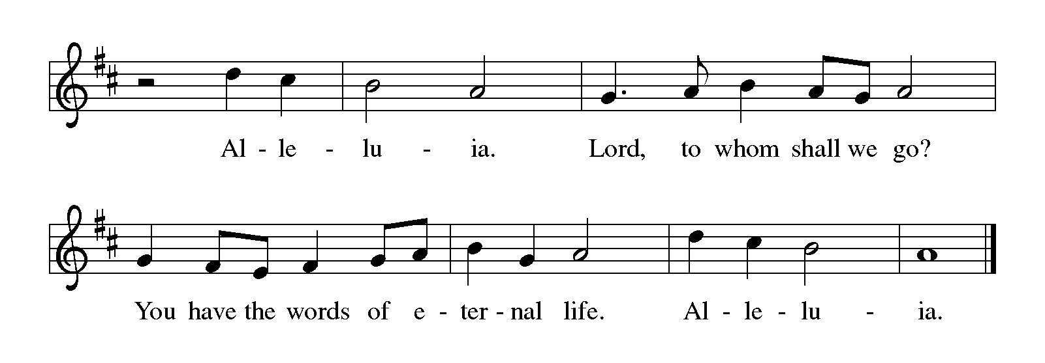
THE HOLY GOSPEL Mark 1: 21-28

The story has barely begun, and already the battle is joined. Jesus sides with humanity against very force that would bring death and disease. These forces recognize Jesus and now what His power means for them. This battle, however, is only the first fight. The war will go on much longer.

P: The Holy Gospel according to St. Mark, the first chapter.

C: Glory to You, O Lord!

Jesus and His disciples went to Capernaum; and when the Sabbath came, He entered the synagogue and taught. ²²They were astounded at His teaching, for He taught them as one having authority, and not as the scribes.
²³Just then there was in their synagogue a man with an unclean spirit, ²⁴and he cried out, "What have you to do with us, Jesus of Nazareth? Have You come to destroy us? I know Who You are, the Holy One of God."
²⁵But Jesus rebuked him, saying, "Be silent, and come out of him!" ²⁶And the unclean spirit, convulsing him and crying with a loud voice, came out of him. ²⁷They were all amazed, and they kept on asking one another, "What is this? A new teaching--with authority! He commands even the unclean spirits, and they obey Him." ²⁸At once His fame began to spread throughout the surrounding region of Galilee.

P: The Gospel of the Lord.

C: Praise to You, O Christ!

The assembly is seated

THE SERMON

Silence for reflection follows the sermon

As you are able please rise

THE HYMN OF THE DAY Cast Out, O Christ
(Sung to the tune of, The King Shall Come)

1 Cast out, O Christ, cast far away
the demons that destroy:
the haunting dreads that choke our souls,
the hates that stifle joy.

2 Our raging griefs, our jealous fears
are Legion in their name.
Our shackled hearts implore Your grace
to loose our binding shame.

3 Once long ago, from Galilee,
You sailed to storm-tossed shores.
And still, in pow'r, You brave new paths
to breach our bolted doors.
4 Your Word breathes life and health and hope
that break through evil's thrall.
You send us, strengthened, home in peace
to live your gospel call.

5 So come, O Christ, and cast away
the demons that destroy.
Transform our lives to sense Your love
and spread abroad Your joy.

The assembly is seated

INSTALLATION OF THE CHURCH COUNCIL

P: The following persons, having been elected by the congregation to positions of leadership, are asked to come forward as their offices and names are read.

President Janet Bakken
Vice-President Fred Hart
Secretary Donna Knoll
Treasurer Karen Fleming

Susan Bagby Diane Egilske
Wayne Dolson Judy Hunt
Paul Brooks Bob Kiser
Judy Mutchler Lynne Nevels

P: St. Paul writes: There are different kinds of spiritual gifts, but the same Spirit gives them. There are different ways of serving, but the same Lord is serviced. There are different abilities to perform service, but the same God gives to everyone ability for particular service. The Spirit’s presence is shown in some way in each person, for the good of all. (1 Corinthians 12:4-7)

You have been elected to positions of leadership and trust in this congregation. You are to see that the words and deeds of this household of faith reflect Him in Whose name we gather.

You are to work together with other members to see that the worship and work of Christ are done in this congregation, and that God’s will is done in this community and in the whole world.

You are to be diligent in your specific area of serving, that the one Lord Who empowers you is glorified.

You are to be examples of faith active in love, to help maintain the life and harmony of this congregation.

On behalf of your sisters and brothers in Christ, I ask you: Are you ready to accept and faithfully to carry out the duties of the offices to which you have been elected?

R: Yes, by the help of God.

Please stand

P: People of God, I ask you: Will you support these, your elected leaders, and will you
share in the mutual ministry that Christ has given to all who are baptized?

C: Yes, by the help of God.

P: I now declare you installed as council of this congregation. God bless you with His
Holy Spirit, that you may prove faithful servants of Christ.

R: Amen.

THE PRAYER OF THE CHURCH

A: As the people gathered in Capernaum to hear Jesus’ words, so too have we come
together to hear God’s Word. Let us boldly offer our prayers to God for the Church,
the world, and all those who seek the light of Christ.

A: That God would continue to raise up prophets in the Church who will speak the
commands and promises of God, let us pray to the Lord:

C: Lord, have mercy.

A: That the Church may, in turn, heed and obey God’s Word spoken by His prophets, let
us pray to the Lord:

C: Lord, have mercy.

A: That leaders and nations of the world might strive with God’s own faithfulness for
justice and an end to violence, oppression, and political tyranny, let us pray to the Lord:

C: Lord, have mercy.

A: That this congregation might be granted the wisdom, courage, and will to seek and
implement faithful ministries in this place, let us pray to the Lord:

C: Lord, have mercy.

A: That our church council: Janet Bakken; Fred Hart; Donna Knoll; Karen Fleming;
Wayne Dolson; Paul Brooks; Diane Egilske; Susan Bagby; Judy Hunt; Lynne
Nevels; Bob Kiser, and Judy Mutchler may lead us with wisdom, vision, and passion
as we seek to faithfully serve this neighborhood and community, let us pray to the
Lord:

C: Lord, have mercy.

A: That those burdened by emotional anguish or mental illness may receive the care they
need, the love they desire, the healing they seek, let us pray to the Lord:

C: Lord, have mercy.

A: That the sick, especially might know the power of Jesus’ healing presence, let us pray
to the Lord:

C: Lord, have mercy.

A: That with all the saints who have gone before us, especially Thomas Aquinas, teacher,
whom we commemorate this Day we too may come before the Holy One of God, let
us pray to the Lord:

C: Lord, have mercy.

P: O God, we commend to Your care all for whom we pray, in the confidence that Your
love for them is greater than anything we can know or imagine. Hear us, through Your
Son, Jesus Christ our Lord.

C: Amen.
MEAL

THE PEACE

P: The peace of the Lord be with you always.

C: And also with you.

The assembly is seated

THE OFFERING

THE VOLUNTARY

As you are able please rise

THE PRESENTATION OF GIFTS 302 As With Gladness Men of Old Stanza 3

THE OFFERTORY PRAYER

A: Let us pray. God of steadfast love,

C: All good gifts are from Your faithful hand. In thanksgiving we bring You these
offerings, and ask that You make them holy for Your service. Through this
heavenly Food that You give, strengthen us to speak and live Your Word of life.
We ask this in the name of Jesus the Lord. Amen.

THE GREAT THANKSGIVING

P: The Lord be with you.

C: And also with you.

P: Lift up your hearts.

C: We lift them up to the Lord.

P: Let us give thanks to the Lord our God.

C: It is right to give Him thanks and praise.

P: God of glory and truth, we praise Your holy name with thanksgiving, because You
sent prophets to inscribe the story of creation, to recall the shaping of Your
covenant with Israel, and to hold Your people to account for their life in You.
These same prophets told of a day when You would restore Your covenant and open
wide Your arms to bring Your people home to You.
In Jesus we see those promises fulfilled.
In His death and resurrection we know our sins are forgiven and receive the
promise of everlasting life with You.
Gracious God, Your Son Jesus ate with friend and stranger, with devoted disciple
and skeptical scrutinizer, with the one who would betray and the one who
had denied.
He made food a place of encounter with You.
By the power of Your Holy Spirit visit Your people and sanctify us in the image
of Your crucified Son.
Through the same Spirit make these gifts of bread and wine be for us the Body and
Blood of Your Son Jesus Christ,
Who, in the night ... “Do this for the remembrance of Me.”
As often as we eat ... we proclaim the Lord’s death until He comes.

C: Christ has died. Christ is risen. Christ will come again.

P: Cleansing God, Your Son Jesus taught and healed as One with authority.
When Your children search in vain for someone to trust, show them Your face.
When Your people long for one to lead or a path to follow, send them Your
pillar of cloud by day and of fire by night.
Where Your Church is faltering in fear and doubt, make Yourself known in
the ones we regard as the least of these. ready.
Usher in the Day when all may taste and see the riches of Your grace, and Your
arms of love will all the world embrace,
In Jesus Christ through the power of the Holy Spirit in union with the Father.

C: Amen!
THE LORD’S PRAYER

P: Let us pray for the coming of the Kingdom as Jesus taught us:

C: (Sung)

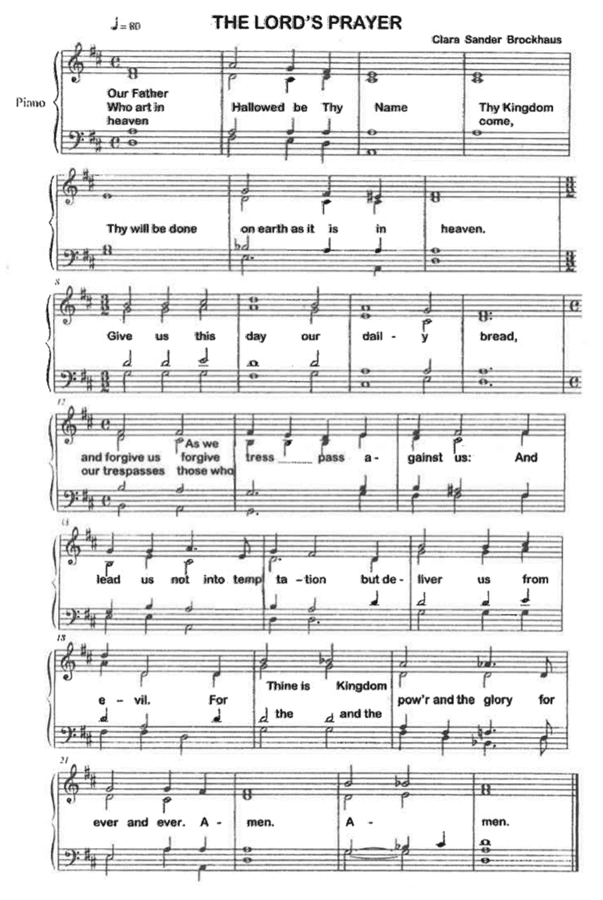

INVITATION TO THE MEAL

P: Behold the Lamb of God Who takes away the sin of the world. Blessed are those
who are called to the Supper of the Lamb. God’s holy gifts for God’s holy people.
Come, for all is now ready.

The assembly is seated

THE DISTRIBUTION
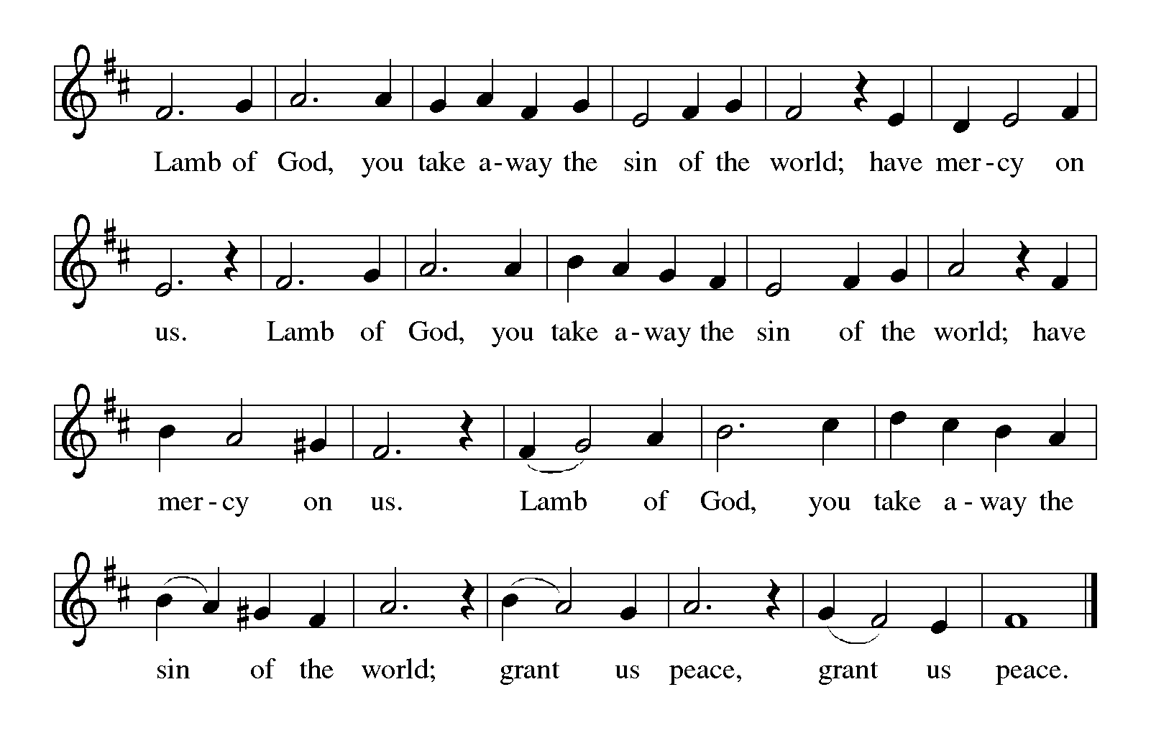
HYMNS DURING DISTRIBUTION 614 There is a Balm in Gilead
612 Healer of Our Every Ill
As you are able please rise

THE POST-COMMUNION BLESSING

P: The Body and Blood of our Lord Jesus Christ strengthen you and keep you in His grace.

C: Amen.

THE POST-COMMUNION PRAYER

A: Let us pray. God of grace, in this Eucharist we are nourished by the Bread of heaven
and invigorated with new wine. May these gifts renew our lives, and raise us up to
reveal Your glory in the darkness of this world. Grant this through Christ our Lord.

C: Amen.
SENDING

THE BENEDICTION

P: The Lord bless you and keep you. The Lord make His face shine on you and be gracious
to you. The Lord look upon you with favor + and give you peace.

C: Amen.

THE SENDING HYMN 310 Songs of Thankfulness and Praise

THE DISMISSAL

A: You are servants of God; you are light to the nations.
Go in peace. Serve the Lord.

C: Thanks be to God!

POSTLUDE

To God Alone Be Glory

The Meditation is taken from Sundays and Seasons Online. Copyright 2017 Augsburg Fortress.

The Eucharistic Prayer is adapted from Eucharistic Prayers. Samuel Wells and Abigail
Kocher. (Grand Rapids: Wm. Eerdmann Publishing Company, 2016) 92-93.
ANNOUNCEMENTS

Please remember to mail your offering to the Church Office at 818 Franklin Street, Michigan City, IN 46360. Another alternative is to give on-line through Tithe.ly. Please see your closure letter for information on how to set up a Tithe.ly account.

St. Paul Members are reminded to have a loved one contact the office if you are hospitalized. Many times, the Pastor doesn’t know someone is in the hospital. If you call and leave a message, please tell us which hospital the patient is at.

Birthdays: Wayne Simerlein (1/25); Elaine Bogart (1/28); Eloise Ponder (1/28)

PRAYER CONCERNS: Sue Koziel, Jana Thomas, Leonard Cross, Margie Torres, Jayla Jacobi, Barbara Reichert, Jim Gleason, Kim Mitchell, Ronwynn Jones, Chris Jones, Mark Tannehill, Joan Seifert, Virginia Murray, Brian Wiseman, Julie Brooks, Jary Tannehill and Sue Granacki.

OFFICE HOURS: Libby will be in the office on Mondays, Wednesdays,
and Fridays; volunteers will cover Tuesdays and Thursdays.

Monday & Wednesday 8:00 a.m. – 5 p.m.
Tuesday & Thursday 9:00 a.m. – 12:00 p.m.
Friday 8:00 a.m. – 12:00 p.m.

If you are listening to the worship broadcast on the radio and would like to watch the Sunday morning service live stream follow these steps:

(1) If you have You Tube available on your TV, search for
St. Paul Lutheran Church Michigan City, IN.

(2) The direct link on the computer is
https://www.youtube.com/channel/UC5AIPNaKr3QN50984jGOa1g.

(3) This link is also on the main page of the church’s website in
the church section and will continue to be posted weekly on the St.
Paul Facebook page.

And it will always be available on the radio broadcast Sunday mornings at 11:00 a.m.
on WEFM (95.9), and on the local cable access station #99 for the previous week’s
service on Sundays at 4:00 p.m. and the current service on Wednesdays at 7:00 p.m. and
Fridays at 8:30 p.m.

The approved and signed minutes of the October 26, 2023 and November 16, 2023 Church Council Meetings are on the table at the back of the church in the Narthex. Please take a copy with you as you go.

To send e-mail to the church office, please use the following addresses:

Pastor Mark Reshan: seniorpastor@stpaulmichigancity.com

Church Office Secretary (Libby Pollock): churchsecretary@stpaulmichigancity.com

Church Treasurer (Karen Fleming): finance@stpaulmichigancity.com

The Good News Newsletter: If you have an article or anything you want included in The Good News please send it to the following e-mail address: splcgoodnews@gmail.com. Pastor Pamela Thiede will be using this e-mail address to assemble The Good News each month. The deadline for getting information to PastorPamela will be the 20th of each month.

Worship Attendance: January 13 and 14, 2024; also January 20 and 21:
4:00 p.m. 19 0
9:00 a.m. 23 0
TOTAL 42 0 due to blizzard/snow

LOOKING FOR IDEAS
We’d like to continue to highlight a different mission each month. We are looking for suggestions! If you volunteer somewhere or have a mission that is close to your heart, please let Paul or Lora Brooks know so we can set up a month to support that cause! Paul: (219) 221-0254, paulbrooks@gmail.com; or Lora: (260) 701-1586, loralmartin15@gmail.com.

Local January monthly Mission: January’s monthly mission will be for our Local YMCA. Our YMCA provides our community with many programs to help youth development, health and well-being, education and community cohesion. The YMC offers preschool school’s day out camo, swim lessons, various sport camps, free family events, fitness classes, and so much more. Their scholarship program allows everyone to be a part of the Y! If you would like to support this mission, please place your donation in the offering plate marked for the YMCA. Thank you!

DONATION/GIVING STATEMENTS

Beginning on January 16, 2024 your annual “giving statements” are now available to you. If you have an email address on record in the church office you will receive your statement via email. If you don’t find it right away make sure to look in your junk mail files first. Otherwise you can find your printed statement in your hanging file at the back of the church in the narthex. If you still haven’t received it by the end of next week please notify the church office and we will work as quickly as possible to take care of this. We greatly appreciate everyone’s patience and cooperation in this matter as it will help alleviate the high cost of postage for sending them through the post office. Thanking you in advance and may God bless you!

ACTIVITIES, EVENTS & MEETINGS, continued
January 2024

Tuesday, January 23, 2024 @ 3:00 p.m. Executive Board Meeting/Luther House

@ 4:00 p.m. Finance Committee Meeting/Luther House

Wednesday, January 24, 2024 @ 9:15 a.m. Bible Study/Luther House

@ 10:00 a.m. God’s Purls/St Paul Room

@ 4:00 p.m. Choir Rehearsal

Thursday, January 25, 2024 @ 5:30 p.m. Church Council Meeting/St. Paul Room

Saturday, January 27, 2024 @ 4:00 p.m. Worship Service

Sunday, January 28, 2024 @ 9:00 a.m. Worship Service

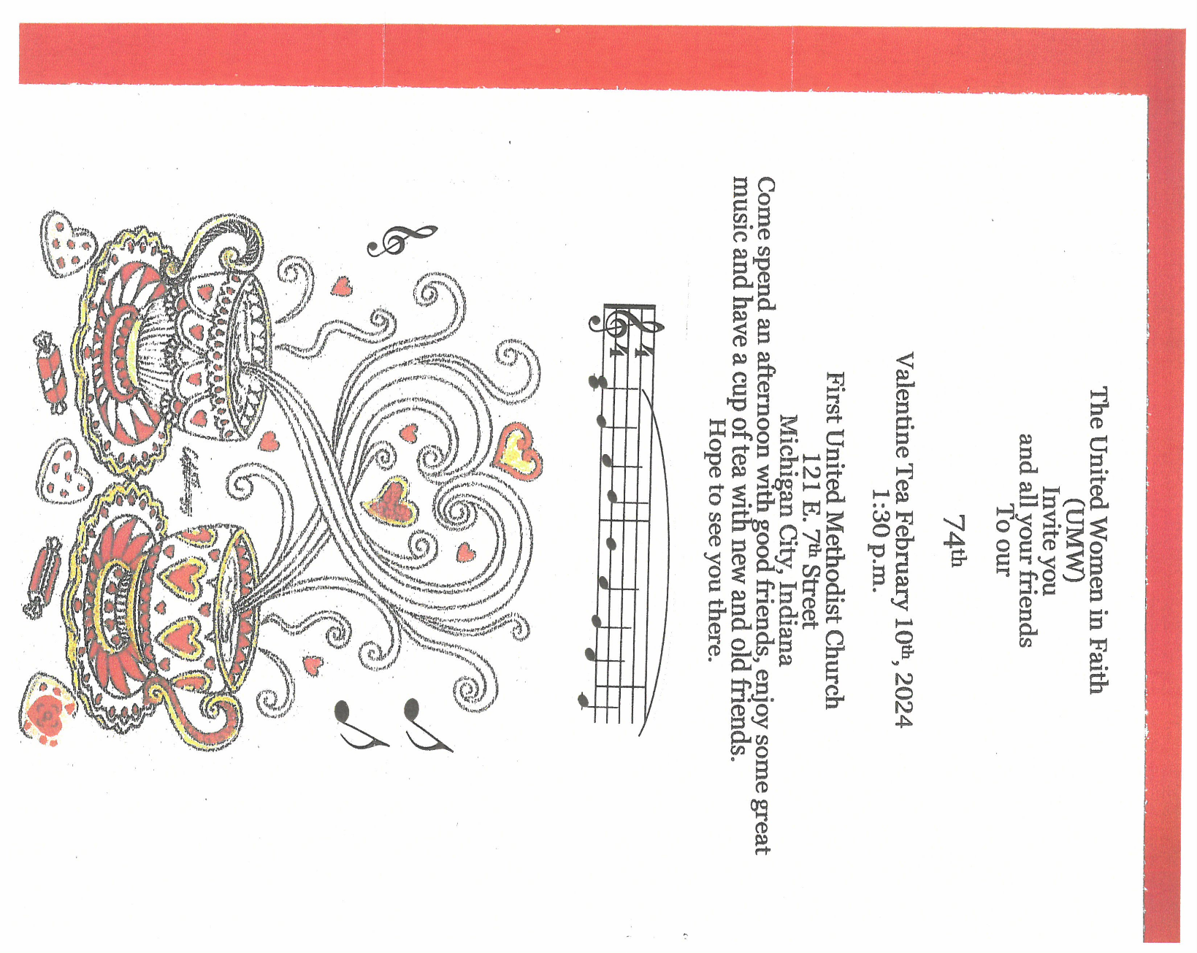

2023 Financial Stewardship
Weekly Church Operating Needs (x 2 weeks): $ 13,850.00
January 13 and 14, January 20 and 21, 2024

General Fund (including General Memorials): $ 8,613.75
Overage/Shortage: —- $ 5,236.25

Restricted Income (not including Memorials)

Supports IK Synod & Church wide Ministries: $ 80.00

Ministries in our Community/Congregation: $ 10.00
Capital Fund: $ 70.00

Memorials
General Fund: $ 310.00
Capital Fund $ 25.00

ACTIVITIES, EVENTS & MEETINGS
FEBRUARY 2024

Thursday, February 1, 2024, Faith Circle

Saturday, February 3, 2024 @ 4:00 p.m. Worship Service

Sunday, February 4, 2024 @ 9:00 a.m. Worship Service

Wednesday, February 7, 2024 @ 10:00 a.m. God’s Purls/St. Paul Room

@ 4:00 p.m. Choir Rehearsal

Saturday, February 10, 2024 Worship Service

Sunday, February 11, 2024 @ 9:00 a.m. Worship Service

Monday, February 12, 2024 @1:00 p.m. Hope Circle/Green Room

;
Tuesday, February 13, 2024 @ 7:00 p.m. Estuary/Luther House

Wednesday, February 14, 2024 @ 10:00 a.m. God’s Purls/St. Paul Room
@ 4:00 p.m. Choir Rehearsal

Saturday, February 17, 2024 @4:00 p.m. Worship Service

Sunday, February 18, 2024 @ 9:00 a.m. Worship Service

Wednesday, February 21, 2024 @ 10:00 p.m. God’s Purls/ St. Paul Room

@ 4:00 p.m. Choir Rehearsal

Saturday, February 24, 2024 @ 4:00 p.m. Worship service

Sunday, February 25, 2024 @ 9:00 a.m. Worship Service

Monday, February 26, 2024 @ 3:00 p.m. Executive Board Mtg/ Luther House

@4:00 p.m. Finance Committee Meeting

Wednesday, February 28, 2024 10:00 a.m. God’s Purls/St. Paul Room

4:00 p.m. Choir Rehearsal

Thursday, February 29, 2024 4:00 p.m. – 9:00 p.m. GIVE BACK @ GALVESTON

5:30 p.m. Church Council

