THE SECOND SUNDAY IN ADVENT
December 7, 2025

In an age which offers a variety of escapes from the human condition, Christians are more than ever a sign of contradiction. They continue to believe that the search for God must begin with the acceptance of the human. They believe this because it is in the stable of humanity that God has come in search of us.
In the human experience of Jesus, God became available to us at the depth of human life. Thus, a Christian believes that the experience of ultimate meaning comes not from a leap out of the human condition, but a journey through its dark waters.

John Heagle

In the fourth century, encouraging those who were preparing for baptism, Cyril of Jerusalem said, “Great indeed is the baptism that is offered you. It is the remission of offenses; the death of sin; the luxury of paradise; a procuring of the kingdom. Prepare your heart to receive this doctrine, to have fellowship in these holy mysteries. Should you find any shameful, any base imagination rising, reflect upon God’s judgment, to remind you of salvation. Give your mind to sacred studies, that you may forget wicked things.”
Cyril of Jerusalem
Fourth century
Lectures on the Christian Sacraments

The Advent mystery is the beginning of the end in all of us that is not yet Christ.

Thomas Merton

INTRODUCTION

At the heart of our Advent preparation stands John the Baptist, who calls us to repent and make a new beginning. As the darkness increases we turn toward the light of Christ's coming. For Christians he is the root of Jesse, the righteous judge who welcomes all, especially the poor and meek of the earth. We wait with hope for that day when the wolf will dwell with the lamb, and there will be no more hurt or destruction. From the Lord's table we are sent in the spirit of John the Baptist to proclaim that in Christ the kingdom of God has come near.

Ambrose, Bishop of Milan, died 397

While a governor of northern Italy, Ambrose was elected bishop of Milan on the same day he was baptized. He was a famous preacher, a writer of hymns we still sing today, and helped lead St. Augustine to faith.

GATHERING

PRESERVICE MUSIC Jesus Messiah New Song Praise Band
(D. Carson, C. Tomlin, E. Cash, J. Reeves)

ANNOUNCEMENTS
As you are able please rise

CONFESSION AND ABSOLUTION

P: In the name of the Father and of the Son and of the Holy Spirit.

C: Amen.

P: “In those days John the Baptist appeared in the wilderness of Judea, proclaiming,
‘Repent, for the kingdom of heaven has come near ... Bear fruit worthy of repentance.’”
(Matthew 3: 1, 8) The repentance to which John calls us is a radical reorientation: a
change of heart, mind, and life. Let us “prepare the way of the Lord” by confessing
our sin against God and neighbor.

Silence for self-examination and reflection is kept

P: Most merciful God,

C: We confess that we have sinned against You in thought, word, and deed. We
acknowledge that often our repentance is not a genuine change of heart and life.
We yet unfairly evaluate others only “by what we see and hear” (Isaiah 11: 3). We
yet neglect the poor and victimize the weak. (11: 4) There is much “chaff” in our
lives that needs to be burned away (Matthew 3:12). Where our faith is dead, O
Lord, resurrect it to blossom with hope and joy. For the sake of Your Son, Jesus
Christ, have mercy on us. Help us to truly repent. Turn us from our sin toward
faithfulness and right living. Help us to “make straight Your paths” (Matthew 3:
3).

P: “Welcome one another, therefore, just as Christ has welcomed you, for the glory of
God.” (Romans 15: 7) In Christ God has “welcomed” you, and forgiven you for a new
way of living. Rejoice in the mercy of God, O friends, for as a called and ordained
minister of the Church of Christ, and by His authority, I declare to you the entire
forgiveness of all your sins, in the name of the Father and of the Son and of the Holy
Spirit.

C: Amen.

GATHERING SONG NSB 28 Days of Elijah

THE GREETING

P “Blessed be the Lord God, the God of Israel, Who alone does wondrous deeds!

C: And blessed be His glorious name forever, and may all the earth be filled with His
glory. Amen. Amen.” (Psalm 72: 18-19)

P: The grace of our Lord Jesus Christ, the love of God, and the communion of the Holy
Spirit be with you all.

C: And also with you.

THE KYRIE

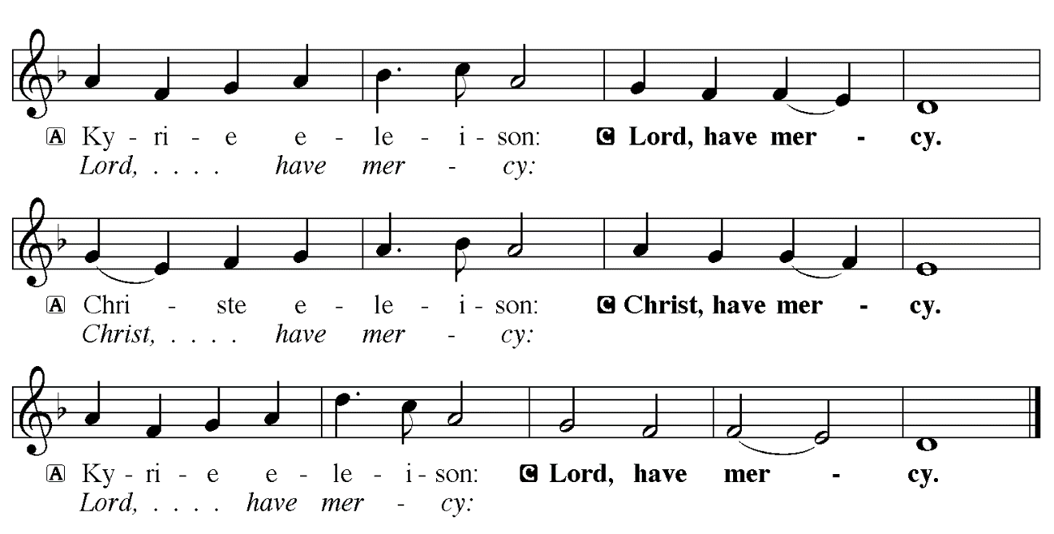

THE PRAYER OF THE DAY

P: The Lord be with you.

C: And also with you.

P: Let us pray. Stir up our hearts, Lord God, to prepare the way of Your only Son. By His
coming nurture our growth as people of repentance and peace; through Jesus Christ,
our Savior and Lord, Who lives and reigns with You and the Holy Spirit, one God, now
and forever.

C: Amen.

The assembly is seated

WORD

LIGHTING OF ADVENT LOG Christ, Be Our Light! Joel Raney

(Stanzas 1, 2)

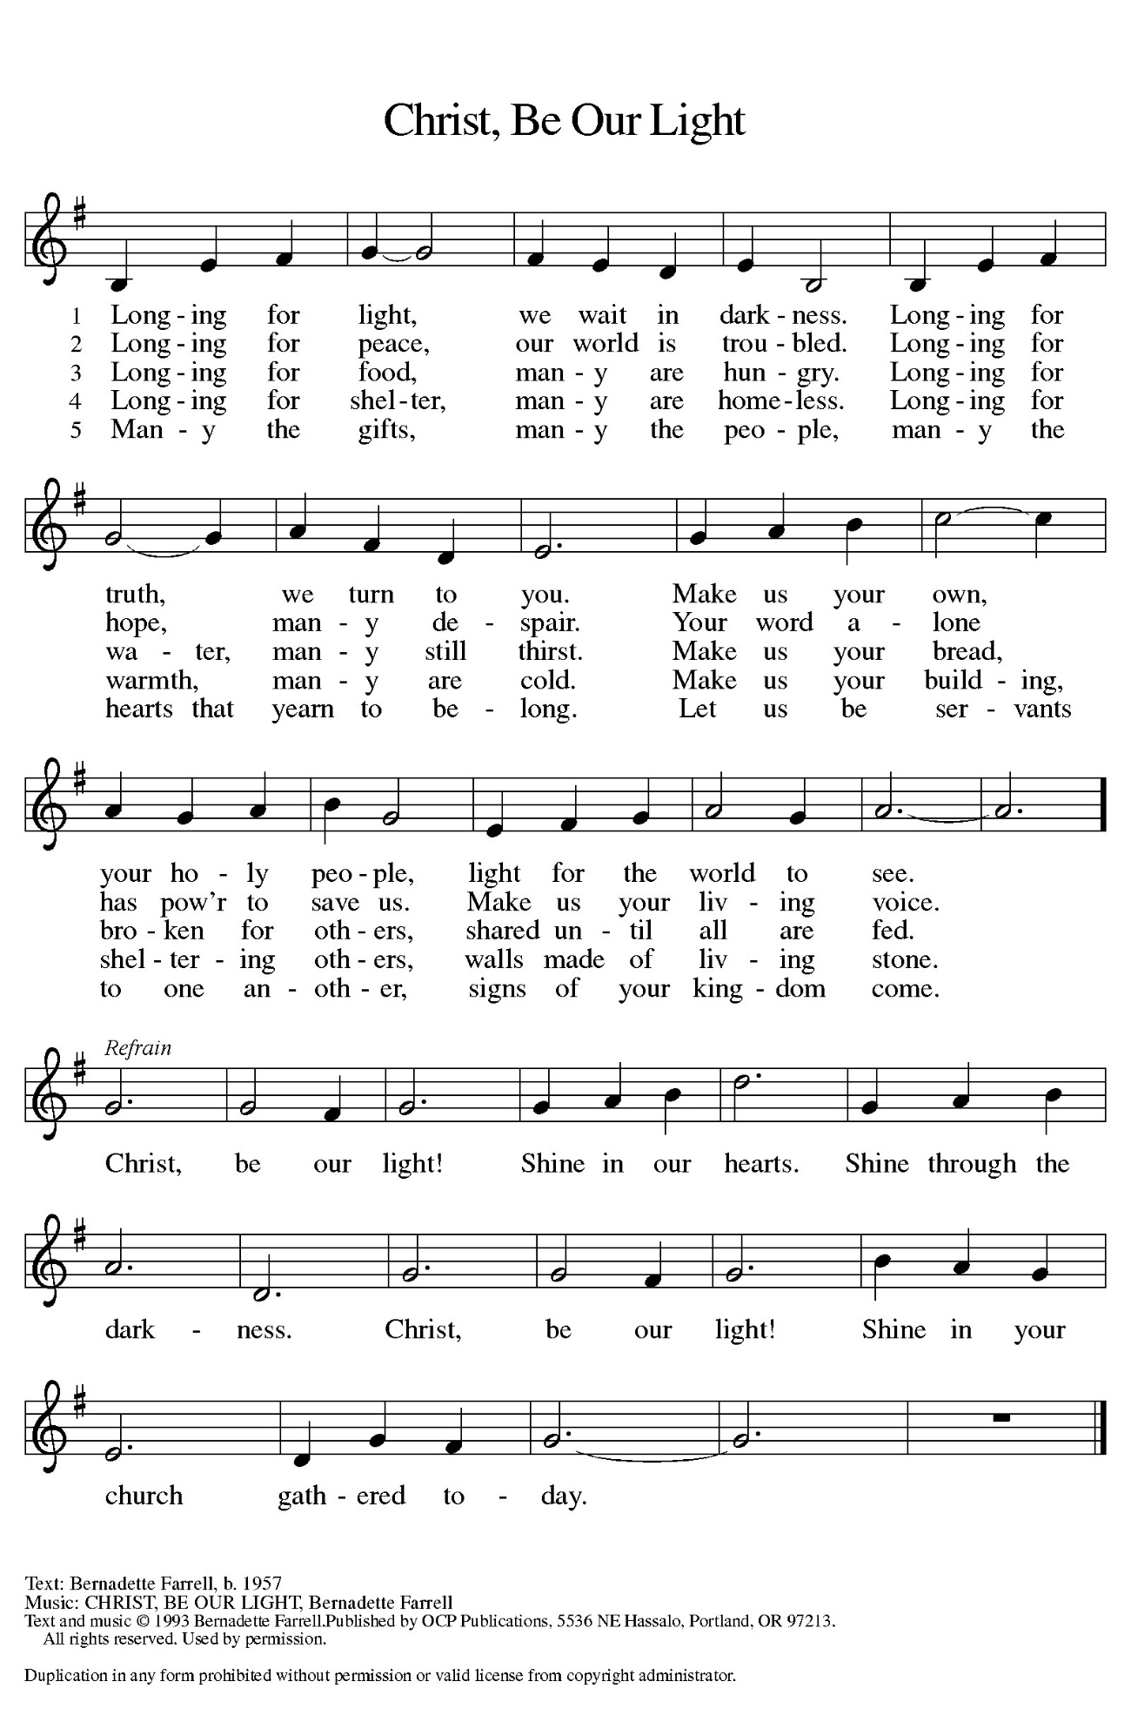
Hope for Those Who are Weary

P: The Light shines in the darkness,

C: But the darkness has not overcome it.

P: During Advent our weary souls seek God’s daily strength.

C: The Lord gives strength to the weary and increases the power of the weak.

P: We grow weary when fear overshadows faith.

C: The Lord gives strength to the weary and increases the power of the weak.

P: We grow weary when destructive actions erupt in the world around us.

C: The Lord gives strength to the weary and increases the power of the weak.

P: For all of us feeling weary in this Advent season:

C: Grant that we might have the peace of Christ as we wait, the love of Christ as we
act, and the grace of Christ as we speak.

(During the candle lighting)

P: Today we light two candles. The first candle illuminates patience in the areas of our
lives where God has called us to wait. The second candle extends the promise of
strength to all who feel weary and weak in the shadows of this world. As we continue
our Advent journey, may our hope be kindled as the Light grows brighter.

(Repeat the refrain)

FIRST READING Isaiah 11: 1-10

In the previous chapter Isaiah portrays God's judgment as the felling of a great forest. In today's reading the prophet describes the ideal ruler who will come in the future as a green shoot springing from the dead stump (David's royal line) of Jesse (David's father). The reign of this monarch will be experienced as paradise regained.

A shoot shall come out from the stump of Jesse,
and a branch shall grow out of his roots.
²The spirit of the LORD shall rest on him,
the spirit of wisdom and understanding,
the spirit of counsel and might,
the spirit of knowledge and the fear of the LORD.
³His delight shall be in the fear of the LORD.
He shall not judge by what his eyes see,
or decide by what his ears hear;
⁴but with righteousness he shall judge the poor,
and decide with equity for the meek of the earth;
he shall strike the earth with the rod of his mouth,
and with the breath of his lips he shall kill the wicked.
⁵Righteousness shall be the belt around his waist,
and faithfulness the belt around his loins.
⁶The wolf shall live with the lamb,
the leopard shall lie down with the kid,
the calf and the lion and the fatling together,
and a little child shall lead them.
⁷The cow and the bear shall graze,
their young shall lie down together;
and the lion shall eat straw like the ox.
⁸The nursing child shall play over the hole of the asp,
and the weaned child shall put its hand on the adder's den.
⁹They will not hurt or destroy on all my holy mountain;
for the earth will be full of the knowledge of the LORD
as the waters cover the sea.
¹⁰On that day the root of Jesse shall stand as a signal to the peoples;
the nations shall inquire of him,
and his dwelling shall be glorious.

The Word of the Lord.

Thanks be to God.

THE PSALM: Psalm 72: 1-7, 18-19 Antiphon by Robert Hobby

Choir sings refrain first, followed immediately by the congregation
and as indicated

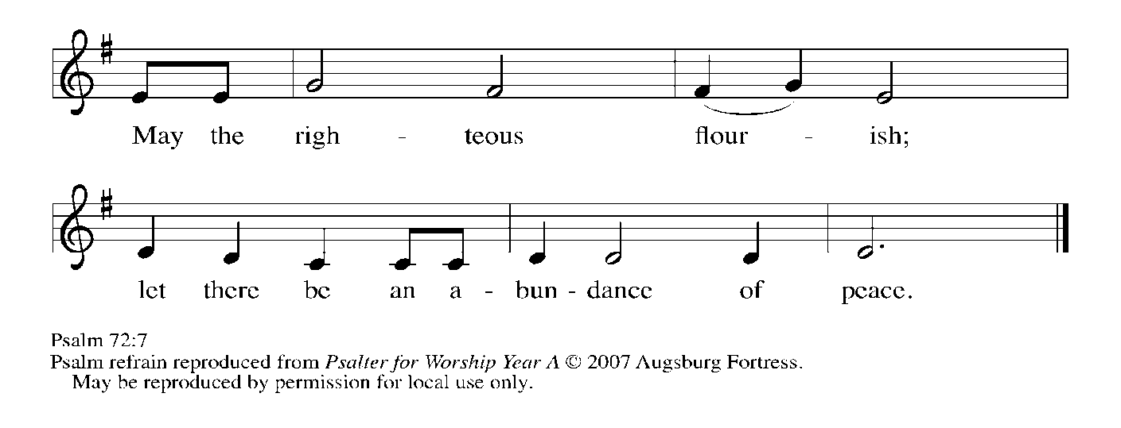
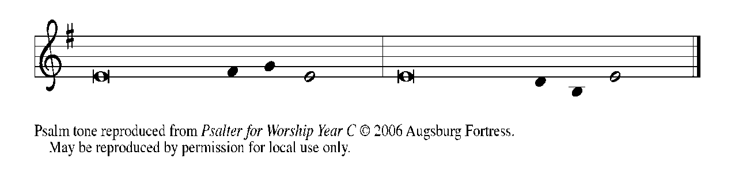

¹Give the king Your jus- | tice, O God,
and Your righteousness to | the king's son;

²that he may rule Your | people righteously
and the | poor with justice;

³that the mountains may bring prosperity | to the people,
and the | hills, in righteousness.

⁴Let him defend the needy a- | mong the people,
rescue the poor, and crush | the oppressor. REFRAIN

⁵May he live as long as the sun and | moon endure,
from one generation | to another.

⁶Let him come down like rain upon | the mown field,
like showers that wa- | ter the earth.

⁷In his time may the | righteous flourish;
and let there be an abundance of peace till the moon shall | be no more.

¹⁸Blessed are You, LORD God, the | God of Israel;
You alone do | wondrous deeds!

¹⁹And blessed be Your glorious | name forever,
and may all the earth be filled with Your glory. A- | men. Amen. REFRAIN

SECOND READING Romans 15: 4-13

Paul encourages Christians to welcome diversity and live in harmony with one another. In particular, the writings of the Hebrew scriptures promise that Gentiles will be welcome among God's people.

Whatever was written in former days was written for our instruction, so that by steadfastness and by the encouragement of the scriptures we might have hope. ⁵May the God of steadfastness and encouragement grant you to live in harmony with one another, in accordance with Christ Jesus, ⁶so that together you may with one voice glorify the God and Father of our Lord Jesus Christ.
⁷Welcome one another, therefore, just as Christ has welcomed you, for the glory of God. ⁸For I tell you that Christ has become a servant of the circumcised on behalf of the truth of God in order that He might confirm the promises given to the patriarchs, ⁹and in order that the Gentiles might glorify God for His mercy. As it is written,
"Therefore I will confess You among the Gentiles,
and sing praises to Your name";
¹⁰and again he says,
"Rejoice, O Gentiles, with His people";
¹¹and again,
"Praise the Lord, all you Gentiles,
and let all the peoples praise Him";
¹²and again Isaiah says,
"The root of Jesse shall come,
the one who rises to rule the Gentiles;
in him the Gentiles shall hope."
¹³May the God of hope fill you with all joy and peace in believing, so that you may abound in hope by the power of the Holy Spirit.

The Word of the Lord.

Thanks be to God.

As you are able please rise

THE VERSE

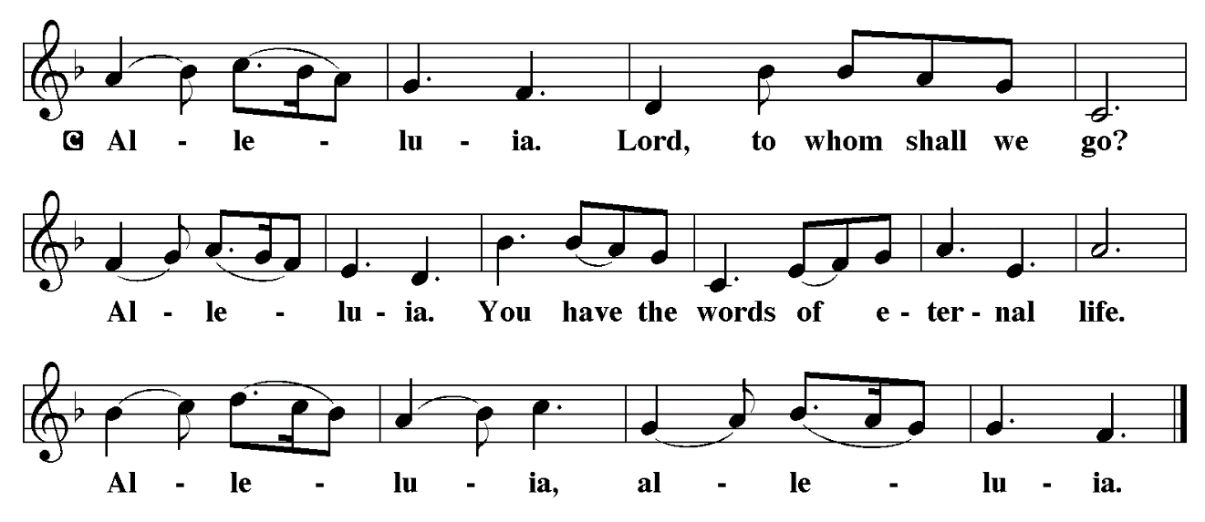

THE HOLY GOSPEL Matthew 3: 1-12

Just before Jesus began his public ministry, John the Baptist appeared, calling people to live in accordance with their words and speaking of the powerful one who was to come.

In those days John the Baptist appeared in the wilderness of Judea, proclaiming, ²"Repent, for the kingdom of heaven has come near." ³This is the one of whom the prophet Isaiah spoke when he said,
"The voice of one crying out in the wilderness:
'Prepare the way of the Lord,
make His paths straight.' "
⁴Now John wore clothing of camel's hair with a leather belt around his waist, and his food was locusts and wild honey. ⁵Then the people of Jerusalem and all Judea were going out to him, and all the region along the Jordan, ⁶and they were baptized by him in the river Jordan, confessing their sins.
⁷But when he saw many Pharisees and Sadducees coming for baptism, he said to them, "You brood of vipers! Who warned you to flee from the wrath to come? ⁸Bear fruit worthy of repentance. ⁹Do not presume to say to yourselves, 'We have Abraham as our ancestor'; for I tell you, God is able from these stones to raise up children to Abraham. ¹⁰Even now the ax is lying at the root of the trees; every tree therefore that does not bear good fruit is cut down and thrown into the fire.
¹¹"I baptize you with water for repentance, but One Who is more powerful than I is coming after me; I am not worthy to carry His sandals. He will baptize you with the Holy Spirit and fire. ¹²His winnowing fork is in His hand, and He will clear his threshing floor and will gather His wheat into the granary; but the chaff He will burn with unquenchable fire."

P: The Gospel of the Lord.

C: Praise to You, O Christ!

The assembly is seated

THE SERMON

Silence for reflection follows the sermon

As you are able please rise

THE HYMN OF THE DAY 249 On Jordan’s Bank the Baptist’s Cry
Stanza 2—Women; Stanza 4--Men

THE NICENE CREED

A: God has made us His people through our Baptism into Christ. Living together in trust and hope, we confess our faith.

We believe in one God,
the Father, the Almighty,
maker of heaven and earth,
of all that is, seen and unseen.

We believe in one Lord, Jesus Christ,
the only Son of God,
eternally begotten of the Father,
God from God, Light from Light,
true God from true God,
begotten, not made,
of one Being with the Father.
Through Him all things were made.
For us and for our salvation
He came down from heaven;
by the power of the Holy Spirit
He became incarnate from the virgin Mary, and was made
man.
For our sake He was crucified under Pontius Pilate;
He suffered death and was buried.
On the third day He rose again
in accordance with the Scriptures;
He ascended into heaven
and is seated at the right hand of the Father.
He will come again in glory to judge the living and the dead,
and His kingdom will have no end.

We believe in the Holy Spirit, the Lord, the giver of life,
Who proceeds from the Father and the Son.
With the Father and the Son He is worshiped and glorified.
He has spoken through the prophets.
We believe in one holy catholic and apostolic Church.
We acknowledge one Baptism for the forgiveness of sins.
We look for the resurrection of the dead,
and the life of the world to come. Amen.

THE PRAYER OF THE CHURCH

A: To God Who is steadfast in His faithfulness, let us pray for the Church, the world, and
all those who need encouragement and hope.

A: That all bishops, especially Yehiel and Timothy; all pastors, especially Mark,
Pamela, Dale, and Mark; all missionaries, and all the baptized may through lives of
holiness prepare a way for the Lord, let us pray to the Lord:

C: Come, Lord Jesus.

A: That the earth may be filled with the knowledge and peace of God as waters cover the
seas, let us pray to the Lord:

C: Come, Lord Jesus.

A: That our leaders may judge for the poor and decide with equity for the meek, let us
pray to the Lord:

C: Come, Lord Jesus.

A: That the victims of flooding and landslides in Indonesia, Thailand, and Sri Lanka may
receive relief from international aid, comfort in their grief for those who died, and
strength and courage to rebuild their homes and communities, let us pray to the Lord:

C: Come, Lord Jesus.

A: That this community of faith may bear witness to Jesus’ reign by fruits of kindness and
compassion, and by living in harmony with one another and glorifying God with one
voice, let us pray to the Lord:

C: Come, Lord Jesus.

A: That the poor and needy, the hungry and forgotten, the lonely, those in danger, and the
sick, especially: Major Payne; Robert Bernth; Carl Wipperman; Chuck Payne;
Martha Schroeder; Joyce Stark; Jackie Gaines; David Weiss; Fred Weiss; Shirley
Shikany Long; Shirley Freels; John Bennitt; Allen Sydow; Catherine Lanigan;

and Lucas Bradshaw might be filled with the hope, joy and peace of God, let us pray
to the Lord:

C: Come, Lord Jesus.

A: That those celebrating birthdays, especially Donna Ottersen; Judy Zimmerman;
Judy Gleason; and Karen Steinborn may grow in grace this day and every day and
be filled with grace for the days ahead, let us pray to the Lord:

C: Come, Lord Jesus.

A: That we might be as steadfast in faith and hope as the saints, especially Ambrose,
Bishop of Milan, whom we commemorate this Day and join with them before God’s
throne to sing God’s praises, let us pray to the Lord:

C: Come, Lord Jesus.

P: Holy God, mighty God, strong God, look tenderly upon Your people. May Your power
and love be with us always. We pray in the name of Jesus Christ, Your Son, our Lord,
for Whose coming we prepare with joy.

C: Amen.

MEAL

P: The peace of the Lord be with you always.

C: And also with you.

OFFERING

VOLUNTARY Come, Light of Hope St. Paul Senior Choir
(A.L. Page & J. A, Shafrman)

As you are able please stand

THE OFFERTORY (see p. 12) Let the Vineyards be Fruitful, Lord

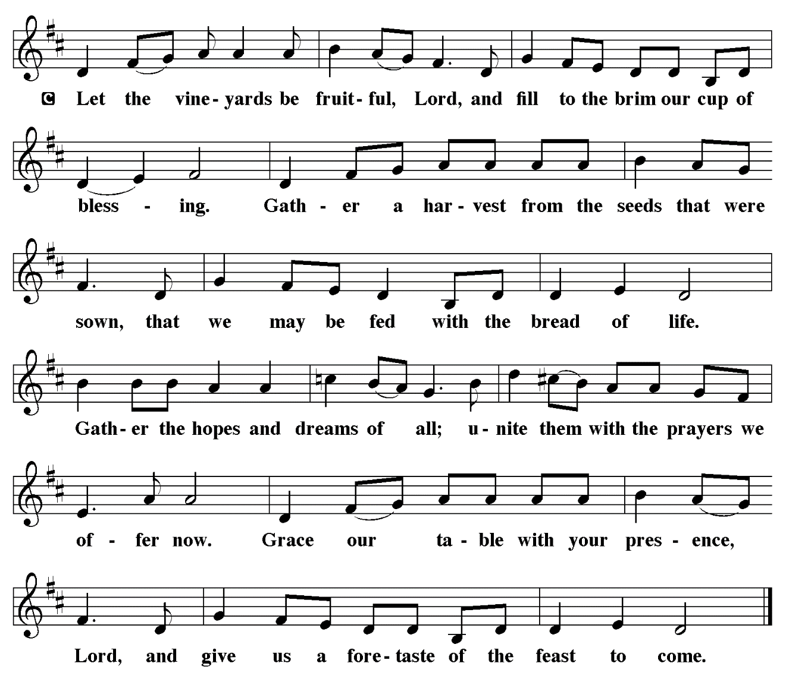

THE OFFERTORY PRAYER

A: Let us pray. God of hope,

C: Daily You shower us with the abundance of Your blessings. We bring You these
offerings as the first-fruits of our repentance and new life in Christ. Prepare us
for Your coming in this Meal. Help us to receive You with all joy and peace in
believing. We ask this in the name of Jesus the Lord. Amen.

THE GREAT THANKSGIVING

C: And also with you.

P: Lift up your hearts.

C: We lift them up to the Lord.

P: Let us give thanks to the Lord our God.

C: It is right to give Him thanks and praise.

P: It is indeed right and salutary … we praise Your name and join their unending hymn:

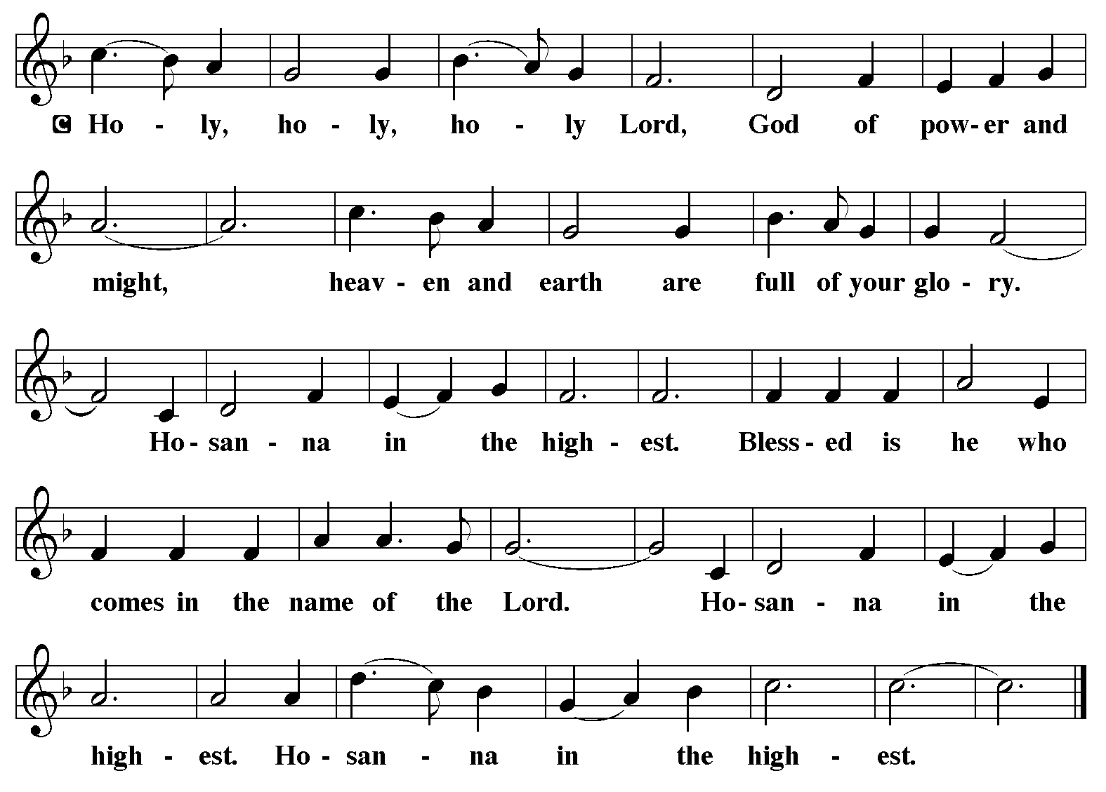

P: Holy are You, God of Jesse, for the Branch of our salvation is rooted in You.
To Abraham You promised to raise up a people bound to You in love, and through the
household of David You brought life greater than our imagining in a child
of grace, Jesus our Lord.
Though we deny Your love for ourselves and seek to limit of the reach of Your mercy
to others, You beckon us to repentance, open our eyes to new life, and
embrace us to join Your family of faith.
In Your Son’s death we see the depth of our sin; yet in His resurrection we seek the
extent of Your grace.
Anointing God, Your Spirit rested upon Your Son with wisdom and understanding,
counsel and might, knowledge and fear.
In Christ You have anointed Your future out of our past, Your Kingdom out of our
plans, and Your salvation out of our poverty.
As Your Spirit rested upon Him, send down that same anointing Spirit upon us and
upon these gifts of bread and wine that they may be for us the Body and
Blood of Your Son Jesus Christ,
Who in the night ... “Do this for the remembrance of Me.”
As often as we eat ... we proclaim the Lord’s death until He comes.

C: Christ has died. Christ is risen. Christ will come again.

P: Astonishing God, Your prophet Isaiah envisioned a Day when the wolf and lamb
would lie down together, and the leopard with the kid, and a little child
would lead them.
Astonish us anew by Your gentle ways of peace.
Shape Your Church to live from faith, not from fear.
Make Your future present through the lives of those who show us how to love our
enemies.
Hasten the Day when the earth will be full of the knowledge of You, and Your fullness
will be all in all, and all creation from the depths of the sea to the heights of
the mountains will know the peace to which Your Son shall lead.
Awaken that Dawn when we are surrounded with everlasting praise to You,
Father, Son, and Holy Spirit.
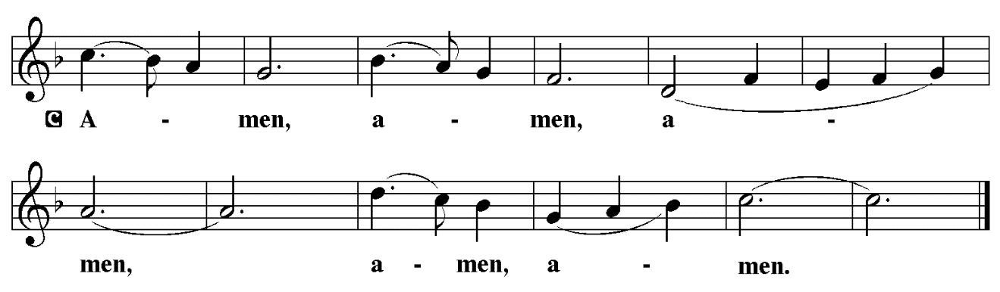

THE LORD’S PRAYER

P: Let us pray for the coming of God’s Reign as Jesus taught us:

C: Our Father in heaven, hallowed be Your name.
Your Kingdom come, Your will be done on earth as in heaven.
Give us today our daily bread, and forgive us our sins, as we forgive
those who sin against us.
Save us from the time of trial, and deliver us from evil.
For the Kingdom, the power, and the glory are Yours, now and forever.
Amen.

INVITATION TO THE MEAL

P: Behold the Lord Whose advent we await, Who will come with glory on the Day of
judgment. Blessed are those who are called to the Supper of the Lamb. God’s holy
gifts for God’s holy people. Come, for all is now ready.

The assembly is seated

THE DISTRIBUTION Lamb of God

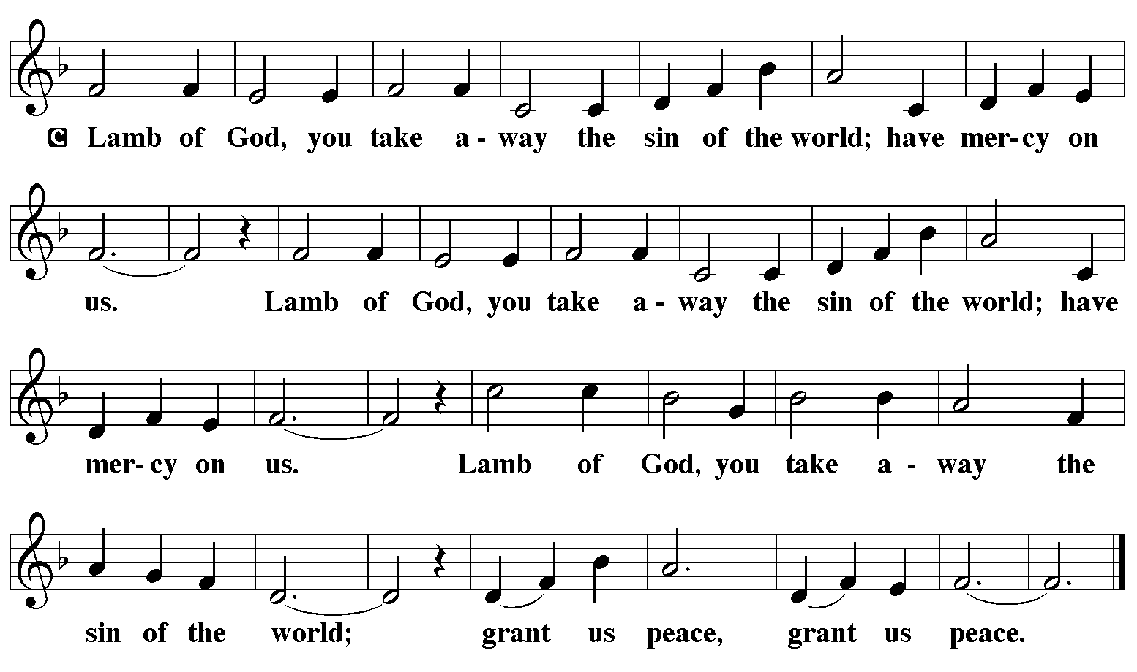

HYMN DURING DISTRIBUTION 266 All Earth is Hopeful
ELW 242 Awake! Awake, and Greet the New Morn
ELW 243 Lost in the Night
ELW 239 Hark, the Glad Sound!
ELW 253 He Came Down

As you are able please rise

THE POST-COMMUNION BLESSING

P: The Body and blood of our Lord Jesus Christ strengthen you and keep you in His grace.

C: Amen.

THE POST-COMMUNION PRAYER

A: Let us pray. God of hope, we thank You for feeding us with this heavenly Banquet.
Help us always to hear the prophet’s call to turn our hearts to You. Stir up in us Your
Spirit, fill us with Your righteousness, and renew us as a sign of Your love in the world.
Grant this through Christ our Lord.

C: Amen.

SENDING

THE BENEDICTION

P: The Lord bless you and keep you. The Lord make His face shine on you and be gracious
to you. The Lord look upon you with favor and give you peace.

C: Amen.
SENDING HYMN 246 Hark! A Thrilling Voice is Sounding

THE DISMISSAL

A: Go in peace. Walk in the light of the Lord.

C: Thanks be to God!

POSTLUDE

To God Alone Be Glory

The Meditations are from An Advent Sourcebook. Thomas J. O’Gorman, ed. (Chicago:
Liturgy Training Publications, 1988) 24-25, 60; and Sundays and Seasons Online. Copyright Augsburg Fortress, 2018.

The Invitation to the Lord’s Prayer, the Prayers, and the Invitation to Communion are from
Prayers for Sundays and Seasons. Year A. Peter J. Scagnelli. (Chicago: Liturgy
Training Publications, 1998) 2-3.

The Eucharistic Prayer is adapted from Eucharistic Prayers. Samuel Wells and Abigail
Kocher. (Grand Rapids: Eerdmann’s Publishing Company, 2016) 42-43.

BIRTHDAY PARTY
The birthday party for those who have a birthday in September, October or November was rescheduled to this Sunday, December 7th. You did not miss the party. When we learned the church services were cancelled as a precautionary measure due to the snow immediate plans were made to hold the celebration off for one week. Today, December 7th, come on down to the St. Paul Room immediately after the Sunday morning service and have a piece of Birthday Pie!

ANNOUNCEMENTS

Please remember to mail your offering to the Church Office at 818 Franklin Street, Michigan City, IN 46360. Another alternative is to give on-line through Tithe.ly. Please see your closure letter for information on how to set up a Tithe.ly account.

St. Paul Members are reminded to have a loved one contact the office if you are hospitalized. Many times, the Pastor doesn’t know someone is in the hospital. If you call and leave a message, please tell us at which hospital the patient is located.

BIRTHDAYS: Donna Ottersen (12/6); Judy Zimmerman (12/8);
Judy Gleason (12/8); Karen Steinborn (12/14)

PRAYER CONCERNS: Robert Bernth; Barry Anderson; John Bennitt; Sarah McNabb; Debbie Martin; Mark Tannehill; Kathy Stein; Jan Paholski; Laura Dovey; Grace Romine; Bill Hazelgrove; Al Levenhagen; Carl Wipperman; Major Payne; Carol Hazelgrove and Allen Sydow.

OFFICE HOURS: Libby will be in the office on Mondays, Wednesdays, and Fridays; volunteers will cover Tuesdays and Thursdays.

Monday & Wednesday 8:00 a.m. – 5 p.m.
Tuesday & Thursday 9:00 a.m. – 12:00 p.m.
Friday 8:00 a.m. – 12:00 p.m.

If you are listening to the worship broadcast on the radio and would like to watch the Sunday morning service live stream follow these steps:

(1) If you have You Tube available on your TV, search for
St. Paul Lutheran Church Michigan City, IN.

(2) The direct link on the computer is https://
www.youtube.com/channel/UC5AIPNaKr3QN50984jGOa1g.

(3) This link is also on the main page of the church’s website in
the church section and will continue to be posted weekly on the St.
Paul Facebook page.

And it will always be available on the radio broadcast Sunday mornings at 11:00 a.m.
on WEFM (95.9), and on the local cable access station #99 for the previous week’s
service on Sundays at 4:00 p.m. and the current service on Wednesdays at 7:00 p.m.
and Fridays at 8:30 p.m.

To send e-mail to the church office, please use the following addresses:

Pastor Mark Reshan: seniorpastor@stpaulmichigancity.com

Church Office Secretary (Libby Pollock): churchsecretary@stpaulmichigancity.com

Church Treasurer (Karen Fleming): finance@stpaulmichigancity.com

2025 Church Council:

Mark Reshan - Pastor

Janet Bakken – President

Donna Knoll – Vice President

Judy Hunt – Secretary

Karen Fleming – Treasurer

Members: Paul Brooks, Diane Egilske, Sue Koziel, Judy Mutchler, Jim Schraidt, Trish Sprague

Worship Attendance:

Saturday , November 22, 2025 @ 4:00 p.m. 35

Sunday, November 23, 2025 @ 9:00 a.m. 55

TOTAL 90

Copies of the minutes from the October 23, 2025 Church Council meeting are on the back table in the upper Narthex. It was approved by the council via email.

The Good News Newsletter: If you have an article or anything you want included in The Good News please send it to the following e-mail address: splcgoodnews@gmail.com. Pastor Pamela Thiede will be using this e-mail address to assemble The Good News each month. The deadline for getting information to Pastor Pamela will be the 20th of each month.

Sunday’s lessons are Isaiah 35: 1-10; Psalm 146: 5-10 or Luke 1: 46b-55; James 5:
7-10; and Matthew 11: 2-11 for those of you who like to study them in advance.

December Mission of the Month – St. Paul Angel Tree
It’s beginning to look a lot like Christmas! We are starting our December mission a little early to ensure our gifts make it to their recipients by Christmas Day. A Mama’s Heart Ministry has provided us with names and wish lists of four children in our community who need assistance this Christmas. Please take a tag (or two) and shop for the item listed on the tag. Gifts can be returned wrapped or unwrapped, your preference. Please attach the angel tree tag to the gift. Toy tags have suggestions based on the child’s interests, but any age appropriate toy will do! Please return all gifts underneath the angel tree by Sunday, December 7th, to ensure everything can be delivered to the families by Christmas. Thank you for your generosity and Christmas spirit!

SNOW EMERGENCY LIST
This is a reminder of where to turn to learn if worship has been canceled because of inclement weather conditions. There are two ways to learn about the status of the service.
First, you may turn to our church and school Facebook page: https://www.facebook.com/stpaulmichigancity/ for updated announcements. Or, perhaps most quickly and easily, you may call the church office number (219-874-7293) and press the “#” key and you will hear a recording about our “open/closed” status.

HELP NEEDED FOR OUR LOCAL SALVATION ARMY
Due to the pause taken by all the programs sponsored by SNAP, our local Salvation Army has been swamped with people needing help. All of the items placed in the grocery store cart located on the upper southwest corner of the outer Narthex is taken to our Michigan City Salvation Army location. The cart has a large hippo asking you to help “fill ‘er up!” Whatever you can do to help is greatly appreciated.

ACTIVITIES, EVENTS & MEETINGS
December 2025

Sunday, December 7, 2025 @ 9:00 a.m. 2nd Sunday in Advent Worship Service/ Sanctuary with coffee after service/St. Paul Room

Monday, December 8, 2025 @ 11:30 a.m. Hope Circle/St. Paul Room

Tuesday, December 9, 2025 from 11:00 a.m. – Close GIVE-BACK @ HOLLY’S Restaurant & Pub

@ 7:00 P.M. Estuary/Luther House

Wednesday, December 10, 2025 @ 9:15 a.m. Bible Study/Luther House

@ 10:00 a.m. God’s Purls/St. Paul Room

@ 3:30 p.m. Worship & Music Mtg/Luther House

@ 4:30 p.m. Choir Rehearsal/Sanctuary

Thursday, December 11, 2025 @ 4:00 p.m. 150th Anniv. Comm. Mtg/Luther House

Saturday, December 13, 2025 @ 4:00 p.m. 3rd Saturday in Advent Worship Service

Sunday, December 14, 2025 @ 9:00 a.m. 3rd Sunday in Advent Worship Service/ Sanctuary/ with coffee after service/St. Paul Room

Monday, December 15, 2025 @ 2:00 p.m. Finance Committee Mtg/Luther House

@ 3:00 p.m. Executive Board Mtg/Luther House

Wednesday, December 17, 2025 @ 10:00 a.m. QUIET SR COMMUNION & LUNCHEON
@ 4:30 p.m. Choir Rehearsal/Sanctuary

Thursday, December 18, 2025 @ 3:00 p.m. and January 2026 Church Council Mtg/St. Paul Room

Saturday, December 20, 2025 @ 4:00 p.m. 4th Saturday in Advent Worship Service

Sunday, December 21, 2025 @ 9:00 a.m. 4th Sunday in Advent Worship Service/ Sanctuary with coffee after service/St. Paul Room

Wednesday, December 24, 2025 @ 5:45 p.m pre - service Music/Sanctuary

@ 6:00 p.m. Christmas Eve Worship Service/Sanctuary

Thursday, December 25, 2025 @ 9:00 a.m. Christmas Worship Service/Sanctuary

Saturday, December 27, 2025 @ 4:00 p.m. 1st Saturday After Christmas Worship Service

Sunday, December 28, 2025 @ 9:00 a.m. 1st Sunday After Christmas Worship
Service/Sanctuary with coffee after /St. Paul Room

First United Methodist Church in Michigan City
Presents their annual
Madrigal Service at

Trinity Episcopal Church
in Barker Hall
600 Franklin St.
Michigan City, IN 46360

On Saturday, December 20th at 5:00 p.m.
(doors open at 4:15 p.m.)

And again on Sunday, December 21st at 3:00 p.m. at
First United Methodist Church
121 E. 7th St.
Michigan City, IN 46360

A free will offering will be taken and proceeds divided between all entities who helped provide space, supplies, support of any kind to the congregation and staff at
Methodist Church during their time of need.

Thank$ for $haring
Thank you to all who participate in our Give-Back opportunities each month where we earn $$ to add to our Mission of the Month donations from our congregation to those in our community who need our help!
This month we’re going to Holly’s Restaurant & Pub on Tuesday, December 9, 2025 from 11a.m.—close. Here are two coupons—one for you and one for a friend.

