THE TWELFTH SUNDAY AFTER PENTECOST
THE COMMEMORATION OF MARY, MOTHER OF OUR LORD
Sunday August 16, 2026

“She became the Mother of God, in which work so many and such great good things are bestowed on her as pass man’s understanding. For on this there follows all honor, all blessedness, and her unique place in the whole of mankind, among which she has no equal, namely, that she had a child by the Father in heaven, and such a Child….
“Hence men have crowded all her glory into a single word, calling her the Mother of God…. None can say of her nor announce to her greater things, even though he had as many tongues as the earth possesses flowers and blades of grass: the sky, stars; and the sea, grains of sand. It needs to be pondered in the heart what it means to be the Mother of God.”
“Mary is the Mother of Jesus and the Mother of all of us even though it was Christ alone who reposed on her knees… If he is ours, we ought to be in his situation; there where he is, we ought also to be and all that he has ought to be ours, and his mother is also our mother.”
“[Mary is the] highest woman and the noblest gem in Christianity after Christ… She is nobility, wisdom, and holiness personified. We can never honor her enough. Still honor and praise must be given to her in such a way as to injure neither Christ nor the Scriptures.”

Martin Luther on Mary

“We are all meant to be mothers of God...for God is always needing to be born.”
Meister Eckhart
In the Name of Jesus
INTRODUCTION

Mary’s role is not limited to giving birth to Jesus and mothering him in his childhood. In John’s gospel, she is among the women standing near the cross; in Acts, she is among the disciples awaiting the gift of the Spirit. Through all that happened she continued to see how God was at work through her son, keeping the ancient promises to her ancestors, brushing aside the rich and powerful, and focusing on those as poor and powerless as Mary herself.

Mary, Mother of Our Lord

The church (including Martin Luther) honored Mary with the title theotokos, meaning "God-bearer," for her role in giving birth to the Son of God. Her song, the Magnificat, speaks eloquently of God's lifting the lowly and feeding the hungry.

GATHERING

PRELUDE

ANNOUNCEMENTS

As you are able please rise

THE GATHERING HYMN 424 Ye Watchers and Ye Holy Ones

THE GREETING AND PRAYER OF THE DAY

P: The grace of our Lord Jesus Christ, the love of God, and the communion of the Holy Spirit be
with you all.

C: And also with you.

P: Let us pray. Almighty God, in choosing the virgin Mary to be the mother of Your Son, You
made known Your gracious regard for the poor, the lowly, and the despised. Grant us grace to
receive Your Word in humility, and so to be made one with Your Son, Jesus Christ our Savior
and Lord, Who lives and reigns with You and the Holy Spirit, one God, now and forever.

C: Amen.

The assembly is seated

WORD

FIRST READING Isaiah 61: 7-11

The prophet proclaims a hopeful message: God loves justice and will make an everlasting covenant with Israel and her descendants. In response, the prophet sings a joyful song, like Mary many generations later, about God’s mercy and salvation.

⁷Because [the] shame [of God’s people] was double,
and dishonor was proclaimed as their lot,
therefore they shall possess a double portion;
everlasting joy shall be theirs.
⁸For I the Lord love justice,
I hate robbery and wrongdoing;
I will faithfully give them their recompense,
and I will make an everlasting covenant with them.
⁹Their descendants shall be known among the nations,
and their offspring among the peoples;
all who see them shall acknowledge
that they are a people whom the Lord has blessed.
¹⁰I will greatly rejoice in the Lord,
my whole being shall exult in my God;
for He has clothed me with the garments of salvation,
He has covered me with the robe of righteousness,
as a bridegroom decks himself with a garland,
and as a bride adorns herself with her jewels.
¹¹For as the earth brings forth its shoots
and as a garden causes what is sown in it to spring up,
so the Lord God will cause righteousness and praise
to spring up before all the nations.

The Word of the Lord.
Thanks be to God.

THE PSALM: 34: 1-9 Read responsively

¹I will bless the LORD at all times;
the praise of God shall ever be in my mouth.
²I will glory in the Lord;
let the lowly hear and rejoice.
³Proclaim with me the greatness of the Lord;
let us exalt God’s name together.
⁴I sought the Lord, Who answered me
and delivered me from all my terrors.
⁵Look upon the Lord and be radiant,
and let not your faces be ashamed.
⁶I called in my affliction, and the Lord heard me
and saved me from all my troubles.
⁷The angel of the Lord encamps around those who fear the Lord
and delivers them.
⁸Taste and see that the Lord is good;
happy are they who take refuge in God!
⁹Fear the Lord, you saints of the Lord,
for those who fear the Lord lack nothing.

SECOND READING Galatians 4: 4-7

In the promise of the Incarnation, Jesus Christ embodies God’s mother-father heart, in love claiming people as adopted children.

⁴When the fullness of time had come, God sent His Son, born of a woman, born under the law, ⁵in order to redeem those who were under the law, so that we might receive adoption as children. ⁶And because you are children, God has sent the Spirit of His Son into our hearts, crying, “Abba! Father!” ⁷So you are no longer a slave but a child, and if a child then also an heir, through God.

The Word of the Lord.

Thanks be to God.

As you are able please rise

THE VERSE (Sung twice) (see p. 4)

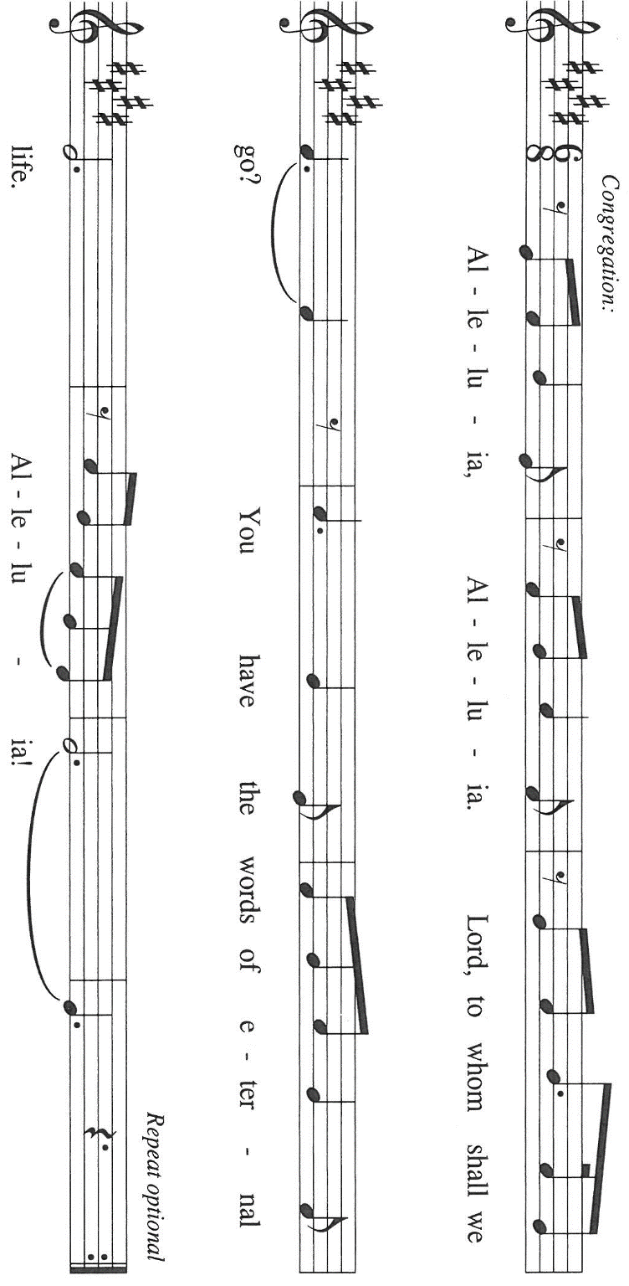

THE HOLY GOSPEL Luke 1: 46-55

Mary’s song, the Magnificat, serves as a thematic anthem for God’s work in the world and therefore for the ministry of her son, Jesus. In Mary’s praise we hear of a saving God who remembers the humble, scatters the proud, lifts up the lowly, and fulfills all things.

P: The Holy Gospel according to St. Luke, the first chapter.

C: Glory to You, O Lord!

⁴⁶Mary said,
“My soul magnifies the Lord,
⁴⁷and my spirit rejoices in God my Savior,
⁴⁸for He has looked with favor on the lowliness of His servant.
Surely, from now on all generations will call me blessed;
⁴⁹for the Mighty One has done great things for me,
and holy is His name.
⁵⁰His mercy is for those who fear Him
from generation to generation.
⁵¹He has shown strength with His arm;
He has scattered the proud in the thoughts of their hearts.
⁵²He has brought down the powerful from their thrones,
and lifted up the lowly;
⁵³He has filled the hungry with good things,
and sent the rich away empty.
⁵⁴He has helped His servant Israel,
in remembrance of His mercy,
⁵⁵according to the promise He made to our ancestors,
to Abraham and to his descendants forever.”

P: The Gospel of the Lord.

C: Praise to You, O Christ!

The assembly is seated

THE SERMON

Silence for reflection follows the sermon

As you are able please rise

THE HYMN OF THE DAY 10,000 Reasons

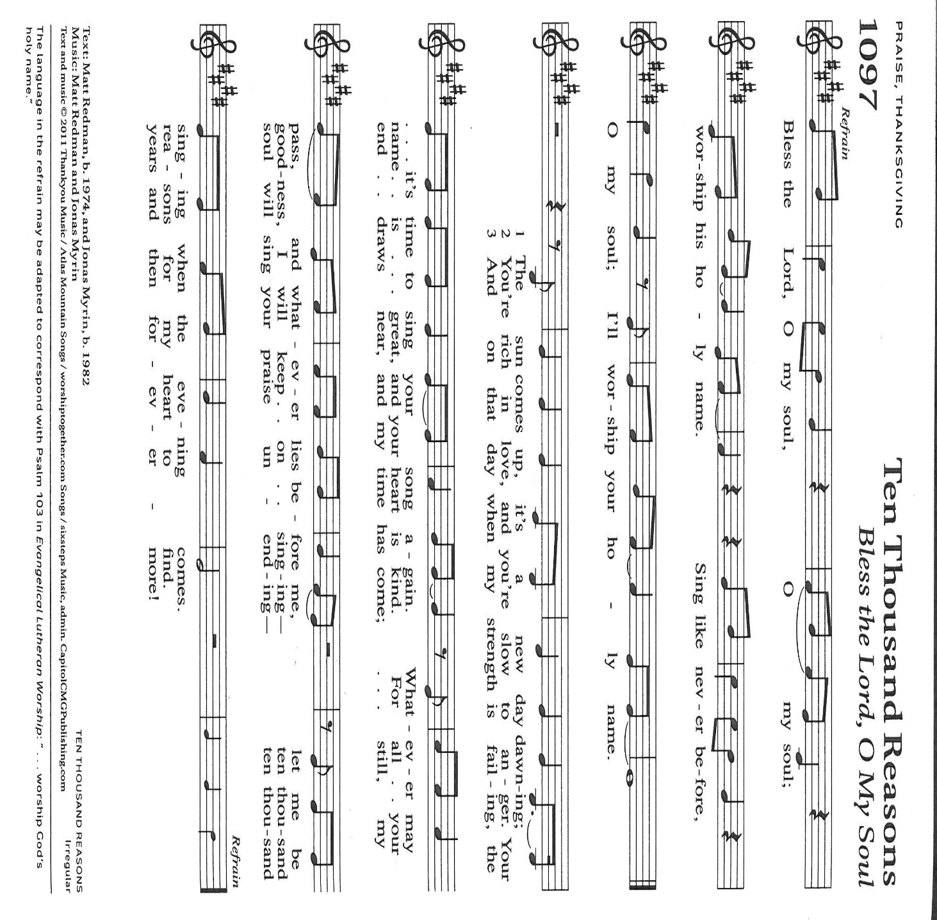

THE NICENE CREED

A: God has made us His people through our Baptism into Christ. Living together in trust and
hope, we confess our faith.

C: We believe in one God,
the Father, the Almighty,
maker of heaven and earth,
of all that is, seen and unseen.

We believe in one Lord, Jesus Christ,
the only Son of God,
eternally begotten of the Father,
God from God, Light from Light,
true God from true God,
begotten, not made,
of one Being with the Father.
Through Him all things were made.
For us and for our salvation
He came down from heaven;
by the power of the Holy Spirit
He became incarnate from the virgin Mary, and was made man.
For our sake He was crucified under Pontius Pilate;
He suffered death and was buried.
On the third day He rose again
in accordance with the Scriptures;
He ascended into heaven
and is seated at the right hand of the Father.
He will come again in glory to judge the living and the dead,
and His kingdom will have no end.

We believe in the Holy Spirit, the Lord, the giver of life,
Who proceeds from the Father and the Son.
With the Father and the Son He is worshiped and glorified.
He has spoken through the prophets.
We believe in one holy catholic and apostolic Church.
We acknowledge one Baptism for the forgiveness of sins.
We look for the resurrection of the dead,
and the life of the world to come. Amen

THE PRAYER OF THE CHURCH

A: May our hearts leap with joy as we with Mary join in prayer to proclaim God’s greatness as
we intercede for the Church, the world, and all those in need.

A: That the Church may sing like Mary and rejoice that wherever it finds itself in mission and
service it might testify to Your unfailing faithfulness: Lord, in Your mercy,

C: Hear our prayer.

A: That as we remember Mary’s lowliness there might be help, compassion, and relief for the
poor, the hungry, the homeless, refugees, and victims of disasters, warfare, or oppression:
Lord, in Your mercy,

C: Hear our prayer.

A: That the victims and survivors of the earthquake in Colombia might be comforted in
their grief; that rescue workers might be strengthened in their efforts; that abundant
food and emergency supplies from nations and relief agencies might be delivered,
and for a swift recovery of those affected by this tragedy: Lord, in Your mercy,

C: Hear our prayer.

A: That we in this congregation may be the strength of God’s arm as through us He cares for those
for whom these days do not bring joy or hope: the lonely, the grieving, the depressed, the
heartbroken, and the sick, especially: Mark Tannehill; Martha Schroeder; Debbie Martin;
Jon Samuelson; Hazel Miller; Jeff Timmrick; Dale Thomas; Kathy Thieleman; Pastor
Dale Zylstra; Jan Paholski; and Laura Dovey might be saved from all their troubles: Lord,
in Your mercy,

C: Hear our prayer.

A: That those who travel in these days might reach their destinations in safety and find joy,
refreshment, and renewal in the fellowship and hospitality of family and friends: Lord, in
Your mercy,

C: Hear our prayer.

A: That those celebrating birthdays, especially: Shirley McCarty might be filled with grace this
day and every day and grow in grace in the days ahead: Lord, in Your mercy,

C: Hear our prayer.

A: That with Mary and all who rejoice in Christ we too may one Day join them in Your eternal
glory: Lord, in Your mercy,

C: Hear our prayer.

P: Confident that the Holy Spirit intercedes for us, we bring to You these prayers and those
unspoken, in the name of Christ, our Savior and Lord.

C: Amen.

MEAL

THE PEACE

P: The peace of the Lord be with you always.

C: And also with you.

The assembly is seated

THE OFFERING

THE VOLUNTARY Testify New Song Praise Band
(Casting Crowns)

As you are able please rise

THE OFFERTORY PRAYER

A: Let us pray. God of mercy,

C: You are in our midst as the Giver of all good things. Accept our gratitude for all Your
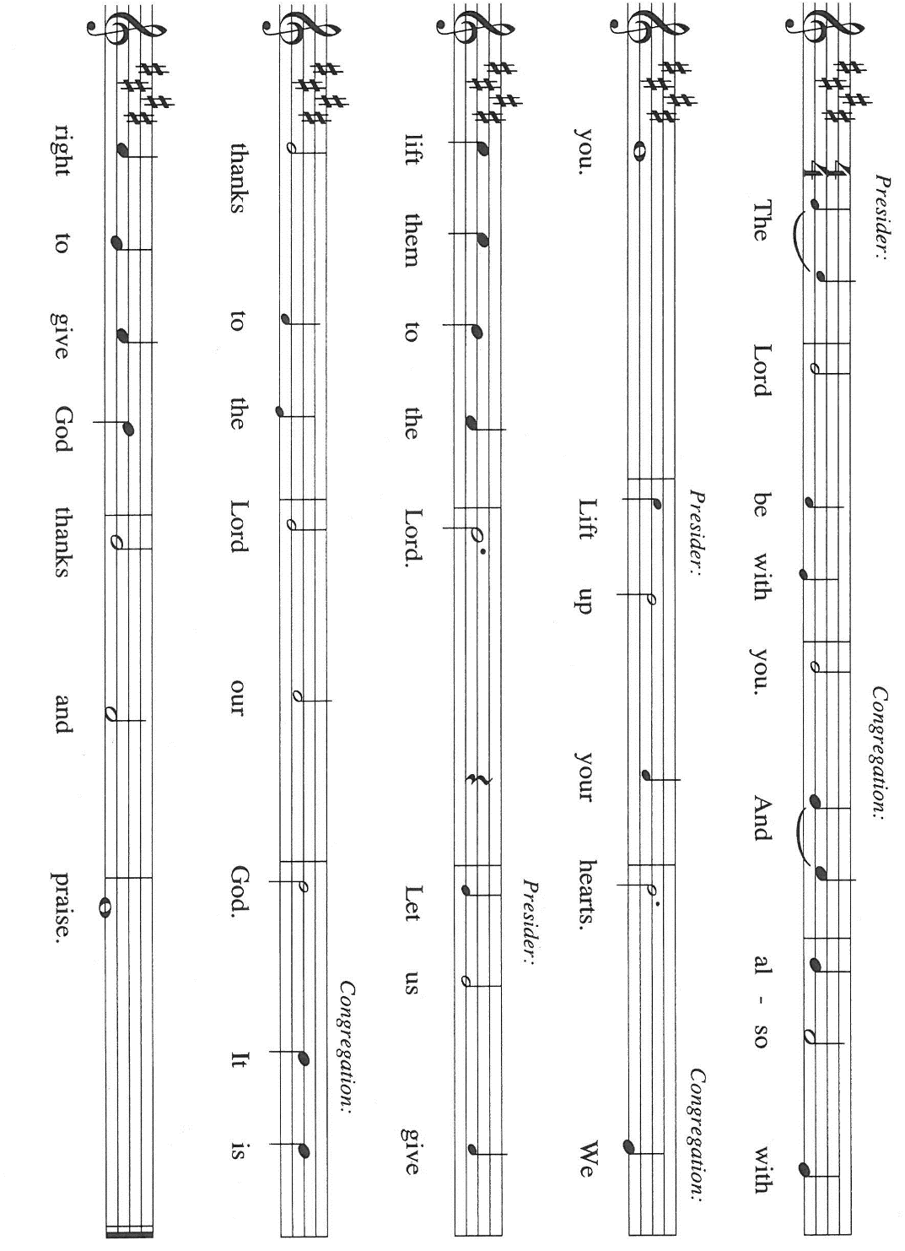
gifts, that our lives may bear witness to Your faithfulness. We ask this in the name of
Jesus the Lord. Amen.

THE GREAT THANKSGIVING

P: It is our duty and delight …join their unending hymn:

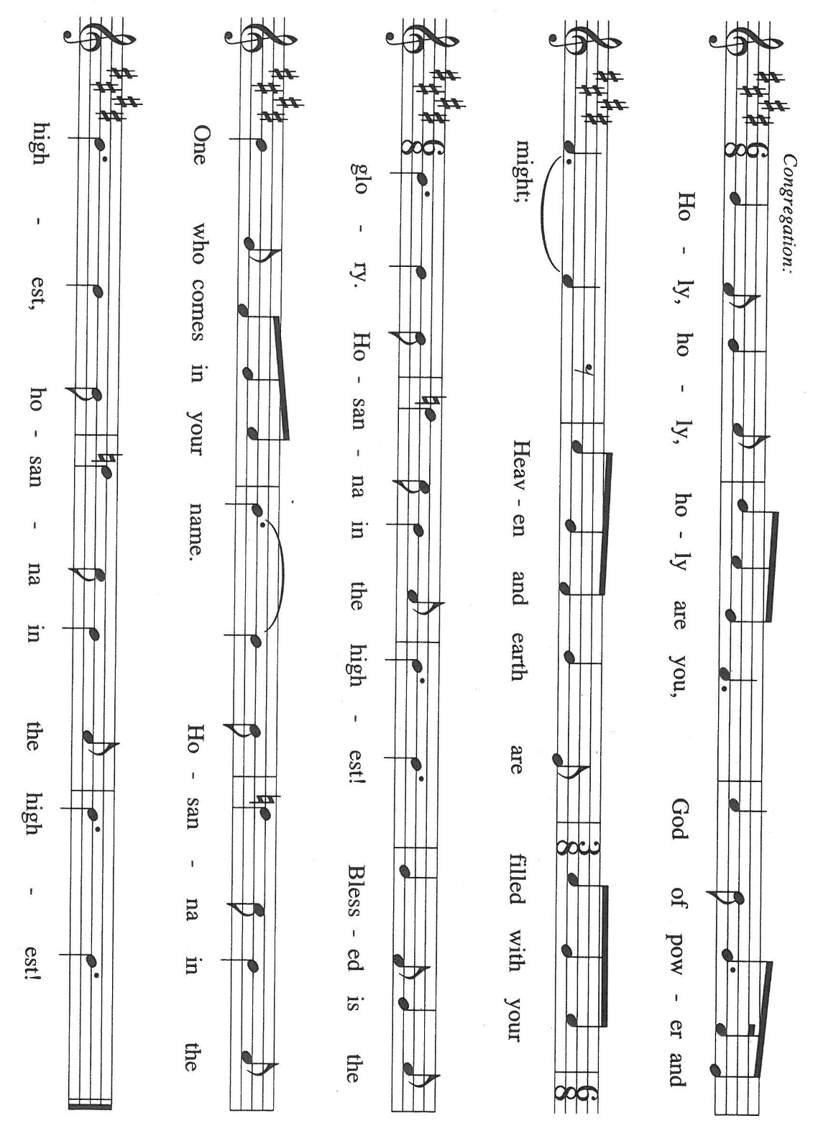

P: Blessed are You, O Shepherd of Israel, Lord God of hosts.
You Who are enthroned above the cherubim are worthy of our praise.
In great love You created heaven and earth and all creatures in them.
You chose Israel through whom to bless all nations with Your love.
Through shepherds, judges, and prophets You rescued them from slavery, restored them from
exile, and spoke words of judgment and hope.

In all this we bless You for Your only-begotten Son, Jesus Christ, born of the Holy Spirit and the Virgin Mary.
In Him all Your promises will be fulfilled.
In the night ... “Do this for the remembrance of Me.”
As often as we eat ... we proclaim the Lord’s death until He comes.

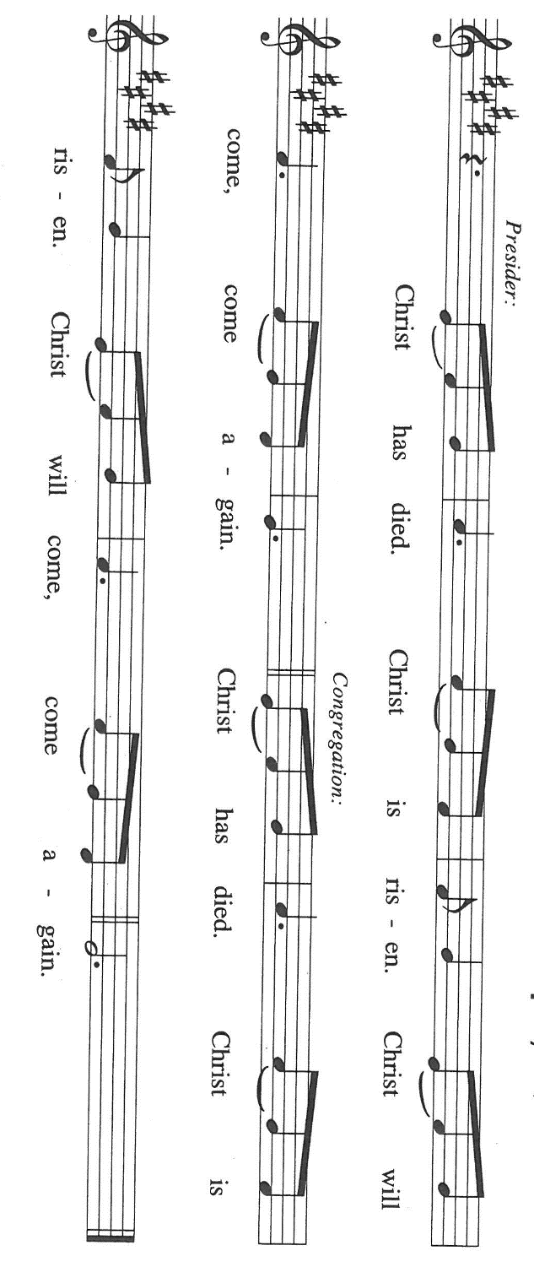

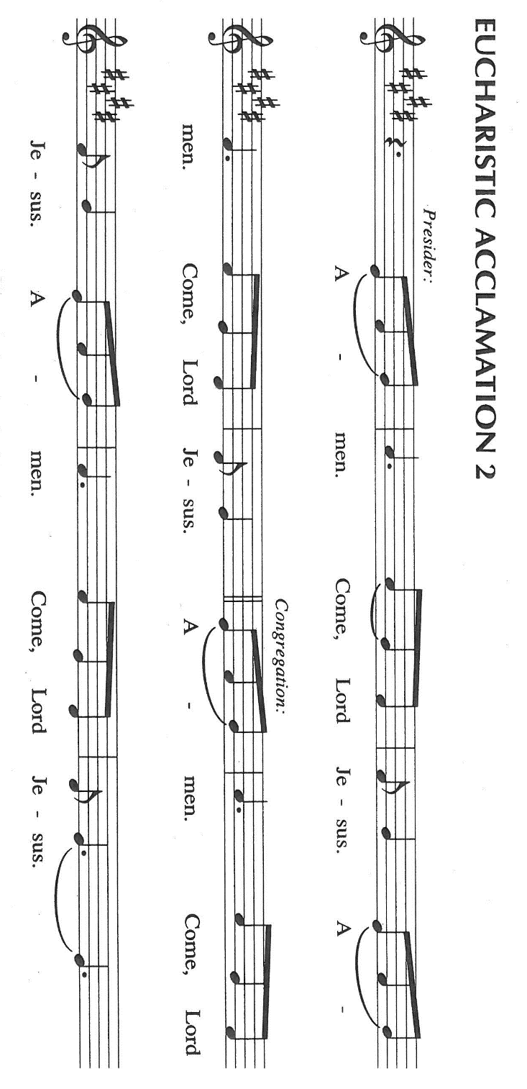

P: With this bread and cup we remember the sacrifice of our Lord’s life.
He “lifted up” those brought low by sin, disease, and shame; He “filled” those “hungry” for
Your life and hope; and “emptied” death of its power.
By “the strength of Your arm” You raised and exalted Him.
Now we await His promised return--watching, waiting, and filled with hope.

Send now, we pray, Your Holy Spirit on us and these Your gifts of bread and wine, that we
and all who share the Lord’s Body and Blood
May, believing in the fulfillment of Your promises, live as Christ’s light of hope until He
comes to gather all into His glory.

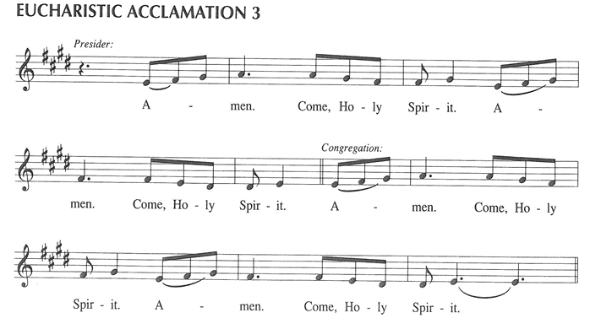

To You, O God: Father, Son, and Holy Spirit, be all honor and glory, in Your holy Church, in
heaven and on earth, now and forever.

C: Amen!

THE LORD’S PRAYER

P: Because in Christ we have received the Spirit of adoption, as daughters and sons of God
we dare to pray:

C: Our Father in heaven, hallowed be Your name. Your Kingdom come. Your will be done
on earth as in heaven. Give us this day our daily bread. Forgive us our sins as we forgive
those who sin against us. Save us from the time of trial and deliver us from evil. For the
Kingdom, the power, and the glory are Yours, now and forever. Amen.

INVITATION TO THE MEAL

P: This is the Lamb of God Who takes away the sin of the world. Blessed are those who are called
to the Supper of the Lamb. God’s holy gifts for God’s holy people. Come, for all is now ready.

The assembly is seated

THE DISTRIBUTION Lamb of God (see p. 12)

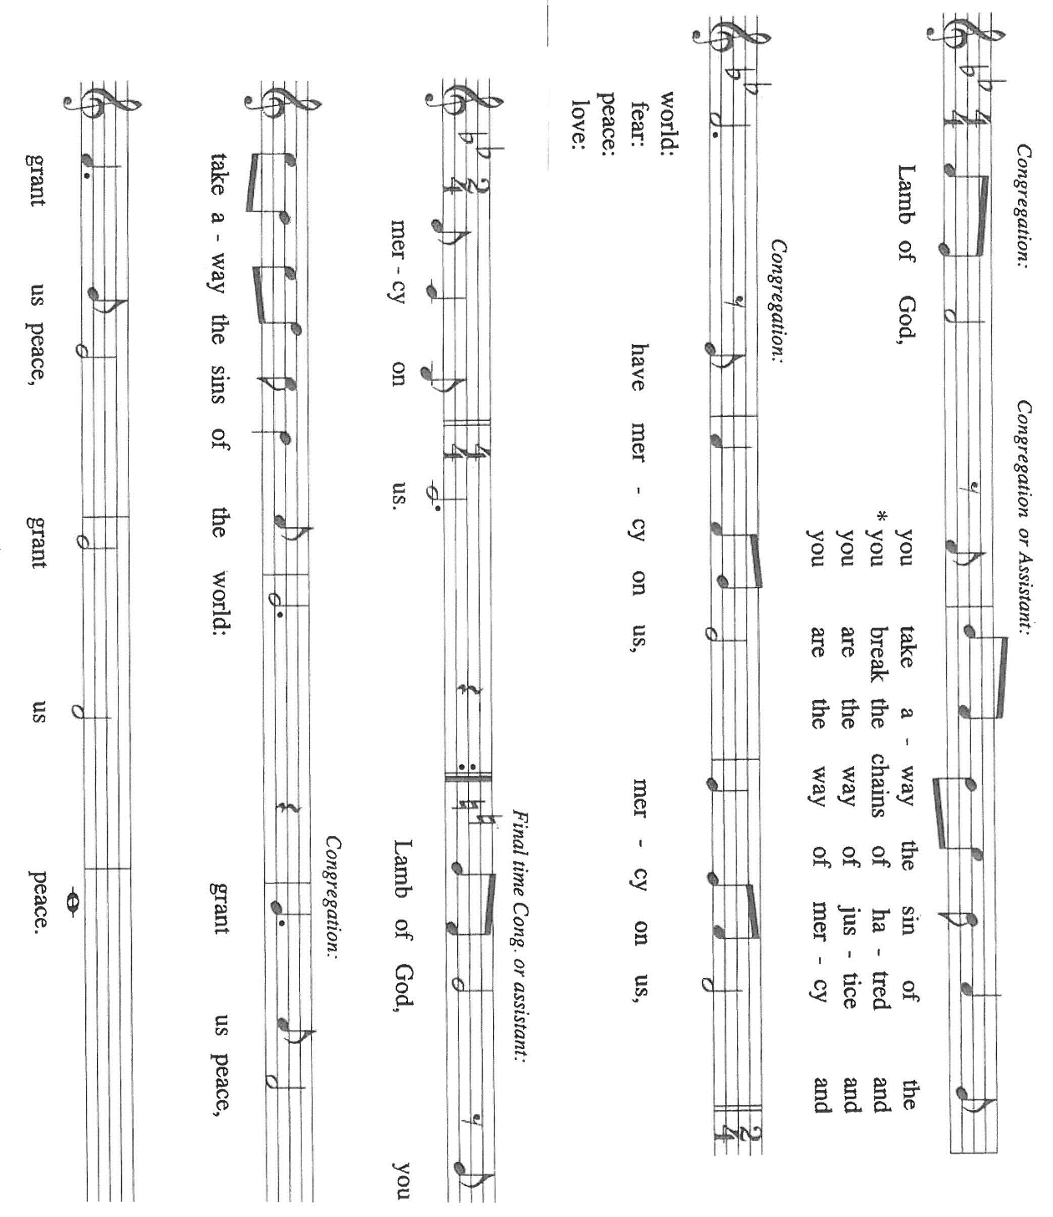

HYMN DURING DISTRIBTION 251 My Soul Proclaims Your Greatness

NSB 100 What the Lord Has Done in Me

ELW 531 The Trumpets Sound, The Angels Sing

ELW 272 Lo, How a Rose E’er Blooming

NSB 20 Celebrate Jesus

As you are able please rise

THE POST-COMMUNION BLESSING

P: The Body and Blood of our Lord Jesus Christ strengthen you and keep you in His grace.

C: Amen.

THE POST-COMMUNION PRAYER

A: Let us pray. O God, in this Eucharist You give us a foretaste of that Day when all the hungry
will be fed with good things. Send us forth to make known Your deeds, and to proclaim the
greatness of Your name. Grant this through Christ our Lord.

C: Amen.

SENDING

THE BENEDICTION

P: Almighty God: Father, Son, and Holy Spirit bless you now and forever.

C: Amen.

THE SENDING SONG 723 Canticle of the Turnng

THE DISMISSAL

A: Go in peace to bear Christ’s love to the world.

C: Thanks be to God!

POSTLUDE

To God Alone Be Glory

ANNOUNCEMENTS

Please remember to mail your offering to the Church Office at 818 Franklin Street, Michigan City, IN 46360. Another alternative is to give on-line through Tithe.ly. Please see your closure letter for information on how to set up a Tithe.ly account.

St. Paul Members are reminded to have a loved one contact the office if you are hospitalized. Many times, the Pastor doesn’t know someone is in the hospital. If you call and leave a message, please tell us at which hospital the patient is located.

BIRTHDAYS: Shirley McCarty (8/19)

PRAYER CONCERNS: Debbie Martin; Mark Tannehill; Kathy Stein; Jan Paholski; Laura Dovey; Bill Hazelgrove; Al Levenhagen; Carl Wipperman; Major Payne.

OFFICE HOURS: Libby will be in the office on Mondays, Wednesdays, and Fridays; volunteers will cover Tuesdays and Thursdays.

Monday & Wednesday 8:00 a.m. – 5 p.m.
Tuesday & Thursday 9:00 a.m. – 12:00 p.m.
Friday 8:00 a.m. – 12:00 p.m.

If you are listening to the worship broadcast on the radio and would like to watch the Sunday morning service live stream follow these steps:

(1) If you have You Tube available on your TV, search for
St. Paul Lutheran Church Michigan City, IN.

(2) The direct link on the computer is https://
www.youtube.com/channel/UC5AIPNaKr3QN50984jGOa1g

(3) This link is also on the main page of the church’s website in
the church section and will continue to be posted weekly on the St.
Paul Facebook page.

And it will always be available on the radio broadcast Sunday mornings at 11:00 a.m.
on WEFM (95.9), and on the local cable access station #99 for the previous week’s
service on Sundays at 4:00 p.m. and the current service on Wednesdays at 7:00 p.m.
and Fridays at 8:30 p.m.

To send e-mail to the church office, please use the following addresses:

Pastor Mark Reshan: seniorpastor@stpaulmichigancity.com

Church Office Secretary (Libby Pollock): churchsecretary@stpaulmichigancity.com

Church Treasurer (Karen Fleming): finance@stpaulmichigancity.com

2026 Church Council:

Pastor - Mark Reshan

President - Donna Knoll

Vice President - Jan Bakken

Secretary - Judy Hunt

Treasurer - Karen Fleming

Members: Sue Koziel; Jim Schraidt; Trish Sprague; Bob Kiser; Barry Anderson; and
Pam Soule

Worship Attendance:

Wednesday, August 5, 2026 Organ Concert @12:15 p.m. 39

Saturday, August 8, 2026 @ 4:00 p.m. 20

Sunday, August 9, 2026 @ 9:00 a.m. 59

TOTAL 118

Copies of the minutes from the June 25, 2026 and July 23, 2026 Church Council meetings are on the back table in the upper Narthex. They were approved by the council via email. Good News Newsletter: If you have an article or anything you want included in The Good News please send it to the following e-mail address: splcgoodnews@gmail.com. Pastor Pamela Thiede will be using this e-mail address to assemble The Good News each month. The deadline for getting information to Pastor Pamela will be the 20th of each month.

Next week’s lessons are Isaiah 51: 1-6; Psalm 138; Romans 12: 1-8;
Matthew 16: 13-20 for those of you who like to study them in advance.

PLEASE NOTE:
From now through Wednesday, August 19, 2026 the front doors of the church (those doors facing Franklin Street) will be open on Wednesdays to invite new visitors in to hear the organ concert. Any Wednesday, at your choosing, at 11:30 a.m. Concerts begin at 12:15 p.m. Please come and help us greet visitors. Your help is appreciated.

MISSION OF THE MONTH FOR AUGUST 2026
Mission of the Month for August 2026 is for Michigan City Area Schools – we will be collecting money to support different projects in various elementary schools in Michigan City through Donors Choose. Donors Choose provides a list of teacher-led classroom projects that need funding. Please consider donating to help fund our local teachers’ classroom projects. Checks can be written to St. Paul and can be marked for MCAS and placed in the offering plate. Noisy coin offering will also support the mission of the month. To see a full list of projects, visit www.donorschoose.org and search for Michigan City.

ACTIVITIES, EVENTS & MEETINGS
AUGUST 2026

Monday, August 10, 2026 @ 1:00 p.m. Hope Circle/Green Room

@ 7:00 p.m. Women’s Bible Study/St. Paul Room

Tuesday, August 11, 2026 @ 11:00 a.m. – close GIVE BACK at Holly’s

Wednesday, August 12, 2026 @ 10:00 a.m. God’s Purls/St. Paul Room

@12:15 p.m. Organ Concert Summer Series/Sanctuary
@ 3:30 p.m. Worship and Music Mtg./Luther House

Thursday, August 13, 2026 @ 5:00 p.m. Volunteer Dinner/St. Paul Rm

Saturday, August 15, 2026 @ 4:00 p.m. 12th Pentecost Worship Service/Sanctuary

Sunday, August 16, 2026 @ 9:00 a.m. 12th Pentecost Worship Service /Sanctuary/coffee after

Monday, August 17, 2026 @ 7:00 p.m. Women’s Bible Study/St. Paul Room

Wednesday, August 19, 2026 @ 10:00 a.m. God’s Purls/St. Paul Room
@ 12:15 p.m. Last Organ Concert Summer Series. 2026
@ 4:30 p.m. Choir Rehearsal/Sanctuary
Saturday, August 22, 2026 @ 4:00 p.m. 13th 21`Pentecost Worship Service/Sanctuary

Sunday, August 23, 2026 @ 9:00 a.m. 13th Pentecost Worship Service/Sanctuary/coffee after

Monday, August 24, 2026 @ 2:00 p.m Finance Comm. Mtg./Luther House

@ 3:00 p.m. Executive Board Mtg./Luther House

Wednesday, August 26, 2026 @ 10:00 a.m. God’s Purls/St. Paul Room

Thursday, August 27, 2026 @ 3:00 p.m. Church Council Mtg./St. Paul Room

Saturday, August 29, 2026 @ 4:00p.m 14 Pentecost Worship Service/Sanctuary

Sunday, August 30, 2026 @ 9:00 a.m. 14 Pentecost Worship Service/Sanctuary/coffee after

