THE TWENTY-FIRST SUNDAY AFTER PENTECOST
October 18, 2026

We are at the point in Matthew’s story about Jesus where things are getting pretty tense. Earlier in the week, Jesus had entered Jerusalem and been greeted by adoring crowds (Mt. 21: 1-11). Riding this wave of popular acclaim, he immediately enters the Temple and overthrows the tables of the money-changes, challenging both the political and religious powers that be. Confronted by the religious leaders regarding the authority behind his actions, Jesus tells several provocative, even threatening parables calling into question their own authority and, indeed, standing before God.
It’s for this reason that two groups that normally wanted little to do with each other – the Herodians derived their power from the Roman occupiers, while the Pharisees aligned more closely with the occupied and oppressed commoners – declare a temporary truce in order to work together to trap this upstart rabbi. The question they pose is beyond clever, asking Jesus whether it was lawful to pay the poll or imperial tax that funded Roman occupation. Should Jesus answer in the affirmative, the adoration of the crowds would likely not simply evaporate, but rather be turned into opposition. Should he answer negatively, however, then he will have positioned himself over and against the Romans, never a wise thing to do. So they’ve got him trapped.
Or at least that’s what they think. Because if their question is clever, Jesus’ response is ingenious or, more appropriately, inspired, leading to an exchange that is as revealing as it is brief. After asking if any of his questioners has a coin of the Empire – the only coin that could be used to pay the tax in question – they quickly procure one. Jesus asks whose image is on it, and they answer “The Emperor’s.”
There’s more going on here than meets the eye, as along with that image is an engraved confession of Caesar’s divinity, which means that any Jew holding the coin is breaking the first two of the commandments. All of which leads to Jesus’ closing line, “Give therefore to the emperor the things that are the emperor’s, and to God the things that are God’s.” And with this one sentence, Jesus does not simply evade their trap or confound their plans, but issues a challenge to his hearers that reverberates through the ages into our sanctuaries.

David Lose

We are accepted and affirmed by God and so do not need to prove ourselves to him. We have been set free, and our liberation is total and comprehensive—it includes being set free from political, social and economic structures that are oppressive and unjust, since these would enslave us and make us less than God intends us to be.
There is little about “pie in the sky when you die” in the gospel of Jesus Christ, for Christianity is the most materialistic of the major religions. There is nowhere that the writ of God does not run, for everything belongs to him. Caesar must be accorded what is appropriate for him, and God must have all—including Caesar’s domain; otherwise there would be a part of the universe, of life, that did not fall under God’s control.

Desmond Tutu
“Hope and Suffering”

GATHERING

INTRODUCTION

In today's first reading God uses the Gentile ruler Cyrus to accomplish divine purposes. When the Pharisees try to trap Jesus, he tells them to give the emperor what belongs to him and to God what belongs to God. To gather for worship reminds us that our ultimate allegiance is to God rather than to any earthly authority. Created in the image of God, we offer our entire selves in the service of God and for the sake of the world.

PRE-SERVICE MUSIC In Crist Alone New Song Praise Band
(Keith Getty & Stuart Townsend)

ANNOUNCEMENTS

As you are able please rise

CONFESSION AND ABSOLUTION

P: In the name of the Father and of the Son and of the Holy Spirit.

C: Amen.

P: “I am the LORD, and there is no other; besides Me there is no god.” (Isaiah 45: 5) All of life
is under God’s care and control. Let us confess the ways in which we have turned from that
rule of God, that in forgiveness God might “form light” (Isaiah 45: 7) from the “darkness” of
our sin.

Silence for self-examination and reflection is kept

P: Most merciful God,

C: We confess that we have sinned against You in thought, word, and deed. We have not
served and loved You with our whole heart, strength, and mind. We have failed to imitate
the life and love of Christ, and to “sound forth” Your Word in our speech and actions
(1 Thessalonians 1: 6, 8). We have neglected “work(s) of faith and labor(s) of love and
steadfastness of hope” (1: 2). For the sake of Your Son, Jesus Christ, have mercy on us.
Forgive us, renew us, and lead us, that we may “with joy inspired by the Holy Spirit”
(1: 6) give our whole lives in loving service to You and our neighbor.

P: “Brothers and sisters, beloved of God, we know that He has chosen you” (1: 4) to hear the
Gospel. So rejoice and be glad: for as a called and ordained minister of the Church of Christ,
and by His authority, I therefore declare to you the entire forgiveness of all your sins, in the
name of the Father and of the Son and of the Holy Spirit.

C: Amen.

GATHERING SONG 525 You Are Holy

THE GREETING AND PRAYER OF THE DAY

P: The grace of our Lord Jesus Christ, the love of God, and the communion of the Holy Spirit be
with you all.

C: And also with you.

P: Let us pray. Sovereign God, raise Your throne in our hearts. Created by You, let us live in
Your image; created for You, let us act for Your glory; redeemed by You, let us give You what
is Yours, through Jesus Christ, our Savior and Lord.

C: Amen.

The assembly is seated

WORD

FIRST READING Isaiah 45: 1-7

The prophet announces a radical vision in today's reading. Late in the period of exile in Babylon, the Persian king Cyrus has taken power in the East and threatens the great Babylonian empire. Seeing this, the prophet announces that God is using Cyrus to accomplish God's purpose of freeing the exiles. Amazingly, God calls Cyrus "his anointed" (a translation of "messiah"), a title earlier reserved solely for Davidic kings.

Thus says the LORD to His anointed, to Cyrus,
whose right hand I have grasped
to subdue nations before him
and strip kings of their robes,
to open doors before him--
and the gates shall not be closed:
²I will go before you
and level the mountains,
I will break in pieces the doors of bronze
and cut through the bars of iron,
³I will give you the treasures of darkness
and riches hidden in secret places,
so that you may know that it is I, the LORD,
the God of Israel, Who call you by your name.
⁴For the sake of My servant Jacob,
and Israel My chosen,
I call you by your name,
I surname you, though you do not know Me.
⁵I am the LORD, and there is no other;
besides me there is no god.
I arm you, though you do not know Me,
⁶so that they may know, from the rising of the sun
and from the west, that there is no one besides Me;
I am the LORD, and there is no other.
⁷I form light and create darkness,
I make weal and create woe;
I the LORD do all these things.

The Word of the Lord.

Thanks be to God.

SECOND READING Genesis 1: 26-27

²⁶Then God said, "Let us make humankind in our image, according to our likeness; and let them have dominion over the fish of the sea, and over the birds of the air, and over the cattle, and over all the wild animals of the earth, and over every creeping thing that creeps upon the earth."
²⁷So God created humankind in His image, in the image of God He created them; male and female He created them.

The Word of the Lord.

Thanks be to God.

THE PSALM: Psalm 96: 1-9 Antiphon by John W. Becker

Choir sings refrain first, followed immediately by the congregation
and as indicated

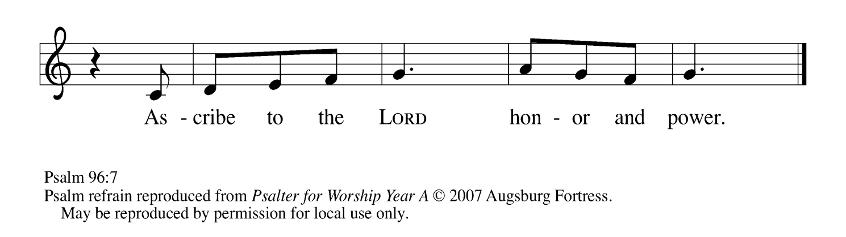

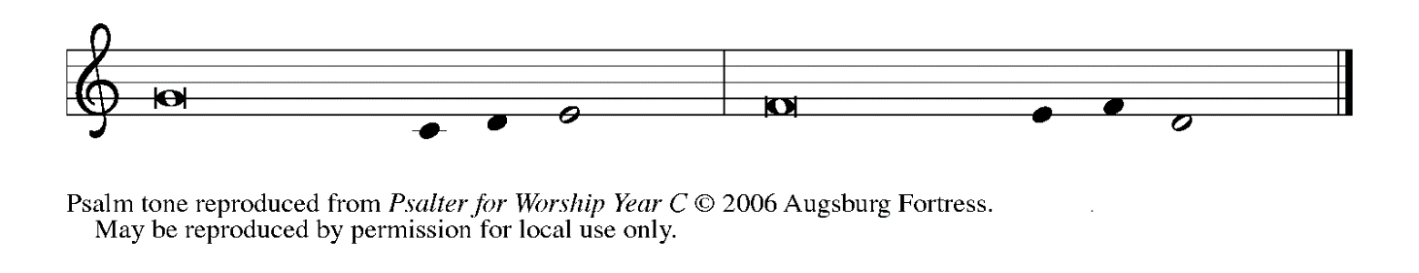

¹Sing to the Lord| a new song;
sing to the Lord, | all the earth.

²Sing to the Lord, bless the name | of the Lord;
proclaim God’s salvation from | day to day.
³Declare God’s glory a- | mong the nations
and God’s wonders a- | mong all peoples.
⁴For great is the Lord and greatly | to be praised,
more to be feared | than all gods. REFRAIN
⁵As for all the gods of the nations, they | are but idols;
but You, O Lord, have | made the heavens.
⁶Majesty and magnificence are | in Your presence;
power and splendor are in Your | sanctuary.
⁷Ascribe to the Lord, you families | of the peoples,
ascribe to the Lord hon- | or and power.
⁸Ascribe to the Lord the honor due the | holy name;
bring offerings and enter the courts | of the Lord.
⁹Worship the Lord in the beau- | ty of holiness;
tremble before the Lord, | all the earth. REFRAIN
.
THIRD READING 1 Thessalonians 1: 1-10

Paul's first letter to the Thessalonians is probably the earliest of any of his writings. He opens with a prayer of thanksgiving for the witness these Christians have provided for others to whom he ministers.

Paul, Silvanus, and Timothy,
To the church of the Thessalonians in God the Father and the Lord Jesus Christ:
Grace to you and peace.
²We always give thanks to God for all of you and mention you in our prayers, constantly ³remembering before our God and Father your work of faith and labor of love and steadfastness of hope in our Lord Jesus Christ. ⁴For we know, brothers and sisters beloved by God, that He has chosen you, ⁵because our message of the gospel came to you not in word only, but also in power and in the Holy Spirit and with full conviction; just as you know what kind of persons we proved to be among you for your sake.
⁶And you became imitators of us and of the Lord, for in spite of persecution you received the word with joy inspired by the Holy Spirit, ⁷so that you became an example to all the believers in Macedonia and in Achaia. ⁸For the word of the Lord has sounded forth from you not only in Macedonia and Achaia, but in every place your faith in God has become known, so that we have no need to speak about it.
⁹For the people of those regions report about us what kind of welcome we had among you, and how you turned to God from idols, to serve a living and true God, ¹⁰and to wait for His Son from heaven, Whom He raised from the dead--Jesus, Who rescues us from the wrath that is coming.
The Word of the Lord.

Thanks be to God.

As you are able please rise

THE VERSE
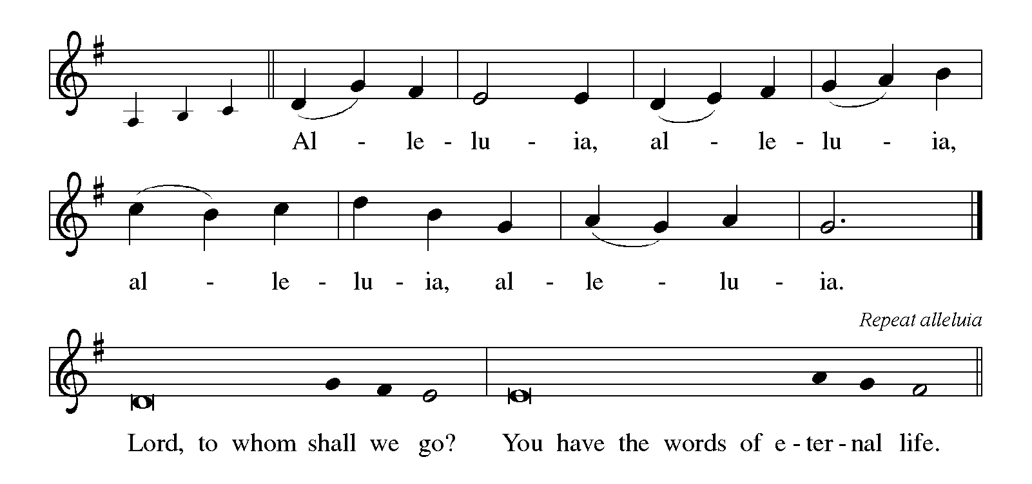

THE HOLY GOSPEL Matthew 22: 15-22

After Jesus comes to Jerusalem and begins teaching in the temple, the religious leaders try to trap him with trick questions. The first of these questions tries to force him to make an arbitrary choice between devotion to religion or politics.

P: The Holy Gospel according to St. Matthew, the twenty-second chapter.

C: Glory to You, O Lord!

The Pharisees went and plotted to entrap Jesus in what He said. ¹⁶So they sent their disciples to Him, along with the Herodians, saying, "Teacher, we know that You are sincere, and teach the way of God in accordance with truth, and show deference to no one; for You do not regard people with partiality. ¹⁷Tell us, then, what You think. Is it lawful to pay taxes to the emperor, or not?"
¹⁸But Jesus, aware of their malice, said, "Why are you putting Me to the test, you hypocrites? ¹⁹Show Me the coin used for the tax." And they brought Him a denarius. ²⁰Then He said to them, "Whose head is this, and whose title?" ²¹They answered, "The emperor's." Then He said to them, "Give therefore to the emperor the things that are the emperor's, and to God the things that are God's." ²²When they heard this, they were amazed; and they left Him and went away.

P: The Gospel of the Lord.

C: Praise to You, O Christ!

The assembly is seated

THE SERMON

Silence for reflection follows the sermon

As you are able please rise

THE HYMN OF THE DAY 685 Take My Life, That I May Be
(Stanza 3-Woman; Stanza 5-Men)

THE PRAYER OF THE CHURCH

A: Brothers and sisters, beloved by God, we have been chosen and called to give the service of
our lives to God and neighbor. Let us therefore intercede for ourselves, the Church, and the
world in its great need.

A: That as those created in God’s image, we may be glad bearers of God’s likeness in word, and
deed: Lord, in Your mercy,

C: Hear our prayer.

A: That as God guided Cyrus for the sake of Israel, God will guide our country, its leaders and its
citizens, to work for justice in places of oppression and peace where there is turmoil: Lord, in
Your mercy,

C: Hear our prayer.

A: That each of us, following Jesus, may be truthful, courting no one’s favor, but living with
simplicity, integrity, and faithfulness to His way of selfless service to others: Lord, in Your
mercy,

C: Hear our prayer.

A: That those whose bodies, minds, or spirits are broken by hunger, homelessness, disease,
loneliness, or illness, especially: Marvin Dirks; Martha Schroeder; Mark Tannehill;
Jon Samuelson; Dale Thomas; Linda Barnes; Jim Tomscheck; Jean Warner;
Angela Cook; Mike Fitzgerald; Jeff Timmrick; Deb Prybylla; and John Ripka … might
be strengthened in hope and trust: Lord, in Your mercy,

C: Hear our prayer.

A: That those celebrating birthdays, especially Judy Mutchler; and anniversaries, especially Jim
and Kim Summers; Warren and Karen Schacht; and Ken and Ruth Baker may grow in
grace this day and every day, and be filled with grace for the days ahead: Lord, in Your mercy,

C: Hear our prayer.

A: That with all the faithful who have gone before us, we too may give our whole lives to God
and receive in return resurrection to everlasting life: Lord, in Your mercy,

C: Hear our prayer.
P: O God, Ruler of all, grant us grace to love You and attend to the needs of others. May the
works we undertake in Your name proclaim the Good News of Your salvation, always
revealing Your glory in Your Son, Jesus Christ our Lord.

C: Amen.

MEAL

THE PEACE

P: The peace of the Lord be with you always.

C: And also with you.

The assembly is seated

THE OFFERING

THE VOLUNTARY At the Table of the Lord St. Paul Senior Choir
(J. Althouse)

As you are able please rise

THE PRESENTATION OF GIFTS (see p. 9) Let the Vineyards Be Fruitful
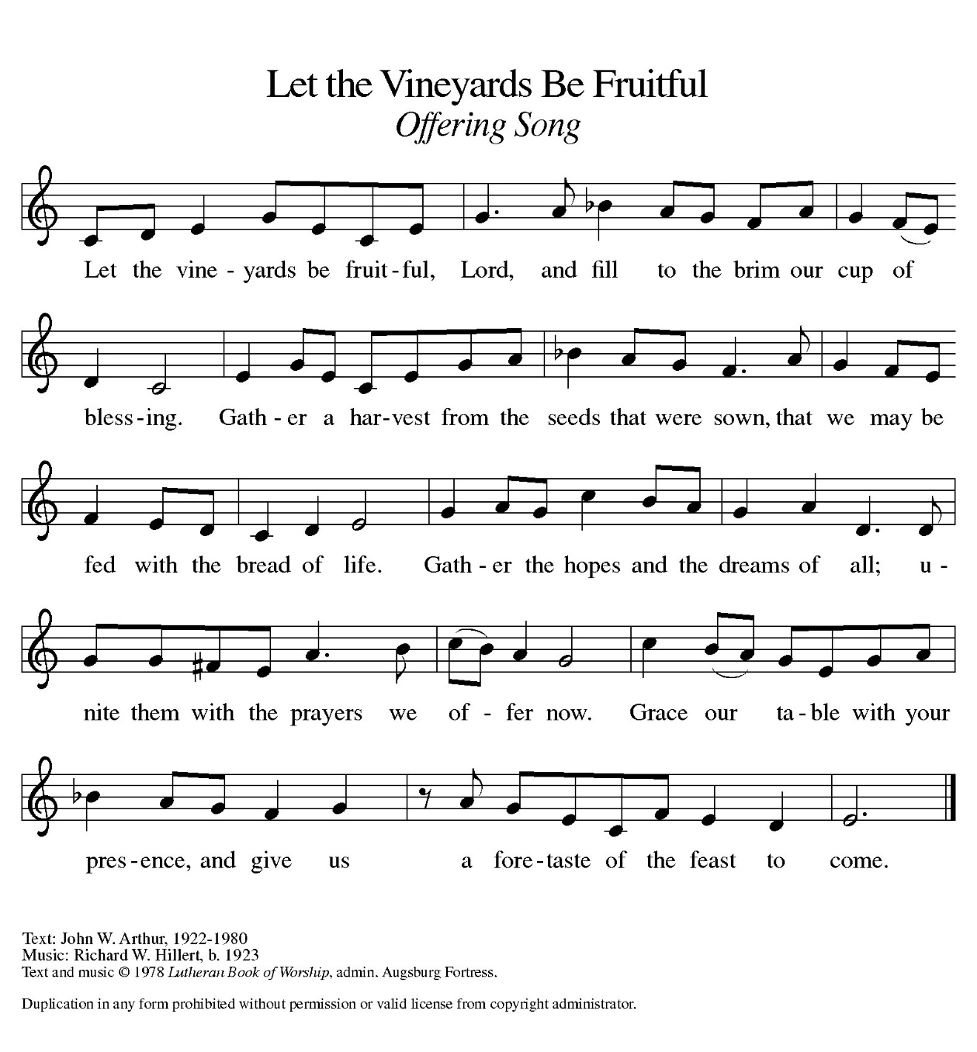
THE OFFERTORY PRAYER

A: Let us pray. Lord of all,

C: Your Gospel comes to us not in word only, but in this Sacrament with power and the
Holy Spirit. As You give Yourself to us, receive from us the offering of our lives.
Reveal Your glory among us, that we may be faithful imitators of Your grace. We ask
this in the name of Jesus the Lord. Amen.

THE GREAT THANKSGIVING

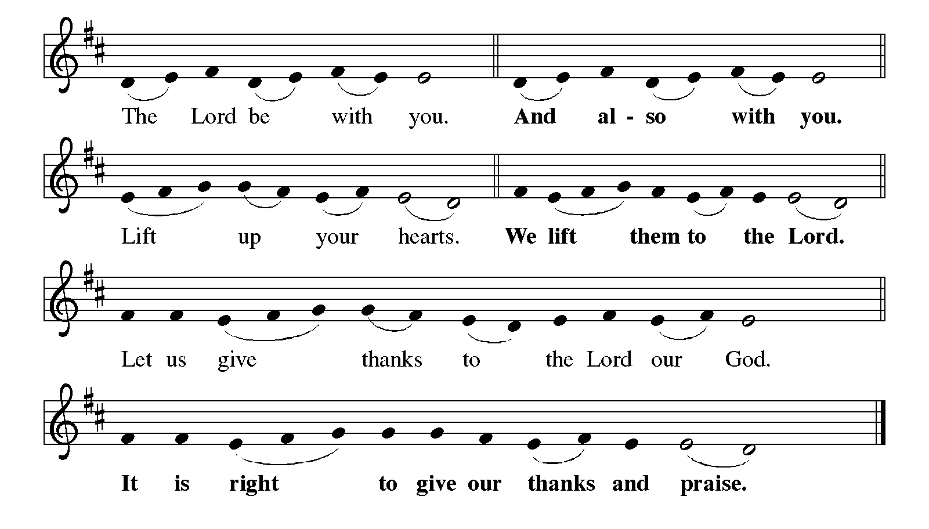
P: It is indeed right, our duty and our joy … join their unending hymn:
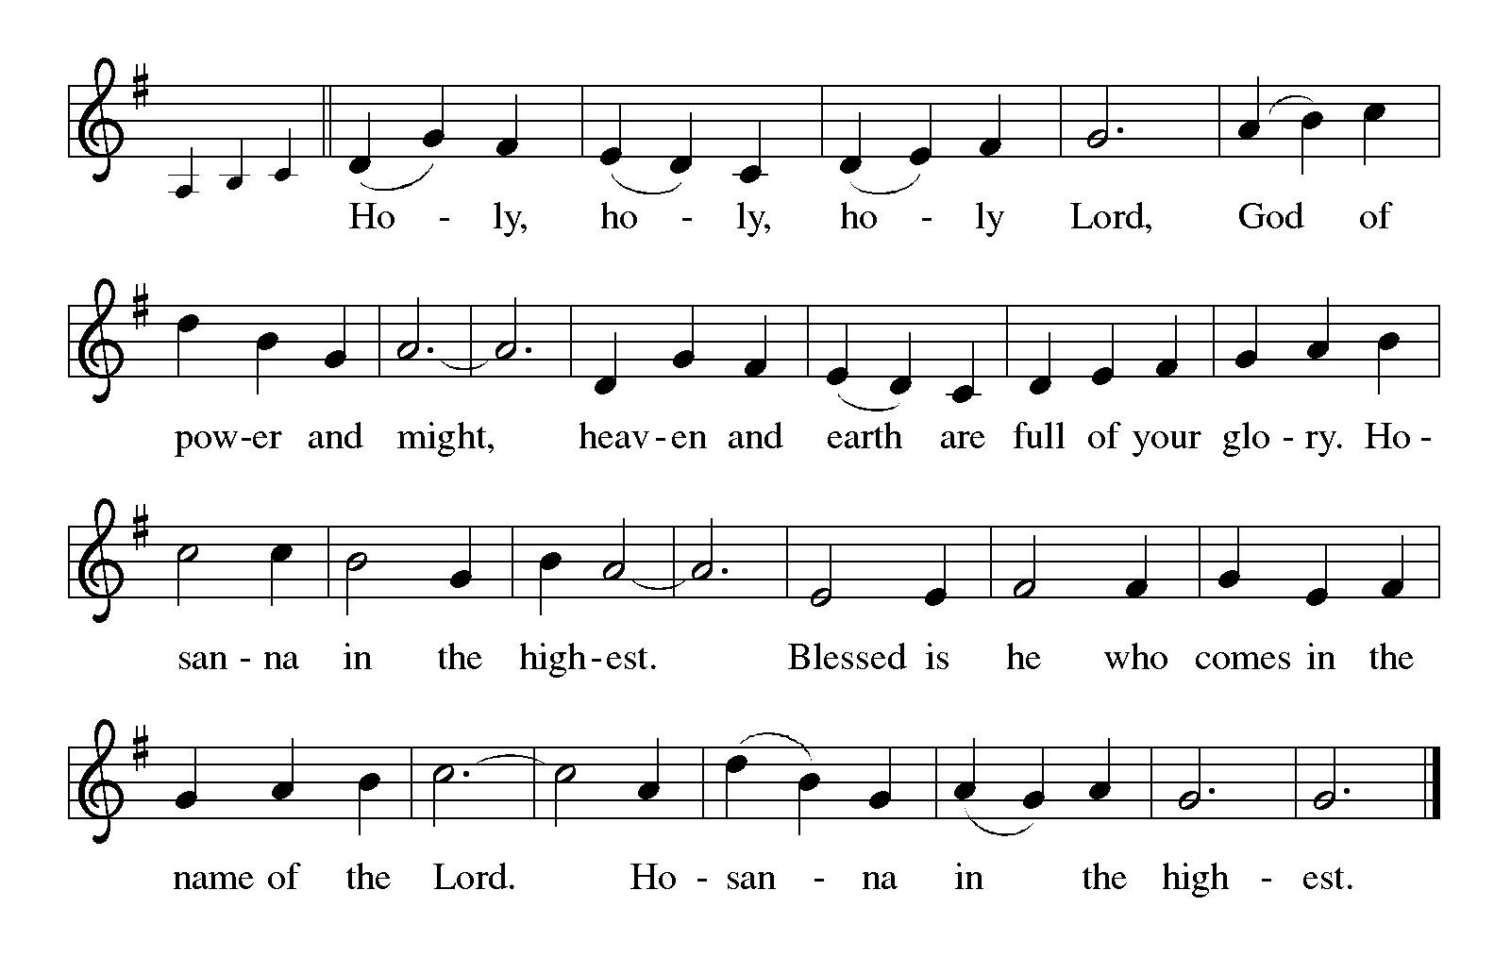

P: We praise and thank You, God of Abraham and Moses, because You have made
Your creation out of nothing,
You have come among us in liberation and covenant,
and in Your Son’s dying and rising You have opened up Your life to share
Your holiness with us.

In Your tender mercy You have broken upon us as the dawn from on high, and
shown us Your glory in the face of Jesus Christ.
You cover us with Your loving hand that we may dare to stand in Your presence,
and You tell us Your name that we may see into Your heart.
In this Meal You show us how much You long for us to be Your companions
and how constant is Your presence among us.
Send down Your Holy Spirit upon us now, that we might become the Body of Christ
You give us to eat.
Give us Your very Self in these gifts of bread and wine and make them for us the
Body and Blood of Your Son Jesus Christ,
Who, in the night ... “Do this for the remembrance of Me.”
As often as we eat ... we proclaim the Lord’s death until He comes.

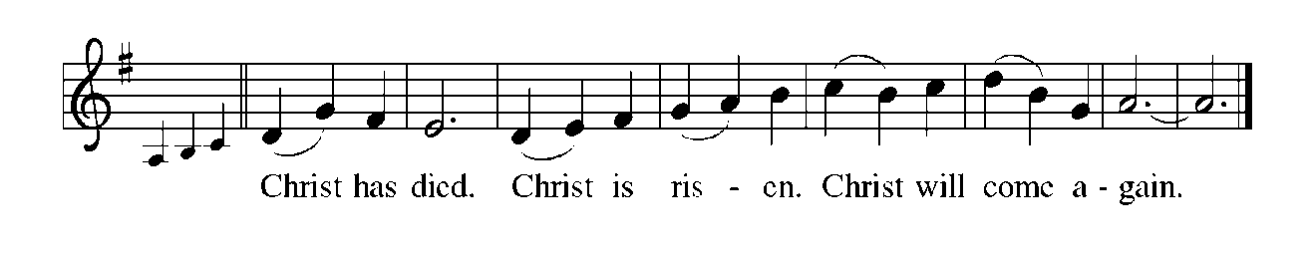

P: With this bread and cup, O God, we remember His living, dying, and rising again for others.

Even as we wait for His return to share with us the Feast of hope fulfilled.
Send now, we pray, Your Holy Spirit on us and these Your gifts of bread and wine, that we
and all who share the Lord’s Body and Blood
May offer our works of faith and labors of live in steadfastness of hope until all nations, rulers,
and peoples are gathered into Your Reign of love.
To You, O God: Father, Son, and Holy Spirit, be all honor and glory, in Your
holy Church, in heaven and on earth, now and forever.

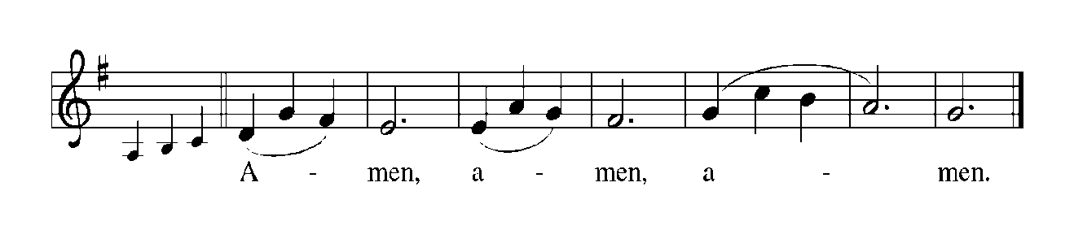
THE LORD’S PRAYER

P: Called to labor in the vineyard for the coming of God’s Kingdom, let us pray as Jesus
taught us:

C: Our Father, Who art in heaven, hallowed be Thy name.
Thy Kingdom come. Thy will be done on earth as it is in heaven.
Give us this day our daily bread, and forgive us our trespasses as we forgive those
Who trespass against us.
And lead us not into temptation, but deliver us from evil.
For Thine is the Kingdom, and the power, and the glory, forever and ever. Amen.

INVITATION TO THE MEAL

P: Behold the living Bread come down from heaven: Those who eat of it will never die. Behold
the cup of eternal life: Those who drink of it will live forever. God’s holy gifts for God’s holy
people. Come, for all is now ready.

The assembly is seated

THE DISTRIBUTION Lamb of God

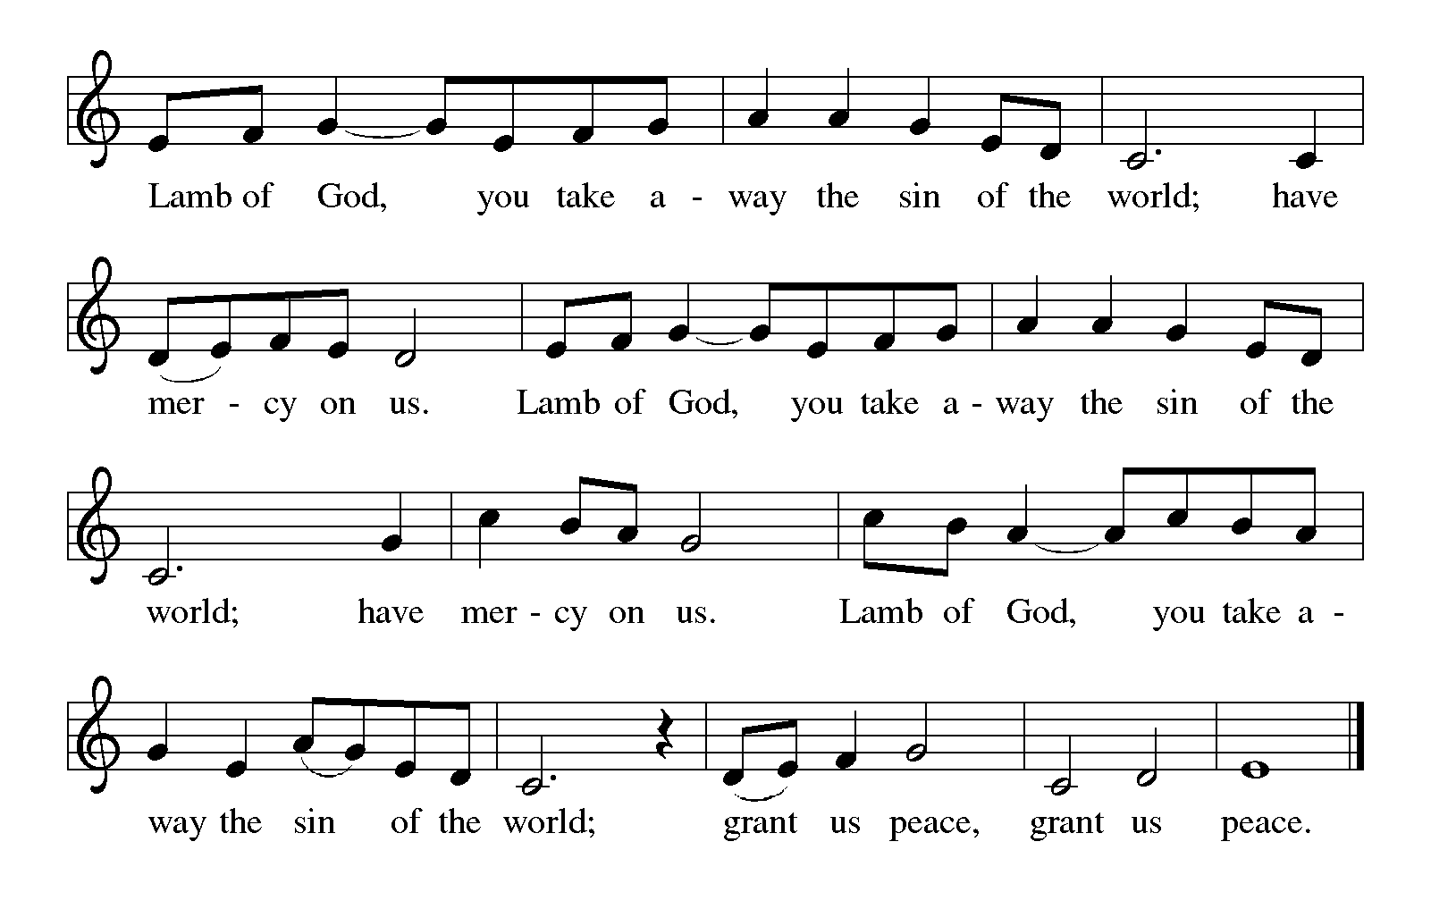

HYMN DURING DISTRIBUTION 623 Rock of Ages
ELW 526 God is Here

ELW 483 Here is Bread

ELW 484 You Satisfy the Hungry Heart

ELW 461 All Who Hunger, Gather Gladly

As you are able please rise

THE POST-COMMUNION BLESSING

P: The Body and Blood of our Lord Jesus Christ strengthen you and keep you in His grace.

C: Amen.

THE POST-COMMUNION PRAYER

A: Let us pray. God of mercy, by Your Holy Spirit, help us to receive this Sacrament with joy.
As You send us out in mission, bless our work of faith, strengthen our labor of love, and
increase our steadfastness of hope in our Lord Jesus Christ. You alone are the Lord
forevermore.
C: Amen.

SENDING

THE BENEDICTION

P: Almighty God: Father, Son, and Holy Spirit bless you now and forever.

C: Amen.

SENDING SONG 551 The Spirit Sends Us Forth to Serve

THE DISMISSAL

A: Go in peace to love and serve the Lord.

C: Thanks be to God!

POSTLUDE

To God Alone Be Glory

The Meditation is from “Dear Partner in Preaching,” an online study resource by David Lose,
October 16, 2017; and Pulpit Resource. William Willimon, ed. Vol. 30 No. 4 (Inver
Heights, MN: Logos Productions, 2002) 14.

The Prayers, Introduction to the Lord’s Prayer, and Invitation to the Meal are adapted from Prayers
For ndays and Seasons. Year A. Peter J. Scagnelli. (Chicago: Liturgy Training Publications, 1998) 124-25.

ANNOUNCEMENTS

Please remember to mail your offering to the Church Office at 818 Franklin Street, Michigan City, IN 46360. Another alternative is to give on-line through Tithe.ly. Please see your closure letter for information on how to set up a Tithe.ly account.

St. Paul Members are reminded to have a loved one contact the office if you are hospitalized. Many times, the Pastor doesn’t know someone is in the hospital. If you call and leave a message, please tell us at which hospital the patient is located.

BIRTHDAYS: Rich Fleming, Jr. (10/18); and Judy Mutchler (10/25)

ANNIVERSARIES: Warren & Karen Schacht (10/21);

Jim & Kim Summers (10/24); and Ken & Ruth Baker (10/24)

PRAYER CONCERNS: Debbie Martin; Mark Tannehill; Kathy Stein; Jan Paholski; Laura Dovey; Bill Hazelgrove; Al Levenhagen; Carl Wipperman; Major Payne.

OFFICE HOURS: Libby will be in the office on Mondays, Wednesdays, and Fridays; volunteers will cover Tuesdays and Thursdays.

Monday & Wednesday 8:00 a.m. – 5 p.m.
Tuesday & Thursday 9:00 a.m. – 12:00 p.m.
Friday 8:00 a.m. – 12:00 p.m.

If you are listening to the worship broadcast on the radio and would like to watch the Sunday morning service live stream follow these steps:

(1) If you have You Tube available on your TV, search for
St. Paul Lutheran Church Michigan City, IN.

(2) The direct link on the computer is https://
www.youtube.com/channel/UC5AIPNaKr3QN50984jGOa1g

(3) This link is also on the main page of the church’s website in
the church section and will continue to be posted weekly on the St.
Paul Facebook page.

And it will always be available on the radio broadcast Sunday mornings at 11:00 a.m.
on WEFM (95.9), and on the local cable access station #99 for the previous week’s
service on Sundays at 4:00 p.m. and the current service on Wednesdays at 7:00 p.m.
and Fridays at 8:30 p.m.

To send e-mail to the church office, please use the following addresses:

Pastor Mark Reshan: seniorpastor@stpaulmichigancity.com

Church Office Secretary (Libby Pollock): churchsecretary@stpaulmichigancity.com

Church Treasurer (Karen Fleming): finance@stpaulmichigancity.com

2026 Church Council:

Pastor - Mark Reshan

President - Donna Knoll

Vice President - Jan Bakken

Secretary - Judy Hunt

Treasurer - Karen Fleming

Members: Sue Koziel; Jim Schraidt; Trish Sprague; Bob Kiser; Barry Anderson; and
Pam Soule

Worship Attendance:

Saturday, October 10, 2026 @ 4:00 p.m. 28

Sunday, October 11, 2026 @ 9:00 a.m. 58

TOTAL 86

Copies of the minutes from the June 25, 2026 and July 23, 2026 Church Council meetings are on the back table in the upper Narthex. They were approved by the council via email.

Good News Newsletter: If you have an article or anything you want included in The Good News please send it to the following e-mail address: splcgoodnews@gmail.com. Pastor Pamela Thiede will be using this e-mail address to assemble The Good News each month. The deadline for getting information to Pastor Pamela will be the 20th of each month.

Next week’s lessons are: .Jeremiah 31: 31-34; Psalm 46; Romans 3: 19-28; John 8:
31-36 for those of you who like to study them in advance.

Mission of the Month for October 2026
Our mission for October is collecting care kits for the Woodland Cancer Center. Please grab a bag or two from the bin in the outer narthex and fill with small items that will help bring a smile to someone’s face as they go through cancer treatments. Gender neutral socks, gloves, hats, snacks, chapstick, gum, mints, candy and small journals or activity books are just some examples of items to fill the care kits with. We will also collect monetary donations to go towards their fund that helps people with treatment expenses when needed. Please make checks out to St. Paul and mark for the Woodland Cancer Center and place in the offering. Noisy coin will also support the mission of the month. Thank you for your giving hearts!

Hymn Festival
The third and final celebration to commemorate our congregation’s 150th Anniversary of St. Paul Lutheran Church will take place on Sunday, October 25, 2026 when we celebrate Reformation Day. It will be held at 4:00 p.m. and will be led by Dr. Steven Wente, Professor Emeritus of Organ and Church Music at Concordia University-Chicago. Steve has played for us a number of times, and we have always been uplifted and inspired by his musical gifts.
We will sing hymns celebrating Reformation Day, All Saints and Christ the King. We will have a combined choir of members of the Harbor Country Singers, and those from our own Senior Choir; there will also be a brass quintet, all under the direction of Maggie Martin. It will be a powerful evening of song, Scripture readings, and prayer, followed by a light reception in the St. Paul Room.

Retirement Luncheon for Pastor Reshan

To commemorate Pastor Reshan’s Retirement there will be a Potluck luncheon in the St. Paul Room following the service on Sunday morning, November 1, 2026. There will be no charge for the meal. Chicken from Al’s Supermarket will be provided. Then please bring a dish to pass.
Reservations are required due to seating capacity being limited to 120 persons in our fellowship hall. We will begin to receive reservations on September 27, 2026. Reservation forms will be printed in the bulletins and newsletter, and available in the narthex for people to fill out and place in the offering plate. If you are unable to attend a service in October and would like to reserve a seat for the luncheon, please email the church at: churchsecretary@stpaulmichigancity.com or call the church office at (219) 874-7293 and leave your name, number of seats to reserve, and phone number. Please respond in a timely manner and come enjoy great food and fellowship!
At our recent executive board and church council meetings it was decided to give a gift from the congregation to Pastor Reshan on his retirement. We are aware that many of you want to give a personal gift also. That’s absolutely wonderful and you are welcome to do that.
Every gift will be a blessing to him.
Reservations are coming in so if you want to attend the luncheon call the church office or fill out the form and put it in the offering plate.

Reservations for Pastor Reshan’s Retirement Luncheon
To commemorate Pastor Reshan’s Retirement there will be a luncheon in the St. Paul Room immediately following the service on Sunday, November 1, 2026. Reservations are required due to seating capacity being limited to 120 persons in our fellowship hall. Reservations will begin to be received on September 27, 2026. There will be no charge for the meal. Chicken from Al’s Supermarket will be provided. Then please bring a dish to pass. This is first come, first served. Once we reach the 120 person limit no more reservations will be accepted.
If you are unable to attend a service in October and would like to reserve a seat for the luncheon, please email the church at churchsecretary@stpaulmicigancity.com or call the church office at (219) 874-7293 with your name, number of seats to reserve, and phone number. Please respond in a timely manner and come enjoy great food and fellowship!
To reserve a seat, please fill out the form below and place in the offering plate during the month of October.

Name:__________________________________________________

Phone number:___________________________________________

# of seats to reserve:_______________________________________

If you have reserved a seat but are unable to attend, please let the church office know.

ACTIVITIES, EVENTS AND MEETINGS
OCTOBER 2026

Saturday, October 17, 2026 @ 4:00 p.m. 21st Pentecost Worship Service/Sanctuary

Sunday, October 18, 2026 @ 9:00 a.m. 21st Pentecost Worship Service/Sanctuary with
coffee after
Monday, October 19, 2026 @ 2:00 p.m. Finance Committee Meeting/Luther House

@ 3:00 p.m. Executive Board Meeting/Luther House

@ 7:00 p.m. Women’s Bible Study/St. Paul Room

Tuesday, October 20, 2026 @ 4p—5p CST Hymn Fest rehearsal with Harbor Country Singers @ Episcopal Church in Harbert, MI

Wednesday, October 21, 2026 @ 10:00 a.m. God’s Purls

@ 4:30 p.m. Choir Rehearsal/Sanctuary

Thursday, October 22, 2026 @ 3:00 p.m. Church Council/St. Paul Room

Saturday, October 24, 2026 @ 4:00 p.m. 22nd Pentecost Reformation Worship
Service/Sanctuary

Sunday, October 25, 2026 @ 9:00 a.m. 22nd Pentecost Reformation Worship
Service with coffee after

OPEN TO PUBLIC @ 3:45 p.m. Pre- service Music/Sanctuary
@ 4:00 p.m. HYMN FESTIVAL/SANCTUARY with light
refreshments after/St. Paul Room

Monday, October 26, 2026 @ 7:00 p.m. Women’s Bible Study/St. Paul Room

Wednesday, October 28 2026 @ 10:00 God’s Purls

@4:30 p.m. Choir Rehearsal/Sanctuary

Saturday, October 31, 2026 NO SERVICE TODAY

Sunday, November 1, 2026 @ 9:00 a.m. ALL SAINTS DAY
PASTOR RESHAN’S LAST SERVICE with Retirement Luncheon
immediately following. POTLUCK: Chicken provided; then please
bring a dish to share.

Thank$ for $haring
Thank you to all who participate in our Give-Back opportunities each month. We earned $155 from our GIVE BACK at Holly’s on August 11, 2026. And at our GIVE BACK at Swingbelly’s on Wednesday, September 9, 2026 we earned $165. Our next GIVE BACK will be at Holly’s Restaurant & Pub, November 3, 2026 from 11am—close. Here are two coupons. One for you and one for a friend.

