THE FIFTH SUNDAY OF EASTER
April 28, 2024

And you, high eternal Trinity,
acted as if you were drunk with love,
infatuated with your creature.
When you saw that this tree could bear no fruit
but the fruit of death
because it was cut down from you who are life,
you came to its rescue
with the same love
with which you had created it:
you engrafted your divinity
into the dead tree of our humanity.
O sweet tender engrafting!
You, sweetness itself,
stooped to join yourself
with our bitterness.

Catherine of Siena

In the Name of Jesus

GATHERING

INTRODUCTION

This Sunday's image of how the risen Christ shares his life with us is the image of the vine. Christ the vine and we the branches are alive in each other, in the mystery of mutual abiding that we read of in the gospel and the first letter of John. Baptism makes us a part of Christ's living and life-giving self and makes us alive with Christ's life. As the vine brings food to the branches, Christ feeds us at his table. We are sent out to bear fruit for the life of the world.

Today we commemorate Catherine of Siena, theologian, died 1380.

She was a member of the Order of Preachers (Dominicans) and among Roman Catholics she was the first woman to receive the title Doctor of the Church. She was a contemplative and known for her visions of Jesus. She was a humanitarian who worked to alleviate the suffering of others, especially the poor and imprisoned. She was also a renewer of society and advised both popes and anyone who told her their problems.

PRELUDE

THE EASTER ACCLAMATION

P: Christ is risen! Alleluia!

C: He is risen indeed! Alleluia!

ANNOUNCEMENTS
As you are able please rise

CONFESSION AND ABSOLUTION

P: In the name of the Father and of the Son and of the Holy Spirit.

C: Amen.

P: With these words we begin our worship by remembering that our life in Christ began
as we were grafted into Him through Baptism. Through water and the Spirit we have
been joined to Christ as branches to the vine. Renewed in that Easter faith, we therefore
confess our sins against God and one another.

Silence for reflection and self-examination is kept

P: Most merciful God,

C: We confess that we have sinned against You in thought, word, and deed. We have
not been fruitful branches on Your vine. (John 15: 2) We have searched and
grasped for life apart from You. (15: 5) We have failed to show Your love by
loving one another. (1 John 4: 7) We have not allowed Your life to flow through
us to a world yet overcome by death. For the sake of Your Son, Jesus Christ, have
mercy on us. Forgive us, strengthen us with Your Spirit, that we may bear the
fruits of Your grace and mercy in Jesus Christ our Lord. Amen.

P: “In this is love, not that we loved God, but that He loved us and sent His Son to be the
atoning sacrifice for our sin.” (1 John 4: 10) Know that God’s love is stronger than
your sin, for as a called and ordained minister of the Church of Christ and by His
authority, I therefore declare to you the entire forgiveness of all your sins, in the name
of the Father and of the Son and of the Holy Spirit.

C: Amen.

THE GATHERING HYMN 379 Now the Green Blade Rises

THE GREETING AND PRAYER OF THE DAY

P: Alleluia! Christ is risen!

C: Christ is risen indeed! Alleluia!

P: The grace of our Lord Jesus Christ, the love of God, and the communion of the Holy
Spirit be with you all.

C: And also with you.

P: Let us pray. O God, You give us Your Son as the vine apart from Whom we cannot
live. Nourish our life in His resurrection, that we may bear the fruit of love and know
the fullness of Your joy, through Jesus Christ, our Savior and Lord, Who lives and
reigns with You and the Holy Spirit, one God, now and forever.

C: Amen.
The assembly is seated

WORD

FIRST READING Acts 8: 26-40

Philip and Stephen were among the first deacons chosen for service in the early church. After Stephen was martyred, Philip and the rest were scattered but continued to preach. In this encounter, reflection on scripture leads to baptism into the body of Christ.

²⁶Then an angel of the Lord said to Philip, "Get up and go toward the south to the road that goes down from Jerusalem to Gaza." (This is a wilderness road.) ²⁷So he got up and went. Now there was an Ethiopian eunuch, a court official of the Candace, queen of the Ethiopians, in charge of her entire treasury. He had come to Jerusalem to worship ²⁸and was returning home; seated in his chariot, he was reading the prophet Isaiah. ²⁹Then the Spirit said to Philip, "Go over to this chariot and join it."
³⁰So Philip ran up to it and heard him reading the prophet Isaiah. He asked, "Do you understand what you are reading?" ³¹He replied, "How can I, unless someone guides me?" And he invited Philip to get in and sit beside him. ³²Now the passage of the scripture that he was reading was this:
"Like a sheep he was led to the slaughter, and like a lamb silent before its shearer, so he
does not open his mouth.
³³In his humiliation justice was denied him.
Who can describe his generation? For his life is taken away
from the earth."
³⁴The eunuch asked Philip, "About whom, may I ask you, does the prophet say this, about himself or about someone else?" ³⁵Then Philip began to speak, and starting with this scripture, he proclaimed to him the good news about Jesus. ³⁶As they were going along the road, they came to some water; and the eunuch said, "Look, here is water! What is to prevent me from being baptized?"
³⁸He commanded the chariot to stop, and both of them, Philip and the eunuch, went down into the water, and Philip baptized him. ³⁹When they came up out of the water, the Spirit of the Lord snatched Philip away; the eunuch saw him no more, and went on his way rejoicing. ⁴⁰But Philip found himself at Azotus, and as he was passing through the region, he proclaimed the good news to all the towns until he came to Caesarea.

The Word of the Lord.

Thanks be to God.

THE PSALM: Psalm 22: 25-31 Read responsively

²⁵From You comes my praise in the great assembly;
I will perform my vows in the sight of those who fear the LORD.

²⁶The poor shall eat and be satisfied,
Let those who seek the LORD give praise!
May your hearts live forever!

²⁷All the ends of the earth shall remember and turn to the LORD;
all the families of nations shall bow before God.

²⁸For dominion belongs to the LORD,
Who rules over the nations.

²⁹Indeed, all who sleep in the earth shall bow down in worship;
all who go down to the dust, though they be dead,
shall kneel before the LORD.

³⁰Their descendants shall serve the LORD,
Whom they shall proclaim to generations to come.

³¹They shall proclaim God's deliverance to a people yet unborn,
saying to them, "The LORD has acted!"

SECOND READING 1 John 4: 7-21

We love God and others because God first loved us. We cannot say we love God, whom we have not seen, while hating fellow Christians, whom we regularly see. Love toward God is to be matched by love toward others because the essence of God is love.

⁷Beloved, let us love one another, because love is from God; everyone who loves is born of God and knows God. ⁸Whoever does not love does not know God, for God is love. ⁹God's love was revealed among us in this way: God sent His only Son into the world so that we might live through Him. ¹⁰In this is love, not that we loved God but that He loved us and sent His Son to be the atoning sacrifice for our sins.
¹¹Beloved, since God loved us so much, we also ought to love one another. ¹²No one has ever seen God; if we love one another, God lives in us, and His love is perfected in us.¹³By this we know that we abide in Him and He in us, because He has given us of His Spirit. ¹⁴And we have seen and do testify that the Father has sent His Son as the Savior of the world. ¹⁵God abides in those who confess that Jesus is the Son of God, and they abide in God. ¹⁶So we have known and believe the love that God has for us.
God is love, and those who abide in love abide in God, and God abides in them. ¹⁷Love has been perfected among us in this: that we may have boldness on the day of judgment, because as He is, so are we in this world. ¹⁸There is no fear in love, but perfect love casts out fear; for fear has to do with punishment, and whoever fears has not reached perfection in love.
¹⁹We love because He first loved us. ²⁰Those who say, "I love God," and hate their brothers or sisters, are liars; for those who do not love a brother or sister whom they have seen, cannot love God Whom they have not seen. ²¹The commandment we have from Him is this: those who love God must love their brothers and sisters also.

The Word of the Lord.

Thanks be to God.

As you are able please rise

THE VERSE

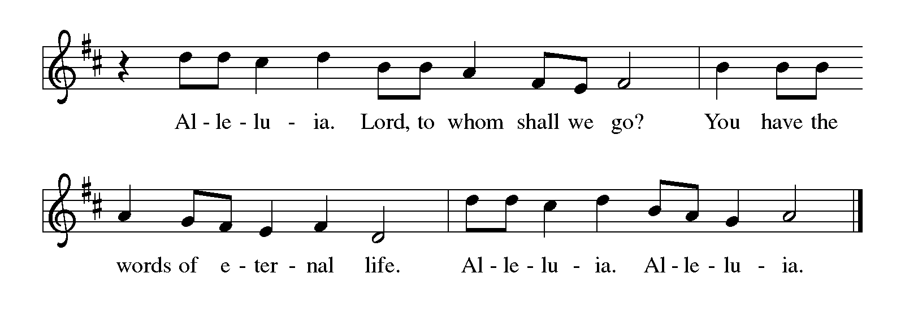
THE HOLY GOSPEL John 15: 1-8

On the night of his arrest, Jesus taught his disciples about the relationship they would have with him. Those who abide in his word and love would bear fruit, for apart from him, they could do nothing.

P: The Holy Gospel according to St. John, the fifteenth chapter.

C: Glory to You, O Lord!

I am the true vine, and My Father is the vinegrower. ²He removes every branch in Me that bears no fruit. Every branch that bears fruit He prunes to make it bear more fruit. ³You have already been cleansed by the word that I have spoken to you. ⁴Abide in Me as I abide in you. Just as the branch cannot bear fruit by itself unless it abides in the vine, neither can you unless you abide in Me.
⁵I am the vine, you are the branches. Those who abide in Me and I in them bear much fruit, because apart from Me you can do nothing. ⁶Whoever does not abide in Me is thrown away like a branch and withers; such branches are gathered, thrown into the fire, and burned. ⁷If you abide in Me, and My words abide in you, ask for whatever you wish, and it will be done for you. ⁸My Father is glorified by this, that you bear much fruit and become My disciples.

P: The Gospel of the Lord.

C: Praise to You, O Christ!

The assembly is seated

THE SERMON
Silence for reflection follows the sermon

As you are able please rise

THE HYMN OF THE DAY 447 O Blessed Spring
(Sung to the tune of, Praise God, From Whom All Blessings Flow)

1 O blessed spring, where word and sign
embrace us into Christ the Vine:
here Christ enjoins each one to be
a branch of this life-giving Tree.
2 Through summer heat of youthful years,
uncertain faith, rebellious tears,
sustained by Christ's infusing rain,
the boughs will shout for joy again.

3 When autumn cools and youth is cold,
when limbs their heavy harvest hold,
then through us, warm, the Christ will move
with gifts of beauty, wisdom, love.

4 As winter comes, as winters must,
we breathe our last, return to dust;
still held in Christ, our souls take wing
and trust the promise of the spring.

5 Christ, holy Vine, Christ, living Tree,
be praised for this blest mystery:
that word and water thus revive
and join us to Your Tree of Life.

THE NICENE CREED

A: God has made us His people through our Baptism into Christ. Living together in trust
and hope, we confess our faith.

C: We believe in one God,
the Father, the Almighty,
maker of heaven and earth,
of all that is, seen and unseen.

We believe in one Lord, Jesus Christ,
the only Son of God,
eternally begotten of the Father,
God from God, Light from Light,
true God from true God,
begotten, not made,
of one Being with the Father.
Through Him all things were made.
For us and for our salvation
He came down from heaven;
by the power of the Holy Spirit
He became incarnate from the virgin Mary, and was made man.
For our sake He was crucified under Pontius Pilate;
He suffered death and was buried.
On the third day He rose again
in accordance with the Scriptures;
He ascended into heaven
and is seated at the right hand of the Father.
He will come again in glory to judge the living and the dead,
and His kingdom will have no end.
We believe in the Holy Spirit, the Lord, the giver of life,
Who proceeds from the Father and the Son.
With the Father and the Son He is worshiped and glorified.
He has spoken through the prophets.
We believe in one holy catholic and apostolic Church.
We acknowledge one Baptism for the forgiveness of sins.
We look for the resurrection of the dead,
and the life of the world to come. Amen

THE PRAYER OF THE CHURCH

A: Christ intercedes for us that we may continue to grow in faith and love. Renewed by
Easter faith, let us pray for the Church, the world, and all who await the fullness of
Christ’s Easter life.

A: That the Church may remain rooted in Jesus and bear the fruit of love for one another
through worship, mission, and service: Lord, in Your mercy,

C: Hear our prayer.

A: That all the ends of the earth might remember and turn to the Lord, and all the families
of the nations bow before Him: Lord, in Your mercy,

C: Hear our prayer.

A: That our military personnel deployed throughout the world, especially Blake Waltz
and Katreen Sommers might be protected from harm and evil: Lord, in Your mercy,

C: Hear our prayer.

A: That God’s love might be perfected in us this week through our love for one another:
Lord, in Your mercy,

C: Hear our prayer.

A: That those who wait patiently for relief from their burdens and long for their health to
be restored, especially . . . might find comfort and strength in the abiding presence
of Jesus: Lord, in Your mercy,

C: Hear our prayer.

A: That those celebrating anniversaries, especially: Leigh and Bev Coburn; Charles
and Carol Thomas II; and Jim and Bernadette Krueger might be filled with grace
this day and every day and grow in grace in the days ahead: Lord, in Your mercy,

C: Hear our prayer.

A: That the mercy revealed in the lives of all the saints who have gone before us might
sustain us until we join them in eternal praise of You: Lord, in Your mercy,

C: Hear our prayer.

P: Gracious God, hear our prayers and receive them for the sake of the Crucified and Risen
One, our Savior, Jesus Christ our Lord.

C: Amen.

MEAL

THE PEACE

P: The peace of the risen Lord be with you always.

C: And also with you.

The assembly is seated

THE OFFERING

THE VOLUNTARY Here I Am St. Paul Senior Choir
(Pote/Schrader)

As you are able please rise

THE PRESENTATION OF THE GIFTS (see p. 9) This Joyful Eastertide

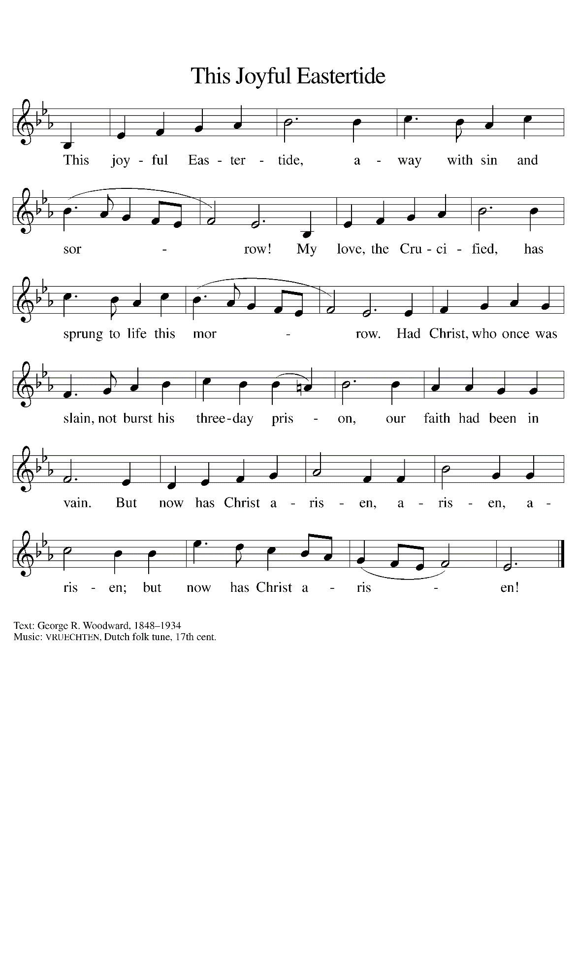
THE OFFERTORY PRAYER

A: Let us pray. Gracious God,

C: You have shown Your love for us by sending Your only Son into the world. By
these gifts we offer our love and lives to You. Receive them for the sake of Jesus
Christ. By this holy Sacrament we ask that You abide in us and we in You, that
we may bear much fruit of faith and love. We ask this in the name of Jesus the
risen Lord. Amen.

THE GREAT THANKSGIVING

P: The Lord be with you.

C: And also with you.

P: Lift up your hearts.

C: We lift them to the Lord.

P: Let us give thanks to the Lord our God.

C: It is right to give Him thanks and praise.

P: Abiding God, You planted the vineyard of creation, and called Your chosen people to
be Your vine, rooted and grounded in You.
In Jesus You gave us the true Vine, turning earth into grapes and the water of life into
the wine of eternal life.
Through Your Son You abide in us, and in the power of Your Holy Spirit You shape
the branches of the vine to make fruit that will last.
Your Son was crucified on the vine of our sin, that the blood of His sacrifice might be
the wine through which we might never be thirsty again.
In this Meal of creation, of resurrection, and of everlasting life You pour out the cup
of Your abundance to give us eternal joy in You.
Transforming God, Your Son took the ordinary substance of human flesh and bone;
and on His last night with His friends He took the ordinary materials of bread
and wine.
Come among us now, and make the ordinariness of our lives glow with the wonder of
Your eternal life.
Take these gifts of bread and wine and make them be for us the Body and Blood of
Your Son Jesus Christ;
Who, in the night ... “Do this for the remembrance of Me.”
As often as we eat ... we proclaim the Lord’s death until He comes.

C: Christ has died. Christ is risen. Christ will come again.

P: Companionable God, You turn Word into flesh, and Your perfect love casts out
our fear.
You show us a way to love You by giving us brothers and sisters to love as we
love You.
Abide with all whose lives are far from fruitful; remain with those who have
experienced pruning; dwell with any who feel like branches that have been
discarded.
Unite Your whole Church, living and departed, as branches of Your one Vine, and
through being rooted and grounded in You, make us fruitful in body, mind,
and spirit,
Until we stand before You, with Your whole creation, and You are all in all, one
God: Father, Son, and Holy Spirit.

C: Amen!

THE LORD’S PRAYER

P: Alleluia! The risen Christ intercedes on our behalf before the throne of God. Let us
therefore join Him in His prayers in the words He taught us:

C: (Sung) see p. 12

INVITATION TO THE MEAL

P: Alleluia! Christ our paschal Lamb has been sacrificed. Therefore, let us keep the Feast.
Blessed are those who are called to the Supper of the Lamb. God’s holy gifts for God’s
holy people. Come, for all is now ready.

The assembly is seated

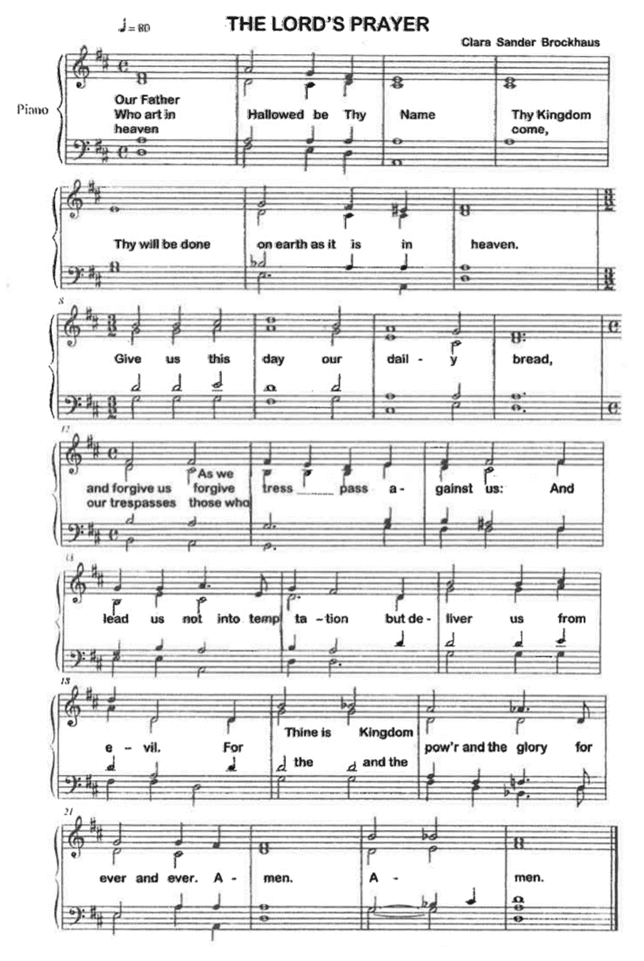

DISTRIBUTION
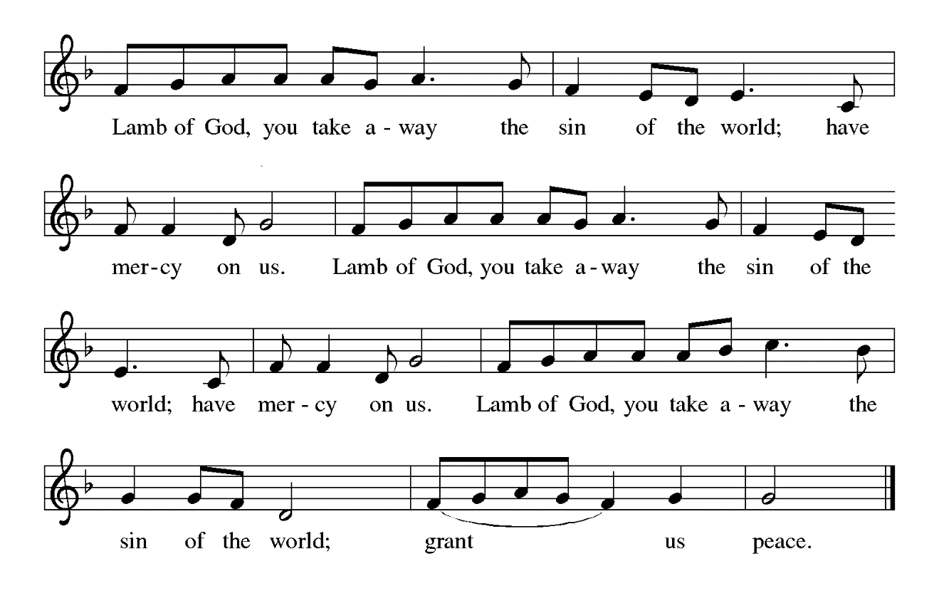
HYMNS DURING DISTRIBUTION 359 Where Charity and Love Prevail
452 Awake, O Sleeper, Rise From Death
As you are able please rise

THE POST-COMMUNION BLESSING

P: The Body and Blood of our Lord Jesus Christ strengthen you and keep you in His grace.

C: Amen.

THE POST-COMMUNION PRAYER

A: Let us pray. God of love, in this Eucharist we have heard Your truth and shared in
Your life. May we always walk in Your way, showing Your love and producing rich
fruits of faith. Grant this through Christ our Lord.

C: Amen.

SENDING

THE BENEDICTION

P: God the Father, Who raised our Lord Jesus from death, lift you up and restore you to
wholeness.

C: Amen.

P: God the Son, Jesus Christ, the Word of Life, bless you and send you to be His witnesses.

C: Amen.

P: God the Holy Spirit, Who renews the earth, refresh you in the gift of Baptism this day
and always.

C: Amen.

P: Almighty God: Father, Son, and Holy Spirit bless you now and forever.

C: Amen.

SENDING HYMN 539 Abide, O Dearest Jesus

THE DISMISSAL

A: Alleluia! Go and tell the News that Christ is risen!

C: Christ is risen indeed! Alleluia!

POSTLUDE

To God Alone Be Glory

The Meditation is from An Easter Sourcebook: The Fifty Days. Gabe Huck, et. al., eds.
(Chicago: Liturgy Training Publications, 1988) 97.

The Greeting, Offertory Prayer, Post-Communion Prayer, and Dismissal are adapted from
Sundays and Seasons. Copyright Augsburg Fortress, 1999.

The Prayer of the Church is adapted from Intercessions for the Christian People. Gail
Ramshaw, ed. (New York: Pueblo Publishing Company, 1988) 103.

ANNOUNCEMENTS

Please remember to mail your offering to the Church Office at 818 Franklin Street, Michigan City, IN 46360. Another alternative is to give on-line through Tithe.ly. Please see your closure letter for information on how to set up a Tithe.ly account.

St. Paul Members are reminded to have a loved one contact the office if you are hospitalized. Many times, the Pastor doesn’t know someone is in the hospital. If you call and leave a message, please tell us which hospital the patient is at.

Anniversaries: Leigh & Bev Coburn (5/1); Charles & Carol Thomas II (5/2);
Jim & Bernadette Krueger (5/5)

PRAYER CONCERNS: Jim Tomsheck, Marsha Kenney, Grace Romine, Debbie Martin, Sue Koziel, Jana Thomas, Margie Torres, Jayla Jacobi, Ronwynn Jones, Chris Jones, Mark Tannehill, Joan Seifert, Virginia Murray, Brian Wiseman, Jary Tannehill, Sue Granacki, and Kathy Stein.

OFFICE HOURS: Libby will be in the office on Mondays, Wednesdays,
and Fridays; volunteers will cover Tuesdays and Thursdays.

Monday & Wednesday 8:00 a.m. – 5 p.m.
Tuesday & Thursday 9:00 a.m. – 12:00 p.m.
Friday 8:00 a.m. – 12:00 p.m.

If you are listening to the worship broadcast on the radio and would like to watch the Sunday morning service live stream follow these steps:

(1) If you have You Tube available on your TV, search for
St. Paul Lutheran Church Michigan City, IN.

(2) The direct link on the computer is
https://www.youtube.com/channel/UC5AIPNaKr3QN50984jGOa1g.

(3) This link is also on the main page of the church’s website in
the church section and will continue to be posted weekly on the St.
Paul Facebook page.

And it will always be available on the radio broadcast Sunday mornings at 11:00 a.m.
on WEFM (95.9), and on the local cable access station #99 for the previous week’s
service on Sundays at 4:00 p.m. and the current service on Wednesdays at 7:00 p.m.
and Fridays at 8:30 p.m.

Next Sunday’s lessons are Acts 10: 44-48; Psalm 98; 1 John 5: 1-6; John 15: 9-17 for those of you who like to study them in advance.

The approved and signed minutes of the January 25 and February 22, 2024 Church Council Meetings are on the table at the back of the church in the Narthex. Please take a copy with you as you go.

To send e-mail to the church office, please use the following addresses:

Pastor Mark Reshan: seniorpastor@stpaulmichigancity.com

Church Office Secretary (Libby Pollock): churchsecretary@stpaulmichigancity.com

Church Treasurer (Karen Fleming): finance@stpaulmichigancity.com

The Good News Newsletter: If you have an article or anything you want included in The Good News please send it to the following e-mail address: splcgoodnews@gmail.com. Pastor Pamela Thiede will be using this e-mail address to assemble The Good News each month. The deadline for getting information to Pastor Pamela will be the 20th of each month.

Worship Attendance:
Saturday, April 20, 2024 @ 4:00 p.m. 29
Sunday, April 21, 2024 @ 9:00 a.m. 66
TOTAL 95

THANK YOU! Thank you for your support of the Service League for March’s monthly mission. We were able to donate $380.00 to help further their mission in Michigan City.

MISSION OF THE MONTH FOR APRIL 2024

April’s monthly mission is Keys to Hope. Keys to Hope helps homeless and disenfranchised individuals get back to sustainable self-sufficiency through a variety of programs. We will be collecting money as well as razors and deodorant. Please make checks out to the church and place in the offering marked for Keys to Hope. There will be a bin in the Narthex for razors and deodorant.

IT’S TIME FOR A NEW DIRECTORY

As you all are well aware the last two years have seen many changes and we are in need of an updated Directory for the church. Please think about how you want to be represented in the new Directory. If you have any changes to any of your information (i.e. new mailing and email addresses, new phone numbers, etc.) please send me an email or call the church office in the next couple weeks and let me know. I look forward to hearing from you as soon as you’re able.

Libby Pollock
Church Secretary

POTLUCK DINNER

Following the congregational meeting on May 19, we will hold a traditional potluck meal. The Council will not be providing the main course this time, so whatever entrees, salads, sides, and desserts we have will come from those who attend. No need to sign up for anything; simply bring a favorite dish to share and enjoy good food and better fellowship following the meeting.

Thank$ for $haring
This month, we will see you again at Galveston on Thursday, May 23! Here are two coupons: one for you and one for a friend.

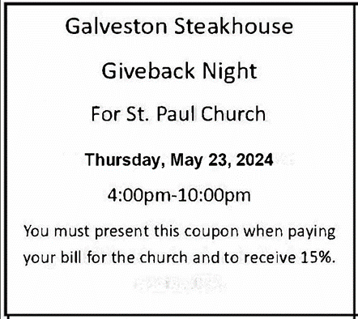

Coming Soon:

We invite you to join us for a lakeshore cruise on the Emita II on Tuesday, June 4. The cost is $35 per person with $10 of that going to the church (no coupon required). Children up to age three are free. The link for making a reservation is:

https://tinyurl.com/mtk3ach6
Please use this link for any communication instead of the longer one previously provided. They have to book via the site (they’re not able to book over the phone). If you have any issues with using a credit card online, you are invited to pay Paul Brooks in person and he will take care of it for you. (please include a few extra dollars for fees)
For now, the day is blocked out on their main page, so the above link is the only way to book a reservation for this particular cruise. The cruise will be made public two to three weeks prior to the cruise date, so the earlier you make your reservation, the better.

The Mission of the Month for May
May’s mission of the month is Dolly Parton’s Imagination Library of
LaPorte County. Dolly Parton’s Imagination Library is dedicated to inspiring a love of reading by gifting books each month to children from birth to age five, free of charge, through funding shared by Dolly and local community partners in the United States, Canada, United Kingdom, Australia and Republic of Ireland. Any child within LaPorte County who is under the age of 5 can sign up. Some of the books Leah has received are “The Little Engine That Could,” “Llama Llama Red Pajama,” “The Very Hungry Caterpillar’s First Summer,” and her favorite, “Goodnight Gorilla.” Please consider helping to foster a love of reading in young kids in our community by donating to the Imagination Library. Checks can be made out to the church and marked for the Imagination Library and placed in the offering plate. Thank you so much!

THANK YOU!
Please give a heartfelt thanks to the James Cook Jr. family for their donation to the Archive Room last week. It is a lovely framed photo of the 4th, 5th, and 6th grade class at St. Paul School from 1944. It will be on display in the glass cabinet in the Archive Room.

ACTIVITIES, EVENTS & MEETINGS
MAY 2024

Sunday, April 28, 2024 @ 9:00 a.m. 5 Easter Worship Service

Wednesday, May 1, 2024 @ 9:15 a.m. Bible Study/Luther House

@ 10:00 a.m. God’s Purls/St. Paul Room

Thursday, May 2, 2024 Faith Circle

Saturday, May 4, 2024 @ 4:00 p.m. 6 Easter Worship Service

Sunday, May 5, 2024 @ 9:00 a.m. 6 Easter Worship Service

Monday, May 6, 2024 @ Noon Choir Rehearsal

Tuesday, May 7, 2024 @ 10:00 a.m. Altar Guild/Green Room

Wednesday, May 8, 2024 @ 10:00 a.m. God’s Purls/St. Paul Room
Saturday, May 11, 2024 @ 4:00 p.m. Ascension Worship Service

Sunday, May 12, 2024 @ 9:00 a.m. Ascension Worship Service
Monday, May 13, 2024 @ Noon Choir Rehearsal
@ 1:00 p.m. Worship & Music Committee Mtg./Luther House
Tuesday, May 14, 2024 @ 7:00 p.m. Estuary/Luther House
Wednesday, May 15, 2024 @ 9:15 a.m. Bible Study/Luther House
Saturday, May 18, 2024 @ 4:00 p.m. Vigil and Day of Pentecost Worship Service

Sunday, May 19, 2024 @ 9:00 a.m. Vigil and Day of Pentecost Worship Service

@ 10:00 a.m. Congregational Spring Meeting & Potluck in
St. Paul Room

Monday, May 20, 2024 @ Noon Choir Rehearsal

Wednesday, May 22, 2024 @ 9:15 a.m. Bible Study/Luther House

@10:00 a.m. God’s Purls/St. Paul Room

Thursday, May 23, 2024 @ 4:00-10:00 p.m. GIVE-BACK at Galveston Steakhouse

Saturday, May 25, 2024 @ 4:00 p.m. Holy Trinity Worship Service

Sunday, May 26, 2024 @ 9:00 a.m. Holy Trinity Worship Service

Monday, May 27, 2024 OFFICE IS CLOSED FOR MEMORIAL DAY

Wednesday, May 29, 2024 @ 9:15 a.m. Bible Study/Luther House

@10:00 a.m. God’s Purls/St. Paul Room

