**THE FIFTH SUNDAY IN LENT**

**April 3, 2022**

"I am doing a new thing." Thus God admonishes us as we enter the last week of Lent: prepare yourselves, for something you have not imagined is about to happen. The day that is coming will not be like any former day. It will come fresh and dazzling as a bright sunrise after a lifetime of drizzle and gloom. The new thing that is almost upon us will relativize everything—even our best preparations. For God is bringing us out of the isolation created by sin, into a communion of the forgiven.

No matter how many times we experience it, no matter now many times we celebrate the repentance, eucharist, and Easter, the forgiving embrace of God always comes upon us as brand new, totally unexpected, awesome in its revelation of ourselves and all others as beloved children of God.

**Mary Frohlich**

***✠ In the Name of Jesus✠***

The vividly sensuous nature of this passage encourages preachers to invite congregations to think about the gospel in ways beyond words, speaking, and reading. Does grace have a scent? It can be worth the effort to reflect on Jesus and his work in terms of meaningful smells and sensations.

Rudyard Kipling wrote, "Smells are surer than sounds or sights / To make your heart-strings crack."1

Most people have experienced a smell that floods the mind with arresting memories of a person, place, or event. Olfaction, emotion, and memory share closely networked real estate in the brain's limbic system. Our sense of smell relates closely to how we experience life and process significant memories …Mary's gift emits an aroma that saturates the house and the minds of everyone in it. How does that passionate aroma persist even today? What real-life experiences does Jesus' death forever define, like a scent we never forget?...

…The pairing of Mary and Judas creates a rhetoric of contrast. Notice a variety of oppositions:

* Mary and Judas contrast true and false discipleship, as well as true and false love.
* The fragrance of the perfume strikes a contrast to Jesus' death and burial. Our interpretation of the scene cannot ignore the gloom. Mary does not anoint Jesus as king or Messiah; she anoints a corpse. If the beautiful scent and ugly crucifixion seem incongruent, then we are onto John's strange logic whereby Jesus is lifted up onto a cross so that he might attract all to himself (12:32).
* Lavish devotion contrasts critical stinginess. This passage gives permission, so to speak, to honor Jesus in extravagant ways, perhaps even by giving a massive donation to the poor. It warns against mistaking discipline for discipleship. It embraces affection as part of a devotion to Jesus that is nothing less than the costly, precious gift of one's whole self--down to every last strand of hair.

**Matt Skinner**

***✠ In the Name of Jesus✠***

**INTRODUCTION**

The Lord our God makes all things new. In the first reading God promises it. In the gospel Mary anticipates it, anointing Jesus' feet with costly perfume in preparation for the day of his burial. In the second reading we recall the transformation of Saul, the persecutor, into Paul, the apostle. In baptism, God's new person (you!) rises daily from the deadly mire of trespasses and sins.

**Benedict the African, confessor, died 1589**

*Born into slavery on the island of Sicily, Benedict lived as a hermit until the pope ordered all hermits to attach themselves to a monastery, at which time Benedict joined the Franciscans. Though illiterate, he was highly respected as a confessor and later superior of his community.*

**✠ GATHERING ✠**

**PRELUDE *Chaconne*  Louis Couperin**

**ANNOUNCEMENTS**

*As you are able please rise*

**CONFESSION**

P: In the name of the Father and of **✠** the Son and of the Holy Spirit.

C: **Amen.**

P: “Thus says the LORD, ... Do not remember the former things, or consider the things of

old. I am about to do a new thing; now it springs forth, do you not perceive it?” (Isaiah

43:18-19) God moves among us in Lent to guide us toward repentance, a change of

heart, mind, and will. Let us therefore turn to God and confess our sins, that God might

give us a clean heart and a right spirit.

*Silence for self-examination and reflection is kept*

P: Our attachment to “the things of old,” our blindness to the “new thing” You are doing

in our lives, and our failure to faithfully praise You in word and deed, we confess to

You, O Lord:

C: **Lord, have mercy.**

P: Our desire to gain more than Christ, our avoidance of His sufferings, and our fear of

“what lies ahead,” we confess to You, O Lord:

C: **Lord, have mercy.**

P: Our lack of devotion to Christ, our neglect of the poor, and our betrayal of Jesus by

word and deed, we confess to You, O Lord:

C: **Lord, have mercy.**

P: Almighty God have mercy on us, forgive us our sins, and bring us to everlasting life.

C: **Amen.**

**GATHERING HYMN 339 *Christ, the Life of All the Living*  p. 11**

**THE GREETING AND PRAYER OF THE DAY**

P: The grace of our Lord Jesus Christ, the love of God, and the communion of the Holy

Spirit be with you all.

C: **And also with you.**

P: Let us pray. Creator God, You prepare a new way in the wilderness, and Your grace

waters our desert. Open our hearts to be transformed by the new thing You are doing,

that our lives may proclaim the extravagance of Your love given to all through Your

Son, Jesus Christ, our Savior and Lord, Who lives and reigns with You and the Holy

Spirit, one God, now and forever.

C: **Amen.**

*The assembly is seated*

**✠ WORD ✠**

**FIRST READING Isaiah 43:16-21**

*This prophet of the exile declares that long ago the Lord performed mighty deeds and delivered Israel from Egyptian bondage. Now, the Lord is about to perform an even greater act of deliverance. This salvation leads the people to praise God.*

16Thus says the Lord,

Who makes a way in the sea,

a path in the mighty waters,

17Who brings out chariot and horse,

army and warrior;

they lie down, they cannot rise,

they are extinguished, quenched like a wick:

18Do not remember the former things,

or consider the things of old.

19I am about to do a new thing;

now it springs forth, do you not perceive it?

I will make a way in the wilderness

and rivers in the desert.

20The wild animals will honor Me,

the jackals and the ostriches;

for I give water in the wilderness,

rivers in the desert,

to give drink to My chosen people,

21the people whom I formed for Myself

so that they might declare My praise.

The Word of the Lord.

**Thanks be to God.**

**THE PSALM: Psalm 126**  **Read responsively**

1When the LORD restored the fortunes of Zion,

     then were we like those who dream.

**2Then was our mouth filled with laughter, and our tongue with shouts of joy.**

**Then they said among the nations, "The LORD has done great things for them."**

3The LORD has done great things for us,

     and we are glad indeed.

**4Restore our fortunes, O LORD,**

**like the watercourses of the Negeb.**

5Those who sowed with tears

     will reap with songs of joy.

**6Those who go out weeping, carrying the seed,**

**will come again with joy, shouldering their sheaves.**

**SECOND READING Philippians 3:4b-14**

*Writing to Christians in Philippi, Paul admits that his heritage and reputation could give him more reason than most people to place "confidence in the flesh." But then, he goes on to say what truly matters to him.*

4bIf anyone else has reason to be confident in the flesh, I have more: 5circumcised on the eighth day, a member of the people of Israel, of the tribe of Benjamin, a Hebrew born of Hebrews; as to the law, a Pharisee; 6as to zeal, a persecutor of the church; as to righteousness under the law, blameless.

7Yet whatever gains I had, these I have come to regard as loss because of Christ. 8More than that, I regard everything as loss because of the surpassing value of knowing Christ Jesus my Lord. For his sake I have suffered the loss of all things, and I regard them as rubbish, in order that I may gain Christ 9and be found in him, not having a righteousness of my own that comes from the law, but one that comes through faith in Christ, the righteousness from God based on faith. 10I want to know Christ and the power of his resurrection and the sharing of his sufferings by becoming like him in his death, 11if somehow I may attain the resurrection from the dead.

12Not that I have already obtained this or have already reached the goal but I press on to make it my own, because Christ Jesus has made me his own. 13Beloved, I do not consider that I have made it my own but this one thing I do: forgetting what lies behind and straining forward to what lies ahead, 14I press on toward the goal for the prize of the heavenly call of God in Christ Jesus.

The Word of the Lord.

**Thanks be to God.**

*As you are able please rise*

**THE VERSE**

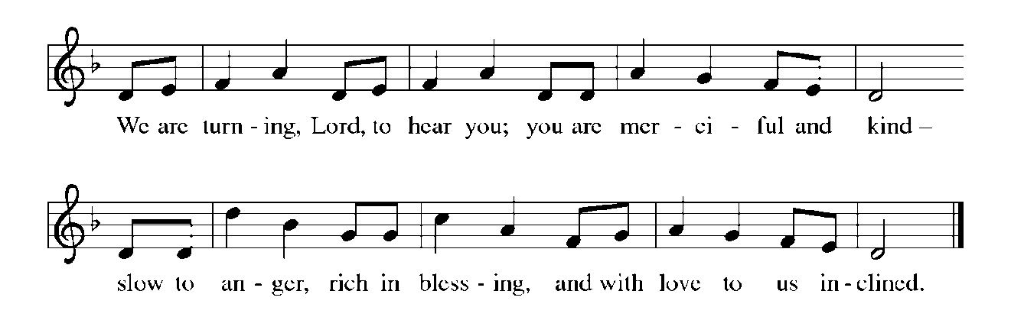

**THE HOLY GOSPEL John 12:1-8**

*Judas misunderstands Mary's extravagant act of anointing Jesus' feet with a costly perfume. Jesus recognizes the true significance of her beautiful expression of love and commitment as an anticipation of his burial.*

P: The Holy Gospel according to St. John, the twelfth chapter.

C: **Glory to You, O Lord!**

1Six days before the Passover Jesus came to Bethany, the home of Lazarus, whom He had raised from the dead. 2There they gave a dinner for Him. Martha served, and Lazarus was one of those at the table with Him. 3Mary took a pound of costly perfume made of pure nard, anointed Jesus' feet, and wiped them with her hair. The house was filled with the fragrance of the perfume.

4But Judas Iscariot, one of His disciples (the one who was about to betray Him), said, 5"Why was this perfume not sold for three hundred denarii and the money given to the poor?" 6(He said this not because he cared about the poor, but because he was a thief; he kept the common purse and used to steal what was put into it.) 7Jesus said, "Leave her alone. She bought it so that she might keep it for the day of My burial. 8You always have the poor with you, but you do not always have Me."

P: The Gospel of the Lord.

C: **Praise to You, O Christ!**

*The assembly is seated*

**THE SERMON**

*Silence for reflection follows the sermon*

*As you are able please rise*

**THE HYMN OF THE DAY NSB 2 *Above All*  p. 12**

**THE NICENE CREED**

A: God has made us His people through our Baptism into Christ. Living together in trust

and hope, we confess our faith.

C: **We believe in one God,**

**the Father, the Almighty,**

**maker of heaven and earth,**

**of all that is, seen and unseen.**

**We believe in one Lord, Jesus Christ,**

**the only Son of God,**

**eternally begotten of the Father,**

**God from God, Light from Light,**

**true God from true God,**

**begotten, not made,**

**of one Being with the Father.**

**Through Him all things were made.**

**For us and for our salvation**

**He came down from heaven;**

**by the power of the Holy Spirit**

**He became incarnate from the virgin Mary, and was made man.**

**For our sake He was crucified under Pontius Pilate;**

**He suffered death and was buried.**

**On the third day He rose again**

**in accordance with the Scriptures;**

**He ascended into heaven**

**and is seated at the right hand of the Father.**

**He will come again in glory to judge the living and the dead,**

**and His kingdom will have no end.**

**We believe in the Holy Spirit, the Lord, the giver of life,**

**Who proceeds from the Father and the Son.**

**With the Father and the Son He is worshiped and glorified.**

**He has spoken through the prophets.**

**We believe in one holy catholic and apostolic Church.**

**We acknowledge one Baptism for the forgiveness of sins.**

**We look for the resurrection of the dead,**

**and the life of the world to come. Amen.**

**THE PRAYER OF THE CHURCH**

A: As God’s new people, formed in Christ Jesus, let us join in prayer to the God Who

makes all things new for the Church, the world, and all those in need.

A: That the Church may gladly share in the sufferings of Christ and in turn show forth the

power of His resurrection, let us pray to the Lord:

C: **Lord, have mercy.**

A: That God’s Spirit might create a path to peace through all places of hatred, violence,

oppression, and bloodshed, especially in Ukraine, let us pray to the Lord:

C: **Lord, have mercy.**

A: That this congregation might pour itself out to the poor, hungry, and needy as a fragrant

offering to God, let us pray to the Lord:

C: **Lord, have mercy.**

A: That the sick, especially . . .might have their health, hope, and fortunes restored, let us

pray to the Lord:

C: **Lord, have mercy.**

A: That those celebrating birthdays, especially **Jana Thomas; Lyle Peters; and Sarah**

**McNabb** that they may be filled with Your grace this day and every day and may live

in Your grace in all the days ahead, let us pray to the Lord:

C: **Lord, have mercy.**

A: That we may press on toward the goal, and together with all the saints, especially,

**Benedict the African, Confessor**whom we commemorate this Day, may attain the

resurrection from the dead through Christ Jesus, let us pray to the Lord:

C: **Lord, have mercy.**

P: God our Savior and Redeemer, You are constantly at work, bringing forth new things

in Your creation. Hear the prayers we make to You, and continue to perform ever

greater wonders for the entire family of humankind, through Your Son, Jesus Christ

our Lord.

C: **Amen.**

**✠ MEAL ✠**

**THE PEACE**

P: Through Christ we have been reconciled to God, Who has given us the ministry of

reconciliation. Let us be reconciled with one another.

The peace of the Lord be with you always.

C: **And also with you.**

*The assembly is seated*

**THE VOLUNTARY *God Will Make a Way*  Praise Band**

*As you are able please rise*

**THE OFFERTORY PRAYER**

A: Let us pray. Mighty God,

C: **As Mary showered Jesus with her love, so we bring You our devotion in these gifts.**

**By this holy Sacrament strengthen us for faithful service, that our lives may be a**

**pleasing and fragrant offering to You. We ask this in the name of Jesus the Lord.**

**Amen.**

**THE GREAT THANKSGIVING**

P: The Lord be with you.

C: **And also with you.**

P: Lift up your hearts.

C: **We lift them up to the Lord.**

P: Let us give thanks to the Lord our God.

C: **It is right to give Him thanks and praise.**

P: Extravagant God, You poured out Your life in covenant with Your chosen people, and

You poured out Your life-blood in the ministry and death of Your Son

Jesus Christ.

You meet our meanness with Your grace, our scarcity with Your abundance, and

our suspicion with Your generous trust.

Sharing God, in Jesus You attended a meal to celebrate Lazarus’s resurrection, and

so we gather today to celebrate Jesus’ resurrection, in faith that even now

You are preparing a Feast to celebrate our resurrection with You.

Make us holy, that even as our flesh and blood decay, our hearts are made ready that

we may meet You face to face.

Send down Your Holy Spirit, that this bread of sustenance and this wine of joy may

be for us the Body and Blood of Your Son Jesus Christ,

Who, in the night ... “Do this for the remembrance of Me.”

As often as we eat ... we proclaim the Lord’s death until He comes.

C: **Christ has died. Christ is risen. Christ will come again.**

P: Abundant God, when we know the price of everything and the value of nothing,

may this Meal remind us of the limitless joy You take in us.

When we are full of criticism of others and hatred of ourselves, may this sacrifice

show us the goodness You see in all.

Bless all our touching, that we may touch Your gifts and one another as if we were

touching Your Body and Blood.

Bless all our desire, that in every craving and longing we may discover a deeper

yearning for You.

Renew the hearts of all Your people, that Your whole Church, working together for

the justice of Your Kingdom, may discover in the stranger the gifts that

come only from You,

Through Whom, and with Whom, and in Whom come all honor and glory, Father,

Son,✠ and Holy Spirit one God, now and forever.

C: **Amen!**

**THE LORD’S PRAYER**

P: Baptized into Christ’s death that we might share in the resurrection, let us pray for the

fulfillment of the mystery as Jesus taught us:

C: **Our Father, Who art in heaven, hallowed be Thy Name. Thy Kingdom come, Thy**

**will be done on earth as it is in heaven. Give us this day our daily bread, and**

**forgive us our trespasses as we forgive those who trespass against us. And lead us**

**not into temptation but deliver us from evil. For Thine is the Kingdom, and the**

**power, and the glory, forever and ever. Amen.**

**INVITATION TO THE MEAL**

P: Behold the Servant of God, obedient unto death on a cross, highly exalted as Lord of

glory. Blessed are those who are called to the banquet of the Lamb. God’s holy gifts

for God’s holy people. Come, for all is now ready.

*The assembly is seated*

**THE DISTRIBUTION**

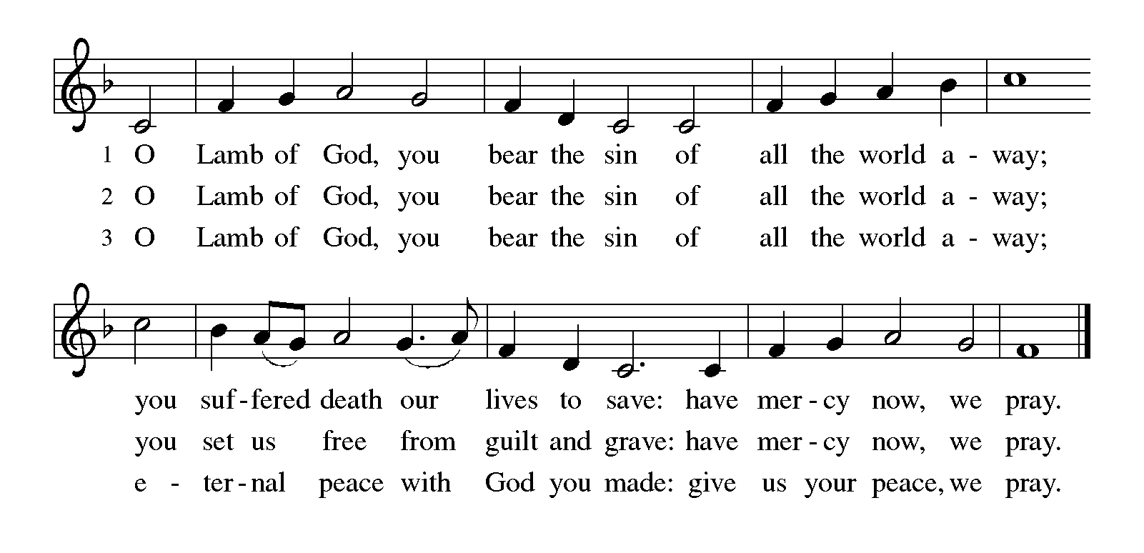

**HYMN DURING DISTRIBUTION 754 *Jesus, the Very Thought of You* p. 13**

**NSB 100  *What the Lord Has Done in Me*  p. 14**

**793 *Be Thou My Vision*  p. 15**

**NSB 37  *Give Thanks* p. 16**

*As you are able please rise*

**THE POST COMMUNION BLESSING**

P: The Body and Blood of our Lord Jesus Christ strengthen you and keep you in His

grace.

C: **Amen.**

**THE POST-COMMUNION PRAYER**

A: Let us pray. Merciful God, we give You thanks for the forgiveness and grace we have

received in this Meal. Grant us the vision to see the new thing You are doing in our

midst, and make us strong to reach the goal of the resurrection life You promise in

Christ. Grant this through Christ our Lord.

C: **Amen.**

**✠ SENDING ✠**

**THE BENEDICTION**

P: Jesus took the form of a servant and was obedient to death, even death on a cross. May

you follow His example and share in the resurrection.

C: **Amen.**

P: Almighty God: Father, Son, ✠ and Holy Spirit bless you now and forever.

C: **Amen.**

**SENDING HYMN 338 *Beneath the Cross of Jesus*  p. 17**

**THE DISMISSAL**

A: Reconciled to God through Christ, let us go out into the world in peace.

C: **Thanks be to God!**

**POSTLUDE *Fugue in G Minor*  Charpentier**

***✠ To God Alone Be Glory✠***

The Meditations are fromMary Frolich, quoted in *Sundays and Seasons,* copyright 2022

Luther Seminary; and *Working Preacher Online,* copyright 2022 Luther

Seminary.

The Eucharistic Prayer is adapted from *Eucharistic Prayers.* Samuel Wells and Abigail

Kocher. (Grand Rapids: Eerdmann’s Publishing Company, 2016) 148-49.

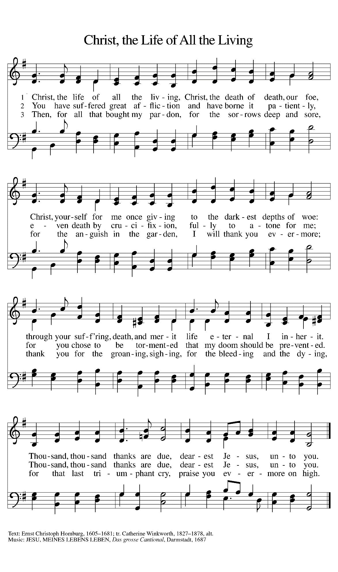

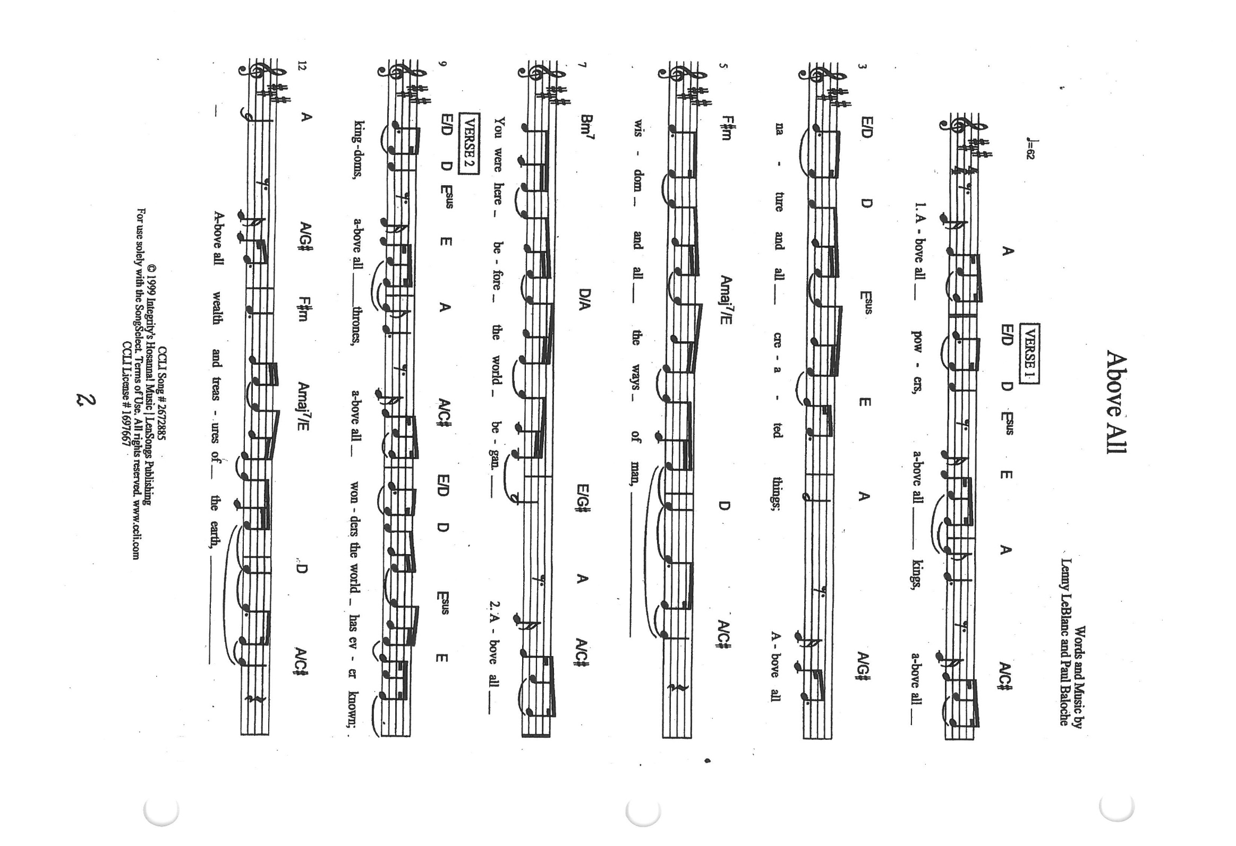

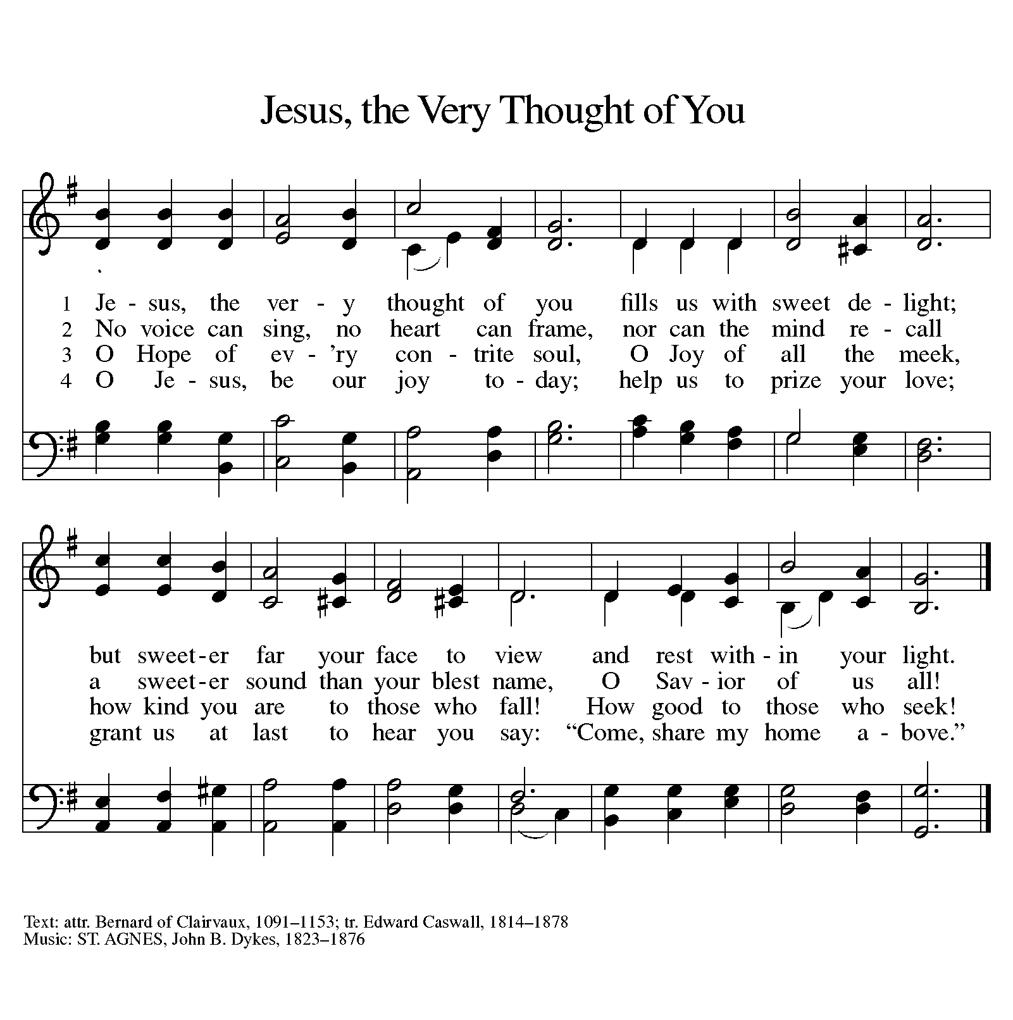

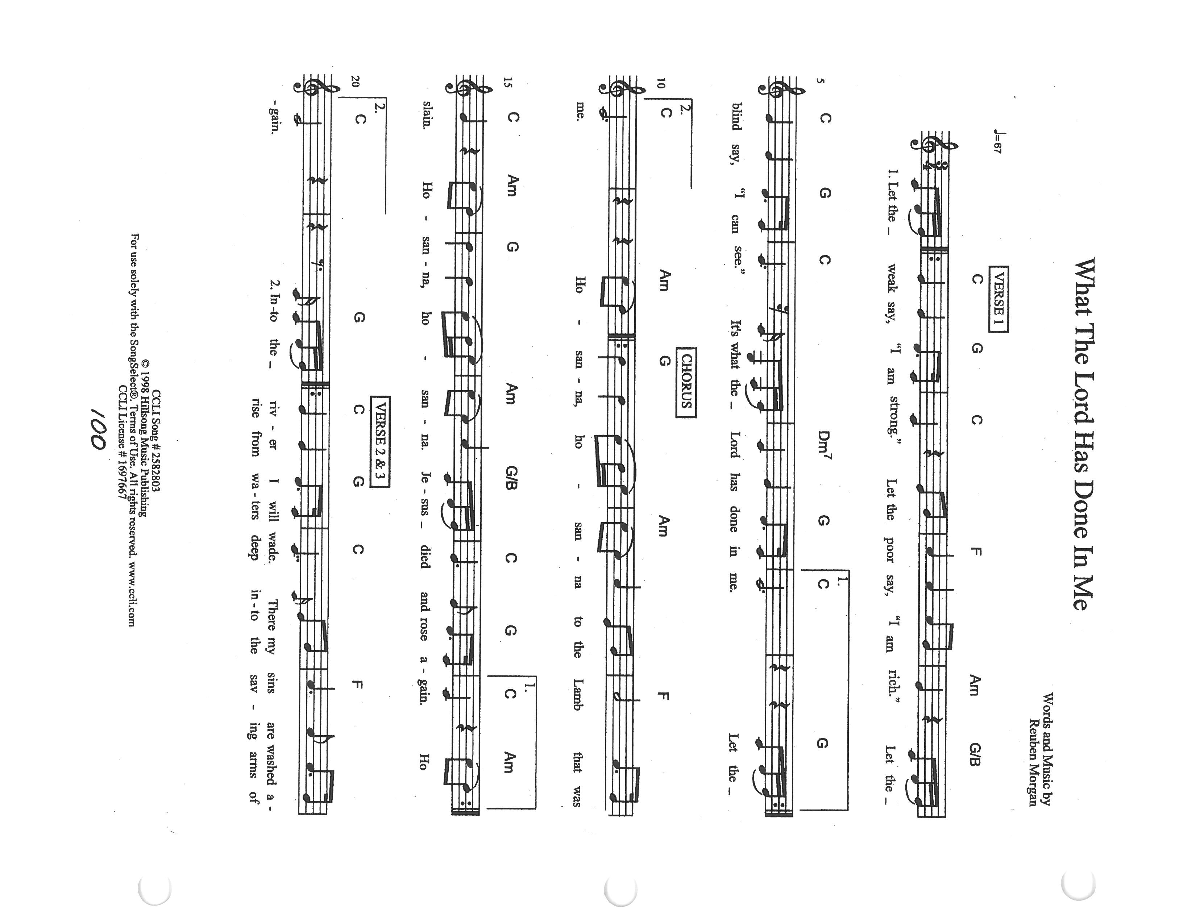

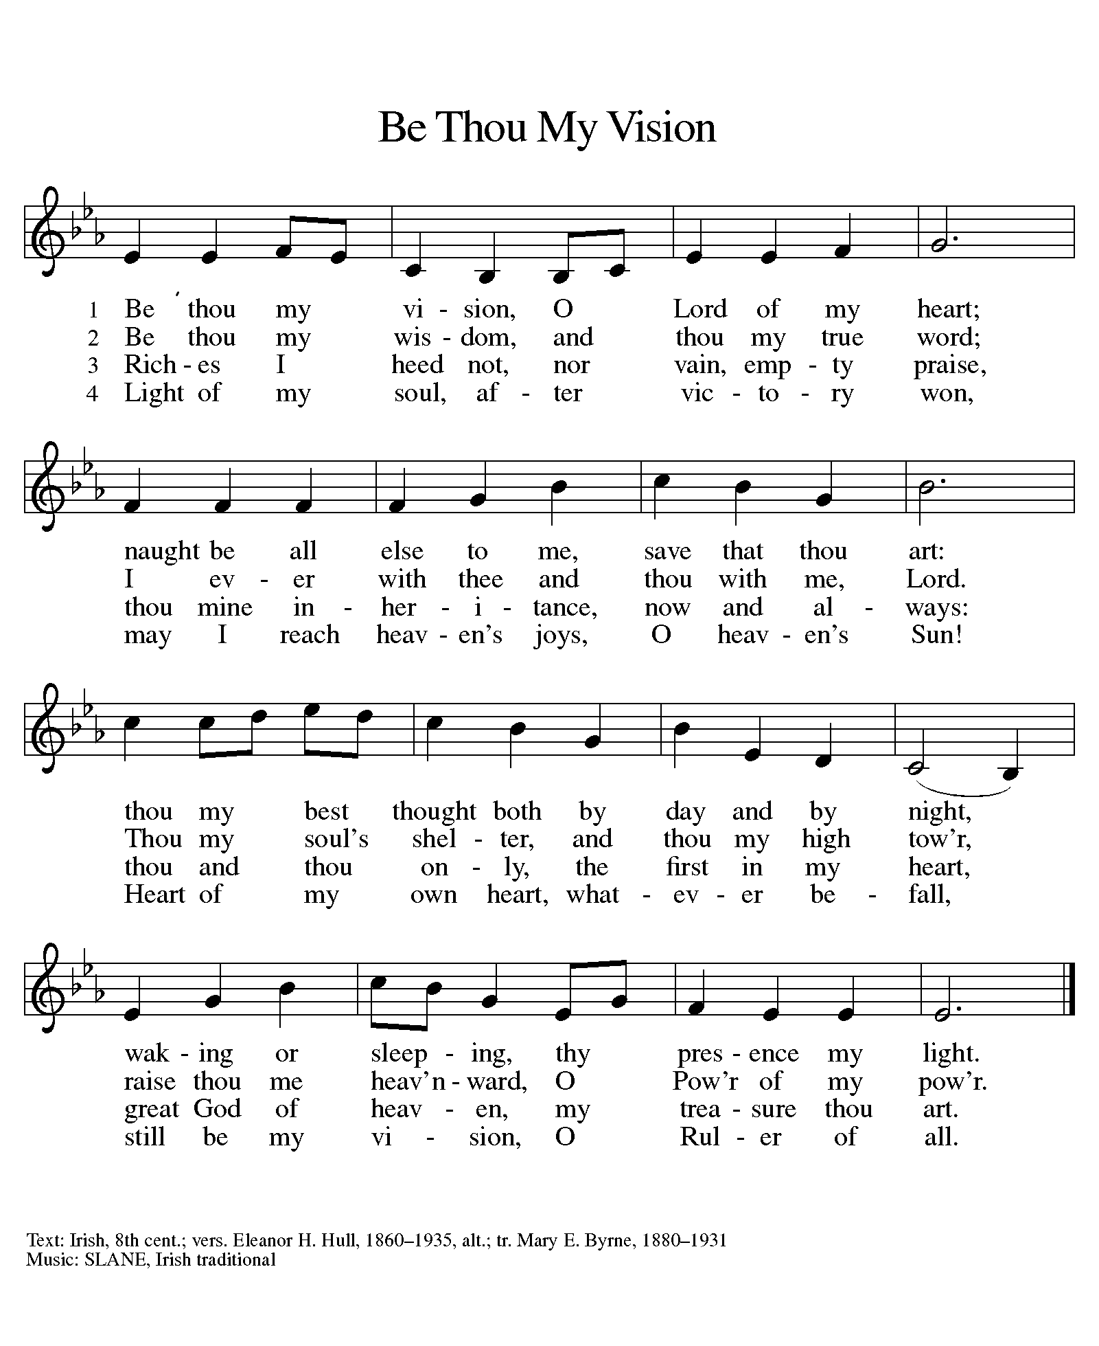

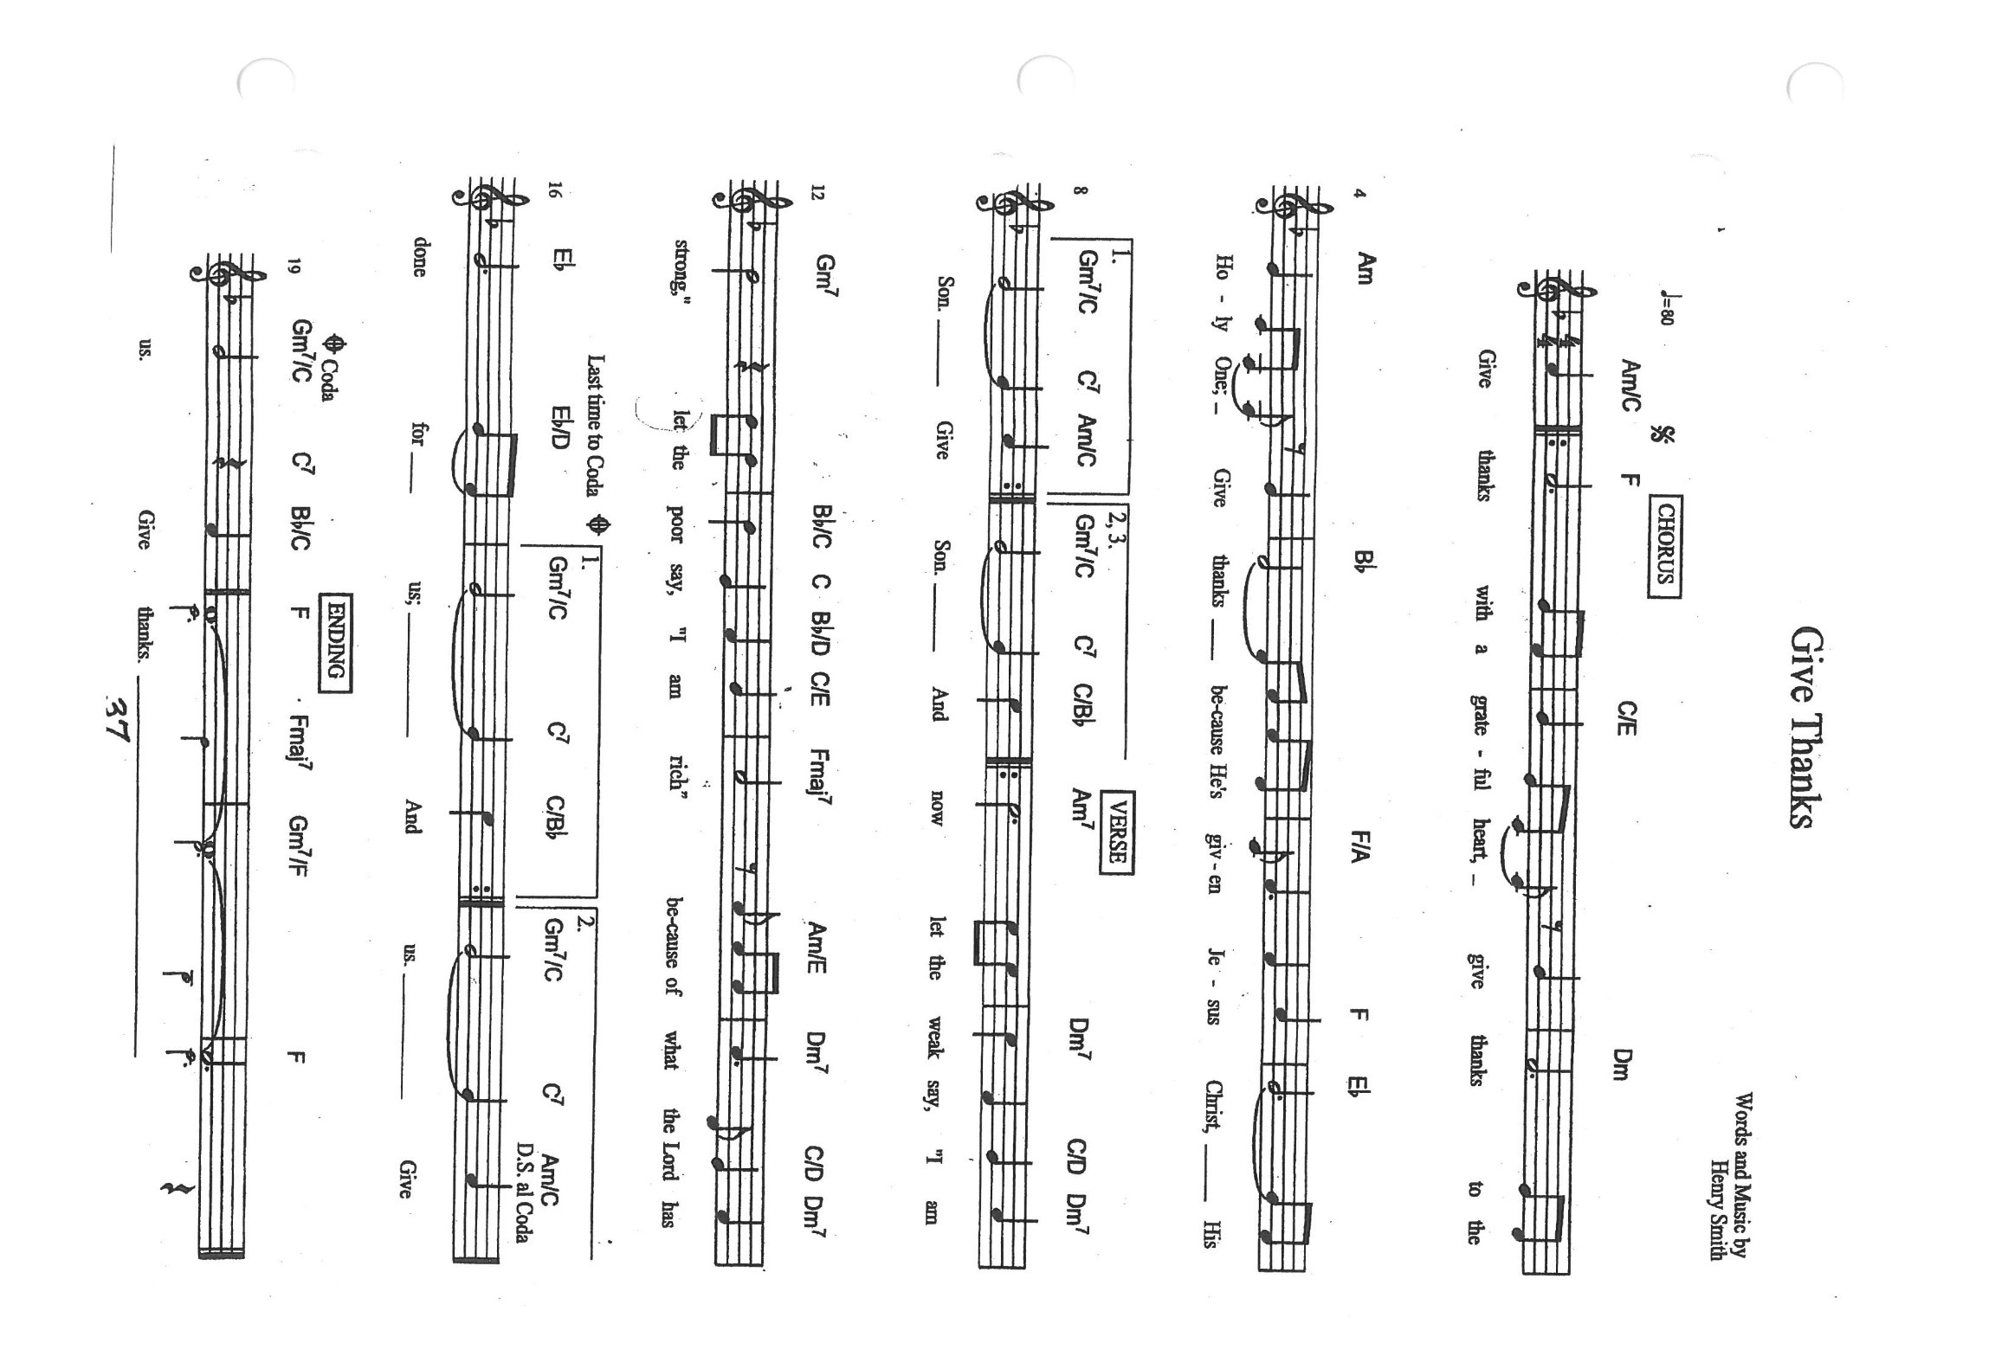

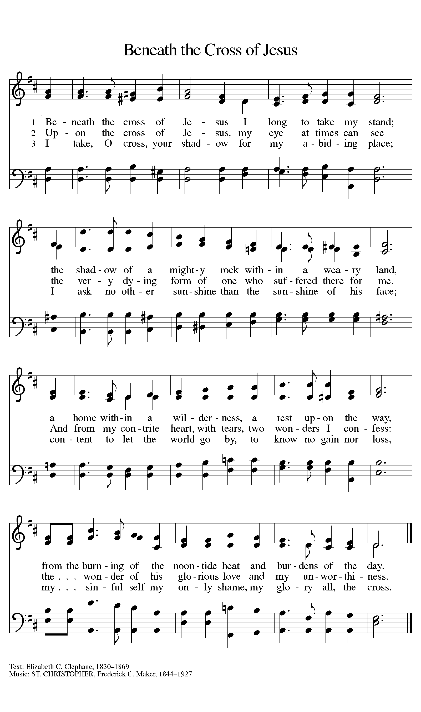

**ANNOUNCEMENTS**

**Please remember to mail your offering to the Church Office** at 818 Franklin Street, Michigan City, IN 46360**.** Another alternative is to give on-line through Tithe.ly. Please see your closure letter for information on how to set up a Tithe.ly account.

**St. Paul Members are reminded to have** a loved one contact the office if you are hospitalized. Many times, the Pastor doesn’t know someone is in the hospital. If you call and leave a message, please tell us which hospital the patient is at.

**Next Sunday’s lessons are Isaiah 50 ; 4-9a; Psalm 31: 9-16; Philippians 2: 5-11; Luke 22: 14-23:56 or Luke 23: 1-49** for those of you who like to study them in advance.

**Birthdays: Jana Thomas (4/1); Lyle Peters (4/2); Sarah McNabb (4/3).**

**PRAYER CONCERNS:** Audrey Beyer, Ryan Krueger, Donna Bostater, Maxine Powell, Jim Tomscheck, Ken Mulder, Roger Milzarek, Eloise Ponder, Mark & Jary Tannehill and Leonard Cross.

**If you requested someone’s name to be on the prayer list and are aware that they need continued imminent prayer then contact the church office and let us know.** Otherwise we will gradually transfer names to the long-term list.

**OFFICE HOURS:** Libby will be in the office on Mondays, Wednesdays, and Fridays; volunteers will cover Tuesdays and Thursdays.

Monday & Wednesday 8:00 a.m. – 5 p.m.

Tuesday & Thursday 9:00 a.m. – 12:00 p.m.

Friday 8:00 a.m. – 12:00 p.m.

**If you are listening to the worship broadcast on the radio and would like to watch the Sunday morning service live stream follow these steps:**

1. If you have You.Tube available on your TV, search for

**St. Paul Lutheran Church Michigan City, IN.**

(2) The direct link on the computer is

https://www.youtube.com/channel/UC5AIPNaKr3QN50984jGOa1g.

(3) This link is also on the main page of the church’s website in the church section and will continue to be posted weekly on the St. Paul Facebook page.

And it will always be available on the radio broadcast Sunday mornings at 11:00 a.m. on WEFM (95.9), and on the local cable access station #99 for the previous week’s service on Sundays at 4:00 p.m. and the current service on Wednesdays at 7:00 p.m. and Fridays at 8:30 p.m.

**To send e-mail to the church office**, please use the following addresses:

Pastor Mark Reshan: seniorpastor@stpaulmichigancity.com

Church Office Secretary (Libby Pollock): churchsecretary@stpaulmichigancity.com

Church Treasurer (Karen Fleming) and Bookkeeper (Billie Atchinson):

finance@stpaulmichigancity.com.

**The Good News Newsletter**: If you have an article or anything you want included in **The Good News** please send it to the following e-mail address: splcgoodnews@gmail.com. Pastor Pamela Thiede will be using this e-mail address to assemble **The Good News** each month. The deadline for getting information to Pastor Pamela will be the 20th of each month.

**WORSHIP ATTENDANCE for March 23, 2022**

**6:30 p.m. 22**

**WORSHIP ATTENDANCE for March 26 and 27, 2022**

**4:00 p.m. 31**

**9:00 a.m. 56**

**Total = 87**

**The Community Soup Kitchen serving out of First United Methodist is in need of volunteers.** Sunday through Tuesday is always need, as is occasionally Wednesdays and Thursdays. Hours are 9:30 a.m. to 1:15 p.m. and it is not necessary to stay the entire time. There is also a need for volunteers to be available to help pick up deliveries from the Food Bank when they arrive. If you are able to help please contact their church office at 872-7200.

**For information regarding worship closure due to inclement weather or COVID concerns** please utilize one of these resources:

* If the decision is made early enough in the week to cancel worship an email will be sent to those on the church email list
* You may tune to WEFM 95.9 for an announcement during their broadcast
* The church and school Facebook page ([St Paul Lutheran Church & School - Michigan City, IN | Facebook](https://www.facebook.com/stpaulmichigancity)) will post an announcement
* You may dial the church office number (219-874-7293) and when the automated menu begins press the # button for a recorded announcement

Between these sources we hope to keep everyone informed as to the status of our worship services.

**Easter Plants**

A variety of spring plants will be available to order for decorating St. Paul’s Church on Easter Morning! The varieties available will be Lily, Tulips, Hydrangeas, and Fern Hanging Baskets. Orders must be placed by Monday, April 4th.

The varieties and color available are Lily, Tulips in yellow, and pink, Hydrangeas in pink or purple/blue, and new to order the 10” Hanging Fern Basket.

**Cost per plant is as follows:**

Lily - $9.50

Tulip - $8.50 (yellow or pink)

Hydrangea - $16.00 (pink or purple/blue)

Hanging Fern - $10.50

**Please specify your choice of plant and your choice of color when applicable.**

**Orders MUST BE PLACED by Monday morning, April 4th.**

Your order may be placed ‘In memory or Honor of a Loved One’. Please call the Church Office, 219-874-7293**, or place your order in an envelope and title it ‘Easter Flowers’ for ordering. REMEMBER,** you must specify what type of plant and color, if applicable!! All checks should be made out to St. Paul Church.

**Please plan on picking up your plant** after the Easter Morning Service by 11:30 a.m..

**APRIL 2022 MEETINGS & ACTIVITIES**

Worship Service: Saturday, April 2, 2022 at 4:00pm

Worship Service: Sunday, April 3, 2022 at 9:00 a.m.

Wednesday Bible Study: April 6, 2022 at 9:45 a.m./Luther House

God’s Purls: Wednesday, April 6, 2022 at 10:00 a.m./St. Paul Room

Choir Rehearsal: Wednesday, April 6, 2022 at 7:00 p.m.

Lenten Service: Wednesday, April 6, 2022 at 6:30 p.m.

Worship Service: **Palm Saturday**, April 9, 2022 at 4:00 p.m.

Worship Service: **Palm Sunday**, April 10, 2022 at 9:00 a.m.

School Board Meeting: Monday, April 11, 2022 at 3:30 p.m./Luther House

Choir Rehearsal: Wednesday, April 13, 2022 at 7:00 p.m.

**Maundy Thursday Senior Communion & Luncheon**: April 14, 2022 at 10:00 a.m.

**Maundy Thursday**: April 14, 2022 at 7:00 p.m.

**Good Friday Tre Ore Worship:** April 15, 2022 at 12:00 p.m.—3:00 p.m.

**Good Friday Service of the Word:** April 15, 2022 at 7:00 p.m.

**Holy Saturday/The Great Vigil of Easter:** April 16, 2022 at 7:00 p.m.

**Easter Sunday:** April 17, 2022 at 9:00 a.m.

Finance Committee Meeting: Monday, April 18, 2022 at 4:00 p.m./St. Paul Room

Executive board Meeting: Monday, April 18, 2022 at 5:30 p.m./Luther House

Wednesday Bible Study: April 20, 2022 at 9:45 a.m./Luther House

God’s Purls: Wednesday, April 20, 2022 at 10:00 a.m./St. Paul Room

Worship & Music Committee: Wednesday, April 20, 2022 at 6:00 p.m.

Choir Rehearsal: Wednesday, April 20, 2022 at 7:00 p.m.

Church Council Meeting: Thursday, April 21, 2022 at 5:30 p.m./St. Paul Room

Worship Service: Saturday, April 23, 2022 at 4:00 p.m.

Worship Service: Sunday, April 24, 2022 at 9:00 a.m.

Wednesday Bible Study: April 27, 2022 at 9:45 a.m./Luther House

God’s Purls: Wednesday, April 27, 2022 at 10:00 a.m./St. Paul Room

BLOOD DRIVE: Thursday, April 28, 2022 2:00 p.m.—6:00 p.m./St. Paul Room

GALVESTON GIVE-BACK: Thursday, April 28, 2022 4p.m.--10:00 p.m.

Worship Service: Saturday, April 30, 2022 at 4:00 p.m.

Although this schedule was published last month, it might be helpful to repeat the list of worship services offered this Holy Week and Easter:

**April 9—4:00 p.m. Saturday of the Passion/Palm Saturday**

Procession with Palms; Holy Communion; the Passion according to St. Luke

**April 10—9:00 a.m. Sunday of the Passion/Palm Sunday**

Procession with Palms; Holy Communion; the Passion according to St. Luke

**April 14—10:00 a.m. Maundy Thursday Senior Communion**

**7:00 p.m. Maundy Thursday**

Foot Washing; Holy Communion; Stripping of the Altar

**April 15—12:00-3:00 p.m. Good Friday**

Tre Ore worship on “The Seven Last Words of Christ”

**7:00 p.m. Good Friday**

Service of the Word; the Passion according to St. John

**April 16—7:00 p.m. Holy Saturday**

The Great Vigil of Easter; the lighting of the new fire; Holy Communion

**April 17—9:00 a.m. Easter Sunday**

The Resurrection according to St. Luke; Holy Communion