THE FIFTH SUNDAY AFTER PENTECOST
June 27, 2021

Sickness may be thought of as a prelude to death, just a whiff of our mortality. When we are healthy, and our bodies are functioning smoothly, we don’t think much about finitude, the limits of life. But one of the reasons why sickness is so productive of great anguish is that sickness reminds us that we are creatures. We are not immortal. Our lives have limits. The greatest limit we face is death.
This woman in today’s Gospel has not merely come from sickness to health; it is as if she has moved from death to life.

William Willimon

Jesus came to raise the dead. The only qualification for the gift of the Gospel is to be dead. You don’t have to be smart. You don’t have to be good. You don’t have to be wise. You don’t have to be wonderful. You don’t have to be anything ... you just have to be dead. That’s it.

Robert Farrar Capon

In the Name of Jesus

INTRODUCTION

A woman finds healing by touching Jesus' cloak, and a girl is restored to life when he takes her by the hand. In both cases a boundary is crossed: in Jesus' time the hemorrhaging woman was considered ritually unclean, polluting others by her touch, and anyone who touched a corpse also became unclean. In Mark's gospel Jesus breaks down barriers, from his first meal at a tax collector's house to his last breath on the cross as the temple curtain is torn in two. We dare to touch Jesus in our "uncleanness" and to live as a community that defines no one as an outsider.

Cyril, Bishop of Alexandria, died 444

Cyril defended the orthodox teachings about the person of Christ. After a conflict involving all of the major Christian leaders of the time, it was decided that Cyril's interpretation, that Christ's person included both divine and human natures, was correct.

GATHERING

PRE-SERVICE MUSIC For the Lord is Good

ANNOUNCEMENTS

As you are able please rise

CONFESSION AND ABSOLUTION

P: In the name of the Father and of the Son and of the Holy Spirit.

C: Amen.

P: “The LORD is good to those who wait for Him, to the soul that seeks Him,

C: it is good that one should wait quietly for the salvation of the LORD.”
P: “It is good ... to sit alone in silence when the LORD has imposed it, to put one’s mouth
to the dust (there may yet be hope) ...”

C: For the LORD will not reject forever ... He will have compassion according to the
abundance of His steadfast love ...”

P: Trusting in God’s promise to heal and forgive, let us confess our sins.

Silence for self-examination and reflection is kept

P: Holy and compassionate God,

C: We confess that we have sinned against You and one another. We have not waited
quietly or patiently for Your help and rescue. (3:26) We have despaired at Your
anger, and lost hope when life has brought us low. Hide not Your face from us, O
Lord. (Psalm 30:8) Let us not sink into the pit of fear and hopelessness. (30:10)
In Your great compassion forgive us for all the ways we doubt Your love and
desire for life for us. Clothe us with joy, that our hearts may sing to You without
ceasing. (30:12-13)

P: “(The LORD’s) mercies never come to an end; they are new every morning.”
(Lamentations 3:22-23) God’s restoring grace is new for you this Day, for as a called
and ordained minister of the Church of Christ, and by His authority, I therefore declare
to you the entire forgiveness of all your sins, in the name of the Father and of the
Son and of the Holy Spirit.

C: Amen.

THE GATHERING SONG He is Exalted page 12

THE GREETING AND PRAYER OF THE DAY

P: The steadfast love of the Lord never ceases.

C: God’s mercies never come to an end.

P: The grace of our Lord Jesus Christ, the love of God, and the communion of the
Holy Spirit be with you all.

C: And also with you.

P: Let us pray. God of the living, in Whose image we have been formed with imperishable
life as our destiny, dispel from Your people the fear of death and awaken within us the
faith that saves. Bid us rise from the death of sin to take our place in the new creation;
through Jesus Christ our Lord.

C: Amen.

The assembly is seated

WORD

FIRST READING Lamentations 3:22-33

The book of Lamentations is one of our most important sources of information about the fall of Jerusalem to the Babylonians in 587 B.C. Though the people admit that God’s judgment was just, today’s reading declares a fervent trust that God will not leave them forever.

²²The steadfast love of the LORD never ceases,
His mercies never come to an end;
²³they are new every morning;
great is Your faithfulness.
²⁴”The LORD is my portion,” says my soul,
“therefore I will hope in Him.”
²⁵The LORD is good to those who wait for Him,
to the soul that seeks Him.
²⁶It is good that one should wait quietly
for the salvation of the LORD.
²⁷It is good for one to bear the yoke
in youth,
²⁸to sit alone in silence
when the LORD has imposed it,
²⁹to put one’s mouth to the dust
(there may yet be hope),
³⁰to give one’s cheek to the smiter,
and be filled with insults.
³¹For the LORD will not reject forever.
³²Although He causes grief, He will have compassion
according to the abundance of His steadfast love;
³³for He does not willingly afflict or grieve anyone.

The Word of the Lord.

Thanks be to God.

THE PSALM: Psalm 30 Read responsively

¹I will exalt You, O LORD, because You have lifted me up
and have not let my enemies triumph over me.

²O LORD my God, I cried out to You,
and You restored me to health.

³You brought me up, O LORD, from the dead;
You restored my life as I was going down to the grave.

⁴Sing praise to the LORD, all you faithful;
give thanks in holy remembrance.

⁵God's wrath is short; God's favor lasts a lifetime.
Weeping spends the night, but joy comes in the morning.

⁶While I felt secure, I said,
"I shall never be disturbed.
⁷You, LORD, with Your favor, made me as strong as the mountains."
Then you hid Your face, and I was filled with fear.

⁸I cried to You, O LORD;
I pleaded with my Lord, saying,

⁹"What profit is there in my blood, if I go down to the pit?
Will the dust praise you or declare Your faithfulness?

¹⁰Hear, O LORD, and have mercy upon me;
O LORD, be my helper."

¹¹You have turned my wailing into dancing;
You have put off my sackcloth and clothed me with joy.

¹²Therefore my heart sings to You without ceasing;
O LORD my God, I will give You thanks forever.

SECOND READING 2 Corinthians 8:7-15

Paul encourages the Corinthians to honor their commitment to participate in the collection his churches are organizing for the Christians in Jerusalem. He presents Jesus as an example of selfless stewardship and reminds them that Christians have received abundantly so that they can share abundantly.

⁷Now as you excel in everything — in faith, in speech, in knowledge, in utmost eagerness, and in our love for you — so we want you to excel also in this generous undertaking.
⁸I do not say this as a command, but I am testing the genuineness of your love against the earnestness of others. ⁹For you know the generous act of our Lord Jesus Christ, that though He was rich, yet for your sakes He became poor, so that by His poverty you might become rich. ¹⁰And in this matter I am giving my advice: it is appropriate for you who began last year not only to do something but even to desire to do something — ¹¹now finish doing it, so that your eagerness may be matched by completing it according to your means. ¹²For if the eagerness is there, the gift is acceptable according to what one has — not according to what one does not have.
¹³I do not mean that there should be relief for others and pressure on you, but it is a question of a fair balance between ¹⁴your present abundance and their need, so that their abundance may be for your need, in order that there may be a fair balance. ¹⁵As it is written,
"The one who had much did not have too much, and the one who had little did not have too little."

The Word of the Lord.

Thanks be to God.

As you are able please rise

THE VERSE (Sung twice) page 5

THE HOLY GOSPEL Mark 5:21-43

Jairus, a respected leader, begs Jesus to heal his daughter. A woman with a hemorrhage is ritually unclean, treated as an outcast in Jewish society. Both Jairus and the unnamed woman come to Jesus in faith, believing in his power to heal and bring life out of death.

P: The Holy Gospel according to St. Mark, the fifth chapter.

C: Glory to You, O Lord!

²¹When Jesus had crossed again in the boat to the other side, a great crowd gathered around Him; and He was by the sea. ²²Then one of the leaders of the synagogue named Jairus came and, when he saw Him, fell at his feet ²³and begged Him repeatedly, "My little daughter is at the point of death. Come and lay Your hands on her, so that she may be made well, and live." ²⁴So He went with him.
And a large crowd followed Him and pressed in on Him. ²⁵Now there was a woman who had been suffering from hemorrhages for twelve years. ²⁶She had endured much under many physicians, and had spent all that she had; and she was no better, but rather grew worse. ²⁷She had heard about Jesus, and came up behind Him in the crowd and touched His cloak, ²⁸for she said, "If I but touch His clothes, I will be made well."
²⁹Immediately her hemorrhage stopped; and she felt in her body that she was healed of her disease. ³⁰Immediately aware that power had gone forth from Him, Jesus turned about in the crowd and said, "Who touched my clothes?" ³¹And His disciples said to Him, "You see the crowd pressing in on you; how can you say, 'Who touched me?'" ³²He looked all around to see who had done it. ³³But the woman, knowing what had happened to her, came in fear and trembling, fell down before Him, and told Him the whole truth. ³⁴He said to her, "Daughter, your faith has made you well; go in peace, and be healed of your disease."
³⁵While He was still speaking, some people came from the leader's house to say, "Your daughter is dead. Why trouble the teacher any further?" ³⁶But overhearing what they said, Jesus said to the leader of the synagogue, "Do not fear, only believe."
³⁷He allowed no one to follow Him except Peter, James, and John, the brother of James. ³⁸When they came to the house of the leader of the synagogue, He saw a commotion, people weeping and wailing loudly. ³⁹When he had entered, He said to them, "Why do you make a commotion and weep? The child is not dead but sleeping." ⁴⁰And they laughed at Him. Then He put them all outside, and took the child's father and mother and those who were with Him, and went in where the child was.
⁴¹He took her by the hand and said to her, "Talitha cum," which means, "Little girl, get up!" ⁴²And immediately the girl got up and began to walk about (she was twelve years of age). At this they were overcome with amazement. ⁴³He strictly ordered them that no one should know this, and told them to give her something to eat.

P: The Gospel of the Lord.

C: Praise to You, O Christ!

The assembly is seated

THE SERMON

Silence for reflection follows the sermon

As you are able please rise

THE HYMN OF THE DAY Great is Thy Faihfulness page 13

THE APOSTLES’ CREED

A: God has made us His people through our Baptism into Christ. Living together in trust
and hope, we confess our faith.

C: I believe in God, the Father almighty,
creator of heaven and earth.
I believe in Jesus Christ, his only Son, our Lord.
He was conceived by the power of the Holy Spirit
and born of the virgin Mary.
He suffered under Pontius Pilate
was crucified, died, and was buried.
He descended into hell.
On the third day he rose again.
He ascended into heaven,
and is seated at the right hand of the Father.
He will come again to judge the living and the dead.
I believe in the Holy Spirit,
the holy catholic Church,
the communion of saints,
the forgiveness of sins,
the resurrection of the body,
and the life everlasting. Amen.
THE PRAYER OF THE CHURCH

A: We gather as creatures fashioned by the life-giving hand of God, confident of God’s
care and compassion, let us pray for the nations of the earth, the Church, and all who
suffer in body, mind, or spirit.

A: That in the face of evil and death God’s people may not fear but cling to the presence
and power of Christ: Lord, in Your mercy:

C: Hear our prayer.

A: That in all places of turmoil, oppression, and violence the enemies of justice, freedom,
and peace might be overcome by God’s Spirit of reconciliation and hope: Lord, in
Your mercy:

C: Hear our prayer.

A: That we in this assembly might be faithful agents in this week of God’s own merciful
compassion: Lord, in Your mercy:

C: Hear our prayer.

A: That the steadfast love of the Lord might sustain, restore, and bring wholeness to those
who suffer, especially the sick: … Lord, in Your mercy:

C: Hear our prayer.

A: That those celebrating anniversaries, especially Ed and Judy Gustum; Pastor Al and
Clara Lorentzen; Chip and Audrey Claussen; Wayne and Melinda Simerlein; and
Dave and Nancy Squires may filled with grace this day and every day, and grow in
grace in all the days ahead: Lord, in Your mercy,

C: Hear our prayer.

A: That with all the faithful who have gone before us, especially Cyril Bishop of
Alexandria, whom we commemorate this Day we too may one Day arise from the
grave to sing, praise, and eat in God’s presence forever: Lord, in Your mercy:

C: Hear our prayer.

P: Gracious God, often we resist Your gentle and compassionate hand in our lives. Open
our hearts to Your life-giving touch, and may we trust the growth of Your Reign in the
world. Give us the grace to serve those in need. We ask this in the name of Jesus
Christ, Your Son, our Lord.

C: Amen.

MEAL

THE PEACE

P: The peace of the Lord be with you always.

C: And also with you.

The assembly is seated
THE VOLUNTARY Cares Chorus page 14

As you are able please rise

THE OFFERTORY PRAYER

A: Let us pray. God of life,

C: For our sakes Jesus became poor so that we might become rich in His life and love.
We offer You these gifts from the blessings You have given us. Receive them for
the sake of Jesus Christ, and fill us with Your Spirit, that we may follow Him in
the way of service to the lost, the sick, and the dying. We ask this in the name of
Jesus the Lord. Amen.

THE GREAT THANKSGIVING

P: The Lord be with you.

C: And also with you.

P: Lift up your hearts.

C: We lift them to the Lord.

P: Let us give thanks to the Lord our God.

C: It is right to give Him thanks and praise.

P: Holy and compassionate God, our portion and our hope, we bless You.
For Your mercies never come to an end; every morning You sustain Your good
creation.
In great love You called Israel to bear Your compassion to all the world.
Through them You promised a new covenant of life that will yet come true.

In the crucified and risen Christ You show us the extent and cost of Your love.
Though He was rich, yet for our sake He became poor, so that by His poverty we
might become rich.
He became what we are, that in the power of Your Spirit we might become what
He is.
Cleansing God, Your touch and word turned death to life in the body of a young girl,
and when a suffering woman touched the hem of Your garment You
proclaimed that her faith had made her well.
Come among us now in that same word and touch, and restore the body, mind,
and spirit of Your Church to life in Your name.
In the power of Your Holy Spirit speak over and touch this bread and wine, that we
may find in them Your healing and resurrection, and they may be for us the
Body and Blood of Your Son, Jesus Christ,
Who, in the night ... “Do this for the remembrance of Me.
As often as we eat ... we proclaim the Lord’s death until He comes.

C: Christ has died. Christ is risen. Christ will come again.

P: Healing God, when Your Son raised the daughter of Jairus He ordered that she be
given something to eat.
Make this Meal one that anticipates the coming of Your Kingdom, where fear is
turned to belief, sickness becomes wholeness, ridicule is changed into
worship, and grief is transformed into dancing.
Instill hope in Your Church, raise up the fallen and disgraced, lift up the downtrodden,
and renew Your creation in the ways of justice and peace,
That all the world may come to enjoy the glorious resurrection of Your Son, Jesus
Christ, in the grace of Your Holy Spirit, in union with You, Father most
merciful, one God, now and forever.

C: Amen!

THE LORD’S PRAYER

P: Because in Christ we have received the Spirit of adoption, as daughters and sons of God
we dare to pray:

C: Our Father, Who art in heaven, hallowed be Thy Name.
Thy Kingdom come, Thy will be done on earth as it is in heaven.
Give us this day our daily bread, and forgive us our trespasses as we forgive those
Who trespass against us.
And lead us not into temptation, but deliver us from evil.
For Thine is the Kingdom, and the power, and the glory, forever and ever. Amen.

INVITATION TO THE MEAL

P: This is the Lamb of God Who takes away the sin of the world. Blessed are those who
are called to the Supper of the Lamb. God’s holy gifts for God’s holy people. Come,
for all is now ready.

The assembly is seated

THE DISTRIBUTION Lamb of God page 11

Nothing But the Blood page 15

Here Is Bread page 16

As you are able please rise

THE POST-COMMUNION BLESSING

P: The Body and Blood of our Lord Jesus Christ strengthen you and keep you in His grace.

C: Amen.

THE POST-COMMUNION PRAYER

A: Let us pray. God of power, we are nourished by the riches of Your grace. Raise us to
new life in Your Son Jesus Christ, and equip us to be Your agents of healing and
compassion in this world. Grant this through Christ our Lord.

C: Amen.

SENDING

THE BENEDICTION

P: Almighty God: Father, Son, and Holy Spirit bless you now and forever.

C: Amen.

THE SENDING SONG Let Us Talents and Tongues Employ page 17

THE DISMISSAL

A: Go in peace to bear Christ’s love to the world.

C: Thanks be to God!

To God Alone Be Glory

The Meditations are from Pulpit Resource. William Willimon, ed. (Inver Grove Heights:
Logos Publications, 1997 and 2000) Vol. 25 No. 3, p. 54, and Vol. 28 No. 3, p. 6.

The Prayer of the Church is adapted from Intercessions for the Christian People. Gail
Ramshaw, ed. (New York: Pueblo Publishing Company, 1988) 109.

The musical setting of the liturgy, “Now the Feast and Celebration” by Marty Haugen, is
used by permission of GIA Publishers, Inc. OneLicense.net License #A-702836.

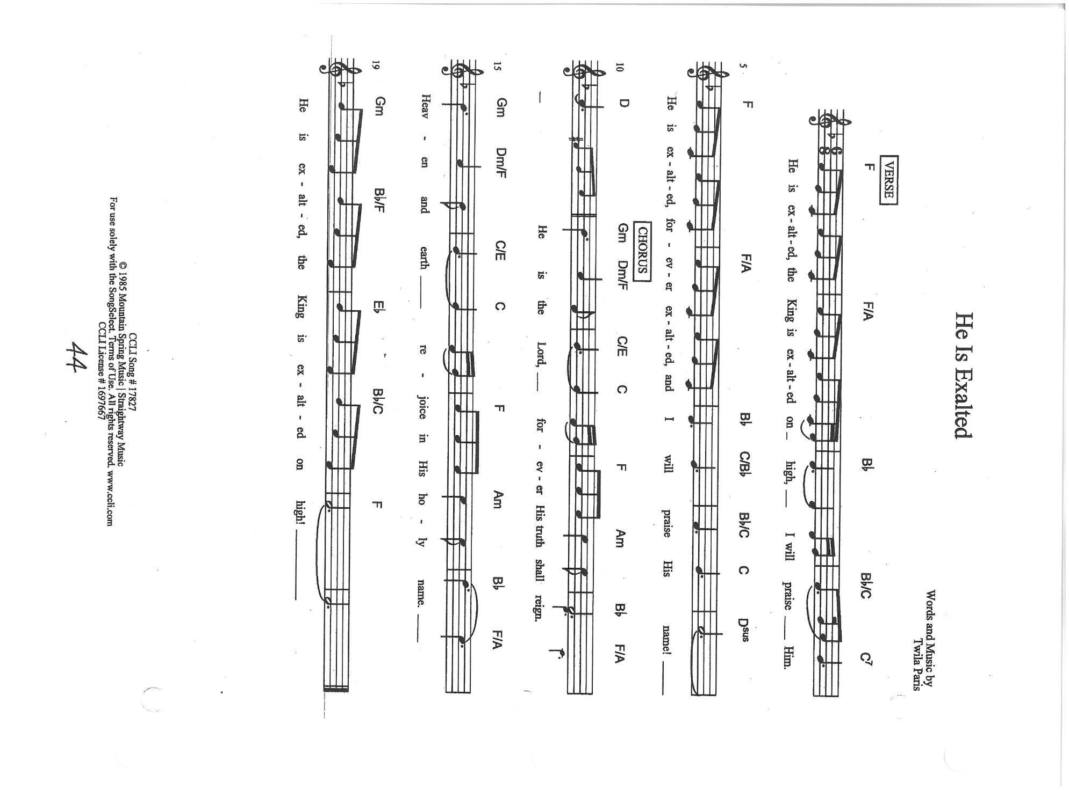

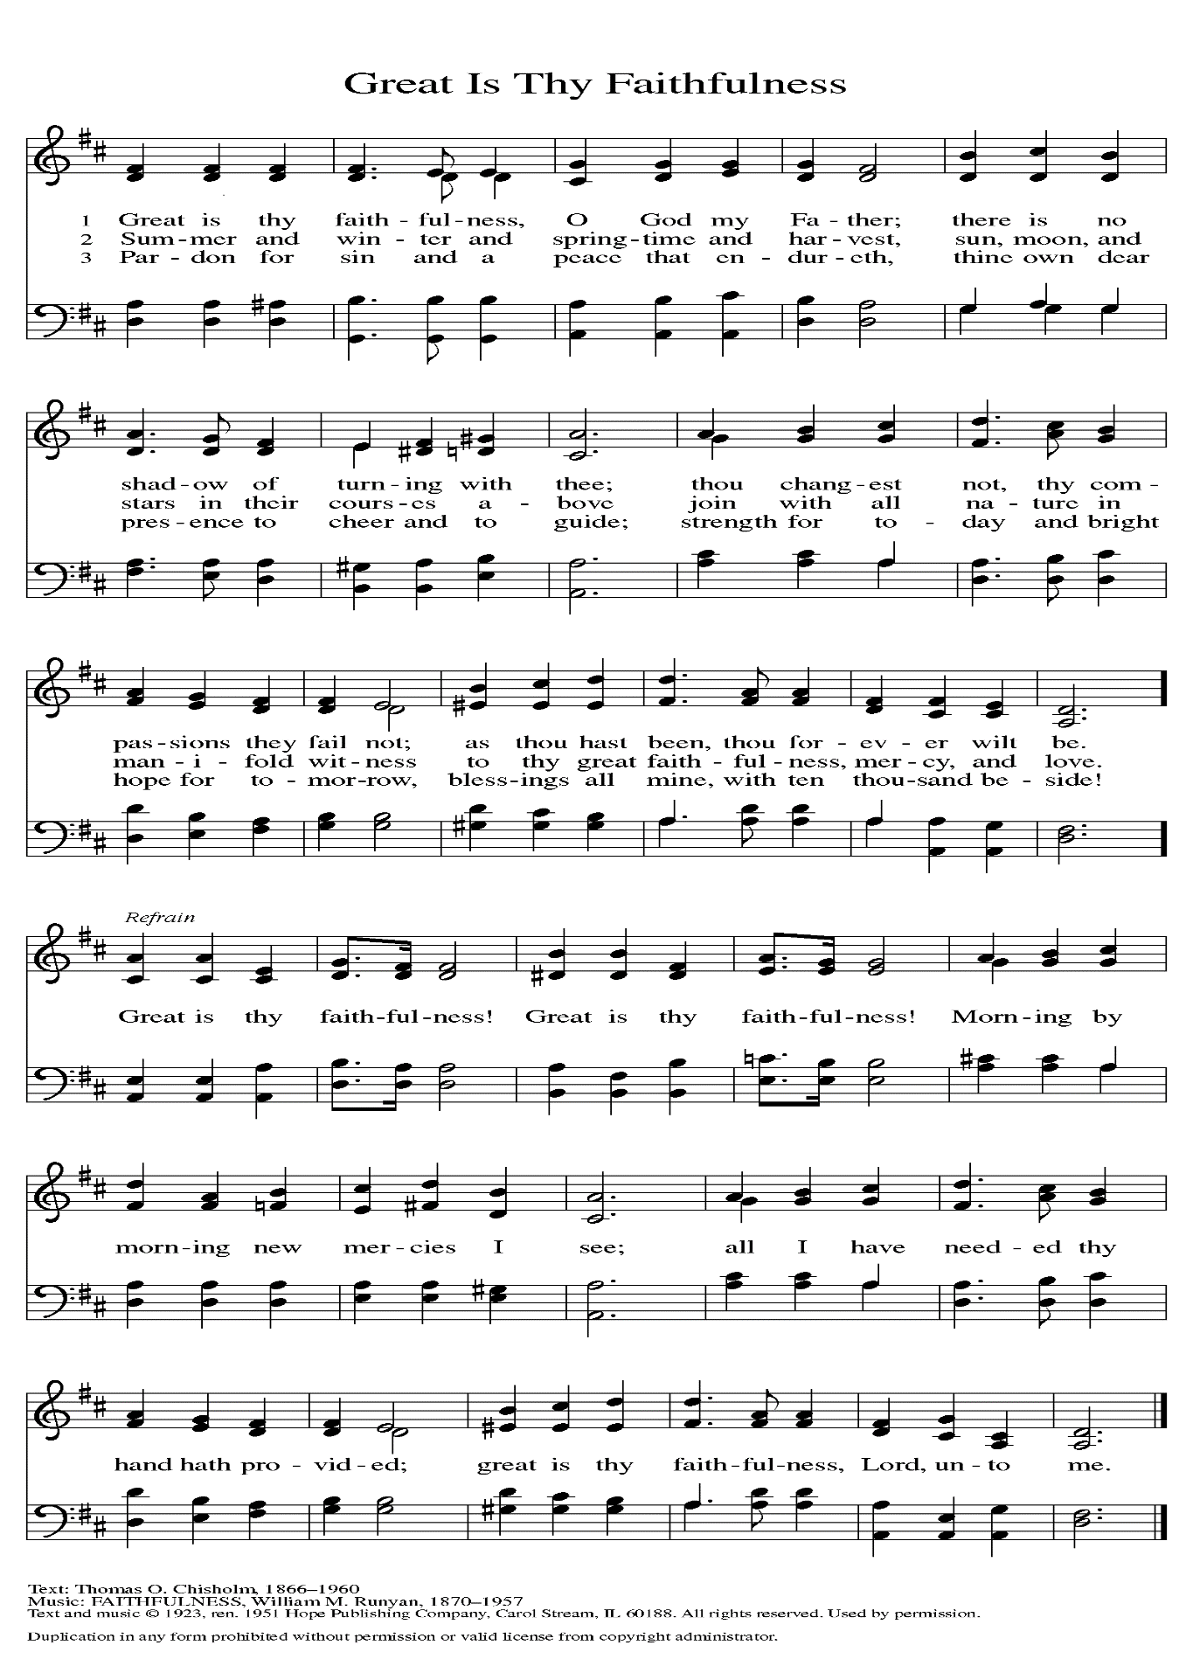

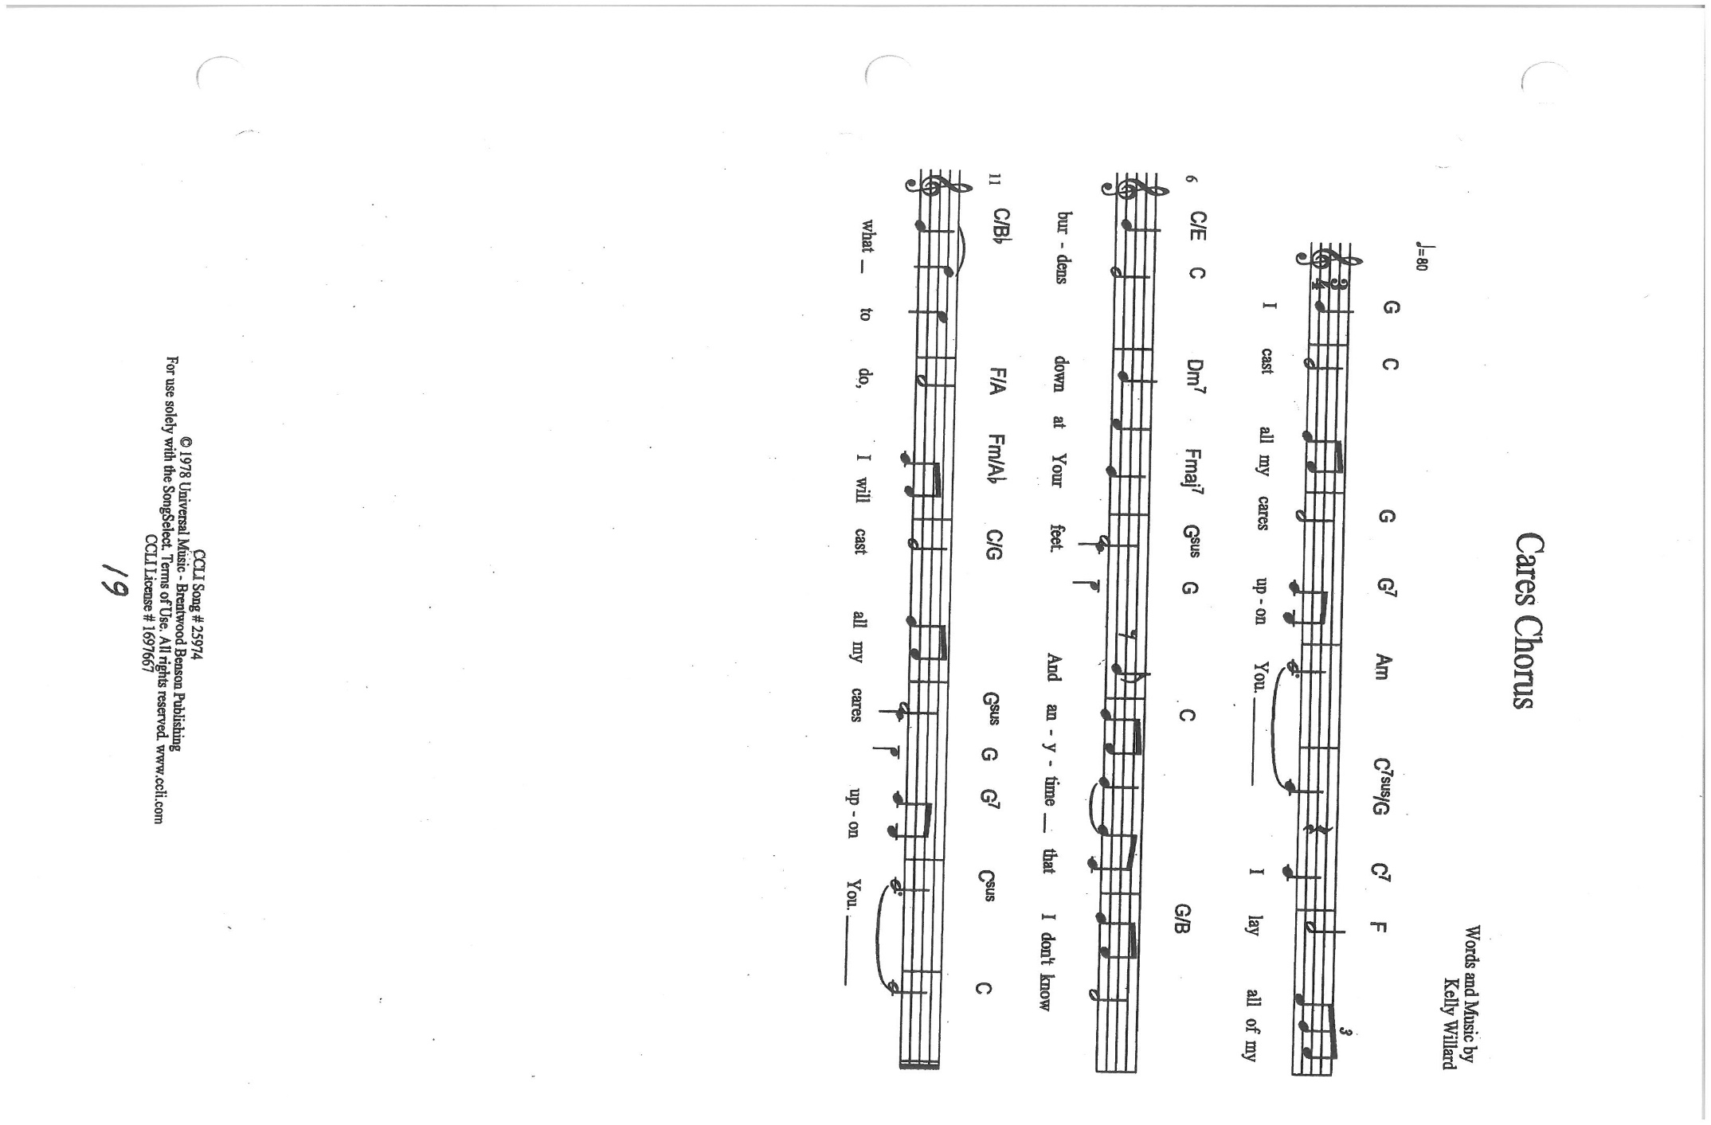
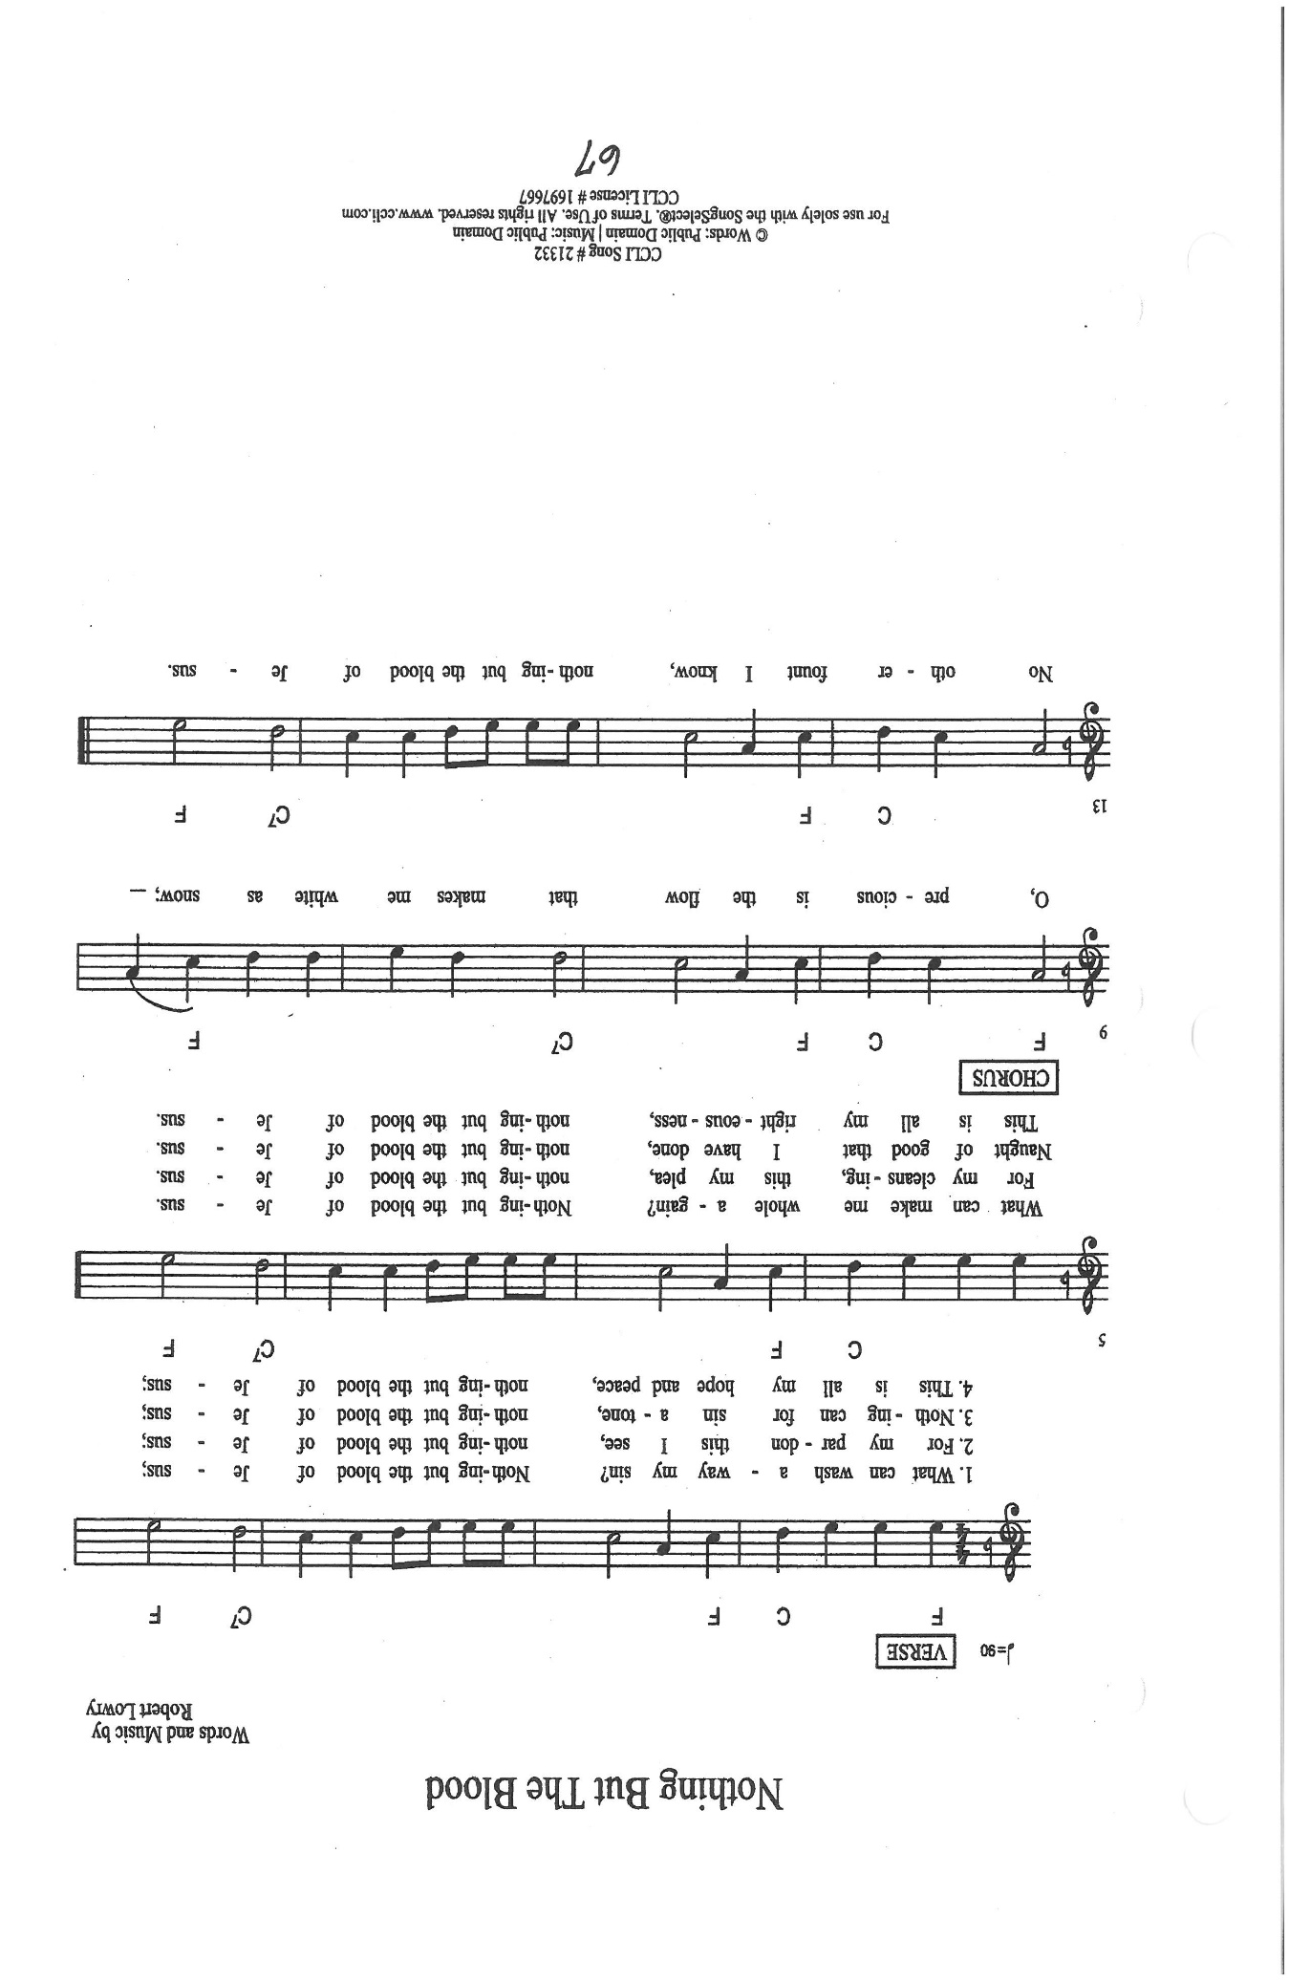

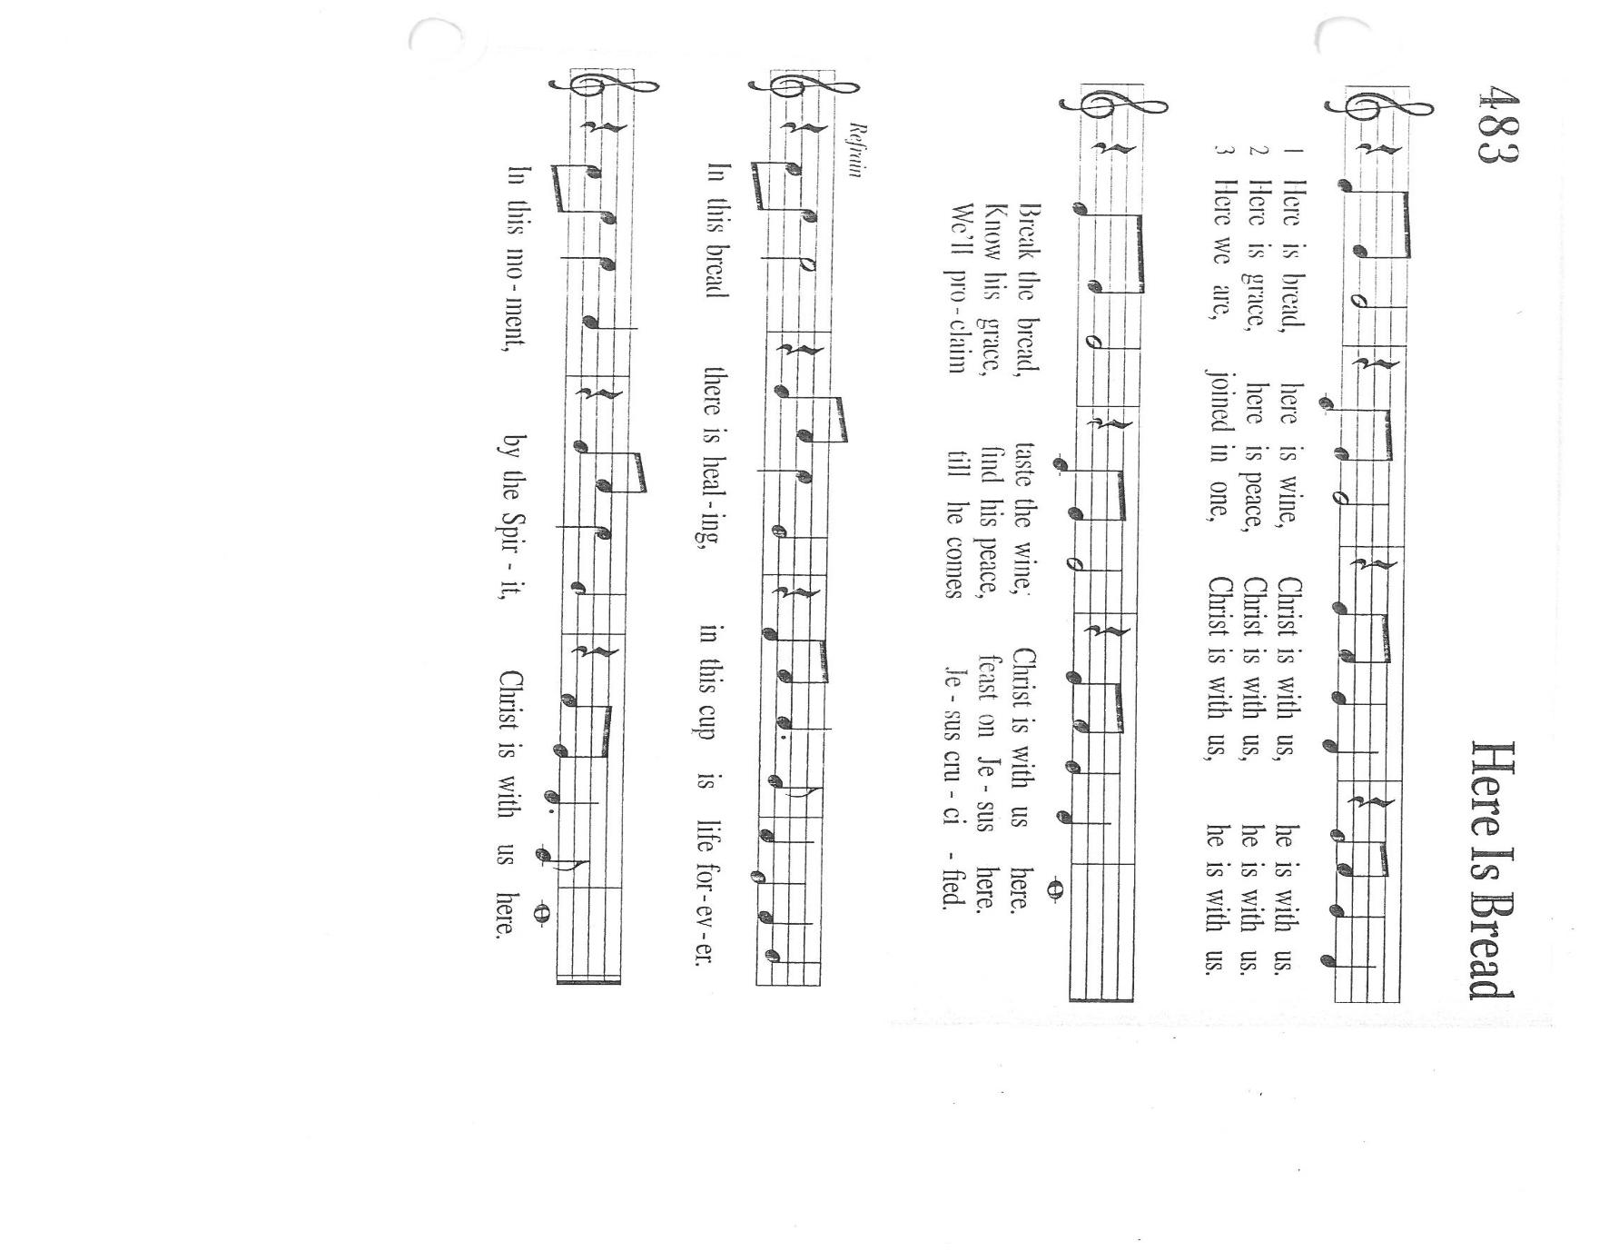

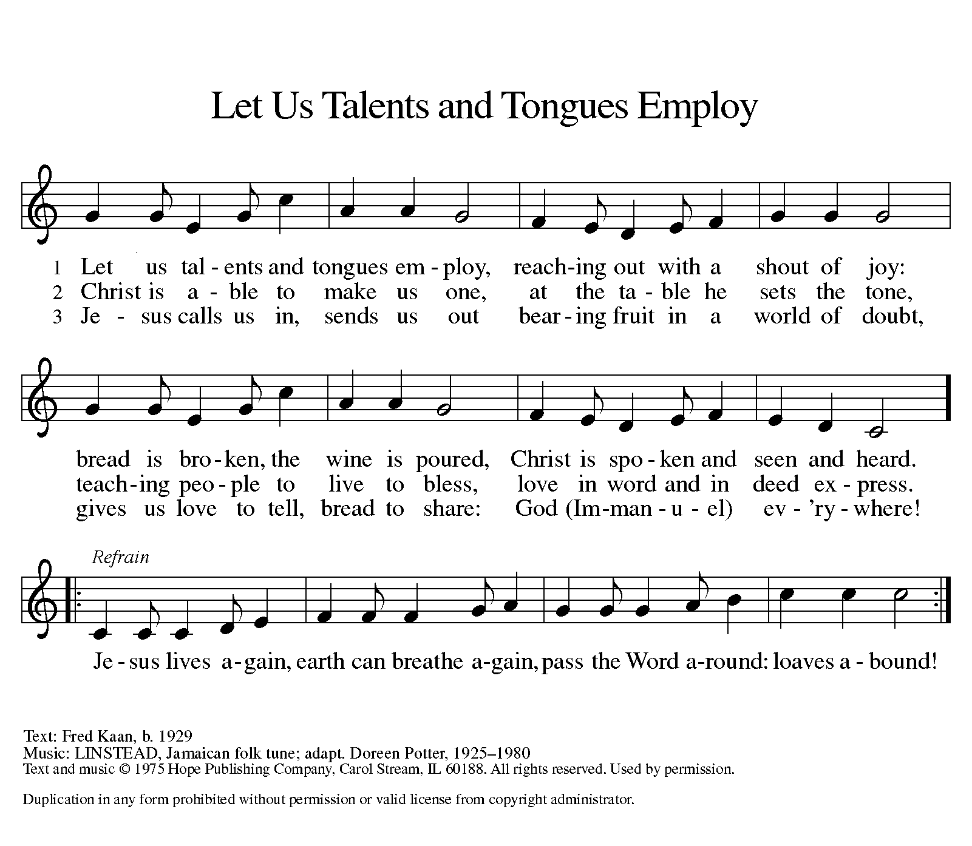

ANNOUNCEMENTS

Please remember to mail your offering to the Church Office at 818 Franklin Street, Michigan City, IN 46360. Another alternative is to give on-line through Tithe.ly. Please see your closure letter for information on how to set up a Tithe.ly account.

St. Paul Members are reminded to have a loved one contact the office if you are hospitalized. Many times, the Pastor doesn’t know someone is in the hospital. If you call and leave a message, please tell us which hospital the patient is at.
Next Sunday’s lessons are Ezekial 2: 1-5; Psalm 123; II Corinthians 12: 2-10; Mark 6: 1-13 for those of you who like to study them in advance.

Anniversaries: Ed & Judy Gustum (6/29); Pastor Al & Clara Laurentzen (6/29);
Chip & Audrey Claussen (7/1); Wayne & Milenda (7/1); David & Nancy Squires (7/3)

PRAYER CONCERNS: Kathy Thielman, Audrey Beyer, George Ottersen, Charles Thomas Sr, Joyce and Bethany Manning, Marla Furness, Christine Kiser, Delores
Hackett, Kay Peglow, Lee Timm, Ryan Krueger, Donna Bostater, Diane Gielow, Jeff Jensen, Maxine Powell, Jim Gleason, Jess Kalvaitis, Gail Leffew, Pastor Al Lorentzen, Jan Paholski, Laura Dovey, Heidi Happel, Gene Marty, Grant Houk, Shane Nevels, Don Smales, Elaine Gehring, Irene Bohnstadt, Joan Coughlin and Deb Prybylla.

If you requested someone’s name to be on the prayer list and are aware that they need continued imminent prayer then contact the church office and let us know. Otherwise we will gradually transfer names to the long-term list.
OFFICE HOURS: Libby will be in the office on Mondays, Wednesdays, and Fridays; volunteers will cover Tuesdays and Thursdays.
Monday & Wednesday 8:00 a.m. – 5 p.m.
Tuesday & Thursday 9:00 a.m. – 12:00 p.m.
Friday 8:00 a.m. – 12:00 p.m.
If you are listening to the worship broadcast on the radio and would like to watch it live stream but you aren’t on Facebook, follow these four steps:

1) Go to your search engine (Google, Bing, etc.).
2) Search for St. Paul Lutheran Church & School, Michigan City, Indiana
3) Click on the option for St. Paul Lutheran Church & School—Home/Facebook
4) Click on “Videos” in the menu on the left side of the screen.

That should take you to the former videos and there should be one with a little red box that says “LIVE.’ Click on that video to enlarge it.

We will continue to live stream/broadcast the Sunday morning service on our Facebook page, and it will always be available on the radio broadcast Sunday mornings at 11:00 a.m. on WEFM (95.9), and on the local cable access station #99 for the previous week’s service on Sundays at 4:00 p.m. and the current service on Wednesdays at 7:00 p.m. and Fridays at 8:30 p.m.

To send e-mail to the church office, please use the following addresses:
Pastor Mark Reshan: seniorpastor@stpaulmichigancity.com
Church Office Secretary (Libby Pollock): churchsecretary@stpaulmichigancity.com
Church Treasurer (Karen Fleming) and Bookkeeper (Billie Atchinson):
finance@stpaulmichigancity.com.

The Good News Newsletter: If you have an article or anything you want included in The Good News please send it to the following e-mail address: splcgoodnews@gmail.com. Pastor Pamela Thiede will be using this e-mail address to assemble The Good News each month. The deadline for getting information to Pastor
Pamela will be the 20th of each month.

WORSHIP ATTENDANCE for June 19 and 20, 2021
4:00 p.m. 22
9:00 a.m. 45
Total = 67

HEARING AID BATTERIES: If you or someone you know are in need of hearing aid batteries size 10A (yellow) or size 13 (orange) we have members who have a supply they want to give away. Please call the church office and let them know.

AN ORDINATION CELEBRATION in honor of Pastor Dale Zylstra will be given by his congregation of Christ Lutheran in Hammond on Sunday, July 11 from 1:00-3:00 pm. at Andorra Banquets, 1112 US 41, Shererville. Price is $25 for adults; $15 for children under 12. A cash bar will be available. Checks should be made to: Christ Lutheran Church and should accompany reservations. Their mailing address is: 7051 Indianapolis Blvd., Hammond, 46324. We are in the process of finalizing a date and time for our congregation to celebrate his ordination.

And Finally: If you have an activity or event or recognition you would like to have
included in our weekly bulletins please contact Libby in the Church office by email or by telephone no later than noon on Mondays. Thank you and God bless!

NEXT GIVE BACK NIGHT
In May we raised $185.00 at Galveston steakhouse! This time we’ll be going to Holly’s on Tuesday, July 6, 2021. Make sure you take your coupon with you! There will be extra coupons in the office until the 6th.

