THE FOURTH SUNDAY IN LENT
The 150th Anniversary Commemoration
Of the Incorporation of St. Paul Lutheran Church
March 15, 2026

+ In the Name of Jesus +

Most high God, Whom the heavens cannot contain, we give You thanks for the gifts of those who have built this house of prayer to Your glory. We praise You for the fellowship of those who by their use had made it holy. And we pray that all who seek You here may find You and be filled with joy and peace, through Jesus Christ, our Savior and Lord, Who lives and reigns with You and the Holy Spirit, one God, now and forever. Amen.

Prayer for the Anniversary of a Congregation

+ GATHERING +

PRE-SERVICE MUSIC

Michiana Brass Quintet Be Thou My Vision arr. Terry Everson

New Song Praise Band How Great is Our God Tomlin, Reeves & Cash

ANNOUNCEMENTS

As you are able please rise

THE PROCESSIONAL HYMN 652 Built on a Rock
Stanza 3 – Choir

The congregation faces the cross as it enters

THE GREETING

P: The grace of our Lord Jesus Christ, the love of God, and the communion of the Holy Spirit
be with you all.

C: And also with you.

DIALOG OF PRAISE

A: Praise the Lord! Praise the name of the Lord!

C: Praise the Lord! Give thanks to Him!

A: God has blessed us and brought us to this time.

C: God has blessed us and brought us to this place.

A: God has caused His name to dwell in our midst.

C: God has stirred our hearts and made us glad.

A: God has shown us his glory in his mighty word.

C: God has shown us the way of truth and life.

A: Praise the Lord! Praise the name of the Lord!

C: Praise the Lord! Give thanks to Him!

A: For 150 years, God has nurtured and fed us.

C: For 150 years, God has shown us His grace.

A: For 150 years, God has given Himself in Word and Sacrament.

C: For 150 years, God has empowered us with His Holy Spirit.

A: For 150 years, God has made us His witnesses in the world.

C: For 150 years, God has placed us in loving fellowship with one another.

A: Praise the Lord for 150 years! Praise Him for 150 more!

C: Praise the Lord for evermore! Oh, praise the name of the Lord!

THE HYMN OF PRAISE

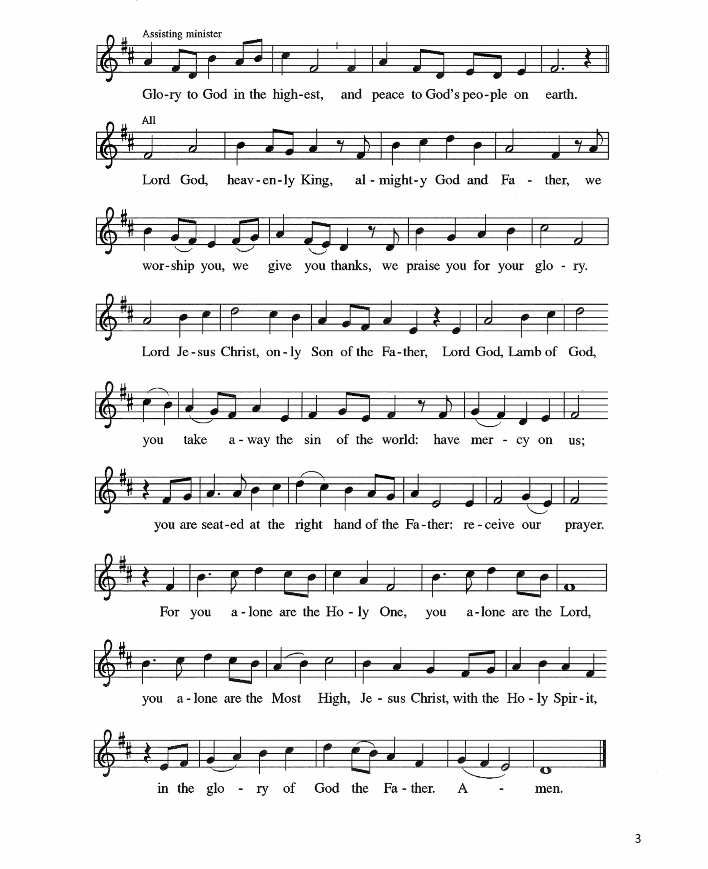

THE PRAYER OF THE DAY

P: The Lord be with you.

C: And also with you.

P: Let us pray. O God, You have promised through Your Son to be with Your Church forever.
We give You thanks for those who founded this community of believers and for the signs of
Your presence in our congregation. Increase in us the spirit of faith and love, and make our
fellowship an example to all believers and to all nations. We pray through Jesus Christ, our
Savior and Lord, Who lives and reigns with You and the Holy Spirit, one God, now and
forever.

C: Amen.

The assembly is seated

+ WORD +

FIRST READING 1 Kings 8: 22-30

King Solomon prays at the dedication of the temple in Jerusalem, built under his direction.
Solomon prays that the temple will be a sign of God’s presence and power, not only to the Israelites, but to all peoples.

²²Then Solomon stood before the altar of the Lord in the presence of the whole assembly of Israel and spread out his hands to heaven. ²³He said, “O Lord, God of Israel, there is no God like You in heaven above or on earth beneath, keeping covenant and steadfast love with Your servants who walk before You with all their heart, ²⁴the covenant that You kept for Your servant my father David as You declared to him; You promised with Your mouth and have this day fulfilled with Your hand.
²⁵Therefore, O Lord, God of Israel, keep for Your servant my father David that which You promised him, saying, ‘There shall never fail you a successor before Me to sit on the throne of Israel, if only your children look to their way, to walk before Me as you have walked before Me.’ ²⁶Therefore, O God of Israel, let Your word be confirmed that You promised to Your servant my father David.
²⁷But will God indeed dwell on the earth? Even heaven and the highest heaven cannot contain You, much less this house that I have built! ²⁸Regard Your servant’s prayer and his plea, O Lord my God, heeding the cry and the prayer that Your servant prays to you today, ²⁹that Your eyes may be open night and day toward this house, the place of which You said, ‘My name shall be there,’ that You may heed the prayer that Your servant prays toward this place.
³⁰Hear the plea of Your servant and of Your people Israel when they pray toward this place; O hear in heaven Your dwelling place; hear and forgive.
The Word of the Lord.

Thanks be to God.

THE PSALM: Psalm 84 Antiphon by Thomas Pavlechko
(After Johannes Brahms’ German Requiem)

Choir sings refrain first, followed by the congregation
and as indicated
``

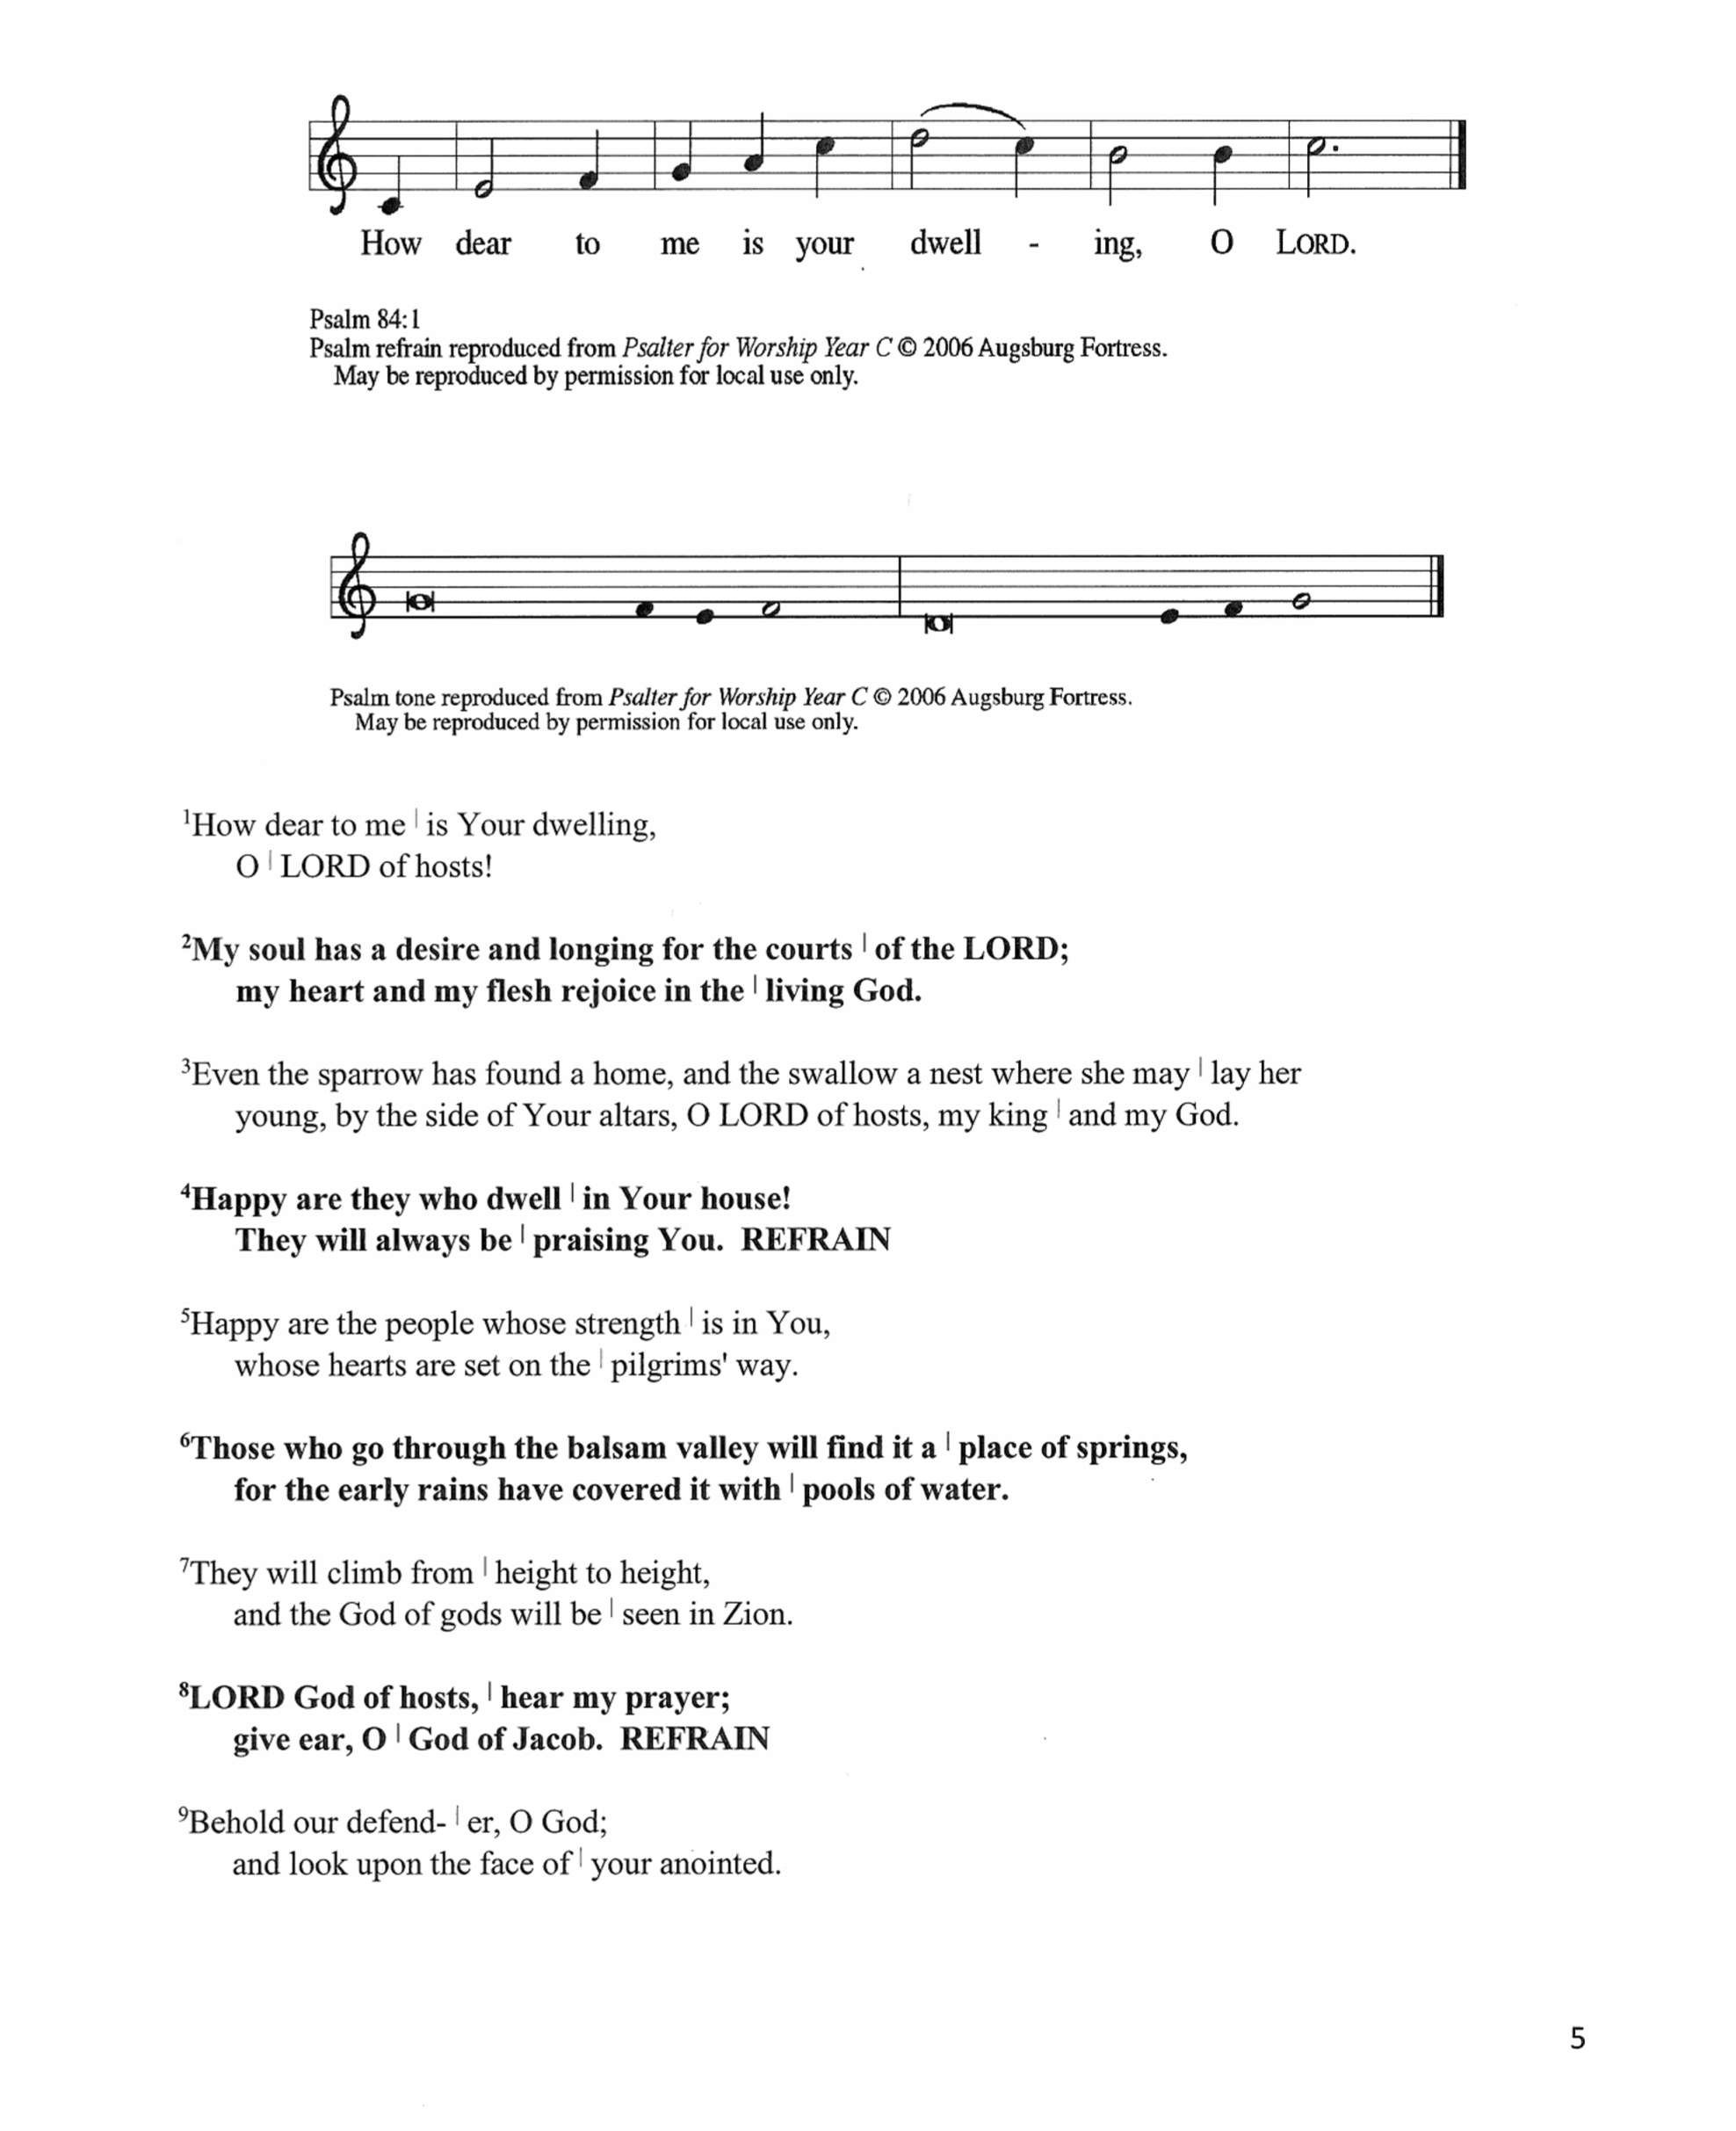

¹How dear to me | is Your dwelling,
O | Lord of hosts!

²My soul has a desire and longing for the courts | of the Lord;
my heart and my flesh rejoice in the | living God.

³Even the sparrow has found a home, and the swallow a nest where she may | lay her
young, by the side of Your altars, O Lord of hosts, my king | and my God.

⁴Happy are they who dwell | in Your house!
They will always be | praising You. REFRAIN

⁵Happy are the people whose strength | is in You,
whose hearts are set on the | pilgrims’ way.

⁶Those who go through the balsam valley will find it a | place of springs,
for the early rains have covered it with | pools of water.

⁷They will climb from | height to height,
and the God of gods will be | seen in Zion.

⁸Lord God of hosts, | hear my prayer;
Give ear, O | God of Jacob. REFRAIN

⁹Behold our defend-| er, O God;
and look upon the face of | your anointed.

¹⁰ For one day in Your courts is better than a | thousand elsewhere.
I would rather stand at the threshold of the house of my God than swell in the tents | of
the wicked.

¹¹For the Lord God is both sun and shield, bestowing | grace and glory;
No good thing will the Lord withhold from those who walk | with integrity.

¹²O | Lord of hosts,
happy are they who put their | trust in You! REFRAIN

SECOND READING 1 Peter 2: 1-9

The first Letter of Peter has spoken of Christians as people reborn through the resurrection of Christ. Now, those who have experienced this new birth in baptism are encouraged to seek the nourishment of scripture that provides spiritual growth.

¹Rid yourselves, therefore, of all malice, and all guile, insincerity, envy, and all slander. ²Like
newborn infants, long for the pure, spiritual milk, so that by it you may grow into salvation –
³if indeed you have tasted that the Lord is good.
⁴Come to Him, a living stone, though rejected by mortals yet chosen and precious in
God’s sight, and like living stones, let yourselves be built into a spiritual house, to be a holy
priesthood, to offer spiritual sacrifices acceptable to God through Jesus Christ.
⁶For it stands in scripture:
“See, I am laying in Zion a stone,
a cornerstone chosen and precious;
and whoever believes in Him will not be put to shame.”
⁷To you then who believe, He is precious; but for those who do not believe,
“The stone that the builders rejected
has become the very head of the corner,” ⁸and
“A stone that makes them stumble,
and a rock that makes them fall.”
They stumble because they disobey the word, as they were destined to do.
⁹But you are a chosen race, a royal priesthood, a holy nation, God’s own people, in order that you may proclaim the mighty acts of Him who called you out of darkness into His marvelous light.

The word of the Lord.

Thanks be to God.

Senior Choir Brother James’ Air arr. G. Jacob

As you are able please rise

THE VERSE

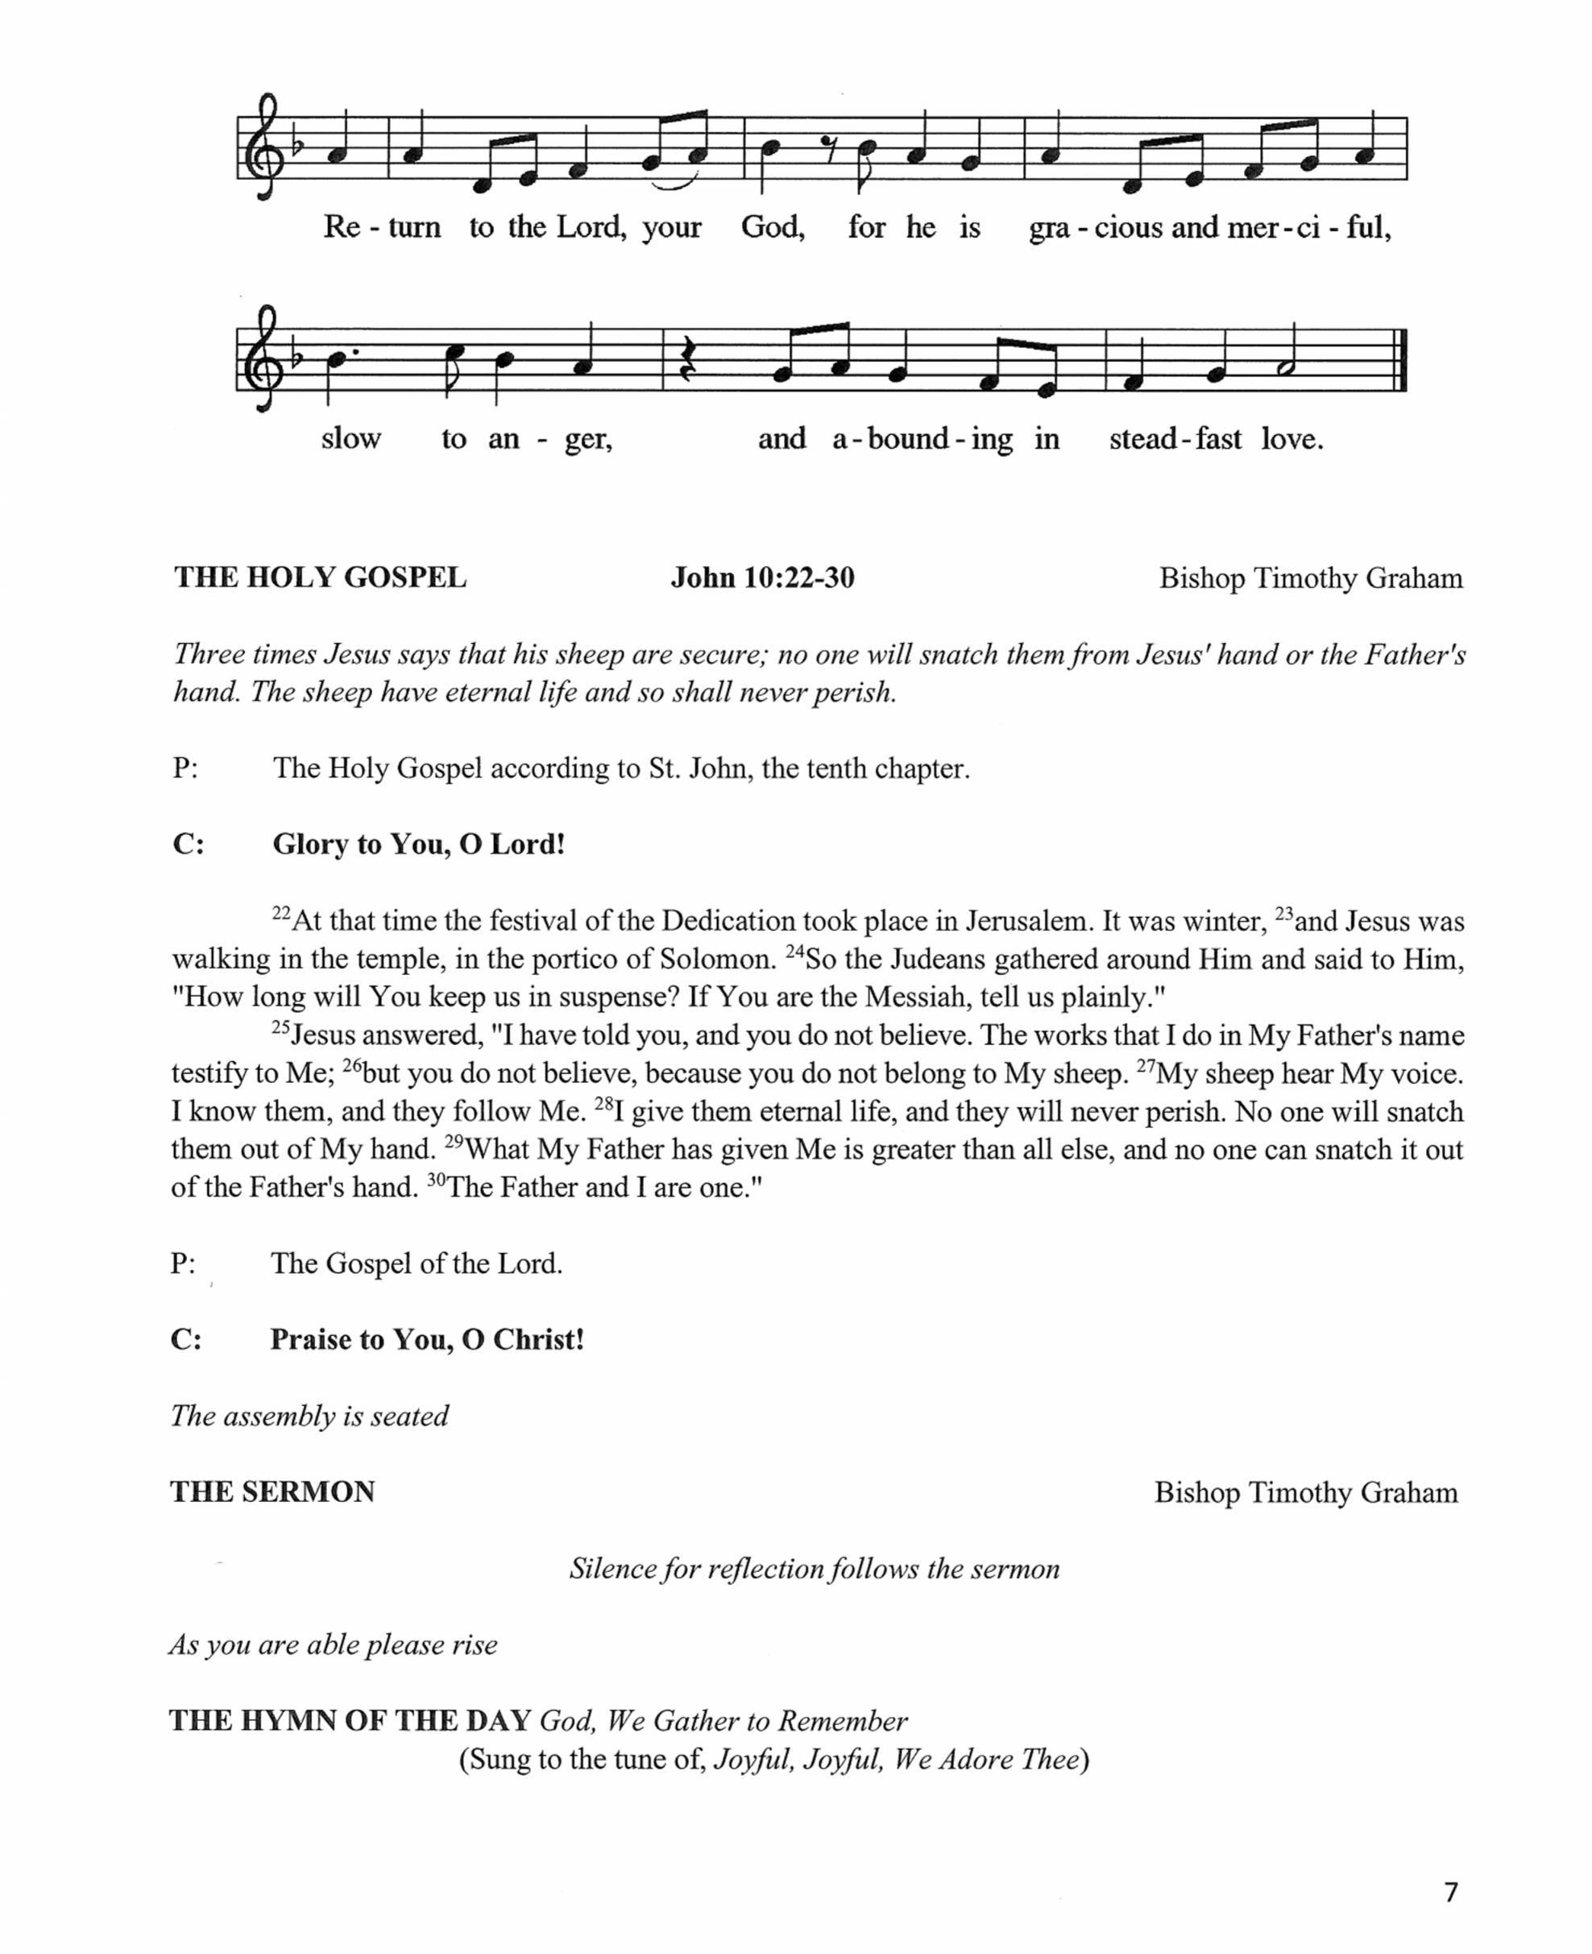

THE HOLY GOSPEL John 10: 22-30 Bishop Timothy Graham

Three times Jesus says that his sheep are secure; no one will snatch them from Jesus’ hand of the Father’s hand. The sheep have eternal life and so shall never perish.

P: The Holy Gospel according to St. John, the tenth chapter.

C: Glory to You, O Lord!

²²At that time the festival of the Dedication took place in Jerusalem. It was winter, ²³and
Jesus was walking in the temple, in the portico of Solomon. ²⁴So the Judeans gathered around Him and said to Him, “How long will You keep us in suspense? If You are the Messiah, tell us plainly.”
²⁵Jesus answered, “I have told you, and you do not believe. The works that I do in My Father’s name testify to Me; ²⁶but you do not believe, because you do not belong to My sheep.
²⁷My sheep hear My voice. I know them, and they follow Me. ²⁸I give them eternal life, and they will never perish. No one will snatch them out of My hand. ²⁹What My Father has given Me is greater than all else, and no one can snatch it out of the Father’s hand. ³⁰The Father and I are one.”

P: The Gospel of the Lord.

C: Praise to You, O Christ!

The assembly is seated

THE SERMON Bishop Timothy Graham

Silence for reflection follows the sermon

As you are able please rise

THE HYMN OF THE DAY God, We Gather to Remember
(Sung to the tune of Joyful, Joyful We Adore Thee)

All: God, we gather to remember all Your blessings in this place.
For the heritage we honor is a heritage of grace.
When or church was given land here, when we laid the cornerstone,
When a Sunday School was planned here, it was by Your grace alone.

Men: By Your grace, You gave a vision to those settlers long ago.
As they served You here in mission soon Your church began to grow.
They promoted education, bought an organ, built new pews.
Year by year this congregation kept on sharing Your good news.

Women: By Your grace we’re still surrounded by those witnesses of old,
For our faith and work are grounded in the good news that they told.
Now they point us toward tomorrow: “We in faith served God’s own Son;
Now it’s your turn to follow, now it is your race to run!”

All: By Your grace, through prayer and singing, worship fills our church’s days.
Band and choir and hand bells ringing – all are forms of joyful praise.
Love of God and love of neighbor send us out in Jesus’ name.
Worship leads us out to labor serving You Whom we proclaim.

A LITANY OF THANKSGIVING

A: For the Church universal, of which this building is a visible symbol:

C: We thank You, Lord.

A: For Your presence whenever two or three have gathered here in Your name,

C: We thank You, Lord.

A: For this place where we may be still and know that You are God,

C: We thank You, Lord.

A: For the fulfilling of our desires and petitions as You see best for us,

C: We thank You, Lord.

A: For our past and a vision of Your future that lies ahead,

C: We thank You, Lord.

A: For the gift of the Holy Spirit and new life in Baptism,

C: We thank you, Lord.

A: For the pardon of our sins when we have fallen short of Your glory,

C: We thank You, Lord.

A: For the holy Eucharist in which we have a foretaste of Your everlasting Kingdom,

C: We thank You, Lord.

A: For the blessing of our vows and the crowning of our years with Your goodness,

C: We thank You, Lord.

A: For the faith of those who have gone before us and for our encouragement by their
perseverance,

C: We thank You, Lord.

A: For Your gifts of healing, patience, comfort, peace, and strength to the sick, especially . . .
The grieving, the lonely, and all who suffer,

C: We thank You, Lord.

A: For the fellowship of all Your saints, and for the hope of sharing with them in Your
everlasting glory,

C: We thank You, Lord.

P: O God, from living and chosen stones You prepare an eternal dwelling place for Your
majesty. Grant that in the power of the Holy Spirit those who serve You here may always
be kept within Your presence, Your power, and Your care; through Jesus Christ, our
Savior and Lord, Who lives and reigns with You and the Holy Spirit, one God, now and
forever.

C: Amen!

+ MEAL +

THE PEACE

P: Through Christ we have been reconciled to God, Who has given us the ministry of
Reconciliation. Let us be reconciled with one another.

The peace of the Lord be with you always.

C: And also with you.

The assembly is seated

THE OFFERING

THE VOLUNTARY Goodness of God Jenn Johnson

As you are able please rise

THE OFFERTORY

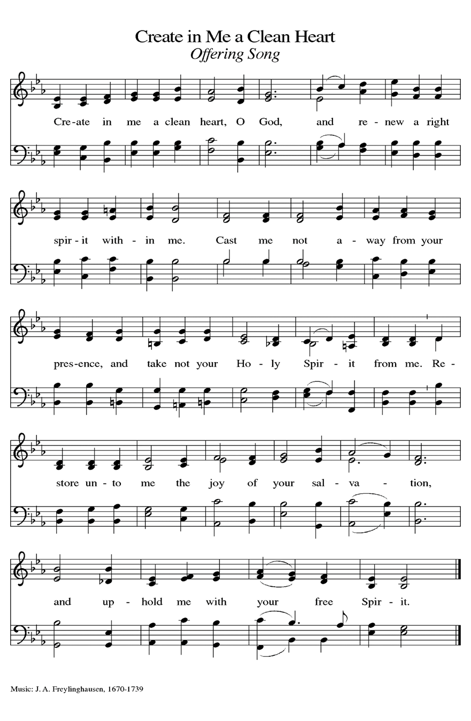

P:

THE OFFERTORY PRAYER
A: Let us pray. Gracious God,
C: Hear the prayers of Your faithful people. Grant that all who celebrate this Meal may
please You by the offering of themselves and the fulfilling of Your will, made known to
us in Your Son, Jesus Christ the Lord. Amen.

THE GREAT THANKSGIVING

P: The Lord be with you.

C: And also with you.

P: Lift up your hearts.

C: We lift them up to the Lord.

P: Let us give thanks to the Lord our God.

C: It is right to give Him thanks and praise.

P: It is indeed right, our duty, and our joy . . . and join their unending hymn:

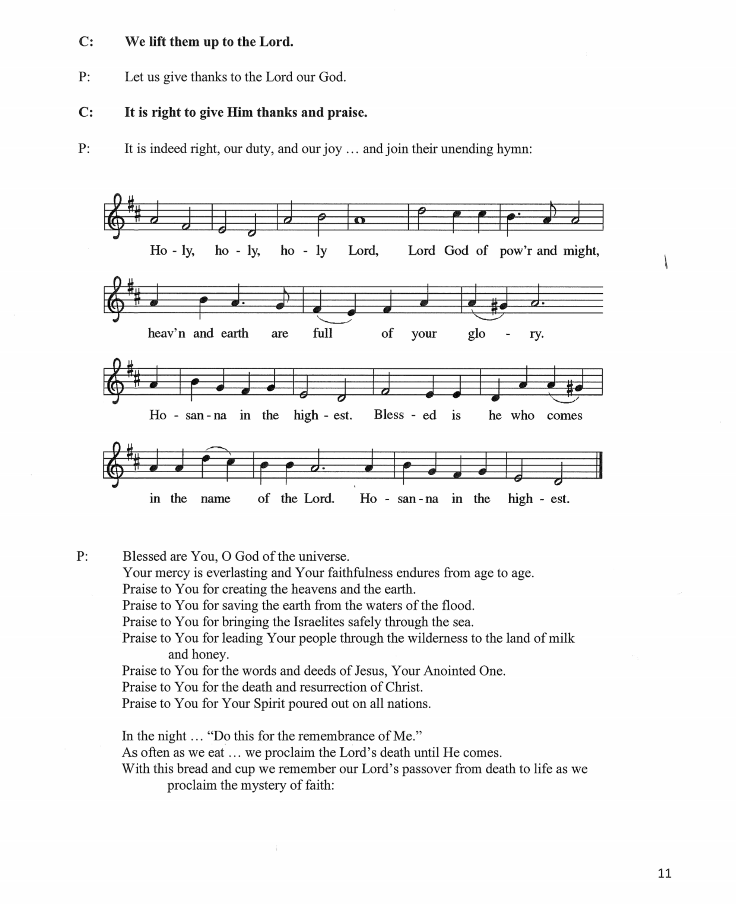

P: Blessed are You, O God of the universe.
Your mercy is everlasting and Your faithfulness endures from age to age.
Praise to You for creating the heavens and the earth.
Praise to You for saving the earth from the waters of the flood.
Praise to You for bringing the Israelites safely through the sea.
Praise to You for leading Your people through the wilderness to the land of milk and
honey.
Praise to You for the words and deeds of Jesus, Your Anointed One.
Praise to You for the death and resurrection of Christ.
Praise to You for Your Spirit poured out on all nations.

In the night . . . “Do this for the remembrance of Me.”
As often as we eat . . . we proclaim the Lord’s death until He comes.
With this bread and cup we remember our Lord’s passover from death to life as we
proclaim the mystery of faith:

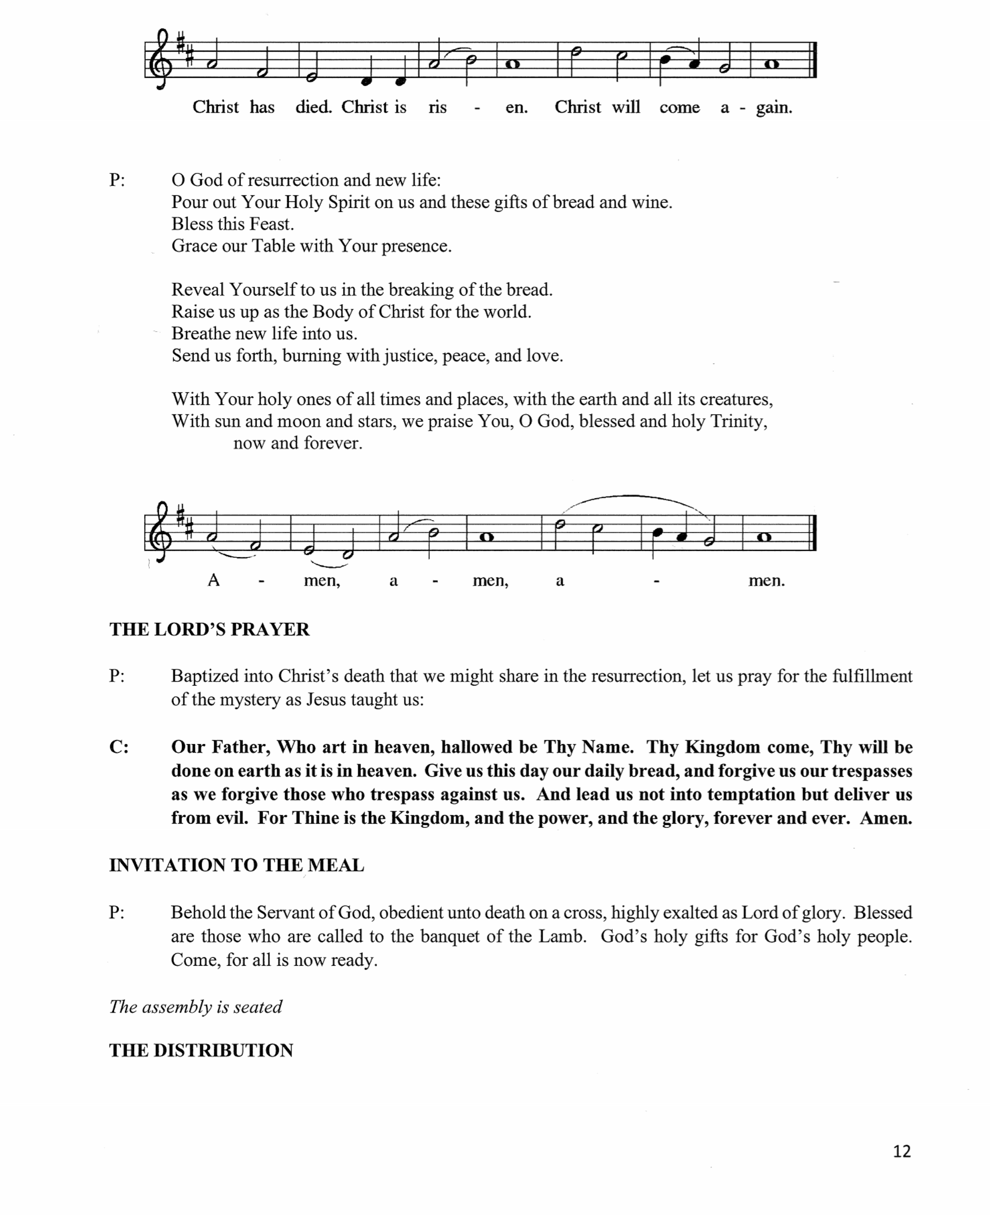
P: O God of resurrection and new life:
Pour out Your Holy Spirit on us and these gifts of bread and wine.
Bless this feast.
Grace our Table with Your presence.

Reveal Yourself to us in the breaking of the bread.
Raise us up as the Body of Christ for the world.
Breathe new life into us.
Send us forth, burning with justice, peace and love.

With Your holy ones of all times and places, with the earth and all its creatures,
With sun and moon and stars, we praise You, O God, blessed and holy Trinity,
now and forever.

THE LORD’S PRAYER

P: Baptized into Christ’s death that we might share in the resurrection, let us pray for the
fulfillment of the mystery as Jesus taught us:

C: Our Father, Who art in heaven, hallowed be Thy Name. Thy Kingdom come, Thy will
be done on earth as it is in heaven. Give us this day our daily bread, and forgive us our
trespasses as we forgive those who trespass against us. And lead us not into temptation
but deliver us from evil. For Thine is the Kingdom, and the power, and the glory,
forever and ever. Amen.

INVITATION TO THE MEAL

P: Behold the Servants of God, obedient unto death on a cross, highly exalted as Lord of glory.
Blessed are those who are called to the banquet of the Lamb. God’s holy gifts for God’s holy
people. Come, for all is now ready.

The assembly is seated.

THE DISTRIBUTION

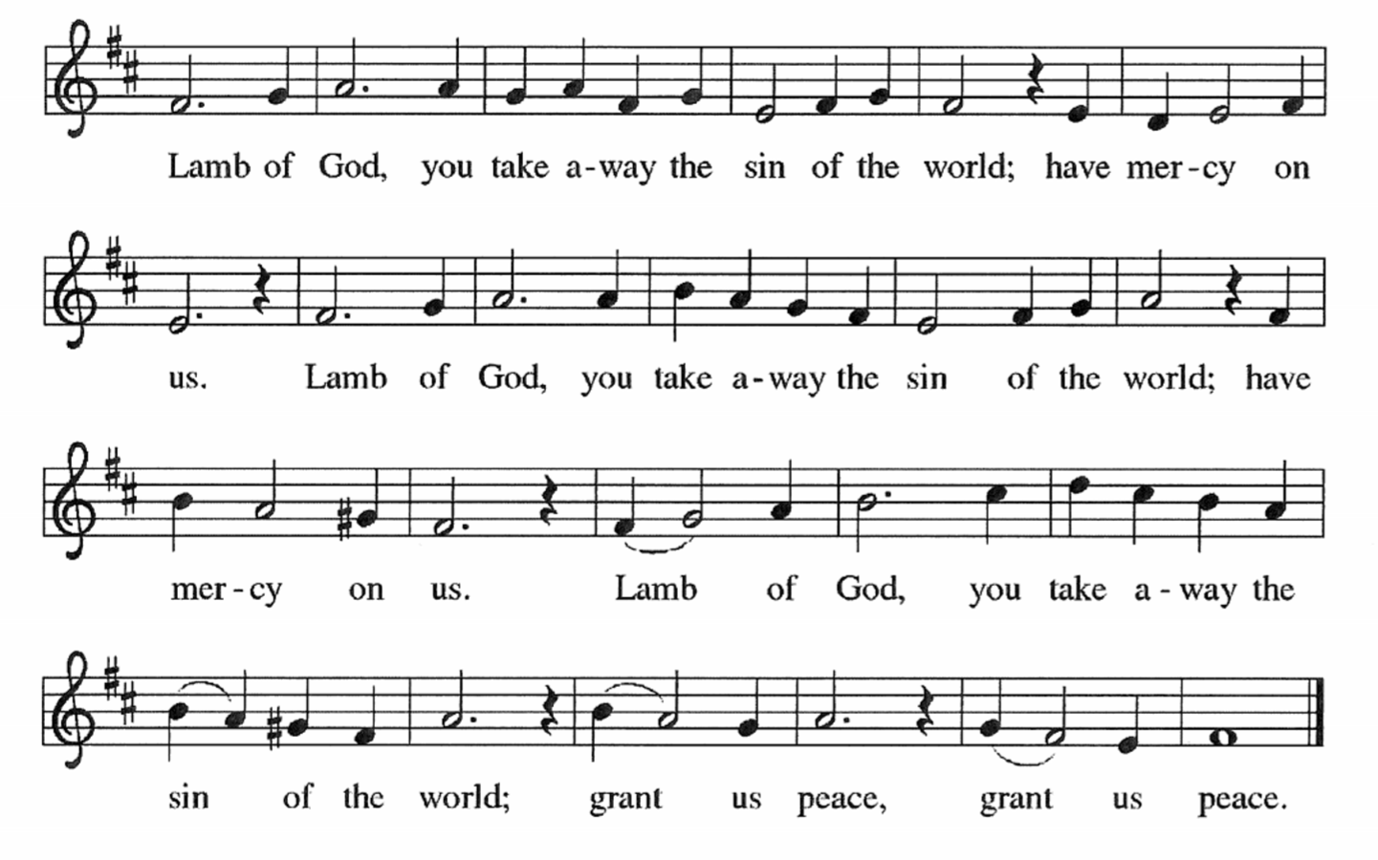

Spirit Song – NSB 81
The Church Song – NSB 32
What a Friend We Have in Jesus – ELW 742

As you are able please rise

THE POST COMMUNION BLESSING

P: The Body and Blood of our Lord Jesus Christ strengthen you and keep you in His grace.

C: Amen.

A: Let us pray. Heavenly Father, You have given us this time of joy and nourished us with
heavenly Food. Grant that we may show in our lives the love of Christ, Who is Lord of all
and in Whose name we pray.

C: Amen.

+ SENDING +

THE BENEDICTION

A: Jesus took the form of a servant and was obedient to death, even death on a cross. May you
follow His example and share in the resurrection.

C: Amen

P: Almighty God: Father, Son, + and Holy Spirit bless you now and forever.

C: Amen.

RECESSIONAL HYMN 632 O God, Our Help in Ages Past arr. Carl Schalk
(stanza 2-Women; Stanza 4 – Men)
The congregation faces the cross as it leaves

THE DISMISSAL

A: Reconciled to God trough Christ, let us go out into the world in peace.

C: Thanks be to God!

POSTLUDE

+ To God Alone Be Glory +

WORSHIP PARTICIPANTS
The 150th Anniversary Service
March 15, 2026

Preacher/Presider Bishop Timothy Graham
Indiana-Kentucky Synod, ELCA

Lectors Bishop Emeritus Jim Stuck (former pastor)
Pastor David Schreiber (former pastor)
Pastor Phil Geleske (son of the congregation)
Pastor Dale Zylstra (adopted son of the congregation)

Crucifer/Assisting Minister Donna Knoll, Church Council President

Deacons/Ushers Bob Kiser, Tim Crozier, Rich Fleming

Handbell Choir Maggie Martin, Director
Kelly Neulieb
Trish Sprague
Judy Hunt
Karen Fleming
Judy Mutchler

Organist/Pianist Maggie Martin, Director of Music

The Michiana Brass Charles Steck, Trumpet
Jay Crouch, Trumpet
William Browne, Horn
Gary Cooper, Trombone
Gary Kurtis, Tuba

Altar Guild Judy Hunt
Virginia Murray
Bernadette Krueger
Karen Peters

St. Paul Choir Stacie Crozier
Mary Knaup
Virginia Murray
Joan Seifert
Susan Bagby
Sue Koziel
Doug Kienitz
David Jocelyn
Pastor Dale Zylstra
Lori Zylstra

New Song Praise Band Jary Tannehill
Mark Tannehill
Charles Marks
Jacob Tannehill
Peggy Wolf
Stacie Crozier
Sue Koziel

Banner Jary Tannehill

Banner Bearer Peggy Wolf

Anniversary Logo & Cover Art Pastor Mark Kloess

