THE FIFTH SUNDAY OF EASTER
May 3, 2026

The work of God is the calling of a people, whether in the Old Covenant or the New. The church is then not simply the bearer of the message of reconciliation, in the way a newspaper or a telephone company can bear any message with which it is entrusted. Nor is the church simply the result of a message, as an alumni association is the product of a school or the crowd in a theater is the product of the reputation of a film.
That men and women are called together to a new social wholeness is itself the work of God, which gives meaning to history.

John Howard Yoder

We do not want, as the newspapers say, a Church that will move with the world. We want a church that will move the world.

G. K. Chesterton

“Each of us, you see, has also had moments where we wanted some reassurance, some glimmer of hope, that all that we had heard and learned about God is not just some false story but true. "Just show us the Father," we plead, "and we will be satisfied."
To which Jesus responds, not in frustration but in love, both to Philip and to us, "Have I been with you all this time and yet still you don't know me? Whoever has seen me has seen the father!"
Which takes us back to the very beginning of John's gospel actually, when John, after singing his hymn about the Word that was from the beginning, the Word that is with God and is God, the Word that became flesh and dwelt among us that we might have life.... After all this, John closes his hymn to the Word by saying, "No one has seen God. But the only begotten Son, who rests in the very bosom of the Father, he has made him known."
And there it is -- the two truths of the life of faith. First, no one has seen God. And that's hard, sometimes crushingly hard, to believe, to trust, to keep faith in and with a God no one can see. And yet the second truth: Jesus, the Son, the Word made flesh, if you've seen him you have seen God and so know what God looks like and, more importantly, what God is up to and who God is for.
Keep in mind that in the story John tells we are on the eve of the crucifixion. Jesus is about to be betrayed, abandoned, handed over, tried, insulted, beaten, and then crucified, nailed to a cross and hung there to die. Why? To appease the righteous anger of a just God? To set for us some kind of example of what real faith looks like? To take the just punishment we deserve? No. Jesus goes to the cross for one reason and one reason only: to show us God, to show us God's grace and mercy, to show just how much God loves us and how far God will go to communicate that love to us that we might believe and, believing, have life in his name.”

David Lose

In the Name of Jesus

INTRODUCTION

As we continue to celebrate the fifty days of Easter, today's gospel includes Jesus' promise that he goes to prepare a place for his followers in his Father's house. Our baptism commissions us to share Jesus' mission in the world. As First Peter reminds us, we are a holy people, called to proclaim the one who called us out of darkness into light. In words and deeds we bear witness to the risen Christ—our way, our truth, our life.

Athanasius, Bishop of Alexandria, died 373

Best remembered for defending the teaching that Christ was fully God against those who taught otherwise, Athanasius was an influential church leader around the time of the Council of Nicea. He was banished from Alexandria five times for his forthright views.

GATHERING

PRE-SERVICE MUSIC To You, O Lord New Song Praise Band
(Graham Kendricks)

THE EASTER ACCLAMATION

P: Christ is risen! Alleluia!

C: He is risen indeed! Alleluia!

ANNOUNCEMENTS

As you are able please rise

CONFESSION AND ABSOLUTION

P: In the name of the Father and of the Son and of the Holy Spirit.

C: Amen.

P: “But you are a chosen race, a royal priesthood, a holy nation, God’s own people, in
order that you may proclaim the mighty acts of God Who called you out of darkness
into His marvelous light.” (1 Peter 2: 9) Our calling as the Church, gifted upon us in
Baptism, is sure. Our faithfulness to that calling is not. Let us repent of our sin, that,
returning to the strong promises of our Baptism, we may be strengthened in our identity
and renewed in our mission.

Silence for self-examination and reflection is kept

P: Most merciful God,

C: We confess that we have sinned against You in thought, word, and deed. We have
failed to show ourselves as Your residence in the world. (1 Peter 2: 5) We have not
always been faithful in offering spiritual sacrifices of prayer, praise, and service
(v. 5). We have too often lived as people of the world. Forgive our sins for Jesus’
sake. As You sent Your Spirit in Baptism to make us Your own, send now Your
Spirit to rekindle in us Your light. Lead us again into the truth of Your love for
us, that we may proclaim Your life to all the world.

P: “Once you had not received mercy, but now you have received mercy.” (1 Peter 2: 10)
As God’s people, mercy is God’s last and best Word to you. So hear the Good News:
as a called and ordained minister of the church of Christ, and by His authority, I
therefore declare to You the entire forgiveness of all your sins, in the name of the Father
and of the Son and of the Holy Spirit.

C: Amen.

GATHERING SONG 336 Lamb of God

THE GREETING AND PRAYER OF THE DAY

P: Alleluia! Christ is risen!

C: Christ is risen indeed! Alleluia!

P: The grace of our Lord Jesus Christ, the love of God, and the communion of the Holy
Spirit be with you all.

C: And also with you.

P: Let us pray. Almighty God, Your Son Jesus Christ is the way, the truth, and the life.
Give us grace to love one another, to follow in the way of His commandments, and to
share His risen life with all the world, for He lives and reigns with You and the Holy
Spirit, one God, now and forever.

C: Amen.

The assembly is seated

WORD

FIRST READING Acts 7: 55-60

Stephen was one of the seven men chosen by the apostles to serve tables so that the apostles could be free to serve the word (Acts 6:1-6). Stephen does more than distribute food, however. For his preaching of God's word, Stephen becomes the first martyr of the faith.

Filled with the Holy Spirit, [Stephen] gazed into heaven and saw the glory of
God and Jesus standing at the right hand of God.
⁵⁶"Look," he said, "I see the heavens opened and the Son of Man standing at the
right hand of God!"
⁵⁷But they covered their ears, and with a loud shout all rushed together against him.
⁵⁸Then they dragged him out of the city and began to stone him; and the witnesses
laid their coats at the feet of a young man named Saul.
⁵⁹While they were stoning Stephen, he prayed, "Lord Jesus, receive my spirit."
⁶⁰Then he knelt down and cried out in a loud voice, "Lord, do not hold this
sin against them." When he had said this, he died.

The Word of the Lord.
Thanks be to God.

THE PSALM: Psalm 31: 1-5, 15-15 Antiphon by Mark Sedio

Choir sings refrain first, followed immediately by the congregation
and as indicated

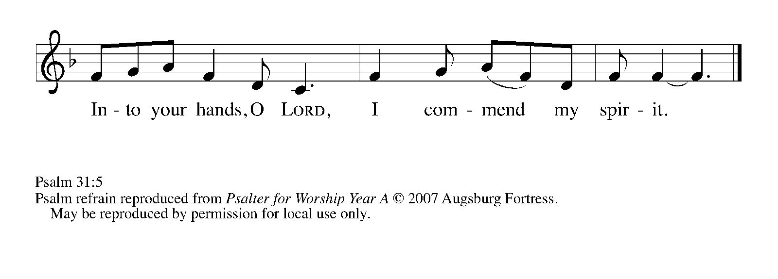
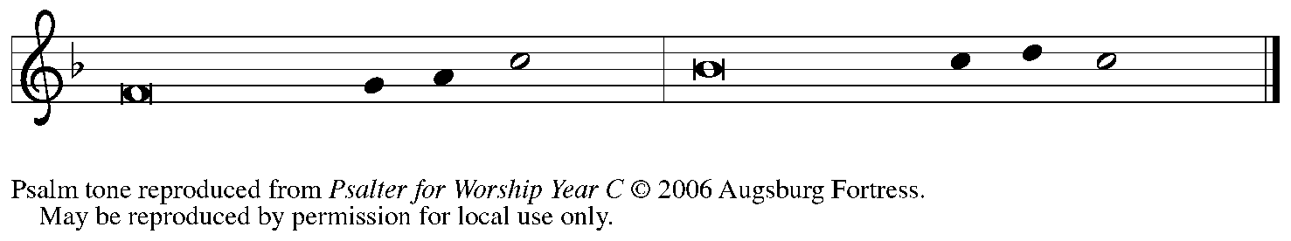

¹In You, O LORD, have I taken refuge; let me never be | put to shame;
deliver me | in Your righteousness.

²Incline Your | ear to me;
make haste to de- | liver me.

³Be my strong rock, a castle to keep me safe,
for You are my crag | and my stronghold;
for the sake of Your name, lead | me and guide me.

⁴Take me out of the net that they have secretly | set for me,
for You are my tow- | er of strength. REFRAIN

⁵Into Your hands I com- | mend my spirit,
for You have redeemed me, O LORD, | God of truth.

¹⁵My times are | in Your hand;
rescue me from the hand of my enemies,
and from those who | persecute me.

¹⁶Let your face shine up- | on Your servant;
save me in Your | steadfast love. REFRAIN

SECOND READING 1 Peter 2: 2-10

The First Letter of Peter has spoken of Christians as people reborn through the resurrection of Christ. Now, those who have experienced this new birth in baptism are encouraged to seek the nourishment of scripture that provides spiritual growth.

Like newborn infants, long for the pure, spiritual milk, so that by it you may grow
into salvation—
³if indeed you have tasted that the Lord is good.
⁴Come to Him, a living stone, though rejected by mortals yet chosen and precious
in God's sight, and
⁵like living stones, let yourselves be built into a spiritual house, to be a holy priesthood,
to offer spiritual sacrifices acceptable to God through Jesus Christ.
⁶For it stands in scripture:
"See, I am laying in Zion a stone,
a cornerstone chosen and precious;
and whoever believes in Him will not be put to shame."
⁷To you then who believe, He is
precious; but for those who do not believe,
"The stone that the builders rejected
has become the very head of the corner,"
⁸and
"A stone that makes them stumble,
and a rock that makes them fall."
They stumble because they disobey the Word, as they were destined to do.
⁹But you are a chosen race, a royal priesthood, a holy nation, God's own people, in
order that you may proclaim the mighty acts of Him Who called you out of
darkness into His marvelous light.
¹⁰Once you were not a people,
but now you are God's people;
once you had not received mercy,
but now you have received mercy.

The Word of the Lord.

Thanks be to God.

As you are able please rise

THE VERSE (see p. 6)

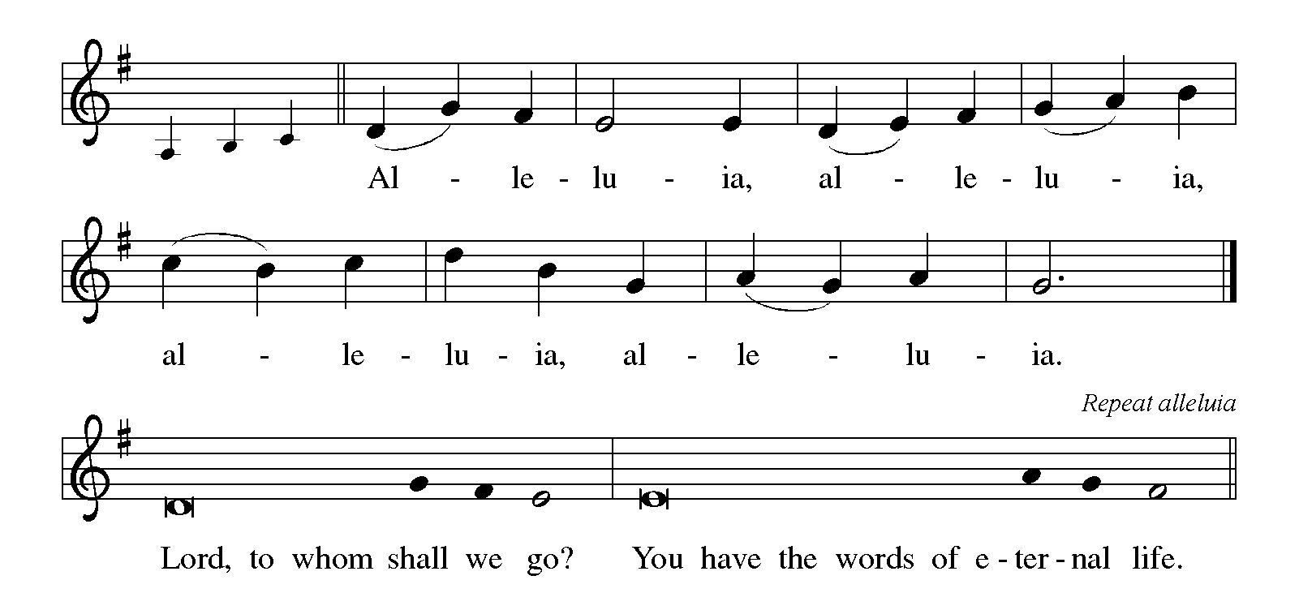

THE HOLY GOSPEL John 14: 1-14

John's gospel records here some of Jesus' final words to his disciples before his departure. As the one through whom God is known, he promises always to go before them and to continue to act on their behalf.

P: The Holy Gospel according to St. John, the fourteenth chapter.

C: Glory to You, O Lord!

[Jesus said to the disciples:] "Do not let your hearts be troubled. Believe in God,
believe also in Me.
²In My Father's house there are many dwelling places. If it were not so, would I
have told you that I go to prepare a place for you?
³And if I go and prepare a place for you, I will come again and will take you to Myself,
so that where I am, there you may be also.
⁴And you know the way to the place where I am going."
⁵Thomas said to Him, "Lord, we do not know where You are going. How can we
know the way?"
⁶Jesus said to him, "I am the way, and the truth, and the life. No one comes to the
Father except through Me.
⁷If you know Me, you will know My Father also. From now on you do know Him and
have seen Him."
⁸Philip said to Him, "Lord, show us the Father, and we will be satisfied."
⁹Jesus said to him, "Have I been with you all this time, Philip, and you still do not know
Me?
Whoever has seen Me has seen the Father. How can you say, 'Show us the Father'?
¹⁰Do you not believe that I am in the Father and the Father is in Me? The words that
I say to you I do not speak on My own; but the Father Who dwells in Me
does His works.
¹¹Believe Me that I am in the Father and the Father is in Me; but if you do not, then
believe Me because of the works themselves.
¹²Very truly, I tell you, the one who believes in Me will also do the works that I do
and, in fact, will do greater works than these, because I am going to the Father.
¹³I will do whatever you ask in My name, so that the Father may be glorified in the Son.
¹⁴If in My name you ask me for anything, I will do it."

P: The Gospel of the Lord.

C: Praise to You, O Christ!

The assembly is seated

THE SERMON

Silence for reflection follows the sermon

As you are able please rise

THE HYMN OF THE DAY 758 You Are the Way
(Stanza 2—Women; Stanza 3—Men)

THE NICENE CREED

A: God has made us His people through our Baptism into Christ. Living together in trust
and hope, we confess our faith.

We believe in one God,
the Father, the Almighty,
maker of heaven and earth,
of all that is, seen and unseen.

We believe in one Lord, Jesus Christ,
the only Son of God,
eternally begotten of the Father,
God from God, Light from Light,
true God from true God,
begotten, not made,
of one Being with the Father.
Through Him all things were made.
For us and for our salvation
He came down from heaven;
by the power of the Holy Spirit
He became incarnate from the virgin Mary, and was made man.
For our sake He was crucified under Pontius Pilate;
He suffered death and was buried.
On the third day He rose again
in accordance with the Scriptures;
He ascended into heaven
and is seated at the right hand of the Father.
He will come again in glory to judge the living and the dead,
and His kingdom will have no end.

We believe in the Holy Spirit, the Lord, the giver of life,
Who proceeds from the Father and the Son.
With the Father and the Son He is worshiped and glorified.
He has spoken through the prophets.
We believe in one holy catholic and apostolic Church.
We acknowledge one Baptism for the forgiveness of sins.
We look for the resurrection of the dead,
and the life of the world to come. Amen

THE PRAYER OF THE CHURCH

A: We are a chosen race, a holy nation, and God’s own people. Empowered by the Lord’s
promise to do what we ask in His name, let us pray for the Church, the world, and all
those in need.

A: That the Church, God’s temple built of living stones, may proclaim God’s mighty acts
through loving service to the troubled and lost, we pray:

C: Hear us, risen Lord.

A: That this world that longs for the face of God might see Him in us and our works of
compassion, forgiveness, and reconciliation, we pray:

C: Hear us, risen Lord.

A: That we might in this week trust God for the courage and wisdom to accomplish Jesus’
life-giving ministry of mercy and sacrificial love, we pray:

C: Hear us, risen Lord.

A: That the lonely and abused, the hungry and homeless, the addicted, and the sick,
especially Mark Tannehill; Martha Schroeder; and Major Payne might be filled
with God’s healing and lovingkindness, we pray:

C: Hear us, risen Lord.

A: That with those who have gone before us, especially Athanasius, Bishop of
Alexandria, whom we commemorate this Day, we too may rest forever in God’s
house, we pray:

C: Hear us, risen Lord.

P: Gracious God, we bring these and all our needs to You, filled with confidence in the
power of Jesus’ name. Hear us and answer our prayers in Your great wisdom and love.
We ask this through Christ Who is our risen Lord now and forever.

C: Amen.

MEAL

THE PEACE

P: The risen Christ stood among the disciples and said, “Peace be with you.”
The peace of the risen Lord be with you always.

C: And also with you.

The assembly is seated

THE OFFERING

THE VOLUNTARY Alleluia, Praise the Risen King! St. Paul Senior Choir ( L. Larson )

As you are able please rise

THE OFFERTORY

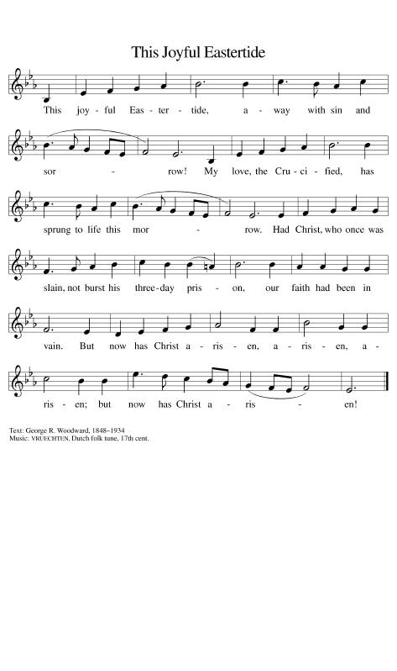

THE OFFERTORY PRAYER

A: Let us pray. Lord our God,

C: In Baptism You have built us into a spiritual house and a holy priesthood. With
joy, therefore, we offer You this sacrifice of our time and talents, praise and
thanksgiving. By this Sacrament make our lives holy and acceptable to You, that
in great faithfulness we may proclaim Your mighty acts by which You call the
world from darkness into Your life-giving Light. We ask this in the name of Jesus
the Lord. Amen.

THE GREAT THANKSGIVING

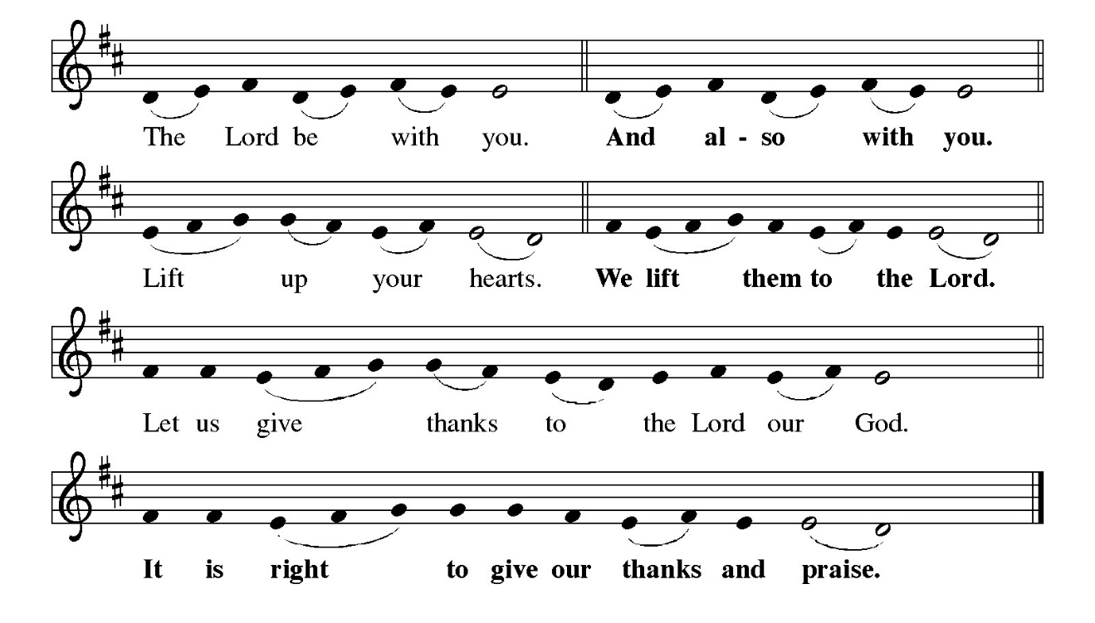
P: It is indeed right, our duty and our joy … and join their unending hymn:

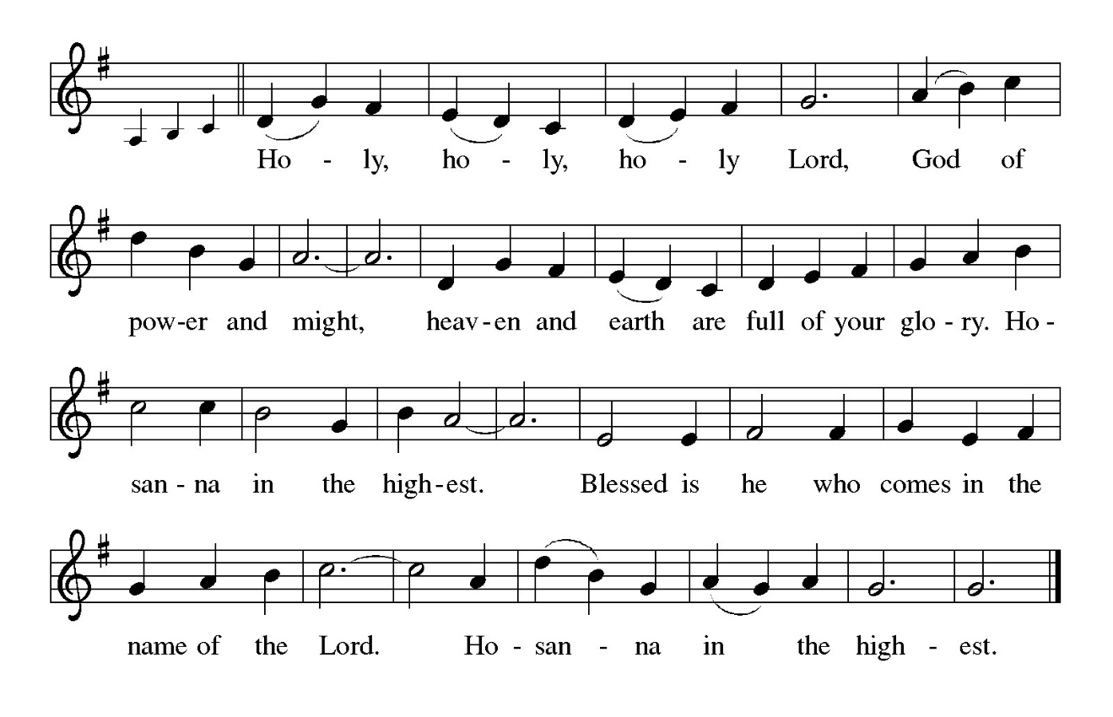
P: We rejoice to give You thanks and praise, God of love, because You called us to exist
in Your image, You filled the earth with wonder and beauty and life, and You
made the children of Abraham Your covenant people.
You made us a chosen race, a royal priesthood, a holy nation, Your own people, and in
the death and resurrection of Jesus You show us the way, the truth, and the
life.
Once we were not a people, but now we are Your people; once we had not received
mercy, but now we have received mercy.
Living God, You prepare a place for us with the Holy Trinity in Your Kingdom
Banquet, and You set a place for us at this Table as we anticipate Your glory.
Come among us now, in the power of Your Holy Spirit, that we may see Your glory in
the breaking of the bread, and these gifts of bread and wine may become for
us the Body and Blood of Your Son, Jesus Christ,
Who, in the night … “Do this for the remembrance of Me.”
As often as we eat … we proclaim the Lord’s death until He comes.

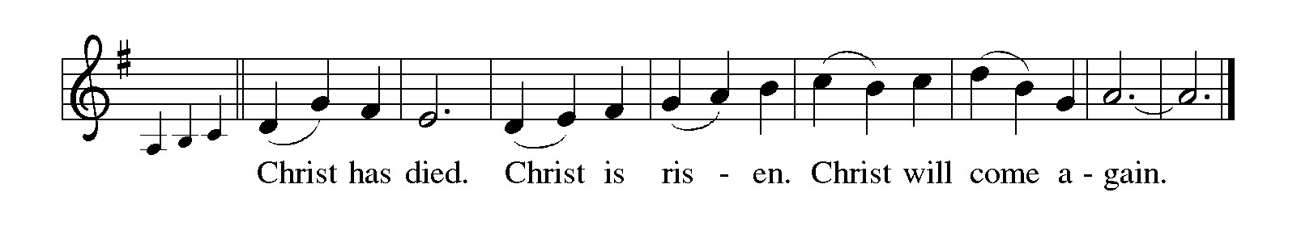

P: Glorious God, You promise that those who believe in You will do greater works than
these.
Bestow upon Your Church the gifts of Your Spirit, that Your people may be with the
hungry, do beautiful things, show grace amid hostility, witness to Your story,
and behold Your glory.
Make us living stones and build us into a spiritual house, that we may be Your holy
priesthood and that all creation, suffering and flourishing, faithful and fallen,
may be suffused with Your glory and may overflow with Your praise,
Father, Son, and Holy Spirit, ever one God.

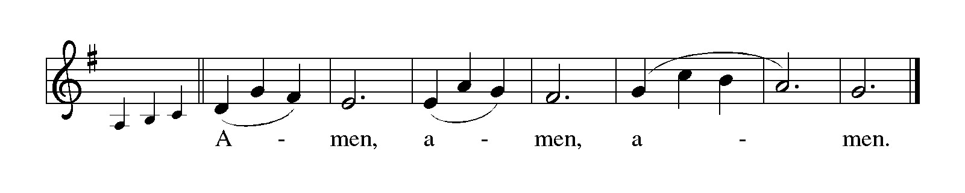

THE LORD’S PRAYER

P: Alleluia! The risen Christ intercedes on our behalf before the throne of God. Let us
therefore join Him in His prayers in the words He taught us:

C: Our Father in heaven, hallowed be Your name.
Your Kingdom come, Your will be done on earth as in heaven.
Give us today our daily bread, and forgive us our sins, as we forgive
those who sin against us.
Save us from the time of trial, and deliver us from evil.
For the Kingdom, the power, and the glory are Yours, now and forever.
Amen.

INVITATION TO THE MEAL

P: Jesus said, I am the true Vine. Abide in Me as I abide in you. Blessed are those who
are called to the Supper of the Lamb. God’s holy gifts for God’s holy people. Come,
for all is now ready.

The assembly is seated

THE DISTRIBUTION Lamb of God (see p. 13)

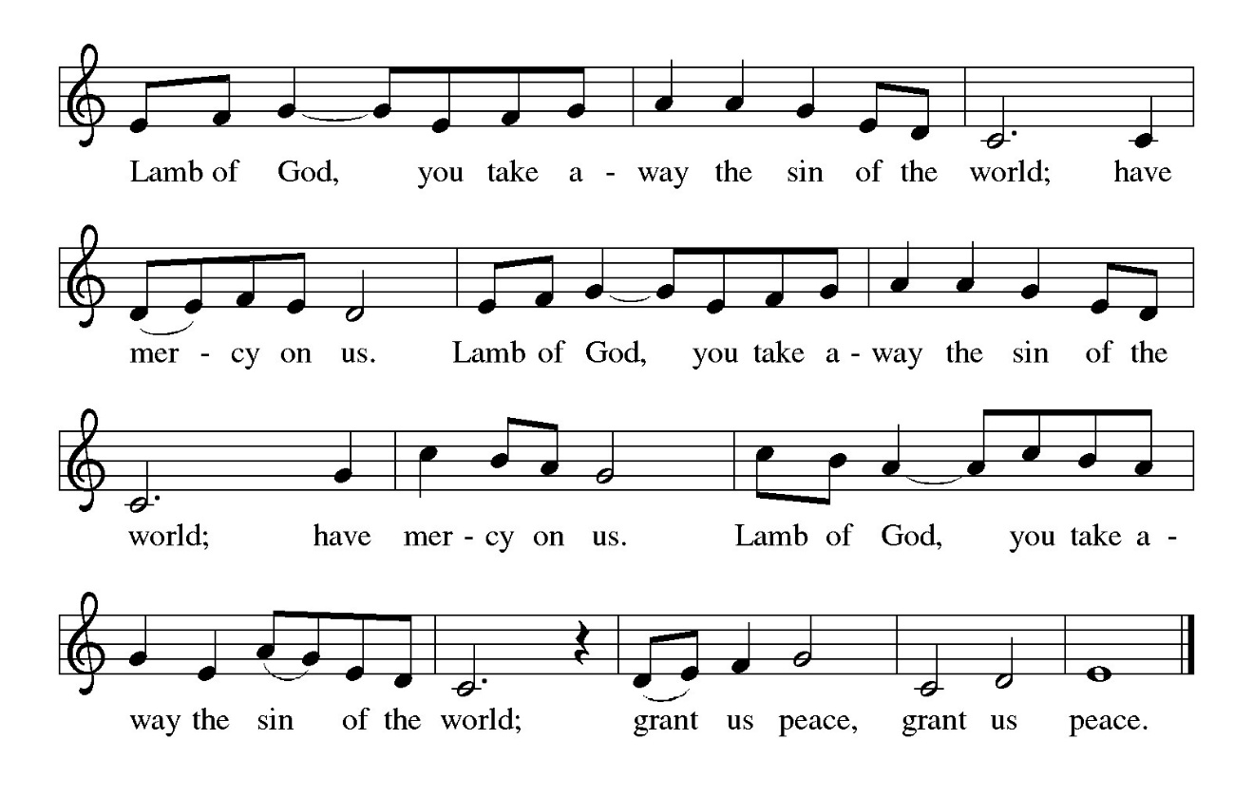

HYMN DURING DISTRIBUTION 810 O Jesus, I Have Promised
485 I Am the Bread of Life
445 Wash, O God, Our Sons and Daughters
439 Soon and Very Soon
547 Waterlife

As you are able please rise

THE POST-COMMUNION BLESSING

P: The Body and Blood of our Lord Jesus Christ strengthen you and keep you in His grace.

C: Amen.

THE POST-COMMUNION PRAYER

A: Let us pray. Lord Jesus, You have fed us with the pure, spiritual Food of Your Body
and Blood. We have tasted again that You are good. May we grow into Your salvation
as we are sent in the power of the Spirit to do Your works of love that glorify the Father
and bring life to the world. You are the Lord forevermore.

C: Amen.

SENDING

THE BENEDICTION

P: Almighty God: Father, Son, and Holy Spirit bless you now and forever.

C: Amen.

SENDING HYMN 619 (Stanzas 1, 2, 7, 8) I Know That My Redeemer Lives!

THE DISMISSAL

A: Go in peace. Proclaim the risen Lord. Alleluia! Alleluia!

C: Thanks be to God! Alleluia! Alleluia!

THE POSTLUDE

To God Alone Be Glory

The Meditations are from Pulpit Resource. William Willimon, ed. Vol. 27 No. 2. (Inver
Heights, MN: Logos Productions, Inc., 1999) 27.

The Greeting, Prayers, Peace, and Dismissal are adapted from Sundays and Seasons.
Copyright 2001 Augsburg Fortress.

The Prayers, Introduction to the Lord’s Prayer, and Invitation to the Meal are adapted from
Prayers for Sundays and Seasons. Year A. Peter J. Scagnelli. (Chicago: Liturgy
Training Publications, 1998) 62-63.

ANNOUNCEMENTS

Please remember to mail your offering to the Church Office at 818 Franklin Street, Michigan City, IN 46360. Another alternative is to give on-line through Tithe.ly. Please see your closure letter for information on how to set up a Tithe.ly account.

St. Paul Members are reminded to have a loved one contact the office if you are hospitalized. Many times, the Pastor doesn’t know someone is in the hospital. If you call and leave a message, please tell us at which hospital the patient is located.

PRAYER CONCERNS: Debbie Martin; Mark Tannehill; Kathy Stein; Jan Paholski; Laura Dovey; Bill Hazelgrove; Al Levenhagen; Carl Wipperman; Major Payne.

OFFICE HOURS: Libby will be in the office on Mondays, Wednesdays, and Fridays; volunteers will cover Tuesdays and Thursdays.

Monday & Wednesday 8:00 a.m. – 5 p.m.
Tuesday & Thursday 9:00 a.m. – 12:00 p.m.
Friday 8:00 a.m. – 12:00 p.m.

If you are listening to the worship broadcast on the radio and would like to watch the Sunday morning service live stream follow these steps:

(1) If you have You Tube available on your TV, search for
St. Paul Lutheran Church Michigan City, IN.

(2) The direct link on the computer is https://
www.youtube.com/channel/UC5AIPNaKr3QN50984jGOa1g

(3) This link is also on the main page of the church’s website in
the church section and will continue to be posted weekly on the St.
Paul Facebook page.

And it will always be available on the radio broadcast Sunday mornings at 11:00 a.m.
on WEFM (95.9), and on the local cable access station #99 for the previous week’s
service on Sundays at 4:00 p.m. and the current service on Wednesdays at 7:00 p.m.
and Fridays at 8:30 p.m.

To send e-mail to the church office, please use the following addresses:

Pastor Mark Reshan: seniorpastor@stpaulmichigancity.com

Church Office Secretary (Libby Pollock): churchsecretary@stpaulmichigancity.com

Church Treasurer (Karen Fleming): finance@stpaulmichigancity.com

2026 Church Council:

Pastor - Mark Reshan

President - Donna Knoll

Vice President - Jan Bakken

Secretary - Judy Hunt

Treasurer - Karen Fleming

Members: Sue Koziel; Jim Schraidt; Trish Sprague; Bob Kiser; Barry Anderson; and
Pam Soule

Worship Attendance:

Saturday, April 25, 2026 @ 4:00 p.m. 24

Sunday, April 26, 2026 @ 9:00 a.m. 63

TOTAL 87

Copies of the minutes from the February 26, 2026 and March 26, 2026 Church Council meetings are on the back table in the upper Narthex. They were approved by the council via email.

The Good News Newsletter: If you have an article or anything you want included in The Good News please send it to the following e-mail address: splcgoodnews@gmail.com. Pastor Pamela Thiede will be using this e-mail address to assemble The Good News each month. The deadline for getting information to Pastor Pamela will be the 20th of each month.

Next week’s lessons are Acts 17: 22-31; Psalm 66: 8-20; 1 Peter 3: 13-22; John 14: 15-21 for those of you who like to study them in advance.

MISSION OF THE MONTH FOR MAY 2026
The Dolly Fund at Lubeznik Center for the Arts is our Mission of the Month for May 2026. The Dolly Fund is an endowment fund that supports scholarships for students age 7- 18 to LCA’s art classes for youth. It was initiated by Paul Marshall, in honor of his late wife and former LCA director, Dolly Marshall. Dolly had a life-long belief that arts education for children was crucial to their development. Some of the classes LCA offers are abstract painting, mixed media for young artists, figure drawing, digital illustration, abstract landscapes, poetry and performance workshops, printmaking, and much more!
Please make checks payable to St. Paul and mark for the Dolly Fund and place in the offering. Noisy coin offering for the month of May will also go to support the Dolly Fund. Thank you for your generosity each month! Lora

2026 Financial Stewardship

Weekly Church Operating Needs (x 2 weeks)
April 18-19 & April 25-26, 2026: $ 11,691.33

General Fund (including General Memorials): $ 7,030.00

\Overage/Shortage: — $ 4,726.00

Restricted Income (not including Memorials)
Supports IK Synod & Church wide Ministries: $ 55.00

Ministries in our Community/Congregation: $ 230.00

Capital Fund: $ 100.00

Memorials
General Fund $ 570.00

ACTIVITIES, EVENTS & MEETINGS
MAY, 2026

Saturday, May 2, 2026 @ 4:00 p.m. 5 Easter Worship Service/Sanctuary

Sunday, May 3, 2026 @ 9:00 a.m. 5 Easter Worship Service/Sanctuary with the Annual SPRING CONGREGATIONAL MEETING immediately after worship AND A True POTLUCK following the meeting. Please bring a dish to share.
Tuesday, May 5, 2026 @ 10:00 a.m. Altar Guild/Green Room
Wednesday, May 6, 2026 @ 9:15 a.m. Bible Study/Luther House
@ 10:00 a.m. God’s Purls/St. Paul Room
@ 4:30 p.m. NO CHOIR REHEARSAL
Thursday, May 7, 2026 @ 4p – 10 p GIVE -- BACK AT GALVESTON STEAK- HOUSE
Saturday, May 9, 2026 @ 4:00 p.m. 6 Easter Worship Service/Sanctuary

Sunday, May 10, 2026 @ 9:00 a.m. 6 Easter Worship Service/Sanctuary with coffee after
Monday, May 11, 2026 @ 1:00 p.m. Hope Circle/Green Room
Wednesday, May 13, 2026 @ 9:15 a.m. Bible Study/Luther House
@ 10:00 a.m. God’s Purls/St. Paul Room
@ 3:30 p.m. Worship & Music Mtg./Luther House
@ 4:30 p.m. Choir Rehearsal/Sanctuary
Saturday, May 16, 2026 @ 4:00 p.m. 7 Easter Worship Service/Sanctuary

Sunday, May 17, 2026 @ 9:00 a.m. 7 Easter Worship Service/Sanctuary with coffee after
Monday, May 18, 2026 @ 2:00 p.m. Finance Committee Mtg./Luther House
@3:00 p.m. Executive Board Mtg./Luther House
Wednesday, May 20, 2026 @ 10:00 a.m. God’s Purls/St. Paul Room
@ 4:30 p.m. Choir Rehearsal/Sanctuary
Thursday, May 21, 2026 @ 3:00 p.m. Church Council/St. Paul Room
Saturday, May 23, 2026 @ 4:00 p.m. Vigil for Pentecost Worship Service/Sanctuary

Sunday, May 24, 2026 @ 9:00 a.m. Day of Pentecost Worship Service/Sanctuary w/ coffee after
Wednesday, May 27, 2026 @ 10:00 a.m. God’s Purls/St. Paul Room
@ 4:30 p.m. Choir Rehearsal/Sanctuary
Saturday, May 30, 2026 @ 4:00 p.m. The Holy Trinity Worship Service/Sanctuary

Sunday, May 31, 2026 @ 9:00 a.m. The Holy Trinity Worship Service/Sanctuary w/ coffee after



The annual Spring Congregational Meeting 2026
The annual Spring Congregational Meeting will be held today, Sunday, May 3, 2026 immediately after Sunday morning worship. It is very important to attend the meeting as we will be approving the budget for the 2026-2027 year. There will also be updates on the 150th anniversary events and some information on Evangelism events on which we need your input. And finally, there will be a true Potluck following the meeting. Please bring a dish to pass and let’s enjoy each other’s fellowship!

Thank$ for $haring
Thank you to all who participate in our Give-Back opportunities each month where we earn $$ to add to our Mission of the Month donations, from our congregation to those in our community who need our help! On Tuesday, March 10th, we earned $263 from our GIVE BACK AT Holly’s Restaurant & Pub
On Thursday, May 7, 2026 we’re meeting at Galveston for our GIVE BACK from 4p.m.—10p.m. Here are two coupons—one for you and one for a friend.

