THE TWENTY-THIRD SUNDAY AFTER PENTECOST
November 16, 2025

Let us turn in continual prayer toward you, our only hope, O Lord. Our heart is filled with sadness: bring joy to our sadness, Lord, and give refreshment to our burning hearts. Day and night sorrow and affliction surround us: cool, O Lord, the flame of our hearts. For apart from you we have no hope to comfort us in our grief. Place your finger, that gives life to all things, on the pain concealed in our heart. Let our soul not be robbed of your strengthening, O Savior, so that we may not be plunged into the waves of despair.

Ephraem
Fourth Century

“Discipleship hasn’t changed much in the last 2000 years. Following Jesus still means testifying to our trust in God in the midst of circumstances that test our confidence and our hope. So we keep going on, with endurance as a hallmark of what it means to be a believer. We will keep witnessing to the marvelous things that the Lord has done and will continue to do (Psalm 98) regardless of the ways in which it looks otherwise. We just have to…”
“ … What you see determines what you have chosen to see. That might give an impression of the obvious, but it’s true. This is not an intentional optimism or a glass half full kind of philosophy. It is the true claim of the true hope we have in God — our God who is still present and powerful when it looks like the church is powerless in the face of all that seems to be working against the Kingdom of God.
Our testimony, our witness gives voice to what Jesus sees, to whom God sees. God needs us to be the eyes of the Gospel when the world and those who have the loudest voices in it seem only to see the temples and towers and how they are adorned with beautiful stones.
It is awfully hard to testify to what others can’t see. Perhaps that is, in part, the truth behind Jesus’ visions which sound hyperbolic at best, terrifying at worst. Yet, we are called to have a vision that can pierce through what seems to be beyond hope, to testify to the hope we have in God. We are called to have a vision that can perceive the activity of God when it looks as if that which is against God has the upper hand. We are called to have a vision that is intent on seeing what God sees and who God sees — no matter what.
And when we question how we will testify or where we will find the words for our witness, Jesus reminds us, “I will give you words and a wisdom that none of your opponents will be able to withstand or contradict.”

Karoline Lewis
In the Name of Jesus

INTRODUCTION

The end is near. There is no doubt about it. The warnings are dire. The tone of today’s texts is ominous. But the baptized know how to live in the "meantimes." The baptized are strengthened for the living of these days in word and sacrament. The baptized rally around the invitation of the apostle: "Brothers and sisters, do not be weary in doing what is right."

Elizabeth of Hungary, renewer of society, died 1231

Born in Hungary, Elizabeth was betrothed to the son of the Landgrave of Thuringia, and at age four was taken to be raised with him at the Wartburg Castle. Ten years later they were married. She was very generous to the poor, and after her husband's death she lived in cruel hardship until her own death at age twenty-four.

GATHERING

PRE-SERVICE MUSIC Wings of An Eagle New Song Praise Band
(Steve Bell)

ANNOUNCEMENTS

As you are able please rise

CONFESSION AND ABSOLUTION

P: In the name of the Father and of + the Son and of the Holy Spirit.

C: Amen.

P: “But for you who revere My name the sun of righteousness shall rise, with healing in
its wing.” (Malachi 4: 2) Let us, who bear God’s name, confess our sins before God
and one another, that God’s righteousness might rise upon us and we might be healed
of our sin.

Silence for reflection and self-examination.

P: Most merciful God,

C: We confess that we are sinners in need of Your forgiveness. We have been idle in
doing Your work (2 Thessalonians 3: 11). We have wearied of doing right (2
Thessalonians 3: 13). We have despaired of hardship and suffering. We have not
endured in hope and faith (Luke 21: 19). We have failed to seize opportunities to
testify to Your name (Luke 21: 13). For the sake of Your Son, Jesus Christ, have
mercy on us. Forgive us, grant us strength and hope, and enable us to stand firm
in faith.

P: “God remembers His mercy and faithfulness to the house of Israel” (Psalm 98:4) For
the sake of Jesus Christ, God remembers mercy for you this Day. For as a called and
ordained minister of the Church of Christ, and by His authority, I therefore declare to
you the entire forgiveness of all your sins, in the name of the Father and of the Son
and of the Holy Spirit.

C: Amen.

GATHERING SONG NSB 22 Change My Heart, Oh God
THE GREETING AND PRAYER OF THE DAY

P: The grace of our Lord Jesus Christ, the love of God, and the communion of the Holy
Spirit be with you all.

C: And also with you.

P: Let us pray. O God, the protector of all who trust in You, without You nothing is strong,
nothing is holy. Embrace us with Your mercy, that with You as our ruler and guide,
we may live through what is temporary without losing what is eternal, through Jesus
Christ, our Savior and Lord.

C: Amen.

The assembly is seated

WORD

FIRST READING Malachi 4: 1-2a

Malachi, whose name means "my messenger," warns that the day of the Lord is coming, bringing doom to the evil, but vindication to those who fear God.

¹See, the day is coming, burning like an oven, when all the arrogant and all evildoers will be stubble; the day that comes shall burn them up, says the Lord of hosts, so that it will leave them neither root nor branch. ²But for you who revere my name the sun of righteousness shall rise, with healing in its wings.

The Word of the Lord.

Thanks be to God.

THE PSALM: Psalm 98 Read responsively

¹Sing a new song to the LORD, Who has done marvelous things,
Whose right hand and holy arm have won the victory.

²O LORD, You have made known Your victory,
You have revealed Your righteousness in the sight of the nations.

³You remember Your steadfast love and faithfulness to the house of Israel;
all the ends of the earth have seen the victory of our God.

⁴Shout with joy to the LORD, all you lands;
lift up your voice, rejoice, and sing.

⁵Sing to the LORD with the harp,
with the harp and the voice of song.

⁶With trumpets and the sound of the horn
shout with joy before the King, the LORD.

⁷Let the sea roar, and all that fills it,
the world and those who dwell therein.

⁸Let the rivers clap their hands,
and let the hills ring out with joy before the LORD, Who comes to judge the earth.

⁹The LORD will judge the world with righteousness
and the peoples with equity.

SECOND READING 2 Thessalonians 3: 6-13

Some members of the community, because of their belief in the nearness of Christ's return, had ceased to work, preferring to live on the generosity of other members of the community. Paul warns them that if they want to eat, they need to work.

⁶Now we command you, beloved, in the name of our Lord Jesus Christ, to keep away from believers who are living in idleness and not according to the tradition that they received from us. ⁷For you yourselves know how you ought to imitate us; we were not idle when we were with you, ⁸and we did not eat anyone's bread without paying for it; but with toil and labor we worked night and day, so that we might not burden any of you. ⁹This was not because we do not have that right, but in order to give you an example to imitate.
¹⁰For even when we were with you, we gave you this command: Anyone unwilling to work should not eat. ¹¹For we hear that some of you are living in idleness, mere busybodies, not doing any work. ¹²Now such persons we command and exhort in the Lord Jesus Christ to do their work quietly and to earn their own living. ¹³Brothers and sisters, do not be weary in doing what is right.

The Word of the Lord.

Thanks be to God.

As you are able please rise

THE VERSE
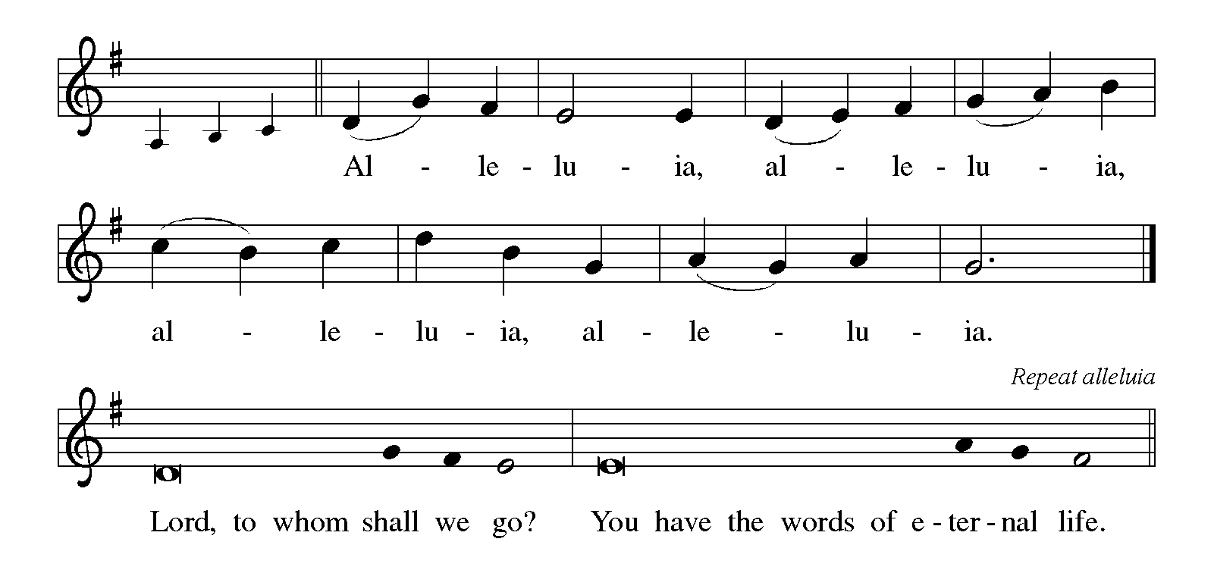
THE HOLY GOSPEL Luke 21: 5-19

Luke's presentation of Jesus' teaching about the last days emphasizes the necessity for responsible behavior in the time between Jesus' ascension and the second coming.

P: The Holy Gospel according to St. Luke, the twenty-first chapter.

C: Glory to You, O Lord!

⁵When some were speaking about the temple, how it was adorned with beautiful stones and gifts dedicated to God, Jesus said, ⁶"As for these things that you see, the days will come when not one stone will be left upon another; all will be thrown down."
⁷They asked him, "Teacher, when will this be, and what will be the sign that this is about to take place?" ⁸And He said, "Beware that you are not led astray; for many will come in My name and say, 'I am he!' and, 'The time is near!' Do not go after them.
⁹"When you hear of wars and insurrections, do not be terrified; for these things must take place first, but the end will not follow immediately." ¹⁰Then He said to them, "Nation will rise against nation, and kingdom against kingdom; ¹¹there will be great earthquakes, and in various places famines and plagues; and there will be dreadful portents and great signs from heaven.
¹²"But before all this occurs, they will arrest you and persecute you; they will hand you over to synagogues and prisons, and you will be brought before kings and governors because of My name. ¹³This will give you an opportunity to testify. ¹⁴So make up your minds not to prepare your defense in advance; ¹⁵for I will give you words and a wisdom that none of your opponents will be able to withstand or contradict.
¹⁶You will be betrayed even by parents and brothers, by relatives and friends; and they will put some of you to death. ¹⁷You will be hated by all because of My name. ¹⁸But not a hair of your head will perish. ¹⁹By your endurance you will gain your souls."

P: The Gospel of the Lord.

C: Praise to You, O Christ!

The assembly is seated

THE SERMON

Silence for reflection follows the sermon

As you are able please rise

THE HYMN OF THE DAY When Our World Is Rent by Violence
(Sung to the tune of, Let All Mortal Flesh Keep Silence)

1 When our world is rent by violence
and our lives are marred by grief,
when our songs of calm assurance
turn to cries of unbelief:
God, we raise our lamentation
seeking refuge and relief.
2 When our cities stand forsaken
and the poor must beg for bread,
when the pris'ner sits forgotten
and the homeless find no bed,
God, we raise our lamentation:
waken justice from the dead!

3 When our lives are burnt to ashes
and our hopes fade like a dream,
when our stories lose their meaning
and despair becomes their theme,
God, we raise our lamentation:
Come, Lord Jesus, to redeem!

4 Raise up beauty from the ashes;
end our violence; tend our peace.
Give us visions of a future
where all captives find release,
where oppression is evicted,
and all works of hatred cease.

Text: David Bjorlin, b. 1984
Text © 2015 Hope Publishing Company, Carol Stream, IL 60188. All rights reserved.

RECEPTION OF NEW MEMBERS

P: These persons have come to us from other Lutheran congregations and desire to
transfer their membership into our community of faith.

As their names are read the new members come forward
A representative of the congregation welcomes them

A: We welcome you as members of St. Paul Lutheran Church to join with us in worshiping
God, hearing His Word and sharing in His Supper, proclaiming the Good News of God
in Christ through word and deed, serving all people, and striving for justice and peace
in all the earth.

A: We thank You, Lord, for these new members of our congregation. By Your life-giving
power, bind us to each other in You, strengthen us for service, support us all our days,
and bring us at last to that Day when all Your children will be one and You will be All-
in-All.

C: Amen.

As you are able please rise

THE PRAYER OF THE CHURCH

A: Knowing that God does not desert us in time of trouble, we offer up our prayers. Let
us beg God not to delay, but to bring help to the Church, the world, and all those in
need.

A: For a fearless passion in the Church to bear witness to God’s coming Kingdom, we
pray:

C: Arise, O Sun of Righteousness.

A: For an end to terrorism, war, and bloodshed, and for the victory of God over all the
forces of evil and oppression, we pray:

C: Arise, O Sun of Righteousness.

A: For reconciliation in families divided by anger, jealousy, or hatred, we pray:

C: Arise, O Sun of Righteousness.

A: For the gift of our new members, Tyler and Jersey, that they may help strengthen us in
this community of faith to never weary of doing what is right, just, and faithful to
Christ, we pray:

C: Arise, O Sun of Righteousness.

A: For the victims of the two typhoons in the Philippines, that they may receive aid and
support as they rebuild their lives, their homes, and their communities, we pray:

C: Arise, O Sun of Righteousness.

A: For those afflicted by hunger, loneliness, grief, or illness, Robert Bernth; Martha
Schroeder; Joyce Stark; Jackie Gaines; Debbie Martin; Carl Wipperman; Major
Payne; David Weiss; Fred Weiss; Shirley Shikany Long; Shirley Freels; John
Bennitt; Chuck Payne; Allen Sydow; and Lucas Bradshaw that God’s wings of
healing might embrace them, we pray:

C: Arise, O Sun of Righteousness.

A: For endurance in faith and hope as we journey with all the faithful, especially Elizabeth
of Hungary, renewer of society, whom we commemorate, toward Your everlasting
Kingdom, we pray:

C: Arise, O Sun of Righteousness.

P: In the cross of Christ, O God, we see Your gracious rule over all creation. Hear the
prayers we offer in hope, and bring us with all the saints to everlasting glory, for the
sake of Your Son, Jesus Christ our Lord.

C: Amen.

MEAL

THE PEACE
P: The peace of the Lord be with you always.

C: And also with you.

The assembly is seated

THE OFFERING

THE VOLUNTARY All Things New New Song Praise Band
(Andrew Peterson, Ben Shive & Andy Gullahorn)

As you are able please rise

THE OFFERTORY
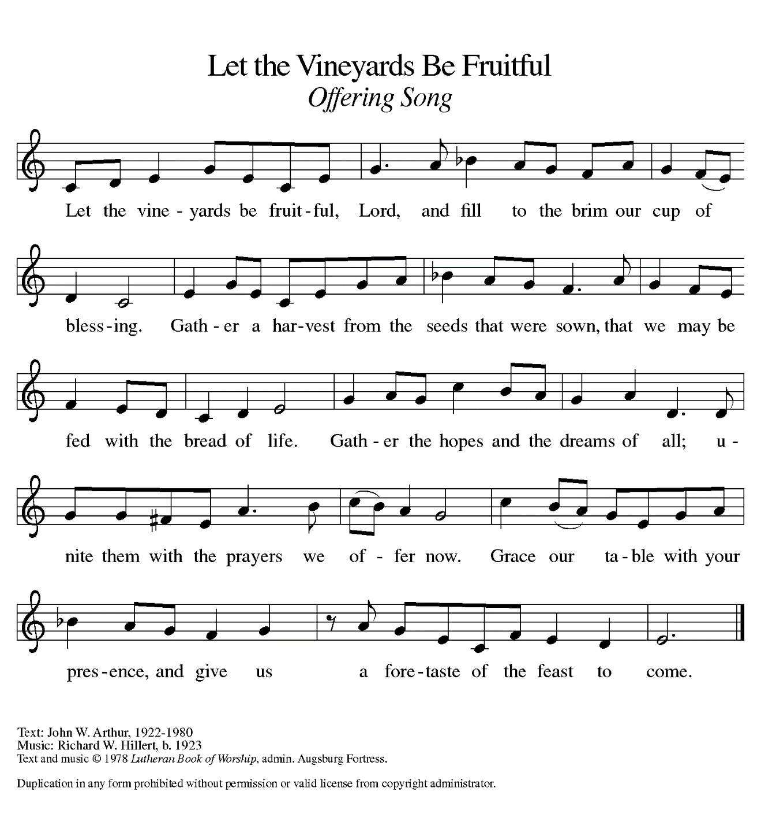

THE OFFERTORY PRAYER

A: Let us pray. Holy God,

C: In mercy and faithfulness You offer us the Bread of Life. In deep thanksgiving
we offer You these gifts of our love and devotion. Through this holy Sacrament
burn away all doubt, fear, and sin, that we may carry out Your work with faith,
joy, and hope. We ask this in the name of Jesus the Lord. Amen.

THE GREAT THANKSGIVING

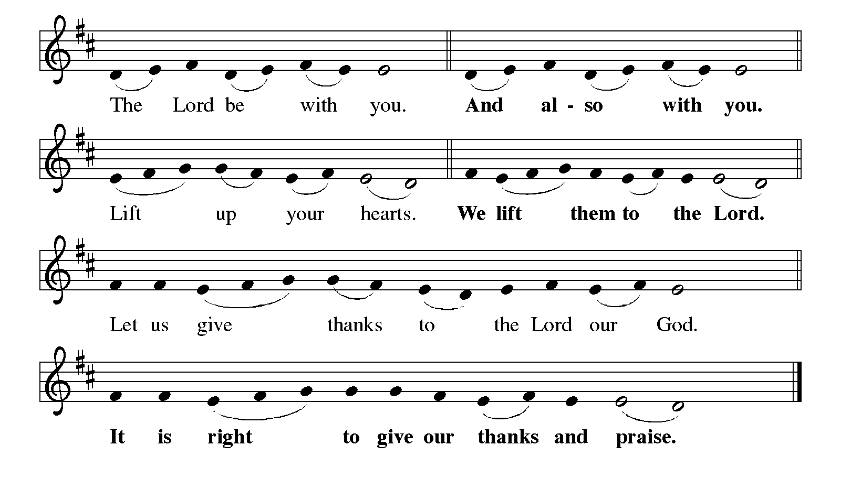 P: It is indeed right, our duty and our joy … join their unending hymn:

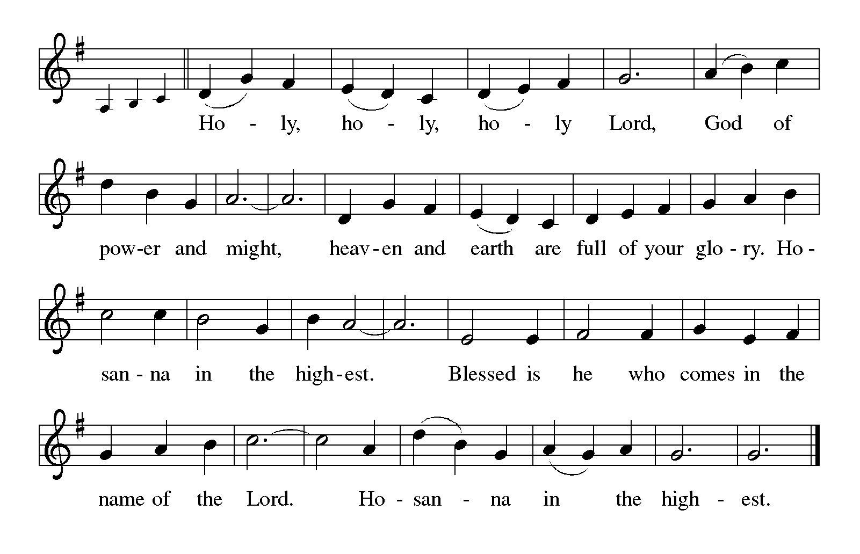
P: We lift our hearts to You in praise and thanksgiving, faithful God, because in Your
generosity You created all things in overflowing plenty,
In love You called the children of Abraham to be Your companions, in covenant
goodness You sent prophets to restore their live, and in grace You sent
Your Son to redeem the past and embody the future in You.
In His crucifixion we see the worst that we can do, yet in His resurrection we behold
Your will and Your power to make sin and death the threshold of everlasting
life in You.
God of destiny and coming joy, You have prepared for those who love You such things
as pass our understanding.
As wheat and grapes reach their fulfillment in bread and wine, so we Your children
await that Day when You turn us from faltering followers into faithful
friends.
Bless Your Church with the power of Your Spirit that it may be ready to meet You
in glory.
Send Your Holy Spirit on this bread and cup, that they may be for us the Body and
Blood of Your Son, Jesus Christ,
Who, in the night ... “Do this for the remembrance of Me.”
As often as we eat ... we proclaim the Lord’s death until He comes.

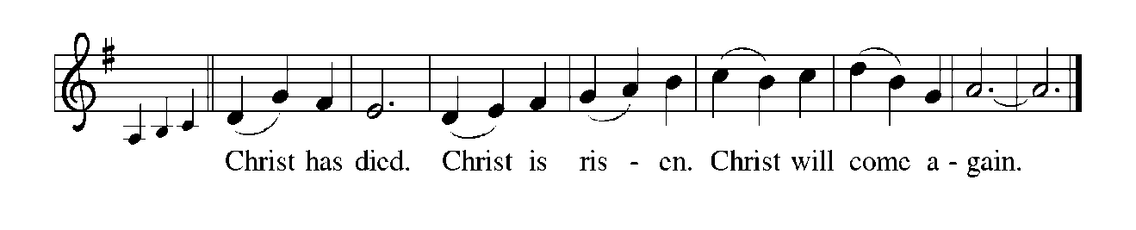
P: God of hope, in You the future is always bigger than the past.
Visit Your children when the sound of their weeping is heard in Your cities;
transfigure the lives of any who labor in vain, or bear children for
calamity.
Strengthen those who build houses and plant vineyards, and inspire all who
strive to restore communities after conflict or disaster.
Give endurance to those who are hated and betrayed, until the time when You
create new heavens and a new earth, and the former things shall pass
away,
And You make Jerusalem a joy, and its people a delight, and Your whole creation
is once again a blessing,
One God: Father, Son, and Holy Spirit, now and forever.


THE LORD’S PRAYER

P: That we may testify to the Rule of God in our midst, let us pray as Jesus taught us:

C: Our Father in heaven, hallowed be Your name.
Your Kingdom come, Your will be done on earth as in heaven.
Give us today our daily bread, and forgive us our sins, as we forgive
those who sin against us.
Save us from the time of trial, and deliver us from evil.
For the Kingdom, the power, and the glory are Yours, now and forever.
Amen.

INVITATION TO THE MEAL

P: This is the Lamb of God Who takes away the sin of the world. Happy are they who are
called to God’s Table. God’s holy gifts for God’s holy people. Come, for all is now
ready.

The assembly is seated

THE DISTRIBUTION
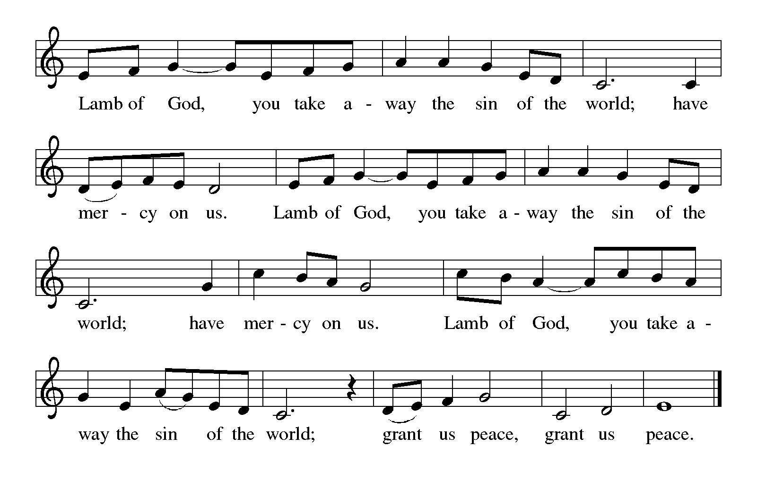
HYMN DURING DISTRIBUTION 723 Canticle of the Turning
ELW 596 My Hope is Built on Nothing Less
ELW 438 My Lord, What A Morning
NSB 48 I Am the Bread of Life (Talbot)
As you are able please rise

THE POST-COMMUNION BLESSING

P: The Body and Blood of our Lord Jesus Christ strengthen you and keep you in His
grace.

C: Amen.

THE POST-COMMUNION PRAYER

A: Let us pray. Gracious God, in this Meal You have again filled us with healing and new
life. Strengthen us now not to be weary in doing what is right. Help us to endure in
the face of suffering, and to remain faithful to You in life and in death. Grant this
through Christ our Lord.

C: Amen.

SENDING

THE BENEDICTION

P: Almighty God: Father, Son, and Holy Spirit bless you now and forever.

C: Amen.

THE SENDING HYMN 452 Awake, O Sleeper, Rise From Death

THE DISMISSAL

A: Do not be weary in doing what is right. Go in peace and serve the Lord.

C: Thanks be to God!

POSTLUDE

To God Alone Be Glory

The Meditation is from Sundays and Seasons Online. Copyright 2013 Augsburg
Fortress.

The Prayers and Dismissal are from Sundays and Seasons. Copyright 2000 Augsburg Fortress.

ANNOUNCEMENTS

Please remember to mail your offering to the Church Office at 818 Franklin Street, Michigan City, IN 46360. Another alternative is to give on-line through Tithe.ly. Please see your closure letter for information on how to set up a Tithe.ly account.

St. Paul Members are reminded to have a loved one contact the office if you are hospitalized. Many times, the Pastor doesn’t know someone is in the hospital. If you call and leave a message, please tell us at which hospital the patient is located.

PRAYER CONCERNS: Robert Bernth; Barry Anderson; John Bennitt; Sarah McNabb; Debbie Martin; Mark Tannehill; Kathy Stein; Jan Paholski; Laura Dovey; Grace Romine; Bill Hazelgrove; Al Levenhagen; Carl Wipperman; Major Payne;
Carol Hazelgrove and Allen Sydow.

OFFICE HOURS: Libby will be in the office on Mondays, Wednesdays, and Fridays; volunteers will cover Tuesdays and Thursdays.

Monday & Wednesday 8:00 a.m. – 5 p.m.
Tuesday & Thursday 9:00 a.m. – 12:00 p.m.
Friday 8:00 a.m. – 12:00 p.m.

If you are listening to the worship broadcast on the radio and would like to watch the Sunday morning service live stream follow these steps:

(1) If you have You Tube available on your TV, search for
St. Paul Lutheran Church Michigan City, IN.

(2) The direct link on the computer is https://
www.youtube.com/channel/UC5AIPNaKr3QN50984jGOa1g.

(3) This link is also on the main page of the church’s website in
the church section and will continue to be posted weekly on the St.
Paul Facebook page.

And it will always be available on the radio broadcast Sunday mornings at 11:00 a.m.
on WEFM (95.9), and on the local cable access station #99 for the previous week’s
service on Sundays at 4:00 p.m. and the current service on Wednesdays at 7:00 p.m.
and Fridays at 8:30 p.m.

To send e-mail to the church office, please use the following addresses:
Pastor Mark Reshan: seniorpastor@stpaulmichigancity.com
Church Office Secretary (Libby Pollock): churchsecretary@stpaulmichigancity.com
Church Treasurer (Karen Fleming): finance@stpaulmichigancity.com

2025 Church Council:

Mark Reshan - Pastor

Janet Bakken – President

Donna Knoll – Vice President

Judy Hunt – Secretary

Karen Fleming – Treasurer

Members: Paul Brooks, Diane Egilske, Sue Koziel, Judy Mutchler, Jim Schraidt, Trish Sprague

Worship Attendance:
Saturday , November 8, 2025 @ 4:00 p.m. 24
Sunday, November 9, 2025 @ 9:00 a.m. 49
TOTAL 73

Copies of the minutes from the October 23 2025 Church Council meeting are on the back table in the upper Narthex. It was approved by the council via email.

The Good News Newsletter: If you have an article or anything you want included in The Good News please send it to the following e-mail address: splcgoodnews@gmail.com. Pastor Pamela Thiede will be using this e-mail address to assemble The Good News each month. The deadline for getting information to Pastor Pamela will be the 20th of each month.

Sunday’s lessons are Jeremiah 23: 1-6; Psalm 46; Colossians 1: 11-20; and Luke 23: 33-43 for those of you who like to study them in advance.
NOVEMBER MISSION OF THE MONTH

The Mission of the Month for November: Nest Community Shelter, located at the old Sacred Heart Church, is a nonprofit organization delivering temporary emergency shelter for the homeless men and women (including women with children) in our community. Nest provides not just shelter but food and other resources. Nest is always in need of the following items:

-Bedding - blankets, pillows, pillow cases

-Food items – sugar, breakfast cereal, coffee, coffee filters, creamer, non-perishable goods

-Dining – 8 oz. foam cups, 12 oz. foam bowls, 6” & 9” plates, plastic flatware, paper towels, paper napkins, plastic wrap, aluminum foil, gallon Ziploc bags, large serving gloves

-Kitchen – 55 gallon trash bags, dish soap

-Hygiene items – liquid hand soap, hand sanitizer, all purpose cleaner, feminine hygiene products, toilet paper

Donations of goods can be placed in the bin in the Narthex. Monetary donations can be marked for Nest and placed in the offering plate. Noisy coin offering will also go toward the mission of the month. Thank you for your help in providing for those in need in our community!

December Mission of the Month – St. Paul Angel Tree

It’s beginning to look a lot like Christmas! We are starting our December mission a little early to ensure our gifts make it to their recipients by Christmas Day. A Mama’s Heart Ministry has provided us with names and wish lists of four children in our community who need assistance this Christmas. Please take a tag (or two) and shop for the item listed on the tag. Gifts can be returned wrapped or unwrapped, your preference. Please attach the angel tree tag to the gift. Toy tags have suggestions based on the child’s interests, but any age appropriate toy will do! Please return all gifts underneath the angel tree by Sunday, December 7th, to ensure everything can be delivered to the families by Christmas. Thank you for your generosity and Christmas spirit!

2025 Financial Stewardship

Weekly Church Operating Needs (x 2 weeks)
October 18-19, 2025; and October 25-26, 2025: $ 12, 563.00

General Fund (including General Memorials): $ 8,412.06

Overage/Shortage: — $ 4,150.94

Restricted Income (not including Memorials)
Supports IK Synod & Church wide Ministries: $ 321.00

Ministries in our Community/Congregation: $ 125.00

Capital Fund: $ 481.00

Memorials
General Fund: $ 525.00

ACTIVITIES, EVENTS & MEETINGS
November 2025

Sunday, November 9, 2025 @ 9:00 a.m. 22 Pent Worship Service/Sanctuary
Immediately following: FALL CONGREGATIONAL MEETING/St. Paul
Room with POTLUCK luncheon to follow/St. Paul Room

Tuesday, November 11, 2025 @ 7:00 p.m. Estuary/Luther House

Wednesday, November 12, 2025 @ 10:00 a.m. God’s Purls/St. Paul Room
@ 11:00 a.m. – 9:00 p.m. GIVE BACK @ SWINGBELLY’S
@ 3:30 p.m. Worship & Music Mtg./Luther House
@ 4:30 p.m. Choir Rehearsal/Sanctuary

Thursday, November 13, 2025 @ 4:00 p.m. 150th Anniv. Mtg./Luther House

Saturday, November 15, 2025 @ 4:00 p.m. 23 Pent Worship Service/Sanctuary

Sunday, November 16, 2025 @ 9:00 a.m. 23 Pent Worship Service/Sanctuary with coffee after/ St. Paul Room with coffee after/St. Paul Room

Monday, November 17, 2025 @ 1:00 p.m. Hope Circle/Green Room
@ 2:00 p.m. Finance Comm. Mtg./Luther House
@ 3:00 p.m. Executive Board Meeting/Luther House
Wednesday, November 19, 2025 @ 4:30 p.m. Choir Rehearsal/Sanctuary
Thursday, November 20, 2025 @ 3:00 p.m. Church Council Mtg./Luther House
Saturday, November 22, 2025 @ 4:00 p.m. CHRIST THE KING Worship Service/ Sanctuary

Sunday, November 23, 2025 @ 9:00 a.m. CHRIST THE KING Worship Sanctuary
with coffee after/St. Paul Room
Wednesday, November 26, 2025 @10:00 a.m. God’s Purls/St. Paul Room

Christmas Poinsettias

Time to place your order! Yes, it’s time to start thinking about purchasing a Christmas Poinsettia from St. Paul Church. Each plant will be a 7.5 inch pot with 4-11 blooms. You will have a choice in color between red, white, or ‘Jingle Bell’ which is a combination of red and white. If you do not specify a color, red will be chosen. Each plant will cost $15.00 and can be put “in memory of. . .” or “in honor of . . .” a loved one. Please place your order through the Church Office by calling (219) 874-7293; or place your information on an envelope with a check made out to the church, or cash, and place in offering plate.
All checks should be made out to St. Paul Church. All plants will be available to take home after the Christmas Eve Service. And all orders must be placed by Thursday, December 11th. The final count will be turned in that day!

