**THE FESTIVAL OF HOLY CROSS DAY**

**The Fourteenth Sunday after Pentecost**

**September 14, 2025**

“ ...Already in the early centuries of the church, Christians practiced the ritual of making the sign of the cross on one’s body. One theory holds that, informed by the Jewish practice of inscribing a Tau for the end of time or a Yod for the name of God on one’s phylactery bands, Christians signed Christ’s name with a Chi on their hands.

Second century churchmen write of tracing the sign of the cross on one’s forehead at baptism and daily in devotion. Ambrose taught that one’s fingers traced first on the forehead, for Christian profession, second over the heart, for love toward God, and last over the arms, for the work of the Christian life. In his catechism, Martin Luther counseled Christians, “In the morning, as soon as you get out of bed, you are to make the sign of the holy cross and say, ‘Under the care of God, the Father, the Son, and the Holy Spirit. Amen.’

Eventually the cross came also to determine the floor plan for church buildings. It was as if God could look down from heaven and see the believers in the shape of the cross ...”

**Gail Ramshaw**

***Treasures Old and New: Images in the Lectionary***

***✠ In the Name of Jesus ✠***

**INTRODUCTION**

*This festival of the Holy Cross began in Jerusalem in the early fourth century when the emperor Constantine built a basilica over the place of the crucifixion. The forty-day period between August 6 (Transfiguration) and September 14 became a special season to honor the central symbol of the Christian faith.*

**✠ GATHERING ✠**

**PRE-SERVICE MUSIC Power of the Cross New Song Praise Band**

**(Keith Getry & Stuart Townsend)**

**ANNOUNCEMENTS**

As you are able please rise

**GATHERING SONGNSB 4 *All Creation Worhips You***

**THE GREETING AND PRAYER OF THE DAY**

P: The grace of our Lord Jesus Christ, the love of God, and the communion of the Holy Spirit be

with you all.

**C: And also with you.**

P: Let us pray. Almighty God, Your Son Jesus Christ was lifted high upon the cross so that He

might draw the whole world to Himself. To those who look upon the cross, grant Your wisdom,

healing, and eternal life, through Jesus Christ, our Savior and Lord, Who lives and reigns with

You and the Holy Spirit, one God, now and forever.

**C: Amen.**

*The assembly is seated*

**✠ WORD ✠**

**FIRST READING Numbers 21: 4b-9**

*This story is one of many describing the journey of the Israelites from Mt. Sinai to Moab. The symbol of the snake, common in Canaan at this time, becomes a sign of God’s judgment and healing.*

From Mount Hor the Israelites set out, 4bbut the people became impatient on the way. 5The people spoke against God and against Moses, "Why have you brought us up out of Egypt to die in the wilderness? For there is no food and no water, and we detest this miserable food."

6Then the Lord sent poisonous serpents among the people, and they bit the people, so that many Israelites died. 7The people came to Moses and said, "We have sinned by speaking against the Lord and against you; pray to the Lord to take away the serpents from us." So Moses prayed for the people.

8And the Lord said to Moses, "Make a poisonous serpent, and set it on a pole; and everyone who is bitten shall look at it and live." 9So Moses made a serpent of bronze, and put it upon a pole; and whenever a serpent bit someone, that person would look at the serpent of bronze and live.

The Word of the Lord.

**Thanks be to God.**

**THE PSALM: Psalm 98: 1-4** Antiphon by Anne Krentz Organ

Choir sings refrain first, followed immediately by the congregation

and as indicated

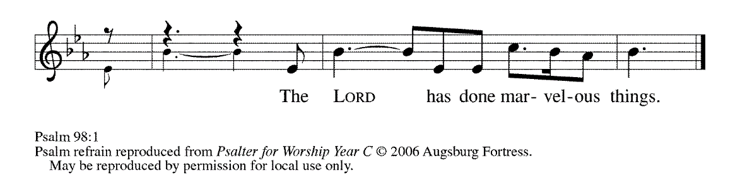

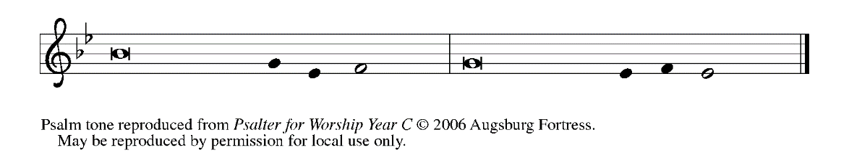

1Sing a new song to the LORD, Who has done | marvelous things,

Whose right hand and holy arm have | won the victory.

**2O LORD, You have made | known Your victory,**

**You have revealed Your righteousness in the sight | of the nations. REFRAIN**

3You remember Your steadfast love and faithfulness to the | house of Israel;

all the ends of the earth have seen the victory | of our God.

**4Shout with joy to the LORD, | all you lands;**

**lift up your voice, re- | joice, and sing. REFRAIN**

**SECOND READING 1 Corinthians 1: 18-24**

*In this letter, Paul makes clear his purpose to preach Christ and the wisdom of the cross. This “wisdom” confounds common perceptions of God: Christ crucified reveals God as the One Who suffers with humankind.*

18The message about the cross is foolishness to those who are perishing, but to us who are being saved it is the power of God. 19For it is written,

"I will destroy the wisdom of the wise,

and the discernment of the discerning I will thwart."

20Where is the one who is wise? Where is the scribe? Where is the debater of this age? Has not God made foolish the wisdom of the world? 21For since, in the wisdom of God, the world did not know God through wisdom, God decided, through the foolishness of our proclamation, to save those who believe. 22For Jews demand signs and Greeks desire wisdom, 23but we proclaim Christ crucified, a stumbling block to Jews and foolishness to Gentiles, 24but to those who are the called, both Jews and Greeks, Christ the power of God and the wisdom of God.

The Word of the Lord.

**Thanks be to God.**

*As you are able please rise*

**THE VERSE** Sung twice

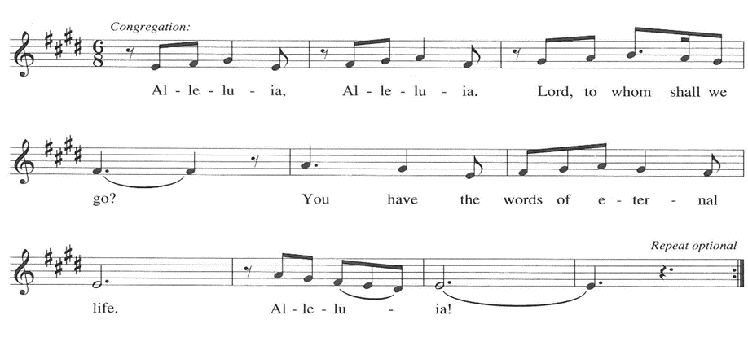

**THE HOLY GOSPEL John 3: 13-17**

*After explaining to Nicodemus that one must be born of water and the Spirit, Jesus speaks of being lifted up on the cross with reference to the bronze serpent lifted up by Moses in the desert. Here the Son of God is revealed as the source of healing.*

P: The Holy Gospel according to St. John, the third chapter.

**C: Glory to You, O Lord!**

Jesus said: 13"No one has ascended into heaven except the One Who descended from heaven, the Son of Man. 14And just as Moses lifted up the serpent in the wilderness, so must the Son of Man be lifted up, 15that whoever believes in Him may have eternal life.

16"For God so loved the world that He gave His only Son, so that everyone who believes in Him may not perish but may have eternal life.

17Indeed, God did not send the Son into the world to condemn the world, but in order that the world might be saved through Him."

P: The Gospel of the Lord.

**C: Praise to You, O Christ!**

*The assembly is seated*

**THE SERMON**

*Silence for reflection follows the sermon*

*As you are able please rise*

**HYMN OF THE DAY 1085 *Hope of the World***

Stanza 2—Women; Stanza 4--Men



*The assembly is seated*

**THE INSTALLATION OF MUSICIANS**

The musicians to be installed come forward

Maggie Martin Pianist and Director of Music

The Senior Choir

Jary Tannehill Director, New Song Praise Band

Mark Tannehill Member, New Song Praise Band

Jacob Tannehill Member, New Song Praise Band

Stacie Crozier Member, New Song Praise Band

Charlie Marks Member, New Song Praise Band

Sue Koziel Member, New Song Praise Band

Peggy Wolf Member, New Song Praise Band

Judy Mutchler Handbell Choir

Trish Sprague Handbell Choi

Judy Hunt Handbell Choir

Karen Fleming Handbell Choir

Kelly Neulieb Handbell Choir

P: Our Lord, Who came among us as a servant, calls us to faith and life of loving service to our

neighbor. You stand among us as those called to a particular service, a gift from God to inspire

us to love and good works.

*A reading from Romans:* Just as each of our bodies has several parts and each part has a

separate function, so all of us, in union with Christ, form one body, and as parts of it we belong

to each other. Our gifts differ according to the grace given us. If your gift is prophecy, then

use it as your faith suggests; if administration, then use it for administration; if teaching, then

use it for teaching. Let the preachers deliver sermons, the almsgivers give freely, the officials

be diligent, and those who do works of mercy do them cheerfully.

P: Will you assume this ministry in the confidence that it comes from God?

*R: I will, and I ask God to help me.*

P: Will you carry out this ministry in accordance with the teachings and practice of the Lutheran

Church?

*R: I will, and I ask God to help me.*

P: Will you be diligent in your study of the Holy Scriptures and faithful in your use of the means

of grace and in prayer?

*R: I will, and I ask God to help me.*

P: Will you trust in God’s care, seek to grow in love for those you serve, strive for excellence in

your skills, and adorn the Gospel with a godly life?

*R: I will, and I ask God to help me.*

P: Almighty God, Who has given you the will to do these things, graciously give you the strength

and compassion to perform them.

**C: Amen.**

P: I install you as musicians of St. Paul Lutheran Church in the name of the Father and of + the

Son and of the Holy Spirit.

**C: Amen.**

P: Let us pray. O God of majesty, Whom saints and angels delight to worship: Be present with

Your servants who seek through Your gift of music to perfect our praises and to proclaim

Your Word with power. Through their ministries grant us new awareness of Your beauty and

grace, and make us all worthy at last to join the praises of the hosts of heaven; through Your

Son, Jesus Christ our Lord.

**C: Amen.**

P: Almighty God, our heavenly Father, guide, bless, and keep you, that you may be faithful to the

ministry to which you have been called.

**C: Amen.**

*As you are able please rise*

**THE PRAYER OF THE CHURCH**

A: Gracious God, we come to You in prayer for the church, the world, and all in need.

A: Sustaining God, guide Your church on the way. Give us patience in our journey, and protect

us from division and doubt. May we look to the cross and live. God of grace,

**C: receive our prayer.**

A: Creator God, renew the earth. Heal our planet from the venom of greed and exploitation, and

direct us to respect all life as a gift from You. May we look to the cross and live. God of grace,

**C: receive our prayer.**

A: God of wisdom, grant discernment to those in authority. Thwart the plans of the proud, bring

low the mighty, and uphold those who work for peace. May they seek the way of the cross and

live. God of grace,

**C: receive our prayer.**

A: God of grace, alleviate suffering. Comfort the sick and the grieving, especially: **Fred Weiss;**

**David Weiss; Martha Schroeder; Shirley Freels; Christine Kiser; Judy Gustum; Kerry**

**Steinborn; Debbie Martin; Larry Litchford; Joyce Stark; Robert Bernth; Craig Hunt;**

**Lucas Bradshaw; Mike Galinowski; and John Bennitt.** Come to the aid of those who are

hungry or needing shelter. May they find hope in the cross and live. God of grace,

**C: receive our prayer.**

A: Good Shepherd, guide Your flock. Protect us from the world’s lies and lead us in the way of

truth. Strengthen us in our faith and inspire us to serve others. May we follow You to the cross

and live. God of grace,

**C: receive our prayer.**

A: Merciful God, You receive into Your loving embrace those who have died. Giving thanks for

them, may we find comfort in the cross and live in the hope of resurrection. God of grace,

**C: receive our prayer.**

P: We entrust these prayers to You, O God, in the name of Jesus Christ, our redeemer and friend.

**C: Amen.**

**✠ MEAL ✠**

**THE PEACE**

P: The peace of the Lord be with you always.

**C: And also with you.**

*The assembly is seated*

**THE VOLUNTARY Choir** ***Take Now My Voice*** **St. Paul Senior Choir**

(D. Nolan)

**THE OFFERING**

*As you are able please rise*

**THE PRESENTATION OF THE GIFTS 465 *As the Grains of Wheat***

**THE OFFERTORY PRAYER**

A: Let us pray. Lord Jesus,

**C: You once offered Your life on the cross to take away the sins of the world. With these**

**gifts we offer our lives in love and service to You. Receive them and bless them for the**

**work of Your Kingdom. By this holy Sacrament, lift us up again from death to new life.**

**You are the Lord forevermore. Amen.**

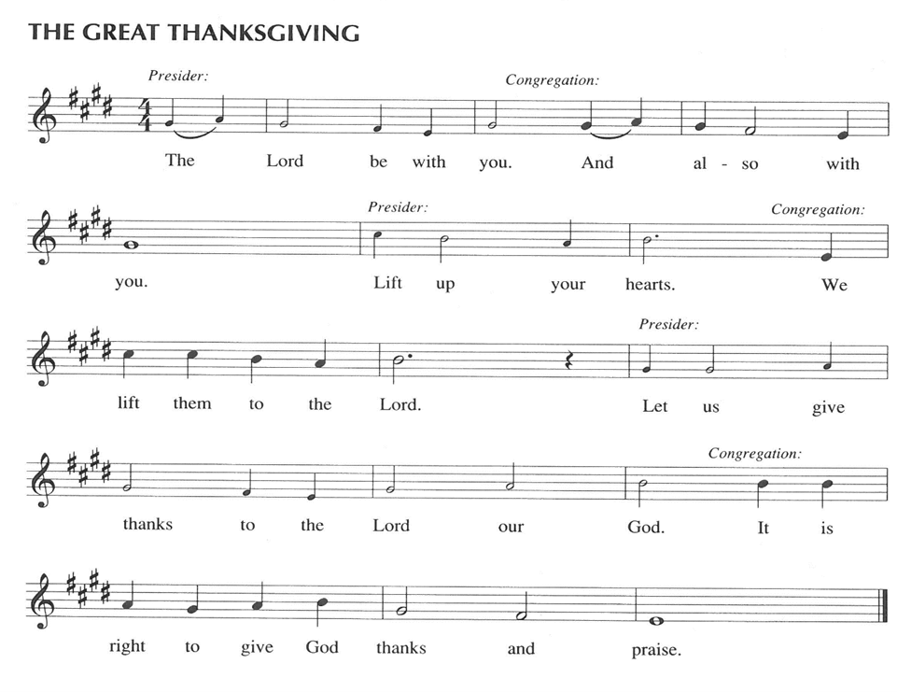

P: It is our duty and delight …and join their unending hymn:

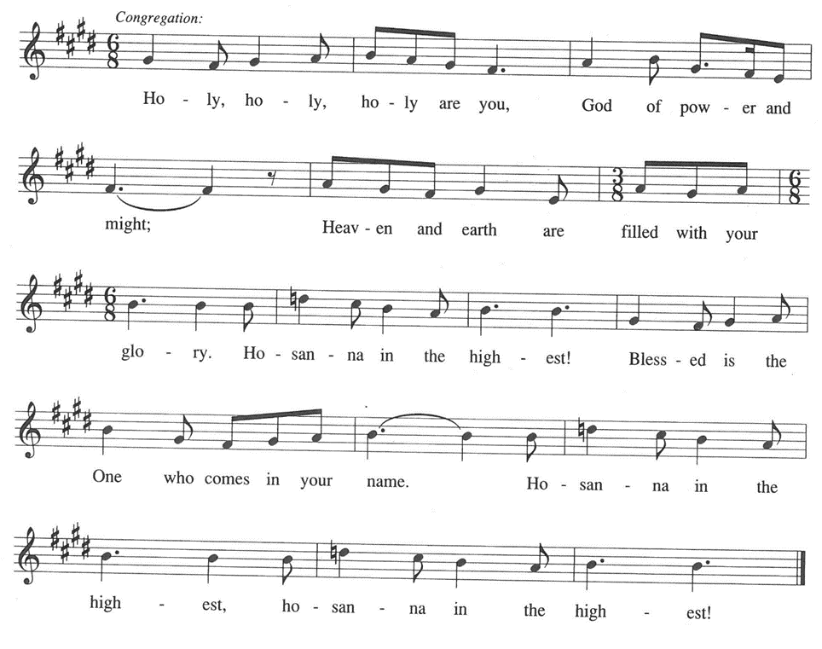

P: Holy God, Lover of the world, we bless and praise You.

We sing to You a new song; all creation shouts with joy to You.

For in great love You created heaven and earth and all creatures in them.

You made covenant with Israel, and with mercy and faithfulness You rescued them from

slavery and exile and sent prophets to call them from sin to new life.

At the last You sent Your only-begotten Son, Jesus Christ.

He is Your Wisdom and power lifted up to draw all people to Himself.

In the night ... “Do this for the remembrance of Me.”

As often as we eat ... we proclaim the Lord’s death until He comes.

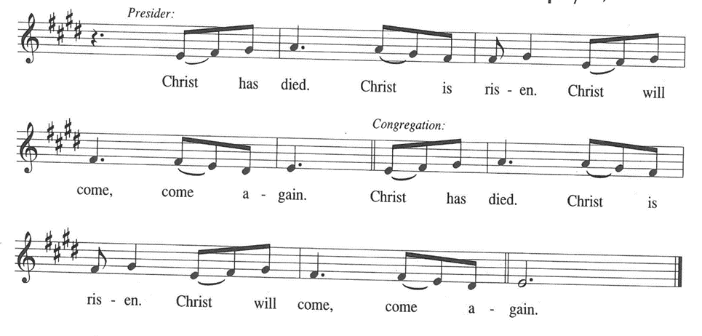

P: With this bread and cup we remember the life our Lord offered for us.

He died and rose to save the world from darkness and death.

We await His promised return to share with us Your final Feast of victory.

Send Your Spirit on us and these Your gifts of bread and wine.

Unite in His cross all who share the food and drink of His unending Life, and bring us by

its power into Your eternal glory with all the saints in light.

To You, O God: Father, Son, **✠** and Holy Spirit, be all honor and glory, in Your holy Church,

in heaven and on earth, now and forever.

**C: Amen!**

**THE LORD’S PRAYER**

P: God so loved the world that He gave His only Son, that whoever believes in Jesus may dare to

pray as He taught us:

**C: Our Father, Who art in heaven, hallowed be Thy Name. Thy Kingdom come. Thy will**

**be done on earth as it is in heaven. Give us this day our daily bread, and forgive us our**

**trespasses as we forgive those who trespass against us. And lead us not into temptation,**

**but deliver us from evil. For Thine is the Kingdom, and the power, and the glory, forever**

**and ever. Amen.**

**INVITATION TO THE MEAL**

P: This is the Lamb of God Who takes away the sin of the world. Blessed are those who are

called to the Supper of the Lamb. God’s holy gifts for God’s holy people. Come, for all is

now ready.

*The assembly is seated*

**THE DISTRIBUTION *“Lamb of God”***

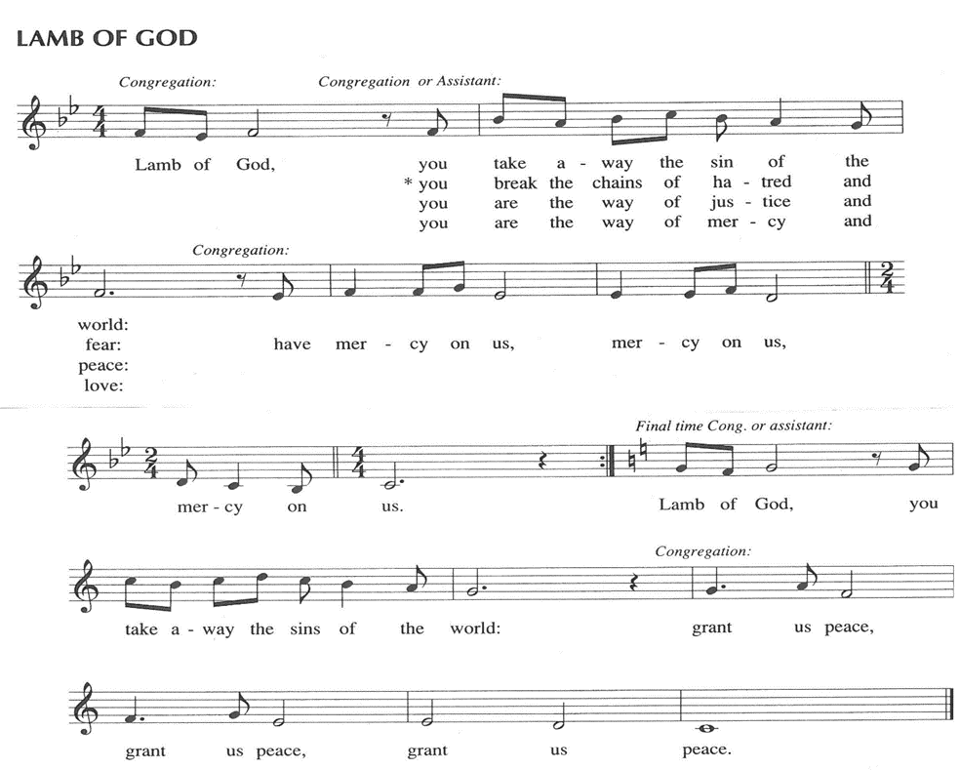

Those wishing to receive the Laying on of Hands, Anointing with Oil, and Prayer for Healing

may go to Pastor at the side aisle

**HYMN DURING DISTRIBUTION 803 *When I Survey the Wondrous Cross***

**NSB 63 *Lord, I Lift Your Name on High***

**NSB 83 *There is A Redeemer***

**ELW 483 *Here is Bread***

**ELW 484 *You Satisfy the Hungry Heart***

*As you are able please rise*

**THE POST-COMMUNION BLESSING**

P: The Body and Blood of our Lord Jesus Christ strengthen you and keep you in His grace.

**C: Amen.**

**THE POST-COMMUNION PRAYER**

A: Let us pray. Lord Jesus Christ, You are the holy Bread of Life. Bring to the glory of the

resurrection the people You have redeemed by the wood of the cross. By our eating and

drinking, grant us the courage to take up the cross and follow where You lead, that we may

proclaim You with power and joy. We bless You now and forever.

**C: Amen.**

**✠ SENDING ✠**

**THE BENEDICTION**

P: Almighty God: Father, Son, **✠** and Holy Spirit bless you now and forever.

**C: Amen.**

**THE SENDING HYMN 355 (see P. 14) *Sing, My Tongue***

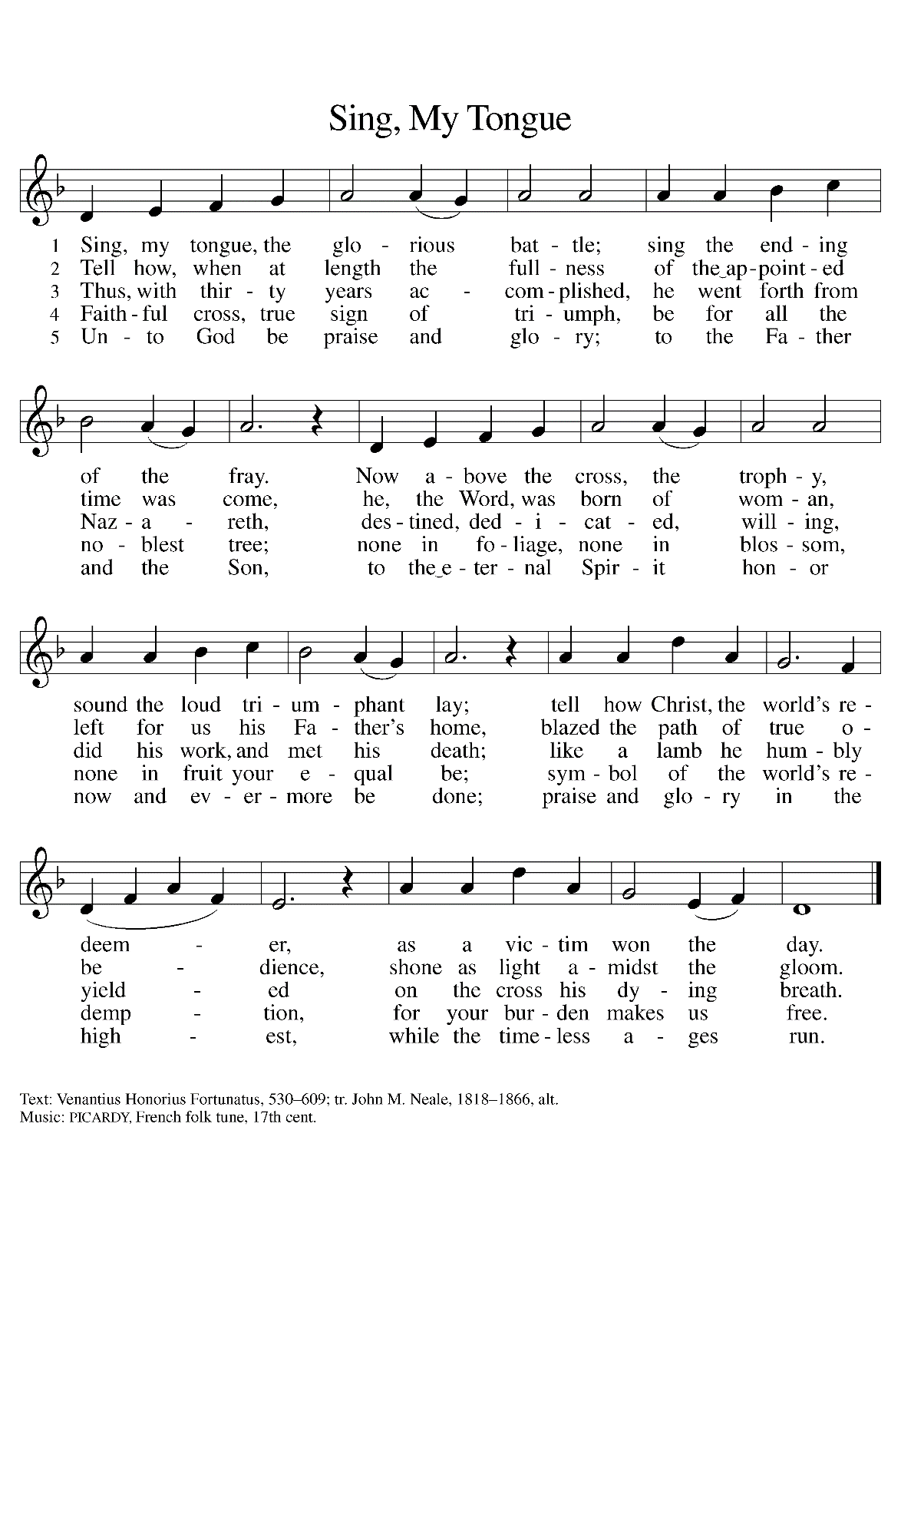

**THE DISMISSAL**

A: Go in peace to bear Christ’s love to the world.

**C: Thanks be to God!**

**POSTLUDE**

***✠ To God Alone Be Glory ✠***

The Meditation is from *Treasures Old and New: Images in the Lectionary.* Gail Ramshaw.

(Minneapolis: Augsburg Fortress, 2002) 126-127.

The musical setting of the liturgy, “Now the Feast and Celebration” by Marty Haugen, is used by

permission of GIA Publishers, Inc. OneLicense.net License #A-702836.

**ANNOUNCEMENTS**

**Please remember to mail your offering to the Church Office** at 818 Franklin Street, Michigan City, IN 46360**.** Another alternative is to give on-line through Tithe.ly. Please see your closure letter for information on how to set up a Tithe.ly account.

**St. Paul Members are reminded to have** a loved one contact the office if you are hospitalized. Many times, the Pastor doesn’t know someone is in the hospital. If you call and leave a message, please tell us at which hospital the patient is located.

**PRAYER CONCERNS:** Bev Coburn; Barry Anderson; John Bennitt; Judy

Gustum; Larry Litchford, Sarah McNabb, Jeanie Boatman Shepple, Debbie Martin, Mark Tannehill, Kathy Stein, Jan Paholski, Laura Dovey, Grace Romine;

Mike Galinowski; Bill Hazelgrove; Kerry Steinborn; Robert Bernth and Craig Hunt.

**OFFICE HOURS:** Libby will be in the office on Mondays, Wednesdays, and Fridays; volunteers will cover Tuesdays and Thursdays.

  Monday & Wednesday 8:00 a.m. – 5 p.m.

Tuesday & Thursday 9:00 a.m. – 12:00 p.m.

Friday 8:00 a.m. – 12:00 p.m.

**If you are listening to the worship broadcast on the radio and would like to watch the Sunday morning service live stream follow these steps:**

(1) If you have You Tube available on your TV, search for

**St. Paul Lutheran Church Michigan City, IN.**

(2) The direct link on the computer is [https://](https://www.youtube.com/channel/UC5AIPNaKr3QN50984jGOa1g)

www.youtube.com/channel/UC5AIPNaKr3QN50984jGOa1g.

   (3) This link is also on the main page of the church’s website in

the church section and will continue to be posted weekly on the St.

Paul Facebook page.

And it will always be available on the radio broadcast Sunday mornings at 11:00 a.m.

on WEFM (95.9), and on the local cable access station #99 for the previous week’s

service on Sundays at 4:00 p.m. and the current service on Wednesdays at 7:00 p.m.

and Fridays at 8:30 p.m.

**Sunday’s lessons are Ezekiel 2: 8 - 3: 11; Psalm 119: 33-40; Ephesian 2: 4-10; and Matthew 9: 9-13** for those of you who like to study them in advance.

**To send e-mail to the church office**, please use the following addresses:

Pastor Mark Reshan: seniorpastor@stpaulmichigancity.com

Church Office Secretary (Libby Pollock): churchsecretary@stpaulmichigancity.com

Church Treasurer (Karen Fleming): finance@stpaulmichigancity.com

**2025 Church Council:**

Mark Reshan - Pastor

 Janet Bakken – President

 Donna Knoll – Vice President

 Judy Hunt – Secretary

 Karen Fleming – Treasurer

 Members: Paul Brooks, Diane Egilske, Sue Koziel, Judy Mutchler,

Jim Schraidt, Trish Sprague

**Worship Attendance:**

**Saturday , September 6, 2025, 2025 @ 4:00 p.m. 16**

**Sunday, September 7, 2025 @ 9:00 a.m. 70**

**TOTAL 86**

**Copies of the minutes from the June 26, 2025 and the August 28, 2025 Church Council meetings are on the back table in the upper Narthex. They were approved by the council via email. There was no Council meeting in July 2025.**

**The Good News Newsletter**: If you have an article or anything you want included in **The Good News** please send it to the following e-mail address: splcgoodnews@gmail.com. Pastor Pamela Thiede will be using this e-mail address to assemble **The Good News** each month. The deadline for getting information to Pastor Pamela will be the 20th of each month.

**September 2025 Mission of the Month**

The Mission of the Month for September 2025: ZERO Prostate Cancer

September is Prostate Cancer Awareness Month. Prostate cancer will affect about one in seven men in their lifetime and about 35,000 men will die from prostate cancer this year. Fortunately, if detected early, prostate cancer can be successfully treated, and new treatments are becoming available to extend the lives of men with advanced disease. ZERO is the largest prostate cancer support, education and advocacy organization in the United States. It offers free support and education services to prostate cancer patients, and advocates for research funding and improved prostate cancer treatment. Jim Schraidt is a fifteen-year prostate cancer survivor and a member of the Board of Directors of ZERO. He leads a monthly ZERO-sponsored support group that meets in Chicago with simultaneous virtual access. Jim is happy to answer questions about prostate cancer and ZERO, and more information can be found at <https://zerocancer.org>.

Checks can be written to St. Paul and can be marked for ZERO and placed in the offering plate.

Noisy coin offering will also support the mission of the month.

**THANK YOU! For your support of MCAS schools** through Donors Choose during our August Monthly Mission. We collected $716 and were able to provide math cubes to a classroom at Pine Elementary School to help the students learn basic addition, subtraction, 2 digit subtraction within 100, and the base 10 system. We also donated towards a simulator for the child development class at the high school, which will help students understand what happens within a baby’s brain after experiencing shaken baby syndrome.

**ACTIVITIES, EVENTS & MEETINGS**

**SEPTEMBER 2025**

**Saturday,** September 13, 2025 @ 4:00 p.m. Pent 14 (Holy Cross Day) Worship

**Sunday,** September 14, 2025 @ 9:00 a.m. Pent 14 (Holy Cross Day) Worship

Installation of Musicians with coffee after/St. Paul Room

**Wednesday,** September 17, 2025 @ 9:15 a.m. Bible Study/Luther House

@10:00 a.m. God’s Purls/St. Paul Room

@ 4:30 p.m. Choir Rehearsal/Sanctuary

**Saturday,** September 20, 2025 @ 4:00 p.m. Pent 15 (Day of St. Matthew)

Worship

**Sunday,** September 21, 2025 @9:00 a.m. Pent 15 (Day of St. Matthew) Worship with coffee after/St. Paul Room

**Monday,** September 22, 2025 @ 2:00 p.m. Finance Comm. Mtg./Luther House

@3:00 p.m. Executive Board Mtg./Luther House

**Tuesday,** September 23, 2025 @ 4:00 p.m. 150th Anniv. Comm. Mtg./Luther

House

**Wednesday,** September 24, 2025 @ 9:15 a.m. Bible Study/Luther House

@ 10:00 a.m. God’s Purls/St. Paul Room

@ 4:30 p.m. Choir Rehearsal/Sanctuary

**Thursday,** September 25, 2025 @ 5:30 p.m. Church Council Mtg./St. Paul Room

**Saturday,** September 27, 2025 @ 4:00 p.m. Pent 16 (Day of St. Michael &All The Angels) Worship Service/Sanctuary

**Sunday,** September 28, 2025 @ 9:00 a.m. Pent 16 (Day of St. Michael &All The Angels) Worship with coffee after/St. Paul Room