November, 2024

**MARK: MY WORDS**

November is one of the most important months of the church year. It begins with the commemoration of All Saints. Originally established as a church festival to honor the martyrs of the faith, by the fourth century it was expanded to include all the baptized on a day of thanksgiving to honor their example for those who followed them in discipleship.

We mark the day at St. Paul both by solemnly calling the names of those who have died in the Lord from the congregation during the past year and, also, holding up those who have entered the Body of Christ from the waters of Baptism. In this way, we both look to the past for our encouragement and inspiration even as we renew the promise we made at their Baptism to support and nurture the newly washed in the ways and teachings of the Lord.

November is also the month in which the current church year comes to its completion, capped off by the Feast of Christ the King on the last Saturday/Sunday after Pentecost. Instituted by Pope Pius XIX in 1925, this Day was meant to counteract what he saw as the rampant materialism and idolatrous coveting of wealth and power that was so prominent during “The Roaring Twenties” as the world recovered from the devastation of World War I.

Following this festival Day is the beginning of the new church year on the First Saturday/Sunday in Advent, which falls on the weekend following Thanksgiving. This begins a new series of lectionary readings for the church year. We enter Year C, the year of St. Luke’s Gospel.

Pastor Mark Wegener provides some helpful background on Luke’s Gospel in an essay from our ELCA worship resource *Sundays and Seasons.*

Luke was likely written around 85–90 CE or even as late as 110–115 CE, perhaps in Rome or some other urban center in the Roman Empire. It is based on at least two other documents. One is the Gospel of Mark. Luke follows Mark’s outline in most respects, but often modifies Mark’s anecdotes and improves Mark’s grammar. The other, known as “Q,” is a reconstructed collection of Jesus’ sayings that appear in Matthew and Luke but not in Mark. Most of Q’s shorter sayings have an edge to them; they provoke a reaction and invite us to reconsider our prior assumptions and beliefs.

In Luke, the chief title for Jesus is “Lord” (Kyrios in Greek), which appears some three dozen times. Mark, by comparison, refers to Jesus as “Lord” only half a dozen times…In the Greco-Roman world of the New Testament, Kyrios was the title for the emperor himself, for some deities, and for the head of a household.

The main idea of this title was not so much that of a master who rules over others, as that of a benefactor, the one whose purpose is to enhance the welfare of the people of Israel, or of the citizens in the empire, or of the members of the family. By pinning the title Kyrios on Jesus, Luke pictures him as a great benefactor, as one who brings the blessings of wholeness and peace, joy and salvation into the world.

At a time when we are so fractured politically, racially, economically, and socially, this emphasis on and promise of those “blessings of wholeness and peace, joy and salvation” are especially welcome. Although some of Luke’s stories are some of the best known and best-loved in all of Scripture it is our prayer that the Holy Spirit Whom he so emphasizes will open our hearts and lives to new and fresh hearings that bring God’s powerful promises to deep life and hope within us and through us to others.



The calendar throws us a bit of a curve as we look to transition from the longest season of the church year, Pentecost, to the four weeks of Advent. As mentioned above, the year of St. Mark ends with the festival of Christ the King, which falls this year on November 23-24. The following weekend, November 30 and December 1, marks the First Sunday of Advent.

Since this is the *November* newsletter, the question arises: should background information on Advent be included in this edition, since for us it technically begins on the last day of the month, or should it wait until the *December* newsletter, during which most of the season falls?

Since most of December is taken up with the weeks of Advent we will wait until next month to offer some insights into its purpose and goal that lead us into the celebration of the Nativity. Surely everyone will be on the edge of their seats in suspense until then 😄.

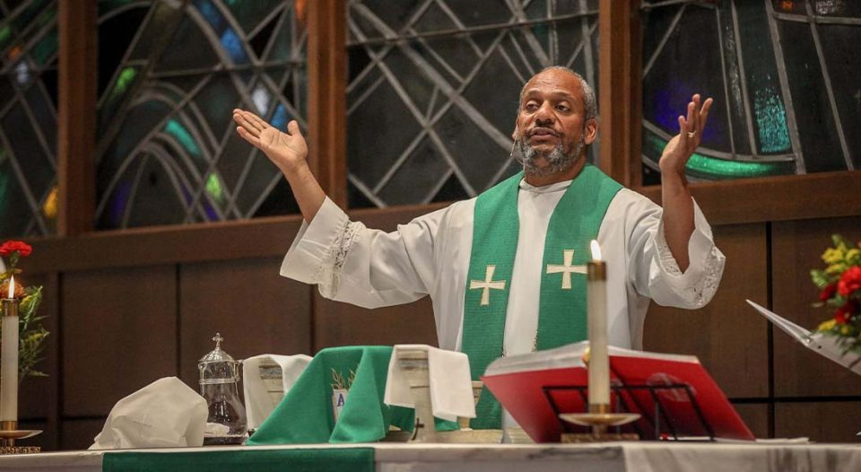

**MEET THE BISHOP**

On Tuesday, November 19 we will be hosting a “Meet and Greet” for our new bishop, Timothy Graham. A group of local ELCA clergy will be here for worship and time for discussion with him. Congregation members are welcome to attend the service which will begin at 9:30 a.m. and during which the Bishop will be preaching. Afterwards, the Bishop and clergy will go downstairs to the St. Paul Room for discussion and lunch.

If you have the time, feel free to join us that morning.

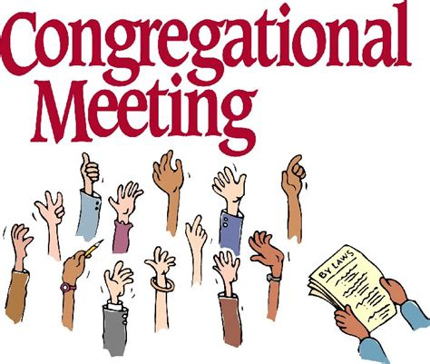

On **Sunday, November 10, at 10:00 a.m.** our regular fall congregational meeting will be held in the St. Paul Room following worship. The primary agenda item will be the election of new Church Council members. The entire executive team **President Janet Bakken, Vice-President Judy Hunt, Treasurer Karen Fleming, and Secretary Donna Knoll** are eligible for another one-year term. As of this writing, they have not indicated whether they will continue or not.

Council members **Susan Bagby, Jean Kleinschmidt, Bob Kiser, Diane Waltz, and Wayne Dolson** have completed their service. We are profoundly grateful for all of their faithful and dedicated service. Their leadership has enriched our church community and has been a rich blessing to us all.

The Nominating Committee consisting of Vice-President Judy Hunt, Susan, Jean, Bob, Diane, and Wayne will be working hard to secure candidates for all these important positions. Thank you to them for their difficult work. One change that we hope will make it a bit easier for them is that the Council voted to reduce the number of members from twelve to ten: four executive members and six council members.

That means that in addition to members **Paul Brooks, Diane Egilske, and Judy Mutchler** who have one year left on their terms, we only need to elect three new members instead of five. Please plan to attend and cast your vote for those who have agreed to be placed on the ballot so that we might have a seamless transition.

We need not only your presence at the meeting but your willingness to step in and fill those slots. We cannot have the same handful of people doing all the work all the time. We have many gifted members whose presence in leadership roles would greatly enrich us. Agree to serve. We need you.



**A PERSONAL NOTE**

I am deeply grateful for the cards and notes that I received for “Pastor Appreciation Month,” and for those who planned the wonderful reception at coffee hour. Thank you to those who so kindly expressed your support. I am blessed and strengthened by your care.

**Pastor Reshan**



**ORGANIST/CHOIR DIRECTOR UPDATE**

There is (again) no news to report on finding a permanent organist/choir director. I placed our job description in the online newsletter for the Association of Lutheran Church Musicians, a national organization made up of pastors and parish musicians. A day later, I received an email from someone who was interested; but he lives in Robbins, Illinois, a south suburb of Chicago, which is 60 miles away. I felt that the distance was too great to seriously consider him, especially when the weather turns nasty over the winter. I thanked him for his interest and wished him blessings as he continued his search.

In the meantime, we continue to rely upon Maggie Martin and George Karst and give thanks for their willingness to continue to serve us and for the great gifts they bring to our worship.

.



Twenty-five years ago (on October 23, 1999) here at St. Paul, Pastor Pamela Thiede was ordained into the ministry. The Calumet Episcopal Ministry Partnership will share in celebrating this anniversary with a potluck luncheon on Sunday, November 3, at 1:30 p.m. Pastor Pamela would like to invite her friends here at St. Paul to join her in the celebration. It will be held at the Cloister in the Woods, a banquet hall at St. Paul Episcopal Church, 1101 Park Drive, Munster. (If a lot of you are coming, that’s fine…please let her know so we have enough tables set up and plenty of chicken for everyone!)



**LIGHTS OFF!**

We have become very lax about making sure lights are turned off in the church building when everyone has left. Twice this week I have gone over in the morning to get something and found the lights in the lower and upper narthex and all the lights in the nave on overnight. **Do not** assume that someone else will turn them off. If a group is meeting designate someone to make sure that nothing is left on when they leave. We are just throwing money away by carelessness. Please help us to be good stewards of our resources.



**CHURCH OFFICE CLOSED**

The church office will be closed on Thursday, November 28, in honor of Thanksgiving. It will reopen on Friday, November 29, as usual from 8:00 a.m.to 12:00 p.m.

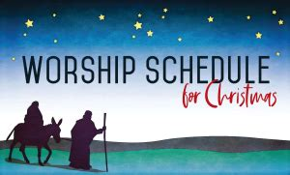

**CHRISTMAS WORSHIP SCHEDULE**

It is not too early to post information about our end-of-Advent and Christmas Eve/Day and following worship services. We will include them in the December newsletter also, but it might be helpful to mark your calendars now for these special liturgies.

**Saturday, December 21** Fourth Saturday in Advent 4:00 p.m.

**Sunday, December 20** Fourth Sunday in Advent 9:00 a.m.

**Tuesday, December 24** Christmas Eve 6:00 p.m.

Pre-service music @ 5:45 p.m.

**Wednesday, December 25** Christmas Day **9:00 a.m.**

**Saturday, December 28** The First Saturday after Christmas 4:00 p.m.

**Sunday, December 29** The First Sunday after Christmas 9:00 a.m.

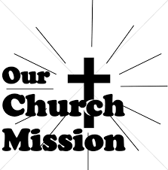

**MONTHLY MISSIONS**

Thank you for your support of the Christian Appalachian Project. We collected $850 and received this kind thank you upon donating:

You are a blessing! Thank you St. Paul Lutheran Church for your donation to Christian Appalachian Project! Your support will help make a difference in the lives of the people in need in Appalachia by providing food, clothing, and much needed home repairs. You are building hope, transforming lives, and sharing Christ's love through service.

Thank you to everyone who purchased and helped pack the personal care and school kits for Lutheran World Relief! We packed 100 personal care kits and 100 school kits, and we donated $95 to the shipping fund! In 2023, Lutheran World Relief shipped 190,043 school kits and 123,920 personal care kits to 14 different countries. In 2024, LWR was able to start providing kits in the United States as well. Recently, quilts and personal care kits were shipped to areas impacted by hurricane Helene. Thank you for your generous giving to help those near and far affected by disaster.

**November Monthly Mission: Guardians of the Children Michiana** is a non-profit organization dedicated to protecting the victims of child abuse. The guardians go to court with abused children (any types of abuse) to provide support to the child and their family. They hold monthly events for the kids to keep their mind off of the courts and the pain or traumas they’ve faced, including taking them to do fun things like bowling, swimming, horseback riding, skating, etc. They also have holiday parties; this year, they will be providing for 21 children at Christmas. We will be collecting monetary donations that they can use to purchase specific gifts for each child and to fund the holiday party. Please place your donations in the offering plate marked for Guardians of the Children. Noisy coin offering will also go towards the mission of the month. Thanks for your support!



**JOIN THE FELLOWSHIP GROUP IN STAFFING A RED KETTLE**

Fellowship can mean many things; it is also the name of an organization here at St. Paul.  No discrimination  -  if you attend services at St. Paul, you can join in any of our events.  During COVID, when no services were held, Fellowship was, of course, not active. When services returned to life, only a small part of the organization became active—the Coffee Hour after the Sunday service.  Before COVID, Fellowship met monthly, usually on a Sunday evening.

A couple of members from that time wanted to reactivate the rest of the Fellowship organization.  A recent poll of some of the former members resulted in a consensus of no monthly meetings.  A proposal of meeting four times a year--twice for a service project and twice for a strictly fun time—received a thumbs up vote.

To get the ball rolling, we will start with a Service Project.  The Salvation Army has been pleading for volunteers to become bellringers for their red kettles.  A couple of Fellowship leaders thought Fellowship could sponsor a Salvation Army red kettle for one day with bell ringers.  The day for St. Paul Fellowship is Saturday, December 7.  Our assigned kettle is located at the north door Al’s at 3535 Franklin Street. We will be inside the building—no worries about temperature, wind, rain or snow!  Because we will be indoors near their registers, Al’s has requested that no bells be rung.  The Salvation Army asks that we respect their request for no bells.  For safety reasons, we are asking that two people be with the red kettle for each hour.  The Salvation Army wants their kettle staffed from 10 a.m. to 7 p.m.  That time frame has been divided into 1-hour segments, beginning on the hour.  A sign-up sheet will be available in the upper narthex beginning the weekend of November 2/3.  Virginia Murray is coordinating this Service Project.  To sign-up or ask any questions, call her at (219)872-9063.



**IN HONOR OF HUSBAND, RANDY PETERS**

**General Fund** from Karen Peters

Bob Kiser and the Finance Team would like to thank **Jim Tomsheck, Mark Kloess, Chuck Payne, Tim Crozier, Larry Litchford, and Rich Fleming** for helping repair and paint the outside frames of the windows in the north elevator entryway. Job well done!.



**FALL CONGREGATIONAL MEETING & POTLUCK LUNCHEON**

The Fall Congregational Meeting will take place in the St. Paul Room immediately following the Sunday Service **on November 10.** At the Fall meeting we elect officers and Council members for 2025. Please plan to attend the Potluck Luncheon following the meeting. Dishes for the potluck may be brought to the kitchen before attending worship. We hope that members who attend Saturday evening service will come back for this meeting. A “voting” member is one who has attended church and communed once since January 2023 and contributed once in that time. Please plan to attend the Fall Congregational Meeting and Potluck on Sunday, November 10, 2024.

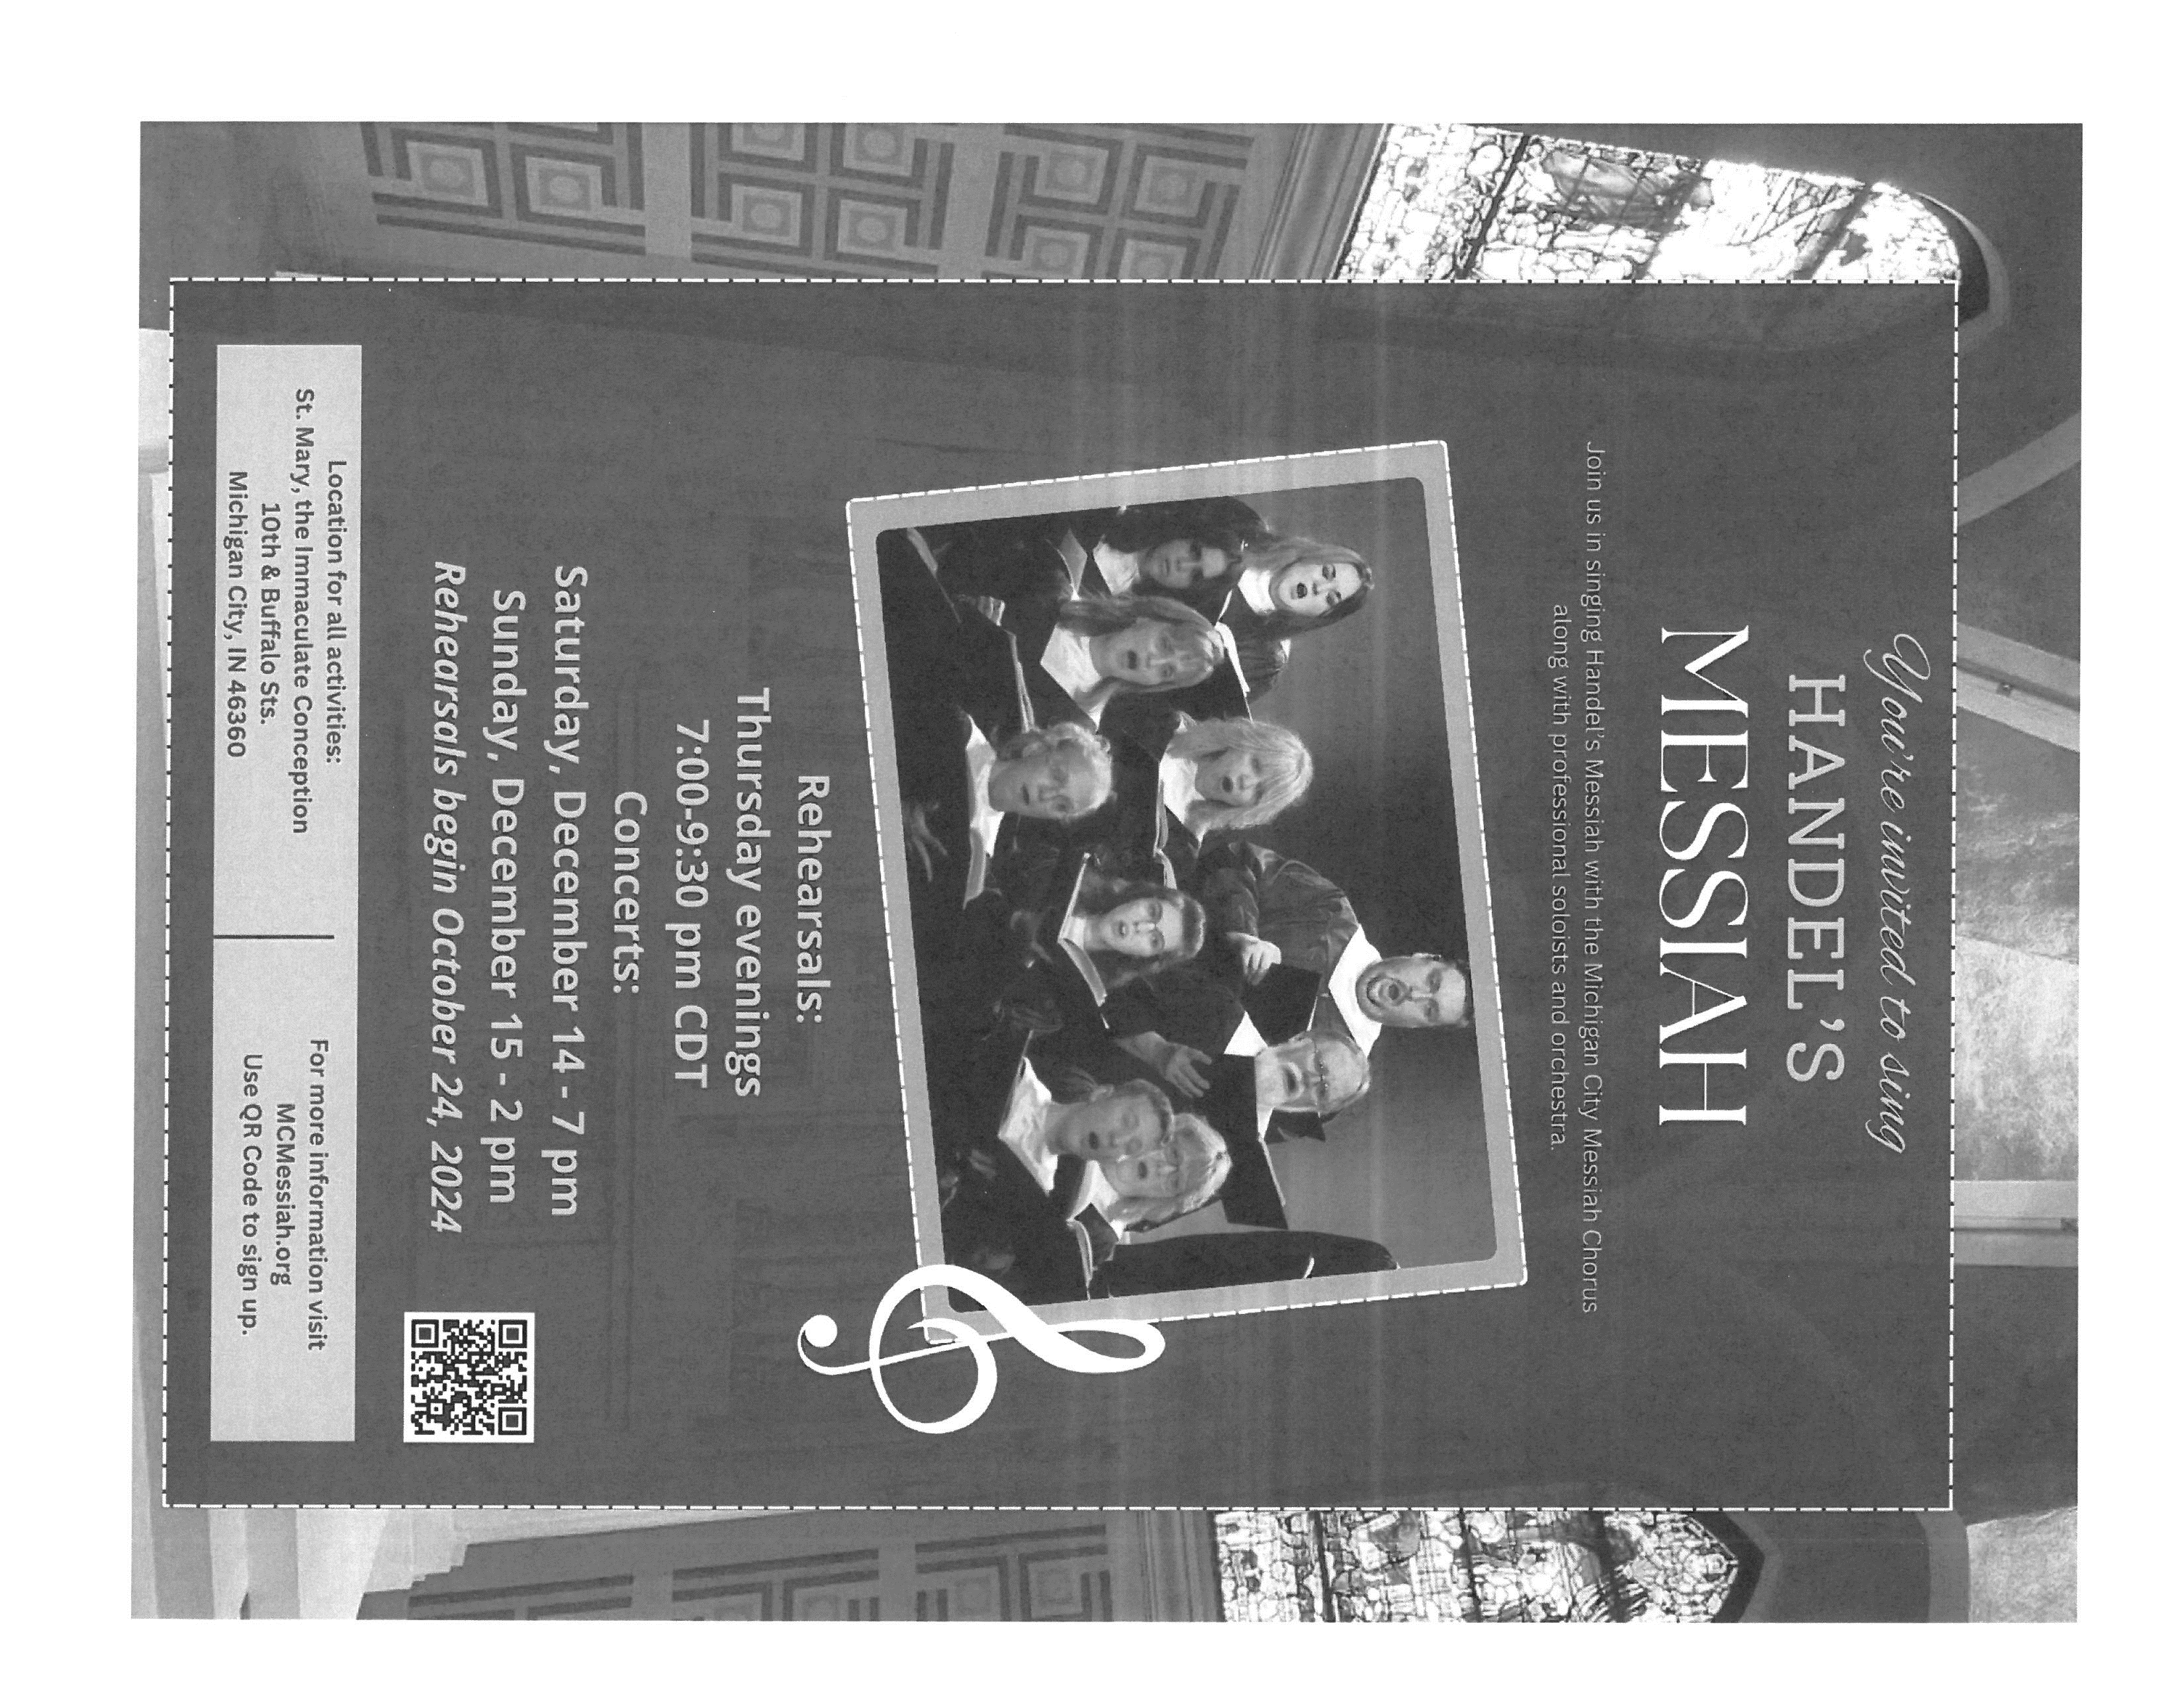

**A REFORMATION SURPRISE**

To help us celebrate the festival of Reformation Day on October 27, we had not one but *seven* Martin Luthers show up! Although they were not present during the liturgy, they did make their appearance at coffee hour afterwards. Their presence added to the joy and fellowship everyone enjoyed. Thank you, Martins!

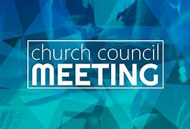

**OCTOBER COUNCIL HIGHLIGHTS**

* After a discussion about the leak in the roof of the Luther House, a motion was made by Karen Fleming, seconded by Judy Hunt and approved by Council to make repairs.
* First Methodist has invited St. Paul members to join in “Messy Church,” which they hold every First Friday. This will be held in the St. Paul Room.
* Based on the 11 suggestions received from congregation members, it was approved by Council to donate proceeds from the school sale to all 11 organizations. It was also decided to increase the St. Paul Samaritan Fund and Katie’s Purse.
* The slate of officers and membersforthe upcoming year was presented. President: Jan Bakken; Vice-President: Donna Knoll; Secretary: Judy Hunt; Treasurer: Karen Fleming; Council members: Sue Koziel, Trish Sprague, and Jim Schraidt. Names will be taken from the floor.

Full copies of the approved minutes are available in the church narthex.



**November Birthdays November Anniversaries**

1 Rian Wiseman 1 Warren & Kathryn Glanz

5 Gary Larson 23 Bob & Karen Kiser

Sarah Sutor 26 Dave & Sue Pfeiffer

6 Allen Sydow

Susan Levenhagen

7 Judy Hunt

8 Brittany Struebing

9 Fred Hart

Kari Hendricks

11 Jeffrey Timmrick

Kaylee Richardson

12 Collin Fisher

17 Susan Tomsheck

Ryan Scheuchner

Noah VanGemeren

20 Scott Bartels

23 JoAnne Sydow

24 Carrie Ziesmer

25 Marla Furness

26 Mark Robbins

Dave Pfeiffer

Gaby Cains

30 Rhys Fratgillo

**Long-Term Prayer List**

Laura Dovey Russ Fischer Marla Furness

Janet Green Nancy Hoover Jess Kalvaitis

Marsha Kenney Christine Kiser Bethany Manning

Christian Martinez Shirley McCarty Ken Mulder

Shane Nevels Jan Paholski Kay Peglow

Danielle Schnell Martha Schroeder Jeanie Boatman Shepple

Joan Siefert Joyce Stark Kathy Stein

Donna Storey Jary Tannehill Mark Tannehill

Kathy Thielman Jana Thomas Venia Wendt

Brian Wiseman

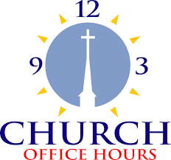

Monday 8:00 a.m. – 5 p.m.

Tuesday 9:00 a.m. – 12:00 noon

Wednesday 8:00 a.m. – 5 p.m.

Thursday 9:00 a.m. – 12 noon

Friday 8:00 a.m. – 12 noon

**St. Paul Lutheran Church Staff**

Pastor Rev. Mark Reshan

Secretary Libby Pollock

Accompanists Jary Tannehill, Mark Tannehill, Jacob Tannehill

Custodian Mark Kloess

Thank$ for $haring

We raised $180 at the Holly’s Give-Back last month and $240 at Galveston the month before. Thank you for your participation!

This month, we will see you at Swingbelly’s on Wednesday, November 13. Here are two coupons: one for you and one for a friend.

