**ALL SAINTS’ DAY**

**The Twenty-Fourth Sunday After Pentecost**

**November 3, 2024**

Though not specifically labelled as such, the raising of Lazarus is the climactic “sign” within Jesus’ ministry in John. In this Gospel, the astounding things Jesus does are not “miracles,” not simply places where the general patterns of the world swerve wildly. Instead, they are revelations, signs that point beyond the astounding event itself to something else. More precisely, they point to someone else.

They testify to Jesus as the Son to whom the Father has given life (John 5:25-26). This scene points to Jesus’ own glorification through his death and resurrection (12:23). There too we will find a tomb, a stone, grieving women, the linen wrappings and face cloth. This means that if we focus on Lazarus being brought back to life and perhaps even wrestle with why others whom we love were not similarly brought back, we have missed the point rather badly.

This text is also not simply about how Jesus will raise us on the last day. This was Martha’s confession, and (though true) it was not sufficient. Jesus calls Lazarus out, like the good shepherd who calls his sheep and gives them life (10:3, 27-28). This is what Jesus does for all those who believe in him. Jesus has the power to give life now, because Jesus is the presence of God’s life become flesh for us.

Jesus raising Lazarus does not negate the promise of the day that is coming when all those in the tombs will hear his voice and come out (John 5:28), but it is not primarily about that claim. What it reveals is that Jesus is the one in whom there is life (1:4), the one who even now calls us out of all the dark and binding places of death (5:25).

In grief, people do not only need or want to know that Jesus is powerful enough to raise the dead. After all, then why didn’t Jesus do more to help their own family member, or to stop the monstrous daily march of death through our world? But Jesus is life itself; Jesus himself is resurrection’s defeat of death. Jesus is the place where death ends and everlasting life begins.

Without denying the eschatological promise of resurrection and death’s final elimination, the life of Jesus breaks into our present and transforms it. What we need to hear is that on both sides of the grave there is life for us because Jesus has been sent to call our names. On both sides of the grave Jesus is life for us.

This is what All Saints Day is for: not just to remember those from long ago or those whose deaths are still painfully near, and not just to point ahead to that ultimate promise of resurrection, though both of these are certainly part of this day and to be affirmed. More centrally, however, this day is about what all God’s saints have known and experienced, that here and now there is no death or grief or fear so deep and dark that the voice of Jesus cannot reach into it, call us out, and bring life.

**Brian Peterson**

**✠ In the Name of Jesus ✠**

**INTRODUCTION**

Of all three years of the lectionary cycle, this year's All Saints readings have the most tears. Isaiah and Revelation look forward to the day when God will wipe away all tears; in John's gospel, Jesus weeps along with Mary and all the gathered mourners before he demonstrates his power over death. On All Saints Day we celebrate the victory won for all the faithful dead, but we grieve for our beloved dead as well, knowing that God honors our tears. We bring our grief to the table and find there a foretaste of Isaiah's feast to come.

**All Saints Day**

The custom of commemorating all of the saints of the church on a single day goes back at least to the third century. All Saints Day celebrates the baptized people of God, living and dead, who make up the body of Christ. On this day or the following Sunday, many congregations will remember the faithful who have died during the past year. We will also give thanks for those saints who in the last year have been raised up from the waters of Baptism.

**✠ GATHERING ✠**

**PRE-SERVICE MUSIC Love is Here New Song Praise Band**

(Donehey, Jamison, LaRue, Ingram and Middleton)

**ANNOUNCEMENTS**

As you are able please rise

**GATHERING SONG 423 *Shall We Gather at the River?***

**THE GREETING**

P: The grace of our Lord Jesus Christ, the love of God, and the communion of the Holy

Spirit be with you all.

**C: And also with you.**

*The assembly is seated*

**THE SACRAMENT OF HOLY BAPTISM**

**Presentation**

*The presiding minister may address the assembly in these or similar words:*

In baptism our gracious heavenly Father frees us from sin and death by joining us to the death and resurrection of our Lord Jesus Christ. We are born children of a fallen humanity; by water and the Holy Spirit we are reborn children of God and made members of the church, the body of Christ. Living with Christ and in the communion of saints, we grow in faith, love, and obedience to the will of God.

*Sponsors for each candidate, in turn, present the candidates:*

I present ***Beckett Reed***for baptism.

*The presiding minister addresses parents or others who bring for baptism children who are not able to answer for themselves:*

Called by the Holy Spirit, trusting in the grace and love of God, do you desire to have ***Beckett Reed***baptized into Christ?

*Response:*

I do.

*The presiding minister continues:*

As you bring ***Beckett Reed***to receive the gift of baptism, you are entrusted with responsibilities:

to live with him among God's faithful people,

bring him to the word of God and the holy supper,

teach him the Lord's Prayer, the Creed, and the Ten Commandments,

place in his hands the holy scriptures,

and nurture him in faith and prayer,

so that he may learn to trust God,

proclaim Christ through word and deed,

care for others and the world God made,

and work for justice and peace.

Do you promise to help ***Beckett Reed***grow in the Christian faith and life?

*Response:*

I do.

*The presiding minister addresses sponsors:*

Sponsors, do you promise to nurture ***Beckett Reed***in the Christian faith as you are empowered by God's Spirit, and to help him live in the covenant of baptism and in communion with the church?

*Response:*

I do.

*The presiding minister addresses the assembly:*

People of God, do you promise to support ***Beckett Reed***and pray for him in his new life in Christ?

**We do.**

**Profession of Faith**

*The presiding minister addresses candidates for baptism as well as the parents and sponsors of young children. The assembly may join in the responses.*

I ask you to profess your faith in Christ Jesus, reject sin, and confess the faith of the church.

Do you renounce the devil and all the forces that defy God?

*Parents and sponsors:*

I renounce them.

Do you renounce the powers of this world that rebel against God?

*Parents and sponsors:*

I renounce them.

Do you renounce the ways of sin that draw you from God?

*Parents and sponsors:*

I renounce them.

*The presiding minister addresses the candidates and the assembly.*

Do you believe in God the Father?

**I believe in God, the Father almighty,**

**creator of heaven and earth.**

Do you believe in Jesus Christ, the Son of God?

**I believe in Jesus Christ, His only Son, our Lord.**

**He was conceived by the power of the Holy Spirit**

**and born of the virgin Mary.**

**He suffered under Pontius Pilate,**

**was crucified, died, and was buried.**

**He descended into hell.**

**On the third day He rose again.**

**He ascended into heaven,**

**and is seated at the right hand of the Father.**

**He will come again to judge the living and the dead.**

Do you believe in God the Holy Spirit?

**I believe in the Holy Spirit,**

**the holy catholic church,**

**the communion of saints,**

**the forgiveness of sins,**

**the resurrection of the body,**

**and the life everlasting. Amen.**

**Thanksgiving at the Font**

*Water may be poured into the font before or during the thanksgiving. At the font, the presiding minister begins the thanksgiving:*

The Lord be with you.

**And also with you.**

Let us give thanks to the Lord our God.

**It is right to give our thanks and praise.**

Blessed are You, O God, maker and ruler of all things. Your voice thundered over the waters at creation. You water the mountains and send springs into the valleys to refresh and satisfy all living things.

Through the waters of the flood You carried those in the ark to safety. Through the sea You led Your people Israel from slavery to freedom. In the wilderness You nourished them with water from the rock, and You brought them across the river Jordan to the promised land.

By the baptism of His death and resurrection, Your Son Jesus has carried us to safety and freedom. The floods shall not overwhelm us, and the deep shall not swallow us up, for Christ has brought us over to the land of promise. He sends us to make disciples, baptizing in the name of the Father, and of the Son, and of the Holy Spirit.

Pour out Your Holy Spirit; wash away sin in this cleansing water; clothe the baptized with Christ; and claim Your daughters and sons, no longer slave and free, no longer male and female, but one with all the baptized in Christ Jesus, Who lives and reigns with You in the unity of the Holy Spirit, one God, now and forever.

**Amen.**

**Baptism**

*The presiding minister baptizes each candidate. The candidate is immersed into the water, or water is poured on the candidate's head, as the presiding minister says:*

***Beckett Reed***, I baptize you in the name of the Father, and of the Son, and of the Holy Spirit.

**Amen.**

**You belong to Christ,**

**in Whom you have been baptized.**

*The presiding minister continues:*

Let us pray.

We give you thanks, O God, that through water and the Holy Spirit you give your daughters and sons new birth, cleanse them from sin, and raise them to eternal life.

*Laying both hands on the head of each of the newly baptized, the minister prays for each:*

Sustain ***Beckett Reed*** with the gift of Your Holy Spirit: the spirit of wisdom and understanding, the spirit of counsel and might, the spirit of knowledge and the fear of the Lord, the spirit of joy in Your presence, both now and forever.

**Amen.**

*The presiding minister marks the sign of the cross on the forehead of each of the baptized. Oil prepared for this purpose may be used. As the sign of the cross is made, the minister says:*

***Beckett Reed***, child of God, you have been sealed by the Holy Spirit and marked with the cross of Christ forever.

**Amen.**

**Welcome**

*A lighted candle may be given to each of the newly baptized (to a sponsor of a young child) as a representative of the congregation says:*

Let your light so shine before others

that they may see your good works

and glorify your Father in heaven.

*The ministers and the baptismal group face the assembly. A representative of the congregation leads the assembly in the welcome.*

Let us welcome the newly baptized.

**We welcome you into the body of Christ and into the mission we share:**

**join us in giving thanks and praise to God**

**and bearing God's creative and redeeming word to all the world.**

**THE PRAYER OF THE DAY**

P: The Lord be with you.

**C: And also with you.**

P: Let us pray. Almighty God, You have knit Your people together in one communion in

the mystical body of Your Son, Jesus Christ our Lord. Grant us grace to follow Your

blessed saints in lives of faith and commitment, and to know the inexpressible joys You

have prepared for those who love You, through Jesus Christ, our Savior and Lord, Who

lives and reigns with You and the Holy Spirit, one God, now and forever.

**C: Amen.**

**✠ WORD ✠**

**FIRST READING Isaiah 25: 6-9**

Isaiah sees a vision of the end of days, when the Lord will gather all God’s people on God’s holy mountain and will prepare for them a rich feast. At this banquet the Lord will wipe the tears from all eyes. And there will be no more sorrow, for God will destroy death itself.

On this mountain the LORD of hosts will make for all peoples

a feast of rich food, a feast of well-aged wines,

of rich food filled with marrow, of well-aged wines strained clear.

7And He will destroy on this mountain

the shroud that is cast over all peoples,

the sheet that is spread over all nations;

He will swallow up death forever.

8Then the Lord GOD will wipe away the tears from all faces,

and the disgrace of His people He will take away from all the earth,

for the LORD has spoken.

9It will be said on that day,

Lo, this is our God; we have waited for Him, so that He might save us.

This is the LORD for whom we have waited;

let us be glad and rejoice in His salvation.

The Word of the Lord.

**Thanks be to God.**

**THE PSALM: Psalm 24** Antiphon by Anne Krentz

Choir sings refrain first, followed immediately by the congregation

and as indicated

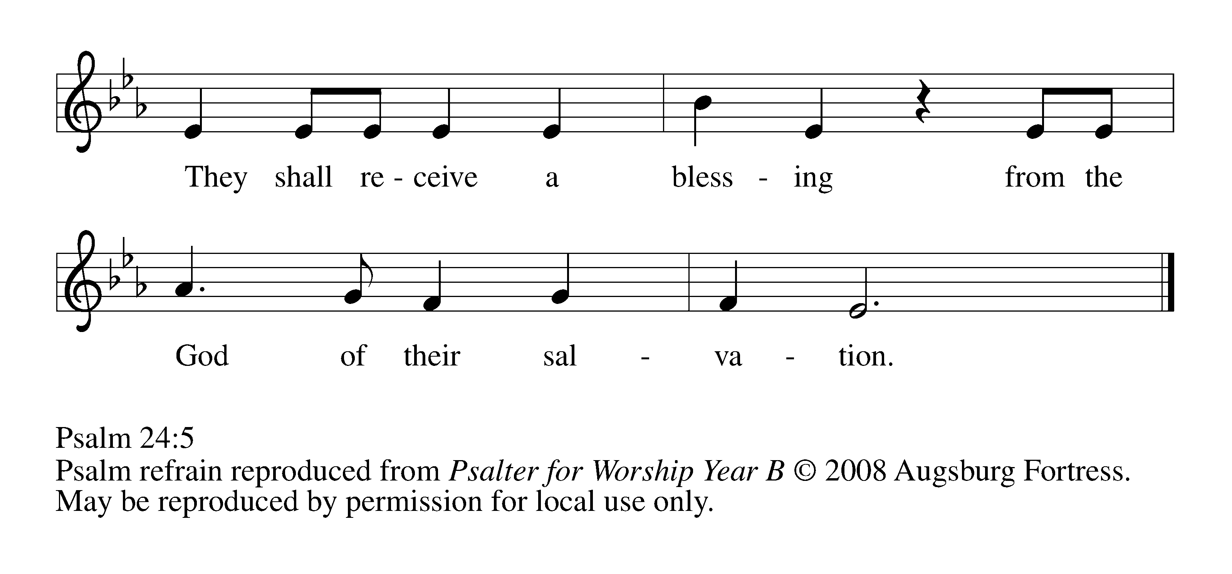

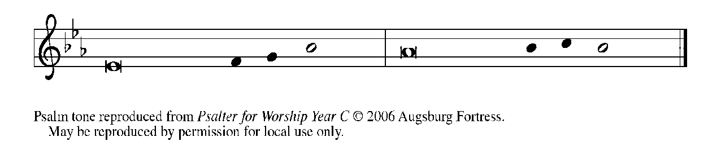

The earth is the LORD's and all | that is in it,*

the world and all who | dwell therein.

**2For it is He Who founded it up- | on the seas\***

**and made it firm upon the rivers | of the deep. REFRAIN**

3 "Who can ascend the hill | of the LORD*

and who can stand in His | holy place?"

**4"Those who have clean hands and | a pure heart,\***

**who have not pledged themselves to falsehood, nor sworn by what | is a fraud.**

5They shall receive a blessing | from the LORD*

and a just reward from the God of | their salvation."

**6Such is the generation of | those who seek Him,\***

**of those who seek Your face, O | God of Jacob. REFRAIN**

7Lift up your heads, O gates; lift them high, O ever- | lasting doors;*

and the King of glory | shall come in.

**8 "Who is this | King of glory?"\***

**"The LORD, strong and mighty, the LORD, might- | y in battle."**

9Lift up your heads, O gates; lift them high, O ever- | lasting doors;*

and the King of glory | shall come in.

**10"Who is He, this | King of glory?"\***

**"The LORD of hosts, He is the | King of glory." REFRAIN**

**SECOND READING Revelation 21: 1-6a**

Here is a vision of the new heaven and new earth in which God resides fully with God’s people so that mourning, despair, and pain have been eradicated. These renewing words from the God who spans all of time are trustworthy and true.

I saw a new heaven and a new earth; for the first heaven and the first earth had passed away, and the sea was no more. 2And I saw the holy city, the new Jerusalem, coming down out of heaven from God, prepared as a bride adorned for her husband. 3And I heard a loud voice from the throne saying,

"See, the home of God is among mortals.

He will dwell with them as their God;

they will be His peoples,

and God Himself will be with them;

4He will wipe every tear from their eyes.

Death will be no more;

mourning and crying and pain will be no more,

for the first things have passed away."

5And the One Who was seated on the throne said, "See, I am making all things new." Also He said, "Write this, for these words are trustworthy and true." 6aThen He said to me, "It is done! I am the Alpha and the Omega, the Beginning and the End."

The Word of the Lord.

**Thanks be to God.**

*As you are able please rise*

**THE VERSE**

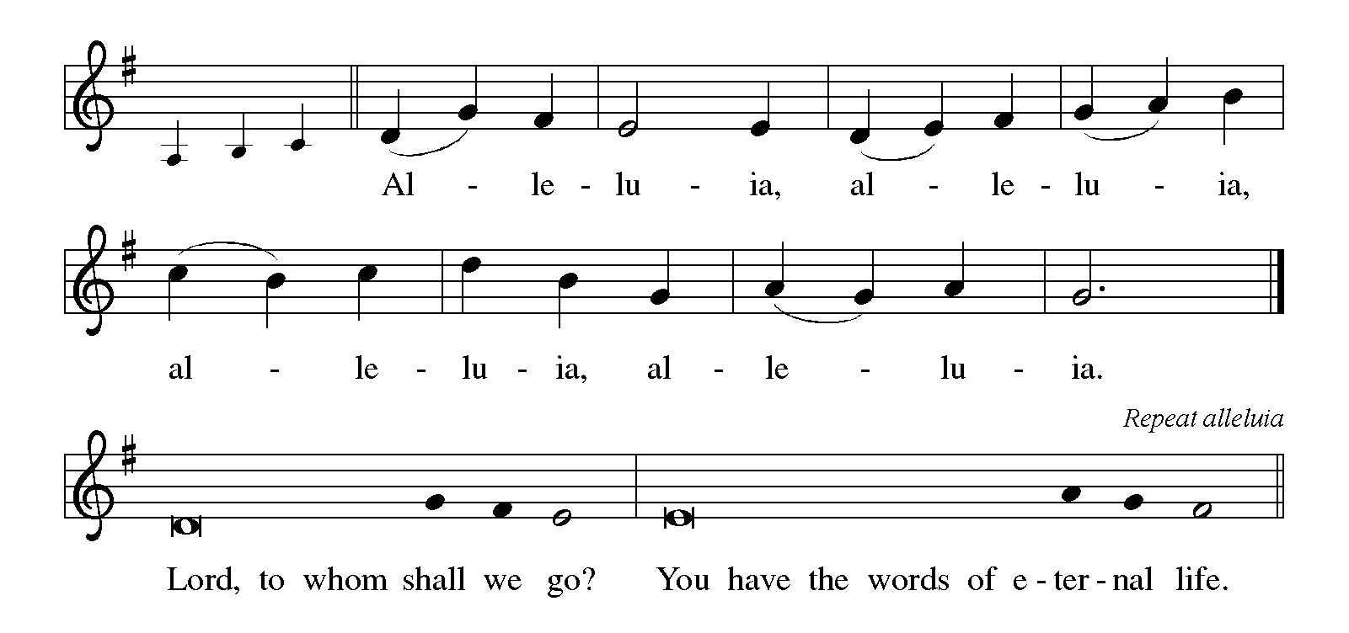

**THE HOLY GOSPEL John 11: 32-44**

Through the raising of Lazarus, Jesus offers the world a vision of the life to come, when death and weeping will be no more.

P: The Holy Gospel according to St. John, the eleventh chapter.

**C: Glory to You, O Lord!**

When Mary came where Jesus was and saw Him, she knelt at His feet and said to Him, "Lord, if You had been here, my brother would not have died." 33When Jesus saw her weeping, and the Judeans who came with her also weeping, He was greatly disturbed in spirit and deeply moved. 34He said, "Where have you laid him?" They said to Him, "Lord, come and see." 35Jesus began to weep. 36So the Judeans said, "See how He loved him!" 37But some of them said, "Could not He Who opened the eyes of the blind man have kept this man from dying?"

38Then Jesus, again greatly disturbed, came to the tomb. It was a cave, and a stone was lying against it. 39Jesus said, "Take away the stone." Martha, the sister of the dead man, said to Him, "Lord, already there is a stench because he has been dead four days." 40Jesus said to her, "Did I not tell you that if you believed, you would see the glory of God?"

41So they took away the stone. And Jesus looked upward and said, "Father, I thank You for having heard Me. 42I knew that You always hear Me, but I have said this for the sake of the crowd standing here, so that they may believe that You sent me."

43When He had said this, He cried with a loud voice, "Lazarus, come out!" 44The dead man came out, his hands and feet bound with strips of cloth, and his face wrapped in a cloth. Jesus said to them, "Unbind him, and let him go."

P: The Gospel of the Lord.

**C: Praise to You, O Christ!**

*The assembly is seated*

**THE SERMON**

*Silence for reflection follows the sermon*

*As you are able please rise*

**THE HYMN OF THE DAY *Look Who Gathers at Christ’s Table***

(Sung to the tune of, *Joyous Light of Heavenly Glory*)

**1 Look who gathers at Christ's table!**

**Hear the stories that they bring.**

**Some are weeping; some are laughing;**

**some have songs they want to sing.**

**Others ask why they're invited,**

**burdened by the wrong they've done.**

**Christ insists they all are welcome.**

**There is room for ev'ryone.**

**2 Clouds of light surround the table;**

**ancient followers appear,**

**saints confessing how they wrestled**

**with their guilt, their doubt and fear.**

**Peter tells of his denying**

**Christ was ever in his sight;**

**Paul relates his fruitless efforts**

**to obliterate the Light.**

**3 Their sad stories are repeated**

**in a thousand diff'rent ways,**

**but they share one thing in common:**

**they all end in thanks and praise**

**for the Host Who has invited**

**north and south and east and west**

**to converge around this table,**

**where all life is fed and blest.**

**4 Bring your joy and bring your sadness,**

**and prepare to be surprised**

**by the Host Whose hands are wounded,**

**Who will open wide your eyes**

**when He blesses bread and breaks it—**

**truth and manna from above!—**

**and then passes wine that wakens**

**in your heart the taste of love.**

Text: Thomas H. Troeger, b. 1945

Text © 2002 Oxford University Press. All rights reserved.

**THE PRAYER OF THE CHURCH**

A: In communion with all the saints, let us pray to God Who is our resurrection, our life,

and our eternal home.

A: For the holy Church of God throughout the world, that God might confirm it in faith,

sustain it in hope, and deepen its witness to Christ, let us pray to the Lord:

**C: Lord, hear our prayer.**

A: For those 340 million Christians being persecuted because of their faith in Christ,

especially in North Korea; Afghanistan; Somalia; Libya; Pakistan; Eritrea; Yemen;

Iran; Nigeria; and India that God may lift their shroud of suffering and establish them

in peace and justice, let us pray to the Lord:

**C: Lord, hear our prayer.**

A: For ***Becket Reed****,* newly baptized, that he may be filled with the Holy Spirit, lack no

spiritual gift, and grow into the fullness of life in the Christ to Whom he has been

joined, let us pray to the Lord:

**C: Lord, hear our prayer.**

A: For our community of faith, that we may grow into and mirror the abundant generosity

of God in our care for one another, and especially the poor, the hungry, the lonely, and

the homeless, let us pray to the Lord:

**C: Lord, hear our prayer.**

A: For those who suffer in body or spirit, especially: **Janet Green; Venia Wendt; Russ**

**Fischer; Martha Schroeder; Ken Mulder; Christine Kiser; Debbie Martin; Kathy**

**Stein; Mark Tannehill; and Brian Wiseman** that they may know the healing power

of God Who banishes crying and pain, let us pray to the Lord:

**C: Lord, hear our prayer.**

A: For those celebrating birthdays, especially: **Allen Sydow,** that they may grow in grace

this day and be filled with grace in the days ahead, let us pray to the Lord:

**C: Lord, hear our prayer.**

A: For all the saints who have gone before us into death in this year**: Pastor Al Lorentzen;**

**Betty Yourist; Charles Thomas, Sr.; Ed Werner; Jim Gleason; Randy Peters; and**

**Darlene Baker**and for those who emerged from the waters of Baptism: **Sophia and**

**Athena Putnam; and Beckett Fratgillo**, we give thanks to the Lord. That with them

we may be brought before the throne of the Lamb in glory, let us pray to the Lord:

**C: Lord, hear our prayer.**

A: For the faithful of every time and place, let us give thanks to the Lord. That surrounded

by so great a cloud of witnesses, we may continue our journey to the new Jerusalem as

we seek the love of Christ in all things, let us pray to the Lord:

**C: Lord, hear our prayer.**

P: Your Reign, O God, endures forever, and in Christ we are free to be Your saints and

servants. Hear our prayers for the sake of Him Who died and rose again, Your Son,

Jesus Christ, Who lives with You and the Holy Spirit in the company of all Your saints

in light.

**C: Amen.**

**✠ MEAL ✠**

**THE PEACE**

P: The peace of the Lord be with you always.

**C: And also with you.**

*The assembly is seated*

**THE VOLUNTARY Choir** ***Seek Ye First***  **St. Paul Senior Choir**

(K. Lafferty)

**THE OFFERING**

*As you are able please rise*

**THE PRESENTATION OF THE GIFTS**

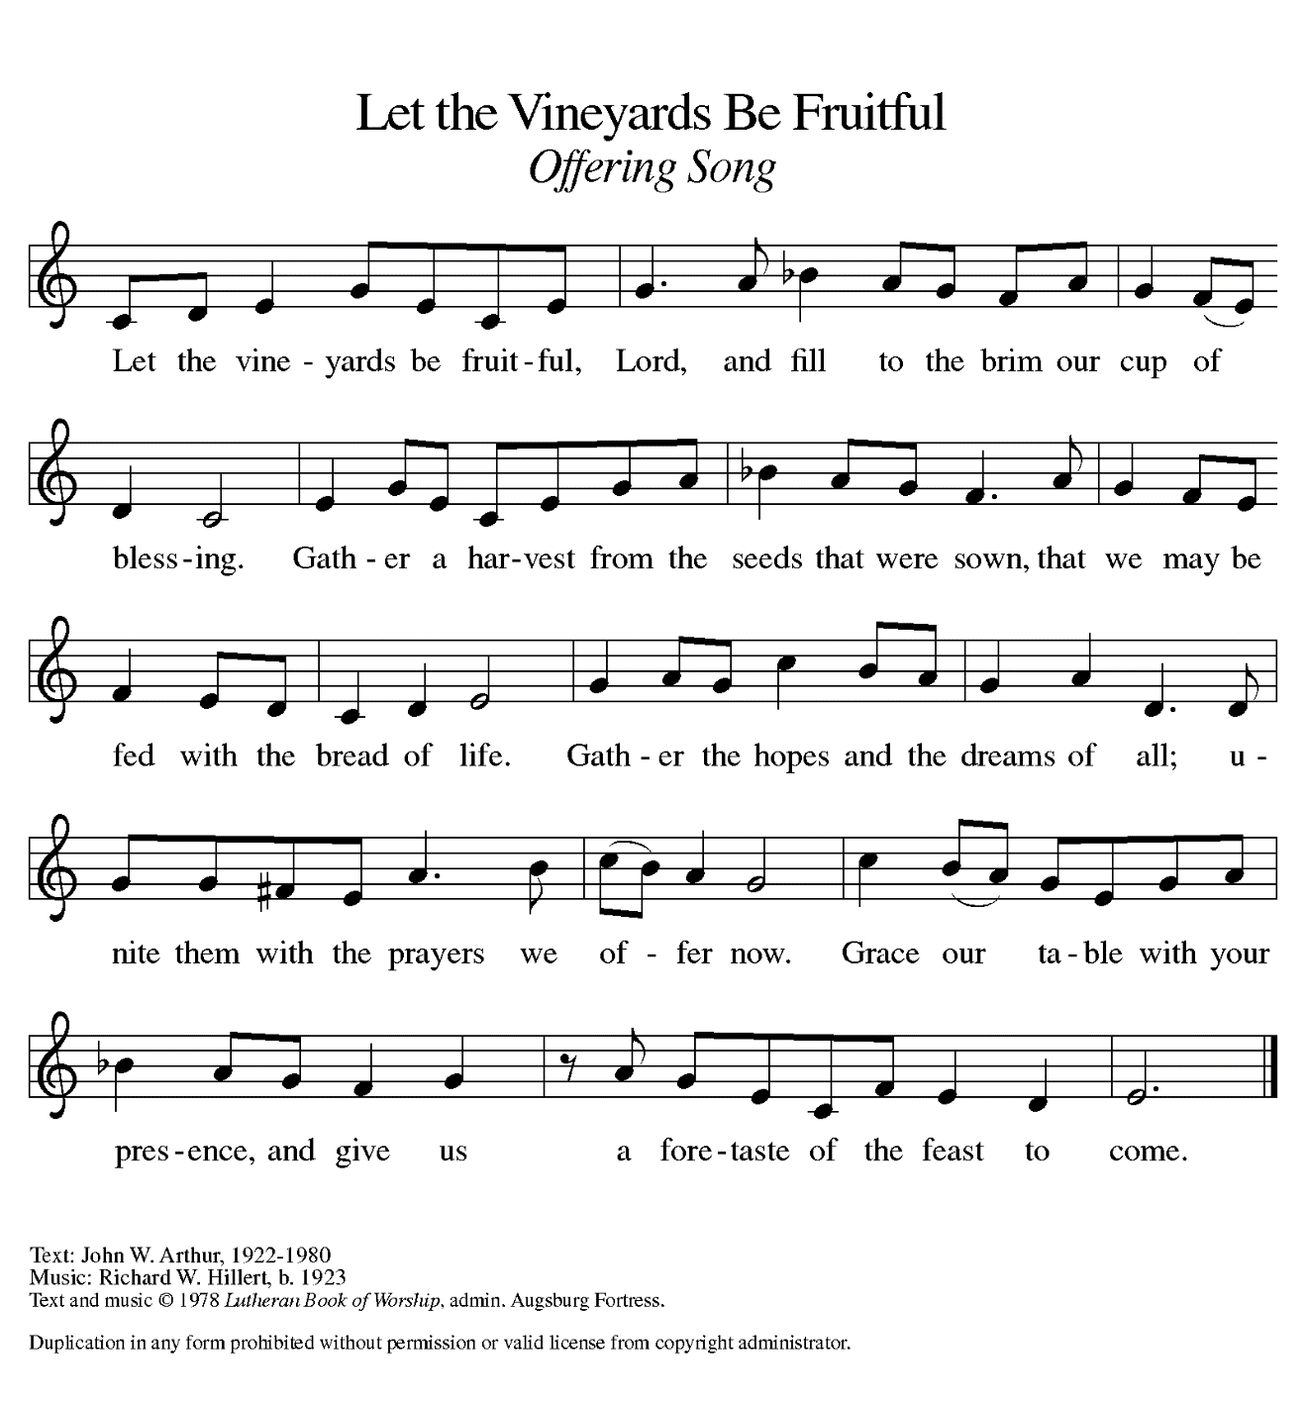**THE OFFERTORY PRAYER**

A: Let us pray. Holy and mighty God,

**C: We give You thanks for the triumph of Christ in the lives of His saints. Receive**

**all we offer You this Day, and help us, like them, to run our course with faith, until**

**we come to the new heaven and earth of Your everlasting Kingdom. We ask this**

**in the name of Jesus the Lord. Amen.**

**THE GREAT THANKSGIVING**

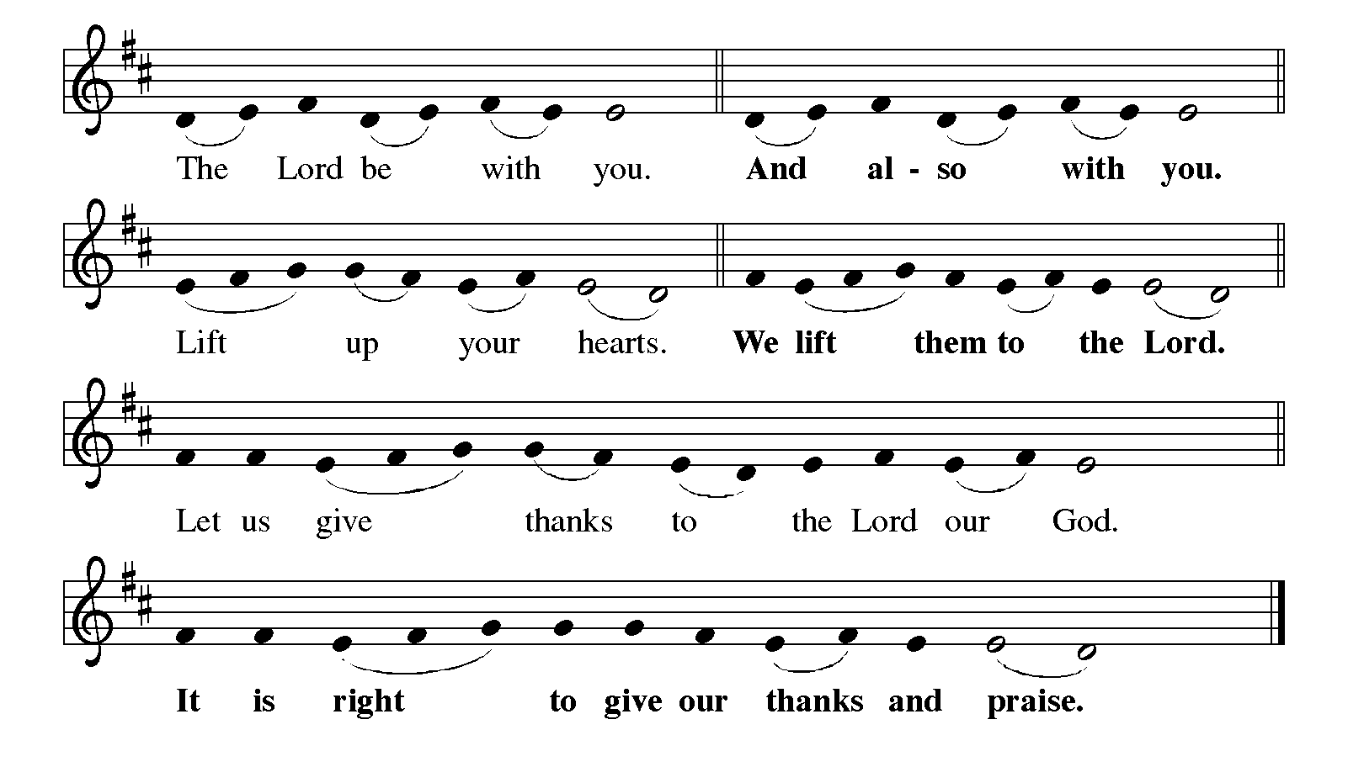

P: It is our duty and delight … and join their unending hymn:

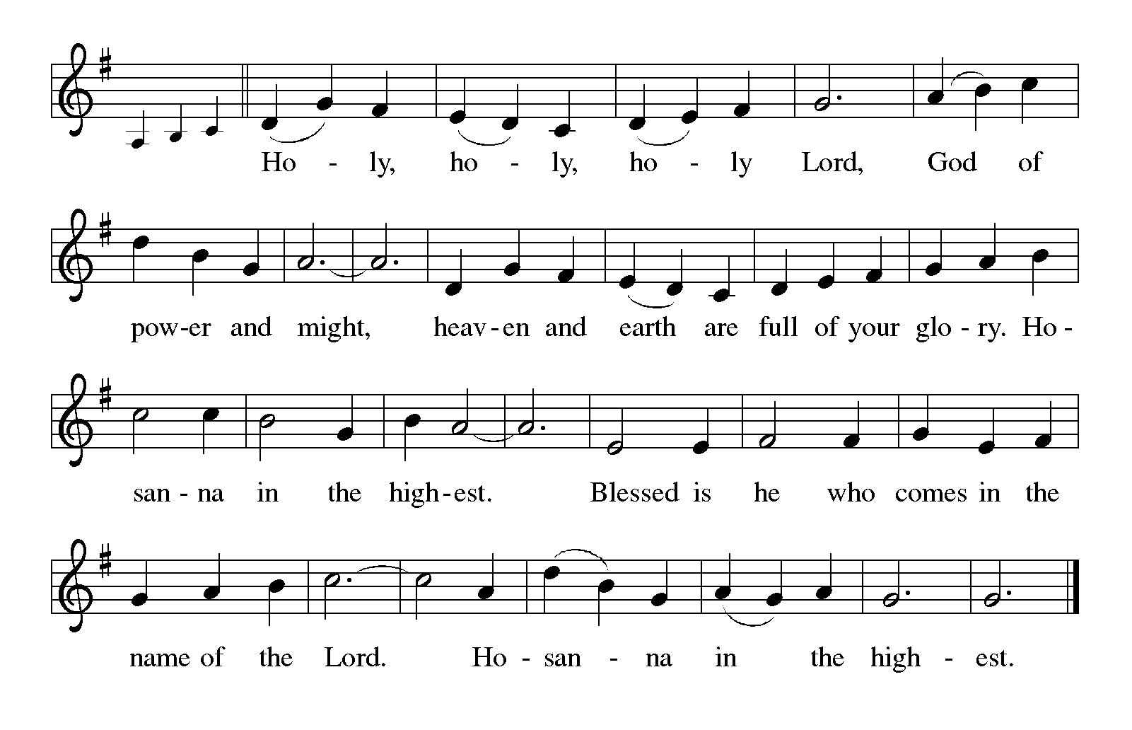

P: Blessed are You, holy God, Lord of Hosts, the Beginning and the End.

For You created the heavens and the earth and all creatures in them.

You raised up women and men to bear witness to Your light and love.

You chose Israel to be a beacon of hope to all the world.

Through her judges and poets, kings and prophets, You delivered them from

defeat, wiped their tears, and promised an end to death forever.

At the last, You made Your promise come true in Your Son, Jesus Christ.

He is the Resurrection and the life.

In the night ... “Do this for the remembrance of Me.”

As often as we eat ... we proclaim the Lord’s death until He comes.

**C: Christ has died. Christ is risen. Christ will come again.**

P: With this bread and cup we remember the life our Lord offered for us.

Making His home among us, He overcame loss and grief by healing the sick,

feeding the hungry, and resurrecting the dead.

He entered our death, that we might share His life. You raised Him as the first-fruits

of the dead, in Whom all will be made new.

He is coming to defeat death forever, and to host Your Feast of victory.

Send Your Spirit on us and these Your gifts of bread and wine, that we and

all who share the Lord’s Body and Blood

May go with Christ to comfort the weak and dying until all people dwell with God and

His saints in everlasting glory.

To You, O God: Father, Son, and Holy Spirit, be all honor and glory, in Your holy

Church, in heaven and on earth, now and forever.

**C: Amen!**

**THE LORD’S PRAYER**

P: Because God’s love has made us God’s beloved children, in the words Jesus taught us

we dare to pray:

**C: Our Father in heaven, hallowed be Your name. Your Kingdom come. Your will**

**be done on earth as in heaven. Give us this day our daily bread. Forgive us our**

**sins as we forgive those who sin against us. Save us from the time of trial and**

**deliver us from evil. For the Kingdom, the power, and the glory are Yours, now**

**and forever. Amen.**

**INVITATION TO THE MEAL**

P: This is the Lamb of God Who takes away the sin of the world. Blessed are those who

are called to the Supper of the Lamb. God's holy gifts for God's holy people. Come,

for all is now ready.

*The assembly is seated*

**THE DISTRIBUTION**

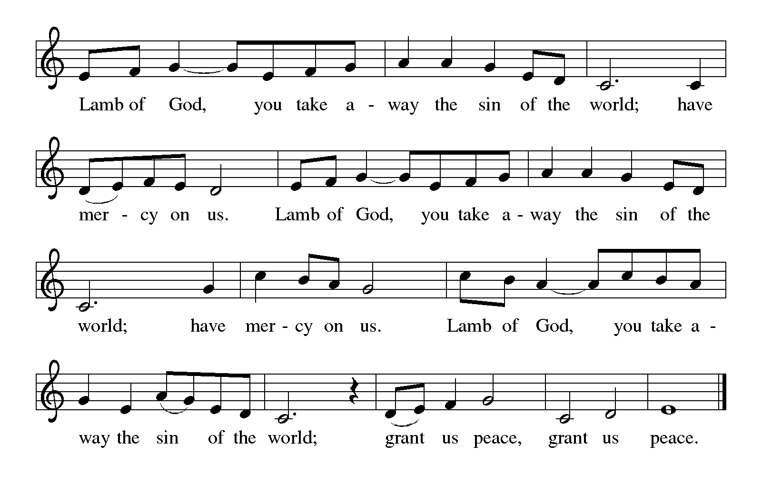

**HYMN DURING DISTRIBUTION 628 *Jerusalem, My Happy Home***

**ELW 785 *When Peace Like a River***

**ELW 423 *Soon and Very Soon***

**NSB 96 *We Are An Offering***

*As you are able please rise*

**THE POST-COMMUNION BLESSING**

P: The Body and Blood of our Lord Jesus Christ strengthen you and keep you in His grace.

**C: Amen.**

**THE POST-COMMUNION PRAYER**

A: Let us pray. God of the ages, in this holy Supper we have received the fruit of the vine

and the Bread of eternal life, the Body and Blood of Your Son. Strengthen us as we

await the harvest of everlasting life, where we will dwell with you and all the saints in

the peace of Your eternal home. Grant this through Christ our Lord.

**C: Amen.**

**✠ SENDING ✠**

**THE BENEDICTION**

P: Almighty God: Father, **✠** Son, and Holy Spirit, bless you now and forever.

**C: Amen.**

**THE SENDING HYMN *Oh, When the Saints Go Marching In***



**THE DISMISSAL**

A: Go in peace to bear Christ's love to the world.

**C: Thanks be to God!**

**POSTLUDE**

**✠ *To God Alone Be Glory* ✠**

The Meditation is from *Working Preacher Online.* Copyright Luther Seminary, 2018.

**ANNOUNCEMENTS**

**Please remember to mail your offering to the Church Office** at 818 Franklin Street, Michigan City, IN 46360**.** Another alternative is to give on-line through Tithe.ly. Please see your closure letter for information on how to set up a Tithe.ly account.

**St. Paul Members are reminded to have** a loved one contact the office if you are hospitalized. Many times, the Pastor doesn’t know someone is in the hospital. If you call and leave a message, please tell us which hospital the patient is at.

**Birthdays: Allen Sydow (11/6)**

**PRAYER CONCERNS:** Jeanie Boatman Shepple, Joan Seifert, Nolan Wilson, Debbie Martin, Mark Tannehill, Brian Wiseman, Kathy Stein, Danielle Schnell; Venia Wendt, Jan Paholski, Laura Dovey, Nancy Hoover, Grace Romine and Janet Green.

**OFFICE HOURS:** Libby will be in the office on Mondays, Wednesdays,

and Fridays; volunteers will cover Tuesdays and Thursdays.

Monday & Wednesday 8:00 a.m. – 5 p.m.

Tuesday & Thursday 9:00 a.m. – 12:00 p.m.

Friday 8:00 a.m. – 12:00 p.m.

**If you are listening to the worship broadcast on the radio and would like to watch the Sunday morning service live stream follow these steps:**

(1) If you have You Tube available on your TV, search for

**St. Paul Lutheran Church Michigan City, IN.**

(2) The direct link on the computer is

https://www.youtube.com/channel/UC5AIPNaKr3QN50984jGOa1g.

   (3) This link is also on the main page of the church’s website in

the church section and will continue to be posted weekly on the St.

Paul Facebook page.

And it will always be available on the radio broadcast Sunday mornings at 11:00 a.m.

on WEFM (95.9), and on the local cable access station #99 for the previous week’s

service on Sundays at 4:00 p.m. and the current service on Wednesdays at 7:00 p.m.

And Fridays at 8:30 p.m.

**Next Sunday’s lessons are I Kings 17: 8-16; Psalm 146; Hebrews 9: 24-28 and Mark 12: 38-44** for those of you who like to study them in advance.

**To send e-mail to the church office**, please use the following addresses:

Pastor Mark Reshan: seniorpastor@stpaulmichigancity.com

Church Office Secretary (Libby Pollock): churchsecretary@stpaulmichigancity.com

Church Treasurer (Karen Fleming): finance@stpaulmichigancity.com

**The Good News Newsletter**: If you have an article or anything you want included

in **The Good News** please send it to the following e-mail address: splcgoodnews@gmail.com. Pastor Pamela Thiede will be using this e-mail address to assemble **The Good News** each month. The deadline for getting information to Pastor Pamela will be the 20th of each month.

**Worship Attendance:**

**Saturday, October 26, 2024 @ 4:00 p.m. 31**

**Sunday, October 27, 2024 @ 9:00 a.m. 63**

**TOTAL 94**

**Copies of the minutes from the September 26, 2024 Church Council meeting and from the October 24, 2024 Church Council meeting are on the back table in the upper Narthex. They were approved by the council via email.**

**NOVEMBER MONTHLY MISSION: Guardians of the Children of Michiana**

**Guardians of the Children of Michiana** is a non-profit organization dedicated to protecting the victims of child abuse. The Guardians go to court with abused children, any types of abuse, to provide support to the child and their family. They hold monthly events for the kids to keep their mind off of the courts and pain or traumas they’ve faced, including taking them to do fun things like bowling, swimming, horseback riding, skating, etc. They also have holiday parties and, this year, will be providing for 21 children at Christmas. We will be collecting monetary donations that they can use to purchase specific gifts for each child and to fund their holiday party. Please place your donations in the offering plate marked for Guardians of the children. Noisy coin offering will also go toward the mission of the month. Thanks for your support!



**TWENTY-FIFTH ANNIVERSARY OF ORDINATION**

Twenty-five years ago (on October 23, 1999) here at St. Paul, Pastor Pamela Thiede was ordained into the ministry. The Calumet Episcopal Ministry Partnership will share in celebrating this anniversary with a potluck luncheon on Sunday, November 3, 2024 at 1:30 pm. Pastor Pamela would like to invite her friends here at St. Paul to join her in the celebration. It will be held at The Cloister in the Woods, a banquet hall at St. Paul Episcopal Church, 1101 Park Drive, Munster, Indiana. (If a lot of you are coming, that’s fine . . . please let her know so we have enough tables set up and plenty of chicken for everyone!)

**2024 Financial Stewardship**

Weekly Church Operating Needs (x 2 weeks): $ 11,602.50

October 19 - 20, October 26 -27, 2024

General Fund (including General Memorials): $ 4,602.00

Overage/Shortage: —- $ 7,000.50

Restricted Income (not including Memorials)

Supports IK Synod & Church wide Ministries: $ 265.00

Ministries in our Community/Congregation: $ 365.00

Capital Fund: $ 305.00

Memorials

General Fund $ 25.00



**FALL CONGREGATIONAL MEETING & POTLUCK LUNCHEON**

The Fall Congregational Meeting will take place in the St. Paul Room immediately following the Sunday Service on November 10th. At the Fall meeting we elect officers and council members for 2025. Please plan to attend the Potluck Luncheon following the meeting. Dishes for the potluck may be brought to the kitchen before attending Church. We hope that members who attend Saturday evening service will come back for this meeting. A “voting” member has to have attended church and communed once since January 2023 and contributed once in that time. Please plan to attend the **Fall Congregational Meeting and Potluck on Sunday, November 10, 2024.**

**WELCOME NEW BISHOP On Tuesday, November 19** we will be hosting a group of local ELCA clergy for a “Meet and Greet” with our new Bishop Timothy Graham of the Indiana-Kentucky Synod. There will be a worship service beginning at 9:30 a.m. with Pastor Reshan presiding and Bishop Graham preaching. Afterwards the Bishop and the clergy will move to the St. Paul Room for a discussion and light lunch. The congregation is invited to the worship service so feel free to join us. In order to help prepare for Communion we are asking those who will be attending to call the church office so that we may have at least a general idea of a count.

**ACTIVITIES, EVENTS & MEMORIALS**

**NOVEMBER 2024**

**Saturday,** November 2, 2024 @ 4:00 p.m. **All Saints’ Eve (24th Pentecost)** Worship Service

**Sunday,** November 3, 2024 @ 9:00 a.m. **All Saints’ Day (24th Pentecost)** Worship Service With Baptism

**Monday,** November 4, 2024 @ 10:30 a.m. Choir Rehearsal/Sanctuary

**Wednesday,** November 6, 2024 @ 9:15 a.m. Bible Study/Luther House

@ 10:00 a.m. God’s Purls/St. Paul Room

**Thursday,** November 7, 2024 Faith Circle

**Saturday,** November 9, 2024 @ 4:00 p.m. 25th Pentecost Worship Service

**Sunday,** November 10, 2024 @ 9:00 a.m. 25th Pentecost Worship Service – Immedi-

ately following service @ 10:00 a.m. **Congregational Meeting**/St. Paul Room with election of officers and Potluck Luncheon to follow

**Monday,** November 11, 2024 @ 10:30 a.m. Choir Rehearsal/Sanctuary

@ 1:00 p.m. Hope Circle/Green Room

**Tuesday,** November 12, 2024 @ 7:00 p.m. Estuary/Luther House

**Wednesday,** November 13, 2024 @ 9:15 a.m. Bible Study/Luther House

@ 10:00 a.m. God’s Purls/St. Paul Room

@ 11:00 a.m. – close **GIVE BACK @ Swingbelly’s**

**Saturday,** November 16, 2024 @ 4:00 p.m. 26th Pentecost Worship Service

**Sunday,** November 17, 2024 @ 9:00 a.m. 26th Pentecost Worship Service

**Monday,** November 18, 2024 @10:30 a.m. Choir Rehearsal/Sanctuary

@ 2:00 p.m. Finance Committee Mtg/Luther House

@3:00 p.m. Executive Board Mtg/Luther House

**Tuesday,** November 19, 2024 @ 9:30 a.m. **Welcome service** for new Bishop,

Timothy Graham; with Ministerium to

follow in St. Paul Room

**Wednesday,** November 20, 2024 @ 9:15 a.m. Bible Study/Luther House

@10:00 a.m. God’s Purls/St. Paul Room

**Thursday,** November 21, 2024 @ 5:30 p.m. Church Council Mtg/St. Paul Room

**Saturday,** November 23, 2024 @ 4:00 p.m. **Christ the King** (27th Pentecost) Worship Service

**Saturday,** November 23, 2024 @ 4:00 p.m. **Christ the King** (27th Pentecost) Worship Service

**Sunday,** November 24, 2024 @ 9:00 a.m. **Christ the King** (27th Pentecost) Worship Service

**Monday,** November 25, 2024 @ 10:30 a.m. Choir Rehearsal/Sanctuary

**Wednesday,** November 27, 2024 @ 9:15 a.m. Bible Study/Luther House

@ 10:00 a.m. God’s Purls/St. Paul Room

**Saturday,** November 30, 2024 @ 4:00 p.m. First Advent Worship Service

**Sunday,** December 1, 2024 @ 9:00 a.m. First Advent Worship Service

**YOUR HELP IS NEEDED**

The St. Paul Fellowship Organization is hosting a volunteer project on Saturday, December 7, 2024 from 10 a.m. to 7 p.m. Volunteers will be collecting donations for the Salvation Army Kettle Campaign. Our assigned kettle is located at Al’s Supermarket, 3535 Franklin Street, the North door entrance — indoors. No need to worry about the temperature, wind, rain, or snow! Because we will be near the registers Al’s has requested no bells be rung inside. Volunteers can wear festive holiday attire and signs will be provided to quietly attract attention to potential donors.

The day long drive has been divided into one hour segments, beginning on the hour. For safety reasons, we are asking that two people be with the red kettle for each hour. A sign up sheet is located in the upper narthex. If you have any questions, contact Virginia

Murray at (219) 872-9063.

 Thank$ for $haring

We raised $180.00 from our Give Back at Holly’s on Tuesday, October 15.Thank you so much to those who participated! This month we’ll see you at Swingbelly’s on Wednesday, November 13, 2024 from 11am—close. Here are two coupons: one for you and one for a friend.

