THE HOLY TRINITY
The First Sunday after Pentecost
May 31, 2026

“ … From the beginning and to this day, the congregation gathered at the Supper gives Trinitarian thanks to God. He is praised as the giver and doer of all good. The good that He does is Christ. And of that good will come the final good, present and anticipated in the Spirit. Thereby, the congregation shares the very triune life of God …”
“ … Pastors often suppose the Trinity to be too complicated to explain to the laity. Nothing could be more misguided. Believers know how to pray to the Father, daring to call him “Father” because they pray with Jesus his Son, and so enter into the future these two have for them, that is, praying in the Spirit. Those who know how to do this, and who realize that just in the space defined by these coordinates they have to do with God, do understand the Trinity.”

Robert W. Jenson
The Triune Identity

Jesus is commissioning his followers to go out and save the world. Right now churches are hoping that people will come in and save the church. They’ll come in and be good tithe-ers, good church-members, good volunteers.
Jesus didn’t tell the disciples to go and build great churches. He told them to go and make disciples.
Pulpit Fiction

In the Name of Jesus

INTRODUCTION

Though the word trinity is not found in the scriptures, today's second reading includes the apostolic greeting that begins the liturgy: The grace of our Lord Jesus Christ, the love of God, and the communion of the Holy Spirit be with you all. In the gospel Jesus sends his disciples forth to baptize in the name of the Father, and the Son, and the Holy Spirit. More than a doctrine, the Trinity expresses the heart of our faith: we have experienced the God of creation made known in Jesus Christ and with us always through the Holy Spirit. We celebrate the mystery of the Holy Trinity in word and sacrament, as we profess the creed, and as we are sent into the world to bear witness to our faith.

Visit of Mary to Elizabeth

This festival marks the occasion when Mary, pregnant with Jesus, visited her cousin Elizabeth who was herself pregnant with John. Elizabeth pronounced Mary "blessed among women," and Mary responded with the song called the Magnificat.

GATHERING

PRELUDE
ANNOUNCEMENTS

As you are able please rise

THE GATHERING HYMN 413 Holy, Holy, Holy, Lord God Almighty!

THE GREETING AND PRAYER OF THE DAY

P: The grace of our Lord Jesus Christ, the love of God, and the communion of the Holy
Spirit be with you all.

C: And also with you.

P: Let us pray. Almighty Creator and ever-living God, we worship Your glory, eternal
Three-in-One, and we praise Your power, majestic One-in-Three. Keep us steadfast in
this faith, defend us in all adversity, and bring us at last into Your presence, where You
live in endless joy and love, Father, Son, and Holy Spirit, now and forever.

C: Amen.

The assembly is seated
WORD

FIRST READING Genesis 1: 1--2:4a

This creation story reached its current form during or after the crisis of the Babylonian exile of Israel. The writer makes profound declarations of faith concerning the world, human life, and God. This faith sees the world and humanity under the sovereignty of the God who redeemed Israel: it was Israel's God who was responsible for creation, not Babylon's.

In the beginning when God created the heavens and the earth, ²the earth was a formless void and darkness covered the face of the deep, while a wind from God swept over the face of the waters. ³Then God said, "Let there be light"; and there was light. ⁴And God saw that the light was good; and God separated the light from the darkness. ⁵God called the light Day, and the darkness he called Night. And there was evening and there was morning, the first day.
⁶And God said, "Let there be a dome in the midst of the waters, and let it separate the waters from the waters." ⁷So God made the dome and separated the waters that were under the dome from the waters that were above the dome. And it was so. ⁸God called the dome Sky. And there was evening and there was morning, the second day.
⁹And God said, "Let the waters under the sky be gathered together into one place, and let the dry land appear." And it was so. ¹⁰God called the dry land Earth, and the waters that were gathered together He called Seas. And God saw that it was good. ¹¹Then God said, "Let the earth put forth vegetation: plants yielding seed, and fruit trees of every kind on earth that bear fruit with the seed in it." And it was so. ¹²The earth brought forth vegetation: plants yielding seed of every kind, and trees of every kind bearing fruit with the seed in it. And God saw that it was good. ¹³And there was evening and there was morning, the third day.
¹⁴And God said, "Let there be lights in the dome of the sky to separate the day from the night; and let them be for signs and for seasons and for days and years, ¹⁵and let them be lights in the dome of the sky to give light upon the earth." And it was so. ¹⁶God made the two great lights--the greater light to rule the day and the lesser light to rule the night--and the stars. ¹⁷God set them in the dome of the sky to give light upon the earth, ¹⁸to rule over the day and over the night, and to separate the light from the darkness. And God saw that it was good. ¹⁹And there was evening and there was morning, the fourth day.
²⁰And God said, "Let the waters bring forth swarms of living creatures, and let birds fly above the earth across the dome of the sky." ²¹So God created the great sea monsters and every living creature that moves, of every kind, with which the waters swarm, and every winged bird of every kind. And God saw that it was good. ²²God blessed them, saying, "Be fruitful and multiply and fill the waters in the seas, and let birds multiply on the earth." ²³And there was evening and there was morning, the fifth day.
²⁴And God said, "Let the earth bring forth living creatures of every kind: cattle and creeping things and wild animals of the earth of every kind." And it was so. ²⁵God made the wild animals of the earth of every kind, and the cattle of every kind, and everything that creeps upon the ground of every kind. And God saw that it was good.
²⁶Then God said, "Let us make humankind in our image, according to our likeness; and let them have dominion over the fish of the sea, and over the birds of the air, and over the cattle, and over all the wild animals of the earth, and over every creeping thing that creeps upon the earth."
²⁷So God created humankind in His image,
in the image of God He created them;
male and female He created them.
²⁸God blessed them, and God said to them, "Be fruitful and multiply, and fill the earth and subdue it; and have dominion over the fish of the sea and over the birds of the air and over every living thing that moves upon the earth." ²⁹God said, "See, I have given you every plant yielding seed that is upon the face of all the earth, and every tree with seed in its fruit; you shall have them for food. ³⁰And to every beast of the earth, and to every bird of the air, and to everything that creeps on the earth, everything that has the breath of life, I have given every green plant for food." And it was so. ³¹God saw everything that He had made, and indeed, it was very good. And there was evening and there was morning, the sixth day.
^{2:1}Thus the heavens and the earth were finished, and all their multitude. ²And on the seventh day God finished the work that He had done, and He rested on the seventh day from all the work that He had done. ³So God blessed the seventh day and hallowed it, because on it God rested from all the work that He had done in creation.
⁴These are the generations of the heavens and the earth when they were created.

The Word of the Lord.

Thanks be to God.

THE PSALM: Psalm 8 Antiphon by Linda Cable Shute
Choir sings refrain first, followed immediately by the congregation
and as indicated

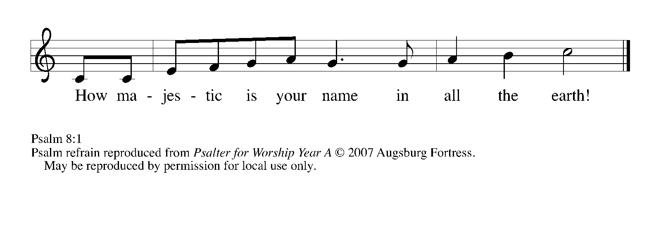

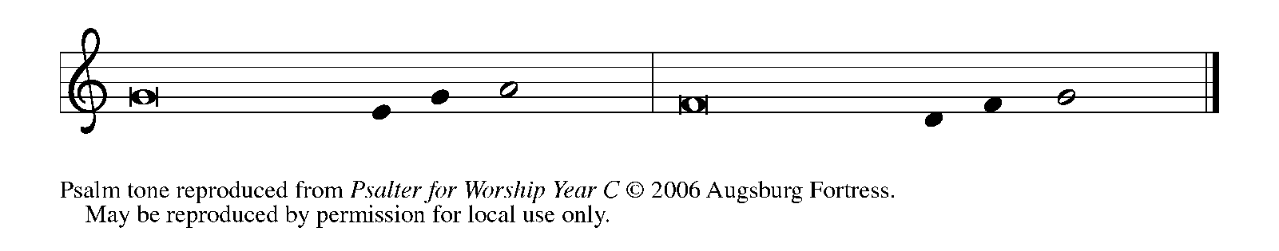

¹O | LORD our Lord,
how majestic is Your name in | all the earth!—

²You Whose glory is chanted above the heavens
out of the mouths of in- | fants and children;
You have set up a fortress against Your enemies,
to silence the foe | and avenger.

³When I consider Your heavens, the work | of Your fingers,
the moon and the stars You have set | in their courses,

⁴what are mere mortals that You should be mind- | ful of them,
human beings that You should | care for them? REFRAIN

⁵Yet You have made them little less | than divine;
with glory and hon- | or You crown them.

⁶You have made them rule over the works | of Your hands;
You have put all things un- | der their feet:

⁷all | flocks and cattle,
even the wild beasts | of the field,

⁸the birds of the air, the fish | of the sea,
and whatever passes along the paths | of the sea.

⁹O | LORD our Lord,
how majestic is Your name in | all the earth! REFRAIN

SECOND READING 2 Corinthians 13: 11-13

Paul concludes his painful letter to the troubled church at Corinth with a final appeal for these Christians to live in peace. His last words form a trinitarian benediction still used in Christian liturgy today.
Finally, brothers and sisters, farewell. Put things in order, listen to my appeal, agree with one another, live in peace; and the God of love and peace will be with you. ¹² Greet one another with a holy kiss. All the saints greet you.
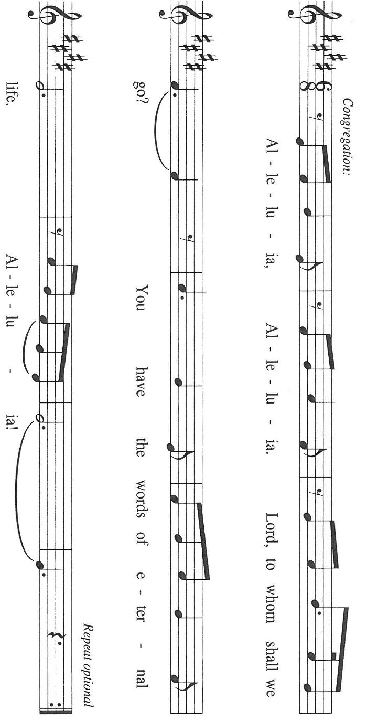
¹³The grace of the Lord Jesus Christ, the love of God, and the communion of the Holy Spirit be with all of you.

The Word of the Lord.

Thanks be to God.

As you are able please rise

THE VERSE (sing twice)

THE HOLY GOSPEL Matthew 28: 16-20

After his resurrection, Jesus summons his remaining disciples and commissions them for mission in the name of the triune God.

P: The Holy Gospel according to St. Matthew, the twenty-eighth chapter.

C: Glory to You, O Lord!

Now the eleven disciples went to Galilee, to the mountain to which Jesus had directed them. ¹⁷When they saw Him, they worshiped Him; but some doubted. ¹⁸And Jesus came and said to them, "All authority in heaven and on earth has been given to Me. ¹⁹Go therefore and make disciples of all nations, baptizing them in the name of the Father and of the Son and of the Holy Spirit, ²⁰and teaching them to obey everything that I have commanded you. And remember, I am with you always, to the end of the age."

P: The Gospel of the Lord.

C: Praise to You, O Christ!
The assembly is seated

THE SERMON The Rev. Dr. Frederick Niedner, Jr.

Silence for reflection follows the sermon

As you are able please rise

THE HYMN OF THE DAY NSB 38 Glorify Thy Name

THE NICENE CREED

A: God has made us His people through our Baptism into Christ. Living together in trust
and hope, we confess our faith.

C: We believe in one God,
the Father, the Almighty,
maker of heaven and earth,
of all that is, seen and unseen.

We believe in one Lord, Jesus Christ,
the only Son of God,
eternally begotten of the Father,
God from God, Light from Light,
true God from true God,
begotten, not made,
of one Being with the Father.
Through him all things were made.
For us and for our salvation
He came down from heaven;
by the power of the Holy Spirit
He became incarnate from the virgin Mary, and was made man.
For our sake He was crucified under Pontius Pilate;
He suffered death and was buried.
On the third day He rose again
in accordance with the Scriptures;
He ascended into heaven
and is seated at the right hand of the Father.
He will come again in glory to judge the living and the dead,
and His kingdom will have no end.
We believe in the Holy Spirit, the Lord, the giver of life,
Who proceeds from the Father and the Son.
With the Father and the Son He is worshiped and glorified.
He has spoken through the prophets.
We believe in one holy catholic and apostolic Church.
We acknowledge one Baptism for the forgiveness of sins.
We look for the resurrection of the dead,
and the life of the world to come. Amen

THE PRAYER OF THE CHURCH

A: Bound together in Christ in the communion of the Holy Spirit, let us pray with one
heart and mind to the Father for the Church, the world, and all those in need.

A: That the Church may be diligent and faithful in its proclamation of the Gospel, that all
nations may become disciples of Christ, we pray: Father, Son, and Holy Spirit,

C: Holy Trinity, hear us.

A: That the Spirit of God might continue to bring life, light, and order to our world
besieged by the chaos of war, terrorism, poverty, disease, hunger, oppression, and
hatred, we pray: Father, Son, and Holy Spirit,

C: Holy Trinity, hear us.

A: That in witness to the grace, love, and communion of God, this congregation might
agree with one another and live in peace, we pray: Father, Son, and Holy Spirit,

C: Holy Trinity, hear us.

A: That the sick and suffering members of our community, especially: Christine Kiser; Debbie Martin; Martha Schroeder; Verne Lee; Jon Samuelson; Pastor Dale
Zylstra; Jan Paholski; and Laura Dovey would know God as a stronghold of help, comfort, and strength, we pray: Father, Son, and Holy Spirit,

C: Holy Trinity, hear us.

A: That those celebrating birthdays, especially: Vivian Zellers; and anniversaries,
especially Mike and Marge Bockover; and Ron and Melinda Nagle would grow in
grace this day and every day and be filled with grace for the days ahead, we pray:
Father, Son, and Holy Spirit,

C: Holy Trinity, hear us.

A: That those who mourn, especially the family and friends of Sarah McNabb, who
died in the Lord this week, may be comforted by the promise of resurrection to life
everlasting, and of being reunited with those they love before the throne of the
Lamb, we pray: Father, Son, and Holy Spirit,

C: Holy Trinity, hear us.

A: That with all the dead whose lives were sealed in Baptism with the sign of the Trinity,
we too may remain in Jesus’ care to the end of the age and into the age to come, we
pray: Father, Son, and Holy Spirit,

C: Holy Trinity, hear us.

P: Gracious God, Whom Jesus called Abba, Father, accept our prayers this day. By the
inner workings of Your Spirit, draw us into communion with You, the Source and Goal
of our life, and make us more and more signs of Your enduring love. This we pray
through Christ our Lord, Who lives and reigns with You and the Holy Spirit, one God,
now and forever.

C: Amen.

MEAL

THE PEACE

P: The peace of the Lord be with you always.

C: And also with you.

The assembly is seated

THE OFFERING

THE VOLUNTARY Great Is the Lord St. Paul Senior Choir
(M.W.Smith & D. Smith; arr. E. Lojeski)

As you are able please rise

THE PRESENTATION OF GIFTS (see p. 9) As the Grains of Wheat

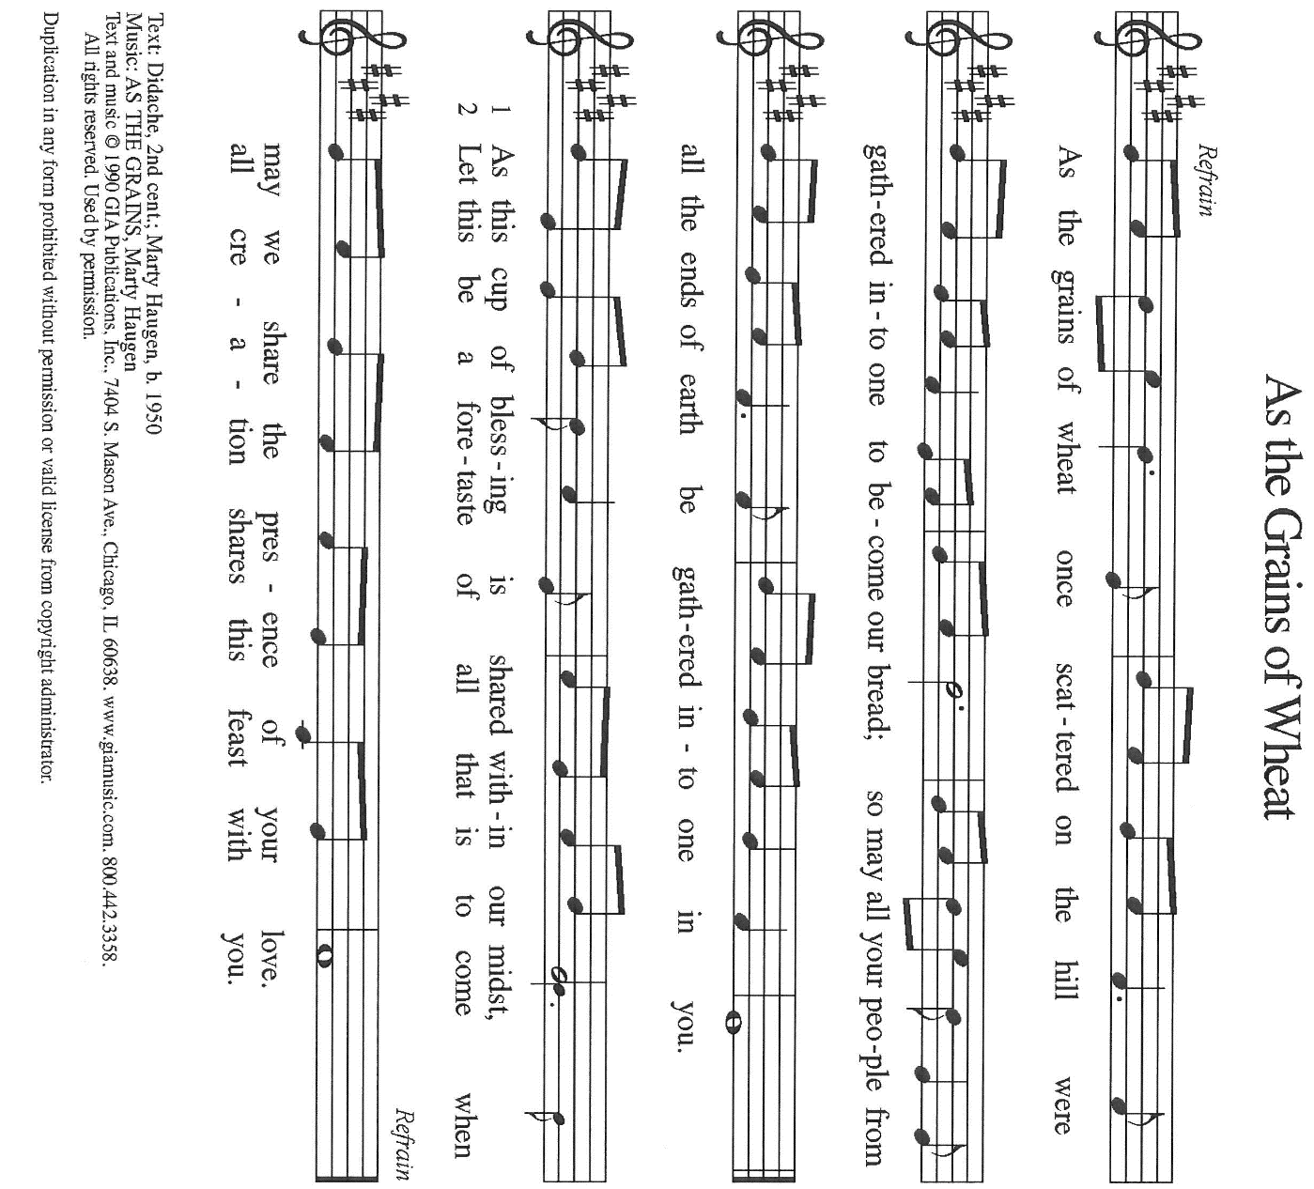

THE OFFERTORY PRAYER

A: Let us pray. God our Father,

C: You sent Your Son to bring us truth and Your Spirit to make us holy. Receive
these gifts we offer You. By this Sacrament and Your mercy, make us good in
Your sight and faithful in our witness to Christ. We ask this in the name of Jesus
the Lord. Amen.

THE GREAT THANKSGIVING
P: The Lord be with you.

C: And also with you.

P: Lift up your hearts.

C: We lift them to the Lord.

P: Let us give thanks to the Lord our God.

C: It is right to give Him thanks and praise.

P: Holy God, holy and mighty, holy and immortal:
You we praise and glorify, You we worship and adore.

You formed the earth from chaos;
You encircled the globe with air;
You created fire for warmth and light;
You nourish the lands with water.
You molded us in Your image,
and with mercy higher than the mountains,
with grace deeper than the seas,
You blessed the Israelites and cherished them as Your own.

That also we, estranged and dying,
might be adopted to live in Your Spirit,
You called to us through the life and death of Jesus.

In the night in which He was betrayed …”Do this for the remembrance of Me.”
Together as the body of Christ,
we proclaim the Lord’s death until He comes:

C: Christ has died.
Christ is risen.
Christ will come again.

With this bread and cup we remember Your Son,
the First-Born of Your new creation.
We remember His life lived for others,
and His death and resurrection, which renews the face of the earth.
We await His coming,
when, with the world made perfect through Your wisdom,
all our sins and sorrows will be no more.

C: Amen. Come, Lord Jesus.

Holy God, holy and merciful One, holy and compassionate,
send upon us and this meal Your Holy Spirit,
Whose breath revives us for life,
Whose fire rouses us to love.
Enfold in Your arms all who share this holy food.
Nurture in us the fruits of the Spirit,
that we may be a living tree, sharing Your bounty with all the world.

C: Amen. Come, Holy Spirit.

Holy and benevolent God,
receive our praise and petitions,
as Jesus received the cry of the needy,
and fill us with Your blessing,
until, needy no longer and bound to You in love,
we feast forever in the triumph of the Lamb:
through whom all glory and honor is Yours, O God, O Living One,
with the Holy Spirit, in Your holy church, now and forever.

C: Amen.

THE LORD’S PRAYER

P: Because in Christ we have received the Spirit of adoption, as daughters and sons of
God, we dare to pray:

C: (Sung) Music is on the front cover of the red hymnal

INVITATION TO THE MEAL

P: This is the Lamb of God Who takes away the sin of the world. Happy are those who
are called to the Supper of the Lamb. God’s holy gifts for God’s holy people. Come,
for all is now ready.

The assembly is seated

THE DISTRIBUTION Lamb of God (see p. 12)

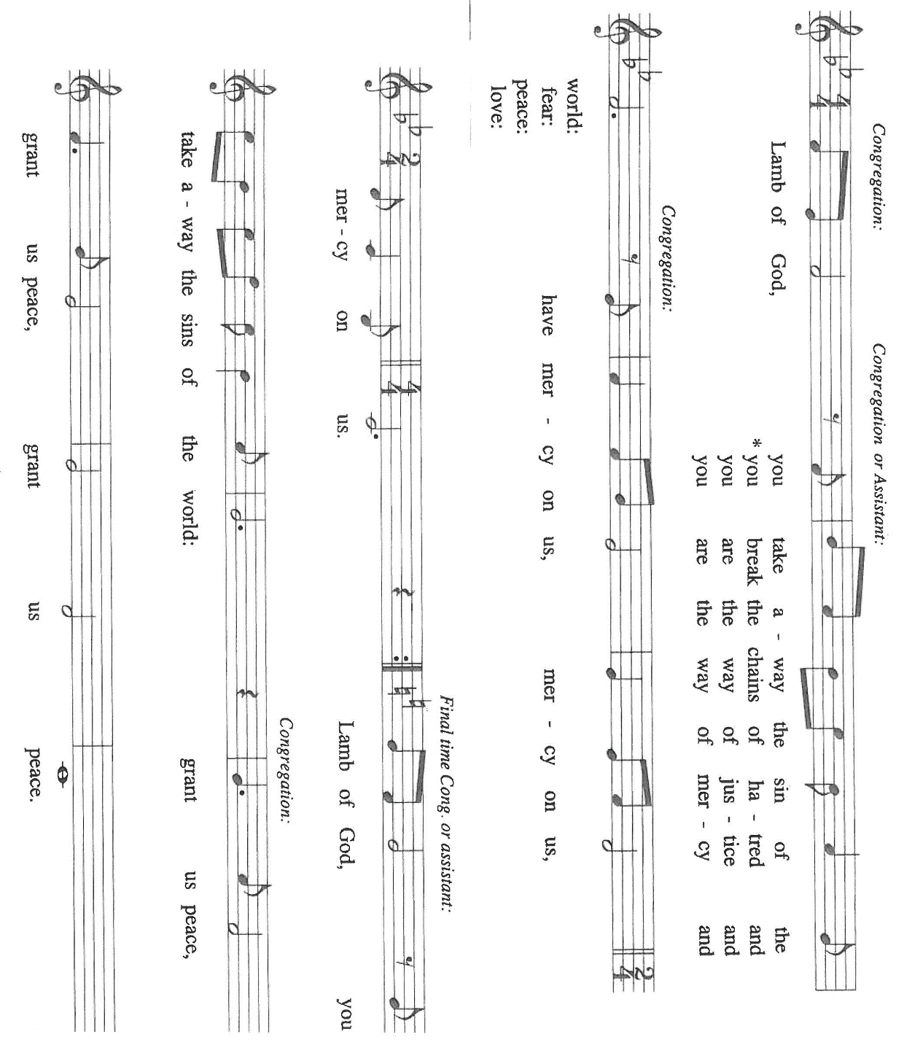

HYMN DURING DISTRIBUTION 412 Come, Join the Dance of Trinity

NSB 46 How Majestic is Your Name

ELW 531 The Trumpets Sound, the Angels Sing

ELW 325 I Want Jesus to Walk with Me

NSB 30 Draw Me Close

As you are able please rise

THE POST-COMMUNION BLESSING

P: The Body and Blood of our Lord Jesus Christ strengthen you and keep you in His grace.

C: Amen.

THE POST-COMMUNION PRAYER

A: Let us pray. Lord our God, by this holy Meal help us grow in the grace of our Lord
Jesus Christ, enrich us with the love of God, and draw us more fully into the
communion of the Holy Spirit. We bless You now and forever.

C: Amen.

SENDING

THE BENEDICTION

P: Almighty God: Father, Son, and Holy Spirit bless you now and forever.

C: Amen.

THE SENDING SONG ELW 525 You Are Holy

THE DISMISSAL

A: Go forth with God’s blessing to love and serve the Lord.

C: Thanks be to God!

POSTLUDE

To God Alone Be Glory

The Meditations are from Pulpit Resource. William Willimon, ed. Vol. 30. No. 2. (Inver
Heights, MN: Logos Productions, Inc. 2002) 36.

The Greeting, Prayers, Peace, and Dismissal are adapted from Sundays and Seasons.
Copyright 2001 Augsburg Fortress.

The Prayers, Introduction to the Lord’s Prayer, and Invitation to the Meal are adapted from
Prayers for Sundays and Seasons. Year A. Peter J. Scagnelli. (Chicago: Liturgy
Training Publications, 1998) 140-141.

ANNOUNCEMENTS

Please remember to mail your offering to the Church Office at 818 Franklin Street, Michigan City, IN 46360. Another alternative is to give on-line through Tithe.ly. Please see your closure letter for information on how to set up a Tithe.ly account.

St. Paul Members are reminded to have a loved one contact the office if you are hospitalized. Many times, the Pastor doesn’t know someone is in the hospital. If you call and leave a message, please tell us at which hospital the patient is located.

BIRTHDAYS: Vivian Zellers (6/7)

ANNIVERSARIES: Mike & Marge Bockover (6/6); Ron & Melinda Nagle (6/9)

PRAYER CONCERNS: Debbie Martin; Mark Tannehill; Kathy Stein; Verne Lee; Jon Samuelson; Pastor Dale Zylstra; Jan Paholski; Laura Dovey; Bill Hazelgrove; Al Levenhagen; Carl Wipperman; Major Payne.

OFFICE HOURS: Libby will be in the office on Mondays, Wednesdays, and Fridays; volunteers will cover Tuesdays and Thursdays.

Monday & Wednesday 8:00 a.m. – 5 p.m.
Tuesday & Thursday 9:00 a.m. – 12:00 p.m.
Friday 8:00 a.m. – 12:00 p.m.

If you are listening to the worship broadcast on the radio and would like to watch the Sunday morning service live stream follow these steps:

(1) If you have You Tube available on your TV, search for
St. Paul Lutheran Church Michigan City, IN.

(2) The direct link on the computer is https://
www.youtube.com/channel/UC5AIPNaKr3QN50984jGOa1g

(3) This link is also on the main page of the church’s website in
the church section and will continue to be posted weekly on the St.
Paul Facebook page.

And it will always be available on the radio broadcast Sunday mornings at 11:00 a.m.
on WEFM (95.9), and on the local cable access station #99 for the previous week’s
service on Sundays at 4:00 p.m. and the current service on Wednesdays at 7:00 p.m.
and Fridays at 8:30 p.m.

To send e-mail to the church office, please use the following addresses:

Pastor Mark Reshan: seniorpastor@stpaulmichigancity.com

Church Office Secretary (Libby Pollock): churchsecretary@stpaulmichigancity.com

Church Treasurer (Karen Fleming): finance@stpaulmichigancity.com

2026 Church Council:

Pastor - Mark Reshan

President - Donna Knoll

Vice President - Jan Bakken

Secretary - Judy Hunt

Treasurer - Karen Fleming

Members: Sue Koziel; Jim Schraidt; Trish Sprague; Bob Kiser; Barry Anderson; and
Pam Soule

Worship Attendance:

Saturday, May 23, 2026 @ 4:00 p.m. 20

Sunday, May 24, 2026 @ 9:00 a.m. 66

TOTAL 86

Copies of the minutes from the March 26, 2026 and April 23, 2026 Church Council meetings are on the back table in the upper Narthex. They were approved by the council via email.

The Good News Newsletter: If you have an article or anything you want included in The Good News please send it to the following e-mail address: splcgoodnews@gmail.com. Pastor Pamela Thiede will be using this e-mail address to assemble The Good News each month. The deadline for getting information to Pastor Pamela will be the 20th of each month.

Next week’s lessons are Hosea 5: 15—6:6; Psalm 50: 7-15; Romans 4: 13-25;
Matthew 9: 9-13, 18-26 for those of you who like to study them in advance.



SPRING BIRTHDAYS:
Anyone who had a birthday during March, April, or May will be celebrated today, May 31. Come down to the St. Paul Room after the 9:00 a.m. service for birthday cake, coffee or water and an abundance of fellowship!

JUNE MONTHLY MISSION

The Service League of Michigan City is a no-profit organization of volunteers that loans medical equipment and provides supplemental adult incontinence supplies to the residents of LaPorte County. Equipment loans are for three months and most items can be borrowed for free. As a non-profit, they maintain their services through the generosity of community donations, competitive grants, memorials and member support. The Service League receives no government funds. To help their generous mission, we will be collecting both monetary donations as well as the following items:

Disposable gloves
Disposable Gauze rolls, dressing pads and surgical tape
Disposable pull up and tab adult briefs (opened and unopened packages)

Please make checks payable to St. Paul and mark for Service League and place in the offering. Noisy Coin for the month of June will also go to support the Service League. Items can be placed in the bin in the outer Narthex. Thank you for your generosity each month! Lora

2026 Financial Stewardship

Weekly Church Operating Needs (x 2 weeks)
May 16-17 & May 23-24, 2026: $ 11,974.59

General Fund (including General Memorials): $ 5,092.00

Overage/Shortage: — $ 6,882.59

Restricted Income (not including Memorials)
Supports IK Synod & Church wide Ministries: $ 45.00

Ministries in our Community/Congregation: $ 155.00

Capital Fund: $ 195.00

ACTIVITIES, EVENTS & MEETINGS
JUNE 2026

Wednesday, June 3, 2026 @ 10:00 a.m. God’s Purls

Thursday, June 4, 2026 Faith Circle

Saturday, June 6, 2026 @ 4:00 p.m. 2 Pentecost Worship Service/Sanctuary

Sunday, June 7, 2026 @ 9:00 a.m. 2 Pentecost Worship Service/Sanctuary with coffee
after

Monday, June 8, 2026 @ 1:00 p.m. Hope Circle/Green Room

Tuesday, June 9, 2026 11:00 a.m.-10:00 p.m. GIVE BACK at Holly’s Restaurant &
Pub

Wednesday, June 10, 2026 @ 10:00 a.m. God’s Purls
@ 4:30 p.m. Choir Rehearsal/Sanctuary

Saturday, June 13, 2026 @ 4:00 p.m. 3 Pentecost Worship Service/Sanctuary

Sunday, June 14, 2026 @ 9:00 a.m. 3 Pentecost Worship Service/Sanctuary with coffee
after

Wednesday, June 17, 2026 @ 10:00 God’s Purls

Saturday, June 20, 2026 at 4:00 p.m. 4 Pentecost Worship Service/Sanctuary

Sunday, June 21, 2026 @ 9:00 a.m. 4 Pentecost Worship Service/Sanctuary with coffee
after

Monday, June 22, 2026 @ 2:00 p.m. Finance Committee Mtg./Luther House

@ 3:00 p.m. Executive Board Mtg/Luther House

Wednesday, June 24, 2026 @ 10:00 a.m. God’s Purls
@ 4:30 p.m. Choir Rehearsal/Sanctuary

Thursday, June 25, 2026 @ 3:00 p.m. Church Council Meeting/St. Paul Room

Saturday, June 27, 2026 @ 4:00 p.m. 5 Pentecost Worship Service/Sanctuary

Sunday, June 28, 2026 @ 9:00 a.m. 5 Pentecost Worship Service/Sanctuary with coffee
after

Thank$ for $haring
Thank you to all who participate in our Give-Back opportunities each month where we earn $$ to add to our Mission of the Month donations, from our congregation to those in our community who need our help! On Tuesday, June 9, 2026 from 11:00 a.m.—10:00 p.m. we’ll be meeting at Holly’s Restaurant for our GIVE BACK for June. Here are two coupons. One for you and one for a friend.

