THE SIXTH SUNDAY AFTER THE EPIPHANY
February 12, 2023

“Jesus does not seek to violently overthrow Rome, because his kingdom is an alternative to the violence of Rome as well as to those who would overthrow Rome with violence. His kingdom, however, cannot avoid being subversive. That subversion is the righteousness that exceeds the scribes and Pharisees and as such is a subversion that will result in his crucifixion, for rather than violently overthrowing the old order Jesus creates a people capable of living in accordance with the new order in the old. The antithesis that follows his admonition that his followers are to be salt and light for the world is but Jesus’s description of the order of this new community …”
“ … (Jesus) gathers people around his word so that a society comes into being like no other society the world has ever seen …” “ … When he called his society together Jesus gave its members a new way of life to live. He gave them a new way to deal with offenders—by forgiving them. He gave them a new way to deal with violence—by suffering. He gave them a new way to deal with money—by sharing it. He gave them a new way to deal with problems of leadership—by drawing upon the gift of every member, even the most humble. He gave them a new way to deal with a corrupt society—by building a new order, not smashing the old.
He gave them a new pattern of relationship between man and woman, between parent and child, between master and slave, in which was made concrete a radical new vision of what it means to be a human person …”

Stanley Hauerwas
Brazos Theological Commentary on the Bible: Matthew

In the Name of Jesus

INTRODUCTION

In today's reading from Deuteronomy we are called to choose life by loving and obeying God. Much of today's gospel reading echoes portions of the Ten Commandments. Jesus' instructions to the crowd reveal a pattern of behavior that honors both God and the neighbor, resulting in life and health for the whole community. We, too, are invited to embrace these commandments, not out of fear of retribution, but because God has promised that to do so means life for us.

Cyril, monk, died 869; Methodius, bishop, died 885; missionaries to the Slavs

These two brothers from Thessalonika, Greece, were monks and were sent to bring Christianity to the Slavic people. In the course of their work they created a written language, inventing the Cyrillic alphabet for it, and translated the Bible and the liturgy.

GATHERING

PRE-SERVICE MUSIC To You, O Lord, I Lift Up My Soul Praise Band

ANNOUNCEMENTS

As you are able please rise

GATHERING SONG NSB 89 Thy Word

THE GREETING

P: To the Church of God in this place, to those who are called to be saints, to all those who
call upon the name of our Lord Jesus Christ:

The grace of our Lord Jesus Christ, the love of God, and the communion of the Holy
Spirit be with you all.

C: And also with you.

THE PRAYER OF THE DAY

P: Let us pray. O God, the strength of all who hope in You, because we are weak mortals
we accomplish nothing good without You. Help us to see and understand the things we
ought to do, and give us grace and power to do them, through Jesus Christ, our Savior
and Lord.

C: Amen.

The assembly is seated

WORD

FIRST READING Deuteronomy 30:15-20
The Lord sets before the people of God a clear choice. Life and prosperity will come to the faithful; loss of the land will be the consequence of disobedience. Choosing life entails loving the Lord and holding fast to him. Life in God's presence presupposes the promise made to the ancestors.

¹⁵See, I have set before you today life and prosperity, death and adversity. ¹⁶If you obey the commandments of the LORD your God that I am commanding you today, by loving the LORD your God, walking in His ways, and observing His commandments, decrees, and ordinances, then you shall live and become numerous, and the LORD your God will bless you in the land that you are entering to possess.
But if your heart turns away and you do not hear, but are led astray to bow down to other gods and serve them, ¹⁸I declare to you today that you shall perish; you shall not live long in the land that you are crossing the Jordan to enter and possess.
¹⁹I call heaven and earth to witness against you today that I have set before you life and death, blessings and curses. Choose life so that you and your descendants may live, ²⁰loving the LORD your God, obeying Him, and holding fast to Him; for that means life to you and length of days, so that you may live in the land that the LORD swore to give to your ancestors, to Abraham, to Isaac, and to Jacob.

The Word of the Lord.

Thanks be to God.

THE PSALM: 119:1-8 Antiphon by Ronald Nelson

Choir sings refrain first, followed immediately by the congregation
and as indicated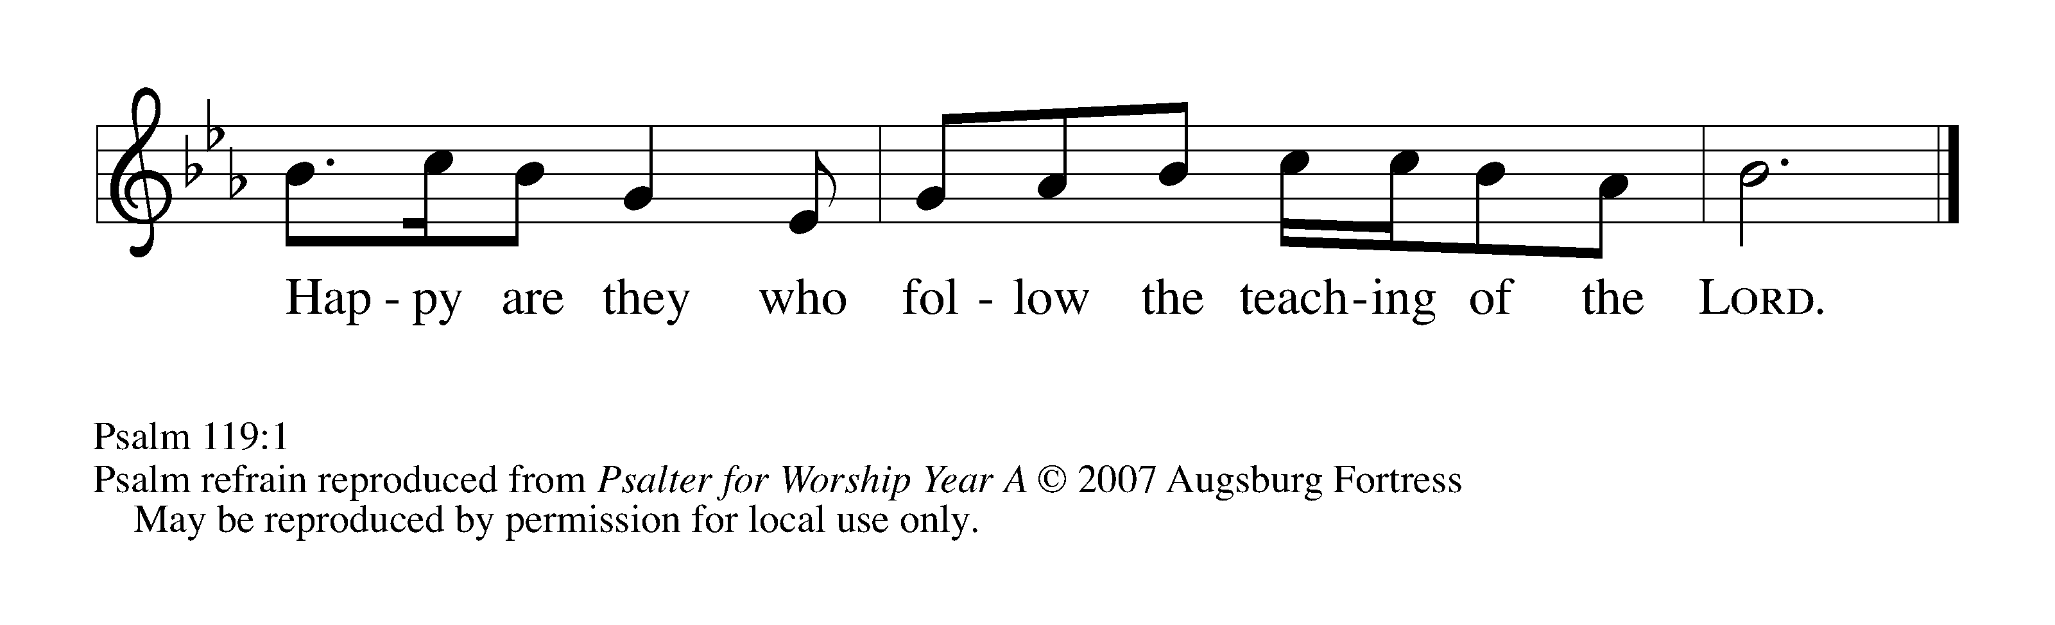

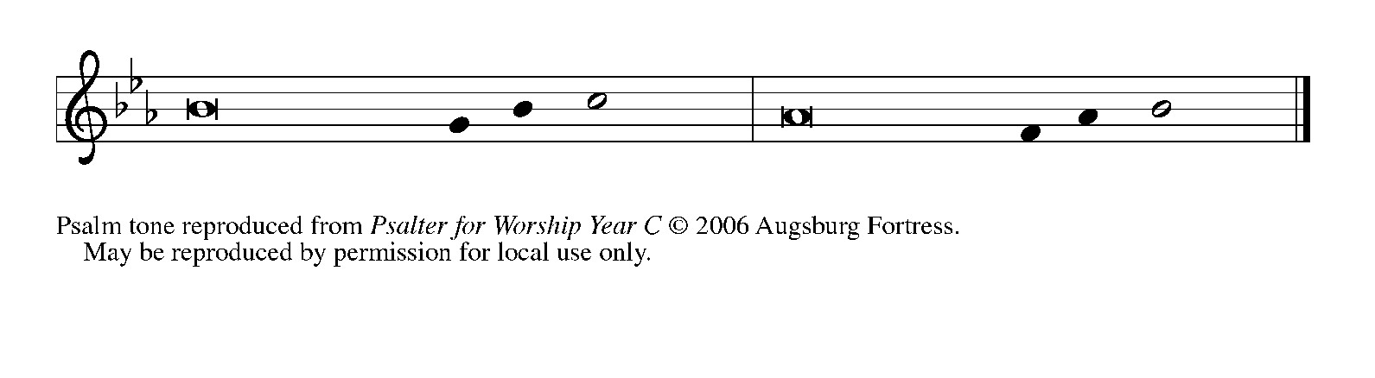
¹Happy are they whose | way is blameless,
who follow the teaching | of the LORD!

²Happy are they who observe | Your decrees
and seek You with | all their hearts,

³who never do | any wrong,
but always walk | in Your ways.

⁴You laid down | Your commandments,
that we should | fully keep them. REFRAIN

⁵Oh, that my ways were made | so direct
that I might | keep Your statutes!

⁶Then I should not be | put to shame,
when I regard all | Your commandments.

⁷I will thank You with | a true heart,
when I have learned Your | righteous judgments.

⁸I will | keep Your statutes;
do not utter- | ly forsake me. REFRAIN

SECOND READING 1 Corinthians 3:1-9

Human leaders in the church are not the ones who control ministry. Rather they are fellow workers who belong to God, the one who truly controls and continuously empowers the ministry of the church.

And so, brothers and sisters, I could not speak to you as spiritual people, but rather as people of the flesh, as infants in Christ. ²I fed you with milk, not solid food, for you were not ready for solid food. Even now you are still not ready, ³for you are still of the flesh. For as long as there is jealousy and quarreling among you, are you not of the flesh, and behaving according to human inclinations? ⁴For when one says, "I belong to Paul," and another, "I belong to Apollos," are you not merely human?
⁵What then is Apollos? What is Paul? Servants through whom you came to believe, as the Lord assigned to each. ⁶I planted, Apollos watered, but God gave the growth. ⁷So neither the one who plants nor the one who waters is anything, but only God who gives the growth. ⁸The one who plants and the one who waters have a common purpose, and each will receive wages according to the labor of each. ⁹For we are God's servants, working together; you are God's field, God's building.

The Word of the Lord.

Thanks be to God.

As you are able please rise

THE VERSE
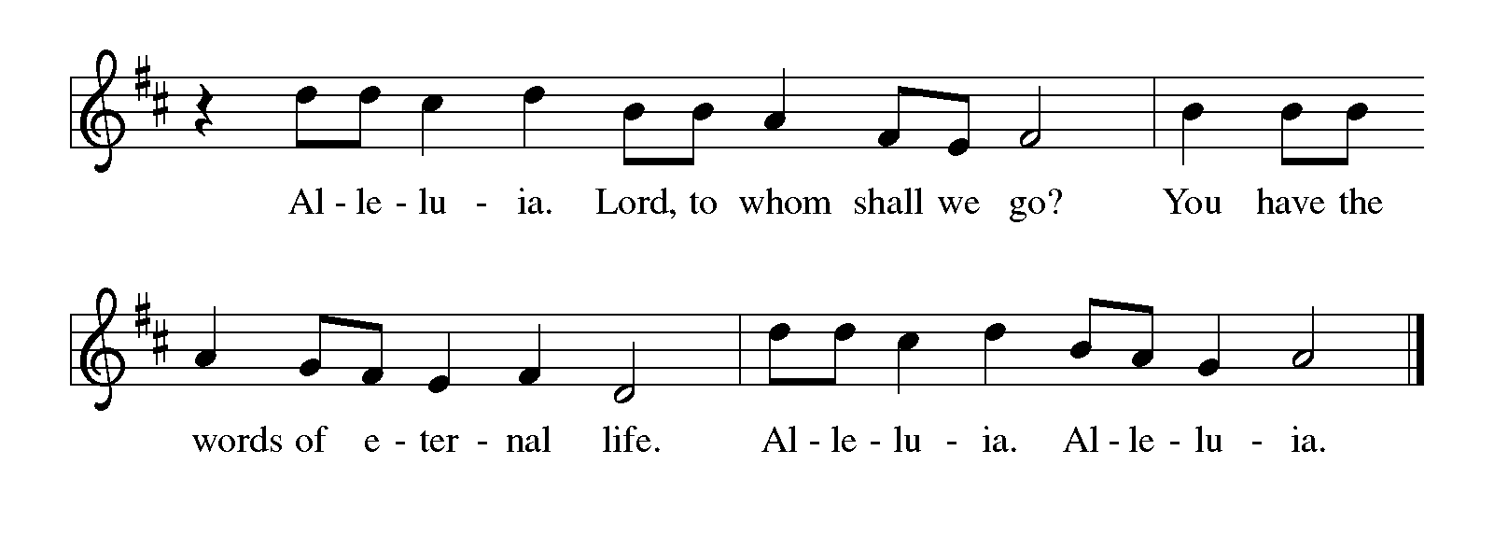
THE HOLY GOSPEL Matthew 5:20-37

In the Sermon on the Mount, Jesus exhorts his followers to embrace standards of righteousness that exceed legal requirements and traditional expectations.

P: The Holy Gospel according to St. Matthew, the fifth chapter.

C: Glory to You, O Lord!

²⁰ For I tell you, unless your righteousness exceeds that of the scribes and Pharisees, you will never enter the kingdom of heaven. ²¹You have heard that it was said to those of ancient times, 'You shall not murder'; and 'whoever murders shall be liable to judgment.' ²²But I say to you that if you are angry with a brother or sister, you will be liable to judgment; and if you insult a brother or sister, you will be liable to the council; and if you say, 'You fool,' you will be liable to the hell of fire.
²³So when you are offering your gift at the altar, if you remember that your brother or sister has something against you, ²⁴leave your gift there before the altar and go; first be reconciled to your brother or sister, and then come and offer your gift. ²⁵Come to terms quickly with your accuser while you are on the way to court with him, or your accuser may hand you over to the judge, and the judge to the guard, and you will be thrown into prison. ²⁶Truly I tell you, you will never get out until you have paid the last penny.
²⁷You have heard that it was said, 'You shall not commit adultery.' ²⁸But I say to you that everyone who looks at a woman with lust has already committed adultery with her in his heart. ²⁹If your right eye causes you to sin, tear it out and throw it away; it is better for you to lose one of your members than for your whole body to be thrown into hell. ³⁰And if your right hand causes you to sin, cut it off and throw it away; it is better for you to lose one of your members than for your whole body to go into hell.
³¹It was also said, 'Whoever divorces his wife, let him give her a certificate of divorce.' ³²But I say to you that anyone who divorces his wife, except on the ground of unchastity, causes her to commit adultery; and whoever marries a divorced woman commits adultery.
³³Again, you have heard that it was said to those of ancient times, 'You shall not swear falsely, but carry out the vows you have made to the Lord.' ³⁴But I say to you, Do not swear at all, either by heaven, for it is the throne of God, ³⁵or by the earth, for it is his footstool, or by Jerusalem, for it is the city of the great King. ³⁶And do not swear by your head, for you cannot make one hair white or black. ³⁷Let your word be 'Yes, Yes' or 'No, No'; anything more than this comes from the evil one.

P: The Gospel of the Lord.

C: Praise to You, O Christ!

The assembly is seated

THE SERMON The Rev. Dr. Frederick Niedner

Silence for reflection follows the sermon

As you are able please rise

THE HYMN OF THE DAY 772 O That the Lord Would Guide My Ways

THE APOSTLES’ CREED

A: God has made us His people through our Baptism into Christ. Living together in trust
and hope, we confess our faith.

C: I believe in God, the Father Almighty,
Creator of heaven and earth.
I believe in Jesus Christ, His only Son, our Lord.
He was conceived by the power of the Holy Spirit,
and born of the Virgin Mary.
He suffered under Pontius Pilate,
was crucified, died, and was buried.
He descended into hell.
On the third day He rose again.
He ascended into heaven,
and is seated at the right hand of the Father.
He will come again to judge the living and the dead.
I believe in the Holy Spirit,
the holy catholic Church,
the communion of saints,
the forgiveness of sins,
the resurrection of the body,
and the life everlasting. Amen.

THE PRAYER OF THE CHURCH

A: Our gracious God calls us to be ministers of reconciliation in a world broken by sin and
death. In acknowledging our Lord’s command, let us pray for one another, for the
Church, and for the world.

A: For the people of God, that we may walk in Your ways and observe Your
commandments, we pray:

C: Send forth Your light, O God.

A: For nations, communities, and families that are estranged by conflict and violence,
especially in Ukraine, and for the gift of reconciliation and mutual forgiveness, we
pray:

C: Send forth Your light, O God.

A: For the victims of the devastating earthquake in Turkey and Syria: those who lost
family members and friends; those yet missing; and for survivors, that those agencies
seeking to provide help, relief, and aid would be granted strength, endurance, and
hope as they struggle against aftershocks, damaged roads, and freezing weather, we
pray:

C: Send forth Your light, O God.

A: For this community of faith, that it may be a place of safety, support, integrity, and
encouragement, we pray:

C: Send forth Your light, O God.

A: For victims of sexual violence; those affected by divorce; those living with addiction,
anger, fear, or illness, especially . . . that they may know Your healing love, we pray:

C: Send forth Your light, O God.

A: For those celebrating birthdays, especially Wayne Dolson and Barbara Bass that they
may grow in grace this day and every day and be filled with grace for the days ahead,
we pray:

C: Send forth Your light, O God.

A: For we who follow Your blessed saints who served You in life and now rest from their
labors, that with them we too may be brought to the joy of everlasting life, we pray:

C: Send forth Your light, O God.

P: Loving God, in Your unsearchable wisdom You command us to do what is right and
good, so that through faith-filled action we may come to now Your loving concern for
us. May be always be single-minded in carrying out Your commands, especially to be
reconciled to one another, and to approach Your holy Table in unity and peace. We
make this prayer through Your Son, Jesus Christ our Lord.

C: Amen.
MEAL

THE PEACE

P: The peace of the Lord be with you always.

C: And also with you.

The assembly is seated

THE OFFERING

THE VOLUNTARY Day by Day Praise Band

As you are able please rise

THE PRESENTATION OF THE GIFTS 312 Jesus Come! For We Invite You
(Stanzas 1,4)
THE OFFERTORY PRAYER

A: Let us pray. Merciful Father,

C: At peace and reconciled with one another, we now offer our gifts of time and
possessions at Your altar. Receive them with the joy with which we offer them.
Feed us with the “solid Food” of the Body and Blood of Your Son, Jesus Christ.
By our eating and drinking, give growth to our faith and righteous living. We ask
this in the name of Jesus the Lord. Amen.

THE GREAT THANKSGIVING

P: The Lord be with you.

C: And also with you.

P: Lift up your hearts.

C: We lift them up to the Lord.

P: Let us give thanks to the Lord our God.

C: It is right to give Him thanks and praise.

P: Holy One, the Beginning and the End, the Giver of life:
Blessed are You for the birth of creation.
Blessed are You in the darkness and in the light.
Blessed are You for the promise to Your people.
Blessed are You in the prophets’ hopes and dreams.
Blessed are You for Mary’s openness to Your will.
Blessed are You for Your Son Jesus, the Word-made-flesh.
In the night …“Do this for the remembrance of Me.”
As often as we eat ... we proclaim the Lord’s death until He comes.

C: Christ has died. Christ is risen. Christ will come again.

P: With this bread and cup we remember Your Word dwelling among us, full of grace
and truth.
We remember our new birth in His death and resurrection.
We look with hope for His coming.
Holy God, we long for Your Spirit.
Come among us.
Bless this Meal.
May Your Word take flesh in us.
Awake Your people.
Fill us with Your light.
Bring the gift of peace on earth.
All praise and glory are Yours, Holy One of Israel,
Word of God incarnate,
Power of the Most High,
one God, now and forever.

C: Amen!

THE LORD’S PRAYER

P: Because in Christ we have received the Spirit of adoption, as daughters and sons of
God, we dare to pray:

C: Our Father, Who art in heaven, hallowed be Thy Name. Thy Kingdom come.
Thy will be done on earth as it is in heaven. Give us this day our daily bread, and
forgive us our trespasses as we forgive those who trespass against us. And lead us
not into temptation, and deliver us from evil, for Thine is the Kingdom, and the
power, and glory, forever and ever. Amen.

INVITATION TO THE MEAL

P: Behold the true Light of the world, the Beloved of God, anointed by the Spirit. Blessed
are those who are called to the Supper of the Lamb. God’s holy gifts for God’s holy
people. Come, for all is now ready.

The assembly is seated

THE DISTRIBUTION

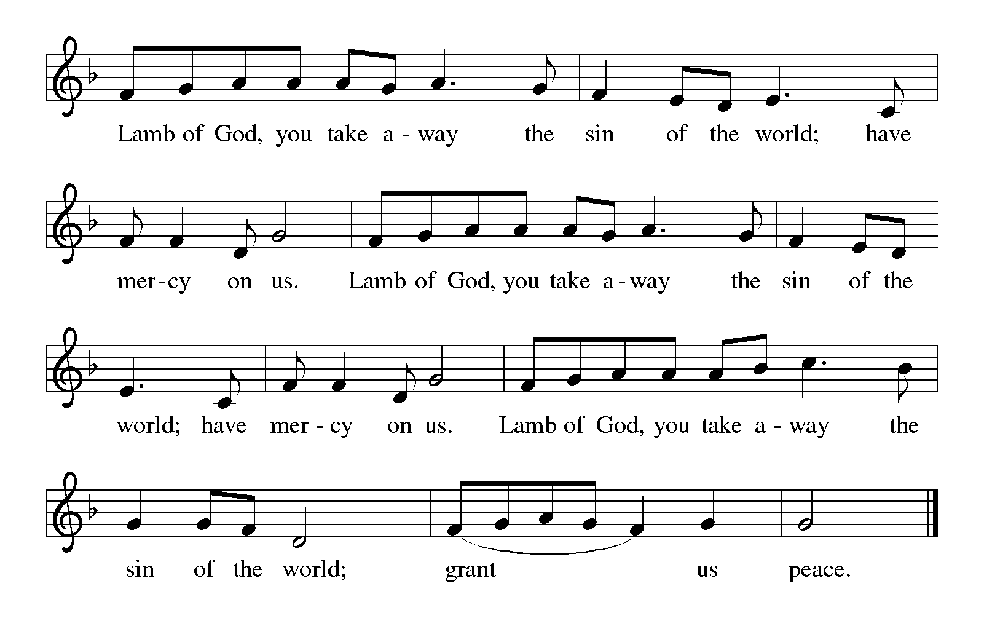
HYMN DURING DISTRIBUTION 612 Healer of Our Every Ill
ELW 472 Eat This Bread
ELW 484 You Satisfy the Hungry Heart
NSB 89 I Exalt Thee
As you are able please rise

THE POST-COMMUNION BLESSING

P: The Body and Blood of our Lord Jesus Christ strengthen you and keep you in His grace.

C: Amen.

THE POST-COMMUNION PRAYER

A: Let us pray. Gracious God, in this Holy Sacrament You have again set before us life
and prosperity. By Your Holy Spirit, enable us to love You, obey Your commands,
and hold fast to You now and in the life to come. Grant this through Christ our Lord.

C: Amen.
SENDING

THE BENEDICTION

P: Almighty God: Father, Son, and Holy Spirit bless you now and forever.

C: Amen.

SENDING HYMN 604 O Christ Our Hope

THE DISMISSAL
A: You are servants of God; you are light to the nations.
Go in peace. Serve the Lord.

C: Thanks be to God!

POSTLUDE Toccata Gordon Young

To God Alone Be Glory

The Meditation is from Brazos Theological Commentary on the Bible: Matthew. Stanley Hauerwas (Grand Rapids, MI: Brazos Press, 2006) 67-68.

The Prayers are adapted from Sundays and Seasons. Copyright 2010. Used by permission.

ANNOUNCEMENTS

Please remember to mail your offering to the Church Office at 818 Franklin Street, Michigan City, IN 46360. Another alternative is to give on-line through Tithe.ly. Please see your closure letter for information on how to set up a Tithe.ly account.

St. Paul Members are reminded to have a loved one contact the office if you are hospitalized. Many times, the Pastor doesn’t know someone is in the hospital. If you call and leave a message, please tell us which hospital the patient is at.

Next Saturday’s lessons are: Exodus 24: 12-18; Psalm 2 or Psalm 99; 11Peter 1: 16-21; and Matthew 17: 1-9 for those of you who like to study them in advance.

Birthdays: Wayne Dolson (2/14); Barbara Bass (2/16)

PRAYER CONCERNS: Audrey Beyer, Donna Bostater, Maxine Powell, Jim Tomscheck, Eloise Ponder, Mark & Jary Tannehill, Leonard Cross, Margie Torres,
Dan Pursely, Jayla Jacobi and Barbara Reichert.

OFFICE HOURS: Libby will be in the office on Mondays, Wednesdays, and Fridays; volunteers will cover Tuesdays and Thursdays.

Monday & Wednesday 8:00 a.m. – 5 p.m.
Tuesday & Thursday 9:00 a.m. – 12:00 p.m.
Friday 8:00 a.m. – 12:00 p.m.

If you are listening to the worship broadcast on the radio and would like to watch the Sunday morning service live stream follow these steps:
(1) If you have You.Tube available on your TV, search for
St. Paul Lutheran Church Michigan City, IN.

(2) The direct link on the computer is
https://www.youtube.com/channel/UC5AIPNaKr3QN50984jGOa1g.

(3) This link is also on the main page of the church’s website in the church sec-
tion and will continue to be posted weekly on the St. Paul Facebook page.

And it will always be available on the radio broadcast Sunday mornings at 11:00 a.m. on WEFM (95.9), and on the local cable access station #99 for the previous week’s service on Sundays at 4:00 p.m. and the current service on Wednesdays at 7:00 p.m. and Fridays at 8:30 p.m.

To send e-mail to the church office, please use the following addresses:

Pastor Mark Reshan: seniorpastor@stpaulmichigancity.com

Church Office Secretary (Libby Pollock): churchsecretary@stpaulmichigancity.com

Church Treasurer (Karen Fleming): finance@stpaulmichigancity.com

The Good News Newsletter: If you have an article or anything you want included in The Good News please send it to the following e-mail address: splcgoodnews@gmail.com. Pastor Pamela Thiede will be using this e-mail address to assemble The Good News each month. The deadline for getting information to Pastor
Pamela will be the 20th of each month.

WORSHIP ATTENDANCE for February 4 and 5th, 2023
4:00 p.m. 35
9:00 a.m. 59
TOTAL 94

Warren Schacht has generously offered to convert audio tapes and cassettes to CD’s and VHS tapes to DVDs at no charge! He is currently converting our church audio tapes/cassettes and has extended the offer to anyone who is interested in updating their material. You may call him directly at: 219-448-1444 or email him at: w.schacht230@comcast.net. Thank you, Warren!

A Reminder
The discussion group “Estuary” led by Pastor Dale Zylstra meets the second Tuesday of the month in the Luther House at 7:00 p.m. The group addresses topics of interest to the participants and is open to everyone.

In an effort to save money on postage: yearly donation state-ments have been emailed to those members who have email. Any members without email will find your statements in your hanging file folder in the Narthex. If you are unable to attend church please let the church office know so we can send your statement through the regular mail.

The approved minutes of the December 20, 2022 Church Council meeting are on the table at the back of the church in the Narthex.

2023 Financial Stewardship

Weekly Church Operating Needs (x 2 weeks): $ 18,615.68
January 28 and 29, and February 4 and 5, 2023
General Fund (including General Memorials): $ 14,126.00
Overage/Shortage: -- $ 4,489.68

Restricted Income (not including Memorials)
Supports IK Synod & Church wide Ministries: $175.00
Ministries in our Community/Congregation: $ 5.00
Capital Fund: $ 346.00

General Fund: $230.00

ACTIVITIES, EVENTS & MEETINGS
February 2023

Saturday, February 11, 2023 at 4:00 p.m. Worship Service

Sunday, February 12, 2023 at 9:00 a.m. Worship Service
Monday, February 13, 2023 at 12:30 p.m. Harmony Circle/Green Room
at 3:30 p.m. School Board Meeting/Luther House
Tuesday, February 14, 2023 at 9:30 a.m. Charity Circle/Green Room
at 7:00 p.m. Estuary/Luther House
Wednesday, February 15, 2023 at 9:45 a.m. Bible Study/Luther House
at 10:00 a.m. God’s Purls/ St. Paul Room
at 6:00 p.m. Choir Rehearsal
Thursday, February 16, 2023 from 4p.m. – 10:00 p.m. GIVE-BACK night at
Galveston Steakhouse

Saturday, February18, 2023 at 4:00 p.m. Worship Service

Sunday, February 19, 2023 at 9:00 a.m. Worship Service
Monday, February 20, 2023 at 4:00 p.m. Finance Committee Mtg./Luther House
at 5:30 p.m. Executive Board Mtg./Luther House
Wednesday, February 22, 2023 at10:00 a.m. ASH Wednesday Worship Service
at 7:00 p.m. Ash Wednesday Worship service
Thursday, February 23, 2023 at 5:30 p.m. Church Council Meeting/St. Paul Room
Saturday, February 25, 2023 at 4:00 p.m. Worship Service

Sunday, February 26, 2023 at 9:00 a.m. Worship Service
Wednesday, March 1, 2023 at 9:45 a.m. Bible Study/Luther House
at 10:00 a.m. God’s Purls/St. Paul Room
at 6:00 p.m. “Holden” Evening Prayer
at 6:30 p.m. Choir Rehearsal
Thursday, March 2, 2023 at 9:30 a.m. Faith Circle/?

Thank$ for $haring

Thanks to all who attended the giveback at Holly’s in January. The church received $298! from that evening.
This month,we will see you at Galveston on Thursday, February 16! Here are two coupons: one for you and one for a friend.

