**THE SIXTH SUNDAY AFTER PENTECOST**

**July 17, 2022**

“You, eternal Father, are the table that offers us as food the Lamb, your only-begotten Son. He is the most exquisite of foods for us, both in his teaching, which nourishes us in your will, and in the sacrament that we receive in Holy Communion, which feeds and strengthens us. And the Holy Spirit is indeed a waiter for us, who serves us charity for our neighbors.”

**Catherine of Siena**

**Prayer 12**

“The problem with Martha is not that she is busy serving and providing hospitality. Certainly Jesus commends this kind of service to the neighbor many times, notably in the parable of the Good Samaritan that immediately precedes the story of Mary and Martha. The problem with Martha is not her serving, but rather that she is worried and distracted. The word translated “distracted” in verse 40, periespato, has the connotation of being pulled or dragged in different directions.

Martha’s distraction and worry leave no room for the most important aspect of hospitality -- gracious attention to the guest. In fact, she breaks all the rules of hospitality by trying to embarrass her sister in front of her guest, and by asking her guest to intervene in a family dispute. She even goes so far as to accuse Jesus of not caring about her (Lord, do you not care…?).

Martha’s worry and distraction prevent her from being truly present with Jesus, and cause her to drive a wedge between her sister and herself, and between Jesus and herself. She has missed out on the “one thing needed” for true hospitality. There is no greater hospitality than listening to your guest. How much more so when the guest is Jesus! So Jesus says that Mary has chosen the better part, which will not be taken away from her…”

Jesus’ words to Martha may be seen as an invitation rather than a rebuke. Martha, Martha, you are worried and distracted by many things; there is need of only one thing. The one thing needed is for Martha to receive the gracious presence of Jesus, to listen to his words, to know that she is valued not for what she does or how well she does it, but for who she is as a child of God.

“…Luke’s story is left suspended. We do not know what happened next -- whether Mary and Martha were reconciled, whether they were all able to enjoy the meal that Martha had prepared, whether Martha was finally able to sit and give her full attention to Jesus.

We do know that Jesus invites all of us who are worried and distracted by many things to sit and rest in his presence, to hear his words of grace and truth, to know that we are loved and valued as children of God, to be renewed in faith and strengthened for service. There is need of only one thing: attention to our guest. As it turns out, our guest is also our host, with abundant gifts to give.”

**Elizabeth Johnson**

**✠ In the Name of Jesus ✠**

**✠ GATHERING ✠**

**INTRODUCTION**

Perhaps the church, at its best, is "all ears." Almighty God urges the faithful, again and again, to "listen up!"—to heed the word from above. So it was with Abraham and Sarah, with Mary and Martha, and the early church at Colossae. So it is today as we join the assembly to hear the word of God, the words of life.

**Bartolomé de Las Casas, missionary to the Indies, died 1566**

*A native of Spain, Las Casas first came to the Western hemisphere while serving in the military. Upon arriving in the West, Las Casas was granted a large estate with Indigenous enslaved people whom he freed after he was ordained a priest. He worked in the Caribbean and Central America to improve the lives of the native peoples.*

**PRELUDE *Dearest Jesus, at Your Word*  J. S. Bach**

**ANNOUNCEMENTS**

*As you are able please rise*

**GATHERING HYMN 520 *Dearest Jesus, At Your Word***

**THE GREETING AND PRAYER OF THE DAY**

A: The grace of our Lord Jesus Christ, the love of God, and the communion of the Holy

Spirit be with you all.

C: **And also with you.**

A: Let us pray. Eternal God, You draw near to us in Christ, and You make Yourself our

guest. Amid the cares of our lives, make us attentive to Your presence, that we may

treasure Your Word above all else, through Jesus Christ, our Savior and Lord.

C: **Amen.**

*The assembly is seated*

**✠ WORD ✠**

**FIRST READING Genesis 18:1-10a**

*The Lord promises the birth of a child to Abraham and Sarah precisely when they are too old to have children on their own. Only the Lord could accomplish such a thing.*

1The Lord appeared to Abraham by the oaks of Mamre, as he sat at the entrance of his tent in the heat of the day. 2He looked up and saw three men standing near him. When he saw them, he ran from the tent entrance to meet them, and bowed down to the ground. 3He said, "My lord, if I find favor with you, do not pass by your servant. 4Let a little water be brought, and wash your feet, and rest yourselves under the tree. 5Let me bring a little bread, that you may refresh yourselves, and after that you may pass on--since you have come to your servant." So they said, "Do as you have said."

6And Abraham hastened into the tent to Sarah, and said, "Make ready quickly three measures of choice flour, knead it, and make cakes." 7Abraham ran to the herd, and took a calf, tender and good, and gave it to the servant, who hastened to prepare it. 8Then he took curds and milk and the calf that he had prepared, and set it before them; and he stood by them under the tree while they ate.

9They said to him, "Where is your wife Sarah?" And he said, "There, in the tent." 10Then one said, "I will surely return to you in due season, and your wife Sarah shall have a son."

The Word of the Lord.

**Thanks be to God.**

**THE PSALM: Psalm 15** Antiphon by John Paradowski

Cantor sings refrain first, followed immediately by the congregation

and as indicated

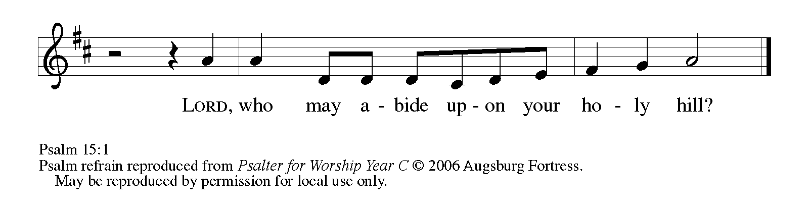

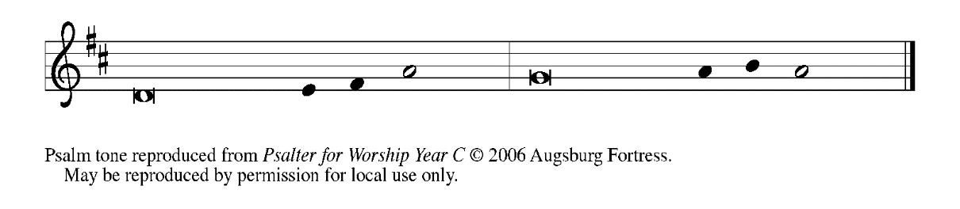

1LORD, who may dwell in Your | tabernacle?

     Who may abide upon Your | holy hill?

**2Those who lead a blameless life and do | what is right,**

**who speak the truth | from their heart;   REFRAIN**

3they do not slander with the tongue, they do no evil | to their friends;

     they do not cast discredit up- | on a neighbor.

**4In their sight the wicked are rejected, but they honor those who | fear the LORD.**

**They have sworn upon their health and do not take | back their word.**

5They do not give their money in hope of gain, nor do they take bribes a- | gainst the innocent.

     Those who do these things shall never be | overthrown.   **REFRAIN**

**THE SECOND READING Colossians 1:15-28**

*The great mystery of God is "Christ in you." Because Christ is present in his body, the church, Christians share in his life, in his suffering, and in his glory.*

15He is the image of the invisible God, the firstborn of all creation; 16for in Him all things in heaven and on earth were created, things visible and invisible, whether thrones or dominions or rulers or powers--all things have been created through Him and for Him. 17He Himself is before all things, and in Him all things hold together.

18He is the head of the body, the church; He is the beginning, the firstborn from the dead, so that He might come to have first place in everything. 19For in Him all the fullness of God was pleased to dwell, 20and through Him God was pleased to reconcile to Himself all things, whether on earth or in heaven, by making peace through the blood of His cross.

21And you who were once estranged and hostile in mind, doing evil deeds, 22He has now reconciled in His fleshly body through death, so as to present you holy and blameless and irreproachable before Him--23provided that you continue securely established and steadfast in the faith, without shifting from the hope promised by the gospel that you heard, which has been proclaimed to every creature under heaven. I, Paul, became a servant of this gospel.

24I am now rejoicing in my sufferings for your sake, and in my flesh I am completing what is lacking in Christ's afflictions for the sake of His body, that is, the church. 25I became its servant according to God's commission that was given to me for you, to make the word of God fully known, 26the mystery that has been hidden throughout the ages and generations but has now been revealed to his saints.

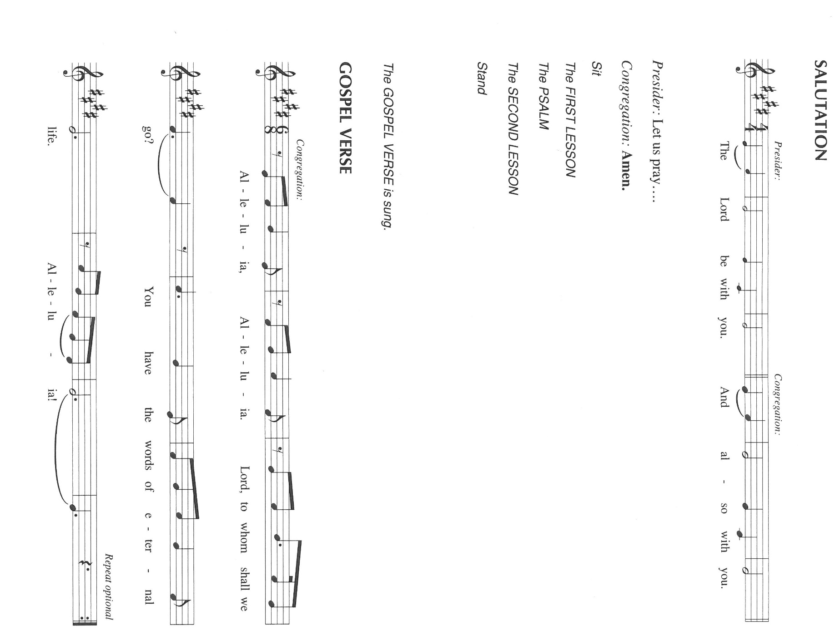27To them God chose to make known how great among the Gentiles are the riches of the glory of this mystery, which is Christ in you, the hope of glory. 28It is He whom we proclaim, warning everyone and teaching everyone in all wisdom, so that we may present everyone mature in Christ.

The Word of the Lord.

**Thanks be to God.**

*As you are able please rise*

**THE VERSE** Sung twice

**THE HOLY GOSPEL: Luke 10:38-42**

*Jesus speaks with two disciples. One is very busy, but the other sits quietly and listens.*

A: The Holy Gospel according to St. Luke, the tenth chapter.

C: **Glory to You, O Lord!**

38Now as Jesus and His disciples went on their way, He entered a certain village, where a woman named Martha welcomed Him into her home. 39She had a sister named Mary, who sat at the Lord's feet and listened to what He was saying. 40But Martha was distracted by her many tasks; so she came to Him and asked, "Lord, do you not care that my sister has left me to do all the work by myself? Tell her then to help me."

41But the Lord answered her, "Martha, Martha, you are worried and distracted by many things; there is need of only one thing. Mary has chosen the better part, which will not be taken away from her."

A: The Gospel of the Lord.

C: **Praise to You, O Christ!**

*The assembly is seated*

**THE SERMON** Homily of Synod Staff Read by Assisting Minister Sue Coziel

*Silence for reflection follows the sermon*

*As you are able please rise*

**THE HYMN OF THE DAY 510 *Word of God, Come Down to Earth***

**THE PRAYER OF THE CHURCH**

A: Like Martha, we have much to do; like Mary, we listen to the Lord’s voice. From the

complexity of our lives, let us raise our voices in prayer for the good and blessing of

all.

A: That through the Church’s faithful proclamation of the mysteries of God all people

might be reconciled to You and brought to maturity in Christ, we pray: gracious God,

C: **Hear our prayer.**

A: That through the power of the cross of Christ peace might be made and known in all

the earth, we pray: gracious God,

C: **Hear our prayer.**

A: That this congregation might be turned from all busyness that distracts us from

proclaiming in word and action the Jesus Who will not be taken from us, we pray:

gracious God,

C: **Hear our prayer.**

A: That those afflicted with hunger, loneliness, grief, or illness, especially . . . might be

held together in the arms of love of Christ, we pray: gracious God,

C: **Hear our prayer.**

A: That those celebrating birthdays, especially **Irene Bohnstadt** may grow in grace this

day and every day and be filled with grace for the days ahead, we pray: gracious God,

C: **Hear our prayer.**

A: That by the examples of Abraham and Sarah, St. Paul, Mary and Martha, **Bartolme de**

**las Casas, missionary** whom we commemorate this Day and all who have gone before

us, we may be led to listen to Jesus and follow Him in this world and the next, we pray:

gracious God,

C: **Hear our prayer.**

A: Father of Jesus, hear our prayers. Hear them in the voice of Your Son, Your Word of

love to us. We listen for His voice as we pray in His name: Jesus Christ, Lord of heaven

and earth forever.

C: **Amen.**

**✠ MEAL ✠**

**THE PEACE**

P: The peace of the Lord be with you always.

C: **And also with you.**

*The assembly is seated*

**OFFERING**

**THE VOLUNTARY *Dwell Thou With Me* Marian Wood Chaplin**

**(Soloist: Stacie Crozier)**

*As you are able please rise*

**THE OFFERTORY 465 *As the Grains of Wheat***

**THE OFFERTORY PRAYER**

A: Let us pray. Gracious God,

C: **With these gifts we bring You our praise and thanksgiving. Accept them and use**

**them, with us, to reveal the glory of Christ. We ask this in the name of Jesus the**

**Lord. Amen.**

A: When our congregation gathered yesterday for the celebration of Holy Communion,

We remembered with great joy and thanksgiving that:

In the night in which He was betrayed, our Lord Jesus took bread, gave thanks, broke

it and gave it to His disciples saying:

“Take and eat. This is My Body broken for you. Do this for the remembrance of Me.”

And that again after supper He took the cup, gave thanks, and gave it for all to drink,

saying, “This cup is the new covenant in My Blood, poured out for you and

for all people for the forgiveness of sins. Do this for the remembrance of

Me.”

And now we share this same Bread of Life and this same cup of blessing that we too

may receive the Body and Blood of Christ.

**THE LORD’S PRAYER**

A: Gathered into one by the Spirit, let us pray as Jesus taught us:

C: **Our Father in heaven, hallowed be Your name.**

**Your Kingdom come, Your will be done on earth as it is in heaven.**

**Give us this day our daily bread, and forgive us our sins as we forgive those**

**who sin against us.**

**Save us from the time of trial and deliver us from evil, for the Kingdom and**

**the power and the glory are Yours, now and forever. Amen.**

**INVITATION TO THE MEAL**

A: Holy things for holy people:

C: **One is holy, one is Lord, Jesus Christ, to the glory of God.**

A: Come, taste and see that the Lord is good.

*The assembly is seated*

**THE DISTRIBUTION “Lamb of God”**

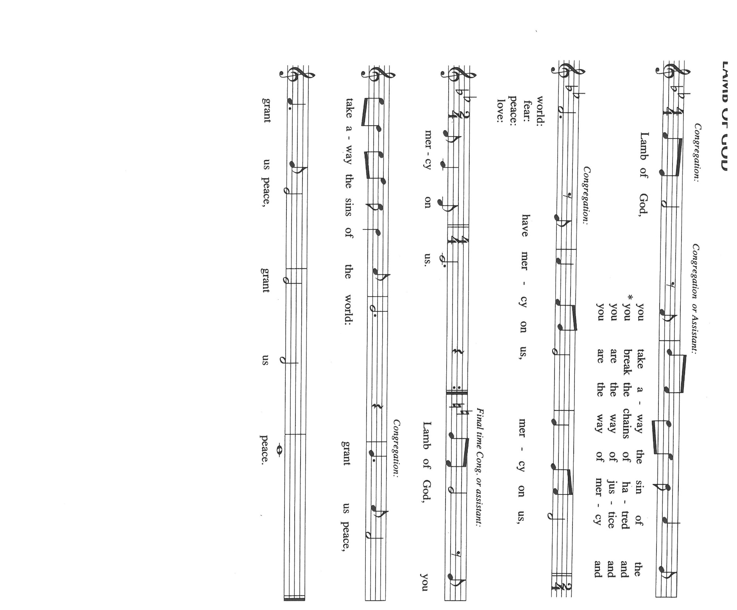

**HYMNS DURING DISTRIBUTION 492 *Eat This Bread, Drink this Cup***

**770 *Give Me Jesus***

**THE POST-COMMUNION BLESSING**

A: The Body and Blood of our Lord Jesus Christ strengthen you and keep you in His grace.

C: **Amen.**

**THE POST-COMMUNION PRAYER**

A: Let us pray. O Lord, Your eternal will is to redeem and restore Your fallen and broken

creation. Strengthen us through this Meal to help us reveal Your loving purposes until

all the world is made one in Christ, in Whose name we pray.

C: **Amen.**

**✠ SENDING ✠**

**THE BENEDICTION**

A: Almighty God: Father, Son, ✠ and Holy Spirit bless you now and forever.

C: **Amen.**

**THE SENDING HYMN 825 *You Servants of God***

**THE DISMISSAL**

A: Go in peace to bear Christ’s love to all the world.

C: **Thanks be to God!**

**POSTLUDE *March*  Jan Nieland**

**✠ To God Alone Be Glory✠**

The Meditation is from *Treasures Old and New: Images in the Lectionary.* Gail Ramshaw.

(Minneapolis: Augsburg Fortress, 2002) 181.

The musical setting of the liturgy, “Now the Feast and Celebration” by Marty Haugen, is

used by permission of GIA Publishers, Inc. OneLicense.net License #A-702836.

**ANNOUNCEMENTS**

**Please remember to mail your offering to the Church Office** at 818 Franklin Street, Michigan City, IN 46360**.** Another alternative is to give on-line through Tithe.ly. Please see your closure letter for information on how to set up a Tithe.ly account.

**St. Paul Members are reminded to have** a loved one contact the office if you are hospitalized. Many times, the Pastor doesn’t know someone is in the hospital. If you call and leave a message, please tell us which hospital the patient is at.

**Next Sunday’s lessons are Genesis 18: 20-32; Psalm138; Colassians 2: 6-15 [16-19]; Luke 11: 1-13** for those of you who like to study them in advance.

**Birthdays: Irene Bohnstadt (7/23)**

**Anniversaries: Allen & JoAnne Sydow (7/17); Mike & Amy Maesch (7/18)**

**PRAYER CONCERNS:** Audrey Beyer, Ryan Krueger, Donna Bostater, Maxine Powell, Jim Tomscheck, Eloise Ponder, Mark & Jary Tannehill, Leonard Cross, George Ottersen, Annette Scroggin, Helen Hill-Weaver and Mike Bockover.

**If you requested someone’s name to be on the prayer list and are aware that they need continued imminent prayer then contact the church office and let us know.** Otherwise we will gradually transfer names to the long-term list.

**OFFICE HOURS:** Libby will be in the office on Mondays, Wednesdays, and Fridays; volunteers will cover Tuesdays and Thursdays.

Monday & Wednesday 8:00 a.m. – 5 p.m.

Tuesday & Thursday 9:00 a.m. – 12:00 p.m.

Friday 8:00 a.m. – 12:00 p.m.

**If you are listening to the worship broadcast on the radio and would like to watch the Sunday morning service live stream follow these steps:**

(1) If you have You.Tube available on your TV, search for

**St. Paul Lutheran Church Michigan City, IN.**

(2) The direct link on the computer is

<https://www.youtube.com/channel/UC5AIPNaKr3QN50984jGOa1g>.

 (3) This link is also on the main page of the church’s website in the church section and will continue to be posted weekly on the St. Paul Facebook page.

And it will always be available on the radio broadcast Sunday mornings at 11:00 a.m. on WEFM (95.9), and on the local cable access station #99 for the previous week’s service on Sundays at 4:00 p.m. and the current service on Wednesdays at 7:00 p.m. and Fridays at 8:30 p.m.

**To send e-mail to the church office**, please use the following addresses:

Pastor Mark Reshan: [seniorpastor@stpaulmichigancity.com](mailto:seniorpastor@stpaulmichigancity.com)

Church Office Secretary (Libby Pollock): [churchsecretary@stpaulmichigancity.com](mailto:churchsecretary@stpaulmichigancity.com)

Church Treasurer (Karen Fleming): [finance@stpaulmichigancity.com](mailto:finance@stpaulmichigancity.com)

**The Good News Newsletter**: If you have an article or anything you want included in **The Good News** please send it to the following e-mail address: splcgoodnews@gmail.com. Pastor Pamela Thiede will be using this e-mail address to assemble **The Good News** each month. The deadline for getting information to Pastor Pamela will be the 20th of each month.

**PLEASE REMEMBER:** the next time you are coming to the church whether it be for one of the worship services or for any other meeting or activity please remember to bring in non-perishable food items to donate to the Salvation Army Food Pantry. There is a

serious need in this community to help especially those whom have little to no access to food and/or shelter. Please open your hearts and continue to be generous in your giving!

**WORSHIP ATTENDANCE for July 9 and 10, 2022**

**4:00 p.m. 42**

**9:00 a.m. 52**

**Total = 94**

**2022 Financial Stewardship**

Weekly Church Operating Needs (x 2 weeks): $14,096.53

July 2 and 3, July 9 and 10, 2022

General Fund (including General Memorials): $ 12,713.70

Overage/Shortage: --$ 1,382.83

Restricted Income (not including Memorials)

Supports IK Synod & Church wide Ministries: $483.00

Ministries in our Community/Congregation: $ 50.00

Capital Fund: $ 807.50

**Memorials:**

Capital Fund $150.00

Altar Guild $ 50.00

**JULY 2022 ACTIVITIES, MEETINGS AND SERVICES**

**Saturday,** July 9, 2022 at 4:00 p.m. Worship Service

**Sunday,** July 10, 2022 at 9:00 a.m. Worship Service

**Monday,** July 11, 2022 at 12:30 p.m. Harmony Circle/Nursery/Green Room

**Tuesday,** July 12, 2022 at 11:30 a.m. Charity Circle to meet at Sugar Bowl Restaurant

**Wednesday,** July 13, 2022 at 10:00 a.m. God’s Purls/St. Paul Room

**Saturday,** July 16, 2022 at 4:00 p.m. Worship Service

**Sunday,** July 17, 2022 at 9:00 a.m. Worship Service

**Monday,** July 18, 2022 at 4:00 p.m. Finance Committee Meeting/St. Paul Room

**Wednesday,** July 20, 2022 at 10:00 a.m. God’s Purls/St. Paul Room

**Saturday,** July 23, 2022 at 4:00 p.m. Worship Service

**Sunday,** July 24, 2022 at 9:00 a.m.Worship Service

**Monday,** July 25, 2022 at 5:30 p.m. Executive Board Meeting/Luther House

**Wednesday,** July 27, 2022 at 10:00 a.m. God’s Purls/St. Paul Room

**Thursday,** July 28, 2022 from 4 p.m. – 10 p.m. **GIVE-BACK at Galveston Steakhouse**

at 5:30 p.m. Church Council Meeting/St. Paul Room

**Saturday,** July 30, 2022 at 4:00 p.m. Worship Service

**Sunday,** July 31, 2022 at 9:00 a.m. Worship Service

**PLEASE NOTE:** Unfortunately Mike Bockover fell and will be unable to help with the filming of the Sunday services for at least the next six weeks. Paul Brooks who also volunteers for this work has agreed to fill in until Mike is able to return. However, there may be a week that Paul would be unable to attend church. If Paul cannot be there, there will be no live broadcast. If you are interested in helping out with this please contact the church office. We send out our best wishes to Mike for a speedy and complete recovery.

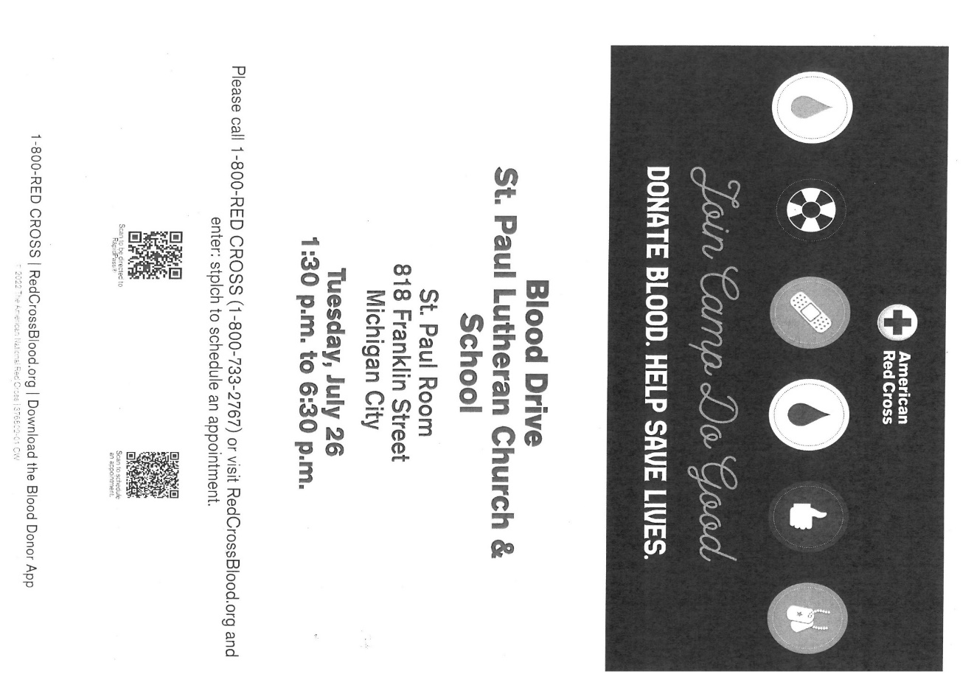

Thank$ for $haring

This month,we will see you at Galveston! We’re giving you two coupons so you can invite a friend and give them their own coupon. Remember, the coupon is required for the Give-Back bucks.

