**THE SECOND SUNDAY OF EASTER**

**April 27, 2025**

Loving, living God, scarcely a week after Easter, after the triumph of Your love in the raising of Jesus, we can already feel our faith slipping from us. What seems so sure and certain here in church, often seems indistinct and unbelievable in the world.

Recall us, during this time of worship, back into Your presence. Stir up in us fresh awareness of Your glory. Raise us again to that new life which You will for us. Bring Your Church from death to life. Again. Amen.

**William Willimon**

A pair of scientists declares “even the most logically beautiful theories or thought experiments can’t hold a candle to real-world data.” This sentiment seems to speak to the yearning of Thomas: “Until I see the mark of the nails in his hands, and put my hand in his side, I will not believe” (John 20: 25b).

Apparently, Thomas believes in data-driven conclusions. And, truth be told, so do we. Thomas speaks to our values more than we recognize. As people of faith, we experience an almost reflexive dislike for “doubting” Thomas, but this is neither fair to him nor to the biblical witness.

True, the biblical text does not engage in abstract arguments about the “existence” of God as a philosophical concept. Nevertheless, the modern debate around the existence of God boils down to this question, one that is not uniquely modern, according to Patrick D. Miller: “Is God a reality, one with which we have to deal, or not? Is God real?” Miller believes the psalmist is preoccupied with this central concern: is God present in our suffering? does God exist in the midst of pain, injustice, and doubt? Miller underlines the characteristic way the Psalms juxtapose extravagant faith claims alongside deep doubts.

Perhaps in Thomas we hear the one who prays like the psalmist prays, pleading for God’s existence amid our groans, watching for God in the land parched with doubt but no water, looking for the God who bears the marks of our weary world in his own body.

Perhaps we could hear Thomas this way, as one who seeks evidence of God’s presence in the world, through the “mark of the nails in his hands” … if so, Thomas’ response to Jesus suggests vastly more than evidence for God’s existence, more even than the Lord God alone, which would have been enough. But, no, on Thomas’ lips we hear the personal confession, “My Lord and my God!” (28b).

Thomas wanted only to see the nail marks in Jesus’ hands, to put his hand into his side -- but what he received on his lips and within his heart was vastly more than the wounds. He received his Lord and God.

**Robert Hoch**

**✠ In the Name of Jesus ✠**

**INTRODUCTION**

In spite of all we have heard and all that we have seen, it is often hard to believe. Because it is hard to believe, we will invest ourselves in the Easter mystery for fifty days (a week of weeks). Because it is hard to believe, John the evangelist will provide sign after sign celebrating Jesus' victory over death. Because it is hard to believe, the Lord Jesus will return to us again and again in the mystery of the holy communion, inviting us to touch and taste His presence, and offering us His peace.

**Mark, Evangelist**

*He was not numbered among the twelve apostles, yet Mark was probably a member of the early church community. The gospel that bears his name is the shortest and most direct, and many scholars think it was the first to be written.*

**✠ GATHERING ✠**

**PRE-SERVICE We Believe New Song Praise Band**

**(Kate Miner)**

**THE EASTER ACCLAMATION**

P: Christ is risen! Alleluia!

**C: (Shouted) Christ is risen indeed! Alleluia!**

**ANNOUNCEMENTS**

As you are able please rise

**CONFESSION AND ABSOLUTION**

P: In the name of the Father and of **✠** the Son and of the Holy Spirit.

**C: Amen.**

P: Rejoicing in the resurrection, let us seek God's forgiveness, that dying to sin, we may

walk in newness of life.

*Silence for reflection and self-examination is kept*

P: Most merciful God,

**C: We confess that we have sinned against You in thought, word, and deed. We have**

**not obeyed You (Acts 5: 29). We have allowed our fear of rejection and ridicule**

**to keep us from bearing faithful witness to You. We have gladly received Your**

**peace and forgiveness (John 20: 19, 23) but have been slow to offer those same**

**gifts to others. Like Thomas, we are guilty of unbelief in Your living presence**

**among us (20: 27). For the sake of Your Son, Jesus Christ, have mercy on us and**

**forgive us. In Your “excellent greatness” (Psalm 150: 2) restore us to a firm faith,**

**deep hope, and a grace-filled joy, that we may serve (Revelation 1: 6) and please**

**You.**

P: We are “loved (by Christ)” and “freed from our sins by His blood” (Revelation 1: 5) so

with Christ we too might be “faithful witnesses.” Therefore, as a called and ordained

minister of the Church of Christ, and by His authority, I declare to you the entire

forgiveness of all your sin, in the name of the Father and of **✠** the Son and of the Holy

Spirit.

**C: Amen.**

**GATHERING SONG NSB 20 *Celebrate Jesus***

**THE GREETING AND PRAYER OF THE DAY**

P: Alleluia! Christ is risen!

**C: He is risen indeed! Alleluia!**

P: The grace of our Lord Jesus Christ, the love of God, and the communion of the Holy

Spirit be with you all.

**C: And also with you.**

P: Let us pray. O God of life, You reach out to us amid our fears with the wounded hands

of Your risen Son. By Your Spirit’s breath revive our faith in Your mercy, and

strengthen us to be the body of Your Son, Jesus Christ, our Savior and Lord, Who lives

and reigns with You and the Holy Spirit, one God, now and forever.

**C: Amen.**

*The assembly is seated*

**✠ WORD ✠**

**FIRST READING Acts 5: 27-32**

*Peter's response to the high priest is a concise summary of the proclamation of the early church, including the crucifixion, resurrection, and ascension of Jesus, and the offer of repentance and the forgiveness of sins.*

27When they had brought the apostles, they had them stand before the council. The high priest questioned them, 28saying, "We gave you strict orders not to teach in this name, yet here you have filled Jerusalem with your teaching and you are determined to bring this man's blood on us." 29But Peter and the apostles answered, "We must obey God rather than any human authority.

30The God of our ancestors raised up Jesus, Whom you had killed by hanging Him on a tree. 31God exalted Him at His right hand as Leader and Savior that He might give repentance to Israel and forgiveness of sins. 32And we are witnesses to these things, and so is the Holy Spirit whom God has given to those who obey Him."

The Word of the Lord.

**Thanks be to God.**

**THE PSALM: Psalm 150** Antiphon by Carl Schalk

Choir sings refrain first, followed immediately by the congregation

and as indicated

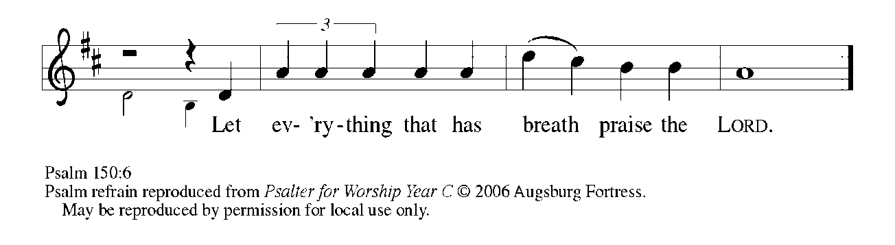

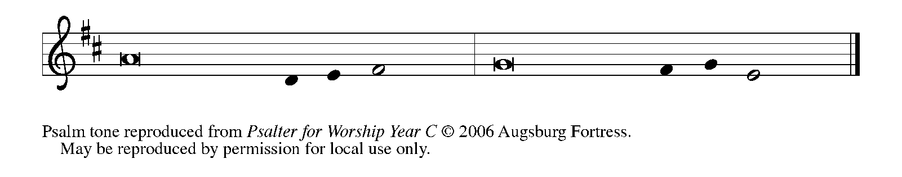

1Hallelujah! Praise God in the | holy temple;

     praise God in the | mighty firmament.

**2Praise God for | mighty acts;**

**praise God for ex- | ceeding greatness.   REFRAIN**

3Praise God with | trumpet sound;

     praise God with | lyre and harp.

**4Praise God with tambou- | rine and dance;**

**praise God with | strings and pipe.**

5Praise God with re- | sounding cymbals;

     praise God with loud- | clanging cymbals.

**6Let everything | that has breath**

**praise the LORD. | Hallelujah!   REFRAIN**

**SECOND READING Revelation 1: 4-8**

*The book of Revelation recounts a vision of the risen Christ experienced by a Christian prophet named John. Here he describes Christ as the faithful witness or martyr, firstborn of the dead, ruler in a kingdom of priests, the one who comes, the beginning and the end of all time.*

4John to the seven churches that are in Asia:

Grace to you and peace from Him Who is and Who was and Who is to come, and from the seven spirits who are before His throne, 5and from Jesus Christ, the faithful witness, the firstborn of the dead, and the ruler of the kings of the earth.

To Him Who loves us and freed us from our sins by His blood, 6and made us to be a kingdom, priests serving His God and Father, to Him be glory and dominion forever and ever. Amen.

7Look! He is coming with the clouds;

every eye will see Him,

even those who pierced Him;

and on His account all the tribes of the earth will wail.

So it is to be. Amen.

8"I am the Alpha and the Omega," says the Lord God, Who is and Who was and Who is to come, the Almighty.

The Word of the Lord.

**Thanks be to God.**

*As you are able please rise*

**THE VERSE**

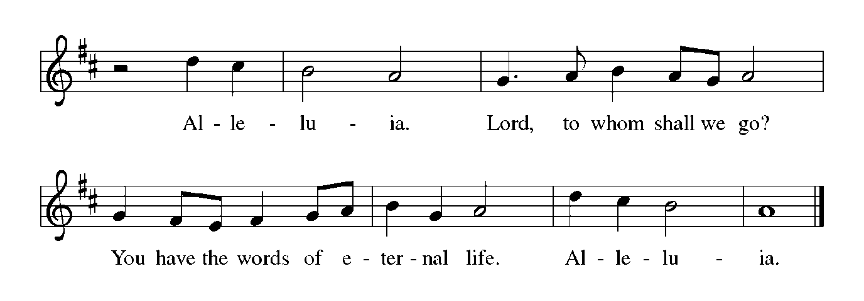

**THE HOLY GOSPEL John 20: 19-31**

*The Easter proclamation continues in John's gospel with reference to peace, joy, mission, the Holy Spirit, and forgiveness. Jesus' words to Thomas assure us that the blessings of the resurrection are also for those who "have not seen and yet believe."*

P: The Holy Gospel according to St. John, the twentieth chapter.

**C: Glory to You, O Lord!**

19When it was evening on that day, the first day of the week, and the doors of the house where the disciples had met were locked for fear of the Judeans, Jesus came and stood among them and said, "Peace be with you." 20After He said this, He showed them His hands and His side. Then the disciples rejoiced when they saw the Lord. 21Jesus said to them again, "Peace be with you. As the Father has sent Me, so I send you." 22When He had said this, He breathed on them and said to them, "Receive the Holy Spirit. 23If you forgive the sins of any, they are forgiven them; if you retain the sins of any, they are retained."

24But Thomas (who was called the Twin), one of the twelve, was not with them when Jesus came. 25So the other disciples told him, "We have seen the Lord." But he said to them, "Unless I see the mark of the nails in His hands, and put my finger in the mark of the nails and my hand in His side, I will not believe."

26A week later His disciples were again in the house, and Thomas was with them. Although the doors were shut, Jesus came and stood among them and said, "Peace be with you." 27Then He said to Thomas, "Put your finger here and see My hands. Reach out your hand and put it in my side. Do not doubt but believe." 28Thomas answered Him, "My Lord and my God!" 29Jesus said to him, "Have you believed because you have seen Me? Blessed are those who have not seen and yet have come to believe."

30Now Jesus did many other signs in the presence of His disciples, which are not written in this book. 31But these are written so that you may come to believe that Jesus is the Messiah, the Son of God, and that through believing you may have life in His name.

P: The Gospel of the Lord.

**C: Praise to You, O Lord!**

*The assembly is seated*

**THE SERMON**

*Silence for reflection follows the sermon*

*As you are able please rise*

**THE HYMN OF THE DAY 635 *We Walk by Faith***

**THE NICENE CREED**

A: God has made us His people through our Baptism into Christ. Living together in trust

and hope, we confess our faith.

**We believe in one God,**

**the Father, the Almighty,**

**maker of heaven and earth,**

**of all that is, seen and unseen.**

**We believe in one Lord, Jesus Christ,**

**the only Son of God,**

**eternally begotten of the Father,**

**God from God, Light from Light,**

**true God from true God,**

**begotten, not made,**

**of one Being with the Father.**

**Through Him all things were made.**

**For us and for our salvation**

**He came down from heaven;**

**by the power of the Holy Spirit**

**He became incarnate from the virgin Mary, and was made man.**

**For our sake He was crucified under Pontius Pilate;**

**He suffered death and was buried.**

**On the third day He rose again**

**in accordance with the Scriptures;**

**He ascended into heaven**

**and is seated at the right hand of the Father.**

**He will come again in glory to judge the living and the dead,**

**and His kingdom will have no end.**

**We believe in the Holy Spirit, the Lord, the giver of life,**

**Who proceeds from the Father and the Son.**

**With the Father and the Son He is worshiped and glorified.**

**He has spoken through the prophets.**

**We believe in one holy catholic and apostolic Church.**

**We acknowledge one Baptism for the forgiveness of sins.**

**We look for the resurrection of the dead,**

**and the life of the world to come. Amen**

**THE PRAYER OF THE CHURCH**

A: In the light of Christ’s resurrection, let us pray for the Church, the world, and all who

long for the grace of new life.

A: That the Church may be delivered from doubt, fear, and inaction to a bold and faithful

witness to the resurrection: Lord, in Your mercy,

**C: Hear our prayer.**

A: That we in this congregation who have not seen Jesus but yet come to believe may have

our faith strengthened and our passion as God’s priests of forgiveness renewed: Lord,

in Your mercy,

**C: Hear our prayer.**

A: That children who suffer abuse of all kinds: physical, emotional, mental and neglect

may be blessed with teachers, neighbors and friends who see what they are afraid to

tell; filled with hope and safe places where their bodies and minds can heal and feel

safe; and the presence of loving and nurturing adults who can help them to grow into

the beloved and precious individuals You created them to be: Lord, in Your mercy,

 C:  **Hear our prayer.**

 A: That those persecuted for the name of Jesus, especially in Afghanistan; Algeria;

Egypt; Iran; Iraq; China, and other places of oppression against the Church, may

witness to their faith by patient endurance and non-violent resistance: Lord, in Your

mercy,

**C: Hear our prayer.**

A: That those imprisoned by the guilt, shame, and despair of sin might be released from

their burden, and that those broken in body, mind, or spirit, especially the sick: **Fred**

**Weiss; Carol Radke; Larry Litchford; Joyce Stark; Martha Schroeder; Jess**

**Kalvaitis; Bill Noble; Kevin Thiede; Ken Mulder; Kathy Stein; Debbie Martin;**

**and Christine Kiser** might experience the healing power of the Spirit of the living

Christ: Lord, in Your mercy,

**C: Hear our prayer.**

A: That those celebrating birthdays, especially **Virginia Murray;** and anniversaries,

especially **Leigh and Bev Coburn** might grow in grace this Day and every day and be

filled with grace in the days ahead: Lord, in Your mercy,

**C: Hear our prayer.**

A: That our celebration of the Resurrection might renew our lives, and that together with

all the saints, especially **Mark, Evangelist,** whom we commemorate this Day we too

might come to Your everlasting life: Lord, in Your mercy,

**C: Hear our prayer.**

P: Lord, we believe. Help our unbelief, and hear us for the sake of Jesus Christ, the First

and the Last, the Living One, in Whose name we pray.

**C: Amen.**

**✠ MEAL ✠**

**THE PEACE**

P: The peace of the risen Lord be with you always.

**C: And also with you.**

*The assembly is seated*

**THE OFFERING**

**THE VOLUNTARY*****Order My Steps* St. Paul Senior Choir**

(G. Burleigh; Arr. J. Schrader)

*As you are able please rise*

**THE OFFERTORY (see p. 9)**

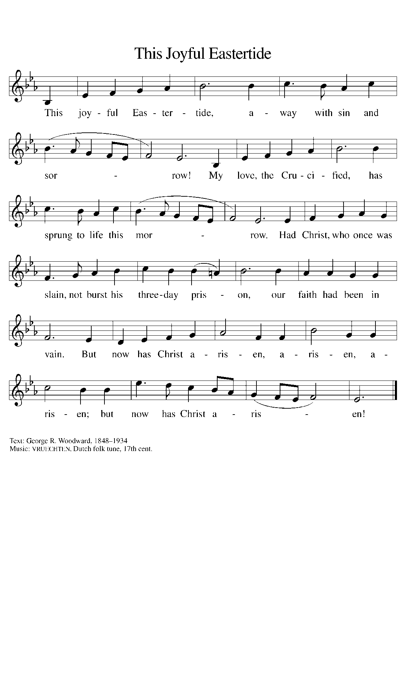

**THE OFFERTORY PRAYER**

A: Let us pray. God of blessing and glory,

**C: With people of every language and nation we bring the first fruits of our labor.**

**Let the sharing of these gifts proclaim our joyful hope in Jesus Christ, the first**

**fruits of the resurrection. We ask this in the name of Jesus the risen Lord. Amen.**

**THE GREAT THANKSGIVING**

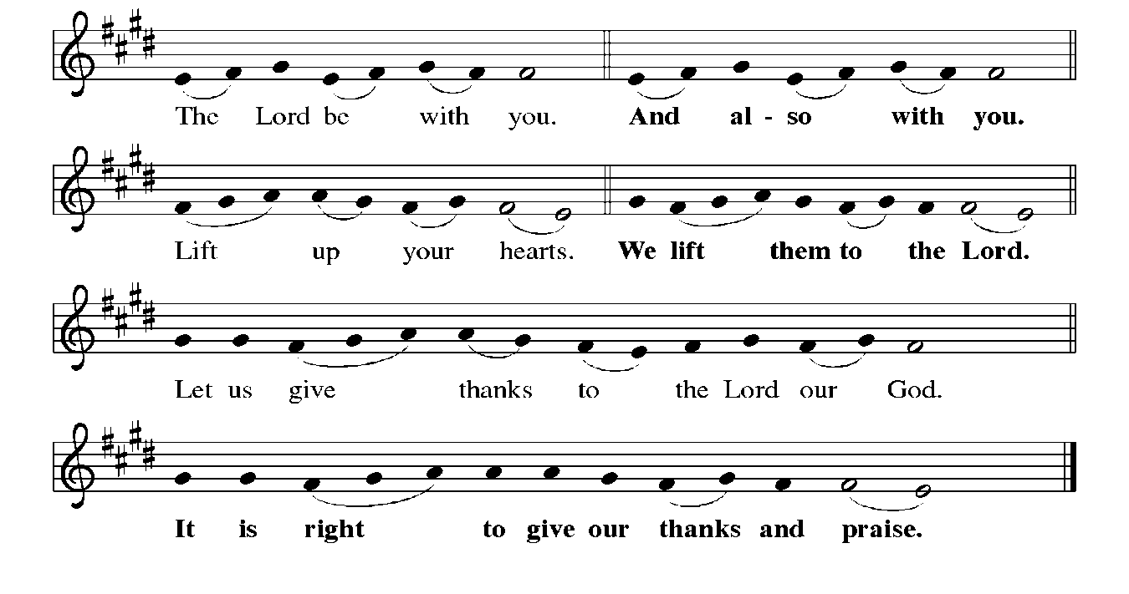

P: It is indeed right, our duty, and our joy … join their unending hymn:

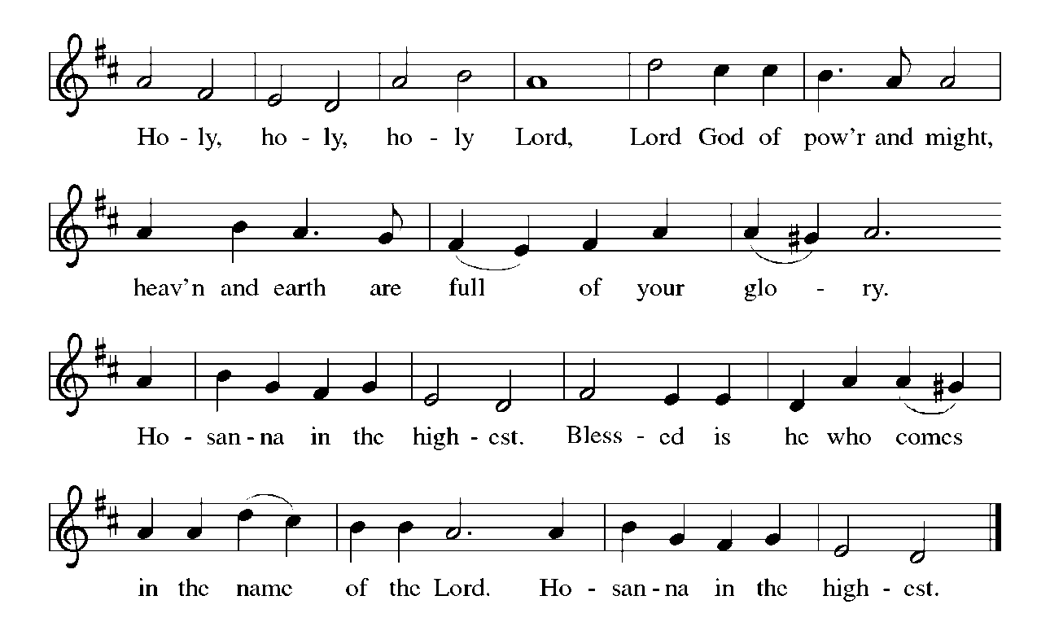

P: It is our duty and our joy to give You thanks and praise, Lord God of heaven and

earth, because You are continually renewing Your work of creation and

transforming it to show Your glory through resurrection.

With Your touch You formed us from the dust of the earth.

You raised Your people from slavery in Egypt; You bound them to You through

Your covenant on Sinai; and You made Yourself known to them in exile

and the Promised Land.

In the cross of Jesus You take into Yourself the scars of our sin, and in His

resurrected Body You invite us to touch the wounds of Your love.

Forgiving God, Your Son’s disciples cowered before locked doors; and yet in Him

You visited them on the evening of resurrection and breathed on them the

Spirit of peace.

Breathe that Holy Spirit on us now, that Your Church may know the power of Your

forgiveness and these gifts of bread and wine may be for us the Body and

Blood of Your Son Jesus Christ;

Who … “Do this for the remembrance of Me.”

As often as we eat … we proclaim the Lord’s death until He comes.

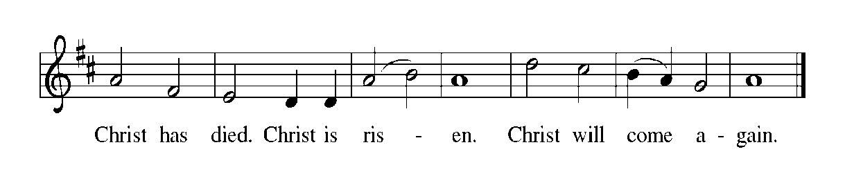

P: Lord and God, intimate Savior of our live and cosmic Ruler of the universe,

In Jesus You are the substance of things hoped for and the knowledge of things unseen.

Visit any who struggle under the shadow of doubt; minister among all who suffer

beneath the claims of oppressive rule; resurrect Your children, Your

Church, and Your earth.

Bless those who have not seen and yet believe, and shape Your wounded Body

the Church to let the world see You through its scars.

Lift every voice to sing Your Easter glory, until the Day when all stand before Your

throne, in eternal communion with one another and with You, ever one

God, Father✠Son, and Holy Spirit.

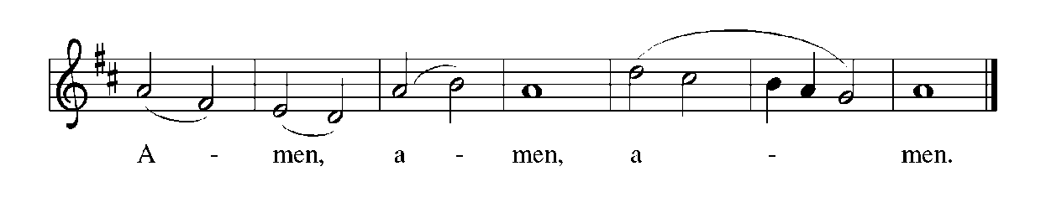

**THE LORD’S PRAYER**

P: Risen from the dead, Jesus lives to intercede for us and join us as He taught us to pray:

**C: Our Father in heaven, hallowed be Your name. Your Kingdom come. Your will**

**be done on earth as it is in heaven. Give us this day our daily bread, and forgive**

**us our sins as we forgive those who sin against us. Save us from the time of trial**

**and deliver us from evil. For the Kingdom, the power, and the glory are Yours,**

**now and forever. Amen.**

**INVITATION TO THE MEAL**

P: Alleluia! Christ the Lamb of God has been sacrificed. Therefore, let us celebrate His

Feast with joy. Blessed are those who are called to the Supper of the Lamb. God’s

holy gifts for God’s holy people. Come, for all is now ready.

*The assembly is seated*

**THE DISTRIBUTION**

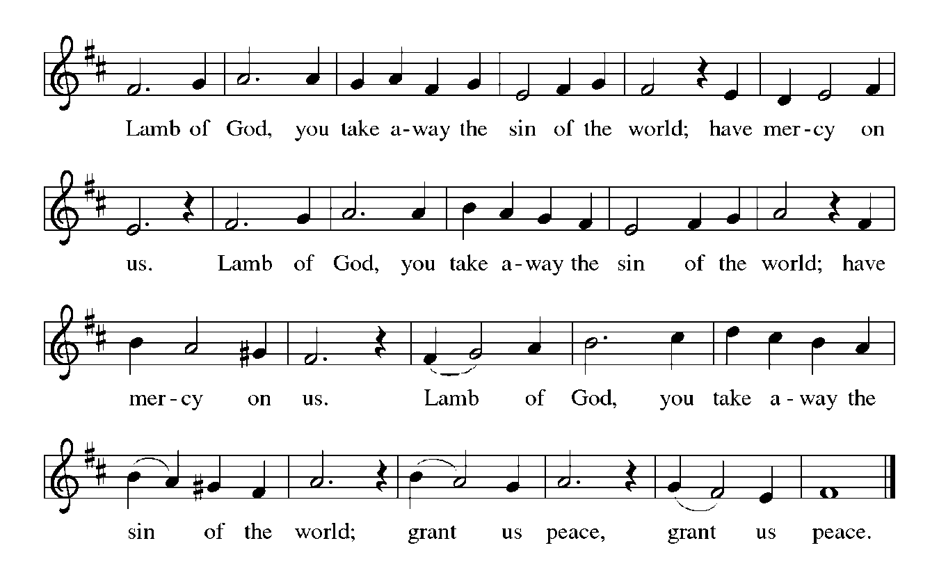

**HYMN DURING DISTRIBUTION 384 *That Easter Day With Joy Was Bright***

**NSB 43 *He Has Made Me Glad***

**ELW 482 *I Come With Joy***

**ELW 485 I am the Bread of Life**

*As you are able please rise*

**THE POST-COMMUNION BLESSING**

P: The Body and Blood of our Lord Jesus Christ strengthen you and keep you in His grace.

**C: Amen.**

**THE POST-COMMUNION PRAYER**

A: Let us pray. Living God, as the disciples ate and drank with their risen Lord, we have

been nourished with the very presence of Christ. Through this Meal may we be

strengthened to keep Your Word and to proclaim the power of Your saving love in

Jesus Christ our Lord.

**C: Amen.**

**✠ SENDING ✠**

**THE BENEDICTION**

P: May God the Father Who raised Christ from the dead open to you the gate of everlasting

life.

**C: Amen.**

P: May God the Son Who burst from the grave give you joy as you celebrate His

resurrection.

**C: Amen.**

P: May God the Holy Spirit Who brought you to birth in Baptism fill you with strength

and peace.

**C: Amen.**

P: Almighty God: Father, Son, **✠** and Holy Spirit bless you now and forever.

**C: Amen.**

**SENDING HYMN 548 *Rise, O Church, Like Christ Arisen***

(Tune: *Praise, My Soul, the King of Heaven*)

**Rise, O Church, like Christ arisen,**

**From this Meal of love and grace;**

**May we through such love envision**

**Whose we are, and Whose, our praise,**

**Alleluia, alleluia;**

**God, the wonder of our days.**

**Rise, transformed, and choose to follow**

**After Christ, though wounded, whole;**

**Broken, shared, our lives are hallowed**

**To release and to console**

**Alleluia, alleluia;**

**Christ, our present, past, and goal.**

**Rise, remember well the future**

**God has called us to receive;**

**Present by God’s loving nurture,**

**Spirited then let us live.**

**Alleluia, alleluia;**

**Spirit, grace by Whom we live.**

**Service be our sure vocation;**

**Courage be our daily breath;**

**Mercy be our destination**

**From this day and unto death.**

**Alleluia, alleluia;**

**Rise, O Church, a living faith.**

**THE DISMISSAL**

A: Alleluia! Christ is risen!

**C: He is risen indeed! Alleluia!**

A: Go in the peace of Christ, alleluia!

**C: Thanks be to God! Alleluia!**

**POSTLUDE**

**✠ To God Alone Be Glory ✠**

The Meditation is from *Pulpit Resource.* William Willimon, ed. Vol. 26 No. 2. (Inver

Heights, MN:Logos Productions, 1998) 15.

The Eucharistic Prayer is adapted from *Eucharistic Prayers.* Samuel Wells and Abigail

Kocher. (Grand Rapids: Eerdmann’s Publishing Company, 2016) 158-59.

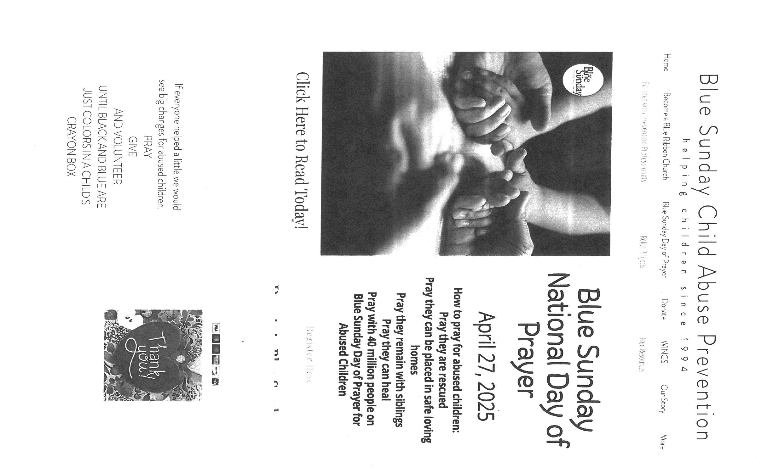

**MISSION OF THE MONTH FOR MAY 2025**

Our Monthly Mission for the month of May, 2025, is Camp Sharing Meadows, part of the Share Foundation. Located in LaPorte, Camp Sharing Meadows is an inclusive Christian camp for adults with intellectual and/or developmental disabilities, where a vibrant blend of community, faith, and creative exploration takes center focus. The camps allow individuals with developmental and intellectual disabilities to have fun while learning faith-based values, participating in various activities, and making lifelong friendships. Monetary and check donations can be made out to the church and marked for Camp Sharing Meadows and placed in the offering plate. Noisy coin offering will also go to the Mission of the Month. Thank you for your generosity!

**ANNOUNCEMENTS**

**Please remember to mail your offering to the Church Office** at 818 Franklin Street, Michigan City, IN 46360**.** Another alternative is to give on-line through Tithe.ly. Please see your closure letter for information on how to set up a Tithe.ly account.

**St. Paul Members are reminded to have** a loved one contact the office if you are hospitalized. Many times, the Pastor doesn’t know someone is in the hospital. If you call and leave a message, please tell us at which hospital the patient is located.

**Birthdays: Virginia Murray (4/28)**

**Anniversaries: Leigh & Beverly Coburn(5/1); Charles & Carol Thomas II (5/2)**

**PRAYER CONCERNS:** Larry Litchford, Sarah McNabb, Carol Radke, Jeanie Boatman Shepple, Nolan Wilson, Debbie Martin, Mark Tannehill, Brian Wiseman, Kathy Stein, Danielle Schnell, Jan Paholski, Laura Dovey, and Grace Romine.

**OFFICE HOURS:** Libby will be in the office on Mondays, Wednesdays, and Fridays; volunteers will cover Tuesdays and Thursdays.

Monday & Wednesday 8:00 a.m. – 5 p.m.

Tuesday & Thursday 9:00 a.m. – 12:00 p.m.

Friday 8:00 a.m. – 12:00 p.m.

**If you are listening to the worship broadcast on the radio and would like to watch the Sunday morning service live stream follow these steps:**

(1) If you have You Tube available on your TV, search for

**St. Paul Lutheran Church Michigan City, IN.**

(2) The direct link on the computer is

https://www.youtube.com/channel/UC5AIPNaKr3QN50984jGOa1g.

   (3) This link is also on the main page of the church’s website in

the church section and will continue to be posted weekly on the St.

Paul Facebook page.

And it will always be available on the radio broadcast Sunday mornings at 11:00 a.m.

on WEFM (95.9), and on the local cable access station #99 for the previous week’s

service on Sundays at 4:00 p.m. and the current service on Wednesdays at 7:00 p.m.

and Fridays at 8:30 p.m.

**Next Sunday’s lessons are Acts 9: 1-6 [7-20]; Psalm 30; Revelation 5: 11-14; John 21: 1-19** for those of you who like to study them in advance.

**To send e-mail to the church office**, please use the following addresses:

Pastor Mark Reshan: seniorpastor@stpaulmichigancity.com

Church Office Secretary (Libby Pollock): churchsecretary@stpaulmichigancity.com

Church Treasurer (Karen Fleming): finance@stpaulmichigancity.com

**The Good News Newsletter**: If you have an article or anything you want included in **The Good News** please send it to the following e-mail address: splcgoodnews@gmail.com. Pastor Pamela Thiede will be using this e-mail address to assemble **The Good News** each month. The deadline for getting information to Pastor Pamela will be the 20th of each month.

**Worship Attendance:**

**Maundy Thursday, April 17, 2025 @ 10:00 a.m. 47**

**Good Friday, April 18, 2025 @7:00 p.m. 44**

**Easter Vigil Saturday , April 19, 2025 @ 7:00 p.m. 30**

**Easter Sunday, April 20, 2025 @ 9:00 a.m. 166**

**TOTAL 287**

**Copies of the minutes from the January 23, 2025 and February 27, 2025 Church Council meetings are on the back table in the upper Narthex. They were approved by the council via email.**

**FYI:**

In response to the ever rising costs for postage we will be putting your copy

of the “Good News” in your hanging file folder in the narthex each month

from now on. Those of you who are unable to attend services on a regular

basis may still receive your copies through your email address or in the

U.S. mail. If you normally receive your copy of the newsletter via your

email address anyway, nothing will change for you. Thank you so much for

your understanding and cooperation!

**THANK YOU!**

**Let’s give a huge thank you to Warren Schacht for putting almost all the Archive Room media on easy-to-watch and hear discs for anyone wanting to have a look or a listen to what’s available. A sincere and heartfelt thank you for taking the time and interest to do something that will benefit the record of the past for future generations to come! Your efforts are so appreciated.**

**ACTIVITIES, EVENTS & MEETINGS**

**May 2025**

**Thursday,** May 1, 2025 @ Faith Circle ?

  @ 5:30p.m. Church Council Mtg./St. Paul Room

**Saturday,** May 3, 2025 @ 4:00 p.m. 3rd Easter Worship Service

**Sunday,** May 4, 2025 @ 9:00 a.m. 3rd Easter Worship Service

Coffee in the St. Paul Room after service

**Wednesday,** May 7, 2025 @ 9:15 a.m. Bible Study/Luther House

  @ 10:00 a.m. God’s Purls/St. Paul Room

  @ 4:30 p.m. Choir Rehearsal/Sanctuary

**@11:00 a.m. – close** **GIVE BACK AT SWINGBELLY’S**

**Saturday,** May 10, 2025 @ 4:00 p.m. 4th Easter Worship Service

**Sunday,** May 11, 2025 @ 9:00 a.m. 4th Easter Worship Service

Coffee in the St. Paul Room after service

**Tuesday,** May 13, 2025 @ 7:00 p.m. Estuary/Luther House

**Wednesday,** May 14, 2025 @ 9:15 a.m. Bible Study/Luther House

  @10:00 a.m. God’s Purls/St. Paul Room

  @ 3:30p.m. Worship & Music Co,, Mtg./Luther House

  @ 4:30 p.m. Choir Rehearsal/Sanctuary

**Saturday,** May 17, 2025 @ 4:00 p.m. 5th Easter Worship Service

**Sunday,** May 18, 2025 @ 9:00a.m. 5th Easter Worship Service

**@10:15 a.m. CONGREGATIONAL MTG/St. Paul Room**

**with a Pot Luck luncheon immediately following**

**Monday,** May 19, 2025 @ 1:00 p.m. Hope Circle/Green Room

  @2:00 p.m. Finance Committee Mtg/Luther House

  @ 3:00 p.m. Executive Board Meeting/Luther House

**Wednesday,** May 21, 2025 @ 9:15 a.m. Bible Study/Luther House

  @10:00 a.m. God’s Purls/St. Paul Room

  @ 4:30 p.m. Choir Rehearsal/Sanctuary

**Saturday,** May 24, 2025 @ 4:00 p.m. 6th Easter Worship Service

**Sunday,** May 25, 2025 @ 9:00 a.m. 6th Easter Worship Service Coffee in the St. Paul Room after service

**Monday,** May 26, 2025 **MEMORIAL DAY – OFFICE WILL BE CLOSED**

**Wednesday,** May 28, 2025 @ 9:15 a.m. Bible Study/Luther House

  @ 10:00 a.m. God’s Purls/St. Paul Room

  @ 4:30 p. m. Choir Rehearsal/Sanctuary

**Thursday,** May 29, 2025 @ 5:30 p.m. Church Council Meeting/St. Paul Room

**Saturday,** May 31, 2025 @ 4:00 p.m. 7th Easter Worship Service