**THE FIFTH SUNDAY IN LENT**

**April 6, 2025**

"I am doing a new thing." Thus God admonishes us as we enter the last week of Lent: prepare yourselves, for something you have not imagined is about to happen. The day that is coming will not be like any former day. It will come fresh and dazzling as a bright sunrise after a lifetime of drizzle and gloom. The new thing that is almost upon us will relativize everything—even our best preparations. For God is bringing us out of the isolation created by sin, into a communion of the forgiven.

No matter how many times we experience it, no matter how many times we celebrate the repentance, eucharist, and Easter, the forgiving embrace of God always comes upon us as brand new, totally unexpected, awesome in its revelation of ourselves and all others as beloved children of God.

**Mary Frohlich**

The vividly sensuous nature of this passage encourages preachers to invite congregations to think about the gospel in ways beyond words, speaking, and reading. Does grace have a scent? It can be worth the effort to reflect on Jesus and his work in terms of meaningful smells and sensations.

Rudyard Kipling wrote, "Smells are surer than sounds or sights / To make your heart-strings crack."1

Most people have experienced a smell that floods the mind with arresting memories of a person, place, or event. Olfaction, emotion, and memory share closely networked real estate in the brain's limbic system. Our sense of smell relates closely to how we experience life and process significant memories …Mary's gift emits an aroma that saturates the house and the minds of everyone in it. How does that passionate aroma persist even today? What real-life experiences does Jesus' death forever define, like a scent we never forget?...

…The pairing of Mary and Judas creates a rhetoric of contrast. Notice a variety of oppositions:

* Mary and Judas contrast true and false discipleship, as well as true and false love.
* The fragrance of the perfume strikes a contrast to Jesus' death and burial. Our interpretation of the scene cannot ignore the gloom. Mary does not anoint Jesus as king or Messiah; she anoints a corpse. If the beautiful scent and ugly crucifixion seem incongruent, then we are onto John's strange logic whereby Jesus is lifted up onto a cross so that he might attract all to himself (12: 32).
* Lavish devotion contrasts critical stinginess. This passage gives permission, so to speak, to honor Jesus in extravagant ways, perhaps even by giving a massive donation to the poor. It warns against mistaking discipline for discipleship. It embraces affection as part of a devotion to Jesus that is nothing less than the costly, precious gift of one's whole self--down to every last strand of hair.

**Matt Skinner**

**✠ *In the Name of Jesus* ✠**

**INTRODUCTION**

The Lord our God makes all things new. In the first reading God promises it. In the gospel Mary anticipates it, anointing Jesus' feet with costly perfume in preparation for the day of his burial. In the second reading we recall the transformation of Saul, the persecutor, into Paul, the apostle. In baptism, God's new person (you!) rises daily from the deadly mire of trespasses and sins.

**Albrecht Dürer, died 1528; Matthias Grünewald, died 1529; Lucas Cranach, died 1553; artists**

*These great artists revealed through their work the mystery of salvation and the wonder of creation. Dürer's work reflected the apocalyptic spirit of his time. Though he remained a Roman Catholic, he was sympathetic to Martin Luther's reforming work. Grünewald's paintings are known for their dramatic forms, vivid colors, and depiction of light. Cranach's work includes many fine religious examples and several portraits of Martin Luther. Cranach was also widely known for his woodcuts.*

**✠ GATHERING ✠**

**PRE-SERVICE MUSIC *Here I Am to Worship* New Song Praise Band**

**(**Tim Hughes)

**ANNOUNCEMENTS**

*As you are able please rise*

**CONFESSION**

P: In the name of the Father and of **✠** the Son and of the Holy Spirit.

**C: Amen.**

P: “Thus says the LORD, ...Do not remember the former things, or consider the things of

old. I am about to do a new thing; now it springs forth, do you not perceive it?” (Isaiah

43: 18-19) God moves among us in Lent to guide us toward repentance, a change of

heart, mind, and will. Let us therefore turn to God and confess our sins, that God might

give us a clean heart and a right spirit.

*Silence for self-examination and reflection is kept*

P: Our attachment to “the things of old,” our blindness to the “new thing” You are doing

in our lives, and our failure to faithfully praise You in word and deed, we confess to

You, O Lord:

**C: Lord, have mercy.**

P: Our desire to gain more than Christ, our avoidance of His sufferings, and our fear of

“what lies ahead,” we confess to You, O Lord:

**C: Lord, have mercy.**

P: Our lack of devotion to Christ, our neglect of the poor, and our betrayal of Jesus by

word and deed, we confess to You, O Lord:

**C: Lord, have mercy.**

P: Almighty God have mercy on us, forgive us our sins, and bring us to everlasting life.

**C: Amen.**

**GATHERING SONG 336 *Lamb of God***

**THE GREETING**

P: The grace of our Lord Jesus Christ, the love of God, and the communion of the Holy

Spirit be with you all.

**C: And also with you.**

**THE KYRIE**

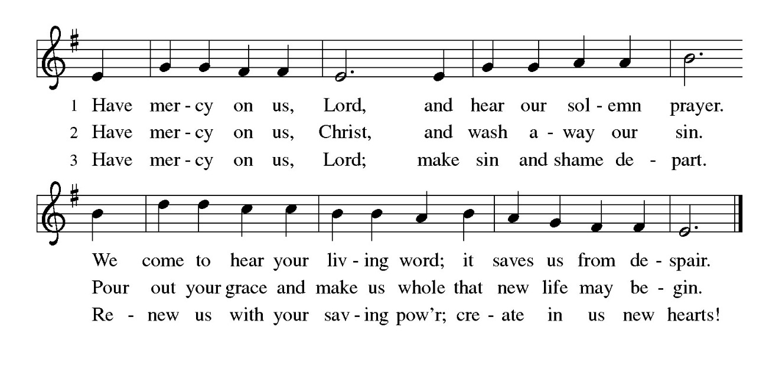

**THE PRAYER OF THE DAY**

P: The Lord be with you.

**C: And also with you.**

P: Let us pray. Creator God, You prepare a new way in the wilderness, and Your grace

waters our desert. Open our hearts to be transformed by the new thing You are doing,

that our lives may proclaim the extravagance of Your love given to all through Your

Son, Jesus Christ, our Savior and Lord, Who lives and reigns with You and the Holy

Spirit, one God, now and forever.

**C: Amen.**

*The assembly is seated*

**✠** **WORD ✠**

**FIRST READING Isaiah 43: 16-21**

*This prophet of the exile declares that long ago the Lord performed mighty deeds and delivered Israel from Egyptian bondage. Now, the Lord is about to perform an even greater act of deliverance. This salvation leads the people to praise God.*

16Thus says the Lord,

Who makes a way in the sea,

a path in the mighty waters,

17Who brings out chariot and horse,

army and warrior;

they lie down, they cannot rise,

they are extinguished, quenched like a wick:

18Do not remember the former things,

or consider the things of old.

19I am about to do a new thing;

now it springs forth, do you not perceive it?

I will make a way in the wilderness

and rivers in the desert.

20The wild animals will honor Me,

the jackals and the ostriches;

for I give water in the wilderness,

rivers in the desert,

to give drink to My chosen people,

21the people whom I formed for Myself

so that they might declare My praise.

The Word of the Lord.

**Thanks be to God.**

**THE PSALM: Psalm 126** Antiphon by Thomas Keesecker

Choir sings refrain first, followed immediately by the congregation

and as indicated

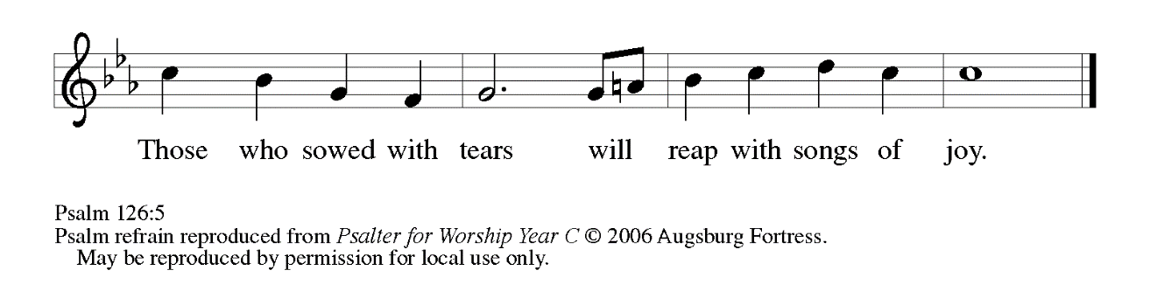

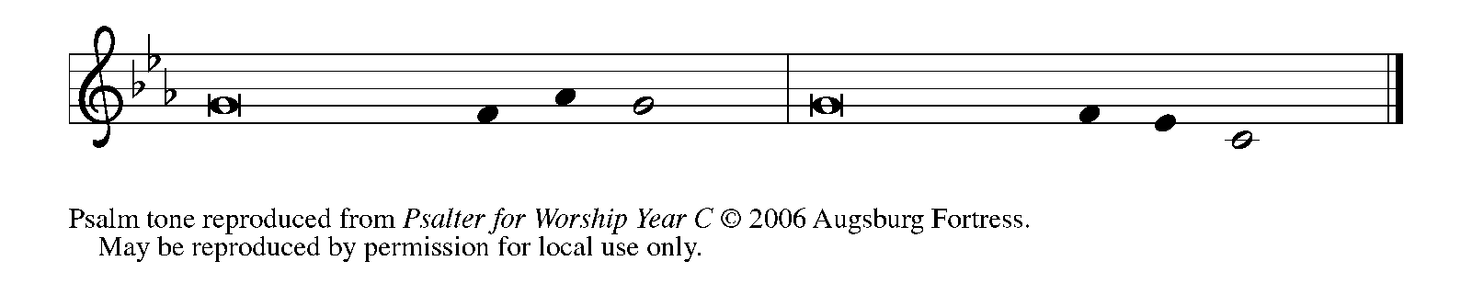

1When the LORD restored the for- | tunes of Zion,

     then were we like | those who dream.

**2Then was our mouth filled with laughter, and our tongue with | shouts of joy.**

**Then they said among the nations, "The LORD has done great | things for them."**

3The LORD has done great | things for us,

     and we are | glad indeed.

**4Restore our for- | tunes, O LORD,**

**like the watercourses | of the Negeb.   REFRAIN**

5Those who | sowed with tears

     will reap with | songs of joy.

**6Those who go out weeping, carry- | ing the seed,**

**will come again with joy, shoulder- | ing their sheaves.   REFRAIN**

**SECOND READING Philippians 3: 4b-14**

*Writing to Christians in Philippi, Paul admits that his heritage and reputation could give him more reason than most people to place "confidence in the flesh." But then, he goes on to say what truly matters to him.*

4bIf anyone else has reason to be confident in the flesh, I have more: 5circumcised on the eighth day, a member of the people of Israel, of the tribe of Benjamin, a Hebrew born of Hebrews; as to the law, a Pharisee; 6as to zeal, a persecutor of the church; as to righteousness under the law, blameless.

7Yet whatever gains I had, these I have come to regard as loss because of Christ. 8More than that, I regard everything as loss because of the surpassing value of knowing Christ Jesus my Lord. For his sake I have suffered the loss of all things, and I regard them as rubbish, in order that I may gain Christ 9and be found in him, not having a righteousness of my own that comes from the law, but one that comes through faith in Christ, the righteousness from God based on faith. 10I want to know Christ and the power of his resurrection and the sharing of his sufferings by becoming like him in his death, 11if somehow I may attain the resurrection from the dead.

12Not that I have already obtained this or have already reached the goal but I press on to make it my own, because Christ Jesus has made me his own. 13Beloved, I do not consider that I have made it my own but this one thing I do: forgetting what lies behind and straining forward to what lies ahead, 14I press on toward the goal for the prize of the heavenly call of God in Christ Jesus.

The Word of the Lord.

**Thanks be to God.**

*As you are able please rise*

**THE VERSE**

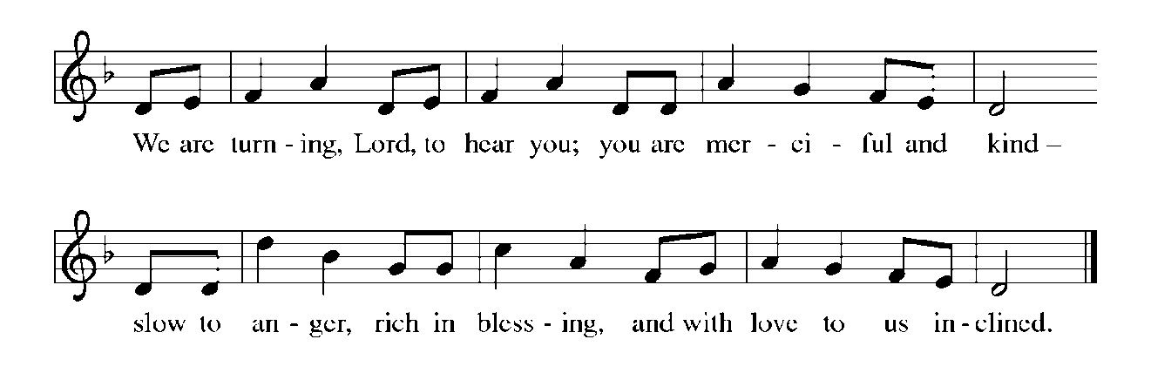

**THE HOLY GOSPEL John 12: 1-8**

*Judas misunderstands Mary's extravagant act of anointing Jesus' feet with a costly perfume. Jesus recognizes the true significance of her beautiful expression of love and commitment as an anticipation of his burial.*

P: The Holy Gospel according to St. John, the twelfth chapter.

**C: Glory to You, O Lord!**

1Six days before the Passover Jesus came to Bethany, the home of Lazarus, whom He had raised from the dead. 2There they gave a dinner for Him. Martha served, and Lazarus was one of those at the table with Him. 3Mary took a pound of costly perfume made of pure nard, anointed Jesus' feet, and wiped them with her hair. The house was filled with the fragrance of the perfume.

4But Judas Iscariot, one of His disciples (the one who was about to betray Him), said, 5"Why was this perfume not sold for three hundred denarii and the money given to the poor?" 6(He said this not because he cared about the poor, but because he was a thief; he kept the common purse and used to steal what was put into it.) 7Jesus said, "Leave her alone. She bought it so that she might keep it for the day of My burial. 8You always have the poor with you, but you do not always have Me."

P: The Gospel of the Lord.

**C: Praise to You, O Christ!**

*The assembly is seated*

**THE SERMON**

*Silence for reflection follows the sermon*

*As you are able please rise*

**THE HYMN OF THE DAY (see p. 7) *Holy Woman, Graceful Giver: John 12***



**THE NICENE CREED**

A: God has made us His people through our Baptism into Christ. Living together in trust

and hope, we confess our faith.

**C: We believe in one God,**

**the Father, the Almighty,**

**maker of heaven and earth,**

**of all that is, seen and unseen.**

**We believe in one Lord, Jesus Christ,**

**the only Son of God,**

**eternally begotten of the Father,**

**God from God, Light from Light,**

**true God from true God,**

**begotten, not made,**

**of one Being with the Father.**

**Through Him all things were made.**

**For us and for our salvation**

**He came down from heaven;**

**by the power of the Holy Spirit**

**He became incarnate from the virgin Mary, and was made man.**

**For our sake He was crucified under Pontius Pilate;**

**He suffered death and was buried.**

**On the third day He rose again**

**in accordance with the Scriptures;**

**He ascended into heaven**

**and is seated at the right hand of the Father.**

**He will come again in glory to judge the living and the dead,**

**and His kingdom will have no end.**

**We believe in the Holy Spirit, the Lord, the giver of life,**

**Who proceeds from the Father and the Son.**

**With the Father and the Son He is worshiped and glorified.**

**He has spoken through the prophets.**

**We believe in one holy catholic and apostolic Church.**

**We acknowledge one Baptism for the forgiveness of sins.**

**We look for the resurrection of the dead,**

**and the life of the world to come. Amen**

**THE PRAYER OF THE CHURCH**

A: As God’s new people, formed in Christ Jesus, let us join in prayer to the God Who

makes all things new for the Church, the world, and all those in need.

A: That the Church may gladly share in the sufferings of Christ and in turn show forth the

power of His resurrection, let us pray to the Lord:

**C: Lord, have mercy.**

A: That God’s Spirit might create a path to peace through all places of hatred, violence,

oppression, and bloodshed, especially in Ukraine, let us pray to the Lord:

**C: Lord, have mercy.**

A: That this congregation might pour itself out to the poor, hungry, and needy as a fragrant

offering to God, let us pray to the Lord:

**C: Lord, have mercy.**

A: That the sick, especially: **Bill Noble;** **Fred Weiss; Martha Schroeder; Joyce Stark;**

**Russ Fischer; Nolan Wilson; Carol Radke; Larry Litchford; Debbie Martin and**

**Ken Mulder** might have their health, hope, and fortunes restored, let us pray to the

Lord:

**C: Lord, have mercy.**

A: That we may press on toward the goal, and together with all the saints, especially

**Albrecht Dürer; Matthias Grünewald; and Lucas Cranach; artists,**whom we

commemorate this Day, may attain the resurrection from the dead through Christ Jesus,

let us pray to the Lord:

**C: Lord, have mercy.**

P: God our Savior and Redeemer, You are constantly at work, bringing forth new things

in Your creation. Hear the prayers we make to You, and continue to perform ever

greater wonders for the entire family of humankind, through Your Son, Jesus Christ

our Lord.

**C: Amen.**

**✠ MEAL ✠**

**THE PEACE**

P: Through Christ we have been reconciled to God, Who has given us the ministry of

reconciliation. Let us be reconciled with one another.

The peace of the Lord be with you always.

**C: And also with you.**

*The assembly is seated*

**THE OFFERING**

**THE VOLUNTARY *Take My Life, That I May Be* St. Paul Senior Choir**

(F. Havergal and W. Pharris; Arr. M. Sedio)

*As you are able please rise*

**THE PRESENTATION OF THE GIFTS**

*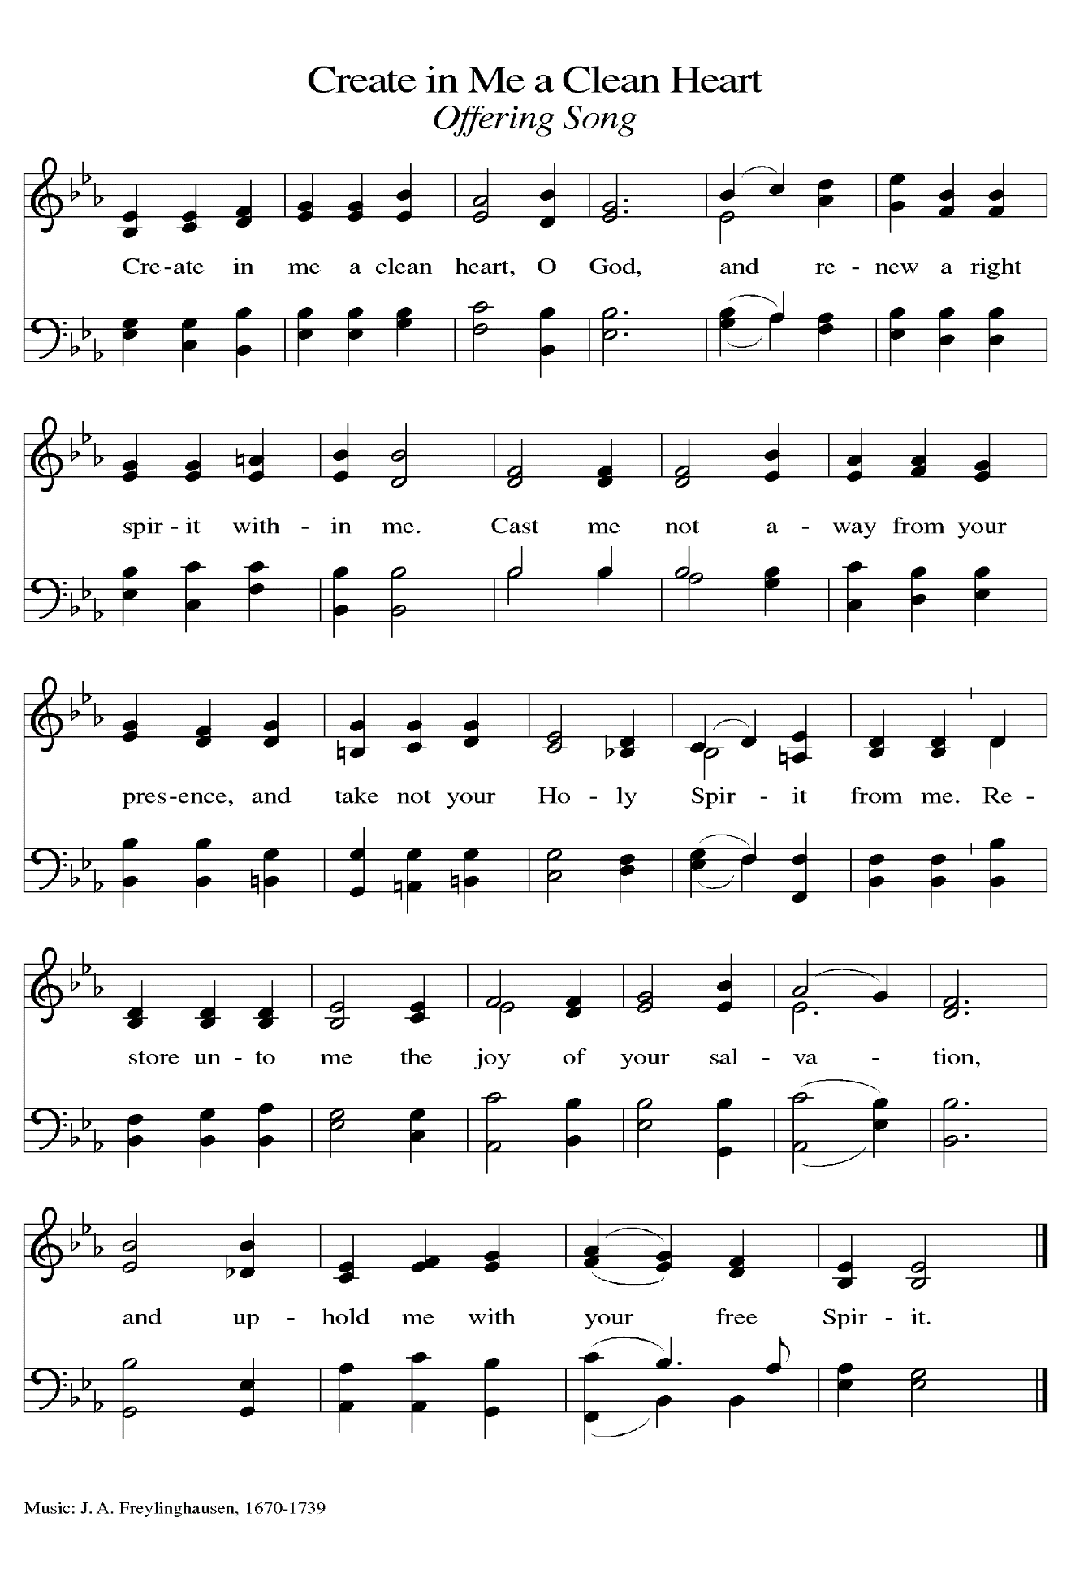***THE OFFERTORY PRAYER**

A: Let us pray. Mighty God,

**C: As Mary showered Jesus with her love, so we bring You our devotion in these**

**gifts. By this holy Sacrament strengthen us for faithful service, that our lives may**

**be a pleasing and fragrant offering to You. We ask this in the name of Jesus the**

**Lord. Amen.**

**THE GREAT THANKSGIVING**

P: The Lord be with you.

**C: And also with you.**

P: Lift up your hearts.

**C: We lift them up to the Lord.**

P: Let us give thanks to the Lord our God.

**C: It is right to give Him thanks and praise.**

P: It is indeed right, our duty, and our joy …join their unending hymn:

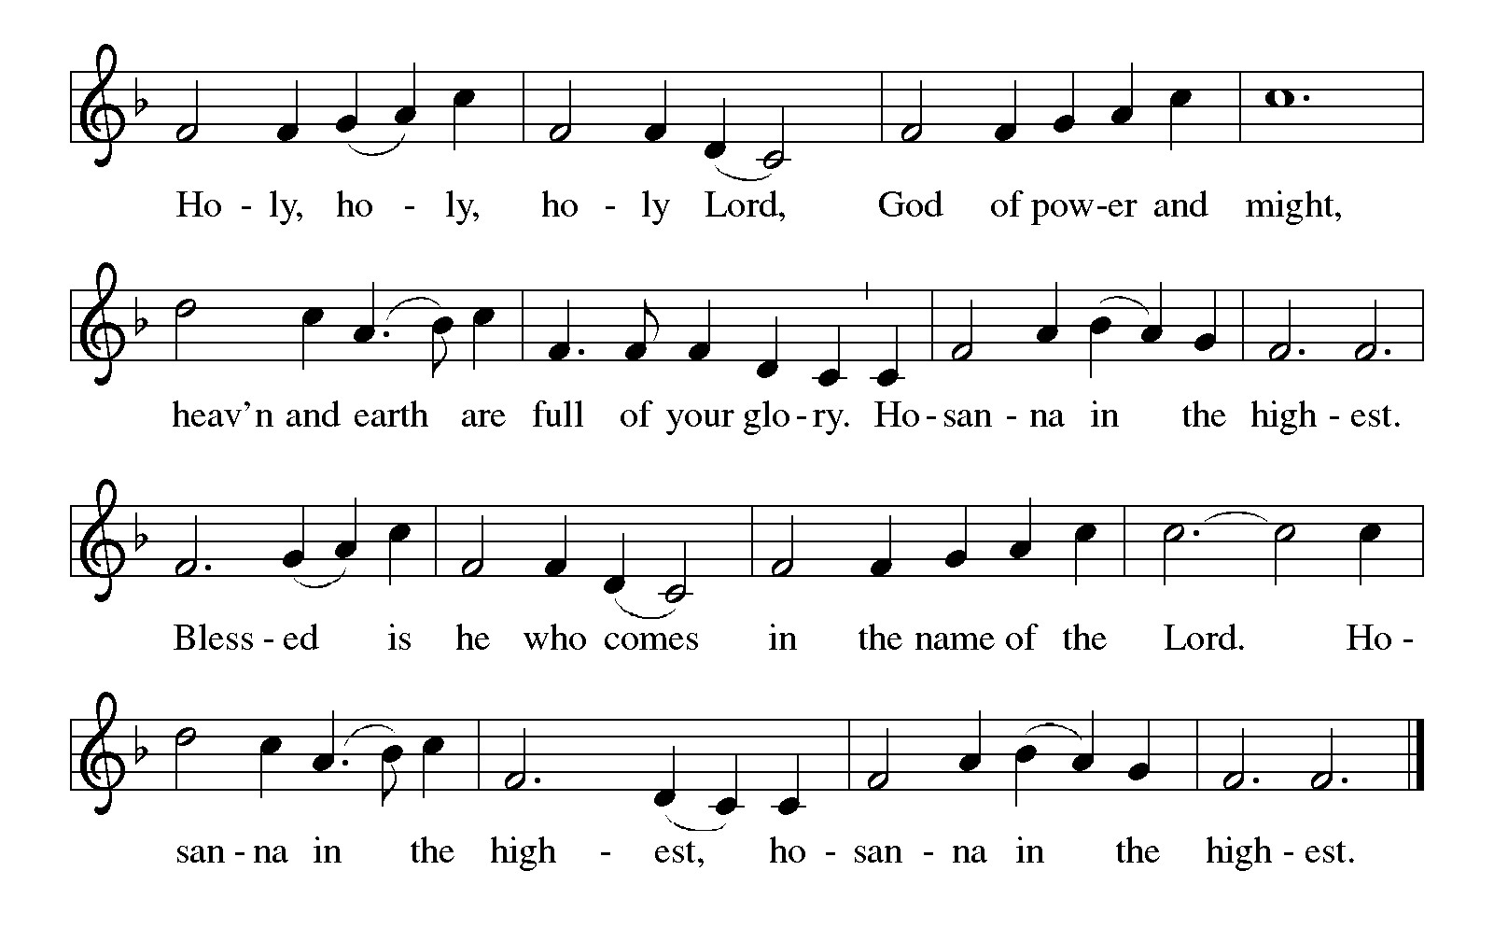

P: Extravagant God, You poured out Your life in covenant with Your chosen people, and

You poured out Your life-blood in the ministry and death of Your Son

Jesus Christ.

You meet our meanness with Your grace, our scarcity with Your abundance, and

our suspicion with Your generous trust.

Sharing God, in Jesus You attended a meal to celebrate Lazarus’s resurrection, and

so we gather today to celebrate Jesus’ resurrection, in faith that even now

You are preparing a Feast to celebrate our resurrection with You.

Make us holy, that even as our flesh and blood decay, our hearts are made ready that

we may meet You face to face.

Send down Your Holy Spirit, that this bread of sustenance and this wine of joy may

be for us the Body and Blood of Your Son Jesus Christ,

Who, in the night ... “Do this for the remembrance of Me.”

As often as we eat ... we proclaim the Lord’s death until He comes.

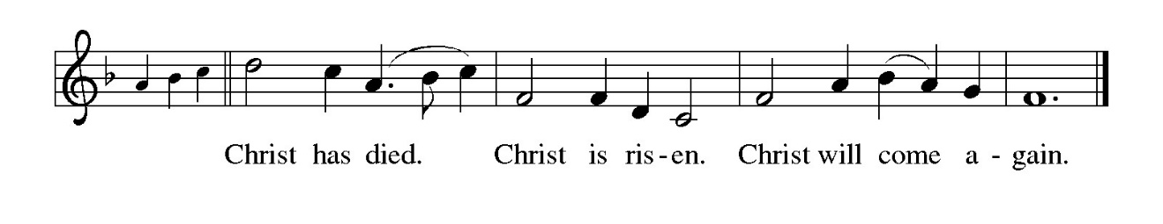

P: Abundant God, when we know the price of everything and the value of nothing,

may this Meal remind us of the limitless joy You take in us.

When we are full of criticism of others and hatred of ourselves, may this sacrifice

show us the goodness You see in all.

Bless all our touching, that we may touch Your gifts and one another as if we were

touching Your Body and Blood.

Bless all our desire, that in every craving and longing we may discover a deeper

yearning for You.

Renew the hearts of all Your people, that Your whole Church, working together for

the justice of Your Kingdom, may discover in the stranger the gifts that

come only from You,

Through Whom, and with Whom, and in Whom come all honor and glory, Father,

Son, **✠**  and Holy Spirit one God, now and forever.

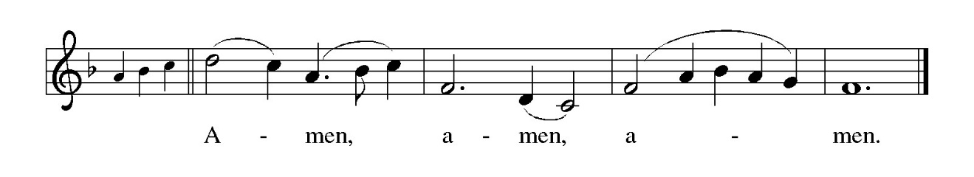

**THE LORD’S PRAYER**

P: Baptized into Christ’s death that we might share in the resurrection, let us pray for the

fulfillment of the mystery as Jesus taught us:

**C: Our Father in heaven, hallowed be Your name.**

**Your Kingdom come, Your will be done on earth as in heaven.**

**Give us today our daily bread, and forgive us our sins, as we forgive**

**those who sin against us.**

**Save us from the time of trial, and deliver us from evil.**

**For the Kingdom, the power, and the glory are Yours, now and forever.**

**Amen.**

**INVITATION TO THE MEAL**

P: Behold the Servant of God, obedient unto death on a cross, highly exalted as Lord of

glory. Blessed are those who are called to the banquet of the Lamb. God’s holy gifts

for God’s holy people. Come, for all is now ready.

*The assembly is seated*

**THE DISTRIBUTION**

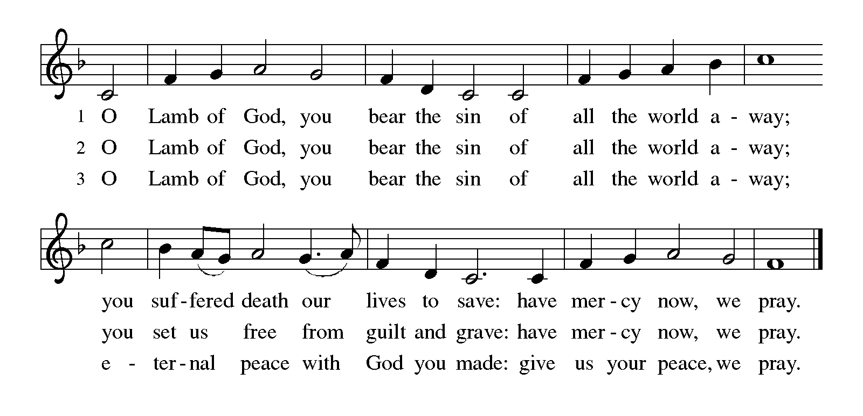

Those wishing to receive the Laying on of Hands, Anointing with Oil, and Prayer for Healing may go to Pastor at the side aisle

**HYMN DURING DISTRIBUTION 754 *Jesus, the Very Thought of You***

**ELW 338 *Beneath the Cross of Jesus***

**ELW 461 *All Who Hunnger, Gather Gladly***

**ELW 471 *Let Us Break Bread Together***

**ELW 485 *I Am the Bread of Life***

*As you are able please rise*

**THE POST COMMUNION BLESSING**

P: The Body and Blood of our Lord Jesus Christ strengthen you and keep you in His

grace.

**C: Amen.**

**THE POST-COMMUNION PRAYER**

A: Let us pray. Merciful God, we give You thanks for the forgiveness and grace we have

received in this Meal. Grant us the vision to see the new thing You are doing in our

midst, and make us strong to reach the goal of the resurrection life You promise in

Christ. Grant this through Christ our Lord.

**C: Amen.**

**✠ SENDING ✠**

**THE BENEDICTION**

P: Jesus took the form of a servant and was obedient to death, even death on a cross. May

you follow His example and share in the resurrection.

**C: Amen.**

P: Almighty God: Father, Son, **✠** and Holy Spirit bless you now and forever.

**C: Amen.**

**SENDING SONG NSB 94 *Turn Your Eyes Upon Jesus (x2)***

**THE DISMISSAL**

A: Reconciled to God through Christ, let us go out into the world in peace.

**C: Thanks be to God!**

**THE POSTLUDE**

**✠ *To God Alone Be Glor*y✠**

The Meditations are fromMary Frolich, quoted in *Sundays and Seasons,* copyright 2022

Luther Seminary; and *Working Preacher Online,* copyright 2022 Luther

Seminary.

**ANNOUNCEMENTS**

**Please remember to mail your offering to the Church Office** at 818 Franklin Street, Michigan City, IN 46360**.** Another alternative is to give on-line through Tithe.ly. Please see your closure letter for information on how to set up a Tithe.ly account.

**St. Paul Members are reminded to have** a loved one contact the office if you are hospitalized. Many times, the Pastor doesn’t know someone is in the hospital. If you call and leave a message, please tell us which hospital the patient is at.

**PRAYER CONCERNS:** Pope Francis, Larry Litchford, Sarah McNabb, Carol Radke, Jeanie Boatman Shepple, Nolan Wilson, Debbie Martin, Mark Tannehill, Brian Wiseman, Kathy Stein, Danielle Schnell, Jan Paholski, Laura Dovey, and Grace Romine.

**OFFICE HOURS:** Libby will be in the office on Mondays, Wednesdays, and Fridays; volunteers will cover Tuesdays and Thursdays.

Monday & Wednesday 8:00 a.m. – 5 p.m.

Tuesday & Thursday 9:00 a.m. – 12:00 p.m.

Friday 8:00 a.m. – 12:00 p.m.

**If you are listening to the worship broadcast on the radio and would like to watch the Sunday morning service live stream follow these steps:**

(1) If you have You Tube available on your TV, search for

**St. Paul Lutheran Church Michigan City, IN.**

(2) The direct link on the computer is

https://www.youtube.com/channel/UC5AIPNaKr3QN50984jGOa1g.

   (3) This link is also on the main page of the church’s website in

the church section and will continue to be posted weekly on the St.

Paul Facebook page.

And it will always be available on the radio broadcast Sunday mornings at 11:00 a.m.

on WEFM (95.9), and on the local cable access station #99 for the previous week’s

service on Sundays at 4:00 p.m. and the current service on Wednesdays at 7:00 p.m.

and Fridays at 8:30 p.m.

**Next Sunday’s lessons are Isaiah 50: 4-9a; Psalm 31: 9-16; Philippians 2: 5-11; Luke 22: 14—23: 56** for those of you who like to study them in advance.

**To send e-mail to the church office**, please use the following addresses:

Pastor Mark Reshan: seniorpastor@stpaulmichigancity.com

Church Office Secretary (Libby Pollock): churchsecretary@stpaulmichigancity.com

Church Treasurer (Karen Fleming): finance@stpaulmichigancity.com

**The Good News Newsletter**: If you have an article or anything you want included in **The Good News** please send it to the following e-mail address: splcgoodnews@gmail.com. Pastor Pamela Thiede will be using this e-mail address to assemble **The Good News** each month. The deadline for getting information to Pastor Pamela will be the 20th of each month.

**Worship Attendance:**

**Wednesday, March 26, 2025 @ 6:00 p.m. 40**

**Saturday , March 29, 2025 @ 4:00 p.m. 35**

**Sunday, March 30, 2025 @ 9:00 a.m. 68**

**TOTAL 143**

**Copies of the minutes from the January 23, 2025 and February 27, 2025 Church Council meetings are on the back table in the upper Narthex. They were approved by the council via email.**

**FYI:**

In response to the ever rising costs for postage we will be putting your copy

of the “Good News” in your hanging file folder in the narthex each month

from now on. Those of you who are unable to attend services on a regular

basis may still receive your copies through your email address or in the

U.S. mail. If you normally receive your copy of the newsletter via your

email address anyway, nothing will change for you. Thank you so much for

your understanding and cooperation!

**THANK YOU!**

**Let’s give a huge thank you to Warren Schacht for putting almost all the Archive Room media on easy-to-watch and hear discs for anyone wanting to have a look or a listen to what’s available. A sincere and heartfelt thank you for taking the time and interest to do something that will benefit the record of the past for future generations to come! Your efforts are so appreciated.**

**MISSION OF THE MONTH FOR APRIL 2025**

April Monthly Mission: Michigan City Area Schools. We will be collecting money to support different projects in various elementary schools in Michigan City through Donors Choose. Donors Choose provides a list of teacher-led classroom projects that need funding, Flexible seating, bubbling fish tubes, classroom supplies, Tinker Tar guitars, and a kid wash for field day are some of the options we can provide to our elementary schools. Please consider donating to help fund our local teachers’ classroom projects! Checks can be written to St. Paul and can be marked for MCAS and placed in the offering plate. Noisy coin offering will also support the mission of the month. To see a full list of projects, visit [www.donorschoose.org](http://www.donorschoose.org) and search for Michigan City.

**2025 Financial Stewardship**

Weekly Church Operating Needs (x 2 weeks)

March 8-9 and March 15-16, 2025: $ 12, 271.38

General Fund (including General Memorials): $ 12,619.00

Overage/Shortage: +$ 634.00

Restricted Income (not including Memorials)

Supports IK Synod & Church wide Ministries: $ 490.00

Ministries in our Community/Congregation: $ 75.00

Capital Fund: $ 255.00

Memorials

General Fund: $ 5,175.00

**ACTIVITIES, EVENTS & MEETINGS**

**APRIL 2025**

**Tuesday,** April 1, 2025 @ 10:00 a.m. Altar Guild Meeting/Green Room

**Wednesday,** April 2, 2025 @ 9:15 a.m. Bible Study/ Luther House

@10:00 a.m. God’s Purls/St. Paul Room

@ 4:30 p.m. Choir Rehearsal/Sanctuary

@6:00 p.m. 5th Lenten Service

**Thursday,** April 3, 2025 Faith Circle

**@ 4:00 p.m. – 10:00 p.m. GIVE BACK at Galveston Steakhouse**

**Saturday,** April 5, 2025 @ 4:00 p.m. 5th Lent Worship Service

**Sunday,** April6, 2025 @ 9:00 a.m. 5th Lent Worship Service

**Tuesday,** April 8, 2025 @ 7:00 p.m. Estuary/Luther House

**Wednesday,** April 9, 2025 @ 9:15 a.m. Bible Study/Luther House

@10:00 a.m. God’s Purls/St. Paul Room

@ 3:30 p.m. Worship & Music Comm. Mtg./Luther House

@ 4:30 p.m. Choir Rehearsal/Sanctuary

@6:00 p.m. Lenten Service

**Saturday,** April 12, 2025 @ 4:00 p.m. **Palm/Passion Saturday Worship Service**

**Sunday,** April 13, 2025@ 9:00 a.m. **Palm/Passion Sunday Worship Service**

**Monday,** April 14, 2025 1:00 p.m. Hope Circle/Green Room

**Wednesday,** April 16, 2025 No Bible Study

@ 10:00 a.m. God’s Purls/St. Paul Room

**Thursday,** April 17, 2025 @ 10:00 a.m**. Maundy Thursday Senior Communion**

**@ 11:00 a.m. Luncheon/St. Paul Room**

**Friday,** April 18, 2025 **@ 7:00 p.m. Good Friday Worship Service**

**Saturday,** April 19, 2025 **@ 7:00 p.m. Vigil of Easter Worship Service**

**Sunday, April 20, 2025 @ 9:00 a.m. Resurrection of Our Lord Easter Service**

(No Coffee Hour After)

**Monday,** April 21, 2025 @ 2:00 p.m. Finance Comm. Mtg./Luther House

**Wednesday,** April 23, 2025 No Bible Study

@ 10:00 a.m. God’s Purls/St. Paul Room

**Saturday,** April 26, 2025 @ 4:00 p.m. 2 Easter Worship Service

**Sunday,** April 27, 2025 @ 9:00 a.m. 2 Easter Worship Service

**Monday,** April 28, 2025 @ 3:00 p.m. Executive Board Mtg./Luther House

**Wednesday,** April 30, 2025 @ 9:5 a.m. Bible Study/Luther House

  @ 10:00 a.m. God’s Purls/St. Paul Room

**Thursday,** May 1, 2025 @ 5:30 p.m. Church Council Mtg./St. Paul Room