May, 2025

**MARK: MY WORDS**

Early June has traditionally been the time when the Indiana-Kentucky Synod Assembly is held, either virtually via Zoom or in person. As a congregation we are allowed representation by the pastor and one female and one male delegate. Last year’s assembly was especially important because of the special election to choose a new bishop after the resignation of Bishop Gafkjen.

This year, however, aside from the election of the synod Vice-President and voting on the proposed budget there are few pressing issues to address. In the past there has almost always been a guest presenter (or more) who has led Bible studies or presented lectures on concerns to the synod and the larger church. This year, Bishop Graham is the only keynote speaker on the topic of “Faith—Hope—Love.”

There are fewer breakout sessions than in the past and, in general, the agenda seems light compared to previous years. Bishop Graham has said that this may well be the last assembly to be done in person due to the cost to congregations. Registration fees, hotel stays, gas, and food allowances can add up to thousands of dollars. At a time when many are greatly struggling financially, one wonders if such gatherings are a good stewardship of their resources.

To be fair, many pastors and lay leaders look forward to the assemblies. The worship is usually well done and inspiring, often offering rites that may not be done regularly in their home congregations. There are many vendors showing their church-related wares, and representatives of various ministries both within the synod and the larger Church. People look forward to the fellowship that is shared and reconnecting with friends they may not have seen since the previous assembly.

For me personally, none of that justifies neither the cost involved nor the time invested in attending. Perhaps it is fatigue from going to 42 of these gatherings in my ministry, but much of the time seems tedious, and I usually feel as though the business could have been conducted in perhaps a day and a half rather than the normal two to three days. Because of that, I will not be attending the assembly this year in Indianapolis.

I have never sensed any real interest from the congregation in what happens at the assembly. I don’t recall anyone asking me afterwards about my experience or what decisions were made. That is not a criticism; it is simply stating the fact that ever since former St. Paul Pastor Jim Stuck retired from being Bishop there has been little feeling of connection to the synod from our congregation.

We do not have any lay representatives attending this year either; but if we receive any reports dealing with an important issue, we will pass that on to the congregation.

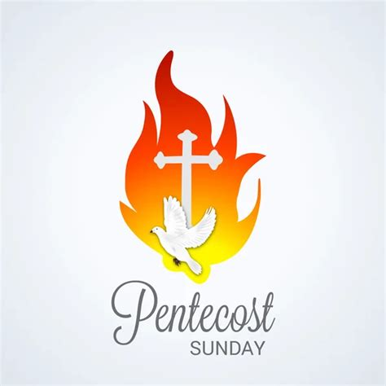

**FESTIVAL DAYS OF WORSHIP**

As mentioned in last month’s newsletter, two of the six major feast days of the church year fall in June: the Day of Pentecost (June 8) and The Holy Trinity (June 15). Can you name the other four? (The answer is at the end of this article).

These days bring the Fifty Days of Easter to their close and usher us into the longest season of the church year, Pentecost. The Holy Trinity in particular is always challenging for preachers to proclaim in a way that doesn’t devolve into an esoteric lecture on theology. These days also provide wonderful and inspiring opportunities for worship, and we look forward to celebrating them with great joy and thanksgiving.

The other four major festivals of the church year are Christmas, the Epiphany of our Lord, Easter, and the Ascension of our Lord. I am sure you all got them correct 😉.

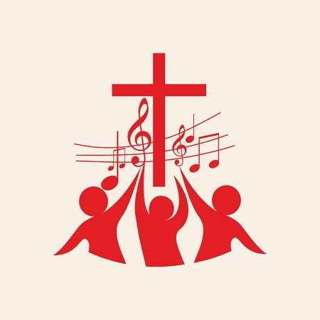

**MUSICAL SETTING OF THE LITURGY**

For some years now we have turned to Marty Haugen’s “Now the Feast and Celebration” musical setting of the liturgy during the summer. It is a more relaxed accompaniment than those from our red hymnal and has grown to be a great favorite of the congregation’s. Beginning with our celebration of Pentecost we will return to that setting and use it throughout the summer.



**NEW PARAMENTS**

In Loving Memory of

Maxine Powell

December 15, 1925 – July 23, 2023

On Saturday, June 28, and Sunday, June 29, we will receive and bless a new set of paraments donated by The Rev. Ralph and Gayle Kuespert, Maxine Powell’s son-in-law and daughter. They wanted to give a lasting gift to the congregation in honor of Maxine’s many years of serving on the Altar Guild. They worked with a religious supply company in Milwaukee designing them and choosing the proper fabric. Below is an explanation of each of the paraments written by Gayle.

* The Color Green: the colors in the Chancel (the front of the church) change with the season of the church year. Green is used for the longest season, called “Ordinary Time.” It symbolizes growth, life, and hope in Christ. The green paraments often include designs that represent growth such as vines and fruit and signs of our life with Christ. The scriptures used during this time find Christ in the middle of His ministry here on earth, providing a foundation and structure for our faith through His teachings and stories. These scriptures carry a common thread that tell of God’s Love for the world. Ultimately, "Ordinary Times" offer great opportunities for exploration and growth in faith, rooted in the resurrection promise in Christ.
* The Lectern (from where the Lessons are read) is dressed in a parament called a Bible marker. The symbol on the Bible Marker is a representation of the Holy Trinity, the Triune God, Three in One, Father, Son, and Holy Spirt, a triangle with three equal sides and three interlocking circles.

* The paraments on the Table are called Frontlets. Each of the Frontlets is adorned with a cross which reminds us of the instrument used in the tortious death that Christ endured. However, because Christ is not on the cross it symbolizes Christ risen.
* One of the Frontlets has grapes on the vine and the other has shafts of wheat. These designs are very appropriate for Christ’s Table because they embody the words of Christ: “This is my body; this is my blood.” Grapes – Wine; Wheat – Bread; the Eucharist where we are fed. Don’t forget the color green—growth of grapes on the vine and wheat. “I am the vine; you are the branches” (John 15:5).

* The Burse and Veil covering the Chalice both have Grape symbols.

* The Stole and Chasuble, worn by the Pastor, are adorned with grapes and wheat, and the Alpha (the Beginning) and the Omega (the End). Christ is our Beginning and our End.

* The Pulpit: The Ship is the liturgical symbol for the Church. This has been consistent in Christian art since it first appeared in the catacombs. It is no coincidence that the part of every church where the people sit is called a nave; this word comes from the Latin *navis,* meaning ship. The Church is a ship, protecting those inside it from the waves and buffets of the world, because Christ is at the helm. The ship reminds us of Jesus protecting Peter's boat in a storm on the sea of Galilee. “Then Jesus rebuked the winds and the sea and there was a dead calm” (Matthew 8:23-27). When the disciples were fishing and were not getting any fish, Christ said, “put your nets on the other side”; and their nets were so full they could hardly pull them in (John 21).

Maxine served with the St. Paul Altar Guild for forty years and as its President for almost thirty years. She was passionate about ensuring that Christ’s table was always precisely set.

We, the friends and family of Maxine, hope that the Paraments and the Vestments will enhance your worship experience and that Maxine’s passion for serving the Lord will also be remembered and shared.



**NEW FENCE**

A huge thanks to our building crew who erected a new fence around our chiller located on Ninth Street right around the corner of the alley as it flows into Ninth. Bob Kiser organized the work day; and as always, our guys responded faithfully and did a beautiful job of replacing the old fence that was worn and aging. We are so blessed to have these and so many others who respond to the call to help keep our facilities repaired and looking great. Those who helped were **Dave Squires, Chuck Payne, Tim Crozier, Mark Kloess, and Rich Fleming.**

Thank you, crew, for your great work! (We hope to have pictures of the work crew and the new fence in next month’s newsletter.)

Correction

In last month’s picture of the First Communion class of 2025, Richer’ea Garrett was wrongly identified as Richer’ea Waltz. We apologize for the error.

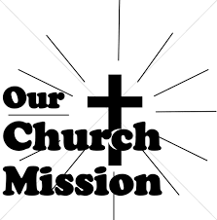

**MONTHLY MISSION**

Thank you to everyone who supported the April mission for our Michigan City schools!  We were able to fully fund the purchase of TinkerTar guitars for the music program at Coolspring Elementary, Going Wild in the Jungle classroom theme supplies for Pine Elementary, and general classroom supplies for a classroom at the high school.  What’s a TinkerTar guitar you ask?  It’s a learning guitar with one string for students to learn melodies.  It’s like the string instrument version of the recorder we all played a very squeaky version of Twinkle, Twinkle, Little Star on in elementary music class!  Thank you for your generous donations and continued support of our monthly missions!

And these notes:

Dear St. Paul Lutheran Church,

I'm so excited to announce that the tinker tars will be in students’ hands before the end of the school year and for many years to come! Thank you for your support, for encouraging our students to get hands on, and for being a wonderful part of our learning community.

With gratitude,

Ms. Camel

Dear St. Paul Lutheran Church,

Thank you so much for bringing our project to life and giving our classroom a jump start. Your generosity helps create an inspiring place for learning and creativity. Donations like yours not only help in the classroom but also show the students what it means to help others and that others care about them and their education. One small act of kindness can change the world.

With gratitude,

Ms. Eiler

**LOVE KITCHEN STOPS AT ST. PAUL**

St. Paul Lutheran would like to express our gratitude to Little Caesars and their Love Kitchen for their generosity in providing pizza to those who were hungry today. They served 60 pizzas which were 240 servings. We were blessed to host them.

This truck kitchen serves the states between the Atlantic Ocean and the Mississippi River 10 days out of every two weeks and has been for 9 years. What a way to serve out their mission!

If you have time, give a shout out to Little Caesar’s!



**IN MEMORY OF MY MOTHER, RUTH BURNS, AND MY MOTHER-IN-LAW, HEDWIG HANFT**

**General Fund** from Carol Hanft

**IN MEMORY OF MY HUSBAND, KEN HANFT, SR., AND MY FATHER, RALPH BURNS**

**General Fund** from Carol Hanft

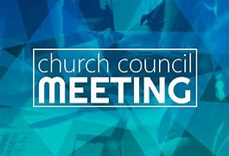

**APRIL COUNCIL HIGHLIGHTS**

The April Council meeting was held May 1. Highlights were discussed at the semi-annual meeting. As always, full copies of the minutes will be available in the narthex.



**June Birthdays June Anniversaries**

1 Andrea Ottersen 6 Michael & Marjory Bockover

2 Bethany Manning 8 Daniel & Brittany Struebing

5 Daniel Struebing 9 Ron & Melonda Nagle

7 Vivian Zellers 12 David & Donna Sutor

8 Richard Cains 13 Tom & Amy Petri, Jr.

9 Lynn Nevels 15 Douglas & Pamela Kienitz

11 Larry Litchford 23 William & Pamela Hackett

12 Leigh Coburn

14 Janet Bakken

Ivye Benson

15 Jacob Ziesmer

16 Jacob Hazel

19 Jeffrey Hazel

20 Jim Schraidt

21 Clara Lorentzen

23 Alex Scheuchner

24 Lou Ann Shebel

Dawn Fitzhugh

25 Muriell Jacobi

26 Helen Hill-Weaver

Daniel Reshan

Jacob Reshan

27 Cynthia Scheuchner

Helena Albertson

Jacob Payne

**Long-Term Prayer List**

Laura Dovey Russ Fischer Jess Kalvaitis

Christine Kiser Bethany Manning Shirley McCarty

Jan Paholski Grace Romine Danielle Schnell

Martha Schroeder Jeanie Boatman Shepple Joyce Stark

Kathy Stein Mark Tannehill Kathy Thielman

Brian Wiseman



Monday 8:00 a.m. – 5 p.m.

Tuesday 9:00 a.m. – 12:00 noon

Wednesday 8:00 a.m. – 5 p.m.

Thursday 9:00 a.m. – 12 noon

Friday 8:00 a.m. – 12 noon

**St. Paul Lutheran Church Staff**

Pastor Rev. Mark Reshan

Secretary Libby Pollock

Accompanists Jary Tannehill, Mark Tannehill, Jacob Tannehill

Custodian Mark Kloess

Thank$ for $haring

Last month we raised $125 at the Swingbelly’s Give Back. Thanks to all who participated.

This month, we will see you at Holly’s on Tuesday, June 10.  Here are two coupons—one for you and one for a friend.

