THE PRESENTATION OF OUR LORD
The Fourth Sunday after the Epiphany
February 1, 2026

Candlemas is another name for the Presentation festival. A service with candlelight epitomizes the phrase from Simeon’s song in today’s Gospel hailing the infant Jesus as a “light for revelation to the Gentiles and for glory for Your people Israel.” The temple scene that the Gospel describes is the event today’s festival commemorates as the Presentation of Our Lord.
The Presentation festival had its origin in Jerusalem in the fourth century. It was first observed annually on February 14, the fortieth day after the festival of the Epiphany. When Christmas replaced Epiphany as the day to celebrate Jesus’ birth, February 2 marked the end of the forty-day period and commemorated the Presentation event …The tradition of blessing and distributing candles during the festival began in the eleventh century.
In the Eastern Church the Presentation festival is called Hypapante, “meeting.” The word calls to mind the meeting between Simeon and Jesus in the temple…Further, the word refers to the meeting between worshiper and God, in that the faithful are like Simeon in receiving Jesus into their lives through Word and Sacrament.

John Tietjen

Presentation of Our Lord

Forty days after the birth of Jesus we mark the day Mary and Joseph presented him in the temple in accordance with Jewish law. There they were greeted by Simeon, an aged priest who offered the song "Lord, now you let your servant depart in peace," as well as by the prophet Anna, who spoke of the redemption of Israel.

In the Name of Jesus

GATHERING

PRE-SERVICE MUSIC Here I Am to Worship New Song Praise Band
(Tim Hughes)

ANNOUNCEMENTS

As you are able please rise

THE CANDLEMAS PROCESSION

P: In the name of the Father and of the Son and of the Holy Spirit.

C: Amen.

P: Light and peace, in Jesus Christ our Lord.

C: Thanks be to God.

P: Forty days ago we celebrated the joyful feast of the birth of our Lord Jesus Christ.
Today we recall the holy day on which He was presented in the temple, fulfilling the
law of Moses and at the same time going to meet His faithful people. Led by the Spirit,
Simeon and Anna came to the temple, recognized Christ as their Lord, and proclaimed
Him with joy.

United by the Spirit, may we now go to the house of God to welcome Christ the Lord.
There we shall recognize Him in the breaking of bread until He comes again in glory.

P: Let us pray. God our Father, source of all light, You revealed to Simeon and Anna
Your Light of revelation to the nations. Bless + these candles and make them holy.
May we who carry them to praise Your glory walk in the path of goodness and come
to the Light that shines forever. Grant this through Christ our Lord.

C: Amen.

P: A Light to enlighten the nations, and the glory of Your people Israel.

C: A Light to enlighten the nations, and the glory of Your people Israel.

P: Lord, You now have set Your servant free to go in peace as You have promised.

C: A Light to enlighten the nations, and the glory of Your people Israel.

P: For these eyes of mine have seen the Savior, Whom You have prepared for all the world
to see.

C: A Light to enlighten the nations, and the glory of Your people Israel.

P: Let us go forth in peace.

C: In the name of Christ. Amen.

THE GATHERING SONG NSB 72 Refiner’s Fire

THE GREETING AND PRAYER OF THE DAY

P: Arise; shine; for your light has come. The grace of our Lord Jesus Christ, the love of
God, and the communion of the Holy Spirit be with you all.

C: And also with you.

P: Let us pray. Inspired by Your Spirit, Lord, we gather in Your temple to welcome Your
Son. Enlighten our minds and lay bare our inmost thoughts. Purify Your people, and
make us obedient to the demands of Your law, so that we may mature in wisdom and
grow to full stature in Your grace. We ask this through our Lord Jesus Christ, Your
Son, Who lives and reigns with You in the unity of the Holy Spirit, God forever and
ever.

C: Amen.

The assembly is seated

WORD

FIRST READING Malachi 3: 1-4

This reading concludes a larger section (2: 17-3: 5) in which the prophet speaks of the coming of the God of justice. Malachi looks for that day when the wondrous power of God will purify the priestly descendants of Levi who minister in the temple at Jerusalem.

¹See, I am sending My messenger to prepare the way before Me, and the Lord Whom you seek will suddenly come to His temple. The messenger of the covenant in whom you delight--indeed, he is coming, says the Lord of hosts. ²But who can endure the day of his coming, and who can stand when he appears?
For he is like a refiner's fire and like fullers' soap; ³he will sit as a refiner and purifier of silver, and he will purify the descendants of Levi and refine them like gold and silver, until they present offerings to the Lord in righteousness. ⁴Then the offering of Judah and Jerusalem will be pleasing to the Lord as in the days of old and as in former years.

The Word of the Lord.

Thanks be to God.

THE PSALM: Psalm 84 Antiphon by Thomas Pavlechko

Choir sings refrain first, followed immediately by the congregation
and as indicated

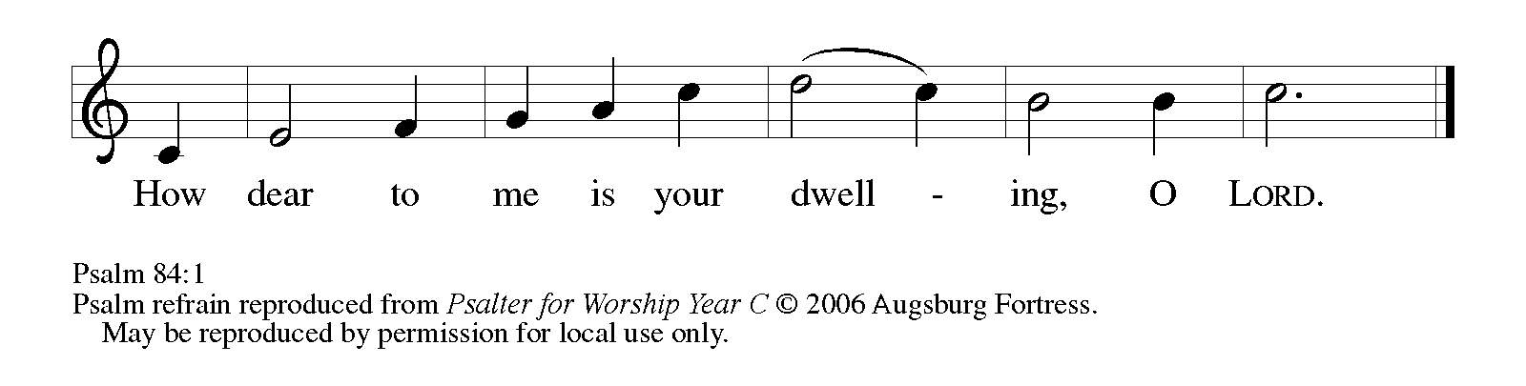

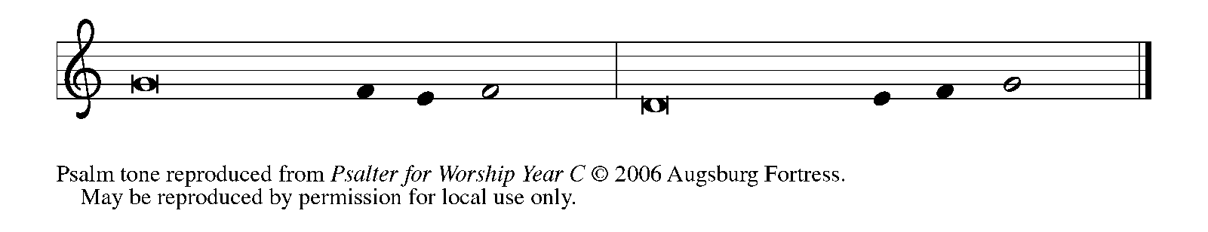

¹How dear to me | is Your dwelling,
O | LORD of hosts!

²My soul has a desire and longing for the courts | of the LORD;
my heart and my flesh rejoice in the | living God.

³Even the sparrow has found a home, and the swallow a nest where she may | lay her
young, by the side of Your altars, O LORD of hosts, my king | and my God.

⁴Happy are they who dwell | in Your house!
They will always be | praising You. REFRAIN

⁵Happy are the people whose strength | is in You,
whose hearts are set on the | pilgrims' way.

⁶Those who go through the balsam valley will find it a | place of springs,
for the early rains have covered it with | pools of water.

⁷They will climb from | height to height,
and the God of gods will be | seen in Zion.

⁸LORD God of hosts, | hear my prayer;
give ear, O | God of Jacob. REFRAIN

⁹Behold our defend- | er, O God;
and look upon the face of | Your anointed.

¹⁰For one day in Your courts is better than a | thousand elsewhere.
I would rather stand at the threshold of the house of my God than dwell in the tents | of the wicked.

¹¹For the LORD God is both sun and shield, bestowing | grace and glory;
no good thing will the LORD withhold from those who walk | with integrity.

¹²O | LORD of hosts,
happy are they who put their | trust in You! REFRAIN

SECOND READING Hebrews 2: 14-18

The writer portrays Jesus as both fully human in His suffering with us, and fully divine in His role as a “merciful and faithful high priest” Whose life is a “sacrifice for the atonement for the sins of the people.”

¹⁴ Since, therefore, the children share flesh and blood, He Himself likewise shared the same things, so that through death He might destroy the one who has the power of death, that is, the devil, ¹⁵ and free those who all their lives were held in slavery by the fear of death. ¹⁶ For it is clear that He did not come to help angels, but the descendants of Abraham.
¹⁷ Therefore He had to become like His brothers and sisters in every respect, so that He might be a merciful and faithful high priest in the service of God, to make a sacrifice of atonement for the sins of the people. ¹⁸ Because He Himself was tested by what He suffered, He is able to help those who are being tested.

The Word of the Lord.

Thanks be to God.

As you are able please rise

THE VERSE

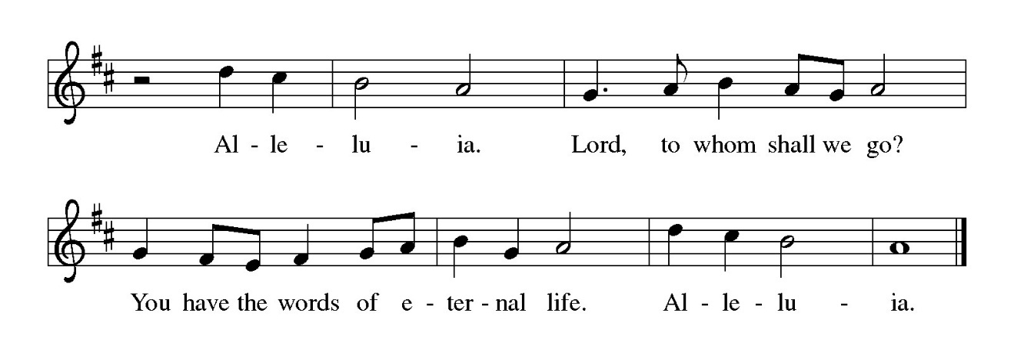
THE HOLY GOSPEL Luke 2: 22-40

Jesus is presented in the temple by Mary and Joseph, and Simeon and Anna testify to Him as God’s Messiah and “the redemption of Israel.”

P: The Holy Gospel according to St. Luke, the second chapter.

C: Glory to You, O Lord.

²² When the time came for their purification according to the law of Moses, they brought Him up to Jerusalem to present Him to the Lord ²³ (as it is written in the law of the Lord, "Every firstborn male shall be designated as holy to the Lord"), ²⁴ and they offered a sacrifice according to what is stated in the law of the Lord, "a pair of turtledoves or two young pigeons."
²⁵ Now there was a man in Jerusalem whose name was Simeon; this man was righteous and devout, looking forward to the consolation of Israel, and the Holy Spirit rested on him. ²⁶ It had been revealed to him by the Holy Spirit that he would not see death before he had seen the Lord's Messiah. ²⁷ Guided by the Spirit, Simeon came into the temple; and when the parents brought in the child Jesus, to do for Him what was customary under the law, ²⁸ Simeon took Him in his arms and praised God, saying,

²⁹"Master, now You are dismissing Your servant in peace,
according to Your word;
³⁰for my eyes have seen Your salvation,
³¹which You have prepared in the presence of all peoples,
³²a light for revelation to the Gentiles
and for glory to Your people Israel."
³³ And the child's father and mother were amazed at what was being said about Him.
³⁴ Then Simeon blessed them and said to His mother Mary, "This child is destined for the falling and the rising of many in Israel, and to be a sign that will be opposed ³⁵ so that the inner thoughts of many will be revealed — and a sword will pierce your own soul too."
³⁶ There was also a prophet, Anna the daughter of Phanuel, of the tribe of Asher. She was of a great age, having lived with her husband seven years after her marriage, ³⁷ then as a widow to the age of eighty- four. She never left the temple but worshiped there with fasting and prayer night and day. ³⁸ At that moment she came, and began to praise God and to speak about the child to all who were looking for the redemption of Jerusalem. ³⁹ When they had finished everything required by the law of the Lord, they returned to Galilee, to their own town of Nazareth.
⁴⁰ The child grew and became strong, filled with wisdom; and the favor of God was upon Him.

P: The Gospel of the Lord.

C: Praise to You, O Christ!

The assembly is seated

THE SERMON
Silence for reflection follows the sermon

As you are able please rise

THE HYMN OF THE DAY 417 In His Temple Now Behold Him

THE NICENE CREED

A: God has made us His people through our Baptism into Christ. Living together in trust
and hope, we confess our faith.

C: We believe in one God,
the Father, the Almighty,
maker of heaven and earth,
of all that is, seen and unseen.

We believe in one Lord, Jesus Christ,
the only Son of God,
eternally begotten of the Father,
God from God, Light from Light,
true God from true God,
begotten, not made,
of one Being with the Father.
Through Him all things were made.
For us and for our salvation
He came down from heaven;
by the power of the Holy Spirit
He became incarnate from the virgin Mary, and was made man.
For our sake He was crucified under Pontius Pilate;
He suffered death and was buried.
On the third day He rose again
in accordance with the Scriptures;
He ascended into heaven
and is seated at the right hand of the Father.
He will come again in glory to judge the living and the dead,
and His kingdom will have no end.
We believe in the Holy Spirit, the Lord, the giver of life,
Who proceeds from the Father and the Son.
With the Father and the Son He is worshiped and glorified.
He has spoken through the prophets.
We believe in one holy catholic and apostolic Church.
We acknowledge one Baptism for the forgiveness of sins.
We look for the resurrection of the dead,
and the life of the world to come. Amen

THE PRAYER OF THE CHURCH

A: Made like us in every respect, Jesus our high priest knows our suffering and intercedes
for us before the throne of mercy. Let us therefore pray through Christ for the Church,
the world, and all those in need.

A: That the bold and faithful witness of the Church might make it a light of revelation, a
sign of contradiction to the darkness and death of this world, and a haven of consolation
for the weak and weary, we pray:

C: Send forth Your light, O God.

A: That God’s reign of peace might so infuse our world that no people need live in the
fear of death, we pray:

C: Send forth Your light, O God.

A: That those living in the midst of terrorism and violence, especially those in Iran,
Venezuela, Syria, and Uganda, and natural disasters and medical crises, especially in
Chile and Australia might come to know stability, order, restoration, and health, we
pray:

C: Send forth Your light, O God.

A: That those serving in our military, especially Blake Waltz and Katreen Somers from
our congregation might be kept in safety, we pray:

C: Send forth Your light, O God.

A: That this congregation, refined by God’s Word and purified by the Lord’s sacrifice,
may faithfully bear the light of Christ in our words and actions this week, we pray:

C: Send forth Your light, O God.

A: That those who suffer from winter’s cold, the hungry, the grieving, the lonely, and the
sick, especially: Major Payne; Martha Schroeder; Fred Weiss; David Weiss; Joyce
Stark; Jackie Gaines; Carl Wipperman; Shirley Shikany Long; John Bennitt;
Catherine Lanigan; Elizabeth Sanders and Tim Miller may know and receive
Jesus’ help and strength, we pray:

C: Send forth Your light, O God.

A: That those celebrating birthdays, especially: Jary Tannehill and Martha Schroeder
may be filled with grace this day and every day and grow in grace in the days ahead,
we pray:

C: Send forth Your light, O God.

A: That those who mourn, especially the family and friends of Bill Seedorf, who died in
the Lord this week, may be comforted by the promise of resurrection to life everlasting
and of being reunited with those they love before the throne of the Lamb, we pray:

C: Send forth Your light, O God.

A: Remembering those servants, especially Simeon and Anna who have gone in peace,
that with them we may at length fully see Your salvation, we pray:

C: Send forth Your light, O God.

P: God of mercy, be our light in darkness and comfort in times of affliction. May we be
as light in a darkened world, proclaiming Your faithful love. We ask this through
Christ, our one High Priest, Who lives and reigns with You and the Holy Spirit, one
God, forever and ever.

C: Amen.

MEAL

THE PEACE

P: The peace of the Lord be with you always.

C: And also with you.

The assembly is seated

THE OFFERING

THE VOLUNTARY You Are My All in All St. Paul Senior Choir
(D. Jernigan; arr. B. Harlan)

As you are able please rise

THE PRESENTATION OF GIFTS 296 (stanzas 1, 2) What Child is This

THE OFFERTORY PRAYER

A: Let us pray. Gracious God,

C: Accept the joyful offering of Your Church, and grant that Your Son may shine in
us as the Light that lightens every nation. We ask this in the name of Jesus the
Lord. Amen.

THE GREAT THANKSGIVING
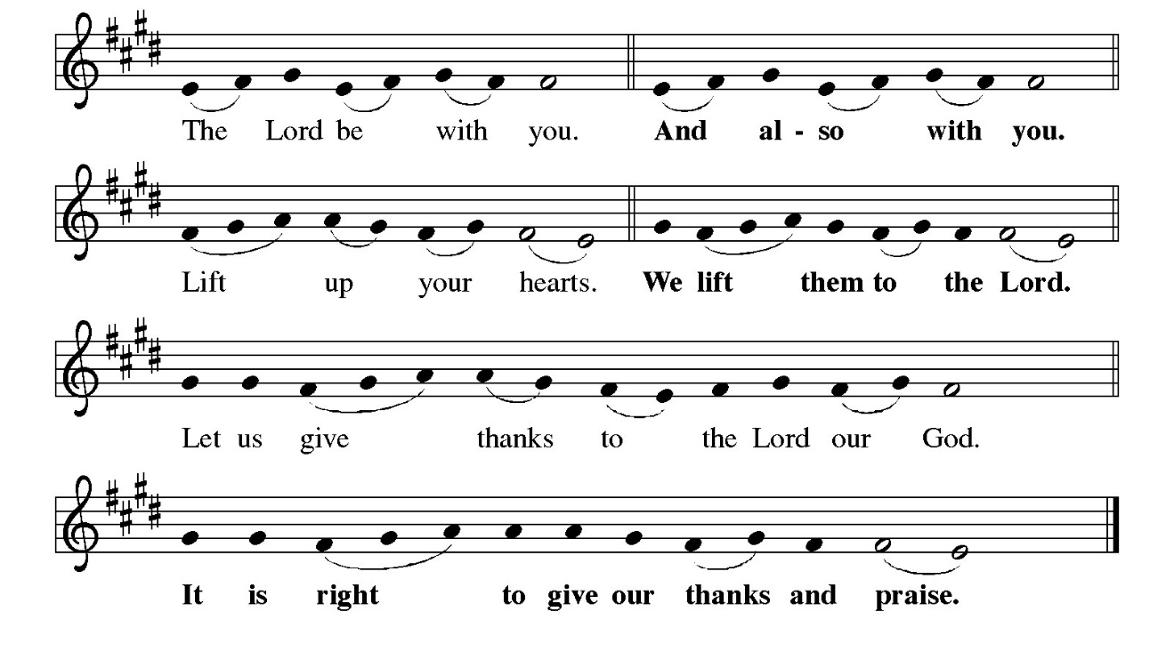P: It is indeed right and salutary …and join their unending hymn:
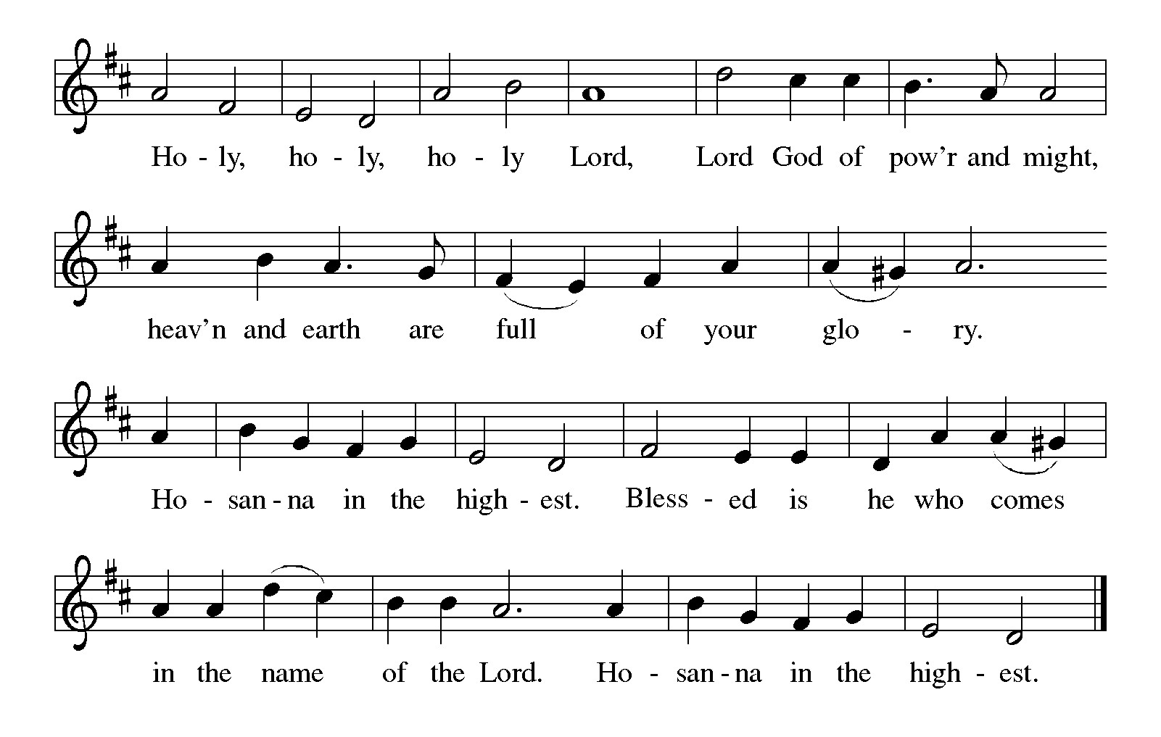P: Holy, gracious, and merciful God, we bless and praise You.
Heaven and earth are filled with Your Light and glory.
You chose Israel to shine Your blessings to all the world.
Through slavery and rescue, exile and homecoming, You sent judges, kings,
and prophets to prepare Your coming and speak Your Word.

Now in these last days You sent us Your Son, Jesus Christ.
He is our merciful and faithful High Priest.
In the night ... “Do this for the remembrance of Me.”
As often as we eat ... we proclaim the Lord’s death until He comes.
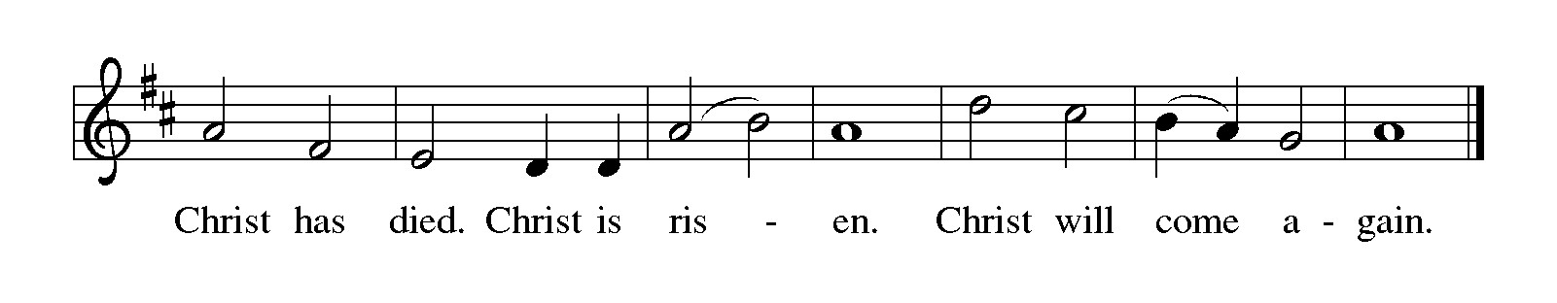
P: With this bread and cup we remember the sacrifice of our Lord’s life:
presented to You in the temple, He grew and became strong and wise.
At His coming the sick were healed, the hungry fed, and sinners received.
By His dying and rising He destroyed the power of death. He will return in glory
to present us into our eternal home with You.
Send Your Holy Spirit on us and these Your gifts of bread and wine.
May we bear the Light of Christ to expel the dark shadows of evil and death until
He comes in final victory and we feast at His heavenly Banquet.
To You, O God: Father, Son, and Holy Spirit, be all honor and glory, in Your
holy Church, in heaven and on earth, now and forever.
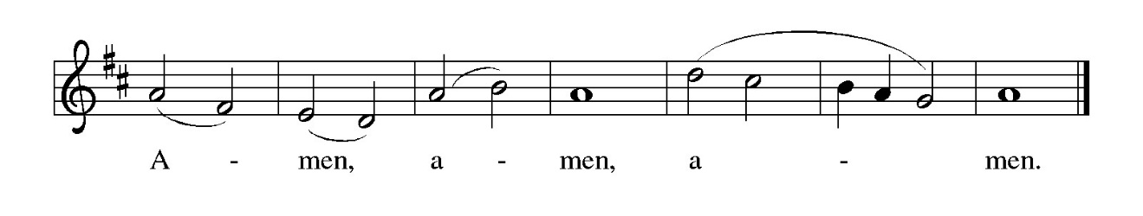
THE LORD’S PRAYER

P: Because in Christ we have received the Spirit of adoption, as daughters and sons of
God, we dare to pray:

C: Our Father in heaven, hallowed be Your name.
Your Kingdom come, Your will be done on earth as in heaven.
Give us today our daily bread, and forgive us our sins, as we forgive
those who sin against us.
Save us from the time of trial, and deliver us from evil.
For the Kingdom, the power, and the glory are Yours, now and forever.
Amen.

INVITATION TO THE MEAL

P: Behold the true Light of the world, the Beloved of God, anointed by the Spirit. Blessed
are those who are called to the Supper of the Lamb. God’s holy gifts for God’s holy
people. Come, for all is now ready.

The assembly is seated

THE DISTRIBUTION
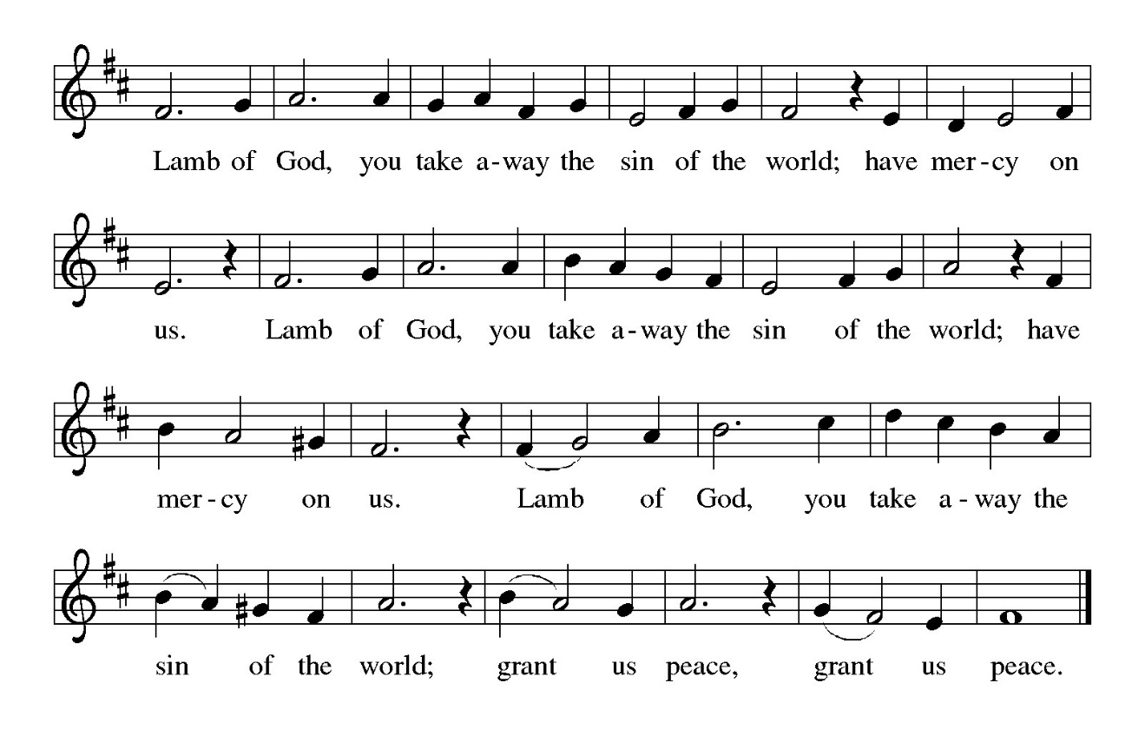
HYMN DURING DISTRIBUTION 677 This Little Light of Mine
NSB 30 Draw Me Close
NSB 81 Spirit Song
NSB 90 ‘Tis So Sweet to Trust in Jesus
NSB 94 Turn Your Eyes Upon Jesus

As you are able please rise

THE POST COMMUNION BLESSING

P: The Body and Blood of our Lord Jesus Christ strengthen you and keep you in His
grace.

C: Amen.

THE POST-COMMUNION PRAYER

A: Let us pray. Lord God, You fulfilled the hope of Simeon, who did not die until he had
been privileged to welcome the Messiah. May this communion perfect Your grace in
us and prepare us to meet Christ when He comes to bring us into everlasting life, for
He is Lord forever and ever.

C: Amen.
SENDING

THE BENEDICTION

P: Almighty God: Father, Son, and Holy Spirit bless you now and forever.

C: Amen.

SENDING HYMN 545 Lord, Dismiss Us With Your Blessing

THE DISMISSAL

A: You are servants of God; you are light to the nations.
Go in peace. Serve the Lord.

C: Thanks be to God!

POSTLUDE
To God Alone Be Glory

The Meditation is from Proclamation 3. Lesser Festivals 2. John H. Tietjen.
(Philadelphia: Fortress Press, 1987) 9-10.

The Prayers, Introduction to the Lord’s Prayer, and Invitation to the Meal are adapted from
Prayers for Sundays and Seasons. Year A. Peter J. Scagnelli. (Chicago: Liturgy
Training Publications, 1998) 146-147.

The Post-Communion Prayer is also adapted from The Book of Alternative Services.
(Toronto: Anglican Book Centre, 1985) 231.
ANNOUNCEMENTS

Please remember to mail your offering to the Church Office at 818 Franklin Street, Michigan City, IN 46360. Another alternative is to give on-line through Tithe.ly. Please see your closure letter for information on how to set up a Tithe.ly account.

St. Paul Members are reminded to have a loved one contact the office if you are hospitalized. Many times, the Pastor doesn’t know someone is in the hospital. If you call and leave a message, please tell us at which hospital the patient is located.

BIRTHDAYS: Jary Tannehill (2/1); Martha Schroeder (2/7)

PRAYER CONCERNS: Robert Bernth; Barry Anderson; John Bennitt; Sarah McNabb; Debbie Martin; Mark Tannehill; Kathy Stein; Jan Paholski; Laura Dovey; Grace Romine; Bill Hazelgrove; Al Levenhagen; Carl Wipperman; Major Payne; Carol Hazelgrove; Allen Sydow; Elizabeth Sanders ; Roy Romine and Tim Miller.

OFFICE HOURS: Libby will be in the office on Mondays, Wednesdays, and Fridays; volunteers will cover Tuesdays and Thursdays.

Monday & Wednesday 8:00 a.m. – 5 p.m.
Tuesday & Thursday 9:00 a.m. – 12:00 p.m.
Friday 8:00 a.m. – 12:00 p.m.

If you are listening to the worship broadcast on the radio and would like to watch the Sunday morning service live stream follow these steps:

(1) If you have You Tube available on your TV, search for
St. Paul Lutheran Church Michigan City, IN.

(2) The direct link on the computer is https://
www.youtube.com/channel/UC5AIPNaKr3QN50984jGOa1g

(3) This link is also on the main page of the church’s website in
the church section and will continue to be posted weekly on the St.
Paul Facebook page.

And it will always be available on the radio broadcast Sunday mornings at 11:00 a.m.
on WEFM (95.9), and on the local cable access station #99 for the previous week’s
service on Sundays at 4:00 p.m. and the current service on Wednesdays at 7:00 p.m.
and Fridays at 8:30 p.m.

To send e-mail to the church office, please use the following addresses:

Pastor Mark Reshan: seniorpastor@stpaulmichigancity.com

Church Office Secretary (Libby Pollock): churchsecretary@stpaulmichigancity.com

Church Treasurer (Karen Fleming): finance@stpaulmichigancity.com

2026 Church Council:

Pastor - Mark Reshan

President - Donna Knoll

Vice President - Jan Bakken

Secretary - Judy Hunt

Treasurer - Karen Fleming

Members: Sue Koziel; Jim Schraidt; Trish Sprague; Bob Kiser; Barry Anderson; and
Pam Soule

Worship Attendance:
Saturday, January 17, 2026 @ 4:00 p.m. 30
Sunday, January 18, 2026 @ 9:00 a.m. 70
TOTAL 100
Services on Saturday, January 24. 2026 and Sunday, January 25, 2026 were cancelled due to severe and dangerous weather.

Copies of the minutes from the December 18, 2025 Church Council meeting are on the back table in the upper Narthex. It was approved by the council via email.

The Good News Newsletter: If you have an article or anything you want included in The Good News please send it to the following e-mail address: splcgoodnews@gmail.com. Pastor Pamela Thiede will be using this e-mail address to assemble The Good News each month. The deadline for getting information to Pastor Pamela will be the 20th of each month.

Next week’s lessons are Isaiah 58: 1-9a, [9b-12]; Psalm 112: 1-9, [10]; I Corinthians 2: 1-12, [13-16]; and Matthew 5: 13-20 for those of you who like to study them in advance.

MISSION OF THE MONTH FOR JANUARY 2026

We have many dedicated Meals on Wheels volunteers within our church family. Their unwavering dedication not only ensures people in our community receive safe and nutritious meals, but the delivery also provides a wellness check, ensuring their safety and well-being. Meals on Wheels has a current need to replace their essential food delivery cases. Black (cold) cases can be sponsored for just $200, and Blue (hot) cases can be sponsored for $500. Every contribution helps ensure their clients receive meals each day. Case sponsorship includes sponsor’s name on the case, recognizing their support and commitment for years to come. Based on the total amount received, we will sponsor as many cases as possible in honor of our St. Paul Volunteers and Congregation. Please make checks payable to St. Paul and place in the offering. Noisy coin offering will also go towards the monthly mission. Thank you for your unwavering and continuous support of Meals on Wheels!

Our members who volunteer for Meals on Wheels include:

Don Thompson Jean Kleinschmidt
Tim & Stacie Crozier Bob & Karen Kiser
Craig & Judy Hunt Mary Knaup
Wayne & Suzann Dolson Charmaine Imperato
Pam Waltz Janet Bakken
Kelly & Brad Neulieb

SNOW EMERGENCY LIST
This is a reminder of where to turn to learn if worship has been canceled because of inclement weather conditions. There are two ways to learn about the status of the service.
First, you may turn to our church and school Facebook page: https://www.facebook.com/stpaulmichigancity/ for updated announcements. Or, perhaps most quickly and easily, you may call the church office number (219-874-7293) and press the “#” key and you will hear a recording about our “open/closed” status.

FEBRUARY 2026 MISSION OF THE MONTH is the Makerspace at the Michigan City Public Library.
The Makerspace is a place where young people can tinker, design, craft, create and explore. It includes a variety of equipment and projects for guided exploration and hands-on learning in the STEAM areas (science, technology, engineering, arts, and math). Some of the items currently available are art supplies (markers, crayons, colored pencils, glue sticks), etch-a-sketch, rubiks cube, building toys, and 3D printers. Lots of youth visit makerspace and many of the art supplies could use a refill. We will be collecting art supplies, or other STEAM supplies. Please place your supplies in the bin in the outer narthex. If you wish to make a monetary donation, please make checks out to the church marked for the makerspace and place in the offering plate. Thank you for your generous donations to our community!

THANK YOU
On behalf of the Payne family and Major, we want to express our deepest gratitude. The congregation and individual kindness through cards, gifts and especially your prayers has been a source of hope and strength during this difficult journey. Major’s recovery from this devastating accident is ongoing, and your outpouring of love and faith have brought us comfort and peace. As scriptures remind us “The Lord is my strength and my shield; my heart trusts Him, and He helps me.” (Psalm 28:7) Please continue to keep him in your prayers, they mean more than words can ever convey.
Chuck & Sherry Payne

2026 Financial Stewardship

Weekly Church Operating Needs (x 2 weeks)
January 10-11, 2026 and January 17-18, 2026 $ 12,912.00

General Fund (including General Memorials): $ 13,750.00

Overage/Shortage: + $ 838.00

Restricted Income (not including Memorials)
Supports IK Synod & Church wide Ministries: $ 196.00

Ministries in our Community/Congregation: $ 275.00

Capital Fund: $ 277.00

Memorials
Organ Fund: $ 60.00

ACTIVITIES, EVENTS & MEETINGS
FEBRUARY 2026

Sunday, February 1, 2026 @ 9:00 a.m. 4th Epiphany/The Presentation of Our Lord Worship/Sanctuary with Coffee after
Tuesday, February 3, 2026 @ 10:00 a.m. Altar Guild Meeting/Green Room
Wednesday, February 4, 2026 @ 9:15 .m. Bible Study/Luther House
@10:00 a.m. God’s Purls/St. Paul Room
@4:30 p.m. Choir Rehearsal/Sanctuary
Thursday, February 5, 2026 @ 4:00 p – 10:00 p GIVE BACK at
Galveston Steakhouse
? Faith Circle
@ 4:00 p.m. 150th Anniversary Comm. Mtg./Luther House
Saturday, February 7, 2026 @ 4:00 p.m. 5th Epiphany Worship Service/Sanctuary

Sunday, February 8, 2026 @ 9:00 a.m. 5th Epiphany Worship Service/Sanctuary with Coffee after
Monday, February 9, 2026 @ 1:00 p.m. Hope Circle/Green Room
Wednesday. February 11, 2026 @ 9:15 a.m. Bible Study/Luther House
@10:00 a.m. God’s Purls/St. Paul Room
@ 3:30 p.m. Worship & Music Mtg./Luther House
@ 4:30 p.m. Choir Rehearsal/Sanctuary
Saturday, February 14, 2026 @ 4:00 p.m. Transfiguration of Our Lord Worship

Sunday, February 15, 2026 @ 9:00 a.m. Transfiguration of Our Lord Worship/ Sanctuary with Coffee after
Wednesday, February 18, 2026 @ 10:00 a.m. Ash Wednesday Worship Service @ 7:00 p.m. Ash Wednesday Worship Service
Saturday, February 21, 2026 @ 4:00 p.m. 1st Lent Worship Service/Sanctuary

Sunday, February 22, 2026 @ 9:00 a.m. 1st Lent Worship Service/Sanctuary with Coffee after
Monday, February 23, 2026 @ 2:00 p.m. Executive Board Meeting/ Luther House
Wednesday, February 25, 2026 @ 9:15 a.m. Bible Study/Luther House
@ 10:00 a.m. God’s Purls/St. Paul Room
@ 4:30 p.m. Choir Rehearsal/Sanctuary
Thursday, February 26, 2026 @ 3:00 p.m. Church Council Meeting/St. Paul Room
Saturday, February 28, 2026 @ 4:00 p.m. 2nd Lent Worship Service/Sanctuary

Thank$ for $haring
Thank you to all who participate in our Give-Back opportunities each month where we earn $$ to add to our Mission of the Month donations from our congregation to those in our community who need our help!
On January 7th, 2026 we earned $114 from our Give Back at 5 Guys.” On
Thursday, February 5, 2026 we’re going to meet at Galveston Steak House for our GIVE BACK from 4pm—10pm. Here are two coupons—one for you and one for a friend.

