**THE SEVENTH SUNDAY AFTER PENTECOST**

**July 24, 2022**

“ …the Lukan version of the Lord’s Prayer breaks into two parts. The first part (v. 2) consists of two imperative petitions, both about God: thy name be hallowed, may thy kingdom come. These two petitions function as acts of praise and doxology because they acknowledge God’s *holiness* and God’s *sovereignty.*

The beginning point for the Lord’s Prayer is thus not very different from the beginning point for Abraham’s petitions in Genesis 18. Abraham’s confidence in God’s sovereign holiness leads him to expect a new way of justice in the world. In the Lord’s Prayer, confidence in God’s sovereign holiness leads to expectations about a new way of life. The assurance of God’s holy name and God’s sovereign kingdom provides the contexts out of which it is possible to pray about our life …”

“ … To come to God timidly in prayer and petition is a sign that we do not trust God’s sovereign holiness. To come to God in timidity is a sign that we do not trust God’s ability to answer, that we are not sure God has the strength to deal with us as we are. It is almost as if we want to protect God from the full weight of our petitions, but by trying to protect God, we actually restrict the arena in which God’s justice and righteousness can act.

To come to God boldly, however, as Abraham did in Genesis 18 and as Jesus instructs in Luke 11, is to proclaim our confidence that God will hear and God will answer. To come to God boldly, pressing God for a new way of life in the world, for daily bread, for the end of brokenness, is an expression of our passionate trust in God.”

**Gail R. O’Day**

Jeremiah lay in squalor, and the Lord hearkened to his prayer. Job prayed from his dunghill, and the Lord was gracious to him. Jonah was in the belly of a whale, and the Lord listened to his prayer. And you, even if you are in the baths, pray; wherever you are, pray.

Do not seek for a place to pray in: you yourself are a temple. And what is the meaning of stretching out hands in prayer? They have been the instrument of many iniquities, and because of this we are bidden to lift them up, that the ministry of prayer may serve them as a withdrawal from iniquity. Thus should you be on the point of committing a theft, or oppressing or striking someone, you may remember that you must raise those hands in pleading before God.

**John Chrysostom**

**Fourth Century**

**✠ In the Name of Jesus ✠**

**✠ GATHERING ✠**

**INTRODUCTION**

Persistence in prayer evoked the admiration of Jesus and wins the attention of the Lord when Abraham intercedes for Sodom. The life of the baptized—to be rooted and built up in Christ Jesus the Lord—is to be rooted in prayer. God hears and answers prayer and so strengthens God’s own. "When I called, you answered me; you increased my strength within me."

**Birgitta of Sweden, renewer of the church, died 1373**

*Birgitta married at age thirteen and had four daughters. Widowed at age thirty-eight, she gave all that she owned to the poor, and founded a community of monks and nuns led by a woman. Her work is continued today by the Society of St. Birgitta.*

**James, Apostle**

*James and his brother John were the sons of Zebedee, fishermen by trade before their call from Jesus. He was the first of the twelve apostles to be martyred, and his death is the only one recorded in scripture (Acts 12:1-2).*

**PRELUDE *Novelette I*  Richard Purvis**

**ANNOUNCEMENTS**

*As you are able please rise*

**CONFESSION AND ABSOLUTION**

P: In the name of the Father and of ✠ the Son and of the Holy Spirit.

C: **Amen.**

P: “When I called, (O God), You answered me; You increased my strength within me.”

(Psalm 138:4) Jesus commands us to “ask; search, and knock” (Luke11:9) in prayer,

promising that we will receive the good gifts God desires to bring. In confidence that

God deals with us not according to His anger but in overflowing mercy, let us “call”

upon the Lord in the confession of our sins.

*Silence for self-examination and reflection is kept*

P: Most merciful God,

C: **We confess that we have sinned against You and others. You desire us to call upon**

**You in prayer, but often we make no time for You. We use prayer as a way to**

**“get” what we desire from You instead of as a gift by which You prepare us for**

**Your Kingdom and teach us Your will. Forgive us for our failures in prayer, O**

**God. Daily “teach us to pray” (Luke 11:1) in ways what will lay hold of Your**

**promises, root us deeply in Christ, and bring Your transforming love to our**

**broken world.**

P: “Everyone who asks, receives, and everyone who searches finds, and for everyone who

knocks, the door will be opened.” (Luke 11:10) “Because of (God’s) love and

faithfulness” (Psalm 138:3) God grants the mercy for which we pray. For as a called

and ordained minister of the Church of Christ and by His authority, I therefore declare

to you the entire forgiveness of all your sin, in the name of the Father, and of ✠ the

Son, and of the Holy Spirit.

C: **Amen.**

**GATHERING HYMN 533 *Open Now Thy Gates of Beauty***

**THE GREETING AND PRAYER OF THE DAY**

P: The grace of our Lord Jesus Christ, the love of God, and the communion of the Holy

Spirit be with you all.

C: **And also with you.**

P: Let us pray. Almighty and ever-living God, You are always more ready to hear than

we are to pray, and You gladly give more than we either desire or deserve. Pour upon

us Your abundant mercy. Forgive us those things that weigh on our conscience, and

give us those good things that come only through Your Son, Jesus Christ, our Savior

and Lord.

C: **Amen.**

*The assembly is seated*

**✠ WORD ✠**

**FIRST READING Genesis 18:20-32**

In today's reading, Abraham undertakes the role of a mediator between God and sinful humanity. Appealing to God's justice, Abraham boldly asks for mercy for the city of Sodom, for the sake of the few righteous people who are in it, including Abraham's nephew, Lot.

20Then the LORD said, "How great is the outcry against Sodom and Gomorrah and how very grave their sin! 21I must go down and see whether they have done altogether according to the outcry that has come to me; and if not, I will know."

22So the men turned from there, and went toward Sodom, while Abraham remained standing before the LORD. 23Then Abraham came near and said, "Will You indeed sweep away the righteous with the wicked?" 24Suppose there are fifty righteous within the city; will You then sweep away the place and not forgive it for the fifty righteous who are in it? 25Far be it from You to do such a thing, to slay the righteous with the wicked, so that the righteous fare as the wicked! Far be that from You! Shall not the Judge of all the earth do what is just?"

26And the LORD said, "If I find at Sodom fifty righteous in the city, I will forgive the whole place for their sake." 27Abraham answered, "Let me take it upon myself to speak to the LORD, I who am but dust and ashes. 28Suppose five of the fifty righteous are lacking? Will You destroy the whole city for lack of five?" And He said, "I will not destroy it if I find forty-five there."

29Again he spoke to Him, "Suppose forty are found there." He answered, "For the sake of forty I will not do it." 30Then he said, "Oh do not let the LORD be angry if I speak. Suppose thirty are found there." He answered, "I will not do it, if I find thirty there." 31He said, "Let me take it upon myself to speak to the LORD. Suppose twenty are found there." He answered, "For the sake of twenty I will not destroy it." 32Then he said, "Oh do not let the LORD be angry if I speak just once more. Suppose ten are found there." He answered, "For the sake of ten I will not destroy it."

The Word of the Lord.

**Thanks be to God.**

**THE PSALM: Psalm 138** **Read responsively**

1I will give thanks to You, O LORD, with my whole heart;

     before the gods I will sing Your praise.

**2I will bow down toward Your holy temple and praise Your name, because of Your steadfast love and faithfulness;**

**for You have glorified Your name and Your word above all things.**

3When I called, You answered me;

     You increased my strength within me.

**4All the rulers of the earth will praise You, O LORD,**

**when they have heard the words of Your mouth.**

5They will sing of the ways of the LORD,

     that great is the glory of the LORD.

**6The LORD is high, yet cares for the lowly,**

**perceiving the haughty from afar.**

7Though I walk in the midst of trouble, You keep me safe;

     You stretch forth Your hand against the fury of my enemies; Your right hand shall save me.

**8You will make good Your purpose for me;**

**O LORD, Your steadfast love endures forever; do not abandon the works of Your hands.**

**SECOND READING Colossians 2:6-15**

Paul warns his congregation in Colossae about "the empty lure" of philosophies and traditions that compromise faith. Through the gift of faith, the church is mystically connected with Christ in his death and resurrection, which is enacted in baptism.

6As you therefore have received Christ Jesus the Lord, continue to live your lives in Him, 7rooted and built up in Him and established in the faith, just as you were taught, abounding in thanksgiving.

8See to it that no one takes you captive through philosophy and empty deceit, according to human tradition, according to the elemental spirits of the universe, and not according to Christ. 9For in Him the whole fullness of deity dwells bodily, 10and you have come to fullness in Him, Who is the head of every ruler and authority. 11In Him also you were circumcised with a spiritual circumcision, by putting off the body of the flesh in the circumcision of Christ; 12when you were buried with Him in baptism, you were also raised with Him through faith in the power of God, Who raised Him from the dead.

13And when you were dead in trespasses and the uncircumcision of your flesh, God made you alive together with Him, when He forgave us all our trespasses, 14erasing the record that stood against us with its legal demands. He set this aside, nailing it to the cross. 15He disarmed the rulers and authorities and made a public example of them, triumphing over them in it.

The Word of the Lord.

**Thanks be to God.**

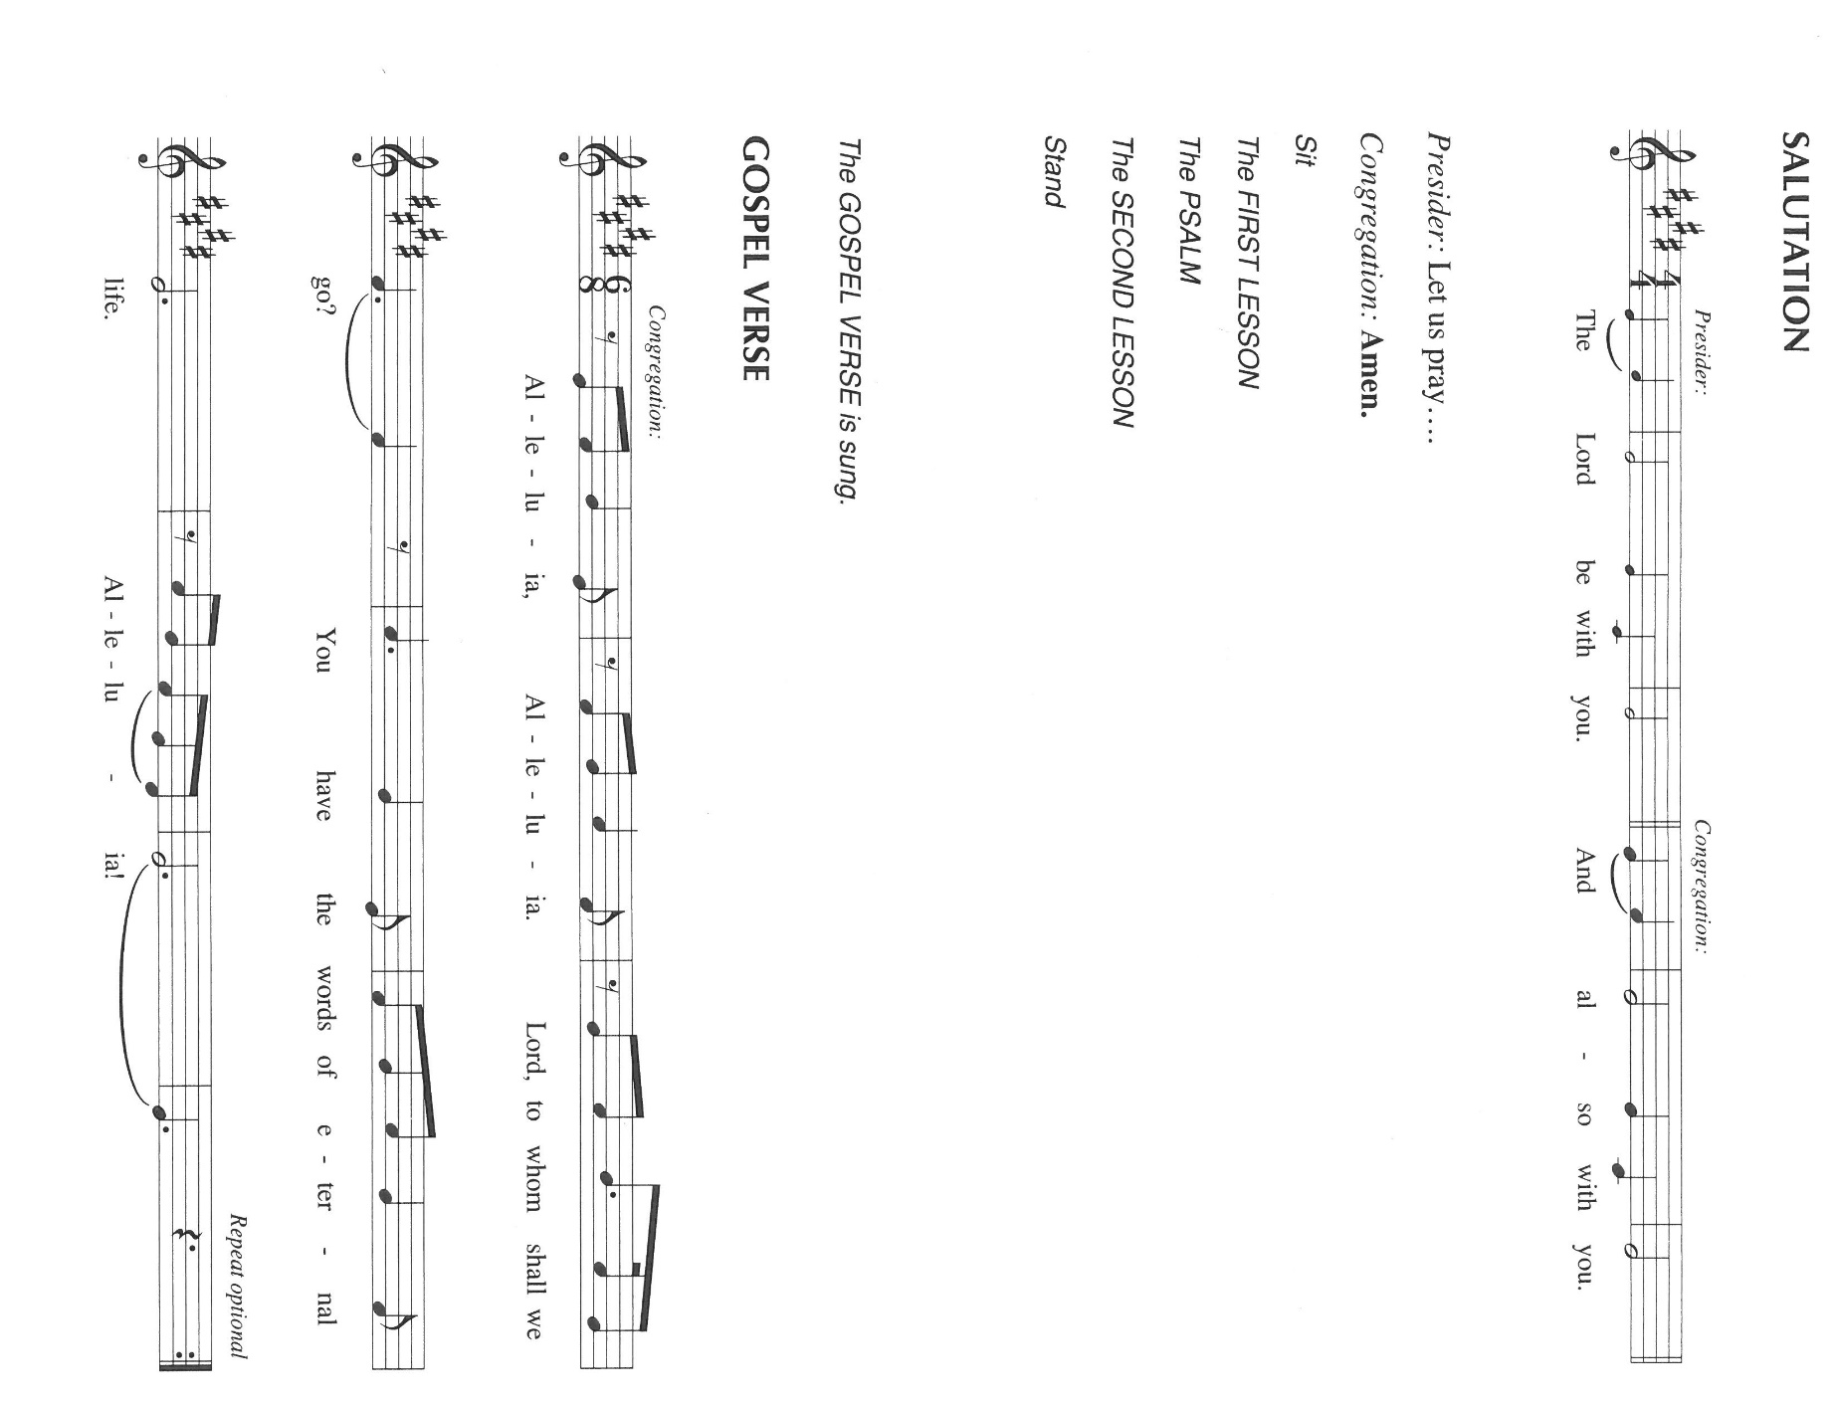*As you are able please rise*

**THE VERSE** Sung twice

**THE HOLY GOSPEL Luke 11:1-13**

In teaching his disciples this prayer, Jesus also reminds them to focus on God's coming reign, God's mercy, and the strengthening of the community. Jesus encourages his disciples to child-like trust and persistence in prayer.

P: The Holy Gospel according to St. Luke, the eleventh chapter.

C: **Glory to You, O Lord!**

Jesus was praying in a certain place, and after He had finished, one of His disciples said to Him, "Lord, teach us to pray, as John taught his disciples." 2He said to them, "When you pray, say:

Father, hallowed be Your name.

Your kingdom come.

3Give us each day our daily bread.

4And forgive us our sins, for we ourselves forgive everyone indebted to us.

And do not bring us to the time of trial."

5And He said to them, "Suppose one of you has a friend, and you go to him at midnight and say to him, 'Friend, lend me three loaves of bread; 6for a friend of mine has arrived, and I have nothing to set before him.' 7And he answers from within, 'Do not bother me; the door has already been locked, and my children are with me in bed; I cannot get up and give you anything.'

8I tell you, even though he will not get up and give him anything because he is his friend, at least because of his persistence he will get up and give him whatever he needs.  
9So I say to you, Ask, and it will be given you; search, and you will find; knock, and the door will be opened for you. 10For everyone who asks receives, and everyone who searches finds, and for everyone who knocks, the door will be opened.

11Is there anyone among you who, if your child asks for a fish, will give a snake instead of a fish? 12Or if the child asks for an egg, will give a scorpion? 13If you then, who are evil, know how to give good gifts to your children, how much more will the heavenly Father give the Holy Spirit to those who ask Him!"

P: The Gospel of the Lord.

C: **Praise to You, O Christ!**

*The assembly is seated*

**THE SERMON**

*Silence for reflection follows the sermon*

*As you are able please rise*

**THE HYMN OF THE DAY 745 *Lord, Teach Us How to Pray Aright***

(Sung to the tune, *O God, Our Help in Ages Past)*

**1 Lord, teach us how to pray aright,**

**with rev'rence and with fear.**

**Though dust and ashes in your sight,**

**we may, we must draw near.**

**2 We perish if we cease from prayer;**

**oh, grant us pow'r to pray.**

**And when to meet you we prepare,**

**Lord, meet us on our way.**

**3 Give deep humility; the sense**

**of godly sorrow give;**

**a strong desire, with confidence,**

**to hear your voice and live;**

**4 Faith in the only sacrifice**

**that can for sin atone;**

**to cast our hopes, to fix our eyes**

**on Christ, on Christ alone.**

**5 Give these, and then your will be done;**

**thus strengthened with all might,**

**we, through your Spirit and your Son,**

**shall pray, and pray aright.**

**Text: James Montgomery, 1771-1854, alt.**

**THE APOSTLES’ CREED**

A: God has made us His people through our Baptism into Christ. Living together in trust

and hope, we confess our faith.

C: **I believe in God, the Father almighty,**

**creator of heaven and earth.**

**I believe in Jesus Christ, His only Son, our Lord.**

**He was conceived by the power of the Holy Spirit**

**and born of the virgin Mary.**

**He suffered under Pontius Pilate,**

**was crucified, died, and was buried.**

**He descended into hell.**

**On the third day He rose again.**

**He ascended into heaven,**

**and is seated at the right hand of the Father.**

**He will come again to judge the living and the dead.**

**I believe in the Holy Spirit,**

**the holy catholic Church,**

**the communion of saints,**

**the forgiveness of sins,**

**the resurrection of the body,**

**and the life everlasting. Amen.**

**THE PRAYER OF THE CHURCH**

A: We have been taught to pray by the Lord. Therefore with the boldness and confidence

of Abraham, we persistently ask, seek, and knock for the life of the Church, the world,

those in need, and all of God’s good creation.

A: That the Church might remain rooted deeply in Christ, built up in Him and established

in a courageous and missionary faith, let us pray to the Lord:

C: **Lord, hear our prayer.**

A: That in places of unrest, especially Ukraine; Sri Lanka; Venezuela; and the Middle East

peace might prevail over violence, bloodshed, and hatred, let us pray to the Lord:

C: **Lord, hear our prayer.**

A: That this congregation may diligently ask and seek Your mission for us that we may

continue our life in Him with deep joy, hope, and thanksgiving, let us pray to the Lord:

C: **Lord, hear our prayer.**

A: That the persistent cries of the hungry, the homeless, refugees, the abused, and the sick,

especially . . . may elicit our compassionate help and God’s healing grace, let us pray

to the Lord:

C: **Lord, hear our prayer.**

A: That those celebrating anniversaries, especially **Charles Sr. and Jana Thomas** may

grow in grace this day and every day and be filled with grace for the days ahead, let us

pray to the Lord:

C: **Lord, hear our prayer.**

A: That with all the saints and martyrs, especially **Birgitta of Sweden, Renewer of the**

**Church, and James, Apostle** whom we commemorate this Day, we may faithfully

testify by word and life to Your Kingdom that is surely coming, let us pray to the Lord:

C: **Lord, hear our prayer.**

P: Loving God, our Father, You fashioned the human heart; You know the needs that make

it ache. Hear us, Your children, praying as Your Son taught us. His is the name we

evoke; His is the Kingdom we await: Jesus Christ, the Lord.

C: **Amen.**

**✠ MEAL ✠**

**THE PEACE**

P: The peace of the Lord be with you always.

C: **And also with you.**

*The assembly is seated*

**THE OFFERING**

**THE VOLUNTARY *We Pray Now to the Holy Spirit*  Dietrich Buxtehude**

*As you are able please rise*

**THE OFFERTORY 465 *As the Grains of Wheat***

**THE OFFERTORY PRAYER**

A: Let us pray. God of grace,

C: **We offer You our prayers in the confidence that You will hear them. With joy**

**and thanksgiving we bring You these gifts of our time, talents, and possessions.**

**Receive them for the sake of Your Son, Jesus Christ, and through this Bread,**

**strengthen us to do Your will on earth as it is in heaven. We ask this in the name**

**of Jesus the Lord. Amen.**

**THE GREAT THANKSGIVING**

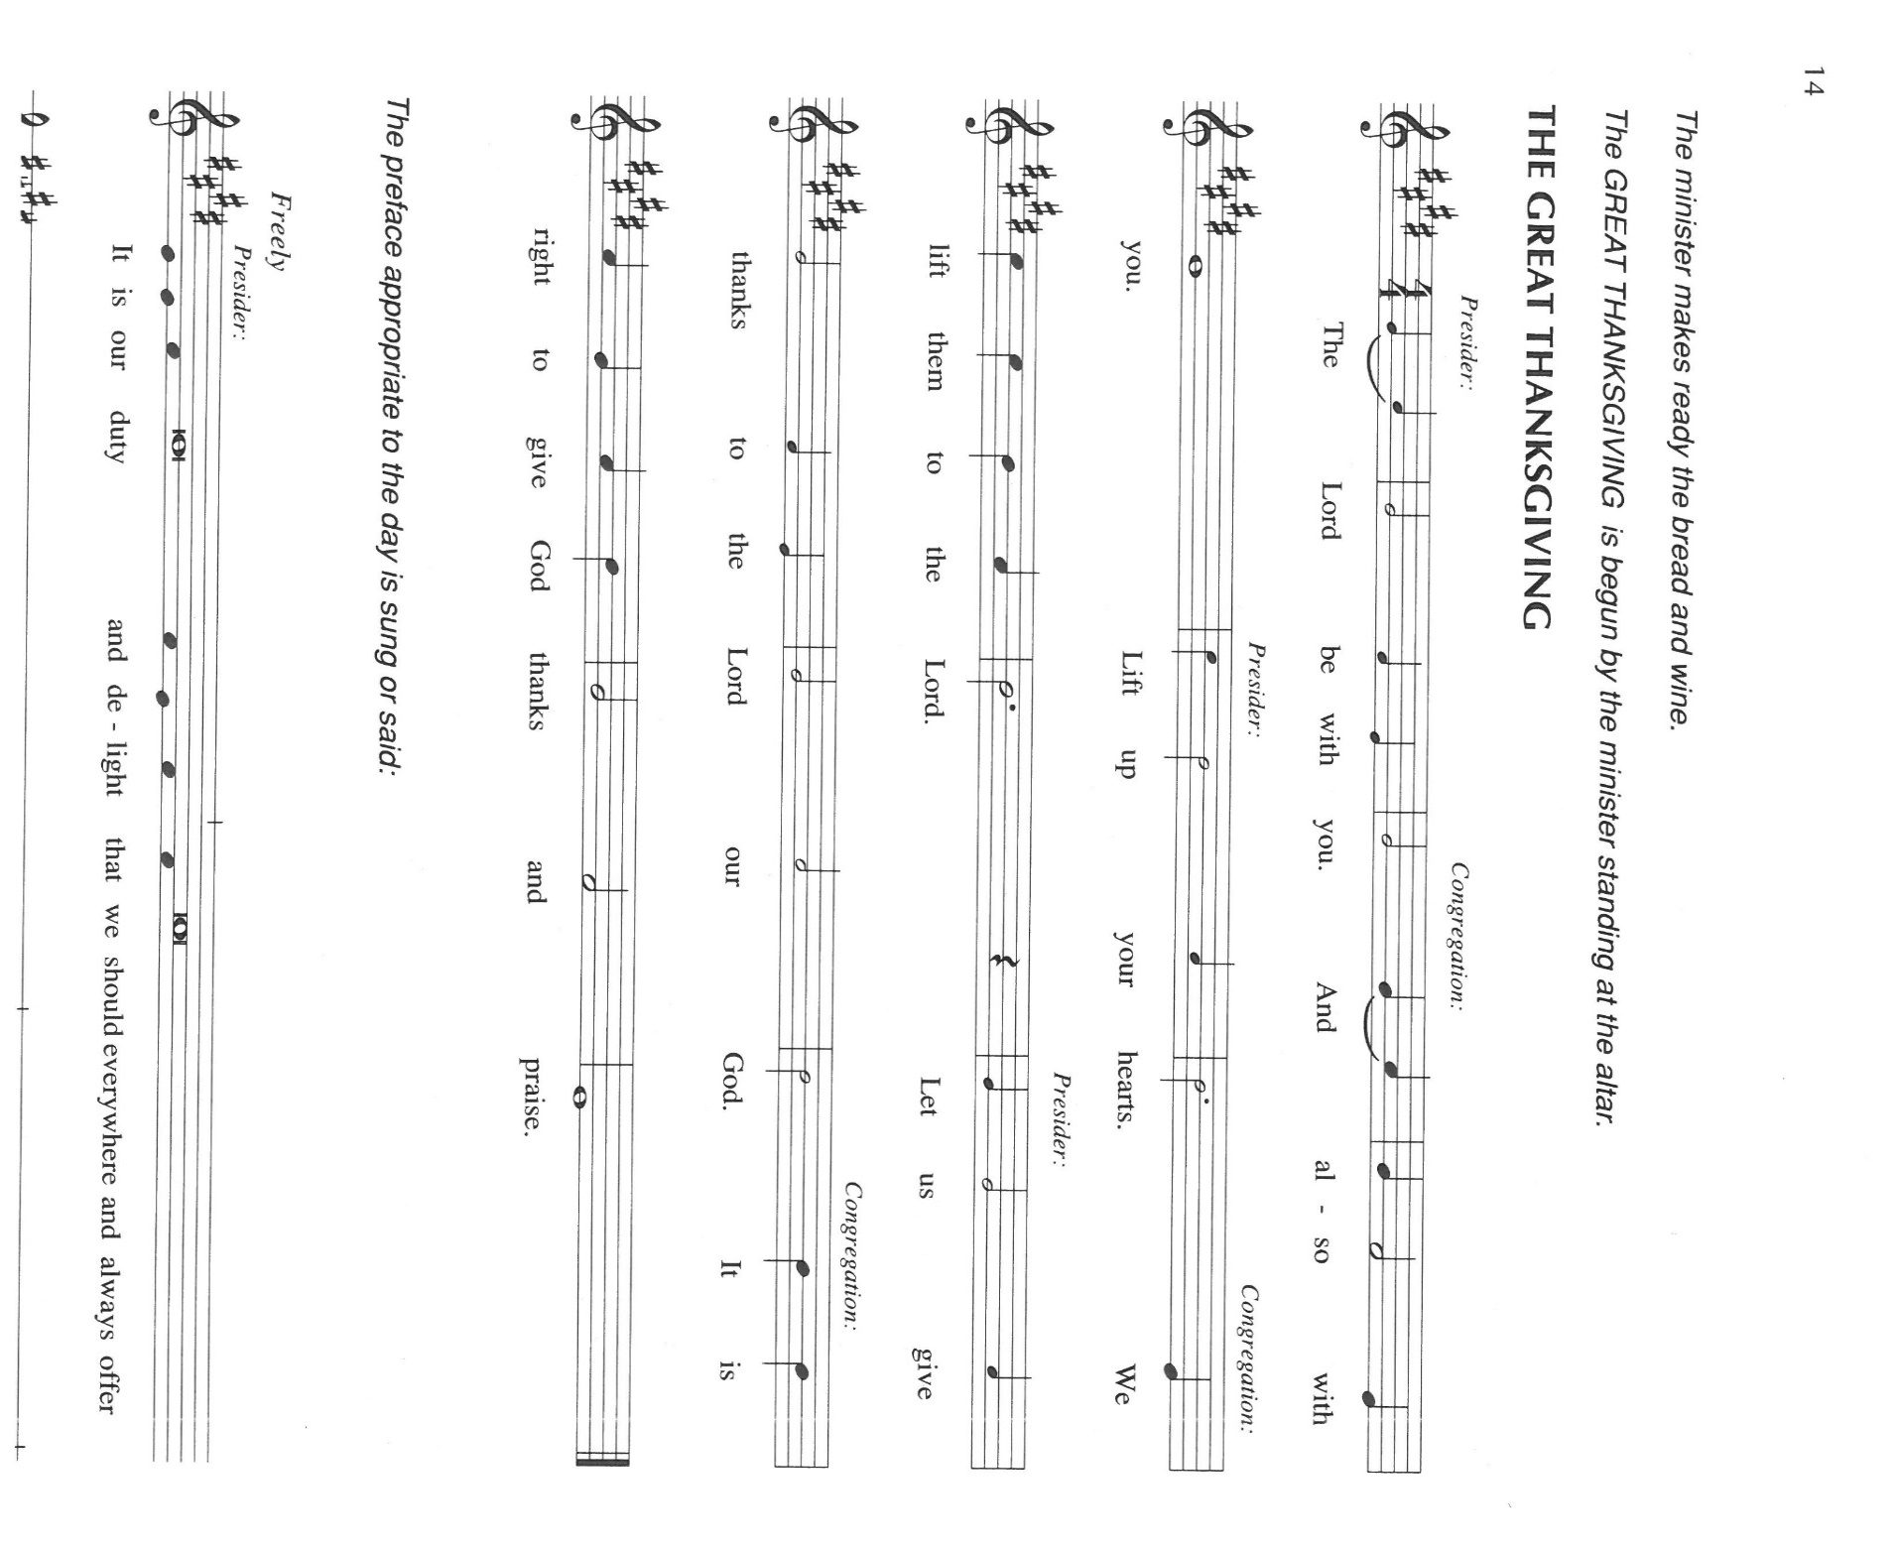

P: It is our duty and delight … join their unending hymn:

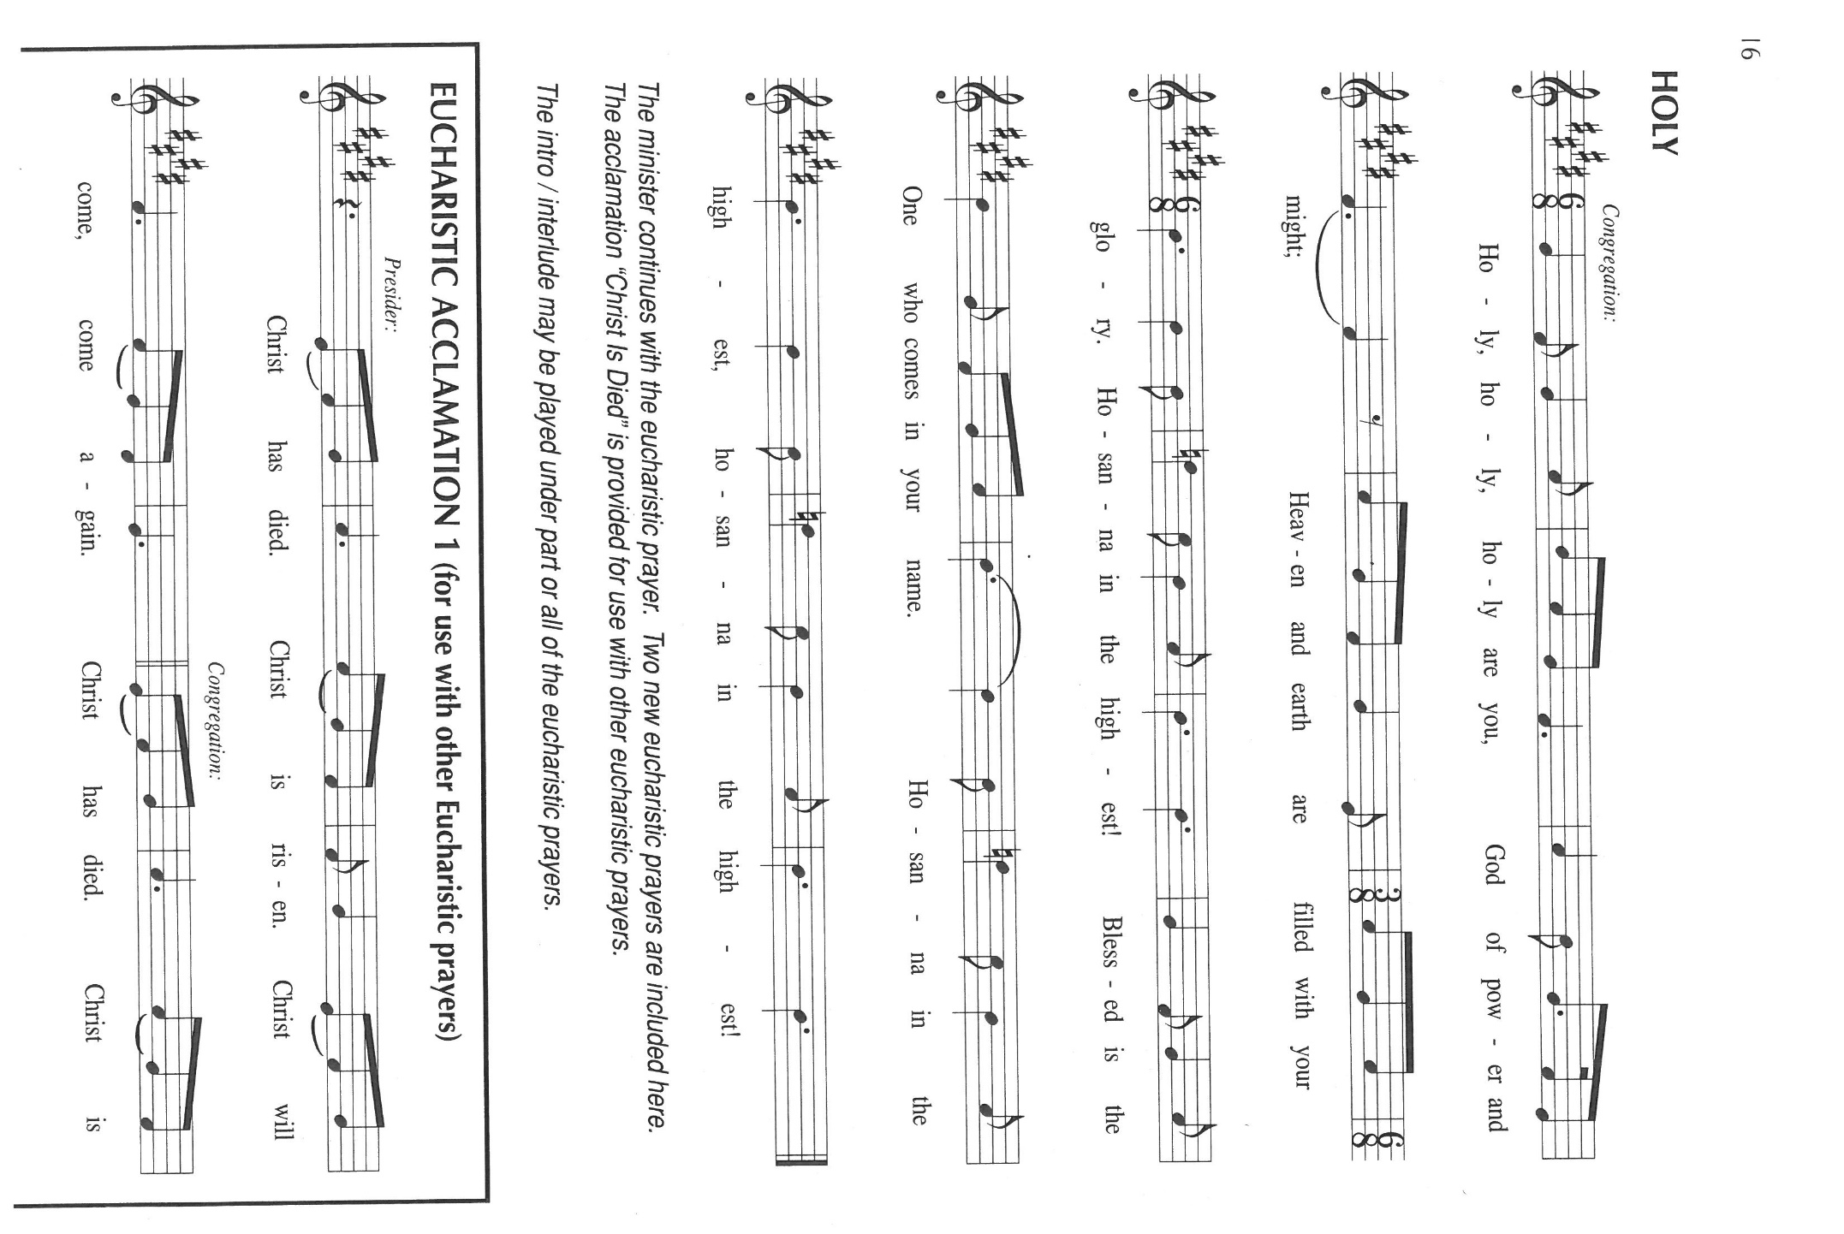

P: *Father, hallowed be Your name;* for You have glorified it through Your everlasting love

and faithfulness.

Heaven and earth praise You, for by Your Word they were created.

Through Your love *Your Kingdom comes,* full of promise, life, and hope.

You gave birth to Your promise in Israel, Your chosen, through whom You raised up

Jesus, Your Son, in Whom all Your purposes will be made good.

In the night … “Do this for the remembrance of Me.”

As often as we eat … we proclaim the Lord’s death until He comes.

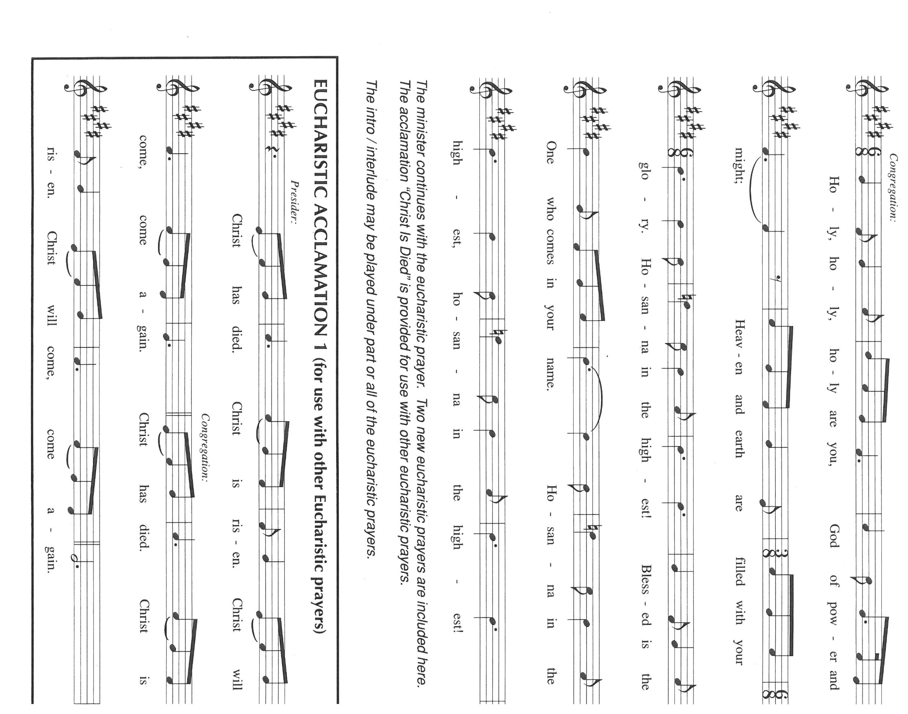

P: Remembering, His willing entry into death and His glorious rising into Life, His

Ascension and sending of the Holy Spirit to those who ask You,

We lift this *Bread* and cup given to us *this day,* seeking Your blessings as we await

His promised return.

Pour out Your Spirit on us and these gifts that we who share this Meal may *forgive*

*as we have been forgiven,* and in the power of the Spirit be *saved from the*

*time of trial* until Christ comes in final victory.

As You teach us to pray, Father, gather our petitions with those of Christ in the unity of

the Holy Spirit, until all honor and glory is Yours, in heaven and on earth,

now and forever.

C: **Amen.**

**THE LORD’S PRAYER**

P: Gathered into one by the Spirit, let us pray as Jesus taught us:

**Our Father, Who art in heaven, hallowed by Thy name.**

**Thy Kingdom come, Thy will be done on earth as it is in heaven.**

**Give us this day our daily bread, and forgive us our trespasses as we forgive those**

**who trespass against us.**

**And lead us not into temptation, but deliver us from evil.**

**For Thine is the Kingdom, and the power, and the glory, forever and ever. Amen.**

**INVITATION TO THE MEAL**

P: This is the Lamb of God Who takes away the sin of the world. Blessed are those who

are called to the Supper of the Lamb. God’s holy gifts for God’s holy people. Come,

for all is now ready.

*The assembly is seated*

**THE DISTRIBUTION**

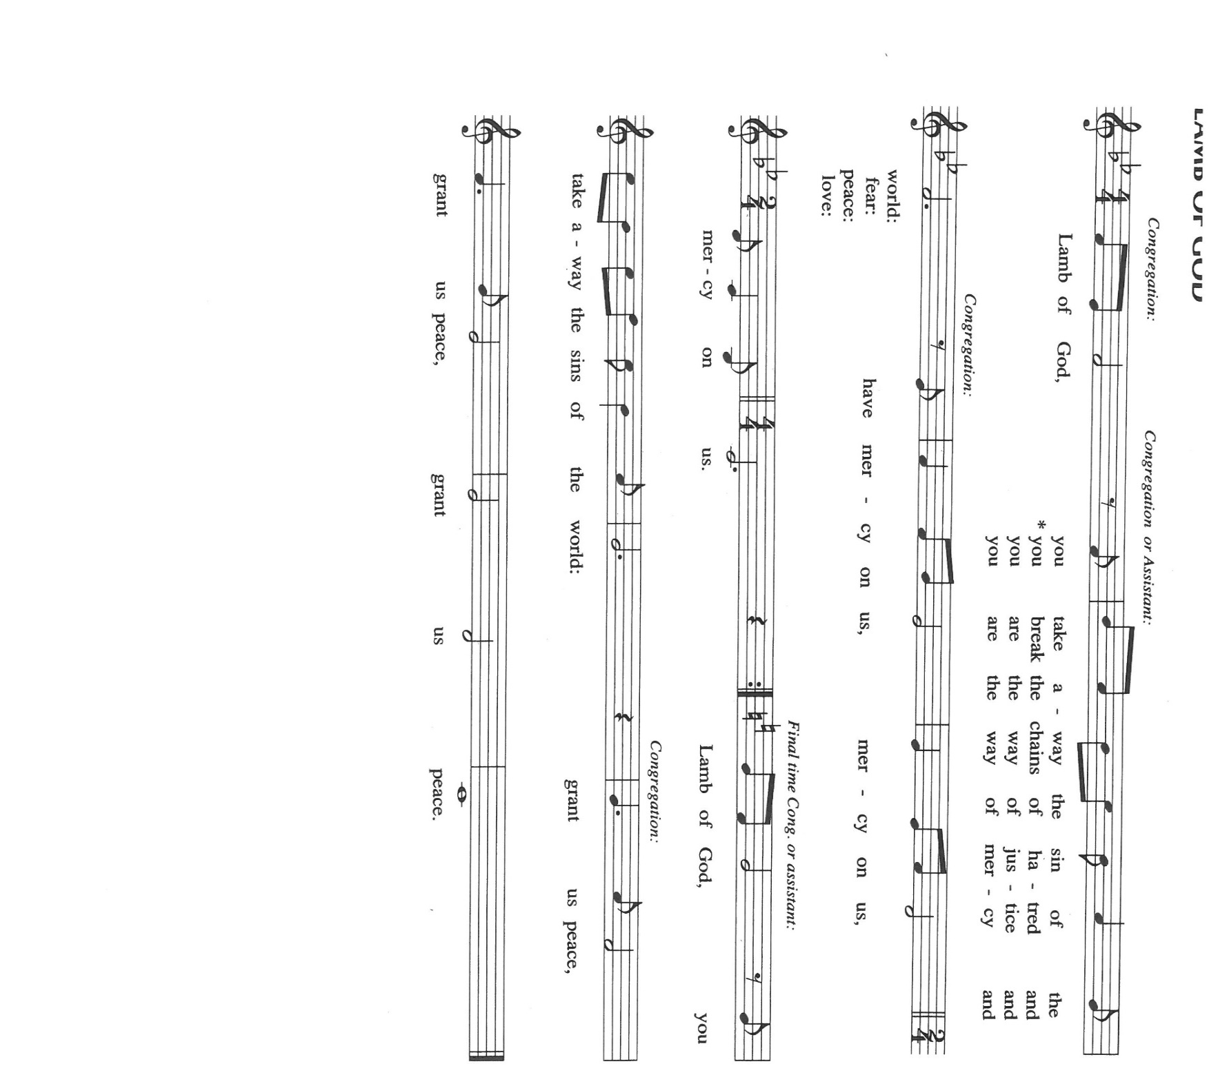

**HYMNS DURING DISTRIBUTION 688 *Lord of Light***

**471 *Let Us Break Bread Together***

*As you are able please rise*

**THE POST-COMMUNION BLESSING**

P: The Body and Blood of our Lord Jesus Christ strengthen you and keep you in His grace.

C: **Amen.**

**THE POST-COMMUNION PRAYER**

A: Let us pray. God of grace, we have again received the gift of the Body and Blood of

Your Son. May this Bread strengthen us to hallow Your name and live out Your

forgiveness until Your Kingdom fully comes in Your Son, Jesus Christ our Lord.

C: **Amen.**

**✠ SENDING ✠**

**THE BENEDICTION**

P: Almighty God: Father, Son, ✠ and Holy Spirit bless you now and forever.

C: **Amen.**

**THE SENDING HYMN 742 *What a Friend We Have in Jesus***

**THE DISMISSAL**

A: Go in peace to bear Christ’s love to all the world.

C: **Thanks be to God!**

**POSTLUDE *Novelette II*  Richard Purvis**

**✠ To God Alone Be Glory✠**

The Meditation is from *Proclamation: Pentecost 2.* Gail R. O’Day. (Philadelphia: Fortress Press, 1989) 5, 9-10; and *Sundays and Seasons Online.* Copyright 2019 Augsburg Fortress.

The Prayers are adapted from *Intercessions for the Christian People.* Gail Ramshaw, ed. (New York: Pueblo Publishing Company, 1988) 186.

**ANNOUNCEMENTS**

**Please remember to mail your offering to the Church Office** at 818 Franklin Street, Michigan City, IN 46360**.** Another alternative is to give on-line through Tithe.ly. Please see your closure letter for information on how to set up a Tithe.ly account.

**St. Paul Members are reminded to have** a loved one contact the office if you are hospitalized. Many times, the Pastor doesn’t know someone is in the hospital. If you call and leave a message, please tell us which hospital the patient is at.

**Next Sunday’s lessons are Ecclesiastes 1: 2, 12-14; 2: 18-23; Psalm49: 1-12; Colossians 3: 1-11; Luke 12: 13-21** for those of you who like to study them in advance.

**Anniversaries: Charles, Sr. and Jana Thomas (7/28)**

**PRAYER CONCERNS:** Audrey Beyer, Ryan Krueger, Donna Bostater, Maxine Powell, Jim Tomscheck, Eloise Ponder, Mark & Jary Tannehill, Leonard Cross, George Ottersen, Annette Scroggin and Helen Hill-Weaver.

**If you requested someone’s name to be on the prayer list and are aware that they need continued imminent prayer then contact the church office and let us know.** Otherwise we will gradually transfer names to the long-term list.

**OFFICE HOURS:** Libby will be in the office on Mondays, Wednesdays, and Fridays; volunteers will cover Tuesdays and Thursdays.

Monday & Wednesday 8:00 a.m. – 5 p.m.

Tuesday & Thursday 9:00 a.m. – 12:00 p.m.

Friday 8:00 a.m. – 12:00 p.m.

**If you are listening to the worship broadcast on the radio and would like to watch the Sunday morning service live stream follow these steps:**

(1) If you have You.Tube available on your TV, search for

**St. Paul Lutheran Church Michigan City, IN.**

(2) The direct link on the computer is

<https://www.youtube.com/channel/UC5AIPNaKr3QN50984jGOa1g>.

 (3) This link is also on the main page of the church’s website in the church section and will continue to be posted weekly on the St. Paul Facebook page.

And it will always be available on the radio broadcast Sunday mornings at 11:00 a.m. on WEFM (95.9), and on the local cable access station #99 for the previous week’s service on Sundays at 4:00 p.m. and the current service on Wednesdays at 7:00 p.m. and Fridays at 8:30 p.m.

**To send e-mail to the church office**, please use the following addresses:

Pastor Mark Reshan: [seniorpastor@stpaulmichigancity.com](mailto:seniorpastor@stpaulmichigancity.com)

Church Office Secretary (Libby Pollock): [churchsecretary@stpaulmichigancity.com](mailto:churchsecretary@stpaulmichigancity.com)

Church Treasurer (Karen Fleming): [finance@stpaulmichigancity.com](mailto:finance@stpaulmichigancity.com)

**The Good News Newsletter**: If you have an article or anything you want included in **The Good News** please send it to the following e-mail address: splcgoodnews@gmail.com. Pastor Pamela Thiede will be using this e-mail address to assemble **The Good News** each month. The deadline for getting information to Pastor Pamela will be the 20th of each month.

**PLEASE REMEMBER:** the next time you are coming to the church whether it be for one of the worship services or for any other meeting or activity please remember to bring in non-perishable food items to donate to the Salvation Army Food Pantry. There is a

serious need in this community to help especially those whom have little to no access to food and/or shelter. Please open your hearts and continue to be generous in your giving!

**WORSHIP ATTENDANCE for July 16 and 17, 2022**

**4:00 p.m. 36**

**9:00 a.m. 40**

**Total = 76**

St. Paul Lutheran Church has always been a supporter of the less fortunate in our community. We hosted the men’s and women’s shelters for many years. The shelters are now in their own building, but **Interfaith PADS** operates by donations and a few grants.

Well, United Healthcare of LaPorte has granted **PADS** with matching dollar for dollar in donations up to $25,000. This means that for every dollar we donate **PADS** gets another dollar from United Healthcare . . .**PLEASE,** let’s show our continued support by making a donation to **PADS. The mailing address is: Interfaith PADS**

**P.O. Box 38**

**Michigan City, IN 46361**

**The 2022 Church Directory is finished!** They are available in the Narthex at the back of the church and there are extra ones in the Church Office. If you have any questions, comments or concerns please feel free to call or email Libby in the Church Office.

**JULY 2022 ACTIVITIES, MEETINGS AND SERVICES**

**Sunday,** July 17, 2022 at 9:00 a.m. Worship Service

**Wednesday,** July 20, 2022 at 10:00 a.m. God’s Purls/St. Paul Room

**Saturday,** July 23, 2022 at 4:00 p.m. Worship Service

**Sunday,** July 24, 2022 at 9:00 a.m.Worship Service

**Monday,** July 25, 2022 at 4:00 p.m. Finanace Committee Meeting/St. Paul Room

at 5:30 p.m. Executive Board Meeting/Luther House

**Wednesday,** July 27, 2022 at 10:00 a.m. God’s Purls/St. Paul Room

**Thursday,** July 28, 2022 from 4 p.m. – 10 p.m. **GIVE-BACK at Galveston Steakhouse**

at 5:30 p.m. Church Council Meeting/St. Paul Room

**Saturday,** July 30, 2022 at 4:00 p.m. Worship Service

**Sunday,** July 31, 2022 at 9:00 a.m. Worship Service

Thank$ for $haring

This month,we will see you at Galveston! We’re giving you two coupons so you can invite a friend and give them their own coupon. Remember, the coupon is required for the Give-Back bucks.

