CHRIST THE KING
The Last Sunday after Pentecost
November 23, 2025

“Nowhere in Scripture is the largeness of (the rule of Christ) more sweepingly and eloquently expressed than in the lyrical, doxological affirmations of Colossians (paralleled in Ephesians). Colossians affirms that God has “transferred” the faithful to the kingdom of his beloved son. The verb “transferred” suggests being reassigned and relocated to a new place, a new home, a new calling, moved out of the arena of death and disorder (the power of darkness) into a fully reconciled new life.
In verses 15-20 the epistle is especially majestic about the new king who will order the chaos of darkness, disorder, and death. The enormous claim made here never loses sight of the historical person of Jesus. At the same time, the text appeals to a mode of thought that escalates the imagery about Jesus well beyond the historical man to give him primordial, ontological importance.
He is the beginning point of a new creation, a new healthy life order which is displacing and will displace the old. In verse 17 the most wondrous claim for this new king of creation is that “all things hold together in him.” He is the glue that keeps the universe coherent, so that things do not fall apart, but each part is rightly related to the whole.”

Walter Brueggemann

"As far as I know, there is only one good reason for believing that he was who he said he was. One of the crooks he was strung up with put it this way: 'If you are the Christ, save yourself and us' (Luke 23: 39). Save us from whatever we need most to be saved from. Save us from each other. Save us from ourselves. Save us from death both beyond the grave and before. If he is, he can. If he isn't, he can't. It may be that the only way in the world to find out is to give him the chance, whatever that involves. It may be just as simple and just as complicated as that."

Frederick Buechner
In the Name of Jesus

INTRODUCTION

Jeremiah’s promise of the execution of "justice and righteousness in the land" finds ironic fulfillment in the execution of Jesus of Nazareth, the King of the Jews. It appears so utterly contradictory that the king should be crucified with the criminal. This victory appears for all the world as ignominious defeat. Yet through the gate of death our Lord opens the door to paradise.

Clement, Bishop of Rome, died around 100

Clement was the third bishop of Rome. He is best remembered for a letter he wrote to the congregation in Corinth, still struggling with the same problems that led to Paul's letters to them. As did Paul, he focused on the need for love among Christians.

Miguel Agustín Pro, martyr, died 1927

Pro grew up in a time when the Mexican revolutionaries accused the church of siding with the wealthy. He became a Jesuit priest, and worked on behalf of the poor and homeless. Falsely accused of throwing a bomb at a government official, he was executed, but not before crying out "Long live Christ the King!"

GATHERING

PRE-SERVICE MUSIC 10,000 Reasons New Song Praise Band
(Matt Redman)

ANNOUNCEMENTS

As you are able please rise

THE GATHERING SONG NSB 2 Above All

THE GREETING AND PRAYER OF THE DAY

P: The grace of our Lord Jesus Christ, the love of God, and the communion of the Holy
Spirit be with you all.

C: And also with you.

P: Let us pray. O God, our true life, to serve You is freedom, and to know You is unending
joy. We worship You, we glorify You, we give thanks to You for Your great glory.
Abide with us, reign in us, and make this world into a fit habitation for Your divine
majesty, through Jesus Christ, our Savior and Lord, Who lives and reigns with You and
the Holy Spirit, one God, now and forever.

C: Amen.

The assembly is seated

WORD

FIRST READING Jeremiah 23: 1-6

Today's reading builds on the common ancient Near Eastern metaphor of the king as shepherd. The influence of an unjust ruler is about to bring disaster. Nevertheless, the Lord will raise up a new and righteous shepherd who will rule a restored Judah.

¹Woe to the shepherds who destroy and scatter the sheep of My pasture! says the Lord. ²Therefore thus says the Lord, the God of Israel, concerning the shepherds who shepherd My people: It is you who have scattered My flock, and have driven them away, and you have not attended to them. So I will attend to you for your evil doings, says the Lord.
³Then I Myself will gather the remnant of My flock out of all the lands where I have driven them, and I will bring them back to their fold, and they shall be fruitful and multiply. ⁴I will raise up shepherds over them who will shepherd them, and they shall not fear any longer, or be dismayed, nor shall any be missing, says the Lord.
⁵The days are surely coming, says the Lord, when I will raise up for David a righteous Branch, and he shall reign as king and deal wisely, and shall execute justice and righteousness in the land. ⁶In his days Judah will be saved and Israel will live in safety. And this is the name by which he will be called: "The Lord is our righteousness."

The Word of the Lord.

Thanks be to God.

THE PSALM: Psalm 46 Antiphon by David Cherwien

Choir sings refrain first, followed immediately by the congregation
and as indicated

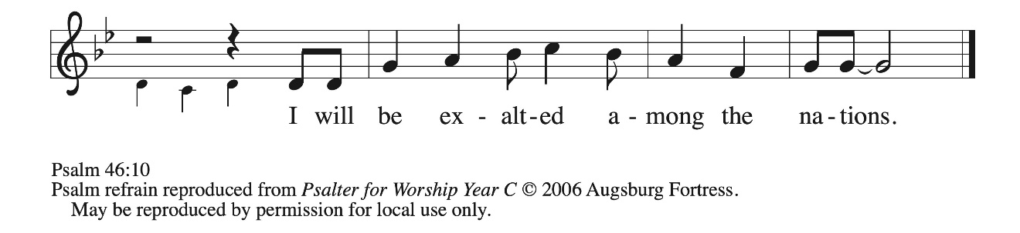



¹God is our ref- | uge and strength,
a very present | help in trouble.

²Therefore we will not fear, though the | earth be moved,
and though the mountains shake in the depths | of the sea;

³though its waters | rage and foam,
and though the mountains tremble | with its tumult.

⁴There is a river whose streams make glad the cit- | y of God,
the holy habitation of | the Most High.

⁵God is in the midst of the city; it shall | not be shaken;
God shall help it at the | break of day.

⁶The nations rage, and the | kingdoms shake;
God speaks, and the earth | melts away. REFRAIN

⁷The LORD of | hosts is with us;
the God of Jacob | is our stronghold.

⁸Come now, regard the works | of the LORD,
what desolations God has brought up- | on the earth;

⁹behold the One Who makes war to cease in | all the world;
Who breaks the bow, and shatters the spear, and burns the | shields with fire.

¹⁰"Be still, then, and know that | I am God;
I will be exalted among the nations; I will be exalted | in the earth."

¹¹The LORD of | hosts is with us;
the God of Jacob | is our stronghold. REFRAIN

SECOND READING Colossians 1: 11-20

An early Christian hymn praises Christ as one who reigns in heaven and on earth.

¹¹May you be made strong with all the strength that comes from His glorious power, and may you be prepared to endure everything with patience, while joyfully ¹²giving thanks to the Father, Who has enabled you to share in the inheritance of the saints in the light. ¹³He has rescued us from the power of darkness and transferred us into the kingdom of His beloved Son, ¹⁴in Whom we have redemption, the forgiveness of sins.
¹⁵He is the image of the invisible God, the firstborn of all creation; ¹⁶for in Him all things in heaven and on earth were created, things visible and invisible, whether thrones or dominions or rulers or powers--all things have been created through Him and for Him. ¹⁷He Himself is before all things, and in Him all things hold together.
¹⁸He is the head of the body, the church; He is the beginning, the firstborn from the dead, so that He might come to have first place in everything. ¹⁹For in Him all the fullness of God was pleased to dwell, ²⁰and through Him God was pleased to reconcile to Himself all things, whether on earth or in heaven, by making peace through the blood of His cross.

The Word of the Lord.

Thanks be to God.

As you are able please rise

THE VERSE

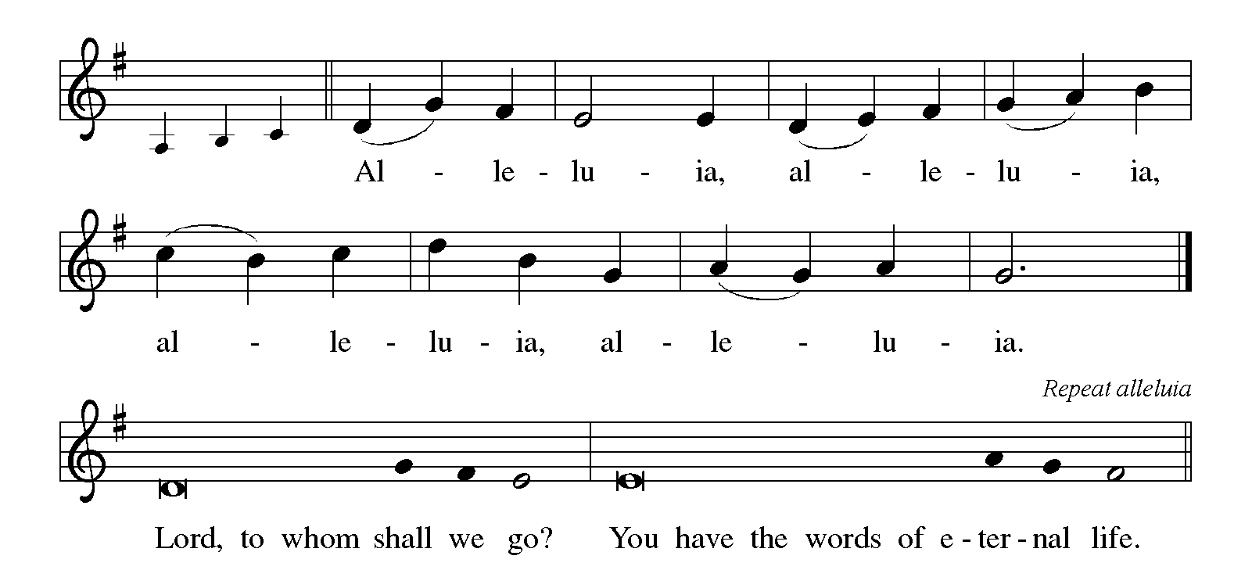
THE HOLY GOSPEL Luke 23: 33-43

On the cross, Jesus is revealed to be a different sort of ruler than many had anticipated. He has the power to welcome others to Paradise, but will not use that power to save himself from death.

P: The Holy Gospel according to St. Luke, the twenty-third chapter.

C: Glory to You, O Lord!

³³When they came to the place that is called The Skull, they crucified Jesus there with the criminals, one on His right and one on His left. [³⁴Then Jesus said, "Father, forgive them; for they do not know what they are doing."] And they cast lots to divide His clothing. ³⁵And the people stood by, watching; but the leaders scoffed at Him, saying, "He saved others; let Him save Himself if He is the Messiah of God, His chosen one!"
³⁶The soldiers also mocked Him, coming up and offering Him sour wine, ³⁷and saying, "If You are the King of the Judeans, save Yourself!" ³⁸There was also an inscription over Him, "This is the King of the Judeans."
³⁹One of the criminals who were hanged there kept deriding Him and saying, "Are You not the Messiah? Save Yourself and us!" ⁴⁰But the other rebuked him, saying, "Do you not fear God, since you are under the same sentence of condemnation? ⁴¹And we indeed have been condemned justly, for we are getting what we deserve for our deeds, but this man has done nothing wrong."
⁴²Then he said, "Jesus, remember me when You come into Your kingdom." ⁴³He replied, "Truly I tell you, today you will be with Me in Paradise."

P: The Gospel of the Lord.

C: Praise to You, O Christ!

The assembly is seated

THE SERMON

Silence for reflection follows the sermon

As you are able please rise

THE HYMN OF THE DAY 954 (see p. 7) You, Lord, Are Both Lamb and Shepherd

Stanza 2—Women; Stanza 3--Men
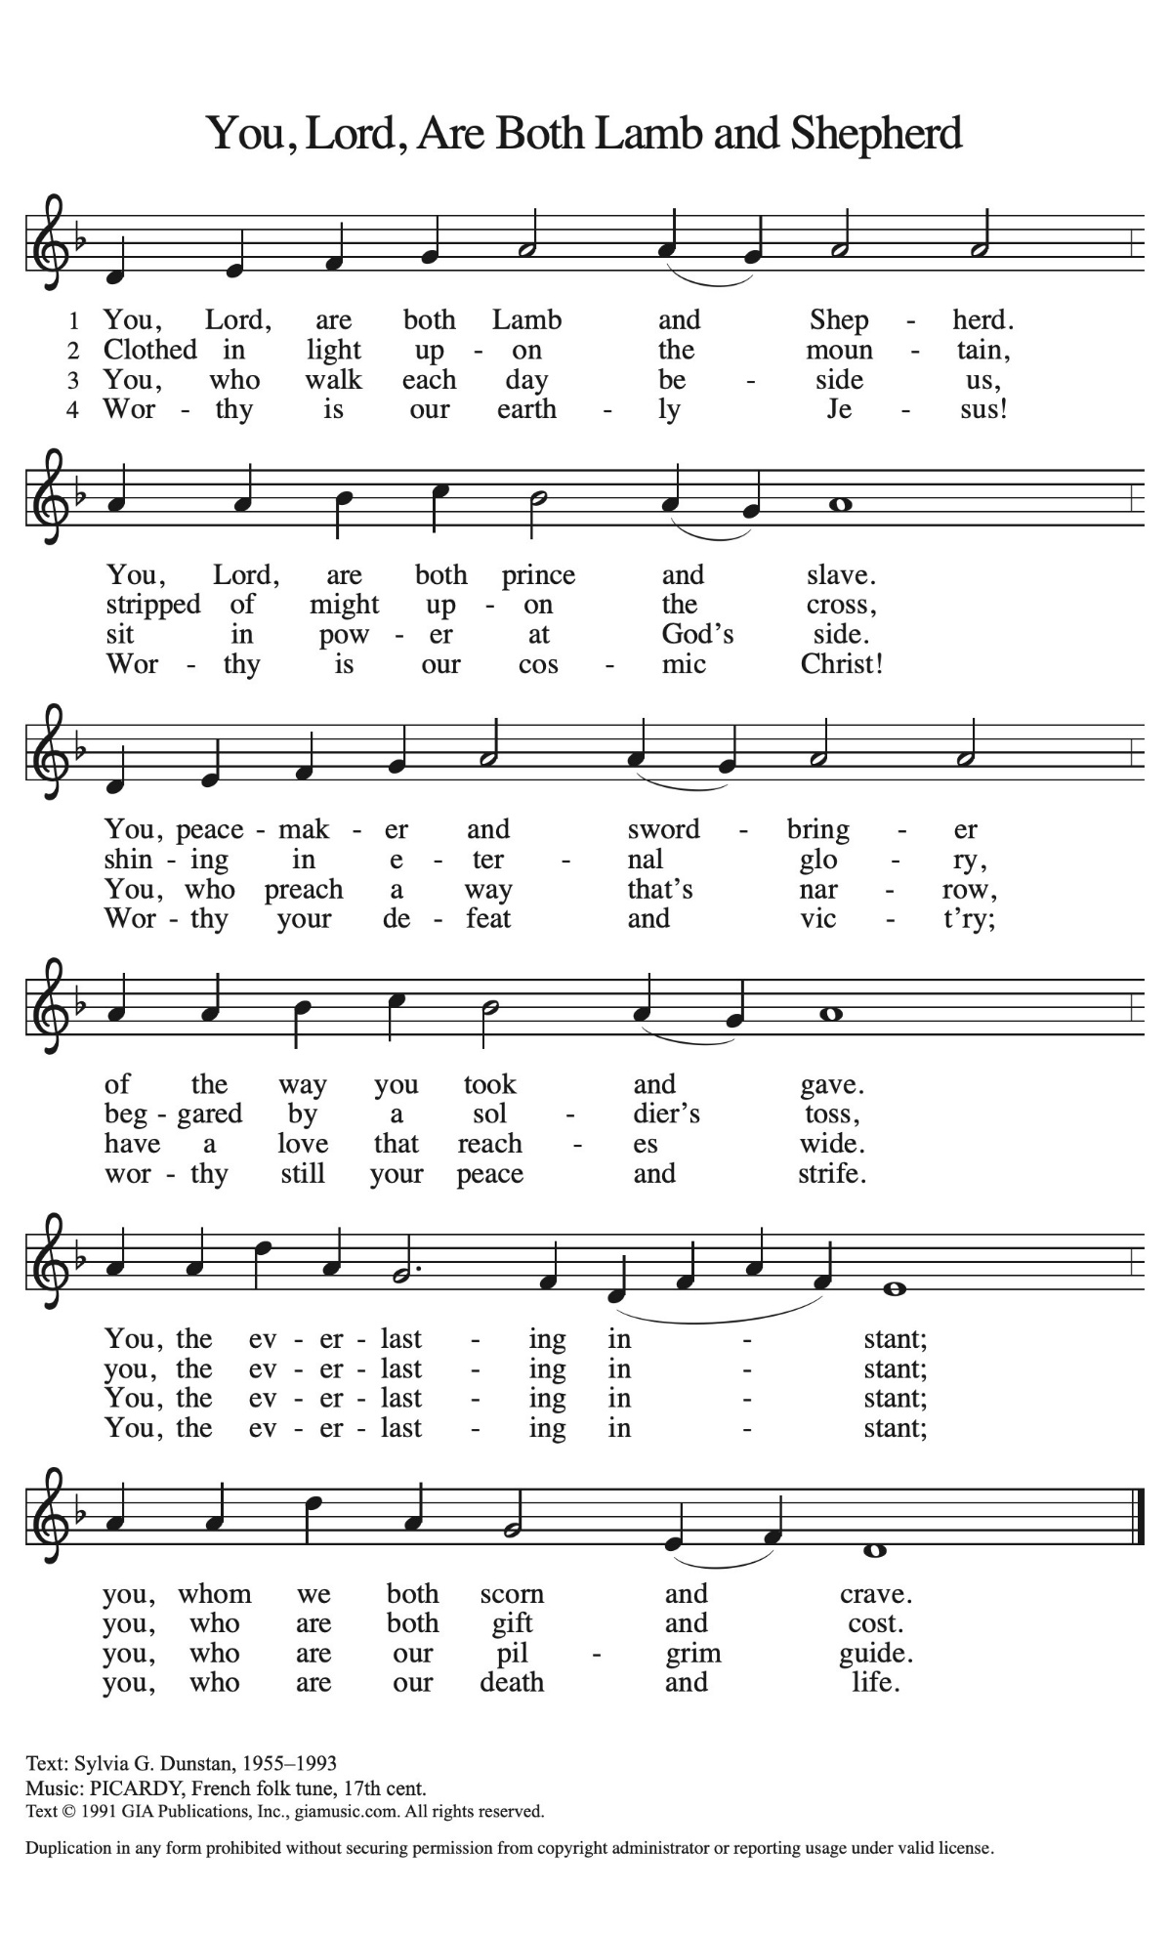
THE NICENE CREED

A: God has made us His people through our Baptism into Christ. Living together in trust
and hope, we confess our faith.

We believe in one God,
the Father, the Almighty,
maker of heaven and earth,
of all that is, seen and unseen.

We believe in one Lord, Jesus Christ,
the only Son of God,
eternally begotten of the Father,
God from God, Light from Light,
true God from true God,
begotten, not made,
of one Being with the Father.
Through Him all things were made.
For us and for our salvation
He came down from heaven;
by the power of the Holy Spirit
He became incarnate from the virgin Mary, and was made
man.
For our sake He was crucified under Pontius Pilate;
He suffered death and was buried.
On the third day He rose again
in accordance with the Scriptures;
He ascended into heaven
and is seated at the right hand of the Father.
He will come again in glory to judge the living and the dead,
and His kingdom will have no end.

We believe in the Holy Spirit, the Lord, the giver of life,
Who proceeds from the Father and the Son.
With the Father and the Son He is worshiped and glorified.
He has spoken through the prophets.
We believe in one holy catholic and apostolic Church.
We acknowledge one Baptism for the forgiveness of sins.
We look for the resurrection of the dead,
and the life of the world to come. Amen

THE PRAYER OF THE CHURCH

A: In the life of Jesus Christ in our midst, we have known God’s judgment and mercy, and
in the glory of Jesus we acclaim the image of God invisible. With the whole Church
we turn to Christ this Day, acknowledging that He alone rules in truth, and we offer our
prayers for all those in need.

A: From the cross Jesus reigns among the powerless and weak. That the Church may
lovingly serve those who are poor, lost, or burdened, let us pray to the Lord:

C: Lord, have mercy.

A: Christ stood powerless before rulers. That the gentle rule of Christ might bring peace
in Gaza, Ukraine, Sudan, Haiti, and other places of violence and turmoil, and justice
and hope to refugees, the hungry, and the oppressed, let us pray to the Lord:

C: Lord, have mercy.

A: Jesus rejected violence, coercion, and self-preservation. That God’s wise and mighty
Spirit might lead us into the ways of patient love and service in the Church, our homes,
and our places of work, let us pray to the Lord:

C: Lord, have mercy.

A: In His Body, Jesus bore our pain and death. That the suffering and the sick, especially:
Laura Dovey; Jan Paholski; Major Payne; Robert Bernth; Carl Wipperman;
Chuck Payne; Martha Schroeder; Joyce Stark; Jackie Gaines; Debbie Martin;
David Weiss; Fred Weiss; Shirley Shikany Long; Shirley Freels; John Bennitt;
Jess Kalvaitis; Allen Sydow; and Lucas Bradshaw might know the strength,
compassion, and healing of Christ the King, let us pray to the Lord:

C: Lord, have mercy.

A: As the firstborn of all creation Jesus gives life to all things. That those celebrating
anniversaries, especially Bob and Karen Kiser may grow in grace this day and every
day and be filled with grace for the days ahead, let us pray to the Lord:

C: Lord, have mercy.

A: From the cross, Jesus called a thief into paradise. That with all the holy saints who
have gone before us, especially Clement, Bishop of Rome, and Miguel Agustín Pro,
martyr, whom we commemorate this Day we too may come to our heavenly home, let
us pray to the Lord:

C: Lord, have mercy.

P: In the cross of Christ, O God, we see Your gracious rule over all creation. Hear the
prayers we offer in hope, and bring us with all the saints to everlasting glory through
Christ our King.

C: Amen.

MEAL

THE PEACE

P: The peace of the Lord be with you always.

C: And also with you.

The assembly is seated

OFFERING

THE VOLUNTARY Brother James’ Air St. Paul Senior Choir
arr. G. Jacob

As you are able please rise

THE OFFERTORY Let the Vineyards
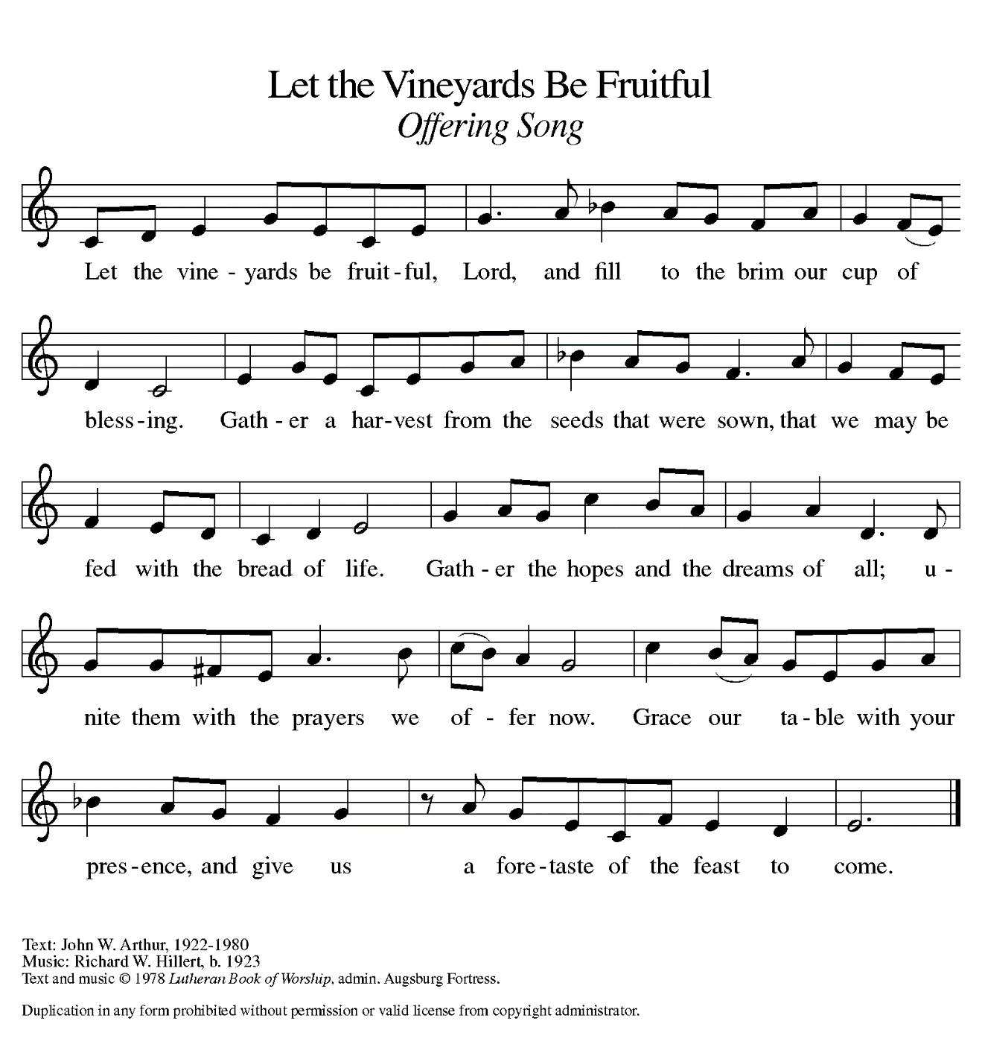

THE OFFERTORY PRAYER

A: Let us pray. Gracious God,

C: In Christ You have reconciled all things to Yourself through the blood of His cross. Receive these offerings as signs of our grateful thanks for Your love. In this Meal, reconcile us to You and one another, that in all things we may bear witness to Your glorious and gentle rule. We ask this in the name of Jesus the Lord. Amen.

THE GREAT THANKSGIVING

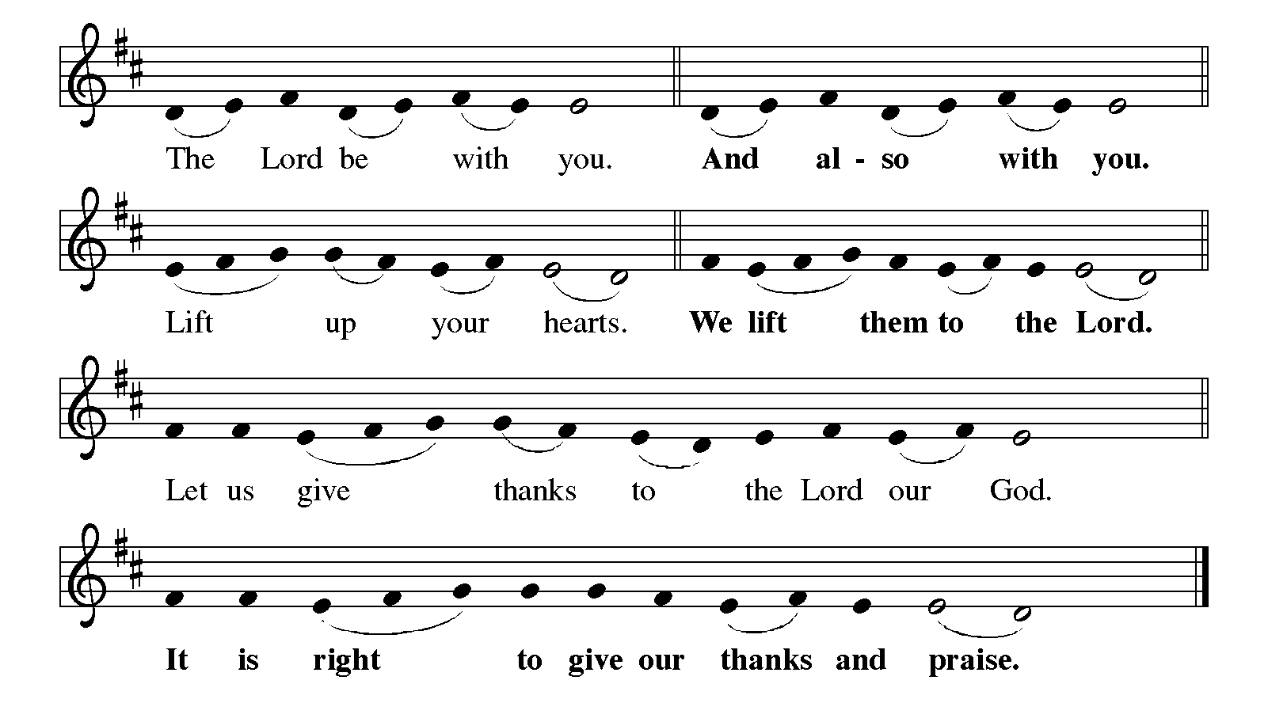

P: It is indeed right, our duty and our joy … join their unending hymn:

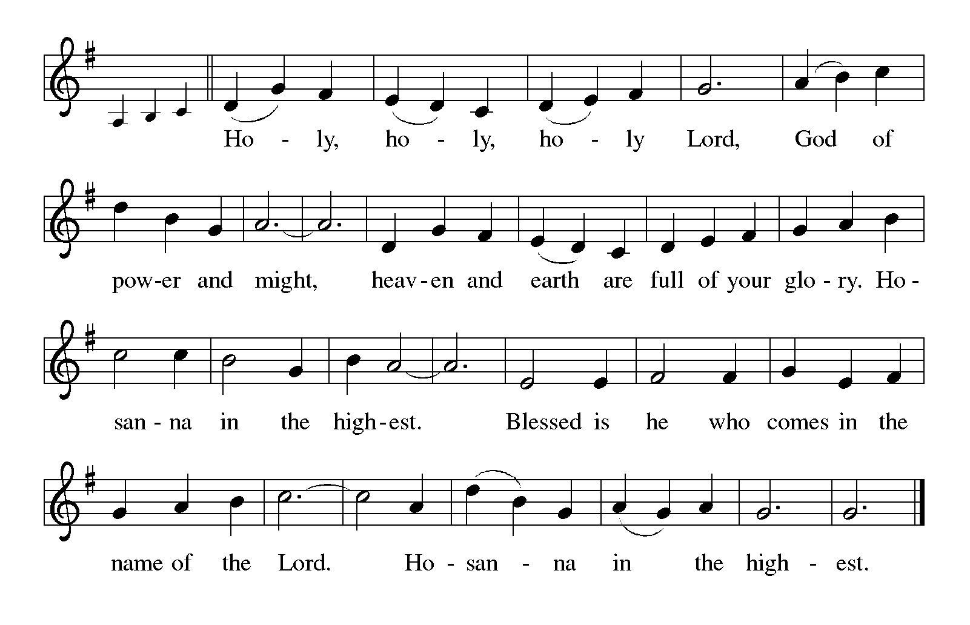P: Holy God, great King above all gods, we bless and praise You.
For in Christ and through Christ and for Christ You created all things.
You are the Shepherd of Israel, attending to them with love,
Rescuing them from slavery and danger, defeat and exile, and promising a
King in whom Your people would live in safety and peace.

In fulfillment of that promise, You sent Your Son, Jesus Christ.
Through Him You made peace, and reconciled all things to Yourself.
In the night ... “Do this for the remembrance of Me.”
As often as we eat ... we proclaim the Lord’s death until He comes.

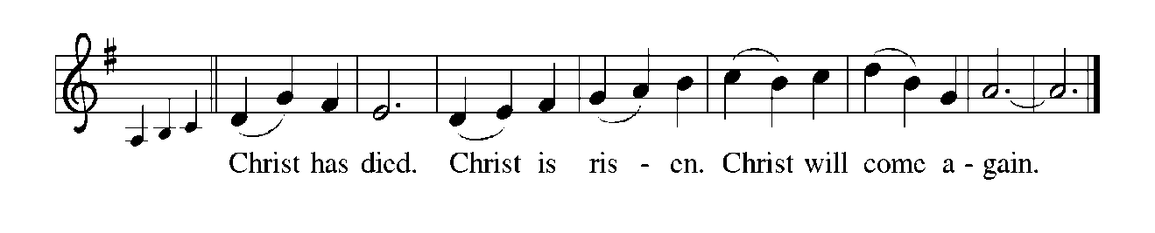P: With this bread and cup, O Father, we remember Your Son’s life and death;
He welcomed outcasts, died with and for us sinners, and made peace through
the blood of His cross.
As the Firstborn from the dead, in Him all things will find their End,
When He returns in glory to share with us Your royal Feast of victory.
Send Your Spirit on us and these Your gifts of bread and wine, that we and
all who share the Lord’s Body and Blood
May show forth His Reign in mercy and kindness until His Kingdom comes
and all things are held together in His everlasting love.
To You, O God: Father, Son, and Holy Spirit, be all honor and glory, in Your holy Church, in heaven and on earth, now and forever.



THE LORD’S PRAYER

P: Lord, remember us in Your Kingdom, and teach us to pray:

C: (Sung) Music is on the front cover of the red hymnal

INVITATION TO THE MEAL

P: This is the Lamb of God, the firstborn of all creation, Who by the blood of His cross has
made peace and reconciled all things to God. Happy are they who are called to His
God’s holy gifts for God’s holy people. Come, for all is now ready.

THE DISTRIBUTION Lamb of God
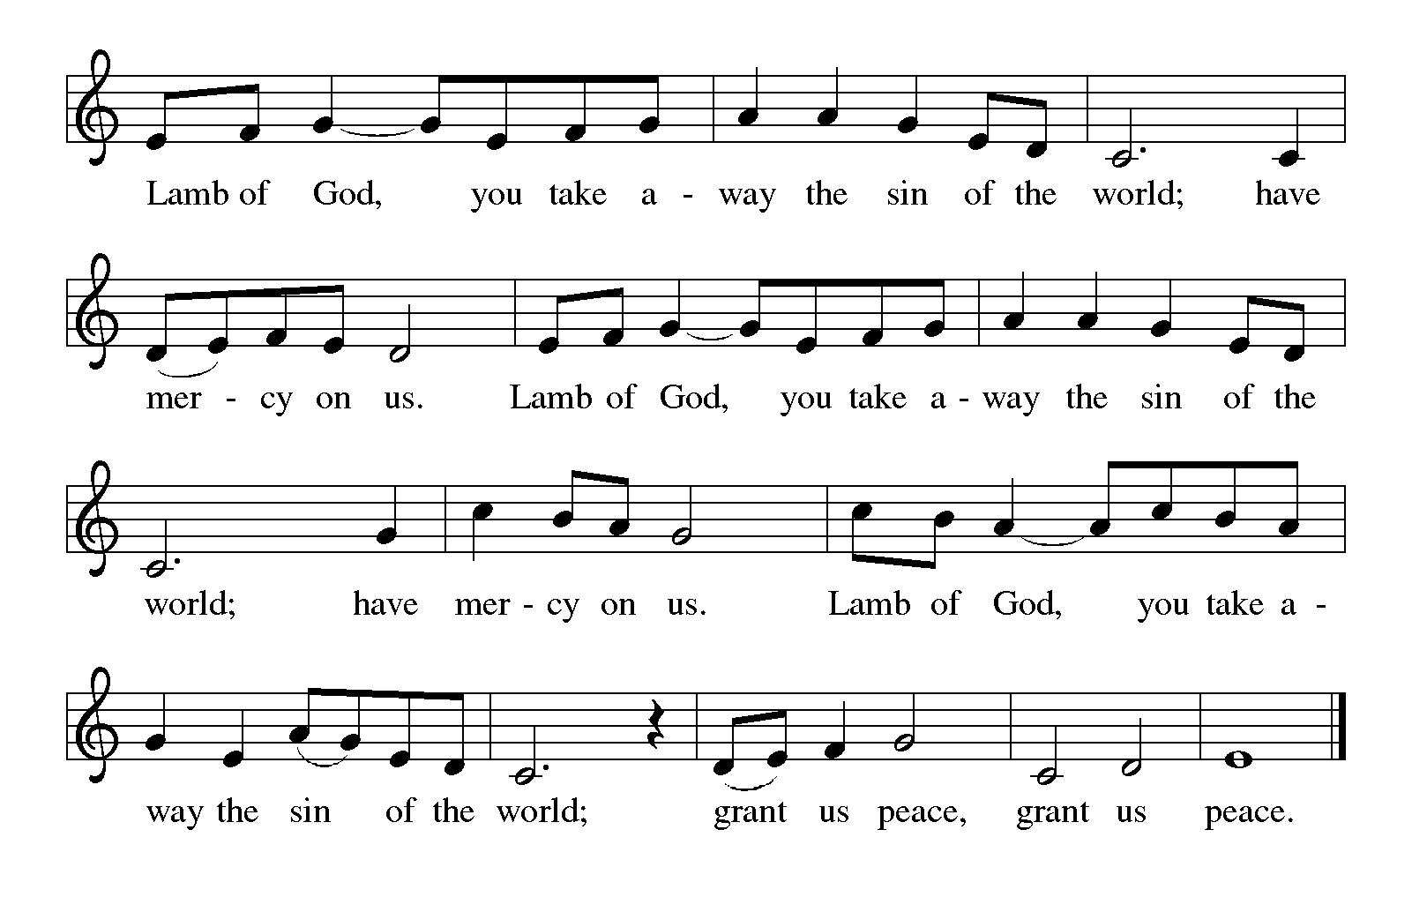
HYMN DURING DISTRIBUTION 434 Jesus Shall Reign
NSB 48 I Am the Bread of Life (Talbot)
ELW 643 All Hail the of Jesus’ Name
ELW 855 Crown Him with Many Crowns

As you are able please rise

THE POST-COMMUNION BLESSING

P: The Body and Blood of our Lord Jesus Christ strengthen you and keep you in His grace.

C: Amen.

THE POST-COMMUNION PRAYER

A: Let us pray. Almighty God, You have made us a royal priesthood in the Kingdom of
Your Son, our Savior Jesus Christ. Make known His victory through us, we pray, that
all the world may see His light. Grant this through Christ our Lord.

C: Amen.

SENDING

THE BENEDICTION

P: Almighty God: Father, Son, and Holy Spirit bless you now and forever.

C: Amen.

THE SENDING SONG NSB 60 King of Kings

THE DISMISSAL

A: Be strong with all the strength that comes from God’s glorious power to go in peace
and serve the Lord.

C: Thanks be to God!

POSTLUDE

To God Alone Be Glory

The Meditation is from Pulpit Resource. William Willimon, ed. Vol. 26, No. 4. (Inver
Heights, MN: Logos Productions, Inc. 1998) 33.

The Prayers and Dismissal are used and adapted by permission of Sundays and Seasons.
Copyright 2000 Augsburg Fortress.
ANNOUNCEMENTS

Please remember to mail your offering to the Church Office at 818 Franklin Street, Michigan City, IN 46360. Another alternative is to give on-line through Tithe.ly. Please see your closure letter for information on how to set up a Tithe.ly account.

St. Paul Members are reminded to have a loved one contact the office if you are hospitalized. Many times, the Pastor doesn’t know someone is in the hospital. If you call and leave a message, please tell us at which hospital the patient is located.

ANNIVERSARIES: Bob & Karen Kiser (11/23)

PRAYER CONCERNS: Robert Bernth; Barry Anderson; John Bennitt; Sarah McNabb; Debbie Martin; Mark Tannehill; Kathy Stein; Jan Paholski; Laura Dovey; Grace Romine; Bill Hazelgrove; Al Levenhagen; Carl Wipperman; Major Payne; Carol Hazelgrove and Allen Sydow.

OFFICE HOURS: Libby will be in the office on Mondays, Wednesdays, and Fridays; volunteers will cover Tuesdays and Thursdays.

Monday & Wednesday 8:00 a.m. – 5 p.m.
Tuesday & Thursday 9:00 a.m. – 12:00 p.m.
Friday 8:00 a.m. – 12:00 p.m.

If you are listening to the worship broadcast on the radio and would like to watch the Sunday morning service live stream follow these steps:

(1) If you have You Tube available on your TV, search for
St. Paul Lutheran Church Michigan City, IN.

(2) The direct link on the computer is https://
www.youtube.com/channel/UC5AIPNaKr3QN50984jGOa1g.

(3) This link is also on the main page of the church’s website in
the church section and will continue to be posted weekly on the St.
Paul Facebook page.

And it will always be available on the radio broadcast Sunday mornings at 11:00 a.m.
on WEFM (95.9), and on the local cable access station #99 for the previous week’s
service on Sundays at 4:00 p.m. and the current service on Wednesdays at 7:00 p.m.
and Fridays at 8:30 p.m.

PASTOR RESHAN will be out of the office this week, but if an emergency arises
you may reach him at (630) 450-1894.

To send e-mail to the church office, please use the following addresses:
Pastor Mark Reshan: seniorpastor@stpaulmichigancity.com
Church Office Secretary (Libby Pollock): churchsecretary@stpaulmichigancity.com
Church Treasurer (Karen Fleming): finance@stpaulmichigancity.com

2025 Church Council:

Mark Reshan - Pastor

Janet Bakken – President

Donna Knoll – Vice President

Judy Hunt – Secretary

Karen Fleming – Treasurer

Members: Paul Brooks, Diane Egilske, Sue Koziel, Judy Mutchler, Jim Schraidt, Trish Sprague

Worship Attendance:

Saturday , November 15, 2025 @ 4:00 p.m. 28

Sunday, November 16, 2025 @ 9:00 a.m. 70

TOTAL 98

Copies of the minutes from the October 23 2025 Church Council meeting are on the back table in the upper Narthex. It was approved by the council via email.

The Good News Newsletter: If you have an article or anything you want included in The Good News please send it to the following e-mail address: splcgoodnews@gmail.com. Pastor Pamela Thiede will be using this e-mail address to assemble The Good News each month. The deadline for getting information to Pastor Pamela will be the 20th of each month.

Sunday’s lessons are Isaiah 2: 1-5; Psalm 122; Romans 13: 11-14; and Matthew 24: 36-44 for those of you who like to study them in advance.

NOVEMBER MISSION OF THE MONTH

The Mission of the Month for November: Nest Community Shelter, located at the old Sacred Heart Church, is a nonprofit organization delivering temporary emergency shelter for the homeless men and women (including women with children) in our community. Nest provides not just shelter but food and other resources. Nest is always in need of the following items:

-Bedding - blankets, pillows, pillow cases

-Food items – sugar, breakfast cereal, coffee, coffee filters, creamer, non-perishable goods

-Dining – 8 oz. foam cups, 12 oz. foam bowls, 6” & 9” plates, plastic flatware, paper towels, paper napkins, plastic wrap, aluminum foil, gallon Ziploc bags, large serving gloves

-Kitchen – 55 gallon trash bags, dish soap

-Hygiene items – liquid hand soap, hand sanitizer, all purpose cleaner, feminine hygiene products, toilet paper

Donations of goods can be placed in the bin in the Narthex. Monetary donations can be marked for Nest and placed in the offering plate. Noisy coin offering will also go toward the mission of the month. Thank you for your help in providing for those in need in our community!

DID YOU HAVE A BIRTHDAY DURING THE MONTHS OF SEPTEMBER, OCTOBER, OR NOVEMBER?

If you did, during the Coffee Hour after the Sunday service next Sunday, November 30th, we will be honoring your Special Day. Not with cake and coffee but with Birthday Pie. You will want to come and enjoy a piece of pie with us.

December Mission of the Month – St. Paul Angel Tree
It’s beginning to look a lot like Christmas! We are starting our December mission a little early to ensure our gifts make it to their recipients by Christmas Day. A Mama’s Heart Ministry has provided us with names and wish lists of four children in our community who need assistance this Christmas. Please take a tag (or two) and shop for the item listed on the tag. Gifts can be returned wrapped or unwrapped, your preference. Please attach the angel tree tag to the gift. Toy tags have suggestions based on the child’s interests, but any age appropriate toy will do! Please return all gifts underneath the angel tree by Sunday, December 7th, to ensure everything can be delivered to the families by Christmas. Thank you for your generosity and Christmas spirit!

ACTIVITIES, EVENTS & MEETINGS
November 2025

Saturday, November 22, 2025 @ 4:00 p.m. CHRIST THE KING Worship
Service/Sanctuary

Sunday, November 23, 2025 @ 9:00 a.m. CHRIST THE KING Worship
Service/Sanctuary with coffee after/St. Paul Room

Wednesday, November 26, 2025 @10:00 a.m. God’s Purls/St. Paul Room

Thursday, November 27, 2025 THANKSGIVING DAY!

Christmas Poinsettias

Time to place your order! Yes, it’s time to start thinking about purchasing a Christmas Poinsettia from St. Paul Church. Each plant will be a 7.5 inch pot with 4-11 blooms. You will have a choice in color between red, white, or ‘Jingle Bell’ which is a combination of red and white. If you do not specify a color, red will be chosen. Each plant will cost $15.00 and can be put “in memory of. . .” or “in honor of . . .” a loved one. Please place your order through the Church Office by calling (219) 874-7293; or place your information on an envelope with a check made out to the church, or cash, and place in offering plate.
All checks should be made out to St. Paul Church. All plants will be available to take home after the Christmas Eve Service. And all orders must be placed by Thursday, December 11th. The final count will be turned in that day!

HELP NEEDED FOR OUR LOCAL SALVATION ARMY

Due to the pause taken by all the programs sponsored by SNAP, our local Salvation Army has been swamped with people needing help. All of the items placed in the grocery store cart located on the upper southwest corner of the outer Narthex is taken to our Michigan City Salvation Army location. The cart has a large hippo asking you to help “fill ‘er up!” Whatever you can do to help is greatly appreciated.

