THE EIGHTH SUNDAY AFTER PENTECOST
July 31, 2022

“When I have these new barns filled,” you say, “then I will distribute something to the poor.” You have given yourself a long time to live! And promises of that sort are not very helpful, but are an indication of a perverse heart, rather than of kindness. For you promise, not that you will afterwards fulfill it, but to relieve yourself of a present embarrassment.
What keeps you from giving now? There are no hungry perhaps?! The hungry are dying before your face. The naked are stiff with cold. And you, you put off your alms until another day? You yourself are indeed poor, poor in love for your neighbor, poor in humanity, poor in faith in God, poor in the hope of eternity. “Who I am injuring,” you will say, “when I keep what is mine for myself?”
And what, tell me, is yours? Did you not come forth naked from your mother’s womb, and will you not return naked to the earth? How then are these things yours?

Basil
Sunday Sermons of the Great Fathers

In the Name of Jesus

GATHERING

Introduction
Today’s texts offer instruction and encouragement for all who are occasionally overwhelmed by the “unhappy business” of life. Jesus urges us to take care and be on guard against all kinds of greed. We who have died with Christ in holy baptism have also been raised with him and are encouraged to elevate our thinking, seeking the “things that are above.” To that end we seek the sustenance of the Lord’s supper and the encouragement of God’s word.

Mary, Martha, and Lazarus of Bethany

Friends of Jesus, Mary and Martha are remembered for the hospitality of their home that they offered him—Martha focused on serving their guest, and Mary on listening to him. Their brother Lazarus was raised from the dead as a sign of the greater resurrection to come.

Olaf, King of Norway, martyr, died 1030

Considered the patron saint of Norway, Olaf went from a life of piracy to becoming Christian and declaring himself king of Norway. He revised the laws and tried to administer them fairly. Driven from Norway in a rebellion, he was killed in battle trying to regain his kingdom.

PRELUDE

ANNOUNCEMENTS

As you are able please rise

GATHERING HYMN 589 All Depends on Our Possessing

THE GREETING AND PRAYER OF THE DAY.

P: The grace of our Lord Jesus Christ, the love of God, and the communion of the Holy Spirit be
with you all.

C: And also with you.

P: Let us pray. Benevolent God, You are the source, the guide, and the goal of our lives. Teach
us to love what is worth loving, to reject what is offensive to You, and to treasure what is
precious in Your sight, through Jesus Christ, our Savior and Lord.

C: Amen.

The assembly is seated
WORD

FIRST READING Ecclesiastes 1:2, 12-14; 2:18-23
The teacher of wisdom who wrote Ecclesiastes sees that working for mere accumulation of wealth turns life into an empty game, a “vanity of vanities.” Nevertheless, he asserts in the next verse, it is good to find enjoyment in one’s work because such enjoyment is a gift from God.

²Vanity of vanities, says the Teacher,
vanity of vanities! All is vanity.
¹²I, the Teacher, when king over Israel in Jerusalem, ¹³applied my mind to seek and to search out by wisdom all that is done under heaven; it is an unhappy business that God has given to human beings to be busy with. ¹⁴I saw all the deeds that are done under the sun; and see, all is vanity and a chasing after wind.
^{2:18}I hated all my toil in which I had toiled under the sun, seeing that I must leave it to those who come after me ¹⁹—and who knows whether they will be wise or foolish? Yet they will be master of all for which I toiled and used my wisdom under the sun. This also is vanity.
²⁰So I turned and gave my heart up to despair concerning all the toil of my labors under the sun, ²¹because sometimes one who has toiled with wisdom and knowledge and skill must leave all to be enjoyed by another who did not toil for it. This also is vanity and a great evil. ²²What do mortals get from all the toil and strain with which they toil under the sun? ²³For all their days are full of pain, and their work is a vexation; even at night their minds do not rest. This also is vanity.

The Word of the Lord.

Thanks be to God.

THE PSALM: Psalm 49:1-12 Read responsively

¹Hear this, all you peoples;
give ear, all you who dwell in the world,
²you of high degree and low,
rich and poor together.

³My mouth shall speak of wisdom,
and my heart shall meditate on understanding.
⁴I will incline my ear to a proverb
and set forth my riddle upon the harp.
⁵Why should I be afraid in evil days,
when the wickedness of those at my heels surrounds me,
⁶the wickedness of those who put their trust in their own prowess,
and boast of their great riches?
⁷One can never redeem another,
or give to God the ransom for another’s life;
⁸for the ransom of a life is so great
that there would never be enough to pay it,
⁹in order to live forever and ever
and never see the grave.
¹⁰For we see that the wise die also; like the dull and stupid they perish
and leave their wealth to those who come after them.
¹¹Their graves shall be their homes forever, their dwelling places from generation to generation,
though they had named lands after themselves.
¹²Even though honored, they cannot live forever;
they are like the beasts that perish.

SECOND READING Colossians 3:1-11
Life in Christ includes a radical reorientation of our values. Just as the newly baptized shed their old clothes in order to put on new garments, so Christians are called to let go of greed and take hold of a life shaped by God’s love in Christ.

¹So if you have been raised with Christ, seek the things that are above, where Christ is, seated at the right hand of God. ²Set your minds on things that are above, not on things that are on earth, ³for you have died, and your life is hidden with Christ in God. ⁴When Christ Who is your life is revealed, then you also will be revealed with Him in glory.
⁵Put to death, therefore, whatever in you is earthly: fornication, impurity, passion, evil desire, and greed (which is idolatry). ⁶On account of these the wrath of God is coming on those who are disobedient. ⁷These are the ways you also once followed, when you were living that life.
⁸But now you must get rid of all such things—anger, wrath, malice, slander, and abusive language from your mouth. ⁹Do not lie to one another, seeing that you have stripped off the old self with its practices ¹⁰and have clothed yourselves with the new self, which is being renewed in knowledge according to the image of its creator. ¹¹In that renewal there is no longer Greek and Jew, circumcised and uncircumcised, barbarian, Scythian, slave and free; but Christ is all and in all!

The Word of the Lord.

Thanks be to God.

As you are able please rise

THE VERSE Sung twice

THE HOLY GOSPEL Luke 12:13-21
In God’s reign, the “rich will be sent away empty.” Jesus uses a parable to warn against identifying the worth of one’s life with the value of one’s possessions rather than one’s relationship with God.

P: The Holy Gospel according to St. Luke, the twelfth chapter.

C: Glory to You, O Lord!

¹³Someone in the crowd said to [Jesus,] “Teacher, tell my brother to divide the family inheritance with me.” ¹⁴But He said to him, “Friend, who set Me to be a judge or arbitrator over you?” ¹⁵And He said to them, “Take care! Be on your guard against all kinds of greed; for one’s life does not consist in the abundance of possessions.”
¹⁶Then He told them a parable: “The land of a rich man produced abundantly. ¹⁷And he thought to himself, ‘What should I do, for I have no place to store my crops?’ ¹⁸Then he said, ‘I will do this: I will pull down my barns and build larger ones, and there I will store all my grain and my goods. ¹⁹And I will say to my soul, Soul, you have ample goods laid up for many years; relax, eat, drink, be merry.’
²⁰But God said to him, ‘You fool! This very night your life is being demanded of you. And the things you have prepared, whose will they be?’ ²¹So it is with those who store up treasures for themselves but are not rich toward God.”

P: The Gospel of the Lord.

C: Praise to You, O Christ!

The assembly is seated

THE SERMON

Silence for reflection follows the sermon

As you are able please rise

THE HYMN OF THE DAY 678 God, Whose Giving Knows No Ending

THE APOSTLES’ CREED

A: God has made us His people through our Baptism into Christ. Living together in trust and
hope, we confess our faith.

C: I believe in God, the Father almighty,
creator of heaven and earth.

I believe in Jesus Christ, His only Son, our Lord.
He was conceived by the power of the Holy Spirit
and born of the virgin Mary.
He suffered under Pontius Pilate,
was crucified, died, and was buried.
He descended into hell.
On the third day He rose again.
He ascended into heaven,
and is seated at the right hand of the Father.
He will come again to judge the living and the dead.

I believe in the Holy Spirit,
the holy catholic Church,
the communion of saints,
the forgiveness of sins,
the resurrection of the body,
and the life everlasting. Amen.

THE PRAYER OF THE CHURCH

A: Treasuring God’s promise to hear us when we call, we pray for the Church, the world, and all
those in need.

A: That the Church, forsaking the vanity of power, may use its earthly resources generously for
the poor: Lord, in Your mercy,

C: Hear our prayer.

A: That fields and crops may blossom and flourish to feed Your world, and that farmers, ranchers,
and laborers might be strengthened in summer’s heat: Lord, in Your mercy,

C: Hear our prayer.

A: That nations and peoples in turmoil, especially in Ukraine, Myanmar, Sri Lanka, Mali, and
Tunisia might be blessed with relief, health and healing, justice and peace: Lord, in Your
mercy,

C: Hear our prayer.

A: That Leah Ann Brooks, born to Lora and Paul this week may be kept in health and safety, and
with the support, love and care of this community of faith may grow to the full life in Christ
You intend for her: Lord, in Your mercy,

C: Hear our prayer.

A: That those suffering from anxiety, distress, or depression; those in chronic pain; the
overworked, the unemployed, and the sick, especially . . . might be granted the fullness of
God’s strength and wholeness: Lord, in Your mercy,

C: Hear our prayer.

A: That those celebrating birthdays, especially Sandra Robbins; and anniversaries, especially
John and Amy VanGemeren; and Virgil and Pat Miller might be filled with grace this day
and every day and grow in grace in the days ahead: Lord, in Your mercy,

C: Hear our prayer.

A: That with the faithful who have died and whose lives are now hidden with Christ in God,
especially Mary, Martha, and Lazarus of Bethany and Olaf, King of Norway, martyr
whom we commemorate this Day we too may be welcomed by God into the glories of our
heavenly home: Lord, in Your mercy,

C: Hear our prayer.

P: All these things and more we ask, Father, through Your Son, Jesus Christ, in the power of Your
Spirit.

C: Amen.
MEAL
THE PEACE

P: The peace of the Lord be with you always.

C: And also with you.

The assembly is seated

THE OFFERING

THE VOLUNTARY Rock of Ages John A. Behnke

As you are able please rise

THE OFFERTORY 465 As the Grains of Wheat

THE OFFERTORY PRAYER

A: Let us pray. God our Sustainer,

C: Accept all we offer You this day, and feed us continually with that Bread which satisfies
all hunger, Your Son, Jesus Christ our Lord. Amen.

THE GREAT THANKSGIVING

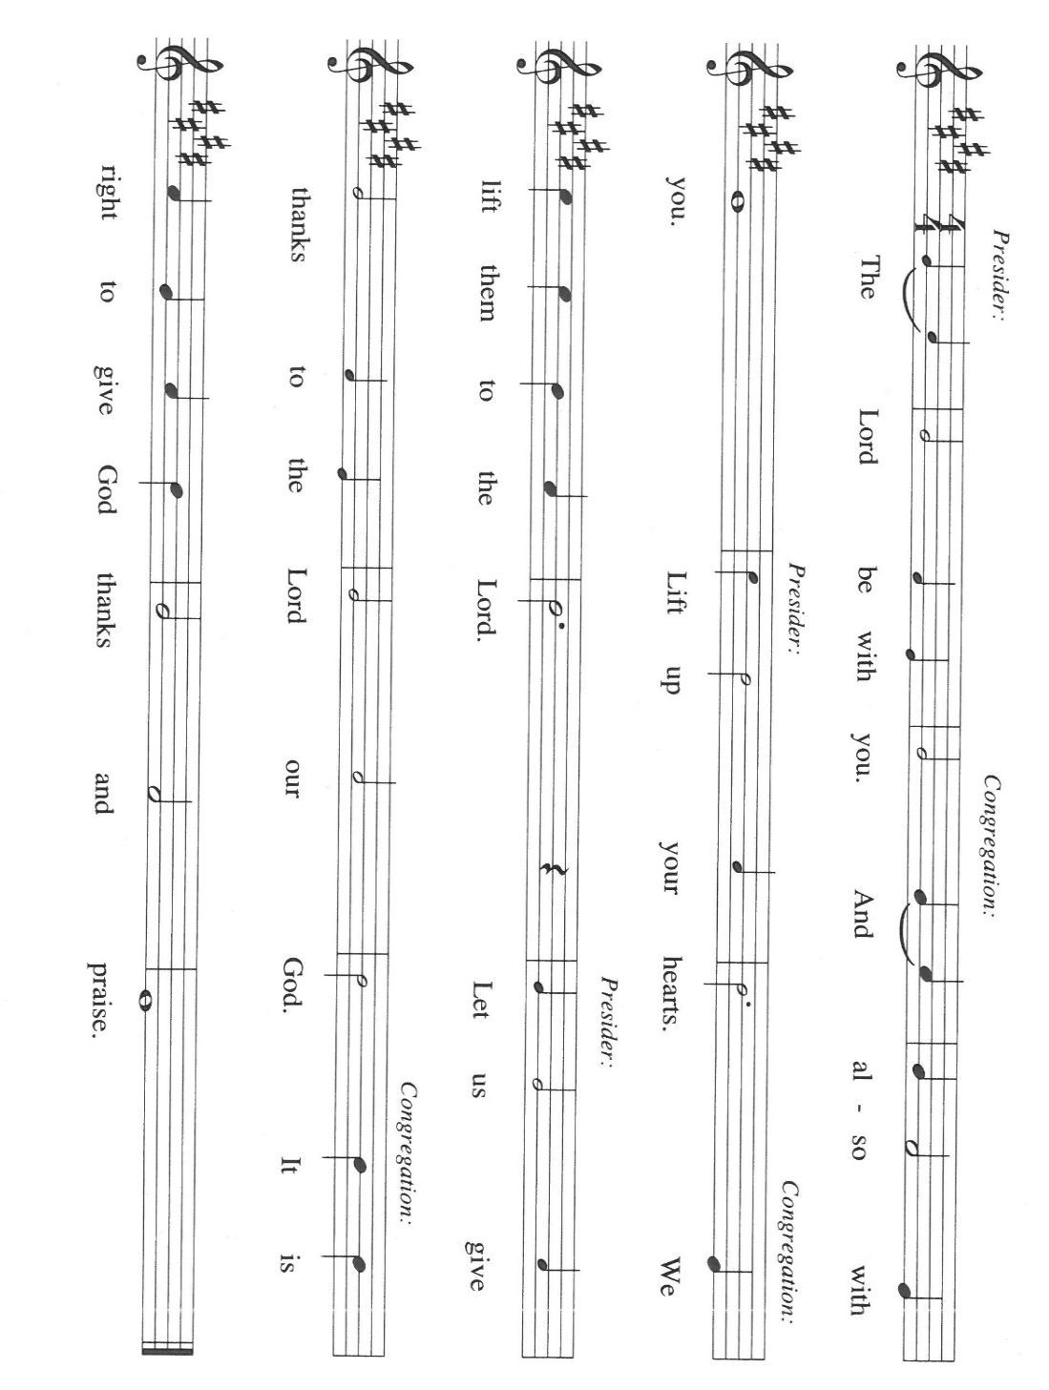

P: It is our duty and delight … join their unending hymn:

P: Holy God, our Maker, Redeemer, and Healer,
In the harmonious world of Your creation the plants and animals, the seas and stars
were whole and well in Your praise.
When sin had scarred the world, You sent Your Son to heal our ills and to form us
again into one.
In the night ... “Do this for the remembrance of Me.”
As often as we eat ... we proclaim the Lord’s death until He comes.

P: Remembering, therefore, His acts of healing, His Body given up, and His victory
over death,
We await that Day when all the peoples of the earth will come to the river to enjoy
the Tree of Life.
Send Your Spirit upon us and this Meal: as grains scattered on the hillside become
one bread,
So let Your Church be gathered from the ends of the earth, that all may be fed with
the Bread of Life, Your Son.
Through Him all honor and glory is Yours, Almighty Father, with the Holy Spirit,
in Your holy Church, both now and forever.

C: Amen!

THE LORD’S PRAYER

P: As disciples who seek to follow Jesus to the Kingdom, with persevering faith let us pray:

C: (Sung) Music is on the front cover of the red hymnal

INVITATION TO THE MEAL

P: This is the Lamb of God Who takes away the sin of the world Blessed are those who are called
to the Supper of the Lamb. God’s holy gifts for God’s holy people. Come, for all is now ready.

The assembly is seated

THE DISTRIBUTION “Lamb of God”

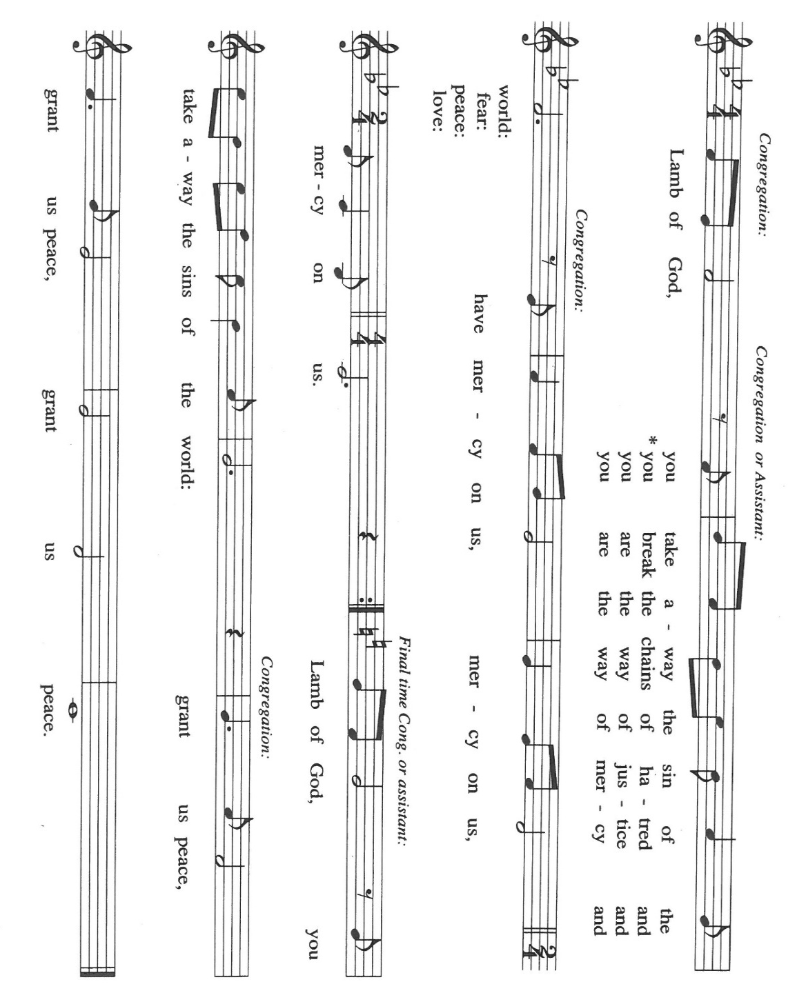

HYMNS DURING DISTRIBUTION 686 We Give Thee But Thine Own
793 Be Thou My Vision

As you are able please rise

THE POST-COMMUNION BLESSING

P: The Body and Blood of our Lord Jesus Christ strengthen you and keep you in His grace.

C: Amen.

THE POST-COMMUNION PRAYER

A: Let us pray. God of grace, we have shared in the mystery of the Body and Blood of Christ.
May we who have tasted of the Bread of Life live with You forever. Grant this through Christ
our Lord.

C: Amen.

SENDING

THE BENEDICTION

P: Almighty God: Father, Son, and Holy Spirit bless you now and forever.

C: Amen.

SENDING HYMN 705 God of Grace and God of Glory

THE DISMISSAL

A: Go in peace to bear Christ’s love to all the world.

C: Thanks be to God!

POSTLUDE God of Grace and God of Glory Paul Manz

To God Alone Be Glory

The Meditation is from Sundays and Seasons Online. Copyright 2019 Augsburg Fortress.

The Prayers are adapted from Sundays and Seasons Online. Copyright 2019 Augsburg Fortress;
and The Prayers are adapted from Prayers for Sundays and Seasons. Year C. Peter
Scagnelli. (Chicago: Liturgy Training Publications, 1992, 112-113.

The Offertory and Post-Communion Prayers are from The Book of Alternative Services of the
Anglican Church of Canada. (Toronto: Anglican Book Centre, 1985). 372-373.

The Eucharistic Prayer is adapted from With One Voice: Leader’s Edition. (Minneapolis:
Augsburg Fortress, 1995) 75.

The musical setting of the liturgy, “Now the Feast and Celebration” by Marty Haugen, is used by
permission of GIA Publishers, Inc. OneLicense.net License #A-702836.

ANNOUNCEMENTS

Please remember to mail your offering to the Church Office at 818 Franklin Street, Michigan City, IN 46360. Another alternative is to give on-line through Tithe.ly. Please see your closure letter for information on how to set up a Tithe.ly account.

St. Paul Members are reminded to have a loved one contact the office if you are hospitalized. Many times, the Pastor doesn’t know someone is in the hospital. If you call and leave a message, please tell us which hospital the patient is at.

Next Sunday’s lessons are Genesis 15: 1-6; Psalm 33: 12-22; Hebrews 11: 1-3, 8-16; Luke 12: 32-40 for those of you who like to study them in advance.

Birthdays: Sandra Robbins (8/4)

Anniversaries: Amy & John VanGemeren (8/3); Virgil & Patricia (8/5)

PRAYER CONCERNS: Audrey Beyer, Ryan Krueger, Donna Bostater, Maxine Powell, Jim Tomscheck, Eloise Ponder, Mark & Jary Tannehill, Leonard Cross, George Ottersen, Annette Scroggin, Helen Hill-Weaver.

If you requested someone’s name to be on the prayer list and are aware that they need continued imminent prayer then contact the church office and let us know. Otherwise we will gradually transfer names to the long-term list.

OFFICE HOURS: Libby will be in the office on Mondays, Wednesdays, and Fridays; volunteers will cover Tuesdays and Thursdays.

Monday & Wednesday 8:00 a.m. – 5 p.m.
Tuesday & Thursday 9:00 a.m. – 12:00 p.m.
Friday 8:00 a.m. – 12:00 p.m.

If you are listening to the worship broadcast on the radio and would like to watch the Sunday morning service live stream follow these steps:

(1) If you have You.Tube available on your TV, search for
St. Paul Lutheran Church Michigan City, IN.

(2) The direct link on the computer is
https://www.youtube.com/channel/UC5AIPNaKr3QN50984jGOa1g.

(3) This link is also on the main page of the church’s website in the church section and will continue to be posted weekly on the St. Paul Facebook page.

And it will always be available on the radio broadcast Sunday mornings at 11:00 a.m. on WEFM (95.9), and on the local cable access station #99 for the previous week’s service on Sundays at 4:00 p.m. and the current service on Wednesdays at 7:00 p.m. and Fridays at 8:30 p.m.

To send e-mail to the church office, please use the following addresses:

Pastor Mark Reshan: seniorpastor@stpaulmichigancity.com

Church Office Secretary (Libby Pollock): churchsecretary@stpaulmichigancity.com

Church Treasurer (Karen Fleming): finance@stpaulmichigancity.com

The Good News Newsletter: If you have an article or anything you want included in The Good News please send it to the following e-mail address: splcgoodnews@gmail.com. Pastor Pamela Thiede will be using this e-mail address to assemble The Good News each month. The deadline for getting information to Pastor Pamela will be the 20th of each month.

PLEASE REMEMBER: the next time you are coming to the church whether it be for one of the worship services or for any other meeting or activity please remember to bring in non-perishable food items to donate to the Salvation Army Food Pantry. There is a
serious need in this community to help especially those whom have little to no access to food and/or shelter. Please open your hearts and continue to be generous in your giving!

WORSHIP ATTENDANCE for July 23 and 24, 2022
4:00 p.m. 20
9:00 a.m. 44
Total = 64

AUGUST 2022 ACTIVITIES, EVENTS & MEETINGS

Saturday, July 30, 2022 at 4:00 p.m. Worship Service

Sunday, July 31, 2022 at 9:00 a.m. Worship Service

Monday, August 1, 2022 at 3:00 p.m. Property Evaluation Team/Luther House

Tuesday, August 2, 2022 at 10:00 a.m. Altar Guild/Green Room/Nursery

Wednesday, August 3, 2022 at 10:00 a.m. God’s Purls/St.Paul Room

Saturday, August 6, 2022 at 4:00 p.m. Worship Service

Sunday, August 7, 2022 at 9:00 a.m. Worship Service

Monday, August 8, 2022 at 12:30 p.m. Harmony Circle/Green Room/Nursery

at 2:00 p.m. School Board Meeting/Luther House

Tuesday, August 9, 2022 at 9:30 a.m. Charity Circle/Green Room/Nursery

Wednesday, August 10, 2022 at 10:00a.m. God’s Pearls

at 6:00 p.m. Worship & Music Committee

Saturday, August 13, 2022 at 4:00 p.m. Worship service

Sunday, August 14, 2022 at 9:00 a.m. Worship Service

Wednesday, August 17, 2022 at 10:00 a.m. God’s Purls/St. Paul Room

Saturday, Augst 20, 2022 at 4:00 p.m. Worship Service

Sunday, August 21, 2022 at 9:00 a.m. Worship Service

Monday, August 22, 2022 at 4:00 p.m. Finance Committee Meeting/Luther House

at 5:30 p.m. Executive Board Meeting/Luther House

Tuesday, August 23, 2022 all day and evening GIVE-BACK AT HOLLY’S

Wednesday, August 24, 2022 at 10:00 a.m. God’s Purls/Green Room/Nursery

Thursday, August 25, 2022 at 5:30 p.m. Church Council Meeting/St. Paul Room

Saturday, August 27, 2022 at 4:00 p.m. Worship Service

Sunday, August 28, 2022

2022 Financial Stewardship

Weekly Church Operating Needs (x 2 weeks): $14,096.53
July 16 and 17, and July 23 and 24, 2022
General Fund (including General Memorials): $ 7,885.20
Overage/Shortage: --$ 6,211.33

Restricted Income (not including Memorials)
Supports IK Synod & Church wide Ministries: $285.00
Ministries in our Community/Congregation: $ 10.00
Capital Fund: $1,410.00

Memorials:
General Fund: $ 100.00

St. Paul Lutheran Church has always been a supporter of the less fortunate in our community. We hosted the men’s and women’s shelters for many years. The shelters are now in their own building, but Interfaith PADS operates by donations and a few grants.
Well, United Healthcare of LaPorte has granted PADS with matching dollar for dollar in donations up to $25,000. This means that for every dollar we donate PADS gets another dollar from United Healthcare . . .PLEASE, let’s show our continued support by making a donation to PADS. The mailing address is: Interfaith PADS
P.O. Box 38
Michigan City, IN 46361

The 2022 Church Directory is finished! They are available in the Narthex at the back of the church and there are extra ones in the Church Office. If you have any questions, comments or concerns please feel free to call or email Libby in the Church Office.

