THE EIGHTH SUNDAY AFTER PENTECOST
July 18, 2021

“ ...When I think of shepherds, I think of one man in particular I know who used to keep sheep here in Rupert a few years back. Some of them he gave names to, and some of them he didn’t, but he knew them equally well either way. If one of them got lost, he didn’t have a moment’s peace till he found it again. If one of them got sick or hurt, he would move Heaven and earth to get it well again. He would feed them out of a bottle when they were newborn lambs if for some reason the mother wasn’t around or wouldn’t ‘own’ them, as he put it.
He always called them in at the end of the day so the wild dogs wouldn’t get them. I’ve seen him wade through snow up to his knees with a bale of hay in each hand to feed them on bitter cold winter evenings, shaking it out and putting it in the manger. I’ve stood with him in their shed with a forty-watt bulb hanging down from the low ceiling to light up their timid, greedy, foolish, half-holy faces as they pushed and butted each other to get at it. The comparison is apt, because if God is like a shepherd, there are more than just a few ways, that people like you and me are like sheep. Being timid, greedy, foolish, and half-holy is only part of it.
Like sheep we get hungry, and hungry for more than just food. We get hungry for more than just a drink ... There is nothing that the world has to give us, there is nothing we have to give to each other even, that ever quite fills (our inner emptiness). But once in a while that inner emptiness is filled even so. That is part of what the psalm means by saying that God is like a shepherd, I think. It means that, like a shepherd, he feeds us. He feeds that part of us which is hungriest and most in need of feeding.”

Frederick Buechner

In the Name of Jesus

INTRODUCTION
Mark's gospel makes clear how great was the press of the crowd, with its countless needs to be met, on Jesus and his disciples. Yet in today's gospel Jesus advises his disciples to get away and rest, to take care of themselves. Sometimes we think that when others are in great need we shouldn't think of ourselves at all; but Jesus also honors the caregivers' need. We are sent from Christ's table to care for others and for ourselves.

Bartolomé de Las Casas, missionary to the Indies, died 1566

A native of Spain, Las Casas first came to the Western hemisphere while serving in the military. Granted a large estate with indigenous slaves, he freed them after he was ordained a priest. He worked in the Caribbean and Central America to improve the lives of the native peoples.

GATHERING

PRELUDE Laudation Gilbert M. Martin

ANNOUNCEMENTS

As you are able please rise

CONFESSION AND ABSOLUTION

P: In the name of the Father and of the Son and of the Holy Spirit.

C: Amen.

P: “Remember that at one time you Gentiles by birth ... you were without Christ ...having no hope
and without God in the world.” (Ephesians 2:11-12) Our sin separates us from God and one
another. But as the faithful Shepherd, God gathers those who are lost and scattered (Jeremiah
23:3). Let us therefore confess the ways in which we have strayed from God, that God’s
“goodness and mercy” (Psalm 23:6) may restore us to wholeness and life.

Silence for reflection and self-examination is kept

P: Most merciful God,

C: We confess that we have sinned against You in thought, word, and deed. We have chosen
wrong “pathways” that lead to “fear” and “dismay.” (Jeremiah 23:4) We “hurry” (Mark
6:33) from one false hope and loyalty to another. We are “in want” (Psalm 23:1) of
everything but You. In Your great mercy, O compassionate Shepherd, “revive” us.
(Psalm 23:3) “Teach” us Your ways (Mark 6:34), and “touch” us with Your “healing”
love, (6:56), that we may live in “safety” (Jeremiah 23:6), without “fear” (Psalm 23:4), to
serve You with joy.

P: “But now in Christ Jesus you who were once far off have been brought near by the blood of
Christ.” (Ephesians 2:13) In Jesus God searches us out, and gathers us to live fully in and for
God. Here is God’s promise: as a called and ordained minister of the Church of Christ, and by
His authority, I therefore declare to you the entire forgiveness of all your sins, in the name of
the Father and of the Son and of the Holy Spirit.

C: Amen.

GATHERING HYMN I Heard the Voice of Jesus Say page 11

THE GREETING AND PRAYER OF THE DAY

P: The grace of our Lord Jesus Christ, the love of God, and the communion of the Holy Spirit be
with you all.

C: And also with you.

P: Let us pray. O God, powerful and compassionate, You shepherd Your people, faithfully feeding
and protecting us. Heal each of us, and make us a whole people, that we may embody the justice
and peace of Your Son, Jesus Christ, our Savior and Lord.

C: Amen.

The assembly is seated

WORD

FIRST READING Jeremiah 23:1-6

Jeremiah prophesied before the exile in 587 B.C. In this passage, he uses the metaphor of a shepherd to describe the bad kings who have scattered the “flock” of Israel. God promises to gather the flock and to raise up a new king from David’s line to save Israel and Judah.

Woe to the shepherds who destroy and scatter the sheep of My pasture! says the LORD. ²Therefore thus says the LORD, the God of Israel, concerning the shepherds who shepherd My people: It is you who have scattered My flock, and have driven them away, and you have not attended to them. So I will attend to you for your evil doings, says the LORD. ³Then I Myself will gather the remnant of My flock out of all the lands where I have driven them, and I will bring them back to their fold, and they shall be fruitful and multiply. ⁴I will raise up shepherds over them who will shepherd them, and they shall not fear any longer, or be dismayed, nor shall any be missing, says the LORD.
⁵The days are surely coming, says the LORD, when I will raise up for David a righteous Branch, and he shall reign as king and deal wisely, and shall execute justice and righteousness in the land. ⁶In his days Judah will be saved and Israel will live in safety. And this is the name by which he will be called: "The LORD is our righteousness."

The Word of the Lord.

Thanks be to God.

THE PSALM: Psalm 23 Read responsively

¹The LORD is my shepherd;
I shall not be in want.

²He makes me lie down in green pastures
and leads me beside still waters.

³He revives my soul
and guides me along right pathways for His name's sake.

⁴Though I walk through the valley of the shadow of death, I shall fear no evil;
for You are with me; Your rod and your staff, they comfort me.

⁵You spread a table before me in the presence of those who trouble me;
You have anointed my head with oil, and my cup is running over.

⁶Surely Your goodness and mercy shall follow me all the days of my life,
and I will dwell in the house of the LORD forever.

SECOND READING Ephesians 2:11-22

The author of this letter is reminding his audience that originally they were not part of God’s chosen people. Through Jesus’ death, however, they are included in God’s household of faith, whose cornerstone is Jesus Christ.

¹¹So then, remember that at one time you Gentiles by birth, called "the uncircumcision" by those who are called "the circumcision" — a physical circumcision made in the flesh by human hands — ¹²remember that you were at that time without Christ, being aliens from the commonwealth of Israel, and strangers to the covenants of promise, having no hope and without God in the world. ¹³But now in Christ Jesus you who once were far off have been brought near by the blood of Christ.
¹⁴For He is our peace; in His flesh He has made both groups into one and has broken down the dividing wall, that is, the hostility between us. ¹⁵He has abolished the law with its commandments and ordinances, that He might create in Himself one new humanity in place of the two, thus making peace, ¹⁶and might reconcile both groups to God in one body through the cross, thus putting to death that hostility through it. ¹⁷So He came and proclaimed peace to you who were far off and peace to those who were near; ¹⁸for through Him both of us have access in one Spirit to the Father.
¹⁹So then you are no longer strangers and aliens, but you are citizens with the saints and also members of the household of God, ²⁰built upon the foundation of the apostles and prophets, with Christ Jesus Himself as the cornerstone. ²¹In Him the whole structure is joined together and grows into a holy temple in the Lord; ²²in Whom you also are built together spiritually into a dwelling place for God.

The Word of the Lord.

Thanks be to God.

As you are able please rise

THE VERSE (Sung twice)

THE HOLY GOSPEL Mark 6:30-34, 53-56

When Jesus sent his disciples out to teach and heal, they ministered among large numbers of people. Their work was motivated by Christ’s desire to be among those in need.

P: The Holy Gospel according to St. Mark, the sixth chapter.

C: Glory to You, O Lord!

³⁰The apostles gathered around Jesus, and told Him all that they had done and taught. ³¹He said to them, "Come away to a deserted place all by yourselves and rest a while." For many were coming and going, and they had no leisure even to eat. ³²And they went away in the boat to a deserted place by themselves. ³³Now many saw them going and recognized them, and they hurried there on foot from all the towns and arrived ahead of them.
³⁴As He went ashore, He saw a great crowd; and He had compassion for them, because they were like sheep without a shepherd; and He began to teach them many things. ⁵³When they had crossed over, they came to land at Gennesaret and moored the boat. ⁵⁴When they got out of the boat, people at once recognized Him, ⁵⁵and rushed about that whole region and began to bring the sick on mats to wherever they heard He was. ⁵⁶And wherever He went, into villages or cities or farms, they laid the sick in the marketplaces, and begged Him that they might touch even the fringe of His cloak; and all who touched it were healed.

P: The Gospel of the Lord.

C: Praise to You, O Christ!

The assembly is seated

THE SERMON
Silence for reflection follows the sermon

As you are able please rise

THE HYMN OF THE DAY Draw Me Close page 12-13

The assembly is seated

RECOGNITION OF GRADUATES

P: Would this year’s graduates please come forward:

Sarah Sutor, St. Paul Lutheran School

Rachel Sutor, Michigan City High School

‘For everything there is a season,’ writes the author of Ecclesiastes. Life is made up of many
stages and rites of passage –birth, baptism, childhood, school, confirmation, adulthood,
graduation, career, marriage, anniversaries, death. In the church we are privileged to be a part
of many of these stages and passages and to see the young people of our parish move through
them.

It is good for us to acknowledge and to mark certain times in the lives of those who are
members with us in the body of Christ, as important. Certainly graduation from high school,
college, nursing or graduate school is one of those times. Today we rejoice with you in your
accomplishments, and we pray God’s blessings upon you fellow members with us in Christ’s
mission of love and mercy for the world.

Let us pray.
Loving God, we give You thanks for our graduates: Sarah, Jacob, Casey, Zachary, and
Autumn. We praise You for their accomplishments and for the talents and abilities with which
You have blessed them, and for those who have supported and encouraged them –parents,
teachers, friends and family. Give them faith to go forward with good courage, not always
knowing where they will go, but that Your love is leading them and Your love supporting
them. Help them to use their gifts wisely, that may they gain understanding and insight to use
their gifts for the benefit of others and always to Your glory. We ask these things in the name
of Jesus Christ our Lord.

C: Amen.

P: Please join our graduates after worship in the fellowship hall to congratulate them, and to
rejoice with them in this special time in their lives.

As you are able please rise

THE PRAYER OF THE CHURCH

A: Confident of our Shepherd’s care and compassion, let us pray for the Church, the nations of
the world, and all who suffer in body, mind, or spirit.

A: For those called to shepherd the Lord’s flock, especially our bishops, Elizabeth and Bill, our
pastors, Mark, Al, Pamela, Dale and Mark, that they may attend with compassion to God’s
people: Lord, in Your mercy,

C: Hear our prayer.

A: For the birth of a new humanity, reconciled to God and each other through Christ, that the
hostilities that divide us might be put to death: Lord, in Your mercy,

C: Hear our prayer.

A: For nations and peoples in turmoil, especially in Haiti, Northern Ireland, Syria, and South
Africa, that there might be an end to divisions and a true and lasting peace: Lord, in Your
mercy,

C: Hear our prayer.

A: For those suffering from heat, drought, and wildfires in the western United States that they
might find comfort, relief, and help in their suffering: Lord, in Your mercy,

C: Hear our prayer.

A: For this congregation, brought near to God and one another through the blood of Christ that
we may continue to grow into a holy temple in the Lord and a dwelling place for God: Lord,
in Your mercy,

C: Hear our prayer.

A: For our graduates, especially Rachel and Sarah, that they may continue their educational
journey with wisdom and growth in the knowledge of the world and of the love of God and
service to others: Lord, in Your mercy,

C: Hear our prayer.

A: For the hungry, the homeless, the forgotten, and the sick, especially … that they might be
comforted by our Shepherd’s presence: Lord, in Your mercy,

C: Hear our prayer.

A: For those celebrating birthdays, especially Beverly Johnson, and Irene Bohnstadt; that they
may grow in grace this day and every day and be filled with grace for the days ahead: Lord,
in Your mercy,

C: Hear our prayer.

A: For those who have gone before us in the faith, especially Bartolomé de Las Casas,
missionary to the Indies, whom we commemorate this Day that we may follow their example
of faithfulness to Christ until one day, with them, we dwell in the house of the Lord forever:
Lord, in Your mercy,

C: Hear our prayer.

P: Hear our prayers, O compassionate Shepherd, and give us the grace to serve those in need, for
the sake of Your Son, Jesus Christ our Lord.

C: Amen.
MEAL
THE PEACE

P: The peace of the Lord be with you always.

C: And also with you.

The assembly is seated

THE VOLUNTARY Beautiful Savior (All My Days) pages 14-15

As you are able please rise

THE OFFERTORY PRAYER

A: Let us pray. God our Shepherd,

C: You spread a Table before us and offer us the bounty of Your love. Receive from our
hands these gifts we offer. By this holy Sacrament, revive us, comfort us, and fill our
lives to overflowing with Your goodness. We ask this in the name of Jesus the Lord.
Amen.

THE GREAT THANKSGIVING

P: The Lord be with you.

C: And also with you.

P: Lift up your hearts.

C: We lift them to the Lord.

P: Let us give thanks to the Lord our God.

C: It is right to give Him thanks and praise.

P: Holy God, Good and Righteous Shepherd, we bless and praise You.
For Your goodness and mercy follow us, and Your love surrounds us.
You tenderly nurture the creation You nourish and sustain.
You chose Israel to make Your blessings known.
You rescued them from slavery, returned them from exile, and sent shepherds and prophets
to execute justice and righteousness in the land.
From them You raised up Jesus, our great Good Shepherd.
He is our peace, in Whom we are reconciled to You, O God, and one another.
In the night ... “Do this for the remembrance of Me.
As often as we eat ... we proclaim the Lord’s death until He comes.

C: Christ has died. Christ is risen. Christ will come again.

P: With this bread and cup, O God, we remember the life He laid down for us.
By His death and rising He created a new humanity as a dwelling place for You, O God.
He will return in glory to complete Your new humanity and creation.
Send now Your Holy Spirit on all who share the bounties of Your Table.
Grant us the compassion of Christ, that with Him we may shepherd all into Your everlasting
peace and glory.
To You, O God: Father, Son, and Holy Spirit, be all honor and glory, in Your holy
Church, in heaven and on earth, now and forever.

C: Amen.

THE LORD’S PRAYER

P: Because in Christ we have received the Spirit of adoption, as daughters and sons of God we
dare to pray:

C: Our Father, Who art in heaven, hallowed be Thy Name.
Thy Kingdom come, Thy will be done on earth as it is in heaven.
Give us this day our daily bread, and forgive us our trespasses as we forgive those
Who trespass against us.
And lead us not into temptation, but deliver us from evil.
For Thine is the Kingdom, and the power, and the glory, forever and ever. Amen.

INVITATION TO THE MEAL

P: This is the Lamb of God Who takes away the sin of the world. Blessed are those who are called
to the Supper of the Lamb. God’s holy gifts for God’s holy people. Come, for all is now ready.

The assembly is seated

DISTRIBUTION Lamb of God

HYMN DURING DISTRIBUTION We Come to the Hungry Feast page 16

You Are My Hiding Place page 17

You Satisfy the Hungry Heart page 18
As you are able please rise

THE POST-COMMUNION BLESSING

P: The Body and Blood of our Lord Jesus Christ strengthen you and keep you in His grace.

C: Amen.

THE POST-COMMUNION PRAYER

A: Let us pray. God of grace, we have received the Sacrament which celebrates the death and
resurrection of Your Son. May this great gift bring us closer to our salvation, and fill us with
Your loving compassion. Grant this through Christ our Lord.

C: Amen.

SENDING
THE BENEDICTION

P: Almighty God: Father, Son, and Holy Spirit bless you now and forever.

C: Amen.

THE SENDING HYMN Let Streams of Living Justice page 19

THE DISMISSAL

A: Go in peace to bear Christ’s love to the world.

C: Thanks be to God!

POSTLUDE Trumpet Tune Douglas E. Wagner

To God Alone Be Glory

The Meditation is from Pulpit Resource. William Willimon, ed. Vol. 25, No. 3(Inver Heights,
MN: Logos Publications, 1997) 52-53.

The musical setting of the liturgy, “Now the Feast and Celebration” by Marty Haugen, is used by
permission of GIA Publishers, Inc. OneLicense.net License #A-702836.
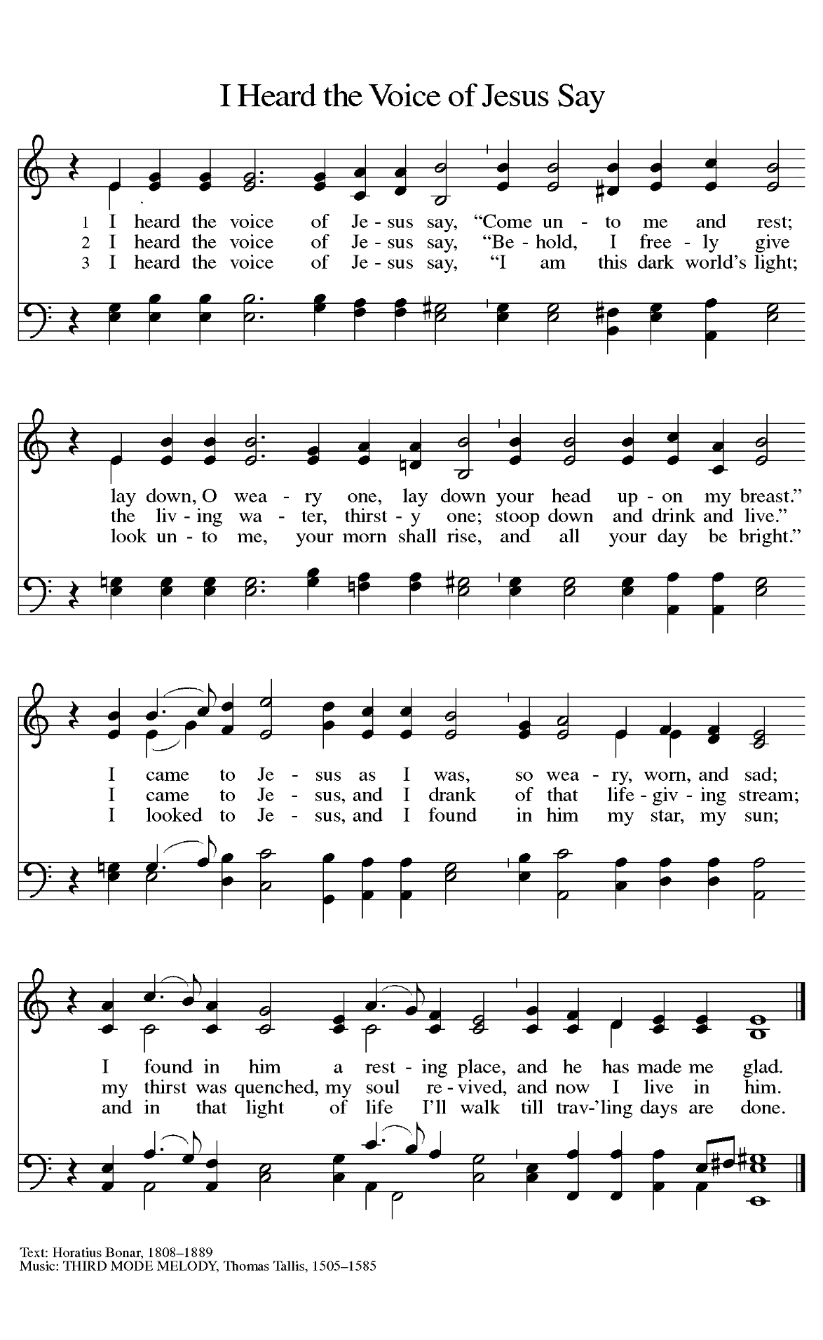
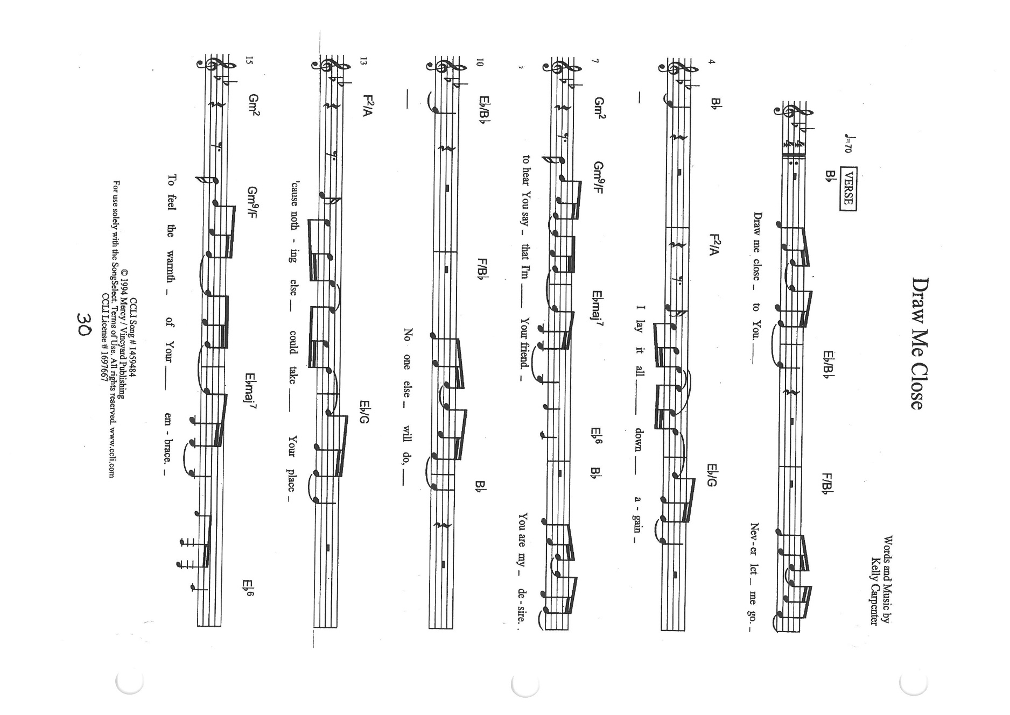

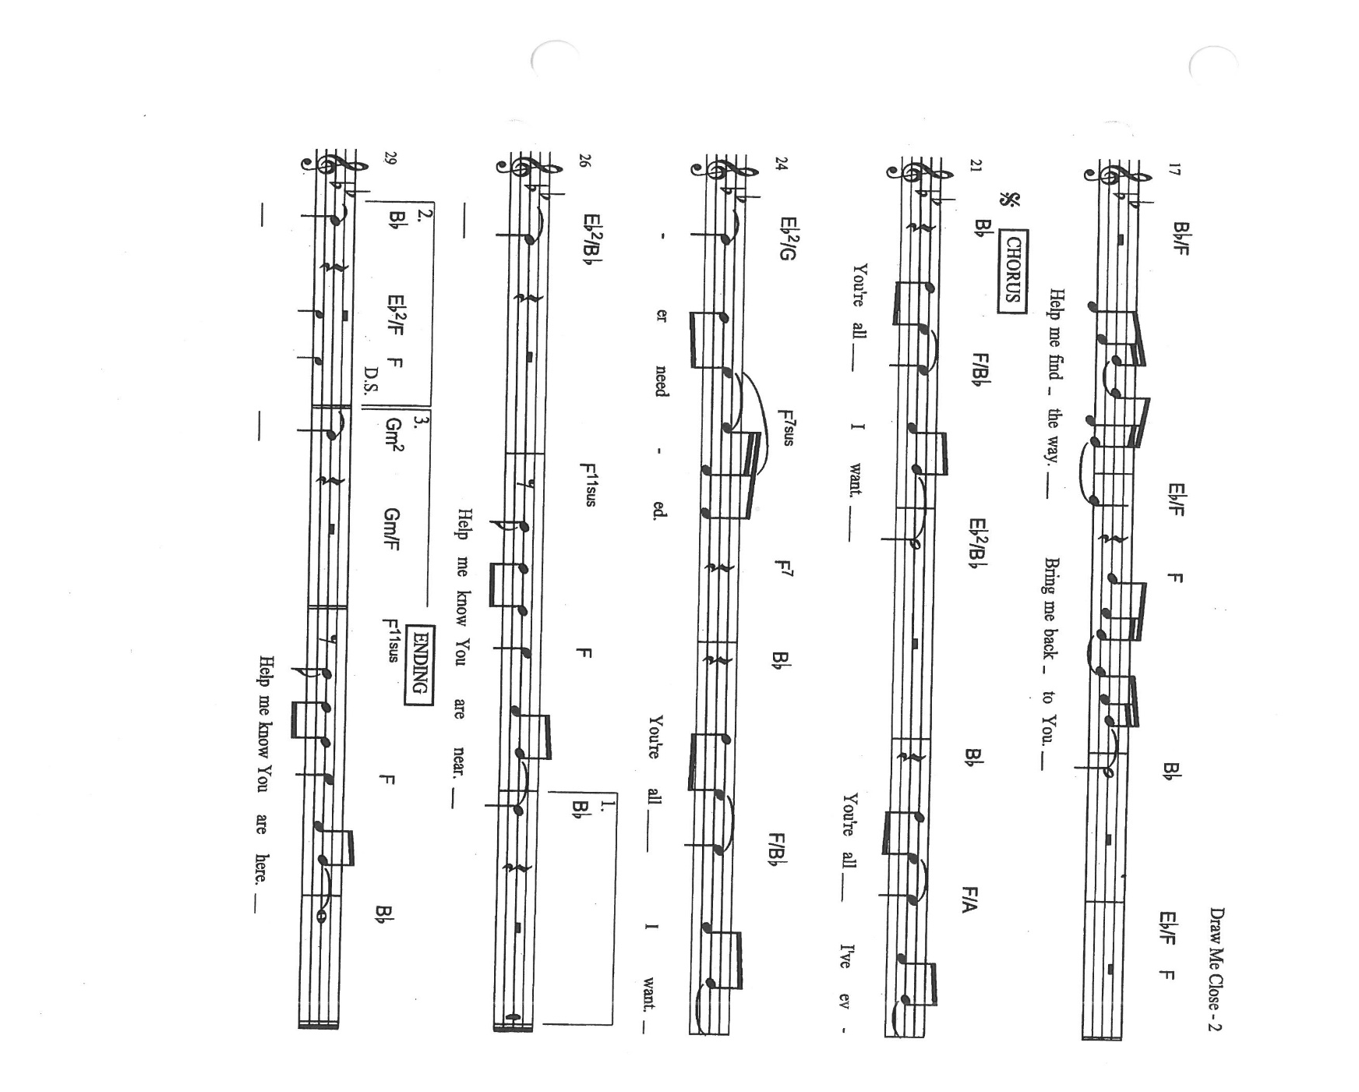

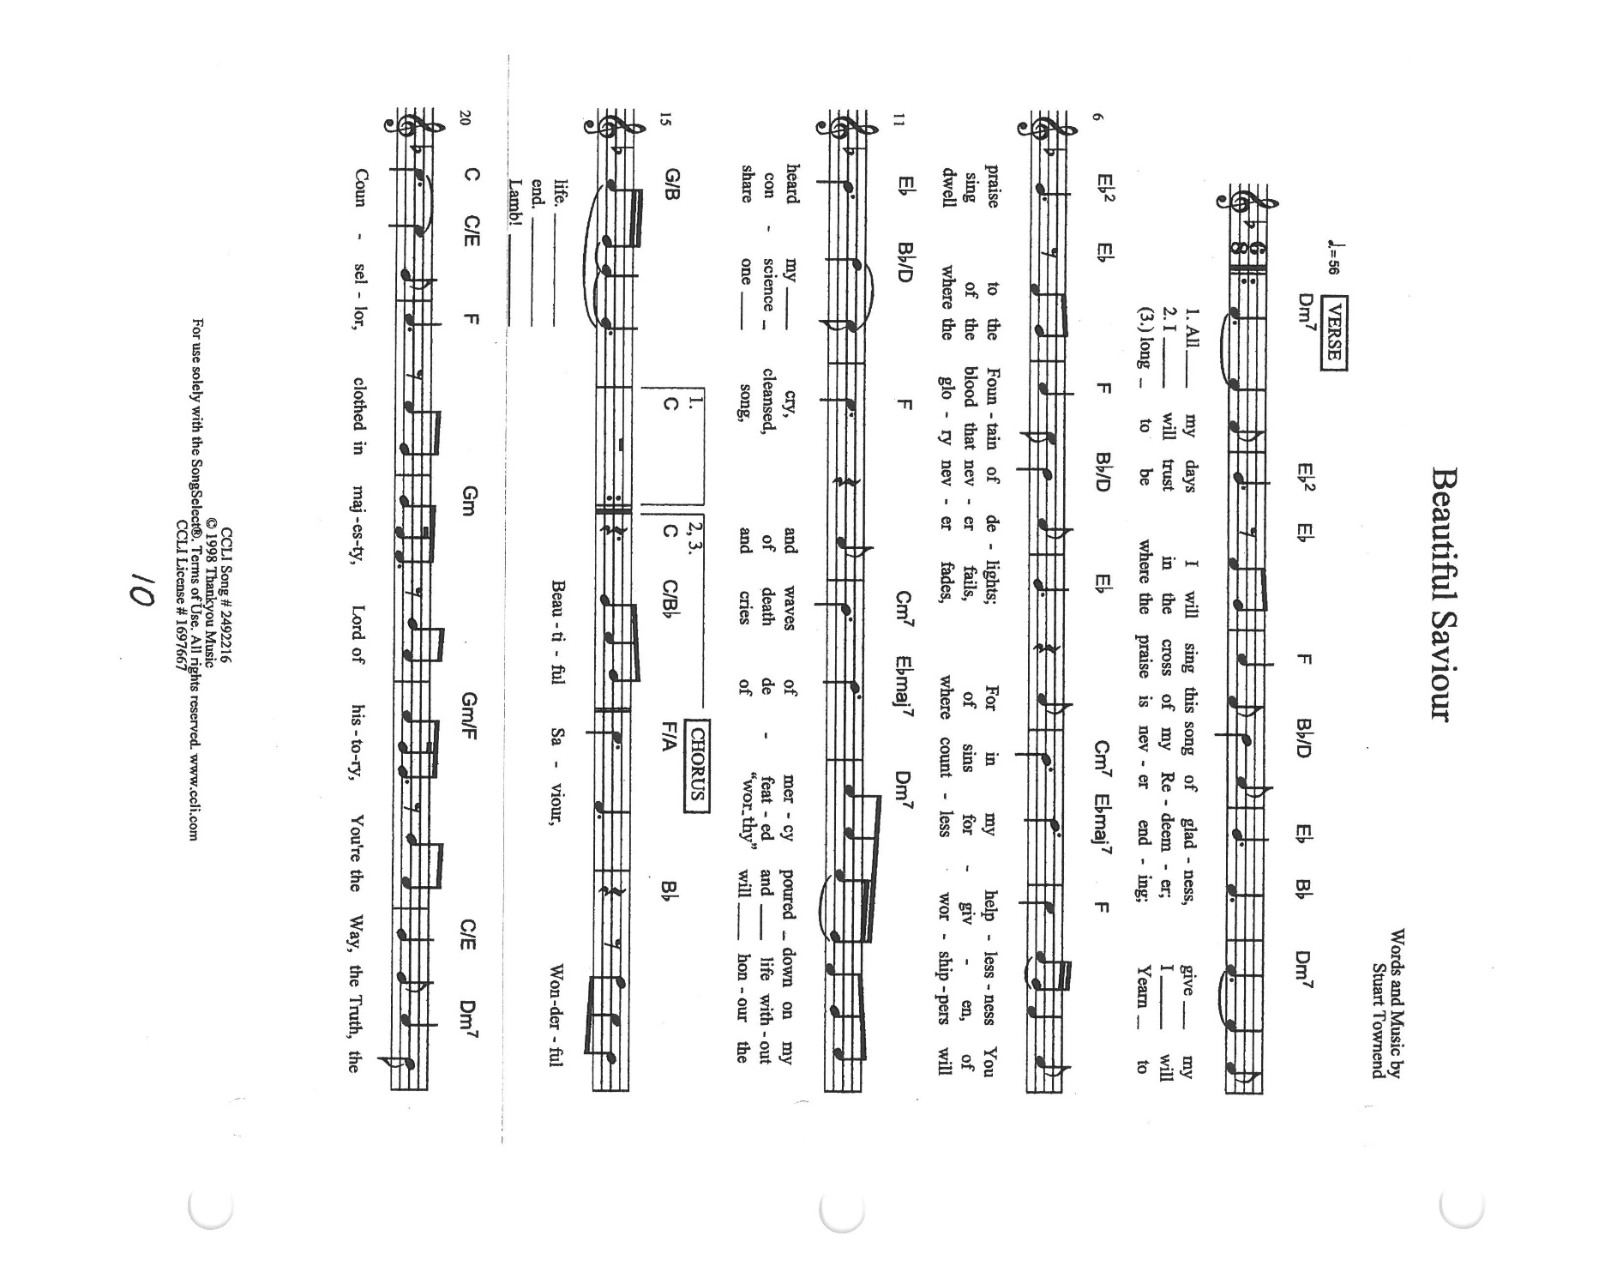

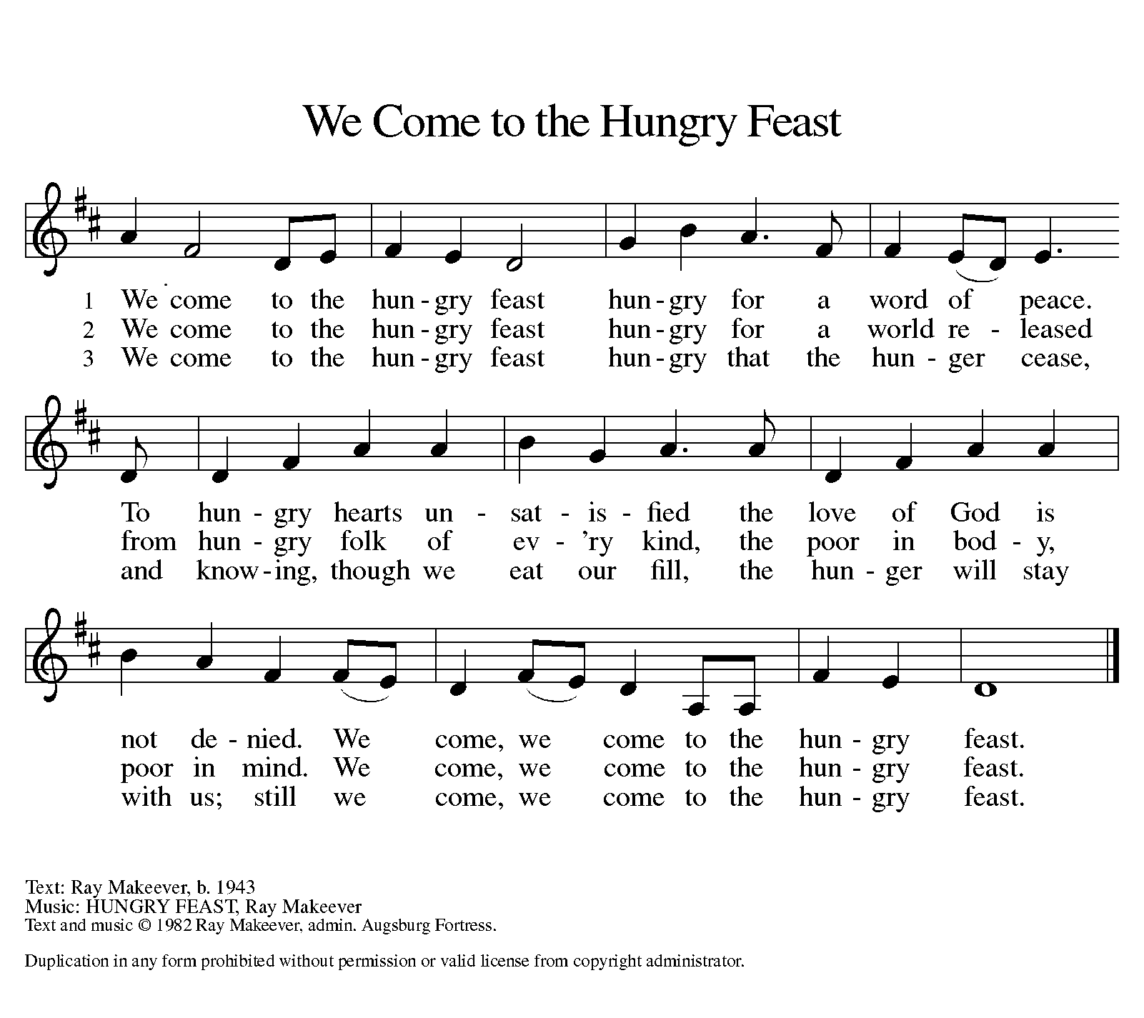

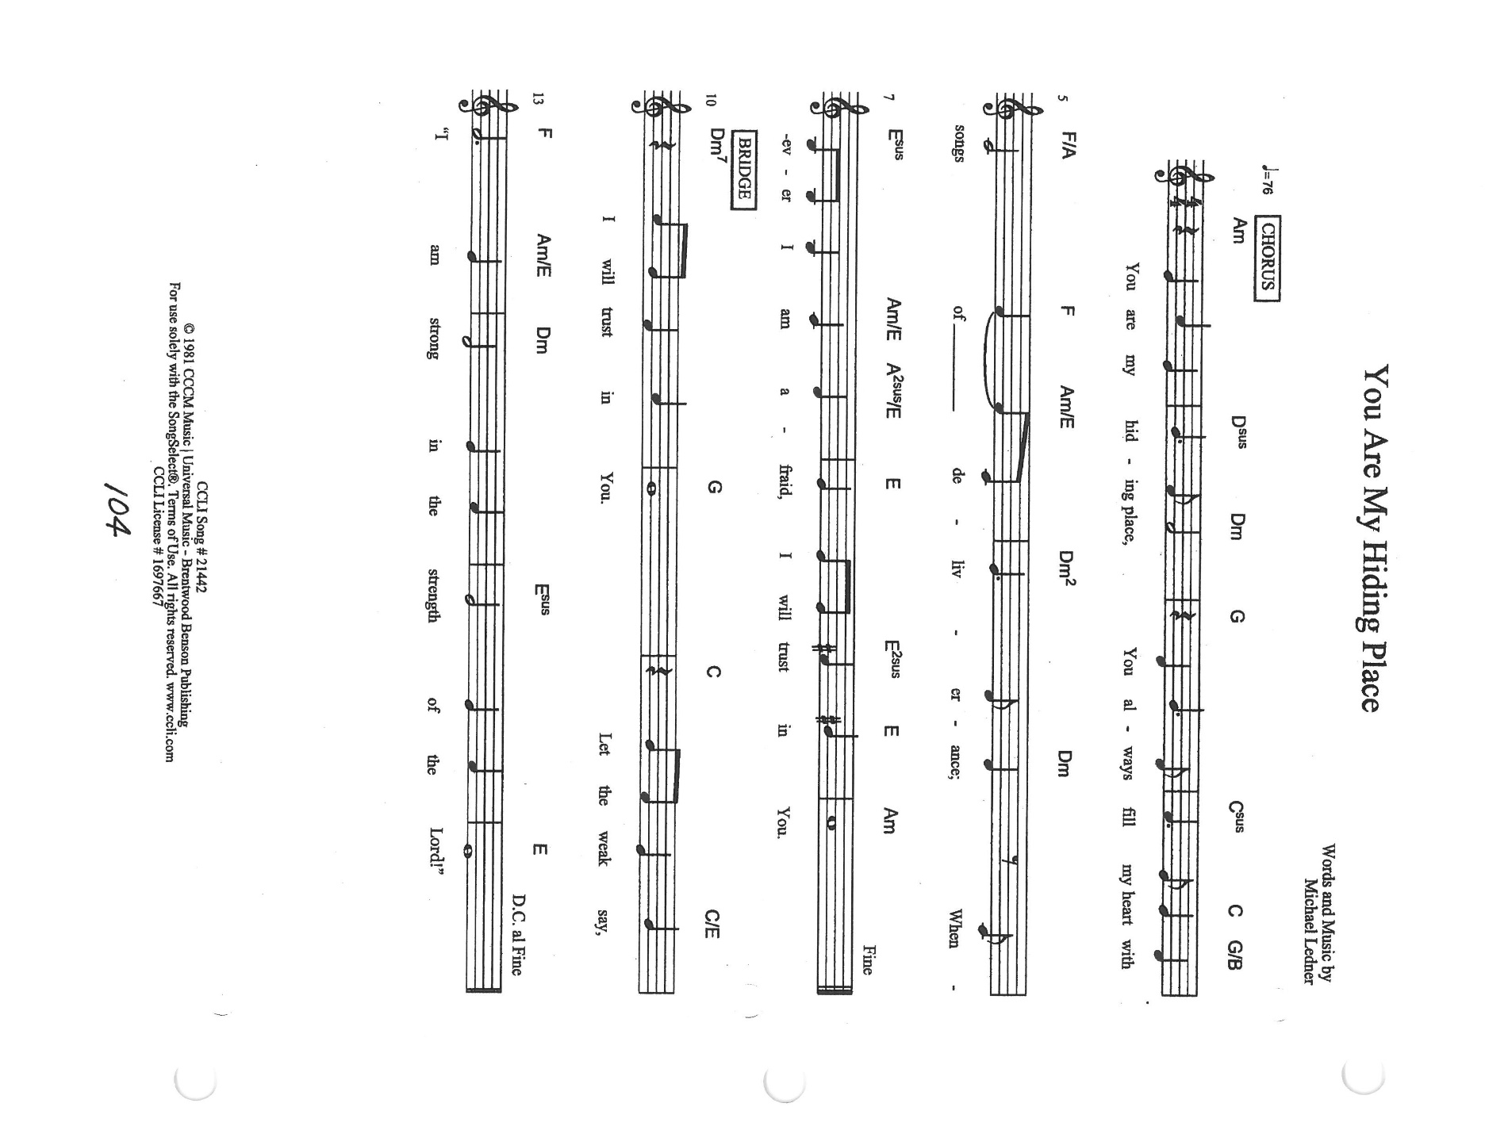
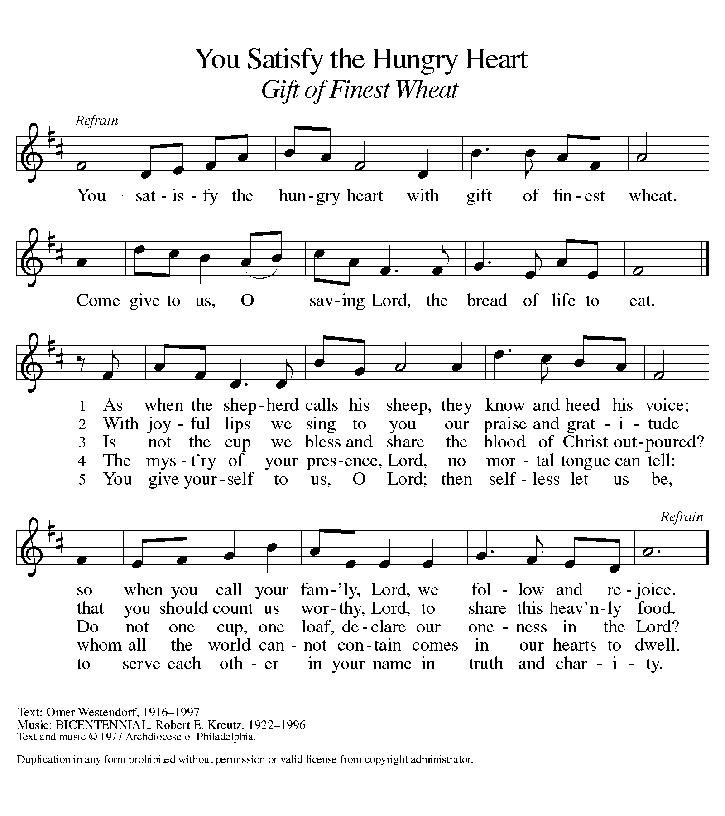

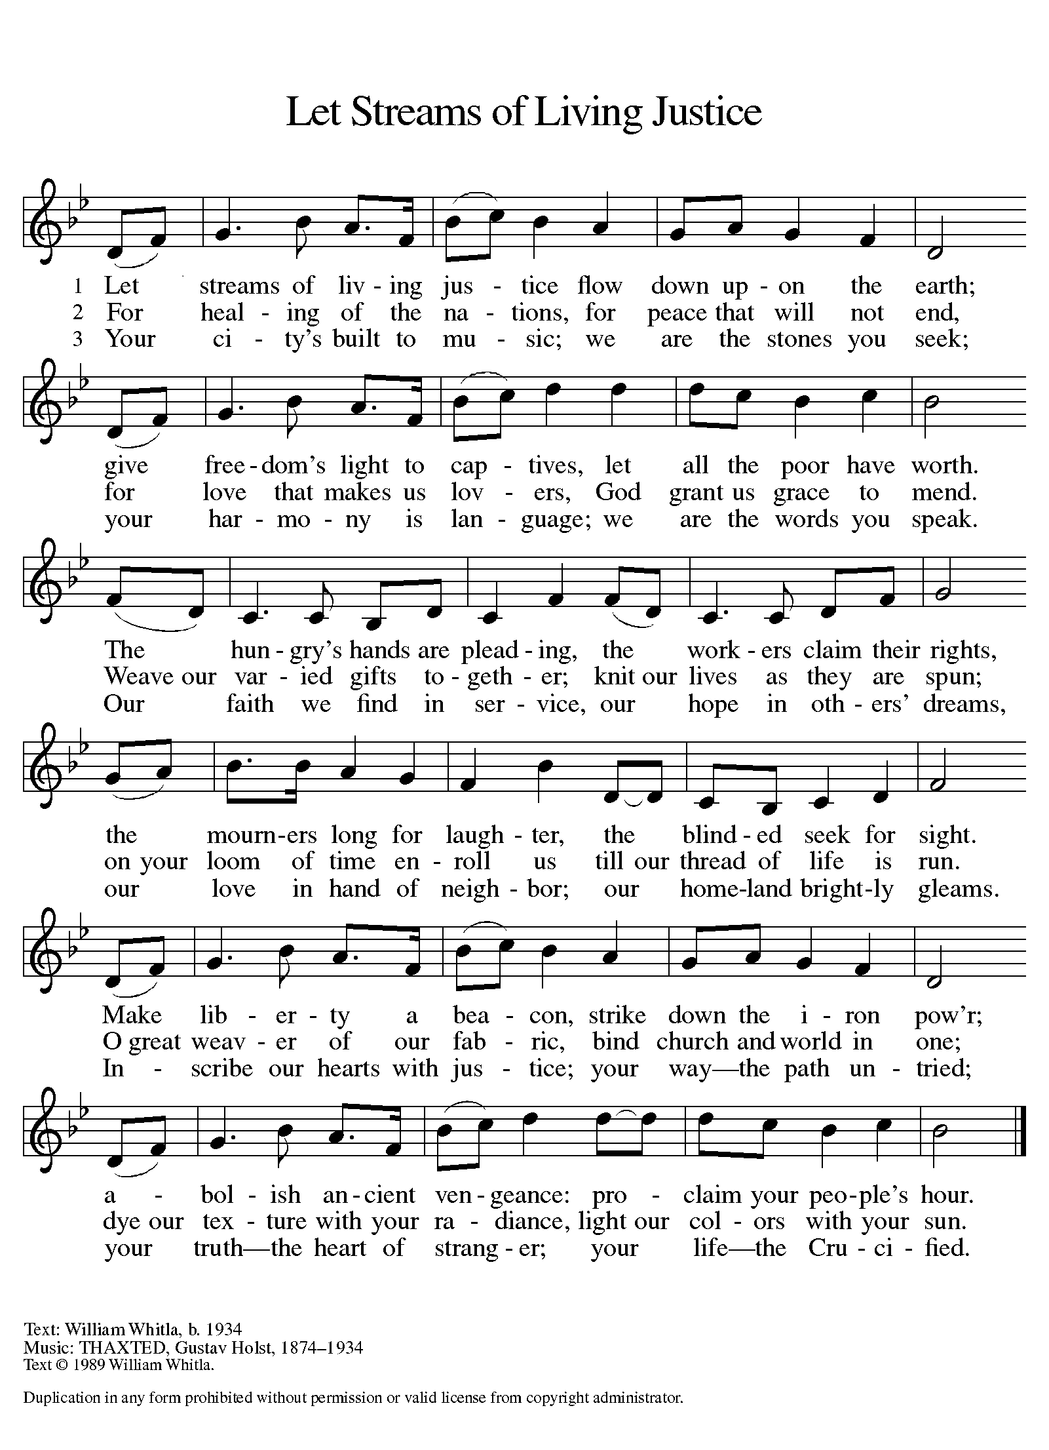
ANNOUNCEMENTS

Please remember to mail your offering to the Church Office at 818 Franklin Street, Michigan City, IN 46360. Another alternative is to give on-line through Tithe.ly. Please see your closure letter for information on how to set up a Tithe.ly account.

St. Paul Members are reminded to have a loved one contact the office if you are hospitalized. Many times, the Pastor doesn’t know someone is in the hospital. If you call and leave a message, please tell us which hospital the patient is at.

Next Sunday’s lessons are 2 Kings 4: 42-44; Psalm 145: 10-18 ; Ephesians 3: 14-21; Mark 6: 1-21 for those of you who like to study them in advance.

Birthdays: Pastor Al Lorentzen (7/18); Beverly Johnson (7-20); Irene Bohnstadt (7- 23)

Anniversaries: Mike & Amy Maesch (7/18); Pastor Mark & Judy Reshan (7- 21)

PRAYER CONCERNS: Kathy Thielman, Audrey Beyer, George Ottersen, Charles Thomas Sr, Joyce and Bethany Manning, Marla Furness, Christine Kiser, Delores Hackett, Kay Peglow, Lee Timm, Ryan Krueger, Donna Bostater, Diane Gielow, Jeff Jensen, Maxine Powell, Jess Kalvaitis, Gail Leffew, Pastor Al Lorentzen, Jan Paholski, Laura Dovey, Heidi Happel, Grant Houk, Shane Nevels, Elaine Gehring, Irene Bohnstadt, Joan Coughlin, Jim Tomscheck, Wally & Betty Ratliff and Laura Moore.

If you requested someone’s name to be on the prayer list and are aware that they need continued imminent prayer then contact the church office and let us know. Otherwise we will gradually transfer names to the long-term list.

OFFICE HOURS: Libby will be in the office on Mondays, Wednesdays, and Fridays; volunteers will cover Tuesdays and Thursdays.
Monday & Wednesday 8:00 a.m. – 5 p.m.
Tuesday & Thursday 9:00 a.m. – 12:00 p.m.
Friday 8:00 a.m. – 12:00 p.m.
If you are listening to the worship broadcast on the radio and would like to watch it live stream but you aren’t on Facebook, follow these four steps:

1) Go to your search engine (Google, Bing, etc.).
2) Search for St. Paul Lutheran Church & School, Michigan City, Indiana
3) Click on the option for St. Paul Lutheran Church & School—Home/Facebook
4) Click on “Videos” in the menu on the left side of the screen.

That should take you to the former videos and there should be one with a little red box that says “LIVE.’ Click on that video to enlarge it.

We will continue to live stream/broadcast the Sunday morning service on our Facebook page, and it will always be available on the radio broadcast Sunday mornings at 11:00 a.m. on WEFM (95.9), and on the local cable access station #99 for the previous week’s service on Sundays at 4:00 p.m. and the current service on Wednesdays at 7:00 p.m. and Fridays at 8:30 p.m.

To send e-mail to the church office, please use the following addresses:
Pastor Mark Reshan: seniorpastor@stpaulmichigancity.com
Church Office Secretary (Libby Pollock): churchsecretary@stpaulmichigancity.com
Church Treasurer (Karen Fleming) and Bookkeeper (Billie Atchinson):
finance@stpaulmichigancity.com.

The Good News Newsletter: If you have an article or anything you want included in The Good News please send it to the following e-mail address: splcgoodnews@gmail.com. Pastor Pamela Thiede will be using this e-mail address to assemble The Good News each month. The deadline for getting information to Pastor Pamela will be the 20th of each month.

HEARING AID BATTERIES: If you or someone you know are in need of hearing aid batteries size 10A (yellow) or size 13 (orange) we have members who have a supply they want to give away. Please call the church office and let them know.

LAPORTE COUNTY MEALS ON WHEELS needs YOU! A commitment of ONE hour per week can make a difference. Monday through Friday meal delivery is totally dependent on volunteers. Volunteers are needed in Michigan City, LaPorte, Westville, and South County routes NOW. Call 219-872-9117 in Michigan City or 219-369-6483 in LaPorte; or visit
www.laportecountymealsonwheels.org or find them on Facebook at LaPorte Co Meals on Wheels.

IMMEDIATE NEEDS Mondays Wednesdays

Substitute Drivers needed MC route 10 LaPorte/Rolling Prairie route
in MC & LP locations LaPorte Route 4

Thursdays
LaPorte Route 2
WORSHIP ATTENDANCE for July 10 and 11, 2021
4:00 p.m. 26
9:00 a.m. 46
Total = 72

RAFFLE TICKETS: St. Paul Church is selling raffle tickets .Proceeds will go toward the 150th anniversary celebration coming up and to purchase more hearing aid devices for the congregation. Please stop in the narthex after services and take some raffle tickets to sell to your family, friends and the general public. Raffle tickets will cost $10.00 each for a chance to win:
1st prize = a $500.00 Meijer gift card
2nd prize = a $400.00 Amazon gift card
3rd prize = a $250.00 Meijer gift card
The drawing will be held on Saturday, August 7, 2021.

BLOOD DRIVE: We are again sponsoring a blood drive with the Red Cross on Tuesday, July 27, from 1:30 p.m.—6:00 p.m. in the St. Paul Room. Please register on their website:
www.redcross.org or by calling their 800 number at (1-800-733-2767). Your donation helps many in need. Please consider participating in this blood drive. We will be following all of the Covid-19 guidelines that are in place at this time.

A reception honoring Pastor Dale Zylstra’s ordination will be held on Saturday, August 7 and Sunday, August 8 following each worship service in the St. Paul Room. On Saturday we will have cake and coffee and on Sunday morning some breakfast casseroles, bagels, fresh fruit and refreshments. In order to help us plan well please fill out the insert to indicate if you will be attending. We need a total by Sunday, August 1. If you normally go out to eat after either service join us for good food, wonderful fellowship, and a joyous celebration of Dale’s hard work and service to the Church and her Lord.

Congratulations to all our graduates, especially Rachel and Sarah Sutor. We wish them God’s blessings as they continue their faith and educational journey and grow more fully into the wisdom and knowledge of the Lord.

2021 Financial Stewardship
Weekly Church Operating Needs (x 2 weeks): $14,116.35
July 3-4, and July 10-11, 2021
General Fund (including General Memorials): $ 8,933.00
Overage/Shortage: --$ 4,759.30

Restricted Income (not including Memorials)
Supports IK Synod & Churchwide Ministries: $344.00
Ministries in our Community/Congregation: $ 10.00
Capital Fund: $600.00

Memorials/Capital Fund $300.00

And Finally: If you have an activity or event or recognition you would like to include in our weekly bulletins please contact Libby in the Church office by email or by telephone no later than noon on Mondays. Thank you and God bless!
Church Office: 219-874-7293 email: churchsecretary@stpaulmichigancity.com

