THE FIFTH SUNDAY AFTER THE EPIPHANY
February 8, 2026

For Jesus, salt and light came out of a long tradition of biblical teaching: salt and light were images for the law of God. Salt and light must take us back to the fullness of the law and the prophets, and the fullness of Jesus' radical teaching in this Sermon on the Mount. The prophets plead for fullness of life: freedom from oppression, bread for the hungry, homes for those who have none, clothing for the naked. Is this not what it means to be the salt of the earth, to keep this prophetic word alive in the midst of our world?
If we lose this vision, if we give in to other values, if we forget God's longing for justice, our salt has lost its taste. If you think Jesus' call is impossible, remember that the One who is our bread is with us and within us, empowering us to be salt and light in this world.

Barbara Lundblad

We're in the second of three weeks of passages from Jesus' Sermon on the Mount as recounted by Matthew. And we are again faced with the insidious temptation to hear Jesus' words as requirement rather than blessing, as command rather than commissioning. But take note: Jesus doesn't say, "If you want to become salt and light, do this...." Or, "before I'll call you salt and light, I'll need to see this from you...." Rather, he says both simply and directly, "You are the salt of the earth. You are the light of the world." It is, as with last week's Beatitudes, sheer blessing, commendation, affirmation, and commissioning.

David Lose
In the Name of Jesus

INTRODUCTION

Light shines in the darkness for the upright, the psalmist sings. Isaiah declares that when we loose the bonds of injustice and share our bread with the hungry, the light breaks forth like the dawn. In another passage from the Sermon on the Mount, Jesus, the light of the world, calls his followers to let the light of their good works shine before others. Through baptism we are sent into the world to shine with the light of Christ.

The Martyrs of Japan, died 1597

Christianity was brought to Japan in the sixteenth century by Jesuit and Franciscan missionaries. The religion was suppressed, however, and in 1597 twenty-six missionaries and converts were crucified. Nevertheless, Christianity survived and later prospered.

GATHERING

PRELUDE

ANNOUNCEMENTS

As you are able please rise

CONFESSION AND ABSOLUTION

P: In the name of the Father and of the Son and of the Holy Spirit.

C: Amen.

P: Jesus said, “You are the salt of the earth; but if salt has lost its taste, how can its saltiness
be restored? ... You are the light of the world ... No one after lighting a lamp puts it
under the bushel basket, but on the lampstand, and it gives light to all in the house.”
(Matthew 5: 13,15) God calls us to a way of life that illumines His presence in the
world. Let us seek God’s forgiveness for the ways in which we have not lived out that
calling, that we may be restored as epiphanies of His love in and for our world.

Silence for self-examination and reflection is kept

P: Most merciful God,

C: We confess that we have hidden Your light in the darkness of our sin of thought,
word, and deed. We proclaim our desire to draw near to You, (Isaiah 58: 2-3) but
in our hearts we serve only our own interests. We turn away from the hungry,
the naked, and the afflicted (58: 7). By our indifference and self-centeredness, we
no longer “flavor” the world with Your love. (Matthew 5: 13) But Your shining is
stronger than our sin. We implore You, O God: let the light of Your mercy break
forth like the dawn. Renew in us the fullness of Your forgiveness. Grant us Your
Spirit for new and radiant living, that our light might “shine before others, so that
they may see our good works and give glory to the Father in heaven.” (Matthew
5: 16)

P: “You are the light of the world.” Christ calls you again this day to shine. Your darkness
is gone, for as a called and ordained minister of the Church of Christ, and by His
authority, I declare to you the entire forgiveness of all your sins, in the name of the
Father and of the Son and of the Holy Spirit.

C: Amen.

GATHERING HYMN 532 Gather Us In

THE GREETING AND PRAYER OF THE DAY

P: To the Church of God in this place, to those who are called to be saints, to all those who
call upon the name of our Lord Jesus Christ:

The grace of our Lord Jesus Christ, the love of God, and the communion of the Holy
Spirit be with you all.

C: And also with you.

P: Let us pray. Lord God, with endless mercy You receive the prayers of all who call upon
You. By Your Spirit show us the things we ought to do, and give us the grace and
power to do them, through Jesus Christ, our Savior and Lord.

C: Amen.

The assembly is seated

WORD

FIRST READING Isaiah 58: 1-12

Shortly after the return of Israel from exile in Babylon, the people were troubled by the ineffectiveness of their fasts. God reminds them that outward observance is no substitute for a genuine faith that results in acts of justice and kindness and living in the light of God's presence.

Shout out, do not hold back!
Lift up your voice like a trumpet!
Announce to My people their rebellion,
to the house of Jacob their sins.
²Yet day after day they seek Me
and delight to know My ways,
as if they were a nation that practiced righteousness
and did not forsake the ordinance of their God;
they ask of Me righteous judgments,
they delight to draw near to God.
³"Why do we fast, but You do not see?
Why humble ourselves, but You do not notice?"
Look, you serve your own interest on your fast day,
and oppress all your workers.
⁴Look, you fast only to quarrel and to fight
and to strike with a wicked fist.
Such fasting as you do today
will not make your voice heard on high.
⁵Is such the fast that I choose,
a day to humble oneself?
Is it to bow down the head like a bulrush,
and to lie in sackcloth and ashes?
Will you call this a fast,
a day acceptable to the LORD?
⁶Is not this the fast that I choose:
to loose the bonds of injustice,
to undo the thongs of the yoke,
to let the oppressed go free,
and to break every yoke?
⁷Is it not to share your bread with the hungry,
and bring the homeless poor into your house;
when you see the naked, to cover them,
and not to hide yourself from your own kin?
⁸Then your light shall break forth like the dawn,
and your healing shall spring up quickly;
your vindicator shall go before you,
the glory of the LORD shall be your rear guard.
⁹Then you shall call, and the LORD will answer;
you shall cry for help and He will say, Here I am.
If you remove the yoke from among you
the pointing of the finger, the speaking of evil,
¹⁰if you offer your food to the hungry
and satisfy the needs of the afflicted,
then your lights shall rise in the darkness
and your gloom be like the noonday.
¹¹The LORD will guide you continually,
and satisfy your needs in parched places,
and make your bones strong;
and you shall be like a watered garden,
like a spring of water,
whose waters never fail.
¹²Your ancient ruins shall be rebuilt;
you shall raise up the foundations of many generations;
you shall be called the repairer of the breach,
the restorer of streets to live in.

The Word of the Lord.

Thanks be to God.

PSALM: Psalm 112: 1-9 Antiphon by Ronald Nelson

Choir sings refrain first, followed immediately by the congregation
and as indicated

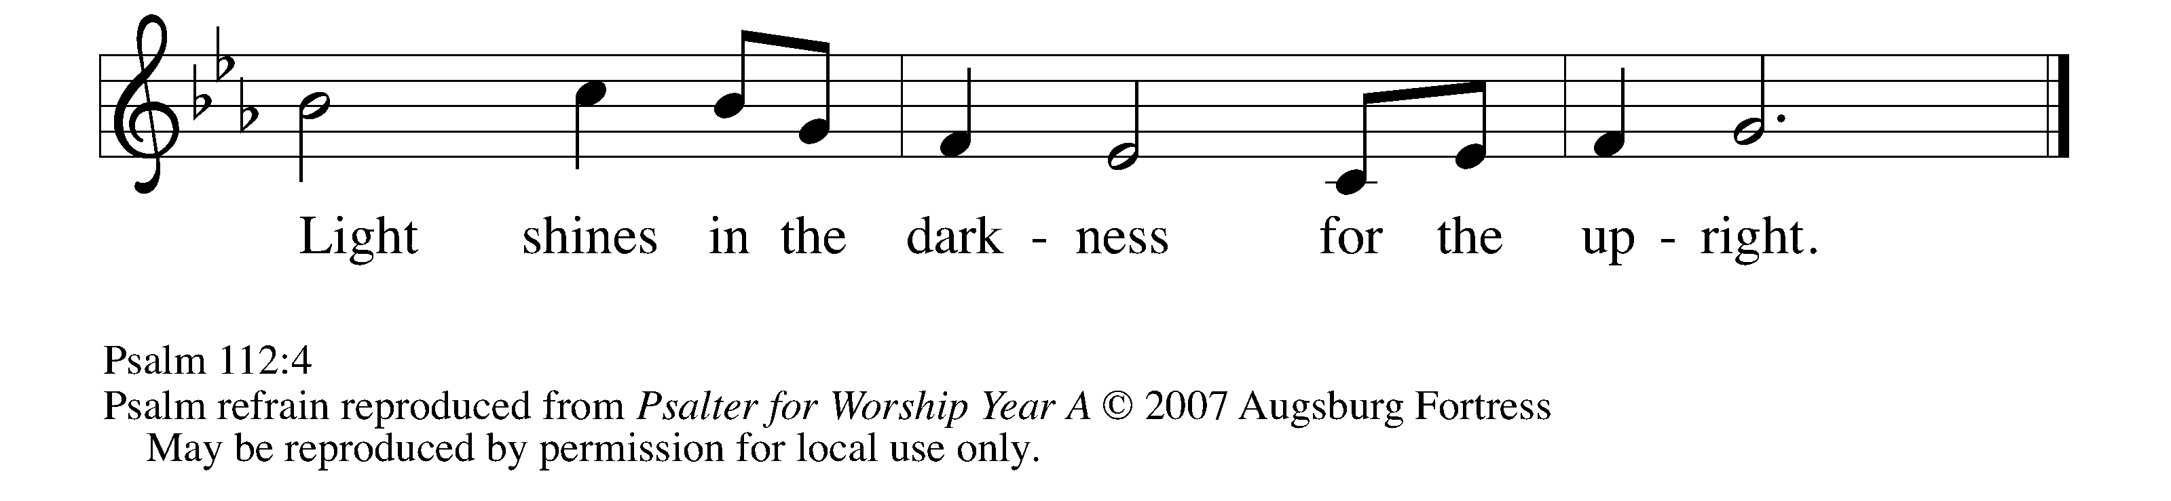
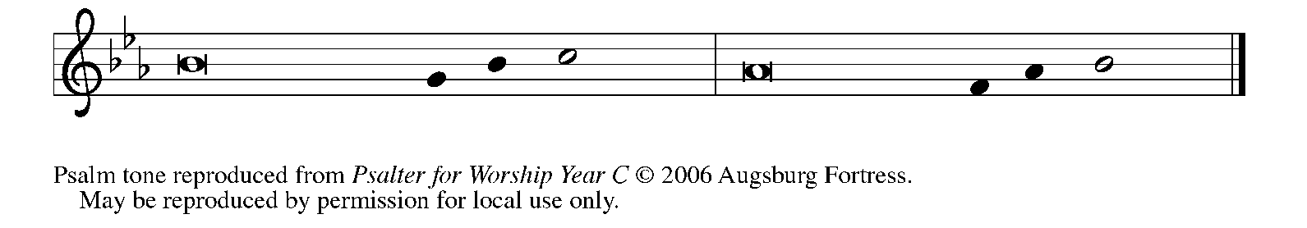
¹Hallelujah! Happy are they who | fear the LORD
and have great delight in | God's commandments!

²Their descendants will be mighty | in the land;
the generation of the upright | will be blessed.
³Wealth and riches will be | in their house,
and their righteousness will | last forever.

⁴Light shines in the darkness | for the upright;
the righteous are merciful and full | of compassion. REFRAIN

⁵It is good for them to be gener- | ous in lending
and to manage their af- | fairs with justice.

⁶For they will nev- | er be shaken;
the righteous will be kept in everlast- | ing remembrance.

⁷They will not be afraid of any | evil rumors;
their heart is steadfast, trusting | in the LORD.

⁸Their heart is established and | will not shrink,
until they see their desire up- | on their enemies.

⁹They have given freely to the poor,
and their righteousness stands | fast forever;
they will hold up their | head with honor. REFRAIN

SECOND READING 1 Corinthians 2: 1

In Corinth, Paul preached the gospel to people enamored with Greek philosophy and wisdom. God's wisdom is proclaimed in the gospel and revealed most clearly in Christ's self-giving.

When I came to you, brothers and sisters, I did not come proclaiming the mystery of God to you in lofty words or wisdom. ²For I decided to know nothing among you except Jesus Christ, and Him crucified. ³And I came to you in weakness and in fear and in much trembling. ⁴My speech and my proclamation were not with plausible words of wisdom, but with a demonstration of the Spirit and of power, ⁵so that your faith might rest not on human wisdom but on the power of God.
⁶Yet among the mature we do speak wisdom, though it is not a wisdom of this age or of the rulers of this age, who are doomed to perish. ⁷But we speak God's wisdom, secret and hidden, which God decreed before the ages for our glory. ⁸None of the rulers of this age understood this; for if they had, they would not have crucified the Lord of glory. ⁹But, as it is written,
"What no eye has seen, nor ear heard,
nor the human heart conceived,
what God has prepared for those who love Him--
¹⁰these things God has revealed to us through the Spirit; for the Spirit searches everything, even the depths of God. ¹¹For what human being knows what is truly human except the human spirit that is within? So also no one comprehends what is truly God's except the Spirit of God. ¹²Now we have received not the spirit of the world, but the Spirit that is from God, so that we may understand the gifts bestowed on us by God. ¹³And we speak of these things in words not taught by human wisdom but taught by the Spirit, interpreting spiritual things to those who are spiritual.
¹⁴Those who are unspiritual do not receive the gifts of God's Spirit, for they are foolishness to them, and they are unable to understand them because they are spiritually discerned. ¹⁵Those who are spiritual discern all things, and they are themselves subject to no one else's scrutiny.
¹⁶"For who has known the mind of the Lord
so as to instruct Him?"
But we have the mind of Christ.

The Word of the Lord.

Thanks be to God.

As you are able please rise

THE VERSE
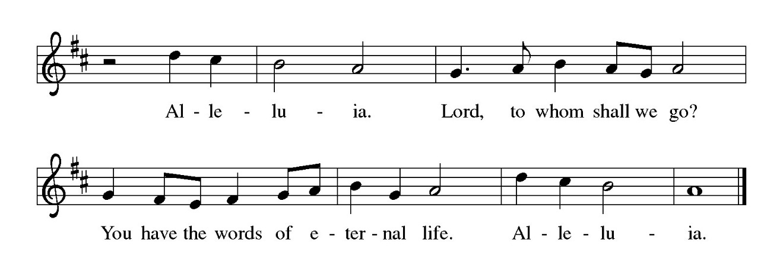
THE HOLY GOSPEL Matthew 5: 13-20

God’s blessing, announced in the beatitudes, can be lost unless disciples live in a manner that leads others to praise God.

P: The Holy Gospel according to St. Matthew, the fifth chapter.

C: Glory to You, O Lord!

Jesus said: "You are the salt of the earth; but if salt has lost its taste, how can its saltiness be restored? It is no longer good for anything, but is thrown out and trampled under foot.
¹⁴"You are the light of the world. A city built on a hill cannot be hid. ¹⁵No one after lighting a lamp puts it under the bushel basket, but on the lampstand, and it gives light to all in the house. ¹⁶In the same way, let your light shine before others, so that they may see your good works and give glory to your Father in heaven.
¹⁷"Do not think that I have come to abolish the law or the prophets; I have come not to abolish but to fulfill. ¹⁸For truly I tell you, until heaven and earth pass away, not one letter, not one stroke of a letter, will pass from the law until all is accomplished. ¹⁹Therefore, whoever breaks one of the least of these commandments, and teaches others to do the same, will be called least in the kingdom of heaven; but whoever does them and teaches them will be called great in the kingdom of heaven. ²⁰For I tell you, unless your righteousness exceeds that of the scribes and Pharisees, you will never enter the kingdom of heaven."

P: The Gospel of the Lord.

C: Praise to You, O Christ!

The assembly is seated

THE SERMON

Silence for reflection follows the sermon

As you are able please rise

THE HYMN OF THE DAY NSB 18 Bring Forth the Kingdom

THE APOSTLES’ CREED

A: God has made us His people through our Baptism into Christ. Living together in trust
and hope, we confess our faith.

C: I believe in God, the Father Almighty,
Creator of heaven and earth.
I believe in Jesus Christ, His only Son, our Lord.
He was conceived by the power of the Holy Spirit,
and born of the Virgin Mary.
He suffered under Pontius Pilate,
was crucified, died, and was buried.
He descended into hell.
On the third day He rose again.
He ascended into heaven,
and is seated at the right hand of the Father.
He will come again to judge the living and the dead.
I believe in the Holy Spirit,
the holy catholic Church,
the communion of saints,
the forgiveness of sins,
the resurrection of the body,
and the life everlasting. Amen.

THE PRAYER OF THE CHURCH

A: For all the baptized people of God, that they may shine forth the light of Christ, and
reflect His love in their words and deeds, we pray:

C: Send forth Your light, O God.

A: For our bishops, especially Yehiel and Timothy, for our pastors, especially Pamela
and Mark, Dale, and Mark, for missionaries, and for all leaders in the Church, that
they may proclaim nothing but Christ crucified in the wisdom and power of God, we
pray:

C: Send forth Your light, O God.

A: For peace in all places of unrest, that the darkness of evil may be dispelled by the light
of God’s justice, we pray:

C: Send forth Your light, O God.

A: For the reconciling power of the Spirit in relationships in families, between races, and
among the nations of the world, we pray:

C: Send forth Your light, O God.

A: For ourselves, that we may be salt and light this week to all in darkness, bringing glory
to God through our good works, we pray:

C: Send forth Your light, O God.

A: For those who suffer from grief or despair, pain or illness, especially: Tim Miller;
Kathy Thielman; Major Payne; Martha Schroeder; Debbie Martin; Fred Weiss;
David Weiss; Joyce Stark; Jackie Gaines; Carl Wipperman; Shirley Shikany
Long; John Bennitt; Catherine Lanigan; Grace Romine; and Robert Bernth, that
their hearts may be established in the love of God, we pray:

C: Send forth Your light, O God.

A: For those celebrating birthdays, especially Wayne Dolson, that they may grow in grace
this day and every day and be filled with grace for the days ahead, we pray:

C: Send forth Your light, O God.

A: We give thanks for all the faithful departed who have lived and died faithful to the
crucified and Risen One. That we may have the grace to bear full witness with our
lives to Christ’s victory on the cross, we pray:

C: Send forth Your light, O God.

P: God of all the living, hear the prayers of Your faithful people, and grant our requests in
accordance with Your good and saving will. Strengthen us for the tasks You give us,
and bring us at last to praise You with all Your saints; through Jesus Christ, Your Son,
our Lord.

C: Amen.

MEAL

THE PEACE

P: The peace of the Lord be with you always.

C: And also with you.

The assembly is seated

THE OFFERING

THE VOLUNTARY Here I Am St. Paul Senior Choir
(T. Long & A. Pote; Arr. J. Schrader)

As you are able please rise

THE PRESENTATION OF THE GIFTS 312 Jesus, Come! For We Invite You
(stanzas 1, 4)

(Sung to the tune of, Angels From the Realms of Glory)

Jesus, come! for we invite You,
Guest and Master, Friend and Lord;
now, as once at Cana's wedding,
speak and let us hear Your word:
lead us through our need or doubting,
hope be born and joy restored.

Jesus, come! surprise our dullness,
make us willing to receive
more than we can yet imagine,
all the best You have to give:
let us find Your hidden riches,
taste Your love, believe, and live!

THE OFFERTORY PRAYER

A: Let us pray. God of light,

C: The fast You choose for us is to break every yoke of oppression and to share our
bread with the hungry and poor. We bring these gifts as a sign of our devotion to
You. Use them and us to shatter every darkness around us. Through the Bread
of heaven You give to us, the Body and Blood of our Lord Jesus Christ, strengthen
us to shine with His glory and life. We ask this in the name of Jesus the Lord.
Amen.

THE GREAT THANKSGIVING

P: The Lord be with you.

C: And also with you.

P: Lift up your hearts.

C: We lift them up to the Lord.

P: Let us give thanks to the Lord our God.

C: It is right to give Him thanks and praise.

P: It is indeed right and salutary …and join their unending hymn:
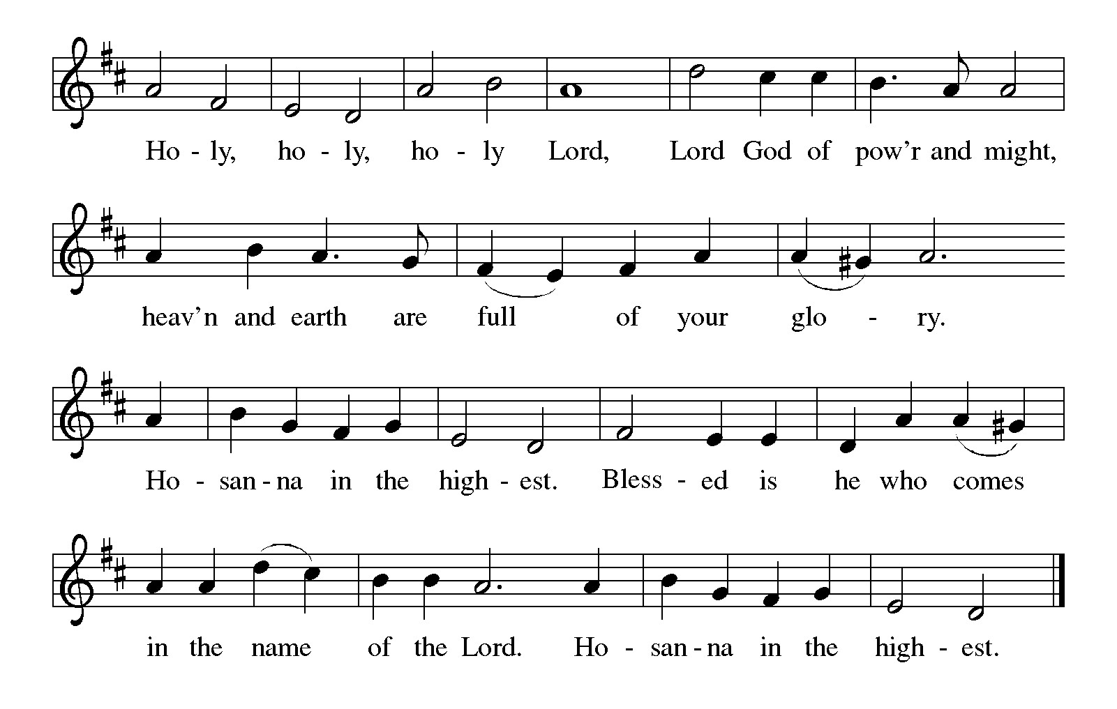P: Empowering God, You established Your creation like a watered garden, and when Your
people’s hopes lay in ruins You answered their call and removed the yoke from among them.
You guided them continually and satisfied their needs in parched places.
In the death and resurrection of Christ You repaired the breach between us and You
and opened the way of peace for all Your people.
Eye has not seen nor ear heard, beckoning God, what You have prepared for those who
love You.
In Jesus You are the salt that preserves us with You forever, and You are the light that
transforms the darkness of death.
On His last evening with His disciples Your Son took the broken body and spilt blood
of the cross and turned them into the glory of resurrection.
Come among us now and turn the brokenness of our lives and the spiltness of Your
world into the wonder of Your new life.

Take these gifts of bread and wine and make them for us the Body and Blood of Your
Son Jesus Christ,
Who, in the night ... “Do this for the remembrance of Me.”
As often as we eat ... we proclaim the Lord’s death until He comes.

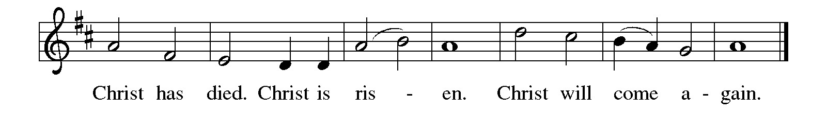P: Inspiring God, You instill in us the wisdom of Your Son’s cross, and You send us the
Spirit
Who searches the depths of Your heart and the depth of ours.
Shape Your people in the image of Your Son to be repairers of the breach; send us to be
beside those who cry, those who are afflicted, alongside all whose foundations lie in ruins.
Bless Your Church that it may bear the marks of the risen and ascended Lord.
Raise up saints to embody Your truth in our midst, loose the bonds of injustice, undo the
thongs of the yoke, and let the oppressed go free, until the Day when You
are all in all, One God: Father, Son, and Holy Spirit.

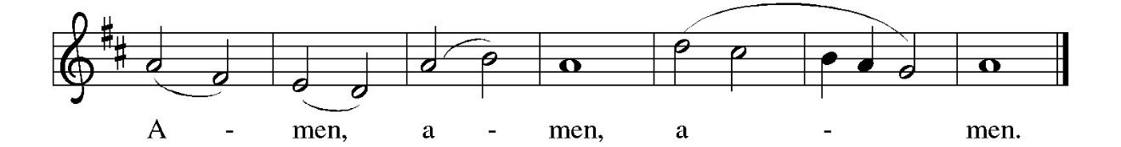
THE LORD’S PRAYER

P: Because in Christ we have received the Spirit of adoption, as daughters and sons of
God, we dare to pray:

C: Our Father, Who art in heaven, hallowed be Thy Name. Thy Kingdom come.
Thy will be done on earth as it is in heaven. Give us this day our daily bread, and
forgive us our trespasses as we forgive those who trespass against us. And lead us
not into temptation, and deliver us from evil, for Thine is the Kingdom, and the
power, and glory, forever and ever. Amen.

INVITATION TO THE MEAL

P: Behold the true Light of the world, the Beloved of God, anointed by the Spirit. Blessed
are those who are called to the Supper of the Lamb. God’s holy gifts for God’s holy
people. Come, for all is now ready.

The assembly is seated

THE DISTRIBUTION Lamb of God (see p. 12)
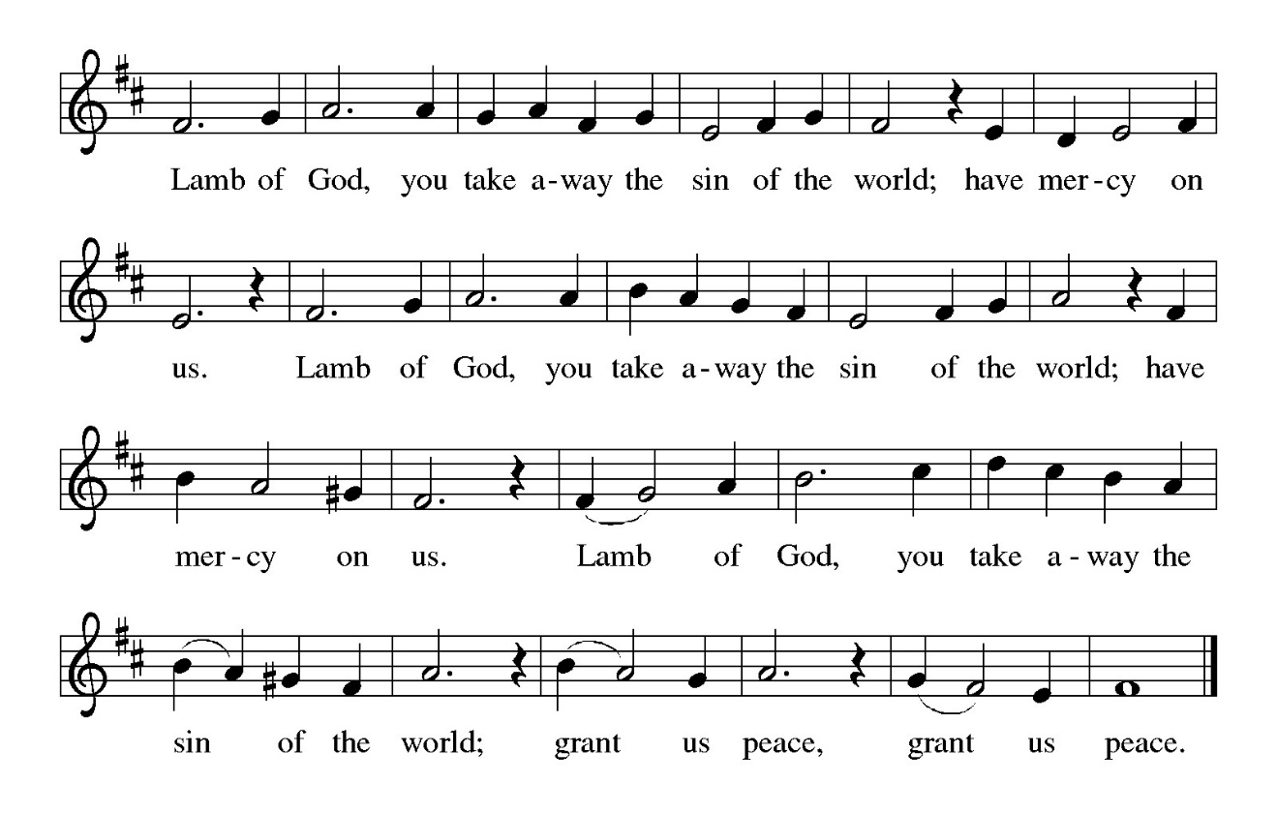

HYMN DURING DISTRIBUTION 712 Lord, Whose Love in Humble Service
ELW 485 I Am the Bread of Life
NSB 78 Shout to the North
NSB 23 Come and See
NSB 66 Make Me A Servant
As you are able please rise

THE POST-COMMUNION BLESSING

P: The Body and Blood of our Lord Jesus Christ strengthen you and keep you in His grace.

C: Amen.

THE POST-COMMUNION PRAYER

A: Let us pray. Holy One, we thank You for the healing that springs forth abundantly
from this Table. Strengthen us through our eating and drinking that Your goodness
might be seen and known in all our words and deeds for the life of the world and for
Your glory. Grant this through Christ our Lord.

C: Amen.
SENDING

THE BENEDICTION

P: Almighty God: Father, Son, and Holy Spirit bless you now and forever.

C: Amen.

SENDING SONG ELW 540 Go, Make Disciples

THE DISMISSAL

A: You are servants of God; you are light to the nations.
Go in peace. Serve the Lord.

C: Thanks be to God!

POSTLUDE

To God Alone Be Glory

The Meditation, Greeting, Prayers, Peace, and Dismissal are used by permission of
Sundays and Seasons. Copyright Augsburg Fortress 1999 and Sundays and Seasons Online. Copyright Augsburg Fortress, 2013.

The Prayers are also adapted from Intercessions for the Christian People. Gail
Ramshaw, ed. (New York: Pueblo Publishing Company, 1988) 15.



HAPPY BIRTHDAY/HAPPY MARDI GRAS!
If you had a birthday in December 2025, or January 2026, or have one in February 2026, we will be honoring your special day during the Coffee Hour after the Sunday service on February 15th. We will turn that Sunday into a ‘Shrove Tuesday’ and help you celebrate with a Mardi Gras during the Coffee Hour with Home Made King Cakes being served!

2026 Financial Stewardship

Weekly Church Operating Needs (x 2 weeks)
January 24-25, 2026 and January 31-February 1, 2026 $ 12,141.00

General Fund (including General Memorials): $ 6,114.00

Overage/Shortage: — $ 6,027.00

Restricted Income (not including Memorials)
Supports IK Synod & Church wide Ministries: $ 240.00

Ministries in our Community/Congregation: $ 725.00

Capital Fund: $ 165.00

Memorials
Organ Fund: $ 125.00

ANNOUNCEMENTS

Please remember to mail your offering to the Church Office at 818 Franklin Street, Michigan City, IN 46360. Another alternative is to give on-line through Tithe.ly. Please see your closure letter for information on how to set up a Tithe.ly account.

St. Paul Members are reminded to have a loved one contact the office if you are hospitalized. Many times, the Pastor doesn’t know someone is in the hospital. If you call and leave a message, please tell us at which hospital the patient is located.

BIRTHDAYS: Wayne Dolson (2/14)

PRAYER CONCERNS: Robert Bernth; Barry Anderson; John Bennitt; Sarah McNabb; Debbie Martin; Mark Tannehill; Kathy Stein; Jan Paholski; Laura Dovey; Grace Romine; Bill Hazelgrove; Al Levenhagen; Carl Wipperman; Major Payne; Carol Hazelgrove; Allen Sydow; Elizabeth Sanders ; Roy Romine and Tim Miller.

OFFICE HOURS: Libby will be in the office on Mondays, Wednesdays, and Fridays; volunteers will cover Tuesdays and Thursdays.

Monday & Wednesday 8:00 a.m. – 5 p.m.
Tuesday & Thursday 9:00 a.m. – 12:00 p.m.
Friday 8:00 a.m. – 12:00 p.m.

If you are listening to the worship broadcast on the radio and would like to watch the Sunday morning service live stream follow these steps:

(1) If you have You Tube available on your TV, search for
St. Paul Lutheran Church Michigan City, IN.

(2) The direct link on the computer is https://
www.youtube.com/channel/UC5AIPNaKr3QN50984jGOa1g

(3) This link is also on the main page of the church’s website in
the church section and will continue to be posted weekly on the St.
Paul Facebook page.

And it will always be available on the radio broadcast Sunday mornings at 11:00 a.m.
on WEFM (95.9), and on the local cable access station #99 for the previous week’s
service on Sundays at 4:00 p.m. and the current service on Wednesdays at 7:00 p.m.
and Fridays at 8:30 p.m.

To send e-mail to the church office, please use the following addresses:

Pastor Mark Reshan: seniorpastor@stpaulmichigancity.com

Church Office Secretary (Libby Pollock): churchsecretary@stpaulmichigancity.com

Church Treasurer (Karen Fleming): finance@stpaulmichigancity.com

2026 Church Council:

Pastor - Mark Reshan

President - Donna Knoll

Vice President - Jan Bakken

Secretary - Judy Hunt

Treasurer - Karen Fleming

Members: Sue Koziel; Jim Schraidt; Trish Sprague; Bob Kiser; Barry Anderson; and
Pam Soule

Worship Attendance:
Saturday, January 31, 2026 @ 4:00 p.m. 24
Sunday, February 1, 2026 @ 9:00 a.m. 63
TOTAL 87

Copies of the minutes from the December 18, 2025 and the January 22, 2026 Church Council meetings are on the back table in the upper Narthex. They were approved by the council via email.

The Good News Newsletter: If you have an article or anything you want included in The Good News please send it to the following e-mail address: splcgoodnews@gmail.com. Pastor Pamela Thiede will be using this e-mail address to assemble The Good News each month. The deadline for getting information to Pastor Pamela will be the 20th of each month.

Next week’s lessons are Exodus 24: 12-18; Psalm 2 or Psalm 99; II Peter 1: 16-21; and Matthew 17: 1-9 for those of you who like to study them in advance.

FEBRUARY 2026 MISSION OF THE MONTH is the Makerspace at the Michigan City Public Library.
The Makerspace is a place where young people can tinker, design, craft, create and explore. It includes a variety of equipment and projects for guided exploration and hands-on learning in the STEAM areas (science, technology, engineering, arts, and math). Some of the items currently available are art supplies (markers, crayons, colored pencils, glue sticks), etch-a-sketch, rubiks cube, building toys, and 3D printers. Lots of youth visit makerspace and many of the art supplies could use a refill. We will be collecting art supplies, or other STEAM supplies. Please place your supplies in the bin in the outer narthex. If you wish to make a monetary donation, please make checks out to the church marked for the makerspace and place in the offering plate. Thank you for your generous donations to our community!

SNOW EMERGENCY LIST
This is a reminder of where to turn to learn if worship has been canceled because of inclement weather conditions. There are two ways to learn about the status of the service.
First, you may turn to our church and school Facebook page: https://www.facebook.com/stpaulmichigancity/ for updated announcements. Or, perhaps most quickly and easily, you may call the church office number (219-874-7293) and press the “#” key and you will hear a recording about our “open/closed” status.

ACTIVITIES, EVENTS & MEETINGS
FEBRUARY 2026

Saturday, February 7, 2026 @ 4:00 p.m. 5th Epiphany Worship Service/Sanctuary

Sunday, February 8, 2026 @ 9:00 a.m. 5th Epiphany Worship Service/Sanctuary with Coffee after
Monday, February 9, 2026 @ 1:00 p.m. Hope Circle/Green Room

Wednesday. February 11, 2026 @ 9:15 a.m. Bible Study/Luther House

@10:00 a.m. God’s Purls/St. Paul Room

@ 3:30 p.m. Worship & Music Mtg./Luther House

@ 4:30 p.m. Choir Rehearsal/Sanctuary

Saturday, February 14, 2026 @ 4:00 p.m. Transfiguration of Our Lord Worship

Sunday, February 15, 2026 @ 9:00 a.m. Transfiguration of Our Lord Worship/ Sanctuary with Coffee after

Wednesday, February 18, 2026 @ 10:00 a.m. Ash Wednesday Worship Service

@ 7:00 p.m. Ash Wednesday Worship Service

Saturday, February 21, 2026 @ 4:00 p.m. 1st Lent Worship Service/Sanctuary

Sunday, February 22, 2026 @ 9:00 a.m. 1st Lent Worship Service/Sanctuary with Coffee after

Monday, February 23, 2026 @ 2:00 p.m. Finance Comm. Mtg./Luther House

@ 3:00 p.m. Executive Board Meeting/ Luther House

Tuesday, February 24, 2026 @ 4:00 p.m. 150th Anniv. Comm. Mtg./Luther House

Wednesday, February 25, 2026 @ 9:15 a.m. Bible Study/Luther House

@ 10:00 a.m. God’s Purls/St. Paul Room

@ 4:30 p.m. Choir Rehearsal/Sanctuary

@ 6:00 p.m. midweek Lenten Service/Sanctuary

Thursday, February 26, 2026 @ 3:00 p.m. Church Council Meeting/St. Paul Room

Saturday, February 28, 2026 @ 4:00 p.m. 2nd Lent Worship Service/Sanctuary

