December, 2024

**MARK: MY WORDS**

As I began last month’s article, so again this month: thank you. Last month it was for allowing our congregation to fully celebrate the season of Advent and not rush into Christmas prematurely. As I mentioned, in previous congregations that was always a struggle to accomplish. Here, there has never been a question of cutting short the time of waiting and preparing to which Advent calls us.

This month my gratitude is for another reason, one that mirrors the Gift of the Child Whose birth is the “good News of great joy” that with the angels and shepherds we observe. When the sale of the school building went through, the Church Council made the radical decision to donate one half of the proceeds to organizations, ministries, and charities in our community who continue the work near to our heart of feeding the hungry, sheltering the homeless, and caring for children and the most needy and vulnerable among us.

When that decision was announced at the spring congregational meeting, we expected there might be some resistance to such generosity. After all, our contributions are often below what we have budgeted; and we continue to face many very expensive repairs on our facilities. It would have been easy for us to decide to keep all of the money from the sale for ourselves.

We also realized that we are at a point in our congregational life when we can no longer provide the kind of volunteers and support for those vital ministries on our own. So, we resolved to help support and strengthen those groups who are doing the daily work of providing food, shelter, counseling support, medical needs, and care for people and animals alike.

We asked for written suggestions from the congregation for worthy 501c3 charities. We received eleven suggestions, and we were deeply grateful that we were able to allocate funds for all of them in varying amounts. The groups were:

* Nest Community (formerly Community PADS Homeless Shelter)
* The Tannehill Soup Kitchen based at First United Methodist Church
* Rise and Shine, a local group that uses our parking lot two days a week to distribute food and other items to those in need. Several people from our congregation benefit from them each month.
* The American School of Music in Three Oaks, which provides music lessons for children and whose President is Donna Mitchell, formerly from our congregation.
* Dunebrook, which serves children at risk in our community
* The Service League, which provides medical supplies to those recovering from surgery and others in need of walkers, canes, etc.
* The Jane Bernard Small Animal Shelter of La Porte, which for many years has helped place stray and abandoned dogs and cats into new and loving homes.
* Junior Achievement, which works in schools to help children succeed in a global economy and business world.
* Soul Steppers of Michigan City, which has a performing arts group for children. They have received national recognition for performances in parades, competitions, and special events.
* Citizens Concerned for the Homeless, which is the umbrella organization which oversees Nest, Steppingstone Shelter for Women, and Sandcastle Shelter for families.
* Meals on Wheels, with which St. Paul has been involved for over 25 years and which delivers nutritious meals to seniors in our community.
* We also are replenishing the funds in our Samaritan Fund, which helps those in the community seeking short-term financial help for food, gas, etc., and Katie’s Purse, which provides money for those in our congregation experiencing an emergency situation.

This lavish generosity well reflects God’s own giving of Himself in Jesus for the life and health, healing and well-being of the world. We still will retain over $400,000 from the sale proceeds for our own needs and ministries. Through your munificence many in our neighborhood and community are helped. St. Paul remains a vital source of God’s blessing and God is glorified.

That sounds a lot like the song the angels sang at the birth of Jesus. Thank you.



**ORGANIST/CHOIR DIRECTOR UPDATE**

We have still not received any inquiries about our Director of Music position. Some weeks ago, Maggie asked me if we were still looking and whether we wanted her to continue to play and direct the choir. I told her “Yes” to both questions. In discussion with the executive team of the Church Council, we decided that until we did receive any serious applicants that we should formalize our working relationship with her.

The Council decided to offer her a 6-month contract to give both of us a sense of security about our arrangement. She will continue to play at both services as she is able and to direct the choir. Written into the contract is the proviso that if we do come across a viable candidate and decide to hire that person, we will give her 30 days’ notice. If at the end of that six-month period we have no one lined up, we may extend the contract if we both are in agreement.

It has been over a year now since Maggie first came to us, and her gifts and musicality have been a tremendous blessing to us and our worship. We are so thankful she is willing to continue to play and lead the choir. We hope to find an organist; but in the meantime, we are grateful for her presence and faithful service to us.



**THE PURPOSE OF ADVENT**

In last month’s newsletter, it was promised that a brief explanation of the meaning and purpose of Advent would be included in this edition. In many congregations, the season gets short-shrift because of the culturally influenced rush towards Christmas that begins in advertising and stores already in October.

It is not known exactly when the Church began to set aside the four weeks prior to the celebration of the Nativity as a separate season of the church year, although some note that by the end of the fifth century such practices were known. In the late sixth century, the church father Gregory the Great preached a series of sermons on Advent in Rome.

As our good friend Dr. Fred Niedner points out, Advent originally preceded but was not intimately connected with the celebration of the Nativity. December 25 was chosen as the date to remember Jesus’ birth to counteract the pagan observance of the winter solstice.

Advent came to be seen as the period of darkness in which the realities of grief and anxiety over our mortality and human weakness could be faced. “In the darkest days of the calendar, when night has swallowed up day, it is appropriate to ponder the meaning of darkness in nature, in the events which cast a pall over the world and humankind, and in the shadow which is part of each of us. Hence, it is both a season of repentance, but also a season to pray, “Come quickly, Lord Jesus.” Healing and reconciliation can come from facing up to the darkness which is both around us and within us, and Advent offers the opportunity to work at that.” (Niedner)

The texts for the season move from proclaiming the “Second Coming” of Jesus at the End of all things to judge the living and the dead and bring about God’s promised new creation to the testimony of John the Baptist to prepare our hearts and lives that Jesus might be born again into each of us.

“He came. He comes. He will come again.” That is the framework around which these weeks are built. May God grant us a holy and faithful waiting, hoping, praying, and watching for the “advent” of the Lord Jesus now and in The End.



**TIME AWAY**

Pastor Reshan will be taking some time off between Christmas Day and New Year’s Eve/Day to recharge for the season of Epiphany and then the busiest time of year as we enter Lent. As always, he is available by phone (630-450-1894) if there is a pastoral emergency.

**CHRISTMAS WORSHIP SCHEDULE**

**Saturday, December 21** Fourth Saturday in Advent 4:00 p.m.

**Sunday, December 20** Fourth Sunday in Advent 9:00 a.m.

**Tuesday, December 24** Christmas Eve 6:00 p.m.

Pre-service music @ 5:45 p.m.

**Wednesday, December 25** Christmas Day **9:00 a.m.**

**Saturday, December 28** The First Saturday after Christmas 4:00 p.m.

**Sunday, December 29** The First Sunday after Christmas 9:00 a.m.



**SENIOR COMMUNION**

It has long been a tradition to hold a “Quiet/Senior Communion” service in Advent and Lent. Originally intended as a special service for those who were homebound or in nursing or assisted living facilities, in recent years it has expanded to include all (not just “seniors”) who wish to gather for a meaningful spoken service and good food and fellowship afterward.

The service will be held on **Wednesday, December 18, at 9:00 a.m.** Since 10:00 a.m. following the service seems a little early for lunch, the Altar Guild will again serve coffee cakes and light desserts.

That gathering after the service is always a warm time of fellowship for those who attend, and we are thankful that we will still be able to provide an opportunity for worshipers to experience that fellowship. An invitation letter will go out in early December, but all are welcome. Mark the date and time on your calendar; we hope to see you on the 18th.



**LIGHTS (AGAIN) AND DOORS**

In spite of last month’s plea to make sure that lights are turned off and doors secured before leaving the building, we are still having those issues arise. In this last week, the outside light over the door to the St. Paul Room and the hallway light have been on all night; the light by the archive room and elevator has been left on; and most disturbingly, the entry door to the church was left open one Monday overnight. I don’t know how to communicate any more simply or clearly that for the sake of the safety and security of our facilities it is essential to make sure that lights are out and doors are locked. **Please** make every effort to insure this is done.

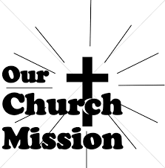

**MONTHLY MISSIONS**

Thank you to everyone who donated to the Tannehill Soup Kitchen during our monthly mission campaign. We raised $834 to help provide meals to those in need this winter season!

**December Monthly Missions—**We have two opportunities for giving to local missions this December. We are starting a little early as items need to be dropped off to the missions prior to Christmas.

* **Salvation Army Angel Tree:** The Christmas tree in the narthex has been adorned with angel tree tags that can be taken to purchase a toy for the child listed on the tag. Please attach the tag to the toy and return unwrapped gifts underneath the Christmas tree no later than **December 8, 2024.**
* **Keys to Hope Kringle Kits:** Keys to Hope needs the following items for Kringle Kits to help make the holidays merry and bright for their participants. A bin has been placed in the narthex for these items. Please donate all items by **December 15, 2024.**
* Chapstick, small bottles of hand lotion, toothbrushes, hand sanitizer, deodorant
* Full sizes of toothpaste, shampoo, and conditioner
* Small notebook or planner and pens
* $5 or $10 McDonald’s or similar gift card
* Beef jerky, nuts, granola bars
* Playing cards
* Handwarmers, hats, and gloves
* Reusable water bottles
* Tote bags

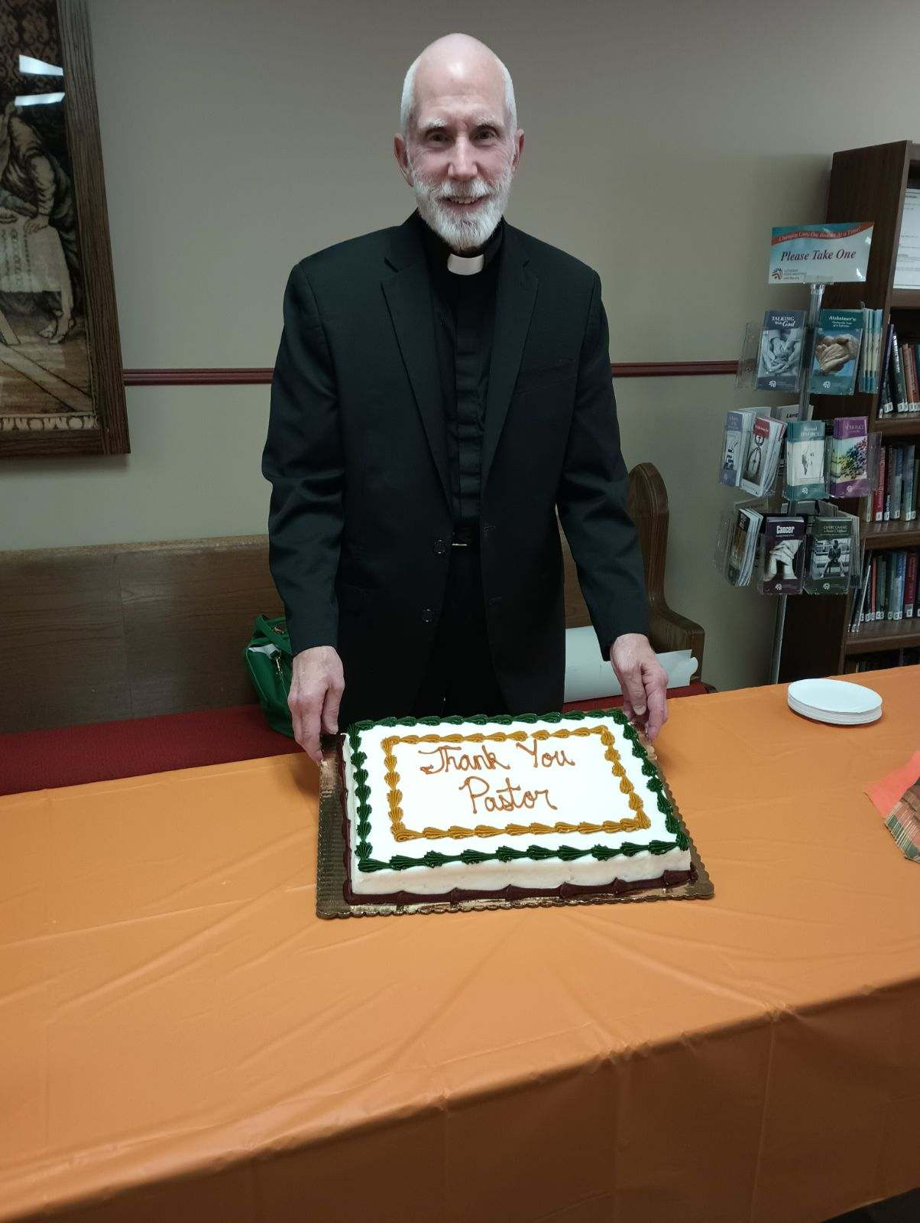

This coffee hour was held October 20 to celebrate Pastor Appreciation Day, but the picture was not available last month.

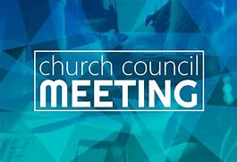

**NOVEMBER COUNCIL HIGHLIGHTS**

There was no Church Council meeting in November.



**GOD’S PURLS**

The knitting/crocheting group (God’s Purls) worked this year making items which were donated to the needy throughout our community.  Twelve lap robes and six prayer shawls were given to the WELCA women at St. Paul which will be distributed to the shut-ins of the church in the Sunshine Baskets.  Baby blankets with matching hats were given to Sandcastle for their families and to Franciscan Health for the newborns.  Bags of hats, scarves, and mittens were given to Sandcastle as well as Arise and Shine Food and Outreach.  Arise and Shine is the organization who distributes food in our parking lot on Saturdays.  We will also be putting a few hats and scarves in the Pantry Box located on the church property.  Hats and mittens will also be given to the Michigan City Schools.  The school bus drivers hand them out to children who do not have warm hats or mittens when boarding the bus.

We welcome anyone who knits or crochets.  We meet on Wednesday mornings at 10:00 a.m. to noon.   Contact Judy Mutchler at 219-229-4764 if you have any questions.

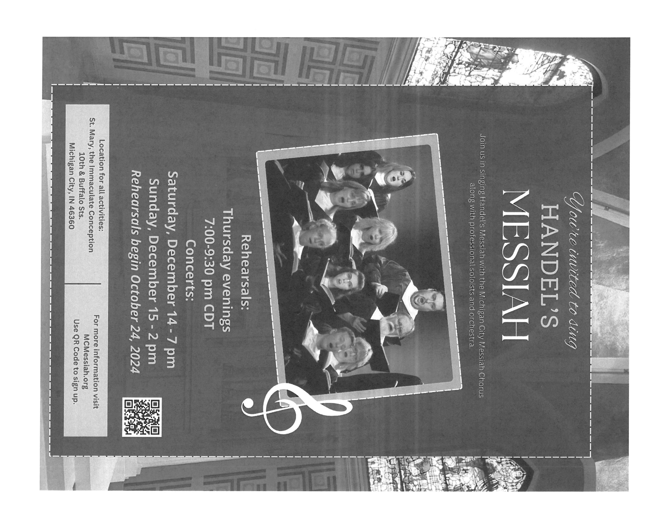



**December Birthdays December Anniversaries**

2 Paul Brooks No December Anniversaries

Amy Maesch

Stephen Hapke

3 John VanGemerem

4 Pastor Mark Reshan

6 Dawn Pagels

Donna Ottersen

8 Janelle Robinson

Judith Gleason

9 Pastor Pamela Thiede

12 Pamela Henderson

13 Douglas Kienitz

14 Karen Steinborn

15 James Summers

17 Carol Radke

20 Stephanie Serrano

22 Virgil Miller

26 Barbara Fulkerson

27 William Hackett

28 Benjamin Robbins

29 Sherry Pay

**Long-Term Prayer List**

Laura Dovey Russ Fischer Marla Furness

Janet Green Nancy Hoover Jess Kalvaitis

Marsha Kenney Christine Kiser Bethany Manning

Christian Martinez Shirley McCarty Ken Mulder

Shane Nevels Jan Paholski Kay Peglow

Grace Romine Danielle Schnell Martha Schroeder

Jeanie Boatman Shepple Joan Siefert Joyce Stark

Kathy Stein Donna Storey Jary Tannehill

Mark Tannehill Kathy Thielman Jana Thomas

Venia Wendt Brian Wiseman



Monday 8:00 a.m. – 5 p.m.

Tuesday 9:00 a.m. – 12:00 noon

Wednesday 8:00 a.m. – 5 p.m.

Thursday 9:00 a.m. – 12 noon

Friday 8:00 a.m. – 12 noon

**St. Paul Lutheran Church Staff**

Pastor Rev. Mark Reshan

Secretary Libby Pollock

Accompanists Jary Tannehill, Mark Tannehill, Jacob Tannehill

Custodian Mark Kloess

Thank$ for $haring

Thank you all who went on the Emita cruise. We raised $220 for the church.

This month, we will see you at Hacienda on Wednesday, December 11.  There is also an opportunity to purchase gift cards. Paul Brooks has placed a sign-up sheet for the gift cards  
on the table in the narthex near the coat rack.  Anyone who can't make it that day or just wants  
gift cards, can pay Paul; he will buy them on the day of the giveback. You can also purchase gift cards when you are dining at Hacienda that day. (What a great holiday gift idea!)  Monies from  
gift card sales will go to our overall total.

Here are two coupons: one for you and one for a friend.

