THE SECOND SUNDAY AFTER THE EPIPHANY
January 18, 2026

Will we know Jesus when we see Him? Some did. John the Baptist declared him the lamb of God, the one John came to reveal. How gracious of John. In our world, the first and famous rarely point to their successors. Yet John saw in Jesus the liberator of his people, the Passover lamb who came to save.
John not only saw him. John gave witness to what he saw. His words and testimony were the light that drew others to see and know Jesus. John confessed to two of his disciples, “Here is ‘the one who baptizes with the Holy Spirit.’ And I myself have seen and have testified that this is the Son of God” (John 1: 33-34). Because of John’s testimony, those disciples wanted to know more, so they followed Jesus.
“What are you looking for?” Jesus asked. “Where are you staying?” the disciples wondered aloud (v. 38). Jesus invited them to come and see. The text says nothing about their conversation, only that they remained with Jesus for that day. But in that time, they saw John’s witness come true. Andrew went to find his brother, Simon, and became a witness himself. “We have found the Messiah” (v. 41).
Jesus might ask of all of us. What are you looking for? Do we seek a rescuer? A conqueror? A pal? A confidant? Through what images do we think of God? In what light do we see Jesus?
In the Spirit’s light, these early believers gave witness to the Jesus they saw--the one long awaited, the one who abides with the Spirit, the one who is intimately connected with God. They came to see him as more than “Rabbi” but as Lord.
In the Spirit’s light, we will see Jesus for who he is. Will we be able to be silent in the face of that grace and glory?

Sundays and Seasons

Inscription on the baptistery of the Church of St. John Lateran in Rome:

Here a people of godly race are born for heaven;
the Spirit gives them life in the fertile waters;
Mother church, in these waves, bears her children
like virginal fruit she has conceived by the Holy Spirit.
Here is to be found the source of life, which washes the whole universe,
which gushed from the wound of Christ.
Sinner, plunge into the sacred fountain to wash away your sin.

In the Name of Jesus

INTRODUCTION

Today's gospel opens with further reflection on Jesus' baptism. He is the Lamb of God who takes away the sin of the world, and the one anointed by the Spirit. In the liturgy we come and see Christ revealed among us in word and meal. We go forth to invite others to come and worship the Holy One, and to receive the gifts of grace and peace made known among us.

Martin Luther King Jr., renewer of society, martyr, died 1968

An American prophet of justice among races and nations, King was an eloquent preacher, a leader of the nonviolent resistance to race-segregated society, and recipient of the Nobel Peace Prize in 1964. Born on this date, he was assassinated on April 4, 1968.

Confession of Peter

Today the church remembers the apostle Peter's great acknowledgement of Jesus as "the Christ, the Son of the living God." This festival serves as a fitting beginning to the week in which we particularly pray that all Christians might be united in faith and witness.

GATHERING

PRE-SERVICE MUSIC How Great is Our God New Song Praise Band
(Tomlin, Reeves and Cash)

ANNOUNCEMENTS

As you are able please rise

P: In the name of the Father and of the Son and of the Holy Spirit.

C: Amen.

P: “It is too light a thing that you should be My servant to raise up the tribes of Jacob and to restore
the survivors of Israel. I will give you as a light to the nations, that My salvation may reach
the ends of the earth.” (Isaiah 49: 6) We too have been called by God to reveal His glory to
all the world. Let us confess the ways in which we have failed to be His luminaries, that,
bathed again in His forgiveness, we might be living epiphanies of His light and life.

Silence for self-examination and reflection is kept

P: Most merciful God,

C: We confess that we have sinned against You in thought, word, and deed. We have hidden
Your unfading light. We become easily discouraged, and believe our work to be for
nothing (Isaiah 49: 3). You have enriched us with every gift necessary to bear faithful
witness to You (1 Corinthians 1: 7). Yet we have been afraid to invite others to “come
and see” Your life and love in Christ (John 1: 39). For the sake of Your Son, have mercy
on us. Forgive us; free us from our disappointment and fear; and embolden us to speak
and enact Your grace in Christ.

P: “God is faithful; by Him you were called into the fellowship of His Son, Jesus Christ our Lord.”
(1 Corinthians 1: 9) As those who belong to Christ, “the Lamb of God Who takes away the sin
of the world” (John 1: 29) you are freed from fear for being God’s faithful Light-bearers.
Therefore, as a called and ordained minister of the Church of Christ, and by His authority, I
declare to you the entire forgiveness of all your sins, in the name of the Father and of the
Son and of the Holy Spirit.

C: Amen.

GATHERING SONG NSB 10 Beautiful Savior

THE GREETING AND PRAYER OF THE DAY

P: To the Church of God in this place, to those who are called to be saints, to all those who call
upon the name of our Lord Jesus Christ:

The grace of our Lord Jesus Christ, the love of God, and the communion of the Holy Spirit be
with you all.

C: And also with you.

P: Let us pray. Holy God, our strength and our redeemer, by Your Spirit hold us forever, that
through Your grace we may worship You and faithfully serve You, follow You and joyfully
find You, through Jesus Christ, our Savior and Lord.

C: Amen.

The assembly is seated

WORD
FIRST READING Isaiah 49: 1-7

Today's reading again picks up the theme of God's transformation of the old into something new. The imagery is familiar: the appointed one is called before birth and equipped to do God's work. The new thing is that the servant will not only do God's work for the benefit of Israel, but will also work for the benefit of the nations.

Listen to me, O coastlands,
pay attention, you peoples from far away!
The LORD called me before I was born,
while I was in my mother's womb He named me.
²He made my mouth like a sharp sword,
in the shadow of His hand he hid me;
He made me a polished arrow,
in His quiver He hid me away.
³And He said to me, "You are My servant,
Israel, in whom I will be glorified."
⁴But I said, "I have labored in vain,
I have spent my strength for nothing and vanity;
yet surely my cause is with the LORD,
and my reward with my God."
⁵And now the LORD says,
Who formed me in the womb to be His servant,
to bring Jacob back to Him,
and that Israel might be gathered to Him,
for I am honored in the sight of the LORD,
and my God has become my strength--
⁶He says,
"It is too light a thing that you should be My servant
to raise up the tribes of Jacob
and to restore the survivors of Israel;
I will give you as a light to the nations,
that My salvation may reach to the end of the earth."
⁷Thus says the LORD,
the Redeemer of Israel and His Holy One,
to one deeply despised, abhorred by the nations,
the slave of rulers,
"Kings shall see and stand up,
princes, and they shall prostrate themselves
because of the LORD, Who is faithful,
the Holy One of Israel, Who has chosen you."

A: The Word of the Lord.

C: Thanks be to God.

THE PSALM: Psalm 40: 1-11 Antiphon by John Folkening

Choir sings refrain first, followed immediately by the congregation
and as indicated

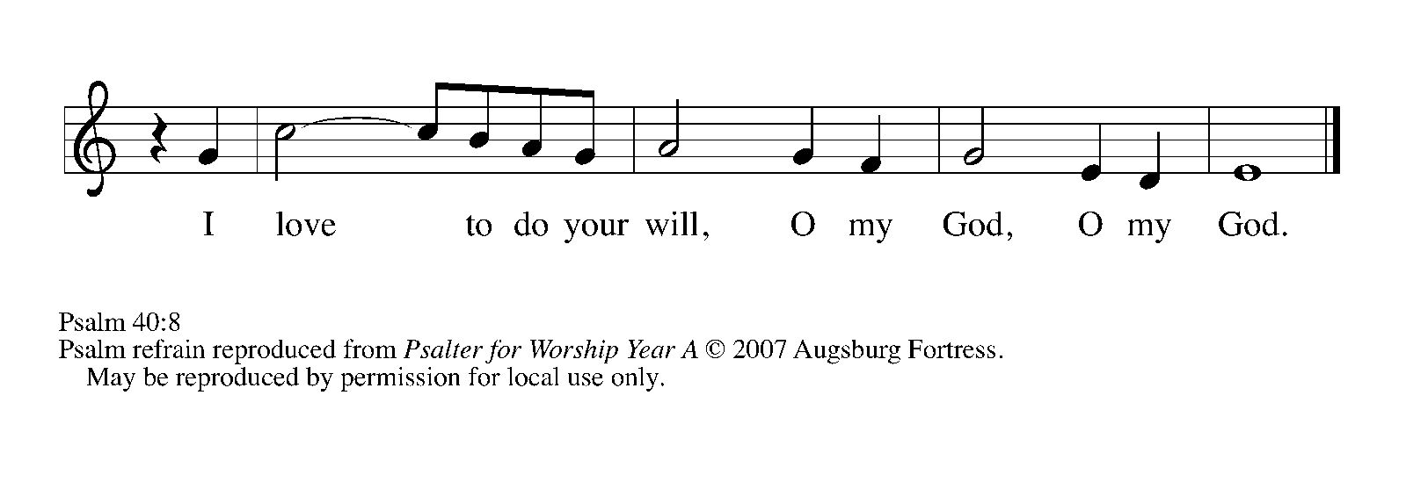
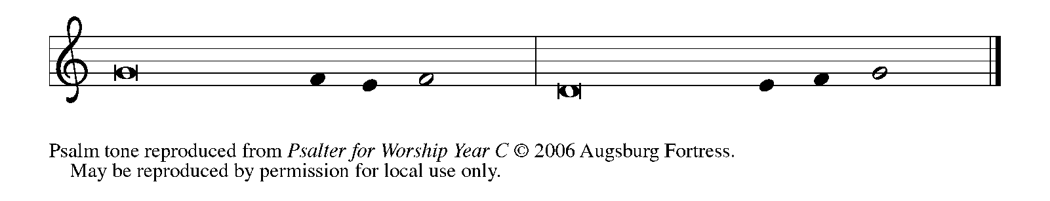

¹I waited patiently up- | on the LORD,
Who stooped to me and | heard my cry.

²The LORD lifted me out of the desolate pit, out of the | miry clay,
and set my feet upon a high cliff, making my | footing sure.

³The LORD put a new song in my mouth, a song of praise | to our God;
many shall see, and stand in awe, and put their trust | in the LORD.

⁴Happy are they who trust | in the LORD!
They do not turn to enemies or to those who | follow lies. REFRAIN

⁵Great are the wonders You have done, O LORD my God! In Your plans for us, none can be com-
| pared with You!
Oh, that I could make them known and tell them! But they are more than | I can count.

⁶Sacrifice and offering You do | not desire;
You have opened my ears: burnt-offering and sin-offering You have | not required. REFRAIN

⁷And so I said, "Here I | am; I come.
In the scroll of the book it is writ- | ten of me:

⁸'I love to do Your will, | O my God;
Your law is | deep within me.'"

⁹I proclaimed righteousness in the | great assembly;
I have not restrained my lips, O | LORD, You know.

¹⁰I have not hidden Your righteousness in my heart; I have spoken of Your faithfulness and
| Your deliverance;
I have not concealed Your steadfast love and truth from the | great assembly.

¹¹You are the LORD; do not withhold Your compas- | sion from me;
may Your steadfast love and Your truth continually | keep me safe. REFRAIN

SECOND READING 1 Corinthians 1: 1-9

Paul's letters to Corinth are addressed to a church beset by many problems. Still, he begins this epistle by emphasizing the faithfulness and grace of God, whose strength will see them through.

Paul, called to be an apostle of Christ Jesus by the will of God, and our brother Sosthenes, ²To the church of God that is in Corinth, to those who are sanctified in Christ Jesus, called to be saints, together with all those who in every place call on the name of our Lord Jesus Christ, both their Lord and ours:
³Grace to you and peace from God our Father and the Lord Jesus Christ.
⁴I give thanks to my God always for you because of the grace of God that has been given you in Christ Jesus, ⁵for in every way you have been enriched in Him, in speech and knowledge of every kind--⁶just as the testimony of Christ has been strengthened among you--⁷so that you are not lacking in any spiritual gift as you wait for the revealing of our Lord Jesus Christ.
⁸He will also strengthen you to the end, so that you may be blameless on the day of our Lord Jesus Christ. ⁹God is faithful; by Him you were called into the fellowship of His Son, Jesus Christ our Lord.

The Word of the Lord.

Thanks be to God.

As you are able please rise

THE VERSE

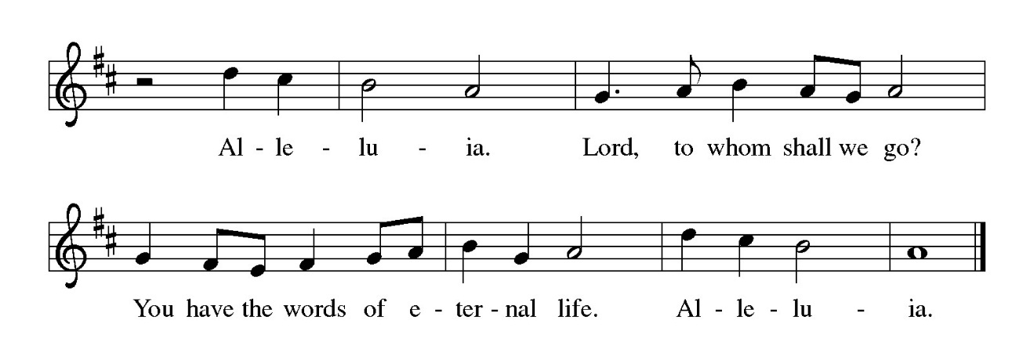

THE HOLY GOSPEL John 1: 29-42

John the Baptist's witness to Jesus initiates a chain of testimony as his disciples begin to share with others what they have found.

P: The Holy Gospel according to St. John, the first chapter.

C: Glory to You, O Lord!

John the Baptist saw Jesus coming toward him and declared, "Here is the Lamb of God who takes away the sin of the world! ³⁰This is He of Whom I said, 'After me comes a man who ranks ahead of me because He was before me.'
³¹I myself did not know Him; but I came baptizing with water for this reason, that He might be revealed to Israel." ³²And John testified, "I saw the Spirit descending from heaven like a dove, and it remained on Him. ³³I myself did not know Him, but the One Who sent me to baptize with water said to me, 'He on Whom you see the Spirit descend and remain is the One Who baptizes with the Holy Spirit.' ³⁴And I myself have seen and have testified that this is the Son of God."
³⁵The next day John again was standing with two of his disciples, ³⁶and as he watched Jesus walk by, he exclaimed, "Look, here is the Lamb of God!" ³⁷The two disciples heard him say this, and they followed Jesus. ³⁸When Jesus turned and saw them following, He said to them, "What are you looking for?" They said to Him, "Rabbi" (which translated means Teacher), "where are you staying?" ³⁹He said to them, "Come and see." They came and saw where He was staying, and they remained with Him that day. It was about four o'clock in the afternoon.
⁴⁰One of the two who heard John speak and followed Him was Andrew, Simon Peter's brother. ⁴¹He first found his brother Simon and said to him, "We have found the Messiah" (which is translated Anointed). ⁴²He brought Simon to Jesus, Who looked at him and said, "You are Simon son of John. You are to be called Cephas" (which is translated Peter).

P: The Gospel of the Lord.

C: Praise to You, O Christ!

The assembly is seated

THE SERMON

Silence for reflection follows the sermon

As you are able please rise

THE HYMN OF THE DAY 539 Abide, O Dearest Jesus

The assembly is seated

INSTALLATION OF THE CHURCH COUNCIL

P: The following persons, having been elected by the congregation to positions of leadership, are
asked to come forward as their offices and names are read.

President Donna Knoll
Vice-President Janet Bakken
Secretary Judy Hunt
Treasurer Karen Fleming

Bob Kiser
Trish Sprague
Barry Anderson
Pam Soule
Susan Koziel
Jim Schrait

P: St. Paul writes: There are different kinds of spiritual gifts, but the same Spirit gives them.
There are different ways of serving, but the same Lord is serviced. There are different abilities
to perform service, but the same God gives to everyone ability for particular service. The
Spirit’s presence is shown in some way in each person, for the good of all. (1 Corinthians 12:
4-7) You have been elected to positions of leadership and trust in this congregation. You are
to see that the words and deeds of this household of faith reflect Him in Whose name we gather.

You are to work together with other members to see that the worship and work of Christ are
done in this congregation, and that God’s will is done in this community and in the whole
world.

You are to be diligent in your specific area of serving, that the one Lord Who empowers you
is glorified.

You are to be an example of faith active in love, to help maintain the life and harmony of this
congregation.

On behalf of your sisters and brothers in Christ, I ask you: Are you ready to accept and
faithfully to carry out the duties of the offices to which you have been elected?

R: Yes, by the help of God.

As you are able please rise

P: People of God, I ask you: Will you support this one of your elected leaders, and will you share
in the mutual ministry that Christ has given to all who are baptized?

C: Yes, by the help of God.

P: I now declare you installed as a council member of this congregation. God bless you with His
Holy Spirit, that you may prove faithful servants of Christ.

R: Amen.

THE PRAYER OF THE CHURCH

A: God has put a new song in our mouth. Sanctified in Christ Jesus and called to be saints, let us
pray for the Church and the world, that all may shine with the radiance of Christ.

A: That God might strengthen the Church to be a light of hope, bringing the good news of salvation
to the ends of the earth, we pray:

C: Send forth Your light, O God.

A: That this community of faith, called to be saints, might be courageous in inviting others to join
our worship and witness, we pray:

C: Send forth Your light, O God.

A: That there might be continuing relief, recovery, and hope for lands, peoples, and animals
suffering from natural disasters, especially in southern California, or political, economic, and
military unrest, especially in Syria, Venezuela, Pakistan, Afghanistan, and Iran, we pray:

C: Send forth Your light, O God.

A: That those who suffer: the hungry, the homeless, the lonely, and the sick, especially: Major
Payne; Lucas Bradshaw; Martha Schroeder; Fred Weiss; David Weiss; Joyce Stark;
Jackie Gaines; Carl Wipperman; Chuck Payne; Shirley Shikany Long; John Bennitt;
Catherine Lanigan; Tim Miller; and Lucas Bradshaw might wait patiently upon the Lord,
and rejoice in His healing presence, we pray:

C: Send forth Your light, O God.

A: For our church council members: Donna and Janet; Karen and Judy; Bob and Sue; Barry
and Pam; Jim and Trish; that by their wisdom and leadership we might faithfully and
fruitfully proclaim and embody the Good News of the daily revealing of the Light of Christ in
our midst, we pray:

C: Send forth Your light, O God.

A: That following the example of the faithful who have gone before us, especially Martin Luther
King Jr., renewer of society and martyr, and Peter, Apostle, whom we commemorate this
Day, we too may strive for God’s justice in this world and one day, with all nations, by His
grace, remain with Him forever, we pray:

C: Send forth Your light, O God.

P: Eternal God, hear the prayers of Your people, and give us the will and courage to serve You
faithfully until the Day of our Lord Jesus Christ, in Whose name we pray.

C: Amen.

MEAL

THE PEACE

P: The peace of the Lord be with you always.

C: And also with you.

The assembly is seated

THE OFFERING

THE VOLUNTARY Lamb of God (with Were You There?) St. Paul Senior Choir (T. Paris; arr. L. Mayfield)

As you are able please rise

THE PRESENTATION OF GIFTS 312 (stanzas 1, 4) Jesus, Come! For We Invite You

(Sung to the tune of, Angels From the Realms of Glory)

Jesus, come! for we invite You,
Guest and Master, Friend and Lord;
now, as once at Cana's wedding,
speak and let us hear Your word:
lead us through our need or doubting,
hope be born and joy restored.

Jesus, come! surprise our dullness,
make us willing to receive
more than we can yet imagine,
all the best You have to give:
let us find Your hidden riches,
taste Your love, believe, and live!

THE OFFERTORY PRAYER

A: Let us pray. Lord our God,

C: With joy and thanksgiving we bring our offerings to Your Table, where You invite us to
feast again on the Lamb of God. By this holy Sacrament, take away our sin and
strengthen us in the fellowship of Your Son, Jesus Christ our Lord. Amen.

THE GREAT THANKSGIVING

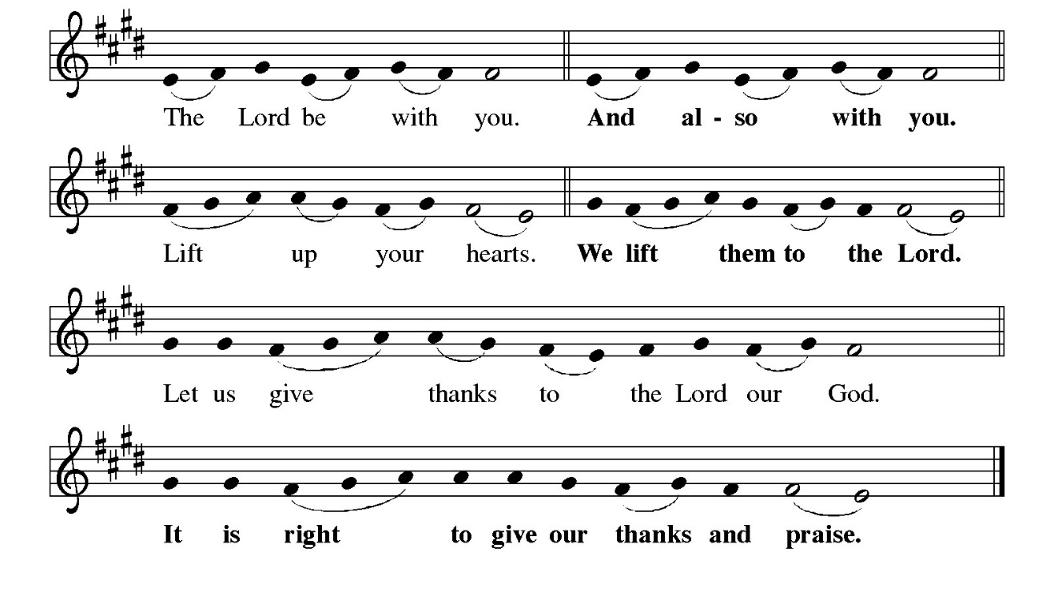
P: It is indeed right and salutary …and join their unending hymn:
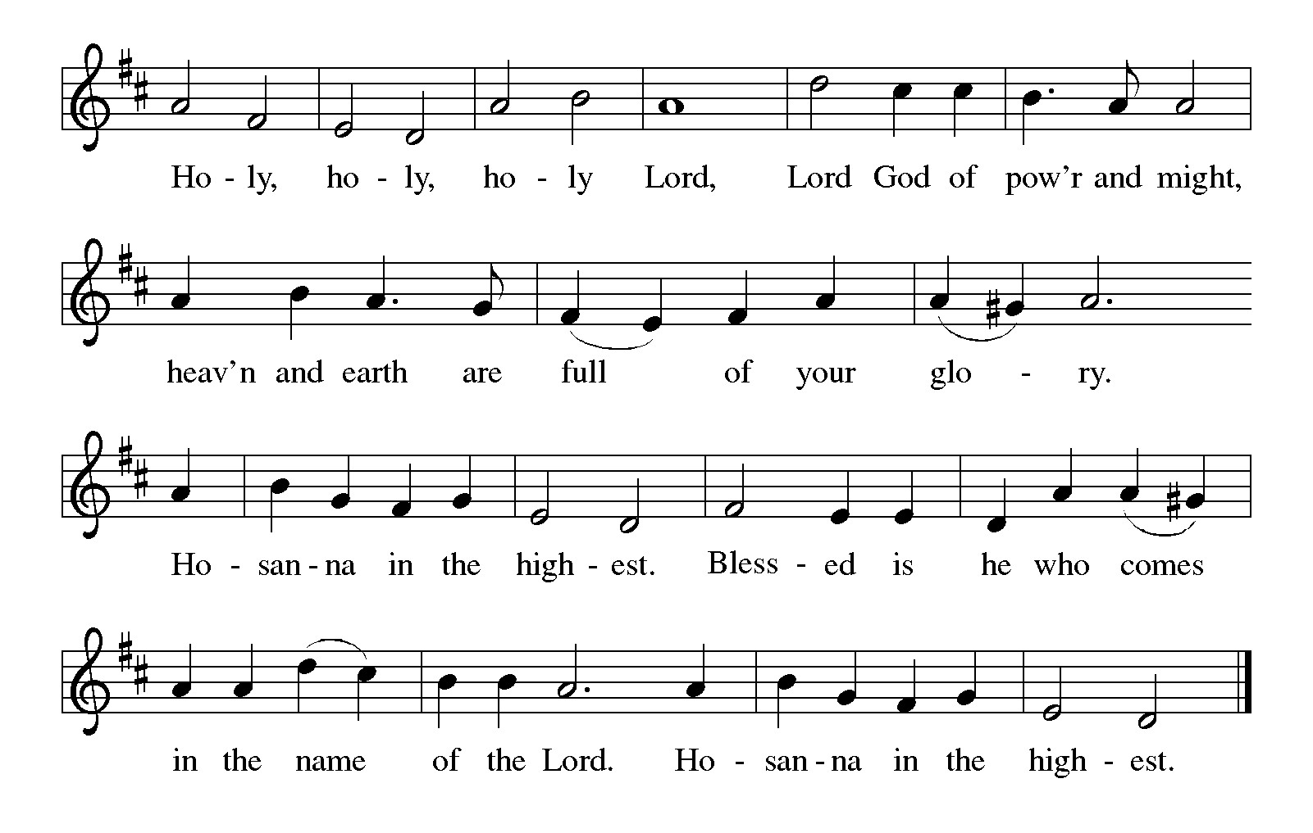P:
P: Blessed are You, Holy One on high, for You have made all things in Your sacred womb,
and You have named and called forth all things according to Your eternal purpose.
Praise upon praise is Yours, for You created such goodness, and it was too light a thing
that You should stop there, so You shaped Your life through making a covenant
with Your people.
When that covenant foundered, it was too light a thing for You to raise up only the
tribes of Jacob and restore only the survivors of Your chosen people, and so
You gave Your Son to be a light to all nations.
As Your Son lived our life and died our death, You showed it was too light a thing that
Your glory should be kept in heaven, and so in Jesus’ resurrection and ascension
You made Your glory known to the ends of the earth.
Summoning God, You beckoned the first disciples to come and see Your anointed Son,
and through Him You anointed each new follower with purpose and power.
Bless us as we come to be with You at this Feast today.
Send Your Holy Spirit and anoint us to be the Body of our living Lord, beckoning others
to come and see the wonders of Your love.
Send down Your Spirit on this breaking bread and this sharing cup that they may be for us
the Body and Blood of Your Son, Jesus Christ,
Who in the night ... “Do this for the remembrance of Me.”
As often as we eat ... we proclaim the Lord’s death until He comes.
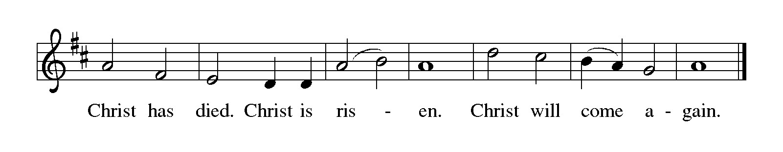
P: Inviting God, Who calls all creation to one perfect End, give Your people grace to receive
the invitation You offer each of us this very day.
When You ask us to take holy risks, deepen our faith.
When You call us to be faithful in small things, give us perseverance.
When You invite us to do beautiful things in the life of Your Kingdom, inspire our
imagination.
When You call us to forgiveness, lead us by the way of the cross, until You bring every
good work You have begun to its completion and You gather heaven and earth
Into a Kingdom that shall have no end; where You reign for evermore as one God,
Father, Son, and Holy Spirit, now and forever.

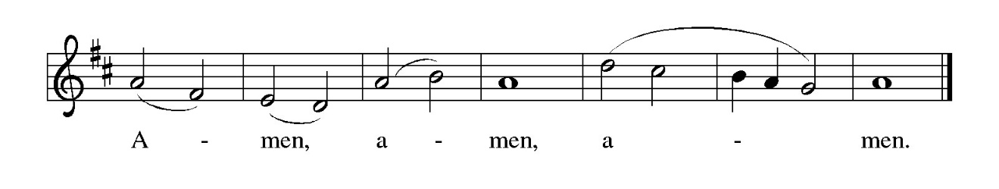

THE LORD’S PRAYER

P: Because in Christ we have received the Spirit of adoption, as daughters and sons of God, we
dare to pray:

C: Our Father in heaven, hallowed be Your name.
Your Kingdom come, Your will be done on earth as in heaven.
Give us today our daily bread, and forgive us our sins, as we forgive
those who sin against us.
Save us from the time of trial, and deliver us from evil.
For the Kingdom, the power, and the glory are Yours, now and forever.
Amen.

INVITATION TO THE MEAL

P: Behold the true Light of the world, the Beloved of God, anointed by the Spirit. Blessed are
those who are called to the Supper of the Lamb. God’s holy gifts for God’s holy people. Come,
for all is now ready.

The assembly is seated

THE DISTRIBUTION Lamb of God
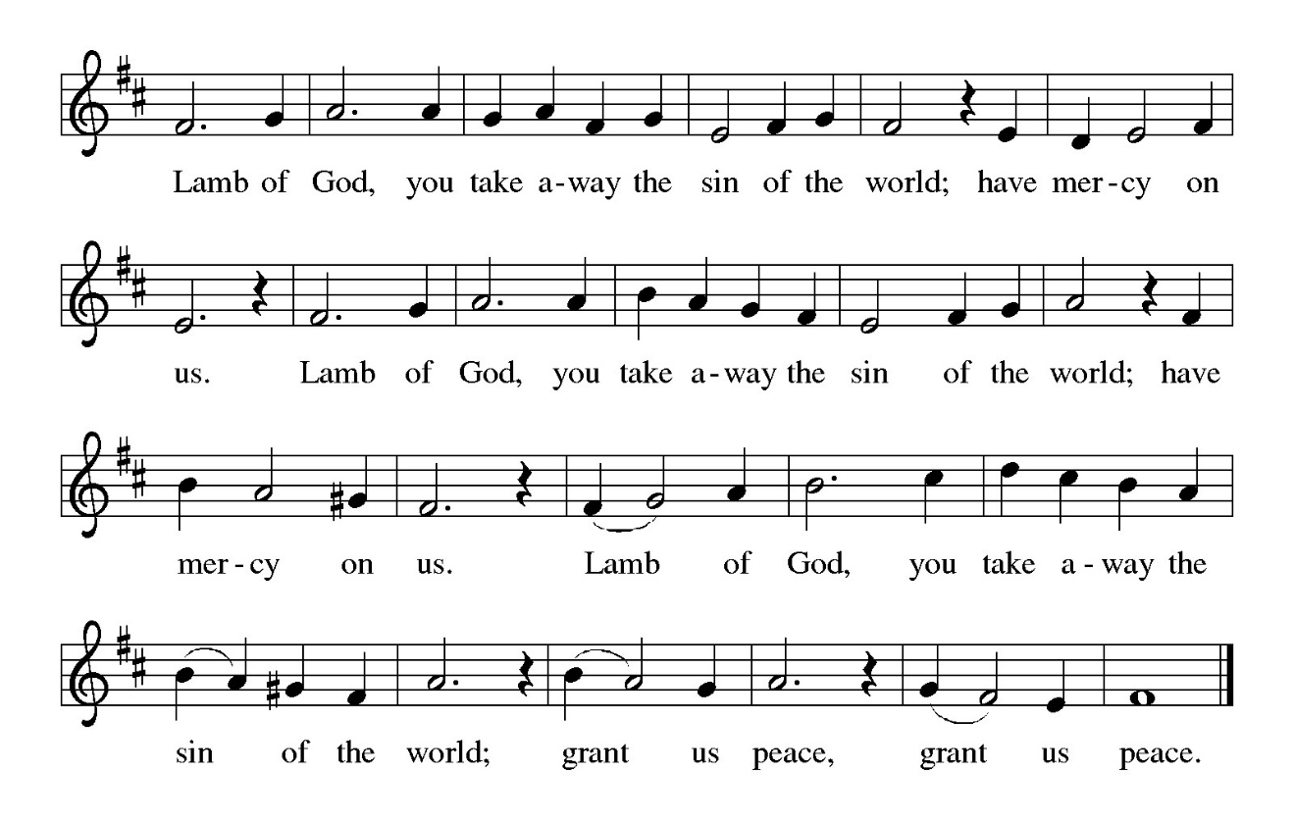
HYMN DURING DISTRIBUTION 696 Jesus Calls Us, O’er the Tumult
NSB 88 There is A Redeemer
NSB 105 You Are My All in All
NSB 104 You Are My Hiding Place
NSB 98 We Will Glorify

As you are able please rise

THE POST-COMMUNION BLESSING

P: The Body and Blood of our Lord Jesus Christ strengthen you and keep you in His grace.

C: Amen.

THE POST-COMMUNION PRAYER

A: Let us pray. Lord Jesus, in this Meal You have again invited us to “come and see” the riches
of Your love. You have revealed Yourself to us and bathed us in Your Light. Grant us grace
to invite others into Your presence, that at this Table, they, with us, may find what they are
looking for, both now and in the age to come. You are the Lord forevermore.

C: Amen.

SENDING

THE BENEDICTION

P: Almighty God: Father, Son, and Holy Spirit bless you now and forever.

C: Amen.

SENDING HYMN God, We Celebrate the Story

(Sung to the tune of: “Joyful, Joyful, We Adore Thee”)

God, we gather to remember all Your blessings in this place.
For the heritage we honor is a heritage of grace.
When our church was given land here, when we laid the corner stone,
When a Sunday School was planned here, it was by Your grace alone.

By Your grace You gave a vision to those settlers long ago.
As they served You here in mission soon Your church began to grow.
They promoted education, bought an organ, built new pews,
Year by year this congregation kept on sharing Your Good News.

By Your grace we’re still surrounded by those witnesses of old,
For our faith and work are grounded in the Good News that they told.
Now they point us toward tomorrow: “We in faith served God’s own Son;
Now it is your turn to follow, now it is your race to run!”

By Your grace through prayer and singing, worship fills our church’s days.
Choir and band and hand bells ringing, all are forms of joyful praise.
Love of God and love of neighbor send us out in Jesus’ name.
Worship leads us out to labor, serving You Whom we proclaim.

Text: Carolyn Winfrey Gillette, used by permission

THE DISMISSAL

A: You are servants of God; you are light to the nations.

Go in peace. Serve the Lord.

C: Thanks be to God!

POSTLUDE

To God Alone Be Glory

The Meditation is from Sundays and Seasons. Copyright 2001 Augsburg Fortress.

The Prayers, Introduction to the Lord’s Prayer, and Invitation to the Meal are adapted from Prayers
for Sundays and Seasons. Year A. Peter J. Scagnelli. (Chicago: Liturgy Training
Publications, 1998) 27-28.

ANNOUNCEMENTS

Please remember to mail your offering to the Church Office at 818 Franklin Street, Michigan City, IN 46360. Another alternative is to give on-line through Tithe.ly. Please see your closure letter for information on how to set up a Tithe.ly account.

St. Paul Members are reminded to have a loved one contact the office if you are hospitalized. Many times, the Pastor doesn’t know someone is in the hospital. If you call and leave a message, please tell us at which hospital the patient is located.

PRAYER CONCERNS: Robert Bernth; Barry Anderson; John Bennitt; Sarah McNabb; Debbie Martin; Mark Tannehill; Kathy Stein; Jan Paholski; Laura Dovey; Grace Romine; Bill Hazelgrove; Al Levenhagen; Carl Wipperman; Major Payne; Carol Hazelgrove; Allen Sydow; Elizabeth Sanders ; Roy Romine and Tim Miller.

OFFICE HOURS: Libby will be in the office on Mondays, Wednesdays, and Fridays; volunteers will cover Tuesdays and Thursdays.

Monday & Wednesday 8:00 a.m. – 5 p.m.
Tuesday & Thursday 9:00 a.m. – 12:00 p.m.
Friday 8:00 a.m. – 12:00 p.m.

If you are listening to the worship broadcast on the radio and would like to watch the Sunday morning service live stream follow these steps:

(1) If you have You Tube available on your TV, search for
St. Paul Lutheran Church Michigan City, IN.

(2) The direct link on the computer is https://
www.youtube.com/channel/UC5AIPNaKr3QN50984jGOa1g

(3) This link is also on the main page of the church’s website in
the church section and will continue to be posted weekly on the St.
Paul Facebook page.

And it will always be available on the radio broadcast Sunday mornings at 11:00 a.m.
on WEFM (95.9), and on the local cable access station #99 for the previous week’s
service on Sundays at 4:00 p.m. and the current service on Wednesdays at 7:00 p.m.
and Fridays at 8:30 p.m.

To send e-mail to the church office, please use the following addresses:

Pastor Mark Reshan: seniorpastor@stpaulmichigancity.com

Church Office Secretary (Libby Pollock): churchsecretary@stpaulmichigancity.com

Church Treasurer (Karen Fleming): finance@stpaulmichigancity.com

2026 Church Council:

Pastor - Mark Reshan

President - Donna Knoll

Vice President - Jan Bakken

Secretary -Judy Hunt

Treasurer -Karen Fleming

Members: Sue Koziel; Jim Schraidt; Trish Sprague; Bob Kiser; Barry Anderson; and
Pam Soule

Worship Attendance:
Saturday, January 10, 2026 @ 4:00 p.m. 24
Sunday, January 11, 2026 @ 9:00 a.m. 67
TOTAL 91

Copies of the minutes from the December 18, 2025 Church Council meeting are on the back table in the upper Narthex. It was approved by the council via email.

The Good News Newsletter: If you have an article or anything you want included in The Good News please send it to the following e-mail address: splcgoodnews@gmail.com. Pastor Pamela Thiede will be using this e-mail address to assemble The Good News each month. The deadline for getting information to Pastor Pamela will be the 20th of each month.

Sunday’s lessons are Isaiah 9: 1-4; Psalm 27: 1, 4-9; I Corinthians 1: 10-18; and
Matthew 4: 12-23 for those of you who like to study them in advance.

**2025 Donation Statements**

Donation statements are being sent out this week. Statements will not be sent through the regular mail due to the high cost of postage. If you have an email address on record in the church office you will receive your statement via email. If you don’t find it in your regular email please check your “junk” mail.

For those who do not have email your statement will be placed in your hanging file folder in the upper narthex at the back of the church. If you don’t find a statement in your hanging file or in your email then call the church office and let us know so we can make sure you get your statement.
Please review your statement and if you have any questions or concerns or have a correction that needs to be made call the church office at (219) 874-7293 and let Libby, the church secretary, or the Treasurer, Karen Fleming, know.

A big thank you to our painting crew: Bob Kiser; Rich Fleming; Craig Hunt; John Konkol; Tim Crozier; and Pastor Mark Kloess for giving the wall around the entry doors on the upper narthex across from the elevator a fresh coat. It looks new! We are so grateful for your time and service!

HELP NEEDED FOR OUR LOCAL SALVATION ARMY
Due to the pause taken by all the programs sponsored by SNAP, our local Salvation Army has been swamped with people needing help. All of the items placed in the grocery store cart located on the upper southwest corner of the outer Narthex is taken to our Michigan City Salvation Army location. The cart has a large hippo asking you to help “fill ‘er up!” Whatever you can do to help is greatly appreciated.

MISSION OF THE MONTH FOR JANUARY 2026

We have many dedicated Meals on Wheels volunteers within our church family. Their unwavering dedication not only ensures people in our community receive safe and nutritious meals, but the delivery also provides a wellness check, ensuring their safety and well-being. Meals on Wheels has a current need to replace their essential food delivery cases. Black (cold) cases can be sponsored for just $200, and Blue (hot) cases can be sponsored for $500. Every contribution helps ensure their clients receive meals each day. Case sponsorship includes sponsor’s name on the case, recognizing their support and commitment for years to come. Based on the total amount received, we will sponsor as many cases as possible in honor of our St. Paul Volunteers and Congregation. Please make checks payable to St. Paul and place in the offering. Noisy coin offering will also go towards the monthly mission. Thank you for your unwavering and continuous support of Meals on Wheels!

Our members who volunteer for Meals on Wheels include:
Don Thompson Jean Kleinschmidt
Tim & Stacie Crozier Bob & Karen Kiser
Craig & Judy Hunt Mary Knaup
Suzann Dolson Charmaine Imperato
Pam Waltz Janet Bakken

SNOW EMERGENCY LIST
This is a reminder of where to turn to learn if worship has been canceled because of inclement weather conditions. There are two ways to learn about the status of the service.
First, you may turn to our church and school Facebook page: https://www.facebook.com/stpaulmichigancity/ for updated announcements. Or, perhaps most quickly and easily, you may call the church office number (219-874-7293) and press the “#” key and you will hear a recording about our “open/closed” status.

ACTIVITIES, EVENTS & MEETINGS
January 2026

Saturday, January 10, 2026 @ 4:00 p.m. Baptism of Our Lord Worship Service/

Sunday, January 11, 2026 @ 9:00 a.m. Baptism of our Lord Worship Service/ Sanctuary with Coffee after/St. Paul Room

Monday, January 12, 2026 @ 1:00 p.m. Hope Circle/Green Room

Wednesday, January 14, 2026 @ 9:15 a.m. Bible Study/Luther House

@10:00 a.m. God’s Purls/St. Paul Room

@3:30 p.m. Worship & Music Mtg./Luther House

@ 4:30 p.m. Choir Rehearsal/Sanctuary
Thursday, January 15, 2026 @ 4:00 p.m. 150th Anniv. Comm./Luther Hose

Saturday, January 17, 2026 @ 4:00 p.m. 2 Epiphany Worship Service/Sanctuary

Sunday, January 18, 2026 @ 9:00 a.m. 2 Epiphany Worship Service/Sanctuary with Coffee after/St. Paul Room

Monday, January 19, 2026 @ 2:00 p.m. Finance Comm. Mtg./Luther House

@ 3:00 p.m. Executive Board Mtg./Lither House

Wednesday, January 21, 2026 @ 9:15 a.m. Bible Study/Luther House

@ 10:00 a.m. God’s Purls/St. Paul Room

@ 4:30 p.m. Choir Rehearsal

Thursday, January 22, 2026 @ 3:00 p.m. Church Council Mtg./St. Paul Room

Saturday, January 24, 2026 @ 4:00 p.m. 3 Epiphany Worship Service/Sanctuary

Sunday, January 25, 2026 @ 9:00 a.m. 3 Epiphany Worship Service/ Sanctuary with Coffee after/St. Paul Room

Wednesday, January 28, 2026 @ 9:15 a.m. Bible Study/Luther House

@10:00 a.m. God’s Purls/St. Paul Room

@ 4:30 p.m. Choir Rehearsal/Sanctuary

Saturday, January 31, 2026 @ 4:00 p.m. 4 Epiphany Worship Service/Sanctuary

