THE THIRD SUNDAY AFTER THE EPIPHANY
January 25, 2026

If we answer the call to discipleship, where will it lead us? What decisions and partings will it demand? To answer the question we shall have to go to Him, for only He knows the answer. Only Jesus Christ, Who bids us follow Him, knows the journey’s end. But we do know that it will be a road of boundless mercy. Discipleship means joy.

Dietrich Bonhoeffer
The Cost of Discipleship

The saints will be within their Creator just as the fish are in the sea. They will drink all they want, without becoming tired and without lessening the amount of water. The more they receive of this sweetness, the more will be their hunger for it. For just as the waves all go toward the sea and all come back, just so the beauty and the sweetness of our Lord, even though they are poured forth everywhere, always return to him. And for that, they can never diminish.

Marguerite d’Oingt

In the Name of Jesus

INTRODUCTION

Jesus begins his public ministry by calling fishers to leave their nets and follow Him. In Jesus the kingdom of God has come near. We who have walked in darkness have seen a great light. We see this light most profoundly in the cross—as God suffers with us and all who are oppressed by sickness, sin, or evil. Light dawns for us as we gather around the word, the font, and the holy table. We are then sent to share the good news that others may be "caught" in the net of God's grace and mercy.

Conversion of Paul

The week of prayer begun by the remembrance of Peter's confession now comes to an end as we recall the pivotal moment in the life of the other pillar of the early church, the apostle Paul. His encounter with the risen Christ turned him from persecutor of the followers of Christ to one of their leaders.

GATHERING

PRE-SERVICE MUSIC Love is Here New Song Praise Band
(Donehay, Jamison, LaRue, Ingram & Middleton)

ANNOUNCEMENTS

As you are able please rise

P: In the name of the Father and of the Son and of the Holy Spirit.

C: Amen.

P: “Hearken to my voice, O LORD, when I call; have mercy on me and answer me.”
(Psalm 27: 10) God is always ready to hear our confession and grant us a new heart and
a right spirit. Let us therefore confess our sins, drawing near to God in humility and
confidence.

Silence for self-examination and reflection is kept

P: Most merciful God,

C: We confess that we are sinners in need of Your forgiveness. We have not sought
You as You desire (Psalm 27: 11). We have not been of the same mind and
purpose, and have quarreled with one another (1 Corinthians 1: 10-11). We have
neither daily repented (Matthew 4: 17), followed Jesus (Matthew 4: 19), nor
“fished for people.” You are our “light and our salvation” O God. (Psalm 27: 1)
To You we now turn in repentance and trust. For the sake of Your Son, Jesus
Christ, “answer” our cries for “mercy” (Psalm 27: 10). Forgive us, renew us, and
strengthen us to follow and serve where Christ leads the way.

P: “Hide not Your face from me, nor turn away Your servant in displeasure.” (Psalm 27:
13) God never tires of granting mercy to those who seek Him. Therefore, as a called
and ordained minister of the Church of Christ, and by His authority, I declare to you
the entire forgiveness of all your sins, in the name of the Father and of the Son and
of the Holy Spirit.

C: Amen.

GATHERING HYMN 520 Dearest Jesus, at Your Word

THE GREETING AND PRAYER OF THE DAY

P: To the Church of God in this place, to those who are called to be saints, to all those who
call upon the name of our Lord Jesus Christ:

The grace of our Lord Jesus Christ, the love of God, and the communion of the Holy
Spirit be with you all.

C: And also with you.

P: Let us pray. Lord God, Your lovingkindness always goes before us and follows after
us. Summon us into Your light, and direct our steps in the ways of goodness that come
through the cross of Your Son, Jesus Christ, our Savior and Lord.

C: Amen.

The assembly is seated

WORD

FIRST READING Isaiah 9: 1-4

The people in the northern parts of Israel have experienced "gloom" and "darkness" because of the destruction wrought by Assyrian military forces. To these people, the prophet announces the shining of a great light of salvation. Matthew equates this light with the beginning of Jesus' ministry in Galilee.

There will be no gloom for those who were in anguish. In the former time the LORD brought into contempt the land of Zebulun and the land of Naphtali, but in the latter time he will make glorious the way of the sea, the land beyond the Jordan, Galilee of the nations.
²The people who walked in darkness
have seen a great light;
those who lived in a land of deep darkness--
on them light has shined.
³You have multiplied the nation,
you have increased its joy;
they rejoice before you
as with joy at the harvest,
as people exult when dividing plunder.
⁴For the yoke of their burden,
and the bar across their shoulders,
the rod of their oppressor,
you have broken as on the day of Midian.

The Word of the Lord.

Thanks be to God.

THE PSALM: Psalm 27: 1, 4-9 Antiphon by Ronald Nelson

Choir sings refrain first, followed immediately by the congregation
and as indicated

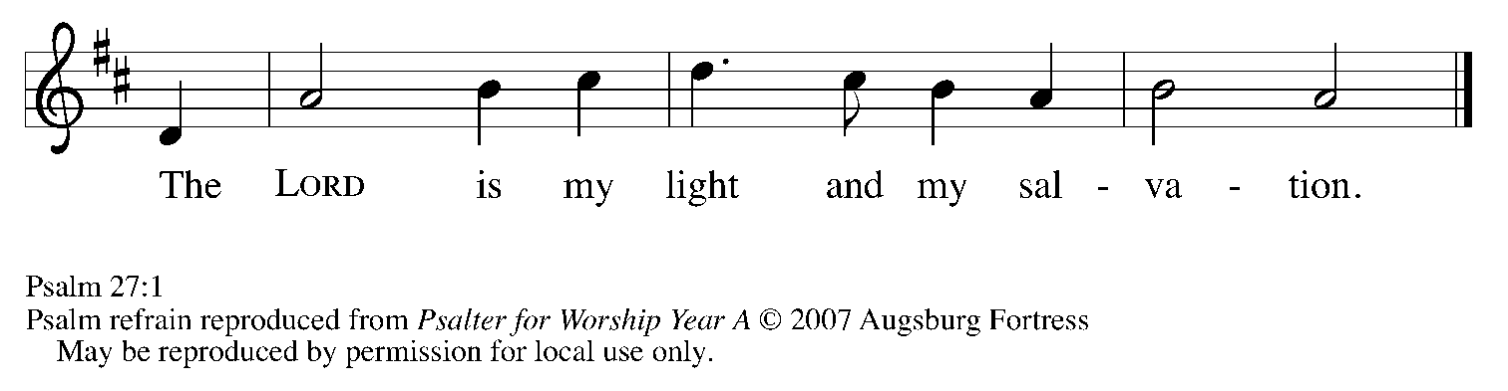

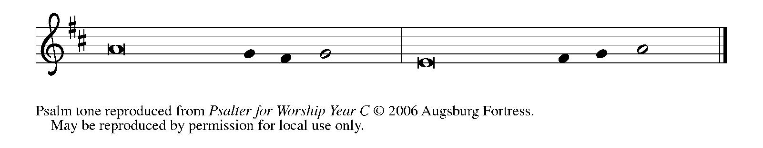

¹The LORD is my light and my salvation; whom then | shall I fear?
The LORD is the stronghold of my life; of whom shall I | be afraid?

⁴One thing I ask of the LORD; one | thing I seek;
that I may dwell in the house of the LORD all the days of my life; to gaze upon the beauty of the LORD and to seek God | in the temple.

⁵For in the day of trouble God will | give me shelter,
hide me in the hidden places of the sanctuary, and raise me high up- | on a rock.

⁶Even now my head is lifted up above my enemies | who surround me.
Therefore I will offer sacrifice in the sanctuary, sacrifices of rejoicing; I will sing and make music | to the LORD. REFRAIN

⁷Hear my voice, O LORD, | when I call;
have mercy on me and | answer me.

⁸My heart speaks Your message— | "Seek My face."
Your face, O LORD, | I will seek.

⁹Hide not Your face from me, turn not away from Your ser- | vant in anger.
Cast me not away—You have been my helper; forsake me not, O God of | my salvation. REFRAIN

SECOND READING 1 Corinthians 1: 10-18

Three of the most highly respected missionaries in the early church were Paul, Apollos, and Cephas (also known as Simon Peter). Still, as Paul himself attests, respect for any human leader is misplaced if it becomes divisive or obscures devotion to Christ.

Now I appeal to you, brothers and sisters, by the name of our Lord Jesus Christ, that all of you be in agreement and that there be no divisions among you, but that you be united in the same mind and the same purpose. ¹¹For it has been reported to me by Chloe's people that there are quarrels among you, my brothers and sisters. ¹²What I mean is that each of you says, "I belong to Paul," or "I belong to Apollos," or "I belong to Cephas," or "I belong to Christ."
¹³Has Christ been divided? Was Paul crucified for you? Or were you baptized in the name of Paul? ¹⁴I thank God that I baptized none of you except Crispus and Gaius, ¹⁵so that no one can say that you were baptized in my name. ¹⁶(I did baptize also the household of Stephanas; beyond that, I do not know whether I baptized anyone else.)
¹⁷For Christ did not send me to baptize but to proclaim the gospel, and not with eloquent wisdom, so that the cross of Christ might not be emptied of its power. ¹⁸For the message about the cross is foolishness to those who are perishing, but to us who are being saved it is the power of God.

The Word of the Lord.

Thanks be to God.

As you are able please rise
THE VERSE

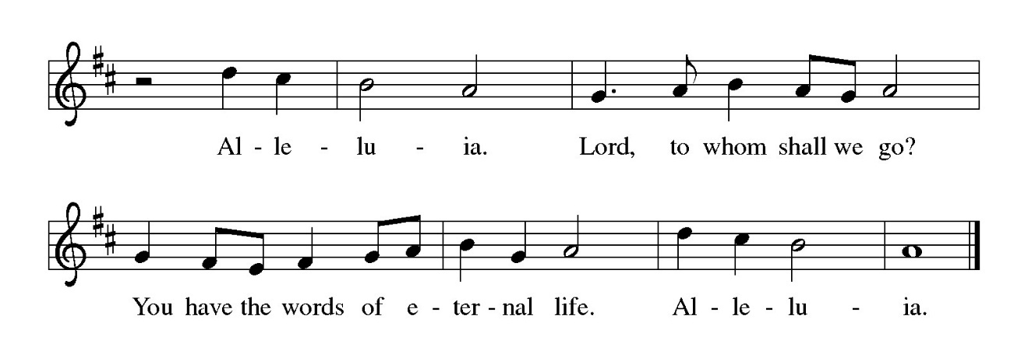

THE HOLY GOSPEL Matthew 4: 12-23

John the Baptist called everyone to repent, including the ruler Herod, who had him thrown in prison. It was at this point that Jesus began his public ministry, proclaiming the nearness of the reign of God.

P: The Holy Gospel according to St. Matthew, the fourth chapter.

C: Glory to You, O Lord!

Now when Jesus heard that John had been arrested, He withdrew to Galilee. ¹³He left Nazareth and made His home in Capernaum by the sea, in the territory of Zebulun and Naphtali, ¹⁴so that what had been spoken through the prophet Isaiah might be fulfilled:
¹⁵"Land of Zebulun, land of Naphtali,
on the road by the sea, across the Jordan, Galilee of the Gentiles--
¹⁶the people who sat in darkness
have seen a great light,
and for those who sat in the region and shadow of death
light has dawned."
¹⁷From that time Jesus began to proclaim, "Repent, for the kingdom of heaven has come near."
¹⁸As He walked by the Sea of Galilee, He saw two brothers, Simon, who is called Peter, and Andrew his brother, casting a net into the sea--for they were fishermen. ¹⁹And He said to them, "Follow Me, and I will make you fish for people."
²⁰Immediately they left their nets and followed Him. ²¹As He went from there, He saw two other brothers, James son of Zebedee and his brother John, in the boat with their father Zebedee, mending their nets, and He called them. ²²Immediately they left the boat and their father, and followed Him.
²³Jesus went throughout Galilee, teaching in their synagogues and proclaiming the good news of the kingdom and curing every disease and every sickness among the people.

P: The Gospel of the Lord.

C: Praise to You, O Christ!

The assembly is seated

THE SERMON

Silence for reflection follows the sermon

As you are able please rise

THE HYMN OF THE DAY 715 Christ Be Our Light

THE APOSTLES’ CREED

A: God has made us His people through our Baptism into Christ. Living together in trust
and hope, we confess our faith.

C: I believe in God, the Father Almighty,
Creator of heaven and earth.
I believe in Jesus Christ, His only Son, our Lord.
He was conceived by the power of the Holy Spirit,
and born of the Virgin Mary.
He suffered under Pontius Pilate,
was crucified, died, and was buried.
He descended into hell.
On the third day He rose again.
He ascended into heaven,
and is seated at the right hand of the Father.
He will come again to judge the living and the dead.
I believe in the Holy Spirit,
the holy catholic Church,
the communion of saints,
the forgiveness of sins,
the resurrection of the body,
and the life everlasting. Amen.

THE PRAYER OF THE CHURCH

A: Illumined by the light of Christ, united in the same mind and the same purpose, let us
pray for all nations, and for all in need of His healing presence.

A: That all Christians, divided and often ignorant of one another, may work to move
beyond the quarrels of the past to be unified in ministry and mission to the world, we
pray:

C: Send forth Your light, O God.

A: That nations and peoples overshadowed by the violence of war, terrorism, and ancient
hatreds may see the joyful dawning of peace, we pray:

C: Send forth Your light, O God.

A: That refugees from every country may be sustained in their fear and weariness, and that
agencies who provide food, shelter, and medical care, especially Lutheran Immigration
and Refugee Service may be Your face of compassion, we pray:
C: Send forth Your light, O God.

A: That our congregation, with its diverse gifts, may show to all in need the power of the
cross through our service and compassion, we pray:

C: Send forth Your light, O God.

A: That the sick, and those in need of our prayers, especially: Major Payne; Martha
Schroeder; Fred Weiss; David Weiss; Joyce Stark; Jackie Gaines; John Bennitt;
Carl Wipperman; Christine Kiser; Kathy Thielman; Shirley Shikany Long;
Catherine Lanigan; Roy Romine and Tim Miller may be filled with the bright light
of God’s healing, we pray:

C: Send forth Your light, O God.

A: That those celebrating birthdays, especially Eloise Ponder and Elaine Bogart may
grow in grace this day and every day and be filled with grace for the days ahead, we
pray:

C: Send forth Your light, O God.

A: That Charlotte Judith Lucille Barton, born to Hannah Payne and Cameron Barton may
be kept in health and safety, and that their family may grow together in the love and
blessings of Christ, we pray:

C: Send forth Your light, O God.

A: That those who mourn, especially the family and friends of Gene Marty, who died in
the Lord this week, may be comforted by the promise of resurrection to life everlasting
and of being reunited with those they love before the throne of the Lamb, we pray:

C: Send forth Your light, O God.

A: That with all the saints, especially Paul, Apostle, whom we commemorate this Day we
may one day rejoice before the glorious presence of God, we pray:

C: Send forth Your light, O God.

P: O God, You revealed Your will to prophets and sages. By Your Holy Spirit, show us
how to serve You today, that all nations may know You in our love, through Jesus
Christ our Lord.

C: Amen.

MEAL

THE PEACE

P: The peace of the Lord be with you always.

C: And also with you.

The assembly is seated
THE OFFERING

THE VOLUNTARY The Power of the Cross New Song Praise Band
(Getty & Townend)

As you are able please rise

THE PRESENTATION OF GIFTS Jesus, Come! For We Invite You
(stanzas 1, 4)

(Sung to the tune of, Angels From the Realms of Glory)

Jesus, come! for we invite You,
Guest and Master, Friend and Lord;
now, as once at Cana's wedding,
speak and let us hear Your word:
lead us through our need or doubting,
hope be born and joy restored.

Jesus, come! surprise our dullness,
make us willing to receive
more than we can yet imagine,
all the best You have to give:
let us find Your hidden riches,
taste Your love, believe, and live!

THE OFFERTORY PRAYER

A: Let us pray. Gracious God,

C: In repentance and faith we bring these gifts to You. As Your Kingdom again
comes near to us in this holy Sacrament, by our eating and drinking, unite us with
the mind and purpose of Christ, that we may faithfully shine His light to all the
world. We ask this in the name of Jesus the Lord. Amen.

THE GREAT THANKSGIVING

P: The Lord be with you.

C: And also with you.

P: Lift up your hearts.

C: We lift them up to the Lord.

P: Let us give thanks to the Lord our God.

C: It is right to give Him thanks and praise.

P: Worthy of praise and thanksgiving are You, Lord God, for You summoned all things
into being, and from the beginning You beckoned Your creation to fullness
of life in You.
Through covenant You claimed a people to share Your life; in slavery You called
them to freedom; in exile You summoned them to faithfulness; in their sin
You beckoned them toward Your Light.
From the first day until now You have called creation to share Your goodness.
In Christ You came seeking our salvation with Your very life, bidding us to come and
follow.
Our rejection of Him led to the horror of the cross, but You have drawn us to Yourself
forever through the glory of His resurrection.
Sustaining God, in You many become one.
You gathered fishermen from their nets to become apostles; just so You take grain
from the fields and grapes from the vine to make this holy Meal.
And now You gather us around this Table to remember the story of our redemption.
Make us one body.
Sustain us by the grace of the one Bread we share and one cup of blessing which we
bless.
Send Your Spirit upon this bread and wine that it may be for us the Body and Blood
of Christ;
Who, in the night ... “Do this for the remembrance of Me.”
As often as we eat ... we proclaim the Lord’s death until He comes.

C: Christ has died. Christ is risen. Christ will come again.

P: Generous God, in Christ You threw wide the net of Your grace, calling disciples one
by one to be Your followers; not in their own righteousness but because
You would have us be Your companions and share Your glory forever.
Reveal in Your Church the wideness of Your mercy.
Bless those today who wonder if they have strayed too far to be found by Your or
to belong among Your people.
Inspire all who struggle to know their purpose in Your Kingdom and long to hear
Your voice.
Beckon Your disciples to come and follow, to work alongside You, casting the
net of grace, until all are gathered and one in You, ever-seeking and
ever-saving God,
Father, Son, and Holy Spirit.

C: Amen!

THE LORD’S PRAYER

P: Because in Christ we have received the Spirit of adoption, as daughters and sons of
God, we dare to pray:

C: Our Father, Who art in heaven, hallowed be Thy Name. Thy Kingdom come.
Thy will be done on earth as it is in heaven. Give us this day our daily bread, and
forgive us our sins as we forgive those who sin against us. And lead us not into
temptation, and deliver us from evil, for Thine is the Kingdom, and the power,
and glory, forever and ever. Amen.

INVITATION TO THE MEAL

P: Behold the true Light of the world, the Beloved of God, anointed by the Spirit. Blessed
are those who are called to the Supper of the Lamb. God’s holy gifts for God’s holy
people. Come, for all is now ready.

The assembly is seated

THE DISTRIBUTION Lamb of God
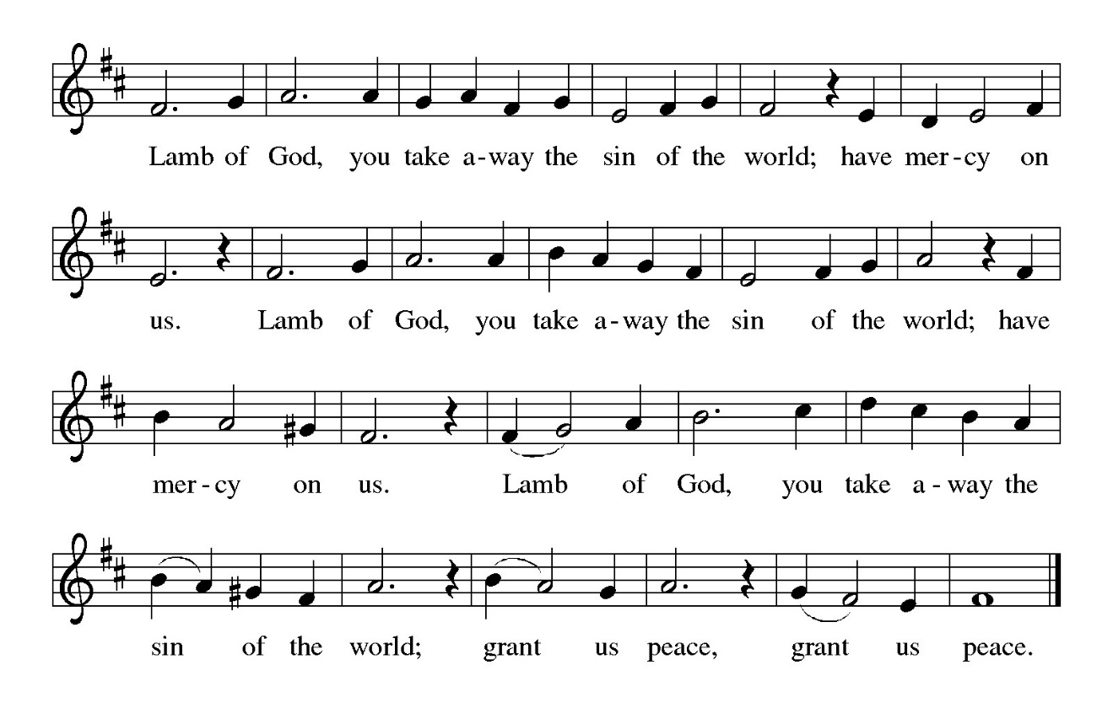
HYMN DURING DISTRIBUTION 798 Will You Come and Follow Me
NSB 86 The Power of Your Love
NSB 84 The Potter’s Hand
NSB 14 Bind Us Together
As you are able please rise

THE POST-COMMUNION BLESSING

P: The Body and Blood of our Lord Jesus Christ strengthen you and keep you in His grace.

C: Amen.

THE POST-COMMUNION PRAYER

A: Let us pray. Gracious God, our hands have taken holy things; our lives have been
nourished by the Body and Blood of Your Son. Increase our joy and faith, that we may
be strengthened for service in Your world. Grant this through Christ our Lord.
C: Amen.

SENDING

THE BENEDICTION

P: Almighty God: Father, Son, and Holy Spirit bless you now and forever.

C: Amen.

SENDING SONG 674 Let Us Talents and Tongues Employ

THE DISMISSAL

A: You are servants of God; you are light to the nations.
Go in peace. Serve the Lord.

C: Thanks be to God!

To God Alone Be Glory

The Meditation is from Words for Worship. Copyright Augsburg Fortress 2001.

The Prayers, Introduction to the Lord’s Prayer, and Invitation to the Meal are adapted from
Prayers for Sundays and Seasons. Year A. Peter J. Scagnelli. (Chicago: Liturgy
Training Publications, 1998) 27-28.

The Post-Communion Prayer is also adapted from The Book of Alternative Services.
(Toronto: Anglican Book Centre, 1985) 231.

ANNOUNCEMENTS

Please remember to mail your offering to the Church Office at 818 Franklin Street, Michigan City, IN 46360. Another alternative is to give on-line through Tithe.ly. Please see your closure letter for information on how to set up a Tithe.ly account.

St. Paul Members are reminded to have a loved one contact the office if you are hospitalized. Many times, the Pastor doesn’t know someone is in the hospital. If you call and leave a message, please tell us at which hospital the patient is located.

BIRTHDAYS: Elaine Bogart and Eloise Ponder (1/28)

PRAYER CONCERNS: Robert Bernth; Barry Anderson; John Bennitt; Sarah McNabb; Debbie Martin; Mark Tannehill; Kathy Stein; Jan Paholski; Laura Dovey; Grace Romine; Bill Hazelgrove; Al Levenhagen; Carl Wipperman; Major Payne; Carol Hazelgrove; Allen Sydow; Elizabeth Sanders ; Roy Romine and Tim Miller.

OFFICE HOURS: Libby will be in the office on Mondays, Wednesdays, and Fridays; volunteers will cover Tuesdays and Thursdays.

Monday & Wednesday 8:00 a.m. – 5 p.m.
Tuesday & Thursday 9:00 a.m. – 12:00 p.m.
Friday 8:00 a.m. – 12:00 p.m.

If you are listening to the worship broadcast on the radio and would like to watch the Sunday morning service live stream follow these steps:

(1) If you have You Tube available on your TV, search for
St. Paul Lutheran Church Michigan City, IN.

(2) The direct link on the computer is https://
www.youtube.com/channel/UC5AIPNaKr3QN50984jGOa1g

(3) This link is also on the main page of the church’s website in
the church section and will continue to be posted weekly on the St.
Paul Facebook page.

And it will always be available on the radio broadcast Sunday mornings at 11:00 a.m.
on WEFM (95.9), and on the local cable access station #99 for the previous week’s
service on Sundays at 4:00 p.m. and the current service on Wednesdays at 7:00 p.m.
and Fridays at 8:30 p.m.

To send e-mail to the church office, please use the following addresses:

Pastor Mark Reshan: seniorpastor@stpaulmichigancity.com

Church Office Secretary (Libby Pollock): churchsecretary@stpaulmichigancity.com

Church Treasurer (Karen Fleming): finance@stpaulmichigancity.com

2026 Church Council:

Pastor - Mark Reshan

President - Donna Knoll

Vice President - Jan Bakken

Secretary -Judy Hunt

Treasurer -Karen Fleming

Members: Sue Koziel; Jim Schraidt; Trish Sprague; Bob Kiser; Barry Anderson; and
Pam Soule

Worship Attendance:
Saturday, January 17, 2026 @ 4:00 p.m. 30
Sunday, January 18, 2026 @ 9:00 a.m. 70
TOTAL 100

Copies of the minutes from the December 18, 2025 Church Council meeting are on the back table in the upper Narthex. It was approved by the council via email.

The Good News Newsletter: If you have an article or anything you want included in The Good News please send it to the following e-mail address: splcgoodnews@gmail.com. Pastor Pamela Thiede will be using this e-mail address to assemble The Good News each month. The deadline for getting information to Pastor Pamela will be the 20th of each month.

Next week’s lessons are Malachi 3: 1-4; Psalm 84; Hebrews 2: 14-18; and Luke 2:
22-40 for those of you who like to study them in advance.

**2025 Donation Statements**

Donation statements have been sent out. Statements will not be sent through the regular mail due to the high cost of postage. If you have an email address on record in the church office you will receive your statement via email. If you don’t find it in your regular email please check your “junk” mail.

For those who do not have email your statement has been placed in your hanging file folder in the upper narthex at the back of the church. If you don’t find a statement in your hanging file or in your email then call the church office and let us know so we can make sure you get your statement.
Please review your statement and if you have any questions or concerns or have a correction that needs to be made call the church office at (219) 874-7293 and let Libby, the church secretary, or the Treasurer, Karen Fleming, know.

A big thank you to our painting crew: Bob Kiser; Rich Fleming; Craig Hunt; John Konkol; Tim Crozier; and Pastor Mark Kloess for giving the wall around the entry doors on the upper narthex across from the elevator a fresh coat. It looks new! We are so grateful for your time and service!

HELP NEEDED FOR OUR LOCAL SALVATION ARMY
Due to the pause taken by all the programs sponsored by SNAP, our local Salvation Army has been swamped with people needing help. All of the items placed in the grocery store cart located on the upper southwest corner of the outer Narthex is taken to our Michigan City Salvation Army location. The cart has a large hippo asking you to help “fill ‘er up!” Whatever you can do to help is greatly appreciated.

MISSION OF THE MONTH FOR JANUARY 2026

We have many dedicated Meals on Wheels volunteers within our church family. Their unwavering dedication not only ensures people in our community receive safe and nutritious meals, but the delivery also provides a wellness check, ensuring their safety and well-being. Meals on Wheels has a current need to replace their essential food delivery cases. Black (cold) cases can be sponsored for just $200, and Blue (hot) cases can be sponsored for $500. Every contribution helps ensure their clients receive meals each day. Case sponsorship includes sponsor’s name on the case, recognizing their support and commitment for years to come. Based on the total amount received, we will sponsor as many cases as possible in honor of our St. Paul Volunteers and Congregation. Please make checks payable to St. Paul and place in the offering. Noisy coin offering will also go towards the monthly mission. Thank you for your unwavering and continuous support of Meals on Wheels!

Our members who volunteer for Meals on Wheels include:

Don Thompson Jean Kleinschmidt
Tim & Stacie Crozier Bob & Karen Kiser
Craig & Judy Hunt Mary Knaup
Wayne & Suzann Dolson Charmaine Imperato
Pam Waltz Janet Bakken
Kelly & Brad Neulieb

SNOW EMERGENCY LIST
This is a reminder of where to turn to learn if worship has been canceled because of inclement weather conditions. There are two ways to learn about the status of the service.
First, you may turn to our church and school Facebook page: https://www.facebook.com/stpaulmichigancity/ for updated announcements. Or, perhaps most quickly and easily, you may call the church office number (219-874-7293) and press the “#” key and you will hear a recording about our “open/closed” status.

THANK YOU
On behalf of the Payne family and Major, we want to express our deepest gratitude. The congregation and individual kindness through cards, gifts and especially your prayers has been a source of hope and strength during this difficult journey. Major’s recovery from this devastating accident is ongoing, and your outpouring of love and faith have brought us comfort and peace. As scriptures remind us “The Lord is my strength and my shield; my heart trusts Him, and He helps me.” (Psalm 28:7) Please continue to keep him in your prayers, they mean more than words can ever convey.
Chuck & Sherry Payne

2026 Financial Stewardship

Weekly Church Operating Needs (x 2 weeks)
January 10-11, 2026 and January 17-18, 2026 $ 12,912.00

General Fund (including General Memorials): $ 13,750.00

Overage/Shortage: + $ 838.00

Restricted Income (not including Memorials)
Supports IK Synod & Church wide Ministries: $ 196.00

Ministries in our Community/Congregation: $ 275.00

Capital Fund: $ 277.00

Memorials
Organ Fund: $ 60.00

Thank$ for $haring
Thank you to all who participate in our Give-Back opportunities each month where we earn $$ to add to our Mission of the Month donations from our congregation to those in our community who need our help!
On January 7th, 2026 we earned $114 from our Give Back at 5 Guys.” On
Thursday, February 5, 2026 we’re going to meet at Galveston Steak House for our GIVE BACK from 4pm—10pm. Here are two coupons—one for you and one for a friend.

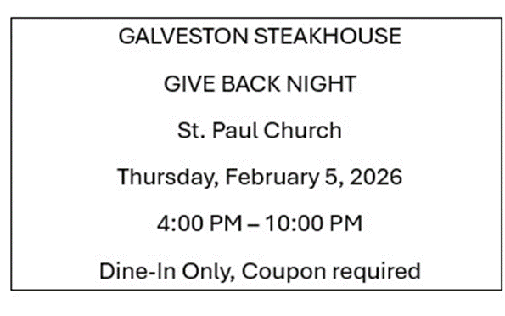

ACTIVITIES, EVENTS & MEETINGS
January 2026

Sunday, January 18, 2026 @ 9:00 a.m. 2 Epiphany Worship Service/Sanctuary with Coffee after/St. Paul Room

Monday, January 19, 2026 @ 2:00 p.m. Finance Comm. Mtg./Luther House

@ 3:00 p.m. Executive Board Mtg./Lither House

Wednesday, January 21, 2026 @ 9:15 a.m. Bible Study/Luther House

@ 10:00 a.m. God’s Purls/St. Paul Room

@ 4:30 p.m. Choir Rehearsal

Thursday, January 22, 2026 @ 3:00 p.m. Church Council Mtg./St. Paul Room

Saturday, January 24, 2026 @ 4:00 p.m. 3 Epiphany Worship Service/Sanctuary

Sunday, January 25, 2026 @ 9:00 a.m. 3 Epiphany Worship Service/ Sanctuary with Coffee after/St. Paul Room

Wednesday, January 28, 2026 @ 9:15 a.m. Bible Study/Luther House

@10:00 a.m. God’s Purls/St. Paul Room

@ 4:30 p.m. Choir Rehearsal/Sanctuary

Saturday, January 31, 2026 @ 4:00 p.m. 4 Epiphany Worship Service/Sanctuary

