THE NINETEENTH SUNDAY AFTER PENTECOST
October 4, 2026

The vineyard should not be too hastily or too completely identified with the church. Matthew identifies it with the Kingdom of God. It would well be viewed as the world, or at least as God's method of dealing with everyone. Moreover, it is the tenants, not the vineyard, who stand at the center of the parable. If these tenants represented the faithless leaders of Israel, then the new tenants represent the leaders of the church. The threat under which the former renters stood remains doubly valid for the new renters. In other words, the allegory becomes a two-edged sword, with a message for every generation of tenants.

Paul Minear

Teach me, O God, so to use all the circumstances of my life today that they may bring forth fruits of holiness rather than the fruits of sin.

John Baille

O heavenly Father, open wide the sluice gate
into my
heart that I may receive living water and be
fruitful.

Prayer of a Punjabi Christian

In the Name of Jesus

GATHERING

INTRODUCTION

In today's gospel reading, Jesus tells a parable of the vineyard, an image of Israel, the prophets' mission, and Christ's death. For Christians, the vineyard also speaks of God's love poured out in the blood of Christ, given to us for the forgiveness of sin. Grafted onto Christ the vine at baptism, we are nourished with wine and bread, that we may share Christ's sufferings and know the power of his resurrection.

Francis of Assisi, renewer of the church, died 1226

Born into the family of a wealthy merchant, Francis gave up his inheritance to serve poor people. He formed the Order of Friars Minor (called Franciscans), who took on poverty and the task of preaching "using words if necessary." Francis had a spirit of gratitude for all of God's creation.

Theodor Fliedner, renewer of society, died 1864

Fliedner helped to bring about a revival of the ministry of deaconesses among Lutherans. He was influenced in this by Moravian deaconesses he had met. The motherhouse he founded in Kaiserswerth, Germany, inspired many around the world to take up this ministry.

PRE-SERVICE MUSIC Eagles’s Wings New Song Praise Band
(Reuben Morgan)

ANNOUNCEMENTS

As you are able please rise

CONFESSION AND ABSOLUTION

P: In the name of the Father and of the Son and of the Holy Spirit.

C: Amen.

P: “For (Christ’s) sake I have suffered the loss of all things, and I regard them as rubbish, in order
that I may gain Christ and be found in Him, not having a righteousness of my own that comes
from the law, but one that comes through faith in Christ, the righteousness from God based on
faith.” (Philippians 3: 8b-10) God desires to make us “right” with Him. Therefore let us
confess our sins that through His gracious mercy we might again be “found” in His forgiveness.

Silence for reflection and self-examination is kept

P: Most merciful God,

C: We confess that we have sinned against You in thought, word, and deed. We have not
produced faithful fruits of just and right living. (Matthew 21: 34) We have sought to keep
Your goodness for ourselves. (21: 35) We have avoided sharing in the sufferings of Christ
and the world. (Philippians 3: 10) We are guilty of seeking other “goals” than knowing
and becoming like Christ (3: 12). We turn to You, O God, for forgiveness. For the sake
of Your Son, Jesus Christ, have mercy on us. Renew us in faith, guide us in faithful living,
and bring us again into the fruitful field of Your love.

P: “Restore us, O God of hosts; show the light of Your countenance, and we shall be saved.”
(Psalm 80: 7) In Jesus Christ, God’s true Vine, God’s face is turned toward you in mercy. For
as a called and ordained minister of the Church of Christ, and by His authority, I therefore
declare to you the entire forgiveness of all your sins, in the name of the Father and of the
Son, and of the Holy Spirit.

C: Amen.

GATHERING HYMN NSB 4 (2x) All Creation Worships You
THE GREETING AND PRAYER OF THE DAY

P: The grace of our Lord Jesus Christ, the love of God, and the communion of the Holy Spirit be
with you all.

C: And also with you.

P: Let us pray. Beloved God, from You come all things that are good. Lead us by the inspiration
of Your Spirit to know those things that are right, and by Your merciful guidance, help us to
do them, through Jesus Christ, our Savior and Lord.

C: Amen.
The assembly is seated

WORD
FIRST READING Isaiah 5: 1-7

The prophet sings a sad, parable-like love song about the relationship between God and Israel. Israel is likened to a promising vineyard that now must be destroyed. Despite God's loving care, Israel has brought forth "wild grapes" of injustice and distress where fine grapes of justice and righteousness were expected. Having failed to uphold the covenant, Israel will bear the Lord's judgment.

Let me sing for my beloved
my love-song concerning His vineyard:
My beloved had a vineyard
on a very fertile hill.
²He dug it and cleared it of stones,
and planted it with choice vines;
He built a watchtower in the midst of it,
and hewed out a wine vat in it;
He expected it to yield grapes,
but it yielded wild grapes.
³And now, inhabitants of Jerusalem
and people of Judah,
judge between Me
and My vineyard.
⁴What more was there to do for my vineyard
that I have not done in it?
When I expected it to yield grapes,
why did it yield wild grapes?
⁵And now I will tell you
what I will do to My vineyard.
I will remove its hedge,
and it shall be devoured;
I will break down its wall,
and it shall be trampled down.
⁶I will make it a waste;
it shall not be pruned or hoed,
and it shall be overgrown with briers and thorns;
I will also command the clouds
that they rain no rain upon it.
⁷For the vineyard of the LORD of hosts
is the house of Israel,
and the people of Judah
are His pleasant planting;
He expected justice,
but saw bloodshed;
righteousness,
but heard a cry!
The Word of the Lord.

Thanks be to God.

THE PSALM: Psalm 80: 7-1 Antiphon by John W. Becker
Choir sings refrain first, followed immediately by the congregation
and as indicated

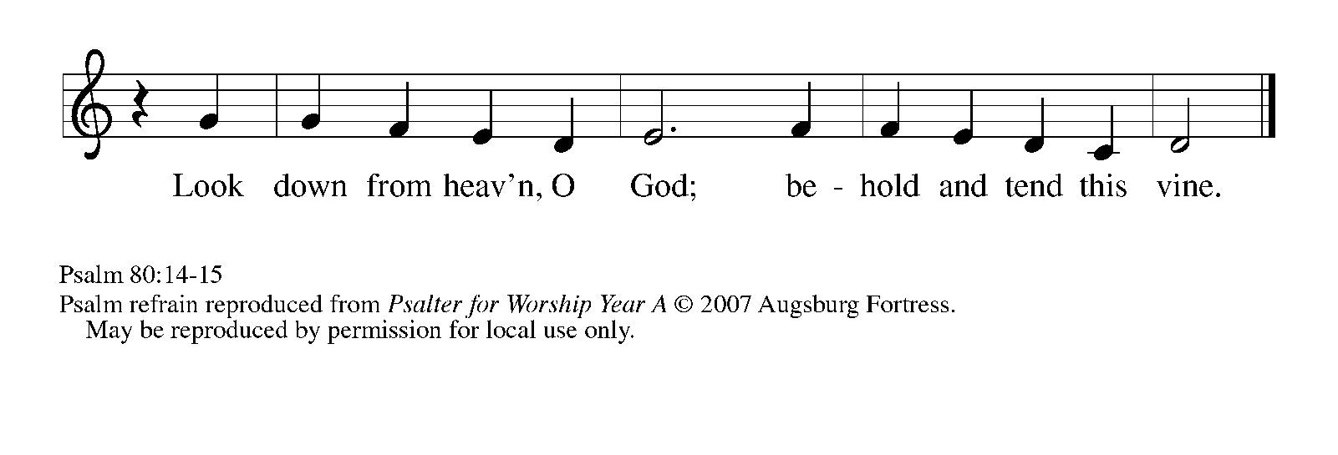
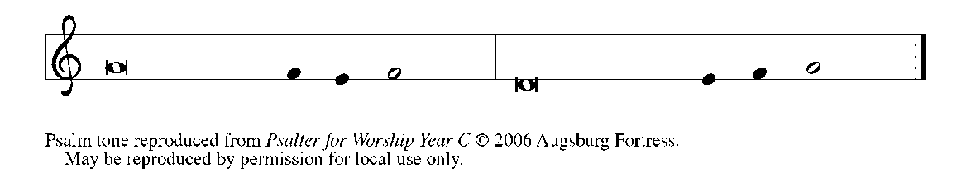
⁷Restore us, O | God of hosts;
let Your face shine upon us, and we | shall be saved.

⁸You have brought a vine | out of Egypt;
You cast out the nations and | planted it.

⁹You cleared the | ground for it;
it took root and | filled the land.

¹⁰The mountains were covered | by its shadow
and the towering cedar trees | by its boughs. REFRAIN

¹¹You stretched out its tendrils | to the sea
and its branches | to the river.

¹²Why have You broken | down its wall,
so that all who pass by pluck | off its grapes?

¹³The wild boar of the forest has | ravaged it,
and the beasts of the field have | grazed upon it.

¹⁴Turn now, O | God of hosts,
look | down from heaven;

¹⁵behold and | tend this vine;
preserve what Your right | hand has planted. REFRAIN
SECOND READING Philippians 3: 4b-14
Paul has warned the Philippians about Christian leaders who may have impressive credentials but do not witness to the gospel of Christ. Now he offers his own list of credentials, only to reject them all in favor of what he considers truly significant.
[Paul writes:] If anyone else has reason to be confident in the flesh, I have more: ⁵circumcised on the eighth day, a member of the people of Israel, of the tribe of Benjamin, a Hebrew born of Hebrews; as to the law, a Pharisee; ⁶as to zeal, a persecutor of the church; as to righteousness under the law, blameless.
⁷Yet whatever gains I had, these I have come to regard as loss because of Christ. ⁸More than that, I regard everything as loss because of the surpassing value of knowing Christ Jesus my Lord. For His sake I have suffered the loss of all things, and I regard them as rubbish, in order that I may gain Christ ⁹and be found in Him, not having a righteousness of my own that comes from the law, but one that comes through faith in Christ, the righteousness from God based on faith. ¹⁰I want to know Christ and the power of His resurrection and the sharing of His sufferings by becoming like Him in his death, ¹¹if somehow I may attain the resurrection from the dead.
¹²Not that I have already obtained this or have already reached the goal; but I press on to make it my own, because Christ Jesus has made me His own. ¹³Beloved, I do not consider that I have made it my own; but this one thing I do: forgetting what lies behind and straining forward to what lies ahead, ¹⁴I press on toward the goal for the prize of the heavenly call of God in Christ Jesus.
The Word of the Lord.
Thanks be to God.
As you are able please rise
THE VERSE (see p. 6)
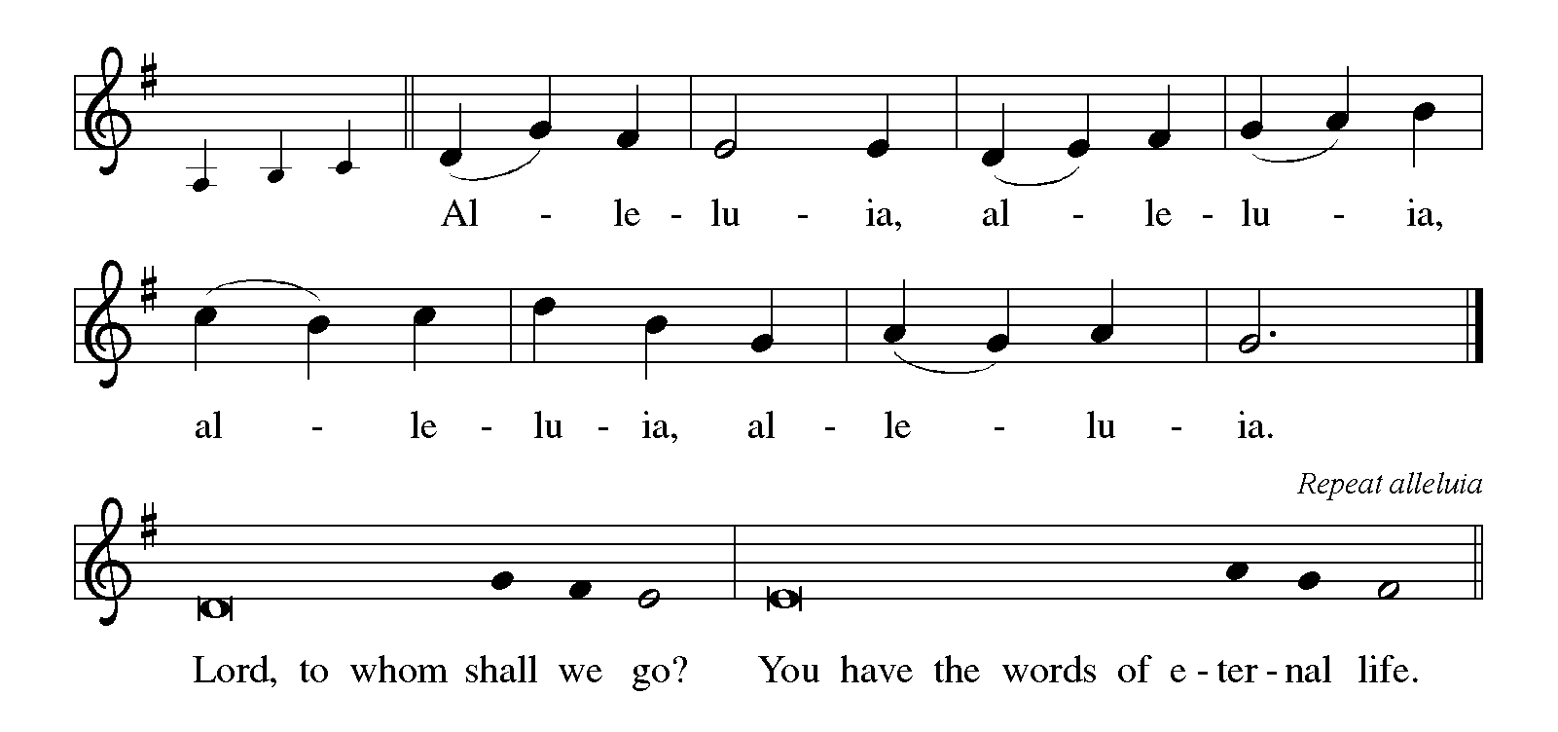

THE HOLY GOSPEL Matthew 21: 33-46

Jesus tells a parable to the religious leaders who are plotting his death, revealing that their plans will ironically bring about the fulfillment of scripture.

P: The Holy Gospel according to St. Matthew, the twenty-first chapter.

C: Glory to You, O Lord!

[Jesus said to the people:] "Listen to another parable. There was a landowner who planted a vineyard, put a fence around it, dug a wine press in it, and built a watchtower. Then he leased it to tenants and went to another country. ³⁴When the harvest time had come, he sent his slaves to the tenants to collect his produce. ³⁵But the tenants seized his slaves and beat one, killed another, and stoned another. ³⁶Again he sent other slaves, more than the first; and they treated them in the same way.
³⁷Finally he sent his son to them, saying, 'They will respect my son.' ³⁸But when the tenants saw the son, they said to themselves, 'This is the heir; come, let us kill him and get his inheritance.' ³⁹So they seized him, threw him out of the vineyard, and killed him.
⁴⁰Now when the owner of the vineyard comes, what will he do to those tenants?" ⁴¹They said to him, "He will put those wretches to a miserable death, and lease the vineyard to other tenants who will give him the produce at the harvest time."
⁴²Jesus said to them, "Have you never read in the scriptures:
'The stone that the builders rejected
has become the cornerstone;
this was the Lord's doing,
and it is amazing in our eyes'?
⁴³Therefore I tell you, the kingdom of God will be taken away from you and given to a people that produces the fruits of the kingdom. ⁴⁴The one who falls on this stone will be broken to pieces; and it will crush anyone on whom it falls."
⁴⁵When the chief priests and the Pharisees heard his parables, they realized that He was speaking about them. ⁴⁶They wanted to arrest Him, but they feared the crowds, because they regarded Him as a prophet.

P: The Gospel of the Lord.

C: Praise to You, O Christ!

The assembly is seated

THE SERMON
Silence for reflection follows the sermon

As you are able please rise

THE HYMN OF THE DAY Christ is the Life
Stanza 2—Women; Stanza 3—Men

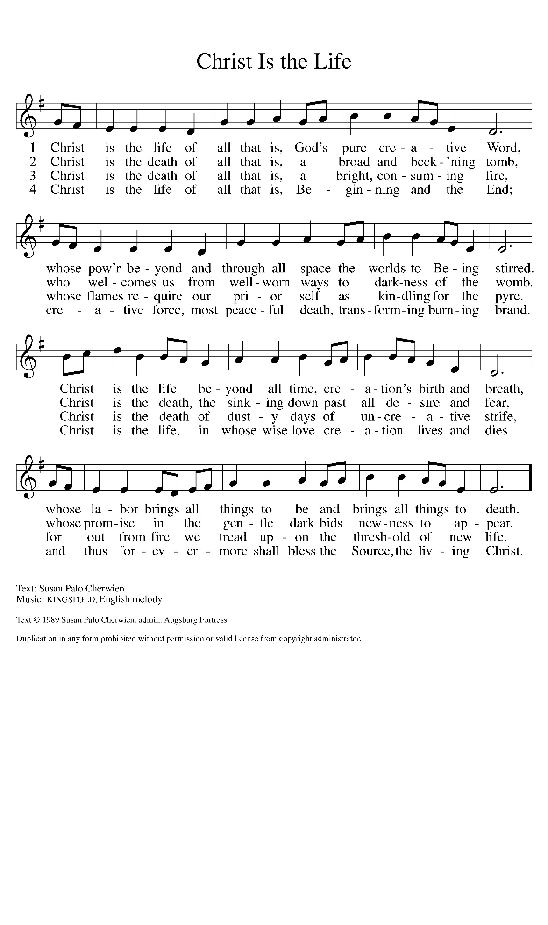

THE APOSTLES’ CREED

A: God has made us His people through our Baptism into Christ. Living together in trust and
hope, we confess our faith.

C: I believe in God, the Father almighty,
creator of heaven and earth.

I believe in Jesus Christ, His only Son, our Lord.
He was conceived by the power of the Holy Spirit
and born of the virgin Mary.
He suffered under Pontius Pilate,
was crucified, died, and was buried.
He descended into hell.
On the third day He rose again.
He ascended into heaven,
and is seated at the right hand of the Father.
He will come again to judge the living and the dead.

I believe in the Holy Spirit,
the holy catholic Church,
the communion of saints,
the forgiveness of sins,
the resurrection of the body,
and the life everlasting. Amen.

THE PRAYER OF THE CHURCH

A: The Church is the vineyard of the Lord, with all its needs and problems: growing the grapes,
making the wine, managing the Lord’s work. Let us pray to the Lord of the vineyard for the
Church, the world, and all those in need.

A: That the fruit of the Church’s prayer and ministry be the Eucharistic vine which will soon unite
all in Christ the Vine, we pray: hear us, O God,

C: For Your mercy is great.

A: That our church might bear ever richer harvest of fruits of compassionate service to others, we
pray: hear us, O God,

C: For Your mercy is great.

A: That we might be faithful and fruitful stewards of the vineyard God has given us to tend in this
neighborhood and community, we pray: hear us, O God,

C: For Your mercy is great.

A: That God’s creating Spirit might bring about justice where there is bloodshed and righteousness
where there is oppression, we pray: hear us, O God,

C: For Your mercy is great.

A: That God’s fruitfulness of healing, peace, and hope might fill the lonely, the abused, the
forgotten, the hungry, and the sick, especially: Martha Schroeder; Mark Tannehill; Jon
Samuelson; Dale Thomas; Linda Barnes; Jim Tomscheck; Jean Warner; Angela Cook;
Mike Fitzgerald; Jeff Timmrick; Deb Prybylla; and John Ripka. we pray: hear us, O God,

C: For Your mercy is great.

A: That those celebrating birthdays, especially: Melinda Simerlein; Laura Childers; Dan
McNabb and Judy Gustum; and anniversaries, especially Jim and Sandy Galinowski; may
be filled with grace this day and every day and grow in grace in the days ahead, we pray: hear
us, O God,

C: For Your mercy is great.

A: That those who mourn, especially the family and friends of Melanie Albano, whose
father, Jerry Stewart, died in the Lord this week, may be comforted by the
promise of resurrection to life everlasting and of being reunited with those they love
before the throne of the Lamb, we pray: hear us, O God,

C: For Your mercy is great.

A: That with Paul, Francis of Assissi, renewer of the church; and Theodor Fliedner, renewer
of society, whom we commemorate this Day, and all the saints who have strained forward
toward the goal of the heavenly call of God in Christ Jesus we too may one day attain
resurrection and life everlasting, we pray, hear us, O God,

C: For Your mercy is great.

P: Lord of the harvest, we pray that Your Church may fulfill Your Son’s prayer and that we may
be one in the name of Christ in our service and mission to the world, just as You live and reign
with the Holy Spirit, one God, now and forever.

C: Amen.
MEAL

THE PEACE

P: The peace of the Lord be with you always.

C: And also with you.

The assembly is seated

THE OFFERING

THE VOLUNTARY The Gift of Love St. Paul Senior Choir
(H. Hopson)
As you are able please rise

THE OFFERTORY

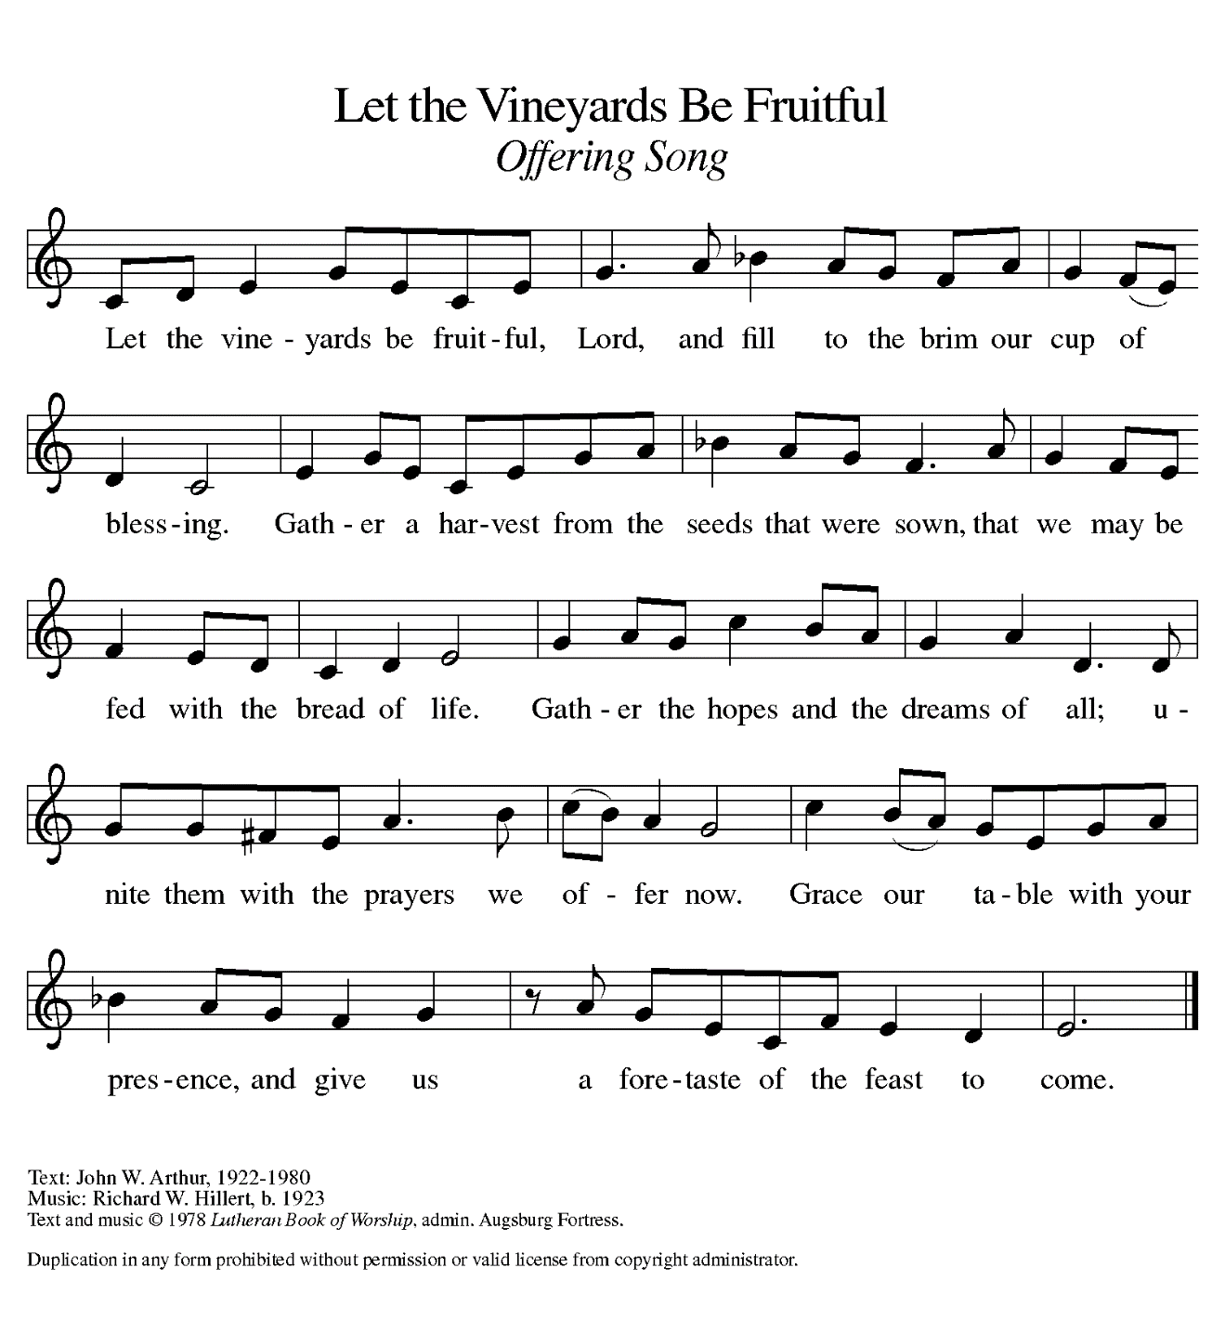

THE OFFERTORY PRAYER

A: Let us pray. Lord of the harvest,

C: In grateful thanks we bring You these offerings of our time, our talents, and our lives.
Receive them with the love we offer them. Make us worthy servants, strong to follow in
the way of our Lord Jesus Christ. Amen.

THE GREAT THANKSGIVING

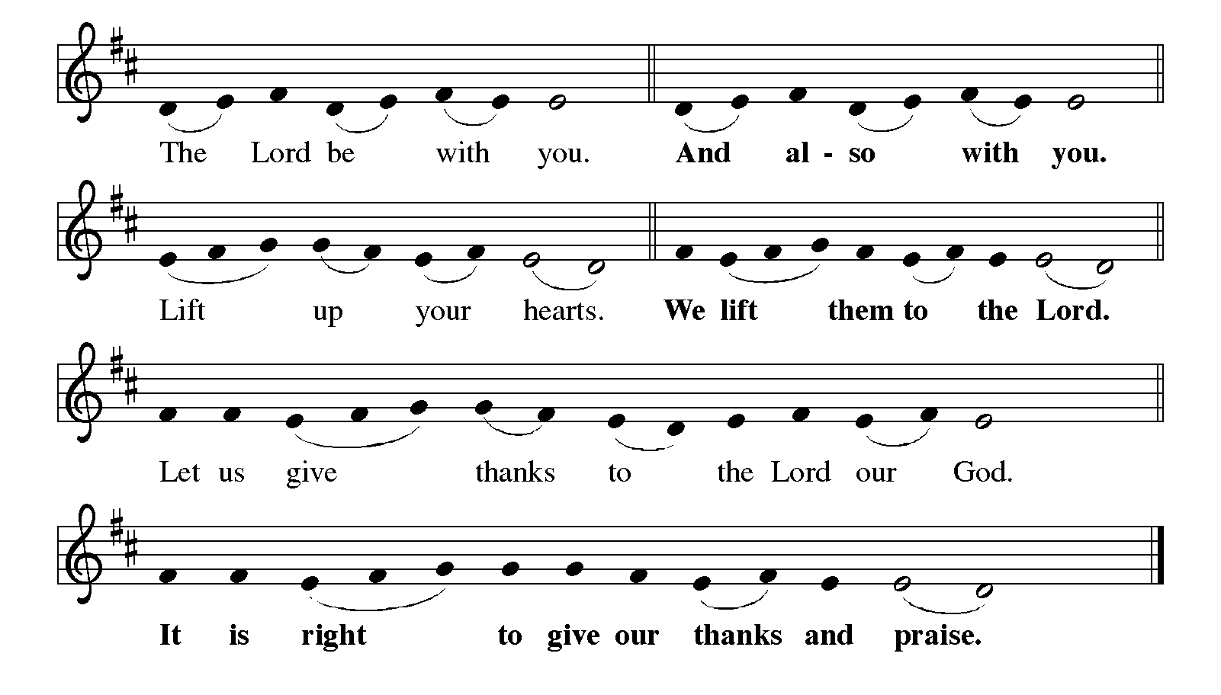

P: It is indeed right, our duty and our joy … join their unending hymn:

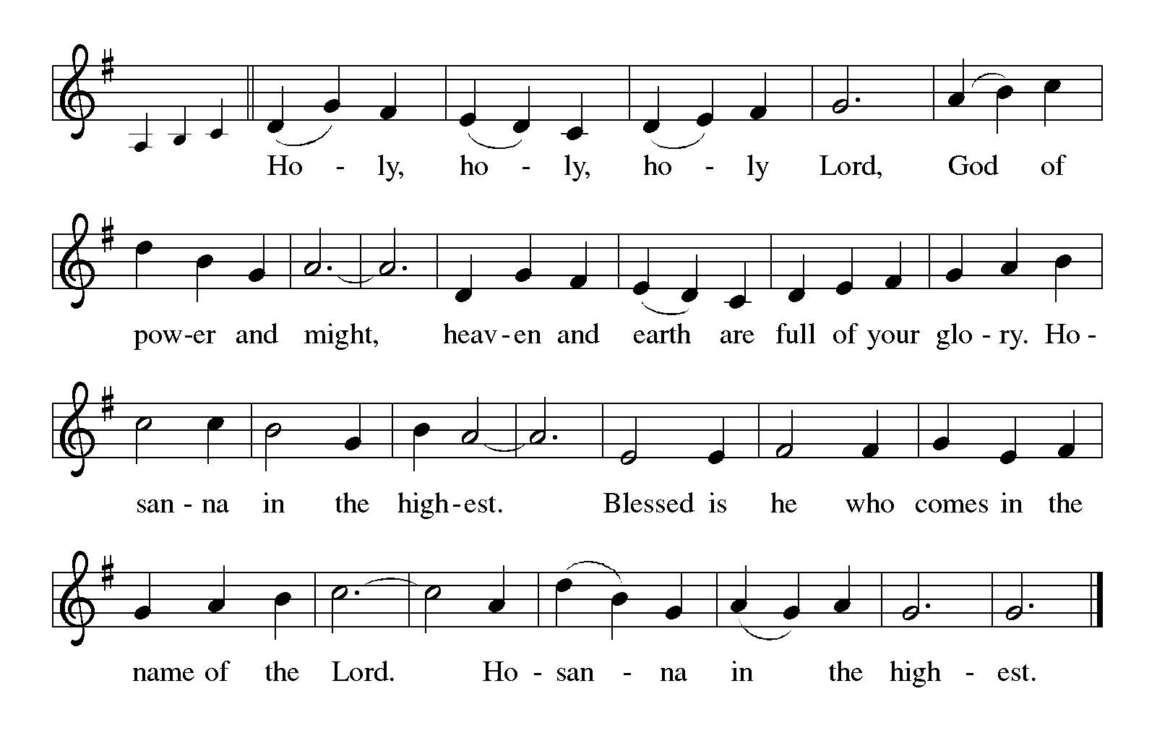

:
P: It is our duty and our joy to thank and praise You, Father of mercies, because when the gift
of Your grace was rejected by Your creation people You offered it to Your chosen
people, and when it was rejected by Your chosen people You offered it once more
in Your Son.
When Your Son was rejected and crucified You came not in wrath but in the power of Your
Holy Spirit to spread the Good News of restoration, reconciliation, and resurrection
beginning in Jerusalem and on to the ends of the earth.
You give us so much, gracious God, but everything we have is loss compared to the wondrous
love we see in Your Son Jesus Christ.
On the night before Your Son died we took away everything You gave us in Him, and yet You
gave us a Meal.
Now in this wonderful sacrament we give You everything we know how to give You, praying
that You will give us Christ in the form of this Meal.
Send down Your Holy Spirit upon us now, that we might become the Body of Christ that You
give us to eat.
Give us Your very self in these gifts of bread and wine, and make them for us the Body and
Blood of Your Son Jesus Christ,
.
Who in the night … “Do this for the remembrance of Me.”
As often as we eat … we proclaim the Lord’s death until He comes.

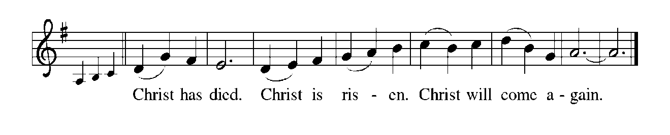

P: Remembering, therefore, His life given for us and His rising from the grave,
We await His coming again to share with us the everlasting Feast.
By Your Spirit nurture and sustain us with this Meal:
Strengthen us to serve all in hunger and want.
Where Your servants are rejected, sustain them. Where Your messengers are beaten,
renew them. Where Your children are cast out, give them hope of justice and
vindication.
Where Your vineyard is in the hands of headstrong tenants, bring Your liberation, bring
Your transformation, bring Your righteousness, until the Day comes when we and
Your suffering people see You face to face.
To You, O God: Father, Son, and Holy Spirit, be all honor and glory, in Your holy
Church, in heaven and on earth, now and forever.
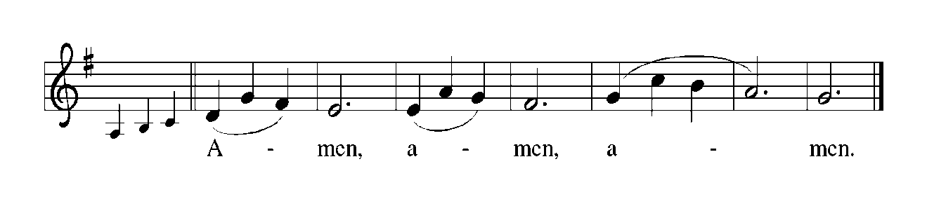

THE LORD’S PRAYER

P: Called to labor in the vineyard for the coming of God’s Kingdom, let us pray as Jesus
taught us:

C: Our Father, Who art in heaven, hallowed be Thy name.
Thy Kingdom come. Thy will be done on earth as it is in heaven.
Give us this day our daily bread, and forgive us our trespasses as we forgive those
who trespass against us.
And lead us not into temptation, but deliver us from evil.
For Thine is the Kingdom, and the power, and the glory, forever and ever. Amen.

INVITATION TO THE MEAL

P: Behold the living Bread come down from heaven: Those who eat of it will never die. Behold
the cup of eternal life: Those who drink of it will live forever. God’s holy gifts for God’s holy
people. Come, for all is now ready.

The assembly is seated

THE DISTRIBUTION Lamb of God

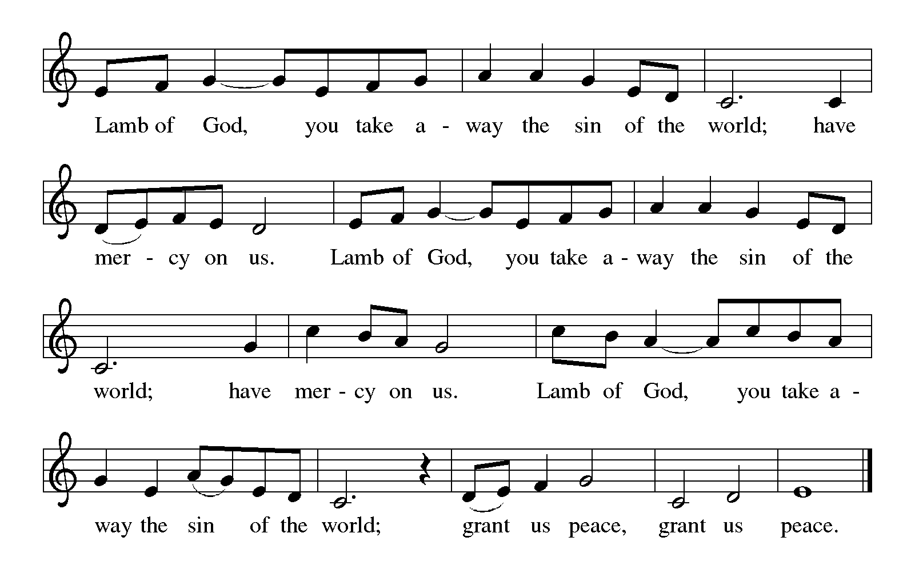
HYMN DURING DISTRIBUTION 595 Jesus Loves Me!
ELW 826 Thine the Amen
ELW 803 When I Survey the Wondrous Cross
NSB 30 Draw Me Close
NSB 89 Thy Word

As you are able please rise

THE POST-COMMUNION BLESSING

P: The Body and Blood of our Lord Jesus Christ strengthen you and keep you in His grace.

C: Amen.

THE POST-COMMUNION PRAYER

A: Let us pray. God of hosts, in this Meal You have again fed us with the Fruit of Jesus’ own
Body and Blood. Strengthen us to be faithful stewards of Your gifts, and fill us with joy in
Your service. Grant this through Christ our Lord.

C: Amen.

SENDING

THE BENEDICTION

P: Almighty God: Father, Son, and Holy Spirit bless you now and forever.

C: Amen.

SENDING SONG NSB 39 Go in Peace and Serve the Lord

THE DISMISSAL

A: Go in peace to love and serve the Lord.

C: Thanks be to God!

POSTLUDE

To God Alone Be Glory

The Meditations are from Preaching Helps. (Silver Spring: The Liturgical Conference, 1995) 47; and Sundays and Seasons Online. Copyright 2011. Used by permission.

The Prayers, Introduction to the Lord’s Prayer, and Invitation to the Meal are adapted from Prayers for Sundays and Seasons. Year A. Peter J. Scagnelli. (Chicago: Liturgy Training Publications, 1998) 120-121.

ANNOUNCEMENTS

Please remember to mail your offering to the Church Office at 818 Franklin Street, Michigan City, IN 46360. Another alternative is to give on-line through Tithe.ly. Please see your closure letter for information on how to set up a Tithe.ly account.

St. Paul Members are reminded to have a loved one contact the office if you are hospitalized. Many times, the Pastor doesn’t know someone is in the hospital. If you call and leave a message, please tell us at which hospital the patient is located.

BIRTHDAYS: Dan McNabb (10/7); Milenda Simerlein (10/7);
Judy Gustum (10/9); Laura Childers (10/11)
ANNIVERSARIES: Jim & Sandy Galinowski (10/9)

PRAYER CONCERNS: Debbie Martin; Mark Tannehill; Kathy Stein; Jan Paholski; Laura Dovey; Bill Hazelgrove; Al Levenhagen; Carl Wipperman; Major Payne.

OFFICE HOURS: Libby will be in the office on Mondays, Wednesdays, and Fridays; volunteers will cover Tuesdays and Thursdays.

Monday & Wednesday 8:00 a.m. – 5 p.m.
Tuesday & Thursday 9:00 a.m. – 12:00 p.m.
Friday 8:00 a.m. – 12:00 p.m.

If you are listening to the worship broadcast on the radio and would like to watch the Sunday morning service live stream follow these steps:

(1) If you have You Tube available on your TV, search for
St. Paul Lutheran Church Michigan City, IN.

(2) The direct link on the computer is https://
www.youtube.com/channel/UC5AIPNaKr3QN50984jGOa1g

(3) This link is also on the main page of the church’s website in
the church section and will continue to be posted weekly on the St.
Paul Facebook page.

And it will always be available on the radio broadcast Sunday mornings at 11:00 a.m.
on WEFM (95.9), and on the local cable access station #99 for the previous week’s
service on Sundays at 4:00 p.m. and the current service on Wednesdays at 7:00 p.m.
and Fridays at 8:30 p.m.

To send e-mail to the church office, please use the following addresses:

Pastor Mark Reshan: seniorpastor@stpaulmichigancity.com

Church Office Secretary (Libby Pollock): churchsecretary@stpaulmichigancity.com

Church Treasurer (Karen Fleming): finance@stpaulmichigancity.com

2026 Church Council:

Pastor - Mark Reshan

President - Donna Knoll

Vice President - Jan Bakken

Secretary - Judy Hunt

Treasurer - Karen Fleming

Members: Sue Koziel; Jim Schraidt; Trish Sprague; Bob Kiser; Barry Anderson; and
Pam Soule

Worship Attendance:

Saturday, September 26, 2026 @ 4:00 p.m. 21

Sunday, September 27, 2026 @ 9:00 a.m. 74

TOTAL 95

Copies of the minutes from the June 25, 2026 and July 23, 2026 Church Council meetings are on the back table in the upper Narthex. They were approved by the council via email.

Good News Newsletter: If you have an article or anything you want included in The Good News please send it to the following e-mail address: splcgoodnews@gmail.com. Pastor Pamela Thiede will be using this e-mail address to assemble The Good News each month. The deadline for getting information to Pastor Pamela will be the 20th of each month.

Next week’s lessons are Isaiah 25: 1-9; Psalm 23; Philippians 4: 1-9;
Matthew 22: 1-14 for those of you who like to study them in advance.

ATTENTION PLEASE!
We are in need of volunteers to drop off the LWR kits to the ingathering at Christ Lutheran Church in Valparaiso on Saturday, October 17th, 2026 from 2pm – 5pm. We will have approximately 20 boxes that need to be delivered. We have been able to fit 9 boxes in the back of our truck in the past. If you are available to deliver, please contact Paul (219) 221-0254 or Lora (260) 701-1586 Brooks.

2026 Financial Stewardship
Weekly Church Operating Needs (x 2 weeks)
September 19-20, 2026 and September 26-27, 2026: $ 10,302.00

General Fund (including General Memorials): $ 6530.00

Overage/Shortage: — $ 3,772.00

Restricted Income (not including Memorials)
Supports IK Synod & Church wide Ministries: $ 385.00

Ministries in our Community/Congregation: $ 300.00

Capital Fund: $ 70.00

Mission of the Month for October 2026
Our mission for October is collecting care kits for the Woodland Cancer Center. Please grab a bag or two from the bin in the outer narthex and fill with small items that will help bring a smile to someone’s face as they go through cancer treatments. Gender neutral socks, gloves, hats, snacks, chapstick, gum, mints, candy and small journals or activity books are just some examples of items to fill the care kits with. We will also collect monetary donations to go towards their fund that helps people with treatment expenses when needed. Please make checks out to St. Paul and mark for the Woodland Cancer Center and place in the offering. Noisy coin will also support the mission of the month. Thank you for your giving hearts!

Hymn Festival
The third and final celebration to commemorate our congregation’s 150th Anniversary of St. Paul Lutheran Church will take place on Sunday, October 25, 2026 when we celebrate Reformation Day. It will be held at 4:00 p.m. and will be led by Dr. Steven Wente, Professor Emeritus of Organ and Church Music at Concordia University-Chicago. Steve has played for us a number of times, and we have always been uplifted and inspired by his musical gifts.
We will sing hymns celebrating Reformation Day, All Saints and Christ the King. We will have a combined choir of members of the Harbor Country Singers, and those from our own Senior Choir; there will also be a brass quintet, all under the direction of Maggie Martin. It will be a powerful evening of song, Scripture readings, and prayer, followed by a light reception in the St. Paul Room.

Retirement Luncheon for Pastor Reshan
To commemorate Pastor Reshan’s Retirement there will be a Potluck luncheon in the St. Paul Room following the service on Sunday morning, November 1, 2026. There will be no charge for the meal. Chicken from Al’s Supermarket will be provided. Then please bring a dish to pass.
Reservations are required due to seating capacity being limited to 120 persons in our fellowship hall. We will begin to receive reservations on September 27, 2026. Reservation forms will be printed in the bulletins and newsletter, and available in the narthex for people to fill out and place in the offering plate. If you are unable to attend a service in October and would like to reserve a seat for the luncheon, please email the church at: churchsecretary@stpaulmichigancity.com or call the church office at (219) 874-7293 and leave your name, number of seats to reserve, and phone number. Please respond in a timely manner and come enjoy great food and fellowship!
At our recent executive board and church council meetings it was decided to give a gift from the congregation to Pastor Reshan on his retirement. We are aware that many of you want to give a personal gift also. That’s absolutely wonderful and you are welcome to do that.
Every gift will be a blessing to him.

Reservations are coming in so if you want to attend the luncheon call the church office or fill out the form and put it in the offering plate.

Reservations for Pastor Reshan’s Retirement Luncheon
To commemorate Pastor Reshan’s Retirement there will be a luncheon in the St. Paul Room immediately following the service on Sunday, November 1, 2026. Reservations are required due to seating capacity being limited to 120 persons in our fellowship hall. Reservations will begin to be received on September 27, 2026. There will be no charge for the meal. Chicken from Al’s Supermarket will be provided. Then please bring a dish to pass. This is first come, first served. Once we reach the 120 person limit no more reservations will be accepted.
If you are unable to attend a service in October and would like to reserve a seat for the luncheon, please email the church at
churchsecretary@stpaulmicigancity.com or call the church office at (219) 874-7293 with your name, number of seats to reserve, and phone number. Please respond in a timely manner and come enjoy great food and fellowship!
To reserve a seat, please fill out the form below and place in the offering plate during the month of October.

Name:__________________________________________________

Phone number:___________________________________________

# of seats to reserve:_______________________________________

If you have reserved a seat but are unable to attend, please let the church office know.

ACTIVITIES, EVENTS AND MEETINGS
OCTOBER 2026

Thursday, October 1, 2026 @ 4:00 p.m. - 10:00 p.m. GIVE BACK @ GALVESTON
STEAK HOUSE
Friday, October 2, 2026 @ 3:00 p.m. set-up for LWR kits/St. Paul Room
Saturday, October 3, 2026 @ 2:30 p.m. Packing LWR kits/St. Paul Room
@ 4:00 p.m. 19th Pentecost Worship Service/Sanctuary

Sunday, October 4, 2026 @ 9:00 a.m. 19th Pentecost Worship Service/Sanctuary with
Coffee after
Monday, October 5, 2026 @ 7:00 p.m. Women’s Bible Study/St. Paul Room
Wednesday, October 7, 2026 @ 9:15 a.m. Bible Study/Luther House
@10:00 a.m. God’s Purls (see note)
@4:30 p.m. Choir Rehearsal/Sanctuary
Saturday, October 10, 2026 @ 4:00 p.m. 20th Pentecost Worship Service/Sanctuary

Sunday, October 11, 2026 @ 9:00 a.m. 20th Pentecost Worship Service/Sanctuary with
Coffee after
Monday, October 12, 2026 @ 1:00 p.m. HOPE/FAITH CIRCLE/Green Room
@ 7:00 p.m. Women’s Bible Study/St. Paul Room
Wednesday, October 14, 2026 @ 9:15 a.m. Bible Study/Luther House
@ 10:00 a.m. God’s Purls (see note)
@ 4:30 p.m. Choir Rehearsal/Sanctuary
Saturday, October 17, 2026 @ 4:00 p.m. 21st Pentecost Worship Service/Sanctuary

Sunday, October 18, 2026 @ 9:00 a.m. 21st Pentecost Worship Service/Sanctuary with
coffee after
Monday, October 19, 2026 @ 2:00 p.m. Finance Committee Meeting/Luther House
@ 3:00 p.m. Executive Board Meeting/Luther House
@ 7:00 p.m. Women’s Bible Study/St. Paul Room
Wednesday, October 21, 2026 @ 10:00 a.m. God’s Purls (see note)
@ 4:30 p.m. Choir Rehearsal/Sanctuary
Thursday, October 22, 2026 @ 3:00 p.m. Church Council/St. Paul Room
Saturday, October 24, 2026 @ 4:00 p.m. 22nd Pentecost Reformation Worship
Service/Sanctuary

Sunday, October 25, 2026 @ 9:00 a.m. 22nd Pentecost Reformation Worship Service
with coffee after
OPEN TO PUBLIC @ 3:45 p.m. Pre- service Music/Sanctuary
@ 4:00 p.m. HYMN FESTIVAL/SANCTUARY with light
refreshments after/St. Paul Room

Monday, October 26, 2026 @ 7:00 p.m. Women’s Bible Study/St. Paul Room
Wednesday, October 28 2026 @ 10:00 God’s Purls (see note)
Saturday, October 31, 2026 NO SERVICE TODAY

Sunday, November 1, 2026 @ 9:00 a.m. ALL SAINTS DAY
PASTOR RESHAN’S LAST SERVICE with Retirement Luncheon
Immediately following. POTLUCK: Chicken provided; then please bring
a dish to share.

PLEASE NOTE:
God’s Purls are still meeting every week on Wednesdays at 10:00 a.m. but they are no longer meeting in the St. Paul Room at the church. If you have any questions or concerns please contact Judy Mutchler at (219) 229-4764.

