THE FESTIVAL OF HOLY CROSS DAY
The Sixteenth Sunday after Pentecost
September 13, 2026

“ ...Already in the early centuries of the church, Christians practiced the ritual of making the sign of the cross on one’s body. One theory holds that, informed by the Jewish practice of inscribing a Tau for the end of time or a Yod for the name of God on one’s phylactery bands, Christians signed Christ’s name with a Chi on their hands.
Second century churchmen write of tracing the sign of the cross on one’s forehead at baptism and daily in devotion. Ambrose taught that one’s fingers traced first on the forehead, for Christian profession, second over the heart, for love toward God, and last over the arms, for the work of the Christian life. In his catechism, Martin Luther counseled Christians, “In the morning, as soon as you get out of bed, you are to make the sign of the holy cross and say, ‘Under the care of God, the Father, the Son, and the Holy Spirit. Amen.’
Eventually the cross came also to determine the floor plan for church buildings. It was as if God could look down from heaven and see the believers in the shape of the cross ...”

Gail Ramshaw
Treasures Old and New: Images in the Lectionary

In the Name of Jesus

INTRODUCTION

This festival of the Holy Cross began in Jerusalem in the early fourth century when the emperor Constantine built a basilica over the place of the crucifixion. The forty-day period between August 6 (Transfiguration) and September 14 became a special season to honor the central symbol of the Christian faith.

GATHERING

PRELUDE

ANNOUNCEMENTS

As you are able please rise

PROCESSIONAL HYMN 324 In the Cross of Christ I Glory

The congregation faces the cross as it enters

THE GREETING AND PRAYER OF THE DAY

P: The grace of our Lord Jesus Christ, the love of God, and the communion of the Holy Spirit be
with you all.

C: And also with you.

P: Let us pray. Almighty God, Your Son Jesus Christ was lifted high upon the cross so that He
might draw the whole world to Himself. To those who look upon the cross, grant Your wisdom,

healing, and eternal life, through Jesus Christ, our Savior and Lord, Who lives and reigns with
You and the Holy Spirit, one God, now and forever.

C: Amen.

The assembly is seated

WORD

FIRST READING Numbers 21:4b-9

This story is one of many describing the journey of the Israelites from Mt. Sinai to Moab. The symbol of the snake, common in Canaan at this time, becomes a sign of God’s judgment and healing.

From Mount Hor the Israelites set out, ^{4b}but the people became impatient on the way. ⁵The people spoke against God and against Moses, "Why have you brought us up out of Egypt to die in the wilderness? For there is no food and no water, and we detest this miserable food."
⁶Then the Lord sent poisonous serpents among the people, and they bit the people, so that many Israelites died. ⁷The people came to Moses and said, "We have sinned by speaking against the Lord and against you; pray to the Lord to take away the serpents from us." So Moses prayed for the people.
⁸And the Lord said to Moses, "Make a poisonous serpent, and set it on a pole; and everyone who is bitten shall look at it and live." ⁹So Moses made a serpent of bronze, and put it upon a pole; and whenever a serpent bit someone, that person would look at the serpent of bronze and live.

The Word of the Lord.

Thanks be to God.

THE PSALM: Psalm 98: 1-4 Antiphon by Anne Krentz Organ
Choir sings refrain first, followed immediately by the congregation
and as indicated

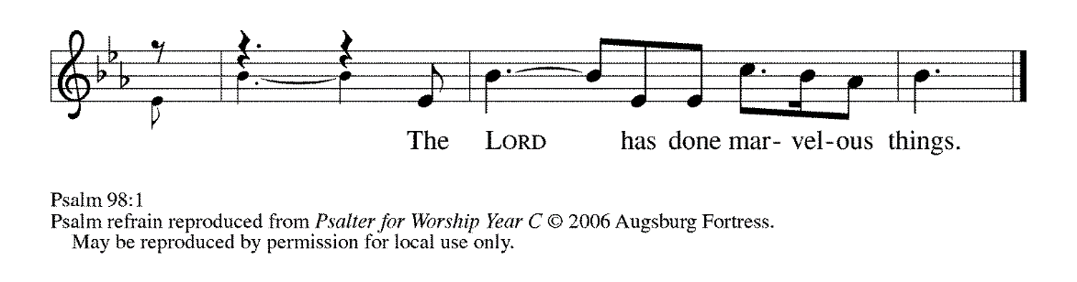
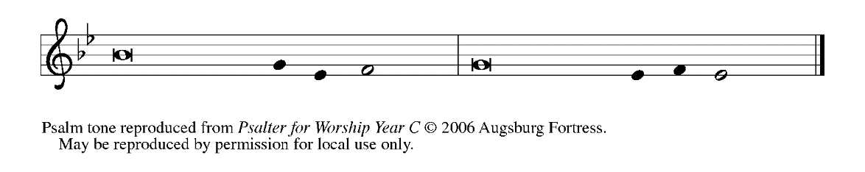

¹Sing a new song to the LORD, Who has done | marvelous things,
Whose right hand and holy arm have | won the victory.

²O LORD, You have made | known Your victory,
You have revealed Your righteousness in the sight | of the nations. REFRAIN

³You remember Your steadfast love and faithfulness to the | house of Israel;
all the ends of the earth have seen the victory | of our God.

⁴Shout with joy to the LORD, | all you lands;
lift up your voice, re- | joice, and sing. REFRAIN

SECOND READING 1 Corinthians 1: 18-24

In this letter, Paul makes clear his purpose to preach Christ and the wisdom of the cross. This “wisdom” confounds common perceptions of God: Christ crucified reveals God as the One Who suffers with humankind.

¹⁸The message about the cross is foolishness to those who are perishing, but to us who are being saved it is the power of God. ¹⁹For it is written,
"I will destroy the wisdom of the wise,
and the discernment of the discerning I will thwart."
²⁰Where is the one who is wise? Where is the scribe? Where is the debater of this age? Has not God made foolish the wisdom of the world? ²¹For since, in the wisdom of God, the world did not know God through wisdom, God decided, through the foolishness of our proclamation, to save those who believe. ²²For Jews demand signs and Greeks desire wisdom, ²³but we proclaim Christ crucified, a stumbling block to Jews and foolishness to Gentiles, ²⁴but to those who are the called, both Jews and Greeks, Christ the power of God and the wisdom of God.

The Word of the Lord.

Thanks be to God.

As you are able please rise

THE VERSE Sung twice (see p. 4)

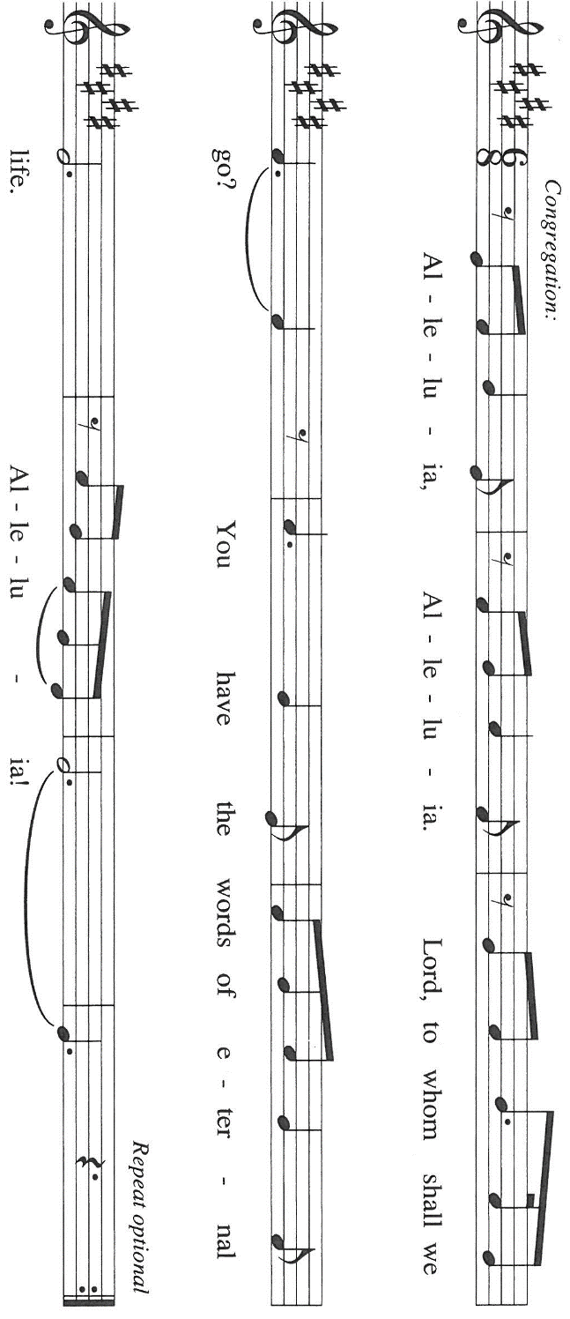

THE HOLY GOSPEL John 3: 13-17

After explaining to Nicodemus that one must be born of water and the Spirit, Jesus speaks of being lifted up on the cross with reference to the bronze serpent lifted up by Moses in the desert. Here the Son of God is revealed as the source of healing.

P: The Holy Gospel according to St. John, the third chapter.

C: Glory to You, O Lord!

Jesus said: ¹³"No one has ascended into heaven except the One Who descended from heaven, the Son of Man. ¹⁴And just as Moses lifted up the serpent in the wilderness, so must the Son of Man be lifted up, ¹⁵that whoever believes in Him may have eternal life.
¹⁶"For God so loved the world that He gave His only Son, so that everyone who believes in Him may not perish but may have eternal life.
¹⁷Indeed, God did not send the Son into the world to condemn the world, but in order that the world might be saved through Him."

P: The Gospel of the Lord.

C: Praise to You, O Christ!

The assembly is seated

THE SERMON
Silence for reflection follows the sermon

As you are able please rise

HYMN OF THE DAY 338 Beneath the Cross of Jesus

The assembly is seated
THE INSTALLATION OF MUSICIANS

The musicians to be installed come forward

Maggie Martin Pianist and Director of Music

The Senior Choir

Jary Tannehill Director, New Song Praise Band

Mark Tannehill Member, New Song Praise Band

Jacob Tannehill Member, New Song Praise Band

Stacie Crozier Member, New Song Praise Band

Charlie Marks Member, New Song Praise Band

Sue Koziel Member, New Song Praise Band

Peggy Wolf Member, New Song Praise Band

Carolyn Cooney Member, New Song Praise Band

Linda Green Member, New Song Praise Band

Judy Mutchler Handbell Choir

Trish Sprague Handbell Choir

Judy Hunt Handbell Choir

Karen Fleming Handbell Choir

Kelly Neulieb Handbell Choir

P: Our Lord, Who came among us as a servant, calls us to faith and life of loving service to our
neighbor. You stand among us as those called to a particular service, a gift from God to inspire
us to love and good works.

A reading from Romans: Just as each of our bodies has several parts and each part has a
separate function, so all of us, in union with Christ, form one body, and as parts of it we belong
to each other. Our gifts differ according to the grace given us. If your gift is prophecy, then
use it as your faith suggests; if administration, then use it for administration; if teaching, then
use it for teaching. Let the preachers deliver sermons, the almsgivers give freely, the officials
be diligent, and those who do works of mercy do them cheerfully.

P: Will you assume this ministry in the confidence that it comes from God?

R: I will, and I ask God to help me.

P: Will you carry out this ministry in accordance with the teachings and practice of the Lutheran
Church?

R: I will, and I ask God to help me.

P: Will you be diligent in your study of the Holy Scriptures and faithful in your use of the means
of grace and in prayer?

R: I will, and I ask God to help me.

P: Will you trust in God’s care, seek to grow in love for those you serve, strive for excellence in
your skills, and adorn the Gospel with a godly life?

R: I will, and I ask God to help me.

P: Almighty God, Who has given you the will to do these things, graciously give you the strength
and compassion to perform them.

C: Amen.

P: I install you as musicians of St. Paul Lutheran Church in the name of the Father and of the
Son and of the Holy Spirit.

C: Amen.

P: Let us pray. O God of majesty, Whom saints and angels delight to worship: Be present with
Your servants who seek through Your gift of music to perfect our praises and to proclaim Your
Word with power. Through their ministries grant us new awareness of Your beauty and grace,
and make us all worthy at last to join the praises of the hosts of heaven; through Your Son,
Jesus Christ our Lord.

C: Amen.

P: Almighty God, our heavenly Father, guide, bless, and keep you, that you may be faithful to the
ministry to which you have been called.

C: Amen.

As you are able please rise

THE PRAYER OF THE CHURCH

A: Gracious God, we come to You in prayer for the church, the world, and all in need.

A: Sustaining God, guide Your church on the way. Give us patience in our journey, and protect
us from division and doubt. May we look to the cross and live. God of grace,

C: receive our prayer.

A: Creator God, renew the earth. Heal our planet from the venom of greed and exploitation, and
direct us to respect all life as a gift from You. May we look to the cross and live. God of grace,

C: receive our prayer.

A: God of wisdom, grant discernment to those in authority. Thwart the plans of the proud, bring
low the mighty, and uphold those who work for peace. May they seek the way of the cross and
live. God of grace,

C: receive our prayer.

A: God of grace, alleviate suffering. Comfort the sick and the grieving, especially: Pastor Dale
Zylstra; Martha Schroeder; Angela Cook; Jeff Timmrick; Dale Thomas; Mark
Tannehill; Jon Samuelson; and John Ripka. Come to the aid of those who are hungry or
needing shelter. May they find hope in the cross and live. God of grace,

C: receive our prayer.

A: That those celebrating birthdays, especially: James Krueger; and Kay Peglow; and
anniversaries, especially Al & Sue Green might be filled with grace this day and
every day and grow in grace in the days ahead: God of grace,

C: receive our prayer.

A: Good Shepherd, guide Your flock. Protect us from the world’s lies and lead us in the way of
truth. Strengthen us in our faith and inspire us to serve others. May we follow You to the cross
and live. God of grace,

C: receive our prayer.

A: Merciful God, You receive into Your loving embrace those who have died. Giving thanks for
them, may we find comfort in the cross and live in the hope of resurrection. God of grace,

C: receive our prayer.

P: We entrust these prayers to You, O God, in the name of Jesus Christ, our redeemer and friend.

C: Amen.
MEAL
THE PEACE

P: The peace of the Lord be with you always.

C: And also with you.

The assembly is seated

THE VOLUNTARY Take Now My Voice St. Paul Senior Choir
(D. Nolan)

THE OFFERING

As you are able please rise

THE PRESENTATION OF GIFTS (see p, 8) As the Grains of Wheat

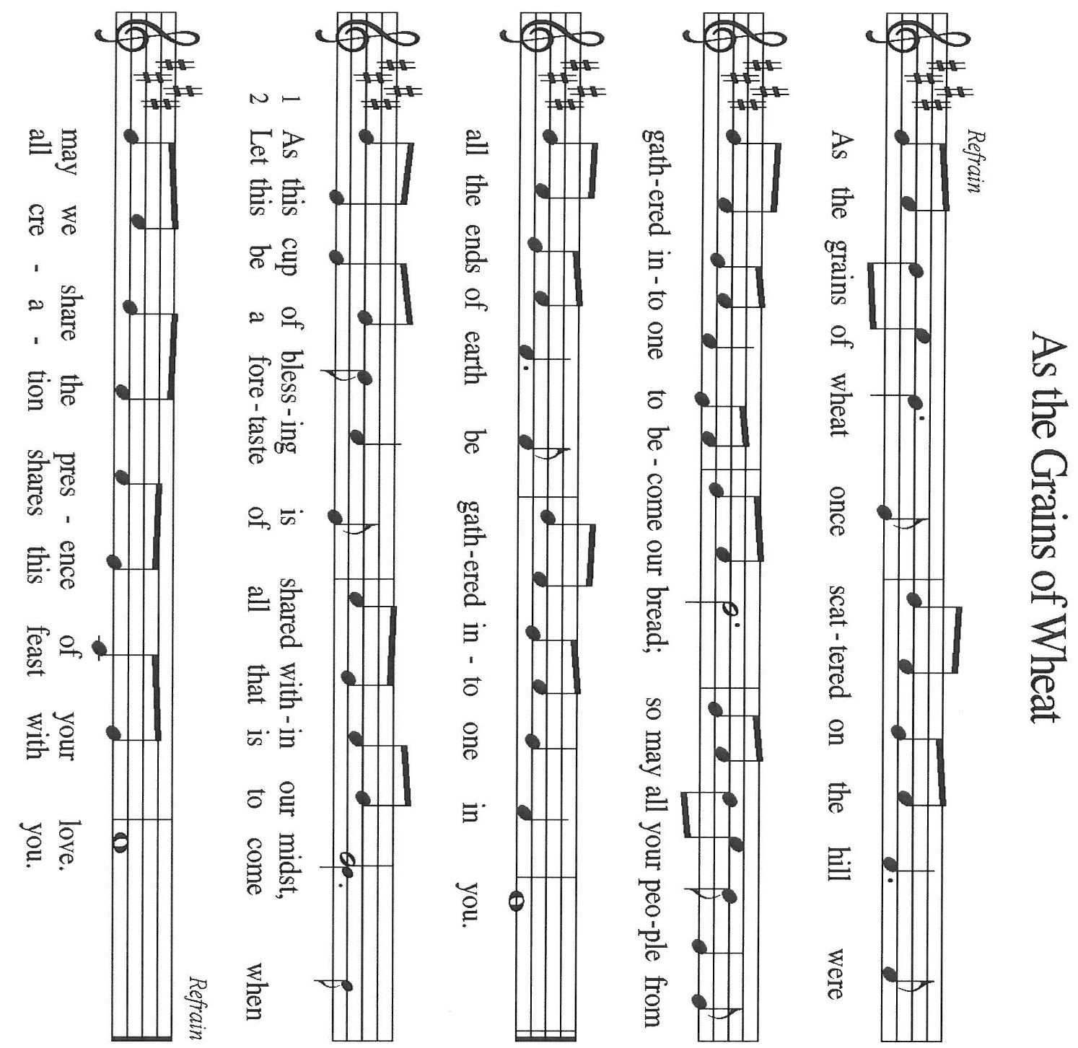

THE OFFERTORY PRAYER

A: Let us pray. Lord Jesus,

C: You once offered Your life on the cross to take away the sins of the world. With these
gifts we offer our lives in love and service to You. Receive them and bless them for the
work of Your Kingdom. By this holy Sacrament, lift us up again from death to new life.
You are the Lord forevermore. Amen.

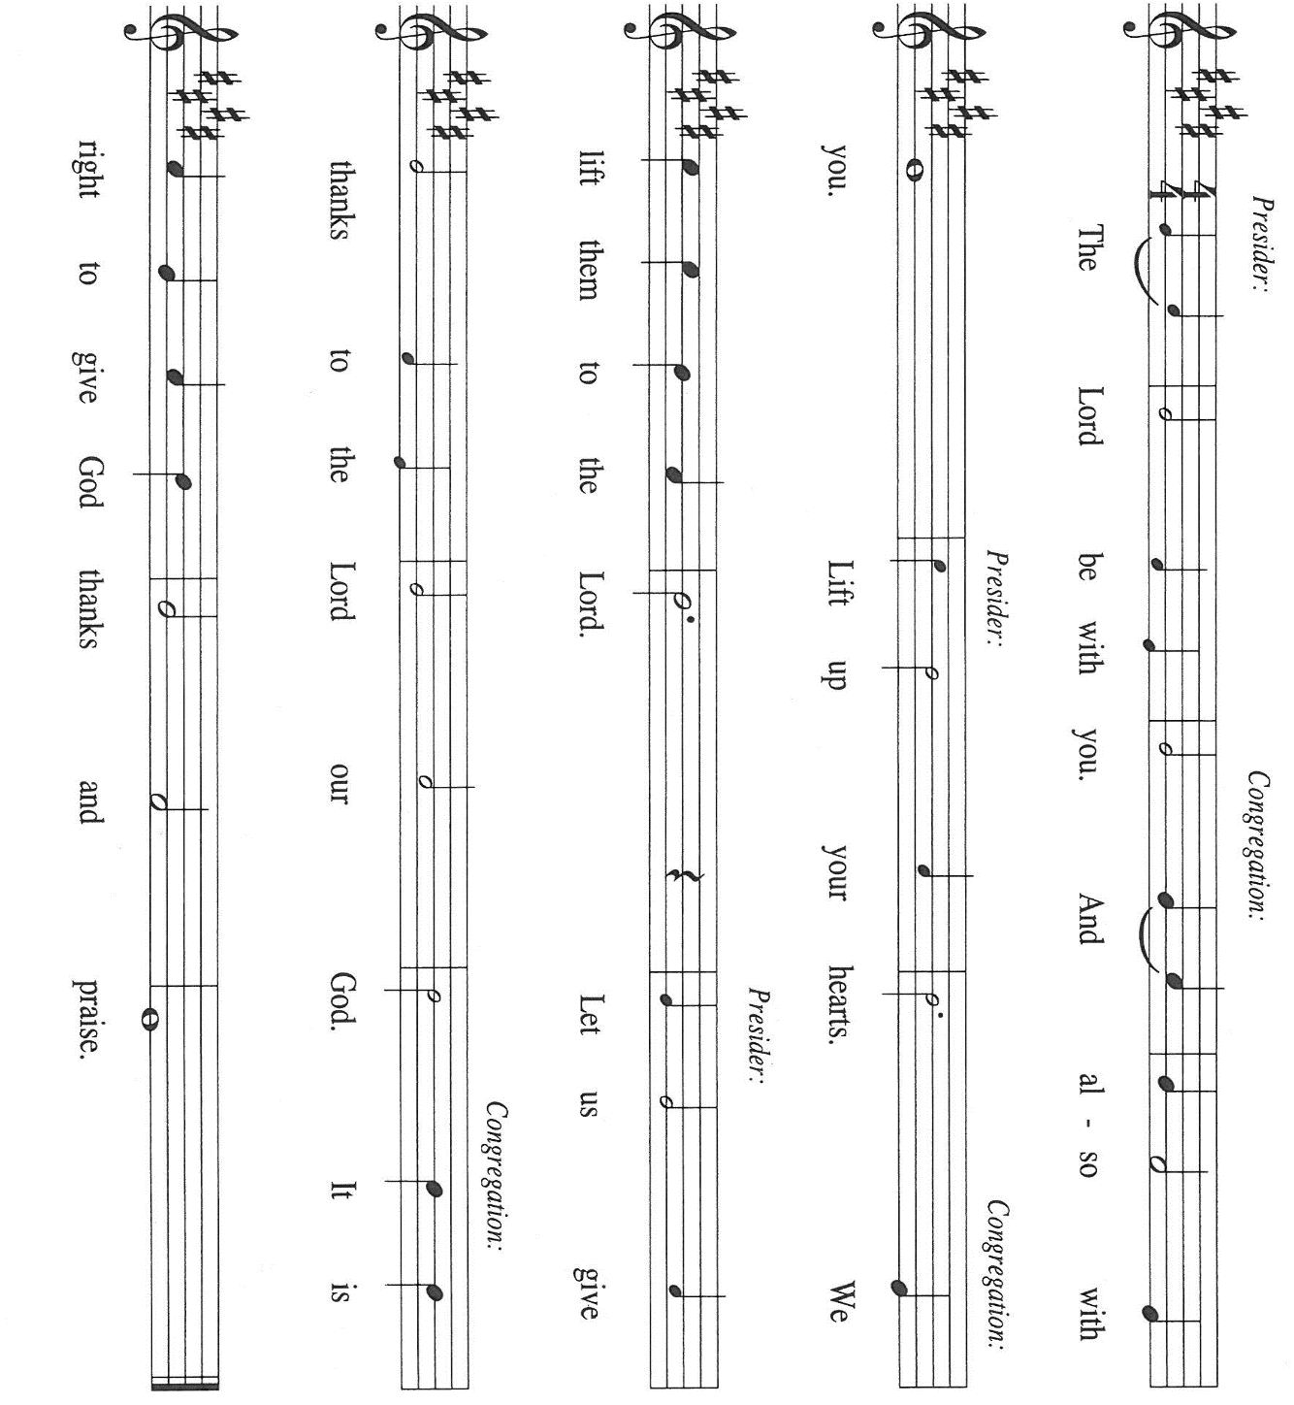
THE GREAT THANKSGIVING

P: It is our duty and delight …and join their unending hymn:

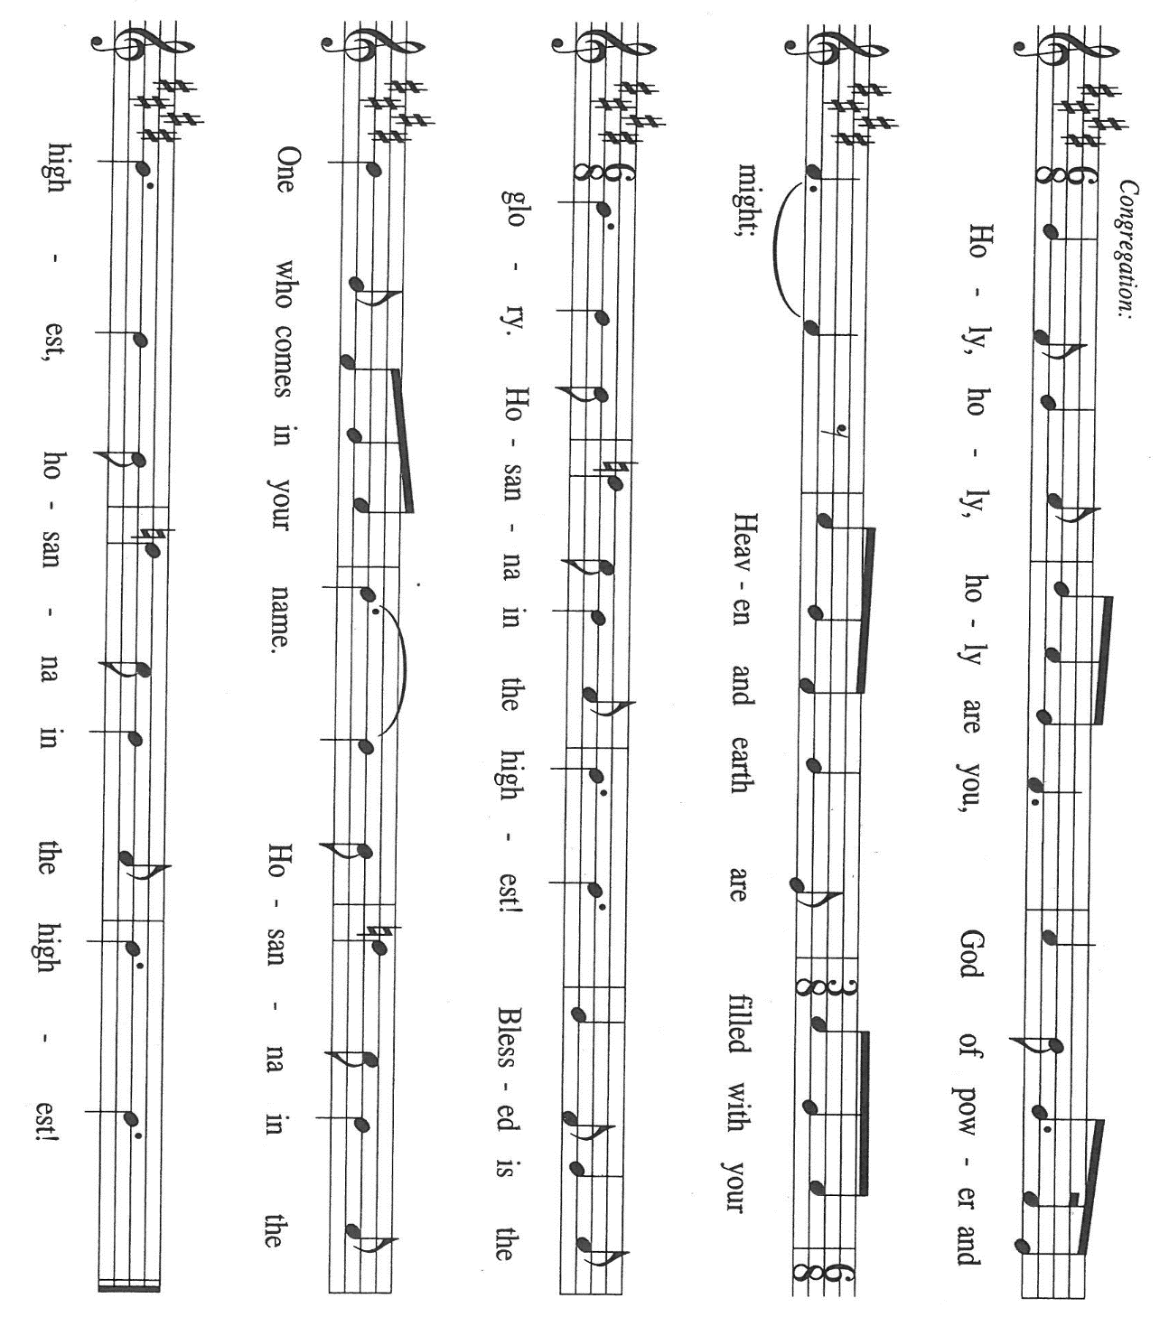

P: Holy God, Lover of the world, we bless and praise You.
We sing to You a new song; all creation shouts with joy to You.
For in great love You created heaven and earth and all creatures in them.
You made covenant with Israel, and with mercy and faithfulness You rescued them
from slavery and exile and sent prophets to call them from sin to new life.

At the last You sent Your only-begotten Son, Jesus Christ.
He is Your Wisdom and power lifted up to draw all people to Himself.
In the night ... “Do this for the remembrance of Me.”
As often as we eat ... we proclaim the Lord’s death until He comes.

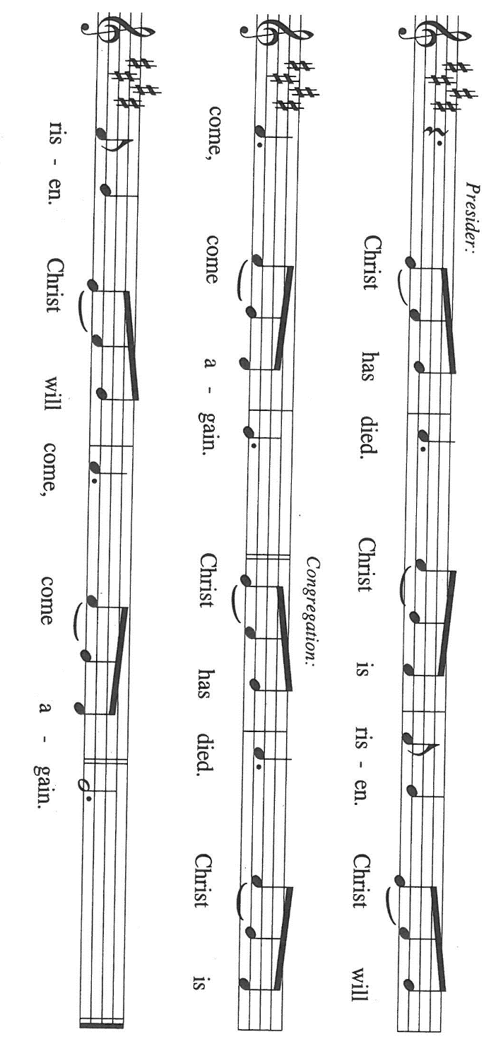

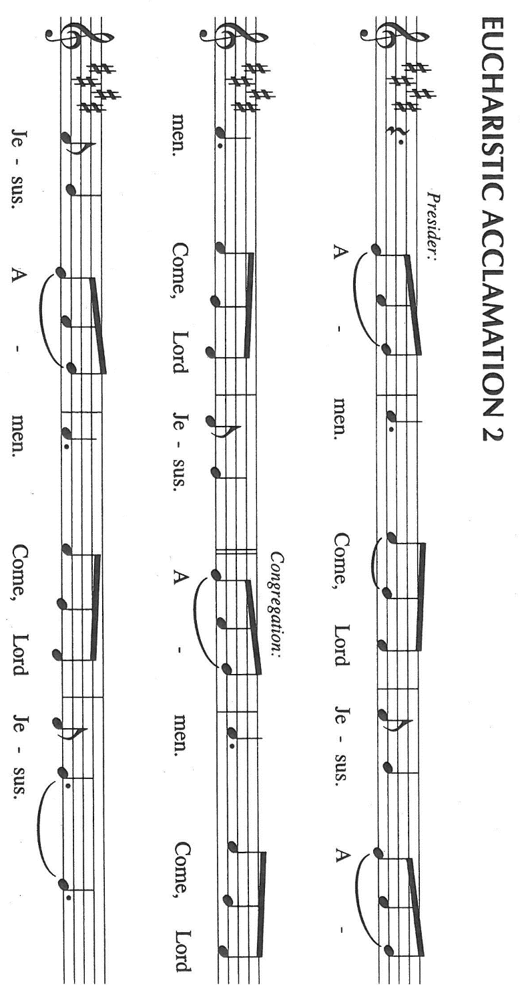

P: With this bread and cup we remember the life our Lord offered for us.
He died and rose to save the world from darkness and death.
We await His promised return to share with us Your final Feast of victory.

C: (Sung) Amen. Come, Lord Jesus. Amen. Come, Lord Jesus.

Send Your Spirit on us and these Your gifts of bread and wine.
Unite in His cross all who share the food and drink of His unending Life, and bring us by its
power into Your eternal glory with all the saints in light.

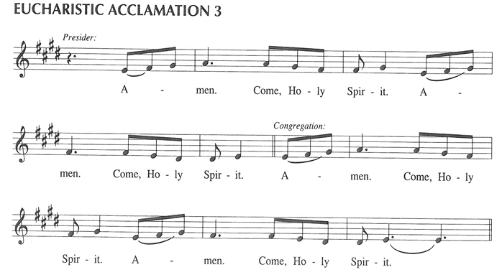

To You, O God: Father, Son, and Holy Spirit, be all honor and glory, in Your holy Church, in
heaven and on earth, now and forever.

C: Amen!

THE LORD’S PRAYER

P: God so loved the world that He gave His only Son, that whoever believes in Jesus may dare to
pray as He taught us:

C: Our Father, Who art in heaven, hallowed be Thy Name. Thy Kingdom come. Thy will
be done on earth as it is in heaven. Give us this day our daily bread, and forgive us our
trespasses as we forgive those who trespass against us. And lead us not into temptation,
but deliver us from evil. For Thine is the Kingdom, and the power, and the glory, forever
and ever. Amen.

INVITATION TO THE MEAL

P: This is the Lamb of God Who takes away the sin of the world. Blessed are those who are
called to the Supper of the Lamb. God’s holy gifts for God’s holy people. Come, for all is
now ready.

The assembly is seated

THE DISTRIBUTION Lamb of God (see p. 13)

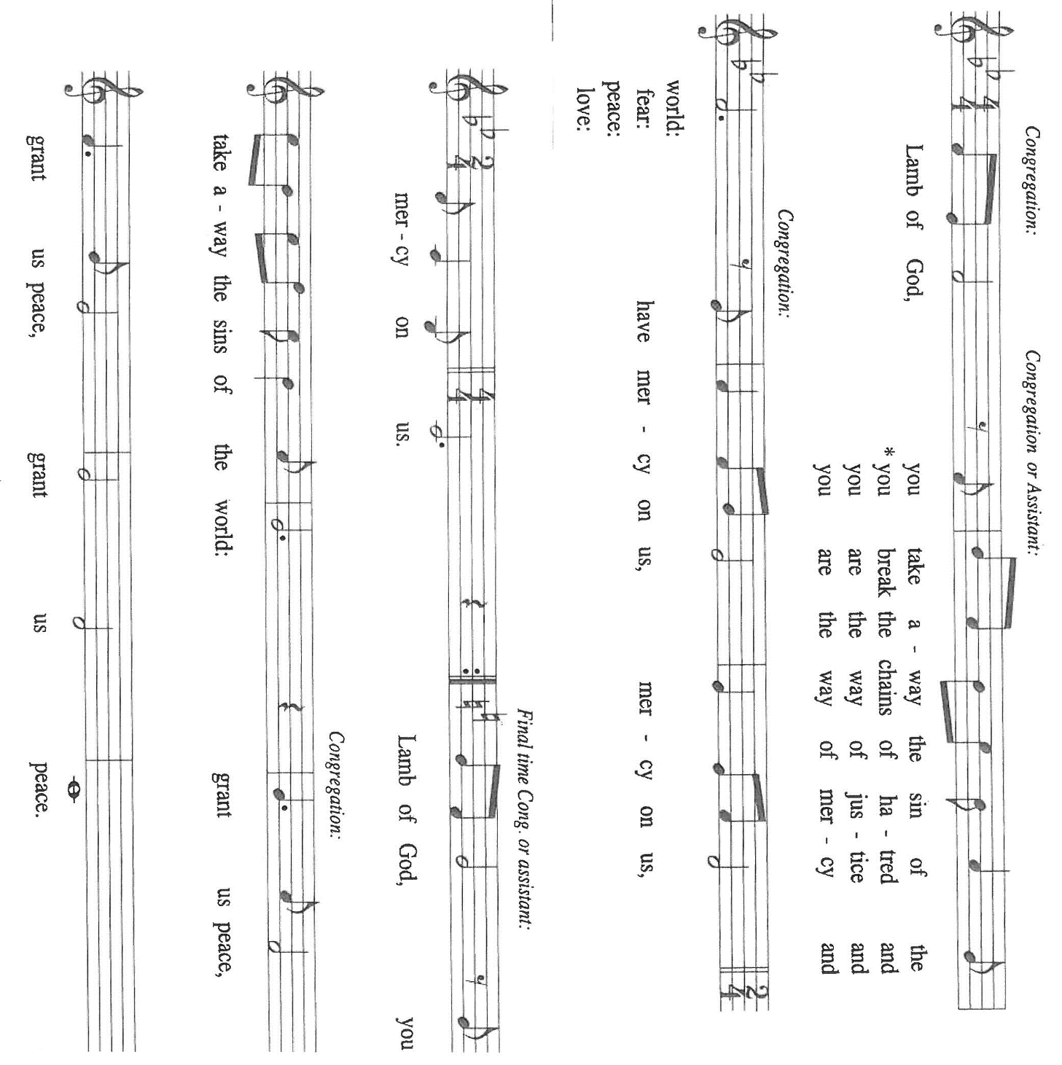

Those wishing to receive the Laying on of Hands, Anointing with Oil, and Prayer for Healing
may go to Pastor at the side aisle

HYMN DURING DISTRIBUTION 803 When I Survey the Wondrous Cross
NSB 63 Lord, I Lift Your Name on High
NSB 6 Amazing Love
ELW 461 All Who Hunger Gather Gladly
ELW 490 Let All Mortal Flesh Keep Silence

As you are able please rise

THE POST-COMMUNION BLESSING

P: The Body and Blood of our Lord Jesus Christ strengthen you and keep you in His grace.

C: Amen.

THE POST-COMMUNION PRAYER

A: Let us pray. Lord Jesus Christ, You are the holy Bread of Life. Bring to the glory of the
resurrection the people You have redeemed by the wood of the cross. By our eating and
drinking, grant us the courage to take up the cross and follow where You lead, that we may
proclaim You with power and joy. We bless You now and forever.

C: Amen.

SENDING

THE BENEDICTION

P: Almighty God: Father, Son, and Holy Spirit bless you now and forever.

C: Amen.

THE SENDING HYMN 535 Hallelujah, We Sing Your Praises

THE DISMISSAL

A: Go in peace to bear Christ’s love to the world.

C: Thanks be to God!

POSTLUDE

To God Alone Be Glory

The Meditation is from Treasures Old and New: Images in the Lectionary. Gail Ramshaw.
(Minneapolis: Augsburg Fortress, 2002) 126-127.

The musical setting of the liturgy, “Now the Feast and Celebration” by Marty Haugen, is used by
permission of GIA Publishers, Inc. OneLicense.net License #A-702836.

ANNOUNCEMENTS

Please remember to mail your offering to the Church Office at 818 Franklin Street, Michigan City, IN 46360. Another alternative is to give on-line through Tithe.ly. Please see your closure letter for information on how to set up a Tithe.ly account.

St. Paul Members are reminded to have a loved one contact the office if you are hospitalized. Many times, the Pastor doesn’t know someone is in the hospital. If you call and leave a message, please tell us at which hospital the patient is located.

BIRTHDAYS: James Krueger (9/15); Kay Peglow (9/19)

ANNIVERSAREIS: Al & Sue Green (9/15)

PRAYER CONCERNS: Debbie Martin; Mark Tannehill; Kathy Stein; Jan Paholski; Laura Dovey; Bill Hazelgrove; Al Levenhagen; Carl Wipperman; Major Payne.

OFFICE HOURS: Libby will be in the office on Mondays, Wednesdays, and Fridays; volunteers will cover Tuesdays and Thursdays.

Monday & Wednesday 8:00 a.m. – 5 p.m.
Tuesday & Thursday 9:00 a.m. – 12:00 p.m.
Friday 8:00 a.m. – 12:00 p.m.

If you are listening to the worship broadcast on the radio and would like to watch the Sunday morning service live stream follow these steps:

(1) If you have You Tube available on your TV, search for
St. Paul Lutheran Church Michigan City, IN.

(2) The direct link on the computer is https://
www.youtube.com/channel/UC5AIPNaKr3QN50984jGOa1g

(3) This link is also on the main page of the church’s website in
the church section and will continue to be posted weekly on the St.
Paul Facebook page.

And it will always be available on the radio broadcast Sunday mornings at 11:00 a.m.
on WEFM (95.9), and on the local cable access station #99 for the previous week’s
service on Sundays at 4:00 p.m. and the current service on Wednesdays at 7:00 p.m.
and Fridays at 8:30 p.m.

To send e-mail to the church office, please use the following addresses:

Pastor Mark Reshan: seniorpastor@stpaulmichigancity.com

Church Office Secretary (Libby Pollock): churchsecretary@stpaulmichigancity.com

Church Treasurer (Karen Fleming): finance@stpaulmichigancity.com

2026 Church Council:

Pastor - Mark Reshan

President - Donna Knoll

Vice President - Jan Bakken

Secretary - Judy Hunt

Treasurer - Karen Fleming

Members: Sue Koziel; Jim Schraidt; Trish Sprague; Bob Kiser; Barry Anderson; and
Pam Soule

Worship Attendance:

Saturday, September 5, 2026 @ 4:00 p.m. 27

Sunday, September 6, 2026 @ 9:00 a.m. 65

TOTAL 92

Copies of the minutes from the June 25, 2026 and July 23, 2026 Church Council meetings are on the back table in the upper Narthex. They were approved by the council via email.

Good News Newsletter: If you have an article or anything you want included in The Good News please send it to the following e-mail address: splcgoodnews@gmail.com. Pastor Pamela Thiede will be using this e-mail address to assemble The Good News each month. The deadline for getting information to Pastor Pamela will be the 20th of each month.

Next week’s lessons are Ezekiel 2: 8—3: 11; Psalm 119: 33-40; Ephesians 2: 4-10;
Matthew 9: 9-13 for those of you who like to study them in advance.

SEPTEMBER 2026 MONTHLY MISSION:

SHRINER’S CHILDREN’S HOSPITAL

We all know Shriner’s from their commercials and their little red hats, but nearly 20,000 children each year get to know Shriner’s Children’s Hospital in Chicago for their incredible pediatric specialty care. The hospital opened in March of 1926 with 60 beds.
60 0% of patients suffered with polio and often lived at the hospital for up to a year. Over the next few decades, an orthopedic residency, bone rodding surgery, halo ring implantation, cleft lip and palate repair, pediatric spinal cord injury surgery, and motion analysis services were added. Our very own little one, Maggie Brooks, has been visiting Shriner’s in Chicago since four weeks old to correct bilateral clubfoot, a condition where she was born with both feet turned inward and upward. Shriner’s offers care to all families no matter their ability to pay or insurance status. They even have financial assistance programs that help reimburse for transportation or lodging if needed.
At Shriner’s Chicago, every child who is inpatient receives a handmade blanket and goody bag upon arrival to the hospital. We will be collecting the following items to help fill their goody bags:

Small cars or toys
Card games
Small activity books
New or gently used children’s books

Please place items in the bin in the outer narthex. If you would like to support Shriner’s financially, please make checks out to St. Paul’s and mark for Shriner’s Children’s Hospital and place in the offering plate. Noisy coin offering will also go towards the mission of the month. Thank you for your generosity!

THANK YOU!
Thank you all for your generous support of the Michigan City Area Schools through our Monthly Mission for the month of August! We collected $1139. We were able to fully fund a solar system STEM project for the high ability classroom at Knapp, providing Project Hail Mary novels along with several different solar system projects and kits. We also donated to the special education classroom, providing supplies to help the classroom feel more inclusive and facilitate better learning.

From the teaching staff:

Dear St. Paul Lutheran Church,
Thank you so much for helping to make this project a reality for my students! You mean the world to us! I cannot wait to see the fantastic STEM activities and learning carried out in our environment. Your generosity will hopefully help inspire the Scientific Minds of tomorrow! Again, many, many thanks.
With gratitude,
Ms. T

Thank you so much! I appreciate your support. Ms. Blakely

ACTIVITIES, EVENTS & MEETINGS
SEPTEMBER 2026

Wednesday, September 9, 2026 @ 9:15 a.m. Bible Study/Luther House
@ 10:00 a.m. God’s Purls
@ 11:00 a.m. – close GIVE Back @ Swingbelly’s
@ 3:45 p.m. Worship & Music Comm. Mtg./Luther House
@ 4:30 p.m. Choir Rehearsal/Sanctuary
Saturday, September 12, 2026 @ 8:30 a.m. – 11:00 a.m. PANCAKE BREAKFAST
St. Paul Room
@ 4:00 p.m. 16th Pentecost Worship Service/Sanctuary

Sunday, September 13, 2026 @ 9:00 a.m. 16th Pentecost Worship Service /Sanctuary
with coffee after
Monday, September 14, 2026 @ 1:00 p.m. Hope Circle/Green Room
@ 7:00 p.m. Women’s Bible Study/St. Paul Room
Wednesday, September 16, 2026 @ 9:15 a.m. Bible Study/Luther House
@ 10:00a.m. God’s Purls
@ 4:30 p.m. Choir Rehearsal/Sanctuary
Saturday, September 19, 2026 @ 9:00 a.m. – 3:00 p.m. Stained Glass Window Tour
@ 4:00 p.m. 17th Pentecost Worship Service/Sanctuary

Sunday, September 20, 2026 @ 9:00 a.m. 17th Pentecost Worship Service/Sanctuary with coffee after
Monday, September 21, 2026 @ 2:00 p.m. Finance Comm. Meeting/Luther House
@3:00 p.m. Executive Board Meeting/Luther House
@7:00 p.m. Women’s Bible Study/St. Paul Room
Wednesday, September 23, 2026 @ 9:15 a.m. Bible Study/Luther House
@ 10:00 a.m. God’s Purls
@ 4:30 p.m. Choir Rehearsal/Sanctuary

Thursday, September 24, 2026 @ 3:00 p.m. Church Council Mtg./St. Paul Room
Saturday, September 26, 2026 @ 4:00 p.m. 18th Pentecost Worship Service/Sanctuary

Sunday, September 27, 2026 29:00 a.m. 18th Pentecost Worship Service/Sanctuary with coffee after

Monday, September 28, 2026 @ 7:00 p.m. Women’s Bible Study/St. Paul Room

Wednesday, September 30, 2026 @ 9:15 a.m. Bible Study/Luther House
@ 10:00 a.m. God’s Purls



Docent guided tour of Michigan City’s historic collection of

Stained Glass Windows

Tour begins and ends at:

Immanuel Lutheran Church

1237 E. Coolspring Avenue, Michigan City, IN

Please register via telephone at 219-326-7259
or email: creativity52 @comcast.net
by September 11, 2026
and let us know if you will be riding our bus or driving your own car.

Light refreshments will be provided

The churches participating in the tour are:
Immanuel Lutheran Church

Saint Paul Lutheran Church

Saint Stanislaus Roman Catholic Church

Trinity Church

Saint Mary Roman Catholic Church

Notre Dame Catholic Church

