**THE NINTH SUNDAY AFTER PENTECOST**

**August 7, 2022**

Abraham and Sarah never gave up responding to God in faith. When their confident assurance was stretched to the limit of its endurance, God fulfilled the promise planted in their hearts so many years earlier. Our confident assurance of hope is intensified in the gospel revelation, a precious little jewel within which the entire gamut of God’s dealings with humankind is compressed.

The injunction “Be dressed and ready” calls us to be prepared to move at once, as the Israelites were on the night of the Passover in Egypt. Our lamps are to be burning, the light of faith as our guide. Jesus can reveal to us God’s tremendous love only when we are willing to make the changes called for in the light of faith.

We are the servants awaiting the return of Christ, not only at the end of time when he will come again to judge the living and the death, but also whenever he comes in the events of our daily life.

**Mary Pierre Ellebracht, C.Pp.S.**

“ …The passage begins with a delightful statement found only in Luke: “Do not be afraid, little flock, for it is your Father’s good pleasure to give you the kingdom” (Luke 12:32). While some congregations will appreciate a preacher who can apply nuance to the verse’s paternal God-language and the reasons why speaking of a “kingdom” sounds a little antiquated, no one should miss a larger point: these words speak an unqualified promise about God. They root God’s generosity in God’s desire. Jesus has just spoken (in 12:22-31) about trusting God while also *seeking* (or striving for) the “kingdom”; now he reminds everyone that the point isn’t to coax a grumpy or frugal deity into being nice to us. Rather, God eagerly wants the “kingdom” -- a whole new set of affairs reflecting God’s intentions for human flourishing -- to take root in the real, lived experiences of Jesus’s followers. Why? Because that’s God’s good *pleasure*…”

“ …When Jesus declares “where your treasure is, there your heart will be also,” he says that we can train our wills and our ways of thinking (for that is what the heart symbolized in his culture) through the ways we use our money. Spend it all on yourself, guess where your heart will go. Give it to those in need, your heart will go where God wants it to go. Moreover, your heart will find God in the process. For there is a sacramental aspect to charity, in which God becomes present to givers through those who receive and need their gifts …”

“ …In other words, Jesus calls for a shift away from a world in which some people survive only because more privileged people chose to act morally from time to time. He has in mind, instead, a different world -- or “kingdom.” With Jesus, that kingdom has arrived. If indeed “the kingdom of God is among [us]” (Luke 17:21), then that reality entails the *destruction* of old categories and demarcations. Almsgiving isn’t about offerings that *help* those with less money; it must be about sharing power and advantage. Such transformative solidarity creates “unfailing treasure in heaven” (cf. 18:22) …”

**Matt Skinner**

**✠ In the Name of Jesus ✠**

**✠ GATHERING ✠**

**INTRODUCTION**

Jesus says, "It is your Father’s good pleasure to give you the kingdom." It is God’s promise from the beginning—to Abraham, to the early church, and to the "little flock" of which we are a part today in assembly. Faith, God’s baptismal gift, trusts the promises of God. Have no fear.

**Dominic, founder of the Order of Preachers (Dominicans), died 1221**

*Dominic was a Spanish priest who saw the wealth of the clergy as a stumbling block for the church, so he formed a movement, the Order of Preachers (commonly called Dominicans) devoted to itinerant preaching and living in poverty.*

**PRELUDE *God, Who Stretched the Spangled Heavens* Wilbur Held**

**ANNOUNCEMENTS**

*As you are able please rise*

**CONFESSION AND ABSOLUTION**

P: In the name of the Father and of ✠ the Son and of the Holy Spirit.

C: **Amen.**

P: Jesus said, “Do not be afraid, little flock, for it is your Father’s good pleasure to give you the

Kingdom.” (Luke 12:32) We are also assured that “the eye of the LORD is upon those who

fear Him, on those who wait for Him ... He is our help and shield” (Psalm 33:18,20b). God

waits upon our confession this Day, so with “good pleasure” He might grant us the “help” and

“love” of His forgiveness. Laying aside our fear, we confess our sins.

*Silence for self-examination and reflection is kept*

P: Most merciful God,

C: **We confess that we have sinned against You and one another. We are afraid of many**

**things. (Genesis 15:1; Luke 12:32). Our past sins haunt us, and we are threatened by the**

**uncertainties of the future. When the fulfillment of Your promises are not immediate,**

**we doubt Your faithfulness. (Genesis 15:2) We want our discipleship to be easy, without**

**risk or commitment. Our “treasures,” and our hearts, have not rested in You. (Luke**

**12:34) For all our sins, O God, we beg Your forgiveness. Calm our fears, and by Your**

**Spirit, give us a firm faith in Your good ways for us in Jesus Christ our Lord.**

P: Hear the Good News that drives our fear and brings hope: as a called and ordained minister of

the Church of Christ, and by His authority, I declare to you the entire forgiveness of all your

sins, in the name of the Father and of ✠ the Son and of the Holy Spirit.

C: **Amen.**

**GATHERING HYMN 771 *God, Who Stretched the Spangled Heavens***

**THE GREETING AND PRAYER OF THE DAY**

P: The grace of our Lord Jesus Christ, the love of God, and the communion of the Holy Spirit be

with you all.

C: **And also with you.**

P: Let us pray. Almighty God, You sent Your Holy Spirit to be the life and light of Your church.

Open our hearts to the riches of Your grace, that we may be ready to receive You wherever

You appear, through Jesus Christ, our Savior and Lord.

C: **Amen.**

*The assembly is seated*

**✠ WORD ✠**

**FIRST READING Genesis 15:1-6**

*God promises childless Abram (later called Abraham) that a child of his own will be his heir and that his descendants will number as many as the stars. Abram trusts God's promise and through this faith, he is considered righteous.*

1After these things the word of the Lord came to Abram in a vision, "Do not be afraid, Abram, I am your shield; your reward shall be very great." 2But Abram said, "O Lord God, what will You give me, for I continue childless, and the heir of my house is Eliezer of Damascus?" 3And Abram said, "You have given me no offspring, and so a slave born in my house is to be my heir."

4But the word of the Lord came to him, "This man shall not be your heir; no one but your very own issue shall be your heir." 5He brought him outside and said, "Look toward heaven and count the stars, if you are able to count them." Then He said to him, "So shall your descendants be." 6And he believed the Lord; and the Lord reckoned it to him as righteousness.

The Word of the Lord.

**Thanks be to God.**

**THE PSALM 33:12-22** **Antiphon by John Paradowski**

Cantor sings refrain first, followed immediately by the congregation

and as indicated

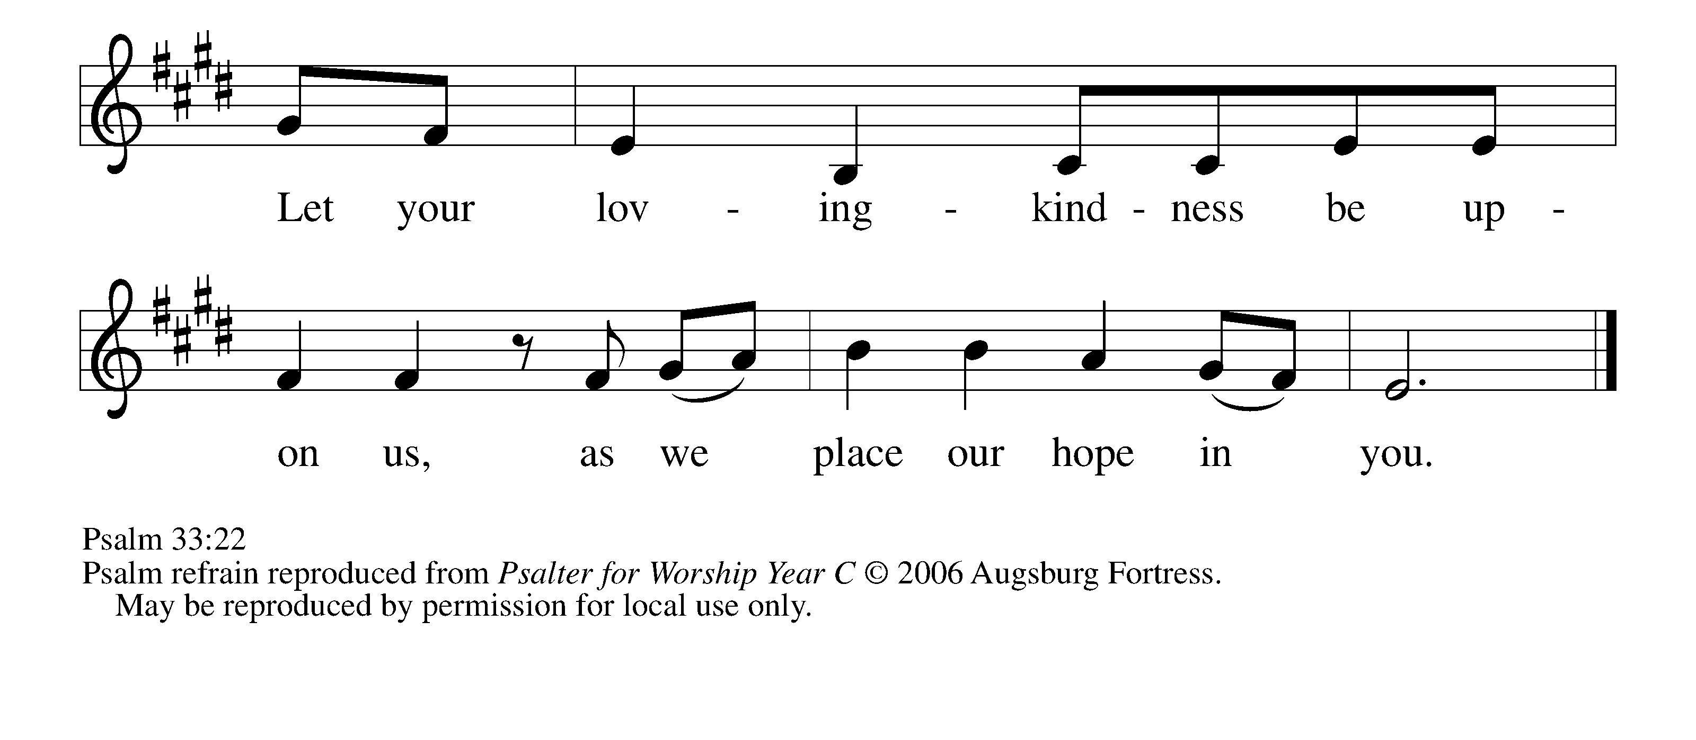

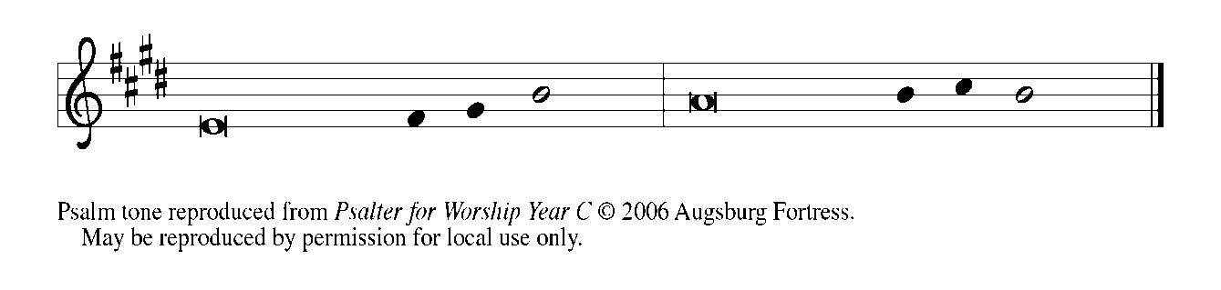

12Happy is the nation whose God | is the Lord!  
Happy the people chosen to| be God’s heritage!

 13**The Lord looks | down from heaven,**  
  **and sees all | humankind.**

 14God sits firmly en- | throned and watches  
all who dwell | on the earth.

15**God fashions | all their hearts**  
  **and observes | all their deeds. REFRAIN**

 16A king is not saved by the size | of the army,  
nor are warriors rescued by| their great strength.

 17**The horse gives vain | hope for victory;**  
  **despite its great strength it | cannot save.**

 18Truly, Your eye is upon those who fear | You, O Lord,  
upon those who wait for Your | steadfast love,

 19**to deliver their | lives from death,**  
  **and to keep them alive in | time of famine. REFRAIN**

 20Our innermost being waits for | You, O Lord,  
our helper | and our shield.

 21**Surely, our heart rejoic- | es in You,**  
  **for in Your holy name we | put our trust.**

 22Let Your lovingkindness, O Lord, | be upon us,  
even as we place our| hope in You. **REFRAIN**

**THE SECOND READING Hebrews 11:1-3, 8-16**

*Abraham and Sarah exemplify the vision of faith that people of God need in every age. Their hope and trust in God's promise allowed them to face an unknown future.*

1Now faith is the assurance of things hoped for, the conviction of things not seen. 2Indeed, by faith our ancestors received approval. 3By faith we understand that the worlds were prepared by the word of God, so that what is seen was made from things that are not visible.

8By faith Abraham obeyed when he was called to set out for a place that he was to receive as an inheritance; and he set out, not knowing where he was going. 9By faith he stayed for a time in the land he had been promised, as in a foreign land, living in tents, as did Isaac and Jacob, who were heirs with him of the same promise. 10For he looked forward to the city that has foundations, whose architect and builder is God. 11By faith he received power of procreation, even though he was too old--and Sarah herself was barren--because he considered him faithful who had promised. 12Therefore from one person, and this one as good as dead, descendants were born, "as many as the stars of heaven and as the innumerable grains of sand by the seashore."

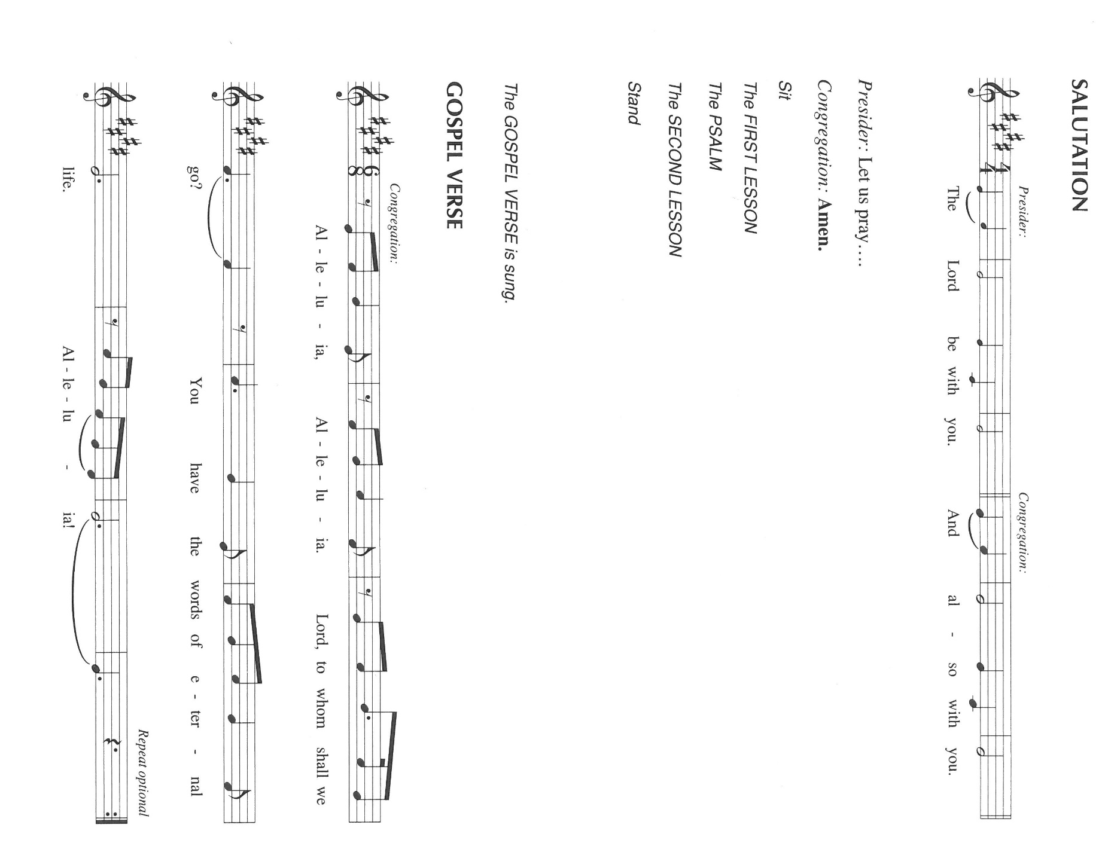 13All of these died in faith without having received the promises, but from a distance they saw and greeted them. They confessed that they were strangers and foreigners on the earth, 14for people who speak in this way make it clear that they are seeking a homeland. 15If they had been thinking of the land that they had left behind, they would have had opportunity to return. 16But as it is, they desire a better country, that is, a heavenly one. Therefore God is not ashamed to be called their God; indeed, He has prepared a city for them.

The Word of the Lord.

**Thanks be to God.**

*As you are able please rise*

**THE VERSE** (Sung twice)

**THE HOLY GOSPEL Luke 12:32-40**

*Jesus encourages his followers to recognize the true value of God's kingdom so that their hearts may be where their real treasure lies. Instead of facing life with fear, those who know God's generosity are always ready to receive from God and to give to others.*

P: The Holy Gospel according to St. Luke, the twelfth chapter.

C: **Glory to You, O Lord!**

Jesus said: 32"Do not be afraid, little flock, for it is your Father's good pleasure to give you the kingdom. 33Sell your possessions, and give alms. Make purses for yourselves that do not wear out, an unfailing treasure in heaven, where no thief comes near and no moth destroys. 34For where your treasure is, there your heart will be also.

35"Be dressed for action and have your lamps lit; 36be like those who are waiting for their master to return from the wedding banquet, so that they may open the door for him as soon as he comes and knocks. 37Blessed are those slaves whom the master finds alert when he comes; truly I tell you, he will fasten his belt and have them sit down to eat, and he will come and serve them. 38If he comes during the middle of the night, or near dawn, and finds them so, blessed are those slaves.

39"But know this: if the owner of the house had known at what hour the thief was coming, he would not have let his house be broken into. 40You also must be ready, for the Son of Man is coming at an unexpected hour."

P: The Gospel of the Lord.

C: **Praise to You, O Christ!**

*The assembly is seated*

**THE SERMON**

*Silence for reflection follows the sermon*

*As you are able please rise*

**THE HYMN OF THE DAY 764 *Have No Fear, Little Flock***

**THE APOSTLES’ CREED**

A: God has made us His people through our Baptism into Christ. Living together in trust and

hope, we confess our faith.

C: **I believe in God, the Father almighty,**

**creator of heaven and earth.**

**I believe in Jesus Christ, His only Son, our Lord.**

**He was conceived by the power of the Holy Spirit**

**and born of the virgin Mary.**

**He suffered under Pontius Pilate,**

**was crucified, died, and was buried.**

**He descended into hell.**

**On the third day He rose again.**

**He ascended into heaven,**

**and is seated at the right hand of the Father.**

**He will come again to judge the living and the dead.**

**I believe in the Holy Spirit,**

**the holy catholic Church,**

**the communion of saints,**

**the forgiveness of sins,**

**the resurrection of the body,**

**and the life everlasting. Amen.**

**THE PRAYER OF THE CHURCH**

A: Confident in God’s steadfast love through Jesus Christ and guided by the Spirit, let us pray for

the Church, the world, and all people according to their needs.

A: That as the Church waits in hope for the return of our Master, we will be found to be faithful

servants of Christ in the world: Lord, in Your mercy,

C: **Hear our prayer.**

A: That places of unrest, turmoil, bloodshed, and threatened violence, especially Iraq, Ukraine,

and Nigeria would be brought to peace by the God Who rules heaven and earth: Lord, in Your

mercy,

C: **Hear our prayer.**

A: That the hearts of those in this assembly would be rooted deeply in the ways of God’s Kingdom

and in ready service to others: Lord, in Your mercy,

C: **Hear our prayer.**

A: That God’s healing lovingkindness might be upon the lonely, the homeless, the hungry, and

the sick, especially . . . Lord, in Your mercy,

C: **Hear our prayer.**

A: That with all those whose faith sustained them as they longed for their heavenly home,

especially **Dominic, founder of the order of preachers,** whom we commemorate this Day

we might be granted God’s unfailing treasure in heaven: Lord, in Your mercy,

C: **Hear our prayer.**

P: You enter our lives, O God, by the gift of Yourself. It is the way we are to enter Yours. Teach

us that generosity, that we may live more fully as Christ the Lord, in Whose name we pray.

C: **Amen.**

**✠ MEAL ✠**

**THE PEACE**

P: The peace of the Lord be with you always.

C**: And also with you.**

*The assembly is seated*

**THE OFFERING**

**THE VOLUNTARY *God of Grace*  Getty/Rea**

**(Mary Knaup soloist)**

*As you are able please rise*

**THE OFFERTORY 465 *As the Grains of Wheat***

**THE OFFERTORY PRAYER**

A: Let us pray. God of grace,

C: **With “good pleasure” You daily give us the gifts of Your Kingdom. Receive these**

**offerings we present to You with our joy and thanksgiving. In this Meal fill us with Your**

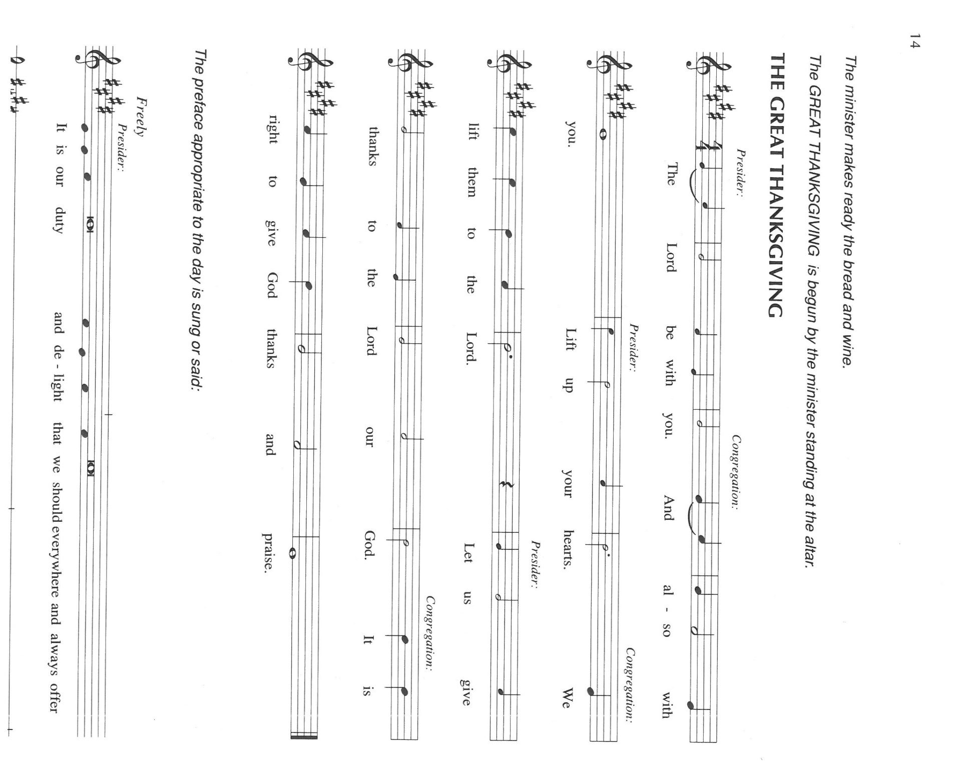 **Spirit, that our hearts may forever be found in Your greatest treasure, Jesus Christ our**

**Lord. Amen.**

**THE GREAT THANKSGIVING**

P: It is our duty and delight … join their unending hymn

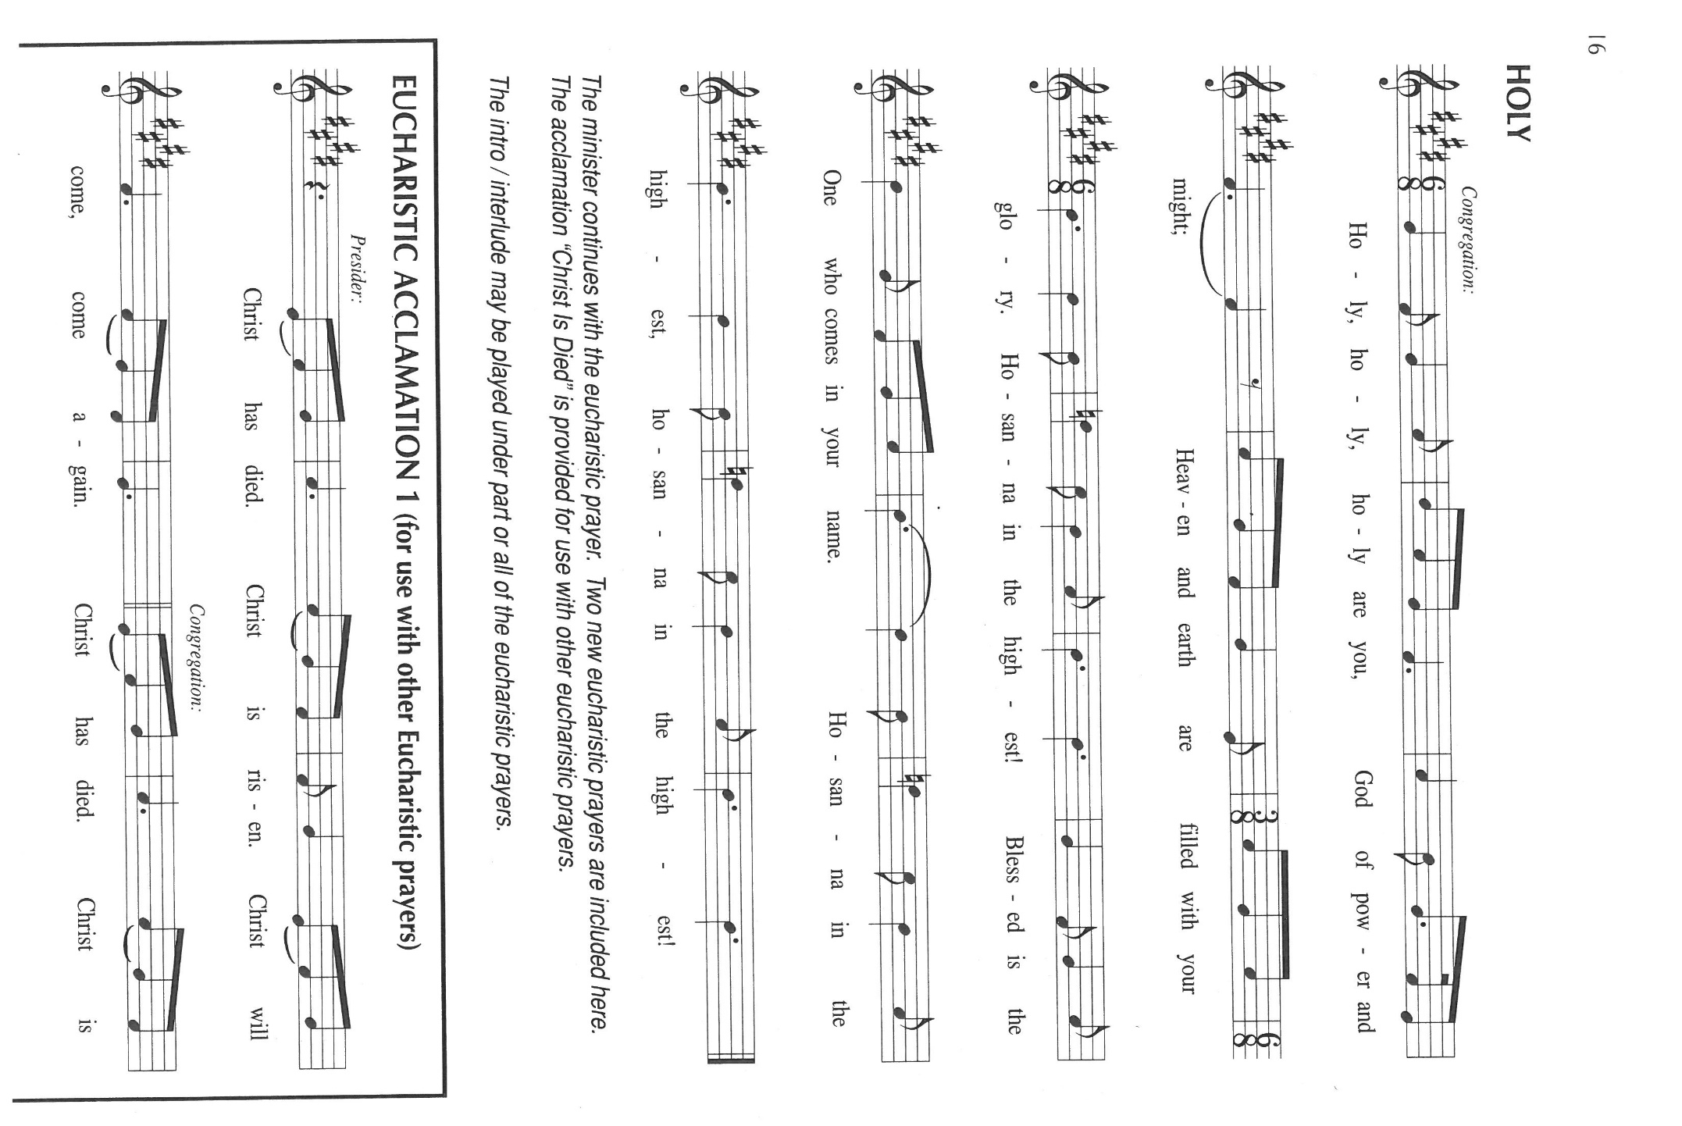

P: God of time and eternity, we give You thanks and praise, that You weave the fabric of

Your purpose through the warp of our faith and the weft of our faithlessness.

You meet us as You met Isaac and Jacob in the tents of our transience and prepare us as

You prepared Abraham for the city of Your joy.

We make ourselves strangers and foreigners to You, but You greet us in Your Son; in

His death and resurrection You bring us home to be the people of Your possession.

Loving God, You call us Your treasure, and You tell us that where Your treasure is, there

Your heart is also.

In Jesus You lodge Your heart among us, and in this sharing of Your holy Meal You place

that heart at the heart of our lives.

Now send down Your Holy Spirit, that we may become holy as You are holy, and that

these gifts of bread and wine may be for us the Body and Blood of Your Son,

Jesus Christ,

Who, in the night ... “Do this for the remembrance of Me.”

As often as we eat ... we proclaim the Lord’s death until He comes.

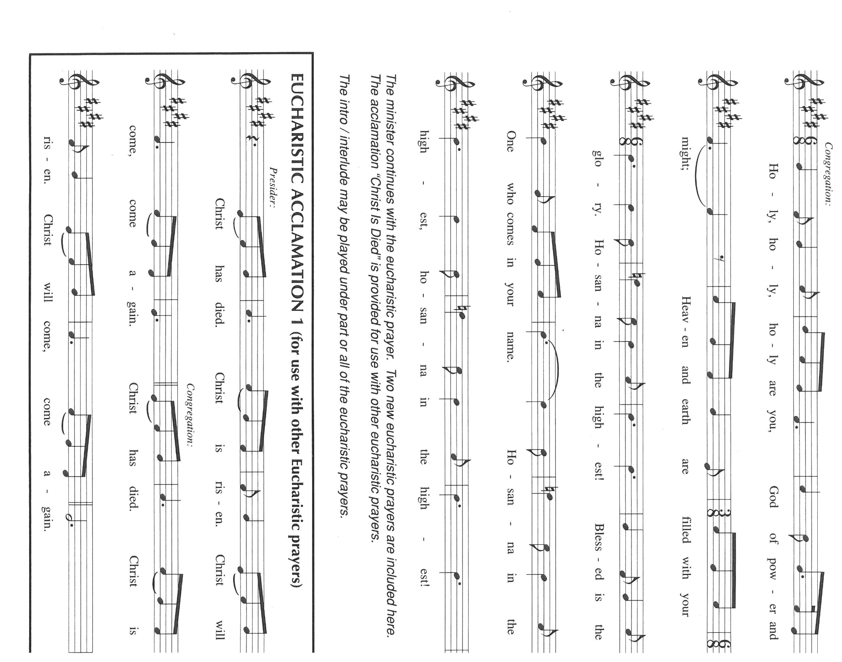

P: Revealing God, as we perceive Your Son, in the power of Your Spirit, to be present in this

bread and wine, open our eyes to see Your presence in the places and people

wherein You make known Your glory,

So that when You come again on the last Day we shall recognize You by the company You

keep and You shall recognize us by the company we keep.

Just as You have shown us that Your heart is always with us, wherever our hearts stray, so

now draw our hearts always to be where Your heart is.

As You have made us Your treasure on earth, transform us and Your whole creation into

Your treasure in heaven, until the Day when all hearts are drawn to You in the

harmony of Your praise,

Ever one God, our Savior and our Friend.

C: **Amen!**

**THE LORD’S PRAYER**

P: Gathered into one by the Spirit, let us pray as Jesus taught us:

C: **Our Father in heaven, hallowed be Your name.**

**Your Kingdom come, Your will be done on earth as it is in heaven.**

**Give us this day our daily bread, and forgive us our sins as we forgive those who**

**sin against us.**

**Save us from the time of trial and deliver us from evil, for the Kingdom and the**

**power and the glory are Yours, now and forever. Amen.**

**INVITATION TO THE MEAL**

P: This is the Lamb of God Who takes away the sin of the world. Blessed are those who are called

to the Supper of the Lamb. God’s holy things for God’s holy people. Come, for all is now

ready.

*The assembly is seated*

**THE DISTRIBUTION “Lamb of God”**

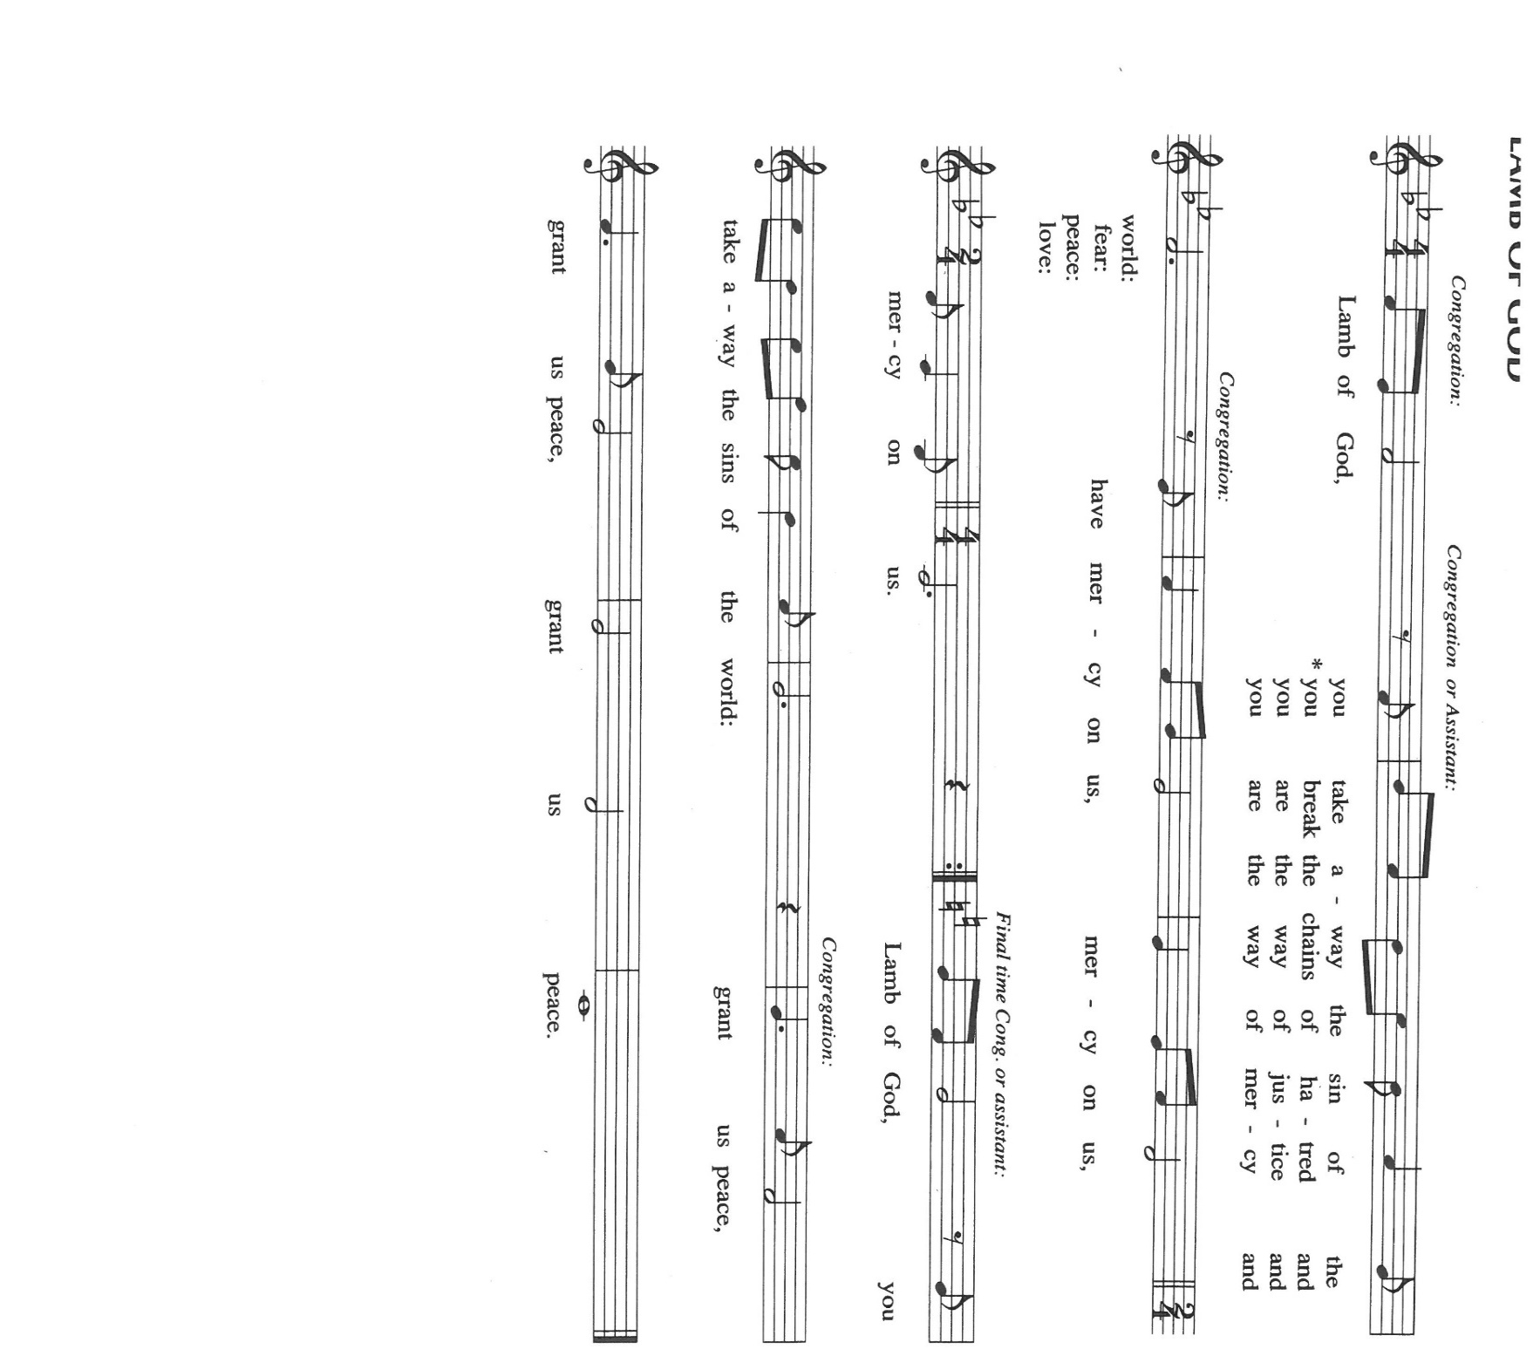

**HYMNS DURING DISTRIBUTION 856 *How Great Thou Art***

**488 *Soul, Adorn Yourself with Gladness***

*As you are able please rise*

**THE POST-COMMUNION BLESSING**

P: The Body and Blood of our Lord Jesus Christ strengthen you and keep you in His grace.

C: **Amen.**

**THE POST-COMMUNION PRAYER**

A: Let us pray. Lord Jesus Christ, once again in our hunger and our fear You have fed us with

the Food of Your Body and Blood that makes us glad and strong to live. By our eating and

drinking make us firm in faith and generous in serving, until You gather us again at Your Table.

You are the Lord forevermore.

C: **Amen.**

**✠ SENDING ✠**

**THE BENEDICTION**

P: Almighty God: Father, Son,✠and Holy Spirit bless you now and forever.

C: **Amen.**

**THE SENDING HYMN 638 *Blessed Assurance***

**THE DISMISSAL**

A: Go in peace to bear Christ’s love to all the world.

C: **Thanks be to God!**

**POSTLUDE *Blessed Assurance*  Knapp/Colvin**

**✠ To God Alone Be Glory ✠**

The Meditation is from *Sundays and Seasons Online.* Copyright 2019 Augsburg Fortress.

The musical setting of the liturgy, “Now the Feast and Celebration” by Marty Haugen, is used by

permission of GIA Publishers, Inc. OneLicense.net License #A-702836.

**ANNOUNCEMENTS**

**Please remember to mail your offering to the Church Office** at 818 Franklin Street, Michigan City, IN 46360**.** Another alternative is to give on-line through Tithe.ly. Please see your closure letter for information on how to set up a Tithe.ly account.

**St. Paul Members are reminded to have** a loved one contact the office if you are hospitalized. Many times, the Pastor doesn’t know someone is in the hospital. If you call and leave a message, please tell us which hospital the patient is at.

**Next Sunday’s lessons are Jeremiah 23: 23-29; Psalm 22; Hebrews 11: 29-12:2; Luke 12: 49-56** for those of you who like to study them in advance.

**Birthdays: Susan Dolson (8/11)**

**PRAYER CONCERNS:** Audrey Beyer, Ryan Krueger, Donna Bostater, Maxine Powell, Jim Tomscheck, Eloise Ponder, Mark & Jary Tannehill, Leonard Cross, George Ottersen, Annette Scroggin, Helen Hill-Weaver.

**If you requested someone’s name to be on the prayer list and are aware that they need continued imminent prayer then contact the church office and let us know.** Otherwise we will gradually transfer names to the long-term list.

**OFFICE HOURS:** Libby will be in the office on Mondays, Wednesdays, and Fridays; volunteers will cover Tuesdays and Thursdays.

Monday & Wednesday 8:00 a.m. – 5 p.m.

Tuesday & Thursday 9:00 a.m. – 12:00 p.m.

Friday 8:00 a.m. – 12:00 p.m.

**If you are listening to the worship broadcast on the radio and would like to watch the Sunday morning service live stream follow these steps:**

(1) If you have You.Tube available on your TV, search for

**St. Paul Lutheran Church Michigan City, IN.**

(2) The direct link on the computer is

<https://www.youtube.com/channel/UC5AIPNaKr3QN50984jGOa1g>.

 (3) This link is also on the main page of the church’s website in the church section and will continue to be posted weekly on the St. Paul Facebook page.

And it will always be available on the radio broadcast Sunday mornings at 11:00 a.m. on WEFM (95.9), and on the local cable access station #99 for the previous week’s service on Sundays at 4:00 p.m. and the current service on Wednesdays at 7:00 p.m. and Fridays at 8:30 p.m.

**To send e-mail to the church office**, please use the following addresses:

Pastor Mark Reshan: [seniorpastor@stpaulmichigancity.com](mailto:seniorpastor@stpaulmichigancity.com)

Church Office Secretary (Libby Pollock): [churchsecretary@stpaulmichigancity.com](mailto:churchsecretary@stpaulmichigancity.com)

Church Treasurer (Karen Fleming): [finance@stpaulmichigancity.com](mailto:finance@stpaulmichigancity.com)

**The Good News Newsletter**: If you have an article or anything you want included in **The Good News** please send it to the following e-mail address: splcgoodnews@gmail.com. Pastor Pamela Thiede will be using this e-mail address to assemble **The Good News** each month. The deadline for getting information to Pastor Pamela will be the 20th of each month.

**PLEASE REMEMBER:** the next time you are coming to the church whether it be for one of the worship services or for any other meeting or activity please remember to bring in non-perishable food items to donate to the Salvation Army Food Pantry. There is a

serious need in this community to help especially those whom have little to no access to food and/or shelter. Please open your hearts and continue to be generous in your giving!

**WORSHIP ATTENDANCE for July 30 and 31, 2022**

**4:00 p.m. 28**

**9:00 a.m. 61**

**Total = 89**

**AUGUST 2022 ACTIVITIES, EVENTS & MEETINGS**

**Saturday,** August 6, 2022 at 4:00 p.m. Worship Service

**Sunday,** August 7, 2022 at 9:00 a.m. Worship Service

**Monday,** August 8, 2022 at 12:30 p.m. Harmony Circle/Green Room/Nursery

at 2:00 p.m. School Board Meeting/Luther House

**Tuesday,** August 9, 2022 at 9:30 a.m. Charity Circle/Green Room/Nursery

**Wednesday,** August 10, 2022 at 10:00a.m. God’s Pearls

at 6:00 p.m. Worship & Music Committee

**Saturday,** August 13, 2022 at 4:00 p.m. Worship service

**Sunday,** August 14, 2022 at 9:00 a.m. Worship Service

**Wednesday,** August 17, 2022 at 10:00 a.m. God’s Purls/St. Paul Room

**Saturday,** Augst 20, 2022 at 4:00 p.m. Worship Service

**Sunday,** August 21, 2022 at 9:00 a.m. Worship Service

**Monday,** August 22, 2022 at 4:00 p.m. Finance Committee Meeting/Luther House

at 5:30 p.m. Executive Board Meeting/Luther House

**Tuesday,** August 23, 2022 all day and evening **GIVE-BACK AT HOLLY’S**

**Wednesday,** August 24, 2022 at 10:00 a.m. God’s Purls/Green Room/Nursery

**Thursday,** August 25, 2022 at 5:30 p.m. Church Council Meeting/St. Paul Room

**Saturday,** August 27, 2022 at 4:00 p.m. Worship Service

**Sunday,** August 28, 2022

St. Paul Lutheran Church has always been a supporter of the less fortunate in our community. We hosted the men’s and women’s shelters for many years. The shelters are now in their own building, but **Interfaith PADS** operates by donations and a few grants.

Well, United Healthcare of LaPorte has granted **PADS** with matching dollar for dollar in donations up to $25,000. This means that for every dollar we donate **PADS** gets another dollar from United Healthcare . . .**PLEASE,** let’s show our continued support by making a donation to **PADS. The mailing address is: Interfaith PADS**

**P.O. Box 38**

**Michigan City, IN 46361**

**The 2022 Church Directory is finished!** They are available in the Narthex at the back of the church and there are extra ones in the Church Office. If you have any questions, comments or concerns please feel free to call or email Libby in the Church Office.

***Rally Days – September 10th and 11th***

Rally means to assemble, reassemble and revive.

Plan on joining together to RALLY on Saturday, September 10th after the Saturday worship service (about 5:00pm) for a Pot Luck dinner. The council will provide Grilled Hot Dogs, buns and condiments. Please bring an appetizer, side dish or dessert.

All are welcome to assemble, reassemble if you have been vacationing, and revive our Christian Lutheran journey.