**THE FIRST SUNDAY OF ADVENT**

**December 1, 2024**

“ …Even the parable of “the fig tree and all the trees” (Luke 21: 29-31) suggests that the past can help to make sense of the future. When buds begin to form on barren trees we are confident that winter is ending and summer will arrive. Why? Because we have previously lived through a change of seasons, or because others have told us of their own experience.

Despite the promise of spring, however, new buds do not always form. Sometimes they are killed by drought or swept away by the roaring waves of a hundred-year flood—for the third time in six years. Fires rage through forests and woods, darkening the sun and sending evidence of ash and smoke even thousands of miles away. Hillsides are cleared for the sake of a better view, corporations fell rainforests in order to improve their bottom line, and nations install border-walls that cut through orchards and separate trees from the people who attend to their care.

The devastation is enough to take one’s breath away—which is the meaning of the Greek word translated as “faint” in Luke 21: 26: People will faint*(apopsychō* = to stop breathing, be breathless*)*from fear and foreboding of what is coming upon the world.”

Nonetheless, the apocalyptic vision shared by Jesus is assurance that even (especially) in the face of devastation—whether it is caused by nature’s fury or by human hubris—the reign of God will not be impeded. No matter how much it appears that the world is coming un-done, God’s way endures.

The message on this first Sunday of Advent paints a hope-filled picture for “all who live on the face of the whole earth” (Luke 21: 34).

Jesus speaks in the language of apocalyptic, or revelation. Vivid images—the heavens being shaken, the Son of Humanity appearing in the clouds—depend on the metaphors’ capacity to express a community’s trauma while also offering powerful hope in the midst of those experiences.

When the present reality includes wars and political tumult (distress among nations), climate catastrophe (signs in the sun, the moon, and the stars), global pandemic (breathless from fear and foreboding), unemployment, hate crimes, racist ideologies, death-dealing illness, displacement by terror, or anything else that traps people in fear or despair (weighs down hearts), it is then that we look for the coming of the Son of Humanity, the Christ whose promised future makes all the difference for today.

Now when these things begin to take place, stand up and raise your heads, because your redemption is drawing near (Luke 21: 28).”

**Audrey West**

**✠  *In the Name of Jesus* ✠**

**INTRODUCTION**

Advent is about the "coming days." God's people have always lived in great expectation, but that expectation finds specific, repeated enunciation in the texts appointed for these four weeks. The ancients anticipated a "righteous Branch to spring up for David." The Thessalonians awaited "the coming of our Lord Jesus with all the saints." Our Lord's contemporaries hoped for the time "to stand before the Son of Man." With them we eagerly await the coming days: another Christmas celebration, a second coming, and the advent of our Lord in word and supper.

**Andrew, Apostle**

*The first of the disciples to be called by Jesus, Andrew quickly began to bring others to the Savior, including Simon Peter. The Bible also shows him leading some Greeks to meet Jesus, and he brought forward the boy with five loaves and two fish, with which Jesus fed thousands.*

**✠ GATHERING ✠**

**PRE-SERVICE MUSIC To You O Lord New Song Praise Band**

**(Graham Kendrick)**

**ANNOUNCEMENTS**

As you are able please rise

**CONFESSION AND ABSOLUTION**

P: In the name of the Father and of **✠** the Son and of the Holy Spirit.

**C: Amen.**

P: “Gracious and upright is the LORD; therefore He teaches sinners in His way. He guides

the humble in doing right and teaches His way to the lowly.” (Psalm 25: 7-8) To

prepare us for the coming of Christ, we ask God to turn us from our sin, and lead us

into His tender mercy and compassion.

*Silence for self-examination and reflection is kept*

P: Most merciful God,

**C: We confess that we sinned against You and one another in thought, word, and**

**deed. We have not trusted in You all the day long. (Psalm 25: 4) We have strayed**

**from Your paths of love and faithfulness. (25: 9) We do not thank You enough for**

**all Your gifts of blessings. (1 Thessalonians 3: 9) We do not abound in love for**

**You and one another. (3: 12) Our hearts and lives lack the holiness of thought,**

**word, and deed to which You call us. (3: 13) Weighed down by the worries and**

**concerns of this life, we are not alert and ready for Christ’s return. (Luke 21: 34)**

**“For Your name’s sake, O LORD, forgive our sin, for it is great.” (Psalm 25: 10)**

P: God does not “remember your sins ... nor your transgressions ...” but remembers you

“according to (His) love and for the sake of (His) goodness.” (Psalm 25: 6) Therefore,

as a called and ordained minister of the Church of Christ, and by His authority, I declare

to you the entire forgiveness of all your sins, in the name of the Father and of **✠** the

Son and of the Holy Spirit.

**C: Amen.**

**GATHERING SONG NSB 28 *Days of Elijah***

**THE GREETING**

P: From the One Who is and Who was and Who is to come, the Almighty: grace, light,

and peace be with you all.

**C: And also with you.**

**THE KYRIE**

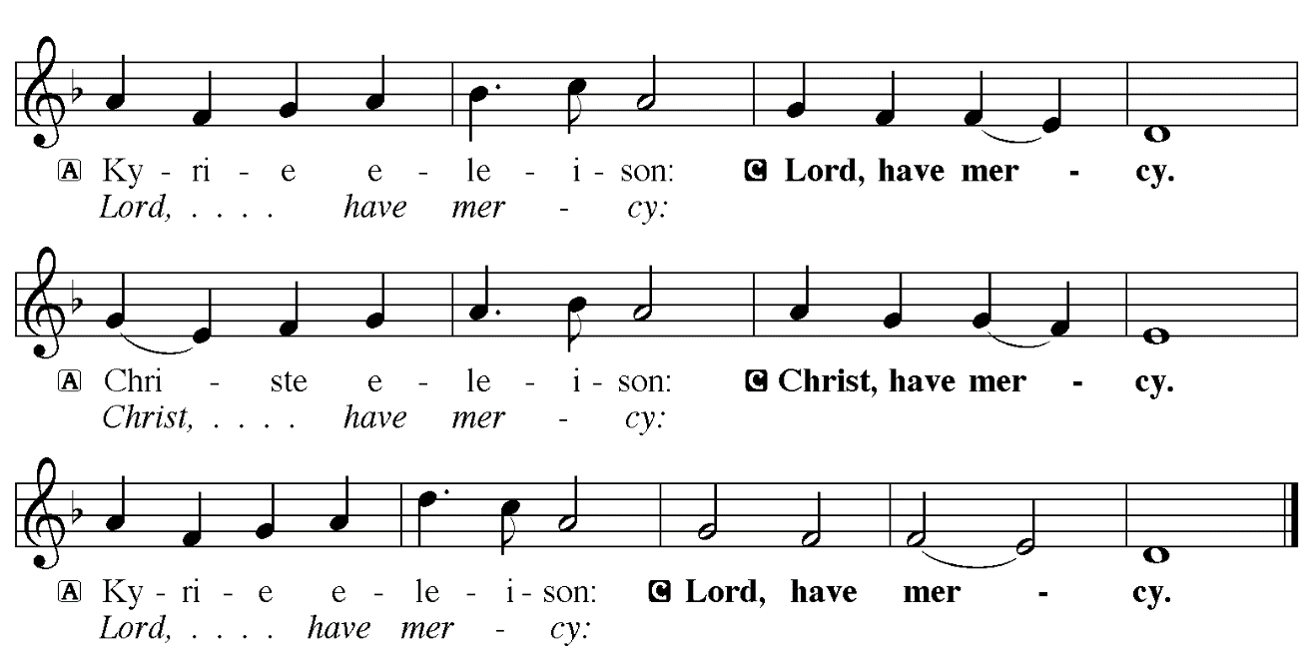

**THE PRAYER OF THE DAY**

P: The Lord be with you.

**C: And also with you.**

P: Let us pray. Stir up Your power, Lord Christ, and come. By Your merciful protection

alert us to the threatening dangers of our sins and redeem us for Your life of justice, for

You live and reign with the Father and the Holy Spirit, one God, now and forever.

**C: Amen.**

*The assembly is seated*

**LIGHTING OF THE ADVENT LOG *Light of Hope*** **St. Paul Senior Choir**  (Joel Raney)

Choir: Light of peace, calm our despair. Light of hope, lift us up when we fall. Light of joy brighten our days; Light of love, teach us Your ways.

***The Gift of Hope***

P: We begin the season of Advent with expectant and believing hearts.

**C: We wait upon the Lord and place our hope in God’s Word.**

P: During Advent we confront the darkness that so often exists around us.

**C: We wait upon the Lord and place our hope in God’s Word.**

P: During Advent we confront the doubt that so often resides within us.

**C: We wait upon the Lord and place our hope in God’s Word.**

P: During Advent we confront the division that so often occurs between us.

**C: We wait upon the Lord and place our hope in God’s Word.**

(During the candle lighting)

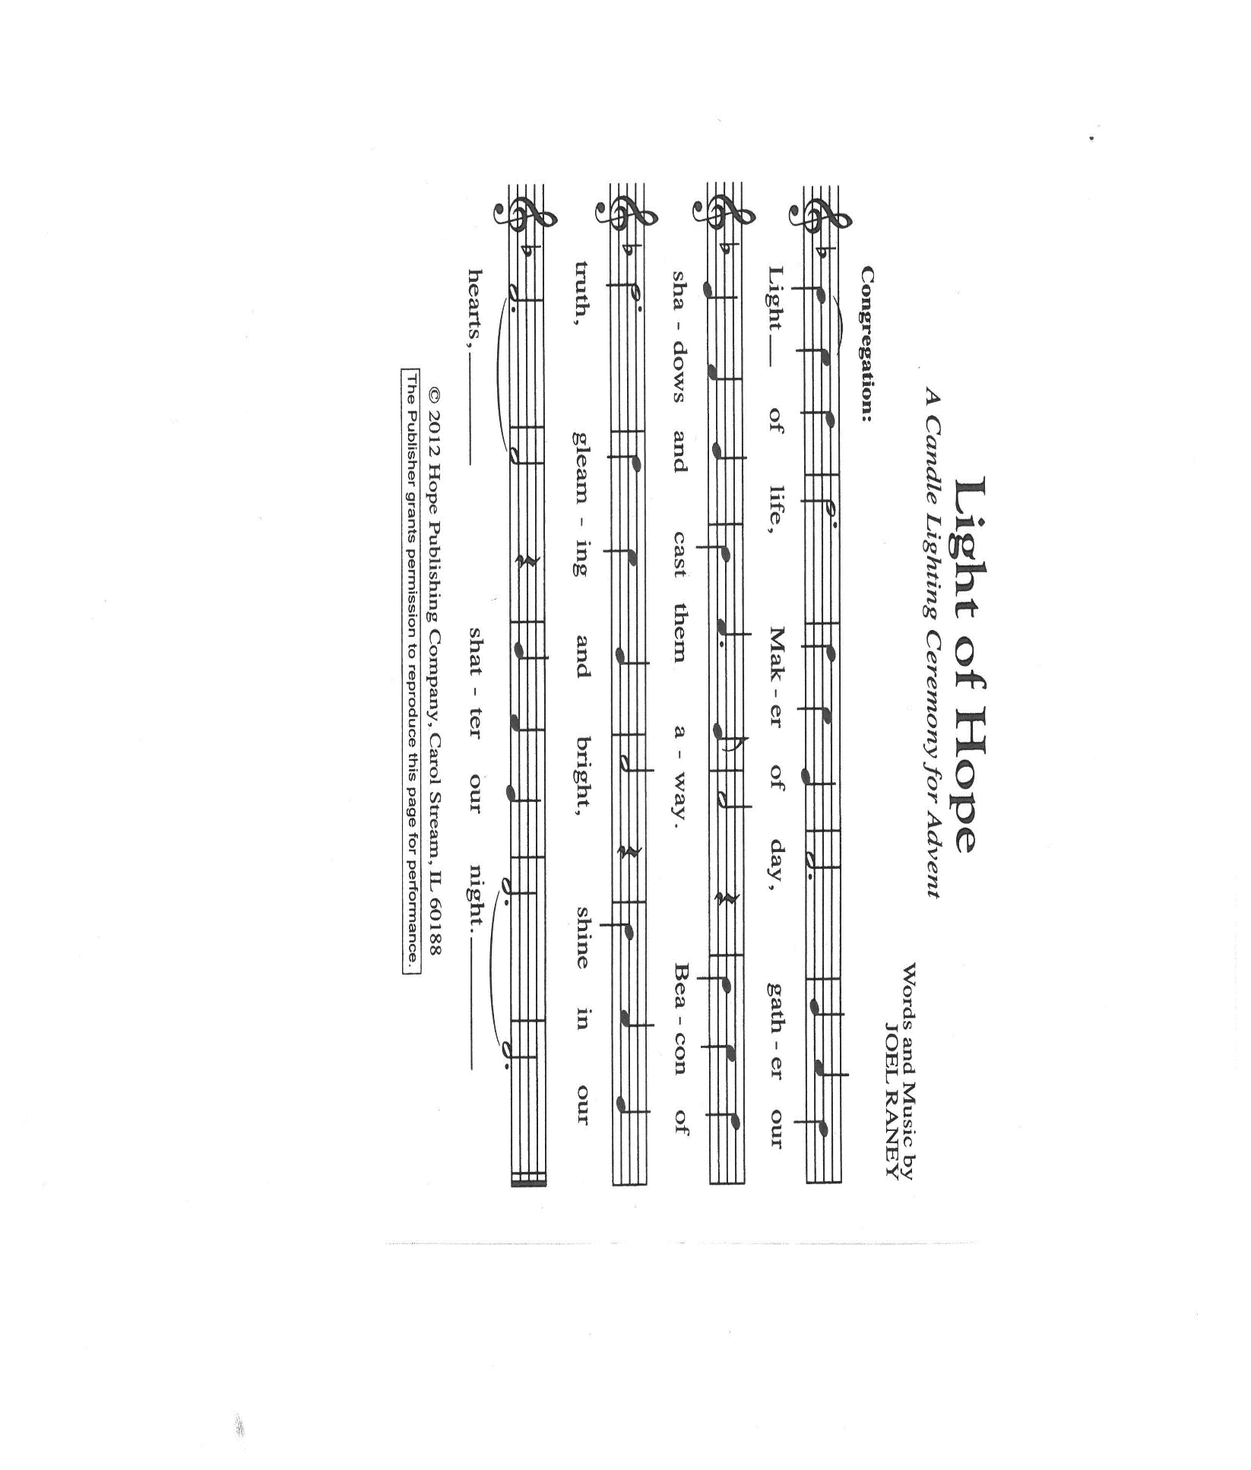

P: This morning we light the **first candle** which reminds us of the ultimate hope that comes

through our Savior’s birth. In a world where we often get overwhelmed by our

circumstances, Advent comes as a gentle whisper offering us hope to heal the broken,

befriend the lonely, and share the good news of the Gospel. This morning let us begin

this Advent season with expectant and believing hearts.

P: Gracious God, as we embark upon another Advent journey, we pray that we would be

encouraged by hope, strengthened in unity, and inspired through faith. May our ears

be open and our hearts ready to receive the gift of hope embodied in the Word-made-

flesh. We pray this in the name of Christ, our Savior.

**C: Amen.**

**✠ WORD ✠**

**FIRST READING Jeremiah 33: 14-16**

*In the Hebrew Scriptures, righteousness is not so much a moral virtue as the fulfillment of the responsibilities of a relationship among people or with God. God acts righteously in speaking against Israel's faithlessness and in working salvation for them. In today's reading, Jerusalem's future name--"The Lord is our righteousness"--serves as a sign that the Lord is even now working salvation for the people.*

14The days are surely coming, says the Lord, when I will fulfill the promise I made to the house of Israel and the house of Judah. 15In those days and at that time I will cause a righteous Branch to spring up for David; and he shall execute justice and righteousness in the land. 16In those days Judah will be saved and Jerusalem will live in safety. And this is the name by which it will be called: "The Lord is our righteousness."

The Word of the Lord.

**Thanks be to God.**

**THE PSALM: Psalm 25**  Antiphon by Carolyn Jennings

Choir sings refrain first, followed immediately by the congregation

and as indicated

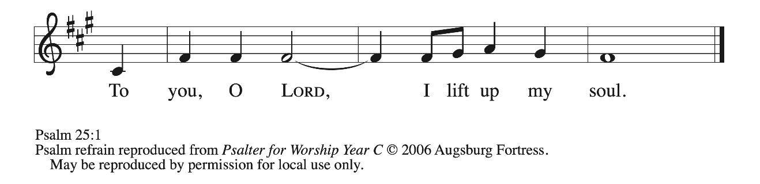

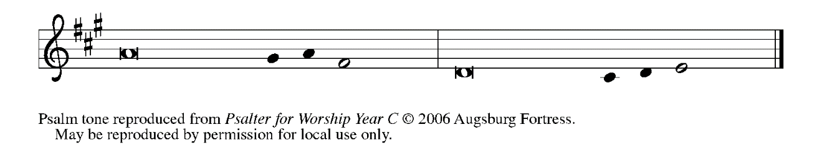

1To **|** You, O Lord,

I lift **|** up my soul.

**2My God, I put my trust in You; let me not be | put to shame,**

**nor let my enemies triumph | over me.**

3Let none who look to You be **|** put to shame;

rather let those be put to shame **|** who are treacherous.

**4Show me Your | ways, O Lord,**

**and teach | me Your paths. REFRAIN**

5Lead me in Your **|** truth and teach me,

for You are the God of my salvation; in You have I trusted all **|** the day long.

**6Remember, O Lord, Your compas- | sion and love,**

**for they are from | everlasting. REFRAIN**

7Remember not the sins of my youth and **|** my transgressions;

remember me according to Your steadfast love and for the sake of Your good- **|** ness, O Lord.

**8You are gracious and up- | right, O Lord;**

**therefore You teach sinners | in Your way.**

9You lead the low- **|** ly in justice

and teach the low- **|** ly Your way.

**10All Your paths, O Lord, are steadfast | love and faithfulness**

**to those who keep Your covenant and Your | testimonies. REFRAIN**

**SECOND READING 1 Thessalonians 3: 9-13**

*From Timothy, Paul hears about the faithful congregation in Thessalonica and is moved to express his thanks to God. He prays that the congregation may grow in love and holiness until "the coming of our Lord Jesus with all the saints."*

9How can we thank God enough for you in return for all the joy that we feel before our God because of you? 10Night and day we pray most earnestly that we may see you face to face and restore whatever is lacking in your faith.

11Now may our God and Father Himself and our Lord Jesus direct our way to you. 12And may the Lord make you increase and abound in love for one another and for all, just as we abound in love for you. 13And may He so strengthen your hearts in holiness that you may be blameless before our God and Father at the coming of our Lord Jesus with all His saints.

The Word of the Lord.

**Thanks be to God.**

*As you are able please rise*

**THE VERSE**

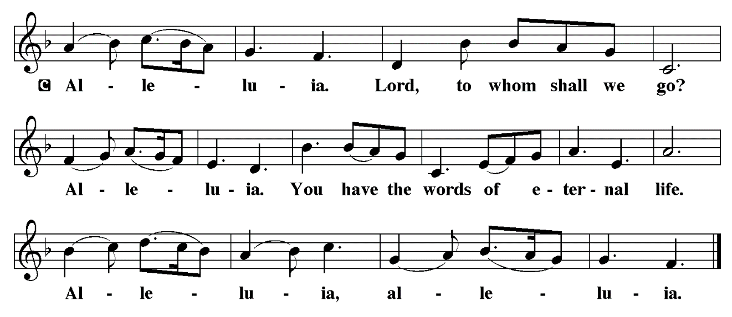

**THE HOLY GOSPEL: Luke 21: 25-36**

*When God brings the creation to fulfillment, there will be dismay, perplexity, fright, and shaking heavens. But with this vision also come words of assurance: for the faithful, this will not be a time to cower in fear, but to stand boldly and receive God’s promised redemption.*

P: The Holy Gospel according to St. Luke, the twenty-first chapter.

**C: Glory to You, O Lord!**

Jesus said: 25"There will be signs in the sun, the moon, and the stars, and on the earth distress among nations confused by the roaring of the sea and the waves. 26People will faint from fear and foreboding of what is coming upon the world, for the powers of the heavens will be shaken. 27Then they will see 'the Son of Man coming in a cloud' with power and great glory. 28Now when these things begin to take place, stand up and raise your heads, because your redemption is drawing near."

29Then He told them a parable: "Look at the fig tree and all the trees; 30as soon as they sprout leaves you can see for yourselves and know that summer is already near. 31So also, when you see these things taking place, you know that the kingdom of God is near. 32Truly I tell you, this generation will not pass away until all things have taken place. 33Heaven and earth will pass away, but My words will not pass away.

34"Be on guard so that your hearts are not weighed down with dissipation and drunkenness and the worries of this life, and that day catch you unexpectedly, 35like a trap. For it will come upon all who live on the face of the whole earth. 36Be alert at all times, praying that you may have the strength to escape all these things that will take place, and to stand before the Son of Man."

P: The Gospel of the Lord.

**C: Praise to You, O Christ!**

*The assembly is seated*

**THE SERMON**

*Silence for reflection follows the sermon*

*As you are able please rise*

**THE HYMN OF THE DAY *Come, Now, O God***



**THE NICENE CREED**

A: God has made us His people through our Baptism into Christ. Living together in trust

and hope, we confess our faith.

**C: We believe in one God,**

**the Father, the Almighty,**

**maker of heaven and earth,**

**of all that is, seen and unseen.**

**We believe in one Lord, Jesus Christ,**

**the only Son of God,**

**eternally begotten of the Father,**

**God from God, Light from Light,**

**true God from true God,**

**begotten, not made,**

**of one Being with the Father.**

**Through Him all things were made.**

**For us and for our salvation**

**He came down from heaven;**

**by the power of the Holy Spirit**

**He became incarnate from the virgin Mary, and was made man.**

**For our sake He was crucified under Pontius Pilate;**

**He suffered death and was buried.**

**On the third day He rose again**

**in accordance with the Scriptures;**

**He ascended into heaven**

**and is seated at the right hand of the Father.**

**He will come again in glory to judge the living and the dead,**

**and His kingdom will have no end.**

**We believe in the Holy Spirit, the Lord, the giver of life,**

**Who proceeds from the Father and the Son.**

**With the Father and the Son He is worshiped and glorified.**

**He has spoken through the prophets.**

**We believe in one holy catholic and apostolic Church.**

**We acknowledge one Baptism for the forgiveness of sins.**

**We look for the resurrection of the dead,**

**and the life of the world to come. Amen**

**THE PRAYER OF THE CHURCH**

A: With longing for the fullness of redemption, let us pray for the Church, the world, and

all people according to their needs.

A: That the Church may abound in love for one another, stay alert to Your advent, and

have strength to do Your will, we pray, hear us, O Lord:

**C: For Your mercy is great.**

A: That the justice, righteousness, and peace promised at Your Son’s return would dawn

now in Sudan, Haiti, Ukraine, Gaza, Israel, Lebanon, Nigeria and other places of

violence and turmoil, we pray, hear us, O Lord:

**C: For Your mercy is great.**

A: That this congregation might be led in these days in God’s paths of love and

faithfulness, we pray, hear us, O Lord:

**C: For Your mercy is great.**

A: That those who suffer illness or any other need, especially …might be sustained as they

wait for wholeness and healing, we pray, hear us, O Lord:

**C: For Your mercy is great.**

A: That those celebrating birthdays, especially **Donna Ottersen** may be filled with grace

this day and every day and grow in grace in the days ahead, we pray, hear us, O Lord:

**C: For Your mercy is great.**

A: That with the faithful who have gone before us, especially **Andrew, Apostle,** whom

we commemorate this Day and all the saints whose hope is now certain, we may stand

before You in praise and worship in the fullness of Your reign, we pray, hear us, O

Lord:

**C: For Your mercy is great.**

P: God our Father, hear the prayers we make in the name of Jesus Christ Whose coming

is certain and Whose Day draws near.

**C: Amen.**

**✠ MEAL ✠**

**THE PEACE**

P: The peace of the Lord be with you always.

**C: And also with you.**

*The assembly is seated*

**THE OFFFERING**

**THE VOLUNTARY*****With Open Hearts, We Are Waiting*** **St. Paul Senior Choir** (P. Choplin)

*As you are able please rise*

**THE PRESENTATION OF THE GIFTS**

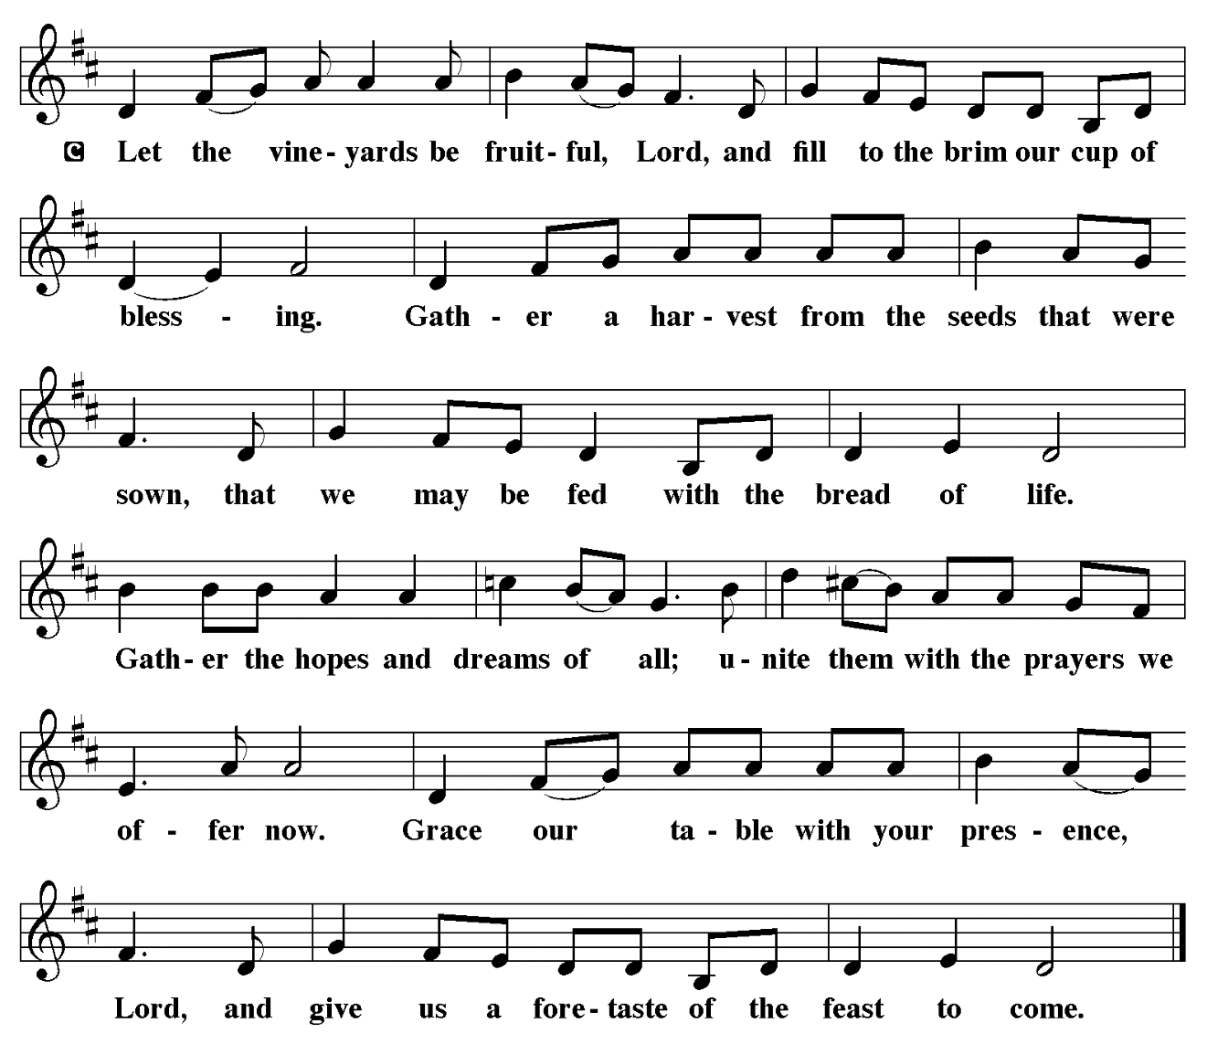

**THE OFFERTORY PRAYER**

A: Let us pray. God of love and power,

**C: Your Word stirs within us the expectation of the coming of Your Son. Accept all**

**we offer You this day. By this holy Sacrament, strengthen our hearts in holiness**

**that we may be blameless before You at the coming of our Lord Jesus Christ, in**

**Whose name we pray. Amen.**

**THE GREAT THANKSGIVING**

P: The Lord be with you.

**C: And also with you.**

P: Lift up your hearts.

**C: We lift them up to the Lord.**

P: Let us give thanks to the Lord our God.

**C: It is right to give Him thanks and praise.**

P: It is indeed right and salutary … we praise Your name and join their unending hymn:

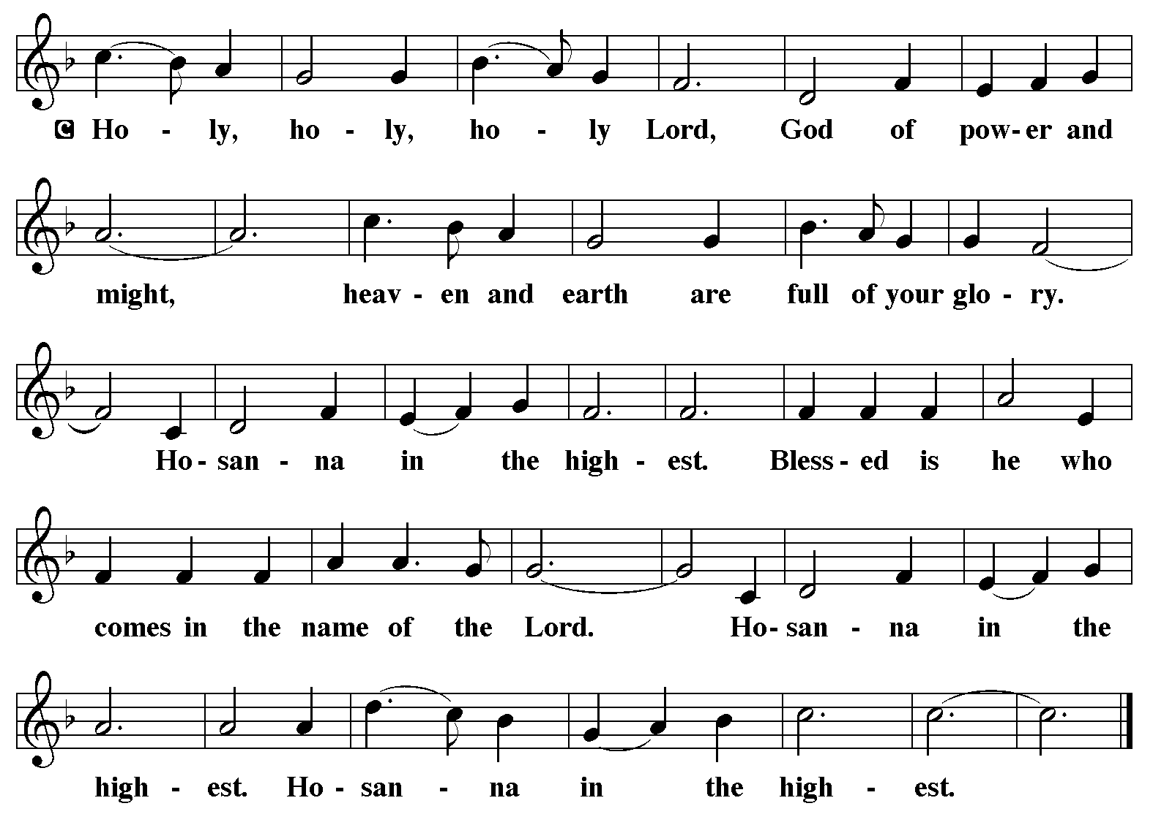

P: Blessed are You, God of David, for Your faithfulness is steadfast and Your mercy

has been from of old.

You draw Your people to You with Your promise of salvation, and every promise

You make, in Your goodness, You fulfill.

From the house of David You raised up Your Messiah to restore Judah and to herald

that Your deliverance was near.

In Your Son’s righteousness we find our life: for His righteousness was more than

enough for Your people who had waited so long for justice, who had

yearned so long for redemption, who had trusted so long in Your grace.

Truly in His righteousness is fulfilled every hope of salvation in every generation.

By His death we can stand forgiven and accepted before You; and through His

resurrection, we can share in Your holy life forever.

God of glory, for Whose coming we wait, make this Meal a sign that our redemption

draws near.

Send Your Holy Spirit upon Your Church: strengthen our hearts in all holiness that we

may be heralds of Your Kingdom.

By that same Spirit, make holy this bread and this cup that they may be for us the

Body and Blood of Your Son,

Who, in the night ... “Do this for the remembrance of Me.”

As often as we eat ... we proclaim the Lord’s death until He comes.

**C: Christ has died. Christ is risen. Christ will come again.**

P: God of power, You have promised to make Your way to us: come quickly to those

who wait for You.

Raise up every head that is bent low in sing.

Uphold every heart that is bowed down in shame.

Uphold every spirit that is made heavy by oppression.

Inspire every weary throat to sing of the Day when justice and mercy meet.

Bring us through all that is passing away to the life that shall never pass away,

When every eye shall be lifted to gaze upon Your Son in everlasting glory with

all Your saints,

And when the redemption for which we have longed shall forever be ours, in

the company of Your Son and the power of Your Spirit, holy Father,

blessed Trinity, now and forever.

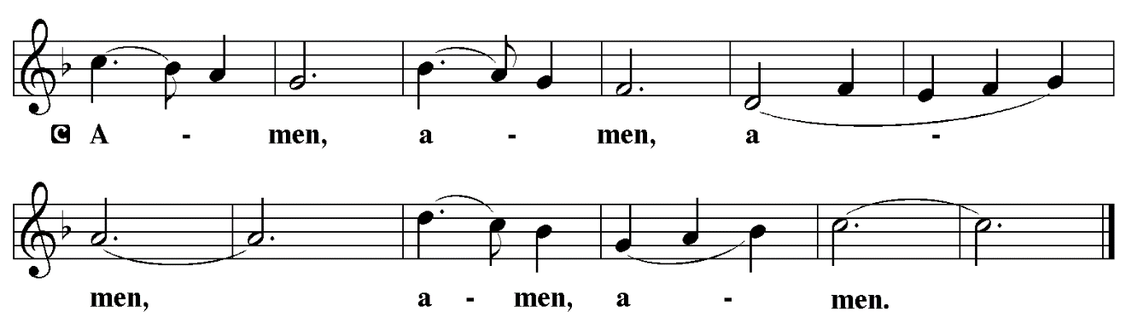

**THE LORD’S PRAYER**

P: Let us pray for the coming of God’s Kingdom as Jesus taught us:

**C: Our Father, Who art in heaven, hallowed be Thy Name.**

**Thy Kingdom come, Thy will be done on earth as it is in heaven.**

**Give us this day our daily bread, and forgive us our trespasses as we**

**forgive those who trespass against us.**

**And lead us not into temptation, but deliver us from evil.**

**For Thine is the Kingdom, and the power, and the glory, forever and**

**ever. Amen.**

**INVITATION TO THE MEAL**

P: Behold the Lord Whose advent we await, Who will come with glory on the Day of

judgment. Blessed are those who are called to the Supper of the Lamb. God’s holy

gifts for God’s holy people. Come, for all is now ready.

**THE DISTRIBUTION**

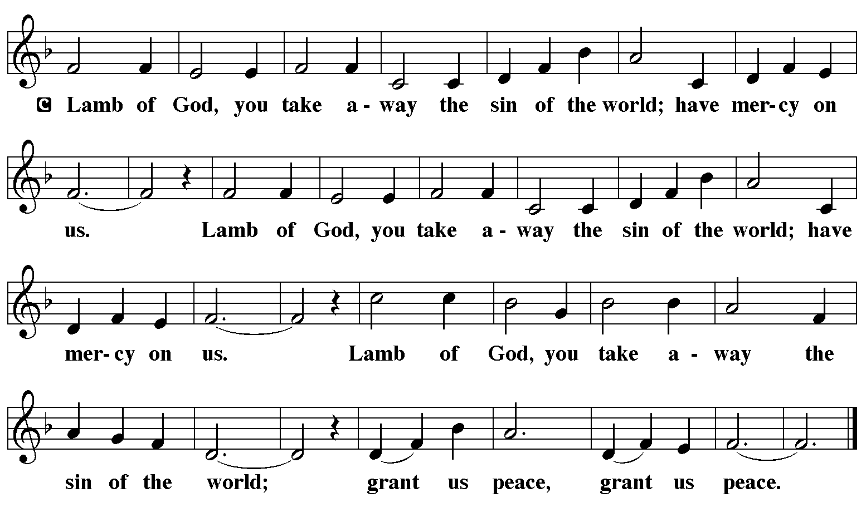

**HYMN DURING DISTRIBUTION 259 *Fling Wide the Door***

**ELW 248 *People Look East***

**NSB 58 *I Will Call Upon the Lord***

**NSB 32 *Emmanuel***

*As you are able please rise*

**THE POST-COMMUNION BLESSING**

P: The Body and Blood of our Lord Jesus Christ strengthen you and keep you in His grace.

**C: Amen.**

**THE POST-COMMUNION PRAYER**

A: Let us pray. God for Whom we wait, You have fed us with the Bread of Life. Through

this holy Sacrament, make us increase and abound in love for one another. Keep us

ever watchful, that we may be ready to stand before the coming Son of Man. Grant

this through Christ our Lord.

**C: Amen.**

**✠ SENDING ✠**

**THE BENEDICTION**

P: Almighty God: Father, Son, **✠** and Holy Spirit bless you now and forever.

**C: Amen.**

**SENDING SONG 715 *Christ Be Our Light***

**THE DISMISSAL**

A: The coming of the Lord is near. Go in peace. Serve the Lord.

**C: Thanks be to God!**

**POSTLUDE**

**✠ *To God Alone Be Glory* ✠**

The Meditation is from *Working Preacher.* Copyright 2021 Luther Seminary.

**ANNOUNCEMENTS**

**Please remember to mail your offering to the Church Office** at 818 Franklin Street, Michigan City, IN 46360**.** Another alternative is to give on-line through Tithe.ly. Please see your closure letter for information on how to set up a Tithe.ly account.

**St. Paul Members are reminded to have** a loved one contact the office if you are hospitalized. Many times, the Pastor doesn’t know someone is in the hospital. If you call and leave a message, please tell us which hospital the patient is at.

**Anniversaries: Donna Ottersen (12/6)**

**PRAYER CONCERNS:** Jeanie Boatman Shepple, Joan Seifert, Nolan Wilson, Debbie Martin, Mark Tannehill, Brian Wiseman, Kathy Stein, Danielle Schnell; Venia Wendt, Jan Paholski, Laura Dovey, Nancy Hoover, Grace Romine and Janet Green.

**OFFICE HOURS:** Libby will be in the office on Mondays, Wednesdays,

and Fridays; volunteers will cover Tuesdays and Thursdays.

Monday & Wednesday 8:00 a.m. – 5 p.m.

Tuesday & Thursday 9:00 a.m. – 12:00 p.m.

Friday 8:00 a.m. – 12:00 p.m.

**If you are listening to the worship broadcast on the radio and would like to watch the Sunday morning service live stream follow these steps:**

(1) If you have You Tube available on your TV, search for

**St. Paul Lutheran Church Michigan City, IN.**

(2) The direct link on the computer is

https://www.youtube.com/channel/UC5AIPNaKr3QN50984jGOa1g.

   (3) This link is also on the main page of the church’s website in

the church section and will continue to be posted weekly on the St.

Paul Facebook page.

And it will always be available on the radio broadcast Sunday mornings at 11:00 a.m.

on WEFM (95.9), and on the local cable access station #99 for the previous week’s

service on Sundays at 4:00 p.m. and the current service on Wednesdays at 7:00 p.m.

and Fridays at 8:30 p.m.

**Next Sunday’s lessons are Malachi 3: 1-4; Luke 1: 68-79; Philippians 1: 3-11 and Luke 3: 1-6** for those of you who like to study them in advance.

**To send e-mail to the church office**, please use the following addresses:

Pastor Mark Reshan: seniorpastor@stpaulmichigancity.com

Church Office Secretary (Libby Pollock): churchsecretary@stpaulmichigancity.com

Church Treasurer (Karen Fleming): finance@stpaulmichigancity.com

**The Good News Newsletter**: If you have an article or anything you want included

in **The Good News** please send it to the following e-mail address: splcgoodnews@gmail.com. Pastor Pamela Thiede will be using this e-mail address to assemble **The Good News** each month. The deadline for getting information to Pastor Pamela will be the 20th of each month.

**Worship Attendance:**

**Wednesday, November 19, 2024 @ 9:30 a.m. 56**

**Saturday, November 23, 2024 @ 4:00 p.m. 29**

**Sunday, November 24, 2024 @ 9:00 a.m. 70**

**TOTAL 155**

**Copies of the minutes from the September 26, 2024 Church Council meeting and from the October 24, 2024 Church Council meeting are on the back table in the upper Narthex. They were approved by the council via email.**

**Christmas Poinsettias**

Time to place your order! Yes, it’s time to start thinking about purchasing a Christmas Poinsettia from St. Paul’s Church. Each plant will be a 7.5 in pot with 4-11 blooms. You will have a choice in color, between red, white, or pink. If you do not specify a color, red will be chosen. Each plant will cost $15.00 and can be put ‘In Memory or Honor of a Loved One’. Please place your order through the Church Office, by calling 219-874-7293, or place your information on an envelope with a check made out to the church or cash, and place in offering plate. All checks should be made out to St. Paul Church. All plants will be available to take home after the Christmas Eve Service.

Orders must be placed by Wednesday, December 11th. The final count is turned in that day!

**DECEMBER MONTHLY MISSIONS –** We have two opportunities for giving to local missions this December. We are starting a little early as items need to be dropped off to the missions prior to Christmas.

**-- Salvation Army Angel Tree –** The Christmas tree in the upper narthex has been adorned with angel tree tags that can be taken to purchase a toy for the child listed on the tag. Please attach the tag to the toy and return unwrapped underneath the Christmas tree no later than **December 8, 2024.**

--**Keys to Hope Kringle Kits –** Keys to Hope is in need of the following items for Kringle Kits to help make the holidays merry and bright for their participants. A bin has been placed in the upper narthex for these items. Please donate all items by **December 15, 2024. Items needed are:**

Chapstick, small bottles of hand lotion, toothbrushes, hand sanitizer, deodorant

Full sizes of toothpaste, shampoo, and conditioner

Small notebook or planner and pens

$5 or $10 McDonald’s or similar gift card

Beef Jerky, nuts, granola bars

Playing cards

Hand warmers, hats, gloves, and scarves

Reusable water bottles

Tote bags

**We are deeply grateful** to our new members, Clay Putnam and Tina Zimmerman-Putnam for the beautiful lights adorning our trees and for the remainder of the outside Christmas decorations that will go up as we draw closer to Advent and the Nativity. Their company, Christmas Décor by Serviscape is so generously donating the time, labor, and materials for the work that will take place over the next weeks. Thank you, Clay and Tina! The church is going to look stunning.

**HARBOR COUNTRY SINGERS present Holiday Concert December 7 & 8, 2024!**

**The Harbor Country Singers** will perform their annual Holiday Concert in two different venues to celebrate the season! The first performance will be Saturday, December 7, 2024 at 4 p.m. Eastern Standard Time at the Episcopal Church of the Mediator, 14280 Red Arrow Hwy., Harbert, Michigan. The second performance will be Sunday, December 8, 2024, at 4:00 p.m. EST at The Acorn, 107 Generations Dr., Three Oaks, Michigan. Both performances are free, but donations are welcome. A personal hygiene or paper products donation is requested for Neighbor by Neighbor, a non-profit organization connecting vulnerable residents of southwest Berrien County with resources and services. Donations such as shampoo, conditioner, body wash, soap, diapers, feminine hygiene items, incontinence products, tissues, paper towels, toilet paper, laundry detergent and 13-gallon trash bags would be much appreciated.

The Harbor Country Singers, a community choir directed by St. Paul’s pianist, Maggie Martin, includes singers with St. Paul ties: Lori Zylstra, John Carrington, Donna Mitchell, Sue Koziel and Stacie Crozier. The choir is a community outreach of the non-profit School of American Music and is supported by a grant from the Pokagon Fund and donations to the choir, and by Episcopal Church of the Mediator providing a place to rehearse and a concert venue.

**We have received two complimentary tickets** to “Christmas at Valpo: How Great Our Joy!” on Friday, December 6 at 7:30pm & Saturday, December 7 at 5:00pm.

This is a ticketed event sponsored by the Department of Music and the Chapel. Members of the two departments have come together to plan an inspirational evening that will also include hymn singing, scripture, and prayers. Musicial ensembles to be featured are Chorale, Kantorei, Bach Choir, Symphony Orchestra, Chamber Concert Band, and the Resurrection Ringers Handbell Choir.

Please email Rachel Webb ([rachel.webb@valpo.edu](mailto:rachel.webb@valpo.edu)) if you would like to attend. These tickets are offered on a first-come, first-served basis.

**2024 Financial Stewardship**

Weekly Church Operating Needs (x 2 weeks)

November 16-17, November 23-24, 2024: $ 14,825.87

General Fund (including General Memorials): $ 11,627.00

Overage/Shortage: —- $ 3,198.87

Restricted Income (not including Memorials)

Supports IK Synod & Church wide Ministries: $ 158.00

Ministries in our Community/Congregation: $ 160.00

Capital Fund: $ 205.00

Memorials: $ 1,000.00

**HAVE YOU HEARD?**

The United Methodist Women of Faith are still having their famous Cookie Walk – Thanks to the generosity of St. Luke Lutheran Church!

**DATE: Saturday, December 14, 2024**

**TIME: 9:00 a.m. until 12 Noon**

**PLACE: St. Luke Lutheran Church**

**2000 E. Coolspring Ave.**

**(Trail Creek)**

**Michigan City, IN 46360**

Please come and visit us - - - - we will still have the same yummy cookies for you to choose from AND they are still only $8.00 per pound!

**ACTIVITIES, EVENTS & MEETINGS**

**DECEMBER 2024**

**Sunday,** December 1, 2024 9:00 a.m. 1st Advent Worship Service

**Monday,** December 2, 2024 @ 10:30 a.m. Choir Rehearsal/Sanctuary

**Tuesday,** December 3, 2024 @ 12:00 Noon, Altar Guild/Green Room

**Wednesday,** December 4, 2024@ 10:00 a.m. God’s Purls/St. Paul Room

**Thursday,** December 5, 2024 Faith Circle/Green Room

**Saturday,** December 7, 2024 @ 4:00 p.m. 2nd Advent Worship Service

**Sunday,** December 8, 2024 @ 9:00 a.m. 2mnd Advent Worship Service

**Monday,** December 9, 2024 @ 9:30 a.m. Worship & Music Committee/Luther House

@ 10:30 a.m. Choir Rehearsal/Sanctuary

@ 1:00 p.m. Hope Circle/Green Room

**Tuesday,** December 10, 2024 @ 7:00 p.m. Estuary/Luther House

**Wednesday,** December 11, 2024 @ 9:15 a.m. Bible Study/Luther House

@ 10:00 a.m. God’s Purls/Green Room

@ 11:00 a.m. – 10:00 p.m. **GIVE BACK at**

**HACIENDA**

**\*\* LAST DAY to order Pointsettias for Christmas! \*\***

**Saturday,** December 14, 2024 @ 4:00 p.m. 3rd Advent Worship Service

**Sunday,** December 15, 2024 @ 9:00 a.m. 3rd Advent Worship Service

**Monday,** December 16, 2024 @ 10:30 a.m. Choir Rehearsal/Sanctuary

@ 3:00 p.m. Executive Board Mtg./Luther House

**Wednesday,** December 18, 2024 @ 9:00 a.m. Quiet/Senior Communion with Brunch immediately following

**Thursday,** December 19, 2024 @ 5:30 p.m. Church Council Mtg/Luther House

**Saturday,** December 21, 2024 @ 4:00 p.m. 4th Advent Worship Service

**Sunday,** December 22, 2024 @ 9:00 a.m. 4th Advent Worship Service

**Monday,** December 23, 2024 @ 10:30 a.m. Choir Rehearsal/Sanctuary

**Tuesday,** December 24, 2024 @ 5:45 p.m. Pre-service music

@ 6:00 p.m. Christmas Eve Service

**Wednesday, December 25, 2024 @ 9:00 a.m. Christmas Day Service**

**Saturday,** December 28, 2024 @ 4:00 p.m. 1st Saturday After Christmas Service

**Sunday,** December 29, 2024 @ 9:00 a.m. 1st Sunday After Christmas Service