THE THIRD SUNDAY IN ADVENT
December 14, 2025

Hair of the camel furnished a coarse raiment
To your blessed members; leather your girdle;
You drink the cold spring, food for you wild honey
Mingled with locusts.

All the other prophets, in their hearts divining,
Sand of the light coming to the people;
Your finger touched the Lamb of God who takes
Sin from the world.

None has arisen in the mighty spaces
Of round earth’s borders holier than John was:
Great was his grace who poured the mystic waters
O’er the Redeemer.

Paul, deacon of Apulia
Eighth century

Our brokenness is the wound through which the full power of God can penetrate our being and transfigure us in God.
Loneliness is not something from which we must flee but the place from which we can cry out to God, where God can find us and we can find God.
Yes, through our wounds the power of God can penetrate us and become like rivers of living water to irrigate the arid earth within us. Thus we may irrigate the arid earth of others, so that hope and love are reborn.

Jean Vanier

It is Advent and we are a people pregnant and waiting. We long for the God/Man to be born, and this waiting is hard. As in a pregnancy, nothing of value comes into being without a period of quiet incubation: not a healthy baby, not a loving relationship, not a reconciliation, a new understanding, a work of art, never a transformation. Rather, a shortened period of incubation brings forth what is not whole or strong or even alive. Waiting could use a fresh look. The hope-filled rituals of our Advent preparations will give new value to the waiting period in our lives.

Gertrud Mueller Nelson

INTRODUCTION

A note of joyful expectation marks today's worship. Isaiah announces that the desert shall rejoice and blossom. Jesus points to signs of God's reign: the blind see, the lame walk, lepers are cleansed, the deaf hear. We wait with patience for the coming of the Lord, even as we rejoice at his presence among us this day: in word and holy supper, in church and in our homes, in silent reflection and in works of justice and love. We pray that God would open our eyes and ears to the wonders of Christ's advent among us.
John of the Cross, renewer of the church, died 1591

John was a member of the Carmelite monastic order, and worked to reform it. His writings reflect a deep interest in mystical thought and meditation.

GATHERING

PRELUDE

ANNOUNCEMENTS

As you are able please rise

CONFESSION AND ABSOLUTION

P: In the name of the Father and of the Son and of the Holy Spirit.

C: Amen.

P: “Say to those of a fearful heart, ‘Be strong, do not fear! Here is your God ...He will come and
save you.’ Then the eyes of the blind shall be opened, and the ears of the deaf unstopped; then
the lame shall leap like a deer, and the tongue of the speechless sing for joy.’” (Isaiah 35: 4-6)
Isaiah promises a coming future of restoration and wholeness. With confidence and hope, let
us confess our sins, that we too may be healed by God’s strong Word of forgiveness.

Silence for self-examination and reflection is kept

P: Most merciful God,

C: We confess that we are bound by sin and cannot free ourselves. We are often “blind” to
the presence of Your love (Isaiah 35: 5). We have been “deaf” to the hope of Your
promises (35: 5). We have been “speechless” in bearing witness to Your advent (35: 6).
We have grumbled against one another (James 5: 9). We have not been patient in
suffering (5: 10). For the sake of Your Son, Jesus Christ, have mercy on us. Come and
rescue us, O God, from the darkness of our sin. Come, and restore us to gladness, and
let Your joy be upon our heads (Isaiah 35: 10).

P: “The LORD sets the captive free” (Psalm 146: 7). It is with that Good News that God comes
to “unstop” your ears with this Word: as a called and ordained minister of the Church of Christ,
and by His authority, I declare to you the entire forgiveness of all your sins, in the name of the
Father and of the Son and of the Holy Spirit.

C: Amen.

GATHERING HYMN 254 Come, Thou Long-Expected Jesus

THE GREETING

P: “Be patient, therefore, beloved, until the coming of the Lord ... Strengthen your hearts, for the
coming of the Lord is near.” (James 5: 7-8)
C: Amen. Come, Lord Jesus!

P: The grace of our Lord Jesus Christ, the love of God, and the communion of the Holy Spirit be
with you all.

C: And also with you.

THE KYRIE

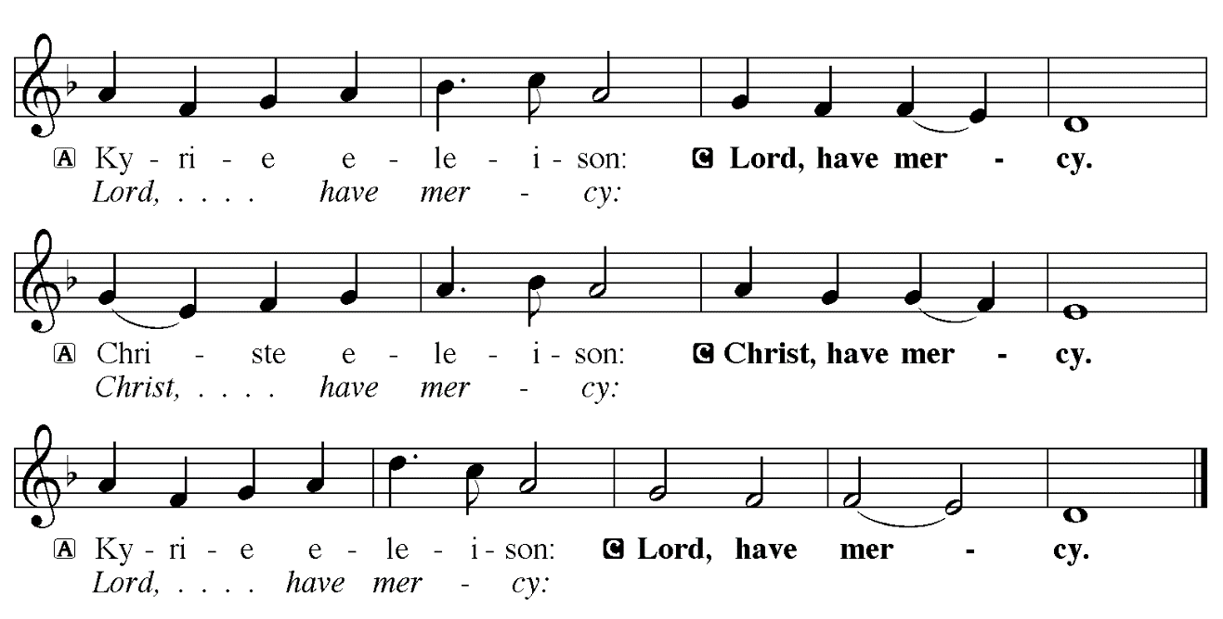

THE PRAYER OF THE DAY

P: The Lord be with you.

C: And also with you.

P: Let us pray. Stir up the wills of all who look to You, Lord God, and strengthen our faith in
Your coming, that, transformed by grace, we may walk in Your way; through Jesus Christ, our
Savior and Lord, Who lives and reigns with You and the Holy Spirit,
one God, now and forever.

C: Amen.

The assembly is seated

WORD

LIGHTING OF ADVENT LOG Christ, Be Our Light!
(B. Farrell, setting by Joel Raney)
Stanzas 1, 2, 3

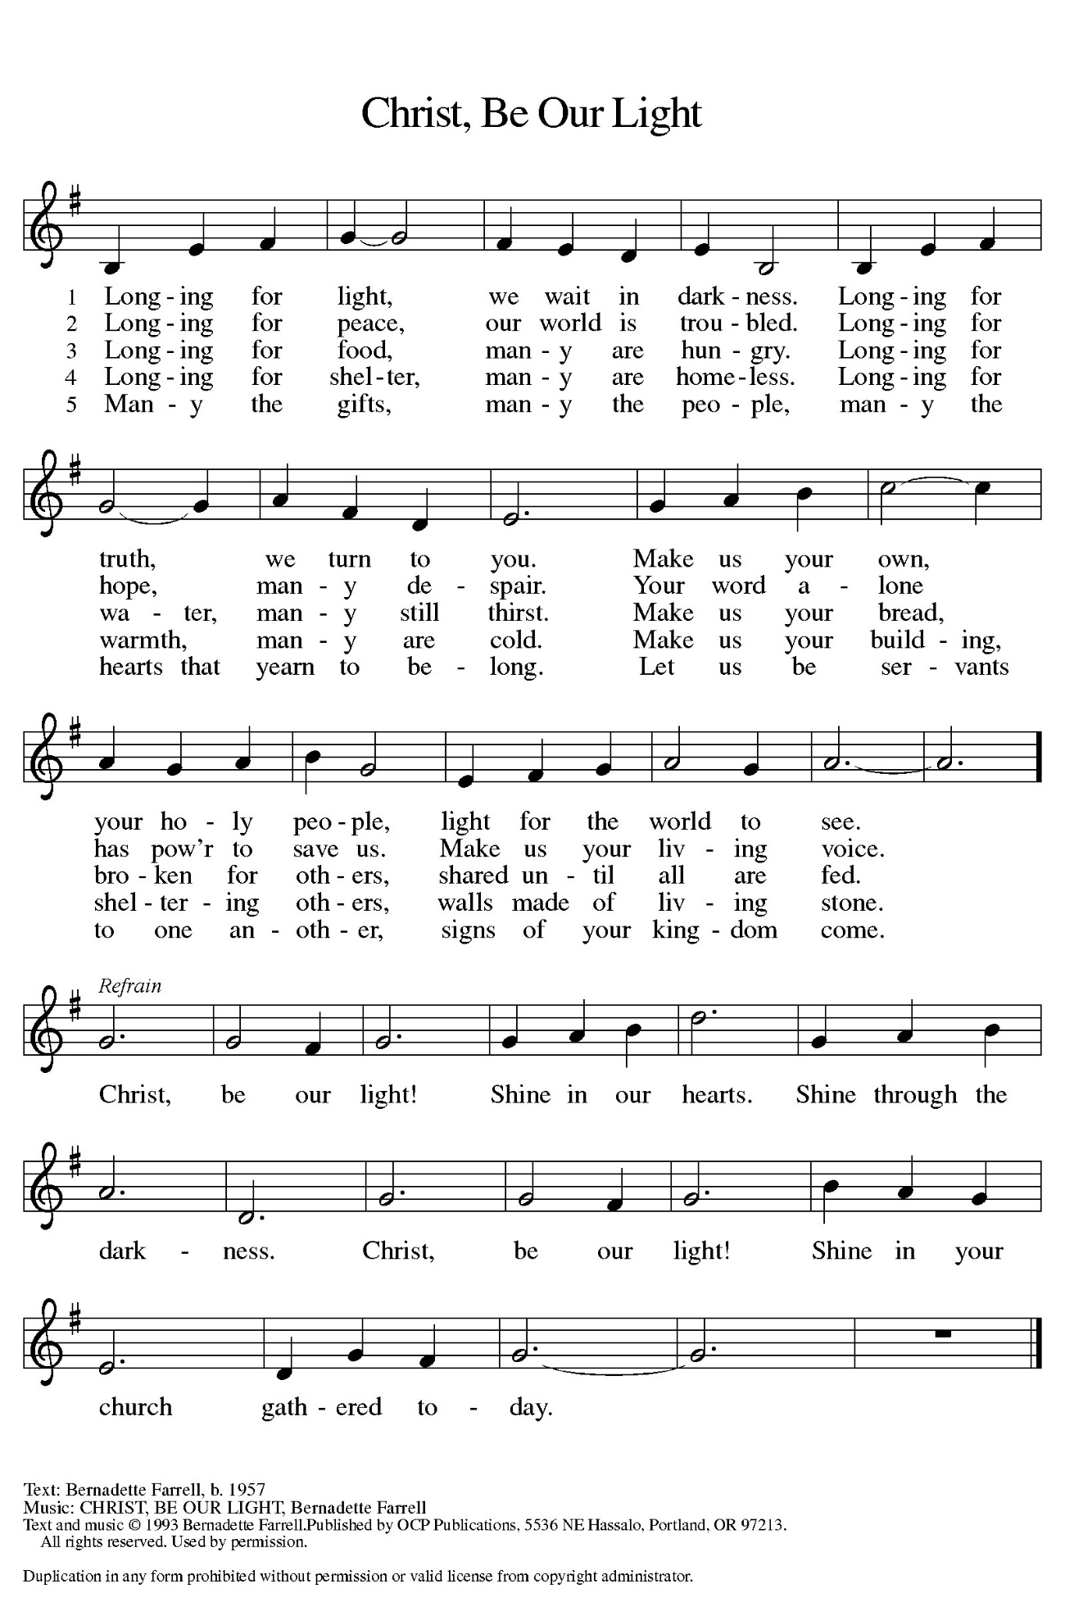
Hope for Those Who are Watching

P: Advent is a time to awaken our spiritual senses,

C: We stand in awe of Your deeds, O Lord, repeat them in our day!

P: Give us vision to behold Your glory.

C: We stand in awe of Your deeds, O Lord, repeat them in our day!

P: Quiet us so we may hear Your still, small voice.

C: We stand in awe of Your deeds, O Lord, repeat them in our day!

P: Make us vessels of Your mercy, compassion, and grace..

C: We stand in awe of Your deeds, O Lord, repeat them in our day!

P: For all of us eagerly watching for Your glory in our midst:

C: Grant that we might have the peace of Christ as we wait, the love of Christ as we act, and
the grace of Christ as we speak.

(During the candle lighting)

P: Today we light three candles. The first candle reminds us of those who find themselves in a
season of waiting, resting in hopeful anticipation for God to act. The second candle is for
anyone feeling weakened and wearied by the circumstances of life. We echo the cry of
Scripture to renew their strength and increase their power. The third candle awakes our
spiritual senses, challenging us to embrace the glory of God, as we await our Savior’s promised
coming.

(Repeat the refrain)
The first three candles are lit.

FIRST READING Isaiah 35: 1-10

The prophet uses the image of the wasteland becoming a garden to describe the restoration of the exiled people of Judah to their homeland.

The wilderness and the dry land shall be glad,
the desert shall rejoice and blossom;
like the crocus ²it shall blossom abundantly,
and rejoice with joy and singing.
The glory of Lebanon shall be given to it,
the majesty of Carmel and Sharon.
They shall see the glory of the LORD,
the majesty of our God.
³Strengthen the weak hands,
and make firm the feeble knees.

⁴Say to those who are of a fearful heart,
"Be strong, do not fear!
Here is your God.
He will come with vengeance,
with terrible recompense.
He will come and save you."
⁵Then the eyes of the blind shall be opened,
and the ears of the deaf unstopped;
⁶then the lame shall leap like a deer,
and the tongue of the speechless sing for joy.
For waters shall break forth in the wilderness,
and streams in the desert;
⁷the burning sand shall become a pool,
and the thirsty ground springs of water;
the haunt of jackals shall become a swamp,
the grass shall become reeds and rushes.
⁸A highway shall be there,
and it shall be called the Holy Way;
the unclean shall not travel on it,
but it shall be for God's people;
no traveler, not even fools, shall go astray.
⁹No lion shall be there,
nor shall any ravenous beast come up on it;
they shall not be found there,
but the redeemed shall walk there.
¹⁰And the ransomed of the LORD shall return,
and come to Zion with singing;
everlasting joy shall be upon their heads;
they shall obtain joy and gladness,
and sorrow and sighing shall flee away.

The Word of the Lord.

Thanks be to God.

THE PSALM: Psalm 146: 5-10 Antiphon by Robert Hobby

Choir sings refrain first, followed immediately by the congregation
and as indicated

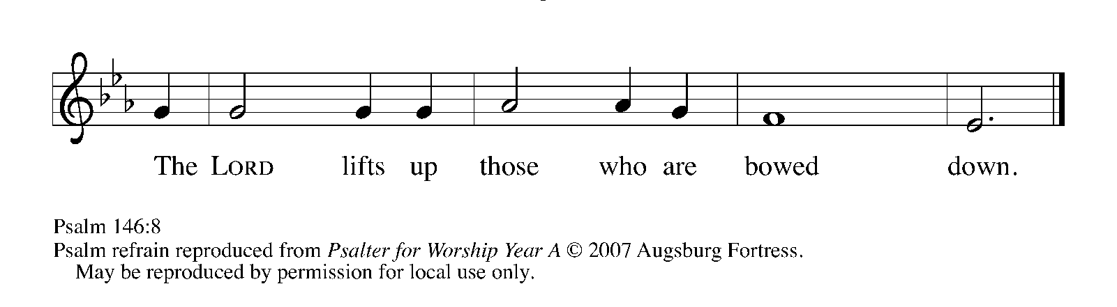
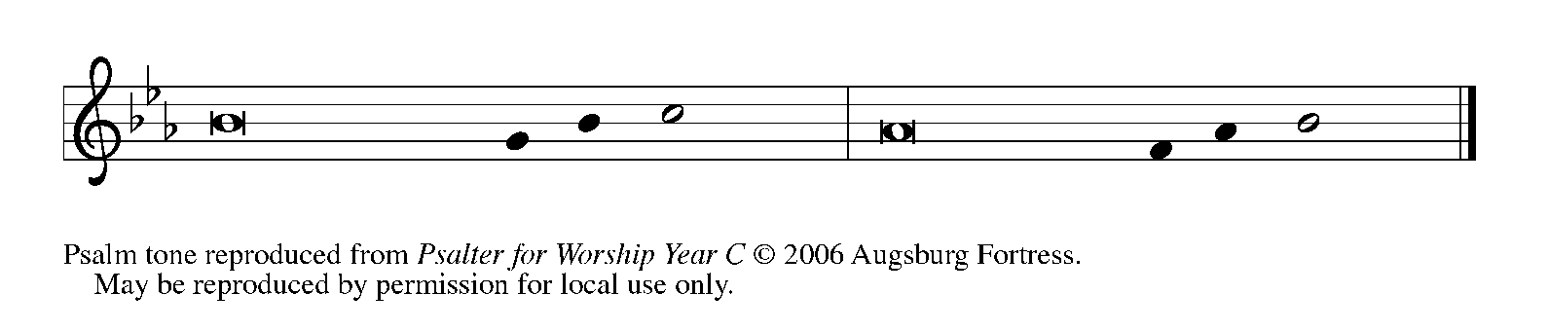

⁵Happy are they who have the God of Jacob | for their help,
whose hope is in the | LORD their God;

⁶Who made heaven and earth, the seas, and all that | is in them;
Who keeps promis- | es forever;

⁷Who gives justice to those who are oppressed, and food to | those who hunger.
The LORD sets the | captive free.

⁸The LORD opens the eyes of the blind; the LORD lifts up those who | are bowed down;
the LORD | loves the righteous. REFRAIN

⁹The LORD cares | for the stranger;
the LORD sustains the orphan and widow, but frustrates the way | of the wicked.

¹⁰The LORD shall | reign forever,
your God, O Zion, throughout all generations. | Hallelujah! REFRAIN

SECOND READING James 5: 7-10

The faith of Christians who are waiting for their Lord should be marked by patience and by trust in God's compassion and mercy.

Be patient, therefore, beloved, until the coming of the Lord. The farmer waits for the precious crop from the earth, being patient with it until it receives the early and the late rains. ⁸You also must be patient. Strengthen your hearts, for the coming of the Lord is near. ⁹Beloved, do not grumble against one another, so that you may not be judged. See, the Judge is standing at the doors! ¹⁰As an example of suffering and patience, beloved, take the prophets who spoke in the name of the Lord.

The Word of the Lord.
Thanks be to God.

As you are able please rise

THE VERSE

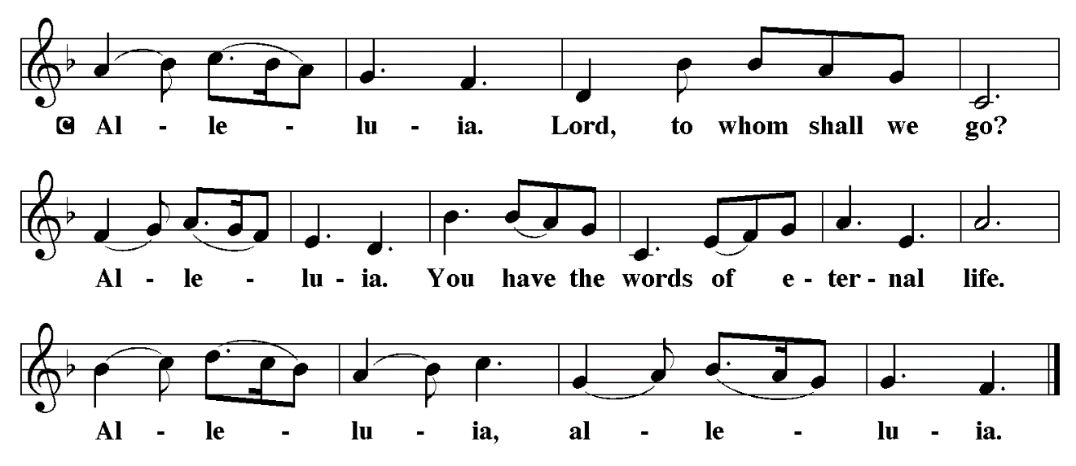
THE HOLY GOSPEL Matthew 11: 2-11

In the early days of his ministry, John the Baptist proclaimed the advent of God's reign and bore witness to Jesus as the promised one of God. But even John had his doubts later, when Jesus demonstrated that God's reign was present in merciful deeds among the poor, rather than a terrifying day of judgment.

P: The Holy Gospel according to St. Matthew, the eleventh chapter.

C: Glory to You, O Lord!

When John heard in prison what the Messiah was doing, he sent word by his disciples ³and said to Him, "Are You the One Who is to come, or are we to wait for another?" ⁴Jesus answered them, "Go and tell John what you hear and see: ⁵the blind receive their sight, the lame walk, the lepers are cleansed, the deaf hear, the dead are raised, and the poor have good news brought to them. ⁶And blessed is anyone who takes no offense at Me."
⁷As they went away, Jesus began to speak to the crowds about John: "What did you go out into the wilderness to look at? A reed shaken by the wind? ⁸What then did you go out to see? Someone dressed in soft robes? Look, those who wear soft robes are in royal palaces. ⁹What then did you go out to see? A prophet? Yes, I tell you, and more than a prophet. ¹⁰This is the one about whom it is written,
'See, I am sending my messenger ahead of you,
who will prepare your way before you.'
¹¹Truly I tell you, among those born of women no one has arisen greater than John the Baptist; yet the least in the kingdom of heaven is greater than he."

P: The Gospel of the Lord.

C: Praise to You, O Christ!

The assembly is seated

THE SERMON

Silence for reflection follows the sermon

As you are able please rise

THE HYMN OF THE DAYNSB 63 Lord, I Lift Your Name on High

THE NICENE CREED

A: God has made us His people through our Baptism into Christ. Living together in trust and
hope, we confess our faith.

We believe in one God,
the Father, the Almighty,
maker of heaven and earth,
of all that is, seen and unseen.

We believe in one Lord, Jesus Christ,
the only Son of God,
eternally begotten of the Father,
God from God, Light from Light,
true God from true God,
begotten, not made,
of one Being with the Father.
Through Him all things were made.
For us and for our salvation
He came down from heaven;
by the power of the Holy Spirit
He became incarnate from the virgin Mary, and was made man.
For our sake He was crucified under Pontius Pilate;
He suffered death and was buried.
On the third day He rose again
in accordance with the Scriptures;
He ascended into heaven
and is seated at the right hand of the Father.
He will come again in glory to judge the living and the dead,
and His kingdom will have no end.

We believe in the Holy Spirit, the Lord, the giver of life,
Who proceeds from the Father and the Son.
With the Father and the Son He is worshiped and glorified.
He has spoken through the prophets.
We believe in one holy catholic and apostolic Church.
We acknowledge one Baptism for the forgiveness of sins.
We look for the resurrection of the dead,
and the life of the world to come. Amen

THE PRAYER OF THE CHURCH

A: God comes to make the deserts bloom and dispel our fears. As we patiently await the coming
of the Lord, with confidence and joy let us pray for the Church, the world, and all those who
need encouragement and hope.

A: That all who serve in the Church’s ministries and all the baptized may be a constant, faithful,
comforting witness to those with fearful hearts, let us pray to the Lord:

C: Come, Lord Jesus.

A: That there might be an end to warfare, terrorism, and bloodshed; that sorrow and sighing might
flee the earth; and that songs of gladness and peace might be heard, let us pray to the Lord:

C: Come, Lord Jesus.

A: That members of this congregation might be strong in acts of kindness, forgiveness, and
compassion as we patiently await the Lord’s return, let us pray to the Lord:

C: Come, Lord Jesus.

A: That those serving in our armed forces, especially Katrine Somers and Blake Waltz might
be kept in safety, let us pray to the Lord:

C: Come, Lord Jesus.

A: That the poor and needy, the hungry and forgotten, the lonely, those in danger, and the sick,
especially: Major Payne; Robert Bernth; Kevin Thiede; Carl Wipperman; Chuck Payne;
Martha Schroeder; Joyce Stark; Jackie Gaines; David Weiss; Fred Weiss; Shirley
Shikany Long; Shirley Freels; John Bennitt; Catherine Lanigan; Jess Kalvaitis;
Lucas Bradshaw and Elizabeth Sanders might be filled with the hope, joy and peace of God,
let us pray to the Lord:

C: Come, Lord Jesus.

A: That those celebrating birthdays, especially Carol Radke may grow in grace this day and every
day and be filled with grace for the days ahead, let us pray to the Lord:

C: Come, Lord Jesus.

A: That with all the saints, especially John of the Cross, renewer of the Church, whom we
commemorate this Day we too may enter into God’s everlasting joy, let us pray to the Lord:

C: Come, Lord Jesus.

P: Gracious and loving God to us all, answer our prayer for our good and for Your glory. We ask
this through Jesus Christ, Your Son, and our Hope.

C: Amen.

MEAL

THE PEACE

P: The peace of the Lord be with you always.

C: And also with you.

The assembly is seated

THE OFFERING

THE VOLUNTARY With Open Hearts We Are Waiting St. Paul Senior Choir
P. Choplin

As you are able please rise

THE OFFERTORY (see p. 12) Let the Vineyards Be Fruitful, Lord
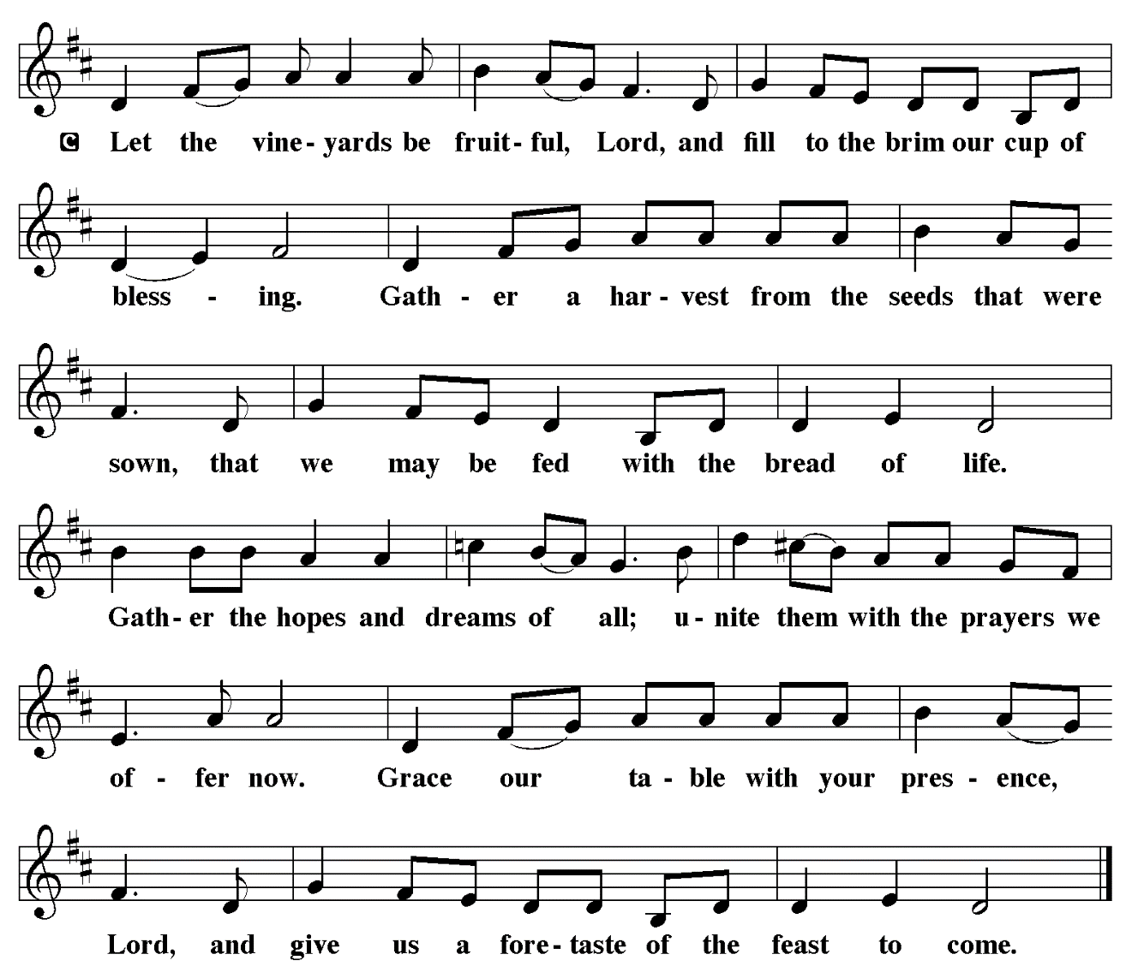

THE OFFERTORY PRAYER

A: Let us pray. God our Savior,

C: You call us to be patient and strong, for the Day of Your advent is near. You come to us
now in this holy Sacrament for our life, health, and hope. Receive these offerings we
bring, and by our eating and drinking strengthen our witness, that we might with joy
prepare Your way. We ask this in the name of Jesus the Lord. Amen.

THE GREAT THANKSGIVING

P: The Lord be with you.

C: And also with you.

P: Lift up your hearts.

C: We lift them up to the Lord.

P: Let us give thanks to the Lord our God.

C: It is right to give Him thanks and praise.

P: It is indeed right and salutary … we praise Your name and join their unending hymn:

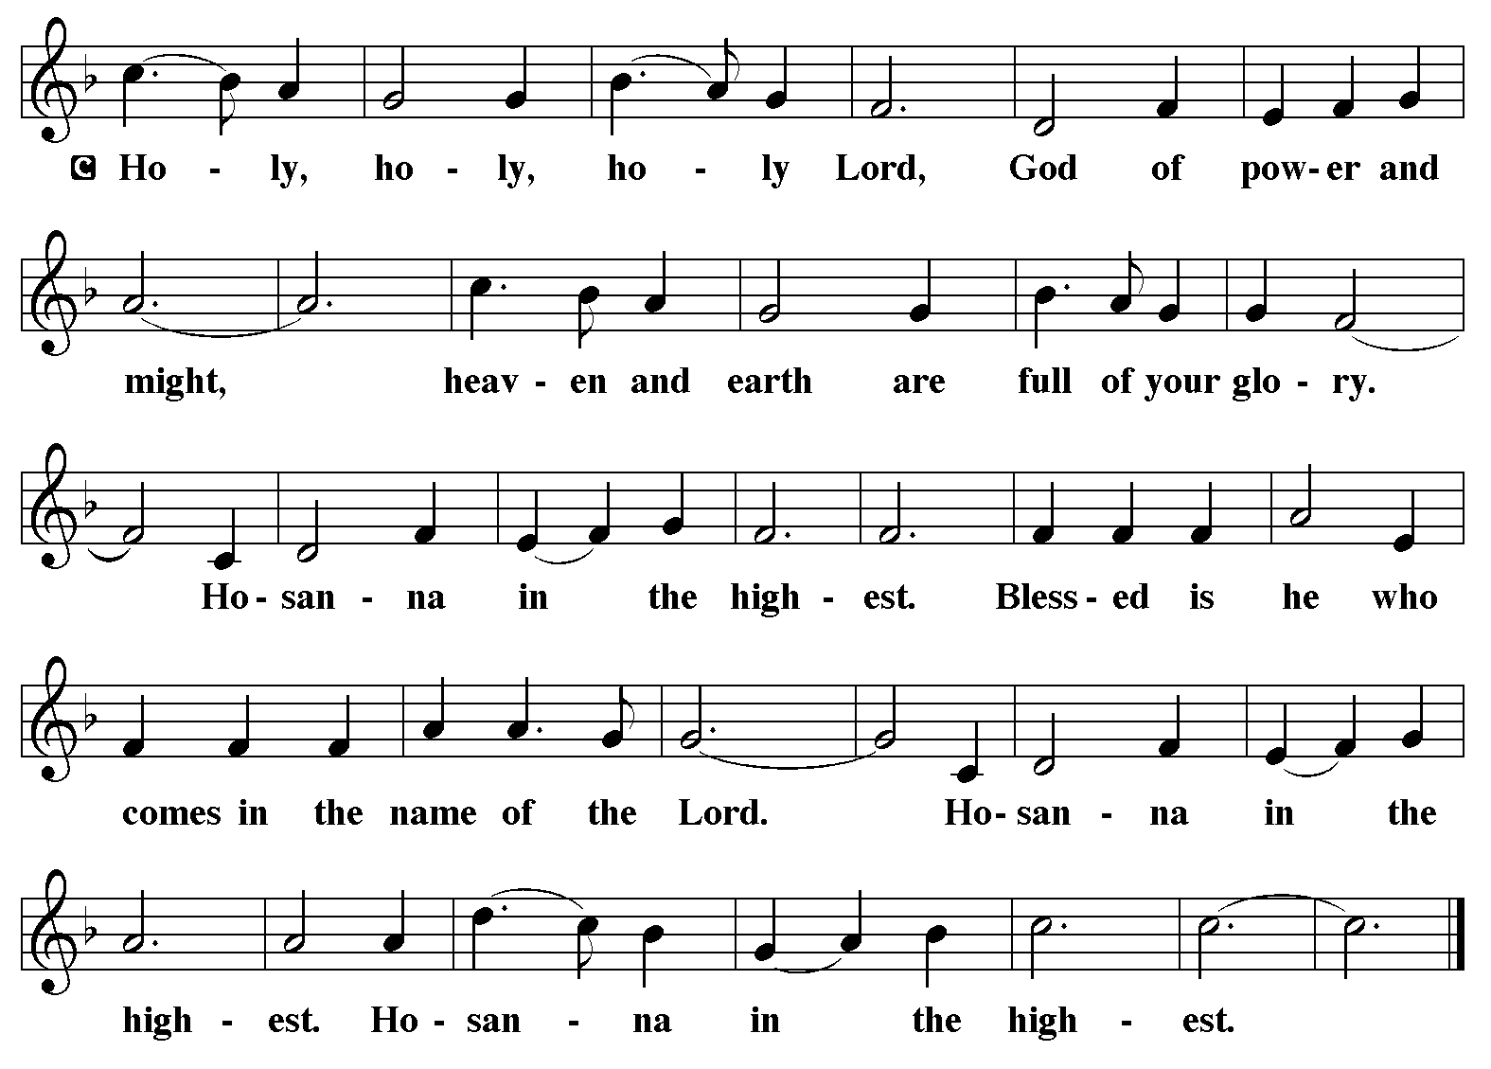
P: Blessed are You, Lord God of time and eternity, for You have opened the eyes of the
blind, and unstopped the ears of the deaf; You have made the lame leap like a
deer and the tongue of the speechless sing for joy.
You made this world a playground of delights, and You called a people to be Your
companion forever.
In Jesus You showed us Who You are, who we are, how far we have strayed from You,
and how to become Your companions again.
In His death You opened a path for our redemption, and in His resurrection You brought
us the joy of forgiveness and everlasting life.
God of blessing, in Jesus You fill the hungry with good things.
You bestow mercy from generation to generation.
You show us the cost and glory of Your salvation in the bread and pouring and sharing
of bread and wine.
Send down Your Holy Spirit, that Your people may be made holy by Your grace, and these
gifts may be for us the Body and Blood of Your Son, Jesus Christ,

Who, in the night ... “Do this for the remembrance of Me.”
As often as we eat ... we proclaim the Lord’s death until He comes.

C: Christ has died. Christ is risen. Christ will come again.

P: Delivering God, we call on You to fulfill Your Advent promise.
May waters break forth in the wilderness, and streams in the desert; make a highway on
which no traveler, not even fools, shall go astray.
Bring home those who are in exile; fill their hearts with singing and shower their heads
with everlasting joy.
Unite Your Church, clothe us with the fruits of Your Spirit, and fill us with the hope of
Advent, the substance of things hoped for and the knowledge of things unseen,
Until all bow before Your throne and worship in Your glory,
Ever one God: Father, + Son, and Holy Spirit.

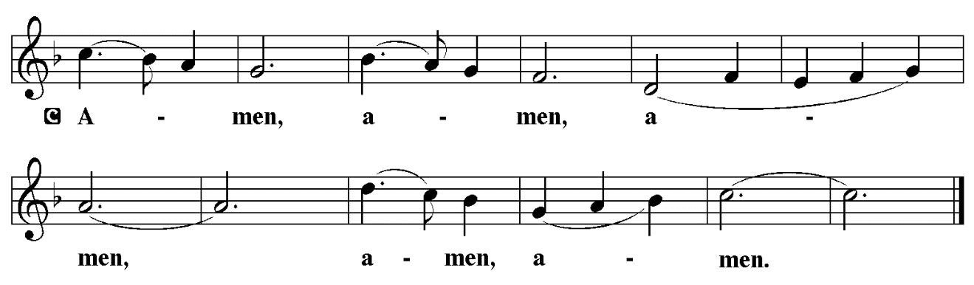

THE LORD’S PRAYER

P: Let us pray for the coming of God’s Reign as Jesus taught us:

C: Our Father, Who art in heaven, hallowed be Thy Name. Thy Kingdom come. Thy will
be done on earth as it is in heaven. Give us this day our daily bread, and forgive us our
trespasses as we forgive those who trespass against us. And lead us not into temptation,
and deliver us from evil, for Thine is the Kingdom, and the power, and glory, forever and
ever. Amen.

INVITATION TO THE MEAL

P: Behold the Lord Whose advent we await, Who will come with glory on the Day of judgment.
Blessed are those who are called to the Supper of the Lamb. God’s holy gifts for God’s holy
people. Come, for all is now ready.

The assembly is seated

THE DISTRIBUTION Lamb of God

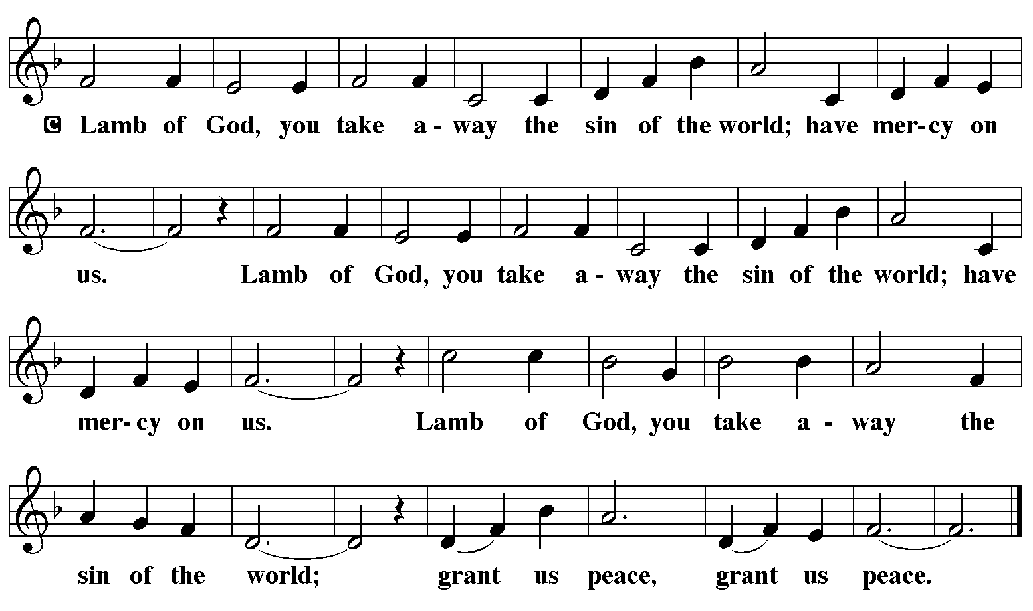

Those wishing to receive the Laying on of Hands, Anointing with Oil, and Prayer for Healing
may go to Pastor at the side aisle

HYMN DURING DISTRIBUTION 264 Prepare the Royal Highway
ELW 239 Hark, The Glad Sound!
ELW 248 People Look East
ELW 252 Each Winter As the Wind Grows Older
ELW 253 He Came Down
As you are able please rise

THE POST-COMMUNION PRAYER

A: Let us pray. God of hope, in this Meal You have again filled our hunger for You with good
things. Strengthen our hearts, give us patience in suffering, and grant us joy in Your coming.
We ask this through Christ our Lord.

C: Amen.

SENDING

THE BENEDICTION

P: The Lord bless you and keep you. The Lord make His face shine on you and be gracious to
you. The Lord look upon you with favor and give you peace.

C: Amen.

SENDING SONG NSB 92 Trading My Sorrows

THE DISMISSAL

A: Go in peace. Walk in the light of the Lord.

C: Thanks be to God!

POSTLUDE

To God Alone Be Glory

The Meditations are from An Advent Sourcebook. Thomas J. O’Gorman, ed. (Chicago: Liturgy
Training Publications, 1988) 24-25; and Sundays and Seasons Online. Copyright 2019 Augsburg Fortress.

The Invitation to the Lord’s Prayer, the Prayers, and the Invitation to Communion are from Prayers
for Sundays and Seasons. Year A. Peter J. Scagnelli. (Chicago: Liturgy Training Publications, 1998) 7-8.

ANNOUNCEMENTS

Please remember to mail your offering to the Church Office at 818 Franklin Street, Michigan City, IN 46360. Another alternative is to give on-line through Tithe.ly. Please see your closure letter for information on how to set up a Tithe.ly account.

St. Paul Members are reminded to have a loved one contact the office if you are hospitalized. Many times, the Pastor doesn’t know someone is in the hospital. If you call and leave a message, please tell us at which hospital the patient is located.

BIRTHDAYS: Carol Radke (12/17)

PRAYER CONCERNS: Kevin Thiede; Robert Bernth; Barry Anderson; John Bennitt; Sarah McNabb; Debbie Martin; Mark Tannehill; Kathy Stein; Jan Paholski; Laura Dovey; Grace Romine; Bill Hazelgrove; Al Levenhagen; Carl Wipperman; Major Payne; Carol Hazelgrove; Allen Sydow and Elizabeth Sanders.

OFFICE HOURS: Libby will be in the office on Mondays, Wednesdays, and Fridays; volunteers will cover Tuesdays and Thursdays.

Monday & Wednesday 8:00 a.m. – 5 p.m.
Tuesday & Thursday 9:00 a.m. – 12:00 p.m.
Friday 8:00 a.m. – 12:00 p.m.

If you are listening to the worship broadcast on the radio and would like to watch the Sunday morning service live stream follow these steps:

(1) If you have You Tube available on your TV, search for
St. Paul Lutheran Church Michigan City, IN.

(2) The direct link on the computer is https://
www.youtube.com/channel/UC5AIPNaKr3QN50984jGOa1g.

(3) This link is also on the main page of the church’s website in
the church section and will continue to be posted weekly on the St.
Paul Facebook page.

And it will always be available on the radio broadcast Sunday mornings at 11:00 a.m.
on WEFM (95.9), and on the local cable access station #99 for the previous week’s
service on Sundays at 4:00 p.m. and the current service on Wednesdays at 7:00 p.m.
and Fridays at 8:30 p.m.

To send e-mail to the church office, please use the following addresses:

Pastor Mark Reshan: seniorpastor@stpaulmichigancity.com

Church Office Secretary (Libby Pollock): churchsecretary@stpaulmichigancity.com

Church Treasurer (Karen Fleming): finance@stpaulmichigancity.com

2025 Church Council:

Mark Reshan - Pastor

Janet Bakken – President

Donna Knoll – Vice President

Judy Hunt – Secretary

Karen Fleming – Treasurer

Members: Paul Brooks, Diane Egilske, Sue Koziel, Judy Mutchler, Jim Schraidt, Trish Sprague

Worship Attendance:
Saturday , December 6, 2025 @ 4:00 p.m. 29
Sunday, December 7, 2025 @ 9:00 a.m. 62
TOTAL 91

Copies of the minutes from the October 23, 2025 Church Council meeting are on the back table in the upper Narthex. It was approved by the council via email.

The Good News Newsletter: If you have an article or anything you want included in The Good News please send it to the following e-mail address: splcgoodnews@gmail.com. Pastor Pamela Thiede will be using this e-mail address to assemble The Good News each month. The deadline for getting information to Pastor Pamela will be the 20th of each month.

Sunday’s lessons are Isaiah 7: 10-16; Psalm 80: 1-7, 17-19; Romans 1: 1-7; and
Matthew 1: 18-25 for those of you who like to study them in advance.

SNOW EMERGENCY LIST
This is a reminder of where to turn to learn if worship has been canceled because of inclement weather conditions. There are two ways to learn about the status of the service.
First, you may turn to our church and school Facebook page: https://www.facebook.com/stpaulmichigancity/ for updated announcements. Or, perhaps most quickly and easily, you may call the church office number (219-874-7293) and press the “#” key and you will hear a recording about our “open/closed” status.

HELP NEEDED FOR OUR LOCAL SALVATION ARMY

Due to the pause taken by all the programs sponsored by SNAP, our local Salvation Army has been swamped with people needing help. All of the items placed in the grocery store cart located on the upper southwest corner of the outer Narthex is taken to our Michigan City Salvation Army location. The cart has a large hippo asking you to help “fill ‘er up!” Whatever you can do to help is greatly appreciated.

2025 Financial Stewardship

Weekly Church Operating Needs (x 2 weeks)
November 15-16, 2025; and November 22-23, 2025: $ 11, 070.00

General Fund (including General Memorials): $ 7,347.00

Overage/Shortage: — $ 3,723.00

Restricted Income (not including Memorials)
Supports IK Synod & Church wide Ministries: $ 130.00

Ministries in our Community/Congregation: $ 260.00

Capital Fund: $ 190.00

Memorials
General Fund: $ 35.00

ACTIVITIES, EVENTS & MEETINGS
December 2025

Monday, December 8, 2025 @ 11:30 a.m. Hope Circle/St. Paul Room

Tuesday, December 9, 2025 from 11:00 a.m. – Close GIVE-BACK @ HOLLY’S Restaurant & Pub

@ 7:00 P.M. Estuary/Luther House

Wednesday, December 10, 2025 @ 9:15 a.m. Bible Study/Luther House

@ 10:00 a.m. God’s Purls/St. Paul Room

@ 3:30 p.m. Worship & Music Mtg/Luther House

@ 4:30 p.m. Choir Rehearsal/Sanctuary

Thursday, December 11, 2025 @ 4:00 p.m. 150th Anniv. Comm. Mtg/Luther House

Saturday, December 13, 2025 @ 4:00 p.m. 3rd Saturday in Advent Worship Service

Sunday, December 14, 2025 @ 9:00 a.m. 3rd Sunday in Advent Worship Service/ Sanctuary/ with coffee after service/St. Paul Room

Monday, December 15, 2025 @ 2:00 p.m. Finance Committee Mtg/Luther House

@ 3:00 p.m. Executive Board Mtg/Luther House

Wednesday, December 17, 2025 @ 10:00 a.m. QUIET SR COMMUNION & LUNCHEON
@ 4:30 p.m. Choir Rehearsal/Sanctuary

Thursday, December 18, 2025 @ 3:00 p.m. and January 2026 Church Council Mtg/St. Paul Room

Saturday, December 20, 2025 @ 4:00 p.m. 4th Saturday in Advent Worship Service

Sunday, December 21, 2025 @ 9:00 a.m. 4th Sunday in Advent Worship Service/ Sanctuary with coffee after service/St. Paul Room

Wednesday, December 24, 2025 @ 5:45 p.m pre - service Music/Sanctuary
@ 6:00 p.m. Christmas Eve Worship Service/Sanctuary

Thursday, December 25, 2025 @ 9:00 a.m. Christmas Worship Service/Sanctuary

Saturday, December 27, 2025 @ 4:00 p.m. 1st Saturday After Christmas Worship
Service

Sunday, December 28, 2025 @ 9:00 a.m. 1st Sunday After Christmas Worship

First United Methodist Church in Michigan City
Presents their annual
Madrigal Service at
Trinity Episcopal Church
in Barker Hall
600 Franklin St.
Michigan City, IN 46360

On Saturday, December 20th at 5:00 p.m.
(doors open at 4:15 p.m.)

And again on Sunday, December 21st at 3:00 p.m. at
First United Methodist Church
121 E. 7th St.
Michigan City, IN 46360

A free will offering will be taken and proceeds divided
between all entities who helped provide space, supplies, support of any kind to the congregation and staff at
Methodist Church during their time of need.

