**THE TENTH SUNDAY AFTER PENTECOST**

**August 17, 2025**

“The following of Christ is inseparable from the cross of Calvary. ‘Do you think that I have come to bring peace on earth? No, I tell you but rather division!’ To those who follow Christ fully is given the world’s hatred, for they are a challenge to his spirit just as Christ himself was hated first. Humiliation, lack of appreciation, criticism—we must remember that the people whom he healed or forgave turned around and crucified him …”

“ …Today the world is an open Calvary. Mental and physical suffering is everywhere. Pain and suffering have come into your life but remember pain, sorrow and suffering are but the kiss of Jesus—signs that you have come so close to him that he can kiss you. Accept them as his gift—all for Jesus. You are really reliving the passion of Christ, so accept Jesus as he comes into your life—bruised, divided, full of pains and wounds.

The Spirit pours love, peace, joy into our hearts proportionately to our emptying ourselves of self-indulgence, vanity, anger, and ambition, and to our willingness to shoulder the cross of Christ …”

“ …Suffering, if it is accepted together, borne together, is joy. Remember that the passion of Christ ends always in the joy of the resurrection of Christ, so when you feel in your own heart the suffering of Christ, remember the resurrection has to come. Never let anything so fill you with sorrow as to make you forget the joy of the risen Christ.”

**Teresa of Calcutta (Mother Teresa)**

“Across the Old Testament, the purifying fire Jesus seems to reference here is most often associated with the fire that burns away impure religious practices. Not impure as in “not liturgically correct,” but rather impure in that they tended to make religion a source of false comfort. Right religious practice and beliefs, too many have thought over the centuries, should exempt you from the suffering or disaster or poverty or even death all around you. In this regard, I believe little has changed. Think, for instance, of the popular Christian obsession with “accepting Jesus into your heart” as the means by which to escape eternal punishment and secure an eternal reward. But what if faith wasn’t about guaranteeing future bliss but rather was an invitation to live differently now, to see those around us neither as souls to be saved or threats to be deterred, but rather to see them – everyone! – God’s children to be loved, honored, and cared for? …”

“ …What if we … (saw the) Church not as an obligation or spiritual destination, but a place to come to be encouraged, equipped, and sent to make a difference to the world. And a place to return to when living like Jesus creates division. Because it will. But it will also create joy. Because the one who sends us out was himself baptized by fire – note, it’s his own baptism Jesus talks about in these verses – and is both with us and for us as we come to church to be reminded of our identity as God’s beloved and are sent out again in mission to tell others in word and deed that God loves them as well.”

**David Lose**

**✠ In the Name of Jesus ✠**

**✠ GATHERING ✠**

**INTRODUCTION**

The word of God is a refining fire. Jesus is the great divide in human history. He invites our undivided attention and devotion. Today, in the assembly, we are surrounded by "so great a cloud of witnesses." In the word and in the holy communion we are invited yet again to look to Jesus, "the pioneer and perfecter of our faith."

**PRE-SERVICE MUSIC *Come Worship the Lord, Jesus* New Song Praise Band**

**(Brian Doerksen)**

**ANNOUNCEMENTS**

*As you are able please rise*

**GATHERING SONG NSB 72 *Refiner’s Fire***

**THE GREETING AND PRAYER OF THE DAY**

P: The grace of our Lord Jesus Christ, the love of God, and the communion of the Holy

Spirit be with you all.

**C: And also with you.**

P: Let us pray. O God, Judge eternal, You love justice and hate oppression, and You call

us to share Your zeal for truth. Give us courage to take our stand with all victims of

bloodshed and greed, and, following Your servants and prophets, to look to the pioneer

and perfecter of our faith, Your Son, Jesus Christ, our Savior and Lord.

**C: Amen.**

*The assembly is seated*

**✠ WORD ✠**

**FIRST READING Jeremiah 23: 23-29**

Because Jeremiah preaches the unpopular message of God's judgment, he suffers rejection. Today's reading distinguishes between the true prophet, like Jeremiah, who speaks God's word, and the false prophet who misleads the people through dreams. One is like wheat; the other like worthless straw.

23Am I a God near by, says the LORD, and not a God far off? 24Who can hide in secret places so that I cannot see them? says the LORD. Do I not fill heaven and earth? says the LORD. 25I have heard what the prophets have said who prophesy lies in My name, saying, "I have dreamed, I have dreamed!"

26How long? Will the hearts of the prophets ever turn back — those who prophesy lies, and who prophesy the deceit of their own heart? 27They plan to make My people forget My name by their dreams that they tell one another, just as their ancestors forgot My name for Baal.

28Let the prophet who has a dream tell the dream, but let the one who has My word speak My word faithfully. What has straw in common with wheat? says the LORD. 29Is not My word like fire, says the LORD, and like a hammer that breaks a rock in pieces?

The Word of the Lord.

**Thanks be to God.**

**THE PSALM: Psalm 82** **Read responsively**

1God stands to charge the divine council assembled,

     giving judgment in the midst of the gods:

**2"How long will You judge unjustly,**

**and show favor to the wicked?**

3Save the weak and the orphan;

     defend the humble and needy;

**4rescue the weak and the poor;**

**deliver them from the power of the wicked.**

5They do not know, neither do they understand;

they wander about in darkness;

all the foundations of the earth are shaken.

**6Now I say to you, 'You are gods,**

**and all of you children of the Most High;**

7nevertheless, you shall die like mortals,

     and fall like any prince.'"

**8Arise, O God, and rule the earth,**

**for You shall take all nations for Your own.**

**SECOND READING Hebrews 11: 29-12: 2**

The author of Hebrews presents us with rich stories of faith. In a long list of biblical heroes, we find examples of trust in God that enabled them to face the trials of life faithfully. In addition to this "cloud of witnesses," we have Jesus, the perfect model of faithful endurance.

**Chapter 11**

29By faith the people passed through the Red Sea as if it were dry land, but when the Egyptians attempted to do so they were drowned. 30By faith the walls of Jericho fell after they had been encircled for seven days. 31By faith Rahab the prostitute did not perish with those who were disobedient, because she had received the spies in peace.

32And what more should I say? For time would fail me to tell of Gideon, Barak, Samson, Jephthah, of David and Samuel and the prophets — 33who through faith conquered kingdoms, administered justice, obtained promises, shut the mouths of lions, 34quenched raging fire, escaped the edge of the sword, won strength out of weakness, became mighty in war, put foreign armies to flight.

35Women received their dead by resurrection. Others were tortured, refusing to accept release, in order to obtain a better resurrection. 36Others suffered mocking and flogging, and even chains and imprisonment. 37They were stoned to death, they were sawn in two, they were killed by the sword; they went about in skins of sheep and goats, destitute, persecuted, tormented — 38of whom the world was not worthy. They wandered in deserts and mountains, and in caves and holes in the ground.

39Yet all these, though they were commended for their faith, did not receive what was promised, 40since God had provided something better so that they would not, apart from us, be made perfect.

**Chapter 12**

Therefore, since we are surrounded by so great a cloud of witnesses, let us also lay aside every weight and the sin that clings so closely, and let us run with perseverance the race that is set before us, 2looking to Jesus the pioneer and perfecter of our faith, Who for the sake of the joy that was set before Him endured the cross, disregarding its shame, and has taken His seat at the right hand of the throne of God.

The Word of the Lord.

**Thanks be to God.**

*As you are able please rise*

**THE VERSE** Sung twice

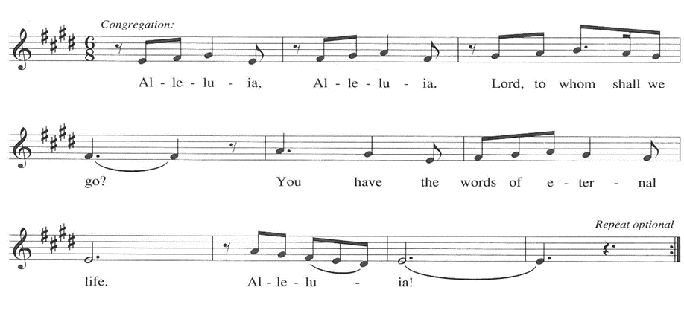

**THE HOLY GOSPEL Luke 12: 49-56**

Jesus delivers harsh words about the purifying and potentially divisive effects of obedience to God's call. The way of the cross often leads followers to encounter hostility and rejection, even from those they love.

P: The Holy Gospel according to St. Luke, the twelfth chapter.

**C: Glory to You, O Lord!**

49I came to bring fire to the earth, and how I wish it were already kindled! 50I have a baptism with which to be baptized, and what stress I am under until it is completed! 51Do you think that I have come to bring peace to the earth? No, I tell you, but rather division!

52From now on five in one household will be divided, three against two and two against three; 53they will be divided:

father against son and son against father,

mother against daughter and daughter against mother,

mother-in-law against her daughter-in-law and daughter-in-law against mother-in-law."  
54He also said to the crowds, "When you see a cloud rising in the west, you immediately say, 'It is going to rain'; and so it happens. 55And when you see the south wind blowing, you say, 'There will be scorching heat'; and it happens. 56You hypocrites! You know how to interpret the appearance of earth and sky, but why do you not know how to interpret the present time?

P: The Gospel of the Lord.

**C: Praise to You, O Christ!**

*The assembly is seated*

**THE SERMON**

*Silence for reflection follows the sermon*

*As you are able please rise*

**THE HYMN OF THE DAY 902 *Come Now, O God***



**THE APOSTLES’ CREED**

A: God has made us His people through our Baptism into Christ. Living together in trust

and hope, we confess our faith.

**C: I believe in God, the Father almighty,**

**creator of heaven and earth.**

**I believe in Jesus Christ, His only Son, our Lord.**

**He was conceived by the power of the Holy Spirit**

**and born of the virgin Mary.**

**He suffered under Pontius Pilate,**

**was crucified, died, and was buried.**

**He descended into hell.**

**On the third day He rose again.**

**He ascended into heaven,**

**and is seated at the right hand of the Father.**

**He will come again to judge the living and the dead.**

**I believe in the Holy Spirit,**

**the holy catholic Church,**

**the communion of saints,**

**the forgiveness of sins,**

**the resurrection of the body,**

**and the life everlasting. Amen.**

**THE PRAYER OF THE CHURCH**

A: We look to see the Lord’s work in this world, answering God’s call to live and act and

intercede on behalf of all in need. With one voice let us make known those needs to

God.

A**:** That a fire might be kindled in the Church for proclaiming the Good News of Jesus

Christ, we pray to You, O Lord:

**C: Lord, hear our prayer.**

A: That leaders of nations will work to bring peace in conflict, relief for the weak and

needy, and justice for the persecuted and oppressed, we pray to You, O Lord:

**C: Lord, hear our prayer.**

A: That this congregation might persevere in faithful compassion and service to the poor

and weary in body and spirit, we pray to You, O Lord:

**C: Lord, hear our prayer.**

A: That families who are divided might be reconciled and unified by the love of Christ,

we pray to You, O Lord:

**C: Lord, hear our prayer.**

A: That the sick, especially: **Bev Coburn; Lucas Bradshaw; Fred Weiss; David Weiss;**

**Barry Anderson; Larry Litchford; Shirley Freels; Shirley McCarty; Martha**

**Schroeder; Bob Pheanis; Christine Kiser; Carol Pauluhn; Laura Dovey; and Jan**

**Paholski** might know the power of Your healing, we pray to You, O Lord:

**C: Lord, hear our prayer.**

A: That those celebrating birthdays, especially **Shirley McCarty;** and anniversaries,

especially **Troy and Hillary Frever** may grow in grace this day and every day and be

filled with grace for the days ahead, we pray to You, O Lord:

**C: Lord, hear our prayer.**

A: That with the “great cloud of witnesses” who have gone before us, we too may receive

our promised place in God’s heavenly city, we pray to You, O Lord:

**C: Lord, hear our prayer.**

P: O Lord, we have learned what to ask through Your Son, Who loved without limit. It is

You that He revealed, and You to Whom we turn. Hear our prayers according to Your

gracious and saving will, for the sake of Jesus Christ our Lord.

**C: Amen.**

**✠ MEAL ✠**

**THE PEACE**

P: The peace of the Lord be with you always.

**C: And also with you.**

*The assembly is seated*

**THE OFFERING**

**THE VOLUNTARY *Where Justice Rolls Down* New Song Praise Band**

**(Michael Pearce Donley)**

*As you are able please rise*

**THE OFFERTORY 465 *As the Grains of Wheat***

**THE OFFERTORY PRAYER**

A: Let us pray. Loving God,

**C: The whole earth belongs to You. We bring You these gifts as signs of our love and**

**devotion. Receive them for Jesus’ sake, and through this Meal, increase our faith**

**and love. We ask this in the name of Jesus the Lord. Amen.**

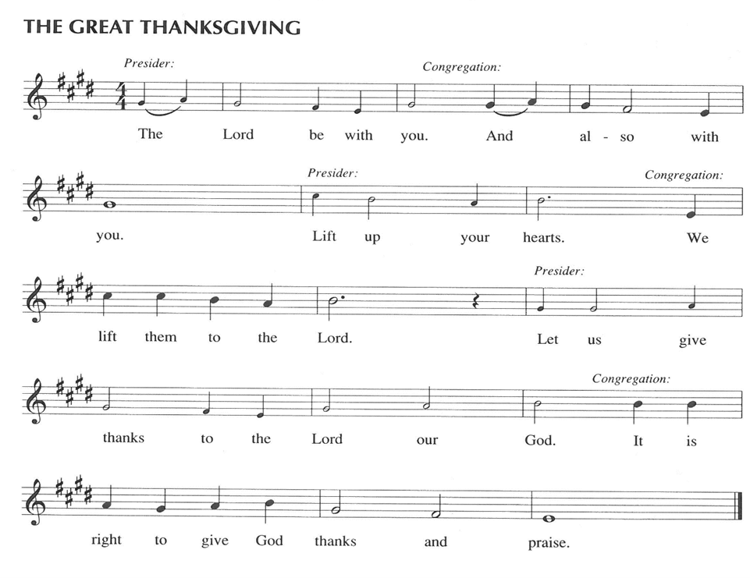

P: It is our duty and delight … join their unending hymn

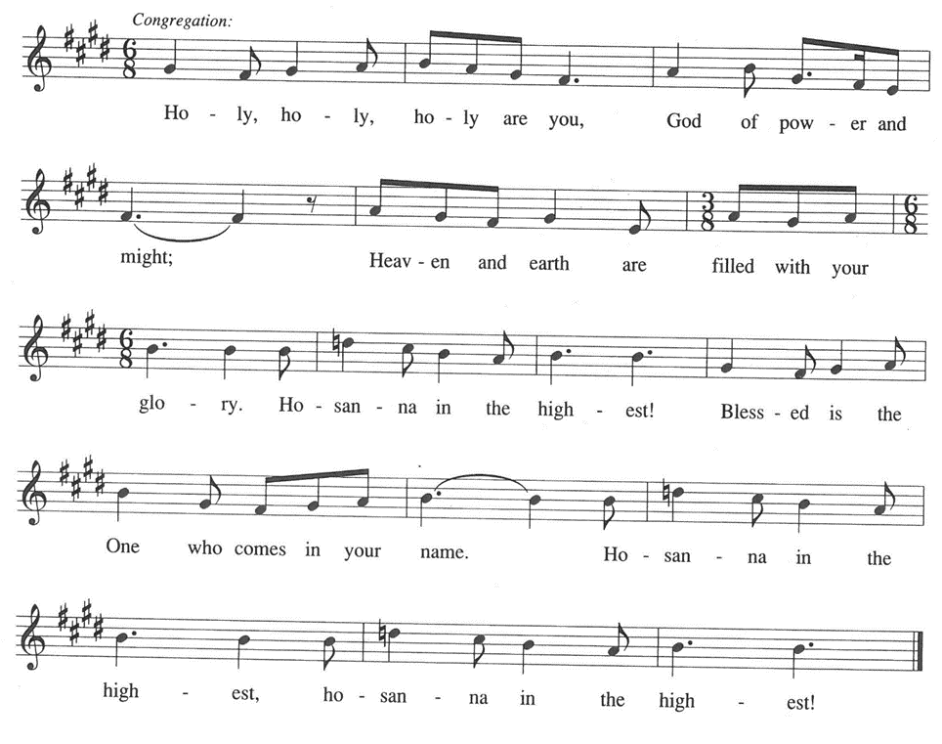

P: It is a good and joyful thing to give our thanks to You, faithful God, because You have

surrounded us with so great a cloud of witnesses who have followed the path of Your promises.

By faith Your people crossed the Red Sea when You brought them out of slavery.

By faith Your Son endured the cross, disregarding its shame.

By faith Your apostles endured chains and imprisonment, testifying to the Gospel.

By faith Your martyrs suffered mockery and death for Your glory alone.

Righteous God, Whose Son is the pioneer and perfecter of our faith, make Your

Church a vineyard of justice and peace.

Nourish Your people with this fruit of the vine and make us holy by Your Spirit,

that we may bring forth the perfect fruit of Your Kingdom.

Send Your Spirit upon this bread and cup, that they may be for us the Body and Blood

of Your Son, Jesus Christ,

Who, in the night … “Do this for the remembrance of Me.”

As often as we eat … we proclaim the Lord’s death until He comes.

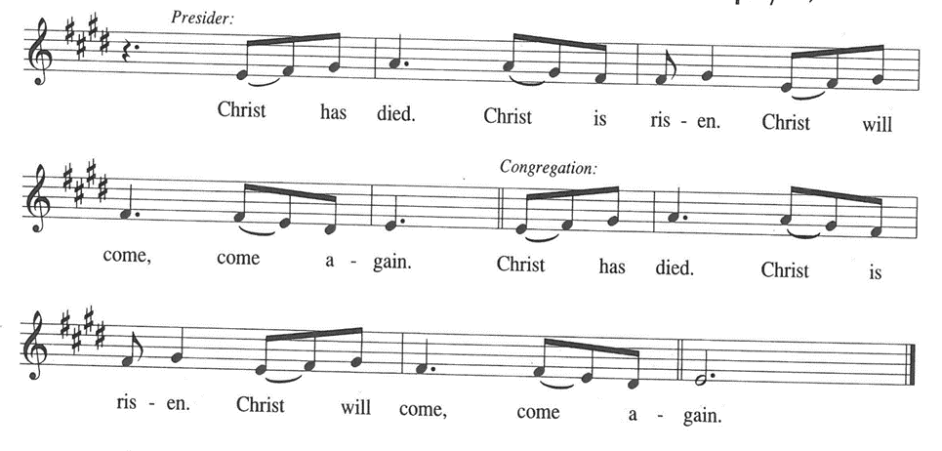

P: Remembering, therefore, His endurance of suffering and death on the cross, His

Redeeming God, Whose Son for the sake of heavenly joy won our salvation, strengthen

us to run with perseverance the race that is set before us.

Liberate Your people in the midst of every sorrow that they may hold fast to Your

unfailing mercy.

Raise up into Your unending glory everyone weighted heavy with struggle.

Give Your children a heart to see through every trial of life to a deeper joy that is

possible only in You.

Grant us wisdom in the midst of conflict to discern Your ways of peace.

Bring us all to the Day when we are made perfect in Your love and rejoice in Your

promises fulfilled,

Beholding Christ our Lord seated at Your right hand on high in the power of the Holy

Spirit, one God, now and always.

**C: Amen!**

**THE LORD’S PRAYER**

P: Setting our hearts on the unfailing treasure of God’s Kingdom, with trust in God’s daily

care for us, we now pray as Jesus taught us:

**C: Our Father, Who art in heaven, hallowed by Thy name.**

**Thy Kingdom come, Thy will be done on earth as it is in heaven.**

**Give us this day our daily bread, and forgive us our trespasses as we forgive those**

**who trespass against us.**

**And lead us not into temptation, but deliver us from evil.**

**For Thine is the Kingdom, and the power, and the glory, forever and ever. Amen.**

**INVITATION TO THE MEAL**

P: They will come from east and west and north and south to sit at Table in the Kingdom

of God. Blessed are those who are called to the Supper of the Lamb. God’s holy gifts

for God’s holy people. Come, for all is now ready.

.

*The assembly is seated*

**THE DISTRIBUTION “Lamb of God”**

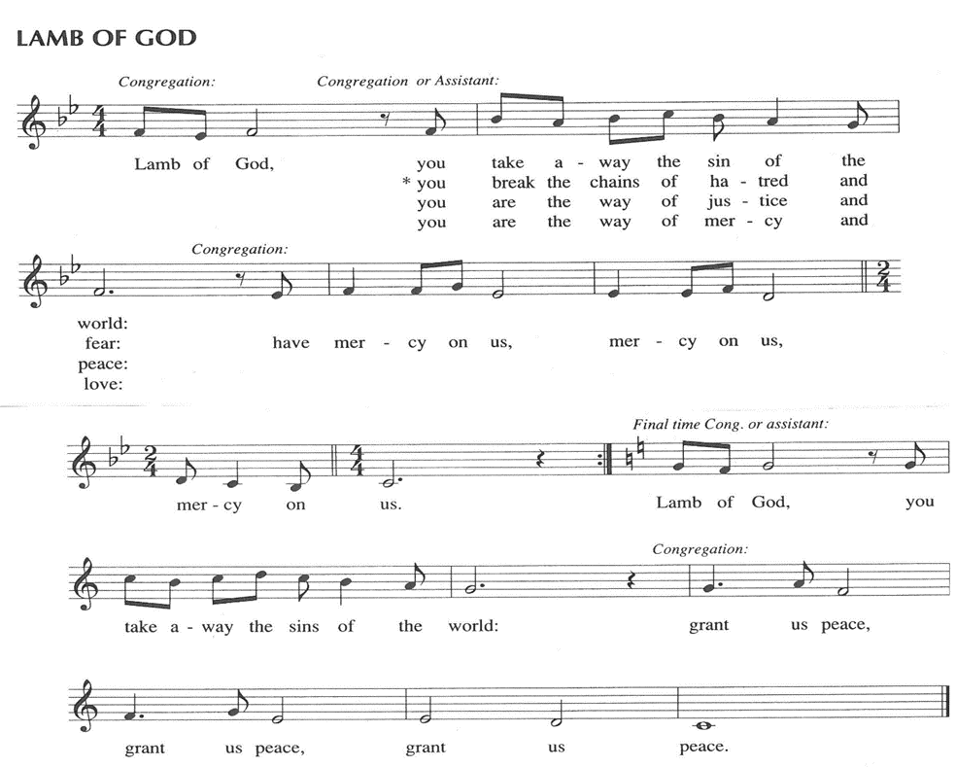

**HYMNS DURING DISTRIBUTION 491 *Come, Let Us Eat***

**484 *You Satisfy the Hungry Heart***

**485 *I Am the Bread of Life***

*As you are able please rise*

**THE POST-COMMUNION BLESSING**

P: The Body and Blood of our Lord Jesus Christ strengthen you and keep you in His grace.

**C: Amen.**

**THE POST-COMMUNION PRAYER**

A: Let us pray. Lord Jesus Christ, through Baptism You have joined us to Your life, death,

and resurrection. Strengthen us through this Meal to look only to You in our journey

through life, until, by Your grace, we join with You and all the saints in the life to

come. We bless You now and forever.

**C: Amen.**

**✠ SENDING ✠**

**THE BENEDICTION**

P: Almighty God: Father, Son, **✠** and Holy Spirit bless you now and forever.

**C: Amen.**

**THE SENDING HYMN 669 *Rise Up, O Saints of God***

**THE DISMISSAL**

A: Go in peace to bear Christ’s love to all the world.

**C: Thanks be to God!**

**POSTLUDE**

**✠ To God Alone Be Glory ✠**

The Meditation is from *Richer Fare for the Christian People.* Gail Ramshaw, ed. (New

York: Pueblo Publishing Company, 1990) 196-197.

The musical setting of the liturgy, “Now the Feast and Celebration” by Marty Haugen, is

used by permission of GIA Publishers, Inc. OneLicense.net License #A-702836.

**ANNOUNCEMENTS**

**Please remember to mail your offering to the Church Office** at 818 Franklin Street, Michigan City, IN 46360**.** Another alternative is to give on-line through Tithe.ly. Please see your closure letter for information on how to set up a Tithe.ly account.

**St. Paul Members are reminded to have** a loved one contact the office if you are hospitalized. Many times, the Pastor doesn’t know someone is in the hospital. If you call and leave a message, please tell us at which hospital the patient is locat

**BIRTHDAYS: Shirley McCarty (8/ 19)**

**ANNIVERSARIES: Troy & Hillary Frever (8/21)**

**PRAYER CONCERNS:** Bev Coburn; Barry Anderson; John Bennitt; Judy

Gustum; Bob Pheanis; Larry Litchford, Sarah McNabb, Jeanie Boatman Shepple,

Debbie Martin, Mark Tannehill, Kathy Stein, Jan Paholski, Laura Dovey, Grace Romine and Mike Galinowski.

**OFFICE HOURS:** Libby will be in the office on Mondays, Wednesdays, and Fridays; volunteers will cover Tuesdays and Thursdays.

  Monday & Wednesday 8:00 a.m. – 5 p.m.

Tuesday & Thursday 9:00 a.m. – 12:00 p.m.

Friday 8:00 a.m. – 12:00 p.m.

**If you are listening to the worship broadcast on the radio and would like to watch the Sunday morning service live stream follow these steps:**

(1) If you have You Tube available on your TV, search for

**St. Paul Lutheran Church Michigan City, IN.**

(2) The direct link on the computer is [https://](https://www.youtube.com/channel/UC5AIPNaKr3QN50984jGOa1g)

[www.youtube.com/channel/UC5AIPNaKr3QN50984jGOa1g](https://www.youtube.com/channel/UC5AIPNaKr3QN50984jGOa1g).

   (3) This link is also on the main page of the church’s website in

the church section and will continue to be posted weekly on the St.

Paul Facebook page.

And it will always be available on the radio broadcast Sunday mornings at 11:00 a.m.

on WEFM (95.9), and on the local cable access station #99 for the previous week’s

service on Sundays at 4:00 p.m. and the current service on Wednesdays at 7:00 p.m.

and Fridays at 8:30 p.m.

**Sunday’s lessons for the Day of St. Bartholomew are Exodus 19: 1-6; Psalm 12;**

**I Corinthians 12: 27-31a; and John 1: 43-51** for those of you who like to study them in advance.

**To send e-mail to the church office**, please use the following addresses:

Pastor Mark Reshan: seniorpastor@stpaulmichigancity.com

Church Office Secretary (Libby Pollock): churchsecretary@stpaulmichigancity.com

Church Treasurer (Karen Fleming): finance@stpaulmichigancity.com

**2025 Church Council:**

Mark Reshan - Pastor

 Janet Bakken – President

 Donna Knoll – Vice President

 Judy Hunt – Secretary

 Karen Fleming – Treasurer

 Members: Paul Brooks, Diane Egilske, Sue Koziel, Judy Mutchler,

Jim Schraidt, Trish Sprague

**Worship Attendance:**

**Saturday , August 9, 2025 @ 4:00 p.m. 28**

**Sunday, August 10, 2025 @ 9:00 a.m. 61**

**TOTAL 89**

**Copies of the minutes from the May 1, 2025 and the June 26, 2025 Church Council meetings are on the back table in the upper Narthex. They were approved by the council via email.**

**FYI:**

In response to the ever rising costs for postage we will be putting your copy

of the “Good News” in your hanging file folder in the narthex each month

from now on. Those of you who are unable to attend services on a regular

basis may still receive your copies through your email address or in the

U.S. mail. If you normally receive your copy of the newsletter via your

email address anyway, nothing will change for you. Thank you so much for

your understanding and cooperation!

**The Good News Newsletter**: If you have an article or anything you want included in **The Good News** please send it to the following e-mail address: splcgoodnews@gmail.com. Pastor Pamela Thiede will be using this e-mail address to assemble **The Good News** each month. The deadline for getting information to Pastor Pamela will be the 20th of each month.

**AUGUST 2025 MISSION OF THE MONTH**

**The Mission of the Month for August: Michigan City Area Schools – It’s back to school time already!** Let’s help our area kids start the year out on a good note! We will be collecting money to support different projects in various elementary schools in Michigan City through Donors Choose. Donors Choose provides a list of teacher-led classroom projects that need funding. Flexible seating, music education, and classroom supplies are some of the options we can provide to our elementary schools. Please consider donating to help fund our local teachers’ classroom projects! Checks can be written to St. Paul Lutheran Church and can be marked for MCAS and placed in the offering plate. Noisy coin offering will also support the mission of the month. To see a full list of projects visit, [www.donorschoose.org](http://www.donorschoose.org) and search for Michigan City.

**ACTIVITIES, EVENTS & MEETINGS**

**AUGUST 2025**

**Saturday,** August 16, 2025 @ 4:00 p.m. Pent 10 Worship Service/Sanctuary

**Sunday,** August 17, 2025 @ 9:00 a.m. Pent 10 Worship Service/Sanctuary

With coffee after/St. Paul Room

**Wednesday,** August 20, 2025 @10:00 a.m. God’s Purls/St. Paul Room

@3:30 p.m. Worship & Music Comm./Luther House

@4:30 p.m. Choir Rehearsal/Sanctuary

@ 5:30 p.m. 150th Anniv. Comm. Mtg./Luther House

**Saturday,** August 23, 2025 @ 4:00 p.m. Pent 11 Worship Service/Sanctuary

**Sunday,** August 24, 2025 @ 9:00 a.m. Pent 11 Worship Service/Sanctuary

With coffee after/St. Paul Room

**Monday,** August 25, 2025 @ 2:00 p.m. Finance Comm. Mtg./Luther House

@ 3:00 p.m. Executive Board Mtg./Luther House

**Wednesday,** August 27, 2025 @ 10:00 a.m. God’s Purls/St. Paul Room

**Thursday,** August 28, 2025 @ 5:30 p.m. Church Council Meeting/St. Paul Room

**Saturday,** August 30, 2025 @ 4:00 p.m. Pent 12 Worship Service/Sanctuary

**Sunday,** August 31, 2025 @ 9:00 a.m. Pent 12 Worship Service/Sanctuary with

Coffee after/St. Paul Room