
November, 2025
MARK: MY WORDS

Finally. After over twenty weeks of (mostly) green paraments, challenging and sometimes head-scratching parables, and a few festival days to break up the season, the time of Pentecost, begun in June, is drawing to its close. With the end of this year of St. Luke, Year C in the three-year lectionary cycle, we begin Year A, the year of St. Matthew’s Gospel.
Advent begins and ushers in a new church year on the last Saturday and Sunday of the month, November 27 and 28. Advent is one of the most powerful and yet often-overlooked seasons of the church year. Much of that has to do with the enormous pressure of the culture around us to start celebrating Christmas as early as possible.
It seems as though stores don’t even wait for Halloween any longer before bringing out their Christmas decorations. I actually saw a display of artificial trees in a “big box store” last July! Online retailers begin numerous “Black Friday” sales long before the traditional day after Thanksgiving events.
Advent is overlooked or brushed aside precisely because of its call and theme. The readings of the season summon us to watch and wait for the coming of Jesus, first at the end of history and then as an infant in Bethlehem. Clearly, we neither want nor are patient enough to wait. Everything must be immediate. We want our internet speeds to be ever faster, our access to information ever quicker, and our news stories ever fresher.
An essay published in Sundays and Seasons, our publishing house resource, well captures the general theme of Advent and the particular emphasis in the texts for this new church year.

Advent calls us to hold this moment in history, the yearning for a tangible and specific arrival of God’s future, and the mysterious magnitude of the cosmos together in each sermon. The lectionary selections themselves, appointed for this hinge of solstice change, become an axis that invites another way of navigating truth. In Advent’s metaphorical darkness, we trust other ways of knowing and come to love what we cannot fully see. This kind of experiential fullness, if we dare trust we can speak it into being, becomes a unified expression of our deepest hopes, our most profound pain, and the unbending truth of God’s grace …

… Each of the biblical writers we journey with in these days of sunset and dawn was trying to do the same thing. Matthew, in just about every phrase we read these four weeks, reaches back to the Hebrew Scriptures to remind us that if God liberated us before, we can certainly trust that it is happening again, both in the Jesus of our storytelling and in communities who live in this different time.
Matthew, John the Baptist, Mary, and, in his rare, tender appearance, Joseph become our icons of Emmanuel, God with us. In the television miniseries The Chosen, Matthew is portrayed as a genuinely recovering tax collector with all the socio-politico-psychological implications. He is somewhere on the neurodivergent spectrum, simultaneously learning scripture and experiencing Jesus in real time, as well as in the lives of other oppressed, broken, and yearning people. In one powerful scene, he weeps as it all remakes him.

In Romans, Paul is writing to a world vastly different in history and mythology than the world of the twelve Jewish disciples. As Paul writes, the Jesus of history begins the journey to universal Christ—a Word that can be born in all places, all times, and all people. The book itself is a witness to the birth.

James arrives on the third Sunday to remind us that we need to be patient as the fullness of future and present come into focus. He, too, urges us to trust the prophets of old. Who doesn’t need the reminder not to be grumpy with one another as we wobble toward Christmas and into yet another year of complicated life?

Of course, Isaiah is the Advent artiste, casting the metaphor and poetry of the future onto the screen of wounded life: swords into plowshares, a branch on the stump of Jesse, the lion and the lamb, streams in the desert, the holy way appearing in what seems like the desert of this first quarter of the twenty-first century.

There are so many last words in this season, words that deify real flesh, but let’s give the last word in this essay to Isaiah. This dwelling—this season, this life, this community, this world, this sermon—shall be glorious (Isa. 11:10).

May that unshakeable promise fill us with hope and joy this Advent and may our journey through the darkness be faithful and fruitful.


A PERSONAL NOTE

I am deeply grateful for the cards and notes I received for “Pastor Appreciation Month,” and for those who planned the wonderful reception at coffee hour. Thank you to those who so kindly expressed your support. I am blessed and strengthened by your care.


CHURCH OFFICE CLOSED

The church office will be closed on Thursday, November 27 in honor of Thanksgiving. It will reopen for its usual Friday schedule on the 28th from 8:00 a.m.-12:00 p.m.

FESTIVAL DAYS

We begin and end this month with important Feast days of the church year. On the first weekend (November 1-2) we commemorate All Saints Day. Originally intended to remember and give thanks for the lives of those martyred for their confession of and faith in Jesus by the fourth century it was expanded to include all the baptized faithful.
We mark the day both by solemnly calling the names of those who have died in the Lord from the congregation during the past year and also holding up those who have entered the Body of Christ through Baptism. In this way, we look to the past for our encouragement and inspiration even as we renew the promise we made to the newly baptized to support and nurture them in the ways and teachings of the Lord.
The current church year ends with the festival of Christ the King on the weekend of November 22-23. Instituted by Pope Pius XIX in 1925, this day was meant to counteract what he saw as the rampant materialism and idolatrous coveting of wealth and power that was so prominent during “The Roaring Twenties” as the world recovered from the devastation of World War I. Such longing remains powerfully entrenched in both our national and global society. Thus, the need to proclaim that amid all the turmoil, violence, and fear that Jesus rules His good creation is an especially important promise to proclaim.
Both serve as a fitting conclusion to our current church year and propel us forward into a new one uplifted and encouraged by their powerful promises.



IN MEMORY OF BOB PHEANIS
General Fund from Rich & Karen Fleming, Donna Ottersen;
“In honor and memory of my Dad” from Suzanne Pheanis
The Salvation Army from Janet Bakken
ZERO Prostate Cancer from Sharon Guip

IN MEMORY OF MY HUSBAND, KENNETH HANFT, SR.
General Fund from Carol Hanft

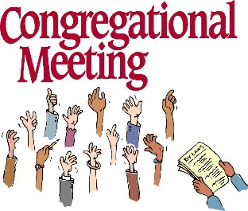
CONGREGATIONAL MEETING

On Sunday, November 9, at 10:15 a.m. our regular fall congregational meeting will be held in the St. Paul Room following worship. The primary agenda item will be the election of new church council and school team members. The candidates for the executive team are: President—Donna Knoll; Vice-President—Janet Bakken; Secretary—Judy Hunt; and Treasurer—Karen Fleming.
Council members Judy Mutchler, Diane Egilske and Paul Brooks have completed their service. We are profoundly grateful for their faithful and dedicated service. Their leadership has enriched our church community and has been a rich blessing to us all. Trish Sprague and Jim Schraidt have one more year on their term.
The Nominating Committee, consisting of Vice-President Donna Knoll, Diane Egilske, and Paul Brooks, has been working to secure candidates for the three remaining positions. Please plan to attend and cast your vote for those who have agreed to be placed on the ballot so that we might have a seamless transition.
Following the meeting, we will again have a potluck meal. The Council will not be providing a meat entrée as we have sometimes done in the past, so please bring a dish to share as we enjoy good food and better fellowship.

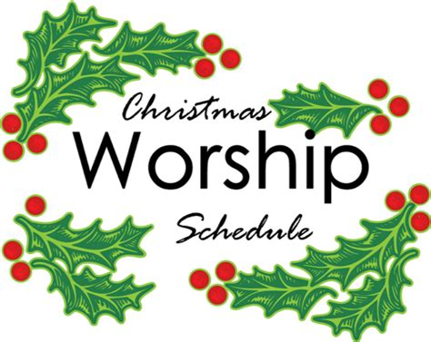

It is not too early to post information about our end-of-Advent and Christmas Eve/Day and following worship services. We will include them in the December newsletter as well, but it might be helpful to mark your calendars now for these special liturgies.

Saturday, December 20 Fourth Saturday in Advent 4:00 p.m.
Sunday, December 21 Fourth Sunday in Advent 9:00 a.m.

Wednesday, December 24 Christmas Eve 6:00 p.m.
Pre-service music @ 5:45 p.m.

Thursday, December 25 Christmas Day 9:00 a.m.

Saturday, December 27 The First Saturday after Christmas 4:00 p.m.
Sunday, December 28 The First Sunday after Christmas 9:00 a.m.

A PARKING REQUEST

We have a good number of worshipers on both Saturdays and Sundays who have some issues with mobility. They need canes or walkers to help them walk and to stabilize their balance so they do not fall. Some, but not all, have handicap placards in their cars so that they may use those designated spaces. We have some of those spaces set aside, but perhaps not as many as needed, especially for those who are not registered as handicapped but would find it helpful to be able to park closer to the building. That is especially true during winter when they must navigate ice and snow in the parking lot.
We have some folks who park in those slots near the Luther House and church who do not have issues with mobility. Could we ask that in addition to the marked handicapped spots that the row in front of the Luther House be left empty for those for whom being closer to the church would be a welcome help? Any spots along the side of the building in front of the entrance to the St. Paul Room from the parking lot that could be left open for those with mobility issues would also be helpful. If you have a placard, by all means, park in the handicapped spots; and any space that we can leave available for those with canes and walkers will be a blessing to them.
Thank you for your care for our friends with those needs.


Thank you for supporting our September mission of the month, Zero Prostrate Cancer. We raised $782 to help us get closer to a world with zero lives lost due to prostrate cancer!


MONTHLY MISSION: NEST COMMUNITY SHELTER

Nest Community Shelter, located at the old Sacred Heart Church, is a nonprofit organization delivering temporary emergency shelter for homeless men and women (including women with children) in our community, providing shelter as well as food and other resources. Nest is always in need of the following items:
- Bedding - blankets, pillows, pillowcases
- Food Items - sugar, breakfast cereal, coffee, coffee filters, creamer, non-perishable goods
- Dining – 8-oz. foam cups, 12-oz. foam bowls, 6" and 9" paper plates, plastic flatware, paper towels, paper napkins, plastic wrap, aluminum foil, gallon Ziploc bags, large serving gloves
- Kitchen - 55-gallon trash bags, dish soap
- Hygiene Items - liquid hand soap, hand sanitizer, all-purpose cleaner, feminine hygiene products, toilet paper
Donations of goods can be placed in the bin in the Narthex. Monetary donations can be marked for Nest and placed in the offering plate. The noisy coin offering will also go towards the mission of the month. Thank you for your help in providing for those in need in our community!

Also, a BIG THANKS to all those who purchased and/or helped pack the Lutheran World Relief kits. We packed 100 health kits, 100 school kits, and donated over $300 to the shipping fund to help get the kits into hands of people struck by disaster around the world! Thank you for your generosity and hard work to make this mission a success each year!

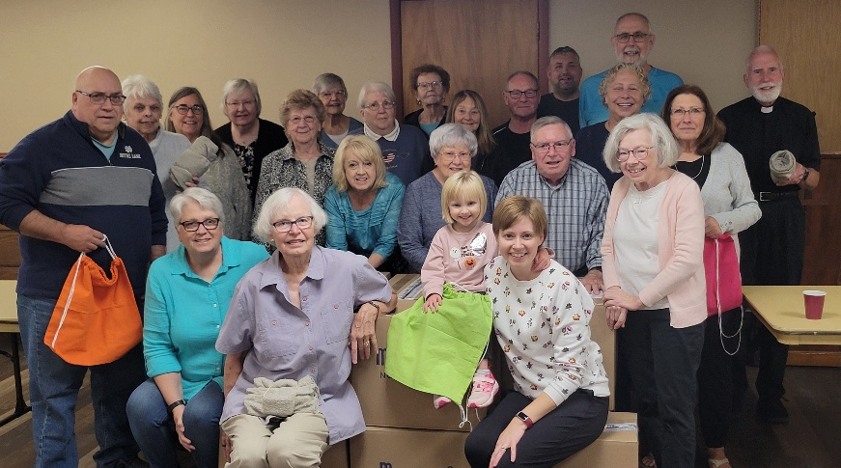
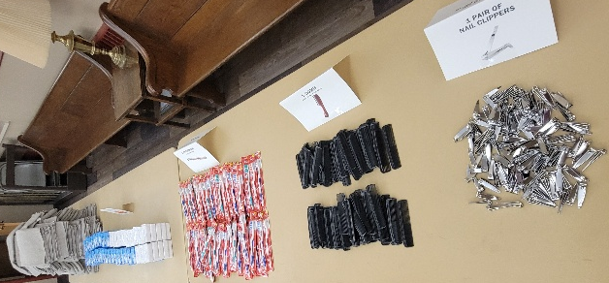


HELP THE FELLOWSHIP GROUP IN STAFFING A RED KETTLE

Last year a wonderful job was done by all those who helped staff a red kettle for the Salvation Army. The job was easy, and a lot of people in need were able to be helped by the funds raised through the Red Kettle Campaign. By donating one hour of your time to staff a red kettle position, you are helping many people.
Saturday, December 6, is the day for St. Paul to ring the bell. Our kettle is located at the north door of Al’s Super Market, 3535 Franklin Street. We will be inside the building – no worries about temperature, wind, rain or snow! Because we will be indoors near the registers, Al’s has requested that no bells be rung. Of course we respected their request last year; and instead, we had signs with “Ding” and “Dong” on them. Some of last year’s bell ringers wore Christmas hats, some wore crazy Christmas sweaters, and all wore a big smile and spread some good cheer. For safety reasons, we are asking that two people be with the red kettle for one hour. The kettle must be staffed from 10 a.m. to 7 p.m. per Salvation Army guidelines. People who are interested in helping staff the St. Paul red kettle for the Salvation Army, call Virginia Murray, (219) 872-9063.


Excerpt “Blessing Prayer at the Completion of the Harvest”
from Prayers for the Domestic Church: A Handbook for Worship in the Home by Edward Hays
(© 1979 by Edward M. Hays; published by Forest of Peace Books, Inc.)

Come, Lord of the Harvest, Lord of Rejoicing,
come and join us in our festive celebration.
May our joy at this harvest
be a taste of the joy we shall share
when we celebrate the final harvest of heaven,
that day of days when all that You have begun
will be matured to completion.
Blessed are you, Lord our God,
who has given to us this harvest.

Amen+

November Birthdays November Anniversaries
5 Sarah Sutor 23 Bob & Karen Kiser
6 Gary Larson 26 Dave & Sue Pfeiffer
Susan Levenhagen
7 Judy Hunt
8 Brittany Struebing
9 Fred Hardt
Keri Kendricks
11 Jeffrey Rimmrick
Kaylee Richardson
12 Collin Fisher
17 Susan Tomsheck
Ryan Scheuchner
Noah VanGemeren
20 Scott Bartels
23 JoAnne Sydow
24 Carrie Ziesmer
25 Marla Furness
26 Mark Robbins
Dave Pfeiffer
Gaby Cains
30 Rhys Fratgillo

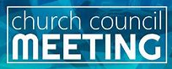
OCTOBER COUNCIL HIGHLIGHTS

The minutes of the October 23 meeting were not available at press time. Copies of the minutes will be available in the narthex after they are approved.



Long-Term Prayer List

Barry Anderson John Bennitt Robert Bernth
Lucas Bradshaw Laura Dovey Shirley Freels
Jess Kalvaitis Christine Kiser Larry Litchford
Bethany Manning Debbie Martin Shirley McCarty
Sarah McNabb Jan Paholski Grace Romine
Martha Schroeder Jeanie Boatman Shepple Joyce Stark
Kathy Stein Mark Tannehill Kevin Thiede
Kathy Thielman David Weiss Fred Weiss
Brian Wiseman

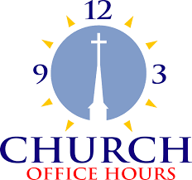

Monday 8:00 a.m. – 5 p.m.
Tuesday 9:00 a.m. – 12:00 noon
Wednesday 8:00 a.m. – 5 p.m.
Thursday 9:00 a.m. – 12 noon
Friday 8:00 a.m. – 12 noon

St. Paul Lutheran Church Staff
Pastor Rev. Mark Reshan
Secretary Libby Pollock
Accompanists Jary Tannehill, Mark Tannehill, Jacob Tannehill
Custodian Mark Kloess

Thank$ for $haring
Last month, the giveback night at Galeston raised $250. Thanks to all who participated!

This month, are going to Swingbelly’s on Wednesday, November 12. Here are two coupons—one for you and one for a friend.

