THE TENTH SUNDAY AFTER PENTECOST
August 2, 2026

Eternal Goodness, I shall contemplate myself in you.
By this light I shall come to know that you, eternal Trinity,
are table and food and waiter for us.
You, eternal Father, are the table that offers us as food,
the Lamb, your only-begotten Son.
He is the most exquisite of foods for us,
both in his teaching, which nourishes us in your will,
and in the sacrament that we receive in Holy Communion,
which feeds and strengthens us while we are pilgrim travelers in this life.
And the Holy Spirit is indeed a waiter for us,
who serves us this teaching by enlightening our mind’s eye with it
and inspiring us to follow it,
and who serves us charity for our neighbors
and the salvation of the whole world for the Father’s honor.

Catherine of Siena
Fourteenth century

God wills all persons to be saved.
Pray for the whole world,
bid this very earth to become a heaven.
Pray especially to be freed from greediness.
Pray to recognize others who are in need–
for there is no such thing as “my” bread.
All bread is ours
and is given to me through others.
For not only bread
but all things necessary for sustenance in this life
are given on loan to us
with others
and because of others
and for others
and to others, through us.

Meister Eckhardt
Fourteenth century

INTRODUCTION

In today's first reading God invites all who are hungry or thirsty to receive food and drink without cost. Jesus feeds the hungry multitude and reveals the abundance of God. At the eucharistic table we remember all who are hungry or poor in our world today. As we share the bread of life, we are sent forth to give ourselves away as bread for the hungry.

Dominic, founder of the Order of Preachers (Dominicans), died 1221

Dominic was a Spanish priest who saw the wealth of the clergy as a stumbling block for the church, so he formed a movement, the Order of Preachers (commonly called Dominicans) devoted to itinerant preaching and living in poverty.

GATHERING

PRELUDE

ANNOUNCEMENTS

As you are able please rise

A LITTLE LITANY “Feeding the Hungry”

P: In the deserted places of our lives, O Lord, You come bringing food to satisfy our bodies
and spirits.

C: You nourish us with life-giving gifts.

P: In places where people are starving for food and thirsting for water,

C: “You open Your hand and satisfy the needs of every living creature.” (Psalm
145: 17)

P: In places where there is lack of faith, O Lord,

C: You feed us with the words of Scripture, restoring our trust and hope.

P: In places where sin and guilt leave us lost, alone, and afraid, O Lord,

C: You sustain us with the bread and wine of Your Supper.

P: In places where anger and mistrust leave a bitter taste in our mouths, O Lord,

C: You pour out Your love upon us and renew our joy in serving You.

P: For all the places, O Lord, where You satisfy our every hunger and thirst,

C: “Our mouth shall speak the praise of the Lord; we shall bless His holy name
forever and ever!” (Psalm 145: 22)

CONFESSION AND ABSOLUTION

P: In the name of the Father and of the Son and of the Holy Spirit.

C: Amen.

P: “The LORD is near to those who call upon Him; to all who call upon Him faithfully.”
(Psalm 145: 19) As we confess our sin, the Lord indeed draws near to us with
forgiveness, healing, and new life.

Silence for self-examination and reflection is kept

P: Most merciful God,

C: We confess that we are captive to sin and cannot free ourselves. We receive Your
good gifts without thanking, and squander them without thinking. We are guilty
of “spending our money for that which is not bread, and our labor for that which
does not satisfy.” (Isaiah 55: 2) We have neglected the poor and hungry among
us. We have left it to others to care for them. We are in need of Your compassion.
(Matthew 14: 14) For the sake of Your Son, Jesus Christ, have mercy on us.
Forgive us our sins and call us by Your Holy Spirit to the new life You ordained
for us, to the glory of Your holy name. Amen.

P: “Incline your ear, and come to Me; listen, so that you may live.” (Isaiah 55: 3) In
God’s Word there is life and hope for you this day. Hear then His promise: as a called
and ordained minister of the Church of Christ, and by His authority, I therefore declare
to you the entire forgiveness of all your sins, in the name of the Father and of the
Son and of the Holy Spirit.

C: Amen.

GATHERING HYMN 461 All Who Hunger, Gather Gladly

THE GREETING AND PRAYER OF THE DAY

P: “The LORD is loving to everyone,

C: and His compassion is over all His works.” (Psalm 145: 9)

P: The grace of our Lord Jesus Christ, the love of God, and the communion of the Holy
Spirit be with you all.

C: And also with you.

P: Let us pray. Gracious God, Your generosity waters the world with goodness, and You
cover creation with abundance. Awaken in us a hunger for the food that satisfies both
body and spirit, and with this food fill all the starving world; through Jesus Christ, our
Savior and Lord.

C: Amen.

The assembly is seated

WORD

FIRST READING Isaiah 55: 1-5

In both ancient Near Eastern history and literature, the building of a temple and the feast held afterward signify the establishment of the kingdom of the temple's builder. Isaiah 54 recounts God's building of a new temple following the exile. Today's reading is the invitation to the feast.
Ho, everyone who thirsts,
come to the waters;
and you that have no money,
come, buy and eat!
Come, buy wine and milk
without money and without price.
²Why do you spend your money for that which is not bread,
and your labor for that which does not satisfy?
Listen carefully to Me, and eat what is good,
and delight yourselves in rich food.
³Incline your ear, and come to Me;
listen, so that you may live.
I will make with you an everlasting covenant,
My steadfast, sure love for David.
⁴See, I made him a witness to the peoples,
a leader and commander for the peoples.
⁵See, you shall call nations that you do not know,
and nations that do not know you shall run to you,
because of the LORD your God, the Holy One of Israel,
for He has glorified you.

The Word of the Lord.

Thanks be to God.

THE PSALM: Psalm 145: 8-9, 14-21 Read responsively

⁸The LORD is gracious and full of compassion,
slow to anger and abounding in steadfast love.

⁹LORD, You are good to all,
and Your compassion is over all Your works.

¹⁴The Lord upholds all those who fall
and lifts up those who are bowed down.

¹⁵The eyes of all wait upon You, O LORD,
and You give them their food in due season.

¹⁶You open wide Your hand
and satisfy the desire of every living thing.

¹⁷You are righteous in all Your ways
and loving in all Your works.

¹⁸You are near to all who call upon You,
to all who call upon You faithfully.

¹⁹You fulfill the desire of those who fear You;
You hear their cry and save them.
²⁰You watch over all those who love You,
but all the wicked You shall destroy.

²¹My mouth shall speak the praise of the LORD;
let all flesh bless God's holy name forever and ever.

SECOND READING Romans 9: 1-5

In his letter to the Romans, Paul proclaims the good news of Jesus Christ, through whom "nothing can separate us from the love of God." Then, his joy turns to sorrow as he considers those among God's people who have not received the gospel.

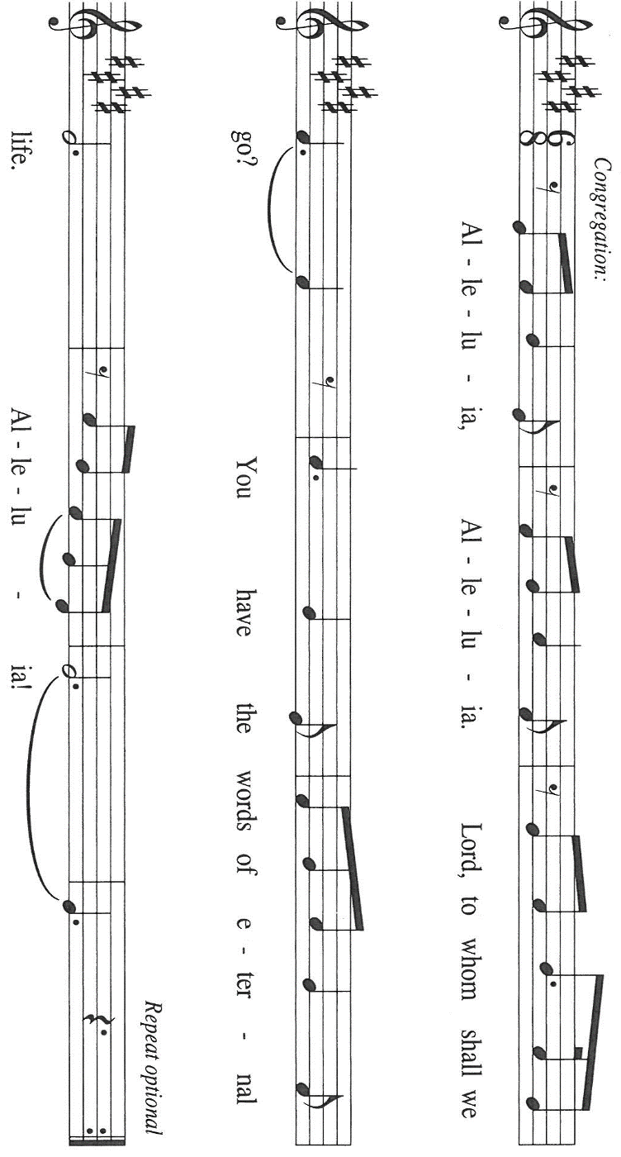
I am speaking the truth in Christ--I am not lying; my conscience confirms it by the Holy Spirit--²I have great sorrow and unceasing anguish in my heart. ³For I could wish that I myself were accursed and cut off from Christ for the sake of my own people, my kindred according to the flesh. ⁴They are Israelites, and to them belong the adoption, the glory, the covenants, the giving of the law, the worship, and the promises; ⁵to them belong the patriarchs, and from them, according to the flesh, comes the Messiah, Who is over all, God blessed forever. Amen.

The Word of the Lord.

Thanks be to God.

As you are able please rise

THE VERSE Sung twice

THE HOLY GOSPEL Matthew 14: 13-21

After John the Baptist is murdered, Jesus desires a time of solitude. Still, his compassion for others will not allow him to dismiss those who still need him but, rather, moves him to perform a great miracle.

P: The Holy Gospel according to St. Matthew, the fourteenth chapter.

C: Glory to You, O Lord!

Now when Jesus heard about the beheading of John the Baptist, He withdrew from there in a boat to a deserted place by Himself. But when the crowds heard it, they followed Him on foot from the towns. ¹⁴When He went ashore, He saw a great crowd; and He had compassion for them and cured their sick.
¹⁵When it was evening, the disciples came to Him and said, "This is a deserted place, and the hour is now late; send the crowds away so that they may go into the villages and buy food for themselves." ¹⁶Jesus said to them, "They need not go away; you give them something to eat." ¹⁷They replied, "We have nothing here but five loaves and two fish." ¹⁸And He said, "Bring them here to me."
¹⁹Then He ordered the crowds to sit down on the grass. Taking the five loaves and the two fish, He looked up to heaven, and blessed and broke the loaves, and gave them to the disciples, and the disciples gave them to the crowds. ²⁰And all ate and were filled; and they took up what was left over of the broken pieces, twelve baskets full. ²¹And those who ate were about five thousand men, besides women and children.

P: The Gospel of the Lord.

C: Praise to You, O Christ!

The assembly is seated

THE SERMON

Silence for reflection follows the sermon

As you are able please rise

THE HYMN OF THE DAY NSB 42 Great is the Lord

THE APOSTLES’ CREED

A: God has made us His people through our Baptism into Christ. Living together in trust
and hope, we confess our faith.

C: I believe in God, the Father almighty,
creator of heaven and earth.

I believe in Jesus Christ, His only Son, our Lord.
He was conceived by the power of the Holy Spirit
and born of the virgin Mary.
He suffered under Pontius Pilate,
was crucified, died, and was buried.
He descended into hell.
On the third day He rose again.
He ascended into heaven,
and is seated at the right hand of the Father.
He will come again to judge the living and the dead.

I believe in the Holy Spirit,
the holy catholic Church,
the communion of saints,
the forgiveness of sins,
the resurrection of the body,
and the life everlasting. Amen.

THE PRAYER OF THE CHURCH

A: Let us offer our prayer in the name of Jesus, Who had compassion on the multitude and
Whose bounty feeds us all.

A: That the Church may distribute the Bread of Life to all who hunger in body and spirit,
sharing generously with others as God shares with us, let us pray to the Lord:

C: Lord, hear our prayer.

A: That prosperous nations may work for a just distribution of resources, and an end to
poverty, especially in Africa, Haiti, the Dominican Republic, and every place of
drought and famine, that all may share in God’s bounty, let us pray to the Lord:

C: Lord, hear our prayer.

A: That this congregation’s gifts of money, time, and talents may be used this week for
the needs of the poor, the hungry, and the hurting, let us pray to the Lord:

C: Lord, hear our prayer.

A: That the sick, especially: Hazel Miller; Jon Samuelson; Pastor Dale Zylstra;
Martha Schroeder; Dale Thomas; Mark Tannehill; Jeff Seifert; Amanda Seedorf;
Bev Coburn; Debbie Martin; Ron Ton; and Jean Warner may know the healing
compassion of Christ, let us pray to the Lord:

C: Lord, hear our prayer.

A: That those celebrating birthdays, especially: Sandy Robbins; Jim Galinowski; Rich
Thielman; and anniversaries, especially: John and Amy VanGemeren; Virgil and
Pat Miller; and Rich and Karen Fleming may be filled with grace this day and grow
in grace in the days ahead, let us pray to the Lord:

C: Lord, hear our prayer.

A: That those who mourn, especially the family and friends of David Hamilton, whose
wife, Kathleen, died in the Lord this week, may be comforted by the promise of res-
urrection to life everlasting and of being reunited with those they love before the
throne of the Lamb, let us pray to the Lord:

C: Lord, hear our prayer.

A: That with all the saints, especially Dominic, whom we commemorate this Day we may
one Day feast at Christ’s heavenly Banquet, where all hungers and thirsts are forever
satisfied, let us pray to the Lord:

C: Lord, hear our prayer.

P: Lord, Creator of the universe, Giver of all that is good, let us feel Your presence in our
need, and be Your presence to others. We ask this in the name of Jesus the Lord.

C: Amen.

MEAL

THE PEACE

P: The peace of the Lord be with you always.

C: And also with you.

The assembly is seated

THE OFFERING

THE VOLUNTARY Love is Here New Song Praise Band
(Donehey, Jamison, LaRue, Ingram & Middleton)

As you are able please rise

THE PRESENTATION OF GIFTS (see p. 9) As the Grains of Wheat

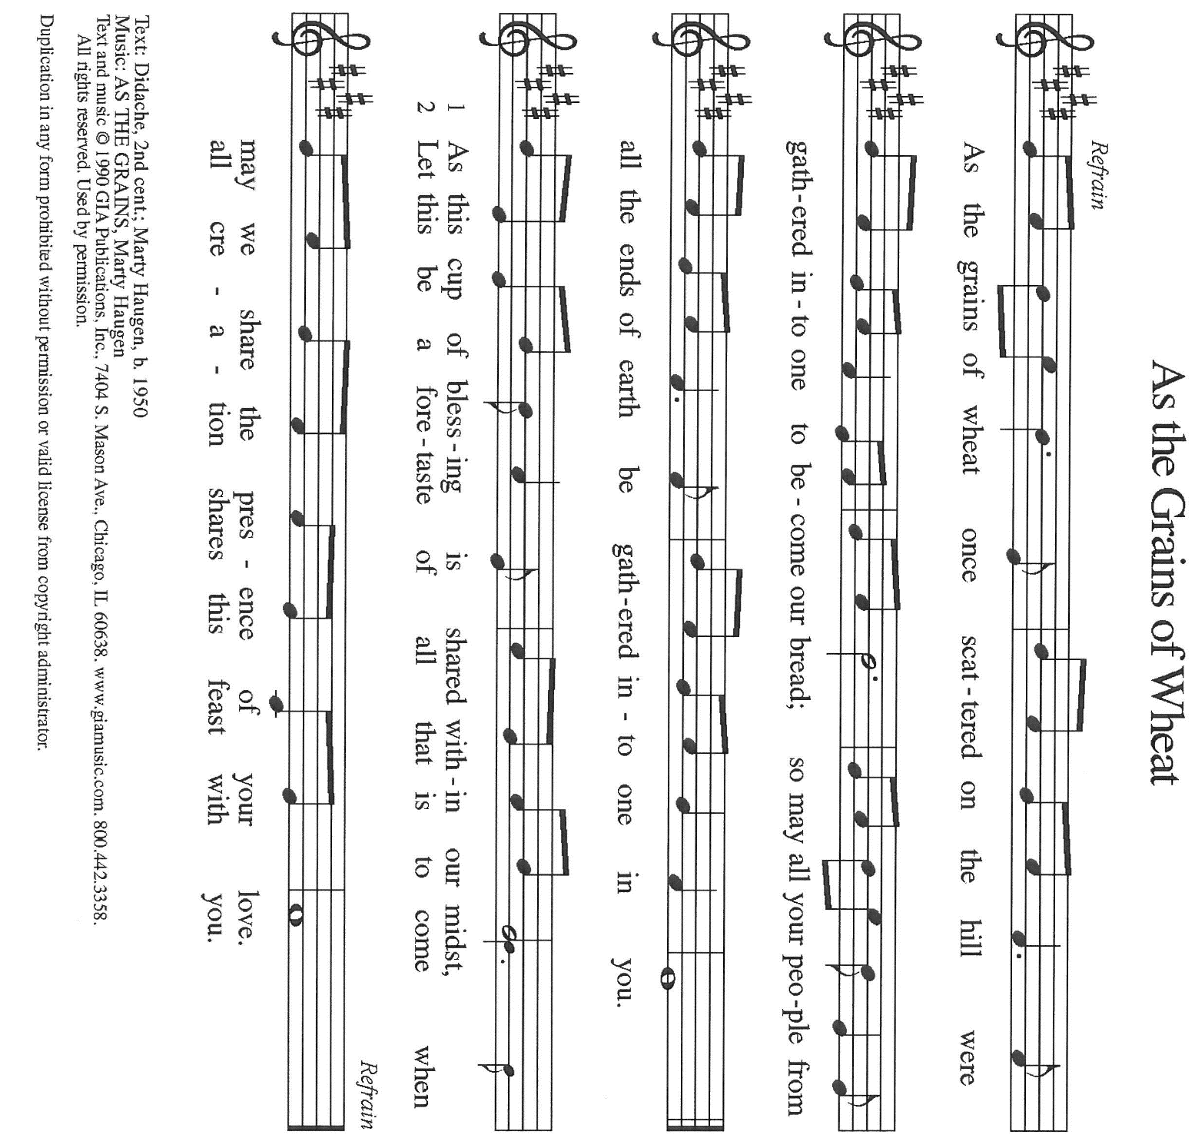

THE OFFERTORY PRAYER

A: Let us pray. Gracious God,

C: With these gifts we offer You the fruits of our labor. Too often, O God, we work
for that which does not satisfy. You invite us to listen carefully to Your Word,
and to eat what is good from Your Table. Fill us with delight at Your rich Food,
and send us to share Your gifts with all in need of Your compassion and help. We
ask this in the name of Jesus the Lord. Amen.
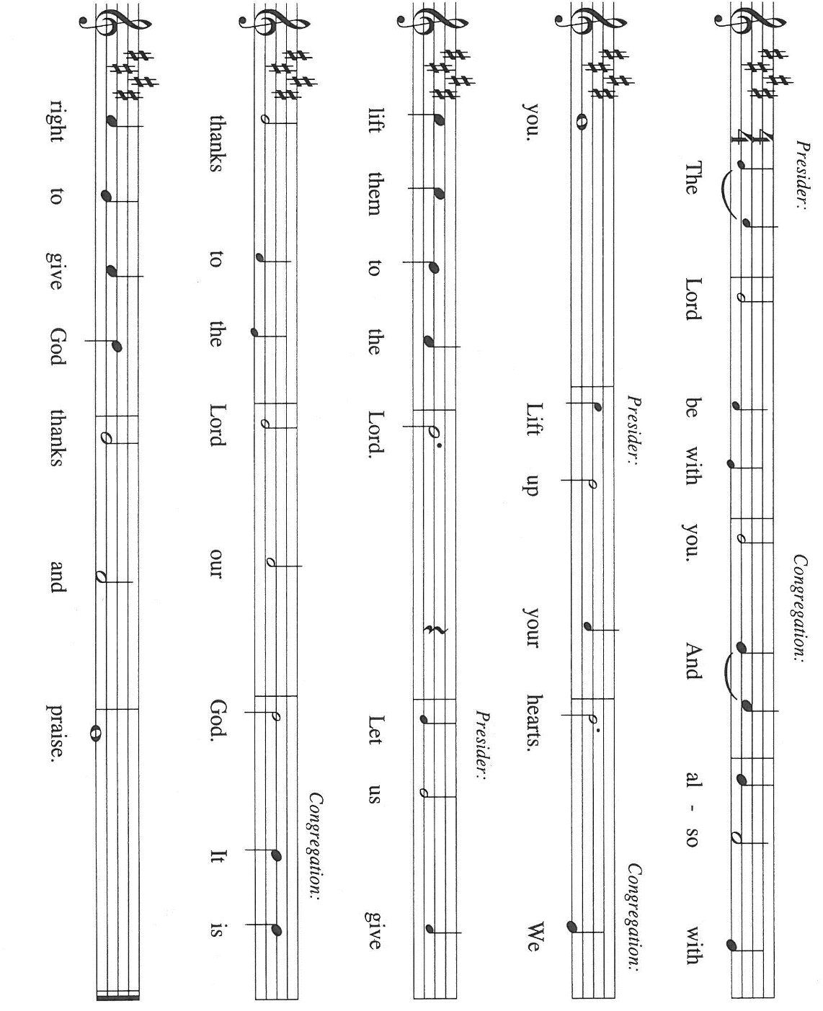
THE GREAT THANKSGIVING

P: It is our duty and delight …join their unending hymn:

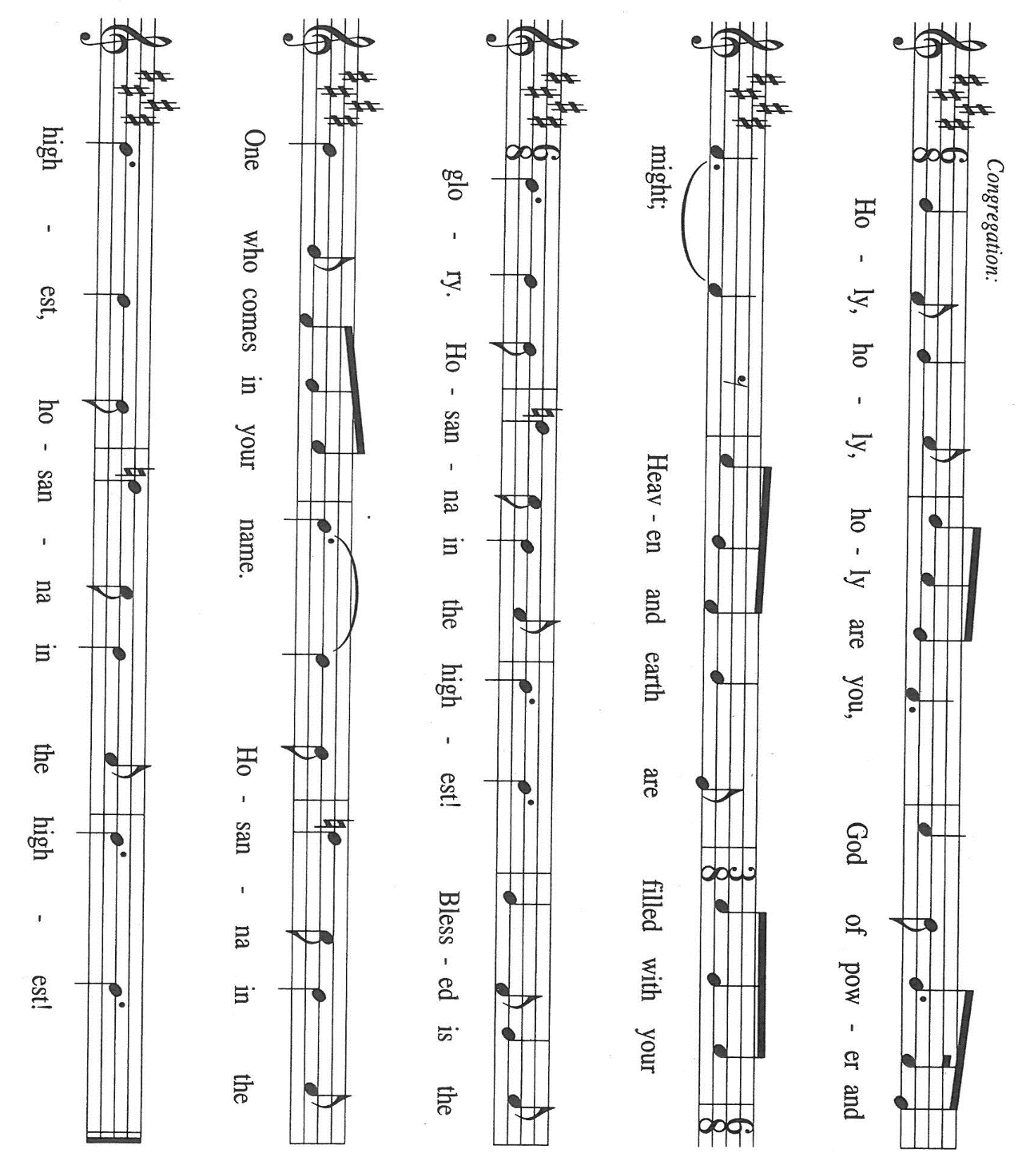

P: Holy God, Bread of Life, we offer You our thanks and praise.
For You are righteous in all Your ways and loving in all Your works.
You open wide Your hand and satisfy the desire of every living creature.
You chose Israel, Your beloved to be Your way of blessing for the world.
Through judges, kings, and prophets, You bestowed the Food of Your Word.

At the last Your Word became flesh in Your only-begotten Son, Jesus Christ.
He is the true Bread from heaven in Whom all our hungers are satisfied.
In the night ... “Do this for the remembrance of Me.”
As often as we eat ... we proclaim the Lord’s death until He comes.

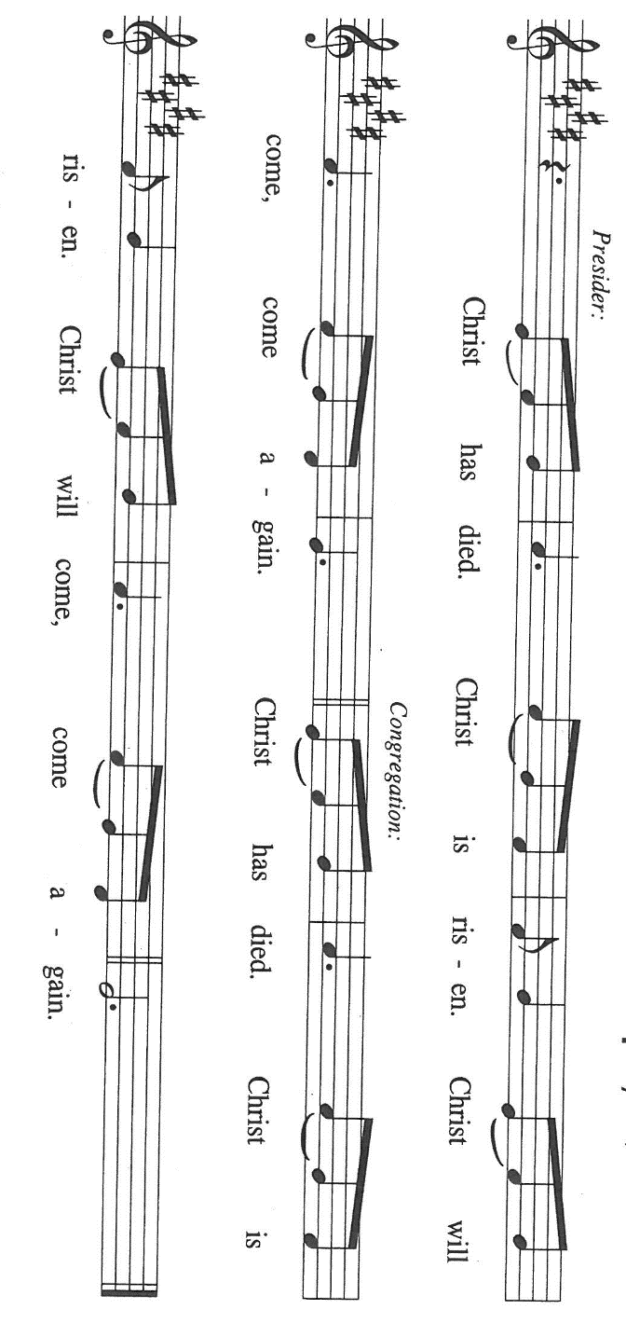

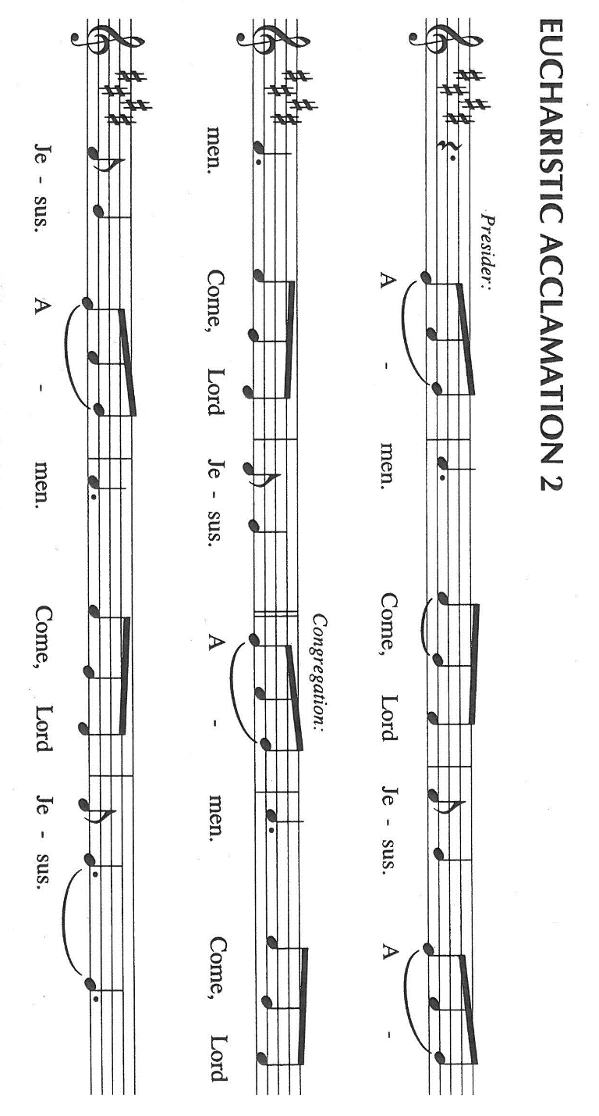

P: With this bread and cup, O God, we remember the life our Lord offered for us: He
healed the sick, fed the hungry, and gave His body to be broken on the cross in
death on our behalf.
You raised Him from death to give life to the world. When He ascended, He promised
to return to host Your final Feast of victory.

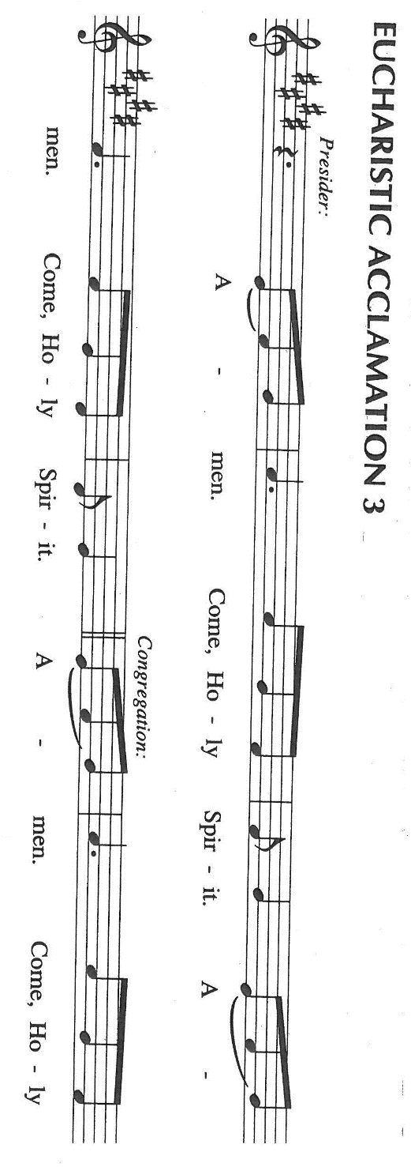
Send Your Spirit on us and these Your gifts of bread and wine.
By this Meal, strengthen us to serve all in hunger and want as we share Your Bread of
Life with our dying world until He comes in glory.

Until that Day, accept our prayers and praises, O God: Father, Son, and Holy Spirit, in
Your holy Church, in heaven and on earth, now and forever.

C: Amen!

THE LORD’S PRAYER

P: Let the good seed of God’s Word bear fruit now as we offer the prayer Jesus taught us
to pray:

C: Our Father in heaven, hallowed be Your name.
Your Kingdom come, Your will be done on earth as in heaven.
Give us today our daily bread, and forgive us our sins, as we forgive
those who sin against us.
Save us from the time of trial, and deliver us from evil.
For the Kingdom, the power, and the glory are Yours, now and forever.
Amen.

INVITATION TO THE MEAL

P: Behold, the Lamb of God Who takes away the sin of the world. Blessed are those who
are called to the Supper of the Lamb. God’s holy gifts for God’s holy people. Come,
for all is now ready.

The assembly is seated

THE DISTRIBUTION Lamb of God (see p. 12)

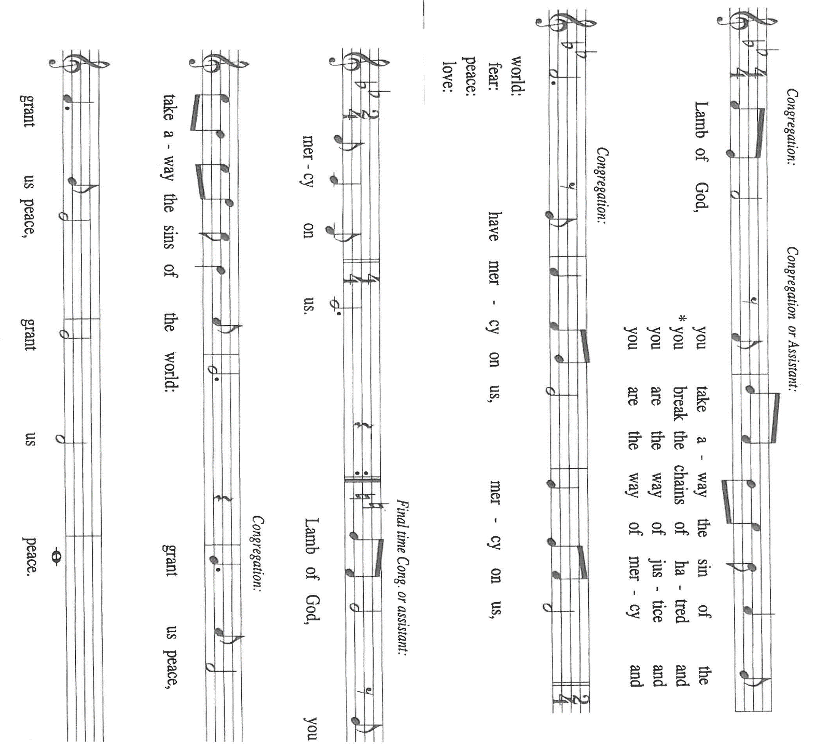

HYMN DURING DISTRIBUTION 484 You Satisfy the Hungry Heart
ELW 817 You Have Come Down to the Lakeshore
ELW 479 We Come to the Hungry Feast
ELW 471 Let Us Break Bread Together
ELW 481 Come to the Table

As you are able please rise

THE POST-COMMUNION BLESSING

P: The Body and Blood of our Lord Jesus Christ strengthen you and keep you in His grace.

C: Amen.

THE POST-COMMUNION PRAYER

A: Let us pray. Lord Jesus, You have again fed us with the rich Food of Your Body and
Blood. Send us now in the power of Your Spirit to feed those who hunger and thirst
for You. You are the Lord forevermore.

C: Amen.

SENDING

THE BENEDICTION

P: Almighty God: Father, Son, and Holy Spirit bless you now and forever.

C: Amen.

THE SENDING SONG ELW 674 Let Us Talents & Tongues Employ

THE DISMISSAL

A: Go forth with God’s blessing to love and serve the Lord.

C: Thanks be to God!

POSTLUDE
To God Alone Be Glory

The Meditation is from Richer Fare for the Christian People. Gail Ramshaw, ed. (New
York: Pueblo Publishing Company, 1990) 76.

The Prayers, Introduction to the Lord’s Prayer, and Invitation to the Meal are adapted from
Prayers for Sundays and Seasons. Year A. Peter J. Scagnelli. (Chicago: Liturgy Training Publications, 1998) 111-112.

The musical setting of the liturgy, “Now the Feast and Celebration” by Marty Haugen, is
used by permission of GIA Publishers, Inc. OneLicense.net License #A-702836.

ANNOUNCEMENTS

Please remember to mail your offering to the Church Office at 818 Franklin Street, Michigan City, IN 46360. Another alternative is to give on-line through Tithe.ly. Please see your closure letter for information on how to set up a Tithe.ly account.

St. Paul Members are reminded to have a loved one contact the office if you are hospitalized. Many times, the Pastor doesn’t know someone is in the hospital. If you call and leave a message, please tell us at which hospital the patient is located.

BIRTHDAYS: Sandra Robbins (8/4); Jim Galinowski (8/4); and
Richard Thielman (8/5)
ANNIVERSARIES: Amy & John VanGemeren (8/3); Virgil & Patricia Miller
(8/5); Rich & Karen Fleming (8/9)

PRAYER CONCERNS: Debbie Martin; Mark Tannehill; Kathy Stein; Jan Paholski; Laura Dovey; Bill Hazelgrove; Al Levenhagen; Carl Wipperman; Major Payne.

OFFICE HOURS: Libby will be in the office on Mondays, Wednesdays, and Fridays; volunteers will cover Tuesdays and Thursdays.

Monday & Wednesday 8:00 a.m. – 5 p.m.
Tuesday & Thursday 9:00 a.m. – 12:00 p.m.
Friday 8:00 a.m. – 12:00 p.m.

If you are listening to the worship broadcast on the radio and would like to watch the Sunday morning service live stream follow these steps:

(1) If you have You Tube available on your TV, search for
St. Paul Lutheran Church Michigan City, IN.

(2) The direct link on the computer is https://
www.youtube.com/channel/UC5AIPNaKr3QN50984jGOa1g

(3) This link is also on the main page of the church’s website in
the church section and will continue to be posted weekly on the St.
Paul Facebook page.

And it will always be available on the radio broadcast Sunday mornings at 11:00 a.m.
on WEFM (95.9), and on the local cable access station #99 for the previous week’s
service on Sundays at 4:00 p.m. and the current service on Wednesdays at 7:00 p.m.
and Fridays at 8:30 p.m.

To send e-mail to the church office, please use the following addresses:
Pastor Mark Reshan: seniorpastor@stpaulmichigancity.com
Church Office Secretary (Libby Pollock): churchsecretary@stpaulmichigancity.com
Church Treasurer (Karen Fleming): finance@stpaulmichigancity.com

2026 Church Council:
Pastor - Mark Reshan
President - Donna Knoll
Vice President - Jan Bakken
Secretary - Judy Hunt
Treasurer - Karen Fleming

Members: Sue Koziel; Jim Schraidt; Trish Sprague; Bob Kiser; Barry Anderson; and
Pam Soule

Worship Attendance:

Wednesday, July 22, 2026 Organ Concert @12:15 p.m. 51

Saturday, July 25, 2026 @ 4:00 p.m. 24

Sunday, July 26, 2026 @ 9:00 a.m. 76

TOTAL 151

Copies of the minutes from the June 25, 2026 and July 23, 2026 Church Council meetings are on the back table in the upper Narthex. They were approved by the council via email.

The Good News Newsletter: If you have an article or anything you want included in The Good News please send it to the following e-mail address: splcgoodnews@gmail.com. Pastor Pamela Thiede will be using this e-mail address to assemble The Good News each month. The deadline for getting information to Pastor Pamela will be the 20th of each month.

Next week’s lessons are 1 Kings 19: 9-18; Psalm 85: 8-13; Romans 10: 5-15;
Matthew 14: 22-33 for those of you who like to study them in advance.

MISSION OF THE MONTH FOR AUGUST 2026

Mission of the Month for August 2026 is for Michigan City Area Schools – we will be collecting money to support different projects in various elementary schools in Michigan City through Donors Choose. Donors Choose provides a list of teacher-led classroom projects that need funding. Please consider donating to help fund our local teachers’ classroom projects. Checks can be written to St. Paul and can be marked for MCAS and placed in the offering plate. Noisy coin offering will also support the mission of the month. To see a full list of projects, visit www.donorschoose.org and search for Michigan City.

PLEASE NOTE:

From now through Wednesday, August 19, 2026 the front doors of the church (those doors facing Franklin Street) will be open on Wednesdays to invite new visitors in to hear the organ concert. Any Wednesday, at your choosing, at 11:30 a.m. Concerts begin at 12:15 p.m. Please come and help us greet visitors. Your help is appreciated.

DOG & SUDS COMING SOON!

Please know that we will be having a Dog & Suds Cookout on August 7, 2026 from 4:00 p.m.—8:00 p.m. in the church parking lot. The public is welcome. The event will include hotdogs with all the trimmings, chips and Carlson’s root beer. There will be musical entertainment by the Praise Band, games and time to spend with neighbors, family and friends. So, please extend an invitation to all. There will be a free will donation. Help us make this a huge success and show the community that St. Paul is alive and vibrant!

ACTIVITIES, EVENTS & MEETINGS
AUGUST 2026

Saturday, August 1, 2026 @ 4:00 p.m. !0th Pentecost Worship Service/Sanctuary

Sunday, August 2, 2026 @ 9:00 a.m. 10th Pentecost Worship Service/Sanctuary/coffee after

Monday, August 3, 2026 @ 7:00 p.m. Women’s Bible Study/St. Paul Room

Wednesday, August 5, 2026 @ 10:00 a.m. God’s Purls/St. Paul Room
@ 12:15 p.m. Organ Concert Summer Series/Sanctuary
@ 4:30 p.m. Choir Rehearsal/Sanctuary

Thursday, August 6, 2026 Faith Circle?

Friday, August 7, 2026 from 4:00 p.m. – 8:00 p.m. Dog & Suds Cookout In the church parking lot Saturday, August 8, 2026 @4:00 p.m. 11th Pentecost Worship Service/Sanctuary

Sunday, August 9, 2026 @ 9:00 a.m. 11th Pentecost Worship Service/Sanctuary/coffee after

Monday, August 10, 2026 @ 1:00 p.m. Hope Circle/Green Room

@ 7:00 p.m. Women’s Bible Study/St. Paul Room

Tuesday, August 11, 2026 @ 11:00 a.m. – close GIVE BACK at Holly’s

Wednesday, August 12, 2026 @ 10:00 a.m. God’s Purls/St. Paul Room

@12:15 p.m. Organ Concert Summer Series/Sanctuary
@ 3:30 p.m. Worship and Music Mtg./Luther House

Thursday, August 13, 2026 @ 5:00 p.m. Volunteer Dinner/St. Paul Rm

Saturday, August 15, 2026 @ 4:00 p.m. 12th Pentecost Worship Service/Sanctuary

Sunday, August 16, 2026 @ 9:00 a.m. 12th Pentecost Worship Service /Sanctuary/coffee after

Monday, August 17, 2026 @ 7:00 p.m. Women’s Bible Study/St. Paul Room

Wednesday, August 19, 2026 @ 10:00 a.m. God’s Purls/St. Paul Room

@ 12:15 p.m. Last Organ Concert Summer Series. 2026

@ 4:30 p.m. Choir Rehearsal/Sanctuary

Saturday, August 22, 2026 @ 4:00 p.m. 13th 21`Pentecost Worship Service/Sanctuary

Sunday, August 23, 2026 @ 9:00 a.m. 13th Pentecost Worship Service/Sanctuary/coffee after

Monday, August 24, 2026 @ 2:00 p.m Finance Comm. Mtg./Luther House

@ 3:00 p.m. Executive Board Mtg./Luther House

Wednesday, August 26, 2026 @ 10:00 a.m. God’s Purls/St. Paul Room

Thursday, August 27, 2026 @ 3:00 p.m. Church Council Mtg./St. Paul Room

Saturday, August 29, 2026 @ 4:00p.m 14 Pentecost Worship Service/Sanctuary

Sunday, August 30, 2026 @ 9:00 a.m. 14 Pentecost Worship Service/Sanctuary/coffee after

Thank$ for $haring
Thank you to all who participate in our Give-Back opportunities each month. We earned $108 from our GIVE BACK at 5 Guys on July 15, 2026. We’ll be meeting at Holly’s Restaurant & Pub on Tuesday, August 11, 2026 from 11:00—close for our next GIVE BACK. Here are two coupons. One for you and one for a friend.

