-
May, 2026
MARK: MY WORDS

It is earlier than normal this year. Our spring congregational meeting is scheduled for Sunday, May 3, at 10:15 a.m. following worship. On every other Sunday of the month, we ran into some conflict: The 10th is Mother’s Day; I will be gone the weekend of May 16-17 for my son Dan’s graduation in Cleveland; Memorial Day is Sunday, May 24; and I will be gone again the weekend of May 30-31 for my son Jacob’s graduation in Terre Haute.
As always, the main agenda item at this semi-annual meeting is consideration of the proposed budget for the 2026-2027 fiscal year that begins on July 1, 2026, and ends on June 30, 2027. Our faithful and tireless treasurer, Karen Fleming, has already been working hard on crunching numbers and working up a viable and attainable balance of income versus our expenses.
This year’s budget proposal will be very different in some ways from previous versions.
As noted in the letter I sent out, I will be retiring at the beginning of November. That means that for the final eight months of the fiscal year there will be a significant reduction in expenses due to the absence of my salary, health care coverage, and other costs. Whether there is a part-time interim pastor or weekly supply pastors for worship, pastoral expenditures will be much less.
As you will also hear, we have had a large number of expensive repairs to the building over the last year. Its age requires a tremendous amount of care that is often very costly. The good news is that in spite of such large bills we have not had to borrow money from the bank to complete the work. All in all, we are well holding our own and meeting our responsibilities.
Through our Mission of the Month, we continue to help support in generous ways many ministries both within and outside of our community.
It is not easy to talk about money in the Church. Somehow, we have come to feel that it is a private matter between us and God. But how we use our gifts is an essential part of our ministry to this neighborhood and community. Jesus talked about money and its use more than any other topic in His ministry.
Because we utilize our resources in the name of this congregation, we need your presence, your wisdom, and your insight as to how best to use God’s gifts to us. So, please plan on attending the meeting. The more agreement we have, the more we will speak and act with one voice in our continued witness to God’s work in and through us.



Following the congregational meeting, we will have a potluck meal. The Council will not be providing the main course this time, so whatever entrees, salads, sides, and desserts we have will come from those who attend. There is no need to sign up for anything; simply bring a favorite dish to share and enjoy good food and better fellowship following the meeting.

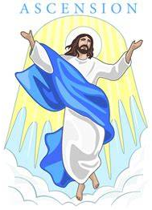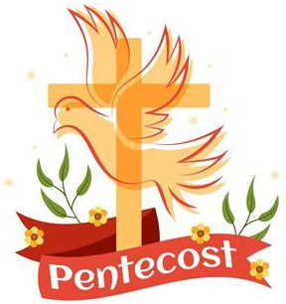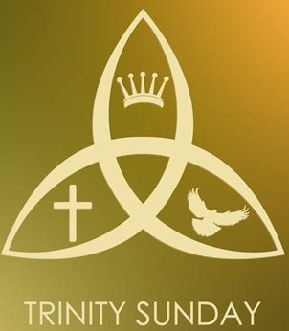

FESTIVAL WORSHIP

Because Easter was earlier than last year, we have three major liturgical festivals to celebrate in May: The Ascension of our Lord (which, as always, falls on a Thursday, this year on May 14, but which we will celebrate on the following Saturday/Sunday May 16-17); the Vigil and Day of Pentecost on Saturday/Sunday, May 23-24; and The Holy Trinity on Saturday/Sunday, May 30-31.
These festivals bring the Fifty Days of Easter to their completion and help transition us into the longest season of the church year, Pentecost. They are some of the most joyous celebrations of the year but also among the most challenging, and we look forward to observing them with special music and uplifting worship.



TIME AWAY

I will be gone for two weekends this month to attend the graduations of our sons, Dan and Jacob, from their colleges. Dan’s is on Sunday, May 17, and Jacob’s on Saturday, May 30. We will leave for Cleveland and Dan’s service on Saturday, May 16, and return on Monday, May 18, and for Terre Haute and Jacob’s commencement on Friday, May 29, returning on Sunday, May 31. Our good friend, Dr. Fred Niedner from Valparaiso University, has graciously agreed to fill in at both services on each weekend.
Dan and Jacob’s graduations are the culmination of four years of very hard work on their part. They both have achieved great grades and many accomplishments, and we are grateful and excited to share in this important milestone in their lives and to continue to walk with them as they enter this new chapter. Thank you to all who ask about their progress and their future.


HOPE CIRCLE
Hope Circle at St. Paul Lutheran Church is part of the WELCA (Women of the Evangelical Lutheran Church of America). We meet monthly on the second Monday of each month at 1:00 p.m. in the Green Meeting Room, located in the basement of St. Paul Church. We gather together to learn together using the guidance of the lessons presented in Gather, the magazine published by WELCA, and to enjoy the fellowship.
Each year we assemble Sunshine Bags during the Christmas holiday season. We visit and honor shut-ins from the congregation with small gifts and treats. We have also shown God's love by participating in the ELCA Good Gift program. It is wonderful that our circle could donate money for oats, hens, and roosters for God's Barnyard.
We would love to have you join us! If you have any questions, please contact Bev Johnson at 2l9-874-6974 or Susan Bagby at 219-872-7126.


Dear Fellow-Members of St. Paul,

Many of you are already aware of this, but I am writing to officially inform you that I will be ending my service at St. Paul and retiring from parish ministry. My last Sunday will be on November 1 (All Saints Day). I have asked that we only have one liturgy that weekend.

The timing for this decision was affected by two goals. First, I wanted to stay through the three major events we have planned for this 150th Anniversary celebration. The last of those three is the Hymn Festival scheduled for the previous Sunday, October 25. The second consideration was the graduation of my sons, Dan and Jacob from college, and (hopefully) their employment. Jacob already has a job at his internship company, Texas Instruments in Dallas, that he will begin in July. As of this writing Dan has not yet found employment, but we are confident that with his great grades and accomplishments that he too will engage in a meaningful and fulfilling position.

At the Synod office’s direction, the Church Council will begin the process of seeking first an interim pastor and then eventually a permanent pastor. They will keep you informed each step of the way as to their progress.

I will say this again over the next months, but once I have retired, I will not be performing any pastoral duties: weddings, Baptisms, funerals, hospital or home visitations. It is only fair to whomever will serve you next that my break with the congregation be complete and final.

I will have more to say as November draws near, but for now I wanted to confirm what many of you have heard and inform those who did not know of my intentions. May God continue to bless our ministry in the time we have left together.

Yours in Christ,

Mark Reshan

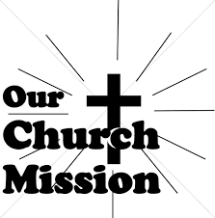

Thank you for your support of our March Mission, Daisy Lee's STEM trips for our young students. We raised $476 to help fund this year's STEM trips!

MAY MONTHLY MISSION –
DOLLY FUND AT LUBEZNIK CENTER FOR THE ARTS

The Dolly Fund is an endowment fund that supports scholarships for students age 7–18 to LCA’s art classes for youth. It was initiated by Paul Marshall in honor of his late wife and the former LCA director, Dolly Marshall. Dolly had a life-long belief that arts education for children was crucial to their development. Some of the classes LCA offers are abstract painting, mixed media for young artists, figure drawing, digital illustration, abstract landscapes, poetry and performance workshops, printmaking, and much more!
Please make checks payable to St. Paul, mark them for the Dolly Fund, and place in the offering. The Noisy Coin offering in May will also go to support the Dolly Fund. Thank you for your generosity each month!

Simply Grateful

Dear Pastor Reshan and the people of St. Paul Lutheran Church,

The peace of the risen Christ be with you. I want to offer my heartfelt thanks for the gracious invitation to preach and preside with you on the significant occasion of your 150th anniversary. It was a deep joy and an honor to share in worship and celebration with you.

Your hospitality was warm and spirit-filled. The meal we shared was wonderfully delightful, and the humor and laughter that filled the space were a gift, a true sign of the love and ife you share as a community of faith.

Thank you as well for the wonderful cups you gave to both Meme and me, especially with our names inscribed. That thoughtful and generous gesture means more than you know, and we will remember you each time we use them.

Thank you again for your kindness, your generosity, and the privilege of joining you in this celebration.

With deep appreciation, and in Christ’s love,
Bishop Tim and Meme

May Birthdays May Anniversaries
2 Isabella Robbins 1 Leigh & Beverly Coburn
4 Tim Mellen 2 Charles & Carol Thomas II
Kimberly Payne 5 Jim & Bernadette Krueger
5 Rachel Sutor Marshall & Belinda Schnick
6 Charles Payne 6 Chris & Cynthia Scheuchner
Brittney Strelesky 19 Fed & Judy LaBorn
7 Marcy Petri 29 Clay & Kimberly Payne
8 Mandy Robbins
Abby Haring
9 Lauretta Hapke
11 Audrey Henderson
15 Adaline Gebbink
16 Patricia Miller
17 Melinda Nagle
21 Hallee Petri
24 Bonnie Ziesmer
25 Marvin Dirks
Pamela Kienitz
Chandler Fisher
26 Emma Robbins
27 Kerry Steinborn
Krysten Fratgillo
30 Sally Timm
31 Audrey Claussen
Pamela Hackett



IN MEMORY AND IN HONOR OF LOVED ONES
Altar Guild and General Fund from Diane Waltz

IN MEMORY OF WAYNE SIMERLEIN
General Fund for the 150th Anniversary of St. Paul from Milenda Simerlein and family

IN MEMORY OF ROGER MILZAREK
General Fund from Norma Milzarek

IN MEMORY OF ALLEN KRING
General Fund from JoAnn Kring, Cindy Swift, Stephanie Dusza, Steve Kring

IN MEMORY OF GRACE ROMINE
General Fund from Kristine & Russell Ackerman, Lester & Lynn Andrews

IN MEMORY OF BRENDA BIGGS
General Fund from Jim & Bernadette Krueger

IN MEMORY OF DIANE WALTZ
General Fund from Virginia Murray, Bob & Karen Kiser, Janet Bakken, Gail Leffew,
Richard & Karen Fleming, Jim & Sandy Galinowski, Wayne & Suzann Dolson, Jean Dreesen, Beverly Johnson, Warren & Kathryn Glanz, Lynette Johnston,
Diane’s cousins (Kay Peglow, Pat Jones, Pam Sullivan, Linda Strohacker)



Long-Term Prayer List

Lucas Bradshaw Laura Dovey Bethany Manning
Debbie Martin Shirley McCarty Sarah McNabb
Jan Paholski Martha Schroeder Jeanie Boatman Shepple
Kathy Stein Mark Tannehill Kathy Thielman
Brian Wiseman

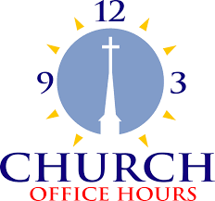

Monday 8:00 a.m. – 5 p.m.
Tuesday 9:00 a.m. – 12:00 noon
Wednesday 8:00 a.m. – 5 p.m.
Thursday 9:00 a.m. – 12 noon
Friday 8:00 a.m. – 12 noon

St. Paul Lutheran Church Staff
Pastor Rev. Mark Reshan
Secretary Libby Pollock
Accompanists Jary Tannehill, Mark Tannehill, Jacob Tannehill
Custodian Mark Kloess

Thank$ for $haring

This month, we are going to Galveston on Thursday, May 7. Here are two coupons—one for you and one for a friend.

